As you know it is 150 years since the opening of the Overland Telegraph. Here is some light reading for you for Christmas and the New Year... Have a Good One. Cheers

December Newsletter


This is the last Newsletter of the OT-150 Committee
www.ot150.net
On this Day in December
In the ot150.net Library – Key dates – December: On the 2nd of December 872 the Great Work is finished (apart from putting in the poles left out in the race to get the wire strung); the speeches have been made and the toasts have been drunk; and the Overland Telegraph Line is passing a steady stream of messages between Australia and England. But then the rumours start and questions are asked in Parliament – is it not in a sound condition and does the entire Line have to be rebuilt? Todd refutes the allegations and offers to resign. The supervising officers emphatically deny there is any “instability” in the Line they have worked so hard to build.
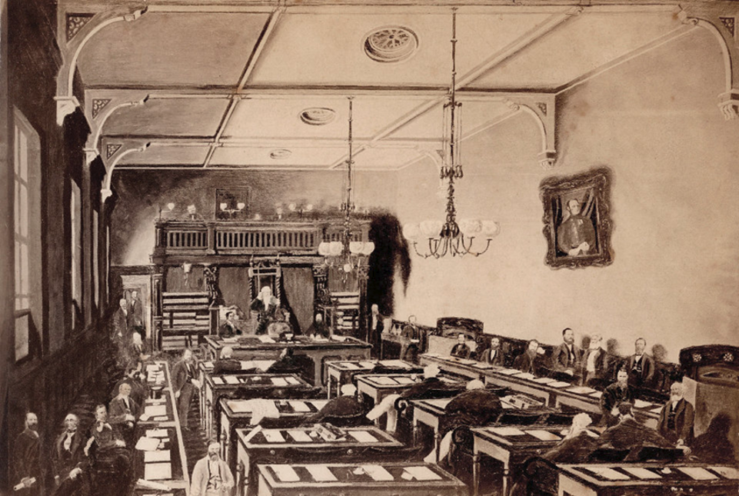
House of Assembly, c1867 [State Library SA, B18117
Newsletter contributions by the OT-150 community follow
Two Years Building the Line – an informative personal diary (Andrew Crouch)
For those interested in the personal observations of workers on the line, Andrew Crouch thoroughly recommends reading the Reminiscences of Sidney (not Sydney) Wellington Herbert (online HERE). He says it is arguably the most readable and richly informative of all the OTL diaries and memoirs and covers Herbert's involvement as the youngest member of the Northern from his departure from Adelaide in August 1870 through to November 1872 when he arrived back in Adelaide over 2 years later OTL (he remained in the North through both expeditions). The last section of the book describes his later experiences as a gold prospector in the Top End, where he returned in 1873.

Whispering Wire Book Review (Susie Herzberg)
Two books on the OT-150 have been published: Twenty to the Mile: The Overland Telegraph Line by Derek Pugh OAM and a limited addition of The End of Isolation - How one-man telegraphed Australia to the modern world, by Adam Courtenay. They are joined by a third book, Whispering Wire: Tracing the Overland Telegraph Line through the Heart of Australia (Wakefield Press) by Rosamund Burton.
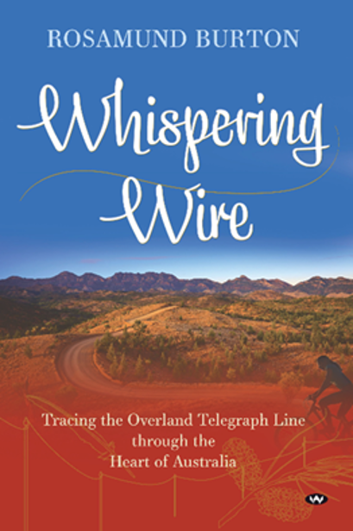
Available at many website book sellers
Ros Burton is one of a number of interstate and overseas people who became enthused by the story of the Overland Telegraph. Whispering Wire tells of her voyage of unravelling stories as she follows the abandoned poles of the Line, at first by bicycle and later by driving. Ros sets the scene by presenting the explorations of Stuart and continues by including details of the construction of the OTL, the work of Charles Todd and the stories of First Nations peoples. Ros’s historical research, her careful observations and her empathy with those she meets are genuinely to be admired.
Tourists could well adopt Whispering Wire as the travel manual for the Overland Telegraph Track. It is a South Australian Odyssey with references to Maggie Beer, Douglas Mawson, and Sidney Kidman. For the cyclist, there is reference to great routes including the Mawson Trail, the Amy Gillett Bikeway, the Riesling Trail, and further north, the beautiful Moralana Scenic Drive.
Ros shares her excitement at being shown stumps of original Callitris posts by Reg Dodd near Finniss Springs, her delight at Oppenheimer posts, porcelain insulators and pins. She also shares her joy (and it is a joy most researchers will have felt) in handling original documents and reading dusty, faint pencil-written journals and letters of those who explored, surveyed, and constructed the line.
In Alice Springs, Ros explores the history of the Telegraph Station and follows up with stories from Doris Blackwell and the anthropological studies of Frank Gillen and his work with Baldwin Spencer. While seeking to understand First Nations people’s connection to country and language, she outlines the policies and practices which led to Aboriginal dispossession.
Descriptions of the natural environment, remind us of the beauty of outback Australia, the starry nights, the landforms, plants and animal and bird life. Whispering Wire is not just a travelogue and not just a history. The reader can share the introspection which travel can bring as we explore the world around and within us.
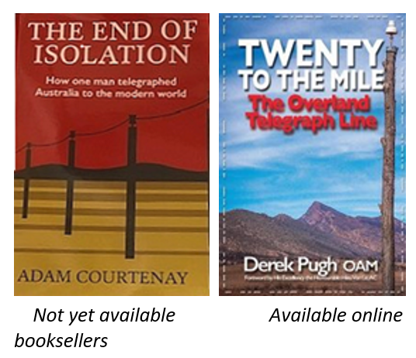

Senior Government figure responsible for major delay - in OTL construction (Andrew Crouch)
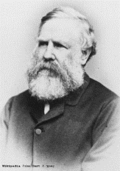 | John Hart was Premier of South Australia from May 1870 to November 1871, a crucial period in the building of the OT Line. It was his third service as Premier at a time of turbulent politics in the Colony. Originally, Hart was a seafarer and ship’s captain, ultimately managing a whaling station at Encounter Bay before giving up the sea and settling in Port Adelaide in 1846 and becoming a flour miller and merchant.  One matter of great debate in the lead-up to the OTL was the question of what to do with the Northern Territory. It was carved off from NSW and provisionally annexed to South Australia in 1863. The primary intent had been to use the NT to bolster the Colony’s finances, but some (perhaps presciently) saw it as a Treasury-draining white elephant.

One grandiose strategy was to create a corridor of development from south to north to facilitate the export of South Australian horses to India. Another was to populate the Top End with immigrant workers (Coolies) from nearby Southeast Asia, who would supposedly adapt rapidly to a climate identical to their own and develop agriculture on a massive scale. The profits from this reverse White Australia scheme would find their way southward through the sale of land to would-be ‘White Rajahs’, and the subsequent sale of produce.
This eventually played out in a major way on the OTL, as there were strong and disparate views on where the northern capital of the ‘Great Central State’ would be. Hart was one of those who insisted on the northwest coast (in particular the Victoria River district) and was utterly opposed to any development on the Gulf of Carpentaria that might detract from this plan. Consequently, he overrode the logical arguments of Todd and Patterson for siting the main OTL Depot on the Roper River, and thus brought about the great crisis of the second Northern OTL expedition.

Little did they know
These 3 extracts were published together in the Week’s News section of the Adelaide Observer on 22nd Oct 1870. They all relate to the start of major projects in South Australia – Bagot on the southern section of the OT, Darwent on the northern section of the OT, and Patterson, the railway beyond Port Augusta. Both the OT reports exude optimism but who of the newspaper’s readers on that Saturday would have foreseen the connection between the first and third items?


THE OVERLAND TELEGRAPH. - Mr E.M. Bagot has received information from Mr Towler, supervisor the southern portion of the overland Telegraph Line, that he has between the first of the month and Saturday last erected 20 miles of line, starting from Port Augusta, and that he anticipates completing length of 50 miles within the month…

THE OVERLAND TELEGRAPH.- Mr. Darwent has received from his nephew very encouraging accounts in relation to Messrs. Darwent and Dalwood’s overland telegraph construction party. The men were all in good spirits, and entering into their work con amore, determined, if possible, to complete their part of the line within the time allotted…

The Port Augusta Railway.- Mr R.C. Patterson, the resident engineer of railways has left Adelaide to undertake the superintendence of the survey of a route for a railway 200 miles northward to Port Augusta. He will proceed to Farrell's Flat by train, and thence overland to Port Augusta. There will be three survey parties, respectively under the charge of Mr. A Stewart, Mr. J Rogers, and Mr W Rutt, each having eight men…

Little did Robert Charles Patterson, Resident Engineer of Railways, know that instead of just surveying a railway line 200 miles northward of Pt Augusta, he would be landing in Darwin a full 1800 miles further north about 10 months later on 24 Aug 1871 to carry forward the work started by Darwent
Government Surveyor William McMinn, who was in charge of the northern section of the line unexpectedly sacked Darwent on 3 May 1871, declaring his contract “void” on the grounds of insufficiency of transport power to complete the line. Darwent’s workers had constructed 225 miles of poles and 156 miles of wire erected but the early wet season had stalled their work. Patterson was then appointed 10 July 1871 to take over the work of the Darwent and Dalwood contract which required 300 more miles of line commencing 200 miles south of Darwin. The tough conditions and hard work that faced Patterson’s team is part of the OT’s folklore, but 22 months later a man, who was in an unrelated story a few column inches away from the hype of one the greatest Australian engineering projects of the 1800s, brought it to a conclusion.

OT-150 in forms and pictures (Martin Walker, SA Philatelic Council)
At the SA Philatelic Council's National ANPEX Exhibition in August, a section was dedicated to commemorate the Overland Telegraph Line anniversary. On show were ten displays of telegram forms, stamps and other material connected to the telegraph service from the Australian Colonies, the Commonwealth and Ecuador. Martin Walker (President) and the Organising Committee also arranged for larger exhibits to tell the wider stories of telegraphy (Patricia Wood) and Telecommunications (Marilyn Syme) in Australia.
Working demonstrations of morse code and amateur radio communications were provided by members of the Northeast Radio Club, and were backed up by fascinating displays. Their participation also allowed visitors to ANPEX to send and receive souvenir telegrams and 98 were sent during the weekend. Special forms and telegram message stamps were produced by the organisers.
One of the most pleasing aspects of the competition was the number of new exhibits. According to the entry form, 9 exhibits had their debut showing. A quarter of these comprised the experimental Telegraph Class, with the Best Telegraph Exhibit being awarded to Dave Elsmore for his Electric Telegraph Queensland.

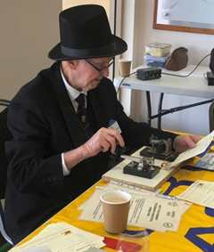  Gordon Oates, in period dress, taps out one of  the souvenir telegram messages on his morse key. | 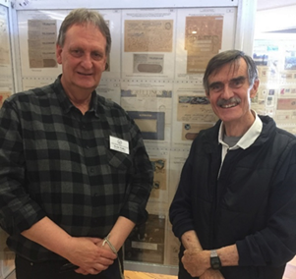  ANPEX 2022 President and Mac Benoy, Co-ordinator of the Overland Telegraph Line Sesquicentenary Committee

“So fast—better than SMS” (Laurie Wallace)
The SA & NT Morsecodians Fraternity was formed in 1988. Since then, the Fraternity has annually celebrated the historic Overland Telegraph Line using temporary telegraph stations in Adelaide, Alice Springs and Darwin. Over the years, visitors to the temporary stations have had the opportunity to send telegrams to friends or loved ones in Australia and overseas.
During OT-150, the SA & NT Morsecodians Fraternity took part in events in both Adelaide and Alice Springs. At the Adelaide function of the Pioneer Association of South Australia, Laurie Wallace (left, age 96) and Dennis Hughes (age 89) took the attendees back in history with demonstrations of the speedy sending and receiving of Morse code messages, which were a lot faster than sending a text message using a mobile phone!
At the OT-150 celebration of the Institution of Engineering Technology and Institute of Electrical and Electronics Engineers Retired Engineers Group (IET/IEEE REG) Dennis Hughes sent a Morse code message to Barry Barnes (85 years) which was a re-enactment of the message sent by Charles Todd from Central Mount Stuart on 22 August 1872 to the Chief Minister, Parliament House Adelaide.
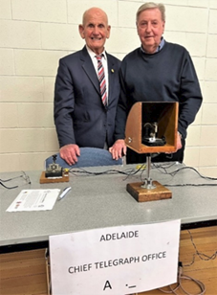
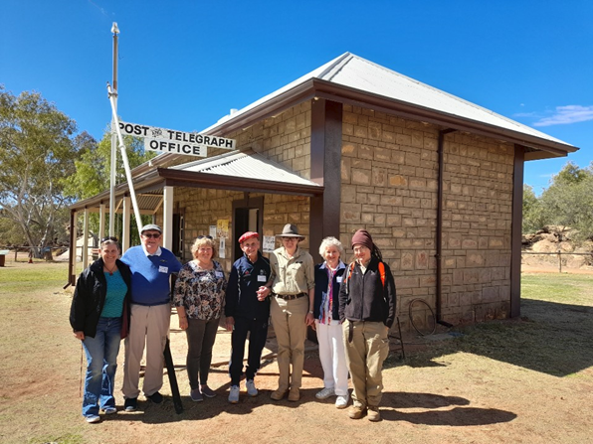
Laurie Wallace and Graham Borlace, Telegraphists with public relations officers Patricia Watkins and Dianne Borlace and NT Parks & Wildlife
Rangers
SA & NT Morsecodians celebrations culminated in a nine-day event at the Historic 1872 Alice Springs Telegraph Station. Record numbers of visitors from across Australia and overseas were attracted to the Station with more than 2,500 over 9 days. Many arrived as bus tour groups with another 200+ as Ghan train guests. The highlight was a visit by great-great grandsons, James and Julian Todd and Todd family members as well as 80+ friends for a Barbecue Banquet Dinner under the Stars and a demonstration of the Morse signalling and presentation of a Souvenir Telegram Message.
Aboriginal workers building the Line (Andrew Crouch)
It seems there was no overt attempt to include First Nations people in the construction of the OTL. Todd's approach to First nations contacts was conservative. In his Instructions to Overseers in Charge of Works, Todd wrote, "No native must be allowed to come within 100 yards of the Camp without permission from the officer in charge". Andrew Crouch writes that while there were several instances of Aboriginal men, particularly Larrakeeyah men, joining and assisting the OTL construction parties at various times, it is not widely known that there was an Aboriginal member of the OTL expedition who had joined at the outset in 1870. His name was Billy Weaver. He is mentioned a number of times in both the memoir of Sidney Herbert and the journal and field books of Stephen King Junior.
Herbert wrote: “Billy Weaver was born in the Port Lincoln district. He had a good natured disposition and had the reputation of being a good native tracker and generally had charge of the stock in Burton’s camp”. King recorded that on one occasion, Weaver went with Charles Tymn from Katherine to No. 2 Depot, a distance of 120 km. Significantly, Weaver returned alone. It was very unusual for men to travel alone over such distances, and presumably little thought was given to the fact that Aboriginal people were just as likely to be attacked as white men when away from their own country.
Overland Telegraph Banquet in London (Stephen Gillam-Smith, London)
At the banquet held on 15th November 1872 in London (a few hours later than the banquet in Adelaide) to celebrate the completion of the construction phase of the Overland Telegraph, a telegram was received from Charles Todd to Sir James Anderson the Managing Director of the Eastern Telegraph Company who had congratulated South Australia for connecting the colonies to the submarine cable from England.
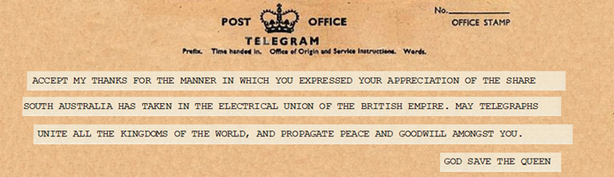

The OTL was not the last link (Gavin Beinke, Todd Citizen Historian Team)
Charles Todd had the ambition of helping to construct a continental telegraph system in Australia and connecting it to England even before he left for Australia in 1855. In the next 22 years he achieved this with telegraph lines connecting most of the settlements in South Australia, along with lines from Adelaide to Melbourne (and Tasmania), then Adelaide to Sydney (and Queensland), and then the great work of Port Augusta to Darwin (and England, Europe, Asia and America). However, there was one last major link to be made, the East-West telegraph line from Port Augusta to Port Lincoln and Eucla where it joined up with a line from Perth. This completed his ambition. As a former resident of the upper Eyre Peninsula, I have taken a personal interest in this line, tracing its route, capturing news stories of its construction and visiting key parts of what’s left of it.

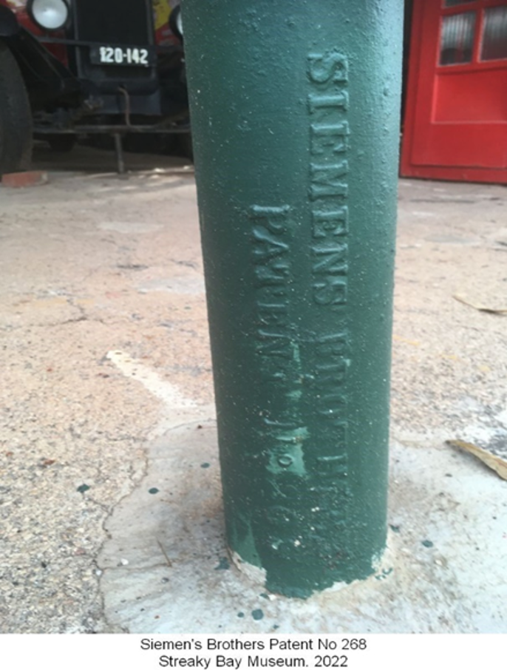

Siemens Brothers poles were apparently used on some of the line in the Streaky Bay area. In the Streaky Bay museum there are 5 of these poles on display.
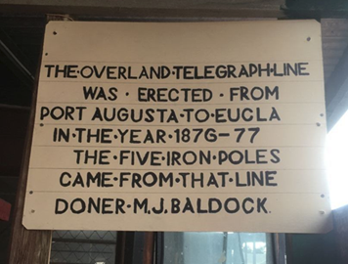
At Fowlers Bay I found Siemens and Oppenheimer poles used as posts for a carport of a

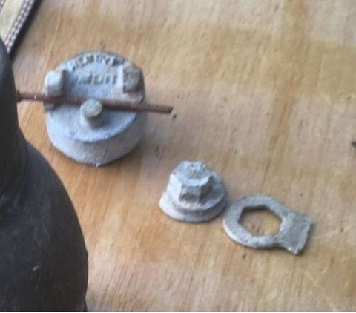
At Ceduna I was put in contact with someone who has examples of the insulators used on the Western Australian line. The metal is attached to the top of a Siemen’s porcelain insulator. It consists of 2 hooks, which the telegraph wire is placed under. The cam is placed on the pin and turned, using the spanner, so it locks under the hooks and on top of the wire, locking it in place.
A Siemen’s Bros. 1876(?) assembled insulator locking device used on W.A.line (spanner is removed after assembly) with a partial sample of a telegraph wire-join on the left.

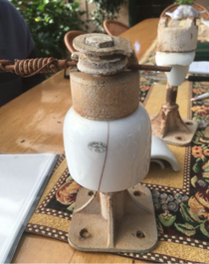
My most significant discovery was that an undersea cable, not an overhead wire, was used to cross the narrow Gulf at Port Augusta.
Remnants of the cable are still on the ground! The copper and steel wires have corroded away leaving holes in what was gutta percha insulation, which has now turned very hard.
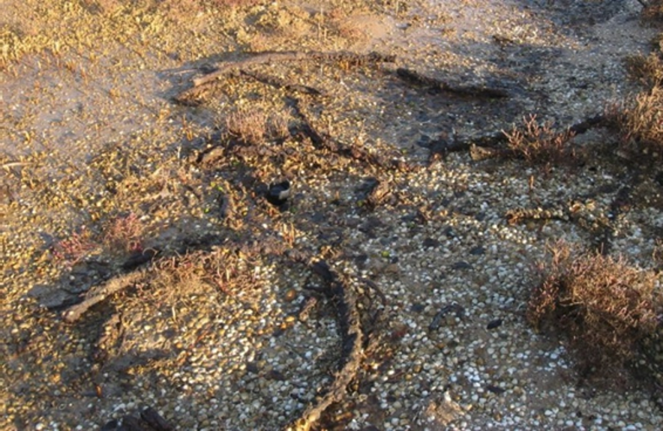

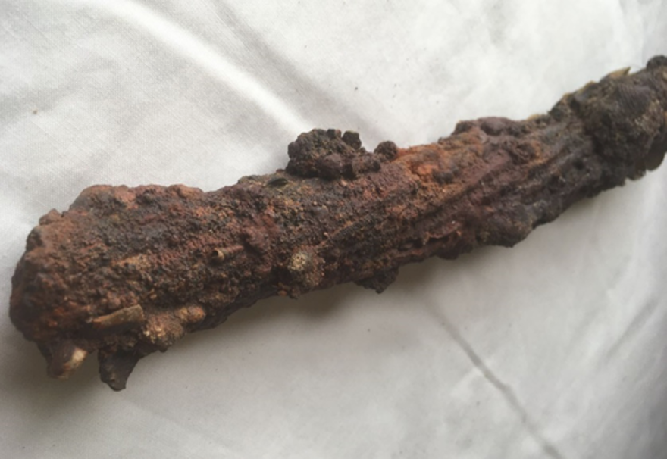
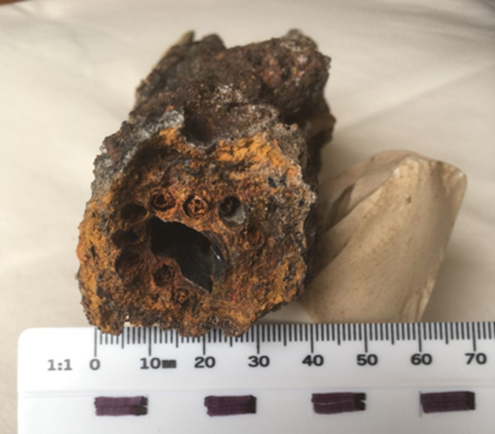
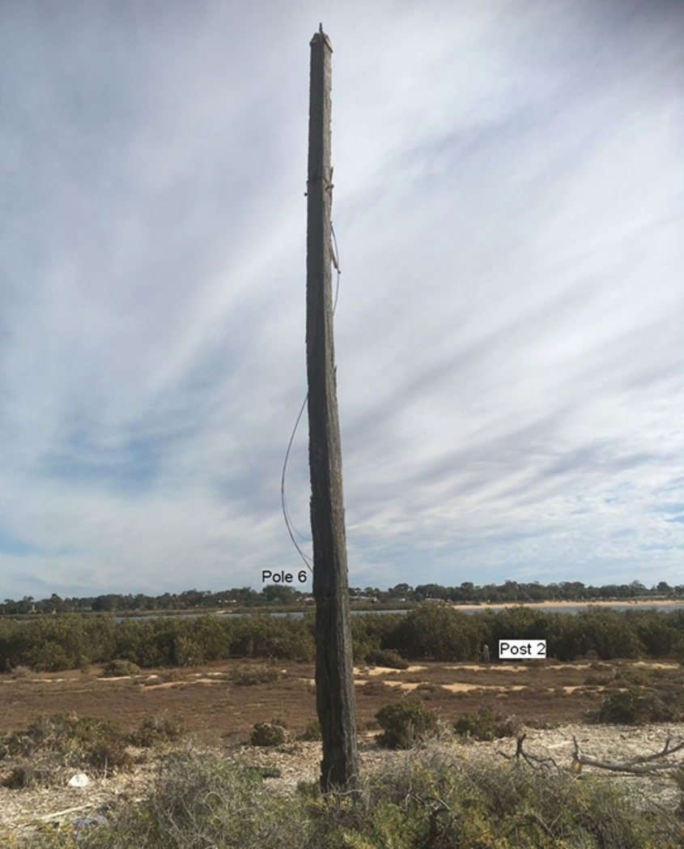
There is also a wooden post five to six metres high, still standing on the east side. On the west side, I found clumps of broken insulators which turned out to be a failsafe way of determining the positions of at least four poles.

My 250 page book, “The Last Link”, detailing all the research on the Port Augusta to Eucla line is available in PDF format on the OT-150 website in the Library/Monograph page or can be downloaded by clicking here.

OT150 Website – A sample of OT-150 reference sources
 | Each newsletter opens with a key OT date associated with  the corresponding month. These come from Richard Venus' impressive series of guides summarising in date order 168 significant events of significance to the building of the OT Line. All events are referenced to their original/contemporary sources. The full set can be found on the website Library/Key Dates page
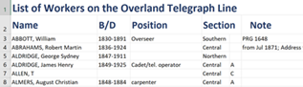 | Well-known genealogist Andrew Peake has created a list of more than 602 workers on the Overland Telegraph, detailing names, year of birth and death, job or position on OTL, section worked on, sub-section and comments or sources. Access it at the Library/Resources page
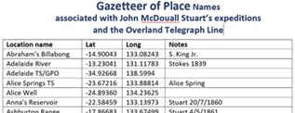 | Andrew Crouch has created the Overland Telegraph Line Gazetteer, a modern and distinct contribution for this era of the GPS. It maps the latitude and longitude of place names associated with John McDouall Stuart’s expeditions and the Overland Telegraph Line. It shows Stuart's work influenced later travel routes and, in particular, the path chosen for the OTL. Access it at the Library/Resources page

OT150 website - Media Page


The media page contains text and some of the audio that was created around the 150th anniversary of the OT story, including an entry made to Hansard. It also guides you on how acquire a souvenir of the event - a coin or a stamp.

A Belt around the world
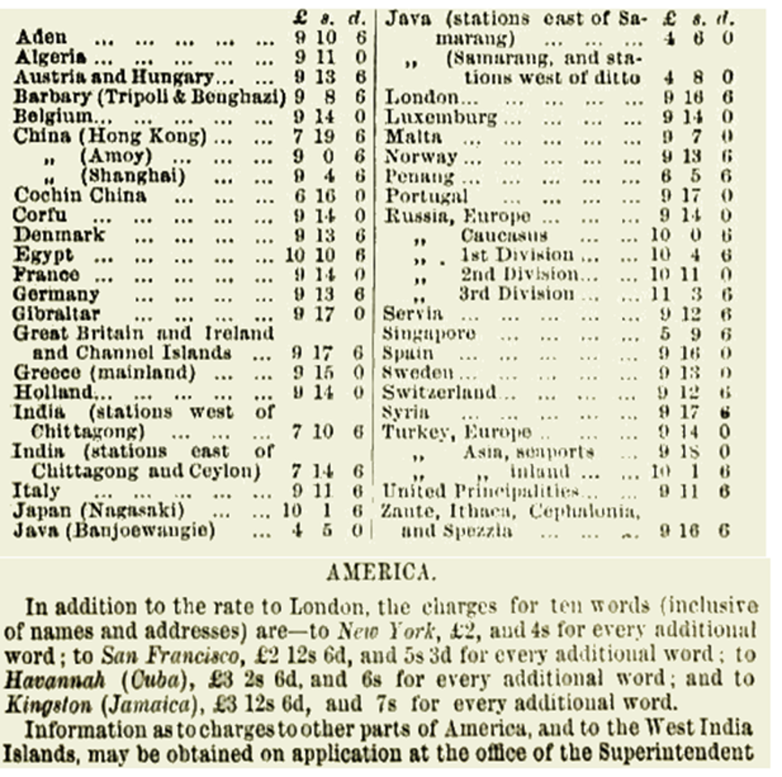
With the completion of the Overland telegraph Line, readers of Pugh's Queensland Almanac of 1874, couldn't have failed to be impressed by this list of exotic and familiar places that could be contacted within hours thanks to the magic of electric telegraphy and the sweat, hard work and technical brilliance that built the lines and laid the cables to bring the world together.

Kids’ Corner
The State Library of SA mounted a display and website titled Kookaburra sits on the telegraph wire - How Australian children connected with the Overland Telegraph. It explored the influence on Australian children of the OT and telegraphy in general. Some quotes from the website highlight this little-known subject:
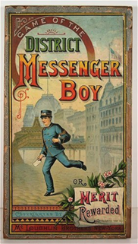
Board Games: The “Messenger Boy”, “Telegraph Boy”, “US Telegraph”
Who delivered all the telegrams? It was kids!. . . .children, mostly boys, were employed to deliver millions of telegrams at any time between the late 1870s and the 1950s
Some of the (OTL) workers were boys aged between 14 and 17 - children by today's standards
Many (OTL) workers were fathers, who worked away from their families (and children) for two years or more
Morse code was also taught in schools for many years and this escalated during the paranoia of Cold War era
Kids have always been able to make their own telegraph sets with the right equipment
And more….

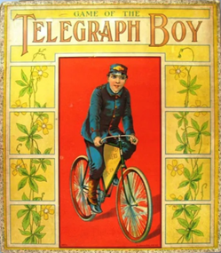


From Stuart to the Overland Telegraph, published in 1952 is a children's Pictorial Social Studies book first published in 1956. As a graphic novel, it uses a comic book (or manga novel) format to tell the story of the OTL from Stuart’s expeditions through to the commissioning of the Line in late 1872. A copy of the book is on the OT-150 website's Library/Monograph page. It is included not only for its uniqueness, but also, as pointed out by Andrew Crouch, because some of its content “illustrates how false narratives can get embedded in the public mind, including the community of historians, when facts are disregarded in the interests of spinning a good yarn or a heroic tale”. It’s a hazard many of us navigate as we explore an historical topic for the first time. We are at risk of taking on board quotes from those we view as experts, quotes that emphasise a point of our interest without fully checking the details involved.

One of the first research publications on the OT-150 website was on this topic: Richard Venus’ documentation of, “Two errors that persistently creep into accounts of Charles Todd’s life - the first is that his middle name was Heavitree; the second is that he was a Fellow of the Society of Electrical Engineers”, both false.

Your life would have been at risk…
in Adelaide in early November 1872 if you were a pig, fowl, cow, ox, sheep, lobster…
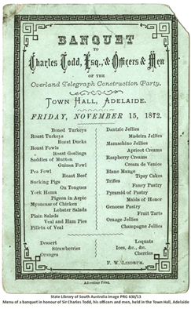 | Banquet to Charles Todd, Esq., & Officers & Men  of the  Overland Telegraph Construction Party.  Town Hall, Adelaide  Friday, November 15, 1872.  Boned turkeys, roast turkeys., roast ducks, roast fowls, roast goslings, saddles of mutton, guinea fowl, pea fowl, roast beef, suckling pigs, ox tongues, york hams, pigeon in aspic, mayonnaise of chicken, lobster salads, veal and ham pies, fillets of veal.  DanTzic jellies, Madeira jellies, maraschino, jellies, apricot creams, raspberry creams, cream de Venice, blanc mange, tipsy cakes, trifles, fancy pastry, pyramid of pastry, maids of honor, Genoese pastry, fruit tarts, orange jellies, champagne jellies  Desert: strawberries, oranges, loquats, ices, cherries, etc. etc.
Courtesy of Gavin Beinke, full details of the proceedings of the banquet are available on the OT-150 website Library/News Articles page or can be downloaded here. The web page also has the proceedings of a second nosh-up only 3 days later, the Officers’ Celebratory Dinner

We Weren't the Overland Telegraph:
In Whitehorse, The Yukon Territory, Canada, the MacBride Museum of Yukon History has a telegraph display with one panel mentioning the …

But it’s not the one we know  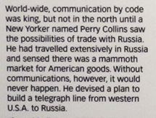  With the Rocky Mountains and T⁰’s of 40 below zero, this project was more challenging than our OTL | The panel goes on to say…. 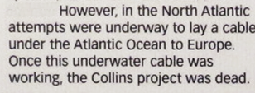  And there is a familiar quote…. 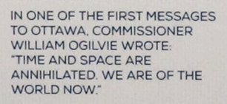
It may interest readers that Wikipedia records on the 24th of October 1861, the completion of the United States overland telegraph line connecting the Pacific and Atlantic Oceans, (and “causing the Pony Express to close two days later”). That’s more than a decade before ‘our’ line and longer than ours by approximately 1,500 kms.

A farewell to OT-150
"History is a path we pick among ruins" historian Felipe Fernández-Armesto
Though referring to ancient cities, this quote likewise applies to other infrastructure like the Overland Telegraph Line. Those of us who have travelled what is now the Overland Telegraph Track will attest to the sometimes frustrating and never-complete investigation of what's left of the stations, the poles and the fragments of wire scattered through central Australia. But equally, for those of us in this sesquicentennial year who have discovered the OT story through our keyboards, we have picked our own paths through a wealth of historical detritus, discovering documents, news articles, photographs, diaries, etc.. Inevitably we picked a path through the OT with our own interests at heart: The engineer contemplating the structures, the project manager reflecting on the planning and execution, the sociologist exposing the effect on First Nation peoples, the biographers focused on entrepreneurial personalities, the politicians highlighting the signature qualities of the Colony, the scientist assessing downstream discoveries, the speaker highlighting the attention-getting facts….
We have picked our own paths, some unique, some familiar, but all being part of a journey of learning. We have examined the scattered pieces of the stories, at times with forensic detachment, at times with romantic nostalgia. Our challenge now is to ensure our work will get added to the historical detritus awaiting the examination of future researchers.

Thank you for your interest in the Overland Telegraph Sesquicentennial. The OT-150 website will stay extant through 2023 but will then be archived. The Committee is now focused on publishing most of the website documents in PDF and limited book form, making the work of the Sesquicentennial available for future reference through the global library system. There may be one last email in 2023 advising of the publication.

