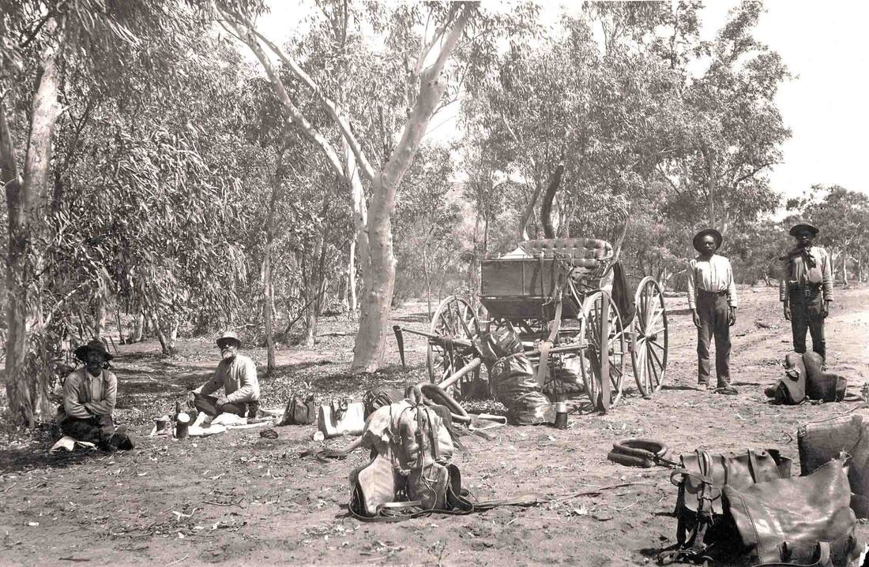
SLSA B22663 Line survey party 1895 NT Collection - The photo was taken during the visit of Lord Kintore's Telegraph Line Survey Party. Mounted Constables Harry Chance and Charles Brookes on the left, and two Aboriginal Troopers at right. The buggy is Lord Kintore's. The expedition travelled along the Overland Telegraph Line in 1891.

Crossed Wires
Ethnographer Arthur Palmer recalls - "Albert Lalka Crowson, already an old man when I first met him in 1977, was a Mudbura stockman who was brought up in the bush with his traditional family before becoming a stockboy and spending the rest of his working life on and around Montejinni, Pigeon Hole and Wave Hill Stations. Over a number of years I spent a lot of time with Albert and two of his brothers, Tobacco Jack Wanamaja and Sugarbag Jayiwa hunting and mapping Mudbura names on the country around Montejinni on the end of the Murranji Track. In the cool of the evening, sitting around a camp fire, Albert would usually relate stories, sometimes for entertainment but often as a means of educating this ‘white boy’.
Those stories, which concerned the early contact days between White settlers and Albert’s family, revealed far more than simple historical notes. He would detail how both sides came to terms with the reality that these changes would demand, although he was always perplexed and regretful that most Whites did not see fit to ‘go company’ with Aboriginals. By this he meant to formalise their working relationship in a business-like manner. Albert reckoned that Aboriginal knowledge of the country and ability to work cattle combined with European management would have been a far more sensible and profitable arrangement right from the start.
Albert related how initially his mother and father could not even conceptually differentiate between rider and horse. That the first explorers and drovers seen riding through the scrub were perceived as one being, a centaur-like supernatural form. Lengthy discussions, after the first contact, were held on how to either deal with or placate the new intruders. Once they were assured that amongst these groups of new beings, there were fairly ordinary, if very different men, then the equation started to narrow down to social and political solutions within their power. Albert told one hilarious story about his father and a group of his mates at a water hole who attempted to address and greet a large, lone scrub bull which had come to drink. The bull responded by scattering everybody up the nearest trees. A little later the group tracked the bull and pin cushioned it with spears. The bull was butchered and eaten on the spot, thereby beginning a long Mudbura association with the cattle industry and also fulfilling the great maxim of cattle country - that is - always eat somebody else’s beef!
Albert described how rapidly Aboriginals adapted and accepted the inevitable changes which White settlement brought. Initially involvement with Whites didn’t necessarily impinge on the independence of Aboriginal groups or individuals. For a long period of time after the initial contact, either by explorers, surveyors or drovers, Aboriginals were very wary of Europeans mainly because they always travelled exclusively as groups of men without women. From an Aboriginal view point, men only travelled into strange territory in the absence of women for the purpose of murder, revenge raids or to kidnap women from another group. Once Europeans started to come through regularly with large mobs of cattle and horses, and it was clear that they could not readily be stopped, Aboriginals started to look closely at what benefits could be gained by association apart from the already rapidly acculturated items such as flour, sugar, tobacco and tea.
Albert’s father’s traditional country had been much farther south in the Mudbura estate when he was a boy and the reason for the move North was told with much mirth. Albert reckons that blackfellas thought that they had the ‘kuddia’ (Whites) sussed out, up until the advent of the overland telegraph line from Alice through to Darwin in the 1870s.
The surveying teams and the building of the line was observed with more than the usual interest. In the absence of better information Albert’s father thought of the telegraph line as a rather unusual fence. A fence with one wire some fifteen feet from the ground on widely spaced posts. The riveting question was; what sort of animal it was meant to contain? Very certainly this animal was extremely tall and without the agility to either duck underneath the wire or the strength to climb over it or break it. With this in mind, and having discovered that the other introduced animals were all fairly harmless herbivores, the size of the new animal was not of any immediate concern, simply a subject of curiosity and unsatisfactory enquiry.
However, the state of alarm was considerably raised when the building teams started erecting the telegraph relay offices. These were stone pill box affairs with purpose built gun slits for warding off hordes of fierce war like and treacherous blackfellas. All the product of bureaucratic concern and over reaction in the far South. Albert’s dad was not burdened with this information. His group reasoned that these fortifications could only be there to protect the ‘shepherds’ at night, or indeed at any other time of the day, from an extremely large and now most certainly carnivorous and fierce new animal that these highly irresponsible Whites were about to introduce. What was going to protect the blackfellas? It was nervously considered very possible that the new animal was being brought in to eat the cattle, which they were only just getting used to. If the Whites were afraid of it, that indicated that this new monster may not be able to distinguish between things it was meant to eat and blackfellas, who it definitely wasn’t supposed to eat.
This is where things became very tricky in the decision making process. The ‘fence’ stretched as straight as a die from horizon to horizon. On which side of the fence was this new beast going to be kept? The ‘shepherd’s’ block houses had gun slits facing in all directions which gave none of the Mudbura any comfort at all. The 50:50 chance of being on the wrong side of the fence were odds far too short. The penalties for being wrong too fearful to contemplate.
To err on the side of caution was rapidly decided upon. As it’s an extremely large continent with plenty of room to move, everybody sensibly decided to quickly and permanently relocate as far away as possible. The embellished stories told by this group to their Northern cousins justifying this move took a lot of living down in later years when the telegraph line monster failed to materialise.
The mass migration by this group of Mudbura saved a large section of the line from one of the great discoveries made by other remaining Aboriginal groups. The insulators, when removed, could be chipped and flaked into superb spear heads and knives. Many share market communications between London and Melbourne were to be rudely interrupted by somebody taking advantage of this newly, evenly distributed, welcome and valuable resource. A lot of these white bifacially flaked spear heads would have found their way into the sides of many a ‘killer’ (any beast killed for immediate consumption) and the occasional careless White man."

