In 1925 the Trans-Australian Railway telegraphic and electric staff working was carried on a single copper wire and galvanised iron wire respectively. The line had 6.7 metre Siemens iron poles spaced 15 to 17 to the kilometre."
Taken straight from Train1959's post today in the thread about the Trans Australia Railway's Centenary.
An alternative to the threaded wooden pegs was to have the threaded section made from lead, with a steel bolt centre. It was much more expensive, but it had the virtue of giving termites a bad case of lead poisoning.
Something I haven’t seen mentioned here was what material was used for the wires themselves.
Most think Copper was the choice but both the PMG and the NSW Railways used galvanised steel wire.
A 10 mile section of a major PMG line was made redundant and sold off and that was when I found all the wire used was at least a 3/8th (3mm) thick single strand galvanised steel wire.
The route had at least 8 crossarms per pole and 5/6 pairs maybe?
To stop one route of wires being stolen on a regular basis, the Railway Linesman used fencing wire which was cut once and when the thieves realised it wasnt copper, never came back.
In the NSW Public Timetables of the 50's was a notice that told how to work out the speed of the Train by counting the poles passed per minute.

Oppenheimer telegraph poles.
Australians are rightly very proud of their Overland Telegraph Line (OTL).
This was a 3,200-kilometre line that connected Darwin with Port Augusta in South Australia. Completed in 1872 the OTL allowed fast communication between Australia and the rest of the world. The original 36,000 telegraph poles were a mixture of timber (Pine, Cypress, Gum) and were eventually replaced with galvanized Oppenheimer poles.
Many of the timber poles were rapidly destroyed by termites and in 1873 work commenced on their replacement. This work continued until 1883 “when all the timber poles had been replaced with an assortment of telescopic galvanised iron poles, manufactured at Manchester in England, under J Oppenheimer’s patent”.
The Oppenheimer poles were designed using three round or oval shaped galvanised pipes of different diameter and each pipe would slide inside the next. These telescopic poles were ideal for handling and storing and their reduced size made them much easier to transport and erect on site. Once on site they would be extended to their full height and a heated iron collar would then be place over the joint. The iron collar would cool and shrink on the join making it firm.
Prior to the poles being installed cast iron base plates were fitted to the bottom of the poles to prevent them from moving. (Information from NT Government site) Then they were placed with an 80-metre spacing and with a repeater station every 250 km.
Disused Oppenheimer poles have been used on properties for fence posts, tank stands and anywhere they could be put to good use. Small numbers though are still standing and are highly valued by the Australian communications historical community. Very few Oppenheimer poles still standing but many can be seen, particularly at museums in some of the towns along the Stuart Highway in SA and NT.
Bullers Ltd iron poles are found in Western Australia. Bullers Ltd were based at Joiners Square Works, Hanley, Stoke-on–Trent. (Some Bullers company history) The best places to to see the poles and insulators etc were at - 1) Tennant Creek (NT) at the Historic Overland Telegraph Station where some poles have been used to support the veranda roof. 2) Alice Springs (NT) at the Historic Overland Telegraph Station. www.telephonetalk.com.au

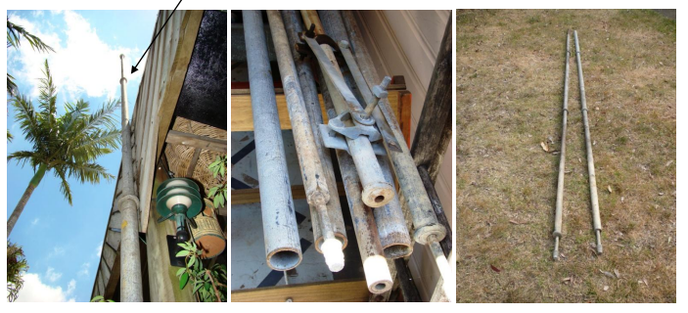
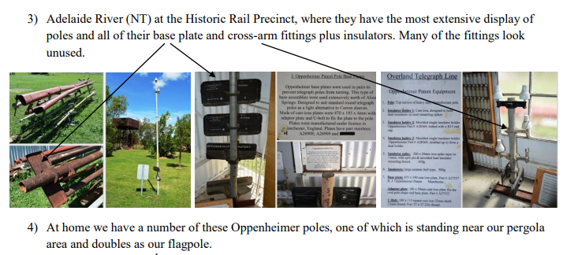
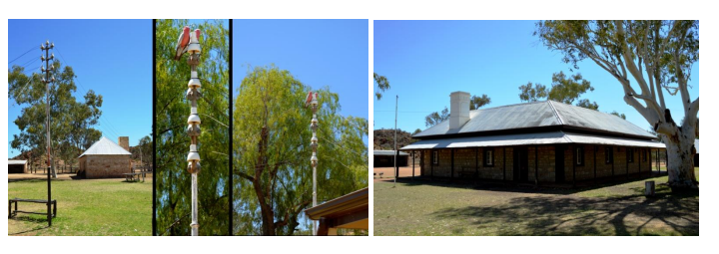
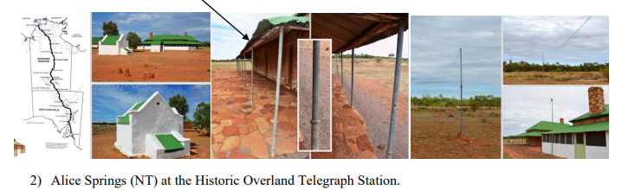

Oppenheimer poles are galvanised iron telegraph poles. They consist of three oval sections that collapse into each other telescope style for transportation. Once extended the joints between the sections are clamped with collars. The pole is fixed to a base for support with a u-bolt.
The poles were used in the construction of the Australian Overland Telegraph Line in 1872, which ran from Darwin in the north to Port Augusta (near Adelaide) in the south. It was initially intended to use Oppenheimer poles in regions where there was no suitable timber, and for poles that needed replacing in service. When it became clear that wooden poles on the northern part of the line were going to be rapidly destroyed by termites, it was decided to construct the line with 3,000 metal poles. Wooden poles are also vulnerable to fire and much of the line's route suffers frequent bushfires. Many poles were later replaced with Oppenheimer poles for this reason.
The initial order for 6,000 poles may have been made in Germany by Oppenheimer and Company (it is not certain) but later production took place in England under licence. Many of these poles were carried overland into the Australian interior by camel trains imported from Egypt, complete with their Egyptian drivers. See Australian feral camel.
Inventor: Joseph Oppenheimer
Joseph Oppenheimer (born Feb 8 1820 in Braunschweig/Brunswick, Germany and died 8 Feb 1893 Manchester, UK), was a German born merchant and inventor, and naturalised British citizen who spent most of his adult life working in the telegraphy industry in Australia and the United Kingdom. He held several key patents, including one for telescoping telegraphic poles -- the Oppenheimer Pole.
Whilst Oppenheimer maintained a household in Manchester, he travelled regularly to Australia in the 1850s, 60s and 70s. Oppenheimer's first visit to Australia appears to have taken place in 1853, when he travelled to Melbourne on the P&O line. Initially, Oppenheimer was an agent for Meyers and Co in Melbourne where he tendered for everything from water works and cast-iron parts to telegraphy. In Melbourne, Oppenheimer becomes develops a working relationship with Samuel McGowan, who was responsible for the introduction of telegraphy to Australia, and the earliest telegraph systems in the colony of Victoria in 1853/54, and contracted with the colonial offices of Victoria for telegraphy supplies. In 1856, he was a member of the South Australian governor's travelling party in 1856 to participate in an inspection and surveying of the country to determine the route for the proposed Victoria-South Australia telegraph line. In the 1850s, Oppenheimer also developed a close relationship, both personal and professional with Charles Todd, then responsible for the installation of telegraphy systems across South Australia, and later the architect of the Overland Telegraph Line and the colony of South Australia's Post Master General. He counted amongst his close friends, Samuel Deering -- the long-time Agent for the South Australian colony
Todd looked to Oppenheimer for assistance, when he commenced the Port Augusta to Port Darwin -- Overland Telegraph -- Line. [8] This telegraph line, which would stretch more than 3200 kms (or 2000 miles) required 36,000 poles, kilometres of wire, thousands of insulators, and the latest in battery technologies, and telegraphic equipment. Oppenheimer helped secure insulators and metal poles. Over time, the original blend of wooden and metal poles were upgraded with new poles, following Oppenheimer's patented innovations for metal telescoping poles. The so-called Oppenheimer poles were produced in Manchester and shipped to Australia, throughout the 1880s. Oppenheimer's poles were installed along the length of the Overland Telegraphy line. They were also installed in Queensland.

Oppenheimer pole patent
The Oppenheimer pole was resistant to rot and termites, it was also designed to be easily transported via camel or bullocky train.
The Oppenheimer poles were designed using three oval shaped galvanised pipes of different diameter and each pipe would slide inside the next. These telescopic poles were ideal for handling and storing and their reduced size made them much easier to transport and erect on site. Once on site they would be extended to their full height and a heated iron collar would then be place over the joint. The iron collar would cool and shrink on the join making it firm. Prior to the poles being installed cast iron base plates were fitted to the bottom of the poles to prevent them from moving.
Oppenheimer poles can still be found in a range of locations along the old Overland Telegraph Line, as well as in Queensland. Oppenheimer poles can also be found repurposed as flag poles, or in the case of the William Creek Hotel as veranda supports.

How to Build a Telegraph Line
AUTHOR:STRANGEAGO PUBLISHED DATE:MARCH 19, 2018
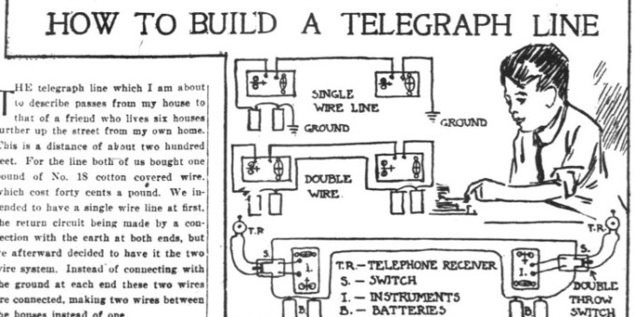
The article below, originally published in 1911, describes how one man set up a telegraph line between his house and a friend’s house so that they could practice Morse code.
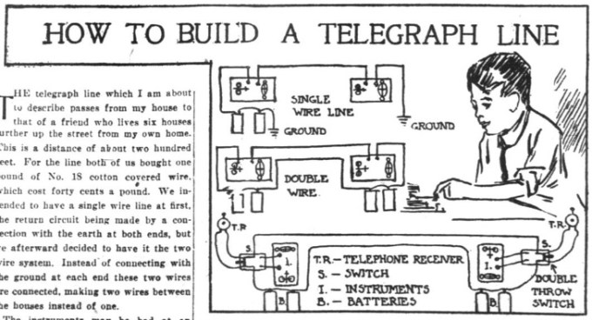

How to Build a Telegraph Line
The telegraph line which I am about to describe passes from my house to that of a friend who lives six houses further up the street from my own home. This is a distance of about two hundred feet of No. 18 cotton covered wire which costs forty cents a pound. We intended to have a single wire line at first, the return circuit being made by a connection with the earth at both ends, but we afterward decided to have it the two wire system. Instead of connecting with the ground at each end these two wires are connected, making two wires between the houses instead of one.
The instruments may be had at an electrical store for $2 apiece. When connecting the batteries with the line one must be careful not to have the carbon element of the battery connected with the other carbon in the other house, because no current would flow, or not to that with the zinc element. Connect them so that the zinc on one battery is connected with the carbon on another battery and the zinc pole on the same battery connected with the carbon on the next, and so on.
We are going to fix our line so we can talk over the wire as well as telegraph. Then, if when practicing telegraphy we do not understand we can signal each other by making two dots, dash, two dots on the telegraph, which will mean to throw over the switch which will connect a pony receiver with another receiver in the other house. One will talk while the other listens, and when he gets through talking he will put the receiver to his ear and listen while the other boy answers him.
Small single pole switches may be used at both ends of the line to “short circuit” your own instrument when you want to practice alone, but they must be open when you practice together.
Source: The Washington herald. (Washington, D.C.), 29 Oct. 1911.

