CBHS Year 5 History
• HOME
• KEY INQUIRY QUESTIONS
• THINKER'S KEYS
• QUESTIONS PAGE
• HELPFUL WEBSITES
The Great Race Across Australia
Explorer John McDouall Stuart leads the first European expedition to travel over the Australian mainland from south to north and return alive. He wins his race from Burke and Wills when they perish on the way home. Explorers had imagined the centre of Australia to be filled with inland seas and fertile plains. The reality is very different. Stuart’s heroic journey enables the construction of the Overland Telegraph Line - 36,000 poles and 3,000 kilometres of wire stretched across the continent. The connection to the information superhighway of the day transforms the colonies.
(Source: au.prime7.yahoo.com)

Role of explorer John Stuart
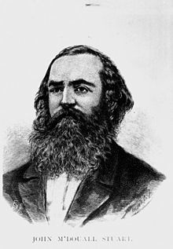
A prize of 2000 pounds was offered by the government to the first European to cross the continent, forming a route for a telegraph line from Adelaide to the north coast. Stuart was fully determined to achieve this. At this same time, in the colony of Victoria, the Burke and Wills Expedition was preparing to set off in an attempt to cross the continent from the south to the north. No expense had been spared for this expedition, including the importing of camels from India. (Source: http://kidcyber.com.au/)
In 1860, a Scot by the name of John McDouall Stuart set out on his first attempt to cross the centre of the continent from south to north, racing against the Burke and Wills expedition. Stuart had previously accompanied Captain Charles Sturt on his expedition to central Australia and had conducted numerous expeditions of his own, surveying extensively throughout South Australia. But his first two attempts at finding a north-south route failed.
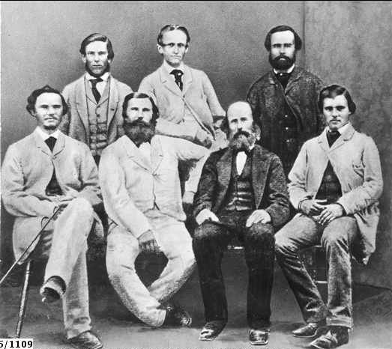
Stuart's expedition party; Back: Auld, Billiat, Thring, Front: Frew, Kekwick, Waterhouse and King
A lack of supplies, dense bushland and confrontations with hostile indigenous peoples thwarted his first two attempts, but his third attempt was successful. Leaving Adelaide in December 1861, his party finally reached the Timor Sea--at a place they named Chambers Bay, after a sponsor of their expeditions--on 24 July 1862.
In crossing the entire continent from south to north, he had traveled a distance of over 2,900 kilometres and, unlike his rivals Burke and Wills (who had reached the Gulf of Carpentaria sixteen months earlier but perished on the return trip), he made it back to Adelaide. Upon his return, he reported that timber was readily available most of the way and that he considered that his route 'could be made nearly a straight line for telegraphic purposes.'
But the trip had cost him dearly. His health, which had been failing before the final expedition and which was further compromised by his very heavy drinking, never recovered. He returned nearly blind and suffering from scurvy.
(Source: http://www.australia.gov.au/)
Stuart and his group were given a special welcome in Adelaide on 16 January 1863. This was also the day that Burke and Wills were buried in Melbourne after the failure of their expedition.
(Source: wikipedia)

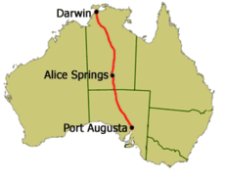
Stuart's passage from south of Australia to the north of Australia.
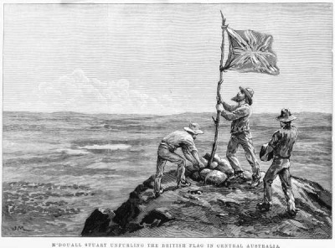
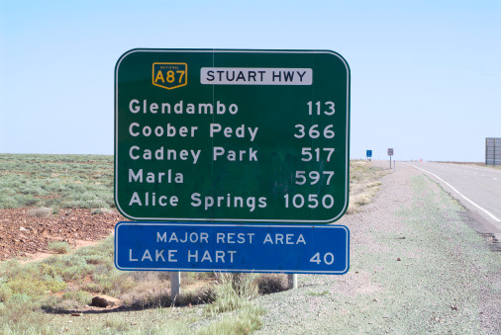
The Stuart Highway, named after John Stuart, begins in Port Augusta and travels to Alice Springs

Stuart Crosses the Continent

There was enormous public and media speculation about whether the Victorian backed Burke and Wills or South Australia's Stuart expedition would be the first to cross the continent's interior.
Stuart Crosses the Continent is an excerpt from the film A Wire Through the Heart (55 mins), the third episode of the three-part series entitled Constructing Australia, produced in 2007.
Click on the image below to access the video from National Film and Sound Archive.
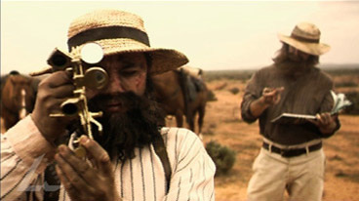
Todd's Telegraph Dream

Charles Todd dreamt of constructing a telegraph line through the heart of the continent.

Todd’s Telegraph Dream is an excerpt from the film A Wire Through the Heart (55 mins), the third episode of the three-part series entitled Constructing Australia, produced in 2007.

Click on the image below to access the video from National Film and Sound Archive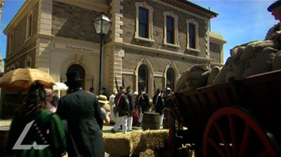

Todd completes Telegraph.

In 1870 Charles Todd, using explorer John McDouall Stuart's maps, organised and lead three teams to lay the overland telegraph wire.
Todd completes Telegraph is an excerpt from the film A Wire Through the Heart (55 mins), the third episode of the three-part series entitled Constructing Australia, produced in 2007.

Click on the image below to access the video from National Film and Sound Archive
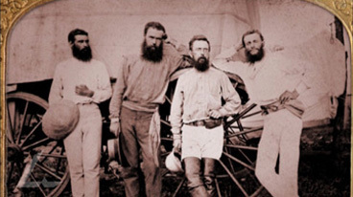
A Telegraph Line across the Continent

The story of the struggle to cross a vast continent and build the telegraph line that would bring Australia to the world and the world to Australia.

Click on the image below to access the video from National Film and Sound Archive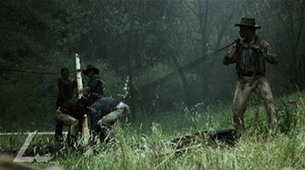

The Overland Telegraph

Covering the width of the continent, the overland telegraph line secured us a direct link to the rest of the world.
15 SEPTEMBER 1870: For early Australian settlers, communication with the rest of the continent, let alone an overseas destination, was a long and difficult process. Letters and news could take months to travel halfway around the world. After the death of Charlotte, Princess of Wales, on 5 November 1817, it wasn't until 2 April 1818 that New South Wales received the news. (That's 5 months!!!)

But in 1870 that would all change. The South Australian government agreed to build a telegraph line through the centre of the continent to link a new submarine cable - a communications line under the seabed carrying telecommunications overseas - with the existing telegraph system.

The first pole at the northern end of the line from Darwin to Port Augusta was planted on 15 September 1870.
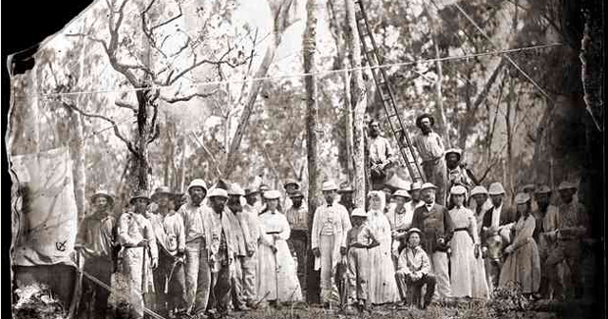
The planting of the first Overland Telegraph Line pole in Darwin in 1870.
The Overland Telegraph Line crossed 3200km through mountains, flood plains and desert. It was one of the greatest engineering achievements of the 19th century.
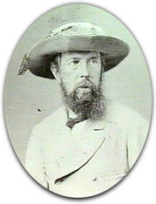
Charles Todd
The project was given to the South Australian Superintendent of Telegraphs, Charles Todd. With only 18 months and a budget of £128,000 ($2,900,000 in 2010 terms) to complete the line, he divided construction into three sections - southern, central and northern.

The telegraph line was made from 36,000 posts, pins and insulators; almost 3000km of galvanised telegraph wire; and numerous and batteries. The materials were transported to the workers by bullocks and horse drawn wagons. Afghan cameleers were also recruited to carry food and supplies to workers along the central and southern sections, giving rise to the name of the famous Ghan train line from Adelaide to Darwin.
However, construction was far from smooth says historian Stuart Traynor.
"The biggest obstacle that Charles Todd faced was that he really had very little idea about the terrain on which the line was to be built," says Stuart. "No white men had travelled along the proposed route since explorer John McDouall Stuart's epic crossing of the continent in 1862. Normally on a project of this type he would have sent surveyors to map out the route, but due to the 18-month time frame this was not possible. So, he sent ahead (explorer) John Ross to check the terrain, but he was only a little ahead of the construction team."
Upon completion on 22 August 1872 Todd was given the honour of sending the first telegraph message along the line:
"We have this day, within two years, completed a line of communications two thousand miles long through the very centre of Australia, until a few years ago a Terra Incognita believed to be a desert."
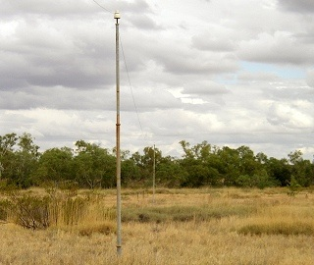
The telegraph proved to be an immediate success with more than 4000 telegrams sent in the first year; its connection greatly reducing transmission time overseas.
"In 1866, it took roughly two-and-a-half months for a letter to get to England by ship. So four-to-five months to travel both ways. After the line was completed, it wasn't instant like email, but it only took a couple of days to get a message from Adelaide to London," Stuart says.
By 1935 the overland telegraph line was no longer carrying international traffic. More advanced communications technology had replaced it. During World War II, extra crossarms and wires were added so that it could serve as a telephone line. By the 1980s this, too, had been replaced by an optic fibre and microwave link and the remaining poles and wire removed.
(Source: http://www.australiangeographic.com.au/)

Laying the Line
(1870-1872)
The Overland Telegraph comprised 3,200 kilometres of single wire suspended from an insulator mounted on a pin on top of a telegraph pole. 36,000 poles were installed Todd had just eighteen months to complete the Overland Telegraph along Stuart's route and the planning involved were almost overwhelming. The only way he could envisage the project being completed on time was by dividing it into three sections--southern, central and northern--that would work simultaneously (same time). Each team was to work six days of the week and was made up of a number of work parties--each included blacksmiths, carpenters, cooks, storekeepers, linesmen, surveyors and telegraphers.
Posts were to be erected no less than 20 to the mile, or 264 yards apart (250 metres). Holes, for the posts to be placed in, were hand dug, the poles erected and the wire strung to the next pole in the line. An area six feet (1.8 metres) wide on either side of the line also had to be cleared.

(Source: http://www.australia.gov.au/)

Southern Section
The southern section ran 800 kilometres from Port Augusta to Alberga Creek, north of Oodnadatta, and proved the easiest section to complete as the land had already been completely surveyed and supplies were nearer to hand.
(Source: http://www.australia.gov.au/)

Central Section
The most difficult section was the central section, which ran through 960 kilometres of inhospitable (harsh) terrain that had only really been explored by Stuart. It spanned from the MacDonnell Ranges to Alice Springs. Explorer John Ross was contracted to lead a team and undertake a more thorough survey of the route through this section.
(Source: http://www.australia.gov.au/)

Northern Section
Another surveying team travelled by ship to Darwin with 80 men and equipment to begin the northern section from Darwin to Tennant Creek. Like the central section, the northern end was plagued with problems, although these had to do with battling the conditions.
The wet season began in November. The track became waterlogged and supply carts were bogged; food supplies rotted in the humidity; holes filled with water as soon as they were dug; and mosquitoes reached plague-like proportions. Conditions were so bad that the workers went on strike.
(Source: http://www.australia.gov.au/)

For many years, the Overland Telegraph was the way Australia kept in touch with the world--and other Australians. In 1942, the rest of Australia heard about the bombing of Darwin by the Japanese via the Overland Telegraph. In anticipation of an invasion, the decision was made to cut the international cable and this was never repaired after the war as new technologies, such as radio and airmail, made the telegraph redundant. Even so, the line remained in use within Australia until the 1970s, when it was replaced by microwave links.

Today, the line is largely in a state of disrepair, although some sections and relay stations, such as the one in Alice Springs which is listed on the Northern Territory Heritage Register have been restored and act as tourist attractions. But the legacy of the Overland Telegraph, an engineering feat that conquered the tyranny of distance and ended Australia's isolation from the world, remains.
(Source: http://www.australia.gov.au/) The legacy of the Overland Telegraph

