Members of the Postmaster General's Department, Queensland, 1900

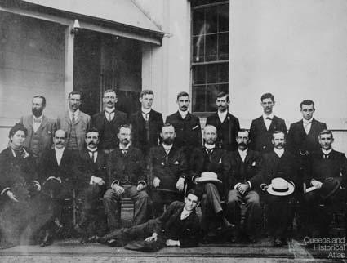
Members of the Postmaster General's Department, Queensland, 1900. Collection of the National Archives of Australia. Left to right, W H Whale, E P Scott, H Nelson, S A Thorn, F B Jefferies, F Walker, J W Palmer, P Gourgard, Mrs Dick, F Watson, S H Smith, J R Bradford, John Hesketh, J Power, G Matthews, F Reisz, J W Sutton, J Lawton.
Extended caption:
In 1896 John Hesketh (1868-1917) became Chief Electrical Engineer for the Queensland Post and Telegraph Department. He was the first British Post Office engineer to be recruited to an Australian Post Office. In Queensland he laid the way for several reforms including the adoption of underground metallic wires (by 1910 practically all city-lines were running underground), the provision of standard telephones and the setting of telephone rates. In 1901 he was nominated as the Queensland delegate for the Departmental Electrical Committee which reported on the communication system in the newly established federal government. Through an inspection of the Brisbane telephone system he concluded that Queensland’s telecommunications system was the best within Australia and therefore did not require major reforms. Five years later Hesketh became Chief Electrical Engineer of the Commonwealth Government’s Postmaster General’s Department and in this function he supported the idea of automatic switching and started to set up automatic exchanges for the Australian capital city networks. This was a bold decision. At this time only two large networks in the world had an automatic exchange - Los Angeles and San Francisco.
Collection of the National Archives of Australia
Theme:
Pathways, Distance
Related:
The telephone in Queensland
Keywords:
communications, electric telegraph, telephone
Date of copyright:
19 August 2010
Date captured:
19 August 2010
Date created:
19 August 2010

Joseph William Sutton jun., (b. 10 September 1874, d. 20 Aug. 1941), A.M.I.E.E. was a prominent electrical engineer for the Postmaster General, Brisbane.
Joseph William Sutton (21 October 1844 – 21 February 1914), identified in the print media as J. W. Sutton, was an Australian engineer, shipbuilder, inventor, pioneer in electric lighting and x-ray pioneer in Queensland.
Electrical pioneer
On 9 December 1882, at Brisbane Queensland, the public was introduced to electricity by having a demonstration that utilized eight arc lights, erected along Queen Street. The lamps were erected on 20 foot cast iron standards.
The power to supply these arc lights was taken from a 10 horsepower Crompton DC generator driven by a Robey steam engine in the foundry of J. W. Sutton & Co. at Adelaide Street.
Later, the Brisbane Courier newspaper received electricity supplied from the foundry of J. W. Sutton at Foundry Lane, later called Isles Lane (now the site of a multi storey building). The power was from a 10 hp Crompton DC generator.
On 10 December 1882, the J. W. Sutton & Co. offices at Adelaide Street in Brisbane were lighted by electricity for the first time in Queensland.
Sutton was the father-in-law of Edward Barton who was also heavily involved in Brisbane's electric lighting. From The Telegraph, Brisbane; 24 Feb 1921.
"Mr. W. M. L'Estrange, of the Ipswich Electric Supply Company, Limited; had stated that the residence of Mr. C. Hardie Buzacott, of Chelmer, was one of the first houses in Australia to be lit up by electric light, as Mr. Buzacott had brought a plant out from England about the year 1887, and which he had installed at his residence for lighting purposes.
Mr. L'Estrange also stated that about the same time Mr. Sutton, of Laurel, avenue, Chelmer also installed an electric plant at his residence, and, that probably Mr. Sutton's residence with that of Mr. Buzacott's could be claimed to be the first private dwellings to be lit up by electricity in Australia."
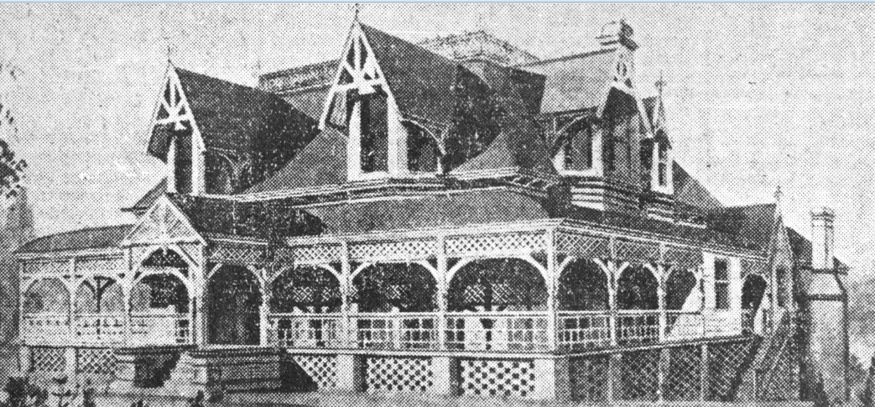
Presbyterian Home for Children also known as W. R. Black Home Brisbane 1928. Originally built for William Joseph Sutton and his wife Mary (nee Hurley) and known as Hurlton (a combination of their surnames). Address: 5-7 Laurel Avenue, Chelmer. Now listed on the Brisbane Heritage Register.
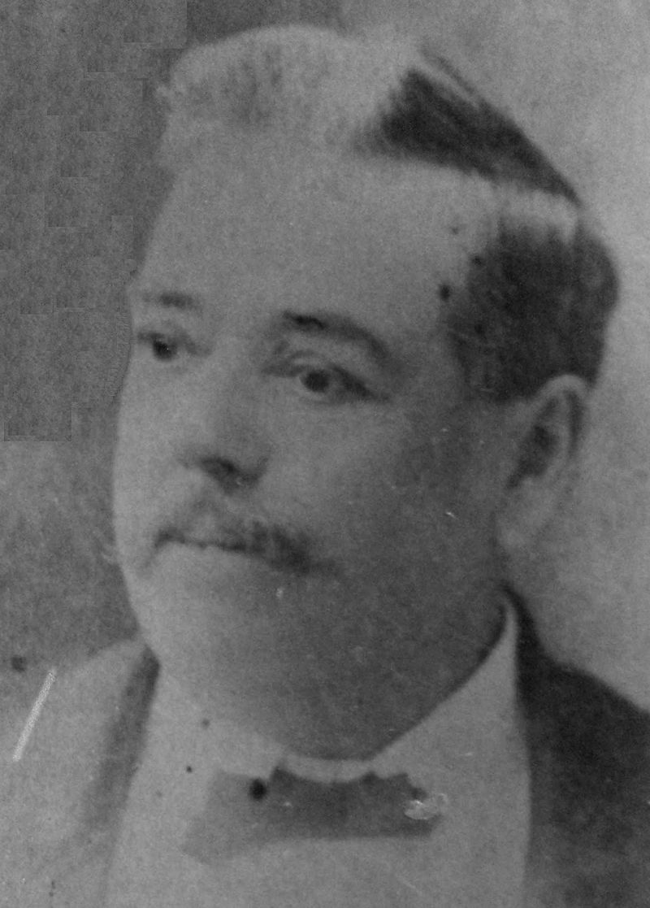

Photographic pioneer
Joseph William Sutton was involved in the very beginning of the Queensland Photographic Society: From "The Week" newspaper Brisbane Sat 20 Sept 1884: "PHOTOGRAPHIC SOCIETY.—The newly formed Queensland photographers' society held a meeting on Monday in rooms over Sloss', confectioners, Queen-street. There was a good attendance of members. The following officers were elected for the ensuing year:—President, the Hon A. C. Gregory; vice-presidents, Professor Pepper, and Mr. J. W. Sutton ; secretary, Mr. J. R. Hall; committee, Messrs. Rickardo, Lyons, and Service." From the beginning Sutton was often availing his steamers to be used to take members along the Brisbane river for photo shoots, as seen from The Brisbane Courier 17 Feb 1885: "The chairman (Sutton on this occasion) notified his intention of taking the members down the Bay, probably on Saturday next, for the purpose of giving them an opportunity to exhibit their skill in "snapping" pretty glimpses of river scenery." In these early days many of the society meetings were held at the Sutton household: Brisbane Courier 25 Jan 1886. "A MEETING of the Queensland Photographic Society was held on Saturday evening at Mr. J.W. Sutton's house. Mr. Sutton, who is vice-president, took the chair..... Mr Sutton very kindly placed his large veranda at the disposal of the members, together with the use of his dark-room for practical demonstrations on the nights of meeting, and also his optical lanterns for exhibitions of transparencies, which generous offer was accepted with a hearty vote of thanks." The Telegraph 17 Mar 1886: "The monthly meeting of the Queensland Photographic Society was held at Mr. J. W. Sutton's house on Monday evening. That gentleman presided....... Mr. Sutton exhibited specimens of prints done with Morgan and Kidd's contact paper, and promised to give a practical demonstration of the process on the next meeting night." The Brisbane Courier 27 July 1886: "A CONVERSAZIONE was held last night at the School of Arts by the Queensland Photographic Society to celebrate the first anniversary of their formation..... The society, which had just completed its first year, at first encountered great difficulties, but through the kindness of several of their members – notably Mr. J. W. Sutton, who had placed many facilities they could not otherwise have obtained at their disposal, they had been very successful. The society now numbered 133 members, and had a satisfactory balance at the bank at its disposal." The Brisbane Courier 1887: "The second annual conversazione of the Queensland Photographic Society was held last night in the lecture hall of the Y.M.C.A. with great success...At 9 o'clock Mr J. W. Sutton exhibited, by means of the oxy-hydrogen limelight, a large collection of lantern-slides. This exhibition opened with a number of very fine views of Melbourne buildings and streets and Victorian scenery." The New Photography; Sutton was the first in Brisbane to demonstrate X-Rays and X-Ray photography, only four months after Roentgen's discovery 29 February 1896. Prof. Lyle being the first in Australia on 4 April 1896, followed by Prof. Bragg 30 May 1896.

