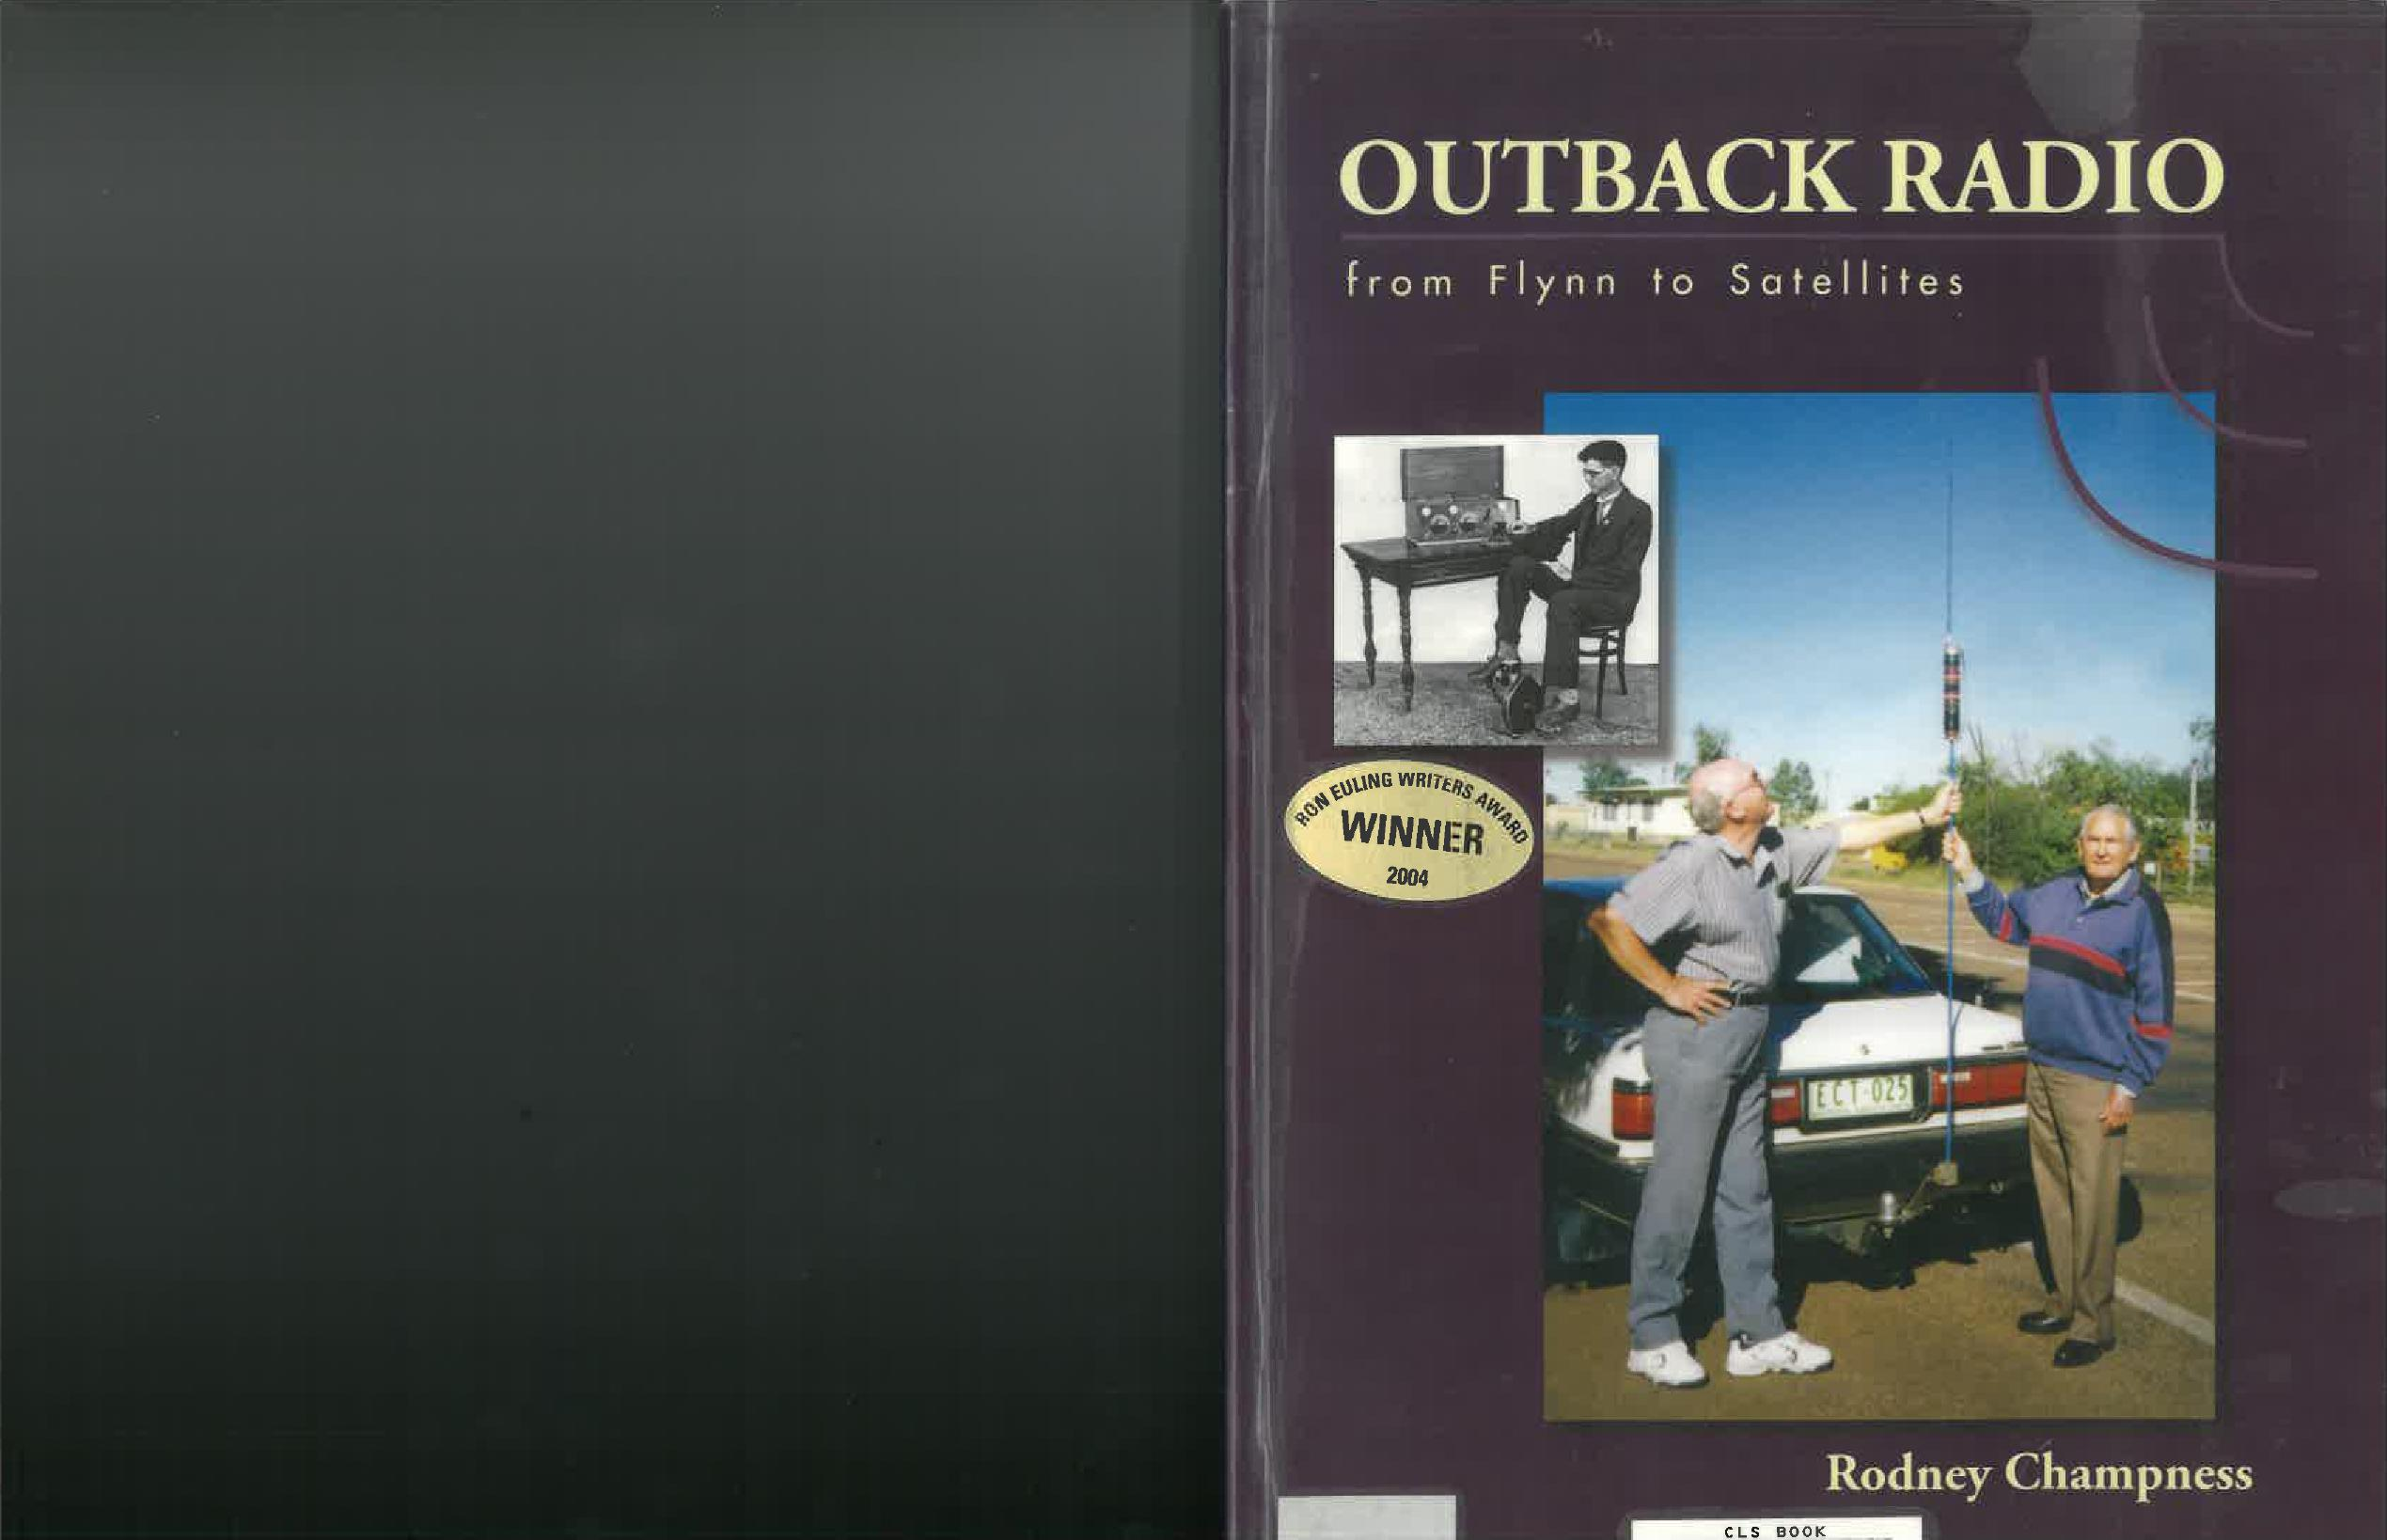

OUTBACK RADIO

From Flynn to Satellites

Published by:
Rodney Donald Champness
6 Mundoona Court
Mooroopna 3629
VIC, Australia
tel.: 03 5825 1354

Copyright 2004, Rodney Donald Champness,
all rights reserved. Except as provided by Australian copyright law,
no part of this book may be reprinted without permission in writing from the publisher.

Printed in Australia by:
Shepparaton Printing Service
48 Harold Street
Shepparton, VIC

National Library of Australia,
Cataloguing-in-Publication data
Champness, Rodney Donald, 1940-.
Outback radio: from Flynn to satellites.
Bibliography.
ISBN: 0 646 43674 0.

1. Mobile communication systems - Australia - History.
2. Public safety radio service - Australia - History.
3. Citizens band radio - Australia - History.
4. Radio - Australia - Receivers and reception.
5. Radio - Australia - Transmitters and transmission.
6. Radio in rural development - Australia - History.

I. Title.
384.530994

Contents
ABOUT THE AUTHOR 5
INTRODUCTION 6
FOREWORD 8
DEDICATION 13
- EARLY TRANSPORT AND COMMUNICATIONS 1788 - 1929 14
- JOHN FLYNN’s DREAM 1887 -1921 27
- EARLY EXPERIMENTS 1922 -1925 34
- THE HERMANNSBURG EXPERIMENTS - 1926 39
- NEW DEVELOPMENTS BRING SUCCESS 1927 - 1928 47
- THE YEAR OF THE “baby” TRANSCEIVER - 1929 53
- THE IMPROVED PEDAL RADIOS 1930 - 1934/5 69
- MORSE CODE REACHES ITS ZENITH 1931 - 1935 78
- THE FIRST PORTABLE TRANSCEIVER - 1933 87
- THE OUTBACK HAS A VOICE 1935 - 1936 92
- THE FIRST OF THE SUPERHETERODYNE RECEIVERS - 1937 99
- NEW POWER SUPPLIES, VOICE ONLY SETS, INCREASED POWER, THE PROBLEMS OF INTERFERENCE - 1937 ONWARDS 104
- SOCIAL AND EDUCATIONAL RADIO - 1951 ONWARDS 112
- THE ADVENT OF TRANSISTORISED EQUIPMENT - 1959 ONWARDS 125
- HF SINGLE SIDEBAND - ITS IMPLEMENTATION 1959 - 1978, AND ONWARDS 130
- AIDS TO IMPROVED COMMUNICATIONS AND THE CB BOOM 141
- COMMUNICATIONS INTO THE 21ST CENTURY 146
Appendices
1. A SYNOPSIS OF THE CONTENTS OF EACH CHAPTER, 155
2. APPENDIX AND MISCELLANEOUS INFORMATION SECTION 155
3. TECHNICAL PERFORMANCE TESTS OF ORIGINAL CIRCUITS, 159
4. CIRCUITS OF EARLY CW AND AM TRANSCEIVERS 159
5. AERIAL (ANTENNA), EARTH, AND COUNTERPOISE SYSTEMS 168
6. INTERFERENCE - MAN MADE AND NATURAL 168
7. METHODS USED TO REDUCE THE EFFECTS OF INTERFERENCE 168
8. MISCELLANEOUS INFORMATION 178
9. PROPAGATION AND FREQUENCIES USED 185
10. PROFILES OF EARLY OUTBACK RADIO PIONEERS 196
11. DEFINITIONS, TERMINOLOGY & EXPLANATIONS 200

ABOUT THE AUTHOR
Rodney Champness
Rodney was born in Western Victoria in 1940 and was educated in both Victoria and South Australia. His interest in radio communications started at the age of 14. He qualified as an amateur radio operator and commenced his professional career in radio at the age of 18. He was a volunteer with emergency fire services in South Australia and Victoria, assisting with high frequency radio communications.

His professional career has been varied - he was a radio and TV serviceman, a radio supervisor in the Antarctic at Macquarie Island, a (district) radio inspector and marine radio surveyor with the Radio Branch of the PMG (and later named successors) for a period of 23 years, and currently is a transmitter technician at Radio Australia. He has always been interested in long distance radio communications from remote areas such as the outback of Australia or the Antarctic.

His enthusiasm for long distance radio communications is shown in his desire to share information on the subject. To share this information, he has written numerous articles for many in-house publications since he was 18. Since 1998 he has been professionally writing a column ‘vintage Radio” for ‘silicon Chip” magazine.

This book has come about due to the desire to share with people the rich and interesting history of the development of radio communications in the outback of Australia.

INTRODUCTION
(By Graham Pitts VK6GF)
No doubt it was because of my long association with the Royal Flying Doctor Service that Mr. Rodney Champness approached me with the invitation to supply his book “Outback Radio” with an introduction. After reading the typewritten copy I was delighted to accept. Such an honour comes to but a few. Having been closely involved with “wireless” since 1932 when I gained an A.O.C.P. (Amateur Operators Certificate of Proficiency), followed by further study at the Marconi School of Wireless, a First-Class Commercial Operators Certificate (First C.O.C.P.) was my most prized possession. A stint with the Union Steamship Company of New Zealand as Radio Officer followed. When W.W.II intervened, I returned to the Marconi School, but this time as an instructor. Men were urgently needed to provide a 24-hour watch on merchant vessels. The sea still called, so the opportunity to sign-on a new Danish motor vessel was accepted, running to the Middle East and other Theatres of War with armament and supplies. Fire eventually damaged her so severely that I found myself without a ship but was offered a relieving position on the Commonwealth Lighthouse Service Cape York where the permanent Radio Officer had been taken ashore to hospital. The accommodation and meals were first-class and the crew likewise. I accepted the position as a permanent appointment following the death of my predecessor.

My duties, in addition to R/O included Master’s Clerk, making up the crew’s wages and servicing the small Traeger Pedal transceivers installed at the Lights for voice communication with the ship for weather reports, etc. I had never seen one before, but this was not a problem as they were simple, and most faults involved the aerials.

Evelyn and I married in 1943, the start of a long and happy marriage. Toward the end of that year, I was offered a position with a Broadcast Station in Adelaide. As both our families lived there, the offer was attractive but great difficulty was experienced obtaining a discharge, though we eventually had success. In July 1944 an advertisement by the RFDS for a Base Director at Alice Springs appeared in the local press and for a bet, a friend at work also decided to apply for it. Evelyn was not impressed when I was successful but eventually agreed to go for 12 months when the cost of our fares and transfer would be refunded.
We were unable to find out much about the Alice Base from the Adelaide Office, but I did learn that the Main and Emergency transmitters had been built by Alf Traeger. A hurried visit to his factory at Marryatville followed, where I was well received and given copies of the circuits and characteristics of the unfamiliar Philips transmitter valves. I also met Jack Drew, his foreman for many years, and was given a thorough briefing on the peculiarities of the pedal radios.

Alf told me not to expect too much as his information was that the Alice was in a mess technically and that little test equipment and spares were available due to the war. The Traeger factory was an unlined tin shed on a corner block, overgrown with soursobs. The floor was of dirt and as the day was cold and windy, everyone wore heavy clothing. The wiremen, seated at a long wooden table, received some warmth from two coke fires in small drums. The eastern end of the shed was enclosed and lined, with the major portion being Alf’s office and drawing room. The remainder was Jack Drew’s domain, the test room and store. All transceivers were checked here prior to dispatch and crystal air-gaps adjusted before checking with the Radio Branch frequency measurement station at Somerton. A home-made battery-powered multi-vibrator was the only frequency measuring device available but in Jack’s experienced hands served well enough because all RFDS frequencies ended in 5 or zero. Alf’s office and the test room had floors of tarred sand and in the latter, soursobs had forced their way through under the benches, probably seeking warmth from the small single-bar radiator. Jack was the practical man and oversaw the daily running of the plant while Alf was occupied with the many problems of running the business. The majority of components were difficult to obtain and so consequently, quite a lot needed to be manufactured in-house.
My wife and I left Adelaide on 1 August 1944 on a troop train for the Alice. We were allotted a two-berth section at the end of the Army women’s sleeping car, the Warrilla, which was an American corridor style car. The engine was problematic, and arrival was at 4 am three days later. Here we met Gordon Buchanan, assistant operator at Halls Creek, who had flown down to keep the Base operating until our arrival.

My wife was delighted with the residence, which had been built as a memorial to the pioneer women, complete with inside toilet, large hot water service and both wood and electric stoves. Gordon was only able to spend two days with me before flying home. I am sure the station people must have wondered what they had got until I found my feet. At that time the radio network was quite small with only about 20 outpost stations, as they were officially designated. They formed a tightly-knit community; most being cattle stations with a few wolfram and mica mines. The original concept of `calling the roll” practised at most base stations was still followed, stations being called in strict rotation to make sure all was well and to dispatch and receive any telegrams. Most signals were weak and hard to copy. No other radio service would have tolerated them.

It was frequently necessary to spell words phonetically. For example, A alpha, B bravo, but the outposts had made a competition of who could devise the most unusual words. G, for example, was Jesus and so on. Coming from a disciplined background, it was decided to `read the riot act” and insist on the use of International Phonetic Alphabet only, a copy being sent to each outpost. This caused some resentment. I well recall pointing out this unsatisfactory behaviour to a certain outpost, only to have him dictate a telegram which started as follows: `The President RFDS Adelaide. Sir, I have just been publicly castigated by your Base Director, etc. etc.”. However, most soon agreed that things improved as the result of a little operational discipline, and we were all friends again.

You were expected to be able to answer all sorts of questions, such as `what are the dimensions of a tennis court?”, and `where can I get some peanuts?” My reply to the lady asking after peanuts was, that they were available to pregnant women only and it seemed rather a lot of trouble to go to for a few peanuts, which was of course heard by most of the network.

Familiarity with the pedal and vibrator powered transceivers soon enabled me to tell the operator which valve to replace in case of trouble, but some faults defied diagnosis. One fault which beat me concerned a signal which fluctuated wildly and rhythmically. Taking advantage of a medical flight to an adjacent property, I was dropped off and collected on the homeward flight. Arriving at the homestead, the manager’s wife was found communicating with the base. The pedal generator was screwed to the floor and to prevent her chair moving backward she had a rope through the window tied to a palm tree outside. Seeing me she said “Christ, you gotta work your passage here, lad”. Her actions were most peculiar, and it was then seen that the two cranks were parallel instead of being 180 degrees apart and a few seconds with a spanner re-established my reputation. Most of the early vibrator sets were designed for 6-volt operation as most vehicles of that era used that voltage. It did not take long for some bush genius to postulate that if the set would communicate 600 miles on 6V, it would cover 1200 miles on 12V. This theory never caught-on as the result was smelly, terminal and expensive.

One outpost complained of electric shocks from their pedal set during dust storms or thunderstorms. Asked if they had the earth wire connected, they assured me it was intact and led to a good earth which was kept moist. After driving over 300 miles to solve this mystery; the `good earth” was found to be a dirt filled flowerpot on the floor below the set. A star-dropper fixed this one. Their billiard room had a dirt floor. It housed a full-size table. White ants had attacked some of the legs resulting in considerable skill and local knowledge being required to play on it successfully.
These few examples illustrate how essential it was to maintain transceivers, which were a complete mystery to most of the outposts, as was anything electrical, and it was quite usual to be asked to repair several station vehicles during a visit.

Rodney Champness is to be congratulated on his painstaking research and cross-checking in producing this book, just in time, because most of the pioneers of Outback Radio Communication are already gone. Despite 43 years” service with the Central Section of the RFDS (previously the South Australian Section) I found numerous items of great interest concerning the remaining sections. “Outback Radio” will become a standard reference for those interested in the technical development of the RFDS over the years, particularly as the service communication provisions are about to be overtaken by technology.
Graham Pitts 2001

FOREWORD
Much has been written about the Reverend John Flynn, Alf Traeger, and other pioneers who were inspired to work towards making the outback a much safer, more enjoyable place to live. Many of these people were responsible for the development of the Australian Inland Mission. The aim of this arm of the Presbyterian Church in Australia was to show practical Christianity by improving the lot of the people inhabiting these remote and inhospitable regions of Australia. A major contribution was in providing easier and speedier access to medical attention.

To provide this, three separate but complementary services were needed. Doctors, nurses and medical facilities, such as hospitals, were needed to provide medical care. It was not enough to have these facilities if patients could not readily access them. Patients may have been several days away by horse and buggy and could well die whilst being transported. The very new aeroplane was not available to provide speedy aerial transport to these facilities until the mid-1920s. Without communications to alert the doctor, he would not know that medical assistance was required until the horse and buggy arrived! Therefore, a rapid method of communication was required so that patients could enlist the aid of a doctor to attend to their medical needs.

Even as far back as 1917, the Reverend John Flynn was thinking that radio may be the means of providing rapid communications. By 1919 he was sure enough of the potential of radio to put his ideas into print, not only to show people what he believed, but also to encourage other people to think constructively along those lines. Radio was the least developed of the three services, and suitable radio transmitter/receivers were not developed until the end of 1928. The dread of not being able to obtain help in times of sickness or accident, and the fear of loneliness, started to be overcome from that time onwards.

Medical aid was not the only requirement of people in the outback. There was a need for someone with a good “listening ear”, for people to be able to talk with in their abject loneliness and to provide opportunity for Christian worship. This was provided by travelling padres - travelling first by camel, later by horse, by car and finally by aeroplane. To fulfil these needs speed wasn’t usually an urgent requirement. However, loneliness between these visits was a real concern and radio eventually helped to overcome this problem, as people were able to talk to each other via the “galah” session. So, in reality there were not just three essential ingredients to make the outback a place worth living in, there were four - medical assistance, radio communications, aerial transport and last but not least a friendly shoulder to “lean on”, in the form of the Patrol Padres.
Radio also became an indispensable aid to the business enterprises of the outback, whereby stock could be bought and sold, supplies ordered, checks on the weather made, etc. Perhaps it could be said that Flynn pioneered the “Internet” of the 1920s, 30s and 40s in the outback!

With these facilities available, living in the outback became a little closer to the standard of living enjoyed in the more densely populated rural areas of Australia. The inspired dream of Rev. John Flynn has meant that the centre of Australia is no longer the “dead centre”.

Before Flynn came on the scene, communications and travel in the outback had advanced little from the time of first settlement in Australia in 1788. There were no political votes in a land where there were few people, no reasonable roads, and no value in or on the land that was, in their opinion, just “desert”. There was of course the overland telegraph which became operational in 1872, but this was not installed for the benefit of the people in the outback. It was physically and politically convenient to put it through ‘the Centre”. The “Ghan” (Central Australia Railway) and the Transcontinental (Trans-Australia) railways provided transport along narrow corridors and provided some communications as a byproduct.

It is with the aim of helping to complete the story of communications in the outback, from the time of Rev John Flynn’s dream to the present time, that this book has been written. Predominantly it is the story of the development of high frequency (HF) radio for use in the hostile environment of outback Australia by non-technical people. The aim is to tell the untold technical stories of some of the equipment used, including technical schematics, photographs, and drawings, with some thumb nail personal portraits and the social benefits achieved through the use of radio. It also explores the likely reasons behind various activities and undertakings.

Wherever possible anomalies in the stories and the technical information are pointed out. Where it has not been possible to obtain definite information on particular technical and operational undertakings, a search of various other information sources has been done. The circumstantial evidence obtained has allowed the assembly of the story of the development of radio communication in the outback. The information is as accurate in the sequence of events as is possible, with the use of all the technical and social information available.

Valve data books have been examined to determine when certain types of valves were first manufactured and when they were available in Australia. Related technical literature of the time was used to determine the common use of these various valves, by the general public and the amateur experimenters of the time. The progression in the development of new valves and later on transistors and integrated circuits, dictated to a large extent the progress that was made in developing radio communications. That is very evident in the evolution of radio communications in the outback.

The information on the Hermannsburg experimental station is an example of the use of this technique. By careful examination of photographs and comparing individual items in the photograph with known items; by perusing the literature describing these experiments; talking with knowledgeable people in this field; checking technical data and personally testing possible formats of the station, a likely technical complement of the station has been achieved.

Another popular but erroneous belief concerns the voltage produced by the pedal generators. Various texts give figures such as 160 to 180 volts, 200 to 240 volts, or 350 to 400 volts or in some texts as high as 600 volts. It is accepted that Alf Traeger did produce generators which produced outputs of these voltages, but tests have shown that significant errors have crept into much published information on the voltage supplied by the pedal generators. Working models of the Mid and MkII pedal generators have been tested by several people and it was found that on load, the Mid pedal generators produce a nominal 160 to 180 volts, whilst the MkII produces between 180 and 220 volts.

Study of circuit diagrams of the earlier sets shows that the transmitter valves had nominally 180 volts applied to them. Consulting valve data books shows that the valves are designed for a maximum of 180 volts to be applied to the radio frequency (RF) valve(s) plates/anodes and 135 volts for the modulator valves. Voltages of the order of 350 volts or more would have resulted in the valves being destroyed in a spectacular display within seconds. Traeger exceeded the normal filament voltages of some of the transmitting valves during the late 1930s and 40s - 2.2 volts instead of 2.0 volts. Exceeding the ratings of valves can only be done by a small percentage, but even this amount causes a significant reduction in the life of a valve. This was and is considered a reasonable trade off as the receiver section of the transceiver operates most of the time and the transmitter for only short periods of time.

In this book I am not limiting myself to the Royal Flying Doctor Service radio network, or to Traeger transceivers. Many other radio networks, and equipment from other manufacturers contributed significantly to the development of communications in Australia’s “centre”. They were, and still are, important elements in the inland, and because of the changing nature of communications, some are gaining greater importance in the whole scheme of outback communications. Medium (MF) and high frequency (HF) (300kHz to 30MHz) radio use has been synonymous with the outback, but very high frequency (VHF) (30 to 300MHz), ultra-high frequency (UHF) (300 to 3GHz) and super high frequencies (SHF) (3 to 30GHz) are being increasingly used for these purposes.

This narrative would not be complete without a brief mention of the history of the communication methods used prior to radio. The aboriginals used smoke signals and message sticks. Various telegraph systems were in use such as the overland telegraph. Telephones also gradually formed part of the communications. The development of the Trans-Australia and “Chan” railways also helped to provide improved accessibility to the outback and provided increased contact as a side benefit. Each of these filled a niche in earlier times but did not have the versatility of radio communications.

Flynn proved himself to be a nation builder when governments had great trouble with myopia. He, with his loyal helpers, took away the horrible dread of living in this isolated region, by providing directly or indirectly - medical aid, companionship, speedy transport and communications. In this book the concentration will be on the part that communications played in the development of over five million square kilometres of Australia and the technical developments that occurred to make this come true.

The flying doctor pedal radios always held a great fascination for me - almost to the extent that I believed the sets had some magical abilities. I’m sure others felt this way too, a feeling no doubt fueled by the way they were portrayed in various areas of the media. I remember as a teenager, listening to weak two-way radio conversations just off the end of the broadcast band, probably on 1610 or 1690 kilohertz. These may have been some of the “galah” sessions. My fascination with the outback, and the radio communications used there, led me to write this book.

Quite a bit has been written about many aspects of the Flying Doctor Service and the radios used in it, but there were so many gaps in the information that I was really interested in, that I decided I must research this and find the missing pieces. Finding people who knew much about the radio history was not all that easy. Eventually I found a font of considerable knowledge in Mervyn Eunson (VK4SO), who supplied me with much information. I could bounce ideas off Mervyn to test theories where no definite information on a particular subject was available. We may not have always agreed, but our discussions brought forth the most likely scenario for a particular part of the development of outback communications. I am most grateful for Mervyn’s input.

Mervyn recommended that I contact the Reverend Doctor Fred McKay as he would probably be able to assist me in some areas too. Reverend McKay graciously invited me to come to John Flynn Place in Cloncurry in August 1998 to have a look at various pieces of early flying doctor radios. He told me he would be there, and this would be a marvellous opportunity to not only see the equipment, but to talk with him about the early days. Fred McKay was recruited by the Very Reverend John Flynn as a patrol padre (“Boundary Rider”) commencing in 1936. I received a wonderful reception from him, he was a friend to all, and I learnt a lot. His assistance has been invaluable. Regrettably Reverend Fred McKay died on Friday March 31st 2000 just a few days short of his 93rd birthday. Whilst he did not see the book in its final format, it is dedicated to him. His biography “Outback Achiever” by Maizie MacKenzie is well worth reading to understand how fortunate I was to have this trip, and to meet Fred. Thank you, Fred.

I thank his wife Meg (now also deceased) and son Bruce for their assistance in completing aspects of this book. Without this continued assistance some areas of the book would not be as well illustrated as they are.

The trip to Cloncurry extended into the Northern Territory and I was given ready access to early equipment by Steve Byrnes, the manager at the Alice Springs (RFDS) Royal Flying Doctor Service base. The opportunity to cross check more than one piece of the early radio transceivers made it easier to be sure that my research and the conclusions I was forming were as accurate as was practical to be. Reading the early Traeger radio service manuals helped to clarify the answers to some questions. Thank you, Steve.

At Adelaide House in Alice Springs there are other rare sets that were inspected in 1999. Travelling throughout the various inland areas, visiting stations and the like, allowed me to gain a firsthand appreciation of the importance of radio in the outback.

It was also interesting to see many of the old sets used in the West, at Kalgoorlie RFDS base in 1999. Not all were Traeger sets.

I also had the pleasant opportunity to talk at length with Graham Pitts (VK6GF) at Bunbury in 1999 and again in 2002. Graham was the Officer in Charge of the Alice Springs base from 1944 until 1953. He was able to give me much information on early sets and early communications methods which was most helpful. His intimate knowledge of the early history of the School of the Air was most appreciated. Thank you, Graham.

Don Laity (VK3NTM) has been a steadfast mentor during the whole time of putting this book together. He has spent many hours reading and re-reading the proofs and has made many suggestions that have helped the flow of the book. Thank you, Don.

Last but not least, a heartfelt thank you to my wife Lyn, for putting up with my obsession with the writing of this book, which took a sizeable amount of our ‘togetherness time”, and for doing the final proof reading.

Perhaps it is opportune in this introduction to discuss the various names that the RFDS has been known under, so that confusion is not caused to readers. From September 9, 1927 the service was known as the Aerial Medical Service (AMS), becoming the Australian Aerial Medical Service (RAMS) in 1934, the Flying Doctor Service (FDS) in 1941 and finally the name for which it is best known, the Royal Flying Doctor Service (RFDS)

in 1955, when granted Royal assent. The RFDS is today the effective organisation providing ‘the Mantle of Safety” that Reverend John Flynn envisaged so many years ago.

Alice Springs was originally called Stuart, and where the old telegraph station is located was called Alice Springs. With the shifting of the post office to Stuart in 1932, it was determined that the name should also follow. Stuart finally became Alice Springs in 1933 with a population of around 400. It now has a population of around 25,000.

A number of the terms, names and titles used in this book may be unknown to readers. Hence, reference to Appendix 7 will be helpful in understanding what they mean. For example, “Dead Spot” doesn’t refer to the local cemetery!

On looking at the list of people who helped me with this book, and who were players in the development of outback HF communications, I couldn’t help but notice the large number of amateur radio operators amongst them. These are the people with the Callsigns starting with ‘VK” following their names in the Bibliography. Whilst these people are or were in many cases professional radio people, most carried their love of radio communications over into the field of the nonprofessional radio operator - the amateur operator. Perhaps it is the other way around in some cases that their love of their hobby gradually drew them into the professional radio sphere, as it did with me. Their dedication to radio communications over the years has meant that Australia is known for its extensive and innovative uses of HF radio communications.

Finally, I would recommend the reading of “Traeger - The Pedal Radio Man” written by the late Rev. Dr. Fred McKay, as it is complementary to this publication.

DEDICATION
Reverend Doctor Fred McKay
15/4/1907 - 31/3/2000
I had been researching the radio communications systems as used by the Flying Doctor Service in early times, from early 1990. I had been talking and corresponding with Mervyn Eunson NK4S0) for some time on the subject of the radio history of the outback. Mervyn had been researching the technical history of the Royal Flying Doctor Service communications over a period of several years and was most knowledgeable on the subject. He had an enormous supply of data on the subject. He also was helping me get various pieces of information, and I asked where some other relevant information might be accessed, to which he replied, “You should contact the Rev. Fred McKay, and do it soon as he is over 90 and won’t be with us forever. I’ll contact him and tell him to expect a letter from you”. This occurred in mid-1998. I wrote to Fred (as he preferred to be called) in July and got a prompt reply suggesting that I come to Cloncurry in early August as he would be there and could gain me access to many valuable historical items. It seemed an ideal opportunity to talk with one of our outback pioneers, as Fred was probably the only one still alive.
This “once in a lifetime” opportunity to meet and be in the presence of such a great gentleman was quickly accepted. Hence, the trip to Cloncurry and other outback areas was quickly arranged. I had read with considerable interest Maizie McKenzie’s book “Fred McKay - Outback Achiever” and knew that I would be meeting and working with a very special person. If you have an opportunity to read this book don’t pass it up. I would like to think that Maizie will write another edition of this wonderful book which will cover the whole life of Fred.

My wife and I arrived in Cloncurry to find out that the group of people travelling with Fred had pulled out due to sickness. I had the horrible feeling that Fred would probably not be there either. I was feeling rather despondent. We set up camp and went into town for a meal. We were just sitting down at a table in the hotel for our meal when an elderly gentleman at the next table asked us “Are you travelers?” I looked around, and there was Fred. What a relief that was, knowing that Fred had been able to come. We talked for a while and found out Fred had only arrived in town that evening, and he would be starting his work at John Flynn Place in the morning.

For the next week I was busy inspecting the museum exhibits and where asked, doing maintenance on some, drawing circuits, and checking items that were not on display. When Fred was not too busy, I had the opportunity to talk with him on various subjects relating to the early days of the service. We had a marvellous week with Fred, the staff at John Flynn Place, and Cloncurry.

We kept in contact with him right up until about a week before his death. He supplied me with much of the important information I needed, and I kept him informed on my progress with the book I was writing - this book. He suggested that it would be ideal that it be launched in November 2000 at the opening of the refurbished John Flynn Place. Regrettably getting all the information has taken longer than had been expected and the deadline has been well and truly passed.

We were very saddened to hear the news of Fred’s passing on the 1st of April 2000, but the book he urged me write is now a reality.

Thank you, Fred, I, along with many thousands of others, have been extremely privileged to know you, and hope we will meet again.
Rodney Champness

CHAPTER ONE

EARLY TRANSPORT AND COMMUNICATIONS 1788 - 1929

We all love to chat!
One of the basic, psychological needs of humanity is for company; companionship; someone with whom, one may relate, and to communicate!
So, communication, in some form, has been vital to people for many thousands of years. In Australia it has been no different, although some of the methods used here may well be different to those used on other continents, due to climate, distance, population densities, and relative advancement of the peoples concerned.
ABORIGINAL COMMUNICATIONS
The indigenous Australian Aboriginals had been communicating within their individual tribes, and with other tribes, for thousands of years before European settlement. Speech could only be heard over a relatively short distance, and a loud yell or “Coo-ee” type of call could, under favourable weather conditions, be heard perhaps two kilometres away.
Naturally, the ability to make contact over longer distances was necessary when a tribe was divided, such as when searching for a variety of foods. So, at times, smoke signals afforded a convenient and easy way of communicating between groups and tribes.
Smoke signals were generated by burning green bushes, wet grass, sticks or anything else that would produce a smoky fire. Smoke signal messages were achieved by using bark to break the ascending smoke column into long and short columns which have an agreed meaning, a little like morse code. The message would have been able to be read up to 60 kilometres away in suitable weather conditions. On occasions today, smoky fires, such as campfires, are observed around the countryside and their plume of smoke can be identified some distance away.
The Australian Aboriginals of that era had keenly developed senses necessary for survival in the areas in which they lived. Their ability to track game, and also people who may have become lost, is well known. Through their extremely keen eyesight, they would have seen and interpreted the smoke signals over greater distances than most can today. They possessed remarkable abilities that are still not fully understood.
Another method of communications used by aboriginals, in some areas, was the “message stick” or “yabba stick”. These pieces of wood would be marked with nicks, designs, symbols, and perhaps even with ochre in some circumstances. These sticks were carried by runners between the tribes to provide news of corroborees, war, abundant game, etc. and could be carried over distances of hundreds of kilometres. They may also have been left in strategic locations to give more permanent information, much like the tourist information boards outside many towns.

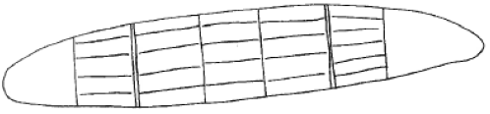

Aboriginal Message Stick - This diagram is similar to a message stick claimed to have been used by the Yalata Tribe.
The length of the message stick is 25 to 30 cm. The markings are surface cuts no more than 2 mm deep.

The runners were allowed to pass through the country of hostile tribes without interference, having what we today would call “diplomatic immunity”.
This is one of many early forms of writing throughout the world, and the method of delivery could be seen as the forerunner of our postal system or courier services.
Some believe that aboriginals also communicated by some form of mental telepathy.
It would seem then, that our indigenous aborigines had very adequate methods of communication over the distances in which they had an interest. It has taken the European much longer to develop a communication system which can achieve similar results.
EUROPEAN SETTLEMENT
Australia was first colonised by European settlers with the arrival of the first fleet in Botany Bay in 1788. The speediest communication system within the colony was by a man on horseback riding between the various places, carrying messages.
An informal system of delivering “letters” came into being soon after the first settlement was established.
Whilst there was very little communication by letter within the community, mail was sent to and from England via any ship’s captain who would take it. This was a very “ad hoc” arrangement and the fees charged varied considerably.
Within the colonies, the mail services were even more chaotic. Letters were handed to people “going that way” in the hope that they would eventually get to their intended destination. Banjo Paterson’s poem “Clancy of the Overflow”, and many others of his works give us a glimpse of the haphazard methods of getting letters from one place to another, and the problems that occurred.
The first real semblance of reliability came in Tasmania, in 1813, when James Mitchell was appointed postmaster. By the time he retired in 1822 he had established a postal system that encompassed the island and was an example to the other colonies in Australia.
Once the Cobb and Co coaches were in operation, they were used to deliver mail into various areas. However, there is little known about the development of a postal service in the outback. It can safely be assumed that an organised postal system did not exist at that time and was slower being developed here than anywhere else on the continent. Letters were delivered along with supplies or were picked up when delivering produce to the markets. Visitors making social calls were rare, but mail would have been delivered at those times too. The first regular mails would have been delivered along the overland telegraph (in the 1870s) on the supply runs. This would have been every few months. A more regular service would have commenced with the operation of the Ghan (Central Australian Railway) in the 1880s and 90s. Away from the telegraph and the Ghan, the mail service would still have been quite unreliable, with delivery times of months in many instances. The outback was still very isolated.
TELEGRAPHY
In the 1800s a system of dot and dash signals was developed to convey telegrams over a single wire telegraph system. Alfred Vale of the Bell Telephone Company, in America, developed this system which replaced the extremely cumbersome telegraph systems that were in use at the time. There were many different codes used on the telegraph systems run by various groups, such as the railways and the postal service. Eventually one code was developed called the International Code, which is more commonly known as morse code after Samuel Morse.
Communications, via wired telegraphy using morse code, became an economic reality in the mid-1840s, with systems in North America, Britain and Europe. Most were using overhead lines, but a significant amount was buried using rubber insulated wire. There were many failures with the insulated wire in this early stage due to faults in the insulation created by the imperfect manufacturing processes of the time.
It wasn’t until 1853 that an electric wire telegraph system was installed in Australia. It was between Melbourne and Williamstown and commenced operation in January 1854. That year saw a number of lines installed, connecting various places in the young Victorian colony.
Not to be outdone, the South Australian colony sought a Superintendent of Telegraphs from Britain. Charles Todd accepted the appointment and arrived in Australia in November 1855. Within three months of arriving in Australia he had the first line operating between Adelaide and Port Adelaide.
The first inter-colonial telegraph line was commissioned for business between South Australia and Victoria in July 1858. In October 1858 New South Wales was connected to Victoria and South Australia. Queensland was not connected to these three colonies until 1861. Tasmania was connected to Victoria in 1859 by undersea cable. Unfortunately, it soon broke down and a reliable cable was not laid until 1869. Whilst Western Australia built telegraph lines to various parts of the colony, it was not until 1877 that it was connected to all the other colonies. Once connected to the other colonies it was also automatically connected with the overland telegraph line through central Australia to Darwin and, as a consequence, to most places within the developed world.
Whilst all of this activity of installing telegraph lines around the coastal fringe of the Australian continent in the 1850s was happening, nothing at all was happening in the centre of Australia. In fact, the centre of Australia from Adelaide through to where Darwin is now located, via the Alice Springs area, had not even been visited by a European. A number of small outposts were established around the coast of the Northern Territory but were soon closed down due to the problems that they experienced. There was a lack of knowledge by the British colonists, of the great difference between conditions of living and working in temperate Britain, and in tropical areas like the Northern Territory.
On the southern edge of the unexplored centre of Australia around the Flinders Ranges, enterprising squatters had explored and utilised some land to graze their sheep, cattle and horses. Even so, there was only a handful of white people in this area. Communications with the outside world from the Flinders Ranges still took several weeks, even when a conscious effort was made to contact anyone. Contact from the coastal area of the Northern Territory could take months by ship.
INTERNATIONAL ISOLATION
Of considerable concern to some was the lack of acceptable communications with Britain and Europe. Communications with Mother England could involve a wait of up to eight months for a letter to be answered. For example, the colonies in Australia did not know for nine months that they, alongside of England, were at war with Russia in the Crimea (1853-56)! The time discrepancy seems to indicate England was rather busy fighting a war and had forgotten about its Australian colonies.
The telegraph system was being extended around Australia, but a wired telegraph system to `Europe was the desire of most ex-patriate Englishmen, and it had yet to come. Undersea cables were initially quite unreliable, and many companies were bankrupted by the failure of these cables. The first successful undersea cable between Britain and France was laid in 1851. During the 1850s the cables became more reliable, so the distance over which they could be laid with a good chance of being, and remaining, successful was increased dramatically. Insulation of the wires carrying the signals improved, as did the mechanical protection of these insulated wires.
With the advent of successful “undersea” telegraph cables, various groups started to approach the Australian colonies to assist in financing an undersea cable to Australia. A number of locations were suggested for the termination of the European/Asian end of the cable, for example, Java in the Indonesian archipelago and Ceylon (Sri Lanka). The terminal points proposed in Australia were Northwest Cape, in Western Australia, and Brisbane in Queensland. Both of these undersea cables would have been very long ¬and expensive, about twice the cost of overland lines. South Australia proposed that a cable from Timor to Australia should terminate at a location selected along the coast of the Northern Territory. This would be a far shorter cable run.
The chief protagonist for the line between Java and Brisbane, it appeared, had a pecuniary interest in the company that made the undersea cable. Therefore, he was not interested in the cheaper and potentially more reliable cable route proposed by South Australia.
South Australia steadfastly held to the view that there would be a saving of around 3200 kilometres of expensive undersea cable by coming from Timor to the Northern Territory, compared to the eastern route to Brisbane or the second western route proposed through Albany in Western Australia. There were also other advantages in having shorter hops of undersea cable. Should a fault develop in a shorter length of cable it was less expensive to repair or replace than a very long cable. There would be the need however to build an overland telegraph of around 3000 kilometres through country largely unknown and unexplored.
THE OVERLAND TELEGRAPH
Superintendent Charles Todd had recommended an overland telegraph line as a result of the initial explorations by John McDouall Stuart. Stuart had advanced as far as the centre of Australia in April 1860. The South Australians refused to accept any other plan until such time as a thorough exploration from Port Augusta to the top of the Northern Territory had been completed. This would prove whether such a line was practical or not.
Explorers John McDouall Stuart, Augustus Charles Gregory and John McKinlay, all in their particular ways, helped to prove that it was quite possible to cross the “great unknown” centre of Australia and live to tell the tale. McKinlay was the first person to cross the continent from South to North and return, and he did this in 1861. He started from Adelaide and arrived at the Gulf of Carpentaria nine months later, complete with a flock of sheep!
However, Stuart was the first to cross the true centre of Australia, which was up to 750 kilometres west of McKinlay’s trail in places, reaching Van Diemen Gulf on the 24th of July, 1862. This trip had taken seven months up to Van Diemen Gulf and a further seven months for the expedition to return to Adelaide. Stuart was quite sick on this expedition, and the communications that we now enjoy would have been most appreciated during his trip.
The frozen wastes of Antarctica, or the International Space Station, remote as they are, can be accessed much more quickly today than the centre of Australia was able to be accessed in those times.
In 1864 the government of South Australia sold land in the Northern Territory to encourage settlement in the Palmerston area (Darwin). The land had to be surveyed within five years, and after four years of government procrastination it hadn’t been done. With less than a year of its five years left, the land was hastily surveyed so the government would not lose the deposits already paid on the land. The surveying work at Port Darwin was completed in August 1869, and then its first permanent residents began to arrive. The first white woman arrived in January 1870 with her children.
Port Darwin was selected as the preferred site for a settlement, as it provided good potential for a deep seaport, and would be a good place to bring the undersea cable ashore. (Port Darwin was renamed Darwin in 1911.) On the downside, however, it was not the best location for a coastal port to service pastoral activities at that time.
But what happened in the centre of Australia during the years from 1862 (when Stuart crossed the centre) to 1869? Very little it seems. Pastoralists and squatters were moving up from the Port Augusta area, and one or two had moved as far north as the area subsequently named Oodnadatta. Their only contact with the rest of the colony was a lengthy trip that took weeks by horse, or horse drawn vehicles.
The connection between Port Darwin and Adelaide was a tenuous one involving a sea voyage of around two months, and for a reply to mail, one anticipated a four-month delay. Port Darwin did have a doctor, although it is unlikely that his knowledge of tropical diseases would have been good due to the training, he received at a medical college located in England. England’s climate, and associated health problems, are vastly different to those of the tropics.
In September 1868 the Suez canal was opened, which reduced the time for a steamer to travel from England to Australia, or to the far East. Undersea cables were now proving quite reliable, and the push to connect this part of the world, had become more urgent. So, with the establishment of Port Darwin as a permanent town at the end of 1869, it became quite apparent that speedier communication with Adelaide was needed, rather than the four months round trip by sea that was required for the mail service.
Following Stuart’s exploration in 1862, the South Australian Government believed it was practical to construct an overland telegraph line joining Port Augusta (and Adelaide) to Port Darwin.
If the undersea cable from Europe terminated at Port Darwin, the South Australian Colonial Government felt they could benefit financially with the transit revenue from the other colonies, as they would access the undersea cable via the overland telegraph system. An additional bonus would be, that this would allow faster and more efficient communication between Port Darwin and Adelaide, hence achieving more effective control of the Port Darwin outpost. The only exception would be Western Australia, as it had not yet connected to the other colonies. This connection didn’t come until 1877.
There was much negotiating between interested parties, including the colonies, and the companies who would be prepared to lay the cables. Queensland had a proposal that the undersea cable terminate in or near Port Darwin, and then extend overland to Burketown and couple into the line planned between Normanton and Cardwell in the Queensland telegraph system. It would have meant that a short overland section was needed to connect into the telegraph system along the east coast of Australia and which also connected to Adelaide. It was much shorter than a line through central Australia. It would have been a more sensible and practical option, but various jealousies and time delays, meant that things did get rather confused.
Eventually South Australia, on the recommendations of Charles Todd, Superintendent of Telegraphs, put forward the proposal that they would build the telegraph line, to be completed by the 1st of January 1872, providing that the company laying the cable would terminate it there. This was accepted. So, an Act of parliament was passed in June 1870 authorising the construction of the overland telegraph at an estimated cost of £120,000 ($240,000).
Todd realised then, for perhaps the first time, the enormity of the task that he had taken on. It was a huge task to organise and complete this mammoth project across approximately 3000 kilometres of virtually uninhabited land in a period of 18 months. The cable company negotiated a hard bargain from the government by altering the conditions so that the overland cable was to be operational one month earlier on 1st December 1871. Another text makes no mention of any date other than 1st January 1872. Penalties would apply to the government or the cable company, should the completion date be delayed, or if problems occurred with the cables of such a nature that telegrams could not be passed on. The cable company was quite confident that it could easily meet the deadline, whereas it believed the government could not, so they would still make money on the deal.
The pressure was really on, with so much to be done, and so little time in which to do it all. Charles Todd certainly had a big job on his hands, as did his many subordinates. Urgent orders were placed via steamer to Ceylon (Sri Lanka) and then cable to London, for shipments of insulators, wire (iron, mostly), iron poles, telegraph material and batteries. Australia, at this early stage of its development, was producing little in the way of such “high tech” items.
Todd only had the maps and reports of Stuart’s pioneering venture of eight years previous, to guide him as to where he should route the overland telegraph. He couldn’t ask Stuart for clarification of any details in the report as Stuart had died in 1866 in England at the age of 51. Neither the government, nor private individuals, had bothered to do anything about exploration further north than where Oodnadatta now stands. Todd could not afford to waste time, so he sent out an exploration party ahead of the construction parties in the south, to determine the best country through which the line could be built. He relied on these men working with the construction teams to use their judgment to obtain the best results under the circumstances.
Not only did he need to have the men and equipment organised to go into these largely unknown areas, but all the back-up requirements, such as food, shelter, and the transport for all this material.
Between Port Augusta and Port Darwin eleven intermediate stations were planned, each to be equipped with plant, equipment, instruments, and batteries. The telegraph station’s buildings were to consist of three 40” by 20” (12.2 x 6.1 metres) log huts, each with four rooms. These buildings were very different to the automatic, unattended, high traffic repeater stations now used. The technical equipment installed enabled closed-circuit hand morse to be used, with large capacity 120 volt banks of primary cells for use along the line, and a 24 volt system for the equipment within the station itself. The projected staff was a station master, four operators and a linesman. The staffing varied over time and was as high as 11 people at some stations. The stations were located in order south from Darwin (Port Darwin), at Yarn Creek (* Southport), Katherine, Daly Waters, Powell Creek, Tennant Creek, Barrow Creek, Alice Springs, Charlotte Waters, The Peaks (*Peake), Strangways Springs (*Strangways Bore), Beltana and finally Port Augusta. (Ref. The Overland Telegraph - Tele-technician, June 1972). (* There appears to be some variations in the names of some stations over time.)
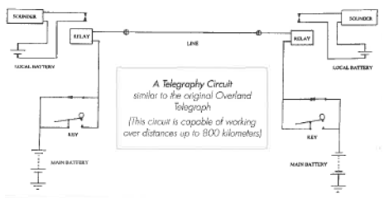
The Southern and Central sections of the telegraph line proceeded well, but problems soon occurred in the Northern section. The problems associated with trying to work during the monsoon season, and the officiousness of a government official, resulted in the Northern contract being cancelled. This caused the installation of the Northern section to grind to a halt, which meant chat time became even more critical in this section to ensure the contract with the cable company was not broken.
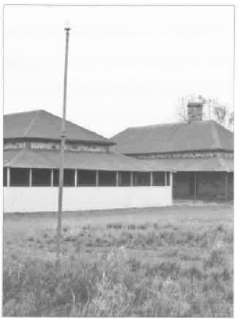
Oppenheimer telegraph pole, Overland Telegraph Tennant Creek.
Only eight months was left before the line was to be commissioned if the government was not to incur monetary penalties. The problems of the north became known on 5th July 1871. which, along with the rather severe penalties by the cable company for late finishing of the cable, galvanised the government into action.
So swift was this reaction, that within eight days a government expedition was authorised under the leadership of Robert Charles Patterson to get the line installed as fast as possible. The agreed penalty finish of the complete telegraph installation was such, that the excess construction costs were less than the penalty that would be applied. The expedition left on 27th July. By the time Patterson’s expedition arrived in Port Darwin there were only two months left to get all the lines installed to meet the agreed deadline. However, the wet season started before any work could commence.
The cable company laid the undersea cable, and it was tested and found operational on the 20th of November 1871. 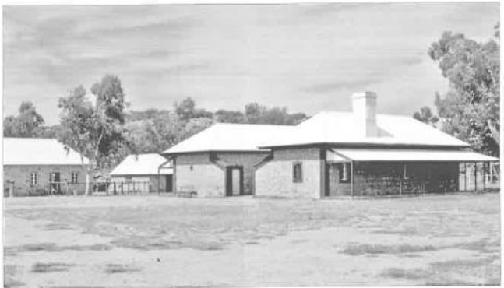
Alice Springs Overland Telegraph station

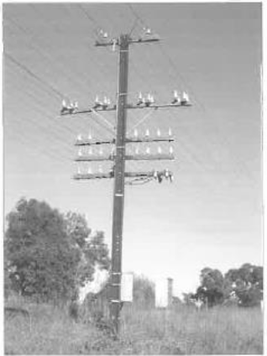
Railway telephone and control lines at Borala Victoria (2002)
The undersea cable and the overland line joined at the telegraphy terminal station at Port Darwin. The staff at this station consisted or six telegraphists with a superintendent in charge of cables. It was ready 10 days before the deadline for having the service operational. There does appear to be some discrepancy as to whether 1st December 1871 or 1st January 1872 was the deadline. However, whichever date was correct the overland line would not be ready by either date.
The wet was playing havoc with the work of installing the land line, and ty 1st January around 400 miles (640 kilometres) of the northern section still had to be poled and wised. This wet season was extremely severe, and almost brought work to a standstill until the dry came in early April. The construction work was then able to proceed rapidly The government coffers were bleeding at the rate of about £3,000 (£6.000) per month because of the time penalties. Another text suggests that the penalty was £70 (£140) per day.
The line had still not been completed when the undersea cable developed a fault on 24th June 1872. At 3 pm on 22nd August 1872 the overland cable linking southern Australia with Port Darwin - and hopefully the rest of the world was complete and tested. The undersea cable was still nonoperational and remained so until 21st October 1872. It was out of service for four months. The penalty clauses were binding on both parties. so South Australia did not lose as much money as had been first feared, although another text suggests that the penalties only applied to the government.

Because of blundering, officiousness. lack of
understanding of the tropical climate, and the face that in some cases, the wrong people had been put in charge of various activities, etc. the taxpayer of South Australia had to pay nearly £500,000 ($1,000,000) for the line. The original estimate was £120,080. This represented an enormous amount of money for those times, but the revenue obtained from the service ultimately recovered the cost. The cost to send a telegraph message from Australia to England was extremely expensive. Initially, it cost £10 to send a 20-word message, this coat being equal to five weeks wages for a working man (£2 per week).
Like many large undertakings such as this, a number of chins had to be re-done to make the line more effective. Many of the wooden poles were replaced with “Oppenheimer” iron poles to overcome the ravages of white ants (termites). Eleven solidly built stone relay stations replaced the original timber buildings. No doubt the white ants liked the original structures just as they liked the wooden poles. Restored examples of these buildings can be seen at Alice Springs, Tennant Creek and Barrow Creek
The aboriginals living along the line removed and broke many of the porcelain insulators. The sharp pieces of insulator made very good tips for their spears. The linesmen had a continuing job maintaining the lines and replacing missing insulators. They much preferred doing this to fighting bardes with the aboriginals.
With the advent of the overland telegraph line, there were in the order of 50 white men permanently based at the various relay stations spread across the “dead” centre of Australia. There were no women at this stage, although a manager’s wife would ultimately live “on station” in some circumstances.
With the ability to contact other people, and because there were now tracks up through the centre to the north of Australia, a small but increasing number of people moved their sheep and carte into areas near the telegraph line. (“Near”, is a relative term in relationship to the enormous distances involved in outback Australia.)
One well known example of this new settlement in the north, Is the Hermannsburg Aboriginal Mission which was established in 1877 by German Lutheran Missionaries. This was 80 miles (130 kilometres) West of Stuart (Alice Springs). More will be heard of the mission, as we trace the spread of radio communications throughout the centre.
Even by 1904 Stuart itself had a population of only 46 non-aboriginals and was very little different when Flynn visited in 1912. The “dead heart” was taking a long time to come to life. Communications were still poor. The telegraph stations were 150 miles (240 kilometres) or so apart, and most people lived some distance away from the line. Hence, people living hundreds of miles from any communications was still the norm, not the exception. The nearest medical facility (two nurses) was at Oodnadatta, 400 miles (640 kilometres) away to the Southeast, and the time to get there front Stuart was around nine days on horseback! Although the telegraph did make some difference to the lives of people living not too far away from it, almost all of the facilities we take for granted today still did not exist. 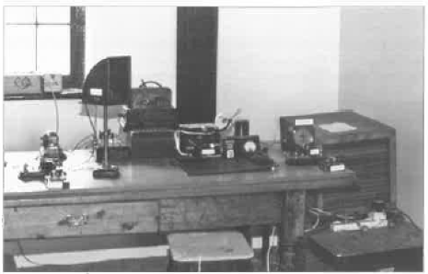
Operators Office in Alice Springs Overland Telegraph Station
To use the telegraph, a slow trip over rough tracks would be required, and may have taken days to complete. Once at the telegraph station, if medical help was required it may have taken a further week or so to obtain, if available, and by that time the person who was ill may have died. When medical assistance was obtained, there was still real doubt about the competency of the doctor or nurse.
The travel was by camel, horse, donkey or perhaps by wagon and bullock team. All of these were slow and very uncomfortable over the rough terrain for people who were in good health; but for the sick it would have been excruciatingly painful. The Government did not seem to be in any hurry to provide roads, and those that were provided could only be considered ‘tracks”. They were provided largely to allow access to the telegraph stations and lines. There were Few votes in the outback to Justify (politically) any other work. and the coffers of the colony of South Australia were not overflowing with money.
THE PUSH NORTH
There was a drought in central to northern South Australia from 1864 to 1866. As a result of this, Surveyor General Gowder was instructed to draw a line between where the country was relatively unaffected, and where the drought had made a significant impact. This was at the 10” (254 mm) rainfall limit. It was also considered the boundary between arable lands and desert, as well as providing a line above which farming was not approved of. As time has shown, ‘the Goyder Line” was a remarkably accurate delineation between arable land, and land that could only be considered “arid”, but not necessarily “desert”, as it was classed at that time.
With great enthusiasm, thoughts of making a lot of money, and hopes for a run of good seasons in the central to northern parts of South Australia. many squatters and graziers moved ever northwards to take advantage of the “land of plenty”. Although not moving as far or as fast, the farmers also moved north to utilise the fine farming land that they found. With good seasons and selective acceptance of the reports of explorers. pressure was brought to bear on the Government to allow fuming and gluing much further north, and to provide them with reasonable access. Mining interests had also been pressing for road or preferably nil access, which would have made it so much easier to open up the country, to provide good transport for the goods being shipped out, and for provisions being brought In. Due to this pressure, the Goyder Line was amended and aligned with the South Australian and Northern Territory border in 1875.
Camels, and the camel trains, commenced being used in this area in 1867 by Sir Thomas Elder, who became one of the founders of the agricultural firm, Elder Smith.
The “Afghan” cameleers were well established by 1880 In Herrgott Springs (Maree). The name was changed during WW1 because of its Germanic connotation.
It Is estimated that over 2000 camels were based at Herrgott Springs. Their transport tentacles spread throughout Central Australia providing a slow but reliable method of sending produce co market and receiving supplies in return. A heavily laden camel could travel around 20 miles a day (32 km). In addition, they would have provided a postal service of sorts, and in discussion with the pastoralists, would have provided some Information on what was going on in the outside world.
Twelve water giving mound springs were found on John Stuart’s second exploration trip to the centre in 1859. One of these was near Herrgott Springs. It is claimed that over 6000 pastoralists and miners lived north of Port Augusta by 1862. and that they drove their cattle and sheep or transported the output from the mines south via Herrgott Springs for sale at the markets. Many areas were unsuited to sheep due to the predation by dingo’s, hence the installation of the “dog fence” many years later.

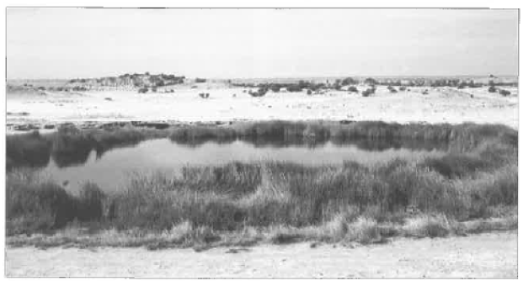
“Blanches Cap” mound along Oodnadatta Track South Australia
Mound” springs occur in various parts of the outback where the mineralised water from the great artesian basin bubbles to the surface. Mounds are formed through the deposition of the minerals out of the water over many thousands of years. Several are visible near the Oodnadatta Track)
As time progressed, droving of cattle from as far afield as Queensland was occurring along what was the Queensland Road, now known as the Birdsville Track, and the Strzelecki Track. One particularly well-known drover was Captain Starlight, who stole the cattle which he drove from Queensland.
Whilst these things were going on in South Australia, settlement of remote regions of Queensland, New South Wales and Western Australia was also taking place. One particular place of interest, Cloncurry in Northwestern Queensland. had become a much less remote outpost than Stuart (Alice Springs) by the mid 1920’s.

THE RAILWAY
In 1876, an Act of Parliament authorised a railway north from Port Augusta to Port Darwin. A variety of routes were talked about, and some surveys were conducted. Several alternative routes were canvassed and surveyed over a period of years.
Local aborigines, in the area through which the railway was to pass, were consulted as to where to place the railway. Some notice was taken of them in regard to suggested tracks to follow, but I suspect that not enough attention was paid to this advice. Availability of water, proximity to the telegraph line, political pressure from various sources, and inter-colonial jealousies (still common between states today) also influenced the route taken. The end result showed that the route chosen was not necessarily the best one that could have been taken.
The gauge was scaled on as 3”6” (1067 mm). It was to be a light railway, and was not to be ballasted, as heavy traffic was not expected. The South Australian Colony being very short of funds wanted to do it as cheaply as possible.
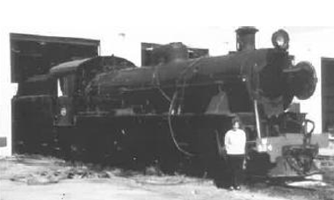
Steam Locomotive (W924) of Alice Springs of type used on Ghan railway.
There were two quite big problems with running a railway through arid regions at that lime. Steam locomotives have an enormous appetite for coal and thirst for water. Their conversion of the energy in good quality coal to useful energy (movement) is typically around 4%, (and up to 8% with an efficiently designed locomotive in good condition), whereas the diesel locomotive is about 30% efficient. Diesel fuel has around 50% more energy available per kilogram compared to good quality coal. Hence, between about five and 11 times as much coal (by weight) was needed. compared to the oil fuel used in a diesel engine, for the same energy output (movement). Coal wasn’t always good quality and the amount of energy per kilogram compared to good quality coal was noticeably inferior. Coal of suitable quality had to be brought by ship from the NSW coal fields to Port Augusta.
The locomotives exhausted all the steam (water, vapour) to the atmosphere instead of condensing and reusing it, as some countries did with their steam locomotives. e.g., South Africa. This meant huge quantities of water were needed. Whilst a number of surface dams stored run off from the hills, it was necessary to supplement this with mineralised bore and spring water, which caused boiler damage. To overcome this. a number of water treatment systems were used to ‘soften” the water and reduce its corrosive effort. Even today the ruins of some of these water treatment systems can be seen along the Oodnadatta Track, of which one is at Curdirmuka. The water softening plants used either un-slaked lime and soda ash, or caustic lime and barium carbonate, in their treatment process. Condenser systems were also used.
Construction of the railway commenced in 1877 at Port Augusta, reaching Quorn 1879, Hawker 1880, Beltana 1881, Farina 1882, and Marne in 1884 where it terminated for a few years. It reached Coward Springs in 1888, Warrina 1889, and Oodnadatta in 1891.
The depression of the 1890s caused the construction of this Adelaide to Darwin railway the Central Australia Railway or as it is affectionately known, the “Ghan” to come to a grinding halt at Oodnadatta for a period of 36 years. It had so far cost £2.3 million in track and plant and would cost a further £1.7 million to get it to Stuart.
As the track was nor well ballasted, If at all, the trains could not travel at more than 30 mph (48 Kph). In the casing days of its use, some sections were safe only if the speed was below 12 mph. (20 Kph). The railway didn’t provide a reliable service as sections of the track were often washed away. While it was better than nothing, it was not a roaring financial success.
The railway provided the much-needed transport for the primary produce grown in the areas around the railway, and to transport the manufactured goods coming back from the cities. Drovers even brought cattle down from Queensland to the railway at Marne. From the various rail heads, the Afghan cameleers loaded their strings of camels with goods for the stations and brought back wool and other primary products. Certainly, the railway did help the people in remote areas to overcome at least, some of their isolation, as some communication was even possible along the line in addition to the carriage of goods and people.
The railway systems of the 1800s and early 1900s were technically not very efficient (steam locomotives), hence cats were high But, where railway systems were accessible, the cost of transporting people, livestock or people was much more cost effective than by bullock or horse-drawn wagon. Cobb and Co. coach or camel train. In 1898, a survey in New South Wales established that to transport one ton of goods me a distance of 100 miles toss £5 (S10) by horse-drawn wagon aid 1816 (31.85) by steam train - less than a fifth of the cost.
At about the time the railway construction started, telephones were beginning to be used in various areas. They were used along the railway, and gradually spread out into the countryside where sufficient population made it economic. However, the “real” outback still had little in the way of transport and no communications facilities to speak of. Hence, what was available was still not good enough for what Flynn envisaged. He needed a communications system that did not rely on vulnerable telephone lines. (Flynn would have been in short pants, and more interested in building sandcastle at the beach than building a nation in the outback at this time.)
As the 20th Century got underway, trucks started to replace, camels. bullocks, and horses as means to get goods from point “A” to point *B”. The cameleers priced themselves out of the market. and by around 1930 then were few camels in use at all. Most had been released into the wild and become feral. Currently we have the most disease-free camels In the world, and actually export them back to their counties of origin. With all these advances in travel, the outback was slowly, but oh, so slowly, getting better transport, but the roads (or were they bush tracks?) were still very poor. The highway from Port Augusta to Alice Springs was only completely bituminised in 1987, some 125 years, after the first successful crossing of the continent south to north through the centre.
In 1913 the Commonwealth Government commenced building another railway using the standard gauge 4”8 1/2” (1435 mm), i.e., the Trans Australia Railway, from Port Augusta to Kalgoorlie. It was competed four years later in 1917. In all regards this railway is of a much higher standard than the 3”6” (1067 mm) railway to the centre, although it may not have had the romance of the “Ghan”. It saves to connect the eastern states with Western Australia. Like the “Ghan” it did provide transport, and some communications, for people in areas not too far from the railway. However, almost all of these small settlements have now vanished, as have many along the original Ghan line.
In 1913 another investigative survey was undertaken to determine a route through the centre to the Katherine river (where the Northern Australia railway terminated), and also from Newcastle Waters to Camooweal. I wonder if well ever get these railways! Back in the 1920s the Commonwealth Government promised to build a railway through the centre to Darwin. The only problem was. no specific time was put on the question of “when”!
The Prime Minister stated in 1999 that the waiting was nearly at an end. and the railway would be completed by early 2004. A newspaper item in August 2002 indicated that the $1.3 billion project should be finished before April 2004, providing the next two wet seasons were kind. In fact, the last piece of track was laid on 25/9/2003. In January 2004 the first freight train travelled the trade and in February 2004 the first “Ghan” passenger train made its inaugural journey. At long last. after over 100 years from commencement of constriction, the railway from Port Augusta to Darwin is now complete.
Two other routes were mooted in 1922. One would have gone east of Lake Eyre in the general vicinity of the Birdsville Track, to Boulia, Camooweal, Daly Waters and then on to Darwin. The second proposal was for a line from Bourke to connect with Wiadorah. Boulia, and onwards as per the first proposal to Darwin. Queensland railways would have connected into the system somewhat near the end of the line that goes to Mt Isa. South Australia and Victoria were expected to send rail traffic up through New South Wales. This second proposal does not seem to be greatly different from the current fast train proposal to connect from Melbourne through NSW to Queensland and across to the Northern Territory to Darwin. However, due to a variety of inter-state political rivalries, South Australia decided it would build a railway up through the centre - much as it had done when the overland telegraph was built.
In 1926 the Commonwealth took over the Port Augusta to Stuart railway and commenced extending it from 0odnadatta. By the 2nd of August 1929 it had reached Stuart, 757 miles (1226 Km) from Port Augusta. (The new standard gauge line to Alice Springs via Tarcoola was commissioned in 1980.) Stuart was still isolated, but it now had transport in the form of the railway and communication via the overland telegraph system.

THE TELEPHONE
Telegrams, morse code and the telegraph system served the early communities well, but in 1876, Alexander Graham Bell claimed to have invented the telephone. (An Italian engineer. Antonio Meucci shared the same laboratory as Bell. Meucci took out a temporary patent in 1860 on the invention of the telephone. Meucci sued Bell when he took out his (Bell’s) patent, and looked like winning, but died before the case came to court. The case was then dropped. Reference: - OTN September 2002 - letter by Allan Dribble VK3AMD.) At this point voice communication became possible. Australians quickly got into the act, and in the following year were experimenting with this new phenomenon. Long distance telephone experiments were conducted In 1878 and the first commercial link occurred in Melbourne in 1879. The first telephone exchange was built in Melbourne in 1880. and all colonial capitals

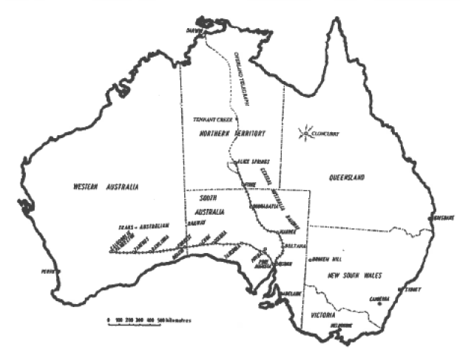
Map of Australia showing route of the Ghan Railway, the Overland Telegraph & the location of Cloncurry, Queensland the site of the first flying Doctor Base.

were interconnected with telephone services in 1883, except Perdu which was connected In 1887.
There is no information that I have been able to source which indicates when telephone services of any sort were extended Into the outback. Back in 1901 the policy of “cross subsidy” came into being. This meant that profitable arms of the Postmaster General’s Department (PMG), now Telstra, i.e., city and suburban telephones and telegraph - subsidised the services in more remote areas which could not be profitable. This continues to be the cue, although there is some concern that it may not continue indefinitely.
Around 1910 country subscribers to the telephone service were encouraged to work on the “party line system. and to install much of the overhead telephone wire themselves. The system was mostly a single wire earth return (SWER) system connected to a magneto type manual exchange.
Each subscriber on this common line (“party line) had a partial number suffixed with a letter. For example, the line may have been allocated the number 20 and each subscriber had a different letter such as S or H or A or some other letter of the alphabet. Is the case of my parents, it was 20H. The exchange, or another member on the party line, could call us by giving four short rings which denotes the letter H in morse code. To call the exchange one long ring was given. Of course, there were the inevitable ‘sticky beaks” who listened in on other people’s conversations It was usually known who they were, and various little traps were set up for them from time to time, so that either they gave themselves away, or some “gossip” war given over the line for their benefit. There were some amusing outcomes of these little traps. Around six or Seven subscribers was the maximum on a party line.
There is no doubt that the telephone service did extend Into the outback. However, its use by more than a small number of wealthy people away from populated areas. or even Its connection to some larger towns, is doubtful until quite recent times. For example, Birdsville received a telephone service in 1976. 100 years after its invention. Up until 1976 it used the Royal Flying Doctor Service radio network for all outside communications. Only in the last few years have some areas been connected to the telephone system, and this has only been made practical by the use of satellites.

WHERE WAS RADIO?
John Flynn’s radio communications network commenced operation in 1929 in Cloncurry, the year chat the railway reached Stuart. By this time, the telegraph was well established through a narrow corridor in the centre, and the telephone service had probably arrived too. The extension of the flying donor service with its complementary radio communications service, came to Alice Springs 10 years later in 1939. But we must go back a decade (to 1919) to see how that radio communications actually developed. It didn’t just “happen”, it involved much “blood, sweat and tears” to get it to the stage it was in 1929.

CHAPTER TWO

JOHN FLYNN’s DREAM 1887 -1921

The `outback” of Australia covers two thirds of the total area of the continent, something of the order of two million square miles (or around five million square kilometres). This MI= is greater than all of Europe, and. at the time of the First World War, had a population of around 50,000 pioneering Europeans, which is around one person to every 100 square kilometres. Today, the Royal Flying Doctor Service aircraft cover an era of ova seven million square kilometres, omitting only the most populated areas. Bringing critically ill people to high technology medical Wicks over medium to long distances is still best done by aeroplane.
Governments were showing link inciter in developing this vast area of Australia. They could set no value in it. The Overland Telegraph became operational in 1872, and the “Ghan railway crept into Oodnadatta by 1891, finally reaching Swan (Alice Springs) in 1929. Other than these two undertakings nothing was being done to improve the hank twang conditions of the hardy pioneers.
Into the picture stepped a most remarkable man, a man who had a vision of providing much of what the lonely, isolated people of the outback desperately needed. The man with this mighty vision was the Reverend John Flynn. In 1911 he started his ordained ministry at Beltana. South Australia, as a travelling Presbyterian Padre. His parish measured some 150 miles (240 Km) by 200 miles (325 Km). As he travelled around his “parish” he became acutely aware of the problems - lack of medical care and facilities, poor transport, poor or no communications, loneliness, virtually no educational facilities, and almost a complete lack of any amenities that urban and metropolitan residents considered both “normal” and necessary:
Prior to Flynn’s arrival at Beltana, a number of other early Presbyterian padres had seen these problems and alerted him to the needs of the outback. Some of the needs were already being addressed at the time Flynn commenced duty. For example, in 1906 a nurse was sent to Oodnadatta, and she worked from a ramshackle bush boarding house. This early facility was superseded by a purpose-built medical hostel which opened in December 1911. Ideally, it was always staffed by two nurses. When a nurse needed assistance with a medical problem a doctor could be contacted via the Overland Telegraph. The Australian Wand Mission (AIM) established a total of 12 medical hostels throughout the outback by the end of 1945. Flynn however was even more far sighted than his fellow ministers.
(Vivid descriptions of life in the outback of this time are contained in the book ‘the man from Oodnadatta by R. Bruce Plowman. He was one of the early padres who travelled through the centre of Australia in the period 1912 to 1917. Most of his travelling was done by camel.)
“What could be done to make the lot of the outback battler more bearable?” Flynn asked both himself and the hierarchy of the Presbyterian Church. He was granted leave from his huge parish to do a survey of the outback and find out what was needed. This took him many months travelling, even going by ship to Darwin. Going through the centre still was not an easy undertaking in 1912. The first car crossing between Adelaide and Darwin had only occurred three years before.
Flynn produced a very extensive document for the Assembly of the Presbyterian Church, setting out the population’s needs. He was a most persuasive man. His document was one of the first to use photographs. maps and sketches as well as words to present his proposal. It was accepted enthusiastically, which was most rewarding considering how radical it may have appeared to be, to so many, in those times. Probably no other man of his time, had the ability to overcome so many obstacles, In implementing the vision of making the outback a place worth living in. He, along with his small band of faithful helpers, achieved more than any government did to open up the centre of Australia. This must remind us of Winston Churchill’s speech where he paid tribute to the pilots in the Battle of Britain in WWII. (Paraphrased) “Never was so much owed by so many to so few”.
Gradually a few medical hostels were built as mentioned above. The railways did provide some hospitals and doctors. and they did co-operate with the Australian Inland Mission (AIM). The Presbyterian Church could not afford to have many hostels and what few there were, were placed where it was believed the most effective use could be made of scarce resources. The travelling padres moved throughout the outback ailing at the hostels from time to time. It was a lonely life for everyone.
Flynn was good with words, he put together many derailed reports complete with charts, sketches and photographs. Written communication of this standard was virtually nonexistent at the start of the century, although common place today. To alleviate some of the loneliness, and to partially educate the people of the outback, he published a quarterly magazine called ‘the Inlander”. The first edition appeared in 1913 and the last in 1929. Due to the pressure of his work the quarterly publishing schedule was often not met. It was, however, a start for his crusade to make life just that much better for these lonely and isolated people.
Flynn struggled with the problem of how speedier transport could be achieved, and how people could contact others quickly in time of need. Camels, horses, donkeys and, as time went by, automobiles did improve transport, but the roads were still abominable.
The solution to the problem of speedy transport came from Clifford Peel in a letter to Flynn In 1917. Peel was intensely interested in what Flynn was trying to establish. He was a qualified pilot and additionally had medical qualifications which put him in the unique position of being able to provide a workable solution to Flynn’s needs. Regrettably Peel never saw the outcome of his suggestions as he died during the war in Europe. He showed Flynn in this letter that aircraft were speedy, relatively safe, and that it was much cheaper to use an aircraft for medical purposes compared to other forms of transport. The cost of airstrips at strategic locations was much less than the cost of providing reasonable roads. The cost of railways was much bigger still, and completely out of the question. Flynn worked on this idea for several years.
He approached the defence forces after World War One to see if they would supply aircraft for the purpose of a “flying doctor” service. The aircraft and pilots had little to do after the end of the war in 1918. However, like many bureaucratic organisations they failed to recognise the potential, so no help was forthcoming, which was a waste of a ready resource, and the skills of competent pilots. Hence the implementation of a king doctor service was delayed by nearly a decade.
Flynn accepted that aircraft were the answer to his need for speedy transport for medical purposes, but du question remained how would the people needing this help summon she aircraft?
It was felt telegraph and telephone lines were not economically viable or practical. In this period a request was made to the Postmaster General’s (PMG) department for a telephone line from Windorah to Birdsville, a distance of about 650 Km (400 miles). The department said that it was not economic as it would cost £70,000 ($140,000) - a lot of money in those days. The telephone line would be worth something like $6,000,000 in today’s money (2004). It would most likely have been a single wire earth return (SWER) type line of doubtful reliability. The lines needed constant maintenance to keep them in working order. Would the lines be in working order when help was needed? Telephone systems were only suitable for use in fixed locations and would be no good for people such as cattle and sheep drovers who were constantly on the mow.
So, lack of communications was very much a problem fur Flynn. In 1917 he was contemplating whether the very new “wireless” would be the solution to his communications problems. By 1919 he had explored the possibilities and he was certain that wireless/radio would be the answer. He went into print expressing this belief. Certainly, at this stage it would have been as practical as an ash tray on a motorbike. as communications stations were large; expensive; required a large power supply; were delicate and not particularly reliable and required trained operators and technicians to keep them in operational condition. But Flynn, ever the optimist, kept an eye on the progress of this intriguing new scientific marvel.
“In that land of vast distances, with the aware of organised communications of any sort, John Flynn dreamed dreams and saw visions of the day when wireless communication could be organised for the benefit of the inhabitants of those territories.
The Institution of Radio Engineers Australia elected him an Honorary Life Member in 1947 because of his efforts in connection with the development of inland communications” (Mr. David G Wyles Article in the Journal of Radio Engineers, Australia.) Wyles association with John Flynn dates back to the early 1920s as will be seen In late: chapters.
The wireless systems in the early 1920s were run by the military or government along with a number of amateur experimenters that the governmental officials tolerated. The installations were still bulky, fixed or (barely: portable installation. They cost a fortune to install and to maintain. The PMG department established two radio communications stations in the late 20s, one being at Wave Hill and the other at Camooweal. The establishment costs were around £2,500 and the annual operating costs were around £1,000 per year. which was a huge cost, considering a man’s wages were approximately £4/15/- ($9.50) per week in, 1925.
At the end of the war (1918) the equipment used were predominantly spark transmitters, and the receiver used coherer or cats whisker detectors, with some equipment starting to use valves. However, the days of spark transmitters and crystal receiver were numbered as valves were increasingly being used in communications equipment.
Aircraft and radio were very much in their infancy in the period 1917 to 1919 and neither in their format at that time, were suitable for the tasks that Flynn envisaged for them, although both were advancing in leaps and bounds.
This advancement continues as we accept the electronic marvel of the Global Positioning System (GPS), which can, with small handheld receivers, tell us where we are on the earth to within a few metres. Even 20 years ago such facilities would have been considered the stuff that science fiction movies were made of. Similarly valve radio communications of around 1920 would have been considered almost like science fiction then compared to the spark transmitting and receiving communication systems.
The development of the excellent radio communications that we take so much for granted today is a fascinating story. From the time of WW1, the development high frequency radio communications suiting the outback of Australia has exercised many brilliant minds who eventually came up with solutions to the “impossible”.

EARLY RADIO HISTORY
La us reflect at this stage, on the development of radio communications or, as it was called in the early days, wireless communications. Many people have pondered why wireless was called “when” when on looking inside a radio it was seen to be full of wires running everywhere and certainly not wireless”. It would seem that the term “wireless” came about because the device sending a message, and the device receiving the message, were not physically connected. All previous senders and receivers (telegraph or telephones were connected by wires. and this was the first method of communications by means that were “wire - less”, hence the name.
In 1887 Heinrich Hertz experimentally proved that radio communications were possible. The measurement of frequencies in hertz, kilohertz. Etc. were named after him. In In 1894 Marconi sent spark signals over a distance of 10 metres by “wireless”. This was the start of wireless or radio as we know it. Marconi and others used spark transmitters almost exclusively until the late I910s. Some enthusiasts and governmental agencies were experimenting with valve technology and achieving results not achievable with spark equipment. Spark transmitters are operated by turnings high voltage spark and arc on and off by a morse code key. Simply put, one side of the spark gap is connected via tuned circuits to the aerial and the other to the earth. 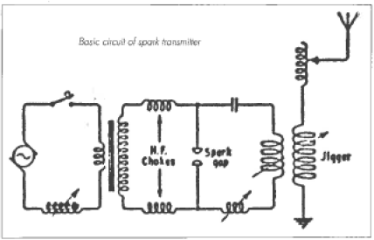A simple, but not very effective, spark transmitter circuit is shown in this chapter. Note the voltage used to generate the spark was often supplied by an alternator with an output of perhaps 10,000 volts. This was lethal if extreme care was not taken.
The receivers used radio signal detectors such as coherers, magnetic detectors, galena crystals and other quite insensitive radio signal detectors. From around 1910 the galena crystal became the favoured detector being more sensitive and, in some ways, easier to use. The crystal sets commonly built by young boys of the 1920s through to the 50s, used the crystal detector, hence the name “crystal set”. Today, electronic equipment extensively uses the modem equivalent of cats-whisker crystal detector, the silicon signal diode.
By 1895 the communication range had extended to a distance of one mile (1.6 Km), and in 1897 ship-to-shore ranges of nine miles had been achieved. 1899 saw the first radio communications across the English Channel.
In 1900 Marconi took out a patent for °Tuned or Syntonic Telegraphy”. This invention introduced tuned circuits into the field of radio development, which meant that a wireless set (radio) could be tuned to a particular station just as is done today. By using tuned circuits, and by improvements in the design of spark transmitters, the effective (efficiency) output power of the transmitters was increased dramatically and the ability of receivers to detect weak signals was enhanced over the next 10 to 15 years. Hence, it meant that the distances over which radio transmitters could be heard was greatly extended, making radio communications so much more efficient effective and economic.
At this time, it was considered that radio waves would not bend around the earth and long-distance communications was not possible. Marconi was able to prove that this was not so. On the 12th of December 1901 he was able to send a signal from Poldhu in Landsend UK to St. Johns in Newfoundland. The frequency used was low, in the 30 to 300 kilohertz range. An extremely high-power spark transmitter coupled to a huge aerial was necessary to achieve this feat. The distance of this historic communication was over 2.000 miles (3,200 Km).
By 1902, ship-to-shore communications were occurring over long distances. By June 1907, 139 ships had Marconi wireless, and the communication range of the installations was from 150 to 300 miles (240 to 480 Km).
There was considerable resistance to the fitting of wireless to ships due to cost, lack of perceived value, and resistance to anything new. These was also considerable opposition from the powerful cable companies who believed that they would lose revenue from messages being sent by Land based wireless stations. At this stage at least, this was unlikely as communications were predominantly ship-to-shore. Radio operators on board ship were tolerated but not accepted. They were probably thought to be an unnecessary parasite who did nothing. Needed space and ate food. However, that attitude changed somewhat when the ship “Republics” put out a distress all on 23 January 1909 after it had been rammed. The most widely remembered distress call was from the ‘titanic” 1912. The ‘titanic” had a five-kilowatt spark transmitter with a range of from 250 to 500 miles (400 to 800 Km) during the day, and further at night, and could receive high power land stations up to 1,500 miles (2.400 Km) away. The °Titanic” disaster really brought radio out into the open and showed the world the value of radio communications. Without radio (wireless) it is likely that almost all of the passengers in the lifeboats would have perished. Suddenly radio had become a recognised lifesaver. No doubt Flynn was saddened by the tragedy, but impressed by what the radio could do.
The first voice and music transmissions took place in December 1906. However, a tremendous amount of work lay ahead of these, and other experimenters, before this type of transmission would become available to the general public. The distortion of the voice or music was extremely high, By 1920 voice and music broadcast transmissions became practical due to the use of the thermionic valve. Dame Nellie Melba sang over the radio in that year. In 1922 2LO in the United Kingdom came on air - introducing entertainment and information radio to the general public. We had to wait until 1935/6 for picture transmissions (television) to be introduced in England and Germany. The BBC inaugurated the first regular high-definition television broadcasts from the Alexander Palace in 1936. Considering the complexity of television picture transmission that was remarkable progress.
Looking more at the local scene in Australia, there were no coastal radio stations that could communicate with ships until 1912. When installed, these stations used spark transmitters, and receivers that had various types of detectors, such as the coherer As time went by the crystal detector was used. None of these stations had any form of amplification in the receivers. Generally, they transmitted and received on 600 metres (500 kHz) the international distress frequency. This frequency has been withdrawn in recent times as more effective means of obtaining assistance in emergencies are now used. At that time, they nominally cost £1,250 to install, plus the ongoing costs such as staff and maintenance.
Experimenters occupied themselves with endeavouring to improve their receiving capability on the wavelengths around those used by the ships, but any frequency between 1000 metres (300 kHz) and 200 metres (1,500 kHz) was used. Aerials and receiver circuits in particular were altered and “improved” to obtain the best results. These were still early days and a scientific approach to most of this experimentation was largely lacking. Some were experimenting with more code transmission and with various types of spark transmitters - whether they had the required “legal” licence or not. Adaptations of some of the ideas tried in this period were later trialed by Harry Kauper and Alf Traeger. A few experimenters obtained valves to experiment with before WWI, but almost exclusively it was spark transmitters and crystal receivers.
An international conference in 1912 banished experimenters-hams-amateurs to wavelengths below 200 metres (above 1,500 kHz). This was so they could do no harm. and they wouldn’t be able to contact anyone much further than their own back yard, or so the authorities smugly thought. The authorities soon had egg on their faces. when it was soon proven that communications were possible over long distances on the ‘short Waves”.
These wireless experimenters formed clubs to help each other technically, and to negotiate with the government organisation that controlled the radio waves. Wireless (radio) experimenters in Victoria established the Wireless Institute of Victoria in 1909. (Some believe that this date may be incorrect due to inconsistencies in available records) It later became the Wireless Institute of Australia (WIA) and is the oldest national amateur radio society in the world, with headquarters in Melbourne. The WIA was, and still is, an organisation that continues to encourage experimenters, and negotiates with the licensing authorities on licensing conditions and related matters. The Reverend John Flynn turned to members of the WIA to obtain the help he desperately needed to develop a suitable portable wireless/radio transmitter and receiver for the outback.
For the duration of WWI and until late in 1921 transmitting by experimenters was not allowed. Many of the experimenters went into the services and of those, quite a number became involved in communications. Spark transmissions were the norm, but as the war dragged on, valves were increasingly used in military transmitters and receivers. The performance of receivers had improved dramatically following the discovery of “regeneration” by Edwin Armstrong in 1912. and a single valve regenerative receiver had worldwide reception capability under the right conditions. As has been the case almost universally during wars, development of better methods to aid the destruction of the foe have been spared no expense.
During WWI the Australian army used a Marconi portable spark wireless set. It weighed around 150 Kg and was designed to be carried by four horses. It could be set up by a team of five to six men in around 10 minutes. Once set up it required two men to operate is The claimed communications range was 60 Km, but greater ranges were often achieved. The transmitter was a 500-watt spark unit. The receiver had a carborundum detector. The aerial was up to 100 metres long in the term of an inverted °L”. The earth consisted of several copper gauze mats. To power the station, a petrol motor drove an alternator. This may have been a “portable” but it certainly didn’t fit the requirements that Flynn was gradually formulating for a transceiver suitable to be used in the outback. (Refer: “A History of Radio in South Australia 1897-1977”by J.F. Ross)
Portable battery-operated spark transmitters with valved receivers were being used up at tile “front lines” in WWI. Portable in those days still had a rather different meaning to today. Portable meant bring able to be carried with difficulty by several soldiers. The next powerful one that could be considered to be portable was a 130-watt (power input) Wilson spark transmitter with a valved receiver. It worked on three wave lengths, 350 metres (857 kHz), 450 metres (667 kHz), and 550 metres (545 kHz) and had a range of eight kilometres. Some other small spark transmitters operated on 65 or 80 metres (4615 kHz or 3750 kHz) and had a range of up to three kilometres. These sets would not be suitable for use in the outback where ranges of at last 300 miles (486 kilometres) would be required. The frequencies quoted above are only approximate, as accurate means of measuring this parameter was not available. Additionally, spark transmitters did not transmit on just one frequency another their many failings.
A number of low power valved trench wireless transmitters and receivers were developed during the war on both sides of the conflict. They were basally short-range units working on low radio frequencies. One transmitter/receiver developed in 1917 for the British Army proved to be better than the rest and remained In service until the early 1930s. It had a single valve in the transmitter and two valves in the receiver. Under the right circumstances it had a communication range up to around 70 kilometres. It was powered by banks of batteries. Some of these designs were not significantly different in concept to the experimental Hermannsburg transceiver of a decade later.
The amateur experimenters in Australia were allowed to use valves in transmitters in 1921, about the same time as transmitting privileges were granted. Until this time around the world ‘spart” had been “king”, but its crown had been slipping since around 1915. It quite rapidly became apparent that valve type transmitters had much greater range for the same amount of pawer used, and they created considerably less interference. Although spark transmitters were quickly superseded by valve transmitters they were still used as emergency transmitters on ships until the end of WWII. In fact, the Marconi School of Wireless in Melbourne still had an operational emergency spark transmitter in 1963, which was used for tuitional purposes. Despite the high cost and relative rarity of valves, valve receivers were also on the increase as they easily outperformed the crystal sets.
Developments were showing Flynn that, slowly but surely, his dream of simple, easy to use, cheap, rugged, reliable radio transceivers in the outback would come true - but, when? Certainly, much work and many years would go by before the dream became a reality.

CHAPTER THREE

EARLY EXPERIMENTS 1922 -1925

From around 1917 Flynn had been researching the progress of radio communication. reading all he could, even buying parts and experimenting. The Australian Inland Mission (AIM) provided a short-wave receiver for him so that he could learn more about the medium. It cost £57/10/0 (S115) - many months of Flynn’s stipend (salary). In 1913 his stipend was £250 per year, later in the 1920s around £400 per year. Sets were extremely expensive up until the late 20s, when their price came down a little, although they were still expensive.
Flynn talked with officials in the Postmaster General’s (PMG) department, the armed services and many amateur (ham) radio operators, explaining what he wanted in the way of radio equipment that would be suitable for use by people with no technical skills. He became a member of the Winless Institute of Australia (WIA), and through the WIA, his cause and his need for a simple radio transceiver for the outback was broadcast far and wide. “Wireless Weekly” magazine championed the cause and offered a prize for a suitable design, but no one could come up with anything likely to be suitable. Many people took up the challenge to see what WAS possible, but the end result in each case was - “no it can’t be done, at least not for many years yet”. Flynn was told that a room full of equipment was needed, plus technical staff to keep it operating, and it would only use morse code. He came to realise that it was much too complicated and delicate for people in the bush to use, and the expense would be prohibitive.
This situation was nothing like what he was hoping for. He continued his search for suitable equipment bur nothing made its appearance. He spoke with a number of his mentors on this subject, people such as radio pioneers David Wyles, Ernest Fisk and Harry Kauper. It must have seemed to David Wyles that Flynn had nor got the message of what was really required to put radio communications into the outback. So,
one day in mid-1925 he spoke with Flynn and laid out the criteria for a set that would do the job of giving the outback a voice. Obviously, Flynn in his enthusiasm had nor looked at all of the problems that needed to be solved before his dream could become a reality. It set Flynn back quite a bit but didn’t dampen his enthusiasm.
What criteria did David Wyles and John Flynn lay down for a set to do the job that Flynn envisaged?
- The set must be simple enough to be operated effectively by people who had never seen a radio “receiver”, let alone a radio “receiver” AND ‘transmitter”. Many had not even heard of electricity.
- It must be semiportable, around the size of the avenge receiver of the day, that could be housed in a comer of a shed or room in a house.
- It would need to weigh no more than about 56 pounds (25 Kg).
- It must be robust, so that it could withstand relatively rough treatment.
- It must be able to be used where no electricity supply was available. If it used batteries these must last a long time and be relatively cheap to replace.
- It must operate on the short-wave bands.
- It must have enough transmitter power to be heard ova distances up co 300 miles (486 Km).
- The transmitter must have good frequency stability so that the base station would know where to listen for these transmitters on the receiver tuning dial. They were all to be on the one frequency.
- The transmitter would operate on both voice (AM) and morse code (CW).
- The receiver need not be particularly sensitive as the base station would be much higher in power and be relatively easily heard at the maximum communications distance envisaged.
- Any maintenance in the field would need to be achieved with minimal technical expertise required. The patrol padres would be expected to be able to fix minor faults.
- It must cost no more than £50 ($100).
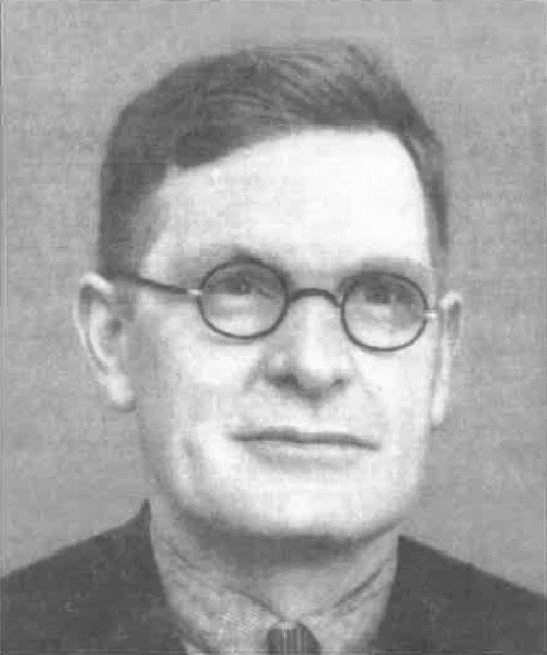
Perhaps they were impossible criteria to meet. Most people thought so. The radio aspens of the day told Flynn he was not only asking for the leading edge of receiver design. but also, for a transmitter design that was not considered achievable for perhaps five to ten years. But then Flynn hadn’t heard of the saying “it can’t be done”. Whilst Kauper and Wyles both agreed that what Flynn was asking for, would prove Henry (Harry) Kauper. He provided the technical and mentoring skills which were so important in formulating the direction radio communications was to take which led up to the development of the “pedal radio.
extremely difficult to achieve, they never-the-less agreed to help in various ways. Flynn asked Wyles. if he knew of anyone who might help him with some experiments that he wanted to conduct in the north of South Australia that year (1925).

Wyles wrote to Flynn soon after this meeting to advise him that George Towns, a returned soldier and a person well versed in radio communications. would be willing to help with experiments for six months in an honorary capacity. (David Wyles retained an interest in the Flying doctor service and was on a committee in NSW in 1935 charged with the establishment of the NSW section of the AAMS.)
The first official broadcast radio transmitting station In Australia 2SB (later called 2BL) came on air on 23/11/1923. By November 1924 broadcast station 5CL came on in Adelaide. Like most of the broadcast stations of the era, the transmitter was a modulated free running oscillator which fed the radiating (aerial/ earth) system. By 1926 the transmitting frequencies of broadcast stations were beginning to be stabilised by quartz crystals - crystal control.
Harry Kauper was 5CLs chief engineer and as such he was involved in the design, the manufacture of some equipment and installation of it all. lie was an extremely enthusiastic experimenter always looking for better ways of achieving improved radio transmission and reception performance. He was familiar with motor generators, AC mains to DC power supplies, and batteries of various types. He was arguably the most competent person in the field of radio transmission and reception in South Australia at that time. It is likely that he wrote the column “Radio Talk by Dr. Fish, of 5CL” in “Wireless Weekly”. as well as other articles. Flynn could not have had a more competent leader in development of the baby” radio transceiver for the outback.
When Flynn and Towns arrived in Adelaide in mid-1925, they approached Harry Kauper for advice and assistance to get a suitable array of equipment ready for the tests. Flynn had been casting his net very wide to get as much advice as he could from many sources, but this was not proving to be at all productive. Some well-meaning but not very capable radio enthusiasts were giving him misleading information.
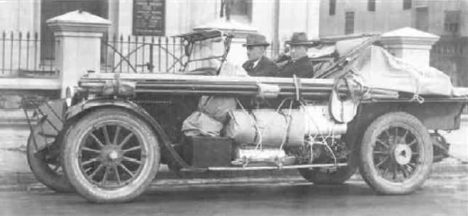
Harry Kauper, being an honest and straight forward chap, told Flynn to stop mucking about with getting information from all and sundry and concentrate on information from the must competent radio man he could find. Flynn had been reprimanded, by both Wyles and Kauper, which no doubt helped him to set his focus on the direction that communications in the outback should take. Flynn asked if he (Kauper) would be prepared to be his mentor. Kauper agreed and hence started the alliance that brought the pedal radio into being. Flynn certainly knew how to ger people to assist him in achieving his vision for the inland.
When put to the test of building suitable equipment for the experiments. Flynn soon found that it was not as simple as he had at first believed. Things took longer than expected and because of its weight and fragility, the equipment had to be carefully built so that it (would not be damaged in the rough travelling they expected on this trip.
For the tests, Towns built an emergency morse transmitter, two short wave receivers and a four-valve broadcast receiver. Additionally, it is claimed in “John Flynn - Apostle to the Inland” Towns built a 10 Walt voice (AM) transmitter using four UV202 valves. I query the accuracy of this text as one UV202 valve would have been quite adequate to provide an output of I0 watts, with another as a Heising modulator a transmitter built by Towns with only one valve, could have been a UV202.
Another text suggests char the transmitter was a 100-watt unit, which could be capable of 100 Watts with four UV202 valves. No indication was given as to whether it had voice capability as well as morse code. During these tests it is known that voice communications did occur, but we’ll never know actually what equipment was used.
A variety of batteries, an aerial matt (four three metre light weight steel tubes) with a timber gin pole, and a block and tackle to erect it, formed most of the other equipment for the test trip.
One problem that greatly concerned them was how to provide the high voltages for the transmitters, as many batteries would be needed to power the motor generator that provided these high voltages. Flynn hit on the idea of powering a generator from the lacked up back
Towns and Flynn (nearest camera) setting out on the 1925 trip to test radio communications ideas.
wheel of a car. By mounting the generator on a bracket in place of the mudguard and driving it from one of the rear wheels via a belt and pulley, he could obtain the energy he needed to power a transmitter. Whilst this worked, the output was not steady enough for the free running oscillator type transmitter to stay on the correct frequency. After several false starts with generators that were not good enough. Kauper suggested that Flynn try Alf Traeger and see if he (Traeger) would sell him a 600-volt generator he had made. Kauper had found it to be of high quality and thought it may be suitable for the transmitters - which it was.
The trip throughout the outback did achieve some success. not to the extent that Flynn could see any real solution to his quest.
The tests proved than-
- The equipment was expensive, so expensive in fact that only the wealthy could have radio communications.
- The equipment was still too touchy, fragile, not particularly reliable, and difficult to set up.
- It was difficult and expensive to supply electrical power in a suitable manner to operate a transceiver.
- A car full of equipment was necessary at that stage to provide radio communications in a portable format. This was neither suitable, nor physically practical for use by unskilled people in the outback. Although, voice communications was the ideal method of communications, the field of wireless / radio had not advanced enough for it to be practical for the outback in the short term. Hence, Kauper and Wyles recommended that initially, the transmitter should be morse code only.
- The equipment necessary to generate morse signals, was easier to operate, cheaper, smaller, simpler and more reliable. Even so, it was still not practical at that stage.
The question could be asked, had any other organisation produced equipment suitable for what Flynn knew was needed? In 1925 the government installed two AWA wireless telegraphy stations at great cost. One was at Camooweal and the other at Wave Hill. (One text states that Wave Hill only operated three times a week and this was around 1936. Hardly satisfactory for the needs of people in an emergency!)
Maintenance and wages were also extremely high. Their purpose was to provide radio communications to surrounding pastoral properties. Very little information is available on these stations. but it is understood that in two years only one property had installed the requisite equipment to work through these stations. The equipment installed at the one pastoral property was no doubt quite costly. complex and difficult to operate effectively Traeger installed one of his sets in 1932 at Victoria River Downs which was to contact the Wave Hill station rather than the flying doctor base at Cloncurry. It appears the governmental stations, with their much greater access to technical facilities and money, still only provided a morse (CW) service. (Ref. AWA Radio Guide, 1929)
All of the experiments by Flynn and Towns, and the many others Flynn had inspired to come up with ideas, had not produced what was needed. The installations by other organisations such as government departments also clearly showed that none of the equipment to date was suitable for the job. Although all the information he received appeared quite negative, there did seem to be minor advances being made in the science of radio/ wireless, which gave him hope that sooner or later the breakthrough, he hoped and prayed for, would come.

He and his supporters did not know of the successful 1917 WWI trench radio transceivers. ‘these were quite similar to the transmitter and receiver installations that were successfully trialed in 1926 at Hermannsburg and Arltunga.
Flynn decided to leave the quest for a radio transceiver alone for a while and just let ideas and technology take their inevitable course. Disappointed he may have been, but he was sure what he envisaged was not impossible. He turned his boundless energy into the building of a hospital (Adelaide House) in Stuart (Alice Springs). (Adelaide House is now a museum honouring the flying doctor service and the Central Australian pioneers.) He was not a person to give up on anything he believed worthwhile, and in his spare time studied radio theory and conducted some minor experiments. He corresponded with Towns and Kauper the PMG department, and any others that he believed may be able to help him in his quest.
In 1922, one-way communications from Police headquarters in Russell Street, Melbourne was occurring to one, and later two, cars. This operated with the voice transmitter (another text suggests it was a morse code transmitter) at Russell street and with a receiver in the car. I believe they had to stop the car to receive messages. Much later in the decade, two-way radio communications were achieved. The base had a power of 2,000 watts and could transmit morse code (CW and ICW). Whilst the NSW police equivalent did have voice transmission ability, it is not clear from the literature available whether the Melbourne transmitter had this facility, but it would seem likely that it did. The mobile transmitters were single valve units with CW and ICW output. Different texts give variations in detail of the radio systems in use at that time.
Their voice transmissions could be heard just off the high frequency end of the broadcast band at around 1650 kHz in the 1950’s but is claimed 1600 kHz was used initially. Many domestic radios could pick up these transmissions. In the 1950s, it was said that the local villains in Melbourne would steal a car with a car radio installed so that they could hear what the police were doing to catch them. (These days, radio scanners are used for the same purpose.) I lived close to Mundulla near the South Australian border and the signals could be heard quite well at night. (Ref AWA Radio Guide 1929) 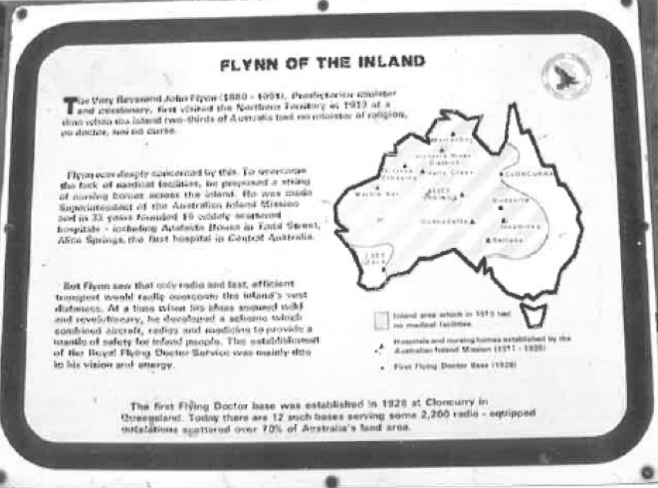
Memorial to the Reverend John Flynn at 3 ways Northern Territory.
In 1924, the Melbourne Fire Brigade commenced using radio communications in this frequency range too. The base station frequency was ultimately quoted as 1655 kHz. It is possible that both stations were on similar frequencies and were heard interstate, but to the Canal listener the slight difference in the tuning of the receivers of the day would not have been obvious.
Towards the end of the 1920s, light-houses and a few fishing trawlers were fitted with radio telephone/ telegraphy equipment. The equipment had a quoted powers of up to 250 watts and they were supplied with power from engine-generator sets. (AWA Radio Guide 1929)
Certainly, these were good news items for Flynn, but the reality was that these installations were totally unsuitable for his purposes.
Progress was happening though. New and more suitable low current drain valves were coming onto the market, and these would be good enough for the “baby” transceivers within three years. However, enough valves. with the right combinations of complimentary characteristics to make voice transmitters practical, didn’t become readily available for another eight years.
A self-contained power supply for the proposed “baby” transceivers was one of the big worries. There were no suitable power supplies - jacking up the rear wheel of the Car, if one was available, to run a generator for the transceiver was just not practical in the real world. The answer to this problem was to come dime years hence, when the genius of Alf Traeger was to produce the pedal generator. It was to power the “pedal radio” transmitters in the outback for more than a decade, until superseded by the vibrator power supply.
Flynn was patient and persistent. The pieces of the jigsaw puzzle were starting to be put together, although many were still missing!

CHAPTER FOUR

THE HERMANNSBURG EXPERIMENTS - 1926

While a portable radio transmitting and receiving station complete with a self-contained and simple power supply was something that was unheard of in 1926, Rev. John Flynn, Harry Kauper and others had researched and experimented at length in the hope that they could design and build a radio transceiver suitable for the outback. Any relevant literature published in Australia, Europe or North America was eagerly read and many of the ideas tried.
Enthusiastic amateur radio operators (experimenters) achieved the first two-way radio communication across the Atlantic Ocean in December 1923. Amateurs were allowed relatively low power transmitters compared to the commercial communications users. However, this achievement would have been noted by Kanpur and other experimenters in Australia.
Kauper in particular was a very keen experimenter/ amateur/ham radio operator and would often contact Overseas amateurs. During these contacts he would have solicited information on any new ideas that he could try in the quest to produce a suitable radio transceiver. From the experiments of 1925 conducted by Towns and Flynn, and from his own experience, Kauper could see that voice communication was possible, but far from practical, in a transceiver built to Flynn’s criteria.
Kauper conducted experiments in Adelaide during 1926, in an endeavour to get operational a more compact, more user friendly, semiportable transmitter and receiver system. Flynn asked Kauper to build three stations for use in experiments around Stuart (Alice Springs). One for use at the Hermannsburg Lutheran Aboriginal mission station and one for the Arltunga police station, with the third as a spare. The tests at Hermannsburg and Arltunga was to establish how `simple” the equipment could be made, to achieve satisfactory communication.
At that time Arltunga had a higher population than Stuart. due to the gold mining boom there. Stuart was gazetted as a township in 1888, and had its first school opened in 1914 with 25 pupils.
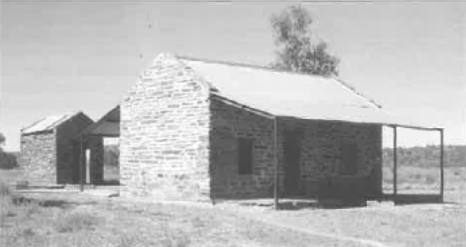
Restored Arltunga Police Station
The transmitters would not need to be powerful, or the receivers ultra-sensitive, as the distance to the two test sites was less than 100 miles (160 Kilometres) from Stuart. The tests could be conducted on the 88-metre band (approximately 3.4 MHz as this band was very suitable for the communication distances involved. PMG approval for the use of this wavelength was obtained. Rev John Flynn in an article in “Wireless Weekly” for 4/2/1927 stated the wavelength as 89 metres (a typographical error I suspect). The book “John Flynn - Apostle to the Inland” page 139, suggests that the Hermannsburg station was on 85 metres (3.529 kHz), and that the Stuart station was on 175 metres (1,714 kHz). The exact frequencies used are not of great importance, but various texts suggest that all three stations used the same wavelength (frequency), (probably in the range 85 to 89 metres) as each station was able to communicate with the other two at the same time. The Postmaster General’s department (PMG) was not happy with the idea of unqualified people operating the transmitting equipment. but with persuasive argument from Flynn, permission was granted for these tests, and callsigns were allocated for their use (8AB, 8AD, 8AE and 8AF - the standby base station).
Kauper was still agonising over how the stations could be powered, as this was the major stumbling block. Vibrator power supplies for ratio equipment had not been invented at this time.
It was certainly possible to operate portable radio stations from generators attached to the back wheels of cars, from 32-volt electric lighting plants via motor-generators (generation), or from the electrical supply mains, but they were all extremely expensive, cumbersome, and took quite some time to set up. After one of his radio experimenting trips. Flynn commented that no one with a car and a good bank balance need be without communications in the outback. Not many people at that time could afford cars! These methods did not fit into the vision that Flynn held.
Back in March 1922 an article appeared in “QST”. the official magazine of the American Radio Relay League (ARRL), of a simple and economical method to obtain power from low voltage batteries. The supply consisted of a 6- or 12-volt battery with a model T Ford car coil (original purpose, to supply the high voltage to the spark plugs in Ford model T cars) which provided a high voltage suitable for use in a simple morse code transmitter. (See the Hermannsburg transmitter in Appendix 2.) The low quality of signal produced by such a transmitter would not be tolerated today, but radio was still a new and developing science at that time, so any success was deemed a real ‘victory”.
It is likely that Harry Kauper saw this article, and probably other amateur radio operators had tried it to supply energy for their transmitters.
The vexing question of how to supply the high voltage necessary to power the valve plate circuit of a small transmitter was at last solved - at least for the time being.
A suitable source of power for the station (including the Ford model T coil) was a bank of Edison primary cells rated at 1.1 volts output, at 500-to-600-amp hours capacity. Nine of these provided 9.9 volts across the whole bank, and
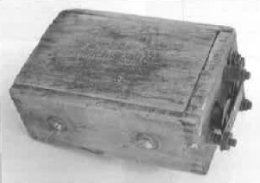
they were tapped at 5.5 volts for the receiver valve filaments.
Model T coil as used to power the Hermannsburg and Arltunga experimental radio stations.
The high voltage for the transmitter was supplied by the Ford T coil which could have run off either the 5.5-volt cap or the total battery voltage of 9.9 volts. The coil was designed For 6 volts but some overseas magazine; showed it being operated off 12-volt batteries, hence Kauper would have considered 9.9 volts to be safe to use.
(Some texts suggest that the voltage from these cells was 0.65 volts. Both Mervyn Eunson (VK4SO) and I believe that 1.1 Volt is the correct figure, having conducted a variety of experiments on cells made up using the same materials as the Edison cells (copper and zinc electrodes with caustic soda electrolyte), and by consulting various chemical and electrical handbooks for data. Reference to these sources can be found in Appendix 4.)
Kauper had the information and experience to build suitable two valve receivers for the experiments. The first valve was a regenerative detector- The regeneration was controlled by a reaction winding that was able to be moved in relationship to the tuned winding. The second valve was a transformer coupled audio stage, feeding a pair of headphones. “Iwo valve sets were the norm for amateurs of the era, providing quite adequate performance. (One text suggests that the receiver had three valves, but this is unlikely as other texts and diagrams suggest the receiver used only two valves The subsequently designed “Baby” transceiver only had two valves in the receiver. See circuit diagram Appendix 2.)
The valves likely to have been used in the receiver were the UV201A or UX201A. They have five-volt filaments, hence the tapping five cells along the Edison all battery bank. The tapping point can be seen with difficulty in the original photograph of the station 5.5 volts is the correct voltage for the valve filaments when allowing for a voltage drop in the leads from the battery to the valves. A rheostat may have been included in series with the valve filaments to control the receiver operation. The high-tension voltage for the valve plates was provided by a 45 (or 60) volt Burgess dry battery.
The transmitter would have been a °standard” design of the period for a low power valve unit, using one valve as a free running oscillator am output stage, coupled to an aerial and counterpoise. A redrawn copy of Kauper’s design. which includes both the transmitter and receiver is shown in Appendix 2, with valve types that were commonly used for this purpose.
Valves such as the UV201. the improved UX/ UV201A (available 1923) and derivatives were beginning to be used in both receivers and transmitters. In transmitters they were considerably overloaded with powers up to 7.5 watts. It seems that output power and input power were rather loosely interchanged and the figure of 7.5 was may well have been “input” power to the plate circuit of the UX/UV20IA. Harry Kauper, experimental amateur callsign 5BG, was one who used the 201A in this mariner.
The valve. used in the transmitter could have been a UV201A or the more robust UV210. The use of the UV210 would seem more likely with the supply voltage of around 10 vols. This voltage was adjusted via a rheostat to provide the correct voltage for the. valve filament. “Ile robust UV210 would stand more unintentional abuse by the potential operators too. (One ten states chat an unnamed valve drawing 0.1 amps filament current at 4 volts was used in the transmitter -1 think this unlikely.)
Flynn intended that in 1926 he and George Towns would travel to ‘the centre (Stuart) to conduct experiments with Hermannsburg and Arltunga using the experimental morse code (ICW) sets built by Kauper. The out stations would be contacting the base station chat was to be installed at Stuart. The base receiver was a multi-band unit using plug in coils for each receiving band. The transmitter was a 50-watt unit capable of voice (AM) transmissions. It was given to Flynn by Ernest Fisk of AWA for use in the various experiments that needed to be undertaken. The station was to be powered from a 32-volt lighting plant at what is now called Adelaide House. Parts of the 32-volt lighting plant are still on show there.
As the time neared for Flynn and Towns to go to Stuart, Towns had to pull out, due to health problems. This would have been a great disappointment for Towns. After all the experimental work that he and Flynn had done throughout the region during the previous year, he wouldn’t be there to see the next, and hopefully successful, experiment conducted.
This posed a dilemma (or Flynn, and he spoke with Harry Kauper about this very real setback which could kill the experiment and put the tests back another year. Kauper told Flynn that he couldn’t go into the outback either, due to his work commitments at broadcasting station 5CL. However, he suggested that Alfred Traeger, the young man that Flynn had bought the generator from the previous year, could well be a suitable replacement. Traeger had also qualified on 30/9/1926 for his amateur radio licence, which made him a good selection for the job in hand. Flynn approached Traeger with an offer of employment at £6 ($12) per week. Traeger readily accepted this offer, and admitted sometime later that he would have gone with Flynn at half the pay he’d been offered.
Traeger had the responsibility to get all the bits and pieces together and to dispatch them To Stuart. He was bemused with the large Edison primary batteries that were to be used to power most of the sections of the experimental sets. There were nine cells each 18” (45 cm) high by 7” (17.5 cm) diameter and weighing around 80 pounds (36 Kg). This totaled about 720 pounds (327 Kg) to power a 10 pound (4.5 Kg) set, and this really appealed to Traeger’s sense of humour.
Traeger installed a 32-volt lighting plant at Adelaide House in Stuart, and then the base transmitter, receiver and aerial system.
In November 1926 the trip to Hermannsburg was undertaken. Flynn’s buckboard was overloaded with the experimental out-station radio system, which weighed around half a ton The station was installed and tested.
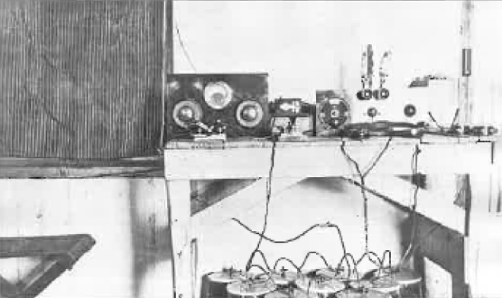

Photo of Hermannsburg experimental radio station 1926.
The initial tests were unsuccessful due to “finger trouble at Stuart where the wrong coil had been put into the receiver. Once this was corrected communications between Hermannsburg and Stuart proved effective and reliable. The station at the Arltunga police station was then installed and the three stations could communicate with each other. This fact contradicts the theory that the base station transmitted on a different frequency to the out stations and proves that they were all on a frequency around 88 metres. The Arltunga station received link use, bur the Hermannsburg station was used for a number of important messages until such time as the transmitter ceased to work several months later in 1927. These extended tests proved to Flynn, beyond all doubt, the value of radio communications to help remove the dread of isolation, and lack of help, in times of accident and illness.
Whilst this experiment did not meet many of Flynn’s criteria, he could now see his “dream” was, in fact, possible.
It was now time to get back to the drawing board to calm the many outstanding problems. The free running oscillator/cum output stage morse code transmitter was not satisfactory for several reasons With several transmitters in use, the various receivers in the network and particularly the base station would have to tune across the band to find the stations as they would not all be on the same ‘spot on the dial” (frequency). This would mean that emergency calls could be missed. The transmitting valve used a substantial amount of filament and high voltage energy. The receiver valves were not frugal with their use of electrical energy either. It had been proven that relatively low radio frequencies power would provide tenable communications to the base station. From experimentation with equipment similar to that used at Hermannsburg, an output power of at least three watts, and possibly as high as five watts, would have been obtained. (See Appendix 2. for information on these tests.)
Whilst the Edison batteries did solve the power supply problem for the filaments of the valves, they were too expensive, heavy, bulky and messy to be considered as the final answer to this question. It was thought that dry batteries may be the answer to some of the requirements. The supply of high voltage to the transmitter was by far the biggest problem. The Ford T coil whilst it provided an answer, was far from an ideal high voltage supply as the quality of the transmitted radio signal was poor. It provided a high voltage spiky alternating current, which the valve had to rectify so that it could operate. The voltage was very high under some circumstances and would eventually cause a breakdown in the valve or components hence reliability could not be guaranteed.
The receiver circuitry was of a tried and proven type. Only minor alterations were needed to make it completely suitable for the job In hand - mainly using valves with lower filament voltage and current requirements.
With radio in its infancy, experience and knowledge limited, and Kauper (Traeger’s mentor) heavily involved with his work at 5CL, Traeger had to face the huge challenge to design and build Flynn’s “baby” transceivers. Kauper was heavily involved with the design, whilst Traeger mostly made the equipment.
If access to electrical power, suitable buildings, the large sums of money necessary to buy equipment and to employ skilled operators was available, radio communications would have been established by this date. But Flynn was looking for a system, as inexpensive, and simple to use as the Citizens Band (CB) radio service which officially commenced in Australia in 1977. What he wanted hadn’t been invented in 1926!
(Information on the transmitters and receivers used at Hermannsburg and Arltunga is contained in Appendix 2. To determine the likely performance of the Hermannsburg and Arltunga transmitters, a similar transmitter was built to assess performance. The results obtained from the term are in the appendix. Whilst it is acknowledged that the circuits are unlikely to be identical to those used, but they are similar to those used in that era by radio amateurs” hams, and the results obtained were similar to those obtained In 1926.)
With all the things that had been learnt on this trip, it was now time to attack the problems head on and solve them. Over the next two years things started to come together. Traeger, with considerable help from Kauper, put the pieces of the jig saw punk together, and the “baby” transceiver was born.
The developmental time appears very long for such apparently simple equipment, when we consider the blistering speed with which new and complex devices are developed and put on the market today. But this was new technology, and valve type radio had only been allowed to be used by experimenters five years earlier in 1921. They had little test equipment, and what they had was crude by today’s standards. This made assessing the progress they were making in their experiments difficult They were leading the world with the work that they were doing. We have reason to be proud of what they achieved.
Kauper’s three experimental sets were eventually returned to Adelaide and were dismantled for parts, having carved their purpose in the experiments:
In summary, may things still had to be solved.
1. Some means of reducing the amount of filament current used by both the transmitter and receiver valves, or some method of economically supplying this power. Size, weight. cost and general inconvenience of structure and the use corrosive chemicals made the Edison all inappropriate for the task if an alternative was at all possible. Whilst they were primary cells, they could be refurbished when they went flat, but this was far from an easy task.
New valves were coming onto the market that used less filament current. Ultimately some would become available drawing current which could be economically supplied by dry batteries.
Originally valves had tungsten filaments which required the filaments to be lit to white heat (bright emitters) so that reasonable plate current could be drawn through the valve. An example of this was the UV201 valve. It drew 1 amp at 5 volts.
Subsequently the UV201 was modified and became the UV201A and the UX201A. The difference was the fitting of a new thoriated tungsten filament, which did not require to be heated to such a high temperature for the valve to draw reasonable plate currents. It drew 0.25 amp at 5 watts, which was a big improvement.
As time progressed during the late 1920s, valves were developed with filaments that required perhaps 2 volts at 0.1 amp and the valves were able to draw quite reasonable plate currents. These valves used a tungsten filament that was coated with a Barium Oxide (or other oxides) which allowed the filament to be run at a dull red colour (dull emitters) and still emit copious quantities of electrons. This equates to plate current. These were the valves that eventually made the simple, effective, low current drain radio transceiver for the outback possible. At the end of the valve era some valve filaments ran on 0.625 volts and drew only 25 ma filament current.
2. A means was needed to maintain all transmitters on the one frequency, to that receivers didn’t have to be retuned to receive each additional transmitter in the network. Both Kauper and Traeger had used crystal control on several of their own transmitters, so this was not a major problem. It was still a new method of accurately controlling the operating frequency of a transmitter, but they had this requirement largely under control. It was just a matter of refining the circuitry and the manufacture of crystals to make crystal control work reliably. Maxwell Howden in Melbourne came to their rescue early in the 1930s and manufactured crystals for many years for Traeger.
3. A method of supplying high voltage economically was proving difficult to solve. While the Model T Ford coil proved that a morse code transmitter could be powered by such a device from a 6 to 12 volt power source, the reliability of the coil, and the valves supplied from it, under such “nonstandard” working conditions was debatable. The tone of the morse from a transmitter using the coil supply was harsh and left a lot to be desired. The current drawn by the coil of 1.5 amps plus the transmitter filament current brought the total current drain up to around 2 amps or 3 amps, depending on which valve was used. This was far too much. There didn’t seem to be too much light on the horizon with this, and it was probably the biggest obstacle to overcome. Vibrator power supplies were still sewed years away, although simple but not very efficient ones started to be used in America very early in the 1930s.
4. Whilst separate pieces of equipment were quite satisfactory for technical people to handle, to connect together and have operating, this arrangement would be a nightmare for non-technical people. It was desirable that the complete equipment be housed in one case that was not too bulky or heavy. This was just a matter of refining the constructional ideas - but something that had rarely been done before. Experimenters liked to have their equipment spread out, so that they could change things as the mood took them. The sets that were to be used in the outback had to be constructed physically and electronically, in such a way, that changing things around became totally unnecessary.
5. The receiver high tension voltage requirements needed to be minimal, as batteries were expensive, they didn’t have a long life in humid environments. and were not always readily available. Like the transmitter valves, things were moving in this area too, and it was only a matter of keeping a look out for any new valves that may help to overcome this deficiency. The UV199 looked to be a suitable valve, but it had a very short life, so whilst its characteristics were satisfactory, Its reliability wasn’t.
6. Whilst the missionaries at Hermannsburg proved that they could operate a relatively complex station, it was acknowledged that this would not be so in all cases. Pastor Albrecht had a very good reason to become proficient in the use of the station and morse code, as his wife was away having a baby He was concerned about their well-being, particularly after the birth, as the doctor had expressed concern.
They were helped in becoming proficient in morse code by the fact that the raucous noise of the ford T coil trembler reed occurred at the same time as the morse key was pressed. This was a form of sidetone or monitoring system that allowed the sender to appraise his or her own sending. It seems that Traeger, and most other technical radio men of the time, did not realise the importance of operators being able to monitor their sending, otherwise that feature would have been incorporated into the sets that were developed in the next few years.
Many operators had trouble coming to grips with technicalities of using the equipment, as well as the actual sending of morse code. Technical people like to have all sore of meters and adjustments on their equipment that tell them how things are going and allow them to readjust for optimum performance. It is a sign of good design when equipment can be made simple to operate and yet everything works well. It took Traeger until the early 1930s to achieve relative simplicity of operation of the equipment, but he was learning, as successive designs show.
Well, it was now time to really put more of the jig saw pieces together. and to find some more pieces for the puzzle. Many gains had been made over the past year, but much more still had to be achieved if the “baby” transceivers were ever to become a reality. Traeger was inspired with Flynn’s vision for the people of the outback, and he attacked the problems with great zeal. He understood the desperate need for ways and means to overcome the dread of illness, and loneliness, that the people of the outback were suffering.
While Flynn and Traeger struggled on a ‘shoe-string” budget, there were already radio communications stations run by the Government at Wave Hill and Camooweal which had been erected the previous year. As Rev John Flynn reported in “Bush Wireless” in “Wireless Weekly” for February 4, 1927 only one station at Brunette Downs had been installed to communicate with Camooweal which was connected with the telegraph system. He said “...the average frontier pastoralist is unable to afford such fine equipment as Brunette enjoys: Brunette, by the way, is regarded as the engineering wonder of Australia’s frontiers? Yes, with a bottomless pocket. it was quite practical to have radio communications with the outside world, but with a very thin wallet - not yet!
In 1925 (the year prior to the Hermannsburg experiments) the PMG department had only issued 140 radio communication licences. These licences would have been for ships. and for government and semi-governmental instrumentalities. This total may have Included the broadcast stations as well. Quite possibly the licences granted to the Australian Inland Mission (AIM) were the first ones outside of the above-mentioned services. In 1989 the Department of Transport and Communications had on issue 1,000,000 radio communication licences.

TRENCH RADIOS
It would seem that Harry Kauper had actually “re-invented the wheel”. By 1917 the British Army had a complete transceiver similar to the units used at Hermannsburg and Arltunga. although not designed for the long range that Flynn Required. Obviously military security and secretiveness was good, and George Towns, although in the army, did not know of the quite successful trench radios of 1917. If Kauper, Towns and Flynn had known of these sets the development and experimentation could have been considerably shortened and perhaps the “baby” transceiver may have been a possibility as early as when the Hermannsburg experiments took place in 1926. It Is doubtful if they ever knew about these sets and certainly not until many years later. Kauper may have come across them in the course of the work that he did during WWII.
The successful 1917 model. the 30-watt C.W. Trench Set, MkIII and III*, used a vibrator type step up transformer arrangement to power a small, single valve, interrupted continuous wave (ICW) transmitter. This was not unlike the valve and Ford coil system used by Kauper. The receiver was a two-valve unit, with a regenerative detector and one stage of audio amplification which was similar to Kauper’s. The transmitter was powered by a wet cell battery feeding both the valve filament, and the vibrator high voltage power supply, whilst the receiver used the battery for the filaments, and a separate dry battery for the receiver high tension supply the design was good enough that this set remained in use with the military until the early I930s, although by then it was quite obsolete.
This model had greater range than most, up to 70 KM or more when coupled with a reasonable aerial and earth system. The valved trench radios of the era used frequencies in the range from I150 kHz to 500 kHz which were not suited for long distance communications without the use of very large aerial systems.
It appears the Australian military only had experience of spark transmitters during, and even after, WWI had ended. It was not until 1924 that the Australian military was supplied with sets of the calibre of the 30-watt C.W. Trench Set MkIII*.
If frequencies in the range above 3000 kilohertz (3 Megahertz) had been used in these early valved Trench Sets, the communication distance would have been sufficient for the needs of the outback - as the radio amateurs and experimenters were soon to prove. The concept was good, but weight, cost, reliability, current drain and complexity of operation, as well as the inappropriate frequency range used, meant that they were not suitable for Flynn’s needs. They would however have served as an excellent starting point. From this time forward, Flynn. Kauper and Towns would have known that they were going in the right direction with their experiments.

CHAPTER FIVE

NEW DEVELOPMENTS BRING SUCCESS 1927 - 1928

Whilst Traeger wasn’t a guru on radio transmitting, and receiving at this stage, he was particularly competent at designing and making high quality high voltage generators, such as the 600-volt unit Flynn had purchased for the experiments conducted with George Towns In 1925. His was the only generator that was good enough for these experiments, although many had been tried and rejected.
AC or DC mains power was ruled out right from the beginning as the remote areas had no sources of power at all with rare exceptions. The most high-tech items in many outback stations were likely to be kerosene lamps and wood stoves, and none of these generated any electrical energy!
Some of the larger cattle and sheep stations did however have 32-volt lighting plants, which became available after World War One. As will be seen later the Cloncurry base station was powered from such a plant. Generators could be used to power radio stations from 32 volts. A genemotor is an electric motor and generator all In the one assembly. It has two (sometimes more) armature windings. One serves as the driving motor from a battery and the second winding is (usually) a high voltage winding for radio or other equipment. They were not particularly efficient and drew high currents, but they were very reliable. Once again this just wasn’t an option to power 99% of the potential radio stations.
On reading the “Radio Trade Annual of Australia” 1933, a number of statements are made about dry batteries, and I have paraphrased the relevant pieces. It is stated due-
batteries should be installed in a cool, dry place as heat quickly dries up the active material contained in the cells. Moisture causes a leakage current to flow across the insulation between adjacent cells and causes the zinc containers to be eaten away more quickly. Light duty batteries are rated at a discharge current up to 6 milliamps, heavy duty batteries to 16 milliamps and super service or triple duty B batteries are rated where current drains may exceed 25 milliamps,
This was the state of the development of dry batteries in 1933, which probably was better than back in 1928. Certainly, dry batteries are not so restricted by the environment these days, due to superior construction and insulation techniques used.
So dry batteries could be used to power the receiver filament and plate circuits, however, the shelf life In hot and humid climates would not be good, and the, cost high. While they were not out of the question, availability depended on the transport services, which were often delayed for long periods by impassible roads. At this time, another problem was to find valves that would only draw small amounts of filament current and high voltage plate current. The valves also needed to be reliable, and they weren’t particularly so at that stage. So, for the receiver, it was a case of wait and see what became available.
The transmitter was much more of a worry, as the filament current and voltage required a more substantial supply for the valve. Valves suitable for transmitting used a considerable amount of power, with even the smallest ones using too much. However, some of the battery valves designed for audio power work (to feed loudspeakers) proved to be suitable for use on the lower short-wave frequencies. The filament voltages and currents were quite reasonable too, which made them attractive for the purpose. The filaments could be powered from dry batteries, but there were concerns about a means of supplying the high voltage for the valve plate circuits.
The previously recorded problems of heat and humidity, would affect the shelf life of dry batteries for the transmitter, as well as the receiver. The problems that caused Traeger to look at other sources of transmitter high voltage supply were,
(1) with four series 45-volt batteries in use, excessive electrical leakage occurred,
(2) the total current drawn from the batteries was the maximum that could be used without damage when using the super service batteries mentioned above,
(3) high cost, (4) physical size, and (5) the logistics of obtaining a supply of batteries continually to meet needs.
In the late 1930s vibrator power supplies replaced the high voltage batteries which meant that the problems associated with them were completely overcome. The quality of inter-cell insulation improved markedly over the years, and batteries now have shelf lives measured in years, rather than months back in the 1920s to 40s.
The filament voltage and currant requirements were less of a problem with the newer valves coming onto the marker in the mid to late 1920s. As the voltages were low between 1.0V and 7.5V the electrical leakage of the batteries was not a great worry in the hot humid climates, so the shelf life was not such a major problem. These batteries were less expensive, lighter, and far more readily available, as they were used extensively in telephone and telegraph systems.
Soon after the Hermannsburg experiments, Traeger toyed with the idea of a hand driven generator to supply the transmitter high voltage. The hand driven geared grinding wheels used to sharpen tools gave him the idea of replacing the stone with a generator to supply electrical energy for a transmitter. After a number of experiments, he produced a generator that would power a low power transmitter. There was quite a variation in the output power with changes in cranking speed, but this variation was largely stabilised with a flywheel.
A very real problem with a hand cranked generator was that the operator had to operate the set controls, and send morse, whilst cranking. It would have been an advantage to be an octopus under these circumstances. It can be imagined what the quality of the message would be like under those situations, particularly when the operator was poorly skilled in sending morse code signals and was getting tired. For many of the tests Traeger conducted, he had another person either operate the experimental set or crank the generator. At the end of this assessment period, he concluded the hand generator system was not suitable for the job, however, he did believe that he was on the right track.
He then came up with an idea which would allow both of the operator’s hands to be free to operate the transmitter, and manipulate the morse key, at the same time, Whilst still supplying electrical power to the transmitter. He achieved this by having two bicycle pedals on a gearbox, driving the generator which could be operated just like pedaling a bicycle. Hence the pedal generator came into being. Pedaling achieved a more even output and the operator’s hands were freed up to do what they did best - operating the equipment and manipulating the morse key.
Some claim that the Germans used a pedal generator to power radios In World War One, and that this inspired Traeger. This is thought to be unlikely, although not impossible, as none have been seen nor any records found. (The military keep their technical developments to themselves.) A pedal generator was used to supply power to a Pathe movie projector, and this is cited as another possible item that inspired Traeger. Wherever the idea of using a pedal generator to supply power for a transmitter came from is unknown. However, Traeger’s experiments resulted in a unit quite suitable for the task of supplying the transmitter high voltage.
Traeger’s previous experience stood him in good stead for ongoing success in building the new revolutionary pedal generators.

There were two models of peddle generator produced. Traeger had no model numbers for then so for clarity of identification, I have labelled them as a Mk I. and MkII. The Mk I. was developed in 1927 or 1928 (records give no clear idea of when these experiments concluded) and powered the pedal radios until the MkII was developed in 1932.
The Mk l. pedal generators have a nominal output of 180 volts, which varies with loading and the speed with which the generator is pedaled. The voltage varies between around 160/170 at maximum load to the nominal 180 volts and could rise to around 200 volts off load. The Mk ll. pedal generators have a nominal output of 200 volts which range between 180 and 250 volts depending on the loading and pedaling speed. With a 15-watt load, the variation in output is between 180 volts pedaling slowly and 220 volts when pedaling rapidly. The often-quoted output power of his generators was 20 watts. The later AM/ CW transceivers never required more than 12 watts peak power, so the generator was never stressed. There are enough pedal generators in existence to prove these figures.
The valves used in the transceivers were rated up to a plate voltage of 180 volts and in some cases only to 135 volts. Like many amateur radio operators, Traeger did exceed the maximum ratings by a ‘safe” amount which reduced the life of the valves. He got away with doing this, but the transmitter valves did have a very limited life, particularly in the later battery valved transceivers. Some texts suggest that pedal generators produced voltages of 350 volts or higher. This is incorrect as the transmitter valves would have failed in a spectacular manner within seconds with such high voltages applied to them.
By reference to the illustrations, it will become dear how the pedal generator was made and worked. To generate any useful level of electricity, it is necessary that the actual generator armature spins at relatively high speeds. Traeger made his generator work well at around 1000 revolutions per minute (rpm). To achieve this he needed a step up ratio from the pedals, and he settled on a step up ratio of 12:1. This meant that the operator would need to pedal at around 80 rpm to achieve the required output voltage. If the generator was pedaled too slowly, the voltage was insufficient and if pedaled too fast, the operator soon became tired. Fortunately, the voltage did not rise alarmingly.
He used a fully enclosed gear train of 192 teeth 8” (20 cm) gear on the pedal shaft meshing with a 16-tooth gear on the generator shaft. At the base of the enclosure there was enough engine oil to keep the gears well lubricated. The bearing on the other end of the generator was lubricated separately.

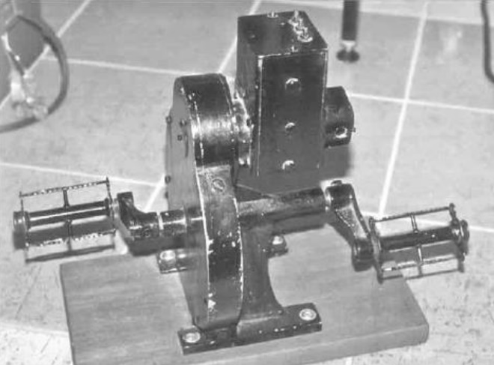
Black Mk II pedal Generator
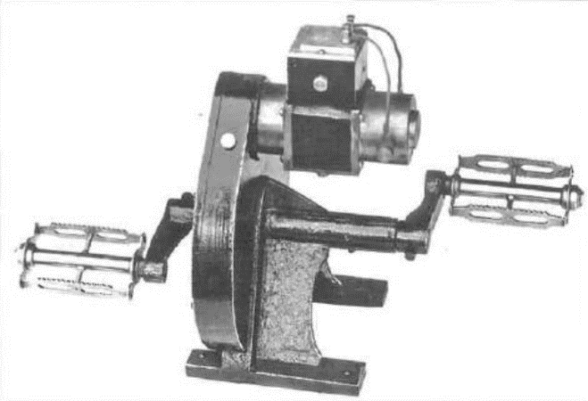
Grey Mk I Pedal generator (Mervyn Eunson)

To ensure minimum generator whine on the transmitted signal, the armature had 13 windings terminating on 26 commutator segments. The two pole pieces consisted of machined iron castings: These held sufficient residual magnetism to create a field strong enough to get the generator operating The field built up as the generator was pedaled.
The Mk l had a high impedance shunt wound field which connected across the brushes and hence the armature. The generator would have had a noticeable variation in output voltage between “no load” and “full load”, due to being only a shunt wound generator. The “off load” voltage (transmitter with key up not transmitting), would have been as high as 200 volts and when loaded (transmitter with key down, and transmitting), may have been as low as 160 volts. The physical layout of the field windings and the whole generator assembly can be seen from the diagram and photos. The Mk l can be identified by the fact that there are only two terminals on top of the generator.
The Mk II was an improved version of the Mk l. It had tightly larger pole pieces and it used a compound wound field. Compound winding of a field for a generator consists of a high impedance shunt field (as the first model had) and a low impedance field winding in series with the load.
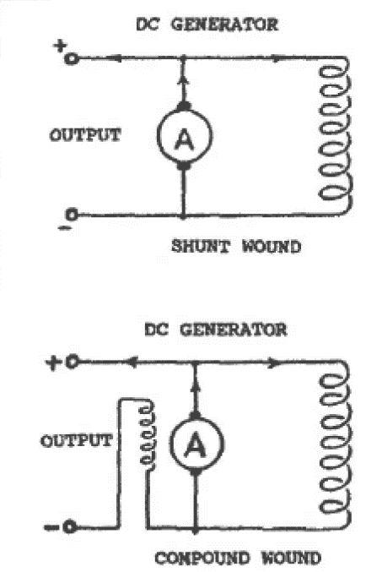
Circuits of shunt and compound wound generators.
The advantage or the compound wound field for the generator Is that when done properly, there is very little variation in output voltage with changes in the current drawn. Near constant voltage would have been required for the AM voice transmitters to achieve best performance. The MkII can be identified by the fact that there are three terminals on top of the generator. The MkII also had a flywheel built in to help maintain constant armature sped.
The Mk l when placed under a variable load, as would occur with modulation in the AM transmitters, would have dipped noticeably in output voltage as the person talked which could cause some, distortion of the voice signal, and variation in the transmitter output power. Variable voltage would also have caused “chirp” in the pure CW transmitters. I imagine Traeger would have been thrilled to have had some of the extremely powerful permanent magnets, that an currently available, to make an even more efficient pedal generator.
The pedal generator solved the problems that the high voltage dry batteries had presented as a source of high voltage supply for the transmitter. Many believe that the “pedal radio” was completely powered by the pedal generator, as I did, until a few years ago. Now of course we have the opportunity to be aware that the pedal generator only supplied the transmitters high voltage.
Hand cranked and pedal type generators have been used for various purposes since Traeger’s pedal generator was produced. Several military radio transceivers were powered by pedal generators during WWII and hand generators have been, and still are used, on many marine emergency lifeboat radios. These invariably supply the low tension as well as the high-tension voltages required for both the transmitter, and receiver. From my own experience, as a marine radio surveyor, cranking the generator and keying the transmitter at the same time was not an easy task, and certainly, as Traeger found - two operators were really needled – one to crank the other to operate.
Traeger produced a pedal generator powered transceiver in the 1960s for export to Nigeria. The benefits of various extremely strong permanent magnets, greater mechanical precision and efficient transistorised circuitry no doubt meant that this later day “pedal radio” was able to be entirely powered from the pedal generator. In quite recent times, a pedal generator powered 100-watt SSB transceiver for use in Africa, has been produced in England. For more Information on this I refer you to Appendix 4. here is also available in Australia the Baygen Freeplay Radio. which uses a clockwork powered generator to supply the porter for the receiver operation. So mechanical methods of supplying power to radio equipment are still being used.
Traeger was now satisfied that the power supply for the high voltage to the transmitter had been solved. The generator was not used to supply power to the receiver as that was too much generator “hash”/ interference which would have drowned out most of the incoming radio signals. It was not used to supply the filaments of the transmitter either, as this would have involved a very complicated winding for the generator armature. Dry batteries were destined to supply the filaments - once reliable low current filament valves were available.
In 1926 Philips released tie B205 valve In Europe. It probably became available in Australia in 1927, and no doubt David Wyles, of “Philips”, who knew of Kauper’s and Traeger’s need, would have let them know what new types of valves arrived in Australia. This proved to be the valve that they were waiting for. It drew 0.15 amps at 2 volts for the filament and 25 ma of plate current could be drawn with a plate voltage of 150 volts. In the typical experimenter fashion of the time, a plate voltage greater than the published maximum was applied to the valve with no adverse effect.
No information is available about the vast number of transceiver experiments conducted during this period, other than that the little sets had a crystal-controlled transmitter and worked well on the amateur radio bands.
Transmitters using free running oscillators could not be relied upon to remain on the correct frequency, hence their transmissions could easily be missed because the transmitter had drifted off frequency and could be disastrous in an emergency.
Kauper and Traeger agreed that crystal control of the transmitters was the only viable way to guarantee that all the transmitters would appear on the same spot on the receiver tuning dial. This was particularly relevant when unskilled operators were to operate the equipment. It was then only a matter of ensuring the reliability of the crystal control in operation, and to get the manufacture of the crystals down to a fine art. This was one problem virtually solved.
Kauper commenced experimenting with crystal control of his amateur/ham band transmitters in 1925. He obtained the quartz in the Adelaide hills and ground the quartz crystals to suit the frequencies that he was interested in. Traeger followed Kauper’s example. They were on the cutting edge of technology, among the very few who did experiment with crystal control at the time, as most transmitters still relied on free running oscillators.
These days, Phase Locked Loop (PLL.) systems are used almost universally to control systems requiring precise frequency accuracy. They are an advanced and more versatile method of obtaining crystal-controlled precision. Wouldn’t Kauper and Traeger loved to have had such devices available to them in those times!
The ability of receivers to detect weak signals was improving. Many sets were starting to use at least one triode valve as a radio frequency (RF) amplifier followed by the regenerative detector. This gave the receiver better performance, which is always useful when listening to weak stations over long distances. However, this added an extra complication to the operation of a set and the aim of simplicity of circuit and operator use would be nullified. This would be even more of a problem with a multi-band receiver. For each band there would be at least two plug-in coils, which created confusion with operators, in that coils could get mixed up. This would mean that the receiver would not work.
Traeger remembered the foul-up that had occurred in Stuart (Alice Springs) at the time of the Hermannsburg experiments. The wrong coil had been put in the receiver at Stuart, which meant it was tuned to the wrong frequency, hence no reception of the Hermannsburg station. This mistake had been made by a technically capable operator.
For these reasons the idea of the use of an RF amplifier was abandoned. The portable receiver needed to be simple, reliable, easy to use and economical in cost and use of power. A tried and proven design used by amateur radio operators of the era was selected as being most suitable for the task in hand. Some modifications were needed to adapt the deign to a pedal radio.
The receiver tuning cod arrangement was altered so that band charging could be achieved via plug in coils. It was decided that the ability to receive broadcast transmissions on the 550 to 1,500 kilohertz band was also important. This was able to be economically accomplished by placing another set of windings on the receiver coil former. This gave the people of the inland the ability to listen to many of the same entertainment transmissions as their city cousins. Regeneration was controlled by a tunable capacitor instead of the ‘swinging coil” arrangement used in the Hermannsburg receiver.
Traeger experimented with various valves looking for some that drew little current for the filaments and in the place circuits. A variety of low filament current Philips valves came out in 1925 and several of these types would have been tried out by Kauper and Traeger with satisfactory results. However, one type looked extremely enticing, the A141 which only required a high-tension voltage of between 2 and 20 volts. Kauper had arranged the importation of a few of these via a friend, for experimentation. The use of such a valve would almost completely overcome their concerns about a high voltage supply for the receiver. For a two-valve receiver the filaments drew 0.12 amps at 1 to 1.3 volts, and the plate circuitry less than 7 ma at 9 volts. This meant that it was very practical and economical to operate the whole receiver off a few small dry batteries. By being able to use such low, high-tension voltages in the receiver, the problems associated with high voltage dry battery use in hot, humid climates was largely eliminated.
By about mid 1928 Kauper and Traeger had all the elements ready to put together the transceiver that John Flynn had sought for so long. It seems that Kauper brought forward most of the ideas and Traeger put them into practice. It was now time to put the untidy mess of bits and pieces that formed the prototype transceiver all together into a neat single cabinet. This took quite some time. When the layout of components Is changed, things often do not work as they did with the previous layout.
Overall, of this period, they quickly found, as had others, that it was not just the question of building a radio/wireless combination transmitting receiving set, but of solving many other problems, too. It was a problem of inventing it first. followed by the problem of making it, then, once the prototype was successfully proven, of obtaining the correct materials to continue to make than. Having achieved this, it was then necessary to make a number of them, install them, and make sure that they worked effectively and reliably. There were many teething problems to be ironed out In the next few years.
However, initial success was at LIST achieved in November 1928, almost two years exactly after the Hermannsburg experiments. Traeger contacted Flynn and gave him the good news. Flynn was no doubt absolutely ecstatic with the news. At last,” he must have mid to himself, “we have the medical facilities. the methods to get people to the facilities and now the method to summon the help, “Praise the Lord”. He hurried around to Traeger’s home and photographed him with the set, and this photograph is now perhaps the best-known photograph depicting the pedal radio.
The bush would no longer be mute.

CHAPTER SIX

THE YEAR OF THE “baby” TRANSCEIVER - 1929

The clouds of war were looming ominously over Europe during 1939. The need for effective small radio transceivers to be used by friends in occupied countries was well recognised by many in authority in Britain. An urgent need was soon recognised by the British War Office, for small portable transceivers that would be used by the “Resistance”, groups of sympathetic civilian supporters of the British forces who were often working as “informants” in German occupied commies. Size was critical. It was essential that the transceivers could be easily hidden from the ever alert and searching eyes of the patrolling German Army Officers.
The sets would be simple to operate and keep operational. be capable of morse code transmission, and morse and voice reception on headphones They would operate in the high frequency (HF) range of 3 to 8 megahertz (MHz) for best performance, using up to three frequencies depending on the time of day or night that transmission was to take place. They needed to have a transmitting and receiving range of up to 500 miles (800 Kilometres). The radio frequency output power of the transmitter should be between 3 and 30 watts to achieve this. The sets would generally obtain the power needed for their operation from the electricity mains, although provision for operation from a 6-volt battery was also included. There was a high priority given to the production of such radio equipment by government and its intelligence gathering organisations, hence money. facilities and personnel were readily available.
One of the first sets produced to meet this reed was called a Paraset. It had a total of three indirectly heated valves, a 6V6 valve as a combined crystal oscillator cum power output stage that operated on morse code only (CW) and two 6SK7 valves; one as a regenerative detector and the other as an audio stage. It tuned from 3 to 7.5 MHz and had a transmitter output power of 4 to 5 watts. (Ref: Secret Warfare)
In 1928. eleven years before the Passer came into being, a small number of people in Adelaide, were developing a set similar to the much later Parma. (they had limited budgets and limited technical back-up, but great dedication to the task in hand. This transceiver was to become the first of the successful radio receivers for the outback.
In the two years following the Hermannsburg experiments of 1926, much experimental work was done, testing various ideas both in Adelaide and in remote areas. With considerable help from Harry Kauper, and the encouragement of John Flynn, AM Traeger finally came up with a set that would meet the needs that John Flynn and David Wyles had promulgated several years beforehand. The “baby” transceiver was finally ready to go into outback Australia on the 11th of November 1928. What a task this had been, but in their accomplishment, they had produced a World first.
At the time of the set’s development, long range radio communication stations required several trained operators and technicians to look after and operate them. The reasons being that the equipment was quite touchy had a high electrical power consumption and needed to be housed in purpose-built buildings to obtain satisfactory reliability and performance.
Prior to the development of this set, the government had said that base radio communication stations suitable to be used for the tasks envisaged by Flynn would cost £1200 to install and £600 a year to run, even more than these figures according to some texts. The concept of portable radio communication stations just made the government officers shudder at the thought of what seemed to them, to be the “impossible”. The Government stations at Camooweal and Ware Hill were something like what Flynn needed for his base station at Cloncurry, except that they appeared to be telegraphy (CW) only stations, whereas Flynn’s desire was that the base station transmit voice (AM).
The cost of the homestead sets to work with the Government commissioned stations, and their complexity, meant that only one homestead was equipped over a period of years! It was a system that was not at all user friendly to the non-technical operator. The alternative option, a telephone line, was quite out of the question. We can understand this, because of the installation and maintenance cost, which were enormous when converted to today’s relative money value.
Haw did the combined mind. and talents of
Kauper, Traeger, and Flynn achieve the “impossible dream”?
1.Traeger and Kauper had done most of their experimentation in the 80 (3.5 MHz) ad 40 (7 Mhz) metre amateur radio bands. While the PMG would not be allocating frequencies within the amateur bands, they both hoped that the frequencies issued would be near the 80 metre
band. This range of frequencies would give the best performance over the distances Flynn wanted the sets to operate.
There appears to be some doubt about which frequency, or frequencies were allocated to the service. An original portable licence and the Cloncurry base licence, both dated 2nd July 1928, show an allocated wavelength as 88 metres, winch equates to a frequency of 3409 kHz. This wavelength was crossed out on both licences. The base licence was altered to 146.3 metres which equates to a frequency of 2051 kHz, whilst the portable licence was altered to show 2230 Kc/s (134.5 metres). (Kc/s - Kilocycles - is an older and

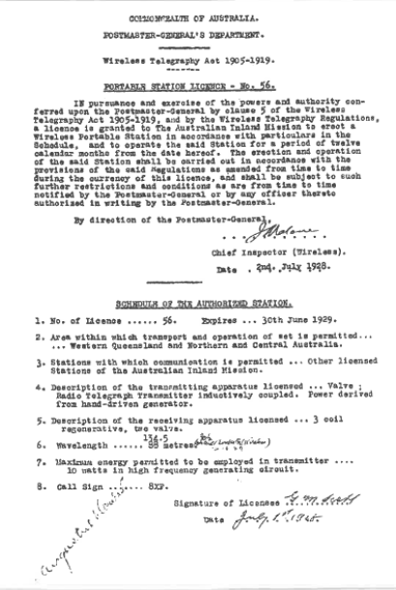
Copy of the original radio licence (No 56) Algoora Downs
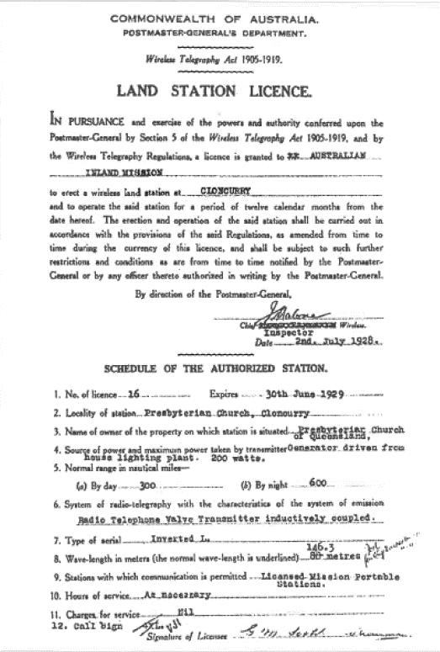
Copy of the original radio licence (No 16) for the Cloncurry Flying Doctor radio base station

now disused term for frequency 2230 Kc/s is the mine as 2230 kHz.)
These licences predate the installation of the pedal radio service by nearly a year. I imagine, they were issued so Traeger knew what frequency or frequencies needed to be accommodated in the design. in the 1920s equipment was not as versatile, or frequency agile, as it is now. It cannot be said with absolute certainty that these frequencies were used in the first “baby” transceivers, and negotiations probably occurred to have the same operating frequency in both the base and portable nations. A licence dated 24th April 1931 (copy in chapter eight) gives a frequency of 2020 Kc/s which calculates out to 148.51 metres, so some changes, occurred in the operational frequencies, between these two dates.
This gave Traeger and Kauper some direction as to what frequencies would be used in the Cloncurry radio network. It would have been frustrating not knowing which frequency the PMG would ultimately settle on for the networks use.
2. We have already seen that the radio equipment of the era was delicate, and unable to stand much physical abuse. The UV/UX201A valves used in the experiments at Hermannsburg were quite unsuitable for the proposed “baby” transceiver as they drew too much current, even though they were reasonably robust.
All Traeger could do was to mount the components so that a minimum amount of physical stress occurred. However, the most vulnerable items were the valves, and there was little he could do to overcome this problem, other than to try different types of valves to find the least fragile.
3. In 1925 Philips brought out a valve called a A141 which was called a “space charge” valve (Illustrated History of Philips Radio Valves - Pm Stewart). It would have been available in Australia in 1927. This valve worked effectively with plate voltages of between 2 and 20 volts.
A friend of Harry Kauper’s imported a few A141 valves for use by experimenters in Adelaide.
Kauper could see that these valves had considerable potential for the set that John Flynn was urging them (Kauper and Traeger) to develop. With these valves requiring such low high-tension voltage, Traeger was able to significantly reduce the shelf-life problem, associated with high voltage “B” batteries. Additionally, the low voltage batteries would be considerably cheaper than the 45- or 60-volt dry batteries commonly used.
Following their experiments, they could see that, at last there was a receiver valve available that required only a very low plate voltage, and also drew relatively low filament current as well. Therefore, two A141 valves were selected as being the most suitable valve for the “baby” transceiver “receiver” section. The receiver would consist of a regenerative detector followed by a transformer coupled audio stage feeding a pair of headphones. The receiver power requirements were 1 to 1.3 volts at up to 120 mA for the filaments, and 9 volts at around 3 - 7 mA for the plate supply. The accelerator grid may have been connected to 4.5 volts or some other voltage on the battery pack. There is no information to confirm or deny this assumption.

(Space charge valves enjoyed only a wry short period of popularity in the 1920s and then faded into oblivion. At the end of the valve era, they had another brief resurgence of popularity being used in hybrid car radios of the early 1960s. using 6- or 12-volt supply to their plate circuits. A few from this later on were types 12AL8, 12DL8, 12DS7, 12DV8, and 12K5.)
Back in November 1927, Traeger and Flynn were in Cloncurry at the time of the running of the 1927 Melbourne Cup. Traeger set up a short-wave receiver tuned to one of the few experimental short wave radio stations active at that time, so that the entertainment value, and hence the communications value of radio, could be demonstrated.
This particular Melbourne cup had a local horse (Trivalve), running so it was even most relevant to the locals. This was a very successful demonstration of the value of radio. - as Trivalve won! If ‘the” race could be heard. perhaps the odd bet could be laid by this newfangled radio too!
It is possible that the nation heard was located at Lyndhurst, southeast of Melbourne. Lyndhurst broadcast daily for two to three hours on an experimental basis from 1928, however it Is highly likely that it had started transmissions by November 1927. particularly with such an Important event taking place. After all, doesn’t all of Australia stop for a few minutes on the first Tuesday in November around 3 pm, to listen to the Melbourne Cup? The radio frequency power used was 500 to 600 Watts into a simple aerial/antenna on a frequency of 9580 Kcs/kHz. Today that same frequency is still in use at Radio Australia in Shepparton with a transmitter power of 100,000 watts into a large curtain array antenna. Today the signal is s0 powerful, it could almost be heard on a crystal set in Cloncurry. It can be heard through the Pacific region and even into Europe during the night.
Another possibility is that the experimental (amateur) radio station (VK)3ME was the one received. It was located in a Melbourne suburb and transmitted on 9590 kHz into a vertical half wave antenna, but it supposedly only transmitted at night, and would have been using lower power than the Lyndhurst station due to power restrictions on the licence. Callsigns with the ‘VK” prefix are allocated to amateur radio operators, but in the early days they were snowed to transmit some music and other entertainment for a limited number of bouts per day, or per week We cannot be sure which station was heard in Cloncurry, so we will never know which of these stations did transmit the “race that stops a nation”.
Traeger remembered the response of the people at Cloncurry to hearing the running of the Melbourne Cup. They were so excited and enthusiastic. It was decided that the planned receiver should be able to be used for entertainment, as well as communication. It was envisaged that the sets were more likely to be used in the evening (after the station work was complete), when radio propagation conditions, suitable for long distance reception were at their best in the lower short wave and AM broadcast band. Very little extra work was required to make it able to do this. An extra plug-in coil was all it took. This was achieved by using two plug-in coils mounted on the one assembly- inserted one way, it gave a tuning range of 550 kHz to 1500 kHz (the AM broadcast band) and when inserted the other way, a short-wave band including 2230 kHz. The extra range of this band is unknown, but it was probably from 2 to 4 MHz, although another source suggests 1.5 to 3 MHz The doubled ended coil assembly had a very distinct advantage - it would be unlikely to get lost as it was always required to be in the set.
It was not a sensitive receiver, but Kauper and Traeger reasoned that it would be adequate to receive the much stronger base transmitter. No doubt they both believed that the receiver problems had been well and truly solved. Regrettably, this was not so.
4. It was necessary that all the transmitters, which included all the proposed out-stations and the base, be totally accurate in their tuning, and tuned in to the same spot on the dial. Kauper and Traeger had decided a couple of years before, that the new “crystal control” be used to keep the transmitter exactly on the same frequency (channel), at all times.
A simple crystal locked transmitter, with a circuit not greatly different to what Traeger ended up using, was published in the July 1924 issue of “QST” the ARRL magazine. However, Kauper and Traeger was a more reliable design, with more positive starting of the oscillator and no “back wave”.
Initially Kauper and Traeger made their own crystals for the transmitters. Crystals are small slabs of quartz crystal that are cut, ground and polished so that they oscillate at some predetermined radio frequency, when voltages are applied across the two sides of the crystal. From 1931 onwards, Max Harden in Melbourne supplied the crystals, leaving Traeger to concentrate on designing and building transceivers. Commercial broadcasting stations were also beginning to use crystal control at this time.
5. The transmitter design had really exercised both Kauper’s and Traeger’s minds. Traeger had built a number of small crystal-controlled transmitters and these had proved quite successful in field trials in remote areas.
At last, a breakthrough occurred in valve development. It gave Kauper and Traeger the low filament current valve that they had been looking for. Philips had developed a battery triode salve in 1926 called the B205 (cost 13/6, $1.35). It drew only 150 milliamps of filament current at 2 volts and under normal receiver conditions would draw around 7 milliamps at 150 volts when driving a loudspeaker. It had ratings for other purposes as well, where currents up to around 30 milliamps could be drawn. The valve may have been designed for receiver use, but Traeger and Kauper saw its potential as the transmitting valve in the “baby` transceiver.
The high-tension voltage needed was around 180 volts and it is likely that the valve drew somewhere between 15 and 25 milliamps, which from published data was within the design rating of the valve. (See Appendix 4) With intermittent use (morse code), and by being operated in a more efficient mode than when used to drive a loudspeaker, the B205 was expected to perform well.
The transmitter was as efficient (40%) as could be obtained at that time. Traeger had learnt, from some of his early experiments about efficiency, and his designs showed this attribute. It had an RF output signal of between 1 to 1.5 watts, which was not very much power to cover the distances envisaged.
The pedal generator that Traeger had developed would easily power the transmitter. The valve filament could be supplied by two No.6 1.5-volt cells (batteries) in series with the voltage reduced to 2 volts by a rheostat.
6. The voltages and currents that the receiver and transmitter would use were now known, and now they could work out how the power could be supplied both reliably and economically.
It could not be assumed that a source of electrical power would be available to power the transmitter and receiver, as electric lighting plants were not common In the outback areas at that time.
The transmitter high voltage would be supplied by a lightly loaded pedal generator which would comfortably give 180 volts. The 2-volt filament would be supplied from two 1.5-volt cells in series. The voltage would be reduced to 2 volts via a rheostat. This had an advantage that even when the cells were nearly flat, 2 volts could still be obtained by adjusting the rheostat. To give a reasonable battery life, two No. 6 cells were used. These have somewhere between a 17- and 30-amp hour capacity (depending on usage) and could be expected to give many months of operation before requiring replacement. They were used by the thousands to power telephones.
The receiver only required a 1.5-volt battery to power Its filaments and a No. 742 (or 735) battery was selected. Once again It used a rheostat in series with the filaments to lower the voltage to between 1 and 1.3 volts. Quite a lengthy life could be expected out of this battery too.
The high-tension plate voltage for these valves could be between 2 and 20 volts. Kauper and Traeger decided that 9 volts would be optimum for this receiver. Two readily available No. 761 (or 714), 4.5-volt bias benefits were wired in series to give 9 volts for the plate supply, although the accelerator grid may have had less voltage applied to it.
As was the custom of the day, the receiver filaments were wired in parallel across the filament battery. The expected life of the batteries was at least six months. Traeger could have saved having a separate battery for the receiver filaments If he had wired them in series and supplied them from the transmitter filament battery. It would also have made biasing of the valves simpler if the bias had been used, as no separate bias battery would have been required. The reason that the series filaments were not used in this, and its immediate successors, was probably that it hadn’t been thought of at that time.
Traeger did what no one else had done, at that stage, In receivers. He fitted three voltmeters on the front of the set so tint the individual rheostats for the receiver and transmitter could be adjusted to give 1.3 and 2 volts respectively from the battery supplies for the receiver and transmitter filaments. As a result, it was possible to wring the last bit of energy out of the batteries whilst still maintaining full output from the transmitter, as well as retaining optimum performance from the receiver. The third meter measured the receiver plate voltage.
Why he used three meters is a bit of a mystery in a cheap set. Perhaps It was a carryover from the common practice of the radio amateurs of the era to have meters on all important function. Each meter was brought into operation by a push button underneath the actual meter. This would
have saved current as the voltmeter, of the era drew considerably more current than meters do today. Radio Corporation used a similar system with one meter to monitor the filament voltage in the RC16B transceiver of WWII vintage – a set not unlike the pedal radios of the late 1930s in many ways.
Some may ask “Why the pedal generator was not used to supply all the power to the receiver and the transmitter” It was not suitable to power the receiver and the filaments of the transmitter for four reasons. (1) The electrical noise (interference) from the generator would have made reception of the base station very difficult, or impossible, (2) the winding of several separate armatures in the generator would have been extremely difficult, costly and of debatable reliability, (3) the voltage would be so variable that optimum performance from the receiver would be unobtainable, plus regulating the filament voltages would have been near impossible with the technology of the day and (4) to continuously pedal the set would be onerous and exhausting over even restively short periods chime
7. The controls to operate the receiver were relatively simple - a tuning control and a regeneration control. To change bands, it was only necessary to pull the coil assembly out, turn it upside down, and re-insert it into the coil socket. Most domestic radios of the era were similar in circuitry and methods of operation, so no great problem was expected in teaching people in the outback how to use the receiver.
Transmitters are very different to receivers and the methods used to achieve best performance are also quite different. The conventional wisdom of the era was that the transmitter would be tuned for best performance by observing the deflection of a needle on a meter face. The transmitter would be adjusted (tuned) for a minimum (“dip”) reading on the meter. Then other adjustments would be done to increase the meter reading. The tuning would be re-adjusted so that a higher minimum was achieved. If this description sounds confusing, it Is, but that is how the equipment was tuned for best performance. The two actions were (are) called ‘tuning” and “loading”. Anyone who was unfamiliar with radio could be expected to think that for best performance, the meter should read as much as possible. A transmitter tuned that way would soon fail, as the valve would be ruined.
Well then, how could an operator be sure that he or she had achieved the best performance out of the transmitter? Another technique often used by the experimenters of the time was to use a small torch globe in series with the aerial lead. The transmitter was adjusted (tuned) for maximum brilliance of the globe. It wasted a bit of power, but it was an unambiguous method of tuning transmitters for optimum output.
Traeger could see during his trips into the outback from 1926 to 1928, that this last method would have to be the way that the equipment would be, tuned. Globes were simpler and cheaper.
8. During these trips various aerial systems would have been tried. He came to the conclusion that a ¼ wave semi vertical aerial fed against a counterpoise would be the most efficient to use with the transmitter. The receiver did not need such an efficient system and it used the same aerial as the transmitter but used an earth instead of the counterpoise.
It was also recognised that in the tropics, electrical storms were common, so the switching of the transceiver was made so that the aerial was earthed automatically once the set was turned off. That was a smart move as it was felt that housewives and station hands could not be expected to understand the importance of earthing the aerial system in a storm.
- Having determined what, the makeup of the receiver, transmitter and power supply would be, the next task was to make the unit “user friendly”.
The current fashion of the time was to have the transmitter, receiver, changeover mechanism (to change from transmitting to receiving, etc.) and relevant power supplies as separate entities, connected by many wires. This was confusing for the untrained, and wrong connections could easily be made with disastrous results.
By putting the receiver and transmitter into the one cabinet, complete with the facilities to effect the changeover from receive to transmit. and site versa, the possibilities of an untrained, non-technical person hooking things up incorrectly was largely overcome.
To achieve the requirement to be semi-portable, it was decided that the set should fit into a “coffin” style cabinet around the size of some of the larger receivers of the time. The result was a set that could be carried even by a small person, and likewise the pedal generator, but not both at the same time!
10. The process of simplifying the operation of the controls for the transceiver was not an easy task, but the end result was quite functional. The controls as best can be determined were bottom row, left to right headphone socket, receiver filament rheostat, transmitter filament rheostat. The middle row, left to right - receiver regeneration (reaction), receiver tuning, and transmit/receive switch. The top row meters, left to right - receiver filament, receiver high tension, and transmitter filament. Below each meter is a small press button switch to actuate each meter as required. The morse key was connected to the set at the back.
(You will probably notice that the photograph of the set with Traeger operating it. does not show the set in actual operating condition. The headphones, morse key, aerial, earth and counterpoise are not connected and there are no power cables from the pedal generator to the set)
To turn the set on it was only necessary to lift the “coffin” lid up. To change the band received from “broadcast band” to ‘short wave” it was necessary to reach into the set and pull out the coil behind the tuning control, turn it upside down and put it back in again. The transmitter actually had no “operator” controls as Traeger decided they were too complex for people to understand at this stage. The torch globe that was used when tuning the set was included, however.
Even though Traeger simplified the operation of the transceiver as much as he could, many out-station operators still found the operation of the sets daunting. It must be remembered some folk had never seen a wireless receiver, let alone a combination receiver AND transmitter. This was real Hl-TECH! Do you remember the first time you saw a computer, and how totally bewildered it seemed? So, you can sympathise with the hard-working outback grazier facing his first transceiver.
11. Sets of that era were not particularly reliable, and valves in particular would need replacement from time to time. The set was as simple as could be made to work properly and was accessible so that most work on a defective set could easily be done. There were no electronics servicemen “just down the road” to fix the sets, so Traeger trained the Patrol Padres to be ‘valve jockeys”, and to be able to correct any of the more obvious faults like broken leads.
12. The projected con of a set was hoped to be no more than £50. Traeger excelled himself and the set cost £33 ($66), which included the pedal generator. In 1928 a four valve AWA Radiola domestic receiver cost £31/10/0 and it didn’t include a pedal generator or a transmitter!
The transceiver described above was probably the first ever developed to be used by non-radio professionals anywhere in the world. At the very
leading edge of the technology of the time, it used very innovative ideas, and potentially placed communications in very remote areas within the grasp of almost anyone. This set was the first to be used in the task of opening up five million square kilometres of Australia to habitation. This, along with the aeroplane and the access to medical facilities took the dread out of living “back of beyond”.
Traeger announced his success to Flynn on 11th. November 1928. It was a red-letter day for communications in the outback. This was the first step towards reducing loneliness and obtaining rapid help in medical emergencies. This simple link radio transceiver provided the last link in Flynn’s dream of a “Mantle of Safety”.
It is interesting to note that, at about the same time as this set was produced, the military services developed a portable transmitting and receiving station. It required skilled operators and had a range of 30 miles, whereas Traeger’s set had a range of at least (600 Km) 370 miles! This far exceeded Flynn’s expected range of 300 miles and could be used by anyone.
While Alf Traeger is credited with the development of the pedal radio, information from a number of sources shows that Harry Kauper. as mentor to Traeger, played a very significant role in the design of this first successful model, the “baby” set. Kauper was undoubtedly starting to step aside as he changed his work abode from 5CL to 5AD when the government took over 5CL. Kauper would also have had an influence on the design of the second model (commonly called the Augustus Downs model) but not to the same degree, as he departed from Adelaide in 1930 to take up a position with 3DB In Melbourne. Traeger did not completely lose touch with Kauper, however. Designs from this time onwards were largely Traeger’s responsibility until transistors became common. However, full credit for the design of the pedal generator must go to Traeger.

THE “baby” PEDAL RADIO
Of the two photographs in this chapter of the lady-pedal radio, the first shows Traeger posing for the photograph as if he were operating the set. The second shows a bird’s eye view of the internal workings of the set. It can be seen that the radio is quite compact for the era. It was convenient to have all the batteries (2 x 4.5-volt batteries No 714 (761), 2 x 1.5-volt cells No 6 and one other 1.5 volt battery No 742 (735)) housed within the case of the set. The transmitting valve (B205) had been removed at the time of this photograph. A circuit of the set is shown in Appendix 2.
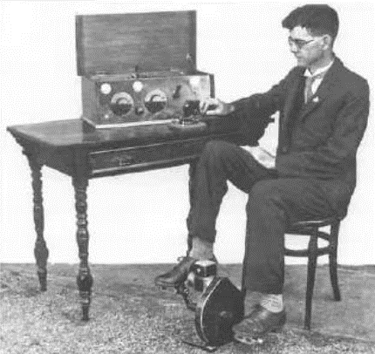
Alf Traeger posing with the original “baby” pedal radio transceiver.

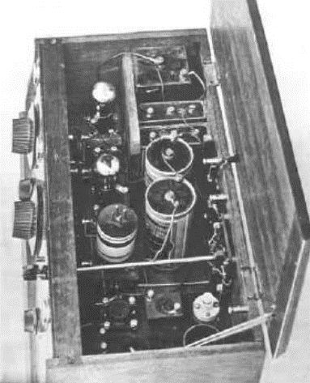
Internal view of the original “baby” pedal radio. Note the transmitting valve was missing from the bottom left hand corner when the picture was taken.
The pedal generator that supplied the 180 volts (nominal) for the transmitter was separate being bolted to the floor. There is a story of a very small lady who operated one of the pedal radios, tying-a rope around her waist and anchoring it to the operating desk legs so that as she pedaled, the chair didn’t “walk” itself away from the table and the generator. (Ref Mervyn Eunson ARA\ Vol 10 No 6)

DIMENSIONS
The radios measured 18” (45.7 cm) long by 7.5” (19 cm) high by 9.5” (24 cm) deep plus the depth of the controls. The case was made of semi polished wood and the chassis mounting plate was ebonite. The controls were unlabeled as was the custom at that stage. The lid was lifted to turn the set on and closed to turn the set off. With the lid closed, a minimum of dust could get into the set. Dust is a menace in virtually any equipment, and radio equipment is no exception. Obviously, the dry inland regions where the sets would be used was very dust prone.

ANTENNA SYSTEM
The transceiver without an efficient radiating system (aerial and earth/counterpoise) attached would be useless. The aerial and earth counterpoise system used with the “baby” set was an important part of the total communications system. The aerial (or more modern term antenna) was attached to a mast that varied in height 40 and 70 feet (nominally 12 metres to 21.35 metres) depending on the particular installation. The aerial system at Augustus Downs was attached to a 60” (18.3 metre) high mast. The higher aerials were used in the more remote locations. The mast was guyed in four directions and had at least two levels of guys, depending on height. The aerial was insulated from the mast by a porcelain egg insulator and brought down to the set through insulated bushings where it needed to enter the dwelling.
Today there are standards in place which specify the construction standards for radio masts. The stringency of the standards varies depending on things like, whether the area is cyclone prone, etc. Whilst those standards didn’t apply in the early days of the pedal radio, the Standards Association of Australia Wiring Rules did, - from at least 1931 (AS CC1-1931). These specified the size and strengths of cables used on aerials and
earths, the insulation used, where the cables could be installed, the fitting of an earthing switch to earth the aerial during electrical storms, and many other points of concern. Whilst these requirements were good in many ways, they were really an overkill. Traeger complied with many of these rules in his installations as they were good common sense. However, some were impractical and superfluous in the outback environment away from mains power reticulation systems, so were Ignored.
The transmitter used what is called a counerpoise instead of an earth. The counterpoise consisted of a wire of approximately the same length as the aerial. This was run horizontally out from the set in the opposite direction to the laid at a height of 6 to 10 feet (nom. 1.8 to 3 m). It was an insulated wire so, if it bushed against trees. etc. it would not be too adversely effected in its operation. An insulator was placed at the end of the counterpoise. The aerial/counterpoise system was installed broadside to the Cloncurry base station or as near as practical to broadside. This system is still used, with some modifications, today. The length of each of the aerial and counterpoise wires for the frequency of 2230 kHz was approximately 105 feet (32 metres) - subject to some adjustment for best results as determines by the brightness of the transmitter power output lamp. (See diagrams of the aerial earth/counterpoise system in Appendix 3.)
A popular activity of radio amateurs both then and now, was to have radio operating schedules (skeds). They would, and do, call one another at prearranged times to compare notes on tests conducted, and for general chit chat. This system was adopted for the use of the out-stations in contacting the base station in Cloncurry.
The base station would be able to monitor (listen to) the 2230 kHz frequency most of time on a loudspeaker, so if a “baby” sec did call in, the operator would most likely hear it - although this did depend quite a bit on the time of day. He would be able to monitor for long periods as the supply of power to the base station was not so restrictive as at the homesteads. The base station, however, would only call the homestead sets at predetermined times, usually, once early in the morning and once in the early evening. This Meant that an out-station only had to operate the set at these times. They rarely had loudspeakers, and battery power was quite limited, so the sets was only switched on at radio schedule times (skeds) unless an emergency developed, or they wanted to listen to the normal entertainment radio stations.

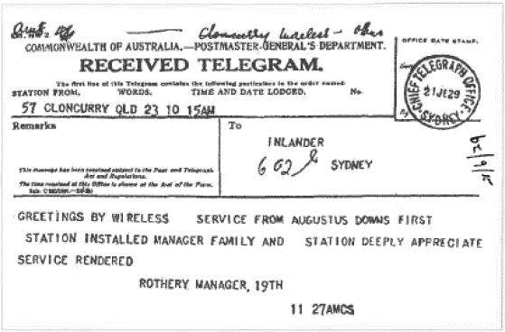

Copy of the first telegram sent over the flying doctor radio service.

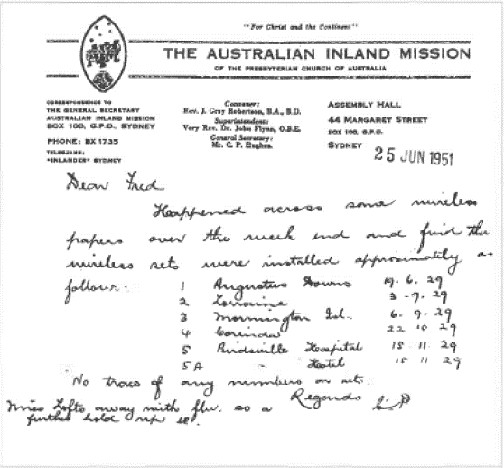

A copy of a letter sent to the late Fred McKay in 1951 advising him of when the first “pedal” radio sets were installed.

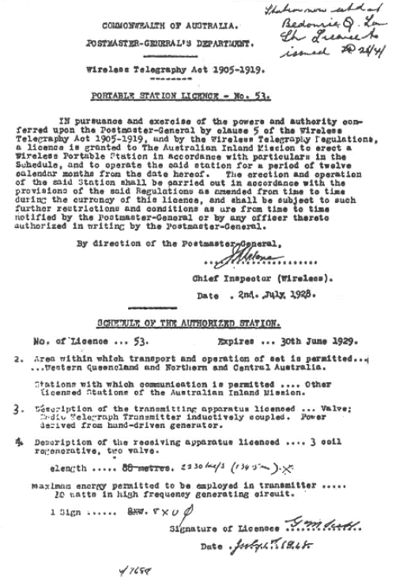

Copy of radio licence (No 53) showing the first frequency to be used by the flying doctor service radio network.

The restricted operating times meant that batteries in the transceivers would last a considerable time. They would be replaced when the volt meters on the set showed that the batteries were exhausted. I understand Padres carried a small supply of batteries with them, although initially Traeger and his technical team did visit the out-stations regularly to check the operation of sets. Calculations indicate that the No 6 cells in the transmitter would last for 100 to 200 hours of transmission, and the receiver batteries for similar periods. Six months operation was estimated to be the likely life of a set of batteries. but they did last longer in some cases Rev. Fred McKay said the batteries for his portable set lasted around two years, but others did not last as long due to greater use.
The initial six sets proved the viability of radio communications in the outback, the first being installed at Augustus Downs nation. in June 1929. However, problems on manifested themselves in the form of poor receiver performance and the need for two transmitter frequencies. Hence these radios were superseded by a superior model within a year. They were stripped for parts which could be used in the later sets. From photographs, and information gathered from various sources, a circuit has been drawn and general specifications calculated. Whilst it may not be identical with Traeger’s design, it is. nevertheless, very dose to the original. (A copy of the style of transmitter used has been constructed and rested to assess the likely performance of the transmitter. It is described in Appendix 2 and information on the valves used is included in Appendix 4.)

WHY CLONCURRY?
The question of why Stuart (Alice Springs) was not selected as the first base for an aerial medical service has no doubt been asked by many readers. A large majority of the tests were conducted around the centre of Australia, with Stuart and Hermannsburg featuring often. When we speak of ‘the outback” today it usually conjures up visions of Alia Springs, as it is the nearest major city to the geographic centre of Australia. We must remember that two thirds of Australia is still sparsely populated, not just the very centre of Australia.
However, there were many good reasons why Cloncurry was selected to be the first flying doctor base, and of course VJ1 the radio base. The need for flying doctors and radio communications was needed throughout all of outback Australia. but Cloncurry had all the ingredients to make the experiment of trialing a flying doctor service more likely to succeed.
In the mid-1920s Cloncurry had a well-equipped aerodrome complete with servicing facilities and a long sloping runway which helped heavily laden aircraft to become airborne. Cloncurry is in the sub-tropical area of Australia and as such has the “wet”, which made roads away from Cloncurry itself, well-nigh impassible for several months of the year. This made the use of aircraft very practical. Importantly it had an established air service conducted by Queensland and Northern Territory Aerial Service (QANTAS) with the first passenger being carried in 1922. Yes, that’s the Qantas we know today.
Cloncurry had a hospital (1879), which boasted of having 40 beds in 1927. a doctor and nursing staff. It had a telephone and telegraph service, a mail centre (post office), a school (1884), a newspaper (1889). and a railway service (1907) back to the east coast. Roads existed, but the quality of them was not likely to have been much better than tracks.
All of these services meant that the remote stations and communities could be effectively accessed, hence the trial of a flying doctor service had the best possible chance of success. This was important not only for the people who were to be assisted by such a service, but to prove to the detractors of the idea that John Flynn’s vision was quite practical.
Cloncurry today is a country town of around 2.400 people which services mining and cattle grazing activities as it has for over a century. it is a fitting home for “John Flynn Place” where memorabilia of the early, days of the Flying Doctor Service arc displayed. A visit is well worthwhile, as John Flynn Place was significantly upgraded in 2000.
The RFDS base at Cloncurry closed its doors on the weekend of 20/21 June 1964, after 35 years as a radio base, callsign, VJ1. The new Mt Isa base took over from that date.
Stuart at that time, had a much smaller population, no air service, no railway (although it did arrive in 1929) and a poor road system. It had a small hospital (Adelaide House) but no doctor, and it had a telegraph service via the Overland Telegraph. It would not have been practical to have the experimental flying doctor service based in Stuart as there were too few facilities to ensure the success of the venture. Stuart really was located “back of beyond”. It was not until 1939 that Alice Springs finally got a flying doctor base Stuart was renamed Alice Springs in 1933.

CHAPTER SEVEN

THE IMPROVED PEDAL RADIOS 1930 - 1934/5

During the first part of 1929 the first six sets were built and the base station at Cloncurry was built and installed. The new “baby” sets were then installed in locations from Birdsville near the South Australian border to Mornington Island in the Gulf of Carpentaria, over a period of five months. The first station was installed at Augustus Downs in June 1929.
Traeger would have been rejoicing at the success of the sets, and no doubt would have “put his feet up” for a bit of a rest. After all the frantic work to get the sets installed, tuned, tested and the new radio operators trained, he deserved to have a rest. The installation of each station took between 10 days and two weeks to achieve. This involved the physical installation, tuning of the aerial/counterpoise system, showing the operator how to operate the set, how to do minor maintenance and last but not least, how to send (and receive) morse code. Later on, this training time would be significantly reduced with the introduction of the revolutionary morse typewriter. The aim of providing a voice for the “dumb inland” had at last been achieved, after many years of hard work.
However, all was not well, and like virtually all new things. teething troubles soon became very obvious. Alarm bells were ringing. Traeger started to get reports that the sets were not doing all that it was hoped of them.
The heat and humidity in North-Western Queensland is severe in comparison to Adelaide and the cases of the sets buckled. causing troubles with the controls and various contacts.
If this was not serious enough, termites found the wooden cases delightful to eat, and eat them they did.
The use of one transmitting frequency only, meant that communications was not always possible due to the vagaries of the ionosphere (see Appendix 5), the high static levels and the time of day or night.
The transmitting crystals of that time also required maintenance as they were not sealed as they are today. Dust and other grime accumulated on them and ultimately caused them to cease working. They could be put back into operation by being cleaned carefully with methylated spirits and a soft cloth. Graham Pieta observed that some of the crystals used would occasionally operate on a frequency close to the correct one, which could cause messages to be missed due to the transmitter being on an incorrect frequency.
The high amount of radio frequency feedback used sometimes caused crystals to crack and hence render them useless.
There was also the possibility of the transmitter not being tuned correctly by the operator, particularly if a problem occurred with the aerial or earth (counterpoise) system. This situation could severely overload the valve, with valve failure occurring after a short period.
Experimenters and amateur/ham radio operators of that time overloaded the receiving type valves used in their transmitters, as proper transmitting valves were quite expensive. The transmitting output valve used in the Cloncurry base Station cost £10. Traeger’s pay at the time was £6 ($12) per week.
The type A141 valves had a voltage gain of around 4.5. These valves were rated to operate effectively with quite low plate potential of between 2 and 20-volts. Even when coupled with the inter-stage audio transformer with a step-up ratio of 1:3.5, a total gain of about 15 could be obtained after the regenerative detector. It was found in practice that the receiver performance was inadequate for reliable communications when used to receive the voice (AM) signals from Cloncurry. the sets had been designed to be useful out to around 300 miles but were being expected to exceed this range from some sites. Calibrated signal generators capable of providing known levels of signal to test receiver sensitivity were unavailable. Hence, Traeger had no ready means of being 100% sure that the receivers had adequate performance. As it turned out, they didn’t.
The successful operation of such a simple low gain two valve receiver depended very much on the critical setting of the regeneration control. The control needed to be set just below the point at which the receiver “howled” or went into oscillation if Cloncurry was to be heard at all. This was a very touchy adjustment and the people in the outback who had no experience of radio would have found it a difficult and terrifying experience. Maladjustment of this control would have meant that at times, the out-stations did not hear the base station operator at Cloncurry.
An additional problem occurs when a regenerative detector is connected directly to an aerial system, as it is in most simple regenerative tuned radio frequency (TRF) receivers. It is found that the regeneration control setting varies significantly as the set is tuned across the band selected. In the case of this first pedal radio set from around 1.5 to 3 MHz or 2 to 4 MHz
It is particularly touchy if the aerial system is resonant on and near the frequency(s) in use, which it would be at these out-nations.
Not a good receiver to put in the hands of non-technical people it would seem! Traeger had no trouble with the receiver. but he could see that the operators in the outback did have problems.
In 1929 the base operator was Harry Kinzbrunner. From 1930 until 1939 Maude Anderson. and later on, Vernon Kerr. were the dedicated and popular base station operators.
In a letter dated 30 November 1929 to a Mr. Sneddon of the Australian Inland Mission (AIM), Traeger reported that an additional frequency in the 30-metre band (nominally 10 megahertz) was needed, a three-valve receiver was needed because the original receiver had insufficient performance, and a better cabinet (metal) was needed. The inference was that a duplicate transmitter was needed, and in fact, Traeger had tried using additional transmitters in some locations - I suspect without official approval by the reading of his letter. He suggested that the existing sets could be rebuilt at a cost of £25 or completely new ones could be built for £55. The eventual cost to build a new set was £35 per radio.
Some texts indicated that Traeger was going to modify the original pedal radios to incorporate an additional transmitter and to expand the receiver to three valves. It would seem that this modification process amounted to dismantling the original transceivers and using any components that were suitable in the new design. Hardly the current meaning of modification.
He also alerted the AIM of the need for a new short-wave transmitter for Cloncurry to work on the proposed 30 metre frequency.
The valves in the original “baby” transceivers were never used in the set that succeeded them. Why the A141 valves and the circuitry was not copied and expanded in the receiver is a mystery. Perhaps as Kauper was leaving Adelaide, Traeger felt more comfortable to concentrate on tried and proven designs as used by amateurs/hams of the era. He just did not have the time to fiddle with a radically new design to get it functioning in a predictable and docile manner - which was so important for a set used by non-technical operators.
I have sometimes wondered why the B205 was not used in this model, as it appears, from the specifications to have been a very suitable valve. Some abbreviated specifications of the B205 are shown in Appendix 4. One possibility is that Traeger could not bear the thought of a transmitter breaking down as had happened. with the result being loss of a life. He may have felt the valve just wasn’t reliable enough, or perhaps it was difficult to obtain in sufficient quantities. He placed so much emphasis on reliability (belts and braced) that the replacement set had TWO transmitters. It was known that all the low filament current valves, whether made in the USA or Europe, were fragile and didn’t like being bumped around the Australian outback. However, the European valves were the worst offenders and the B205 was a European valve.
To back up this belief that Traeger could not bear the idea of a transmitter breakdown, I quote from ‘Traeger - The Pedal Radio Man” page 33.
‘the year did not end without its sad happenings. The baby set at Birdsville Hospital failed to function when Sister Maude Gilbert developed acute peritonitis. She had to be conveyed in a station truck to Boulia, and then by police car for the rest of the journey to Cloncurry, a total distance of 640 kilometres by slow and rough roads. Sister Gilbert died in the Cloncurry. Hospital two days later on November 2nd and her grave in the local cemetery bears solemn witness to the grim battle that was part of the life of people in the outback when there was no way of calling for medical help.”
One part of the system that was proving very reliable was the pedal generator, although this too was upgraded in its design during its life, though never because of any fundamental fault.
Being presented with all these problems it was obvious to Traeger that a complete redesign in all areas was needed if the sets in the field were to prove reliable and as easy to operate as he and the users had envisaged. If medical emergencies occurred, the pedal radios needed to work and be dependable. He was concerned that Flynn would be terribly disappointed. Fortunately, Flynn was overseas at that time. So Traeger was able to redeem himself before Flynn’s return.
Some might say that the first radios were an absolute disaster. Yes, it could have been a disaster, but from all the feedback obtained from the users and the base union operator. a very good idea of what was needed to replace the first model was obtained. Remember this was the FIRST RADIO TRANSCEIVER DESIGN IN THE WORLD INTENDED FOR NON-TECHNICAL PEOPLE TO OPERATE.
It proved many of the ideas incorporated in it to be very sound some that needed development, and some that didn’t warrant continuing with. It could be considered a very successful failure because of what was learnt from it.
At this critical time, Traeger was most fortunate to still have Harry Kauper on hand to bounce ideas off.
Traeger, with his assistants, worked day and night to get the new improved model designed. built and tested. This time even more strenuous tests were conducted - no one likes to have two failures in a row.
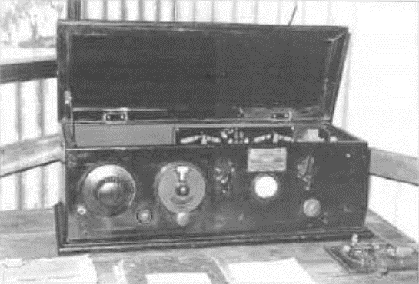
Augustus Downs set in a typical location.
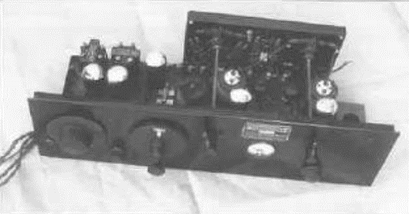
Front top view out of case. Augustus Downs set.
.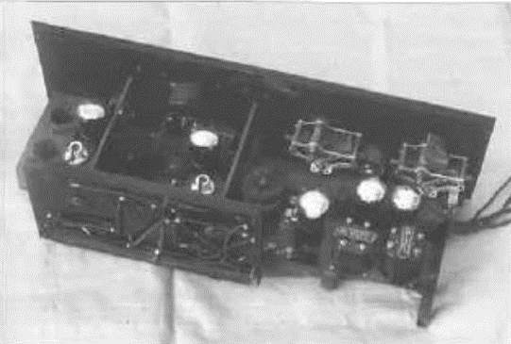
Rear view out of case. Augustus Downs set.
The re-design meant that a metal cabinet was needed to disappoint the termites, and to overcome the warping. The cabinet was still the coffin type where the lid was opened to turn the set on, to remove a short from the aerial, to facilitate adjustments to the set and to see it operating. When not operating the lid was closed as a dust preventative.
The receiver was re-designed to have three stages. It was not greatly different in design to the experimental sets used at Hermannsburg and Arltunga, not the receiver that it was to replace. The main differences in design compared to the experimental units were the use of a variable capacitor as a regeneration control, the addition of another audio stage, and the use of normal triode valves. To us today these may seem relatively minor changes, but back at the end of the 1920s these would have been “major” changes considering the technology of the time.
The receiver had a Reinartz regenerative detector. It used plug-in coils which were accessible from the top of the chassis with the lid open and two transformer (1:3.5 ratio) coupled audio stages. It used three Philips A109 valves with a gain of around eight in each valve. The gain for the two audio stages would have been nearly 800 times compared to the 15 times for the previous receiver. It was a more sensitive receiver which made reception of the base at Cloncurry easier, particularly when installed up to 1000 kilometres or more away. The setting of the regeneration control would have been easier in this receiver, as it would not have had to be so critically adjusted for good performance.
The gain of the set was such that a sensitive speaker could be used in lieu of the headphones in some situations. Plug in coils were supplied with the set, so that frequencies from 550 kilohertz (kHz) up to around 10 megahertz (MHz) could be tuned. Hence in addition to receiving the flying doctor base at Cloncurry, users could tune to the increasing number of broadcasting (entertainment) stations that operated throughout Australia and overseas. This was a bonus, as it meant the pedal radio was not only a communications transmitter/ receiver, but also an entertainment set. Domestic radios were just starting to be used in the more remote areas.
As had always been the problem, the supply of electrical power to the sets was extremely limited. The use of valves that drew very little current for their filaments and high-tension circuits was a must, and the A109 valves filled this requirement admirably for the receiver. With the value of the filament rheostat used in the receiver, the low tension (LT) voltage could be from either one No 6 cell or two No 6 cells in series. In the interests of most effective use of the battery power available, only one cell would have been used. This provided between 1 and 1.3 volts at a current drain of 0.18 amps via a series rheostat from the No 6 cell. Once again, series connection of the receiver valve filaments would have made use of the one battery bank for both the transmitter and receiver filaments practical, but this was not done.
The high tension (HT) supply came from one large 45 volt thy battery with a current drain of 5 to 6 milliamps. When used, a high sensitivity speaker would have provided acceptable volume for those days. Higher voltage than this appears unlikely, due to the lack of bias on the valves. The batteries would last between four months and two years before replacement became necessary, depending on usage.
Even in the very short period of time that the first sets were in operation, it became obvious separate day and night radio frequencies were needed. A higher frequency was also needed to reach the more distant outpost stations from Cloncurry. The effect of the radiation from the sun, which varies widely between day and night, generally creates conditions in the ionosphere that require a higher frequency to be used during the day and a lower frequency at night. This problem was solved by building two single valve morse code transmitters into the transceiver case. One was permanently set to the night frequency and the other to the day frequency. The switching between transmitters was accomplished by switching the aerial and the filament voltage to the particular transmitter. This also had the advantage that, should one transmitter develop a fault, the other would still be operational. This considerably reduced the likelihood of losing communication with the base station if one transmitter was faulty. It would still be possible to make contact either by day or by night, depending on which transmitter was in working order. Many believe that equipment redundancy is a modern-day phenomena. but as can be seen it was practiced even in 1930. The new set was much more reliable than the original “baby” set.
An A615 (or in some instances an A415) receiving valve was used as the combined crystal oscillator and output stage of each transmitter. The valve would have been considerably overloaded as was customary in small transmitters of the era. The valve is nominally designed for a maximum plate voltage of 160 volts at a current of 4 milliamps. The valve would have had around 180 volts applied to the plate and it is estimated that between 15 and 25 milliamps of plate current would have been drawn. Many, but not all of these very early valves, seemed able to stand quite high currents being drawn out of them. (Valves like the 201A were claimed to be able to generate up to around 7.5 watts of radio frequency energy, which is a massive overload.) This would have given a radio frequency output power of around 1.0 to 1.5 Watts, which is quite low power by today’s standards. However, with the use of morse code to communicate with Cloncurry. an efficient aerial/earth system and the electrically quieter radio bands of that era, combined with the competence of the base station operator, communications were effective, although often difficult.
Whilst the short-wave bands may have been quieter due to fewer radio transmitters being used, the noise from atmospherics (static) lightning flashes, is high in the north of the continent. Maurie Anderson who was the Cloncurry operator, often had difficulty in reading the incoming signals as mentioned above.
Once again filament power consumption was quite low at six volts (or four volts if the A415 used) and 0.08 amps current drain. It seems that Traeger may have used either valve type interchangeably as the circuit would accommodate either. The same type of valve must be used in both transmitters in any particular set. Transmitter filament current drain was not a pressing problem as the transmitter was not turned on for extended periods of time.
One puzzle with this second model is that both 1.3 volt and 6-volt (or 4 volt) filament valves were used, which made supplying the required filament voltages rather awkward compared to the later models, which used 2-volt valves almost universally. With five No 6 cells used in series, the 7.5 volts available was reduced to 6 volts via a rheostat. It was still possible to apply 6 volts to the filaments even when the No 6 cells were “flat” at 1 volt per cell. The filament rheostat resistance value confirms that a battery bank of this voltage could be used, and a photograph of a working set shows only four cells in use. It also means that the set could be used with four or five cells to power the transmitter valve filaments. The receiver filaments are either tapped off the first cell in the battery bank or could be used off an independent cell.
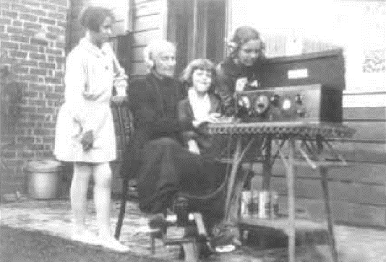
Grandma (with help from her grandchildren) using the pedal radio.
The practice of using multiple meters on transmitting equipment of the era was considered essential by the amateur radio operators, of which Traeger was one (callsign VIC5AX). However, he came to one conclusion that meters didn’t impress the operators. They were bewildered by them and hence they weren’t always used effectively, plus they were expensive. He could see with the experience of the first sets in the field, that by careful design. one meter could still achieve almost the same results as three meters, a saving of the cost of two meters.
Traeger urged the AIM to apply for an additional frequency. This was done and total of three frequencies were issued by the PMG. The exact frequencies used in these sets in 1930 is unclear. However, in 1931 a licence for Betoota (which worked through Cloncurry base) lists three frequencies 2020 kHz, 8630 kHz and 8830 kHz. As the transmitters had the capability of transmitting on only two frequencies. it seems likely that the only two used were 2020 kHz and 8630 kHz, with 8831 kHz remaining unused. It appears that because 8830 kHz was not used, it was then allocated to Wyndham in 1935. It is highly likely that the frequency 2230 kHz was not allotted to these new sets (1930). It was a time of much flux in regard to frequencies, as up until then frequencies had not been quoted. Only the wavelength. This reflects the inexact nature of frequency control at that time.
The problem of crystals becoming dirty and
requiring cleaning was recognised. and the crystals were easy enough to access and clean. The crystals were at times covered with an upturned wine glass to keep them clean. Later ones had a screw on metal cover. When a clean was required, the operator was instructed to carefully wipe the translucent crystal with methylated spirits and a clean rag. “Don’t drop
-- them though, they break very easily!”
At the end of a very hard few months, all of the earlier (1929) single frequency transceivers had been replaced by the much more reliable, better performing, two frequency transceivers.
The first pedal radios cost £33 ($66). and this second improved mode cost £35 ($70). The average weekly wage in 1925 was £4/15/0 and in 1935 £4/4/0. For two pounds more, Traeger and his helpers had a achieved a miracle. Four valve domestic receivers were selling for little less than this. This was even more of a miracle as the economic depression of the 1930s was starting to severely effect Australia. The set now had two transmitters winch gave greater reliability and a much more sensitive receiver with three valves. It became obvious that this set was a success when this model, with modifications, was produced until around 1934/5. A great deal was learnt from the first model, which made this succeeding one much more successful.
The sets” dimensions were as follows The initial units measured 24” (61cm) long by 9” (23cm) high by 9” (23cm) deep plus the depth of the controls. Lam units had a higher caw which were around 12.8” (32.5cm) high and appeared to house the batteries underneath the transceiver. The filament rheostats were removed from the front panel and were put inside the cabinet as it was realised they did not require frequent adjustment. Both models were painted black, and the controls were unlabeled. Traeger recommended that the operating instructions and panel layout diagrams be tacked to the wall behind the set.
The transmitter section consisted of two single frequency transmitters, each with one valve. One transmitter was on a medium frequency while the other was on a high frequency. The transmitters were morse code (CVV) only and had an output power of between 1 and 1.5 watts. To tune a transmitter for maximum output power it was only necessary to adjust one control inside the set for maximum brightness of a small torch globe. The globe was in series with the counterpoise and there was one adjustment for each transmitter. Modified sets had a tuning capacitor in series with each counterpoise and this was also adjusted for peak brightness of the tuning lamp. The sets were easily adjusted for maximum transmitting efficiency and is one of the reasons non-technical people had little trouble in operating them. Even though three frequencies had been allocated for their use, only the two most appropriate for any particular location would have been fitted.
The receivers used three triode valves one as a regenerative detector and two transformer coupled audio stages. Headphones were used and a sensitive loudspeaker could be used if stations were strong enough. Several plug-in tuning coils were used in the receivers to give a tuning range from the broadcast band well up into the short-wave bands.
The network controlled from Cloncurry had grown extensively and the distances had risen to 800 miles (1300 kilometres), which is excellent for a set with a nominal output power of I to 1.5 watts. Not only was the set good, but it coupled effectively to an efficient aerial and earth /counterpoise system. Full marks must be given to Traeger and his helpers, and to the obvious ability and dedication of Maurie Anderson, the base operator at Cloncurry. At this time there was still only one flying doctor service base. The next one to be established was at Port Hedland in October 1935. Flynn’s dream was taking a while to really get off the ground, but this was not surprising when we consider that, by now, the depression was hitting hard.
As stated in the previous chapter, Traeger placed great importance on the efficiency of the aerial/ counterpoise earth system. Now that there were two quite different frequencies in use, an aerial system that suited one frequency would be unsuitable for the other and poor efficiency would result in poor or no communications. To overcome this, two counterpoises were used - one for each frequency in use. The set had only one aerial terminal. There may have been two different length aerial wires (to suit the different frequencies) with both wires attached to the aerial terminal of the set.
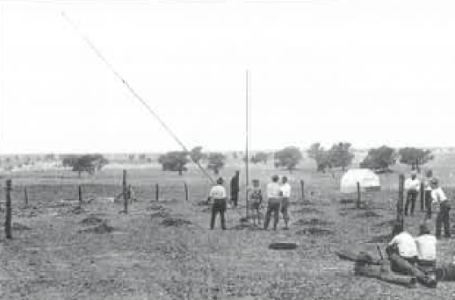
Installing and outpost antenna.

However, as the frequencies in use appear to be almost in third harmonic relationship it is likely that the one aerial wire of a length to suit the lower frequency was used and then on the higher frequency it worked on its third harmonic. If this was so, the end of the aerial remote from the set would have been pointing nominally towards the base station at Cloncurry, at an angle (45°) about halfway between pointing directly at the base and being broadside to the base. This would tend to give best performance on the higher frequency. Most people involved with achieving long range communications with low transmitting power realise the majority of the success relies on having a very efficient aerial (antenna) earth/ counterpoise system. Traeger definitely knew this, and his systems were tuned for maximum performance. (For more information on antenna/aerial systems see Appendix 3).
The counterpoise system consisted of two wires, one for each frequency and each was electronically adjusted in the set with a variable series capacitor for optimum performance of the whole aerial/counterpoise system. The receiver once again used the aerial/earth system, with the aerial shorted to earth when the set was turned off.
There is no doubt this set was a success, however, continual experimentation and upgrading occurred. Whilst voice (AM) transmitters were still not practical, other areas of the transmitter design were evolving. These improvements would make them more easier for the non-technical operator to use effectively.
A technical description and circuit of the set appear in Appendix 2.

CLONCURRY BASE
The coordinating support for these low powered pedal radios was the base station at Cloncurry, and a brief description of this station is in order. The quoted power of the first transmitter installed was 50 watts. Means of accurately measuring radio frequency (R.F) power were not readily available except in a few laboratories. Thermocouple RF amp meters were used by many operators and were reasonably accurate, but in themselves could not measure power - just current. Household light globes were often used as a so called “dummy load” in place of the aerial system. The globes were illuminated by the radio frequency energy and a judgement on the brightness of the globes formed the very primitive estimation of the output power.
Whilst no data exists on this station. from photographs and various texts, the transmitter is shown to have had three radio frequency stages. The first stage was a crystal oscillator. The second was the driver stage, which amplified the oscillator output to a level sufficient to drive the output stage (a 203A or more likely a 211 valve) for optimum radio frequency output. Voice modulation of the transmitter appears to have been achieved by grid modulating the driver stage via a separate valve modulator stage and carbon microphone. The radio frequency output valve would have been operated as a linear class B stage, which was a common configuration for AM radio transmitters of the era. This transmitter was a single frequency (channel) unit operating in the two-megahertz range.

When the radio network was granted the use of eight megahertz frequencies. Traeger recommended that another transmitter be built or bought for the new frequencies.
The high voltage for the transmitter (1000 volts, DC, for the output stage) was supplied from a motor generator (genernotor) connected to the 32-volt lighting plant installed at the Presbyterian church. How the other voltages were provided for the rest of the transmitter is not clear, however, it seems likely that the filaments were supplied from batteries charged off the 32-volt lighting plant while the other high voltages required for the transmitter were supplied from another small genemotor. Bias voltages would have been provided by dry batteries. 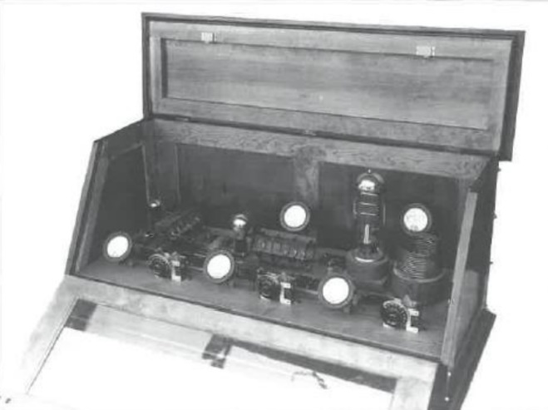
First Cloncurry base station transmitter. This was a 3 valve unit rated at 50 watts. It used grid modulation to provide voice transmission.

As time progressed. additional frequencies were licensed for use by the Cloncurry base and our-stations, as shown in a licence issued to an out-station at Betoota in 1931. The base transmitter was not suitable for rapid frequency changes. as the pedal radio sets were. Hence, additional transmitters would have been built and installed so that rapid change of frequency could be achieved.
Whilst the original transmitter was supposed to be 200 watts, only a 50-watt AM unit was available when the service was first established. An order had been placed with Traeger to build a 200-wart transmitter. Later on, he recommended that a 500-watt transmitter be built for use at Cloncurry. Certainly, the out-stations would have little trouble hearing the base station, even if the base had trouble hearing them.
It was rarely made clear in that era whether the transmitter power quoted was “input” or “output power”. Due to the lack of accurate methods of measuring the output power, it was usual to measure the total DC power (volts x amps=watts) fed cc the plate circuit of the transmitter output valve. The input power could be up to three times as great as the output power It always sounded more impressive to vote the lager figure, the input power! If the proposed 500-watt transmitter had the power measured going to the transmitting valve, the effective output power could have been as low as 150 watts. We’ll never really know. Even so these were substantial transmitters which made reception at the homestead sets quite comfortable most of the time.
The first receiver may have been a four-valve tuned radio Frequency (TRF) set, using mostly triode valves. One of the new tetrode valves may have been used as a tuned or maybe un-tuned radio frequency amplifier, feeding a regenerative detector, followed by two stages of audio, with the last valve feeding a speaker or headphones as required. In between the audio stags a (CW) morse code filter may have been fined to enhance the weak signals from the out-stations. This could be switched out when voice signals were being received. Outside of scheduled operating times (sked times) the operator would do other necessary work around the station. He would leave the receiver(s) running with the loudspeaker connected, so he could hear any emergency calls over the radio.
As more frequencies were added to the station, a receiver would have been devoted to each frequency that the out-stations were licensed to use. A spare receiver would also be available in case one of the other sets developed a fault. Ultimately, the total official complement of receivers at the station was probably four.
Maurie Anderson was a keen operator and listener to all sorts of radio stations throughout Australia and overseas. He had several sensitive receivers at his disposal and aerials that were better than average which they needed to be so that he could her the weak out-station transmitters. As tine progressed during the early 1930s. Anderson would have built better receivers using the tetrode and pentode valves and would have experimented with superheterodyne sets too. These developments meant that more sensitive receivers could be built using a radio frequency (RF) stage.
As a spin off from Anderson’s short wave listening interest, he often paraphrased the news of the world that he heard on short wave and broadcast it to the out-station operators. Hence, they often got the news before their city cousins.
Maurie Anderson had a very demanding job as the radio operator at Cloncurry for several years from 1930 onwards. As the distance, and the number of pedal radio stations increased, there was more interference between stations in the network and the signals over longer distances became much weaker. The tropics are well known for electrical norms so be had to contend with weaker signal and severe interference from powerful electrical storms, which made operating very difficult. There was an increasing amount of electrical equipment being used in Cloncurry which caused interference to reception of the out-stations. Many of the domestic entertainment receivers in Cloncurry could not discriminate between distant broadcast stations and the Cloncurry base station due to the inadequacies of receiver design at the time.
Anderson was well liked and appreciated for his absolute dedication and ability to achieve what was necessary to make the communications service work successfully. Not only did he look after the base station but was involved in the installation and service of the out-stations.
Anderson was a key figure in the technical development of the communications network that developed. Perhaps it is not realised how much help the base station operators were in formulating the technical dilution that the radio communications network took over the years. In 1934 Maurie Anderson was joined by another dedicated operator - Vernon Kerr. Traeger received feedback from Anderson and Kerr on improvements to transmitting and receiving equipment, monitoring facilities for emergency calls, improved aerial and earth systems, and means of reducing locally produced electrical interference. Much is owed to Anderson, and Kerr, for the jobs that they did, and did so well, in those early days.

CHAPTER EIGHT

MORSE CODE REACHES ITS ZENITH 1931 - 1935

THE PROBLEMS WITH MORSE CODE
By May 1933 there were 30 our-stations using the second model of the pedal radio. Morse code was still the only method of transmission from the out-stations.
Alf Traeger obtained an Associate Diploma in Electrical and Mechanical Engineering in 1916. There was no doubt that he had exceptional abilities in the fields where mechanical and electrical requirements were combined. His development of the pedal generator was the first well known example of his ingenuity in the combining of the disciplines of these two usually separate engineering fields. His high voltage generators of the mid 1920s were quality items, as efficient and effective as any available. These achievements gave many people the hint that even greater things could be expected from Traeger as years went by. They were not to be disappointed.
The quality of the morse signals sent by the out-stations varied from superb (ex-professional radio telegraphists) to absolutely atrocious. That Harry Kinzbrunner (the first base operator) and Maurie Anderson (the second base operator) at Cloncurry were able to extract messages from the extremely poor quality morse code sent, is a tribute to their ability and patience. Kinzbrunner had only a few sets to contact, and only stayed a year at Cloncurry as the base operator. On the other hand, Anderson, an exceptional operator, had to operate with an increasing number of stations over much greater distances. He did this until such time as Traeger was able to produce sets capable of effectively transmitting voice (AM). Suitable valves for an AM transmitter modulator (valve type 19) were in use in Australian domestic receivers in 1934. Traeger experimented with the types 19 and 33 valves for transmitter use. The first voice transceivers suitable for field use went into service in late 1934 or early 1935, but it was several years before the morse only (CW) sets were replaced.
It would only be a guess, but the use of morse sent either by hand or typewriter probably did not cease being used by some out-stations until after World War II, when improved sets with higher transmitter output power became available. Many owners of pure morse code transceivers were reluctant to spend money in replacing their sets, as they may have rarely used them and could not see any advantage in the new (AM) voice sets. Some of these operators were quite prepared to selfishly continue to inflict their terrible morse code on an increasingly busy base station. Those who persisted, in using older sets were progressively relegated to last place on the list of stations called. This was because of the repeats that were necessary for the base station to receive any message correctly.
The criticism of the ability of the out-station radio operators to send morse code signals of a reasonable standard must be tempered with a realisation of the difficulties under which these operators did send their messages in the morse only era. Radio operators received a crash course on how to send morse code over a period of a few days, along with all the information on how to operate the station. It is not clear whether they were also taught how to receive morse and be able to read what was being sent by another station, although it is clear that some operators did learn morse sending and receiving very well indeed.
There is a case related where a romance was conducted over the pedal radio using morse code, as it was so much more private than by voice. It must also be considered that the hands of the men in particular, would have been used to doing heavy jobs not requiring delicate movements - which the morse key requires for the sending of quality signals. The lady of the house would have been more dexterous, and so. often got the job of using the radio. Additionally, women tend to be better at things like language (morse is often likened to a language) and activities requiring dexterity. Some may not agree with this, but research shows this to be true. Many of the early settlers were functionally illiterate, so the operator had to be selected from those who could read and write.
However, there was another way in which Traeger could have made it so much easier for many of the station operators to improve the quality of their morn code. That was to install what is called ‘sidetone” in the transmitter. This would have involved an extra valve (such as a 30 or an A109 as already used in the pedal radios) in the transmitter, wired to produce an audio tone in the receiver headphones every time that the morse key was pressed down to send a morse character. This audio tone produced at the same time as the transmitter sends a signal, is called ‘sidetone”, which is a standard fitting on any transceiver used today that transmits morse. Operators would have then been able to more accurately determine the length of the “dots- and “dashes” that they were sending.
The extra current would not have been a problem as the number of repeats necessary for Harry or Maurie to receive the message correctly would have been reduced. At that stage in the development of radio communications, monitoring of the quality of the morse code transmissions was rarely done, unfortunately. This was certainly an area of design in which Traeger and (Kauper) well and truly made a bad error of judgment. I personally find it much harder to send good quality morse code without a monitoring system, compared to when I am able to use sidetone. It is easy with the benefit of hindsight to criticise how a number of things were done, or not done, in ratio communications in those developing days. Could we have done better? I wonder!

THE INGENIOUS MORSE TYPEWRITER
The poor morse standard caused Traeger to look at a way of overcoming the multiple repeats as a result of the poor operating standards. He thought about this for quite some time and finally came up with the morse type-writer. This invention was a stroke of pure genius - the communications computer of the 1930’s.
The morse typewriter was, and still is, a marvellous invention. Today, computers are used to achieve what Traeger achieved back in 1931. By early 1932 most typewriters were being installed, and once installed, overcame all bad sending of individual letters of the alphabet and a few other morse code specific signals.
It didn’t have all the features of a normal mechanical typewriter as they were irrelevant.
It did not overcome bad spacing or bad spelling, although it did help as the message could be written out beforehand if need be. It was a quantum leap in enabling the unskilled to send acceptable morse code.
The morse typewriter, like the normal typewriter, is a complex mechanical piece of equipment. The keyboard is almost identical to a conventional keyboard with four rows of keys installed in the normal “QWERTY” typewriter fashion. As mentioned earlier, Traeger omitted a number of keys and facilities that were superfluous to sending morse code. A couple that come to mind, arc upper and lower case. Morse is normally considered to be sent in upper case and there is no character for tick, change of case or carriage return. The message is sent continuously with no carriage return just as typing is done on a word processor.
Morse code consist of short and long signals in particular sequences to represent individual numbers and letters of the alphabet. and other signals that are peculiar to morse code transmission. (A copy of the morse code can be found in Appendix 4.) The extra morse code keys were as follows:-
- “10” = ----- (0) to the right of “10” is -.-.-(start of transmission, commencing signal)
- Far right second row is .-.-. (end of message) and this is followed by K -.- which has its usual meaning as well as “go ahead and transmit”.
- Far right third row is -…- (=),
- Far right bottom row has nothing connected and
- Alongside this key is ……. (error, meaning. I’ve made a mistake, scrub out the last thing I sent, and I’ll send it again.)
“Error” is the only official meaning of this symbol and is used with other abbreviations to indicate what sending will recommence in the text being sent.
In the Flying Doctor Service radio network, (more correctly the Aerial Medical Service in the early 1930s) the base radio operators often had to be mind readers, and their ability to work with very unskilled operators, with extremely weak signals, is a tribute to their dedication and ability.
Regrettably, it is not practical to present a mechanical drawing of the typewriter. However, a short description of how the morse typewriter operates is now given which will give readers some idea of how this ingenious device functioned. Photographs do give an idea of the construction and will help to provide some understanding of the operation.
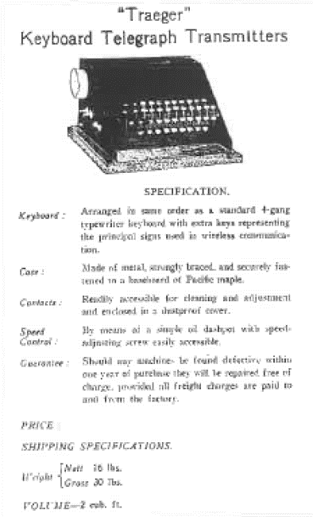
Advertising for morse typewriter
At rest the morse typewriter does not do anything. The electrical contacts that key the transmitter “on” and “off are in the open position. The keying rod (bar) along the back of the device is held away from the keying bars by a spring, which keeps the keying rod (bar) from dosing the electrical contacts. A semi-circular notch on the back of each keying bar allows a bar to rest in all of the aligned keys across the typewriter. This bar. in conjunction with the keying rod, prevent the key contacts from making contact. Each individual keying bar is extended to the keyboard to form an individual typewriter type (finger) key.
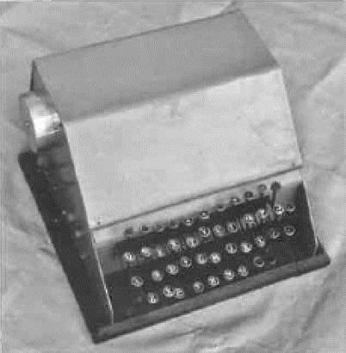
Front View of a complete morse typewriter.

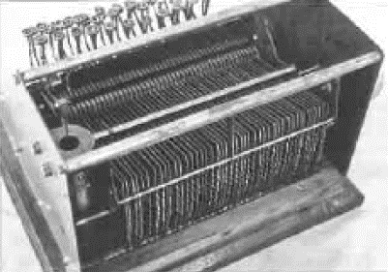
Rear top view with cover off typewriter. Dashpot on left.

When a key is dead, the keying rod is held away from the keying bar by a friction clutch arrangement so that no keying of the transmitter by the indentations of the keying bar will occur whilst the typewriter key is being depressed. The bar in the semi-circular notch is pushed out of the notch and causes the keying contacts to be 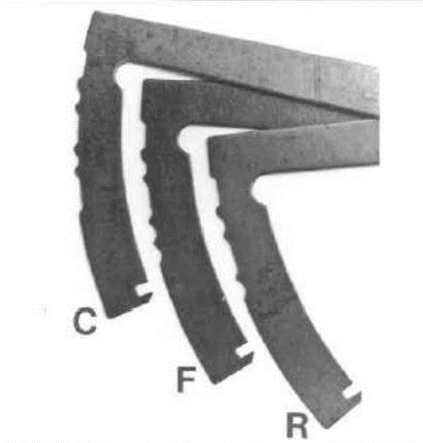
Morse cams used in morse typewriter (Mervyn Euson)

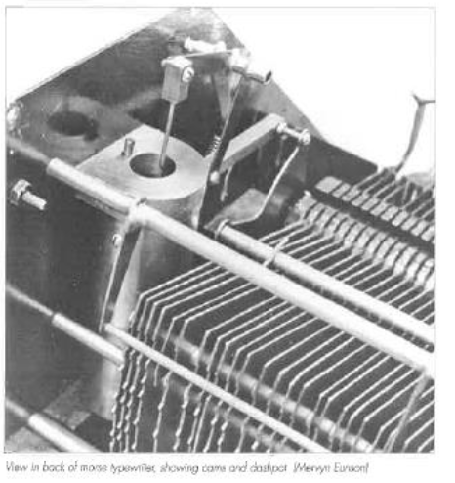
View of back of morse typewriter showing cams and dashpot. (Mervyn Euson)

made ready to operate. Once the key is fully depressed, the friction clutch is released and the keying rod rests on the keying bar. A dash-pot controls the speed that the (finger) key rises and the keying bar indentations go down past the keying rod. When the rod rides down into one of the hollows, the keying contacts are closed, causing the transmitter to put out a signal. The indentations on each individual bar form a particular morse character. When the bar reaches the end of its travel. the transmitter no longer transmits, as the bar on the inside of the keying bar causes the contacts to remain separated.
The speed of the transmission is regulated by adjusting the oil dash pot and is usually set so characters are sent at a rate of around 10 words per minute. There is a mechanical interlock that ensures that only one key at a time can be deposed, preventing garbled characters being produced. This is a rather simplistic description of a quite complex piece of mechanical wizardry. It is difficult to understand its construction and operation without being able to examine it closely and observing the action of the typewriter. The quality of morse that the machine sends is excellent.
Few people will get the opportunity to see one of the small numbers of these machines still in existence, so it may be hard to realise just what a magnificent electromechanical device it really is. It is difficult to comprehend how Traeger was able to invent, then design and build such a precision instrument. He must be admired for it. It is very complex, and as such, is not an easy piece of equipment to disassemble, and very hard to reassemble.
The morse typewriter largely overcame the problem of poor sending skills by out station operators. It also meant that morse code did not have to be learnt to be able to send a message to the base station as a reply was always by voice. If out-stations wanted to contact one another. they still needed to know morse and be able to read the often poorly sent hand morse. The morse typewriters were produced up until the end of 1937. A total of 50 (another text suggests 70) of these marvelous mechanical communications computers were made.
Morse code is still used today, mainly by amateur/ ham operators, some of whom can send and receive high speed, quality morse. In commercial service, it is rarely used except in some third world countries. When signals are poor and where operators are proficient, it is still a very effective means of communications, using simple radio equipment.

THE LAST OF THE MORSE (CW) TRANSCEIVERS - 1932 to 1935
The second model of the homestead radio transceivers had proved to be good and reliable. But still, minor modifications were done from time to time to improve their level of performance. When teamed up with the ingenious morse typewriter, satisfactory performance was assured under most conditions.
However, the modifications showed Traeger that they should be included as standard in the transceivers at the time of manufacture. The modifications were also incorporated as equipment upgrades. This meant that any set could be sent to any station homestead and be expected to work satisfactorily with just the normal tune up.
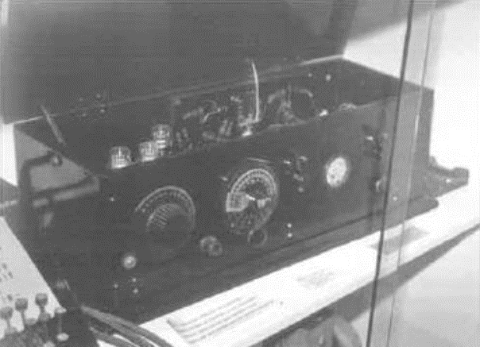
Traeger model 34 set at the RFDS museum Alice Springs.
The case that had been used was quite suitable and continued to be used for the last models of the pure CW transceivers. Traeger decided that it was desirable to install the batteries inside the set as had been done with the very first model of the pedal radio. This had the advantage that leads didn’t break or become disconnected. In the past if there was a break, or the leads had become disconnected, they may have been put back on the wrong battery, which could destroy the valves. The later upgraded model can be identified by the higher cabinet compared to the earlier units of this model.
The dual frequency, dual transmitter philosophy continued for a short while, and surfaced in individual transceivers from time to time. It appears that Traeger still made sets almost on a custom basis. One interesting transceiver was made for Arrabury station, on the South Australian and Queensland borders. It is called type 34 and uses two 33 valves in the transmitters and three 30 valves in the receiver, in a TRF circuit. (A copy of the circuit is shown in Appendix 2.) The 33 valves became available In Australia in quite limited quantities in 1932, and equipment using them was on the market in 1933, hence it is probable that this model pedal radio was operational in 1933. or early 1934. In later times. the type numbers of Traeger radios appear to relate to the year of initial manufacture or design for that model. This may be so even with the model under discussion. (Various other experts believe that this is not strictly true.) How many of type 34 were made is unknown, but one restored example is located in the REDS Alice Springs museum.
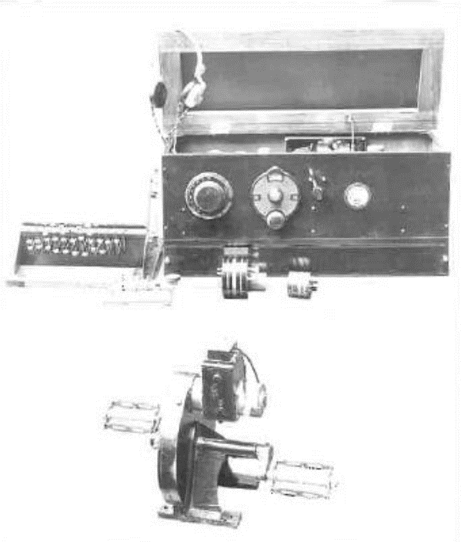
Multi frequency “pedal radio” transceiver.
The dual transmitter, whilst being very much a bits and braces approach, had not proven to be necessary as the reliability of the transmitter valves had been quite satisfactory. Consequentially, the dual transmitter was dispensed with. However, this gave rise to the question of how the transmitter was going to be used on two (or more) frequencies without elaborate switching.

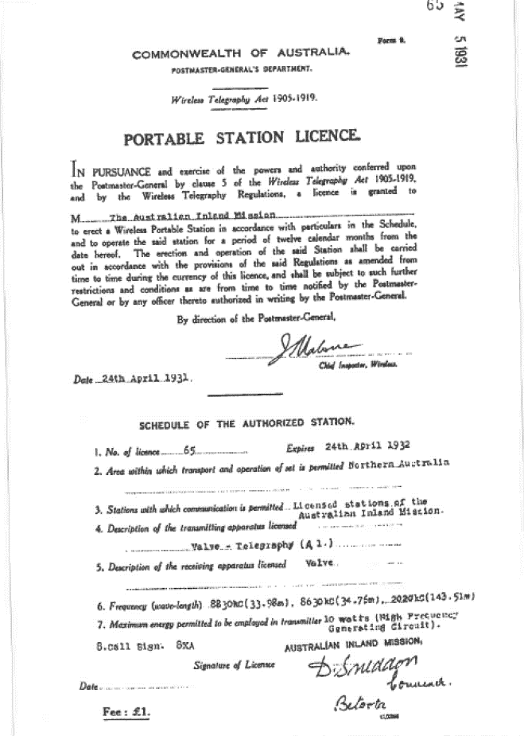
Betoota 1931 Licence (No56) Note three frequencies listed 833kc, 8630kc, 2020kc.

Traeger reverted to plug in coils for the transmitter just as the receivers had. He went one step further however, and included almost all the components necessary in the plug-in assembly for the transmitter to operate on a particular frequency by just plugging it in. To change the transmitter frequency, it was only necessary to change a plug-in coil and crystal assembly. Initially he had two plug-In coil/crystal assemblies for each set. Should the need for a third or fourth frequency become obvious, it was quite easy to make up another plug-in coil/crystal assembly that could be plugged in. It meant that the assembles could be pre-set so that one could be sent out from the workshop and simply “plugged in” by the operator.
The operator would be able to get the transmitter fully operational by adjusting (tuning) the counterpoise preset control for maximum brightness of the tuning lamp. There was no need for a radio technician to do the setting up on site. In some instances, Traeger may have needed to suggest that the length of the counterpoise or aerial would require some variation in length.
This was a major step forward for the day, as complete pre-tuned assemblies for radio transceivers did not come into regular use, by the industry in general, until the transistorised era. As mentioned earlier, Traeger and Kauper were on the leading edge of some aspects of communications technology. It is likely that this innovation was purely Traeger’s, as Kauper moved to Melbourne is 1930.
Knowledge of the way that radio waves behaved was not well understood at this stage. The effect of the 11-year sunspot cycle day and night, day to day and monthly variations in propagation were slowly becoming recognised. The distances that communication was being attempted. showed that stations located nearer to the base needed to use a lower frequency than those that were located at extreme range from the Cloncurry base station. Alf Traeger and other amateur radio operators would have been observing these variations, as would have Maurie Anderson. It may well have been for this reason that Traeger made provision for extra transmitting channels. He could see that over a period of several years, frequencies that were perfect when installed simply weren’t suitable a few years later. It was becoming more complex as time went by.
Certainly, at this time, Traeger would have been looking seriously at the need for a total of three frequencies to use on the pedal radio network. The closer in stations would generally use the lowest and middle frequency, whilst the distant stations would use the middle and highest frequencies.
The PMG approved the use of a third frequency as shown in a 1931 licence. It lists 2020 kHz, 8630 kHz, and 8830 kHz. During the period 1931 to 1935 the frequency 8830 kHz was withdrawn and replaced with 5110 kHz This meant that Cloncurry had a more effective selection of frequencies and could more effectively communicate with the out-stations at any time of the day or night.
The receiver remained almost the same as used in the previous successful mode. Why change something if it is doing all that is required of it! The receiving tuning range would have covered from the broadcast band to around 10 MHz, using three or four plug-in coils. By tuning to 9580 kHz, VLR. Lyndhurst – Victoria would have been received, even if no broadcast band stations could be tuned. At night broadcast band (553 to 1500 Kc/kHz) stations would have been heard. The tuning of stations in the short-wave bands was not easy without “band-spread” In these later sets band-spread was fitted, which made tuning on the high frequencies much easier. Band-spreading is either a mechanical or electronic method of tuning that makes tuning to a particular station much easier, and more accurate.
That the padres looked after the spiritual needs of the outback people is well known, but the fact that they also looked after the radio equipment needs, is perhaps not so well known. They were the original ‘valve jockeys”. Valves were the least reliable components in the sets. The transmitter valve in particular was severely overloaded in doing its particular task and could not be expected to have a long life. Padres also installed many of the homestead sets on the stations, took out fresh plug-in transmitter modules and tuned the sets. The services of the Australian Inland Mission through their patrol padres must certainly helped may people in the outback to overcome the dread of both isolation and sickness.
Radio communications for the ordinary man in the outback had progressed steadily since the time the first sets were installed. But at this stage only the Cloncurry “Australian Inland Mission” (AIM) station was operational, and able to give remote people the chance of medical assistance in the Northern and Central areas of Australia.
Another point that had to be very seriously considered was the cost of the set, as the Depression was not over when this upgraded set was produced. Traeger did a remarkable job of providing all effective and reliable radio transceiver, at the low price charged for then The cost of the sets had crept up to £75 ($150). The complete installation consisted of the set - with a set of plug-in coils for the transmitter and receiver, headphones and a morse key, plus the pedal generator and the morse typewriter. The typewriter if required separately was sold at £15, which seems ridiculously cheap for such a complex piece of equipment. It is not clear if the aerial, earth/ counterpoise system was included in the price. The various records do not make it clear whether the CW transceiver installation or the later AM/CW transceiver installation both cost £75. Whatever the cost, the sets were extremely good value, and no other organisations believed it was commercially viable for them to provide radio transceivers for use by the AIM and the flying doctor service.
Over a period of half a decade, the reliability of the transmitters had improved markedly. With up to three operational frequencies to use, communications to the base nation were practical at some time during any one day. The receivers had minor upgrades and were doing their job well, and the morse typewriters were making life so much easier for all the operators.
A refinement in the method of adjusting the aerial earth/counterpoise systems for maximum efficiency was installed in the transmitters. This overcame the lengthy, tedious, and not always precise, method of tuning the system by cutting small lengths of wire off the counterpoise until the best performance was achieved. What if too much wire was cut off!! It was now able to be done electronically within the set which only took a minute or two to accomplish.
The improvements in the performance. ease of installation and use, reliability and adaptability to operate on changing frequencies over the period from 1929 to 1935 was immense for this fledgling communications service. Good as this all was, it was soon to change, for (AM) voice transmissions were just around the corner. Just as the advent of the first sets in 1929 revolutionised communications in the outback, the new AM sets created another revolution whereby people at the various outstations (homesteads), could hear the voice of their next-door neighbour by radio for the first time.

CHAPTER NINE

THE FIRST PORTABLE TRANSCEIVER - 1933

The Reverend Kingsley ‘skipper” Partridge and the Reverend John Flynn became very close friends over their 40-year association. Following Flynn’s death in 1951, It was ‘skipper” who gave the address at his (Flynn’s) Memorial Service in Alice Springs. He knew the outback and its needs.
He often guided Traeger on his trips to install pedal radios at stations, mining camps or anywhere else they were needed. The communications network had become increasingly highly valued and expanded. Partridge could see the value that a portable version of the homestead (out-station) pedal radio could be to padres, such as himself. Also, it would be valuable to asset the people that they visited from time to time, who were still without communications and to whet their interest to have a pedal radio. He put the question to Traeger, which in essence was, “Could you make a portable pedal radio that could be used whilst out on patrol?” this simple question really exercised Traeger’s mind to find a solution. The idea was tremendous, but how could the set be made robust enough, compact enough, light enough, easily set up, and be able to communicate effectively with the Cloncurry base station?
All of the features that had been incorporated into the homestead sets needed to be built into any portable set, plus it had to be just so much better and smaller. What Traeger was being called on to design, and make, was the forerunner of the high frequency (HF) mobiles that are commonly seen in outback Australia today. The greatest problem experienced in getting a portable or mobile HF transceiver to operate effectively, is in getting an aerial system to efficiently radiate the limited power produced by the set.
Traeger’s experience over the last four years had proven various ideas to work and work well, so it was just a matter of refining them. This sounds simple, but in reality, this was as big a challenge, as was the development of the original sets.
- The pedal generator could be redesigned to make it fit into a smaller space.
- The transmitter radio frequency plug-in modules. were about to be tried and possibly ‘skipper” Partridge was the guinea pig to try this innovation.
- New valve types coming onto the market required less voltage on the transmitter filaments.
- The aerial and earth/counterpoise system had proven to be very effective. There was a problem though, in that it was impractical to any 70 foot, high (21 metre) collapsible masts around with the portable stations. To erect them would be impossible for a single person, and probably so for less than three people. Note the number of people assisting with the erection of an antenna in chapter seven. This dilemma was to keep Traeger’s mind active for some time.
- Were the sets robust enough to be bumped around all the time whilst being transported from place to place This was all area over which he had little control. Valves were fragile. so, what could he do to overcome this problem to allow transport by camel or buckboard.
- The out-station sets were relatively heavy and bulky, so some method of lightening the weight and size had to be devised.
- There was no need to protect the controls on the front of the existing sets, but if they were being transported the controls and meter could easily be broken.
- It was not necessary to store the headphones, key, coils, aerial and earth wires, and batteries for the homestead sets. For a portable transceiver, some method of storage was needed so that everything was available the next time the portable set was used. Leaving something behind meant the set would be unusable. Not a smart thing to do!
Having looked at all the criteria. he had to sit down and work out how this latest challenge could be attacked. I’m sure much lateral thinking took place, and to get ideas many resources would have been researched – e.g., “Amateur Radio” the journal of the Wireless institute of Australia, “QST” the journal of the American Radio Relay League, and probably Harry Kauper, in Melbourne. He did stay in touch with Kauper, from time to time, and visited him In Melbourne at least once.
Once again, we, in the 21st century think the answer to the problem is so simple that we find it difficult to comprehend why they didn’t think of the solutions much earlier. We have often thought that navigating through the outback is difficult with a compass and sextant. Surely, we could have thought of, and developed Global Positioning System (GPS) navigation much earlier! Don’t we often look back and think, “Why didn’t we think of that before!”
It was a matter of refining the ideas that had been incorporated into the homestead pedal radios so that the “portable pedal radio would be a practical device. Traeger’s thinking was that the portable should be housed in one, or at most, two cases. In the second model (1930) Traeger had gone away from installing the batteries in the same cabinet as the radio, although they were incorporated into some variations of this model. Power supplies for the radios consisted of the pedal generator, two sets of filament batteries, and the high tension (HT) battery for the receiver.
The pedal generator is an awkward device as can be seen in photographs in this book Traeger must have thought “Perhaps it could be mounted in a narrow box something like a kerosene box. (See Appendix 7, Terminology) It would need to be more robust to stand bumping around over rough tracks for several years. If the generator was mounted into such a narrow box and the longer axis was extended, the batteries could be accommodated too. Yes, this was a good idea, as the extra weight of the batteries would tend to keep the generator in the one place whilst it was being “pedaled”. The next question was, what should be done about the pedals, as they stuck out like “cauliflower ears” and would get in the way when the whole unit was being packed up. “Mmh” he must have mused, “I screwed them on, so why not have them unscrewed when the set is packed up.” And then where to store them? “In the box with the batteries of course. Well why not store the headphones, morse key receiver and transmitter coils, and aerial and counterpoise wire in there too”. Good idea Alfred!

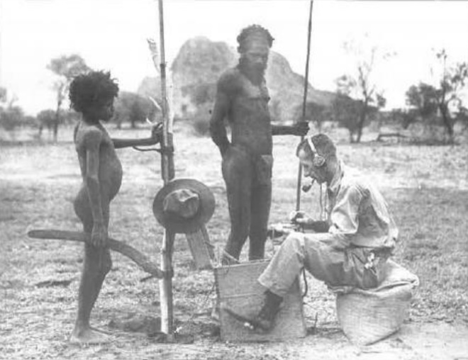
“Skipper” Partridge operating his pedal radio near Hoasts Bluff with Aboriginals looking on.
With that major hurdle over what about the transceiver itself? “Miniaturisation” is a familiar catch cry these days - but not so easy in those days with decidedly large componentry.
Traeger would have faced the dilemma, of how he could fit all these radio bits into a smaller space. He still needed to retain accessibility and good performance as well as maintaining reliability - after all they were going to have a rough life bumping around outback tracks.
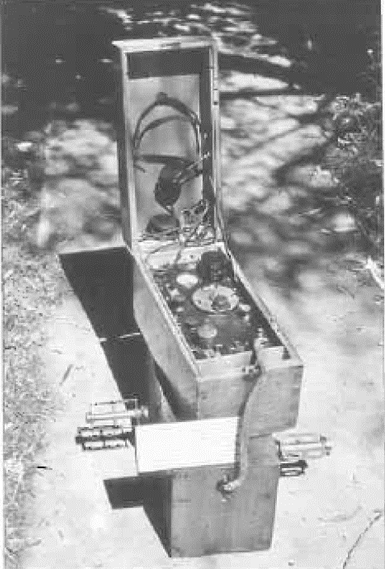
Fortunately, the most fragile parts in the transceiver, the valves, were becoming more reliable due to improved manufacturing quality control and with the advent of newer and more suitable valves. ‘shoehorning” all the components into a smaller space required much careful thinking, as well as trial and error, in determining the correct placing of the components. Traeger may have started out using the “landscape (horizontal) layout of his original sets, after all, that was the conventional wisdom of the era on how radio equipment was laid out. He obviously came to the conclusion that this method would not mate at all well with the long thin pedal generator box he had developed. Hence, the long thin “portrait” (vertical) method of mounting the equipment was more appropriate. By making the two boxes the same
Portable pedal radio (rebuilt model used by “Skipper” Partridge Adelaide House Alice Springs.
size (width and length) it was practical to mount the transceiver on top, whilst the second box contained the pedal generator, and the ancillary items was placed on the ground.
The combined weight would stop the generator moving as it was pedaled, and the transceiver would be virtually at normal operating height, hence - convenient. The convenience of this layout can be seen in photographs of operators using the portable sets, although these are pictures of the later portables which used similar layouts. Two similar sized boxes allowed slinging the sets over the back of a camel to be a more balanced load. ‘the convenience for doing this was there, but it is not clear If any sets were transported this way.
Several mockups of the layout of the transceiver were tried and Traeger finally found that it was possible to get all the equipment into a box of a size that was convenient. He departed from the conventional chassis that looks like a cake tin turned upside down with the various components and valves attached to the chassis. He mounted the valves, coils, transformers. and the minor components on various sub-assemblies. This way he was able to cram the bits and pieces into a much smaller space and still have the set reasonably accessible for maintenance. To protect the sets operating panel, a hinged lid covered all the controls, plugs,
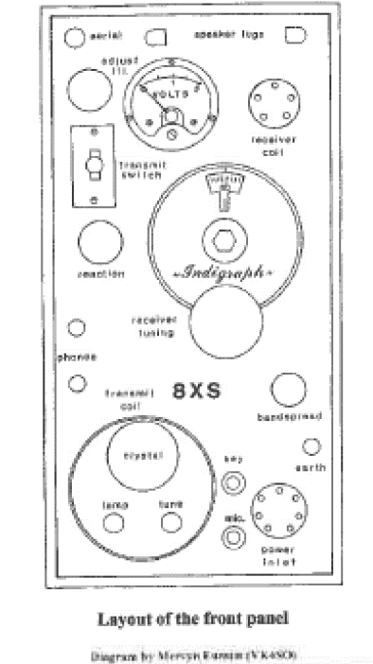
Diagram of front panel controls of an early portable pedal radio, similar to “Skipper” Partridges set.

At last, Traeger had his first portable transceiver, and he must have been justifiably proud of it. It was yet another world “first”. Never before had the world seen a ‘simple to use” truly portable high frequency (HF) radio transceiver. The receiver used three A109 valves in a TRF circuit a regenerative detector, and two audio stages feeding a pair of headphones, suitable for voice and morse code, It covered several different wavebands with the use of plug-in tuning coils. The transmitter is claimed to have used a single PH233 valve (type 33 is similar) crystal oscillator cum output stage suitable for morse code operation. For each transmitter frequency there was a separate plug-in module. ‘skipper’s’ set may well have been the first set to incorporate plug-in transmitter modules. ‘skipper” would certainly have been a good person to trial some of the innovations.
However, there were still problems with the antenna and counterpoise system. Ideally the aerial/ antenna should be at least 40” high (12 metres). Such a mast even in a collapsible style would have been too big, How could Traeger overcome this vexing issue? The solution was virtually to string the antenna and counterpoise out Just above the ground, as high as was practical (to the nearest tree or shrub) and tune it for best performance at the set. That it worked as well as is did, indicates that the soil was largely nonconductive, so the aerial and counterpoise appeared for all practical purposes to be much further above ground electrically than it was physically. An aerial counterpoise system such as this would vary in its effectiveness at different locations. and would not be as effective as the homestead installations. But the point is that it worked and worked well enough for the parables to be a surety Reverend Fred McKay confirmed that the portable; worked well on the 8 MHz frequencies. More information on the antenna/ aerial systems used is shown in Appendix 3.
One particular area where the early ‘Traeger sets did fall down was that they were not easy to service. He persisted for many years in doing all the wiring with wires having the same colour insulation. This however made individual wires hard to identify in a bundle. It made it even harder to see where each of the wires went in amongst the jumble of parts. The large components and mounting brackets were also of a similar dark colour. All in all, this system was not conducive to repairing these sets when new, or now as a restoration project. despite this problem, the comment is, ““Well done Alf Traeger”. However, restoring the very few early sets still in existence to working condition is extremely difficult due to the failure of some unique and irreplaceable components.
Regrettably, it is not known if this first example of a portable high frequency transceiver, as used by Padre Kingsley ‘skipper” Partridge, still exists ¬probably not. It may be stacked away in some dusty corner somewhere. Someone reading this book may remember it, and bring it out, so that this most important development in radio communications history can be seen again. However, enough is known to be certain that the receiver used a circuit similar to the second model pedal radio. The transmitter was similar to the last of the pure CW morse homestead sets.
Traeger rebuilt a number of sets over time, to incorporate improvements. In discussions with Mervyn Eunson (VK4SO) and Graham Pitts (VK6GF). both of whom have had a long association with the RFDS, we came to the conclusion that ‘skipper’s’ original set was rebuilt (or another one built using most of its parts) by Traeger to incorporate a VOICE transmitter. It still used three A109 valves in the receiver, a single PH233 valve in the radio frequency section of the transmitter, and a PH230 and a 19 valve in the modulator (voice section). This set does exist and resides at Adelaide House Museum in Alice Springs. ‘skipper” Partridge gave Graham Pitts this set, and after restoration, Graham presented it to the museum.
The transmitter circuitry appears to be similar to late AM/CW transmitters, with some simplification of the changeover mechanism to go from morse to voice and vice versa. The receiver is still the tried and proven design that had been used since 1930. The batteries would be similar to those used in the model 34 set only a lighter duty (762) 45-volt battery was used. This set would appear to have been one of the first AM/CW sets that Traeger made for use out in the field. It was probably rebuilt during 1934 or early 1935.
Certainly, the time of the pure CW (morse code) pedal radio was coming to an end. Voice or AM transceivers were becoming a reality. Traeger, on a trip in 1933 with ‘skipper” Partridge, had experimented with a prototype homestead pedal radio AM transceiver. He was satisfied that, with some improvements, it was practical. As a result of his research, Mervyn Eunson believes that at the end of 1933, a portable transceiver was produced which had an elementary method of producing AM (voice) transmissions. This was achieved by having a carbon microphone coupled to a transformer inserted in the plate circuit of the transmitting valve. The modulation percentage would have been low, so radio communication conditions would have needed to very good for it to work effectively. It was probably just an experiment to see if the idea was feasible. However, it meant that the part of voice transmissions was imminent. Operators would then find the portable and homestead pedal radios so much easier to use. when compared to the use of morse code with the older sets.

CHAPTER TEN

THE OUTBACK HAS A VOICE 1935 - 1936

Back in 1925 Harry Kauper and David Whyles had advised the Reverend John Flynn to forget about trying to develop (AM) voice transmitters for the time being. They said the technology was not advanced enough to successfully satisfy this aim, but that with a lot of hard work a (CW) morse code transmitter could be developed. Although quite disappointed, Flynn accepted that a method of communications that Involved morse code messages being sent one way and voice the other was the only practical way to go at that stage. The old adage that you must crawl before you can walk was so true in this instance, as even the CW transmitters presented quite a challenge. Simple today maybe, but then, less than 25 years after the first successful radio transmissions by Marconi over long distances, it was a formidable challenge.
Since the design and installation of the first transceivers, developments had occurred to now make Flynn’s dream of the voice communications possible. The most significant, of course was the arrival of much better valves. This would facilitate the design of improved transmitters and receivers, far superior to the original “baby” transceivers.
The same criteria as applied to the CW sets still applied to the AM units, but with changing radio communications conditions, and the range that the sets were required to operate over, a more sensitive receiver was necessary. Any maintenance in the field would still need to be achieved with minimal technical expertise, and the final cost kept to a minimum.
The receivers that had been used in outpost homestead transceivers were quite capable of operating on both voice and morse code. so initially at least an upgrade of the receiver was not needed. A number of the larger battery powered audio output valves that were coming onto the market looked promising as transmitter output valves, and some others as the audio modulator (which impresses the voice onto the radio carrier). Additionally. the quality of the passive components was improving too, ‘the opportunity to produce an AM voice transceiver looked very promising in 1933.
The new tetrode and pentode audio power valves were proving to be noticeably easier to use in transmitting circuits, with potentially more output power, and they were easier to tune for optimum performance. This in itself would make communications with the expanding networks easier on morse code, even if the AM voice facility wasn’t incorporated. The RCA type 33 and the Philips PH233 pentodes became available in Australia during 1932 in limited quantities. Chapters 8 and 9 describe CW transmitters that used these valves in 1934.
By 1934 the 19 valve was available in Australia in reasonable quantities. This is a twin triode valve that is designed for use as a Class B audio amplifier feeding the speaker in a battery radio. The Class B audio stage is much more efficient; hence it would draw less current for the same audio output (voice or music) compared to the Class A audio output stage commonly used to feed speakers (and headphones). Every little bit of battery current that could be saved was a bonus in those times when battery power was so expensive.
These valves all had 2-volt filaments, being designed to operate off a single lead acid cell (battery). Lead acid batteries require to be charged every so often just as they do in our cars. Facilities for charging batteries were still rare in the outback, so dry batteries were still required to heat the valve filaments. Dry batteries have only 1.5 volts output as a single cell, so were unsuitable for use in the transmitter. However. by putting, two cells in series. 3 volts would be obtained. By using a rheostat in series with the 3 volts it could he reduced to 2 volts to suit the valves. This had an advantage in that, as the dry battery discharged and its voltage dropped, the required 2 volts for the valves could be maintained by adjusting the rheostat until the battery was completely flat. It was essential, for maximum possible output, that the filament voltage was maintained at 2 volts.
The high voltage for the plates/anodes of the valves was still supplied by the pedal generator. The MKI version put out nominally 180 volts and the MKII about 220 volts. The 33 valve had ratings of 180 volts on its plate whilst the 19 valve had ratings only to 135 volts. We have noted before, the common practice of amateur radio. experimenters (of which Traeger was one) of overloading the valves that they used in transmitters. Overloading would shorten the life of the valve, but if a transmitter only operated for 15 minutes a day. its shortened life of perhaps 100 hours still equated to over a year of use. When used in receivers, the same valves lasted up to 2000 hours.
Traeger experimented with the valves, and suitable circuits, to achieve the best performance possible in the voice (AM) mode. The 33 valve was not greatly overloaded and performed quite satisfactorily in the radio frequency (RF) output stage. The efficiency of the valve (40%) was lower than expected and (with 180 volts on its plate) gave only around 1.5 watts of output. With around 200 volts this crept up to around 2 watts.
The last of the CW only transmitters used a complete “plug-in” module to connect to the valve and select the transmitting frequency. These new sets also used this plug-in module system. The module was quite large as can be seen in some of the photographs. It contained the quartz crystal and a feedback winding in the grid circuit of the 33 valve to ensure reliable operation of the crystal oscillator. Additionally, on the same coil former, the tuned circuit for the plate circuit, and the coupling coil for the aerial/counterpoise system were incorporated. The module had eight pins and, in each module, only six were used. The output coil was wired so that the appropriate counterpoise was connected, there being a different one for each of the three bands used to contact the Cloncurry base station, These modules were well made, and pre-tuned, so that they only had to be plugged into the transmitter and one control within the transmitter adjusted for optimum output. Whether this was a world first is unknown. but plug-in modules have become a popular method of adapting electronic equipment in recent years for different functions. It had one deficiency in that the metal shield caused a reduction in the transmitter efficiency. A circuit of this system is shown in Appendix 2.
The 19 valve was ideally suited to the job of impressing the audio (voice) on to the transmitter output. Traeger did something uncommon for the 1930s with the 19 valves. He used it as a class B modulator. It was a much more efficient modulator for placing voice on the transmitted signal than any other methods in use at that time. This equates to less current being drawn to achieve the same end result, as was mentioned earlier when the 19 was used in receiver audio stages. He was ahead of his time, in that this method of impressing the audio onto the transmitter carrier signal was not commonly used in the large, fixed location AM broadcasting transmitters until the 1940s. It was even less common in the small transceivers in the same class as the Traeger transceivers. However, the 19 (and the later 1J6G) struggled to provide all the audio necessary to fully modulate the transmitters.
Whilst the 19 valve was successful in its role as a modulator, it was extremely overloaded. If Traeger had used negative bias on the 19 valve the reliability would have been much better. Two volts of bias was used in some later vibrator powered transceivers, and this was insufficient when plate voltages of over 200 volts were applied to the valve. I discussed the overloading of the valves with some of the older operators (Graham Pitts in particular) and they stated that the valves in the transmitters did not last long, and if any visits were made to the out-stations they always took a swag of valves with them.
It amazes me that Traeger did not use a pair of 49 valves in the modulator. The total filament current is nearly identical to that used by a single 19, and the valve is rated for 180 volts and zero bias and would have given more output than the 19. He did use the 49 as a triode in the audio output of the Improved TRF receivers fitted to most of these early AWCW transceivers.
The other components that were necessary to use with the new valves were either already in existence or Traeger could make them, as he did with the audio transformers. He was very good at making all sorts of devices, such as his pedal generators, which all required many turns of insulated wire to be wound onto various types of formers. The microphone he planned to use was a carbon type. These were very common and extremely robust. They were used in telephones by the hundreds of thousands until just a few years ago.
The new 36 model AM/CW transmitter became the standard design and was adapted to pedal radios and vibrator powered radios for several years. It consisted of a 33 valve as the crystal oscillator cum output stage, which could be used for morse code operation as well as voice. Initially it had an output of 1.5 to 2 watts depending on the plate voltage used on the valve. Later model “pedal radios” used the 1L5G valve, and with voltages up to 240 volts they provided 3 watts. output. The transmitter valves were very overloaded and Traeger suggested a modification to reduce the severe overload in one of his letters to the FDS. The modulator section consisted of a carbon microphone, which fed a 30-valve acting as an amplifier for the voice signal. The output of the 30 fed the 19 valve which farther amplified the audio signal. This signal was of a level sufficient to effectively impress the voice onto the radio frequency output. This was received in the same way as the local radio stations on the AM band. The end of 1935 was certainly a good time for outback radio communications.
The first of the AM/CW transceivers had the existing three valve TRF receiver using the Al09 valves. Probably ‘skipper” Partridge’s modified/rebuilt set was the first AN/CW set in the field. It is thought that it appeared in 1934. From the information available it appears the only other ones so equipped were the second and third portable transceivers.
However, there is one missing link in the progression of transceiver; that Traeger produced. He gave each new model a number that roughly equated to the year in which It was first produced. The missing link is model 35. Model 34 had a pure morse (CW) transmitter. The model 36 was a completely new design. Its receiver was a much-improved TRF with an AM/CW transmitter. However, ‘skipper” Partridge’s set (which is on display at the Adelaide House Museum in Alice Springs) has the same receiver as the 34 set but a transmitter similar to the 36 set. The late Fred McKay’s portable set has virtually the same circuit as the model 36. The portable sets did not follow the same model numbering series used for the homestead radios, but they did have similar circuitry to the homestead sets of that particular time. My belief is that the outback got a voice in a limited way during 1935 (or late 1934) using the missing link - model 35. However, I believe very few model 35 sets were produced as Traeger found he could build a much better receiver with the new valves that had recently become available.
Up until the early to mid-1930s Traeger had been using triode valves throughout his receivers. He was finding that the pedal radio receivers needed to be more sensitive now that the communication ranges had increased from around 300 miles to something like 800 miles. Triode valves could be used to amplify radio frequency signals to obtain the increased sensitivity needed. However, they required neutralisation for stable operation. (See definition of neutralisation, AM, CW and TRF in Appendix 7, ‘terminology”). This was a tricky technical adjustment totally unsuited for use in simple, easy to use pedal radio receiver:
Early in the 1930s a plethora of new 2-volt battery tetrode, pentode and other multi grid valves became available which were very suitable for use in making more sensitive receivers, and which would generally make the designing of better receivers much easier-These revolutionised the design of valve receivers over the next few years. Traeger would have been rejoicing. It was now quite practical to design a receiver that used a radio frequency (RF) stage before the regenerative detector, which would improve the receiver performance markedly.
As a result, the new 36 model receiver used a totally different design approach. Traeger used an un-tuned tetrode RF amplifier (32) feeding the amplified signal to a regenerative detector (32). Following the detector was a triode audio amplifier (30), which could either feed headphones to conserve battery current, or feed an audio output valve (49) which fed a speaker. At last, the whole family could listen to the radio comfortably.
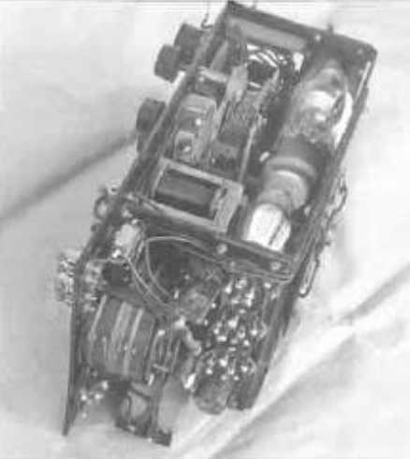
“QS”—, the monthly magazine of the American Radio Relay League. in its April 1929 issue, published a number of circuits of receivers suitable for amateur radio use. The circuits shown for two, three and four valve receivers were similar to the receivers used by Kauper from 1926 to 1929 and used by Traeger from 1929 up to 1936. with the exception of the original “Pedal Radio” which used the space charge tetrode valves. Traeger waited for low Fred McKay’s pedal radio, inside view of transmitter.
filament current drain versions of the valves to become common before using ideas from the American designs.

The receiver was still only a TRF unit. but it was more sensitive, could hear weak signals. and it had better control of the regeneration in the regenerative detector. Best of all everyone could listen in at the onetime to other people’s conversations, the base station operators, the flying doctor, and the world or entertainment from short wave and broadcast stations. Each out-station could talk to others within range and quickly the “galah” session was established where folk just had a chat at slack times, usually in the evening. Suddenly, the isolation and loneliness in the outback was reduced dramatically. just with the advent of this new pedal radio. The morse code sets had started the ball rolling but it was a quantum leap forward with the amplitude modulated (AM) sets. Reverend John Flynn must have praised God for this new development. Traeger had finally “brought home the goods”.
Graham Pitts remembers that by the rime he became the officer in charge at Alice Springs in 1944 that morse had ceased to be used except occasionally between skilled morse telegraphists. 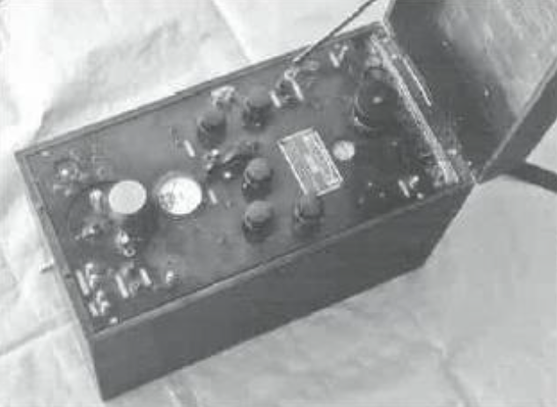
Fred McKay’s portable pedal radio, John Flynn Place, Cloncurry.
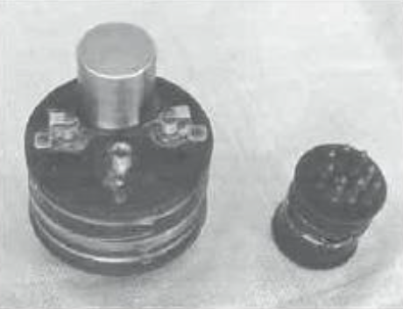
Plug in coils for transmitter (left) and receiver (right) Fred McKays portable pedal radio.
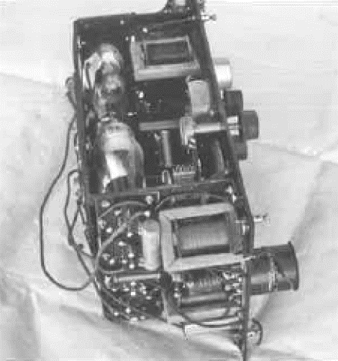
From all information that has been possible to obtain, the number 36 model set appears to be the first of the new homestead AN/CW pedal radios produced in any numbers. There were several models that incorporated the features of this basic design - they were the later portable transceivers, such as the late Reverend Fred McKay’s at John Flynn Place in Cloncurry, and to a lesser extent the 36/40 model. There is a 36 model in Adelaide House in Alice Springs, and a circuit of the 36 set is shown in Appendix 2. The set measures around 69 cm long by 20 cm deep Fred McKay’s pedal radio, inside view of receiver.

and 23 cm high. it is installed in a metal case with a wooden top and bottom.
It might be thought that this book is purely about the work, of Alf Traeger, but the early development of radio for the outback was the combined effort of a number of people. One often forgotten was Jack Drew, a member of Traeger’s staff In later times it is understood that he did most of the design work and running of the day-to-day activities of the firm.
Amalgamated Wireless Australasia (AWA) had also developed pedal radios and had a number in service in New Guinea and the South Pacific by 1933. It appears that the sets were capable of both morse code (CW and ICW) and voice operation (AM) and were probably more powerful than Traeger sets considering the areas in which they were required to operate. AWA believed that they had a model suitable for use in the outback too. From the little information available and photographs. too poor to include in this book, it is obvious that the transceivers were cumbersome and more suited to a semi-skilled operator compared to Traeger’s. The pedal generator shown in photographs is larger than it appears and is attached to a frame like a bicycle frame. The two models displayed appear to be well built, as AWA equipment of the era was, heavy and robust. One at least, was powered by the muscular effort of one person whilst the transceiver was being operated by another. The other unit was probably capable of being operated entirely by one person, with difficulty.
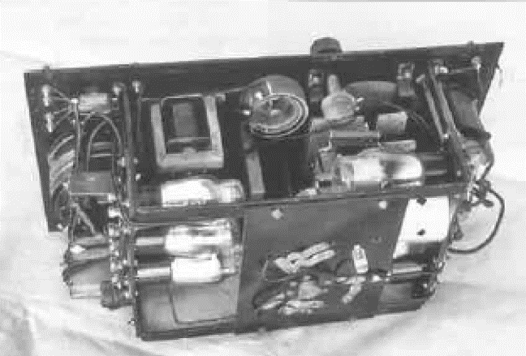
Rear view inside of Fred McKay’s pedal radio.
It would appear that AWA had stolen a march on Traeger and had a set capable of AM transmission in 1933 around a year ahead of Traeger. The model more suited to the outback probably became available in 1934 or early 1935.
The fact that they appeared to need two people to operate them satisfactorily made them unsuitable in most circumstances for the outback. Had AWA taken more notice of the criteria Flynn had placed on pedal radio design, AWA would have been able to supply suitable equipment for the outback. They used an aerial-earth system for transmission and reception. Whilst this is good, in the outback the aerial/ counterpoise system for the transmit was superior and was one of the reasons that the Traeger sets worked as well as they did.
The AWA sets were not adopted for use within the Australian Aerial Medial Service (AAMS) at this time for a variety of reasons. These appear to have related to personalities, “politics”, costs, perceived difficulty to operate. and perhaps some jealousies. This is a pity as competition usually means that an improved product results. They were the first of a successful run of what were called ‘teleradios” produced by AWA. The Teleradio 3A, 3B, 3BZ, 5A, 60A/B, 80 are probably the best known of the AM sets produced. The 3B and the 3BZ were used extensively by the coast watchers in the Pacific Islands during World War II.
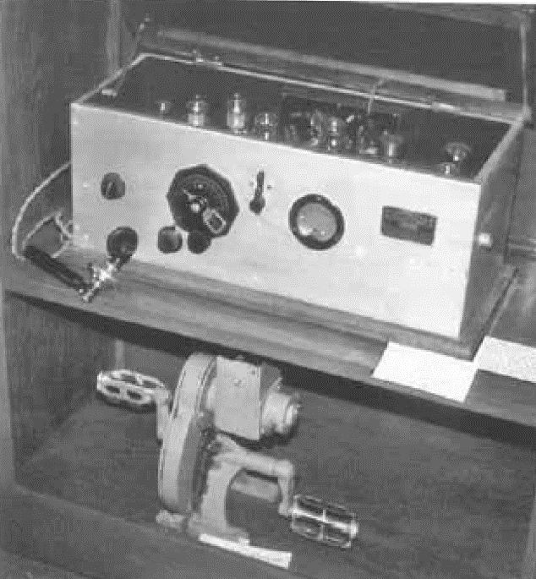
No 36 set with pedal generator on the shelf below it.

With the advent of the voice transmission the flying doctor radio network really came alive with many uses. At this rime Traeger was thinking of ways in which out-stations could call the base station when it was closed down. At night particularly, no operator would be available except in an emergency. The base station receiver could be left running, but the operator would soon get sick of hunting to continual static, whistles, morse code and overseas stations operating on the same Frequency and would quite likely miss emergency calls. From talking with Graham Pitts, it appears that after Traeger had developed the first “out of hours” call system, a number of operators refused to use it as it was extremely prone to false alarms. After all, the base operators had sleep sometime too. The brain teaser of how out-stations could reliably contact the base out of hours, would exercise Traeger’s mind for quite a Inns while
However. in addition to the AAMS, there were other people who could see the advantage of radio to call for assistance in time of need. One of these was Harry Ding. Ding was a mail contractor and general carrier throughout northern South Australia, parts of New South Wales and southwest Queensland in the early part of the 20th century Ding became the PMG mail contractor for the run from Marie to Birdsville in 1936. Not long after it began, one of his trucks was quite overdue. He went out on the next mail run to hopefully find out what had happened, as well as to deliver the mail. The broken-down truck and driver were about 200 miles out. No swift help was available in an emergency for Ding’s drivers!
Ding bad seen the pedal radios in use at various stations over the last few years. He could see that they would be the answer to his problem of knowing if something happened to his drivers or trucks along this lonely track. He would then be able to arrange some rescue mission. At that time, it was a lonely run, the mail truck may be the only vehicle using the Birdsville track for many weeks.
Ding approached Traeger to produce some radios suitable for his needs. He didn’t like the single case transceiver became of its sheer bulk, and he wanted the transceiver to operate off the vehicle battery. Traeger produced transceivers to this requirement. It would appear that these sets were some of the last vibrator powered sets, possibly adaptations of the model 37k The sets operated with callsigns VHU9 (base) and VHU6 (mobile) on three channels 1690 kHz (177 metres) 5300 kHz and 8630 kHz (this channel being the same as Cloncurry. His base station was located at Yunta on the Barrier Highway in South Australia.
Ding also supplied, or station owners along the track bought, sets to operate on his channels. The progress of the mail contractor and his other contractors going into very remote areas could therefore be followed in case of some mishap. or to order goods, etc.
One of Ding’s drivers on the Birdsville Track was Tom Kruse. Tom bought the Birdsville run from Harry Ding in 1948. The saga of Tom Kruse on the Birdsville Track, in the Shell Oil Company film “Back of Beyond” is well known to many older people. It is an excellent film depicting life in the outback as it was in the 1940s and 50s. The film was shown at the Wadlata Outback Centre in Port Augusta on a daily basis in 2001 and may still be. It is claimed in “Flying Doctor Story 1928-78” that the first radio medical consultation from an aircraft took place on 31st July 1934. Maurie Anderson accompanied Dr. Rosati”, who gave advice to the Sister at the AIM nursing home in Innamincka. This would appear that this was no more than an experiment, as liming a radio transceiver into the aircraft used by the AAMS was no easy task. No mention is made of whether the consultation took place via morse code or voice, although I suspect that it was morse code from Innamincka and voice from aircraft.
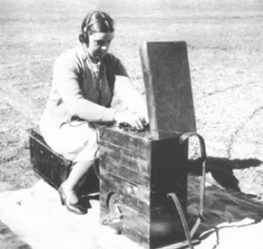
Meg McKay receiving a message on Fred’s set while they were on patrol.
However, Graham Pitts (VK6GF) believes that voice from the aircraft was unlikely due to the noise of the aircraft. Graham was very much involved in the flying Doctor Service from 1944 onwards and had flown in the type of aircraft that would have been used in this experiment. He also said that the aircraft would have been extremely difficult to set up for radio communications. which seems to re-enforce the idea that the consultation in flight was purely an experiment- No mention of aerial radio consultations occurs in literature for some time after this date. It is doubtful that any voice transmitters were installed at this time at out-stations. If there were, it would probably have been the “missing link” model 35.
The radio service’s original purpose of providing life-saving communications had by now expanded to include social, information-seeking, business and life enhancing activities.

CHAPTER ELEVEN

THE FIRST OF THE SUPERHETERODYNE RECEIVERS - 1937

As we have seen, pedal radios up until 1956 had tuned radio frequency (TRF) receivers. Their design had not altered a great deal from the time of the “baby” transceiver of 1929.
All manufacturers of domestic radio receivers were manufacturing superheterodyne receivers in reasonable numbers by 1933, and by 1936 were almost exclusively making superhets, as they had noticeably superior performance to TRF receivers. What TRFs ware still being produced were for the low-cost end of the market where good performance was not a prime concern. What were the advantages of the superhet over the TRF receiver?
Superhet advantages and TRF disadvantages: -
The superhet has better selectivity which is consistent across all bands tuned by the receiver. This usually meant that the superhet would accept all signals within a 10 kHz bandwidth (depending on design) on all the bands to which it is tuned. This was nominally the amount of a radio band (spectrum) that was occupied by a single station. The TRF on the other hand may accept all signals in a 10 kHz bandwidth on the broadcast band. However, due to its design, it would not be able to discriminate between stations which were less than 100 kHz away (on the tuning dial) from the desired signal on short wave bands. This meant that the receiver may receive ten channels (stations) at once (poor selectivity), hence there would be considerable interference and the desired station may not even be heard. Stations were spaced around 10 kHz apart across the radio bands in the 1930s, and the bands were becoming crowded.
The superhet is more sensitive. They are able to amplify signals more highly at radio frequencies (RF) before detection due to the style of circuitry used; hence they are generally more sensitive than TRF receivers. When high RF amplification is attempted with TRF receivers, it is difficult to maintain stability so that extraneous whistles and howls don’t occur. Mechanically it is difficult to tune multiple tuned frequencies in a TRF receiver. A high-performance receiver is difficult to produce, difficult to use, and expensive.
The superhet has an intermediate frequency (IF) amplifying section at 455 kHz where a high level of stable amplification can be achieved. The TRF does not have this section winch allows the superhet to have greater sensitivity than the TRF. With a TRF, amplification can only be accomplished at the signal frequencies with the problems as previously mentioned. (I am only referring to radio receivers of this era which predominantly used a frequency of 455 kHz as the IF frequency.
The superhet has no touchy regeneration control. Superhet receivers do not need regeneration because of the high gain of the IF stage(s). With TRF’s the regeneration can be quite tricky to use on some parts of the band being tuned and may not even work on some bands.
We can accept then, that a superhet receiver is far superior to a TRF receiver, so one must ask “Why did Traeger persist with the obsolescent TRF design for so long. Could it be that he hadn’t moved with the times, or was there some not so obvious reasons?
It really was a case of appropriate technology for the circumstances prevailing, although one must question why he used technology commonly used in 1929 up to 1936. Here are a few points that kept the TRF in use in the outback for a number of years after it had been sidelined in the domestic market.
- The TRF is a simple, trouble-free design, that was cheaper, easy to fault find and repair. It is a sensitive set when the regeneration control is used expertly. There were no servicemen in the outback, so the Patrol Padre often fixed the sets. A superhet would have been too complicated for them to repair with their limited technical knowledge.
- Only one tuned circuit was necessary for each band, a superhet required at least two. Plug-in coils were suitable for a TRF set but quite cumbersome for a superhet. Operators putting the wrong coils into a set was not an uncommon occurrence, resulting in no, or poor reception.
A band change switch was a better way to switch coils and was virtually mandatory for the superhet. Band switching via a switch on the front panel had not been a reliable option until the mid-1930s.
- It was possible to turn the TRF receiver on. and be sure that when the base or another out-station came on air, it would usually be heard without adjusting the receiver tuning, particularly on the eight-megahertz frequency. Because of the higher selectivity of the superhet (a good feature in itself, which allowed the operator to accurately select individual channels/frequencies as required), it was not always possible to be sure that the receiver was tuned/adjusted exactly to the right spot on the dial - particularly if the base station was not on the air at the time.
- The early superhets prior to around 1936 used an autodyne converter to convert the signal on (say) 8630 kHz to 455 KHz. The autodyne was a tricky circuit to gain optimum performance from, particularly on short wave, and particularly with battery valves. Traeger was not prepared to put such a set into the field where reliability was paramount. Later superhets used valves specifically designed to convert the signal frequency to the IF frequency.
- Early converter valves were not very reliable, even with good circuit design. They did not work well on short wave and suitable battery types were few and far between.
- Early superhet receivers required more valves to do the same job as the TRF sets. Valves were still expensive in the 1930’s.
- Extra valves meant that extra filament and plate current was used, hence batteries went flat quicker.
- The ability of the regenerative TRF set to receive morse signals was valuable when signals from other out-stations were exclusively on morse code. A superhet usually required another valve (beat frequency oscillator (BFO) stage) so that the operator could read the morse code being sent.

Graham Pitts reports that some sets were fined with a BFO in the field.
However, in spite of this, the time of the TRF was coming to an end as far as any serious communications purpose was concerned. In the earlier times there were few short-wave stations which would cause interference to broadly tuned TRF receivers. Now. in the latter years of the 1930s, there were many more stations which did cause a considerable amount of interference in the out-station receivers. Using the tricky regeneration control for best reception had proved a very real challenge for many operators and some never really got the hang of how to use it for optimum performance. Remember. the users were cattlemen. drovers, housewives, etc. and the technicalities of radio certainly were not their prime interest.
So, the deficiencies of the TRF had become serious. whilst the problems of the superhet were being solved - with new valves, better components, higher reliability and less complexity. Additionally, there were more people in the outback with some understanding of radio in the mid to late 1930s. Today, even the lowest priced AM/FM transistor portable radio uses the superhet principle.
In 1936 Traeger had the new AM/CW transceiver (model 36) up and going, and within a year, he had the model 37 transceiver fully operational. The 37 retained the same general transmitter design as the 36 but had an “all new superhet receiver. It had a new much more professional looking cabinet design, and the receiver bands were selected by a wave change switch instead of plug-in coils.
The transmitter was basically the same as the previous model, but It did have some important innovations which made it a much easier unit to set up and operate, namely the selection of the transmitter channels through the channel change switch. This meant that it took only a second to change channels. whereas previously it may have taken a minute or so. Traeger still used the highly successful plug-in preset transmitter modules that he had developed for use in 1934/5, and they were now installed inside the transceiver case. The modules were now encased in Individual aluminium shields which regrettably dropped the efficiency of the transmitter a little.
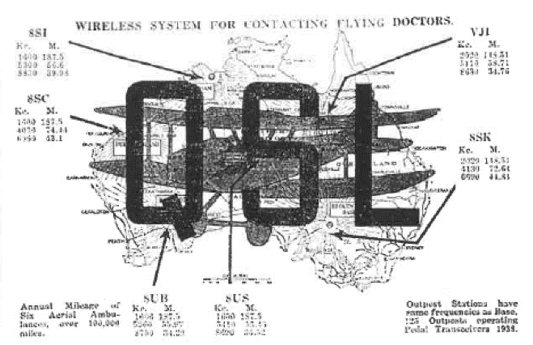
QSL card Reception confirmation card of the flying doctor service circa 1939.
In this model the wiring was such that relatively simple switching changed the channel and the counterpoise. On the front panel of the transceiver there were three counterpoise adjustments, one for each channel, fitted to the transmitter. The counterpoise adjustment was the only control that required alteration to get peak performance of the transmitter and the antenna system when a new frequency was fitted. The modules were all pre-tuned at the Traeger factory.
The transmitters had provision for three channels. There was a 1600 kHz or 2020 kHz channel, a channel in the four- or five-megahertz band and a channel in the six- or eight-megahertz band. Traeger called these long wave, medium wave or short wave respectively. These are not the official designations of these bands, but suited Traeger’s desire to keep the designation of each band simple for the non-technical operators.
In previous models, the filaments were fed off 3 volts and a series dual rheostat was used to set the voltage for the filaments to 2 volts. As the filaments for the modulator were switched off when transmitter operated in the morse code (CW) mode, the filament voltage would rise above the 2 volts on the transmitter radio frequency valve. To overcome this, a second section of the rheostat was switched in to bring the voltage back to 2 volts. A similar system was used in the previous receivers where one valve was switched out, if only headphone operation was required.
However. experience with the 36-model showed that morse code (CW) was rarely used by out stations so the extra complication of compensating for differences in voltage on the filament lines was dispensed with by running them at all times, whether morse code or voice was being used. The saving of battery life was felt to be minimal. All the receiver valves were in use at all triodes, hence only one rheostat was needed to set the receiver filament voltage, as was done with the transmitter.
The microphone was still the robust, high output carbon unit. It was powered from the 2-volt filament line. The first audio valve was the ubiquitous 30 valve, followed by a B240 Philips twin triode (similar to the 19 and IJ6G valves) as the modulator. The radio frequency oscillator output valve was the 33 valve which Traeger had standardised on in the last few models.
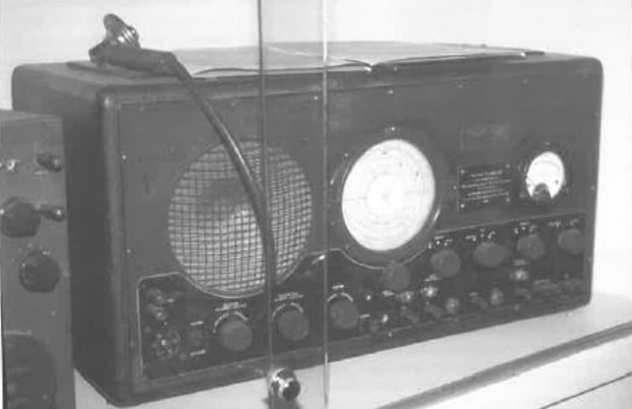
Model 37 set transceiver, Alice Springs RFDS Museum.
The receiver was of a very different design to those of the past. The coils for the three bands that the receiver tuned were all switched by a four-section switch, there being a total of six coils to be switched. The receiver tuned the broadcast band (550 to 1500 kHz), and the two short wave bands tuned from around 1500 kHz to 10 MHz These tuning ranges covered the frequencies from which most people obtained their entertainment. The two short wave bands covered all the allocated frequency channels used by the Australian Aerial Medical Service (AAMS). A number of the inland services such as VTR from Lyndhurst, Victoria on 9580 kHz could also be received.
The first stage of the receiver was a (KK2 valve) converter stage, which changed the incoming signal to 455 kHz - the intermediate frequency (IF). This was amplified by a KP3 valve and applied to a KL4 valve which was used as a grid detector and audio amplifier. The audio signal was amplified by a KL4 valve which applied the signal to either a loudspeaker or a set of headphones. The volume was continual by varying the screen voltage of the IF valve KF3. The receiver filament drain was around 0.4 amps at three volts and the receiver high tension current was around 12 mA at 120 volts. Two 60-volt dry batteries were used to supply the receiver high tension voltage.
The receiver was an elementary superhet as it had no automatic gain control (AGC) which most superhero had at the time. It also used a grid detector in lieu of the popular diode detector. It could be asked why Traeger still seemed to lag behind the innovations of the day? It can only be assumed chat whilst he did lag behind in some technical aims, he did this to make his equipment as reliable and as easy to use as possible, considering the resources available in the outback.
It could be said that his transceivers were like an old model Hoiden compared to the best computer-controlled vehicle. If the old Holden broke down in the outback. it would be relatively easy and quick to get going with the resources available. Could that be said of one of the latest cars with their computer control? - I suspect not! Traeger was after reliability, and case of service, rather than the immediate implementation of the latest technology.
The transceiver was mounted in a black steel cabinet roughly the same size as the previous homestead pedal radios. All the components were mounted on a metal chassis which had become standard with domestic receivers of the era. It was a method almost universally used until transistors took over from valves. It had a loudspeaker mounted on the front left end of the cabinet. the receiver tuning dial approximately in the middle of the front of the set, and the voltmeter towards the right side. The various controls were spaced along the bottom lip of the front panel. At long last Traeger labelled the various controls. A plug connected the batteries and pedal generator to the set via a socket on the from panel. The set could be used with a pedal generator or a set of batteries for the transmitter high tension voltage.
The number 36 set introduced voice (AM) transmissions with the “galah sessions” becoming a way of life. The 37 set introduced a much more “user friendly” sets which had a superior superhet receiver.
It must be remembered that communications in the outback (i.e., two thirds of the continent) in the mid to late 1930s, involved the use of only a few hundred pedal radios.
Large manufacturers employed design engineers to get things “just right”- although they often didn’t achieve this in practice - and sets we produced in their thousands. which kept prices down and made for mechanically tidier sets. Traeger, on the other hand, had to be “designer, as well as “manufacturer”, of sets that had to meet more stringent design criteria than domestic radios had to meet.
However, the day of the pedal generator, dry batteries and morse code was gradually coming to an end. To this end. Traeger was ever working to improve the pedal radios using established and proven techniques that were appropriate to the use of radio transceivers in the outback.

CHAPTER TWELVE

NEW POWER SUPPLIES, VOICE ONLY SETS, INCREASED POWER, THE PROBLEMS OF INTERFERENCE - 1937 ONWARDS

Up until the early 1930s vibrator power supplies weren’t known. A predecessor of the vibrator was the model T Ford car ignition coil. It consisted of a 6-volt winding in series with a pair of contacts across a 6-volt battery. One of the contacts had a ferrous metal strip that was magnetically attracted to the iron wire core of the winding when current flowed through the winding. When it was pulled close to the core the pair of contacts separated and caused the power to, be removed and the core lost its magnetism. It swung back to the other contact and the whole process was repeated continually, whilst power continued to be applied.
To obtain the high voltage output for the spark plugs, another winding of many more turns of wire than the first winding (60 times as many) was wound onto the same core. A voltage was developed in this second winding that was considerably higher, and it became even higher still, when current ceased flowing through the primary 6-volt winding.
During WWI, the British army used power supplies somewhat similar to this in their trench wireless/radio transceivers, with the transmitter valve acting as the rectifier to convert the alternating current (AC) to direct current (DC).
By 1932 car radios were being imported into Australia and these were vibrator powered. (It is chimed that the vibrator was an Australian invention of 1932). By 1934 the importation of these sets was embargoed by the government so that local manufacturers had an opportunity to compete against, what was believed to be, unfair competition. Companies such as Eclipse Radio. and Stromberg Carlson then manufactured their own vibrator powered radios.
Whether these early vibrators were the full wave type, that we commonly call a vibrator, or the earlier half wave type, is not clear.
Traeger did not use vibrators at this early stage. He may have considered that they were not sufficiently reliable, or perhaps lacked the power handling capacity to power the AM transmitters. The pedal generator had proved very reliable, and the battery supply was reliable too, so why change what had proven to be a good working system. Additionally, there were very few plans where the 6-volt lead acid battery could be charged so until facilities became more common to charge these batteries, this development had to go onto the back burner. It was ready to use, but he had to wait for the right time to implement this new development.
The right time came along late in 1936, when Harry Ding requested sets to run off the batteries of his outback mail and general delivery trucks. (See Chapter 10) The sets Ding obtained were not the same as sets provided for the outback stations. However, the general design would have been similar.
There were quite a number of 32-volt home lighting plants on the stations and the number of cars and trucks with 6-volt electrical systems was growing steadily. Traeger had produced the 37 set which looked good, worked well and was relatively simple for a set using a superhet receiver. He decided that the 37 could be modified to incorporate a vibrator power supply. He tided the set the 37A. He produced both the 37 and the 37A to cover the circumstances where no power was available and the increasing number of circumstances where 32 or 6 volts was available. It would appear that Ding’s sets were a `special” based on the 37A, designed for portable use.
What a 32-volt lighting plant was in use, a resistor or globe could be used in series with the 32-volt battery system to charge a 6-volt battery for the pedal radio - and so dispense with the pedal generator (The term “pedal” lasted for many years after the pedal generators were no longer used. The battery from a car or truck could also be used as a power source in a more portable situation.
The modifications to the 37 set to make it suitable for use on a 6-volt vibrator power supply were not extensive. The main alteration was in the way the filament circuits were wired to suit 6-volt operation, compared to 3-volt operation in the battery/pedal generator.
The high voltage supply to the receiver and transmitter consisted of two vibrator supplies. One supplied around 120 volts to the receiver and the other supplied between 200 and 240 volts to the transmitter valves. The later 43S3 transceiver used 240 volts on the transmitter valves. This high voltage greatly exceeded the voltage ratings of the 19, B240 or IJ6G valves. This caused the life of those valves and 33 RE valve to be rather short, as was pointed out me by Graham Pitts. Graham also commented that the filaments of the transmitter valves (where series filaments were used in vibrator powered sets) lit up more brightly with modulation. This was due to the increased plate current drawn by the modulator valve which also increased the current through the filament of the 33 (or IL5G valves in later sets). On their routine visits to stations a supply of valves was always taken in case the transmitting valves - in particular - needed replacement.
Gradually morse code was being replaced by voice transmissions. The more code facility was becoming a mode that was used only if voice could not get through to the base. It was not possible with the superhet receivers in the 37, the 37A, and later sets, to resolve morse code anyway, so communication between various homesteads and out-stations had to be by voice. As a teenager at night, I could hear voice transmissions just past 1600 kHz on the broadcast band. That could have been some of these and later models of Flying Doctor Radio on either 1610 or 1690 kHz. They were very weak which is to be expected over the distances I was hearing them, at Mundane, near the SA/VIC border.
Traeger kept on bringing out new sets, each a little better than the previous design. By 1939 the 39 set had a two-stage radio frequency (RF) section in the transmitter, using a KL4G valve as an oscillator and a 1L5G in place of the 33 as a neutralised RF output sage The 1L5G proved to be a slightly more efficient valve than the 33, but like many valves designed for audio work it required neutralisation to work effectively at RF when used as an amplifier. The receiver performance had been improved by the addition of a KF3G RF stage. In 1940 the receiver had automatic gain control (AGC) added making it a much better receiver to use when radio reception conditions were poor.
By 1943 the battery valve transceivers had reached their peak in the 43S3 transceiver. This set had a receiver somewhat similar to the model 40. The transmitter was vibrator powered and had an output of 3 watt.
The increases in power at outpost stations were needed so that there was a reasonable chance of being head and understood by the base station. This had a negative side, in that the life of the transmitter valves was short as mentioned above. Traeger even sent out a letter suggesting that sets using a IL5G valve in the output of the transmitter should have another fitted in parallel to share the load.
The problem of alerting the base station of a medical emergency outside of normal operating hours had exercised Traeger’s mind for a long time. In 1945 he developed the 45AR alarm receiver which was installed at Broken Hill. This receiver had a filter in the audio section which only allowed audio frequencies at and around 1000 hertz to pass through it. Any 1000 hertz signal was amplified and detected. Once detected various timing circuits determined if the signal was from an out-station sending a 1000 hertz whistle (tone) over the air. An alarm bell sounded when a valid signal was received which woke up the base operator, or in some cases, the doctor. The 1000 hertz tone was produced by a tin whistle that Traeger tuned to that frequency. The system worked quite satisfactorily in daylight but there were too many extraneous whistles and noises at night which could set the alarm off. Because of the number of false alarms most base station operators refused to use the system, which is quite understandable.
In 1959 a much more reliable emergency tone all system (59ECS) was implemented. It used two audio tones (2,500 and 2,000 hertz) which were sequentially sent by the out-station over a predetermined number of seconds. With the correct sequence used, the alarm would sound at the base and the operator or doctor was woken up - probably cursing the alarm! At the same time the filaments of the valves in the base transmitter were switched on. The transmitter would be ready to transmit by the time the base operator or doctor was fully awake.
The whistle used in this case consisted of two tin whistles welded together in the form of a ‘v”. The shorter one being the higher-toned unit. To operate the alarm, call the out-station operator took a deep breath and blew into the shorter whistle for three to four seconds, then quickly changed to the longer whistle and blew for a further five seconds or so, until the operator ran out of breath. Sounds simple, but operators in a panic often got it wrong by blowing the whistles in the wrong order, blowing too hard causing distortion of the tones, not counting the seconds correctly or running out of breath.
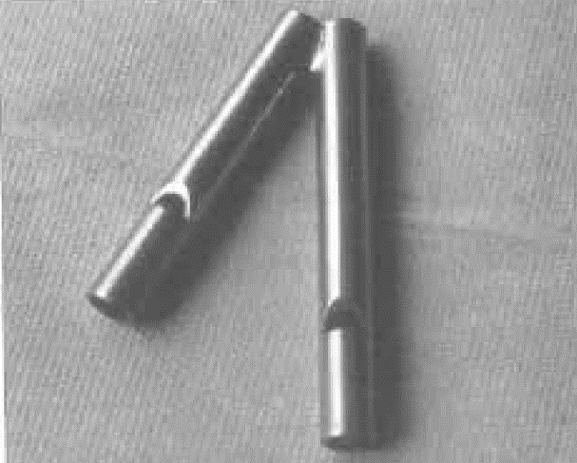
Two tone whistle, used to summon aid over the flying doctor service radio when the base was closed.
As time progressed an electronic version of the two-tone whistle was developed.
During the second world war some Traeger sets were used by the military in Australia and the nearer Pacific Islands on coast watch duties, although AWA Teleradios types 3B and 3BZ were the most common sets used in this task.
However, I am told that quite a number of Traeger Pedal Radios were actually loaned to the armed forces during this period.
As a part of our northern defenses, an information network of outback station owners, drovers, stockmen, etc. was also established particularly in the Kimberley, Northern Territory and Northern Queensland.
Their role was to be alert, keeping their eyes and ears open for any suspicious activity, and passing the information on in pre-arranged, covert terms, over the pedal radio network The system formed a strategic part of our defence against unexpected attacks from Japanese aircraft and possible landings, particularly along our vast and uninhabited northern coastline.
A quantum leap in the effectiveness of HF radio communications in the outback occurred when it was practical to use AC indirectly heated valves in the transmitters. Previously the output power of the out-station transmitters had been severely limited by the use of battery type filament valves such as the 33 and 1L5G, as the source of power had been from dry batteries in many cases. These valves had been stretched to their absolute limits and hence their reliability had not been good. AC indirectly heated valves required much greater heater power hence had not been practical until 32-volt lighting plants and vehicles with 6-volt electrical systems had become relatively common.
Hence, after the war, manufacturers were able to increase their transmitter powers to a more effective level. Up until them the most powerful homestead set had an output of 3 watts, which, in reality, was insufficient to obtain good radio communications to the base station. Communications was possible only because many repeats were given when radio communications conditions were poor.
AWA had the quite effective 3BZ 10-watt transceiver from WWII which would have been quite suitable for FDS radio work, although its receiver current drain was rather high. In late 1945 Traeger built the 45A20 transceiver and in 1948 the model 48S20. These were built into the same size case as the 43S3 and at first glance looked like one. The receiver in each unit was a conventional vibrator powered unit using five 2-volt filament valves. Both models had a vibrator power supply providing around 135 volts to the plates of the valves. By retaining battery valves, the current drain from a 12-volt battery was less than one amp. It could therefore be used as an entertainment set for many hours of the day on either the broadcast band, or one of the three short wave bands.
The transmitter design was, however. a significant departure from preceding units. It was powered by a heavy duty 12-volt vibrator power supply. The transmitter (of the 48S20) used five 6.3 volt indirectly heated valves. The ubiquitous 807 small transmitting valve was used in the output of both models of the transmitter and a pair of 807 valves were used in the modulator. An emergency tone all system was incorporated as standard. The transmitter power was increased from an inadequate 3 watts in the 43S3 to the reasonably adequate 20 watts in the 45A20 and 48S20. The PMG department allowed a maximum transmitter output power of 25 watts. The 45A20 design was an attempt to make the operating of the transceiver as close to that of using a telephone as practical. A circuit of the 48S20 was more conventional and is shown in Appendix 2.
As time went by, other two-way radio networks also became established in the outback. Other organisations, such as large mining groups established their own high frequency radio networks to communicate amongst their own people. This was more convenient and practical than operating through the Flying Doctor Service. The Anglian, Bush Church Aid Society of Australia also had its own network based at Ceduna. At a later stage they also had a Radio School, which operated from 1956 to 1967. In 1968 most students of this school transferred to the Port Augusta School of the Air.
Many outback people didn’t have the money to buy transceivers to use on the Flying Doctor Service (FDS). So, in 1949, the Kalgoorlie base operator Lee Cordell arranged the purchase and conversion of a number of ex-service FS6 transceivers, for use on the FDS. The sets were purchased for £10, and they were sold for £60, when converted. Military sets such as the No 11, and RC16 sets were also suitable for use on the FDS once modified to the satisfaction of PMG’s Radio Branch. The modification cost was much less than the cost of a commercial transceiver.
The modifications to the No 11 and the FS6 transmitters were extensive as they had to be convened to crystal control operation. The Radio Corporation RC16 set was rather similar in performance to the 39 Traeger set. It was perhaps a little better built in some areas, certainly much lighter, but its current drain would have caused it to use more batteries.
Ex-service radio equipment was used until manufacturers started to supply radios suitable for communications in the outback. Manufacturers such as Weston, AWA. Vaughan. Crammond, Coxon, Colville, etc. commenced production of sets that were quite suitable for use as mobiles/portable and home station equipment. The Weston BCAS4 transceivers were used by the Anglican Bush Church Aid Society. They used similar valves to those in the Traeger set of the same era and used plug in modules to change the frequency of use much the same as Traeger had done. Wally Caron from Western Australia built a number of sets for Traeger, but also built a near equivalent which was called the Coxon Communicator. It was considered by some to be a better set than the Traeger sets of similar type. It is said that the transmitter used a 6V6GT valve as the radio frequency output valve and a pair of 6V6GTs as modulators. It would have had between 7 and 10 wafts of output power. Very little else is known about the Coxon Communicator.
As mentioned earlier, manufacturers were building a variety of sets suitable for use off 6 and 12 volt supplies and in some cases 32-volt lighting plants. The first portable sets were used back in the mid-1930s.
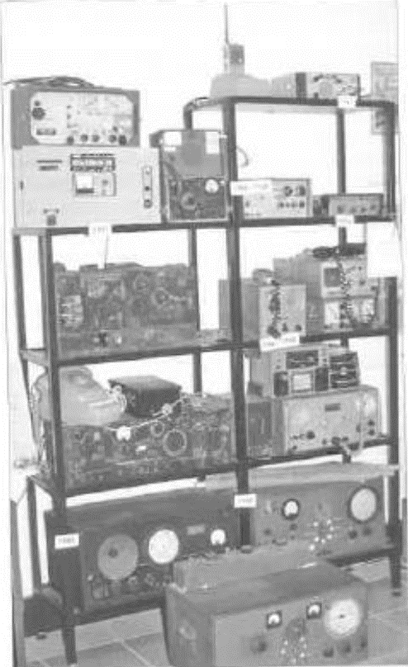
Ex RFDS (AM) sets Kalgoorlie RFDS – different brands.
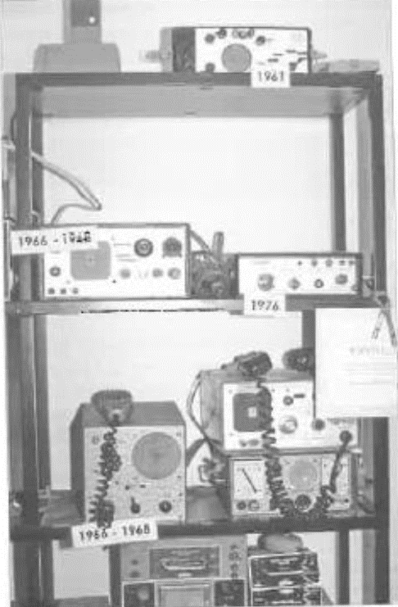
Ex RFDS (AM) sets Kalgoorlie RFDS – different brands.

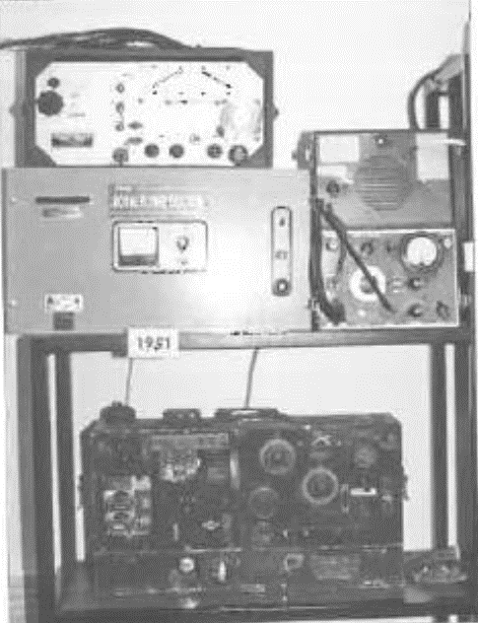
Ex RFDS (AM) sets Kalgoorlie RFDS – different brands.
Now it was time to see a resurgence of rugged, truly portable, transceivers.
In 1951. Traeger built the 51MA - a set designed to be used anywhere. to be able to be treated roughly, and still work. It consisted of a case within a case. Between the two cases there was sponge rubber which shock mounted the actual set. To change frequencies, a modified version of the time renowned plug-in assemblies that Traeger had used for nearly 20 years, were used again. The set was not as powerful as the 48S20 having an output of about 7 watts from a 6M5 valve which was driven by a 6N8 oscillator. It was very adequately modulated by a “push-pull” pair of 6M5 valves. The receiver used a common valve line-up of the day, a 6N8 RF amplifier, 6AN7 converter, 6N8 IF amplifier, 6N8 detector and first audio, and a 6M5 audio output. Traeger had changed from using battery valves to exclusively using AC type valves. They were more reliable than the battery valves which have rather fragile filaments. The set still worked with the time-proven aerial and tuned counterpoise that Traeger had found to be so successful.
ELECTRICAL INTERFERENCE
Even in the very early days of the Aerial Medical Service CAMS) there were problems of electrical interference to the operation of the base station at Cloncurry. Electric motors, generators, and spark ignition engines - cars and stationary engines - were probably the main sources of interference that Mauric Anderson had to contend with. It has not been specifically stated in any records, but it is believed that Mauric went around Cloncurry fitting suppressor capacitors to offending devices so that radio reception was the best possible.
Additionally, residents complained about interference from the base station transmitters to their receivers. The problem here was due to the inadequate design of the receivers which made them susceptible to the presence of transmitters in the vicinity. Shifting the whole station to another site was thought of but this did not occur until after WWII.
The problem of interference from electrical apparatus in the neighborhood continued to be a festering sore. At times the interference was so severe that it made reception of radio transmissions from the various homesteads impossible. The attitude of many people causing the interference through the operation of electrical equipment was ‘tough it’s your problem not mine”. They could not be convinced, and refused to be shown that their selfish attitude could result in the death of someone way out in the sticks. Regrettably this same attitude still persists today, although there are those who are most co-operative and make every effort to avoid causing any disturbance to radio reception.
Today there are Electro Magnetic Compatibility and Electro Magnetic Interference regulations in place which are designed to overcome interference problems. Regrettably, the majority of electronic equipment, appears not to comply even though compliance stickers as attached to the equipment, Compliance stickers are cheap! There appears to be little or no policing of the standards by the Australian Communications Authority. So even in the 21st century we are still no nearer to controlling interference than we were at the beginning of the 20th century.
As radio equipment improved, various means were evolved to overcome, eradicate, or reduce interference to base receiver reception. Automatic noise limiters in receivers were of limited value, as have been noise reducing aerial systems. As time went by the interference sources previously mentioned were supplemented by many other sources. High voltage power lines can be a potent source of interference even today, as can television sets, computers, and a myriad of other domestic electronic equipment.
The most effective method of reducing the electrical noise into the receivers if to move the receivers away from the noise sources. This involved setting up several receivers at some remote location in an electrically quiet area, well away from the town or city in which the base station was sited. The receivers in most cases were powered down telephone lines (underground where possible), which also carried the audio from the receivers to the base station. This provided a quantum leap in the ability of the base station to hear weak stations. In some cases, stations that previously could not be heard became quite clear and “relaying” via stronger out-stations became unnecessary.
Certainly, the RFDS base stations still use remote receivers to achieve the ability to receive weak signals dearly. Other organisations do the same, including in the past some rural fire brigades when HF radio communications were being used.

REMOTE RECEIVERS AND BASE STATIONS
In 1951, Cloncurry base station did get a remote receiving station. It was located several kilometres out of Cloncurry in a radio interference free zone. It was connected by telephone lines (land lines) to the base station. I do not have information on how the receivers were fed the power to operate them.
The Charleville base was established in 1943 and was erected around five kilometres south of the town to avoid interference problems. It was not remotely controlled. The base transmitter(s) had a power of 200 watts in 1956.
The Broken Hill base was established eight kilometres out of town in 1938. Once again this allowed interference free reception and the ability to install sizeable antenna.
They all found it necessary in the long term to have remote receiving, and in some cases remote transmitting facilities, because of the interference problems.
In 1949 Graham Pitts arranged for a remote receiving installation for the Alice Springs FDS. This was, and still is, located around four kilometres north of the old telegraph station, in an area that has no electrical interference. It was connected to the base station by a three pair telephone line.
Around 1960 Graham Thornton arranged for a remote receiving facility to be installed at Derby at the same time as the station was commissioned. The receivers were located around 10 kilometres out of Derby in an electrically quiet area.
It would appear from all the information available that all RFDS base stations had remote receiving sites after WWII. Certainly, any new stations installed during WWII had either a remote receiver, or the actual base station was located out of town away from interference sources.

BASE STATION TRANSMITTERS
Prior to WWII the base transmitters used by the Flying Doctor Service and other organisations were predominantly “homemade”. Even when the transmitters were made by organisations such as AWA or Traeger Transceivers they were very much “one offs” as there were only a few base stations. Alice Springs was equipped with a 300-watt three band transmitter, using high level plate and screen modulation. However, AWA was a much larger company with a much larger area of influence throughout Australia and the pacific region. This meant that small production runs of transmitters and receivers could be undertaken. They produced some impressive equipment. Most organisations had power limitations placed on them by the PMG department of 50-watt voice (AM) for a base station. The FDS appeared not to have been bound by the same power limitations, due to the long distances over which each base station was expected to operate. Transmitter powers of 200 to 500 watts AM are claimed to have been used in various base stations. Whether these powers were input, or output is unclear.
Following WWII many ex-service radio transmitters and receivers came onto the market at “fire sale” prices. The FDS was always run very much on a ‘shoestring budget”, so access to these readymade transmitters and receivers made life so much easier for the base station operators. Some of these had to be modified so that good quality voice transmissions could be achieved. The morse code facility that was standard on the transmitters and receivers was ignored, as It was no longer used by the FDS or other organisations, as all transmissions were now by voice. Anyone endeavouring to use morse code were encouraged to install a modern voice set.
Ex service transmitters included the AT14A Thom and Smith 300–400-watt output transmitters. Modified AT13 transmitters of around 300 watts output were also used. Zephyr Products produced the 300AM transmitter. It had an output power of 300 watts on amplitude modulation (voice) on three channels over the 1.6 MHz to 10 MHz frequency range. Usually, one transmitter was used on each licensed FDS frequency so that it was possible to operate more than one transmitter at a time or change frequency quickly. The transmitters were capable of transmitting on several frequencies, but it would have taken a minute or two to change from one frequency to another, which was far from convenient. Additionally, this was a technical job that non-technical operators often had trouble accomplishing with ease. Frequency agile equipment that we are familiar with today just wasn’t available in the 1940s and 50s and even in the 60s.
Initially, until such time as powerful transmitters and sensitive receivers could be purchased, sets such as the 20-watt Traeger 48S20 were used at some of the bases. The signals would certainly have been inferior compared to the later 300-to-400-watt transmitters.
Prior to WWII most receivers would have been home made with a sprinkling of commercially made equipment. After the war two receivers commonly used by the FDS were the American BC348 and the Australian made Kingsley AR7.These sets were easy to use and gave good performance.
More information on the remote installations appears in Appendix 3.

CHAPTER THIRTEEN

SOCIAL AND EDUCATIONAL RADIO - 1951 ONWARDS

Alf Traeger and the Reverend George Scott started installing the first of the pedal radios in June 1929. All involved were very excited about these new and marvellous pedal radios which would allow them (the people in remote areas of Queensland) to communicate with the flying doctor base at Cloncurry, and hence the world.
Initially at least, these new and frail pedal radios were installed so that help could be summoned quickly in medical emergencies. The Reverend John Flynn however, had ideas of a much broader use for the transceivers. In 1925 when he and George Towns were doing their communication experiments in the outback, they visited many outback stations. He saw that the children only had correspondence school facilities which were quite limited, having only been started in South Australia in 1920. ‘to be able to talk with a teacher over a radio system would be an ideal way to improve their education,” he thought. Flynn lived long enough to know that his dreams of 1925, of education over the radio, were starting to take place from Alice Springs. I’m sure he saw many future uses that others would only come to grasp as they occurred.
The Postmaster General’s department (PMG), (the radio licensing authority,) were not renowned for their help, and often put obstacles in the way to discourage potential users of radio communications. They could have been described as obstructionist. Many of the PMG officers would be hurt to hear such things said about them, when in reality often their motivation was for the radio spectrum to be used economically by competent people. It is only in the last few years that an encouraging attitude has prevailed in regard to the use of radio communications. Cynics would say this has much to do with the amount of revenue generated by licence fees for Government coffers!
The fact that Flynn was an extremely persuasive person is well known to anyone who has read the many books about him. The Government kept a very firm hold onto the use of the radio waves (spectrum). ANYONE who wanted to be able to transmit signals as well as receive signals had to hold at least an experimental licence. An experimental licence was only granted after the applicant had proven himself/ herself competent by-passing examinations conducted by the PMG. The examinations consisted of four subjects, the first two were written tests and the last two were practical tests. They were, (1) wireless technical theory (equivalent to a car mechanic of the time), (2) wireless operation regulations (the driver’s licence of ‘the radio waves), (3) a receiving test in morse code and (4) a sending test in morse code, both at a speed of 12 words per minute. This was the level required for an experimental or amateur radio certificate of proficiency. How many people in the outback had ever seen a receiver, let alone a transmitter - few, if any, I suspect. Having never seen wireless equipment, there would have been no reason for any of the outback folk to learn about wireless, many were semi-literate, and books on these technical subjects were nonexistent in the outback areas. To learn morse code - well, that is often a big ask for those who have access to tutors in the subject - without a tutor it would be almost impossible.
Flynn was able to persuade the PMG officials to waive the requirement to have an Operators Certificate of Proficiency. That was a very highly prized concession. Without the concession, the radio communications networks could not have been established - at least not legally. Operations would have to take place illegally without licences. The penalty for unlicensed operation, or even the possession of transmitting equipment without a licence, was a fine of up to £1,000 ($2,000) on each charge, and confiscation of the equipment. Remember the average wage of a radio technician at a radio station in 1929 was only about £6 per week. It would not have been worth the risk of establishing such a service without licences. The base station operator was required to have an Operators Certificate of Proficiency, which was reasonable, considering the technical and morse code abilities that he needed to do the job competently, and the potential output power of the transmitting equipment he was using.

REV. SCOTT CHURCH OF THE AIR
Whilst Traeger and the Rev. Scott were installing the pedal radio at Gregory Downs station, a picnic race meeting was being held on the banks of the Gregory river. There were approximately 200 people in attendance. The race goers marveled at the new radio equipment. which included Traeger’s own voice transmitter as well as the pedal radio.
Rev. Scott. having assisted Traeger install a couple of the pedal radios, could see that the pedal radio had a much greater potential use than just for medical emergencies and business telegrams. With so many race goers as a captive audience he grasped the opportunity to show them how the pedal radio could be of value to them in everyday use, and to spread the Christian message. Scott arranged that on the Sunday of the race meeting he would address his Sunday School pupils who would be assembled in the Cloncurry Presbyterian Church vestry. This was accomplished via Traeger’s voice transmitter. He even planned to conduct the evening worship service the same way, but a grass fire near Gregory Downs caused the service to be cancelled. This was undoubtedly the first Sunday School address ever conducted over a communications radio network. It is not known if Church service or Sunday School lessons ever featured in the activities of the network again.
It is doubtful that the PMG would have approved of the network being used for church services anyway. However, the normal AM broadcast radio services did, and still do. broadcasts Christian church services and programs. In later years the “school of the Air” has religious education as part of the extracurricular program.

DIVERSIFIED RADIO USAGE
The PMG department didn’t officially approve of this activity on what was a communications network. It was not an entertainment cum broadcasting network as some were tending to use it for occasionally. However, many of the enlightened PMG officials knew that that unapproved activities were important to the well-being of the people of the outback and chose to ignore what they could. Some people stepped over the boundary of commonsense from time to time. and were admonished for their misdeeds by the base station operator. The base station operators took their responsibility very seriously. If this did not achieve the desired result the PMG would admonish the misguided operator, and quite rightly so.
The radio network expanded gradually and its use for various purposes other than medical emergencies also expanded.
Right from the beginning the network radio communications consisted of many telegrams to outside bodies. These were for the purposes of running the business (homestead, station) by ordering goods for the operation of the enterprise, or for personal items, to sell produce such as wool, cattle or what, to keep in contact with friends and relatives when letters were just too slow.
This is another area where the PMG had a problem. Telegrams involved messages being received via the radio base station and then being sent over the PMG official telegraph network. There were problems with the legality of how they were being sent, the collection of revenue. etc. It seemed just too hard for the PMG.
Eventually a compromise was agreed upon, and the PMG and the Cloncurry station each collected a portion of the telegram revenue.
The (Traeger) transceivers were placed at strategic locations to assist people obtain medical aid and other benefits in remote area. They were installed by the Australian Inland Mission (AIM), a branch of the Presbyterian Church, at no cost to the users. There were two reasons for this. Purdy, Amalgamated Wireless Australasia (AWA) held most of the patent rights on radio equipment, but Ernest Fisk, manager of AWA was prepared to waive royalties while the service was not profit making. Secondly, most people in the outback could not afford to purchase a radio.

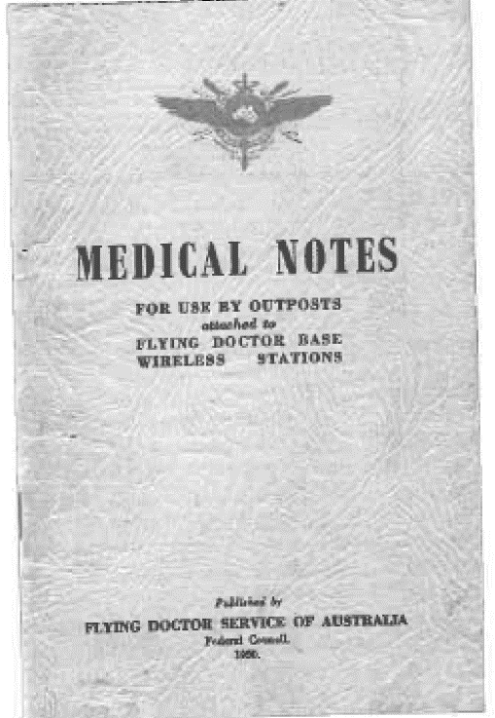
Front Cover of “Medical Notes” (1950) for outposts, which contains concise notes on first aid and administering of drugs under the guidance of the Flying Doctor.
The depression also meant that things were tough and very little money was available for the radio equipment that was being supplied to the Cloncurry radio network by the AIM. The Church was able to scrape through financially, but only just.
It certainly seemed that, not only were there technical problems concerned with the establishment of the radio network, there was plenty of red tape and very little money to keep the flying doctor service flying. It is to Rev. John Flynn’s credit that the red tape was cut and with the help of loyal stalwarts enough money was made available to keep the whole flying doctor service operating. Without his persuasive actions on behalf of the people in the outback, the radio network may not have become a reality until acme World War II, if at all.

THE “GALAH SESSION”
During 1935 all new pedal radios came equipped with voice (AM) transmission ability as well as morse code (CW). This meant that, as more and more sets had voice transmission capability, they could now hear each other’s voices. Imagine - they could then talk to each other in adjoining stations (homesteads) throughout the Cloncurry network. The abolition of loneliness in the outback had just taken a giant step forward. Most pedal radios site operated by the manager’s wife, or daughter. They may be the only female on the station and as such were desperate for the sound of another female voice, someone that they could talk “girl talk” to.
General chit-chat even at this stage had not been approved of, so the talk between stations was not officially accepted. It was eventually and reluctantly sanctioned, and a “good old chin wag” could then occur outside of normal operating hours, providing no emergencies were in progress, and the base station approved. Generally, the frequency used at that time was 2020 kHz, Casual conversations occurred mostly at night after the day’s work, and the evening meal, had finished.
The ability to talk with neighbours by pedal radio was welcomed with open arms. The men as well as the women participated in this opportunity to talk with one another. These chat sessions quickly became known as the “galah session(s)”. This occurred after a lighthearted remark Traeger made to the nursing sisters at Birdsville, about the galah’s that were damaging their radio aerial.
The “Galah Session” became a very important part of the fabric of social life in the outback. The opportunity to talk with neighbours about common interests, made life just that much more bearable. They came to know each other even though they were many hundreds, and in some cases thousands, of kilometres apart. The children also could chat to other isolated children, although at this stage this was probably relatively rare.
Necessity is often called the mother of invention. Over a period of time a lady and a gentleman conducted their romance over the radio network, as the distance separating than meant meeting each other often was impossible. Even though voice (AM) transmitters were in operation by the mid-1930s. they decided for privacy reasons that they would conduct their romance by morse code. Perhaps some of the other homestead operators would have learned to receive morse code if they had realised that some interesting discussions were ‘taking place by way of morse code”. The base station operator would have been able to read and understand all that was being said, as he was very competent with morse code receiving (and transmitting). He probably tuned in to the conversations from time to time but would have kept anything he heard to himself. He had to sign a Declaration of Secrecy which stated he was not to acknowledge the existence of message not intended for his station (the base station), except to (PMG) departmental officials. The base station operators took their responsibility very seriously.
The “Galah Session” started “officially in late 1935 in the Cloncurry network. Two networks in Western Australia also commenced operation in 1935, so the “Galah Session” came as an integral part of these new networks. but on a frequency of 1600 kHz. not 2020 kHz as used by Cloncurry.
At this stage the pedal radios had an output power of 15 to 2 watts. Even when they were coupled to an efficient aerial earth/counterpoise system, radio reception between the various out-stations and also the base stations, was often poor. In these times, at the beginning of the 21st century, we would not put up with such poor reception. In the 1930s any reception was better than nothing At times though, reception was excellent.
The power of the radios increased to around 3 watts. particularly when they became powered by vibrator power supplies from 6- or 12-volt batteries in the late 1930s and early 40s. With each increase in power, reception improved. It cannot be emphasised too strongly, what a difference it made to lives in the outback, when people in so many of the remote areas could talk to someone else. This helped to overcome the great loneliness that so many suffered, particularly the women. There were no telephones in the remote areas at this time. Telephones are a relatively recent reality for these people.
As telephones became more readily available in the 1980s and 90s. the “galah session” was discouraged. “You’ve got the telephone, so use it, and don’t clog up the airwaves”, seems to have been the message given to the people. Some people still use 2020 kHz for the “galah session, but not to the extent it previously was. This has had the effect of once again, isolating people, as ALL telephone calls are at STD rates because of the distances between stations. People would talk on a one-to-one basis over the telephone whilst keeping an eye on the time of the call, and hence the cost. What is now missing with the use of the phone. is a sense of community togetherness in the outback that the “galah session” fostered. A giant step backwards for technology! One slight bright light in recent times has been the relatively cheap STD calls available between seven pm and midnight. However, it still doesn’t give these people the ability to talk to each other in a group, as they would in a “get together” at the local pub or ball. This was the type of “community” that the “galah sessions” provided.

OUTRACK RADIO AT WAR
In 1939/40 the second world war commenced. Initially not a lot happened in Australia as Europe was the centre of the conflict. After the bombing of Pearl Harbour, the war seemed a little too close for comfort. The effect was like stirring up a beehive with a stick, and military activity in the northern part of Australia commenced in earnest. Restrictions were placed on the use of the ten flying doctor radio networks. The military requested any information on unidentified aircraft or unusual activity in the immediate area of each outpost. The outposts became part of the militaries North Australia Observation Unit (NAOU). The outposts of the flying doctor network had to be rather more circumspect in their conversations, so that nothing of value could be gleaned by the enemy from the day-to-day radio communications. Information on anything strange would be given to the base station by seemingly innocent remarks in normal conversation. There were around 200 sets in the outback by the outbreak of war. How many assisted the military in this watching brief is unknown, but all would have taken the request for help most seriously, as their little bit to help Australia win the war.
Maurie Anderson the base station operator in Cloncurry moved in 1939, to start the Alice Springs flying doctor base. In 1940 he joined the RAAF and worked In collaboration with the army as a radio officer with the North Australia Observation Unit. He died from cancer in 1960 at the relatively young age of 52. He was sadly missed in the flying doctor networks. The people of the outback were proud that, even in their isolation, they were able to help defend their country through the use of their eyes and can, and the pedal radio networks.

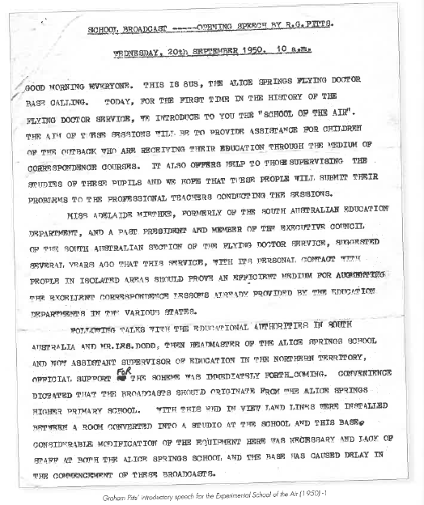
Graham Pitts introductory speech for the experimental “School of the Air” (1950)

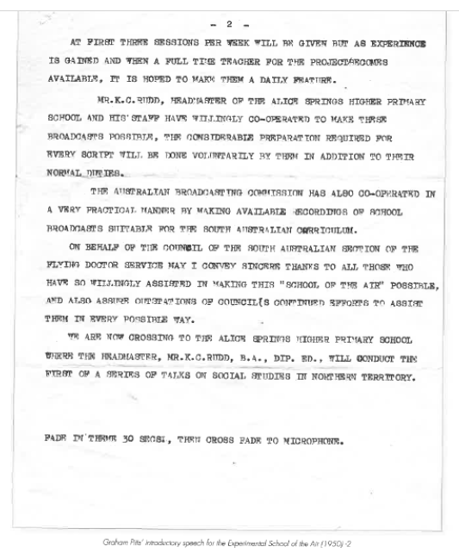
Graham Pitts introductory speech for the experimental “School of the Air” (1950)
IMPROVED RADIO RECEPTION
Even with the 3-watt pedal radios it was not easy to contact the base station, or other out stations, and many repeats were often required if a message was to get through. It was difficult to get clear messages through when most signals were weak and noisy. In the northern areas of Australia thunderstorms are common, particularly in summer. This means that there are heavy static crashes in the radios which overpower the weak outpost radio signals and even the much stronger base station signals. At night on the domestic AM broadcast band, radio signals (531 to 1602 kHz) from distant stations often fade and suffer distortion. This phenomenon was a constant companion of the short-wave radio signals emanating from any of the flying doctor radio networks. This problem is not quite as evident since the advent of single sideband transmissions. Reception wasn’t always terrible, but times of good radio reception were bliss to operators.
In 1945 Traeger produced a much more powerful transceiver in the 45A20, with a radio frequency output power of 20 watts. Better known is the 48S20 of 1948 of similar output power. These sets provided a quantum leap forward in the strength of the received signals compared to their predecessors with 3-watt outputs. It also meant that signals were clearer and fewer repeats were required and good reception day and night was more common. Sets of this calibre required much more electrical power to operate them. However, by 1948 electric lighting plants and vehicles were relatively common which meant that supplying power to the “pedal” radios was so much easier than in the 1920s and 30s. The outback radio transceivers at this stage were not pedal radios, although the name “pedal radio” persisted long after the radios were no longer powered by pedal generators. The 48520 ran from 12 volts DC, the high voltage for the valves being provided by a vibrator power supply, whilst the 12 volts was used directly on the valve filaments and heaters. The 12 volts was supplied either from a battery specifically used for the radio, or from the station homestead lighting plant. Some sets were designed to operate directly off 32 volts DC.
With the improved reception the flying doctor radio network users started to find more uses for the radio network. Life in the outback was once again on the improve.

SCHOOL OF THE AIR
Outback families have always had to take a proactive attitude to education for themselves, and particularly, their children. Around the turn of the 19th/20th century no formal education was available to anyone living in the more remote regions. A large percentage of the people came from populated areas and did have some formal education and could usually read and write. The children born in the outback were lucky indeed to have any formal education and, in many cases, would have been illiterate. Mothers did provide what education they could for their children, amongst the heavy workload of the everyday station and camp life.
State correspondence schools were established in Victoria and New South Wales in 1916. Western Australia in 1919, Tasmania in 1919, South Australia in 1920, and Queensland in 1922. As the years went by children were slowly enrolled with the correspondence schools. Mothers (and governesses in the case of the wealthy) provided schooling along with the correspondence school material. There was quite a delay between the time a child completed an assignment. sent it away, had it corrected and received it back. By the time the child received the corrected assignment the contents would not be fresh in their mind, which reduced the effectiveness of the teaching.
People naturally associate Rev. John Flynn with the outback and the REDS. The trials and tribulations that he went through to make living in the outback bearable, arc well known to many, with but a few glimpses given in this book But there was another equally determined crusader for these isolated people, this was Miss Adelaide Meithke OBE. She is not warn known to the general public, but her contribution to the education of children in the outback is legend. She could see that the children were severely disadvantaged in the quality and level of education available to them. Her life had been devoted to the education of children, having been an Inspector of Girl’s Schools in South Australia. On occasions she had travelled into the outback and had seen how children received their education via the correspondence school. Good though it was, she could see that something better was needed if children were to get a comparable education to those in more populated areas. It was during a trip through the territory covered by the Alice Springs base, around 1945/6, that the problem became distressingly obvious to her.
The question was, how an education of a high standard be provided for these isolated children? Although retired, the problems of “remote” education weighed heavily on her heart. Rather like Flynn she mulled over ways in which the problem of educating children in remote area, could be overcome.
In 1945 she was Vice-President of the South Australian Section of the Flying Doctor Service (FDS). Her keen interest in education of children and the FDS, ultimately gave her the idea of how isolated children could receive a better education.
During a trip to Alice Springs in 1946 she talked With Graham Pitts the director of the flying doctor base. During one of these discussions, he mentioned that a popular nursing sister from the hospital had given a health talk over the radio system to the isolated mothers. It had been very well received and proved productive. The way to improve the education of the children was Immediately obvious to Adelaide Meithke. She asked Graham that if mothers could be talked to and obtain good health information, why not do something similar with the children and their education. Graham replied that he thought it could, but he”d have to think about it.
She mulled over how children could be taught via the radio in a way that was effective. The children were used to seeing their parents use the radio, and it would not take much tuition for the children to become proficient in using the radio too. Some children were already using the radios quite competently.
She thought about this, talked to various people in education circles, and to radio technical people, particularly Graham Pitts. Gradually methods of providing education via the FDS radio system were formulated. Like so many new and innovative Ideas, it had no active support from within the hierarchy of the Education Department. She had to go it alone. She had support at lower levels of the Education Department in Alice Springs, and on the technical side from Graham Pitts.
Then were naturally many problems to be solved, but like Flynn before her, Adelaide Meithke was a persistent crusader for her task. Over the period from 1946 to 1950 the various problems were looked at, discussed and finally solved.
The teachers who were to reach the children over the air had to have rather special qualities. Their voice must be clear and friendly conveying a love of children, they must be interested in, and get to know about life, on the isolated stations and particularly the children’s’ interests; be very dedicated to the children’s’ education and be prepared to go that extra mile. A mediocre teacher would never be successful in this demanding role.
Equally, Graham Pitts had the self-imposed task of working out the most practical and effective way that the FDS radio network could be used to achieve the best radio reception. This was certainly not just a case of turning the transmitters and receivers on, speaking into a microphone, and expecting it all to happen. Basically, this is what does happen, but the fine tuning of any new and innovative idea, to get the best out of it, takes time and effort.
When the first experimental broadcast transmissions were to take place, teachers willing to take part had to be found. Leslie Dodd, Headmaster of the Alice Springs Higher Primary School had enthusiastically embraced the concept from the beginning, and when he asked for volunteers to take part in ‘school of the Air” he had 13 volunteers who were prepared to “give It a go”. (Graham Pitts opening speech shows that although Leslie Dodd organised most of this, Mr. Rudd his successor actually carried it through).
On September 20, 1950 the first of the experimental School of the Air transmissions took place via the flying doctor radio base station in Alice Springs. Graham Pitts opened the first of the experimental broadcasts and a copy of his speech is printed in this book. These broadcasts continued and were successful in blazing the path for the permanent and official ‘school of the Air” to be launched in 1951, from Alice Springs.
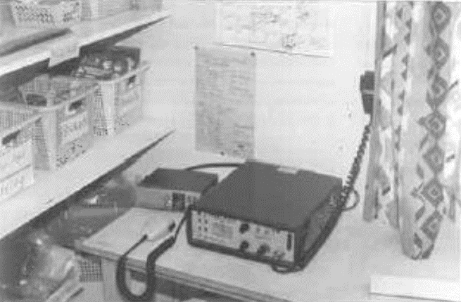
School of the Air transceiver at Mt Barry Station South Australia.

During this experimental stage it was found that it was necessary to use two radio frequencies to effectively cover all the out stations involved in the School of the Air. Short wave radio signals are subject to skip, where stations close to the base may not hear the radio signals, but those further away will. By the choice of another radio frequency, it is possible to transmit and receive signals effectively. reaching the arms where the other signal cannot be heard. (See Appendix 5 for more details). Graham was also asked whether music could be played over the radio. A transmitter was modified so that it could reproduce music and singing satisfactorily. 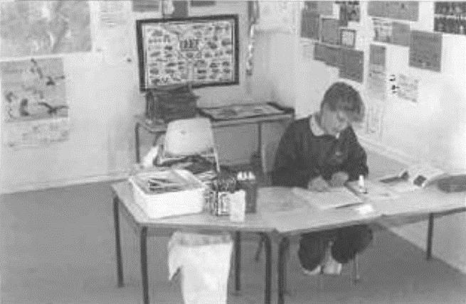
Student at Mt Barry Station S.A. School of the Air.
School of the Air has used a variety of systems to achieve the effective functioning of the service. For many years the FDS and later the Royal Flying Doctor Service (RFDS) radio networks were used to provide an education link to the isolated outback children. The ‘school room”, studio may have been at the FDS/ RFDS base, a separate building at the local primary school or a completely separate “school of the Air” complex. Today School of the Air, is completely separate from the FDS/RFDS, with its own communications network buildings separate from existing schools, but often on the same grounds, and teachers exclusive to the School of the Air although often sharing the same staff rooms. Today, School of the Air is more appropriately named, in most instance, ‘school of Distance Education”. 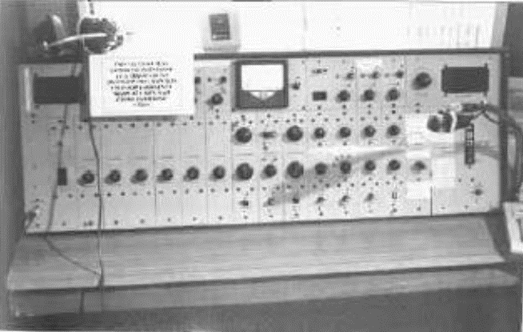
RFDS audio, transmitter & receiver control panel, Charleville, Qld.
After a six-month experiment, the permanent School of the Air was opened on June 8, 1951. From humble beginnings in 1951, more schools were established following the resounding success of the Alice Springs school. The New South Wales Minister of Education visited the School of the Air in Alice Springs some considerable time later, and was so enthusiastic with what he saw, that he promptly made funds available to establish the Broken Hill school which came into being in 1956. Other schools soon followed.
1956, the Anglican Bush Church Aid Society established a radio school (Ceduna, South Australia).
1958. Port Augusta was established, which Graham Pitts also commissioned.
1959, Meekatharra.
1960. Cloncurry (transferred to Mt isa when Cloncurry closed in 1964) and herby.
1962, Kalgoorlie.
1963, Charters Towers.
1964, Port Hedland.
1966, Katherine and Charleville.
1968. Carnarvon.
1972, Cairns.
These were all still operational in 1972.
By 1992. School of the Air (School of Distance Education) had 14 networks operating with Longreach added to the last.
By 1990 there were a total of 16 networks using HF radio, with Dubbo and Rockhampton added to the list. A number of VHF networks have been established in New South Wales and were active in 2001. These are centred on Bourke, Broken Hill (transferred from HF). Cobar. Hay, Tibooburra and Walgett.
School of the Air has catered mostly for primary schoolchildren, as most parents have sent their children away to boarding school, once they reached secondary school level. Correspondence school and School of the Air can only do so much. The extra facilities and social contact, that regular schools can provide, are essential for the complex, education of isolated children from the Outback. However, a few children have done some secondary schooling before going off to boarding school. In the 1970s kindergarten was started over the air, and in some areas it still continues.
Adelaide Meitike would be thrilled to see the idea she started back in 1945 proving to be so successful. Many thousands of children have benefited from her foresight. John Flynn also would be ecstatic to see his idea of radio networks in the outback being used to benefit the isolated children.
The School of the Air has not been a ‘stand alone” entity dealing with education. However, it has proven to be a powerful ally of the correspondence schools which have done such a marvellous job over the years. I can speak from personal experience, that the quality of information coming from the South Australian Correspondence School, has been excellent.
‘the Australian Broadcasting Commission (ABC), (now “Corporation”) had a program for correspondence students called “On Parade”. Whether it was sent out on short wave, the ordinary (AM) broadcast band, I don’t know. As a primary school student, in the 1940s and 50’s in a little one teacher school. I well remember the schools” broadcasts by the ABC on 3WV. I always looked forward to these as I found them so interesting. All of these broadcasts were done in such a way that it could be assumed that the person listening to the program, if blind, could understand it perfectly.
I was told during a visit to one of the schools in August 2001, about music being taught to a small group over the air. Each student had a different instrument to play, and none had heard how they would sound when playing together. They were entered into a competition and were to play as a group when the annual get together of remote students took place. The time came and they were all together. Their teacher had them practice together ONCE and then they played as a group and played as if they had been playing together for some considerable time. What an achievement for the students and their teacher. It says in me that the teachers using ‘school of the Air” to educate children are very dedicated. No mediocrity allowed here.
To assist the children’s’ education, teachers talk with the children’s mother/father or governess either over the air or in person about reaching methods, how to help little Johnny”, or any other thing that would help with the effectiveness of the over-the-air teaching.
People in the outback areas, have a feeling that they are Missing out on many things. The parents of the children want the very best for their children and take a very active interest in their children’s’ education. They encourage their children to perform to high standards and have the expectations that their children have the ability and will achieve these high standards. That this is so, can be seen in the way that the facilities are arranged for the children on many stations. The children have their very own school rooms with all facilities that the parents can provide. They usually have their own HF (VHF) radio for School of the Air. See the photographs of the school room at Mt. Barry station in this chapter.
Many teachers in schools in towns and cities would be ecstatic to have the same level of absolute support, given to teaches and children, that occurs in these remote regions. Does this say anything about the priorities we have in life!

THE PROBLEMS OF RECEPTION AND USING THE RADIOS
Some children found that the homestead flying doctor radio transceiver was difficult to operate. The Anglican Bush Church Aid Society at Ceduna used a simple to operate radio transceiver built in Victoria (manufacturer unknown). Graham Pitts endeavoured to obtain a number of them for the Port Augusta School, but the manufacturer of these sets was unable to supply them in sufficient quantities to fill the need.
Graham persuaded Alf Traeger to build a set similar to the ones used at Ceduna. The School of the Air Traeger - 59SA transceiver came onto the market in 1959. It was simple to operate, with two controls - on/off volume and channel change. The microphone had a press to talk switch. This set had a nominal radio frequency output of 10 watts. Quite often the children had ‘their” set for School of the Air, whilst Mum and Dad had the “big set in the house. In some of the School of the Air networks, sets were available on a rental basis for station hands, etc. Currently, transceivers and other aids to learning (teaching) are available for use by remote students.
Radio reception was often poor, particularly in the far north of Australia. and particularly in the months of September and October, with quite high static levels. It was so bad on occasions, that School of the Air broadcasts had to be abandoned until the storms were many thousands of kilometres away. In the early days of School of the Air when the RFDS transmitters were being used to conduct the service, emergency medical calls would call a halt to the school lessons. The children did however get quite a good grounding In para medical matters as a result of these interruptions.
Radio reception continually improved as better sets came onto the market, and when single sideband (SSB) transmission became mandatory, in 1978, reception improved markedly. SSB transmitters process the radio frequency energy more efficiently than the older AM sets, producing around eight times as much effective signal for the same amount of electrical energy. Hence the clarity of signals rose dramatically.
Whilst the use of VHF radio for School of Distance Education has been generally successful for students up to 120 kilometres away, interference from other networks (not necessarily schools) on the same frequencies, quite some distance away, has been quite troublesome. Signals are only heard out to around 120 kilometres in normal radio conditions. However, like HF radio, VHF does have Its own peculiarities which affect the distance over which signals are heard. Things like sporadic “E” propagation, and Tropospheric ducting, to name only a couple of phenomena, enhance the propagation of signals over hundreds, and sometimes thousands, of kilometres to the detriment of local signals.
To provide stronger signals into some areas, VHF and UHF links are used to connect with radio “repeater”, stations. The repeaters supply good signals into areas where signals are normally weak or non-existent (dead spots) - from the main base at Bourke, for example.
Hamilton Island, off the Queensland coast, has a number of children who are on the island for short periods due to the itinerant nature of their parents” work. It is not practical or economic to install a HF radio station for each child. Each child is issued with a UHF handheld transceiver, which they use for their link into the School of Distance Education. The UHF radios communicate with a UHF-to-HF (and vice versa) repeater station on the island. The children’s’ transmissions on UHF are received by a UHF receiver whose output is connected to a HF radio transmitter which via HF radio signals is picked up by the School of Distance Education base station on the mainland. The school’s transmissions on HF are repeated onto the UHF band on Hamilton Island and are received on the children’s’ hand held radios.

SCHOOL OF THE AIR - EXTRA CURRICULA ACTIVITIES
Besides teaching the three ‘Rs’ ”reading, riting and rithmetic”, various other ancillary activities take place. The School of the Air facilities have been, and are still used, for many extra curricula activities that help both children and adults overcome social isolation.
The various State Governments encourage a wide range of activities to do with education, health and social cohesion within these remote areas. Conducting such activities over the air is more cost effective and practical, than any other method currently available.
The following list includes some of the “extra curricula” activities that have been, and are, provided via either the RFDS, or the School of the Air radio networks: -
- individual “one on one lessons”.
- home tutor sessions.
- recorder (music) sessions.
- learning music.
- Science Club.
- religious education (Good News Club, and Scripture Club to name a couple),
- Craft Club,
- activity groups (computers, fitness),
- Writer’s Club on the Air,
- book reading on the air,
- guest artists and speakers - for example Her Majesty Queen Elizabeth II, and many others.
- There were also children’s chat sessions, Parent: and Citizens meetings.
- Isolated Children’s’ Parents Association meetings.
- Brownies and Guides of the Air.
- Cubs and Scouts on Air.
- Junior Red Cross.
- First Aid Club.
- Photography Club.
- Pony Club.
- Gould League (of Bird Lovers).
- Country Women’s Association (CWA) of the Air.
- Pet Club.
- Landcare Club.
- Fishing Club.
- Infant Health talks,
and perhaps other clubs that appeared and disappeared as interest demanded. At Broken Hill from time to time. the Department of Agriculture have conducted talks over the RFDS network.
The Isolated Children’s Parents Association hold meetings once a month after school hours.
Religious education has been presented over the School of the Air network, although this does not seem to have been available every year. It was given as a Christian non-denominational segment overseen by both Catholic and Protestant Church groups. Scripture Club - is the name that one group calls their religious education segment. In this particular instance it is conducted by the local Catholic Priest, although other denominations are welcome to be involved. The Rev. George Scott, mentioned early in this chapter, would have been thrilled about this segment.
Scouts and Guides over the Air commenced quite a number of years ago. Both are still conducted from various networks either by teachers in their own time, or by other interested men and women from the community. At Mt. Isa one lady has conducted this activity for around 25 years. It takes a lot of dedication to do this, even without the radio reception problems expressed earlier in the chapter. I can vouch for this personally, as I was privileged to be given the opportunity to sit in, and to talk on a ‘scouts on the Air” session in Cairns, in August 2001. The number of children “attending” varies from time to time, as does the location of the centre conducting the sessions. It can be as low as two, and as high as seven or eight, participants. 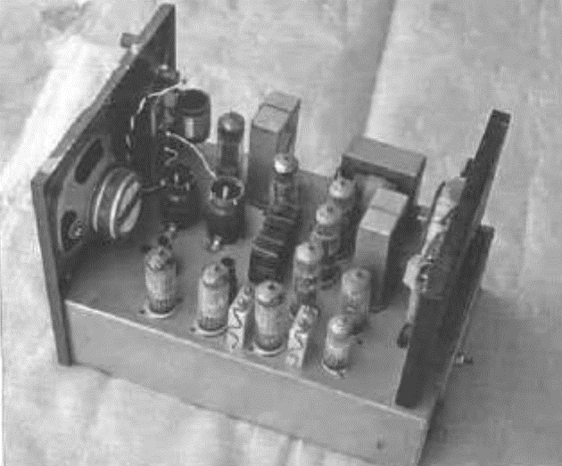
Internal new School of the Air transceiver type 505A
School of the Air does receive quite a lot of publicity. This is achieved through the various schools being thrown open to tourists to see what actually goes on. Hence many people come to know of this unique educational system. The number of children taught from each school varies. For example, (2001) Charters Towers has upwards of 400 to 450 involved in distance education with around 180 to 190 transceivers in use.
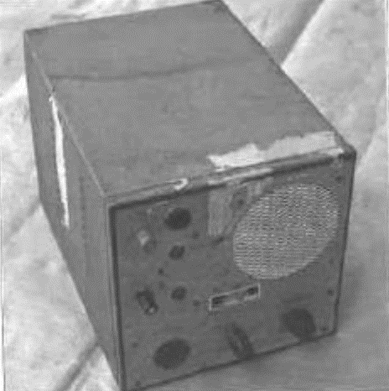
Unrestored School of the Air transceiver type 595A.
Whilst School of the Air continues, there are other educational mediums being used to augment it. There is a loan video service, whereby isolated children and parents can learn from educational videos. Some education has been provided via satellite to television receivers in the outback homes, while other children do their education not via radio, but by loudspeaker telephone.
School of the Air has been hugely successful. and this can be demonstrated by the number of students who have been through the system. Until the end of 1970 just under 4,000 students had been schooled through the service. Now, in 2003 how many thousands more have been through the School of the Air? It is recognised that School of the Air, and the Correspondence schools. cannot hope to provide some of the features that only the classroom can provide, but all sorts of innovative ideas are tried to improve the service even more, Congratulations.
Books and literature on the School of the Air are not common, but some of the schools do have literature, and some books have been written on the subject. I know of no books that are currently in print, however, then are a few worth keeping a look out for in secondhand bookshops.
“Bush Tracks and Radio Waves - A History of Port Augusta School of the Air 1958-1990” by Carrie Motley and Bill Starr published by Tread Softly Publishing 1990.
‘school of the Air” by Jean Ashton published by Rigby limited 1978.
“Over to You - The first 25 years of the School of the Air in Northwest Queensland” by Helen McKerrow, published by Mt Isa School-of-the-Air P & C. Association Publishers 1985.
A number of the schools publish “yearbooks” of the students” activities for the year, and these we worth reading too.
It seems that the era of School of the Air over High Frequency (HF) radio is nearly at an end. An article in the Melbourne ‘sun-Herald- for 4/3/2001 titled ‘school goes off air and on-line” tells of the anticipated closure of the HF radio teaching system within a couple of years. It is to be replaced by video and teleconferencing, CD-ROMS. and “on-line” technology. The clarity of voice with the new system will be better than the existing HF radio. With video, students will see their teachers and have things explained to them in much the same way as in a normal classroom.
Announcements in the media In May 2033 reveal that the ‘school goes off air and on-line” is well underway. It appears that the teacher will be able to see the student via internet video pictures (Webcam). The teacher will be able to see students” projects, their pet dog, the picture they have just drawn, and many other things of particular interest to the student and the teacher.

The first satellite linked experiments were conducted at Leederville in Western Australia in 1997, and the following year at Broken Hill in New South Wales. The children could see the teacher via the satellite link and a telephone line modem connects to the internet, was used to connect back to the teacher. Whilst it proved that the system had potential, the modem system was quite unreliable. However, like each new development. the problems will be overcome in time. The delivery costs are considerable, so appropriate funding limitations may slow the implementation of this method of delivering education to children (and adults) in remote areas. The transfer of the service completely to this medium would appear to be some time off yet. Meanwhile. HF (and VHF) radio still carries School of the Air broadcasts.

COUNTRY WOMEN’S ASSOCIATION OF THE AIR
The success of the School of the Air prompted one lady to ask the State Secretary of the Country Women’s Association whether something like the School of the Air, could be arranged for the women of the outback. Adelaide Meithke suggested a “CWA of the Air”. After some organising “CWA of the Air” became a reality. Meetings were held over the air, usually once a month. When this service came into being is not exactly known, but it was sometime between 1952 and 1955. Port Augusta commenced “CWA of the Air” on 30/8/1955. The idea caught or and the Gascoyne area of Western Australia commenced their “CWA of the Air” in 1956.
Information from here on a sparse, but it appears that “CWA of the Air” is no longer operating. It was still being enjoyed in the early 1970s, as a lady I spoke with took part in it when she and her husband were living at a lighthouse on an island off the Western Australian coast. Approaches to various groups has not brought forth any information as to when it ceased us operate, but no doubt it was missed by many. CWA itself, started in early 1928 and continues today, although the number of members has decreased in recent years.
HF radio has done a marvellous job over the last 50 years in its social and educational role but is now getting ready to retire and let the new exciting technology take over. Well done HF radio.

CHAPTER FOURTEEN

THE ADVENT OF TRANSISTORISED EQUIPMENT - 1959 ONWARDS

A LITTLE TRANSISTOR HISTORY
The ubiquitous transistor was invented, back in 1948, in America. It took a number of years for it to become a practical partner, and ultimately a replacement, for most valves. By 1956 there were small transistorised portable receivers being imported from Japan. I bought one in 1958 and what a horrible little thing it was. I was lucky to get any stations other than the very powerful 3WV which was around 150 kilometres away. Thankfully, transistors have improved tremendously since then. Australian manufacturers were also using transistors. although they were not taking advantage of the opportunity to reduce the size of their receivers.
The early days of transistors could be compared to the early days of valve development. The transistors used germanium semi-conductor material. Whilst good, it was found that the transistors were very susceptible to heat and slight over voltage, resulting in “thermal runaway", which destroyed the transistors. Initially they were quite expensive, and suitable only for audio and broadcast band AM receivers. Only low voltages could be tolerated, and the amplification factor was low. Circuit design was quite different to that used with valves more complex and less forgiving of design errors. One would have to think that, with so many limitations compared to valves, it would hardly be worth bothering to use transistors.
Equipment using the new transistors was built in a similar way to valved equipment, using in some cases transistor sockets and point to point wiring, a procedure which had been used throughout the valve era. Gradually the advantages of creating transistors as just "another component" to be fitted in a circuit, made printed circuit board (PCB) manufacture practical. PCBs meant that all pieces of equipment using a PCB were identical, with fewer chances of error in wiring. The early PCBs used copper tracks printed onto phenolic board. Phenolic board is still used but its reliability compared to the later fibre glass board is noticeably inferior, as it is not as strong, and tends to be hydroscopic (absorbs moisture).
In the late 1950s, transistors were not suitable for use in the radio frequency stages of HF transceivers, however, they were reasonably reliable for use in audio and power supply circuits.

POWER SUPPLIES
Audio power transistors presented an exciting opportunity to transceiver designers of developing high power, simple. economical (in both price and power consumption), compact. electrically quiet DC to DC power supplies. e.g., 12 volts DC to 300 volts DC. This was a major break through which assisted the development of compact high power HF mobile transceivers.
Vibrator power supplies had been powering transceivers since the late 1930s. However, they did have their deficiencies. Vibrators are an electro-mechanical device with moving contacts, and as such, they have a finite life. The vibrating electrical points spark as they make and break the electrical circuit hundreds of times a second. (The vibrating frequency is between 100 and 150 cycles per second but the make and break total is four times as high.) The sparking causes erosion of the vibrating contact points, and also causes considerable interference to reception in any receiver in the near neighbourhood. When the supply is mounted alongside the receiver, reception is impossible. The fact that vibrator power supplies were used in such close proximity indicates that methods of eliminating the interference were successful.
The suppression of the interference was achieved by placing the whole supply within a metal box and placing filters (radio frequency chokes (RFC) and bypass capacitors) in the leads going into the box. It was often necessary to employ 'one point earthing' within the box to prevent stray currents radiating interference.
The vibrator supply was a complex mechanical and electronic device, that was up to 70% efficient, bulky. heavy, expensive, and required regular maintenance.
In the late 1950s a number of high-power germanium transistors became available that would operate reliably up to a few kilohertz. Circuits were developed that used these power transistors to act as push-pull oscillators (switches) in place of the vibrators. It was also found that solid state rectifiers (silicon power diodes) could be used on the high voltage side of a vibrator transformer to convert the AC voltage to DC for the valves in the receiver and transmitter. Care was needed to ensure that the voltage rating of both the transistors and rectifiers was not exceeded, otherwise they would be destroyed. Valves and vibrators are much more forgiving of short-term overloads.
It was realised that the frequency of operation of the power supply oscillator was not restricted by the speed of a vibrating contact. Hence, the transistor oscillator in the DC-to-DC power supplies was increased in frequency to between 400 hertz and several kilohertz. This had the advantage that a smaller and lighter transformer could he used in the power supply. Ferrite cores also became readily available at this time, so most of the transformers were made with a ferrite core. All of these advances contributed to making a more compact, more reliable, more efficient (up to 90%), cheaper power supply that, due to its design, generated little or no radio interference. and had fewer parts. This was quite a quantum leap forward in the design of power supplies. The only thing that had to be carefully observed was the polarity of the power input to the supply. If it was incorrect, the transistors were destroyed instantly, often before the protecting fuse blew!

AUDIO USES
The next area of introduction of transistors was into the audio modulator of the transmittal and the audio stages of the receiver. Each of these moves meant that the transceivers became more efficient in their use of electrical power, and the size of the secs could be reduced. Gradually the bulky, power-hungry sections of the transceivers, were being replaced by electrically efficient, compact transistor equivalents.

TRANSISTORISED RECEIVERS
By the early 1960s, transistors had improved - their upper frequency of use had increased markedly, so much so, that a number of HF transceivers were being built using them in the receiver. However, all did not go as well as many initially expected, as circuit design for transistors, as mentioned earlier, is quite different to that used for valves. A number of designers tried to use valve design techniques with transistors and found, to their dismay, that they had to relearn their theory and design practices.
A number of the first transistorised receivers were insensitive, noisy, easily overloaded by the operation of nearby transmitters, subject to damage from nearby lightning strikes, and subject to failure from causes that valved equipment completely ignored. The Luddites would have said "I told you so". and continued on using valves.
The second generation of germanium transistors designed for radio frequency (RF) work (OC170, etc.) were noticeably better than the previous OC44 and similar types. With these new transistors, the "all transistor receiver” was now a viable alternative to "valved" receivers, and they became even more so as the years rolled by. The receivers were now largely built onto PCBs, so with the use of smaller components (including the transistors), quite compact high-performance receivers were the result.
In the mid-1960s silicon transistors started to replace germanium transistors. They had a number of advantages. They were not as sensitive to heat, and 'thermal runaway' was less common, the amplification was greater, the top operating frequency was much higher, they tended to be more reliable, and were no more expensive than the older germanium transistors. Today (2004) it is difficult to find any germanium transistors in use, except in obsolete equipment.
One very important property that transistorised receivers have is the minimal current that is drawn compared to a valved receiver of similar performance. A typical transistor receiver within a transceiver may draw from 0.025 to 0.250 amps (25 to 250 milliamps) of current from 12 volts, whilst a comparable valve receiver would draw 2 to 3 amps of current.
The fact that transistorised receivers consumed between a tenth and one hundredth of the current that a valved receiver did, for the same performance, was an enormous leap forward in design, particularly when only battery power was available. Receivers consuming only 25 mA of current were often left on permanently in the “receiver only” mode with no concern about flat batteries, particularly in vehicles.

HYBRID TRANSCEIVERS (Transceivers that use both valves and translators)
Valves were still in use in the RF section of the transmitters as suitable high power, high frequency transistors were unavailable at this time. In the output stage of the transmitter section of many transceivers powered from 12 volts, small transmitting valves such as the 6146 and QCOS/35 were commonly found. However, many manufacturers found that common, cheap, radio and television power valves, such as the types 6AQ5, 6BW6, 6CW5, 6M5, 6LDQ6(A/B), 12DQ6(A/B) worked very well in these hybrid transceivers. Transmitter output powers varied from around 7 watts output to nearly 100 watts in a set such as the Ferris “Marina 150” where two 12DQ6B valves were used.
On "standby"' when these hybrid transceivers were made ready to transmit during a “sked”, the total current drain was about 1 to 3 amps. depending on the size of the transmitter. When transmitting the current drain increased dramatically to between 3 and about 20 amps, once again depending on the size of the transmitter. However, as this only occurred whilst transmitting, it had little impact on the total power used from a vehicle or out-station battery. Once the sked was over the set would be returned to “receiver only” and the current drain would revert to around 25 milliamps as mentioned before. Later fully synthesised receivers do draw noticeably more than 25 milliamps.
Portable transceivers for use on 12 volts were now evolving into quite compact sets. For example, EILCO, an up-and-coming company. designed their Elko 6104 "lunch box" hybrid transceiver in 1961. It weighed around 4.5 kilograms, measured 105 mm wide by 280 mm long and 200 mm high, and was very suited for portable use in the outback. It proved to be very popular as it was rugged, reliable, light weight, compact and only drew 3 amps from a 12-volt battery to produce a genuine 8 watts of radio frequency signal. Like many of the earlier Traeger sets. It could tune most antennas via its inbuilt antenna tuner, which was adjusted for greatest tuning lamp brightness. It became almost a standard portable set amongst mining companies, government departments, church organisations, surveyors and to a lesser extent RFDS stations and School of the Air. Comparable transceivers produced by other manufacturers were bulkier, much more complex, not as easy to service or to set up on a new frequency. Arguably, It was the first of the small high performance HF transceivers of this era. 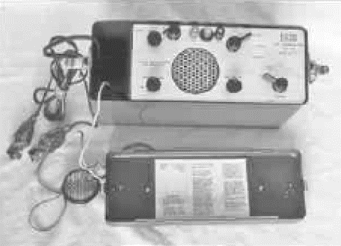
Elico 6104 (Codan), portable “Lunch Box” high frequency (HF) transceiver complete.
It has an eight transistor crystal locked receiver. with a total of four power transistors in the transmitter power supply and the modulator. The RF section of the transmitter has a 6CK6 crystal oscillator and a 6CW5 RF output stage.
The number of manufacturers producing hybrid HF transceivers, suitable for use in isolated areas, increased significantly. Among these were, AWA, Crammond. Elko (Codan), Ferris, Vaughan, Weston, and Traeger. The near monopoly that Traeger Transceivers had in being an exclusive supplier to the RFDS had come to an end.

THE WIDENING LIST OF HF RADIO USERS
The RFDS and the School of the Air, were now, not the only users of HF radios in the outback.
The advent of large mineral finds and gas/oil fields (such as Moomba) in isolated areas, placed huge strains on the PMG to provide telephone services, and in many cases, they were unable to do so. The mining/ oil/gas companies used the RFDS network to some extent, but their requirements became too great to be handled by that network, so they developed their own network. They had HF radio installations and could contact their head offices in the capital cities on a regular basis via HF radio. Remember, there were no communications satellites at that time. On a more local basis, sets were installed in vehicles and machinery to co-ordinate the operations. In some cases, this was on HF, and other cases, on VHF.
These new hybrid sets made it much easier to use the sets in a mobile capacity, hence pastoralists installed mobile HF sets in their station vehicles, with a base station at the homestead. They had RFDS, School of the Air and private (station) frequencies quite a number of frequencies in fact. At times the activities of various groups would conflict, hence two transceivers were often installed at the homestead. The children often had their own transceiver, exclusively for use on School of the Air in their classroom.
Government Departments also realised the value of communications and started to use HF radio extensively. Groups such as Aboriginal Affairs, Police. Surveying (e.g. Len Beadell), and Conservation are but a few of the groups that use radio communications. For those who didn't know of Len, he surveyed access roads for the Woomera rocket range throughout the outback, and sites for the Maralinga atomic bomb tests. The books he wrote on his experiences in surveying and making these outback roads are both humorous and fascinating to read. He was perhaps the last outback explorer.
High frequency radio communications throughout Australia has largely been concentrated in the remote inland areas. The exceptions are - the fishing industry, some government and semi-government departments, and amateur radio operators.
Around the populated fringe of Australia Very High Frequency (VHF) radio networks in the 70 to 85 MHz and 156 to 174 MHz ranges were very much the preferred option. Initially, the VHF networks used AM but as radio knowledge and ability improved, FM transmissions became more common. When transistorised transmitters became practical, FM transmission became the norm as high-power transistors were most suited to FM rather than AM at that stage. There was also no need of a high-power drain modulator.

MOBILE OPERATION
Up until the advent of hybrid transceivers, mobile HF radio operation was not particularly common. The usual procedure was to stop the vehicle at a pre-determined time (sked time), put up the wire aerial/antenna (approximately 13 metres long), tune the set, and call the base. With the higher-powered mobile transceivers and the more sensitive receivers, it was possible to talk whilst on the move, from the vehicle to base, and get reasonable communications. The antennas mounted on vehicles were much shorter than the 13 metres motioned above, being usually of the order of 2.4 to 3.6 metres long. These antennas were of a “loader type” that were resonant on each frequency used. This was achieved by the virtue of tappings on a coil. The two most common antenna types were. and are, the helical whip, and the less popular centre loaded whip. Whilst the efficiency of these antennas is not high, the extra power and sensitivity of the transceivers largely made up for this deficiency.

ALL TRANSISTORISED EQUIPMENT
Hybrid transceivers, using valves in the radio frequency section of the transmitter worked, and worked well. However, the production of transistors for use in AM transmitters was not progressing particularly quickly, and what transistors were produced were more suited to FM transmissions. The transistors that fed the radio signal to the antenna system could not tolerate any mismatching or mistuning of the circuits or maladjustment of the antenna system. This often resulted in the emission of copious spurious signals which interfered with other services and could cause the transistor(s) to fail.
However, by around 1970 some manufacturers had produced fully transistorised AM transceivers. The radio frequency power output was less than 10 watts in the early fully transistorised sets. They never became particularly popular as transistors suitable for the output of an AM transmitter tended to be expensive and relatively low powered. A valve in the output of the transmitter was still an economic viability. By the time that better transistors became available, AM transmissions were giving way to single side band (SSB). The era of the valve in mobile transmitters was nearly at an end.
Care was definitely needed in tuning fully transistorised transmitters so that spurious signals were not generated, and this can still be a problem, even today, with solid state transmitters. The higher-powered base transmitters were still using valves in the output. Transistors were still not suited for use in high powered stages and valve circuits were easier to design, cheaper, and rarely produced spurious emissions.
So hybrid and fully transistorised radio equipment made the use of HF radio much more attractive, and generally cheaper, than the “all valved” equipment it had replaced. The standard of manufacture had a bearing on the improved quality and reliability of the transceivers.
The PMG was fairly easy going in its attitude towards the technical standard (excellence) of the HF equipment that it approved for use. Generally, up until single sideband (SSB) equipment became mandatory, it was sufficient for a manufacturer to submit the circuit of a new model transceiver with data. Providing the circuit met certain design criteria, it would be approved. However, before each transmitter went into service a frequency check was required with one of the PMG Radio Branch monitoring stations to make sure all was well. Even homemade transmitters could be approved in this way - at least this was the case in the 1950s, when I built a set to operate on the local fire brigade network My design didn't pass official scrutiny!
During the AM era the PMG had specification RB242 which applied to AM communications transmitters. It was an easy but adequate specification to meet, and few sets would have failed when tested in the PMG Type Approval Laboratory.
However, problems were arising that were causing communications effectiveness to deteriorate. Because of the popularity of radio, an ever-increasing number of organisations were applying to install HF radio communication networks. Hence, interference from other services was becoming widespread. The PMG and the equivalent organisations overseas were finding it harder and harder to find radio frequencies to suit the requirements of various groups, and to keep interference problems to a minimum.
Radio technology had been advancing steadily and an answer to these problems became viable - single side band (SSB) transmission. The new incoming SSB specifications tested all manufacturers' design and manufacturing abilities, and many decided not to spend the time or money involved in upgrading their standards and disappeared from the manufacturing scene.

CHAPTER FIFTEEN

HF SINGLE SIDEBAND - ITS IMPLEMENTATION 1959 - 1978, AND ONWARDS

THE HISTORY OF THE INTRODUCTION OF SINGLE SIDEBAND (SSB)
In 1959 the World Administrative Radio Conference (WARC) was held to decide ways and means of using the radio frequency spectrum more effectively throughout the world. One of the matters discussed was the use of the high frequency radio spectrum. The use of this section of the spectrum was expanding rapidly. As a result of this expanding use, some method had to be found for using the HF radio spectrum more efficiently, and hence, allow access to it by more users. The solution for HF communications services was for them to convert to single sideband (SSB) transmissions. This system is almost three times as efficient at using spectrum space, as was the AM system in use at the time. AM systems were usually allocated channels 10 kHz apart to prevent services on adjacent channels interfering with each other. With SSB transmissions a spacing of (approximately) 3 kHz between services on adjacent channels proved to be adequate.
SSB had been used in telephone services on trunk routes for many years and had been used by a small number of amateur radio operators for a few years. Many of the delegates at the WARC conference had either a telephone. or amateur radio background and could see that SSB was the way that the aims of the conference could be achieved.

AM radio transmitters and receivers are relatively simple devices. They do not require a frequency accuracy, as set by the frequency control element in the equipment, of greater than around +/- 0.02%
(+/- 0.05% was more than adequate in most cases) and this accuracy is easily achieved. However. SSB equipment must have its transmitting and receiving frequency controlled to within +/- 50 hertz, which at 25 MHz equates to +/- 0.0002%, a 100 times improvement in frequency stability. This improvement in frequency accuracy would prove to be difficult to achieve.
It was not expected chat services would change immediately to SSB, in fact, it would not be compulsory to convert from AM to SSB until 1970 11 years on, and later for some services. This would give manufacturers time to gain the expertise to produce suitable transmitters and receivers to the new PMG and Postal and Telecommunications Department standards (RB208. RB209 & RB210) and give users time to amortise the investment they currently had in AM equipment. SSB equipment was expected to be more expensive than AM equipment, and it was.
Radio communications transmitters in the exclusively AM days were licensed for output powers between 25 and 300 watts. In the changeover period from AM to SSB transmission, it was expected that the SSB transmitters would transmit a signal that could be received just like AM, until such time as the networks were completely convened to SSB. AM and SSB modes of communication are not compatible. AM receivers could hear AM transmissions quite well but could only detect SSB as a distorted “duck-talk” signal. SSB transceivers could be heard quite clearly by SSB receivers, and with careful adjustment of the clarifier control AM signals could be resolved as SSB. However, this could only occur if the AM transmitter had the same frequency stability as the SSD transmitter, and most didn't. In this compatible mode (for the technically minded, A3H (H3E)) the transmitter transmits a carrier, as the AM transmitter does, but only transmits one side band not two as an AM transmitter does.
In this mode, many transmitters were licensed for I Kw output. When the networks all changed over to SSB the transmitters only transmitted one sideband (usually upper sideband) and no carrier (A3) (J3E) mode). The licensing authority (Postal and Telecommunications Department) expected the licensees to reduce the peak power from the transmitters in the SSB mode to 500 watts, possibly 400 watts. Information is not clear about the exact output power allowed to be used by the base stations in 1978. New stations today are licensed at 400 watts peak envelope power (PEP). Many existing licensees continue to use upwards of 1 Kw so that the service they provide is effective.
There was considerable resistance to the introduction of the SSB mode of transmission. After all, the AM method of communications had improved so much since WWII, and particularly since transistors had become suitable for power supplies. modulators and receivers. Transmitters using transistors in the transmitter radio frequency output stage had proved difficult to design, and the power levels achieved had not been sufficient to oust valves from this job. However, there were many high performance, compact valves that performed well in this task. The improvements in the performance of AM communications was impressive, as transistors and integrated circuits made Improvements not possible with valves, and many believed that more improvements were “just around the corner”.
It seemed to users, and many manufacturers, that there was no sensible reason to change to this relatively unknown, complex (technically) and expensive means of communications called single side band, as outlined in previous paragraphs. Was it just change for the sake of change, that some government departments were keen to foist onto people? Initially it could have seemed so.
What were the disadvantages of the new method of HF radio communications as seen by so many?
- Not many people knew much about SSB,
- It was known to be costly; sets were around two or three times the cost of a "comparable” AM transceiver,
- The electronic circuitry used was more complex than that used in AM equipment,
- The circuit alignment adjustments had to be done with greater precision than necessary with AM equipment.
- Maintenance would be difficult to arrange. as skilled technicians would be scarce.
- Not a technical problem - but why throw out perfectly adequate AM equipment, before its "use by " date?
- AM equipment standards and facilities had progressed in leaps and bounds as transistors became more common in radio transceivers,
- and, it suffered with a problem of "duck-talk" if it wasn't set up very precisely, and it could get out of adjustment easily. This very real problem has largely been overcome in the last few years.
“Duck-talk" was something that the general public found difficult to come to grips with when SSB initially commenced. "Duck-talk is the distortion and loss of intelligibility of the audio signal in the receiver when the SSB transmitter and receiver are not tuned to precisely the same frequency as each other, or at worst, within around 50 hertz of one another. This is the reason for the requirement of the tuning accuracy to be so precise as mentioned earlier in the chapter.
Many powerful organisations such as Defence. Maritime and the RFDS voiced strong objections to the implementation of SSB. The implications of the change to SSB were not understood by many private or government organisations. nor by many manufacturers. PMG/Department of Transport & Communications. Radio Inspectors were called upon to address groups of engineers and technicians to support the concept of SSB. Experienced officers, such as Rob Gurr (VK5RG), spent quite some time travelling and talking with various groups throughout Australia explaining the system and its advantages. Rob (along with many others) was well qualified for this task having been involved with SSB communications on a technical and operational basis since 1953.
So, what were the advantages of this new system.
- SSB transmissions only use around a third of the spectrum space, therefore more stations can be fitted in without interference. Each channel is nominally 3 kHz wide whilst for AM it is nominally l0 kHz-
- Total transmitting power required for the same communications effectiveness is considerably less. A 25-watt peak envelope power (PEP) output SSB transmitter will be at least as effective at a 100-watt (mean power) AM transmitter.
- Whilst costly initially, it would drop in cost as the new technology became mature. This would mean that, over time, it would be cheaper than comparative performance AM transceivers. This has occurred.
- It is less affected by selective fading of signals that causes considerable distortion to AM signals.
The target date for the changeover to SSB was initially set down for the 1st January 1970. The various problems with implementing such a new and radial system had to be solved, and they could not be solved overnight, hence the lead time from after the 1959 WARC conference.
There was, of course a problem that was unique to any existing services. They may have a number of relatively new AM transceivers in use (they couldn't wait for SSB equipment to become available), and they would then be recruited to change over to SSB exclusively in 1970. A two-stage approach was instigated to overcome this problem. All new SSB transceivers had to be able to operate on a compatible AM mode so that they could operate in an AM equipped service. In an AM service the technical advantages of SSB were being lost, but it was felt than this was the only way that compatibility could be achieved until the complete changeover to SSB occurred. Once the changeover date arrived the equipment would work exclusively on SSB. By having this staged changeover. AM sets would be working with compatible AM/SSB transceivers. so that the AM equipment could see out its economic working life. Then, on the changeover date, all sets would work on SSB. In many cases organisations made the change much more quickly than anticipated.
Many of the manufacturers who produced AM transceivers, particularly the smaller manufacturers, decided it would not be worth their while to upgrade to the production of SSB equipment. Many just ceased operations, whilst others branched out into other fields. However quite a few manufacturers did look at producing SSB HF radio transceivers. A few manufacturers actually bit the bullet and went on to produce equipment of a high standard. Some of these companies had been producing radio equipment for many years and some were relative newcomers to the field.
Throughout this book, Traeger Transceivers has featured prominently. Sadly, in 1979, Traeger Transceivers closed its doors for the last time as it went into receivership. Traeger had pioneered the use of HF two-way radio in the outback and produced over 3,000 transceivers, by the time of the closure.
It took longer than expected to get equipment up to a high enough standard to meet the PMG/Department of Transport and Communication's specifications. Negotiations took place and the final date for HF AM operation became 31 December 1977. Only SSB radio communications would be allowed after this date. Base stations were required to be capable of operating on AM and SSB by 1970, but this had to be extended as there wasn't enough suitable equipment available to change every base station by the due date. Most bases were convened by around 1973. Each network ran compatible AM until such time as all of their mobiles and out-stations were converted to SSB.
So, on the 1st of January 1978 all HF services were operating on SSB. A few AM services no doubt resisted the change, and continued to use AM until it became untenable due to peer pressure, interference, or through the licensing authorities leaning on them. The long-protracted changeover to SSB was now an established fact, and all services now enjoyed improved communications efficiency.
Almost all mobile SSB HF transceivers were totally transistorised. Drake (USA) did trial a hybrid transceiver, but it was never put on the market in Australia. Transistors had come of age, so much so that mobile and base nations up to 25 watts (PEP) were being produced using them. Base stations were still using valves in the transmitter power amplifier stage when 100-, 400- or 1,000-watts output (PEP) was required. Units such as the Codan 7021/7010 transmitter used low 4CX250 valves to produce an output of one kilowatt. Many of these transmitters are still in use with the RFDS. and other services 30 years after they were installed. A tribute to the quality of Codan design and engineering.
However, transistors suitable for higher power output in SSB transceivers were on the way, and during the 1970s mobile transceivers with outputs of 100 watts were coming onto the market. By the 1990s base stations of 400 watts output were common.
Today, to my knowledge, only three Australian companies supply HF SSB communications equipment, being Codan limited. Adelaide; Barrett Communications Pty Ltd, Perth; and Q-MAC Electronics Pty Ltd, Perth.
SOLVING THE PROBLEMS
OVERCOMING"DUCK-TALK"-IMPROVING FREQUENCY STABILITY
One problem that proved difficult to overcome was "duck-talk". Each transmitter and receiver on a particular frequency (channel) needed to remain accurately tuned to that frequency to overcome this problem. In other words, its frequency stability needed to be very good. Regrettably, in these early stages of the development of SSB, the transmit and receive frequency stability was not particularly good, and "duck talk” was all too common. The receivers had a 'clarifier' fitted so that the transmitted signal could be heard at its clearest when the clarifier was adjusted correctly. It often had to be adjusted to receive clearly each transmitter operating within a radio network. This was a nuisance to say the least. Initially it was thought that the transmitting frequency could also be adjusted as well, but this proved to be a bigger nuisance, and operators soon got sick of adjusting the clarifier all the time. The frequency stability of some SSB, transceivers proved to be so poor, that other stations simply couldn't adjust the clarifier control to resolve dearly what was being said.
This problem was caused by the grade of crystal oscillator(s) used in each transceiver. As the ambient and case temperature of a transceiver changed, the crystals changed frequency sufficiently that the signal either received or sent became garbled (duck-talk) - or became clear. Some crystals were not accurately manufactured to allow them to be adjusted to the correct frequency. At base stations, the frequency controlling crystal can be mounted inside what is called a crystal oven. The oven operates at around 60°C and a special crystal is designed to be accurate at that temperature. The base equipment therefore was able to stay exactly on its assigned frequency. Crystal ovens were put into some mobile transceivers, but the current drain on batteries was relatively high which meant that care had to be taken or the vehicle would have a flat battery and the advantages transistors had, of low current drain, was lost. It was also necessary to regulate the voltage going to the oscillator so that it remained constant as variations in voltage would also cause the frequency to vary. However, this was simple to implement and drew little current.
Over time, crystal oscillators have been designed which charge frequency very little over quite a wide temperature range. so crystal ovens are rarely required today. Although they are more expensive, these high-grade crystals are now incorporated into new transceivers as standard. However, sets normally only require one high grade crystal as will now be explained.
DESIGNING SETS WITH MORE THAN 10 CHANNELS - A CHALLENGE REQUIRING THE USE OF THE PLL OR FREQUENCY SYNTHESISER
Initially. SSB transceivers were only able to operate on 5 to 10 crystal locked channels, as the switching complexity became very high if more channels were to be used. This same restriction applied to the earlier AM transceivers too. This restricted many uses to operating with one organisation - such as the RFDS or with the Telstra Radphone - but not both.
This posed a dilemma for many operators and manufacturers alike, as many mobile transceivers were required to work in several networks, each using a different suite of frequencies. Hence, transceivers needed well in excess of 10 channels, and with one or two crystals required per channel, the cost of crystals for any set was becoming prohibitive. The crystals could cost $15 each (a median figure), and with 20 required the cost could be $300, a substantial proportion of the cost of a transceiver.
There had to be a way to reduce the spiraling cost and complexity of providing more than 10 operating frequencies. Manufacturers searched around and found circuit, that would give than the flexibility to provide many channels with only one (reference) crystal in use. These circuits are called, a phase locked loop (ELL), and a frequency synthesiser. In reality they are both used together each forming part of the whole circuit. The names are loosely used interchangeably. To change channels, small switches or a microprocessor alter parameters within the frequency synthesiser, causing it to change its oscillation frequency to another frequency with the accuracy of the reference crystal in the circuit. Purists may not find this description to their liking, but I am not trying to give a technical treatise, rather a cause-and-effect description.
The PLI/frequency synthesiser had been around for many years but had been unsuitable for use in mobile or even base radio equipment. In the days of valves, this circuit had proven to be much too complicated, expensive, bulky, power hungry and unreliable to be used in most instances. However, the advent of transistors and particularly the integrated circuit made the use of this circuit quite attractive. It is compact, simple to use (the complicated parts are inside an integrated circuit), very economical when more than three or four radio channels (frequencies) are needed, and quite reliable.
Manufacturers eagerly embraced the PLL/ frequency synthesis circuit, as it gave them the opportunity to provide all the channels (frequencies) that any organisation or person would need. It had the additional feature that It (PLL) could be programmed to provide other frequencies quite simply on the serviceman's bench or via the front panel. Previously it was necessary to wait for a week or two to get additional crystals from a manufacturer, then have them installed, and the various circuits tuned. This was obviously very time wasting and expensive.
All new transceivers, except the most basic, use a phase locked loop (PLL) frequency synthesiser. Only one high grade crystal is required despite the fact that the transceiver may have upwards of 600 channels installed. The clarifier control rarely needs to be adjusted in these later sets, which relieves operators of the continual task of adjusting this control.
However it was all very well to have the ability to select any frequency almost at will, but this was of very limited use when it was necessary to have preset tuning controls adjusted inside the set for any new channel. This was still messy, time consuming and expensive. There had to be a way of overcoming this restriction.
ELECTRONIC TUNING AND FILTERS TAKE THE PLACE OF CONVENTIONAL TUNED CIRCUITS.
Whilst the ability to be able to switch to several hundred channels as requited was very convenient, there was also the problem of having to tune the receiver, and more importantly the transmitter, for optimum performance. When so many channels are required over a wide frequency range, preset adjustments for the receiver or transmitter are much too cumbersome and complex, so another method, which would do away with tuning problems, had to be found.
The PLL as part of its circuit function has a variable voltage output that can be used to electronically tune a receiver, in step with the frequency selected by the heart of the PLL. However, whilst this is a good idea, many manufacturers choose not to use it, as it can be difficult to get the tuned circuits to tune precisely to the required frequency/channel.
Instead, many use “broad band” filters rather than tuned circuits. For example, a “broad band” filter may allow all frequencies through it from 2 to 4 megahertz. The next filter may allow 4 to 6 MHz frequencies through. or depending on design, 4 to 8 MHz. The actual segment of the radio frequency spectrum that the filter allowed to pass through it depends on the particular deign of the receiver. These filters are electronically switched too, via a microprocessor or hard-wired switching in step with the selection of the channel/frequency.
This neat system did away with the necessity of preset tuning of the receiver for every channel, and the extreme mechanical complexity and cost that it had previously created. Broad band filters and amplifiers are commonly used today, because of their convenience and relative low cost, when compared to the use of tuned circuits. These filters and amplifiers are more suited to circuits using transistors; hence they were rarely seen in valved equipment.
It is now only necessary to program the PLL/ frequency synthesizer for the frequency required and perhaps select the correct filter for the band in use. In later transceivers the microprocessor controlled the frequency selection. the receiver (and transmitter) filters, and in some cases the transmitter power.
Either of the two methods described above would overcome the problems of multiple adjustments for each channel in use. The electronically tuned receiver is, however, less likely to be distressed by operating close to other transmitters.
Just as it was most convenient and economical to use broad band filters or electronically tuned circuits in receivers it was equally important to be able to do the same is the transmitter.
To achieve this end, many experiments took place, and it was found that the transistor transmitting stages could be made to operate as broad band amplifiers. In other words, they could be made to operate with no tuning from around 2 to 16 MHz. Few communications services operated above 16 megahertz in Australia back in the 1980s. However, this task proved much harder than designing the same type of circuits for the receiver section. The perseverance of the design engineers ultimately paid off and high-power radio frequency amplifiers can now operate from around 1.6 MHz to over 30 MHz with quite high efficiency.
So now it is quite possible to operate a HF SSB transceiver anywhere within the HF bands, just by selecting the correct frequency via the phase locked loop (frequency synthesiser), with the assurance both the receiver and the transmitter will operate on that frequency without any retuning.
However, designers still had another problem to solve, as the transmitter broadband amplifiers produced quite high amounts of spurious energy (mostly in the form of harmonics). To suppress this spurious energy, it was necessary to design and fit one or more low pas filters between the broad band amplifier end the antenna. Fortunately, these were perhaps the easiest part of the transmitter to design. The practice of using a low pass filter) in transmitters had been common for many years, although Traeger's early transmitters didn't have such refinements. The switching of the lowpass filters is achieved in the same way as the receiver filters, but the actual switches tend to be relays, because of the amount of radio frequency energy in that section of the transmitter.
All transmitters generate some harmonic energy. Harmonics are a multiple of the wanted frequency. For example, if a transmitter is on 2020 kHz its second harmonic is on 4040 kHz, the third is on 6060 kHz, etc. The transmitter broadband amplifier will let all of these signals through or regenerate them self. A low pass filter only allows signals below the frequency it is designed for, to go through. Therefore, in the example the filter will allow 2020 kHz through, but 4040 and 6060 kHz will be prevented from being transmitted. High frequency valved transmitters hardly needed these filters, but fitting these filters was a small price to pay for the convenience and lack of complexity required, with a broad band RF amplifier.
With the multitudinous frequencies available in these transceivers, it was also obvious that attention had to be given to the mobile antennas being used. The antennas needed to be able to work efficiently at all the frequencies the transceiver would operate on.
THE MOBILE ANTENNA PROBLEM BEING ABLE TO TUNE TO HUNDREDS OF CHANNELS
When only a few frequencies were in use, It was practical to physically tune a mobile whip to a maximum of around 20 channels by a plug and socket system on the antenna, and hence select these channels once it was tuned. However. this is a very inflexible system. if a new channel is required that is not close to any other frequency in use, a new antenna would need to be made and tuned. Therefore, in some circumstances more than one whip antenna would need to be carried. It is quite time consuming to change antennas or even a frequency tap as it involves stopping the vehicle, getting our, doing the adjustment getting back in the vehicle and trying the new frequency - which may not be satisfactory anyway. Multiple whips are expensive and physically awkward to carry.
A transmitter and receiver that could be programmed from the front panel to many hundreds of channels was quite practical. Therefore, wouldn't a broad band mobile antenna be ideal too! That is, one able to cover all the frequencies/channels in use without having to do anything to the antenna. No doubt many experiments were carried out to try and make an antenna that would work effectively across a wide range of frequencies. However, success was not to be theirs, and still no mobile antenna is available that will operate efficiently over a wide band with no need for tuning. Whilst there are broadband antennas available, they are large base station units, and totally unsuitable for mobile use. For mobile use an antenna MUST be tuned for each frequency. It would seem that HF radio users were stuck with the helically wound or centre loaded whip antenna. Helical whips are still used and will continue to be used where only a few channel frequencies are required.
However. antennas that are remotely tuned and/or automatically tuned have been available for quite a few years. A design suitable to tune a 2.4 metre whip on any frequency between 1.6 and 30 megahertz was not available until around 10 years ago. Once again new technology in the form of transistors and microprocessors came to the aid of the designers. The antennas around 2.4 metres long, with a whip around 1.8 metres long and a tube at the base between 50 mm and 100 mm in diameter and around 0.6 metres long. In this base tube is a very clever piece of electronics that creates in effect a “broad band” mobile antenna.
When the operator starts to transmit, a small amount of signal is sent to the antenna. This signal is sensed by the electronics, and it proceeds to tune the antenna. The electronics inserts or removes small coils or capacitors in series and parallel with the antenna whip and after a short period (from milli-seconds to a few seconds) the electronics has tuned the antenna for best efficiency. Now full power can be applied to the antenna from the transmitter This is but one way in which an automatic antenna tune itself to the correct channel /frequency, although the principles remain the same with other designs.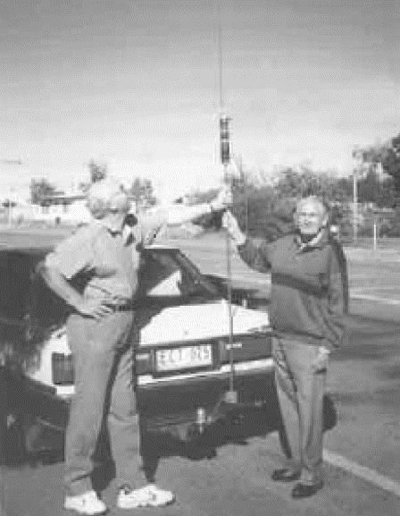
Fred McKay and the author examining the authors HF amateur radio mobile whip antenna.
Looking inside a sophisticated HF SSB transceiver today you could be excused for thinking that there isn't much there. Physically there isn't, as so much is achieved inside integrated circuits, and by the use of circuitry not practical in the pre- transistor age.
Since those early days of single sideband transmission, transistor technology has been improving all the time. Mobile HF SSB transceivers capable of 100 waits PEP may be as small in volume as two house bricks and have the effectiveness of an 800 to 1000 watt AM transmitter which would have taken up a whole room.
We now have a complete high frequency (HF) SSB 100-watt mobile station that is able to be used on almost any frequency at will, that can be controlled from the driver's or passenger's' seat whilst mobile at 100 Kph. Certainly, HF radio has come a long, long way since Traeger produced his first three valve, single frequency, morse code only, pedal radio.
A SHORT HISTORY OF CODAN
During the 1950s two young engineers Ian Wall and Alistair Wood, graduated from Adelaide University. Ian graduated in Electrical Engineering and Alistair graduated in Mechanical Engineering. lan commenced work with Philips Electrical Industries in Hendon In the design section in 1955 and developed the first of the Philips black and white television receivers. The early days of television was very much, like the early days of the pedal radio, where much had to be learnt quickly about a technology, which was totally new to Australia.
In 1959, Ian and Alistair as the engineers and Jim Benison as the accountant started a small business in Adelaide, called the Electronics. Instrument & Lighting Company Limited (EILCO). Their prime interest initially was to provide professional instrumentation for the university. The quality of their work became known outside the strictly professional instrumentation area. As a result of this known high standard, they were approached by Anglican Bush Church Aid Society in Ceduna to complete the construction of partly completed HF radio equipment (from another manufacturer) for use In the School of the Air.
Ian and Alistair looked at the design of the transceiver they were being asked to complete. They believed that they could design and build a better transceiver for the Society, so they rolled up their sleeves and designed the EILCO 6104 AM HF 5 channel 8 watt transceiver. The Society accepted the 6104 instead of the Incomplete sets. This set has been mentioned in Chapter 14. The experience at Philips had been invaluable and made designing the 6104 so much easier. particularly as they had access to the latest and best Philips components.
The original 6104 was designed in 1961 and gradually gained acceptance into various HF radio networks. It was compact, well protected against damage, portable, had low current drain on receive, and looked rather like a “lunch box”-which was easily carried for portable use. As the set and the company became better known the number of sets sold escalated to the detriment of sales by other companies. However, there was business for all in those halcyon days of the mining/oil/gas boom in the 1960s. The 6104 was improved over the years and the MkIII came out in 1964. and updated versions were produced until 1970.
The electrical noise experienced in most towns, and small cities was so great that HF receivers were almost useless in that environment. A number of receivers were designed for remote operation starting with the 601- and 602-, followed by the 6415 and other remotely controlled AM receivers. The 6415 receiver board also found its way into later versions of the 6104 transceiver. These receivers (and other makes too) were located in electrically quiet areas, often many kilometres away from the base stations and were powered in most instances down the phone line which conveyed the audio signal from the receiver to the base.
Associated Electronic Services (AES) distributed the EILCO sets in Western Australia. Over time it seemed sensible for EILCO and AES to amalgamate, hence the company became known as Codan Proprietary Ltd. The name EILCO ultimately became a brand name only.
When it became apparent to manufacturers that SSB would be compulsory within a few years, a number of manufacturers started to experiment or tool up for HF SSB transceiver production, or alternatively to import equipment suitable for the Australian market. Firms such as Crammond, Wagner, ACI. Drake, Marna, Granger Associates, Philips and Codan, were actively planning and trialing designs.
Most of these firms did produce some SSB transceivers. Codan came to be considered the leading manufacturer where high frequency SSB radio communications in the outback was concerned. In fact, very few HF SSB transceivers were being produced by other manufacturers, as they decided SSB equipment was not a viable product for them to produce. There are now a few other manufacturers which share the work of providing HF SSB transceivers throughout Australia.
Ian's former employers knew that they (EILCO) were developing SSB equipment and the Elcoma section alerted him to a line of transistors eminently suitable for high frequency SSB transmitter use. The use of these transistors meant that the first or their sets designed for SSB could be fully solid state and the first was the 6801 in 1968. Initially it was planned to be a three channel 15 watt (PEP) output set. The final product became available as a five channel 100 watt set.
In 1969 the very popular Codan 6924 “lunch box” AM/SSB transceiver came into being and was one of the first fully transistorised SSB transceivers used in quantity in the outback. It is very similar in size and casual examination to the earlier 6104. with many of the features that made the 6104 so popular, but it was/is a much more sophisticated transceiver. It has an output power of 8 watts (compatible AM) and 24 watts (SSB PEP). Remembering that a 25-watt SSB transmitter is approximately equivalent to a 100-Watt AM transmitter this was a great step forward for mobile and portable transmitting effectiveness. No longer was it necessary to listen so intently through noise and static to understand what was being said.
EILCO/Codan won the contract to supply and install the new AM compact SSB base stations at all of the RFDS base stations throughout Australia. The requirement was for a 0.5/1 kilowatt AM compatible/ SSB transmitter and receiver installation at each base to be capable of operating remotely on six frequencies in the frequency range from 2 to 12 Megahertz.
They rose to the occasion and produced the 7010/7021 transmitter and the 7004 receiver. Many of these high-quality installations are still providing sterling service after 30 years.
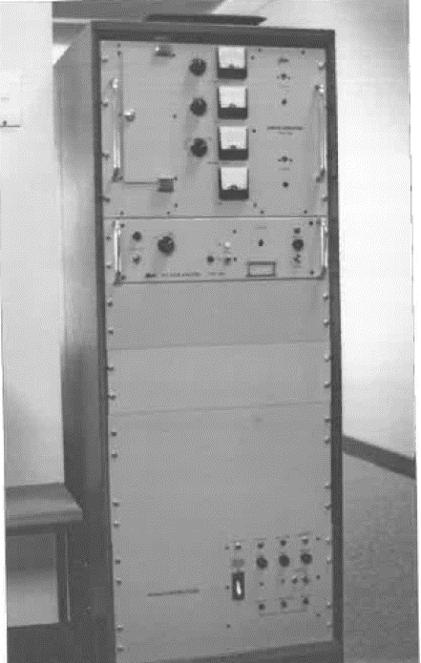
Codan 1000watt (HF) SSB transmitter, of the type used by the RFDS and other services.

In 1985 the next quantum leap in design appeared, in the form of the 8525 synthesised 600 channel mobile transceiver. Its receiver covers from 250 kHz to 30 MH: and its transmitter covers from 2 to 24 MHz at 100 watts (PEP) output power. The transceiver uses a crystal oven which warms up within a minute. and then the overall stability is such that the clarifier is rarely used. electronics and the oven cause the receiver to draw 0.4 amps which is considerably more than the early transistorised AM receivers. On transmit, the current drain varies from three to 12 amps on 12 volts DC. Its compact at 270 x 250 x 90 mm (W.H.D.) and weighs less than 4 Kg. Comparing the 6104 with the 8535 it can be seen that they are as different as chalk and cheese. The 6104 was an excellent set for its time, but the 8525 was so much more advanced, and well suited for the needs of outback users in the busy SSB era.
Codan have produced many other HF transceivers over the years with improved and additional features. The production of HF radio equipment has been only one facet of their work as they are active in many other areas of electronics. The company has grown from three people, to over 350 employees, in around 40 years. They export most of their production to over 150 countries. A truly successful company bult on quality equipment.
Barrett Communications Pty. Ltd. commenced operation in Perth, Western Australia in 1976, towards the end of the changeover period from AM to SSB HF communications. Whilst Barrett may not have been in at the start of SSB, it has rapidly gained a reputation for quality equipment, and currently shares a significant proportion of the market for HF SSB equipment and the ancillary equipment used to make HF communications as effective at possible. They also export a considerable quantity of their output.
Another more recent player in the HF SSB field is Q-MAC Electronics Pty Ltd. in Western Australia- They commenced operation in 1994 and consider themselves a niche-market communications product supplier, with a number of innovative products. They also export product to overseas countries.
There were a few other companies producing SSB equipment, but none lasted in the marketplace for any length of time The only other company with HF SSB equipment on the market in any quantity is Icom a Japanese company renowned for the quality of its equipment.
The quality of the equipment produced by these three Australian companies is world class. If it had not been, there would not have been exports to so many overseas countries. We can be proud of these companies, their use of cutting-edge technology, and quality.

CHAPTER SIXTEEN

AIDS TO IMPROVED COMMUNICATIONS AND THE CB BOOM

High frequency single side band radio communications networks were really working well after the changeover date of 1/1/1978. The performance was good, but people still wanted more. Computer technology was becoming more and more utilised, and methods of sending data were becoming essential.
The companies mostly involved in HF SSB, Barrett and Codan, branched out into the development of various "add-ons” for their equipment to make it even more suitable for the isolated user.

AIDS TO IMPROVED COMMUNICATION
Electronic technology has been bounding forward ever since transistors came into use, and that has escalated even more so since communications type integrated circuits have become readily available. The progress has been so rapid, that equipment 10 years old can often be claimed to be obsolete.
It isn't all that much fun listening to static, and other crackles and noise, on the HF radio bands. Many sets do have a mute control that will alleviate most of the noise, but you will still hear every radio transmission on the channel whether it is intended for you or for someone else. It is annoying to have to listen to everyone else's call whilst endevouring to make sure calls meant for you are not missed.
One of the early “add-ons" has been the use of selective calling. A unique set of tones sent in a particular order are received, and then processed, which then makes the receiver receptive to the signals from the transmitter. If the wrong tone code is sent the receives does not respond and remains muted. This has made using the HF radio so much more pleasant, as the set will remain quiet until such time as a call is received that is intended for your station. In some installations, the receiver will sound the vehicle horn when the correct selective call signal is received, hence alerting the driver to the fact that he or she is being called.
Another handy feature on many receivers is “scanning”. The receiver is programmed to listen, in turn, for a short period on a number of preselected channels. This is useful when radio conditions are not predictable and it isn't known which channel will prove to be best for communications between your station, and the station likely to be calling you. Scanning improves the chances of successful communications.

Mobile phones don't work in the outback away from places like Alice Springs or Yulara, hence there has been a need for telephone connections to the outside world. Considerable work was done to develop a HF telephone system not too unlike what we are used to in populated areas. Telstra (and before it OTC) had a system called Radphone, where marine and land mobile stations could make telephone calls via their HF radio transceivers. It wasn't as good as the normal telephone but was much better than nothing. It was prone to all the electrical noise, static and fading that HF radio experiences. Additionally, it was necessary to say "over" when you had finished each segment of your conversation so that the other person could reply. Mobile transceivers cannot transmit (talk) and receive (listen) at the same lime, although on board large ships this is possible (their equipment is more sophisticated). Now of course, satellite mobile phone, are tending to make this mode obsolete in Australia. Telstra closed their Radphone service in February 2002. Other organisations still continue to have a radio telephone service available.
Lap top computers have been increasingly used by field staff attached to government departments or private companies. The data obtained often needs to be relayed to their headquarters almost as soon as collected. In more populated areas this it achieved by connecting the computer via a modem to the telephone network. This is not possible away from the telephone system. However, special modems have been designed and built to effectively send the data over the noisy HF radio systems. Our designers have really done well in their design work.
HF radio has had one feature that has sometimes been blest, and sometimes cursed, and this is the fact that anyone can listen in and hear what everyone else is saying. That was fine in the early days of the flying doctor service when people welcomed the chance to talk to each and everyone else on the network. It was a good social activity for lonely people. But there are other circumstances where you do not want anyone else to hear what you are talking about.
To give users privacy, devices called scramblers were developed. Heads of State have used them for many decades but for the man in the street, or underneath the coolabah tree, this feature has only been available in the last 10 to 20 years. The early devices were not particularly secure, but the latest digital scramblers perform effectively, and people other than those to whom the messages are directed, cannot understand what is being said or sent.
It hasn't been hard to get lost in the great outdoors, particularly if you are a “city slicker” going for an adventure across land where man has never been before! Today if you have a HF radio, with a Global Positioning System (GPS) coupled to it, you can have your progress plotted remotely, as the radio transmits the GPS location every so often. There are many variants of this system that can be used to fulfil a variety of needs. GPS is explained more fully in chapter 17.
Q-MAC have provided other Interesting facilities on their HF-90 transceiver This transceiver is very small and light (1 Kg). It is very suitable for man-pack use and particularly so for the military it seems. It has the ability to do “frequency hopping”. What is this you may ask? It is a system whereby a transmitter and receiver change frequency in synchronism with each other several times a second in a pseudo random manner. This makes it difficult for an enemy to disrupt the transmissions or to listen to them. Whether this facility is available for use by the general public I cannot say. But, once again the designers and manufacturers in Australia have proved very innovative, and again, have made HF radio for the general public in Australia a very useful and satisfactory means of communications.
HF mobile antennas have always been inefficient compared to full sized base antennas, with efficiencies benefits around 2% and 50%. The efficiency depends on the frequency in use, the length of the antenna, and where it is able to be mounted on the vehicle.
In recent years the magnetic loop antenna has shown promise in base station locations where full-size antennas are not practical to install. It appears to have the additional advantage that it does not need to be mounted on a high mast to achieve quite satisfactory results. It is not as effective as a full-sized base antenna but where the siting of an antenna is difficult, it achieves quite satisfactory results. The magnetic loop antenna consists of a single loop of tubing (copper preferably) of around one to two metres in diameter.
Its size has made it suitable to try as a mobile antenna. It will fit onto a specially made roof rack and makes the vehicle look like it has a carrying handle on the top. It is no higher (perhaps even Iower) than a normal whip type antenna. It does require an automatic tuning system so is around the same price as a the automatically tuned whip antennas commonly seen on vehicles with HF radio installed. It is claimed by the manufacturers that it is between 10 and 14 dB (10 to 24 times more effective signal) more effective than a whip antenna, and that it picks up less electrical interference, when compared to whip antennas. This is an antenna well worth watching - we may see many vehicles with carrying “handles” on the top, in the future.

VERYHIGH AND ULTRAHIGH FREQUENCY SERVICES
Whilst high frequency radio has been used for the long distance, and not-so-long distance, communications in the outback, VHF and UHF services have increasingly been used where long-range communications has not been necessary. VHF (and to a lesser extent UHF) has proved to provide economical and satisfactory communications out to around 40 kilometres (base to mobile) as an alternative to HF communications.
Generally, VHF and UHF services enjoy interference free communications whether it be from vehicle electrical systems noise, other man made noise, or from static and other noise that HF often suffers.
So, it is very much a case of "horses for courses", whether a VHF or HF service is installed.

THE CITIZENS' BAND (CB) BOOM
During the late 1960s a few people imported American CB radios. In the 1970s the import of CB radios developed into a flood. It was quite legal to import them, but it was illegal to own or operate them, as Australia did not have a legal CB band. Some importers became quite wealthy supplying this perceived need. Many people believed that their right to use the radio frequency spectrum was being denied to them, and they used political pressure in their effort to get a legal CB band In Australia.
The pressure was sufficient that ultimately the Government relented and allowed the licensing (and hence use) of CB radio equipment. This change of heart occurred during 1977. However, the Postal and Telecommunications Department had a rather myopic view, and proposed, and implemented, a unique Australian 18 channel 27 MHz CB band. The Department would also allow 23 channel American sets to licensed for a limited period. Some channels were NOT to be used and of course ALL, CB radio operators complied”!" On the CB band it is allowable to use AM (4 watts) and SSB (12 watts PEP) and both upper and lower sideband.
America then introduced a 40 channel CB system on 27 MHz. There was then more activity taking place to get the American 40 channel system licensed In Australia. Reluctantly this was agreed to, CB radio operators were required to licence each of their sets, and many did, however, around 50% never complied. Also, a considerable number used modified CB radios that went onto many more channels than the 40 licence-able channels, and often with increased power.
Some also used, and still use, modified amateur radio transceivers to transmit illegally with excess power on channels and bands for which they are not licensed to operate. Any operator operating outside licence conditions (CB radio operates on a Class Licence system) is liable to be fined (up to $12,000) and have their equipment confiscated through the course. This does occur, but we rarely hear about it as few people like to boast of being caught out doing the wrong thing. Organisations such as the RFDS and the CFA have reported interference from such illegal use.
Around I5 years ago, the Kalgoorlie RFDS was experiencing interference to their operations on one of their HF frequencies. From listening to the transmissions they believed that the illegal operators were in Northern Victoria. The Victorian branch of the Department of Transport and Communications was advised of the problem. The Department swung into action and in collaboration with the RFDS started to achieve results. Over a short period, it was determined where the main offending station was located; who was operating it: when it was being operated; and what equipment (modified, and therefore considered un-licensed) was being used. The stations with whom the operator was talking were weak, and subsequent action was to be taken to locate them as well.
Departmental officers had a “visit” planned to “assist” (the operator to see the error of his ways and to remove the source of temptation (the Codan transceiver) from his possession. Regrettably all this activity occurred near the end of the financial year and suddenly there was no money for overtime to deal with the problem.
However, all was not lost, as by some means or another the illegal operator became aware of the official interest In his activities. He rang and talked with the radio inspectors of the Department to ascertain what they knew and what they intended to do. A rather nervous operator got off the phone still not knowing what was going to happen. He, and his mates, were not heard on the RFDS frequency again.
In another instance a few years earlier in the middle of the fire season, the Country Fire Authority (CFA) reported severe interference to their HF services on the Mornington Peninsula in Victoria. Once again, an emergency service was suffering interference to vital communications. There appeared to be a network of four stations and their signals were stronger than the CFA mobile stations. This suggested that the stations were more powerful than many of the CFA stations, and that they were in fixed locations. Actions taken by the Department through direction finding and other information gathering activities, pinpointed four locations where the illegal stations were located.
Four teams were assembled, and simultaneous visits (raids) were made on all locations, if the visits bad been done sequentially, the operators in the other three locations would have been advised to “hide the equipment, the radio inspectors are coming”, as soon as the officers left the first location. Four teenage boys on school holidays, were found to be the culprits. A heavy load of old, reasonably high power, ex-service radio transceivers was seized. They nearly broke the springs of the Holden they were so heavy! The culprits were presented to court, where they were fined, and their equipment was officially confiscated.
Fortunately, no lives or property were lost as a consequence either of these two examples, but the end results could have been very different.
Whilst the 27 MHz CB band, and the HF bands, have been misused by many people, a great number have used it as it was intended, a short-range personal communications system. In the more remote areas, Farming and various groups have used CB radio to co-ordinate their activities.
One instance in the Wimmera region of Victoria saw CB radio used as a 'life saver", when a farmer working his header had a serious heart attack. He was able to contact his wife as their residence in town, and have her call an ambulance, and hence obtain help. No doubt there are many other instances where the radio has served this life saving purpose In farming communities.
Initially, many people in outback areas did use 27 MHz quite extensively for shorter distance communication where the cost of a full blown
HF SSB transceiver was not warranted. However, 27 MHz CB radio is very susceptible to "skip" type communications and overseas CB operators can often drown out the reception of quite local CB transmissions.
Over time 27 MHz CB was found wanting, so many people began to use the UHF CB band on 477 MHz using 5 watts FM transceivers. This was implemented at around the same time as 27 MHz CB became officially sanctioned. The first sets to become available were locally designed and manufactured Philips FM320 transceivers. The nominal range on UHF CB, set to set is around 10 kilometres. Philips also suggested to the P. & T. Department that on this band "talk through" radio repeaters could be used to extend the range of the transceivers. With the use of a “repeating” radio station on the top of some convenient hill, the range mobile to mobile could be extended to 100 kilometres or more.
The Department took this on board and allocated eight channels for repeater operation. Initially these were planned to be "out-of-band", but subsequently the frequencies set aside were withdrawn. and "in-band" repeaters were licensed instead. The “out-of-band” repeater system with either the repeater receive or transmit frequency in band would have been a much easier system for the average non-technical user to handle.

Own arm quite a number of UHF CB repeaters have been installed throughout Australia. It might be thought that, in the outback, there would be few if any of these repeaters. However, this is not so. In many areas these repeaters are used on outback stations and in until communities. For example, when people go with ease mailman from Coober Pedy to Oodnadatta they soon hear the outback UHF CB repeaters in use. The mailman calls up the Pink Roadhouse it Oodnadatta to order the midday meal for those on board. More people than this use the repeater of course, and some small repeater systems are installed on individual stations. Once again it is so much cheaper than HF SSB for short range communications and very reliable.
In 1989, an enterprising rural community in regional Victoria, who were suffering from frequent thefts from farm properties, implemented a Rural Surveillance / Neighbourhood Watch type system. This covered the urban and rural areas of the Shire and was coordinated by the local Police.
it had the approval of the Police Commissioner, and the local Police vehicles were fitted with UHF CB radios, where they could be contacted by farmers or other: when out on patrol. Weekly “meetings” were held over the air, along with any news that the Police wanted distributed. The region was incorporated into the "official Neighbourhood Watch program in 1992 and still continues very successfully, in the same way to this very day.
The UHF CB repeaters have taken over from the 27 MHz CB usage, as it is so much quieter with little interference, and the only people you hear are the ones you will want to talk with from time to time. The UHF CB spurn has been one of the success stories of Australian initiative.
In recent times two of the UHF CB channels (channels 22 and 23) have been allocated for digital transmissions. A distant transceiver can be called up by the base transceiver and interrogated to check some device that is connected to the distant transceiver. This is a very convenient low-cost method of checking, for example, whether the water tank down the back of the station has water in, or whether the windmill has broken down. Some people probably use the repeaters, for this purpose though!
The frequencies allocated for the 27 MHz and 477 MHz citizen’s bands can be found in appendix 5.
Certainly, all the various communications facilities available today make living and working in the outback much more convenient, enjoyable and productive.

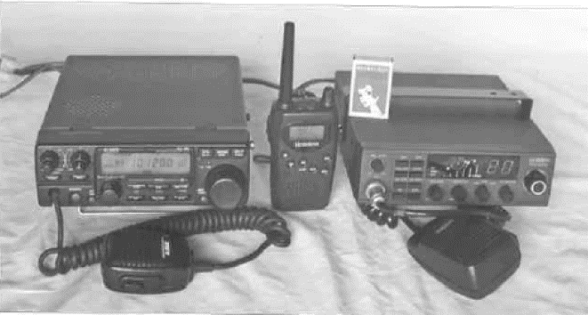

Left to right A high frequency (HF) multi mode (AM, FM, CW and SSB) 100 watt PEP amateur radio transceiver, a 0.5 watt 40 channel hand held UHF, FM, CB transceiver and 27Mhz AM/SSB CB transceiver.

CHAPTER SEVENTEEN

COMMUNICATIONS INTO THE 21ST CENTURY

Instant communications anywhere in the world is now possible, due to the technologies that have come online since the first "Sputnik" satellite was launched in 1957. The RFDS and other organisations that use high frequency (HF) communications, are reducing their use of this medium and relying more on telephone and satellite communications systems. Telstra gradually reduced the number of base stations in its HF radio telephone service (Radphone) network, with the last station being closed in February 2002. All of the remaining maritime radio stations (Sydney VIS, Melbourne VIM, Perth VIP. Darwin VID. Townsville VIT. and Brisbane VIB) ceased operation on 1/7/2002. Hence, no monitoring by official radio stations now occurs within Australia, on frequencies such as the telephony HF distress frequency of 2182 kHz.
The high frequency radio communications services which have proven so essential to the development of the outback of Australia are now taking more of a "back-up” role. High frequency operation is far from dead, however. In many ways the romance and vagaries of HF radio, form part of the fun of it all.
It is only necessary to travel to the outback to see the number of HF mobile transceiver antennas that adorn four-wheel drive and conventional vehicles. Normally, they would not be installing HF transceivers in their vehicles just for the fun of it. Many mining, governmental departments and agencies, pastoral, military, transport, and farming interests find that HF radio is still the most suitable communications system for many of their needs, despite its inherent draw backs such as noise and variable communications performance.
But, outback safari, four-wheel drive clubs, and radio amateurs lave a great deal of fun using HF radio. It still fulfils the emergency need as well as having the "fun", or "social contact" element built in.

TERRESTRIAL TELEPHONE SYSTEMS
Throughout the outback, telephones have gradually been extended further and further from centres of population. Telephones in built up areas have basically been connected by a pair of thin copper wires to a telephone exchange nearby. However, the cost of laying hundreds of kilometres of cable to isolated settlements is prohibitive.
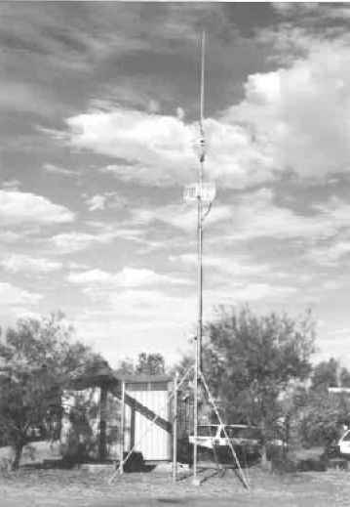
Mt. Barry radio linked telephone S.A.
To overcome this cost, and to provide a telephone service, the PMG (Telecom, Telstra) connects telephones via adapting boxes (interfaces) to Radio transmitters and receivers in the very high frequency (VHF) range (150 MHz to 170 MHz, nominally) which are then coupled to high gain antennas. The other end of the link is a telephone exchange with similar radio equipment. The distance to the telephone exchange varies with terrain and whether radio repeating (intermediate) stations, are used. A single hop system on these frequencies has a range of up to 80 kilometres between repeating stations, or the telephone and the telephone exchange. Services on these frequencies were operational in the 1960s In the outback and in other isolated areas, even within Victoria. The various types of equipment initially used were variant, of the frequency modulated (FM) analog equipment used by groups such as taxi companies.
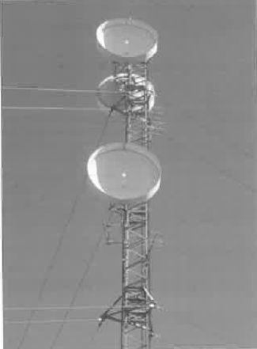
Microwave tower in NT with microwave dishes and Yagi antennas linking telephones etc.
The demand for VHF radio frequencies for all sorts of communications services increased to such an extent, that spare frequencies available for telephone services became scarce in more populated areas. Services were then allocated frequencies around 450 MHz in the UHF band which gave ranges of 40 to 60 kilometres but were similar to the VHF services in other regards.
Demand increased even further, and by the mid-1980s, a new digital service was implemented. This conserved the number of radio frequencies necessary to provide a telephone service. The service used a digital radio concentrator system (DRCS). which that more than one service could use the one set of frequencies Initially frequencies around 500 MHz were used with ranges of around 60 kilometres per hop. Frequencies around 1.500 MHz. are now used too, with up to 40 kilometres between repeaters.

The radio aerial/antenna systems are often mounted on quite high towers, and you will see them dotted throughout the outback. Due to the increasing amount of telephone and data type transmissions used these days, the interconnection of the isolated telephone exchanges into the main telephone network requires radio equipment with many channels to perform this task. In most cases dish type antennas are used and the signals are mostly in the super high frequency (SHF) range.
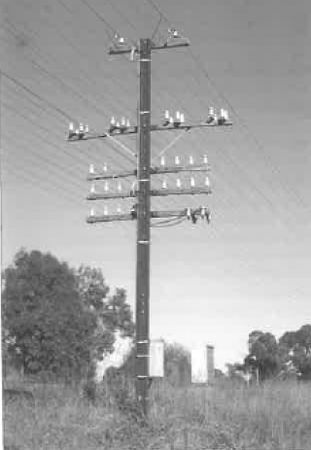
Railway telephone and control lines at Boralla, Victoria (2002)
With digital systems it has become possible to send facsimile (FAX) messages, and more recently, gain access to the internet and e-mail. All of these marvellous and speedy forms of communications are now available to many outback people - but still not all. it is claimed that over 95% of homes are provided with a telephone service via the Telstra terrestrial network.
Connecting all of these facilities to the mainstream telephone system has required an enormous infrastructure. In the 1800s it was the Overland Telegraph and similar telegraph systems. The single wire telegraph system was replaced by many overhead wires on poles. which carried many telephone and telegraph messages It was impractical to increase the number of wires on a pole above a certain number, so methods were introduced to carry more than one conversation on a telephone line.
One of these is called “carrier telephony”. The number of “carriers” determined the number of
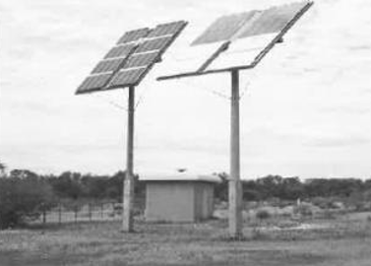
conversations that could take place over the one telephone line. These methods saved having enormous numbers of wire lines attached to each pole. An example of how they could look is shown in the photograph of the lines along the railway at Beadle in Victoria in 2002. Yes, this rather outmoded communication system is still in place, obviously still doing the job it was installed for.
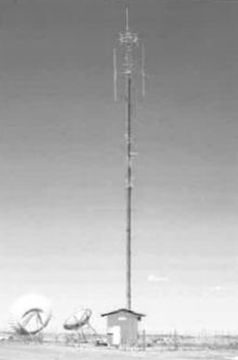
Solar powered fibre optic repeater besides the Stuart Highway northern Australia.
Overhead telephone lines were gradually replaced with underground cables in some areas, and microwave radio systems using large dishes on tall towers, in other places. Many of these towers can be seen around the outback. It is interesting to look at the communications tower Coober Pedy Communications TV and FM tower at Cooba Pedy. It has television and FM radio
stations broadcasting from it, as well as a plethora of other communications antennas, including radio telephone. Satellite and mobile phone antennas.
The latest of the terrestrial communications links is the optical fibre network. Small diameter glass fibre cables, protected by a sheath of steel wires, connect many areas In the outback The most commonly observed repeater links in the optical fibre network nominally follow the Stuart Highway through the centre of Australia. About every 60 kilometres, a brick building around five metres square can be seen, usually with a short
mast alongside it supporting a large solar cell array. The solar cells charge a bank of batteries which power the fibre optic repeater equipment. Each glass fibre not much thicker than a human hair can carry several television programs or thousands of telephone calls at the one time.
So now, in many areas of the outback, all the communications facilities that anyone could want are available. Regrettably these all come at a cost, and the price of telephone calls over long distances can be quite expensive. Most calls will be over long distances due to die distance between each outback homestead. With the special deals promoted by the various telephone carriers, lengthy phone talks on be made during certain times of the day for prices around $1.50 to S2.50 maximum per call for up to around five hours of “talk time” (2002). Various government initiatives are subsidising communications systems, such as the 'Extended Zone' program. to decrease the cost of telephone and internet calls.
It must also be remembered that the installation cost (to the subscriber) of a telephone service in remote area is quite expensive, being at least $1,000. possibly several thousands of dollars in some instances. This is much greater than the cost of connecting a telephone service in a town or city.
The days of the “galah” session have largely gone, being to a certain extent discouraged by governmental agencies as telephone facilities were made available. This is sad as it means that many people in the outback are now starting to become lonely again, despite the availability of better communications. Once you bought the equipment the “galah sessions” were “free”. Many of the HF radios are still in use, kept as a back up, just in case these new and sophisticated communications systems break down.
The “galah session” has to some extent been replaced by the advent of television in the outback. Up until the last twenty years outback folk have not had access to television reception. That changed with the implementation of the HABACUS satellite system. It used what was called the B-MAC system of transmission. It has been withdrawn from service and has been replaced with several direct satellite TV services, of which Imparja from Alice Springs is one.

MOBILE PHONES
Many will ask 'Why haven't the HF radios been replaced with mobile phones?". They are so much a part of life in the cities and densely populated areas of Australia, that it is unusual not to sec at least one person in a crowd with a mobile phone “glued to their ear”. As anyone who has ventured out into the sparsely populated areas will have found, they just do not work there, the GSM and CDMA mobile phones have had a reputation of not working as well as the older analogue mobile phone system anyway.
The mobile phone services operate in a band around 900 megahertz, while some work in the 1,800-megahertz band. These bands have a line-of-sight communications characteristic, so if you cannot 'see' or be 'seen by the mobile phone base station, communication is unlikely. As there are so few people in the outback. few base stations have been installed. and therefore, a mobile phone is of no use at all. except in the few large towns where a mobile phone base is located. An examination of the coverage maps provided by Telstra, Opus and Vodaphone will show the outback. and many areas that are certainly not 'outback', do not get any mobile phone service. It is claimed more than 97% of the population can access terrestrial mobile phone service, but they neglect to say that around 85% to 95% of the area of Australia has no mobile phone service. The 3% of the population that don't get communications live in the 85% to 95% of the country that is not covered by a mobile phone service. If you are a traveler going into these remote areas, there will be little point in taking the mobile phone with you.

COMMUNICATIONS SATELLITES
The era of communications via satellites for civilian purposes commenced in 1979, when the International Mobile Satellite Organisation (INMARSAT) was born. The intended purpose was to provide worldwide mobile communications via satellites for the maritime industry. There are four satellites in geo-synchronous orbit 37,786 kilometres above the earth. There is up to a third of a second delay between when something is spoken and it is heard by the person on the receiving end. This phenomenon often causes confusion to those who use this system.
Another group in 1987, commenced planning to provide a global satellite communications system that could be accessed by anyone anywhere, with a suitable over the shoulder type portable phone. It was to be a digital system, capable of voice and data facilities. Over a period of time, it was developed and became available in Australia in late 1998. The system is called Iridium (World Satellite Service) and is capable of providing a telephone service anywhere in the world on the 1616-to-1626.5-megahertz (L) band. The system consists of 66 satellites (+ 6 spare) orbiting 780 kilometres above the earth. At any one time a suitable satellite mobile phone would “see” at least one of these satellites and then be able to make a phone call to anywhere else on Earth.
Another new satellite system called Globalstar is commencing operation too. Globalstar has 48 satellites orbiting the Earth at 1,414 kilometres. Dual mode mobile phones can use either the Satellite or land based mobile phone modes. The phone calls whilst expensive on the satellite mode are still only four times the price of land based mobile phone charges. The units are no bigger than some of the older mobile phones and cost between about $2,000 and $3,000. Now communications can be achieved on a phone anywhere in Australia and 200 nautical miles to sea, (and throughout most of the World) on a reasonably compact satellite and terrestrial mobile phone.
Telstra have a satellite mobile telephone service which they call Minisat. This uses the Inmarsat satellite system, basically as described earlier in this chapter. It transmits on channels between 1626.5 and 1660.5 MHz and receives on channels between 1525 and 1559 MH2. Telstra now (2003), also use the Iridium satellite system. The sets in use weigh less than 500 grams and are not much larger than the previous generation of mobile phones. The call costs are generally less than a dollar per minute and the plan costs are such that it is becoming economic for regular travelers in the outback to consider the of use satellite phones.
Optus also have a satellite mobile telephone service via one of their geo-stationary satellites. The service uses frequencies in the same general range as the Telstra system and its satellite mobile phone units are somewhat similar to Telstra’s, except they appear to be about twice the weight and the transmitter power is 3 watts.
USING THE COMMUNICATIONS SATELLITES
From experience, wets of mobile phones find that they have to move around to get best performance (reception); and so it is with hand held satellite phones. In some situations, to get a clear “view” of the satellites, it is necessary to go outside buildings to achieve communications. This also means incoming calls could be missed, and in these times of instant communications, this is considered a real downside. Certainly, these systems are not without limitations, although an external antenna will assist to overcome this problem.
With the services using the geo-synchronous satellites, it is only necessary to point the antenna system to the satellite and leave it at that. For all practical purposes the satellite does not move, so the direction for best performance will always remain the same. The signals from low earth orbit satellites, like Iridium and Globlestar, are much stronger than the signals from geo-synchronous satellites (because they are between 27 and 48 times closer), hence a small omni-directional antenna is all that is needed for good performance. The satellites only take a few minutes to go from one horizon to the other, so as one satellite goes out of range another will come within range. However, like moving around with a GSM or CDMA mobile phone from one call to another 'drop-outs' may occasionally occur.
Whilst satellite telephone services are quite expensive compared to GSM and COMA, they are the only suitable service in many remote areas of Australia and out to sea. Where safety is important and the HF service is perhaps unreliable, it may be the only option available to many people.
There are also fixed satellite phone services, which have been around for a number of years. Telstra has a fixed satellite phone system too, using a sizable dish pointing to a geo-synchronous satellite above the equator. A typical small installation using this satellite system can be seen in the photographs of the installation at the remote Tjukayirla (Derka Yurla) roadhouse (population two plus two dogs) In the outback of Western Australia. It has three lines, one for the roadhouse, a public phone booth and a FAX line. They can process credit cards "online" too!
The service in operation at Tjukayirla in 1998 was the first fixed satellite telephone site, which was the original satellite service as used in many areas throughout the outback. From the information that I have obtained, it appears it works in band C (6 and 4 gigahertz (GHz) using a rather large dish. At the time of my visit to Tjnkayirla there was another system under trial which used a much smaller dish and uses the Ku band (12 and 14 GHz). Telstra uses the Pan Am Sat II satellite for this service.
The Commonwealth Government is subsidising (a grant of up to $1,100 (2003)) the purchase of satellite mobile phones for users in remote and rural areas where conventional mobile phones don't work. For more information, ring 1800 674 058.
The facilities available on the satellite phone systems are the same as available on the normal mobile phone networks. With camera phones you can talk to and see your friends in the city, or you can show them the scenery around the camp on the Canning Stock route - just to make them envious!
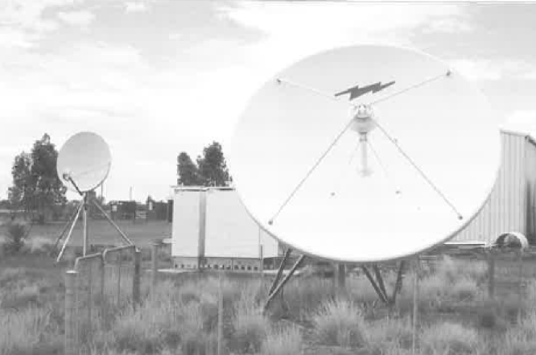
Satellite Telephone Dishes at Tjukayirla (Derka Yurla) roadhouse on the Great Central Road, W.A.

GLOBAL POSITIONING SYSTEM (GPS)
Whilst GPS is not a communications system as such, it is an invaluable aid to determining where you are. With GPS if you do become “lost” at least you would know where you are “lost”. The next move would be to call someone by radio who could come and 'find' you.
There have been a number of navigation systems used over the years, bur none as convenient, compact. easy to use and relatively inexpensive as CPS. A receiver can be obtained for less than $300 (2004).
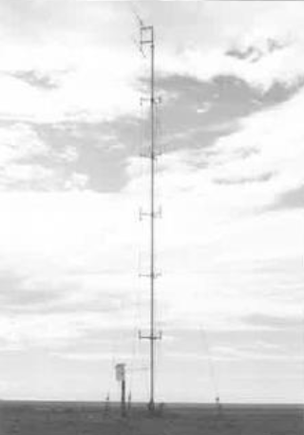
Emergency radio telephone, Stuart Highway
In 1993, this totally new navigational system was launched. It consists of 21 satellites orbiting the earth at 20,200 kilometres operating on 1575.42 MHz and 1227.6 MHz. The linked States Defence Department developed this system over a period of 20 years at a cost of more than S10 billion US.
GPS works by triangulation methods, combined with accurate timing signals, sent via the satellites. The mathematics operating within the GPS receiver microprocessor are enormously complex and give us on the receiver screen the coordinates of where the receiver antenna is located. It will also give the receiver antenna's altitude above sea level. In recent times the accuracy of the system has been increased to such an extent that your location on earth can be determined to within a few metres at worst, and as close as approximately 30 centimetres in some circumstances.
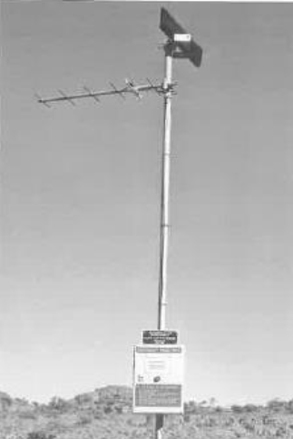
Wow, what a system! No excuse for getting lost now. Wouldn't Len Beadell have really enjoyed having such a system available to him in the 1950s and 60s when he was surveying the
Emergency radio Kings Canyon.
outback. It would have been so much simpler than the systems in vogue then. But probably he would have missed the great challenges he had in those times.
Industry and commerce have also hastened to avail themselves of this new technology:
Grampians Region Water Authority, for example. based as Horsham. Victoria, uses this technology to trace, identify and chart their older infrastructure of water and sewerage mains. These were installed underground in rural towns across the Wimmera and Southern Mallee Regions prior to the Authority's formation in 1995. Much of the information had not been recorded by previous local Water-Trusts or Shire Councils, but was made redeemable through GPS.
Mobile and satellite phones are starting to be connected to GPS receivers. In an emergency your location will be determined at the press of a button by either you, the operator, or the emergency service. Science fiction is becoming reality in so many areas. It is now being used to routinely plot the position of taxis, truck fleets, and emergency vehicles.
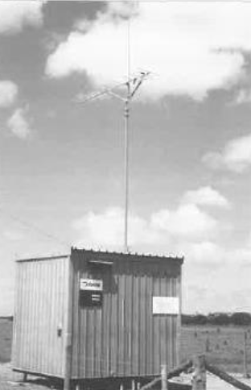
Rural Automatic Telephone Exchange with radio telephone link to some subscribers, South West W.A.

EMERGENCY POSITION INDICATING RADIO BEACONS (EPIRBs)
An EPIRB is a small battery-operated transmitter which. when activated in an emergency, emits a beacon signal This signal is picked up by orbiting satellites which relay the signal to satellite earth stations. The information Is processed to determine where the EPIRB and the person in trouble are located. Once again not a communications system in the strict meaning of the word, but still an important device that can be used when in dire trouble. Satellites on the COSPAS-SARSAT International Satellite System are used to assist in locating activated EPIRB’s.
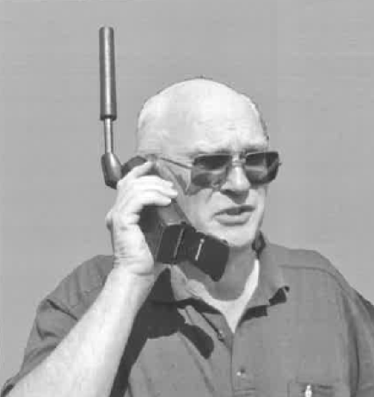
Author using a Satellite Phone
When activated, the cheaper units transmit on 121.5 and 243 MHz and more sophisticated units transmit on 406.025 and 121.5 MHz. Satellites will hear the signals and the ground stations (Albany WA. Bundaberg QLD and Wellington, New Zealand) will plot the approximate location of the EPIRB. The location of the superior 406.025 MHz beacons can be narrowed down to a radius of less than 5 kilometres within two hours In Australia, and the waters between Australia and New Zealand. The location of the cheaper units when actuated, can be narrowed down to around 20 kilometres by satellite. Note: older types of EPIRB manufactured to specification DOC24IA or DOG241B rarely work effectively with the satellite system.
Aircraft have the ability to receive the 121.5 (and 243 MHz in some cases) signals and they can assist in locoing the beacon once the nominal area has been determined. High flying aircraft can hear the 121.5 MHz signal at a distance of up to around 300 kilometres. On land, once the general area of those in distress is determined. suitably equipped ground vehicles, helicopters and people on foot complete the final task of finding the beacon, hence those in distress. At sea, suitably equipped ships will find the beacon.
"These devices are not to be activated except where loss of life is likely if help is not obtained within a reasonable time. It is a handy device which is compulsory on ships. A land version of the EPIRB is the Personal locator Beacon (PLB). which is usually cheaper, as it does not have to withstand the rigours of a marine environment. People working, travelling or living in isolated places often take PLBs. as an additional safety precaution.

SUMMARY
So much has changed in the past 150 years since
people first recognised the need for some form of communication across this great land. Up until the time of the Overland Telegraph in 1872 there was no communications in the outback, not even for the populated parts of Australia, to the rest of the world. By the early 1920s little else had been done to improve communications of transport into the inland regions.
The few hardy, lonely battlers were forgotten by the “powers that be” in government, and the community in general. Then, along came the Reverend John Flynn, the visionary who pushed for better medical, transport, communications, and spiritual support for these hardy pioneers. Through his drive, what we know as the Royal Flying Doctor Service was instigated in Cloncurry. Hand in hand with this service radio communications was a key part of the opening up of the outback.
Australia had the first high frequency radio communications service for use by non-technical people, and it has been copied elsewhere in more recent times. The radio communications initially by morse code, was only available from a few isolated homesteads and communities. with the number increasing each year from 1929. Ultimately anyone, anywhere in the outback, could communicate with a flying doctor base.
Morse code made way for voice. By 1935/6 two-way voice communications was established with morse code as a backup. Gradually more base stations were established and by 1939 there were ten. This meant that communications became more reliable as the distance between base stations and homestead stations were significantly reduced compared to 1929.
Initially, the RFDS was the main user of communications in the outback (and the one with the highest profile), but now there are hundreds of other networks actively using HF communications. The improved equipment, the increased transmitter power, and the mode of operation (single side band), have all contributed to much improved communications.
Various other communications methods are used today in addition to HF radio. HF communications has come a long way, whether i it is now past its zenith is hard to say, but it is still there, doing its bit, for the people of the outback.
The Reverend John Flynn would be happy with the progress that has been made to provide facilities (such as communications) for the people of the outback since his death in 1951. He once said “If you start an idea, nothing can stop it” He was right. The Royal Flying Doctor Service continues on from strength to strength, covering now, even more of Australia than even he believed it would. Many spin offs from his vision are evident throughout the “centre”.
We've come from the era of the Overland Telegraph to the era of mobile satellite phones. Today we need never be out of contact with anyone, or not know where we are. We can summon aid in even the most remote areas of Australia through a single phone call on the satellite phone. The loneliness of the outback need no longer exist.
The final question is - where do we go from here? It is exciting to contemplate, and only time will tell.

APPENDIX ONE

A SYNOPSIS OF THE CONTENTS OF EACH CHAPTER,

APPENDIX AND MISCELLANEOUS INFORMATION SECTION
Chapter 1
EARLYTRANSPORT AND COMMUNICATIONS 1788 — 1929
We look at various communications methods used up until the infancy of radio. 'the aboriginals had smoke signals and message sticks. There was the postal service, the Overland Telegraph and other telegraph/ telephone systems. Camels, horses, donkeys, bullock teams, trucks, ans. the "Ghan" - Central Australia railway, Transcontinental -Trans-Australia railway, as well as other overland methods of transport and communications all played their part. Finally wireless, the high speed versatile communication medium arrived.

Chapter 2
JOHN FLYNN'S DREAM 1887 — 1921
We discuss John Flynn's drum for the outback in the time of the Overland Telegraph, the 'Ghan Railway", camel trains. and early government radio stations. Included is a short history of radio development in those early days, which includes spark transmitters. crystal receivers, and the valved WWI trench radios.

Chapter 3
EARLY EXPERIMENTS 1922 —1925
We investigate the early experiments of Flynn, Towns, Kauper and others.
The invitation is issued to radio experimenters for the design of suitable radio transceiver for the outback.
The disappointment when no practical ideas eventuated.
Why the proposed "baby" transmitters would be morse code only, in the foreseeable future.
Proven that receivers could successfully operate on both voice and Morse transmissions.

Chapter 4
THE HERMANNSBURG EXPERIMENTS - 1926
We look at the Hermannsburg and Arkunga experiments of 1926. There was the raucous interrupted continuous wave (ICW) morse code transmissions at the outposts, with amplitude modulation (AM) voice at the base in Stuart (Alice Springs). the experiments proved that simple radio transmitting and receiving equipment could be handled competently by non-technical and unqualified (in radio) people. However. much work needed to be done to produce a fully satisfactory radio transceiver. Finally, a look at World War I Trench Radios.

Chapter 5
NEW DEVELOPMENTS BRING SUCCESS 1927 —1928
We investigate the development of an easy to operate, robust, reliable, inexpensive. low current drain. Portable high frequency wireless/radio transceiver to Flynn's specifications.
The search for suitable reliable low current valves from AWA and Philips.
The search for a suitable source of power for the "baby" radio transceivers. Commercial mains power supplies. home lighting plants, primary and secondary batteries, the Model T Ford Coil, genernotors (motor generators), hand and pedal generators.

Chapter 6
THE YEAR OF THE "BABY" TRANSCEIVER - 1929
We look at the development of the "Baby" transceiver at the end of 1928 - the first successful `Pohl Radio". designed to be used confidently and competently by non-technical operators.

During the period when the ideas of what a suitable radio network should consist of, Flynn spoke (An article in a copy of -The Islander" for 1927) of the idea of a mother (base station) and baby (out-station) radio transceivers in a communications network Ultimately we see the small (for those days) radio transceiver that was developed as the first pedal radio. Flynn called It the 'baby" transceiver.
Why Cloncurry was selected as the base for the Aerial Medical Service, a predecessor of the Royal Flying Doctor Service.

Chapter 7
THE IMPROVED PEDAL RADIOS 1930 —1934/5
We discuss how Traeger overcame the problems of the first model. The “baby” transceiver replacements, featuring a dual frequency transmitter, a three valve receiver and other variations. The Cloncurry base station is described.

Chapter 8
MORSE CODE REACHES ITS ZENITH 1931 — 1935
How the poor quality morse code sending of out-station (homestead) radio operators was overcome. The communications computer of the 1930s - the morse code typewriter.
We explore the development of the last of the pure morse (CW) homestead sets. There was multi-channel operation, new valve types in use and other experimentation.

Chapter 9
THE FIRST PORTABLE TRANSCEIVER - 1933
Here comes the first of the portable transceivers, and Padre Kingsley “Skip” Partridge's involvement in their development. The hint that voice communications was SA around the comer.

Chapter 10
THE OUTBACK HAS A VOICE 1934 —1936
The first AM/CW transceivers appear on the scene, both homestead and portable sets. The 36 set appears, the first production model AM/CW set produced in any number for stations and homesteads. Was there another AM/CW transceiver before the 36? Another manufacturer shows interest in producing pedal radios.

Chapter II
THE FIRST SUPERHETERODYNE RECEIVERS -1937
Why Traeger stayed with the TRF receiver, long after others had converted to superheterodyne receivers. We look at how the problem of band switching was overcome and how the superheterodyne receiver was developed, with its inherent better performance compared to the older TRF receivers.

Chapter 12
NEW POWER SUPPLIES, VOICE ONLY SETS, INCREASED POWER, THE PROBLEMS OF INTERFERENCE - 1937 ONWARDS
We look at sources of power other than dry batteries and the pedal generator. The advent of the voice (AM) only sets, increased transmitter power and other brands of equipment in the outback. Man made electrical interference near the base stations was increasing. We investigate how-this was minimised or overcome.

Chapter 13
SOCIAL AND EDUCATIONAL RADIO - 1951 ONWARDS
The social, business, lifesaving, and religious activities to which radio communications in the outback have been put, are investigated. They include the School of the Air, Country Women's Association, Brownies, Scouts, the “Galah”,session, business dealings for stations, homesteads and mining groups, medical and safety matters.

Chapter 14
THE ADVENT OF TRANSISTORISED EQUIPMENT - 1959 ONWARDS
We look at the gradual changeover from valved equipment to transistorised equipment. More manufacturers making high frequency radio equipment, and ever increasing standard's of construction. The number of organisations using HF radio in the outback increases dramatically, no longer just the RFDS and School of the Air. Mining, Pastoral, Government departments, private individuals, etc. could all see a need for portable and mobile HF radio communications.

Chapter 15
HP SINGLE SIDEBAND ITS IMPLEMENTATION 1959 — t978, AND ONWARDS
Another leap forward, single sideband (SSB) the efficient means of transmitting voice. With the introduction of SSB, there was a quantum leap necessary in technical standards to produce suitable equipment. Some of the existing manufacturers “call it a day”, whilst other manufacturers tackle the technical challenges of the new technology with enthusiasm.

Chapter 16
AIDS TO IMPROVED COMMUNICATIONS AND THE CB BOOM
We look at the general expansion of communications. Selective calling. data. HF and UHF CB radio ¬including UHF CB repeaters. etc. VHF and UHF services.

Chapter 17
COMMUNICATIONS INTO THE 21ST CENTURY
In this chapter the expansion of die telephone service. radio linked telephones, satellite and cellular telephones, fax, data, e-mail, GPS (Global Positioning System), EPIRB’s (Emergency Position Indicating Radio Beacon). internet and fibre optics are explored.
The final question is asked - where to from here?

Appendix 1
A SYNOPSIS OF THE CONTENTS

Appendix 2
TECHNICAL PERFORMANCE TESTS OF ORIGINAL CIRCUITS OF CW & AM TRANSCEIVERS
The Hermannsburg transmitter, the crystal controlled morse (CW) only transmitters, the first AN/CW transmitters, the two stage AM/CW transmitters, and the pi-coupler output. Circuits of relevant transceivers.

Appendix 3
AERIAL/ANTENNA SYSTEMS
Radiating systems used by fixed outpost. portable, mobile and base stations: Man made and natural interference, and the various methods used to minimise or eliminate this scourge of radio communications.

Appendix 4
MISCELLANEOUS INFORMATION
Significant Dates and Years. Morse Code. Relative Value of Money. Recent Communications Equipment using Pedal, Hand and Battery Power. Opening and closing dates of RFDS bases. Transmitter Power Ratings. Transmitter Modulators. Edison Cells. Valve Data and Usage

Appendix 5
PROPAGATION. FREQUENCY ALLOCATIONS, AND GENERAL USERS
Propagation, the sunspot cycle, and daily propagation variations. The frequencies used by RFDS, School of the Air, and other social communications services between 1925 and 2002. HF services available to outback travelers.

Appendix 6
PROFILES OF EARLY OUTBACK RADIO PIONEERS
Maude Anderson, Wally Coxon, Rev. John Flynn, Harry Kauper, Vernon Kerr, Adelaide Meithke, Graham Pitts, Alfred Traeger.

Appendix 7
TERMINOLOGY
Explaining technical terms, names, and titles

Appendix 8
BIBLIOGRAPHY

APPENDIX TWO

TECHNICAL PERFORMANCE TESTS OF ORIGINAL CIRCUITS,

CIRCUITS OF EARLY CW AND AM TRANSCEIVERS
THE HERMANNSBURG TRANSMITTER
To assess the likely performance of the Hermannsburg transmitter, a test transmitter was built, similar in circuitry to the Hermannsburg unit, and then adjusted to operate in the 3.5 to 3.7megahertz amateur band. It is almost identical to the circuit drawn of the Hermannsburg transmitter except that the frame of the plate tuning capacitor was earthed, and a modem low pin triode valve (6CM7) designed for vertical deflection television work, was used. These valves have quite a high voltage rating which is needed In this instance, to prevent internal flash over. The original valves are unavailable, and if obtainable, would be very expensive and of doubtful quality. A milliamp meter was placed in the HT supply lead to observe the amount of current drawn.
Initially, a high voltage DC power supply was connected to the transmitter, until such time as the circuit adjustments were made, for reliable operation. It was necessary to have quite close coupling between the grid and plate coils to achieve oscillation. The output link coil was wound over the plate coil, and its position adjusted for maximum brilliance of the dial lamp in the output line. This also required adjustment of the grid and plate tuned circuits, which also changed the output frequency. The “aerial/earth” was a carbon resistor in series with the lamp. This network is commonly called a dummy lead and takes the place of the aerial/earth network for testing purposes.
The signal as heard on a nearby receiver had sonic hum on it and considerable chirp when morse was sent. It would not be considered a quality signal on the amateur radio bands.
The transmitter was then connected to the output of the Ford T ignition coil. When first switched on, the tuning capacitor in the plate circuit flashed over continuously. This had previously been tested to 1000 volts with no flash over. The output from the Ford T coil is far from a pure sine wave and although the total energy in the positive and negative excursions of voltage is the same, the peak in one direction is considerably greater than in the other. By reversing the polarity of the 6-volt supply to the coil the flash over of the tuning capacitor ceased. The transmitter valve acts as a half wave self-rectifying oscillator, and as such one-half wave, (the negative part of the wave) is applied across the whole circuit. So, in the first instance, the voltage across the capacitors and the valve amounted to well over 1000 volts negative to plate and positive to chassis /frame. In a short time all of these components would have been damaged.
In this circuit the transmitter emits what is called Interrupted Continuous Wave (ICW) signals. an outmoded, outlawed type transmission. As the waveform from the Ford coil is very spiky and irregular by nature. it is not possible to directly measure the output power of the transmitter. This is due to cheaper power meters responding to peaks of energy rather than the mean output power. To obtain a reasonably accurate power output figure an identical "dummy" load was made to that used in the transmitter and supplied with variable voltage direct current. It was adjusted for the same perceived brilliance with the two globes side by side. The power though the network was calculated and hence the radio frequency output power of the transmitter was obtained. The peak drawn varied by up to 10 decibels according to the wave forms shown on a spectrum analyser.
The signal as heard on an AM receiver is broad in that it can be tuned over a small distance across the dial, and is raucous and unpleasant to listen to. It would have been reasonably easy to find on the band used for the Hermannsburg experiment. This would have been desirable as adjusting either of the tuning controls would cause the transmitter frequency to change. A most unsatisfactory type of transmitter, totally unsuited for use by non-technical people.
Here are the technical specifications of the test transmitter, which would be similar to the 1926 Hermannsburg transmitter.
With reference to the carrier signal, the sidebands occupy the surrounding radio spectrum as follows. The signal is 5 kHz wide at the -10db point, 15 kHz wide at the -20db points. 40 kHz wide at the -30db points, 60 kHz wide at the -40db points, 90 kHz wide at the -50db points and 350 kHz wide at the -60db points. This signal is around 100 times wider than a good quality morse (CW) signal today!
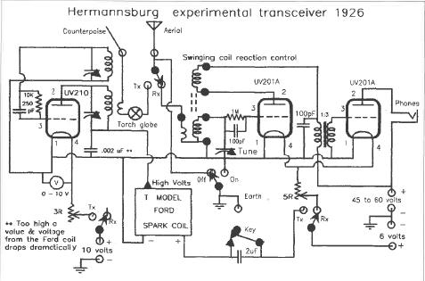
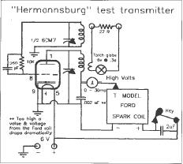
Circuit of Hermannsburg test transmitter model 6CM7
The harmonic outputs are 2nd -75db down, 3rd -35db down, and the 4th -50db down with reference to the carrier frequency. The harmonic output energy is much higher than would be allowed today. Today in the high frequency region transmitters up to 1 kilowatt, must have no spurious or harmonic energy output greater than 40db down, and in the case of citizens band (CB) radio the figure is -60db down on the fundamental frequency.
The average plate current drawn is 15 mA. The estimated effective place voltage is at least 500 volts. The radio frequency is about 3 watts. The transmitter would have an estimated efficiency of around 40%.
See test transmitter circuit. Note that the test circuit and the Hermannsburg experimental circuits have assumed a supply voltage of either 6 or 10 volts from the Edison cells. An explanation of why both voltages are quoted is given In Appendix 4.)

THE CRYSTAL CONTROLLED (CW) MORSE ONLY TRANSMITTERS
THE "BABY" AND THE “AUGUSTUS DOWNS" TRANSCEIVERS
An experimental CW transmitter was constructed along the lines of the origins/ 'baby'. (1929) transmitter and its successor. B205 and A615 valves are unavailable, so one section of a 1J6G valve (19 equivalent) was used. The tests were done on 3.56 MHz, under the amateur callsign of VK3UG.
Circuit of Hermannsburg experimental receiver 1926.
Reliable oscillation with scannable coupling to the antenna was achieved via an auxiliary winding in series with the crystal to earth, which is coupled to the output coil (tank circuit). This is the same as the original transmitter circuit. The amount of feedback, and the coupling to the antenna proved to be quite critical for best results.
The grid drive varied from near zero to over 3 mA as the plate tuned circuit was Aligned. The feedback was adjusted so that 1.5mA of grid current flowed at optimum output. Maximum output of the transmitter does not occur at plate dip, in fact there is very little dip at all. As the tuning capacitor is tuned from maximum capacity to minimum capacity the plate current varies between 15mA and over 40mA. With a plate voltage of 180V and around 25mA of plate current, an output of 1.3 watts was obtained. Careless tuning would result in very short valve life. Operators would be told to be quite careful to tune for the maximum brilliance of the tuning light.

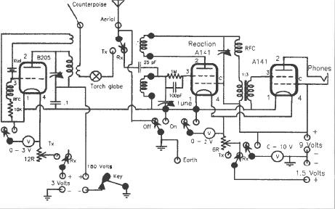
Traeger “Baby” transceiver 1929 circuit.
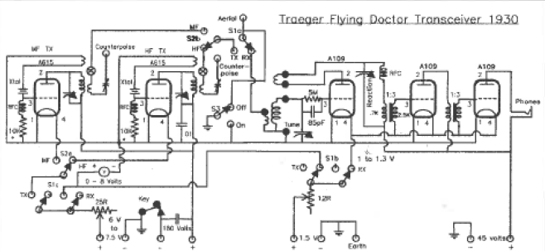
Traeger “Baby” transceiver 1930 circuit.

The efficiency of the transmitter (plate circuit) is around 36%. Low power battery valves are not very efficient as radio frequency power generators, and the crystal also required some drive from the output which reduced the total output. If the tuning lamp was taken out of circuit the output climbed to 15 watts giving an efficiency of about 42%.
It Is not clear from examination of an early set whether Traeger used a resistor in series with the radio frequency choke in the grid of the transmitter valve. A resistor of 10 K to 30 K ohms improves the efficiency of the transmitter. 'When a resistor is inserted into the grid circuit, the plate current significantly for very little reduction in power. A resistor of 22K ohms was left In circuit for the majority of the tests to keep the valve plate dissipation down. The valve was being overloaded as it is designed for 135 volt operation not 180 volts. It is easy to damage a valve when it is being overloaded like this.
As the transmitter is tuned, noticeable pulling of the crystal frequency is observed. There is some "chirp" as the transmitter is keyed, but certainly not annoying.
The harmonic outputs compared to the fundamental output of the transmitter are as follows:-
2nd harmonic - -30db. 3rd - -55db, 4th, etc > -60db.
See "Baby" (1929) and "Augustus Downs" (1930) transceiver circuits.

THE FIRST AM/CW TRANSMITTERS
The first common AM/CW transmitter used the following valves- the 33 as the combined RF oscillator/ output stage, with a 30 as and audio voltage amplifier drives, to a 19 push-pull class B audio modulator.

This experimental transmitter used a 33 and a 1J6G (Octal 19), and almost identical circuitry to the model 36 set.
The crystal feedback circuit it not quite as critical as in the CW transmitters using triode valves. There is quite a bit of adjustment, just the same, to achieve optimum output. This model. and other succeeding models used plug in modules to change the frequency of the transmitter. They were pre-aligned in the factory and could be expected to work once plugged into the set and the counterpoise/ aerial (antenna) system tuned. This overcame any problems with getting feedback and output coupling correct in the field. This was a smart move on the part of Traeger and was followed in later years by other manufacturers.
A 22k ohm resistor was placed in the grid circuit of the 33 in addition to the RF choke. The feedback was adjusted for 1.5mA grid current. As in the earlier CW only transmitters shorting the grid resistor gives slightly more output but with significantly more plate current. The transmitter is more efficient with the grid resistor in place. Some models did have a grid resistor of 10k ohms.
When the plate circuit Is tuned, the plate current "dips" quite noticeably. and is easier to tune for maximum output. when compared with the earlier sets.
The plate current drawn is 21mA at 180 volts for 1.5-watt output (after the lamp), giving an efficiency of 40%. If thee tuning lamp is shorted, then it rises to 45%. The overall efficiency including the screen current is 33% with the lamp shorted. The tool DC input (high voltage) to the 33 valve is 5.25 watts.
The harmonic output compared to the fundamental output arc as follows: -
2nd harmonic -32db, 3rd -54db, 4th - -65db, 5th - -72db
The modulator used a 1J6G the octal equivalent of the 19 used in the original 36 model. This valve is considerably overloaded in this circuit. It is designed for a plate voltage of 135 volts and will then draw 10mA standing current with zero bias, but in this circuit, it has 180 volts applied to it and it draws 20mA of standing current. With modulation, the current drawn rises to up to 40mA at maximum modulation. By applying a bias of -3 volts the standing current is reduced to 10mA and the peak current drawn is 35mA. This would have been much kinder on the valve, and no doubt it would have lasted much longer than it may have done in these sets. Later sets that used a vibrator power supply with a six-volt lead acid battery did have a bias of -2 volts applied to the 1J6G modulator vibe.
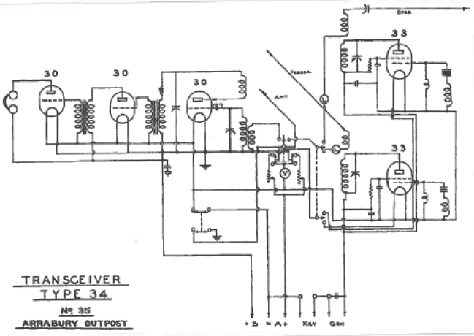
Traeger model 34 transceiver circuit (note similarity with the 1930 model.

The 19/1J6G is rated at 2.2 watts output with 135 volts plate voltage. In this application the modulator would be required to give considerably more output. The DC input of the 33 valve is 5.25watts, and for full modulation around 2.6watts of audio is required for full modulation. However, the modulation transformer is likely to have been only wound 70% efficient so the total audio power required is 3.75 waits for 100% modulation. The transmitter can be modulated to 100%. The peak transmitter HT current is 60mA.
It seems, strange that Traeger did not use a pair of 49 valves in the modulator as their filament total current drain was the same as the 19/1J6G. and they were rated for 180 volts on the plate. Traeger was already using a 49 valve in the receiver. In the push pull mode they were capable of 3.5watts of audio output with 180 volts plate voltage supply. The 49 is wired with both grids tied together and with zero bias in axis mode of operation.
It would have been expected that these later valves would have achieved higher efficiency and hence greater RF output from the transmitter, They achieved easier adjustment of the transmitter, but the output remained much the same. Later transmitting type miniature battery valves, such as the 3A4 (full ratings to 10MHz) and the 3A5 achieve similar plate efficiencies of 44% and 49% respectively. The frequency rating of a 33 valve for full output is unknown but would appear to be well under 10MHz hence its lower efficiency compared to the 1D4/1L5G in the following transmitter tests.
See model 36 circuit.

TWO STAGE AM/CW TRANSMITTERS. model 36/40 etc.
As time progressed the transmitter circuits improved. The modulators remained much the same, but the Rf section was changed so that there was a separate oscillator followed by the power amplifier stage.
The overall efficiency didn't appear to improve but the adjustment of the transmitter did. The 33 was used in the output of the first two stage transmitters. A 1D4 was tried as a “plug-in” alternative to the 33 and the output remained the same but the current drawn was slightly less, indicating higher efficiency. The harmonic outputs are similar to the previous transmitter described.
It was noted during the experiments that the output valves (battery types like the 1L5G, etc.) in the two stage transmitters required neutralisation, even at the frequency of 3560 kHz The inter-electrode capacities in the valve available and used in the transmitters was quite high. Happily, valves had improved is all regards by the end of the 1930s, and small valves like the 6V6GT rarely, if ever, required neutralisation on the frequencies used by the flying doctor service.

The 1L5G (octal equivalent of the 1D4) was used in slightly later model transmitters taking the place of the 33. The 1L5G would have been overloaded in this circuit as its ratings an around half those of the 33. The 33 was being operated within its ratings. Some models even had two 1L5G valves in parallel which would have given around double the output power at three watts. The HT voltage on some of the later sets was as high as 240 volts, which meant the transmitter valves were severely overloaded. The designed filament voltage on these valves is 2.0volts, but Traeger increased this voltage In later sets to 2.2 volts for best performance. Thu shortened the life of the valves noticeably.
Transmitters fitted with a 19 or 1J6G (modulator) and a single 1L5G (RF) could be expected to be hard on these valves. They would require relatively frequent replacement compared to those which were used for their intended purpose in receivers.

THE PI-COUPLER OUTPUT CIRCUIT
An experiment was also conducted using a pi- couples output to the transmitter. The output power was the same as obtained with the link coupling that was used in the Traeger transmitters of the 1930s. The harmonic outputs were considerably lower with the 2nd harmonic down at -45db, relative to the fundamental output, and other harmonics were at least 60db down. The pi-coupler output did not come into common usage until the 1950s and 60s where its property of harmonic suppression became important in preventing television interference. It was not suitable for the coupling of the aerial/counterpoise to the Traeger transmitters, the link system being much simpler, and coupled efficiently between transmitter and aerial system.
The pi-coupler output circuit. and variants of it. is almost exclusively used in HF communications transmitters today.

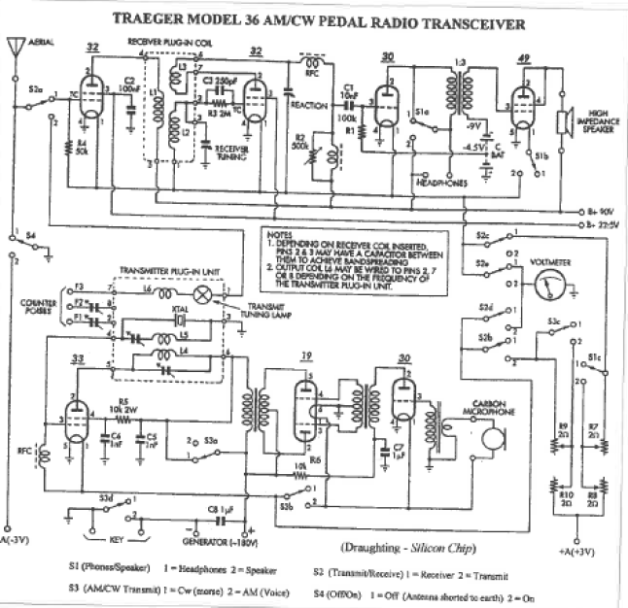

Traeger model 36 transceiver circuit
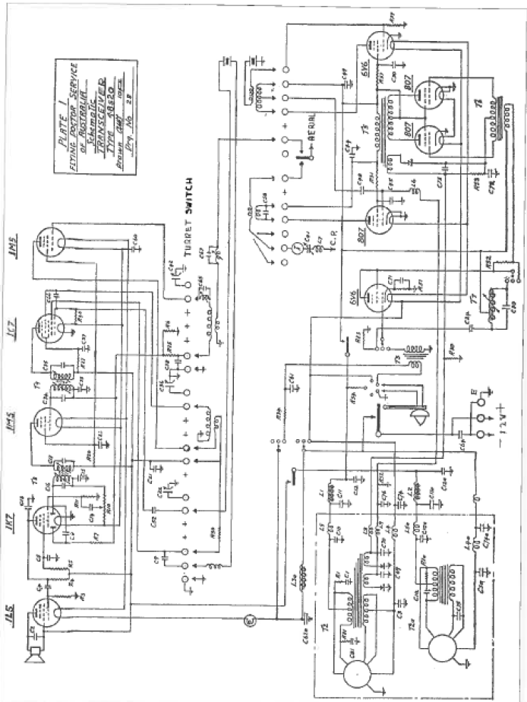

Traeger model 48S20 transceiver circuit

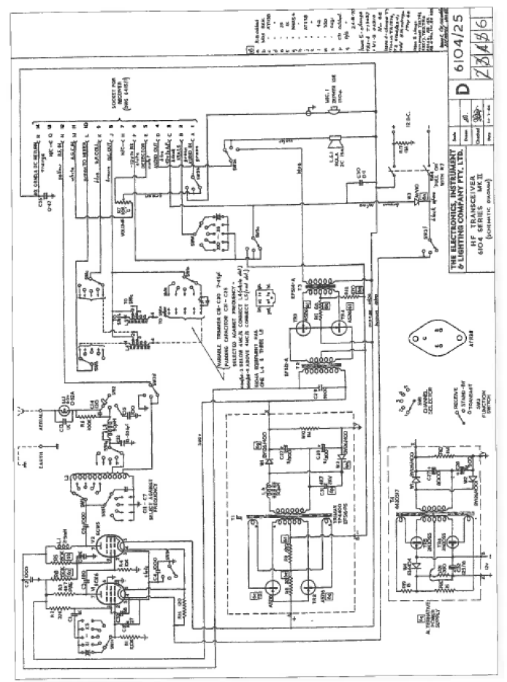
Part circuit of Elico (Codan) 6104 transceiver

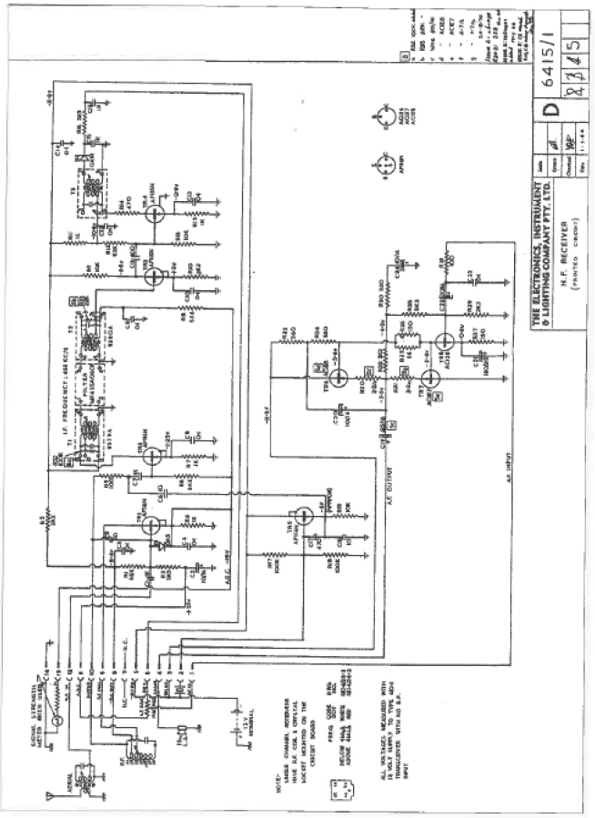
Part circuit of Elico (Codan) 6104 transceiver. Note The receiver section was also used extensively in remote and fixed receiving stations.

APPENDIX THREE

AERIAL (ANTENNA), EARTH, AND COUNTERPOISE SYSTEMS

INTERFERENCE - MAN MADE AND NATURAL

METHODS USED TO REDUCE THE EFFECTS OF INTERFERENCE

The initial section of this appendix. on aerial-earth-counterpoise systems is a combination of Graham Thornton's (K3IY) article on “Traeger's Unique Tribander” antenna system, as presented in the Journal of the Radio Amateurs Old Timers Club for September 1999. and my own research. Graham was the base station director at Derby in the 1960s. He has given me permission to use his article on this subject. Slight amendments and additions have been made to make some points clearer to readers who have less technical knowledge than the group for which the original article was prepared. Amendments are enclosed within [ and] or [*].
In the second and third parts of the appendix the problems of interference to reception and ways used to overcome or minimise its effects are discussed.

FIXED OUTPOST STATION ANTENNAS
"Traeger's Unique Tribander”.
This ingenious antenna saw service from the early pedal days, through the vibrator / lead acid- battery era and, as far as I know, into the solid state SSB times as well. (An amended version of this antenna system was used in some installations in the SSB era. The Traeger Transceivers P/L diagram in this appendix shows the difference). They, together with their accompanying Traeger transceivers, were dotted across the face of Australia in their hundreds. A description does not seem to have appeared in print before and may be of interest to readers. It is worth recording before it disappears into antiquity.
Three specific frequencies were assigned to each network. They were not harmonically related. The lowest frequency was around 1.6 or 2 MHz. This was used for contacts between fairly close outposts. This required ground wave propagation, and thus substantially vertical polarisation and omnidirectional pattern. About a hundred miles [160 Km] was frequently achieved. [At times I believe the range achieved was several hundreds of kilometres with the more powerful sets].
The middle frequency was in the range of 4 to 5.5 MHz. The upper frequency (wavelength) was initially about 34 metres [8.8 MHz], changing to 43 metres (6.9 MHz] in the mid-50s. Both these frequencies required high angle sky wave propagation to cover distances up to 300 miles or more.
Thus, Alf Traeger was faced with conflicting requirements for a single antenna. He chose a 'Sloper” to solve these problems. This had the practical advantage of only requiring one mast at each outpost. The sloping antenna wire was made a half wavelength at the middle frequency. it was fed with conventional “Zepp” feeders at this frequency. (labelled “A” and “F2” in the diagram.) The feeders, from memory. were about 22' long. An 80' counterpoise ('F3') was used with “A” as a Marconi antenna on the lowest frequency. Another feeder (“F1” was used with “A” on the highest frequency. This terminated in a short horizontal wire, roughly at right angles to the antenna. The length of this 'tail' was made equal to the difference in linear dimensions of dipoles for the middle and highest frequencies. Its purpose was to balance the feeder currents in the “A” and “F1” feeders where they ran parallel. Due to the small length and height of the “tail”, it would not have radiated much.
The input impedance in all three cases was capacitive. Within the transceiver the 'FI', 'F2' and T3' terminals were connected to series inductors for compensation. These inductors were made variable by the simple artifice of wiring each in series with a compression mica capacitor ('trimmer' type). A resonance indicating torch globe, also in series with each inductor, was brought out on the front panel adjacent to the appropriate screwdriver adjustable mica capacitor [trimmer]. It was only necessary to tune each capacitor for the brightest light, and the installation was complete. Re-adjustment of the tuning was rarely, if ever, required. (Getting a light' was regarded as the hallmark of success!). The resistive component of input impedance was taken into account in the design of each frequency specific PA tank circuit. This foolproof arrangement was a factor in the undoubted success of Traeger's communication system.
From Alf's point of view, it was important that the installation could be done by unskilled persons following simple instructions. To this end, the antenna was prefabricated in the Traeger works and shipped with the transceiver. [The antenna systems provided by Traeger were made with wire lengths to suit the particular network in which the transceiver was to be used.] It was made from stranded bare copper wire. The feeder spreaders were made from wooden dowelling (boiled in paraffin wax].
Originally, the modulated pedal sets had a carrier power of 3watts. This restriction was imposed by human limitations of pedal power. [*See comments at the end of Graham's article.] However, that power was shown to be adequate, so his vibrator models followed suit to conserve battery energy and reduce cost. He did make some 30watt models with an 807 final modulated by a pair of the same. [The PMG officially rated the 48S20 transceiver at 20 watts output.] These sets did not use torch globes, but an RF ammeter in series with the ‘A’ lead. Pictures of than may be found in Fred McKay's book Traeger The Pedal Radio Man pages 74 and 76. Both were 12V models, not 6V as stated in the caption P 74. The much more common 3-watt sets were homed in cabinets of the same size, with the same front panel layout except as noted above. A further feature of all sets of this era was the provision of crystal locked receivers, as well as three tunable receiver ranges. The 3 watt sets performed quite well, with the proviso that the noise level was low at the point of reception. This was never a problem for the outposts, but some bases, including the one established by myself at Derby WA. were forced to resort to an 'Out of town’ remote receiving site.
One faithful old pedal set was used on the Derby network until the early 1960's. This was used by the late Frank Lacey of Mt Elizabeth station. Frank suffered from cardiac asthma, and his laboured breathing could be heard. particularly on long messages.
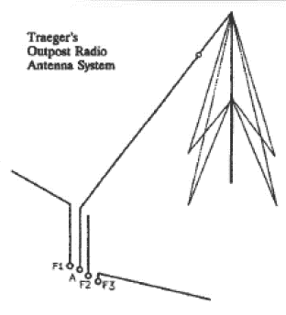
Diagram of Traeger’s unique “triband” antenna
There was one drawback with the three-band antenna. As the reader will appreciate, there was a deep propagation null centred along the axis of the antenna wire. Care needed to be exercised that the pathway to the base station made a significant angle with this axis. This gave rise to a novel solution to this problem. The owner of a sheep station on the lower reaches of the Fitzroy river was accustomed to having a good signal at Wyndham, his previous base. He was barely audible in Derby. [Due to the large number of out-nations coming into service, the territory originally handled exclusively by Wyndham was split into two sections with Derby taking over the Western Kimberley from the Wyndham base] He would not accept the fact that the alignment of his antenna was the problem. Instead, he chose to raise a petition for removal of the incumbent base operator (the writer) from office Fortunately, for me he received but one signature on the petition his own! King Canute??
Measurements indicated that the propagation mode of closer outposts was exclusively via the F layer. while more distant ones showed a dual path via both the E and F layers. Thus, the sloper design was a good choice. The provision of known antenna characteristics enabled the transceiver design to be optimum both in transmission and reception. Yet another reason for Traeger's great success. One pedal set was installed at Maria Island off Tasmania's east coast. Someone got the bright idea of using a Windom antenna instead. Operation was never satisfactory which is hardly surprising" Graham Thornton. 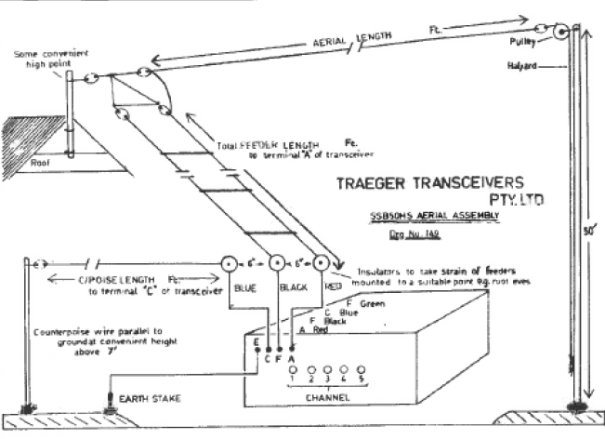
Diagram of a low antenna design to suit SSB 50HS transceiver.
*[The voice (AM) sets were gradually increased in power from around 1.5 watts (36 set) to three watts by 1943 (e.g. the 43S3 set). Vibrator sets of this particular era, all appear to be capable of up to 3 watts, whilst the pedal sets did depend on which pedal generator was used. and how hard it was pedaled. The transmitters used battery valves, and these became progressively more heavily overloaded as the output power was increased. For example the 1J6G, which was used as a modulator in the transmitter has a plate voltage rating of 135 volts, yet in some models a plate voltage of up to 240 volts was applied. No wonder the valves didn't last all that long.
The efficiency of the conversion of physical effort to electricity in the pedal generators Is not known. The MKII pedal generator (output voltage up around 225 volts) would have provided between 15 and 20 watts of electrical energy to power a transmitter. A small person would find pedaling a demanding exercise supplying the electrical energy for such a transmitter. Pedal powered radio transceivers are still used today. In Africa where power is rare in small villages, new generation pedal powered -single sideband (SSB) transceivers are used to communicate to the outside World. They have a radio frequency output power of 100watts peak power. Technology has come a long way since Traeger's pedal radios.
With the advent of vibrator power, Traeger could have used indirectly heated valves such as the 6V6G valve in the transmitter output and achieved much greater power output. However, even where batteries were used for the vibrator sets, economy of use of power was still needed as facilities to charge the batteries in many areas were still rather limited.
There were no high-power battery type valves that could be used in a transmitter. By using valves in parallel in a transmitter the output power would have been boosted. However, the extra complexity introduced would not have been worth it and In the case of the pedal powered sets, pedaling would have become quite a chore. The generator may have needed to be redesigned. Hence Traeger was caught `between a rock and a hard place’. He simply did the best he could in these circumstances to get the best performance for the least amount of electrical energy available.]
When the pedal radio network was first installed in 1929 only one frequency was in use (2230 kHz) hence an aerial and one counterpoise were installed. This early system had no facility For tuning the aerial or counterpoise. It was necessary to physically install the aerial system with the wire lengths a little longer than calculated, then gradually shorten them until optimum performance was achieved. Woops! What if the aerial system was cot too short? A piece of wire would have to be added, preferably soldered, to the original wire. The aerial (antenna) and the counterpoise were each around 32 metres long in these first sets. It was a laborious, time consuming, task to adjust the antenna system for best performance.
The second model pedal radio (1930) had facilities for two transmit frequencies, and two frequencies (possibly three) were authorised for use. It Is thought that 2020 kHz and 8630 kHz were used. This involved using one antenna wire and two counterpoises. Initially the counterpoises had to be individually tuned by cutting them to a length that gave the best transmitter performance. A little later on, the counterpoises were made longer than the calculated resonant length, then electrically shortened by an adjustable variable capacitor in series with the counterpoise, one for each counterpoise. The variation available with these capacitors was quite small. Sometimes it was necessary to change the number of plates and mica's. In extreme cases the number of turns on the counterpoise loading aerials had to be varied. Some of the older original sets had that counterpoise tuning capacitors retrospectively fitted during their life.
When the antenna system described by Graham finally evolved is hard to say, but it would seem that by 1935/6 it was operational, as all bases at that time had three operational frequencies.
Much of the success of the pedal radio network can be attributed to the efficient antenna systems that Traeger devised. These were a variant of the Zepp antenna. Only one mast was required between 40’(12m) and 70' (21.3 m) high with the tuned counterpoises two to three metres horizontally above ground level. His semi pre-tuned antenna systems worked extremely well when fine-tuned after installation. The installation and tuning (within the set) could be done by technically unskilled people. The tuning was unambiguous as it was always "tune for maximum light' on the tuning indicator. Traeger certainly got it right - others I believe didn't do It as well.
The “tuning" light was usually a 2.3-volt 0.3-amp globe in later sets, shunted by a three turn coil of resistance wire. The idea of the shunt was that as the resistance of the globe rose (as it brightened) more of the aerial current flowed through the shunt.
Other manufacturers used either an aerial fed against earth, or a horizontal half wave dipole - which required two masts. In most cases they did not have a method of fine tuning the antenna system for optimum performance.

PORTABLE ANTTENNAS
Portable transceivers naturally could not use the same sort of antenna system as installed at a homestead. Putting up a 12-metre mast every time communications were desired was not practical. However, Traeger did make a few helical antennas. These consisted of three 8’ (2.4 m) lengths of 1" (2.54 cm) diameter wood wound with insulated wire. The pieces of the antenna were joined by ferrules something like those used with fishing rods.
In 1951 Traeger developed the 51MA portable transceiver with a transmitter output power of around 7 to 10watt. The set was designed to be used with a 28' (8.5 as) aerial (antenna) and a 28' (8.5 m) counterpoise. The instructions state that the aerial was to be mounted as high as possible, over a tree branch, etc. The counterpoise was to be stretched out around 2' to 4' above the ground and earthed at the remote end. A telescopic aerial could be used too but its performance was not as good. On the medium and long wavelengths (Traeger’s terms) a 50' (15 m) aerial length would almost always give better results.

The set itself had controls for accurately tuning the counterpoise to optimum transmission performance on each frequency. The portable installation was certainly not as efficient or effective as a fixed homestead installation, but it proved to be a reasonable “portable” communications system.
In later times other sets were designed for portable use by Traeger and other manufacturers such as Codan. The Elko (Codan) 6104 (circa 1961) was the set that launched Codan as a serious manufacturer of high frequency radio communications equipment. It is compact and versatile and will tune to most antennas.

MOBILE ANTENNAS
Mobile communications has always been the desire of so many, and this rook a while to come to effective fruition. High frequency mobile antennas are not renowned for high efficiency. lf, for example, a quarter wave antenna was about 20 metre long it would make a good mobile antenna as far as communications efficiency is concerned, on a frequency of around 3.5 MHz. It is completely Impractical, so some means of reducing the physical size of the antenna is needed whilst retaining usability to work as if it were a 20metre long antenna. Basically, what is done is to concertina the antenna down into a total length, to from two to four metres. The 20 metres of wire is basically wound into a coil which is spread out over the two to four metres physical antenna length. This style of antenna is often called a helically wound whip.
Whilst the physical length has been reduced the electrical length remains much the same as it would have been. Regrettably it is not possible to shorten an antenna and still retain the same efficiency. The example I’ve quoted will have an efficiency of roughly between 2% (two metre whip) and 8% (four metre whip) compared to the full-sized antenna. As a result, mobile signals are usually much weaker than fixed station signals. Mobile transmitters have been lower powered than fixed stations although today modern single 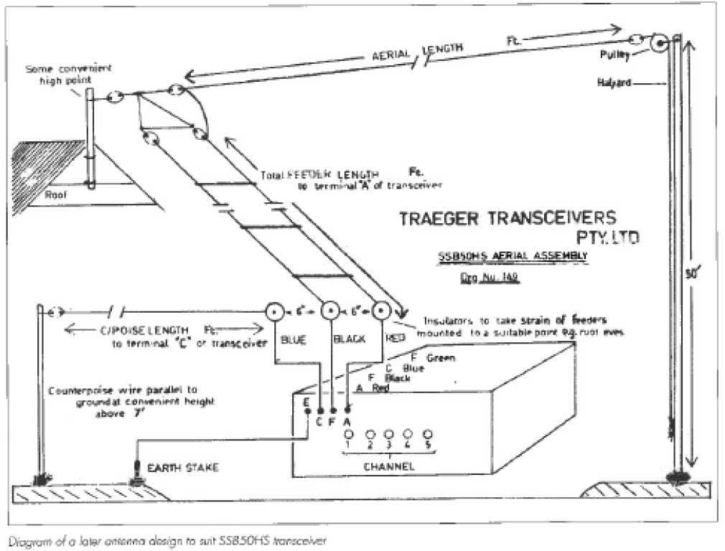 sideband (SSB) transceivers operate with around 100 watts output, much the same as many fixed stations. SSB signals are much more effective than AM signals so mobiles these days provide quite effective intercommunications.
There are several types of mobile antenna in use on vehicles. Today probably the most popular is the automatically tuned whip antenna- It consists of a tube around 100 mm in diameter and approximately a metre long, in which is enclosed an automatic tuning mechanism that will tune the antenna to any frequency in use. Above this is a stainless steel or a fibre glass whip. The total length of the antenna is between two and three metres. These antennas are popular as HF mobile antennas, as most will tune automatically to any frequency within the range 2 MHz to 30 MHz. This it very convenient when a large number of frequencies are being used.
A helical whip antenna is usually of much the same length as the automatic antenna but is slim, being around 20 mm or less in diameter, and has a wire winding over its whole length. To operate at various frequencies, the winding Is tapped at various spots to suit individual frequencies. The helical whip antenna, and the centre loaded whip antenna, are basically narrow band antennas. They will only tune to one frequency or a few close by frequencies, without having to be retuned, regularly around 2 megahertz. The number of frequencies or narrow band; that this, and the centre loaded whip can physically be made to tune, between eight and twenty.
The olden style of HF mobile antenna is the centre loaded whip. It varies in length from around two metres to four metres, usually the longer lengths are used. In the centre of the antenna is a coil former from 25 mm to 50 mm in diameter. On this is wound enough wire to tune the antenna to the lowest frequency In use. The coil has several caps, much like the helical whip, to enable it to tune to the other needed higher frequencies. A variant of the centre loaded whip is the base loaded whip. The coil is mounted at the base of the antenna. It is easier to tune but less efficient, as much of the radio frequency current heats the coil rather than being radiating out into space. The author's centre loaded amateur radio HF mobile whip can be seen on the front cover.
Traeger had one portable antenna that was assembled when stationary and mounted on a vehicle. It consisted of a 35' (11 m) vertical mast with loading coils used in conjunction with the tuning mechanisms of the set in use. This would have been considerably more efficient and effective than later much shorter antennas. With the lower (AM) powers used, the overall effectiveness of the communications would have been similar to later sets using SSB mode of operation and higher power using shorter whip antennas.

BASE STATION ANTENNAS
Base stations usually have fewer frequencies to use than mobile or portable stations hence they have purpose-built antennas for the frequencies installed. Their effectiveness and range is also much higher.
Base stations such as the RFDS, School of the Air, mining, pastoral and government departments have all tended to use horizontal centre fed half wave dipoles, one dipole for each frequency. They are strung between two towers between 12 and 25 metres high. Where "close-in” - working of stations is required, a sloping Marconi type antenna is often used. In some later installations multiple loaded horizontally mounted whips are used. These are not as efficient as the full sized half wave dipole but due to the power used today allow quite effective communications.
A couple of other antennas that have been used in the past, are the Windom and the Zeppelin antennas. They are still used occasionally but are difficult to match to modern transmitters and transceivers for best performance. Additionally, the Windom is not an efficient antenna. Traeger's multiple antenna system described by Graham Thornton is a variant of the Zeppelin antenna on some frequencies.

INTERFERENCE AND METHODS USED TO REDUCE ITS EFFECT
Interference to reception of weak and not so weak high frequency (HF) signals has always been one of the weaknesses of HF communications systems. This may take the form of manmade or natural (electrical storms – static) interference.

NATURAL INTERFERENCE
Electrical storms have always been with us and create very loud bursts (crashes) of noise (static) that completely disrupt communications. If an operator Is using headphones, the effect can be to cause ringing in the ears due to the loudness of the noise. It is most unpleasant, and over a longer period of time, may damage a persons hearing.

MAN MADE INTERFERENCE
Man made interference has been with us from the first time that electricity was generated and used by man. Radio was discovered and we became aware of the interference generated by the electrical equipment that we used.
Right from the start at Cloncurry, when the first radio base of the Aerial Medical Service started in 1929, Harry Kinzbrunner and Mamie Anderson experienced interference to the reception of the out-stations. It became more serious for Anderson as the number of out-stations and distance from the base station increased.
The interference experienced was from various types of DC motors and generators around Cloncurry, as well as the spark ignition systems on the few vehicles that went past the base station. The petrol/kerosene powered engines of the home lighting plants also caused interference. At that time there was no town reticulated power supply. Later Cloncurry was to get a 240-volt 50 Hz mains system throughout the town.

Anderson would have fitted radio interference- suppression capacitors to many devices around the town, to reduce the interference to reception. Texts read seem to indicate he either didn't have complete success in suppression work or didn't receive the co-operation he needed from some residents.
Even at this early stage he was thinking of a remote receiving station away from the electrical noises of Cloncurry. Remote controlling the early receivers was not practical and wasn't so until crystal locked superheterodyne receivers were well established. Alternatively, he may have been thinking of having the base station relocated out of Cloncurry to escape the interference. It appears that a remote receiving station was installed in 1951 many years after he left Cloncurry.
As time progressed the problem of electrical noise disrupting communications became even more severe, with more and more electrical equipment being used. The towns in which the flying doctor bases were located expanded, and reticulated power from a power station in the towns became common. The interference problem worsened as interference from many sources travelled along the power lines to the base station. Additionally, where high voltage lines (6.6 KV, II KV and 22 KV) were installed, interference from problems on these structures also became common, as it still is today.
Whilst noise limiters were of some help, the level of the noise was so great that weak transmissions were not heard at all. Interference could be dealt with and cured temporarily, but soon another source would commence causing trouble. It was a never-ending task. It had definitely become the time to investigate seriously the use of receivers located in areas of no interference, connected to the base via telephone lines (preferably underground). These receivers would be remote controlled, with power either supplied along the telephone lines, via batteries located on site, or a combination of both methods.

THE ALICE SPRINGS REMOTE RECEIVER INSTALATION
Graham Pitts the officer in charge (director) of the base from 1944 to 1953, found that by 1948 the electrical noise in Alice Springs made reception of out stations difficult and at times completely impossible. Suppression of the noise was impractical, so thoughts and suggestions of how to work around it were canvassed. The only idea that appeared to have merit enough to warrant investigation was to place the base receivers out of Alice Springs in some electrically quiet location.
A move was then made to establish a remote receiving site. In 1949 Graham designed a HF receiver for remote operation, and this was produced commercially by Philips. Graham checked many areas near Allice Springs for a suitable site for the remote station. The site had to be electrically quiet, the spread of housing from Alice Springs should not encroach on the site, it must have reasonable access for telephone lines, it must be legally available, not cost too much to rent or buy, and not be a recognisable site for vandals. After much investigation a site four kilometres north of the old telegraph station was selected and obtained.
The telephone lines (3 pair) were overhead except for the last few hundred metres. The telephone lines carried some electrical interference along then. A filter was put at the end of the overhead cable and the last section was in “armour encased" under-sea cable. It could not be effectively buried due to the rocky nature of the site, but the use of the under-sea cable was successful in getting rid of the last remnants of the interference.
The antenna used on 2020 kHz was a centre fed dipole. On 5 MHz, an antenna with three half wave dipoles in phase was used and on 8 MHz, five half wave dipoles in phase was used. These were strung between two "bore casing" masts around 21 metres high.
There were two receivers, and each had three channels. One channel at a tine could be selected remotely for each receiver. hence two frequencies were monitored at any one time. Each, receiver nominally had a 455kHz. intermediate frequency (IF), however as there would be radiation between the two receivers they would interfere with one another. To overcome this one set was built with a 465 kHz IF whilst the other was on 455 kHz.
Each receiver had three independent front ends. Each consisted of two IT4 RF amplifiers and a 1R5 converter, tuned and crystal locked to a particular channel. Each front end was connected into a common IF amplifier, which consisted of two 1T4 IF amplifiers a 1S5 detector and audio stage. The filaments were connected in series with a dropping resistor to a 12-volt battery. To change channels the filaments of the appropriate front end were lit, the other front ends were inactive as no voltage was applied to the filaments.
The high tension to the valves was supplied by a 28 volt to 250 volts geometer. However, by running It off a 12-volt battery the output voltage was approximately 100 volts which suited the valves. They were well made, and there was virtually no electrical interference from this supply.
The station was installed well before solar cells and transistors were available, hence power had to be supplied by an alternative method. By careful design the telephone lines could be made to accomplish other tasks as well as supplying the audio from the receiving station back to the base. 110 volts DC was fed down the lines from the base and this charged the 12-volt battery on site. I gather the PMG wave not happy with the amount of voltage fed down the line but tolerated it because of the nature of the service. The small size of the wires meant that there was a considerable voltage drop along the line. It was also necessary to be able to switch each receiver to a chosen channel. and this was accomplished by switching voltages and polarity down one pair of wires. Because the soil conductivity was so poor a number of "steel droppers” were put into the ground wherever possible to improve earthing so that the “phantom” power supply would work.

THE DERBY REMOTE RECEIVER INSTALLATION
Around 1960, as Graham Thornton recalls, he instigated and installed a remote receiver installation at Derby to overcome the high level of interference experienced in the town environment. A remote site approximately 10 kilometres out of Derby was selected, with a quarter mile square (400 metres approximately) plot of land available for the insulation of antennae.
Three transistorised receivers were installed, the first on 5300kHz it the second on 6925kHz and the third on the School of the Air frequency of 6945 kHz..
The receivers were connected to two telephone pairs of wires. The receiver on 5300 kHz. had exclusive use of one pair and received its power via a `Phantom' circuit. The second pair fed the two 6 megahertz receivers. Power was supplied down the telephone lines in a similar but not identical way, with one wire in the pair supplying voltage to one receiver and voltage to the other receiver via the second wire in the pair. To complete the DC circuit the earth was used as the 'missing' wire back to the base station, as in the first maim Only one 6-megahertz receiver was in use at a time. At the base a constant current power supply powered each receiver as required. The constant current supply provided an almost constant voltage at each receiver (as they drew almost constant current) even though the soil conductivity would vary throughout the year. To switch receivers, or turn them on or off, it was only necessary to switch the power supply on and off as required. I understand that the receivers were made by Filco - Codan.
Base transmitters were not affected by the local interference and remained at the control centre of the base station. Ultimately these were remotely controlled too as space in town became more valuable, which restricted the installation of any new antenna systems. When Graham Pitts established the Port Augusta base, to made sure a remote receiving station was established at the same rime in an electrically quiet location. He didn't want to have to go through the same interference troubles as he experienced in Alice Springs. Later when transmitters became more suited for remote control the base transmitters were also located in a place out of town where good transmission effectiveness would be achieved.
Whilst I’m only quoting examples of what two base directors did to overcome interference problems, no doubt similar activity occurred at all of the other base installations.

VEHICLE INTERFERENCE PROBLEMS
Portable and particularly mobile transceivers suffered badly with interference from vehicle electrical systems particularly the spark ignition systems in petrol powered vehicles. Small electricity generating plant used in a portable situation cause the same problems. Whilst the vehicle electrical system can be suppressed to a large degree, it is usually not sufficient for highly sensitivity HF receivers.
In older vehicles, interference suppression consisted of resistive spark plug leads, a capacitor across the supply line of the distributor and a capacitor on the output of the generator. Even with this work, many vehicles were still noisy. As time has gone by many manufacturers have been able to reduce the amount of interference generated by the vehicle electrical system.
Back in the 70s and 80s Japanese car manufacturers placed the ignition coil on the metalwork shielding the engine bay from the front wheel. The distributor was on one side of the motor block and the spark plugs on the other side of the motor. This meant that there were large circulating currents and exposed radiating leads which created high, levels of interference. Suppression was extremely difficult, almost impossible in some cases. Later vehicles mounted the whole ignition assembly in a compact group on the engine and effective suppression was relatively easily achieved.
Techniques such as enclosing the ignition system within a bronze flywire cover and then bonding it to the motor have been completely successful in eliminating ALL interference in some cases. Bonding the exhaust pipe to the vehicle, frame at various spots along its length has been helpful too. Bonding straps in various parts of the engine bay and making sure the bonnet is electively earthed to the vehicle are all helpful.

Owners of vehicles with diesel engines have been the winners as these engines do not have a spark ignition system, hence little interference is produced from the remaining electrical items. However, this is not so in all cases now. The latest diesel engines use electronic fuel injection that creates interference that sounds like ignition noise. So far it has not been recognised as a problem by the manufacturers of diesel engine vehicles, although it is quite severe. It is extremely difficult to suppress, mainly because of the inaccessibility of the components requiting suppression treatment.

REDUCING A RECEIVER'S SUSCEPTIBILITY TO INTERFERENCE
Means of reducing or eliminating interference to radio communications has exercised many people’s minds since radio became a reality. Whilst FM radio largely does overcome this problem, it is not a suitable transmission mode for HF radio. In the 1920s and 30s there were no simple methods of overcoming static, or interference from vehicles. There was also limited success in suppressing domestic devices In the past. Because there were so many devices contributing to the problem, success was only achieved for a short time, as a new source would soon become apparent.
In the 1940s simple circuits were added to receivers which did reduce substantially the loud crashes of static. Basically, they consisted of circuits which clipped loud (static) audio signals to a similar level as the normal audio. Some were better than others, and some variants are still in use today. They went under various names, but the two most common are the Crash limiter and the Automatic Noise limiter (ANL).
Noise blankets (NB) came into use towards the end of the 20th century. Some work on the principle of turning off all the audio signal to the loudspeaker or headphones for the duration of the interference. Others work on the principle of blocking the interference from getting into the intermediate frequency amplifier of the receiver. They are a much more complex devices than crash limiters and automatic noise limiters.
Noise blankets vary considerably in their ability to suppress static and manmade interference. Various types of interference have differing characteristics. Noise blankets may be optimised to suppress interference of a particular characteristic and be effective at doing it, however, that particular blanket may be ineffective on another type of interference. Hence noise blankets are not completely effective on all types of interference. They are however, more effective than crash limiters and automatic noise limiters.
Noise blankets tend to be used in more expensive HF receivers, whilst automatic noise limiters are more likely to be encountered in 27 MHz CB talks. Crash limiters are rarely seen today but were reasonably common around WWII, and some worked remarkably well despite their simplicity.
Unfortunately, all crash limiters, automatic noise limiters and noise blankets do degrade the quality of the incoming signal to a lesser or greater degree under varying circumstances.

APPENDIX FOUR

MISCELLANEOUS INFORMATION
Significant Dates and Years
Morse Code
Relative Value of Money
Recent Communications Equipment using Pedal, Hand and Battery Powered Equipment
Opening and Closing dates of AMS, AAMS. FDS and RFDS Base Stations
Transmitter Power Ratings
Transmitter Modulators
Edison Cells
Valve Data and Usage

SIGNIFICANT DATES AND YEARS
1372, Overland Telegraph fully operational, connecting Australia with the rest of the World. 21/10/1872
1891, Central Australian Railway (The Ghan) reached Oodnadatta.
1901, Marconi transmits a radio signal from England to Newfoundland. 12/12/1901
1909, The first car travels through the Centre (Stuart) from Adelaide to (Port) Darwin.
1911, Rev John Flynn starts his ministry at Beltana
1912, The sinking of the “Titanic”.
1917, British Army develops effective valved “trench radios”.
1923, First Official Broadcast Radio Station in Australia commences operation. 2SB (2BL) 23/11/1923
1925, Flynn and Towns experiment with voice and morse code transmitters and receivers in the outback.
1926, Flynn and Traeger test out a communications system at Hermannsburg, Arlrunga and Stuart (Alice Springs).
1928, Charles Kingsford-Smith uses CW from his aeroplane-
1928, Traeger presents Flynn with the first Pedal Radio. 17/11/1928
1929, The first Pedal Radio goes into service 19/6/1929
1930, The improved Pedal Radios go into service, using two transmitters.
1931, The morse computer is developed.
1933, The first portable HF transceiver goes into service. (Actual date is not able to be attained from information available.)
1933, Charles Kingsford-Smith uses voice transmissions from his aeroplane.
1934, AAMS Flying Doctor Service first airborne radio communications medical consultation, 21 July 34. Believe that this was an experiment and no indication is given as to whether morse or voice were used. A considerable number of problems needed solving before this would occur again, just as Flynn's experiments of 1925 did not become a workable system until 1929.
1934/5, Pedal Radios start to have AM transmit capability.
1935/6, The model 36 Pedal Radio a quantum leap ahead of all other AM or CW transceivers of the time.
1936/7. The first superhet receivers, and vibrator power supplies.
1945. The first of the high power FDS homestead transceivers.
1950, The first experimental “School of the Air” broadcast. 20/9/1950
1951, "School of the Air" starts officially. 8/6/1951
1959, The WARC decrees that HF radio communications will change over to Single Sideband (SSB) by 1970.
1970, The implementation of SSB well under way with many base stations converted to SSB.
1977, HF (27 MHz) and UHF (4772MHz.) CB radio service officially recognised and licensed.
1978, All HF communications services converted to SSB.
19??, Mobile HF two way radio phone service via Telstra available. (More exact information not available to author)
2002, Telstra closes down, its Radphone service.
2003, Satellite phones well established in the outback.
2003, Adelaide to Darwin railway completed. 2004, Adelaide to Darwin railway Officially in use.

MORSE CODE
MOM code is a sound language sent as a series of short and long sounds, with unique series of sounds for each letter of the alphabet. There are additional combinations that have other meanings which are used as a form of shorthand. There is also a “Q” code. Each group of three letters may represent a whole sentence either in the form of a question or a statement. e.g. QRZ?= Who is calling me? QRZ = You are being
called by …… The group may have also have some
figures after it, depending on the exact meaning being conveyed.
Morse code was used in Australian Post Offices until the 1960s to send and receive telegrams, and aboard ships until the late 1990s until replaced by voice, and digital data communications systems. Amateur radio operators and aeronautical navigation beacons still use it.
A competent professional morse telegraphist will be able to copy accurately 25 to 35 words per minute. Women tend to find learning morse easier than men, which may be a partial explanation of why the women at the homesteads in the outback were the operators.

The Morse Alphabet and some Extra Groups

(.) = a dot or short sound. (-) = a dash or long sound. The letter "A" will sound like “D’Dah"
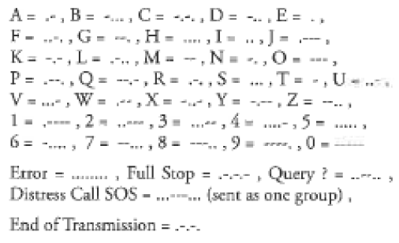

RELATIVE VALUE OF MONEY
Flynn required that transceivers be affordable. This was when government stations cost at least $2000 (£1,000). He wanted a set to cost less than $100 (£50) in 1925/27.
The average wage in 1925 was around $9.50 (£4/1510),
1935 - $8.40,
1947 -$13.30,
1977 - $180.00,
1997 - 3700,

2001 - $695 (male average $821),
2003 - $928 (average gross weekly wage).
Radio sets in 1924 cost: - Home assembly sets 1 valve $11, 2 valve $19, 3 valve $23, 4 valve $27. Assembled sets $111 up. 1927 prices were a little lower at $60 (£30) for a 3 valve TRF. AM 25-watt transceivers in the early 1960s cost about, $500 SSB transceivers cost $1200 to $2000 in the mid-1970s.

RECENT DEVELOPMENTS USING
PEDAL HAND, AND BATTERY POWERED COMMUNICATIONS EQUIPMENT
The pedal radio concept may have disappeared here in Australia, but not in some other areas of the World. In the 1950s Traeger received a request for a high frequency pedal radio for an aero-medical service in Nigeria. Jack Drew of Traeger Transceivers redesigned the original 20s and 30s pedal generator and designed a transceiver to use with the generator. This was of course a much improved radio, and all the power for the transceiver was generated by the pedal generator. Batteries are expensive in Africa.
The Flying Doctor Development Service (FDDS) in Africa has been active for over 30 years in the development of two way radio communications for isolated communities. Initially they relied on equipment made in Australia which over time, with the closure of Traeger Transceivers, has become costly to maintain. Tanzania has had a successful network in operation over the last 18 or so years.
The FDDS developed their own efficient pedal generator, which can be made locally with a minimum of imported components. The equipment has been designed by dedicated people in the United Kingdom who want to assist those in Africa less fortunate than themselves.
The generator is in fact an alternator based on a heavy flywheel which smooths out variations of speed, and hence energy, with variations in energy taken by the transceiver. The transceiver transmits single sideband with an output of 100 watts. From the information supplied it is not clear whether the receiver is powered by batteries or via the pedal generator. The complete transceiver would be transistorised and it is possible that the receiver is powered by a rechargeable battery which is charged from the generator/alternator.
In South Africa a domestic radio has been developed that is powered for approximately 30 minutes after having had clockwork mechanism wound for around 40 seconds. The set is designed this way as batteries are quite expensive for the poor in the African states. This radio was available in Australia from some electronics stores for around $149 (1999). It may still be available.
Marine lifeboat radios have been powered by hand or foot actuated generators. Their importance now has decreased dramatically with the use of battery powered Emergency Indicating Position Radio Beacons (EPIRB). When actuated these are located by orbiting satellites so identifying the position of those who are in distress. Frequencies of 121.5 MHz and 243 MHz are used on the cheaper units which can be pinpointed to within about 20 Kms, whilst 406.025 MHz is used on more sophisticated units whose location can be pinpointed to within 5 KM. Even more sophisticated EPIRBs use the Global Positioning System (GPS) to (order enhance the accuracy of the system to within 100 metres.

RADIO BASE STATIONS OF THE RFDS (and Its predecessors), OPENING (AND CLOSING) DATES
Cloncurry 1928 (radio 1929),
Wyndham and Port Hedland 1935,
Kalgoorlie 1937,
Broken Hill 1938,
Alice Springs 1939,
Charleville 1943,
Meekatharra 1949,
Charters Towers 1952,
Port Augusta, Derby and Cameroon 1955.
The Cloncurry base was closed and taken over by Mt Isa in June 1964.
In mid 1973 Charters Towers closed and was taken over by Cairns (Queensland Ambulance Transport Brigade).
Wyndham base was closed during the period between 1992 and 1998 with its communications being transferred to Derby.

POWER RATINGS OF TRANSMITTERS
It has appealed to many people to rate transmitters on the input power to the final stage (output stage) of a transmitter. For example, a transmitter may have a DC power input of 100 watts and yet due to its circuit design is only capable of perhaps 25 to 35 watts of radio frequency output (the useful output), whereas another design may have an output of 75 watts for 100 watts DC power input.
Up until 1929 it was common to rate broadcast transmitters on their input power. In 1929 the CCIR at the Hague determined that broadcast transmitters would be rated on their output power not their DC input power. This is a realistic and practical measurement of the performance of a transmitter.
Up until that time transmitters generally had the current and voltage applied to the output stage of a transmitter measured and the input power calculated. This was convenient and practical a radio frequency power measurement equipment was scarce and expensive.
Radio amateurs - experimenters, did not have access to such equipment and continued for many years to measure input - it sounded better anyway! More is better! The Postmaster Generals Department in their licensing booklet indicated that amateurs could not use more than 150 watts DC input power. Since the late 1960s early 70s it has been almost universal practice to measure output power rather than input power - accept where efficiency needs to be known by the designer, or where a power supply of sufficient ratings to power the transmitter needed to be designed and supplied.
Hence, in the 1920s and early 30s at least, the transmitters used in the outback would have had their input power quoted rather than their output power. In the 40s Traeger did measure the output power. An example is the 48S20 which had a 20-watt output rating, as per the suffix on the model number. The DC input to the output stage of the transmitter of this model was around 30 to 35 watts.

TRANSMITTER MODULATORS
To impress voice or music (audio) onto the radio transmitter carrier wave, a variety of methods have been employed.
In early broadcast transmitters a method called grid modulation was used. This impressed an audio voltage onto the grid of a radio frequency stage (RF) (commonly the power amplifier or RF output stage) in series with the radio frequency signal from the radio frequency oscillator. This caused the RF stage efficiency to vary in sympathy with volume and frequency of the audio signal applied to it. This stage had an efficiency of between 25% and 35%. It tended to be a relatively critical method to set up for optimum performance. It was also used in many communications transmitters until after WWII. This is called a low level “efficiency” modulating system. That are several variants of this method. The overall efficiency of a transmitter in converting the total energy supplied to the transmitter to the amount developed as useful RF energy could be as low as 10%. It is rarely used now.
Heising modulation was often used in small broadcast transmitters in the 1920s, and in small communications transmitters even into the 60s. It requires a relatively high-power audio amplifier connected by circuitry to the transmitter RF output valve. This system is easier to adjust and the efficiency of the RF stage of the transmitter is from 60% to 75% in transmitters above a few watts output. This is rarely used these days.
Plate and screen modulation is similar to Heising modulation in that it is a high level type of modulation, where the audio is applied to the transmitter output stage. It did not come into common usage until the late 1930s and continued until the 70s when superior modulation systems were implemented. It involves using a push-pull audio amplifier coupled via a transformer, with the secondary in series with the high-tension voltage supply to the RF output valve. The output stage is between 60% and 80% efficient (depending on the size of the transmitter), and the audio modulator (amplifier) is around 65% efficient This system was considered quite efficient and is still used.
Alf Traeger in hie portable transceivers used class B audio modulators to modulate the plate and screen circuits of the RF amplifier. He implemented this in the mid-1930s. He was years ahead of most other manufacturers who did not employ this method until WWII, or later in their potable transceivers. This was by far the best method of getting the most out of a small transmitter for the least amount of electrical energy expended.
Series modulation of the RF output stage of a transmitter was also commonly used in smaller broadcast transmitters. Whilst the RF amplifier was efficient, the audio amplifier (modulator) only had an efficiency of 25% to 40%, and quite high voltages were used in such transmitters making safety a real concern. It is rarely used today - if ever.
A more recent variant of the series modulation system is one in which the series audio valve is replaced with a valve used as a Pulse Duration Modulator (PDM). This is highly efficient at over 90% efficiency, allowing a transmitter to achieve over 50% total efficiency in conversion of electrical energy from raw AC to RF energy. This system and even more efficient variants has been used since the 1970s which economise on the use of electricity, which is the highest operating cost with high power transmitters.

EDISON CELLS
In researching this experimental station, various texts both technical and otherwise, give a variety of dimensions, weights and voltages for these batteries.
The dimensions quoted in chapter four appear to be correct by scaling the battery size against the known size of the Ford T coil in the photograph of the Hermannsburg station. One set of dimensions indicated that the battery coils were 15" (38cm) in diameter and 21” (55cm) high (Transcript of Alfred Traeger's Handwritten Story up to 1930). These dimensions could not be correct, as once again. looking at the photograph, 2’ high cells would almost be flush with the bottom of the frame for the typical tabletop. which is nominally 2'6" (76cm). The tops of the cells are some distance bellow the tabletop. Later, Edison cells were in rectangular glass jars.
The quoted total weights vary from in excess of 400 pounds (182 Kg) to half a ton - 1120 pounds (509 Kg), depending on the author. This is quite a variation. A cell weight of 80pounds (36 Kg) appears to be within reason, allowing a total relative density of 3.3 for the cells.
The texts concerning the experiments at Hermannsburg quote the (Input voltage of each of these Edison cells (almost the same as LaLande Cells) as being 0.65 volts. These cells use copper oxide and zinc plates in a strong caustic soda electrolyte. According to the "Metallurgists & Chemists' Handbook" a voltage of 1.12 volts is produced and around one volt according to the "Chemical Engineers Handbook" (1935). Another book the 'Standard Handbook for Electrical Engineers' by A.E. Knowlton (1941), quotes "The open circuit voltage of the cell to be about 1 volt. but the average voltage under load is about 0.65 volt." The I.C.S. Reference Library Book 43 (1905) of the U.S.A. International Textbook Company quotes the voltage as 0.7 volts at a current drain of three amperes from a 150-amp hour capacity (AHC) cell. `The Electrician' series, Primary Batteries by W.R. Cooper. MA. B.Sc. London (1901) also agrees with the lower voltage.
It is claimed in some texts, both, that the open circuit voltage of the cells is of the order of one volt but drops to around 0.65 volts under load, whilst the cells have very low internal resistance! This is impossible as low resistance in a circuit means that there will be very little voltage variation with variation in load. Careful experiments conducted by Mervyn Raison (VK4SO) who was an industrial chemist, have proven the statement that the cells drop from 1.1 volts with no load, to 0.65 volts under load is quite inaccurate. It would appear that the later text books have copied the results of flawed experiments without checking their accuracy. It is quite likely that the cells do eventually drop to 0.65 volts when the chemicals are exhausted in them.
As any experimenter who has worked with directly heated valves will realise, a drop of 33% in the filament and high tension voltage from the intended voltage causes the valve to nearly completely shut down within around a second or two. Kauper would not have considered these cells if this wide variation in voltage had occurred.
The circuit diagram in Appendix 2, is of a station powered by a 9.9 volt battery, bank.

VALVE DATA AND USAGE
Of necessity, virtually all receivers produced up to about 1927 were designed around existing battery type valves which required the provision of pure DC. "A" (filament battery) = 2, 3, 4 or 6 volts up to around 1 amp, B" (HT battery) = 22.5, 45, 67.5, 90 or 135 volts at up to 20ma, “C" (bias battery) -1.5 to around -9 volts.
A number of these valves became available in the 20s and were used extensively in low to medium power transmitters. The 211 is likely to have been used as the output valve in the first Cloncurry (VJI) base station. The UV210 may have been used in the Hermannsburg transmitter. The UV201A (1923) was an ubiquitous valve used for almost anything in radio in the early to late 20s. The prefixes UV and UX refer to the type of base used on valves, such as the 201A. The electrical characteristics arc the nine, with the 201A ultimately being called the 01A. “UV” (circa 1920) and/or “UX” (at end of 1925) versions of these valves were used in the early experimental equipment.
In 1930 US the radio industry followed the trend already set in Europe by introducing a range of battery powered valves with 2 volt filaments. These 2 volt filament valves were used in the "pedal" radios up until the late 1940s.

Basic Valve Data: The published valve data for early valves was rather elastic and only gave an indication of their capabilities. For example, the 201A (and many other types) were often grossly overloaded as transmitting valves. As a transmitting valve the 201A WIC often quoted in articles as running up to 7.5 watts (whether input or output power was not quoted, but input power appears the more likely quote). Note also the A615 used in the 1930 model pedal radio, it is quoted as having a plate current drain of 4 milliamps, but in the transmitter, it would have drawn at least 15 milliamps plate current to achieve the output power the transmitter was capable of.

The year that various valves were obtainable in Australia is a little elastic, as some of the valves were available overseas before the year specified in the chart However, they were not commonly available in quantities sufficient to warrant their use until continuity of supply could be expected. There was also a need in Australia to experiment with these new valves to ascertain their suitability for use in Australia.

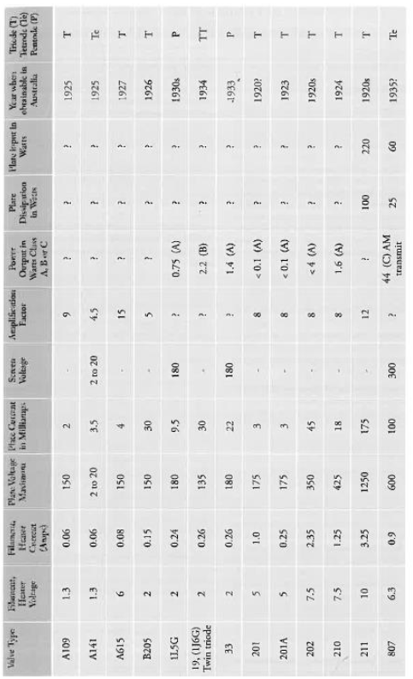

APPENDIX FIVE

PROPAGATION AND FREQUENCIES USED
PROPAGATION
THE SUNSPOT CYCLE
The sun emits many types of radiation. When observed through special telescopes dark spots are seen on the sun. The number and size vary over time. Typically, when there are large numbers of sunspots radio communication on the high frequency and lower very high frequency ranges is extremely good and long communication distances are achieved with quire low power. When the number of sunspots is low, radio communication on the higher frequencies is usually poor and lower frequencies need to be used. Generally, radio communication even at these lower frequencies is not as good as when there are greater numbers of sunspots, but it is more predictable.
The sunspot cycle goes through a complete cycle approximately every 11years. No two sunspot peaks (or nulls) are the same so the communications achieved at one peak may not be as good as, or may be much better than, the previous peak.
Beside sunspots, other phenomena do occur which affect radio communications. We are gradually coming to understand that radio propagation does not rely exclusively on the number of sunspots.
Sunspot peaks of interest for the time frame of this book occurred in the following years: -
1923, 1934, 1945, 1956, 1967, 1978, 1989, 2000.

Daily Propagation Variations
Not only do we experience a 11-year cycle, we experience variations from day to day, and from day to night.
Most people will have observed on the AM broadcast band (531 kHz to 1701 kHz) that during the day reception is restricted to relatively local stations up to a few hundred kilometres away. This depends on the power of the station transmitter, which may vary between 50 watts and 50,000 watts, the size of the antenna (and earth mat), which may be 20 metres high to around 200 metres high, and the soil conductivity (particularly near the transmitter). A transmitter located near the sea will be heard many hundreds of kilometres seaward due to the high conductivity of the sea water.
When I was at Macquarie Island in Sub-Antarctica, coastal broadcasting radio stations in southeastern Australia, Tasmania and New Zealand were heard at entertainment strength during the day. The distance to Macquarie Island (latitude 54°29' South and longitude 158°57' East) from these locations is between 1200 and 2000 kilometres.
Radio signals up to around 1.5 to 2 megahertz rely very much on a radio wave that follows the surface of the earth called the "ground wave". This is rarely affected by the conditions in the ionosphere. Nighttime reception is a different matter. At night radio propagation changes. and nations many thousands of kilometres away can be herd. They may be strong one minute and fade away the next minute. They can be very distorted and because more than one station is assigned to transmit on the same frequency (channel), when one station fades another may take its place for a while.
On the high frequency bands used by communications services, similar effects do take place, but are characterised by additional features.
There is a region above the stratosphere which is called the ionosphere. The ionosphere is a part of the earth's outer atmosphere where sufficient free electrons are present to affect the propagation of radio waves. For all practical purposes it starts at around 60 kilometres above the earth and extends to 700 kilometres.
There are several regions where concentrations of electrons form either a radio signal reflecting region or absorption region. The lowest region is called "D" located nominally at 70 kilometres above earth, and this acts as an absorber particularly for radio frequencies below 3 megahertz, hence the information in the preceding paragraph which discusses the daytime range of broadcast radio stations. The next region is the "E" region located nominally 120 kilometres above earth. This is a reflecting region and is the principle reflecting region for high frequency radio transmissions within a few hundred kilometres. The "F" regions designated as "F1" and "F2" are nominally at 220 and 400 kilometres, with the "F2” region being dominant. This is also a radio signal reflecting region and is the medium by which short wave (HF) radio signals are received over distances of many thousands of kilometres.
The D. "E", and "F regions are all affected by ultraviolet radiation from the sun. During the day the regions are bombarded by ultraviolet radiation and each region becomes an absorber or a reflector of radio signals. The effects peak around the middle of the day. In the evening the “D” region rapidly loses its ability to absorb radio signals and they then penetrate further and are reflected by the combined “F” region.
The "D” region disappears soon after sundown so has little effect on radio signals at night, whilst the combined “F” region only gradually loses its reflecting ability, being at a minimum just before dawn.
The above descriptions show that radio propagation conditions change daily from night to day and even over a 11 year cycle. There are also other much shorter term, less predictable variations in communications ability caused by other sporadic radiations from the sun. It is possible to have radio black-outs where no signals are heard night or day on the high frequency bands. The Antarctic is an area where this is not uncommon and radio communications may not be possible for several days.
As a general rule however, during the day, higher frequencies are used for radio communications (above the absorption frequency of the “D” region), when communicating over long distances is required. Where stations are much closer together, over frequencies we used. At night lower frequencies are used, but stations further apart will still use higher frequencies than those who are closer.
In the Flying Doctor Service radio networks, the frequencies used have been in the 2 to 3 megahertz range, the 4 to 5.5 megahertz range and the 6 to 8 megahertz range. Other networks with similar distances to cover will have channels in the same general, frequency ranges.
The 2 to 3 megahertz frequencies are used for relatively short distances dining the day and for several hundred kilometres at night. The frequency of 2020 kilohertz has been used for the “Galah” session over the years. The 4 to 5.5 megahertz frequencies are used for medium distance daytime communications cut to a few hundred kilometres and for many hundreds of kilometres at night. The 6-to-8-megahertz range is used for long distance communications during the day out to 1000 kilometres or more. At night it will have extended range which will mean that overseas stations will be heard which interfere with "local" Australian communications. This frequency range tends mostly not to be used much at night by the likes of the RFDS due to the interference from strong overseas stations.

FREQUENCIES
1925
The wavelengths used in the experiments conducted by the Rev John Flynn and Gorge Towns in 1925 were around 80 to 88 metres. Frequencies were rarely mentioned as accurately measuring radio frequencies was not possible without laboratory standard measuring instruments. Normally the frequencies used were around 3.5 megahertz on the radio amateur or experimenter’s band.

1926
The wavelengths used in the1926 Hermannsburg and Arltunga experiments were variously quoted as 88 metres, 85 metres and 175 metres. As the base station at Stuart (Alice Springs) and the two out stations could all hear one another, the thought expressed in some literature that the base was on 175 metres and the out-stations were on 88 metres appears incorrect. The impression gained has been that the wavelength was around 85 to 88 metres by all three stations. The base may have had other wavelengths available so that other people such as Harry Kauper in Adelaide could be contacted to arrange various listening periods or operating schedules.

1928
The method of defining a location in the radio frequency spectrum by quoting an operating wavelength was gradually assuming less importance. In its place the more precise and less cumbersome “frequency of operation” was taking over. For some time both methods of definition were used, frequency first followed by wavelength. Currently frequency is quoted and where relevant, the nominal wavelength is quoted.
Licences which were obtained in 1928 had the wavelength 88 metres on them which was subsequently struck out. For the Cloncurry base station, the wavelength 146.3 metres was inserted and initialed by the Chief Inspector Wireless (James Malone) on 4/4/29. The portable station license had the wavelength 134.5 metres inserted and initialed and in the case of portable licence 53 (Bedourie) the frequency of 2230 Kc/s was also shown. By calculation the base station frequency was 2050 kilohertz.
It would appear that the Postmaster General's department (PMG) did not want individual portable/ homestead stations being able to talk to one another, only to the base at Cloncurry. Cloncurry would be able to hear all homestead stations, and they would all be able to hear Cloncurry but not each other. This was to ensure that the base station retained control of all communication. This occurred because all out-stations had to listen on 2050 kHz for the base but they each would transmit on 2230 kHz, and they were not tuned to receive that frequency. Out of hours the operators of the homestead set probably would have arranged to listen on the frequency used by other homestead sets. However, this did not occur, as licensing conditions changed even before the network was installed.
In the mid to late 1920s AWA on behalf of the Commonwealth Government installed two radio stations, one at Wave Hill in the Northern Territory, and Camooweal on the Queensland and Northern Territory border. It was the intentional the government that people in the outback would use these stations to keep in touch with the outside world, in much the same way as Flynn envisaged, with the network being established around Cloncurry.
This network never really got going as it would seem the government had the stations installed but did not consider what was necessary to have these stations used electively. There were no effective transceivers at reasonable cost available. It is unclear from the scanty information available whether the transmissions from the base station were by voice or morse code, but the transmissions from the out-stations were by morse code it would seem. The out-station transceivers, at least in the early 1930s, appear to have been pedal operated and may have been made either by AWA or Traeger.
It was an ill-conceived cumbersome system, whereas the flying doctor network was well planned. The frequencies used are unknown but were likely to be similar to those used by Cloncurry. However. the government tended to use quite low frequencies until much later in the 1930s, so I cannot he too certain about what range of frequencies were used.
Radio was still relatively new at this time, and the means by which radio waves were propagated over medium and long distances was not well understood. The selection of appropriate frequencies was still very much a matter of trial and error. In reality the people with the greatest understanding of propagation, were the experimenters such as Harry Kauper, Alf Traeger and many of their peers. Flynn was most fortunate to have these capable people on his team.
1929
There seems to have been a change of heart by the PMG department concerning the way that the frequencies were allocated. Instead of having two frequencies which meant that homestead operators could not normally hear other homestead sets, a common frequency was allocated so that all stations, base or homestead could hear one another. There is no known record of why the initial decision was changed. It seems likely that Rev. John Flynn talked with the Chief Wireless Inspector and pointed out that the dual frequency system would reduce the effectiveness of the radio network that was about to be installed. James Malone the Chief Wireless Inspector, it seems, was a man who whilst upholding the charter, rules and regulations and the Wireless Telegraphy Act which he worked under, was a progressive man. He could see that some of the official ways needed to be tempered with commonsense if radio communications was to work properly.
it appears that 2230 kHz was the first frequency used by the flying doctor radio network at Cloncurry.

1930 to 193_?
It is not known what frequencies were used throughout most of this period. The first single frequency pedal radio transmitter was superseded by a dual frequency transmitter in 1930. Flynn and Traeger had campaigned for an additional frequency up around nine megahertz to be used in addition to the original frequency. The distances that the radios were expected to work over had increased quite dramatically in a very short time to around 800 kilometres instead of the 450 to 500 kilometres initially expected. A second frequency was issued so that communications could be maintained during the day or night, and over considerable distance. The sunspot cycle was coining out of its null and radio communications were on the improve.
A licence dated 24th April 1931 lists three frequencies for use in the Australian Inland Mission (flying doctor) network based at Cloncurry. These frequencies were 2020 kHz, 8630 kHz and 8830 kHz. Why two 8 MHz frequencies were issued is a mystery. Propagation conditions would be nearly identical on these two frequencies as they are quite close together. The second frequency was superfluous. It would seem likely that only one 8 MHz frequency was used, as the transceiver used at this stage only had provision for two transmit frequencies. Around 1933 an updated version of the 1930 model transceiver appeared. This had provision for multiple transmit frequencies just by changing a “plug-in” assembly in the transmitter.
By 1935 or maybe earlier, the frequencies in use at Cloncurry were 2020 kHz, 5110 kHz and 8630 kHz. It is interesting to note that Wyndham was issued 8830 kHz when it was established in 1935. The Cloncurry dying doctor radio network was now (1935) contacting stations as far as Hermannsburg and Goulburn Island.
Harry Ding's private network in outback Australia, was allocated 1690 kHz (177 metres). 5300 kHz. and 8630 kHz. 8630 kHz was shared with the Cloncurry flying doctor radio network, and at times each network helped the other when difficult radio conditions prevailed. Ding's base station was located at Yunta on the Barrier Highway in South Australia. The equipment used was supplied by Alf Traeger.

1938 to 19_?
In 1938 the frequencies in use or assigned to be used at the six Flying Doctor Service Base Stations were as follows.

Location | Callsign | Commenced | Frequencies  in kilohertz
Cloncurry | VJI | 1929 | 2020, 5110 and 8630
Wyndham | 8SI | 1935 | 1600, 5300  and 8830
Port Hedland | 8SC | 1935 | 1600, 4030 and 040
Kalgoorlie | 8UB | 1937 | 1600, 5360  and 8750
Broken Hill | 8SK | 1938 | 2020, 4130  and 6690
Alice Springs | 8US | 1939 | 1600, 5410  and 8690

At this time the broadcast band went from 550 kHz to 1500 kHz, hence the allocation of 1600 kHz. When the broadcast band was extended to 1600 kHz this frequency was withdrawn and most stations using it were then allocated 1610 kHz. This appears to have occurred in 1939.
1939 to 1945, (and to 1957)
There was a great expansion in the use of high frequency radio systems by the military throughout the inland. The military would have used many hundreds, maybe thousands, of high frequencies during the war. Domestic radio communication services such as the Flying Doctor Service were retained to those frequencies that they already had, and certain restrictions were also placed on how they used them.
Flying Doctor Service bases were opened at Charleville in 1943, and after the war at Meekatharra in 1949. Charters Towers in 1952, and Port Augusta, Derby and Carnarvon in 1955 A number of frequencies were changed in the period 1955 to 1957 at Broken Hill, Windham and Derby. Other networks may have had frequency changes as well.

1973
The use of radio had been extended considerably after World War II. with many other radio communication networks beside the Royal Flying Doctor service. These other services were private networks, not open to the general public.
The following services and frequencies was used by Outpost Radio Communication Services.

Royal Flying Doctor Service

Location | Callsign | Frequencies in kilohertz
Alice Springs | VJD | 2020. 5370*, 5410, and  6950
Broken Hill | VJC | 2020, 4055, 4635, and  6920
Cairns#  (Qld Ambulance Transport Brigade) | VKA | 2260>. 5145,5865`. and  7465
Carnavon | VJT | 1610^, 2280, 4045, and  6890
Charleville | VJJ | 2020. 4045. 4980. 6845,  and 8165*+
Charters Towers# | VKQ | 2020. 5300. 5861*and  8165+
Derby | VJB | 1610^. 2792, 5300, and  6925
Kalgoorlie | VJQ | 1610^, 2656, 5010, 5360,  and 6825
Meekathara | VKJ | 1610^,2280.4010, 5260,  and 6880
Mt Isa** | VJI | 2020, 5110, and 6965
Port Augusta | VNZ | 1690, 2020, 4010, 5145, 6890 and 8165
Port Headland | VKL | 1610^.2280, 4030. and 6965
Wyndham | VKF | 1610^,3224, 5300, and  6945

Overseas Telecommunications Commission
Location | Call Sign | Freq. KHz
Broome Radio | VIO | Tx 4980, rx 4940, tx/rx490
Esperence Radio | VIE | 3393, and 6770
Geraldron Radio | VIN | 4440
Hobart Radio | VIH | 5355
Rockhampton Radio | VIR | 2020, and 5765
Townsville Radio | VIT | Tx4870, rx5020, tx/rx 6204 (emergency use)

Department of Aboriginal and Island Affairs

Thursday Island | VL4GA | 2784, 5020, and 7840

Department of Education
Katherine< | KN | 4860 and 7340

PMG Department

Darwin | VJY | 2020, 4010, 6840, and 6975
Whitemark | VL7AA | 1680, and 3252

K. Bassham Service to four offshore islands
Port Lincoln | VJA | 2020, and 5110

Mr Linklater. Service to two offshore islands.

# Charters Towers closed in the middle of 1973
^ Frequency 1610 withdrawn on 31/12/77 and replaced with 2020
< “School of the Air” only
+ Withdrawn when Charters Towers and Cairns amalgamated.
> Frequencies 1690 and 2260 withdrawn when conversion to SSB was completed.
* School of the Air
** Cloncurry closed over the weekend of 20/21 June 1964 with Mt Isa opening in its place after that weekend

1992 onwards
All high frequency communication services changed to single sideband (SSB) using upper sideband at the beginning of 1978. Prior to this, services mostly used amplitude modulation (AM). According to the brochure R1B29 (1992) (Outpost Radio) of the Department of Transport and Communications that were many radio frequencies issued to "School of the Air". Originally "School of the Air" In 1950/1 used the radio frequencies issued to the Royal Flying Doctor Service and also their radio communications facilities. As time went by, separate frequencies were used for "School of the Air” and ultimately it became a totally separate entity with its own radio communications facilities and frequencies.
Then would have been a number of frequencies used exclusively by the school, at the time of the information presented for 1573. However. this was not available to me. This information for 1992 however, gives an idea of how much importance is placed on remote education.

School of the Air

Alice Springs | VZ8BZ | 5340, 5370, 8035
Broken Hill | VJC | 4635, 5130, 5735, 5895, 6920, 7565, 8150
Cairns | VCN | 5300, 5865, 7357
Charleville | VCH | 4045, 4926, 5230, 6890
Carnarvon | VJT | 4045, 4926, 5230, 6890
Charters Towers | VCT | 4488,4583, 4791, 4992
Derby | VJB | 5200, 5300, 5850
Kalgoorlie | VJO | 5010, 5360, 5740, 6825
Katherine | VZ8SK | 4860, 5731, 7340, 8014
Longreach | VLR | 4869, 4975, 5116
Meekathara | VKJ | 4010, 4880, 5260, 6880
Mt Isa | VMT | 4800, 5445, 6965, 7803
Port Augusta | VNZ | 4010, 5145, 5845, 6890, 8171
Port Hedland | VKL | 4030, 6960

Royal Flying Doctor Service

Location | Callsign | Frequency KHz
Alice Springs | VJD | 2020, 4350, 5410, 6950
Broken Hill | VJC | 2020, 4055, 6920
Cairns | VJN | 2020, 2260, 5145, 7465
Carnarvon | VJT | 2020, 2280, 4045, 6890
Charleville | VJJ | 2020, 4980, 6845
Derby | VJB | 2020, 2792, 5300, 6925
Kalgoorlie | VJO | 2020, 2656, 5360, 6825
Meekatharra | VKJ | 2020, 2280, 4010, 6880
Mount Isa | VJI | 2020, 5110, 6965
Port Augusta | VNZ | 2020, 4010. 5145, 6890,  8165
Port Hedland | VKL | 2020, 2280,4030,6960
Wyndham  (Receive only,  controlled  from Derby) | VKF | 2020. 2805. 5300, 6945

The RFDS also had facilities for radio telephone calls at this time, using either one Frequency for transmit and receive or two frequencies - one for transmit and the other for receive. Even though this system provided a telephone hookup, it was not easy for people used to the normal telephone service to adapt to, as it required users to talk then say "over" so that the other person could then talk. It allowed only one person at a time to talk. it is not possible to interrupt the other party whilst he/she talks with this type of telephone system.

St Johns Ambulance

Darwin | VJY | 2360, 4010, 6840, 7975

The Overseas Telecommunications Commission also provided a public access radio-telephone and Seatex service through its coastal radio stations. They used frequencies in the 2, 4.8, 12/13, 16/17, and 22 megahertz marine radio bands. A total of 37 pairs (one transmit and one receive) of frequencies were used plus three simplex frequencies.

Royal Flying Doctor Service (RFDS)
The frequencies in use were almost the same as In 1992 with the following alterations. Carnarvon. Derby, Kalgoorlie, Meekatharra, and Port Hedland no longer have 2020 kilohertz allocated to them. However, in their areas 2020 kHz is still permitted to be used by outpost stations. Wyndham was completely closed between 1992 and 1998. Derby changed its highest frequency from 6925 to 6945. Meekatharra gained a new frequency of 11466 kilohertz. This is the highest frequency allocated to the RFDS, to my knowledge.
The RFDS is gradually reducing their reliance on the use of HF radio as more and more outback people are able to access the base via telephone or satellite phones.

School of the Air
The number of frequencies used in this service increased noticeably since 1992.

Alice Springs | 4 frequencies
Broken Hill | Unknown, not shown  in official brochures
Cairns | 8 frequencies
Carnarvon | 2 frequencies
Charleville | 8 frequencies
Charters Towers | 8 frequencies
Derby | 3 frequencies
Dubbo | 4 frequencies
Kalgoorlie | 1 frequency
Katherine | 4 frequencies
Longreach | 8 frequencies
Meekatharra | 2 frequencies
Mount Isa | 7 frequencies
Port Augusta | 2 frequencies
Port Hedland | 2 frequencies
Rockhampton (Capricomia) | 8 frequencies

The lowest frequency used is 3857 kHz. and the highest is 11015 kHz.
Whilst School of the Air (School of Distance Education) has used HF radio almost exclusively, in NSW a number of schools are now using frequency modulation (FM) VHF radio on frequencies between 78 and 82 MHz. With beam antennas, ranges up to 120 kilometres are achieved between the school and the students’ homes. However, there are “dead spots” where the signals are not heard within the 120 kilometre range. Additional base stations (controlled from the school) have been installed in some instances, but this dramatically escalates the cost of providing the service.
Currently, the School of Distance Education in
Bourke, Broken Hill (VHF in lieu of HF), Cobar, Hay, Tibooburra and Walgett are using VHF radio instead of HF radio. Dubbo is still using HF and covers areas where the VHF has proved ineffective.
The frequencies used in these VHF services are in the 78-79 MHz and 81-82 MHz range, with two frequency duplex ability at least at the base. To fill in some of the “dead spots”. repeaters in the 77-79 MHz. and 80-82 MHz frequency ranges, as well as around 461 and 451 MHz (with 9.5 MHz frequency splits between receiver and transmit frequencies) are used.
Whilst radio is used extensively for remote education, loudspeaker telephone connections with students is also undertaken.
Telstra Radphone and Seafax Service
38 pairs of radio frequencies in the 4, 6.8. 12/13, 16/17, 22 and 25/26 megahertz maritime mobile service bands have been used to provide this service. There were several base stations around Australia, and they were controlled from Ningi (near Bribie Island in Queensland).
In September 2001 a letter was received by users of this network which stated that Telstra would be withdrawing Radphone and Radphone Direct services on 28/2/2002 on the HF bands. It has now been withdrawn. Alternatives, such as a satellite service were offered as a replacement. It was pointed out that CDMA mobile phone services cover 97% of the population, but neglected to mention that CDMA is only available in the moat populated 5 to 10% of the Australian land mass. Most users of HF radio in the 90 to 95% of Australia that has no CDMA coverage.

2000 - Royal Flying Doctor Service (RFDS)

Location | Callsign | Frequency KHz
Alice Springs | VJD | 2020, 4350, 5410, 6950
Broken Hill | VJC | 2020, 4055, 6920
Cairns | VJN | 2020, 2260, 5145, 7465
Carnarvon | VJT | 2280, 4045, 5300, 5360, 6890
Charleville | VJJ | 2020, 4980, 6845
Derby | VJB | 2792, 5300, 5360, 6945
Kalgoorlie | VJO | 2656, 5300, 5360, 6825
Meekatharra | VKJ | 2280, 4010, 5300, 5360, 6880
Mount Isa | VJI | 2020, 5145, 6965
Port Augusta | VNZ | 2020, 2890, 4010, 5145, 6890, 8165
Port Hedland | VKL | 2280,4030, 5300, 5360, 6960

Other Organisations with HF Radio Communications Facilities.
These organisations provide high frequency communications facilities, some as club, business group or as traveler type networks throughout outback Australia.

Pasta Comsat VZX at Firefly on the mid-north coast of N.S.W.

Location | Callsign | Frequencies in kilohertz
Central NSW | VZX | 4354rx 4354tx, 6221rx 6522tx, 8713rx 8713tx, 12329rx, 13176tx, 16483rx, 17365tx, 22126rx, 22822tx

This is a two-frequency service, where the mobile service listens on the “rx” frequency and transmits on the "tx" frequency: Selcall facilities are necessary to access the network. Address (1995), Penta Radio Communications, PO Box 530, Gosford, NSW 2250. Telephone 02 6559 1888

Australian National 4WD Radio Network Inc.
'The base stations are located in Derby, Sandstone and Perth in Western Australia, Alice Springs and Darwin in the Northern Territory, Adelaide in South Australia. St Marys in Tasmania, Newcastle in New South Wales, and Cairns and Charters Towers in Queensland They all use the genetic callsign of VKS-737. They have a total of five frequencies at their disposal, namely 3995. 5455, 8022, 11612, and 14977 kilohertz. Access to this network is by being a member of the club and then holding a licence Issued by the Australian Communications Authority. The address in 1995 was, South Australian Association of Four Wheel Drive Clubs Inc., PO Box 178, Blair Athol, SA. 5084. Telephone 08 8359 0627.

HF Radio Club Incorporated

Callsign VKE-237. Frequencies allocated are-3995, 5135, 8022,11487 and 14662 kHz. They share the frequencies 3995 and 8022 kHz with the VKS-737 network. Their address is PO Box 58, Beresford, NSW. 2322. Telephone 02 4964 1169.

Amateur Radio Travelers Network
A number of radio amateurs (mostly in Western Australia) provide a service for other radio amateurs travelling throughout Australia. They usually communicate on 14.116 MHz daily at around 0300 Universal Time (UT or GMT) (1300 hrs which equates to 1 pm Eastern Australian Standard Time (EAST)). There is also another daily net on 21.185 MHz at 0100 UT (11.00am EAST). It can be for a chit chat or for emergency requirements. Friends/family can contact the amateur radio control stations to pass on important messages. There is no charge for this, but there are restrictions on the content of any messages. See the Amateur Radio Callbook for current details. The callbook is available from the Wireless Institute of Australia, and Dick Smith Electronics stores.
There are a number of other organisations that do provide HF communications for either the general public or their own customers. These may or may not be suitable for the needs of many HF radio users. It would be best to inquire what services are available at your nearest HF communications radio dealer.

Citizen Band Radio Frequencies and Channels
High Frequency (27 megahertz) and Ultra High frequency (477 megahertz) Citizens Band radio has been legal since 1977 and many people in the outback use these bands in addition to the high frequency bands previously mentioned.
Surprisingly, there are a sprinkling of UHF CB repeater stations throughout the outback. Lists of the locations of these stations and the channels used are often found in the Wireless Institute of Australia, Amateur Radio Callbook- This is available from Dick Smith Electronics stores, and the Wireless Institute of Australia.

High Frequency (HE) ABC Inland Services
Normal A.M broadcast band (531.1701 kHz) services are unsuitable to covers the vast distances in Central Australia. For this reason the ABC has established AM HF stations at Alice Springs, Tennant Creek and Katherine.

Location Night Frequency Day Frequency
Alice Springs 2310 kHz 4835 kHz
Tennant Creek 2325 kHz 4910 kHz
Katherine 2485 kHz 5025 kHz

The nighttime frequencies are heard quite satisfactorily in southern Australia.

Weather Forecasts
The Bureau of Meteorology provides weather forecasts on a number of marine radio frequencies on a regular basis. Information about this service is available on the website www.bom.gov.au/marine.
Transmissions for the western part of Australia come from Wiluna WA. on the following frequencies 2056, 4149, 6230, 8113, 12362, and 16528 kHz Upper Sideband.
Transmissions for the eastern part of Australia comes from Charleville, QLD on the following frequencies 2201, 4426, 6507, 8176, 12365, 16546 kHz Upper Sideband.
How useful these transmissions will be away from coastal areas will need to be assessed by listeners.

CB Radio Channels and Frequencies in Megahertz
Ch 1 = 26.965 HF, 476.425 UHF,
Ch 2 = 26.975 HF, 476.450 UHF,
Ch 3 = 26.985 HF, 476.475 UHF,
Ch 4 = 27.005 HF, 476.500 UHF,
Ch 5 = 27.015 HF, 476.525 UHF,
Ch 6 = 27.025 HF, 476.550 UHF,
Ch 7 = 27.035 HF, 476.575 UHF,
Ch 8 = 27.055 HF, 476.600 UHF,
Ch 9 = 27.065 HF, 476.625 UHF,
Ch 10 = 27.075 HF, 476.650 UHF,
Ch 11 = 27.085 HF, 476.675 UHF,
Ch 12 = 27.105 HF, 476.700 UHF,
Ch 13 = 27.115 HF, 476.725 UHF,
Ch 14 = 27.125 HF, 476.750 UHF,
Ch 13 = 27.135 HF, 476.775 UHF,
CI 16 = 27.155 HF, 476.800 UHF,
Ch 17 = 27.165 HF, 476.825 UHF,
Ch 18 = 27.175 HF, 476.850 UHF,
Ch 19 = 27.185 HF, 476.875 UHF,
Ch 20 = 27.205 HF, 476.900 UHF,
Ch 21 = 27.215 HF, 476.925 UHF,
Ch 22 = 27.225 HF, 476.950 UHF,
Ch 23 = 27.255 HF, 476.975 UHF,
Ch 24 = 27.235 HF, 477.000 UHF,
Ch 25 = 27.245 HF, 477.025 UHF,
Ch 26 = 27.265 HF, 477.050 UHF,
Ch 27 = 27.275 HF, 477.075 UHF,
Ch 28 = 27.285 HF, 477.100 UHF,
Ch 29 = 27.295 HF, 477.125 UHF,
Ch 30 = 27.305 HF, 477.150 UHF,
Ch 31 = 27.315 HF, 477.175 UHF,
Ch 32 = 27.325 HF, 477.200 UHF,
Ch 33 = 27.335 HF, 477.225 UHF
Ch 34 = 27.345 HF, 477.250 UHF
Ch 35 = 27.355 HF, 477.275 UHF
Ch 36 = 27.365 HF, 477.300 UHF
Ch 37 = 27.375 HF, 477.325 UHF
Ch 38 = 27.385 HF, 477.350 UHF
Ch 39 = 27.395 HF, 477.375 UHF
Ch 40 = 27.405 HF, 477.400 UHF

APPENDIX SIX

PROFILES OF EARLY OUTBACK RADIO PIONEERS

The profiles are not complete in many cases but will girt readers an idea of the calibre of each oldie pioneers. More information is available on many of these people in other publications. Some pioneers have been omitted from this appendix, not because their contribution wasn't important, but through lack of relevant information.

Anderson, Maurice Bernard
Born 1908 Died 1960 age 52
Maisie came to the Cloncurry base as a radio operator in 1930. He had qualified as a ship's radio operator and had spent some time on ships before this appointment. He was considered an exceptional operator. He copied messages through severe static, from very weak stations, whose operators sent extremely poor morse. He was transferred to Alice Springs in 1939 to establish the base there.
He joined the RAAF in 1940 (worked in co-operation with the Army) and was in charge of the North Australia Observer Unit network in Darwin, which was involved with radio surveillance. After the war he was involved in the radio and television industry in Melbourne. He held an amateur radio licence and was quite active “on the air” He died of cancer in 1960. He was so well respected within the RFDS that radio silence was observed dining his funeral.
Caton, Wally
Born late 18801 Died 1968
He was a radio experimenter from the early days of radio. He held the amateur callsign 6AG prior to 1929. and then VKGAG. He was actively involved in the Wireless Institute of Australia and would often arrive at meetings with his latest radio project. He installed the first national broadcast station in Western Australia. 6 WF in the 1920s.
He drew many of the early RFDS Traeger set circuit diagrams. Early sets all had a 1945 date on their schematic diagrams, even if the set was manufactured as early as 1936. He prepared service data, and supervised the construction of transceivers for the FDS. He also built transceivers for the FDS called the “Coxon Communicator”. Not much is known about it but it is claimed by some, that it was superior to the Traeger transceivers of the era (post war 1940s, 50’s).
Quoting from “Radio History of the Royal Flying Doctor Service of Australia 1928 -1981” written by John Behr. Dave Hanscomb VK6ATE says that the Federal Councils Radio Committee met in Melbourne on November 20.1936. Included in the initial six members was WE Coxon, technical adviser to the Victorian and WA section. and Mr Traeger's representative in WA. etc. Further information on Wally Coxon is contained in an article by the late Neville Williams. “When I think back” in “Electronics Australia” for May 94. Coxon was involved in the AAMS as early as 1935 and resigned from active involvement in the Western Australian Section in 1957.
Drew, Jack
Born 1_? Died 199_?
Jack was very secretive about his age. He started work with Traeger Transceivers prior to WWII. Due to his keen interest in radio, he became very involved with improvements and modifications to the transceivers and is likely to have had considerable input to the design of some transceivers. He was factory foreman and used to test all the transceivers from the production line.

Flynn, The Very Reverend Doctor John (OBE, Dr)
Born in Moliagul Victoria 1880 Died 1951 aged 71
The Reverend John Flynn had a burning desire to help all people who were in the outback of Australia. His vision was for medical facilities, aircraft transport to these facilities, and communications of some sort that would alert the medical authorities that assistance was required.
He pondered over this for many years but came to the conclusion in 1919 that wireless/radio communications was the only practical method of summoning aid in emergencies.
He continually encouraged radio experimenters to come up with something that would fulfil his vision for a simple, inexpensive, easy to use, portable radio transceiver with a communications range of around 300 miles.
Despite his multitudinous activities within the AIM, he found time to conduct experiments himself and in 1925 he and George Towns proved that radio communications would do what was wanted.
He encouraged Harry Kauper and Alf Traeger to build the equipment that was needed. The first radio transceivers to meet Flynn's criteria were put into service by Alf Traeger in 1929. They had their problems and were replaced by an updated model in 1930.
From here on John Flynn was able to leave the radio communications details to Alf Traeger and concentrate on the many other areas of concern within the Australian Inland Mission of the Presbyterian Church. He was an extremely busy man who did so much for the people of the outback and Australia in general.
There have been many books written about the Reverend John Flynn, and they make very interesting reading about one of the truly great people In Australia’s history.
Readers of these books will come to realise some of Flynn’s other abilities. He was an amateur photographer who took photographs of a high professional standard. Many of his thousands of photographs are now being reproduced as historical records of life in various parts of Australia dating back 100 years.
When he visited remote and isolated homesteads, he took a small kit of tools. His visits to these places was always welcome for many reasons, and the fact that he could repair clocks and other small devices was an additional bonus. His actions as always were to show practical Christianity wherever he went.

Kauper, Henry (Harry) Alexis Born in Hawthorn, Victoria 1888 Died 1942
Kauper was a radio engineer and inventor.
He worked with Harry Hawker at the Sopwith Aviation Co., UK, from 1913 and during WWI. He was the co-pilot with Harry Hawker in the "Daily Mail Circuit” of Britain Contest of 1913. He was a man of considerable talent, being a first-class mathematician and engineer. During WWI he developed an interrupter gear so that machine gun bullets fired through a revolving aircraft propeller did not hit it. Following the war Harry Butler and he formed an aviation company in Adelaide. Butler died in 1921 in an aircraft accident. Possibly as result of this sad accident, Harry returned to his other love, radio.
Like many others In the early days of the 20th century, he was an active amateur/experimenter in the radio field. He was considered one of the most capable radio men of this era, particularly in South Australia. A very capable mentor for the up-and-coming Alf Traeger. He formed the Adelaide Radio Company with lance Jones, and G A Miller-Randle in 1922.
Kauper was the Chief Engineer of South Australia's first Class A radio station 5CL from 1926 to 1929.

He held experimental/amateur callsign 5BG up to 1929, then VKSBG. The prefix ‘VK” was added by the PMG from the beginning of 1929 to identify amateur experimental radio stations as Australian stations. He was at the forefront of development of crystal control for transmitters in the mid-1920s.
The experimental sets used at Hermannsburg and Arltunga in 1926 were designed and built by Kauper, to a design very similar to that used by the WWI 1917 trench radio transmitters and receivers. It is likely that the “baby” homestead transceivers were to his design, although built by Alf Traeger.
In 1430 he left South Australia and joined 3DB in Melbourne. He held many technical positions In broadcasting during the 30s, being well liked in those positions. At this stage he largely faded from the scene as far as radio communications in the outback was concerned, except for some radio technical administrative activities as needed. At the beginning of World War II he was in charge of the Radio, Electrical and Instrument Section of the Aeronautical inspection Directorate. He died in 1942 at the age of 53/4, a sad loss at an early age of a very talented individual.

Kerr, Vernon
Born in Longreach, Queensland in 1912 Died 1979
He trained in the electrical field. He became the assistant to Maurie Anderson in Cloncurry in 1933 and took over the station in 1935. He would also have had a Commercial Radio Operators certificate, as all base station operators were required to hold such a qualification. He established the Charters Towers base in 1952 and the School of the Air in 1963. A drive is named after Vernon in Charters Towers.

Meithke, Adelaide (Miss) OBE
Born 1883 (approx) Died 1962
Adelaide Meithke devoted her life to the education of children. Before she retired in the early 1940s she was an Inspector of Girls' Schools in South Australia. After her retirement she became Vice President of the South Australian Section of the Flying Doctor Service. Her education background increasingly made her aware of the difficulties children experienced in obtaining a good education in remote areas. Whilst education via the correspondence school was excellent, the very important instant inter-reaction of teacher and pupil was missing.
She noted that many children used the FDS radio effectively, she pondered over this, and came to the conclusion, during a visit to Alice Springs in 1945. that perhaps a teacher could be at the FDS base and children (and teachers) could ask questions and receive a reply immediately via the radio.
She took this up with Graham Pitts the base director of the Alice Springs base station to see whether what she proposed was practical. Graham thought about this at length and came to the conclusion that the FDS base equipment with minor modifications could be used as an aid for education of the children.
She approached people in authority to gain permission for experimental broadcasts of a °School of the Air" to take place. It seems that she did not receive any support from a key person in authority. This meant that it took until 1950 for an experimental "School of the Air" to be tried. "School of the Air” was officially launched in 1951.
The “School of the Air” concept was embraced enthusiastically by the NSW Minister for Education after spending around a week at the Alice Springs school. He made funds available as soon as he could, and Broken Hill had its own “School of the Air” established in 1956.
After the success of the “School of the Air” it became apparent to members of the C.W.A. that perhaps a women’s' session could be instigated. Hence, Miss Meithke became involved with the establishment of "C.W.A. of die Air” initially from Alice Springs.
The concept that Adelaide Meithke established in the early 1950s for School of the Air is very alive and well today, although the C.W.A. of the Air seems to have faded away.

Pitts, Graham
Born 8/8/1915
Graham obtained his First Class Commercial Certificate of Proficiency in the early 1930’s, following study at the Marconi School of Wireless-This, at the time, was the highest grade of radio qualification that could be obtained outside of a University degree.
He served as radio officer on a number of ships, and in the early days of WWII returned to the Marconi school as a lecturer.
On marrying in 1943, Graham found employment at a broadcast station in Adelaide. He then gained the position of Base Director at the Alice Springs Flying Doctor Base in 1944. He worked at the base from 1944 until he transferred to Port Augusta, to establish that base, in 1953.
in 1945 Adelaide Meithke discussed ways and means of providing education over radio with Graham. "the discussions between the experts in education, and radio communications came to the conclusion that children could receive much of their education via the FDS radio network. A teacher would be at the base station and would talk to pupils, and pupils would talk to the teacher via the outpost station. Teacher pupil inter-reaction would be much as it is in normal schools. Some technical problems needed to be overcome but they were not too difficult foreman of Graham’s talents.
Work behind the scenes occurred for several years particularly to get the necessary authorisations to conduct such a service. Suitable modifications to studios, provision of modifications to transmitters to make them suitable for music, and one hundred and one other things that crop up, were all dealt with. The experimental "School of the Air” commenced in 1950, with the permanent school operating during 1951.
The radio reception at Alice Springs was marred by interference, so Graham installed a remote radio receiving site north of Alice Springs. When he moved to Port Augusta, he automatically installed a remote receiving site to overcome potential interference right from the outset, later the transmitters were also located in a remote location.
Graham retired in 1980 and then acted as a HF radio communications consultant to a number of governmental and semi-government instrumentalities until 1985 (ETSA. WRE etc.). He now (2004) lives contentedly in retirement with Evelyn his wife, in Bunbury, Western Australia He looks after the garden, a number of native birds that visit their garden, and enjoys the occasional contact on the amateur radio bands using the callsign VK6GF.

Traeger, Alfred Hermann OBE
Born Glenlee. Victoria 1895 Died 1980 age 85
He was a keen radio experimenter, who held amateur callsign 5AX prior to 1929, and after that VK5AX. in particular Alf was extremely talented in the electro-mechanical field. He obtained an Associate Diploma of Mechanical and Electrical engineering in 1916. He built a number of high-quality generators in his younger days. In the late 1920s he became intimately involved with John Flynn's dream of simple HF radio transceivers for people in the outback.
With considerable assistance from his mentor Harry Kauper, he developed the first of the pedal radio transceivers in 1928. It was a simple transceiver (by today's standards) of three valves, which was powered by batteries and a pedal generator of his design and manufacture. Much of the effectiveness of the Traeger transceivers could be arguably attributed to use of an efficient radiating system for the transmitter, and an effective method of coupling it to the transmitter.
He continued to build improved transceivers for the outback over many years, progressing from CW only transmitters, to AM/CW transmitters, AM only and finally SSB transmitters. The appropriate receivers were built into the same cabinets. Perhaps his most ingenious development was the morse typewriter, an electro-mechanical masterpiece - the communications computer of the 1930s.
"Traeger -The Pedal Radio Man" by Fred McKay. goes into the life of Alf Traeger in considerable detail.

APPENDIX SEVEN

DEFINITIONS, TERMINOLOGY & EXPLANATIONS

Throughout the book a number of abbreviations and symbols are used and reference to this section maybe helpful. where an unfamiliar one is encountered.
A
A.A.M.S. Australian Aerial Medical Service. 1934 to 1941, predecessor in name to the Flying Doctor Service.
A.M.S, Aerial Medical Service. 1927 to 1934, predecessor in name to AAM.S.
Aerial A wire or other metallic device connected to a transmitter or receiver directly or indirectly, intended to radiate a signal effectively in the case of transmitter, and to collect signals effectively in the case of a receiver. Used extensively in connection with descriptions of early radio equipment. Also known as an antenna.
AF Audio frequency. The audible frequency large, approximately 20 Hz. to 16 kHz for younger people. In the musical range, middle C on a piano keyboard, is nominally 256 Hz or 0.256 kHz.
A.I.M Australian Inland Mission - an arm of the Presbyterian Church of Australia.
Amateur Radio (Operators) Non-professional communications enthusiasts, authorised to transmit on various radio bands. They are required to pass examinations and to hold an amateur radio licence. Also known as "Hams", they are not to be confused with CB operators. who require no qualifications or licence to operate.
AM Amplitude modulation. A form of radio transmission that can be received on the simplest of receivers, and usually consists of voice or music. The amplitude of the signal is varied at an audio rate (voice or music) at the transmitter. The receiver detector responds to the amplitude variations and reproduces them as a voice or music output the same as applied to the transmitter. Most common AM radio transmissions are broadcast radio stations in the frequency band between 531 kHz and 1701 kHz, and the international broadcasters such as Radio Australia.
Amp A measure of electrical current flow.
Amplifier A device that increases the volume, amplitude and/or power of an electrical signal.
Antenna A more modern word for aerial, used almost exclusively since the 80s. Used extensively in later parts of the book. Often shortened to Ant.
ATU Aerial/Antenna Tuning Unit (or maybe AATU meaning Automatic Antenna Tuning Unit). Devices used to match a transmitter to an antenna and tune the antenna for best performance. Has a dual role of tuning and matching. It may be manually accomplished, or in the case of the automatic units, will tune and match an antenna (usually a mobile antenna) to a transmitter automatically, once the transmitter is turned on.
AWA Amalgamated Wireless (Australiia) Ltd., Sydney. An Australian manufacturer of domestic and commercial radio equipment.
B
"Baby" Transceiver Flynn in an article in a 1927 issue of "The Inlander", described a sprinkling of “Mother” stations spread throughout the inland, contacting many "Baby" radio stations.
Backwave A low level signal sent out by poorly designed morse code (CW) transmitters when the morse key is released.
Base Station Usually refers to the radio control station for a network of mobile or homestead type radio communication stations. Colloquially called the base or base.
Broadcast Band In the 1920s and 30s the broadcast band used frequencies from 55.0 kHz to 1500 kHz. This was changed later to become 535 kHz to 1600 kHz- With the conversion to 9 kHz spacing of radio stations, the frequency range became 531 kHz to 1602 kHz and in 1999 it became 531 kHz to 1701 kHz, with the last 99 kHz being used by special interest groups.
C
Callsign An identifying series of letters and numbers unique to a particular radio station. For example Cloncurry had the callsign VJI. In early times Harry Kauper had the amateur radio callsign 5BG but, from the end of 1928, his callsign and the callsign of all other amateur radio operators, had the prefix VK added, so his
callsign became VK5BG. Alf Traeger’s callsign was VK5AX
Capacitor Also known as a "condenser". These may have variable or fixed values, and these are measured in "micro-farads" (uF), "nanofarads (nF) or "picofarads" (pF). They store electrical energy.
CB Citizens Band Radio - may be in the 27 MHz HF band or in the 477 MHz UHF band. On 27 MHz AM or SSB can be used, with radio frequency powers of 4 watts on AM and 12 watts (peak) on SSB. On 477 MHz. FM transmission is used with a radio frequency power of 5 watts. Each band has 40 channels. see list in Appendix 5.
COMA A digital mobile telephone communications system. (Code Division. Multiple Access)
Centre Loaded Whip Usually a high frequency mobile antenna, that has a coil, or coils, near the centre of the antenna to tune the antenna to specific frequencies in the high frequency range. The coil may be tapped so that several frequencies can be tuned.
Circuit This is the electrical wiring of a radio. It may be drawn up as seen or more commonly as a schematic diagram. It is radio shorthand, and tells those familiar with it, much of what is needed to be known about the radio.
Clarifier A front panel control on a SSB receiver, that allows fine tuning of the receiver to overcome "duck-talk' distortion of received signals.
Coaxial Cable This is commonly the round (usually black) able about the thickness of a pencil which connects a transceiver to the antenna such as used on CB and HF transceivers. There are larger diameter cables too.
"Coffin" A style of radio cabinet used in the 20s and early 30s that looked like a miniature coffin. It had a lid that lifted up like a coffin lid. The early pedal radios were built into such cabinet.
Coil A radio term for a length of wire (usually insulated) wound around a cylindrical tube the number of turns can vary from just a few to many hundreds. The method of construction of coils today is different but the effect in a circuit (see above) is still the same. A coil of few Turns may tune to a short wave frequency with a capacitor whereas one with many turns may tune to the AM broadcast band.
Condenser An early name for a capacitor.
Converter In a superhet (superheterodyne) receiver, a converter is a section of the radio that converts radio signals from one frequency to another (usually 455 kilohertz) for the purpose of achieving easier operator use, and for technical reasons.
Counterpoise In some instances, instead of an earth a counterpoise is used. It is approximately the same length as the aerial and is run parallel with the ground. It may consist of one or more wires, usually up to a total of four radiating out from a central point, near the lowest part of the aerial/antenna.
Crystal Quartz crystal. It is ground in a particular way so that with a metal plate on either side of it, it will oscillate when a voltage is applied to the plates. Is used to accurately control the output frequency (Channel) of a transmitter, and sometimes used to accurately control the receive frequency of a receiver.
CW Continuous Wave. This is incorrectly used to indicate a continuous wave radio signal that is interrupted to provide messages in morse code.
D
Day/Night effect Variation in radiation level from the sun between night and day causes higher radio frequencies to be more useful in daytime whilst lower radio frequencies are more useful at night. Usually, the frequency used to communicate is increased the further the high frequency (HF) radio stations are apart.
dB Decibel. Used to measure relative levels of radio signals (and other things like sound). IF one signal has a particular level, a signal 10 dB stronger, has 10 times the power. If It is 20 dB stronger it would be 100 times the power. It is a convenient way of comparing large differences in power. For example, something 60 dB stronger than the original signal quoted is 1,000,000 stronger.
Dead Spot An area where radio reception is severely limited or nonexistent. On VHF it may occur in valleys or behind hills. On MF and HF it may occur in areas with particular types of ground. Often noticed on vehicle radios when volume drops in particular areas then increases as you move out of the area.
Dipole (Usually) a horizontal antenna that has the feeder cable from the transceiver connected to its centre.
DRCS Digital Radio Concentrator System. A digital system that is used with remote radio connected telephone services to minimise radio frequency use and provide superior quality telephone services. It is also more private.

“Duck-talk” A colloquial term to describe the sound of an inaccurately tuned SSB signal It tends to sound like duck talk.
E
Earth With some types of aerial/antennae an earth is an essential part of the whole transmitting or waving installation. if good performances is to be achieved. The earth is usually a pipe driven into the earth or wires buried just under the surface.
EPERB Emergency Position Indicating Radio Beacon. A VHF or VHF/UHF handheld or portable radio transmitter that transmits signals on aeronautical and marine distress frequencies. Initially, the signals an picked up by satellites and aircraft, and the general location of the beacon is pinpointed. Suitably equipped ships, land vehicles. helicopters and people on foot then locate the beacon and the people in distress. For more details see Chapter 17.
F
Flying Doctor Service. name commenced 1941 and used until superseded in 1955 by
R.F.D.S. (Royal Flying Doctor Service).
Feeder This is the cable/wire connecting a radio transceiver to the actual antenna/earth system. Commonly in a mobile situation it is the coaxial cable (feeder cable) going from the transceiver to the antenna. It does not always take the form of a coaxial able.
F.E.T. Field Effect Transistor, is a form of transistor that acts like a solid state version of a valve.
FM Frequency Modulation. At the transmitter the frequency of a radio signal is varied at an audio (voice or music) rate around a specific reference frequency in response to a voice or music input. At the receive, the varying frequency radio signals are applied to a detector that is sensitive to frequency variations only, which are convened to the original voice or music. Used on UHF CB, TV sound and FM broadcasts,
Foot Pre decimal distance measurement, 1 foot 30.5 cm, 3 feet =1 yard.
Frequency Synthesiser Sec (PLL.) Phase Locked Loop
G
Generator Mostly in this book, a generator is a device that convert, mechanical energy into electrical energy. Examples are car generators and the pedal generators.
GHz Gigahertz A gigahertz is a frequency of 1,000 megahertz.
Gin Pole Usually an “A” frame structure consisting of two poles tied together at or near the apex. Viewed from the side the frame is vertical. Guy wire cables are taken over the apex of the gin pole and attached to the mast/tower at the guying points. The gin pole achieves a much better leverage advantage angle, when starting to raise a mast or tower lying along the ground.
Global Star A satellite communications system for mobile phones using low earth orbiting satellites.
GPS Global Positioning Systems. A Satellite Navigation System.
GSM A digital mobile telephone service (Global System for Mobile Communications)
H
Ham An amateur radio or ham radio operator. See Amateur.
Harmonic A radio transmitter may transmit on a frequency of say 2,000 kHz, as fundamental frequency. Sometimes called the 1st harmonic. The 2nd harmonic is 4,000 kHz, the 3rd harmonic is 6,000 kHz.
Headphones Used with the early radio receivers to listen to the program or message being received. Today, used more by audio high fidelity enthusiasts.
Helical Whip A mobile antenna designed for use in the HF region that has a continuous winding along its length. It may have the winding tapped at various points so that several different frequencies can be used on the one antenna.
Hertz (Hz) The measurement of the number of cyclic oscillations that occur per second. The power mains has a frequency of 50 Hz. Named the Heinrich Hertz. Previous name was cycles per second.
HF High Frequency. A frequency between 3 Megahertz and 50 Megahertz. Used for long distance communications such as shipping, land mobiles, amateur radio, 27 MHz CB radio, international broadcasting such as Radio Australia, and internal short wave broadcasting etc.
Horizontal In radio communications usually refers to an antenna that is nominally horizontal
and does not use an earth connection. e.g. horizontal dipole. Usually used at base stations. It is also classed as horizontally polarised.
I
ICW Interrupted Continuous Wave. This is a form of radio frequency transmission that is Interrupted usually at an audio rate. Additionally, it is further interrupted to provide messages in morse code. Today, this is an unapproved mode of operation.
lnch Pre decimal distance measurement. I inch =
2.54crn or 25.4mm. 12 inches =1 foot.
Inmarsat Geo-synchronous satellite system used for communications including some portable telephone systems. There is a noticeable delay in the time it takes for voice to travel to the satellite and bark to earth which gives an unpleasant echo effect. Used by Telstra for some fixed and mobile telephone services.
Integrated Circuit A small, many terminal electronic components. It may have hundreds or thousands of individual transistors within its case, along with resistors and some capacitors. They make the design of quite complex electronic devices readily achievable. As an example, the first computer in the world was housed in a large room, it consumed a large amount of electricity. and required a technician In attendance almost continuously to keep it operating. Its computing power was less than. a simple hand held calculator.
Ionosphere Electrically charged layers 60 to 700 kilometres above the surface of the earth that reflect radio waves back to earth. The effectiveness of these layers in reflecting radio signals is governed by radiation of the sun (hence time of day), frequency used, angle of radiation. sunspot cycle. etc. Some layers absorb signals.
Iridium A satellite communication system for mobile phones using law earth orbiting satellites.
J
Jack The receptacle that accepts a plug, specifically a phone plug. Used extensively on the early radio transceivers.
K
Kerosene Box A wooden box used to transport two 4 gallon (I gallon . 4.54 litres) tins filled with kerosene (usually lighting kerosene) in the period approximately 1900 to 1960. In fiction and non-fiction books in the first part of the 20th century reference was often made to walls of building; being made from kerosene tins that were cut and flattened.
Key Morse Key a hand operated device for sending morse code messages.
kHz Kilohertz. Previously known as kilocycles, and relates to audio or radio frequencies. One kilohertz is one thousand hertz/cycles.
Kilocycle A thousand cycles per second, a kilohertz. For example, a swing goes forward and backwards, when it has come back to the starting point it has completed one cycle.
Kilowatt 1000 watts of electrical energy
L
L.E.O. Low Earth Orbiting satellite, commonly used for satellite phone services, weather satellites and many other purposes.
LF Low Frequency, from 30 kHz to 300 kHz.
Link May refer to a system that consists of series of radio repeaters, or to physical connections within equipment.
M
Ma Milliamp, a thousandth of an amp. A measure of electrical current.
Marconi Aerial A 1/4 wave antenna usually fed against earth. or used with a counterpoise. Typically used by AM broadcast radio stations.
Mean Power The carrier power of an AM transmitter or the carrier power of a compatible AM/SSB transmitter.
Meter Devices similar in principal today may be the fuel and temperature gauges on a car where a needle moves across a scale on the meter. (This spelling is not to be confused with metre measure of length.)
Metres:Frequency To convert a wavelength in metres to frequency in megahertz, divide 300 by the operating wavelength of the station. e.g 300 divided by 75 (metres) = 4 MHz. Commonly used in the early days of radio communication to specify where to “look” on the radio dial for particular stations. A very imprecise method superseded by defining frequency.
MF Medium Frequency A frequency between 300 kilohertz and 3 Megahertz. Used for shipping, broadcasting, medium distance communications networks particularly in outback areas, etc.
MHz Megahertz. Previously known as megacycles. and relates to radio frequencies. 0.531 to 1.701 MHz is the AM broadcast radio band. A megahertz is 1,000,000 hertz or cycles.
Mile Pre decimal distance. 1 mile = 1.62 kilometres. (80 chains or 1760 yards).
Milliamp This is a measure of electrical current flow and is one thousandth the size of an amp.
M
Mobile Phone Usually, a small handheld digital telephone that is used in the more populated areas. In remote areas there are no terrestrial base stations to operate through. In those locations a portable satellite telephone can be used. The cost of using the satellite phone at this time is high (2004). See also CDMA and GSM.
Morse Commonly called morse code. It uses a series of short and long signals (dots and dashes). Each letter or figure, etc. consists of a unique combination of these short and long signals, with a short gap between each element of that letter or figure. Particular combinations represent different tenets, figures, punctuation, or other service indicators. Between each combination in a word will be a longer gap, and an even longer gap between words. For example the group -.-. represents the letter C, .-
represents A and - represents the Ietter T. The
word (cat) would look like this (-.- .- -). See
Appendix 4 for a list of morse code characters.
Morse Typewriter invented by Alf Traeger In 1930/31. Resembles a normal typewriter but when each key if pressed it opens and closes electrical contact in a pattern that represents the particular letter in morse code. When connected to a transmitter it sends near perfect morse code at a nominal speed of 10 words per minute.
N
Network In this book it means a radio communications network. A group of radio outpost stations (homesteads. etc.) reporting to a base station such as Cloncurry in the early 30’s.
Neutralisation A method whereby receiver and transmitter circuits can be made more stable In their operation whilst maintaining a high degree of amplification.
0
Ohm A unit of resistance to the flow of electricity.
Also measured in kilohms and megohms. See resistor
Oscillator A generator of an alternating signal, which may be at an audio or radio frequency.
p
P.A. Power Amplifier. In this book it refers to the last section (stage) of a radio transmitter which feeds the amplified radio signals to the aerial/ antenna system. (It an also refer to a PA system meaning a public address system.)
Pedal Generator A type of electrical generator that used the efforts of a person using bicycle type pedals coupled through a gear mechanism to generate electricity. Specifically in this book relates to the pedal generators developed by Alf Traeger to power the early transmitters in the pedal radios used in outback Australia.
Pentode A radio valve with five elements. A cathode/ filament, three grids and a plate/anode.
PEP Peak Envelope Power. Refers to the peak power output of a single sideband transmitter. It is often measured by putting two equal level,
non harmonically related audio frequencies
through the transmitter and observing the resultant pattern on a calibrated oscilloscope, and calculating the power from these readings.
Phantom circuit A superimposed circuit derived from two suitably arranged wires as a pair. Each wire pair is a circuit itself, and at the same time acts as one conductor of the phantom circuit. Remote receiving sites, (eg RFDS remote receivers) often used to supply power down a telephone line (for switching and power for the receiver) whilst audio returned down the same lines. The two wires in a pair would carry the audio signal DC. voltage is applied between the two wires (in parallel) and earth. The two functions do not interfere with one another.
PLL Phase Locked Loop. A system (circuit) used in late model radio transceivers to achieve high frequency accuracy, on hundreds of frequencies (channels) without recourse to using a separate (quartz) crystal for every frequency in use, as was required in earlier times. Also commonly known as a Frequency Synthesiser.
PMG Post Master General's Department. Superseded in name in the 1970s by Postal & Telecommunications Department and currently (2004) is called the Australian Communications Authority.
Port Darwin Renamed Darwin in 1911.
Pound the pre decimal currency. One pound (£1) = $2
Pound(lb) Pre decimal weight. 1 lb 454 grams, 2.2 lbs - I Kg, I lb = 16 ounces.
Q
Quartz Crystal Sec crystal.
QSL Card QSL in morse code means `I acknowledge receipt of …." These cards were used extensively in the early days of radio to confirm that a listener did hear particular radio stations, even if it was a voice transmission. Many people would just say that they heard a station to obtain a QSL card. Stations found out that many people were not actually hearing the station at all, they were just collecting QSL cards.
This way they collected many cards - it became a hobby. As a fault of these fictitious reception reports, a radio station would require an extract of the content of the transmission to verify that the listener did In fact hear the station. This way they didn't get false ideas of the performance of the station or waste time and money on bogus reports.
The issuing of QSL cards reduced over time as most stations knew that their services were covering the areas of interest. Amateur radio operators and some CB operators still send QSL cards. QSL may also form the question "QSL?”. meaning to you acknowledge receipt of.. .... ?
QSL is one of many morse code short cuts that formed the “Q code”.
R
Radio An all-encompassing term for domestic radio receivers, a method of communications. particularly without a mechanical connection between transmitter and receiver.
Receiver A radio, wireless, "trannie”. Used for reception of radio signals such as the local broadcast station.
Relay An electro mechanical switch that is controlled remotely. Also radio messages can be "relayed" via intermediate radio stations if the receiving station cannot hear the sending stat on.
Repeater This is a radio transmitting and receiving installation that receives a signal on one frequency and then sends it out on another. e.g. UHF CB repeaters.
Resistor A component that resists flow of electricity. The amount of resistance is measured in ohms.
RF Radio Frequency. As far as early radios were concerned this varied from about 455 kHz. to around 10 MHz. but has a much wider range
RFDS. Royal Flying Doctor Service. By Royal Assent the Flying Doctor Service adopted this name in 1955.
Rheostat A device that can be adjusted to regulate the current flowing through a circuit, (A variable resistor).
Rx Abbreviation for "Receiver" or “Receive”
depends on context.
S
Satellite The ones we are mostly interested in are in geo-synchronous orbit around earth, about 37,786 kilometres above the equator. That provide, television relays throughout the World. Telephone services and communications services. In remote areas of Australia some telephone services to individual subscribers are provided.
The new satellite mobile telephone services use many Low Earth Orbit (LEO) satellites circling the earth a few hundred kilometres above the earth.
Scrambler An electronic device/circuit that modifies a voice signal at a transmitter so that it is unrecognisable to anyone listening on a normal receiver. On a suitably modified receiver the signal is unscrambled and becomes readable again. Military and heads of government have used various forms of scrambling for security purposes for many years.
Selective Calling A means whereby specific radio stations can be called, with the called radio transceiver responding in some way to this selective call. It is usually achieved by the sending of a combination of audio tones much the same as tone dialing telephones.
Sender An early name for a radio/wireless transmitter.
SHF Super High Frequency. Frequencies in the range 3 and 30 Giga Hertz - Usually used for link services such, as between telephone exchanges using large diameter dish antennas. Used For satellite communications, television outside broadcasts, etc.
Short Wave Terminology used in the early days of radio to indicate frequencies in the range from 1.5 MHz to 30 MHz. Superseded by definitions MF and HF
Sidetone A monitoring system used to help morse code operators to assess the quality of their sending. It consists of an audio tone that is heard by the operator, each time the morse key is held down.
Single Side Band (SSB) A variation of AM radio transmission. AM consists of a carrier wave, and, what are called sidebands - one upper side band and one Iower sideband. The carrier wave carries no intelligence, and the two sidebands carry identical, but inverted, voice or other intelligence. In SSB the carrier and (usually) the lower sideband are removed from the transmitted signal. This achieves much greater communications efficiency, at the cost of greater equipment complexity. It doubles or triples the number of available radio communications channels.
Sked A colloquial term for a prearranged time schedule for communicating between radio communications stations.
Skip A term referring to the propagation of radio signals over considerable distances, due to reflections off the ionosphere. This applies to short wave radio signals in particular, and accounts for the long distance communications achieved on high frequency radio. Signals are heard out to a certain distance from a transmitter then disappear and then re-appear again much further away. The signal is said to skip over the area when no signals are heard. See also 'Zone of silence'.
Specifications A radio will have "specifications” that tell technical people what they need to know about the relative performance of different equipment.
Stuart Name of Alice Springs prior to 1933. The Post Office was shifted from the location of the old Telegraph Station which was called Alice Springs in 1932. The name followed the Post Office and hence the town became Alice Springs in 1933.
Sun Spot Cycle This cycle takes approximately 11 years. At the peak of the cycle radio propagation can be extremely good. In the low part of a cycle radio propagation can be poor with considerable difficulty being experienced by radio communications services. Peaks were experienced in 1923, 1934, 1945, 1956,
1967, 1978, 1989 and 2000.
Supahet A slang term for Superheterodyne. A superhet receiver converts the incoming signal
frequency to a different fixed (intermediate) frequency where it is more easily amplified. For example 2020 kHz may be converted to 455 kHz (a common intermediate frequency) for additional amplification before it is detected.
T
Transceiver A combined receiver and transmitter with some common parts.
Transmitter In this book - a radio transmitter. Used to send out signals to be picked up by radio receivers.
T.R.F Tuned Radio Frequency. An early type of receiver rarely used today. All amplification of radio signals is done at the frequency of the station being received. Up until around 1935/6 all out-station flying doctor radio receivers were of this type.
Transistor A solid state device usually made of silicon. It can amplify signals of various sorts, such as radio signals, etc.
Transformer It may be designed to work at power, audio or radio frequencies. It can change the voltage and current levels in a radio. Power transformers in radios often change the 240 volts mains supply to 9 volts for a transistor radio.
Tetrode A four element radio valve, consisting of cathode/filament, two grids and a plate/anode.
Thermal Runaway Transistors, in particular germanium transistors, will draw current as per the circuit design. This causes heating which causes the transistor to draw more current. This could easily escalate so that the transistor draws enough current for it to destroy itself. This is called "thermal runaway". It is prevented by conservative design, and circuit features which counteract the "thermal runaway" effect.
Triode A three element radio valve, consisting of a cathode/filament, a grid and a plate/anode. These formed the earliest valves that could amplify signals. They had many deficiencies that limited their use for radio frequency operation. Neutralisation was used to endeavour to overcome some of these deficiencies. Tetrode and Pentode valves largely overcame these problems.
Tx An abbreviation for "Transmitter' or "Transmit', which depends on context.
U
UHF Ultra high frequency. Frequencies between 300 and 3000 megahertz. Used for television, mobile phones, two way radios, telephone links, satellite communications, amateur radio,
UHF CB radio.
V
Valve Usually, a tubular glass (vacuum) evacuated envelope containing metal structures. These structures when coupled with external circuitry amplify signals. Also known as vacuum tubes in the USA. See also triode, tetrode, pentode.
VHF Very High Frequency. 30 MHz to 300 MHz Used for television, two way radio, amateur radio. military communications, FM radio, etc.
Vibrator An electro-mechanical switch that vibrates at between 100 and 150 times per second. It forms put of a vibrator power supply. turning direct current (DC) into alternating current (AC). and in some cases, convening it back again from AC to DC.
Vertical Usually, In radio communications, refers to an antenna that is venial (although angles as low as 45 degrees from the vertical are classified as verticals if the antenna is operated with an earth system), such as the whip antenna on a vehicle. It is classed as vertically polarised.
Volt This is a measure of electrical pressure. A car battery is normally 12 volts. Other voltages are selected to do different jobs. The pedal generator produced 180 volts (nominally).
W
Wtt A unit of electrical power, obtained by multiplying together the voltage and the current used in a device. e.g. 12 volts at 2 amps equals 24 watts of energy.
Whip Antenna Usually a mobile antenna mounted on a vehicle and intended for use whilst the vehicle is in motion. Can be for any frequency used in a mobile situation.
Wireless The original name for radio. Probably Sled wireless because there was a 'wire-less' connection between the sender and the receiver.
W.I.A. Wireless Institute of Australia. It has represented the interests of amateur radio operators (hams) since the early 1900s. Rev John Flynn, Harry Kauper and Alf Traeger enlisted the aid of WIA members in the quest to develop the "baby" transceiver for communications in the outback of Australia.
X
Y
Yagi An antenna that concentrates the energy that it radiates in a particular direction. Consists of a boom with two but usually more cross pieces attached to the boom. Used for television, radio-telephone links, etc. (More commonly seen as antennas for TV reception on domestic residences.)
Z
Zepp Zeppelin Antenna. A type of antenna not greatly different to the antennas used by the homestead pedal radios and later sets.
Zone of Silence An area/distance, between the points at which the ground wave (on short wave 10 to 40 Kms) becomes too weak to be received and the sky wave first returns to earth. The sky wave may reflect straight down to the transmitter (hence there will be continuous reception out for perhaps several hundreds of kilometres) or may first be detected several thousand kilometres away - depending on frequency used, time of day, the sunspot cycle, etc.. This is the area where the short wave signals cannot normally be heard. See also Skip.

