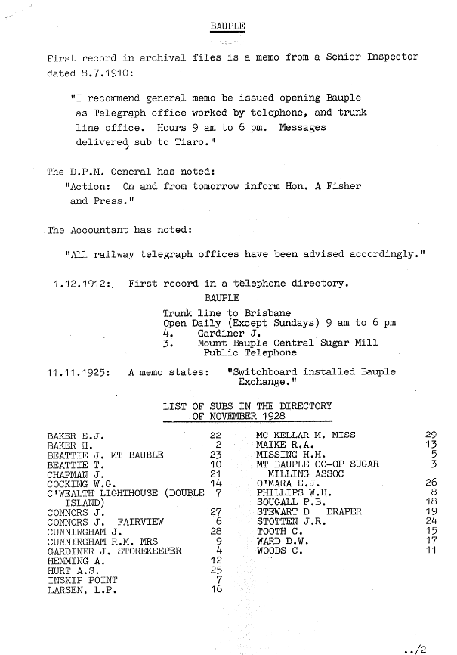

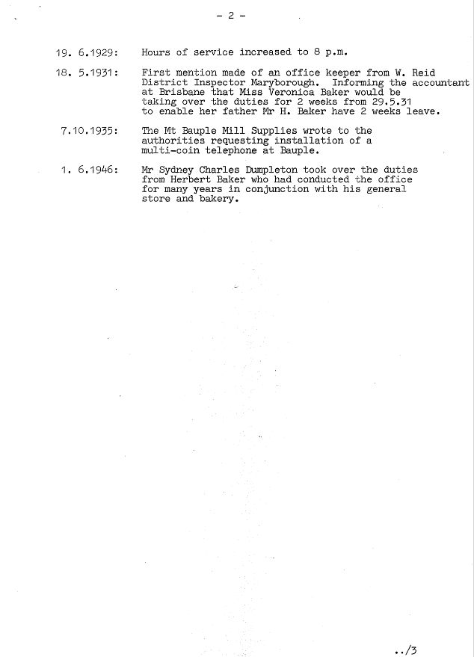

BAUPLE
First record in archival files is a memo from a Senior Inspector dated 8.7.1910:
"I recommend general memo be issued opening Bauple as Telegraph office worked by telephone, and trunk line office. Hours 9 am to 6 pm. Messages delivered) sub to Tiara."
The D.P.M. General has noted:
"Action: On and from tomorrow inform Hon. A Fisher and Press."
The Accountant has noted:
"All railway telegraph offices have been advised accordingly."
1.12.1912:. First record in a telephone directory.
BAUPLE
Trunk line to Brisbane
Open Daily (Except Sundays) 9 am to 6 pm
4. Gardiner J.
3. Mount Bauple Central Sugar Mill Public Telephone
11.11.1925: A memo states: "Switchboard installed Bauple Exchange."
LIST OF SUBS IN THE DIRECTORY OF NOVEMBER 1928

BAKER E.J. 22 MC KELLAR M. MISS 29
BAKER H. 2 MAIKE R.A. 13
BEATTIE J. MT BAUBLE 23 MISSING H.H. 5
BEATTIE T. 10 MT BAUPLE CO-OP SUGAR 3
CHAPMAN J. 21 MILLING ASSOC
COCKING W.G. 14 O’MARA E.J. 26
CtWEALTH LIGHTHOUSE (DOUBLE 7 PHILLIPS W.H. 8
ISLAND) SOUGALL P.B. 18
CONNORS J. 27 STEWART D DRAPER 19
CONNORS J. FAIRVIEW 6 STOTTEN J.R. 24
CUNNINGHAM J. 28 TOOTH C. 15
CUNNINGHAM R.M. MRS 9 WARD D.W. 17
GARDINER J. STOREKEEPER 4 WOODS C. 11
HEMMING A. 12
HURT A.S. 25
INSKIP POINT 7
LARSEN, L.P. 16

19. 6.1929: Hours of service increased to 8 p.m.
18. 5.1931: First mention made of an office keeper from W. Reid
District Inspector Maryborough. Informing the accountant at Brisbane that Miss Veronica Baker would be taking over the duties for 2 weeks from 29.5.31 to enable her father Mr H. Baker have 2 weeks leave.
7.10.1935: The Mt Bauple Mill Supplies wrote to the authorities requesting installation of a multi-coin telephone at Bauple.
1. 6.1946: Mr Sydney Charles Dumpleton took over the duties from Herbert Baker who had conducted the office for many years in conjunction with his general store and bakery.

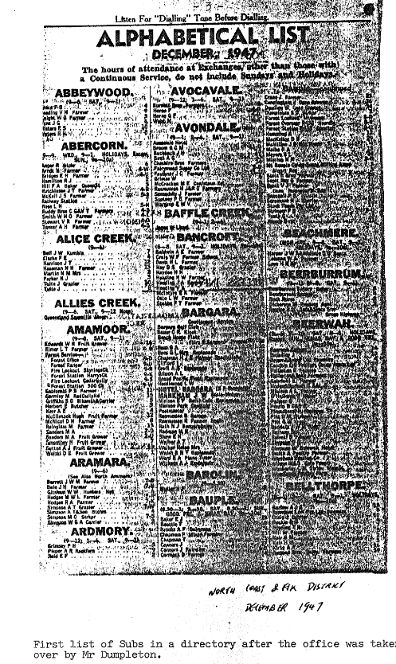

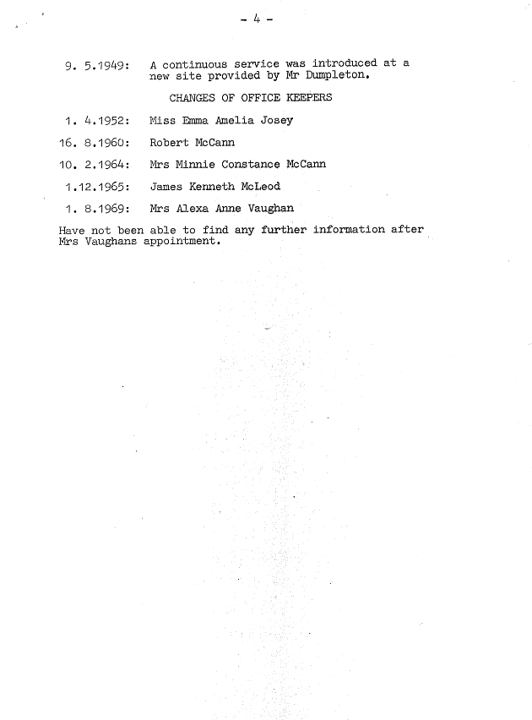
9. 5.1949: A continuous service was introduced at a new site provided by Mr Dumpleton.
CHANGES OF OFFICE KEEPERS
1. 4.1952: Miss Emma Amelia Josey
16. 8.1960: Robert McCann
10. 2.1964: Mrs Minnie Constance McCann
1.12.1965: James Kenneth McLeod
1. 8.1969: Mrs Alexa Anne Vaughan
Have not been able to find any further information after Mrs Vaughans appointment.

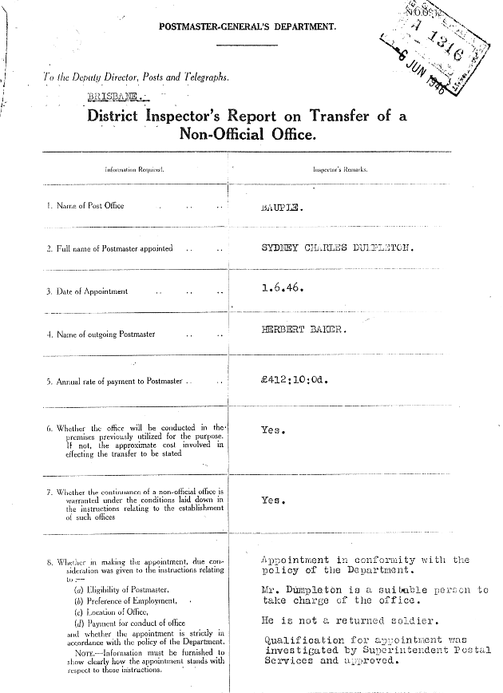

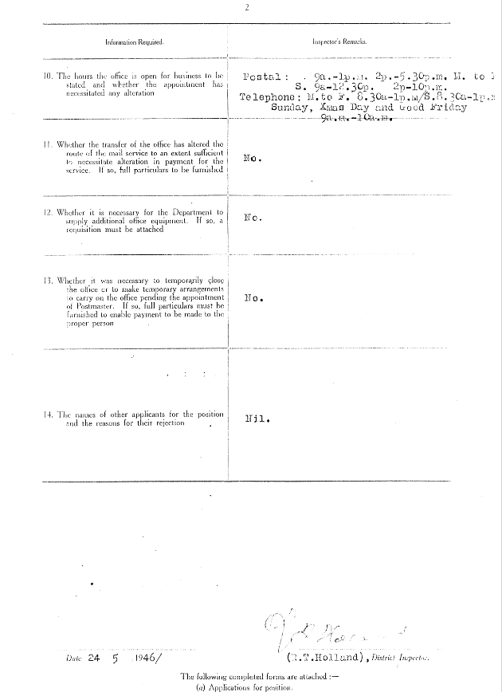

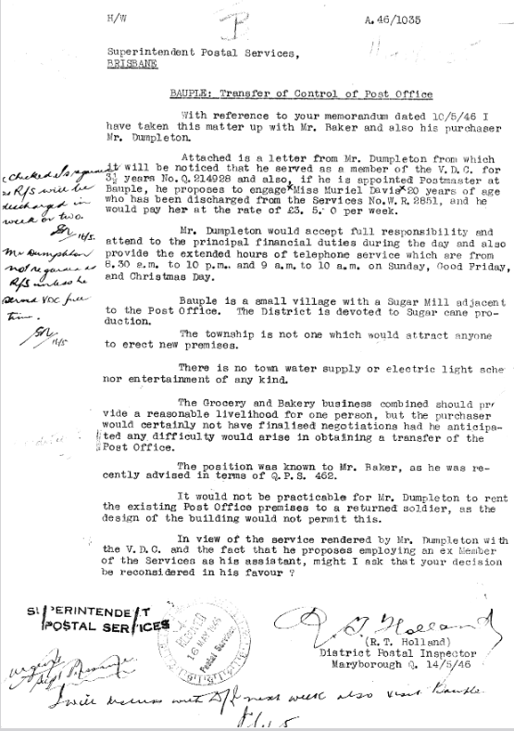

H/W
A.46/1035

Superintendent Postal Services,
BRISBANE
BAUBLE: Transfer of Control of Post Office
With reference to your memorandum dated 10/5/46 I have taken this matter up with Mr. Baker and also his purchaser Mr. Dumpleton.
Attached is a letter from Mr. Dumpleton from which 'will be noticed that he served as a member of the V.D.C. for Years No.Q.214928 and also, if he is appointed Postmaster at Bauple, he proposes to engage)(Miss Muriel Davie)c20 years of age who has been discharged from the Services No.W.R.2851, and he would pay her at the rate of £3. 5. 0 per week.
Mr. Dumpleton would accept full responsibility and attend to the principal financial duties during the day and also provide the extended hours of telephone service which are from 8.30 a.m. to 10 p.m., and 9 a.m.to 10 a.m. on Sunday, Good Friday, and Christmas Day.
Bauple is a small village with a Sugar Mill adjacent to the Post Office. The District is devoted to Sugar cane pro-duction.
The township is not one which would attract anyone to erect new premises.
There is no town water supply or electric light scheme nor entertainment of any kind.
The Grocery and Bakery business combined should provide a reasonable livelihood for one person, but the purchaser would certainly not have finalised negotiations had he anticipated any, difficulty would arise in obtaining a transfer of the Post Office.
The position was known to Mr. Baker, as he was recently advised in terms of Q.P.S. 462.
It would not be practicable for Mr. Dumpleton to rent the existing Post Office premises to a returned soldier, as the design of the building would not permit this.
In view of the service rendered by Mr. Dumpleton with the V.D.C. and the fact that he proposes employing an ex-Member of the Services as his assistant, might I ask that your decision be reconsidered in his favour?

(R. T. Holland) District Postal Inspector Maryborough Q. 14/5/46

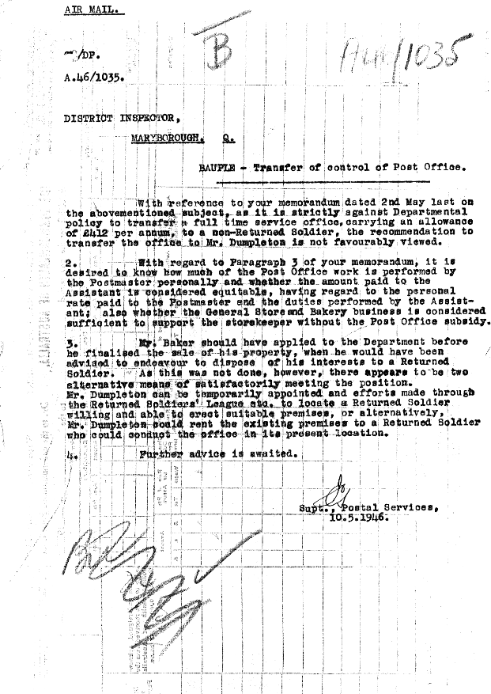

AIR MAIL.
/DF.
A. 46/1035,
DISTRICT INPECTOR,
MARYBOROUGH Q
BAUPLE - Transfer of control of Post Office.
With reference to your memorandum dated 2nd May last on the above-mentioned subject, as it is strictly against Departmental policy to transfer a full time service office, carrying an allowance of £412 per annum, to a non-Returned Soldier, the recommendation to transfer the office to Mr. Dumpleton is not favourably viewed.
2. With regard to Paragraph 3 of your memorandum, it is desired to know how much of the Post Office work is performed by the Post master personally and whether the amount paid to the Assistant is considered equitable, having regard to the personal rate paid to the Postmaster and the duties: performed by the Assistant; also whether the General Store and Bakery business is considered sufficient to support the storekeeper without the Post Office subsidy.
3. Mr. baker should have applied to the Department before he finalised the sale of his property, when he would have been advised to endevour to dispose of his interests to a Returned Soldier. As this was not done, however, there appears to be two alternative means of satisfactorily meeting the position. Mr. Dumpleton can be temporarily appointed and efforts made through the Returned Soldiers’ League etc. to locate a Returned Soldier willing and able to erect suitable premises, or alternatively, Mr. Dumpleton could rent the existing premises to a Returned Soldier who could conduct the office in its present location.
4. Further advice is awaited

Supt. Postal Services
10.5.1946

