Old Australian Telephones |  | - Home  - Collection  - History  - Technical  - Events  - Interesting links  - Contact  - For sale  - Wanted  - Collecting and Restoration
- Australian Telephony - History
This page is not an exhaustive study of Australian telephony. Its role is to give a general picture of the progression of telephony and related systems in Australia, particularly since Federation.
Further, related, historical information from this writer's home state of WA can be seen here
​
This writer thanks and acknowledges all information sources and these are listed where possible.
Of particular note is: http://www.telephonecollecting.org/Bobs%20phones/index.htm
This website was produced by Bob Estreich. Bob died in 2011 and the site is now managed by the ATCS.
Some of the information in this essay was derived from Bob’s work.​
Contents
- Australian Telecommunications timeline - Major events
- Before telephones - The Morse telegraph network
- The first telephones in Australia?
- Colonial telephony
- Commonwealth of Australia/PMG/Telecom/Telstra
- Telephone exchanges
- 1880-2 Melbourne Brisbane telephone directories
- Automatic (dial) telephony
- Public Switched Telephone Network (PSTN)
- Community Telephone Plan for Australia 1960
- Subscriber Trunk Dialling and International Subscriber Dialling
​​Typical Australian rental telephones since Federation
- Sale phones
- Mobile phones
- Public telephones
- Australian telephone numbers and dials - historical
- World dials
- Technical training
- PMG/Telecom/Telstra workshops
- ​Telstra Research laboratories
- The speaking clock
- 1951; the Centennial-Jubilee train Victoria and SA
- Telecommunication Journal of Australia
- An overview of telecommunications in Australia - Parliamentary report ca 2002
- After telephony - the rise of the internet
- ​References and acknowledgements ​​​
Australian telecommunications timeline - Major events
1854: Before telephones. The first Australian telegraph line (Melbourne)
1872 Overland telegraph Adelaide – Darwin- Java -Europe
1877-78: First Australian (colonies) telephone experiments
1880: The first Australian (manual) telephone exchange (Melbourne)
1901: Federation - PMG - Australian Post Office
1912: First public automatic (dial) exchange - Geelong Vic.
1930: Australia to Britain first radiotelephone link. First E-W telephony
1950: First mobile phones (in cars) switched via a telephonist
1975: Telecom Australia splits from Postal service
1981: First automatic mobile car-phones
1987: First handheld mobile phone
1991: Duopoly Optus/Telecom Australia
Early 1990s: First (dial up) internet
1995: Telstra formed out of Telecom Australia. Progressively privatised
2000: 1st internet ADSL (Max. 1500/256 kb/s) & internet telephony (VoIP)
2009: NBN installation began. Landline phone network progressively transferred to VoIP
2020: 5G mobile & progressively shutting down landline ‘phone network
Before telephones - the Morse telegraph network
Telegraphy (lit. distance - writing) dates to antiquity. Coded smoke signals or drum beats could be described as forms of telegraphy as were later systems using flags etc.
A number of electrical telegraph systems were devised during the late 1700s and early 1800s but telegraphy did not become firmly established until 1844 when Samuel Morse is claimed to have transmitted the world's first public telegraph message in the USA. Interestingly it ended with the words "What hath God wrought?“
​Versions of Morse's code were used worldwide for more than a century to come. https://en.wikipedia.org/wiki/Morse_code
In 1854 the first Australian telegraph line was installed in Melbourne and by 1877 there was a network spanning the Australian colonies. The overland and east-west lines are documented at:
https://en.wikipedia.org/wiki/Australian_Overland_Telegraph_Line
and
https://portal.engineersaustralia.org.au/system/files/engineering-heritage-australia/nomination-title/East-West%20Telegraph.pdf
​Australia's first sub-sea telegraph cable was installed between Victoria and Tasmania in 1859 but failed within two years and wasn't replaced until 1869. International connection was first made via Darwin through the Dutch East Indies (Indonesia) in 1872. Some information on these and other sub-sea cables can be seen at:
https://atlantic-cable.com/CableCos/Australia/​
Many Australian post offices had staff qualified in Morse telegraphy (During the first half of the 20th century, appointment as PMG postmaster/mistress required a Morse qualification) and the ubiquitous telegram is well remembered by many older people in our society. The WA group "Morsecodians", comprising retired Morse operators, kept the technology alive for many years doing public demonstrations of telegraphy in WA but time finally caught up with them and they disbanded in 2017. Their website was still operational early in 2020 and gives good background on Australian telegraphy: http://members.iinet.net.au/~oseagram/mfwahome.html
A short video of the Morsecodians last presentation and showing them using their Morse equipment at: https://www.youtube.com/watch?v=bPAA-oy1PB8
Other interesting Australian, telegraphy history sites can be viewed at:
https://telegramsaustralia.com/
https://australiantelegraph.wordpress.com/
The following images show a simple telegraph circuit, a "Morsecodian" and late 19th c. telegraph operators.
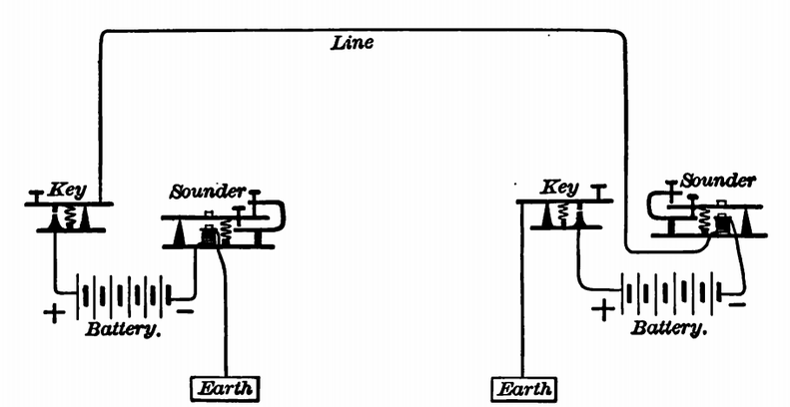  Concept of single wire telegraph line. Morse code is transmitted by long and short key strokes. Current flows through the line (and earth return) and operates the sounder. Operator interprets and records the received message. Original image source: Atkinson, Philip Electricity for Everybody; Its Nature and Uses Explained: (The Century Company, 1899) | 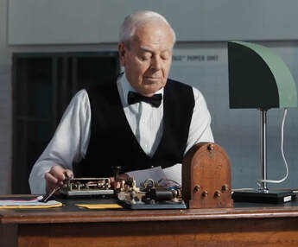  Morse demonstration. Image source: Still from: https://www.youtube.com/watch?v=iCdGAj7N6nY (above)
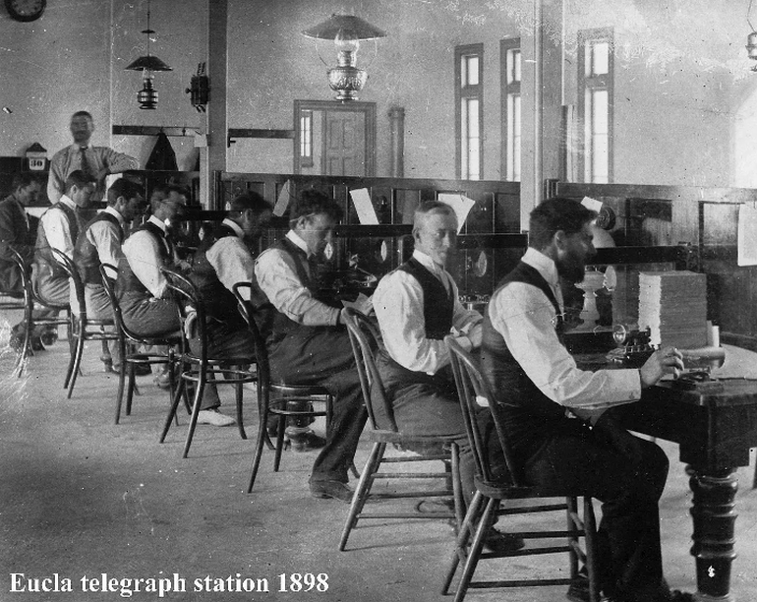  Eucla Telegraph Station on the Western and South Australian colonial border ca. 1898. Each side received their respective messages and handed them through a window in the low dividing wall to the operator on the other side for re-transmission! On Federation in 1901 the wall was removed! Image source: Old PMG photo collection G. Cowan |  | 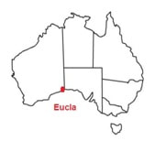
The end of Morse telegraphy
The traditional wisdom "Wikipedia" states that the last Australian Morse telegram message was sent in WA in 1963 but the "Morsecodians" website states "1968. Nov 5th. Morse telegraphy was last used in Australia between Roebourne and Wittenoom Gorge in the north-west of Western Australia, just eight months short of 100 years after the transmitting of the first telegram." History is, at best, an opinion!
The first telephones in Australia?
A.G. Bell published various scientific articles on telephony during 1876 and 1877 and Australians were quick to experiment with this novel technology. Several sources report that a number of successful telephone experiments had been undertaken in the colonies by the end of 1877.
Mr W.J. Thomas of Geelong is believed to have set up a simple network with homemade instruments in the town to amuse friends and colleagues late in 1877. The National Communications Museum, previously known as Telstra Museum, has an example of Mr Thomas' instruments, shown below.
Image source: Victorian Collections https://victoriancollections.net.au/items/5ae6461f21ea671820c25abb
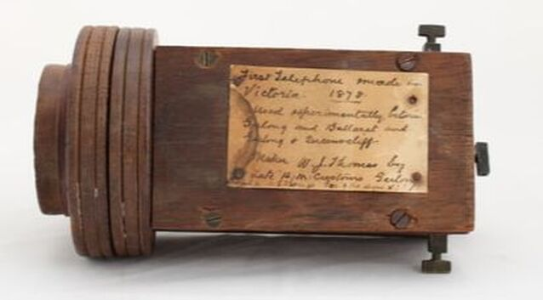
Mr Henry Sutton of Ballarat developed several versions at around the same time. He was a brilliant self taught scientist and developed numerous inventions. An article here
In December 1877 Mr E.C. Cracknell, NSW Superintendent - Electric Telegraphs, is reported to have "successfully transmitted songs and music over the 224 km distance between West Maitland and Sydney using telegraph wires".
Similarly. in South Australia Mr AW Dobbie, Sir Charles Todd and Mr C.A. Unbehaun were reported to have conducted successful experiments with various instruments in December 1877.
Tasmanian, Mr Alfred B. Biggs is also believed to have built several functioning telephones during 1877 so it is difficult to assign "bragging rights" for Australia's first phones to a particular colony.
Another person of interest in this period was Mr J.E. (John Edward?) Edwards who is recorded in 1878 in
The Argus (Melbourne, Vic. : 1848 - 1957) Mon 30 Sep 1878 Page 3:
“Letters patent were granted by the Attorney- General on 18th inst. to…… Mr J. E. Edwards, of Erskine-street, Hotham, for certain improvements in the means of and apparatus for transmitting and receiving sounds by electricity, by which means sounds of every description can be more accurately conveyed, and a higher volume produced at the receiving end than by the ordinary telephone…….” and on 7 May 1880 in Melbourne. "fitting up his own patent telephone to connect the public Works office and the Post Office"
Mr Edwards also probably installed Australia's first permanent "point-to-point" telephone service for McLean Bros and Rigg in Melbourne in Feb. 1878. He pops up a couple of times in newspapers of the time, in one example as a Melbourne electrical retailer in 1886. if you can add to his story please contact me
​In August 1878, two instruments were connected between Government House and the Colonial Secretary's office in WA, so also a very early "commercial" service in Australia. More info. here. By the start of 1879, similar commercial services were appearing in the other Australian colonies.
Colonial Telephony
Australia was a group of separate British colonies until Federation (i.e formation of the Commonwealth of Australia) in 1901 and today Australia is still part of the British Commonwealth.
Prior to Federation, each Australian colony managed its own affairs, including telegraphs and telephony, so there was a plethora of equipment types scattered across the continent. Colonial telephony would require a website of its own but a good place to start researching is the book “History of the Telephone in New South Wales” by Jim Bateman (1980). Reprints are available through the ATCS here.
The very first (mostly experimental) phones used in the Australia colonies would have been Bell's cased models or locally made copies. These were very simple instruments consisting of a large "horseshoe" magnet, two coils of insulated wire and a iron sheet diaphragm enclosed in a wooden box. They were "sound powered" i.e. no battery voltage was applied. The one unit served as both the transmitter and receiver and they operated in a similar way to modern permanent magnet telephone microphones and receivers. These phones were very limited in what they could do. They were only suitable for short distance, point-to-point services and the first versions didn't even have any call signalling arrangement (requiring the caller to shout or tap the transmitter to get the attention of the far end!).
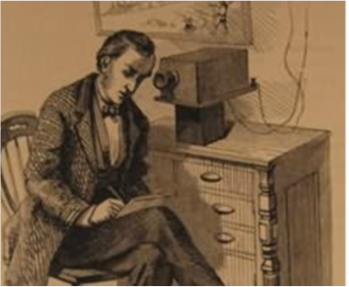
Bell phone: Image source; http://americanhistory.si.edu/collections/search/object/nmah_704159

Bell 1877 telephone: Original image source; Illustrated Christian Weekly - May 5, 1877 per http://collectingoldmagazines.com/3272/morse-telegraph-bell-telephone/
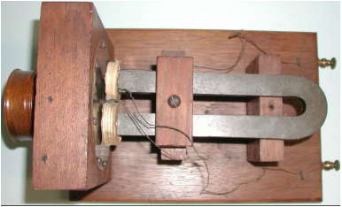

By the introduction of the first telephone exchange in Australia in 1880, telephone technology had advanced significantly. Battery powered, carbon transmitters (i.e. microphones) were developed by several inventors in the late 1870s (Blake, Edison and Berliner). These enabled much longer transmission distances. Similarly, Thomas Watson (Bell's colleague) had developed the hand wound magneto generator and polarised ringer by late 1878 so by combining all of these features the "magneto" telephone was developed, a principle that persisted into modern times. The following three magneto phones are typical of the colonial era. Left to right; 1885 Berthon Ader (Image source ref. 1), 1882 “Pulpit" Ericsson (Image source ref. 2), 1890s British Insulated & Helsby (Image source ref. 1).
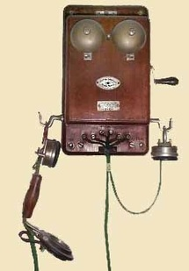 | 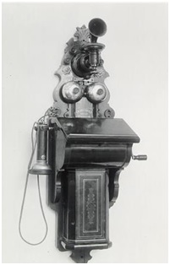 | 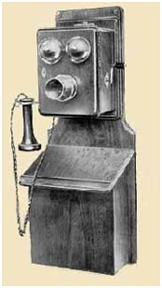
Some specific information about Western Australian colonial telecommunications can be found here.
Commonwealth of Australia and PMG/Telecom Australia/Telstra
Australia became an independent nation on 1 January 1901 when the British Parliament passed legislation allowing the six Australian colonies to govern in their own right as part of the Commonwealth of Australia. The Commonwealth of Australia was established as a constitutional monarchy. 'Constitutional' because the Commonwealth was established with a written constitution, and 'monarchy' because Australia's head of state was/is the British monarch - Queen Victoria in 1901 (Source: Australia.gov.au). The term Commonwealth is interesting. It is a traditional English term for a political community e.g. group of states or a country in which the supreme power is vested in the people i.e. a republic or a democracy, and derived from Old English ‘common’ (public) and ‘weal’ (well-being). It is used by numerous states or countries around the English speaking world (Source: Wikipedia et al.).
On Federation in 1901, the Post Master General’s Department (PMG) was created to run Australia’s post and telecommunication services (Australian Post Office - APO). The services were highly regulated, government owned entities until the 1990s. The terms PMG and APO are synonymous.
Australia has used many models of telephones between 1901 and today. Initially, the PMG employed existing telephones and infrastructure inherited from the colonies but, over time, it attempted to standardise its equipment where possible. There was a progression of phone types preferred by the PMG/Telecom/Telstra over the decades but other telephones were imported, or manufactured locally, to meet shortages, mostly around the World Wars and Great Depression. Click here to see images of typical (rental) telephones from 1901 to the 2000s.
The PMG was restructured in 1975 as two individual corporate identities. Postal and related services were controlled by Australia Post and telephony and other electronic telecommunications by Telecom Australia. Telecom Australia was renamed Telstra in the mid 1990s and progressively privatised from 1997 and now Telstra is a wholly private corporation. There are several telecommunications companies competing for market share in Australia but Telstra is still the largest. An historical timeline of major telecommunications events in Australia can be found at Telstra's site:
https://www.telstra.com.au/aboutus/our-company/past
A long- winded but useful summary of Australian telecommunications history from the start of the 20th C to the start of the 21st C can be read in this parliamentary report at: https://www.aph.gov.au/Parliamentary_Business/Committees/Senate/Environment_and_Communications/Completed_inquiries/2002-4/telenetwork/report/c01www.aph.gov.au/Parliamentary_Business/Committees/Senate/Environment_and_Communications/Completed_inquiries/2002-04/telenetwork/report/c01
Telephone exchanges
Australia's first manual exchange was installed in Melbourne (Victoria) in September 1880 (Brisbane followed in October 1880 so missed out on the bragging rights by a few weeks!). The first public automatic exchange in Geelong, Victoria opened in 1912.
​The very early manual systems were magneto type which persisted in some rural areas until the late 20th century (I remember changing out the batteries on the "party line" at Edaggee sheep station - near Carnarvon WA in about 1985). In December 1991 the Wanaaring manual exchange (NSW) closed and the Australian network became a wholly national, automatic system. If progress seems a little slow compared to other western countries, it must be remembered that Australia has vast distances to cover and a relatively small population so modernising all rural areas took a long time. Telephone switching technologies progressed from "Manual" to "Step by Step" to "Crossbar" and now "Digital" and "NBN/Internet".
By the early 2020s the public switched telephone network (PSTN) comprising thousands of exchanges will have disappeared. In 2017, according to media reports, Telstra detailed plans to close up to 2500 of its traditional telecommunications exchanges and the remaining exchanges will be converted into distributed data centres to support the software layer of Telstra's network.
Source: https://www.crn.com.au/news/telstra-to-close-up-to-2500-telco-exchanges-customers-to-shift-to-ip-calling-over-the-nbn-476712
(John's note; these figures don't appear to reconcile with other available online data about exchanges but taken as read). ​
​1880 to 1882; Melbourne telephone directories
Copies of the Melbourne telephone directories for 1880, 1881 and 1882 are available below. Click to download a PDF copy of 1881 and 1882. Melbourne exchange opened in 1880 with 43 subscribers. Three years later 380 are listed. This uptake of new communications technology parallels the uptake of the internet over a century later.
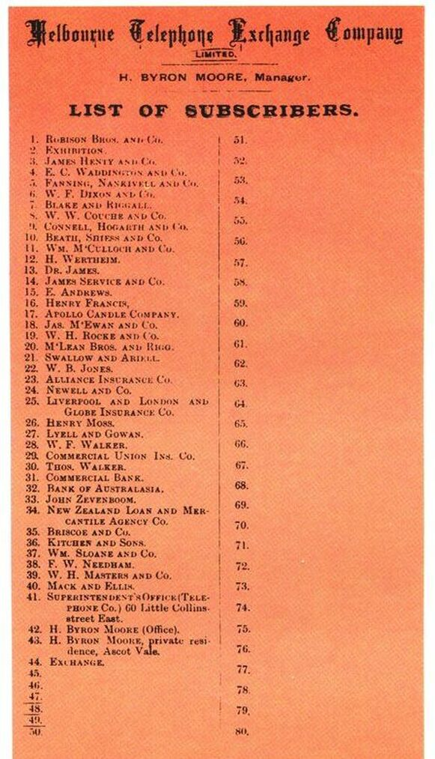
1880. Melbourne's first telephone directory (source; 1980 Telecom Australia publicity brochure)

1881melbournesubscribers.pdf
Download File

1882_melb_tel_nla.obj-209992374__1_.pdf
Download File

A typical triple box magneto wall telephone used by subscribers to this exchange is described on Dave Dockray's site here
Brisbane First telephone directory 1880
The first Brisbane Telephone exchange opened in October 1880, barely a month after Melbourne's. Details can be read at the Queensland State Library site
https://www.slq.qld.gov.au/blog/hold-line-please-brisbane-telephone-exchange
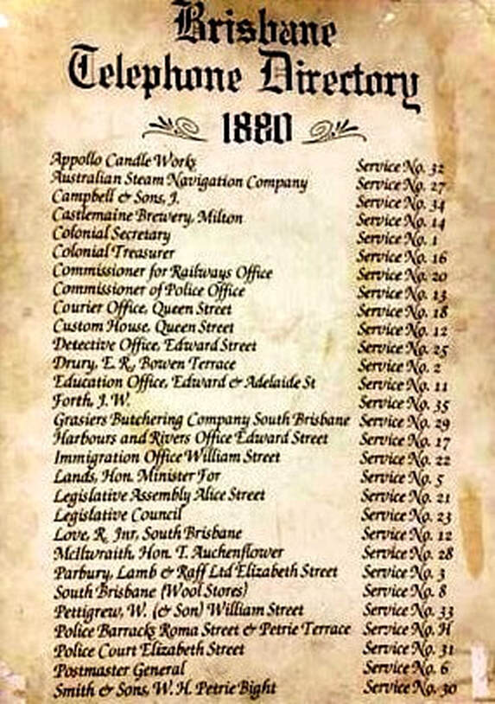
Automatic (dial) telephony
Victoria regularly lays claim to having the first automatic exchange in Australia. It was an 800 line, Automatic Electric Co. of Chicago, step by step system installed in Geelong and "cut over" on July 6 1912. This was the first public exchange in Australia but Sydney (NSW) can lay claim to the first overall.
“A test of this system was made in the Sydney General Post Office, where all the official telephones were connected to an automatic switchboard. Thirty-four instruments were connected up with the board, and it has given such complete satisfaction that the Geelong installation was decided upon.”
Source: Argus 2/11/1911. https://trove.nla.gov.au/newspaper/article/11629033
​The Sydney GPO system was purchased from the Automatic Electric Co. in 1913 and retained as a PABX for many years.
Detailed information about the Geelong automatic exchange is published in the Oct 1962 edition of the Telecommunications Journal of Australia. Kindly preserved by Ric Coxhill at: http://www.coxhill.com/trlhistory/history/australian_publications.htm
Being a parochial West Australian, I will point out that Australia's first significant public exchange was actually installed in Perth WA in 1914. It was much larger than Geelong or the other Vic/NSW exchanges, also installed in 1914, and the first in a Capital city CBD. Go to:
1914 First Automatic (Dial) Telephone Exchange in Western Australia
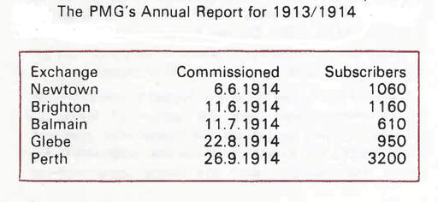
Dial tone?
It seems that the first AE Co exchanges didn't have tone generators like later incarnations of step by step switching. For example no dial tone was present on pick up. Apparently the customer only heard a click, implying line was ready. An article here. Scroll to bottom of page to read Ross' research.
Automatic telephony tones (This note also appears elsewhere on this site. It describes later, standardised systems)
To advise users of the progress of a call, a range of standard tones were used. This Youtube clip gives a very clear rendition of tones from around 1950. https://www.youtube.com/watch?v=223k6xxIkbo
It is British Post Office but virtually the same as Australian. In fact, the voice is possibly of the Australian actor Gordon Gow who worked in the UK in the 1950s. Gordon was the first voice of the speaking clock here installed in Victoria and NSW in 1954.
Public Switched Telephone Network (PSTN)
The automatic telephone system is known (worldwide) as the PSTN (Public Switched Telephone Network).
The Australian PSTN will mostly be closed by 2022 - superseded by NBN/internet. After that time this information will be of historical interest only.
​
​Analogue exchanges
The original automatic exchanges used analogue transmission and electro-mechanical switching technologies and dialling signals were originally DC electrical pulses from a rotary dial. This method is also referred to as impulse, decadic, loop disconnect or rotary dialling.
Digital exchanges
The last generation of exchanges in the PSTN are/were electronic, using digital switching techniques similar to modern computers. The customer's phone uses DTMF tones from a keypad to signal the exchange, although, prior to NBN telephony, most Australian digital exchanges also still accepted the obsolete dial impulses.
More on analogue and digital exchanges here
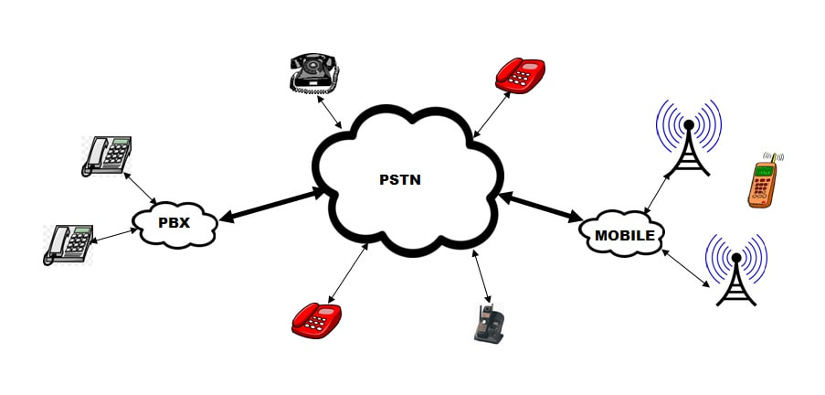
PSTN concept. Image J Paskulich
Community Telephone Plan for Australia 1960
This Commonwealth Gov't publication outlined the new telephone policy and described the plans for the future telephone network. The policy and plan represented a milestone in the history of Australia’s telecommunication services and a dramatic shift away from the system and methodology that had been in place for nearly five decades. My thanks to former Telstra Engineer Mr A Hampel for digitising and making this document available.
Click on download file below. ​​
communitytelephoneplan1960-1.pdf
Download File

Subscriber Trunk Dialling
From around 1960, the PMG started an ambitious development programme and by the mid 1970s the majority of the country was connected with a high capacity telephone transmission network. The preferred media were coaxial cable and microwave radio systems. This network provided a large number of telephone “trunk” (long distance) circuits all around Australia.
Coincident with the development of this national transmission network was implementation of “common control” Crossbar telephone exchanges across the country.
The outcome of improved transmission and switching networks was subscriber trunk dialling (STD). STD enabled the customer to dial national trunk calls directly. Until then, long distance calls needed to be connected through an operator at a trunk switchboard.
In 1962, the only available STD connections were between Canberra and Sydney and from Warragul (Vic.) to Melbourne.
WA introduced STD in October 1966. Full STD was initially introduced from 15 Perth exchanges to 11 country exchanges including Pinjarra, Bunbury and Northam.
By 1975 over 90% of Australian subscribers had access to STD.
There is some good general information about STD and early Australian STD dialling codes at:
https://en.wikipedia.org/wiki/Subscriber_trunk_dialling
https://en.wikipedia.org/wiki/Former_Australian_dialling_codes
International subscriber dialling
Subscriber trunk dialling was joined by international subscriber dialling (ISD) in Australia in 1976. ISD enabled callers to dial directly overseas, rather than having to connect via an operator. Initially available to Sydney residents, ISD had spread across Australia by the end of the decade.
Typical Australian rental telephones since Federation
For most of the 20th century, the Australian telephone network was highly regulated and government owned. With limited exceptions, telephone instruments were owned by the PMG/APO and rented to subscribers. It wasn't until the 1980s that restrictions eased and privately owned telephones appeared in any numbers. Go here to see images of typical PMG-Telecom-Telstra (rental) telephone types used in Australia since federation in 1901.
It should be noted that other organisations also maintain/ed telecommunications networks, in particular the various State railways. If you come across a telephone that does not seem to "fit the mould" it may be from one of these independent networks.​
More information on the principles of analogue telephones can be found here.
​Sale Phones
Until the mid 1970s most telephones were owned by the PMG and rented to their customers. Regulations were slowly relaxed from then and a range of “novelty” phones were offered for sale alongside the standard rental phones. Since deregulation in the 1990s the range of privately owned telephones in the network has grown enormously. The following are a few examples of Telecom Australia sale phones from the 1980s.
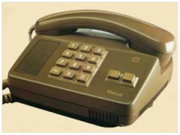
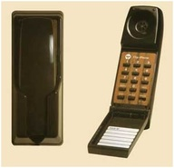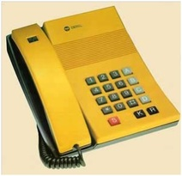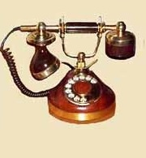Mobile Phones
Various "mobile" telephone systems have existed in Australia since 1950 but numbers were very small. They were typically vehicle mounted and were connected to dedicated PMG manual switchboards. In effect, "upmarket" two-way radios that could be operator connected to the telephone network.
Automatic mobile phones first arrived in Australia in 1981 in the form of the "car-phone", an analogue mobile system built into a vehicle. Hand-held "cellular" models first appeared in 1987. These were very expensive and disparagingly known as "bricks" due to their large size and weight but within a few years the instruments had shrunk to a much more manageable size (and cost) along with improvements in battery life and transmission performance. The analogue mobile network was phased out progressively and completely updated to digital technology by 2000. Technical changes were rapid and are ongoing. Telstra's CDMA network (a special digital service ideally suited for rural areas) ended in 2008 and its obsolescent 2G (GSM) digital technology closed in 2016. News reports suggest that Telstra plans to fully close its 3G network by 2024. 5G networks are currently (2020) being implemented in Australia.
In 2015 there were approximately 10 million landlines in Australia but around 32 million mobile services. Australia had far more mobile phone connections than people! Since then, "landline" telephony has almost disappeared with the imminent completion of the NBN (these phones are now peripherals off the NBN modem). Mobiles/Smartphones now dominate our network.
The historical development of mobile technologies, some images and an overview of their operating principles can be found here
​Public telephones
The first public telephones (PTs) in Australia date back to 1893 in Sydney NSW. Telstra is still legally obliged to provide PT services.
For some technical background on PTs go here
Australian telephone numbers and dials - historical
Technical information on Australian and other world dials here and here
Until the start of 1960 Australian telephone dials had a centre label (or in very early ones, the number ring) marked with letters representing individual numbers. The Australian letter-to-number mapping was A=1, B=2, F=3, J=4, L=5, M=6, U=7, W=8, X=9, Y=0, so the phone number WM1246 was in fact 861246. The letters were only memory aids for users and had no technical role.
As I understand it, the first portion was alpha followed by a maximum of four numbers. Apparently operators and subscribers were considered unable to remember a string of more than four numbers in a row! Examples from 1940 WA adverts: B3284 = 23284, WM1246 = 861246. The first exchange had five digit dialling, the second six digits hence its two letter code.
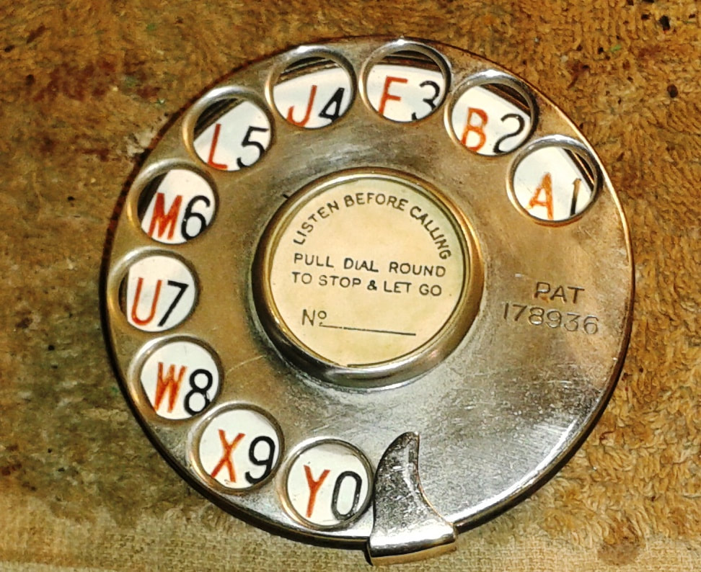
Australian dial letter codes. L on dial plate. R on centre disc. Images J Paskulich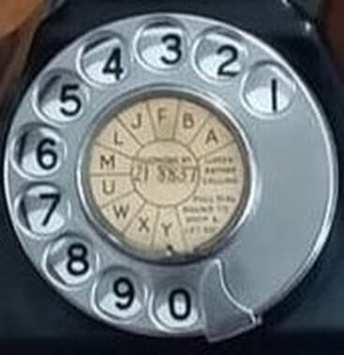
Australia did not use the British three letter system described below. There was no correlation between the letters and an exchange name, e.g. BA (21) was a Perth exchange.
A search of newspaper advertisements showed that they published a mix of alphanumeric and numeric only numbers in 1959 but in 1960 only numeric customer numbers. So Australia completely dropped its alphanumeric telephone number scheme by the start of 1960. The abovementioned idea about number strings had been proven wrong.
​Extract: ​Community Telephone Plan for Australia 1960 p.11 (full document here).
“ (V) Memory – Extensive tests conducted by the British Medical Council′s Applied Psychology Research Unit on the ability of telephone operators to remember long telephone numbers show that all-figure combinations are greatly superior to letter-figure combinations when heard and are only slightly inferior when read. The conclusion was that ″..... There is no real advantage in using relatively non-meaningful letter arrangements″. Research by the Australian Post Office confirms the conclusions drawn.“
In fact, alpha-numeric subscriber numbers were being phased out in the second half of the 1950s. Some reasons quoted were; the appearance of 7 digit exchanges, the ultimate goal of subscriber trunk dialling over the next couple of decades where every subscriber would have a unique number (area code starting with 0) and the proven confusion between similar sounding letters and numbers when spoken over the telephone.
Information about later Australian schemes and dialling codes can be seen here
World dials
Although not Australian history, it is worth examining some dial variations around the world.
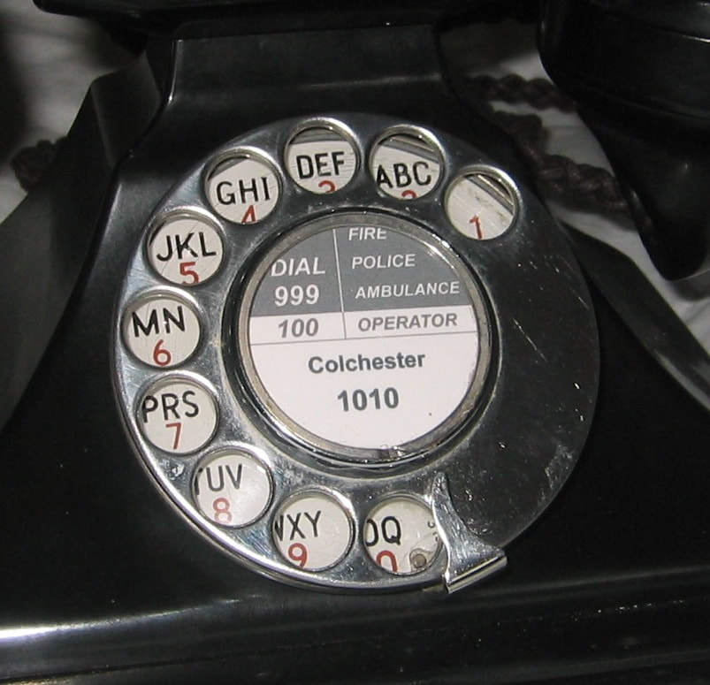  Director dial. Image source: Deben Dave English Wikipedia | Later UK dial letters. Image source: https://www.antiquetelephones.co.uk/
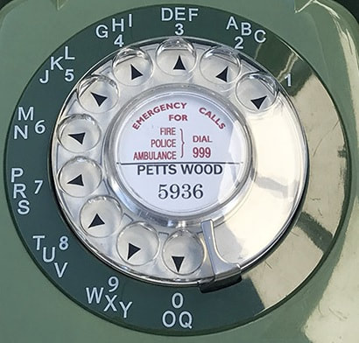Three letter dials
Australian c​ollectors should be mindful that some early British, USA and some other countries' alphanumeric dials had three letters per digit. They pop up occasionally in Australian collections but these phones cannot be genuine Australian items. The British (and USA etc) again used this three letter system as a memory aid for subscribers. For example, in Britain, the letters originally represented an exchange name (e.g ASH [274] for Ashfield) then followed by the remaining digits. These phones would have originated in one of the larger British cities served by "Director" SxS exchanges (below).
Non - director exchanges
Note; This is British terminology. Non-director exchanges are traditional step by step (SXS) telephone exchanges. These are of the type first introduced in Britain and Australia in 1912. British non-director exchange dials will generally have the simple numeric-only dial plate.
​
Director Exchanges
Original Strowger SXS exchanges had no central control system overseeing the switching of calls. Each selector working independently on a step-by step basis. Changes to routes were difficult, if not impossible, especially in complex networks with lots of big exchanges directly connected together.
AT&E engineers devised a common control system for Strowger SXS called the “Director” and, in 1927, the first British Director exchange opened at Holborn Exchange, London. A description of Director exchange principles can be viewed at: https://en.wikipedia.org/wiki/Director_telephone_system
The AT&E Director system was developed to compete with Western Electric's Rotary and Panel systems. Descriptions of these appear at:
https://en.wikipedia.org/wiki/Rotary_system and https://en.wikipedia.org/wiki/Panel_switch .
The Director system persisted in Britain from 1927 to about 1970
Cities which used Director exchanges (London, Manchester, Birmingham, Liverpool, Glasgow & Edinburgh) had three digit local exchange codes and four figure customer numbers. The first three digits corresponded to the exchange name and were chosen to give the name a recognisable mnemonic.
​Sam Hallas has listed these codes etc. at:
http://www.samhallas.co.uk/repository/documents/london_director_codes.pdf
Modern application
In the latter part of the 20th C., a modified version of this alphanumeric mapping was adopted worldwide and appears on many modern push-button keypads. It is often used for adverting memory aids. ​For example a local, West Australian, taxi company 132227 uses the advertising mnemonic 13CABS.
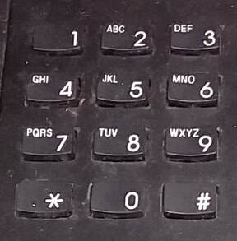
Modern keypad. Image J Paskulich
Dial variations
Very early dialling systems were quite different to what we would now recognise. An interesting article appears here. The USA, Britain, Australia and many others used what we would consider "traditional" rotary dials. 10 digits in the order 1, 2, 3, 4, 5, 6, 7, 8, 9 and 0 where one pulse was no. 1, through to 9 pulses representing no. 9 and 10 pulses equalling 0 (zero). This was not the case in some places. For example New Zealand used a "reverse" dial (described here), Sweden had an interesting arrangement where zero was one pulse, no. 1 was two pulses through to no. 9 of 10 pulses. Also in addition to the above-mentioned alphanumeric schemes, some early USA telephone companies used proprietary single alpha systems and some European countries also used a variation of a single alpha system.
Some dial variations appear below (compare to Australian and UK above). Please note the sources of the images. My thanks to those authors.
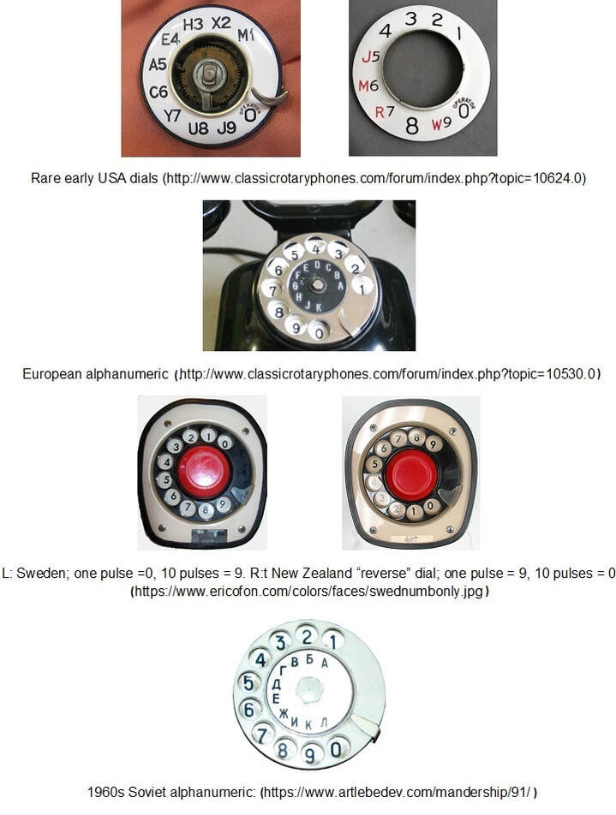
An approximate translation of the Russian dial above into into Western letters 1 = A, 2 = B, 3 = V, 4 = G, 5 = D, 6 = E, 7 = ž, 8 = Y, 9 = K, 0 = P
Technical training
The PMG/APO/Telecom Australia/Telstra conducted its own training of technical staff at dedicated facilities all around Australia. This was almost from inception until the early 2000s when it closed the majority of its training centres and outsourced technical training. This writer served as both a student and technical instructor in PMG/Telecom between the mid 1960s and the early 1990s. The training was similar in each state.
Detailed information about technical training can be seen here. It focusses on this writer's home state, WA, but applies equally around Australia.
PMG/Telecom/Telstra Workshops
A little known facet of the PMG (and later Telecom Australia/Telstra) was its system of workshops across Australia. Set up in the early 1900s, most states had their own workshops that manufactured and repaired or refurbished a wide range of telecommunications equipment. The PMG/Telecom workshops also refurbished many thousands of recovered rental telephones. These were then reissued to new customers. No "throw away" society in those days!
As far as I can determine the workshops continued in some states until the early 2000s but there is almost nothing published on the internet about them.
Further information on the workshops in this writer's state, WA, can be viewed here
The following article and images were kindly provided by Ken O’Connor, former Manager (Test and Telephone Products) Telstra Product Engineering (Telecom Workshops), Victoria. These workshops were typical of those in the other Australian states.
Postal Workshops / Telecom Workshops / Telecom Industries /Product Engineering, Victoria
The title above recognises some of the names used by the former Telstra Manufacture and Service facility.
Commencing in the early 1930’s the role of Postal Workshops, as it was then known, was to support the many requirements of the Post Master General’s Department. Situated at the corner of Grant & Dodds St South Melbourne was the headquarters of the facility with an annex in Williamstown Rd Port Melbourne and later another in Lorimer St Port Melbourne. The Workshops provided a wide range of services in every trade designation from signwriting, clockmaking, typewriter repairs, carpentry, blacksmithing, French polishing, telephone and switchboard repairs and reconditioning to, step by step and crossbar switching equipment repair and modification, cables and wiring looms manufacture. During WW2 a special section was created to work on development of the early radar systems used in the defence of Australia. Also critical at this time was the repair and reconditioning of teleprinter machines. Spares from Europe were unobtainable and the Workshops had an important role in providing vital maintenance and spares. Teleprinter equipment was critical to rapid communication throughout the region as long distance telephone systems were very limited.
Over time the range of services available grew and included compression and injection moulding, toolmaking, spray and powder coat painting, electroplating, steel and aluminium fabrication, precision and repetition machining. The manufacture and modification of a range of communications equipment was a growing activity as automation of telephone services expanded and interworking of the range of switching technologies employed at the time from step by step to Crossbar exchange equipment which was being introduced to the network. The introduction of STD [subscriber trunk dialling] and other facilities presented continuing modification workloads for the Workshops right until its closure.
During the 1970’s the balance swung from trade based activities to communications and electronics. New products were developed in house and in conjunction with other Telstra divisions. The Workshops had produced test handsets [Buttinski’s] for many years commencing with the black compression moulded bakelite model and the red nylon version; all rotary dial handsets. Then followed the development of full featured push button dialling versions, the Versadial and Ruggabutt. Wholly designed in house including injection moulding dies to produce the plastic components they were the standard Telecom buttinskis for many years. Following on from the buttinski, Workshops then produced the Contour Telephone; the only telephone ever wholly designed and manufactured by Telecom. With the introduction of the T200 telephone as the standard issue product a range of modules to provide additional features such as 2 line working, security,and loudspeaking operation
Strong links were formed with Telstra Research Laboratories commencing in the 1960’s with the manufacture of PETRA equipment which could control the unauthorised use of STD facilities after this feature was implemented into the network. A range of data and signalling test and maintenance equipment was produced in co-operation with the Research Labs.
At its peak Workshops employed over 1000 people from over 20 nationalities. It was not seen as a popular place to work by many in the PMG days as it had strict start and finish times and meal breaks. It was often where troublesome field staff were transferred to keep some control over their attendance, diligence and sometimes drinking habits. When I was told at the end of my first year of training that I was allocated to Workshops I was devastated. The Training School instructors told us what a terrible place it was and I seriously considered resigning and looking for another career. After a few weeks there however I came to see what an interesting place it really was. There was a huge variety of skills and equipment, interesting people and an endless variety of work.
Each year about 10 Technicians in Training commenced work there along with a similar number of trades apprentices. Most of the staff we thought were pretty old, probably in their 50’s! Women outnumbered the men by 10 to 1. The trainees were looked on by them a bit like their sons. Some of the men were handicapped in some way either by accidents on the job or through wounds from the war. A few of them were not so pleased to see the influx of new young faces as they feared unnecessarily for losing their jobs.
Generally it was a highly social workplace, concerts and dances were held and Melbourne Radio station 3DB even broadcast some of the concerts. Strong bonds were developed among Workshops staff, one which continues to this day is the annual Tech’s Turn. It was a rite of passage for 5th year trainees to who were allowed to attend for the first time. Originally a gathering in a city pub it became an overnight camping event with a spit roast or barbecue as drink driving laws tightened. I has been in this form since 1971 and has endured snow and heatwave conditions, sometimes needing a generator to power an electric barby during total fire bans.
In 1987, the South Melbourne and Fishermans Bend facilities were closed and all plant and personnel were moved and combined on a single site in East Bentleigh. This was the former WD&HO Wills cigarette manufacturing operation. All looked promising for a long future however as Telstra embarked on massive redundancy actions the East Bentleigh site was gradually run down and closed. The few remaining critical maintenance activities were transferred to a site in Carlton until it too ceased in about 2000.
I have never regretted a day of my time at Workshops despite my initial disgust. It has given me a wide knowledge of materials and process, an understanding of a variety of cultural values from the many nationalities employed there and most importantly, the ability to work as a team. The closing of Workshops was a sad time for many of us but the experience we gained there made it much easier to gain further employment.
​The stories from Workshops would run to thousands of pages, this is a snippet of just a small part of my Workshops memories.
Ken O’Connor
​October 2020
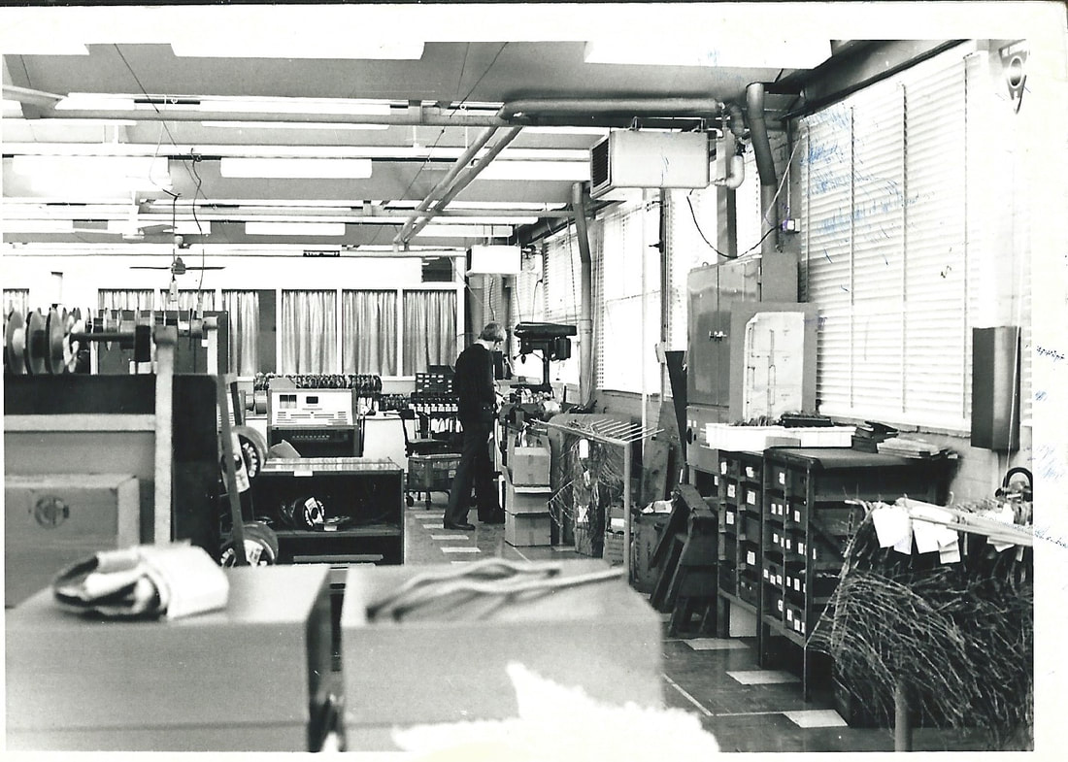  Author K. O'Connor in one of the workshops ca. 1965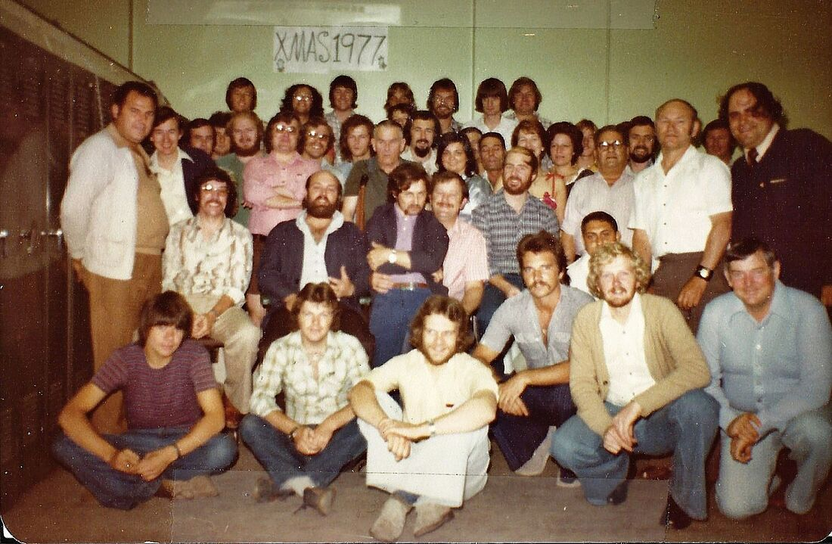 | Test Section staff Christmas break up 1977
Further images of the South Melbourne Workshops can be viewed at the State Library of Victoria site at:
https://viewer.slv.vic.gov.au/?entity=IE5738864&mode=browse
A detailed heritage discussion of the South Melbourne site with images can also be viewed here
​
East Bentleigh Vic. Workshops
An overview of the East Bentleigh facility (extracted from a late 1980s Telecom Australia publication - courtesy K O'Connor) appears in the PDF file below. Click on download file to view.
victoria_bentleigh_telecom_workshops_-_copy.pdf
Download File

Telstra Research Laboratories
The Australian Post Office (APO) as part of the Postmaster General’s Department (PMG) established the APO Research Laboratories in 1923. The Laboratories continued as the PMG progressed to Telecom Australia in 1975 and Telstra in 1995. Its final incarnation was as the Telstra Research Laboratories (TRL) until it was closed by Telstra in January 2006.
The Australian Post Office Research laboratories developed numerous key technologies. From Wikipedia; “Notable achievements included a part in the development of radar for WW2, the first fax service in Australia, the first public TV broadcast in Australia, developed termite-resistant cabling, assisted with the development of the bionic ear and the cochlear ear implant, developed the optical fibre cold clamp, built the first system to route calls to a single number to destination depending on location (One3), and even demonstrated a working Internet fridge”.
​A very comprehensive history of the APO through to Telstra Research Laboratories can be found at ﻿http://www.coxhill.com/trlhistory/history/history.htm.﻿ The website is managed by Mr Rick Coxhill an employee of the laboratories for 40 years.
References:
http://en.wikipedia.org/wiki/Telstra_Research_Laboratories
http://www.coxhill.com/trlhistory/history/history.htm
The speaking clock
​"At the third stroke after midnight on October 1 2019, Australia's 'talking clock' will fall silent." Telstra will shut down its 1194 dial up time service stating "the service was not compatible with its new network technology" (https://www.smh.com.au/business/consumer-affairs/at-the-third-stroke-there-will-be-no-more-dial-up-talking-clock-20190418-p51ff8.html)
An interesting video on the history of the speaking clock can be seen at:
https://www.youtube.com/watch?v=fp4zlMZVcmM
Western Australia's automatic speaking clock came much later. Some technicians' memories here.
1951; The Centennial-Jubilee train Victoria and SA
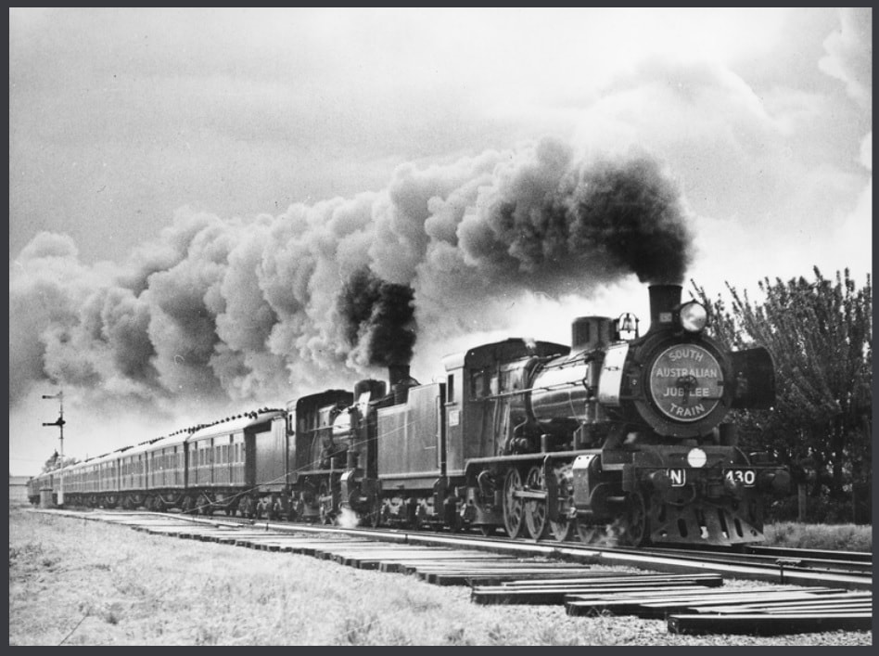
The Jubilee train in South Australia. Image source State Library South Australia
In 1951 The Vic, South Australian and Federal Governments set up a train that traversed Victoria and South Australia that celebrated both 100 years of Victoria and the 50th anniversary of Federation. It was limited to these two states because of incompatibilities of rail gauges in other states. From a telecomms history perspective the interesting part is the PMG display.
A Victorian publication describing the layout, exhibits etc. of the Victorian tour can be found at:
https://nla.gov.au/nla.obj-52848578/view?partId=nla.obj-100623316#page/n0/mode/1up
Similarly, information about the South Australian tour:
https://nla.gov.au/nla.obj-52847851/view?partId=nla.obj-100230464#page/n2/mode/1up
Images of the SA train and displays can be viewed at: https://collections.slsa.sa.gov.au/resource/B+21855
​PMG display; image numbers B-21862, B-21863 and B-21864
Telecommunication Journal of Australia
With thanks to Rick Coxhill. All Telecommunications Journals of Australia 1935 - 1987 etc. published at: http://www.coxhill.com/trlhistory/history/australian_publications.htm ​
An overview of telecommunications in Australia
Parliamentary report ca 2002
https://www.aph.gov.au/Parliamentary_Business/Committees/Senate/Environment_and_Communications/Completed_inquiries/2002-04/telenetwork/report/c01
After telephony - The rise of the internet
The internet now connects the world. For a comprehensive article of the rise of the internet in Australia
go here
​
References and Acknowledgements
This writer wishes to acknowledge the following sources for some of the images and information above and on other pages:
Ref 1. ﻿﻿http://www.telephonecollecting.org/Bobs phones﻿﻿
Ref. 2 http://www.ericssonhistory.com/products/the-telephones/Ericssons-wall-telephone-set-the-pulpit-telephone-from-1882/
Ref. 3 http://www.telephonearchive.com/phones/ae/ae-step-base-stick.html
Ref. 4 https://www.telstra.com.au/aboutus/our-company/past
Ref. 5 http://www.telephonecollecting.org/Bobs%20phones/index.htm Bob Estreich (1949-2011). Much of the information and images in this article were derived from this author’s website.
Acknowledgement from Bob’s website: Most images where not otherwise attributed are from Telecom Australia 1989 Payphone Services review. Most of the information is from Post Office Engineering Instructions, and from Jim Bateman's book "History of the Telephone in New South Wales" (1980)
Ref. 6 http://www.gizmodo.com.au/2011/08/australia-made-its-first-mobile-call-30-years-ago-today/
Ref. 7 http://www.phonearena.com/news/Here-follow-some-of-the-smallest-and-most-compact-phones-ever-made_id62714
Other sources:
http://www.vintagephones.com.au/ccp0-display/history-of-the-telephone-exchange-in-australia.html
http://trove.nla.gov.au﻿﻿​
https://sites.google.com/a/politicalscience.com.au/home/Home/chronologies/australian-chronology
http://schoolpa.com.au/sxs/historyoftelephoneswitchinginaustralia.pdf
​http://www.slsa.sa.gov.au/manning/sa/communic/telephon.htm

