This is a reproduction of a library book that was digitized by Google as part of an ongoing effort to preserve the information in books and make it universally accessible.

Google. books  https://books.google.com | 

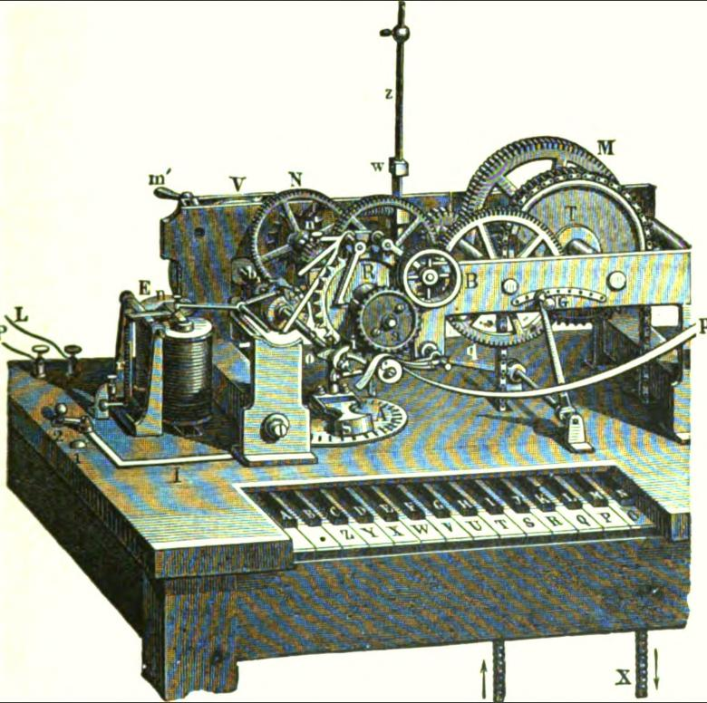

Electricity and
the electric telegraph

George Bartlett Prescott

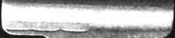

University of Wisconsin
LIBRARY
Book | 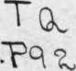

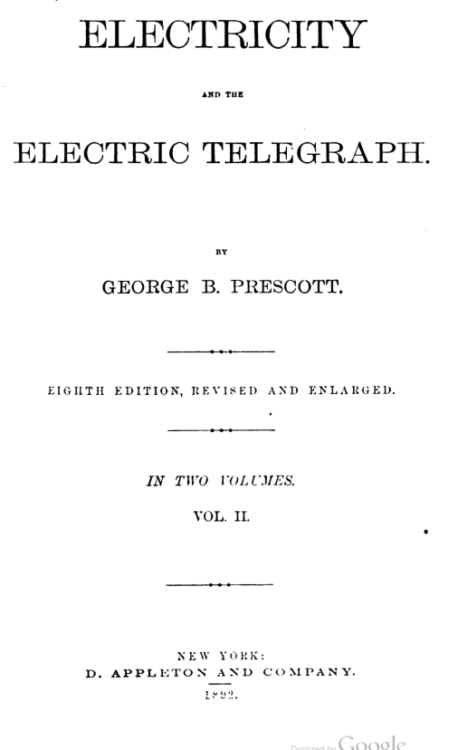

GEORGE B. PRESCOTT.
EIGHTH EDITION, REVISED AND ENLARGED.
IN TWO VOLUMES.
VOL. II.
NEW YORK
D. APPLETON AND COMPANY.
1892

Entered according to Act of Congress. in the year 1892, by
GEORGE B. PRESCOTT,
In the Office of the Libarian of Congress, at Washington.

RUSSELL BROTHERS, PRIRTERS, 149,151,153 LEONARD ST., N.Y.

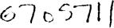
APR 25 1900

CONTENTS—VOL. II.
CHAPTER XXXIV.
THE TYPE PRINTING TELEGRAPH. PAGE
Vail and Wheatstone's type printing telegraphs 603
House's type printing telegraph 605
Hughes' type printing telegraph 609
Phelps' combination type printing telegraph ……………………………… 642
Phelps' electro-motor printing telegraph ………………………………….. 647
CHAPTER XXXV.
REPORTING AND PRIVATE LINE TELEGRAPHS.
Law's gold quotation indicator 672
•
Callahan'a stock reporting telegraph ……………………………………… 673
Edison's universal stock printer 676
Phelps' fast stock printer 678
Gray's private line printer 682
Phelps' private line printer …………………………………………………. 685
CHAPTER XXXVI.
THE AUTOMATIC TELEGRAPH.
Morse's early experimental system 689
Bain's automatic telegraph 691
Siemens-Halske's automatic telegraph 695
Garnier's automatic telegraph 700
Humaston's automatic telegraph 701
Wheatstone's automatic telegraph …………………………………………. 702
Siemens' automatic telegraph.......................................................................... 712

iv CONTENTS.
PAGE
Little's automatic telegraph 724
Edison's automatic telegraph 725
Park's automatic transmitter.... 728
Siemens' automatic cylinder transmitter 729
Siemens' automatic chain transmitter...... 733
Siemens' automatic type printing telegraph………………………………... 734
Phelps' automatic type printing telegraph 736
Jaite's automatic repeating telegraph 737
CHAPTER XXXVIL
AUTOGRAPHIC OR COPYING TELEGRAPHS.
Bakewell's copying telegraph ………………………………………………... 741
Cros' copying telegraph 744
Caselli's pantelegraph 745
Meyer's autographic telegraph ………………………………………………. 756
Lenoir's autographic telegraph……………………………………………….. 758
Sawyer's autographic telegraph .. 762
Bonelli's autographic typo-telegraph ……163
CHAPTER XXXVIII.
SIMULTANEOUS TRANSMISSION IN OPPOSITE DIRECTIONS.
Gintl's differential duplex telegraph 769
Frischen's differential duplex telegraph 771
Gintl's split battery duplex telegraph ………………………………………. 777
Nystrom's differential duplex telegraph…………………………………….. 780
Preece's split battery duplex telegraph 781
Siemens- Halske duplex telegraph 782
Zur Nedden's duplex telegraph......................................................................... 783
Farmer's duplex telegraph 785
Frischen's polarized relay duplex telegraph 790
Maron's bridge duplex telegraph 791
Stearns' differential duplex telegraph 792
Stearns' bridge duplex telegraph …………………………………………….. 800
Stearns' mechanical duplex telegraph.............................................................. 807
Vaes' differential duplex telegraph 811
Winter's duplex telegraph 812
Smith's duplex telegraph……………………………………………………… 815
Haskin's duplex telegraph 819
Edison's duplex telegraph

CONTENTS._

CHAPTER XXXIX.

SIMULTANEOUS TRANSMISSION IN THE SAME DIRECTION. PAGE

Stark's duplex telegraph……………………………………………… 826
Kramer's duplex telegraph…………………………………………… 830
Bernstein's duplex telegraph…………………………………………. 832
Bosscha's duplex telegraph ………………………………………….. 839
Schreder'e duplex telegraph………………………………………….. 846

CHAPTER XL
EDISON'S QUADRUPLEX TELEGRAPH.

The distinguishing principle of the system…………………………… 843
The bridge quadruple' Method……………………………………….. 845
The differential quadruplex method …………………………………. 848
Combination of differential and bridge methods…………………….. 855
Improved differential method ………………………………………… 857
Arrangement of apparatus for long circuits………………………….. 859
Double acting relay................................................................................... 863
Improved quadruplex relay …………………………………………… 868
Directions for setting up the quadruplex ……….…………………….. 870
The double current transmitter ……………….………………………. 870
The single current transmitter ………………………………………... 872
The compound polarized relay ………………………………………... 873
The single polarized relay……………………………………………… 874
Adjustment of the apparatus for working……………………………. 877
Compound quadruplex and duplex circuits………………………….. 879
Arrangement for contraplex transmission……………………………. 881
Combined duplex and contraplex transmission……………………… 883
Combination of quadruplex and duplex systems…………………….. 887
The quadruplex repeater………………………………………………. 889
Arrangement for branch offices ………………………………………. 893
Quadruple' and single circuit combination…………………………… 895
Arrangement for neutralizing current induction. ……………………. 896
Induction between parallel lines ……………………………………… 897
Meyer's method of multiple transmission …………………………….. 898

CHAPTER XLI.
APPLICATION OP THE DUPLEX TELEGRAPH TO SUBMARINE CABLES.

De Sauty's duplex method ………………………………………… 903
Muirhead and Taylor's experiments................................................ 905
Construction of Muirhead's artificial cable …………….……….. 906

vi CONTENTS.
PAGE
Application of Stearns' duplex method 907
Ailhaud's duplex method 909
Muirhead's duplex method 911
CHAPTER XLII.
ELECTRICAL MEASUREMENT.
Units of measurement …………………………………………………… 919
The absolute system………………………………………………………. 919
Fundamental units………………………………………………………… 920
Derived unite ... 921
Practical mechanical units ... 922
Electro magnetic units ... 924
Standard of electro motive force … 929
Practical electro motive units…………………………………………….... 932
Electrical work................................................................................................. 933
Development of heat by electric currents………………………………...... 934
Chemical work by currents ……………………………………………..…. 939
Determination of the ohm by the electrical congress … 940
CHAPTER XLIII.
TO MEASUREMENT AND TESTING OP LAND LIMES.
Locating faults in land lines ………………………………………………… 947
Testing by the tangent galvanometer……………………………………...… 942
Rheostats and resistance coils …………………………………………… ..... 947
Siemens' universal galvanometer 951
The differential galvanometer 957
Conductivity tests by differential galvanometer 961
Testing for faults by the differential galvanometer 964
Locating fauna in underground wires 969
CHAPTER XLIV.
THE MEASUREMENT AND TESTING OF SUBMARINE CABLES.
Formula for making accurate tests 972
Testing cables during submersion ………………………………………….. 973
Smith's method of continuous testing ………………………………………. 974
Thomson's modification for long cables ……………………………………. 976
Comparison of static capacities …………………………………………… 977

CONTENTS. Vii
PAGE
Loop test by the bridge system …………………………………………… 979
Correction for the loop test …………………………………………………. 981
Testing from one station only 983
Remarks on the bridge or electrical balance 985
Sir William Thomson's bridge 987
Cromwell F. Varley's bridge 989
CHAPTER XLV.
Miscellaneous Matters
Thomson's quadrant electrometer …………………………………………. 994
The construction of condensers..... 997
Apparatus for measuring resistance of telegraph wire..... 999
Specifications for galvanized iron telegraph wire 1001
Compound wire—steel and iron 1003
Amalgamating solution for rues 1004
Useful recipes for electrical purposes 1005
Dictionary of technical terms 1007
Construction of electro-magnets 1011
Maximum of magnetization 1013
Proportion of forces to diameters 1015
Movement of the armature 1017
Various forms of electro-magnets 1019
Electro-magnets with multiple poles 1021
Arrangement of the armatures 1023
Electro-magnets with polarized armatures. 1025
Electric time service 1026
Standard time in New York City 1027
Dropping of the time ball .1029
Distribution of time signals. 1031
Electric call bells 1033
Combination keys 1035
Apparatus for giving signals 1037
The vibrating bell 1039
Double bells 1041
Non-interrupting circuit bells 1043
Electric alarm with keys 1045
Breguet's alarm or call 1047
Combination of call bells and relays 1049
Relays with annunciator plates 1051
Clock work alarm 1053
The electro motograph 1057
Dumoulin-Froment's electric counter, for gas meters 1060

CONTENTS.
PAGE
Carpenter's proportion galvanometer. 1063
Thomas' electro-chronometric indicator 1063
Maxim's electro-automatic fire extinguisher 1070
Brooks' underground telegraph system. 1076
Lewis' improved insulator 1078
CHAPTER XLVI.
D'ARLINCOURT'S RELAY.
Defect in Siemens' polarized relay. 1080
Novelty of D'Arlincourt's relay 1081
Mr. Schwendler's explanation of its operation. 1082
Residual magnetism employed as an antagonistic force 1033
Its rapidity of action. 1086
CHAPTER XLVII.
THE HARMONIC TELEGRAPH.
Phenomena of sound. 1086
Reiss' telephone..... 1088
Gray's telephonic apparatus. 1090
Gray's harmonic multiple telegraph 1095
Combination of the harmonic and the Morse telegraph 1098
Bell's harmonic multiple telegraph 1101
La Cour's harmonic telegraph 1101
CHAPTER XLVIII.

DELANY'S SYNCHRONOUS MULTIPLEX TELEGRAPH.
Methods of transmission 1102
Vibration of steel fork 1104
Rotation of phonic wheel 1105
Rate of transmission 1108
CHAPTER X LIX.
PNEUMATIC TRANSMISSION.
Single sluice valves 1111
Wilmot's double sluice valves 1115
Electric signals. 1120

CONTENTS.
CHAPTER L.
THE SIPHON-RECORDER.
PAGE
The effects of induction in perfectly insulated circuits...... 1121
The receiving apparatus 1122
Varley's modified.induction machine 1126
Signals produced by the siphon-recorder 1130
The mouse-mill ……………………………………………………………1131 The interrupter …………………………………………………………….1133
Operation of the decagon cam 1135
The operation of the mouse-mill 1137
The bobbin and siphon. .. 1139
Fabrication of the glass siphons 1145
The movement of the paper 1147
Adjustment of the paper 1148
Arrest of the apparatus 1149
Electrical connection of the system 1150
Thomson's tray batteries 1150
Maintenance of the batteries 1159
Tests of the battery 1160
Jameson's improved mouse-mill 1167
Lauritzen's simplified recorder 1173
Sir William Thomson's latest improvements 1174
CHAPTER LL

THE AUTOMATIC CURB-SENDER.
Varley's zinc-sender 1177
Object of the automatic curb-sender 1179
The curve of arrival on a line worked without condenser 1182
Effect of curb-sending 1183
Principle of the automatic curb-sender 1184
Operation of reversal of currents 1185
General views of the automatic curb-sender 1186
The governor regulating the speed 1188
The revolution of the machinery 1190
The toothed roller which carries the paper 1191
The signal and curb cams....... 1195
Electrical action of the automatic curb-sender 1196
Relative length of currents 1197
The contact plate and signal and double curb 1198
Preparatory curb 1200
Production of sharply defined signals 1201

CONTENTS.

PAGE
Adjustment of the determining cam ………….. 1203
Speed of the machinery …………………..…..1204
Electrical connections…………..………………1206
General directions…………………… ………..1209
Machines for perforating the paper ribbon .…1210
The power puncher……………………...……... 1212
The single lever puncher ……………..…..….... 1214
The feed mechanism ………………………..…. 1215

CHAPTER LII

EDISON'S MAGNETIC BRIDGE.
Principle of the Edison's magnetic bridge … 1217
Construction of the Edison bridge……….….. 1218

CHAPTER XXXIV.
THE TYPE-PRINTING TELEGRAPH.

THE type-printing telegraph system may be said to be, both in its, inception. and in its practical development, a distinctively American one. The earliest suggestion of the possibility of constructing an instrument of this kind originated with Alfred Vail, an associate of Morse, as early as the year 1837. Vail at that time made elaborate and detailed working drawings of his instrument, but, so far as known, never actually constructed it, he being at that time of the opinion that it could never successfully compete with the simple, economical and rapid system of Morse.
Wheatstone was the next to attempt a type-printing apparatus. A working model of his first instrument was exhibited by him before the Royal Polytechnic Institution of London in 1841. This was based upon his first dial telegraph, described in a preceding chapter. In his first printing instrument two line ⁻wires were made use of, the second wire serving to operate the printing mechanism. In place of the index hand of the dial instrument a thin brass wheel was employed, cut into a number of radial strips, each one of which carried a type. A hammer, actuated by mechanism under control of an electro-magnet in the second circuit, when released, struck the type against a cylinder, upon which was rolled a sheet of white paper, overlaid by a sheet of carbonized paper, and thus produced an impression of whatever letter had previously been brought into position by the escapement. He immediately afterwards invented a method of working this apparatus on one wire. This consisted of a commutator, driven by a train of clockwork, which was released whenever the type wheel movement was operated, and was so arranged as to make one revolution while the type wheel was

604 THE TYPE-PRINTING TELEGRAPH.

being brought into position. Just at the completion of the revolution of the commutator it momentarily switched the circuit through the electromagnet, which released the printing mechanism, and was then stopped by a detent, in readiness for a repetition of the process This method was necessarily slow, because a letter could only be printed after a complete revolution of the commutator, which requited as much time for one letter as for another. This instrument never came into practical use.
The various kinds of type-printing telegraph instruments differ widely from each other in many respects, but the following essential characteristics are common to all of them:
- Mechanism by means of which the type or character which is to be printed is brought into a suitable position for transferring its impression to the paper, termed the type wheel movement
- A device for furnishing the type with a constant supply of ink, termed the inking apparatus.
- Mechanism by means of which the type or character, after having been placed in position, is forcibly brought in contact with the paper, and an impression taken, termed the printing movement
- Mechanism by means of which the paper is moved forward a certain distance after each letter or character has been printed, in order to provide a fresh surface for the succeeding impression, termed the paper feed.
- A device by which the type wheel of the receiving instrument may be brought into correspondence with the transmitting machinery of the sending instrument, termed the unison apparatus.
Type-printing instruments may be divided into two distinct classes, one having a step-by-step movement and the other a synchronous movement of the type wheel. There are also a small number of instruments which combine these two characteristics and which may be said to constitute a third class.
In the instruments having a step-by-step movement the revolution of the type wheel is effected either by a clockwork under control of an electro-magnetic escapement, or by the

HOUSE'S TELEGRAPH. 605

direct action of the vibrating Armature without the aid of clock work. The printing of the characters is effected in various ways: sometimes by clockwork mechanism and sometimes by the direct action of an electro-magnet. The instruments of Wheatstone, House, Breguet, Dujardin and many others, in-chiding those used in the United States for stock and market reporting and private telegraphs, are of this class.
In the instruments having a synchronous movement., the motion of the type wheel at one station and of the transmitting mechanism at the other station is regulated by two separate sets of mechanism, keeping exact time with each other. The instruments of Hughes, Farmer and Phelps are of this class.
HOUSE'S TELEGRAPH.
The first printing telegraph which was brought to such perfection as to be available for extensive practical use was that of Royal E. House, of Vermont. His invention formed the subject of an application for a patent in April, 1846, although the invention was at that time in a crude state in comparison with the high degree of perfection to which it was afterwards brought. The first despatch transmitted over a line by this instrument was sent from Cincinnati to Jeffersonville, a distance of 150 miles, in the fall of 1847. The first regular commercial use of the apparatus was upon a competing line between New York and Philadelphia, which went into operation in March, 1849. During the following ten years the system was rapidly and successfully extended to other parts of the country.
House's telegraph is constructed upon the step-by-step principle, the mechanism being operated by manual paver, which is simply controlled by the electric current. It consists of two entirely distinct parts: the transmitter or commutator, and the receiver or printing apparatus. The transmitter consists of a toothed contact wheel, similar to that of Wheatstone's dial apparatus, illustrated in fig. 325, which, in turning, sends a series of pulsations or currents from the battery at the transmitting station, . There are fourteen teeth and fourteen spaces upon the

4306 THE TYPE-PRINTING TELEGRAPH.

wheel, and consequently, when the wheel is made to revolve, the circuit is broken and closed twenty-eight times in each revolution. In order to stop the contact wheel at its proper place to indicate each of the letters, a keyboard like that of a piano is employed, having twenty-eight keys, representing the twenty-six letters of the alphabet, a period, and a space or blank, technically termed the dash. Underneath the keys and extending across the keyboard is a cylinder, fixed upon the axis of the contact wheel and turning with it. Twenty-eight pins are inserted in the cylinder, each pin revolving underneath its corresponding key. The keys are held up by springs, and are furnished with cams or detents. When any key is depressed its detent is struck by the corresponding pin upon the cylinder in its revolution, and the motion of the latter, together with that of the contact wheel, is thereby arrested. The pins corresponding to the successive letters follow each other around the cylinder in a spiral, and are distant from each other one twenty-eighth part of its circumference, and therefore, when the cylinder is turned from one letter to another, exactly such a number of contacts and interruptions are given as will bring the type wheel of the receiving apparatus round to the same point. The arrangement of the keyboard, cylinder, and spirally arranged pins in House's transmitter, arc similar to those of Froment's dial apparatus (fig. 335), the only difference being in the apparatus for closing and breaking the circuit.
The receiving apparatus of the House instrument is somewhat complicated. The electro-magnet by which its movements are controlled is of a very peculiar construction. It consists of a large, upright, hollow helix or coil of fine insulated wire, within which is placed a series of six or eight soft iron tubes, each of which becomes magnetic upon the passage of a current through the helix. A series of bell shaped armatures are fixed upon a brass rod, which passes through the series of hollow magnets, and is suspended from a spring above. The whole arrangement acts together as a powerful compound magnet, but as each separate section of it is very short, its magnetic

HOUSE'S TELEGRAPH. 60T
inertia is small, and it admits of being successively charged and discharged with much greater rapidity than an electro-magnet of the ordinary form. The great speed of transmission of which this instrument is capable depends almost entirely upon the rapidity of vibration which this electromagnet is capable of communicating to the escapement.
Above the compound armature, but fixed upon the same rod, is a hollow cylindrical slide valve, which controls the passage of the compressed air from an air chamber supplied by a pump. The escape wheel, upon the shaft of the type wheel, is controlled by an anchor escapement, operated by a piston which moves to and fro within an air tight cylinder, and is controlled by the, slide valve before referred to, the principal of the whole arrangement being similar to that of a steam engine. When the circuit is closed the compound armature is drawn down and the slide valve attached thereto admits the compressed air into one end of the cylinder and forces the piston to the opposite end, thus releasing a tooth of the escape wheel; when the circuit is broken the armature rises by the action of a spring, the valve admits the air to the opposite end of the cylinder and the motion of the Piston is reversed, which releases another tooth of the escape wheel.
The escape wheel has fourteen teeth and requires therefore twenty eight movements of the piston to complete a revolution. The steel type wheel is fixed upon the axis of the escape wheel, its circumference being furnished with twenty-eight equidistant P^{r}ojections, upon which are engraved the twenty-six letters of the alphabet, a period and a blank space. The same shaft also carries a little drum with letters painted on it in the same order as they are placed upon the type wheel, by which the operator may read off the message as in a dial instrument, without printing a record of it.
Th_{e} means by which the printing of a letter is effected whenever the type wheel is arrested is as follows: Upon the upper surface of the type wheel, and at its extreme edge, are twenty-eight angular pins or teeth. A small steel arm, rigidly attached

608 THE TYPE: PRINTING TELEGRAPH.

to a metal cap,turned by friction upon a shaft revolving in a
direction opposite to that of the type wheel, plays over the pins
upon the type wheel while the latter is in motion.. When, how-
ever, the type wheel stops, the arm falls in between two of the angular pins, which it has not time to do while they are in motion; in doing this it allows the cap to revolve a short distance with its shaft, and .by means of two pins to release a detent fixed upon the same shaft with an eccentric. When the detent is released this shaft makes one revolution, and the eccentric, by means of a connecting rod, forces the paper against a blackened silk ribbon or ink band, pressing it against the type wheel with sufficient force to make a legible impression of the letter which happens to be in position.
The paper feed consists of a notched drum, over which the paper passes from a roll, and this is turned by means of a ratchet wheel and click during the latter part of the movement of the eccentric.
In order to bring the type wheel into correspondence with the transmitting cylinder at the beginning of a communication, a detent lever is provided, which may be thrown by the receiving operator into the path of a pin or stop placed in the rim of the type wheel, and thus arrest the motion of the latter. This unison stop is so placed that it arrests the type wheel with the blank space or dash opposite the printing press, and it being understood that the transmitting operator is always to commence with the blank or dash key, it follows that the instruments must ⁻always start together.
The speed of transmission which has been attained with this apparatus in the hands of some of the more skillful employees, under favorable circumstances, is very remarkable. Upon circuits of 150 to 200 miles messages have frequently been transmitted and printed in full at the rate of 2,600 words per hour. On one occasion the annual message of the Governor of New York, containing 5,000 words, was transmitted by this instrument and published entire in New York two hours after its delivery in Albany.

HUGHES'S TELEGRAPH 609
The House instrument, after having been quite extensively used on some of the lines of the United States from 1849 to 1860, was gradually superseded by the improved instruments of
Mr. Phelps, which will hereafter be described:
HUGHES'S TELEGRAPH.
In 1855 Mr. David E. Hughes, of Kentucky, patented a type-printing instrument, the essential principle of which consists in the synchronous movement of the transmitting and receiving⁻apparatus at two or more stations, so that each letter may be printed by a single electric pulsation, and without arresting the continuous revolution of the type wheel. The accomplishment Of such a result, with sufficient accuracy for practical purposes, presents a problem of considerable mechanical difficulty. Hughes's original apparatus was provided with two ⁻separate and independent trains of wheel work, each driven by a weight The first train caused the type wheel and transmitting cylinder to revolve at a uniform rate of speed, this being governed by an escapement and a rapidly vibrating steel spring, the length of which was capable of adjustment: thus, enabling its rate of vibration to be controlled with great accuracy. The second train actuated the printing mechanism, and was released by a peculiarly sensitive combination of permanent and electro-magnets, which will hereafter be more particularly described. By means of
the spring governor the transmitting cylinder of one instrument and the type wheel of the other were caused to revolve in The revolving cylinder connected with the keyboard was provided with spirally arranged pins, each of which closed the circuit for an instant upon arriving at; or rather passing by fixed point, if the corresponding ley was depressed. This being the case, it is obvious that two machines might be so adjusted
that when in its revolution the pin upon the transmitting cylinder corresponding to the letter A, for instance, passed by the depressed key A and closed the circuit, the corresponding letter A upon the type wheel of the receiving instrument would at the same instant be passing the platen.

610 THE TYPE-PRINTING TELEGRAPH.

The printing mechanism being at that moment released by the action of the electro-magnet, an impression of the letter would be taken as it was passing, and so of any other letter when its corresponding key was depressed.
During the greater portion of the years 1855-56 Mr. Hughes, in conjunction with Mr. George M. Phelps, an accomplished mechanician, at that time residing in Troy, N. Y., was engaged in perfecting the instrument, with a view to its practical introduction upon the lines of the American Telegraph Company, which were at that time equipped principally with the House apparatus. During this time two important and in fact essential improvements were made in the invention. The first of these is a device for readjusting the synchronism of the type wheel at the printing of each letter, by means of which any slight irregularity in the correspondence of the sending and receiving instruments, arising from the mechanical inaccuracies of the governors, or from their imperfect adjustment, is corrected. The second improvement consists in gearing the type wheel shaft and printing mechanism together, so as to be driven and controlled by the same prime motor and governor, but in so arranging the parts that four or five letters in succession upon the type wheel will pass the platen during the shortest interval that can elapse between two successive impressions, by which means, as will be hereafter explained, the effective speed of transmission is very greatly increased. This important improvement is entirely due to the ingenuity of Mr. Phelps.
The Hughes invention, thus improved, was first put in practical operation upon the line between Worcester and Springfield, Mass., in 1856, and in the autumn of that year was also employed to work a new line between New York and Boston. In 1858 Mr. Hughes went to Europe, taking with him two of his instruments, accompanied by an experienced American operator. His negotiations with the French administration of telegraphs, in relation to the introduction of his system, were successful, and the patents were conditionally purchased by the French Government in October, 1860. Arrangements were entered

HUGES'S TELEGRAPH. 611H

into with M. Froment, an expert French mechanician, for the construction of additional instruments, which were introduced upon the government lines at Paris, Lyons, Marseilles, Bordeaux, Havre and Lille, in 1862. The United Kingdom Telegraph Company of Great Britain also adopted the Hughes apparatus in 1863. At the present time they are employed to a greater or less extent in almost every country in Europe.
The principal parts of the Hughes apparatus as now constructed are as follows:
- The keys and sledge or circuit-closer.
- The wheel work and type wheel shaft
- The printing axis and the printing mechanism.
- The electromagnet and escapement for releasing the printing mechanism.
- The governor for maintaining the synchronism.
- The course of the current and the mutual action of the electrical and mechanical power.
The transmission is effected by means of twenty-eight keys, (fig. 364), twenty-six of which are for the letters of the alphabet, and one each for a stop or period and a blank to separate the words. Each key K (fig. 365) presses upon a lever K', which has its centre of motion at K" and supports a vertical pin k, which is drawn downwards and somewhat sidewise by a spiral spring (fig. 366) connected with it by means of a link. These twenty-eight pins k are placed in a circle around a vertical axis Q, within a round box A; the levers K', consequently, are so constructed that each of them may operate on the corresponding pin k when its own key is depressed. In their ordinary position these pins are kept down by means of the spiral springs (fig. 363); their rounded tops are then lying flush with the top plate of the box A within corresponding openings, as seen in fig. 367. When, however, a key is depressed, the opposite end of the lever K K' is raised, and the corresponding pin k is caused to project a little from its opening in the top plate of the box. A shoulder 0 (fig. 366), to which the spiral spring is attached,

1512 THE TYPE•PRINTING TELEGRAPH.
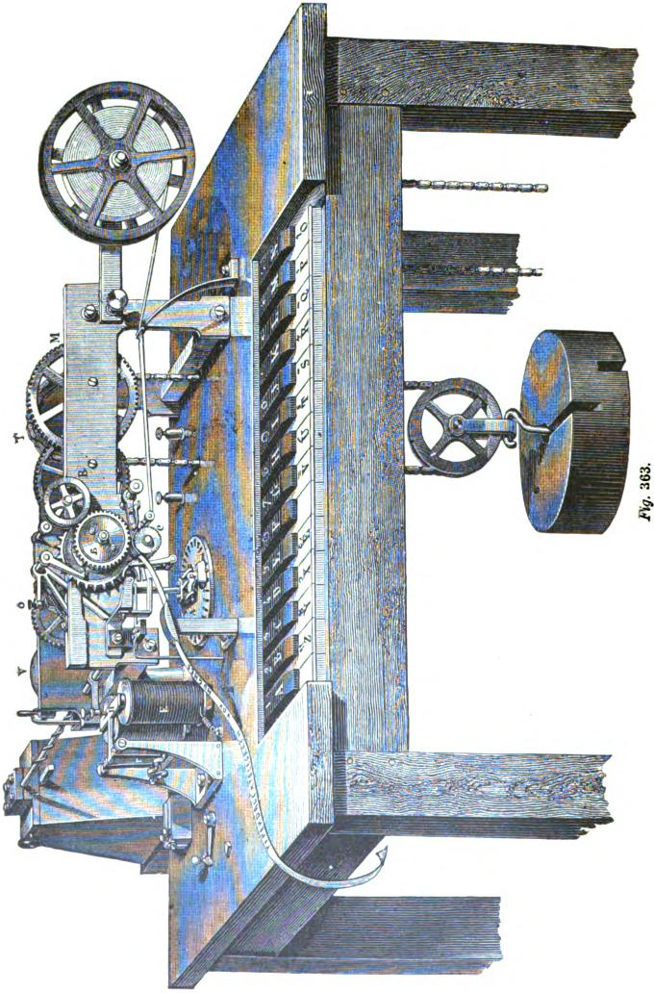

HUGHES'S TELEGRAPH. 618
prevents it from projecting beyond a certain distance. In the centre of the circular box A A is a vertical axis P Q, which is rotated rapidly by means of a beveled gear f. This axis consists of two metallic parts P and Q, insulated from each other by an ivory plate q. The lower part P, which enters the centre of the box A A, revolves in a hollow bearing Q₁.
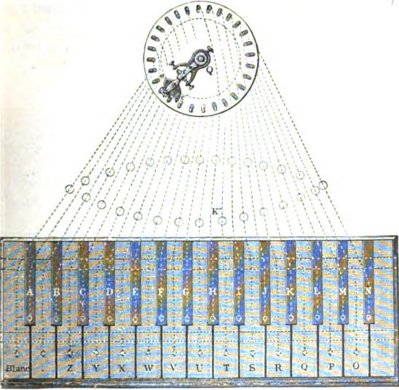
Rg. 364.
At the lower end of the upper part of the axis, directly over the top plate of the box A A, is placed the sledge. The details of this sledge are represented in section in fig. 366, in a plan view from above in fig. 367, and in perspective in fig. 368. It consists of two parts. The lower part e e' is rigidly attached to the lower part of the axis P. The upper part r S s is connected to the upper part Q of the axis by a hinge. The lower part e e'

614 THE TYPE-PRINTING TELEGRAPH.
(the pusher) slides closely over the upper plate of the box A when the axis Q revolves. Both of its ends are rounded off and channeled, in order to operate on the pink when raised by the depression of a key. As the axis revolves in the direction shown by the arrow, the end c of the pusher is in front, and when no key is depressed it passes lightly over the pins, as shown in fig. 367. When a key is depressed the corresponding pin k is raised a little out of its slot and is pushed sideways toward the outer edge and in front of the steel rider S. The pusher, in its revolution,
Fig. 365:

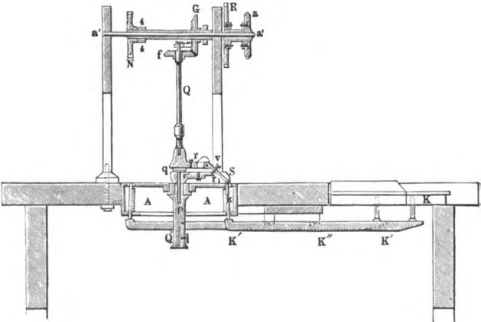
G
a'
4
a
K
always covers five pins; when the first, k, is struck, the four following pins cannot come in contact with the rider S, even if their keys were depressed, owing to their coming in contact with the under side of the pusher e e' and thus being arrested. The pusher also serves to force back, by means of its curve e', the pin to its first position, after the rider S has passed over it. In this way the sledge is enabled to revolve continuously, without interruption, even if the operator should neglect to release the key which has been depressed.

HUGHES'S TELEGRAPH. 615
The upper part of the sledge consists of the rider S, a flat spring r, which presses the rider constantly downward, and a contact screw v which passes through the top of the rider (fig. 366). These parts, as represented in fig. 367, are fixed to an axis turning between two screw points and attached to the upper axis Q.
When no key is depressed, and the pin k is in its normal position, screw v is in contact with the spring r₁, which is on the
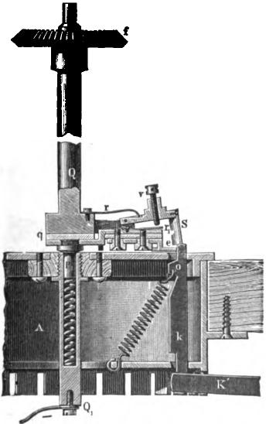
366.
lower part P of the axis. In this case P and Q are connected, and any current arriving at Q will pass over r v and r₁ to P Q', and so on. Such is always the case when the apparatus is receiving.
When, by the depression of a key, the pin k is raised, the latter, by the rotation of the sledge, is pushed outward by the

616 THE TYPE-PRINTING TELEGRAPH.
curved end of the pusher e into the centre of the slot, and into the path of the rider S, which immediately comes in contact with it This contact raises the rider into the position occupied by S in fig. 366. Screw v is withdrawn from the contact spring r, and the connection between Q and P is broken. At the same time a new circuit is established by way of Q r₁ S and pin k with axis K" (fig. 364 and 365). A current arriving at K" passes over K" k S S r Q, and so on. To accomplish this, all of the twenty-eight key fulcrums K" are constructed so as to be in metallic connection with each other.
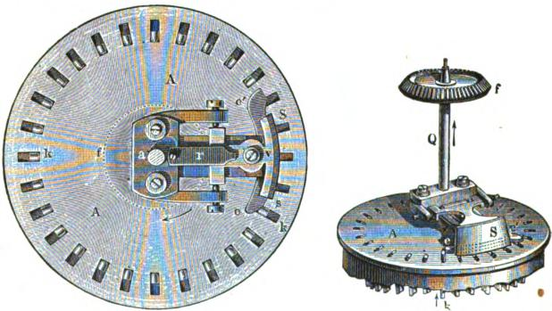
Pig. 367. Mg. 368.
Transmission is effected in the following manner:
A key is depressed by the operator, who, with his fingers, feels the push occasioned by the slide e e' coming in contact with the pin k, as well as by the pressure of the rider S, which slides over the raised pin. The key is then released, even though it should be desired to repeat the same letter. If the key remains depressed, then the sledge passes by the pin k, which has been brought beyond the range of S, which consequently would not be raised, nor would the connection between P and Q be broken.
As will presently be seen, the upper part S of the sledge or the axis Q is connected with the wire L; each axis K" is con-

HUGHES S TELEGRAPFL 617
fleeted to the positive pole of the line battery, its negative pole being connected to the earth.
At the receiving instrument the current arriving from the line passes through the electro-magnet, which releases the printing mechanism, and over Q v r₁ and P to the earth.
In transmission, when a key is depressed, the current is from the + pole, by way of K" and k When the steel rider S of
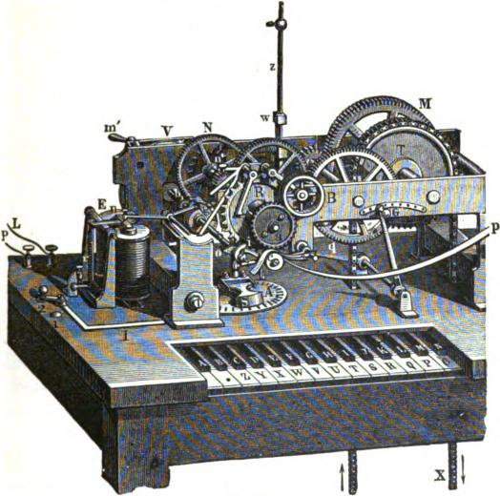
Fig. 369.
the rotating sledge comes in contact with k, the course of the current is changed and is from +, through K" k S (as v is separated from r) Q and L, to the other station. This current is of very short duration. The steel rider S always covers three pins at the same time; the circuit of box A has twenty-eight pins, and if the sledge revolves twice in one second the duration
of the contact between S S and k is 3/28 ½ = 3/56 = 0.536 seconds,

618 THE TYPE-PRINTING TELEGRAPH.

or about the one nineteenth part of a second. This short duration of current is sufficient for circuits of ordinary length, but not for very long aerial or for submarine lines. In working the latter, the speed of rotation of the sledge should be reduced, or the length of the rider S 8 increased. When, for instance, the latter covers six pins, the speed of rotation being as before, the duration of the current would be 0.1072 seconds.
Figures 363 and 369 are views, in perspective, of the Hughes apparatus complete. Fig. 370 is a plan view of the same.
In front is the keyboard of twenty-eight keys; at the back of this the covering plate of the box A, with the twenty-eight pins, in the centre of which is the vertical axis Q and the rider
which is rotated by means of a beveled gear (fig. 366), and which revolves twice in one second. Behind the box A is a strong iron frame, which supports the machinery. The first wheel T is actuated by a weight of 120 pounds. This weight hangs on an endless chain, in such a manner that, when it is wound up, the revolving wheelwork is not interrupted or retarded. The re-winding is usually done by means of a pedal, every five or ten minutes, on account of the exceedingly rapid motion of the wheelwork. The wheel M turns with the wheel and this motion, multiplied, is communicated to wheel N. The latter puts a fly wheel V in motion, upon which, by means of a handle in', a brake is operated for the purpose of stopping the instrument The wheel N also actuates a pinion 5 (behind g, fig. 370), and so conveys its movements to the printing axis b₁, the operation of which will be described hereafter. In front, on the axis of the wheel N (a' a', fig. 363), which passes through the front plate of the frame, a hollow axis is placed, which unites wheels a and R This axis is carried by a small friction. a is the type wheel (figs. 367 and 369), on the circumference of which are twenty-seven projections of hard steel, and one blank space. Twenty-six of these have engraved upon them the different letters of the alphabet, and one is a point for a stop or period. B is the ink roller, pressing against the face of the types. and revolving with the wheel. R is the correcting wheel,

HUGHES'S TELEGRAPH. 619
whose connection with the type wheel a and the rest of the apparatus is clearly represented in fig. 371. Upon the axis which connects wheels R and a a steel disc F is placed, which
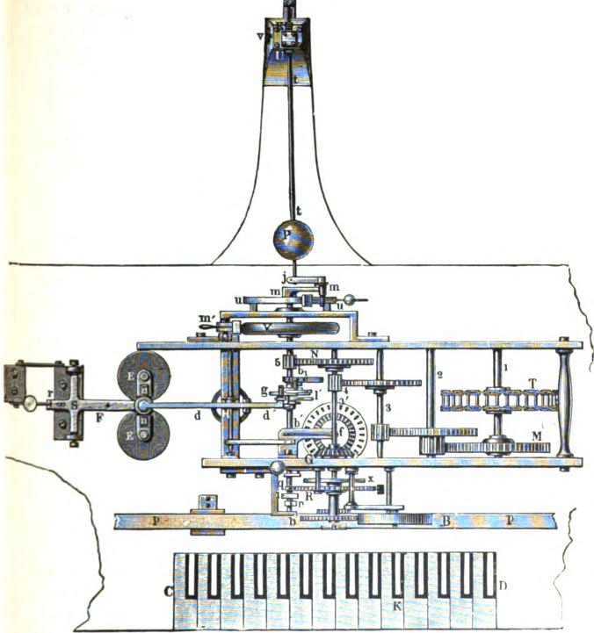
370.
is provided with a notch, in order to catch the hook of a lever K., when the latter is pressed against the steel disc by the depression of the button or key n'. When this takes place, and the hook

620 THE TYPE PRINTING TELEGRAPH.
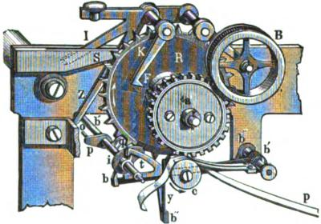
of the lever K catches in the notch F, the blank space of the type wheel stands exactly over the impression roller or platen c, which carries the slip of paper. Thus, when the apparatus is in motion, and the key n' is depressed, the lever K falls into the notch F and stops wheels R and a. This places the blank upon the type wheel opposite the impression roller c. In order to prevent axis a' a' and the remainder of the work from stopping when the motion of R and a is arrested, these parts are connected together in the following manner: Upon the axis a a', behind the correcting wheel R (fig. 370), is another wheel x, with very fine teeth. On the back of the correcting wheel is a ratchet with three teeth, which, under the action of a detent, catches in
Fig. 371.
the teeth of the wheel x. In this position, by means of the wheel x and the catching teeth, axis a a' must communicate its motion to the correcting wheel R, and by that to the type wheel. Upon the tri-dental catch of the correcting wheel is also a small pin, which ordinarily passes the coupling with tooth wheel x, on plate S (fig. 371). Should the key n' be depressed, the arm I pushes the plate S forward so that the pin strikes against it, and, in so doing, lifts the catch out of the teeth of wheel x. So long as the key n remains depressed there is no connection between the wheel x or the axis a' a' and the wheels R and a. As soon as the tooth of the lever K catches the notch F, R and a

HUGHES'S TELEGRAPH. 621

stop, whilst the remainder of the apparatus continues in motion without interruption.
In order to correctly understand what now follows, it must be borne in mind that (see figs. 365 and 370) axis a' a' not only turns the type wheel and the correcting wheel, but by means of a beveled gear G, also the wheel f, its axis Q (fig. 366). The sledge S and the type wheel a cannot move independently of each other, but being geared together revolve with equal velocity, thus always remaining in harmony with each other and in the same relative position. Their normal position, however, is such, that at the same time that the rider S (fig. 367) of the sledge comes into contact with the pin k of a depressed key, the letter upon the type wheel which is represented by this key' is exactly opposite the impression roller or platen c (fig. 371).
When, for instance, the key for the letter H is depressed, the rotating sledge brings the rider S to the pin which corresponds with this key, and as the type wheel and pins correspond
and the type wheel and the sledge revolve together, the letter H upon the type wheel will be found immediately over the impression roller c. The corresponding position of both should he kept up as long as the apparatus is in action. The harmonious action of these parts may be brought about at any time by the key n’ and the blank or space key of the keyboard, because the result of the depression of the key n' is to arrest the space on the type wheel immediately over the impression roller c. The inking roller B is always in contact with the circumference of the type wheel when the apparatus is at work. It consists of a heavy woollen cloth, which from time to time is moistened with an inking fluid.
The printing axis b, b' (figs. 369 and 370), which receives its motion from the wheel N, is the most important part of time Hughes, apparatus. It has a number of duties to perform. First, it throws the impression roller c, at the right moment, against the type wheel a; second, after a letter has been printed upon the paper it feeds the latter forward to make room for the next

622 THE TYPE-PRINTING TELEGRAPH.

letter; third, it acts upon the correcting wheel; and, fourth, it returns the key n' to its normal position after it has set and locked the type wheel and connects the arrested wheels R and a with the rest of the wheelwork at the proper time. To effect these different results the axis is provided with four cams (fig. 871). The front cam m (fig. 372) effects the printing. At each revolution of the axis it raises a forked arm t t' (fig. 374), which has its centre of motion at t'. This arm supports the impression roller c, which carries the slip of paper to receive the printed letters. As the cam m raises the arm, the impression roller with the slip of paper is thrown against the letter upon the type wheel, which is immediately over it. This operation is repeated at each revolution of the axis b', which revolves in a less space of time than the 1/200 part of a second. After each impression

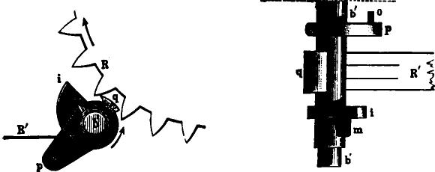

F. 372. R_{g}. 373.
the paper is fed forward by the eccentric Behind the forked arm t t' is an angular shaped lever b b' b" (fig. 374), which has its axis at b" (right hand side) and to the lower part of which is attached a flexible steel spring y, the head of the spring carrying a hook or catch. To the impression roller c is attached a ratchet wheel with very fine teeth. Whenever the roller is raised the tooth y engages the teeth of the ratchet wheel, and is raised at the same time with the lever b b' b". As the axis revolves the cam or eccentric i operates upon the lever, depressing it, and during its downward motion the catch of the spring y turns the ratchet wheel, and thus moves the paper the distance required.

HUGHES S TELEGRAPH. 623

The third cam q (figs. 372 and 373) operates on the correcting wheel R in such a way as to maintain the unison of the type wheels of the receiving and the sending instruments. To accomplish this, at every revolution of the axis the cam q gears into the teeth of the correcting wheel R and accelerates or retards the motion of the correcting and type wheels, as may be necessary from their position. These wheels, being carried by a friction, yield readily to the operation of the cam.
The fourth cam p (figs. 371, 372 and 373) has a pin o inserted parallel to the axis b', which strikes against the lever Z (fig. 371) at each revolution of the axis, forcing it to the right at the moment that the key n' in front is pressed down. As we have seen heretofore, at the pressing down of key n', not only
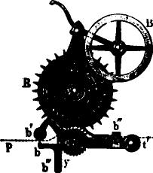
p
Fig. 374.
the coupling between the wheel R and type wheel a, and the cog wheel x (fig. 370) and the axis a' is disengaged, but also, in consequence of the catching of the lever K in the notch F, both the correcting wheel and type wheel come to a stand with the blank space of the type wheel over the impression roller. When the key n' is released, the next revolution of the axis b, b' brings the pin o against the arm Z, and thus n' I, Z, K, all of which forte part of a single lever with a common centre of motion, are brought back to a position of rest. This movement of the pin o lifts the lever K out of the notch F, the detent S moves back, the tri-dental catch, which is fixed on R, engages with the teeth of the wheel x, and the wheel R and type wheel a are released and resume their rotation from axis a' a' in harmony with the

624 THE TYPE-PRINTING TELEGRAPH.

rest of the wheelwork. Thus, it will be seen that when the key n' is depressed the type wheel is locked, with its blank space opposite the impression roller c, while the remainder of the wheel-work continues to revolve without interruption. At the first revolution of the printing axis b' the pin o, upon the cam p, raises the key n', and in so doing couples the wheel R and type wheel a to the wheel work, which continues its revolution.
The four cams upon axis h, just described, are all upon the front part b' of the axis, which is connected with the printing mechanism. The other part of the axis h, is not continuous with the front part, but is coupled on to it at the moment that an impression is taken upon the paper from one of the letters of the type wheel. The rotation of the rear portion of the axis is continuous, owing to the permanent gearing of the wheel N to the pinion 5 (fig. 370), but the front part, with the earns, remains inactive until, by means of a catch, both parts are united and revolve together. This connection is effected by the lever d d' of the electro-magnet E E. Upon the depression of one of the keys of the keyboard a pin k (fig. 367) is raised, and the rider S of the sledge, in sliding over it, is raised, and thus causes a current to pass through the coils of the electro-magnet E E, which controls the movements of the lever d (1", and, consequently, the action of that part of the axis carrying the cams.
Figure 373 represents the action of the electro-magnet E upon the printing mechanism of the apparatus, and also the device for coupling together the two parts b, and b' of the printing axis.
The cores of the electro-magnet are not connected together at the back by a yoke, as in the case of an ordinary electro-magnet, but, as shown in fig. 376, they are attached to the N and S poles of a powerful steel magnet. The action of this magnet upon the cores is regulated by means of an armature of soft iron placed on the legs N and S. which can be moved up or down. The nearer it is placed to the end of the poles the less will be the magnetic effect upon the cores of the electro-magnet.
By this arrangement the cores are constantly magnetic, and attract the armature n (fig. 373) as long as no current passes

HUGHES'S TELEGRAPH. 625
through the coils. A strong steel spring r operating on the arm F
serves, by its attractive power, to withdraw the armature, when
by the passage of a current through the coils, the magnetic power derived from the steel magnet is neutralized. In order to avoid too strong an attraction, the armature does not touch the surface of the poles, but is separated by a space equal to about the thickness of an ordinary sheet of paper.
When a current whose polarity is opposite to the polarity of the steel magnet is passed through the coils E E the magnetism is Weakened or neutralized, and it no longer holds the armature against the retractile force of the spring r, which immediately draws the armature upward with considerable power. This
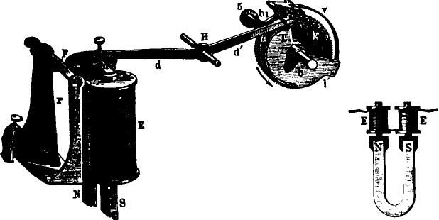
Fig. 375. Kg. 376.
movement is communicated to the lever d d', which has its centre of motion at the axis II. One end of the lever rests, With an adjusting screw, on the top of the armature; therefore, when under the action of the current, the armature is released and flies upward, one extremity d is raised with it, while the other goes downward, and it is by this movement that the coupling of the two portions of the printing axis b, b' (figs. 369 and 370) is effected, and the motion of the wheel work transmitted from the pinion 5 to the front part of the printing axis b’ and its four cams.

626 THE TYPE-PRINTING TELEGRAPH.

The transmission of this motion is effected in the following. manner. On the back part of the printing axis b, a wheel g (fig. 375), with very fine and strong teeth, is fixed. On the front part of the axis b' is a circular sector 1 l', on one side of which is a flyer c', to which is attached a detent c". This detent has three teeth which gear into the teeth of wheel g. On the other side of the sector is a spring v which presses down the toothed detent, which, with its flyer c', is allowed to rise and fall a little. When it is free; as represented in fig. 375, the spring v presses the detent c" into the teeth of wheel g, and it revolves with the wheel in the direction indicated by the arrow, and thus the rotation of printing axis b, at once effects the revolution of the sector 1 l' and the axis b'. When, however, c' c" is raised, its teeth leave the wheel g; the latter continues to. turn while the motion of the sector mid the axis 1/ is arrested.
The sector 1 l' also carries an eccentric cam u, which raises the end d' of the lever, when by the action of the armature n it has. fallen. This movement presses the armature against the poles of the magnet, where it remains attracted by the permanent magnetism of the cores so long as no current passes through the coils. When in the position shown in the engraving, the sector 1 l' turns in the direction of the arrow, and after making half of a revolution the front part (in fig. 375 the lowest part) of the cam u slides under the extreme end of lever d'. As the following end of the cam is more distant from the axis b' than the front end, the extreme end of lever d' is raised by the cam, the other end d consequently falls, and the adjusting screw returns the armature to the poles of the electro-magnet.
In the figure the front end of the cam u has not reached the end of the lever d', therefore this end is depressed, and the toothed detent is still engaged with the teeth of wheel g. When the axis 11 is turned a little farther d' will have reached its highest position, and d will be resting against the armature of the magnet. The axis 11, sector 1 l' and flyer c' continue to revolve; but when the revolution of the axis b' is nearly completed the flyer c', to which c" is attached, reaches the inclined

HUGHES'S TELEGRAPH. 627

end of the arm d', which is now firmly held, and moves upward, lifting c" out of the teeth of wheel g. By this the printing axis 6" is disconnected from b, and the revolving wheelwork, and its motion arrested, in which position of rest it remains until the arm d' again falls, owing to the release of the armature by a current passing through the coils, when the flyer c' is set free; c" again catches into the wheel g, and thus both b’ and b1 are again coupled together. It will be seen that the printing axis b' makes a complete revolution at each action of the electro-magnet, and that the movement of armature n and the release and action of the printing mechanism is effected exclusively by mechanical Power, and not by the power of an electric current. The current, durin_{g} its very short duration, merely weakens or destroys the Permanent magnetism of the cores of the magnet, at which the spring r raises the armature n and through the lever d d’ regulates the revolutions of the printing mechanism.
The apparatus is arranged in the same manner at both the sending and the receiving stations, and as the speed of rotation of both instruments, while in action, is exactly the same, consequently the same letter on each of the type wheels is at the same time immediately over the impression roller, and can be printed upon either or both instruments by the depression of a key at the sending instrument. In order to secure perfect synchronism between the two corresponding instruments, Hughes, at different times, has employed several arrangements. The following probably, one of the best.

As will be seen in fig. 369, a very elastic tongue z is fixed in an upright position in front of the back wheel plate. To the lower end of this tongue a lever is attached by means of a spiral spring.
The teeth of a wheel which lies behind and is connected with the wheel N, are arranged to operate upon one of the arms of this lever. During the revolution of the wheel its teeth move the lever to and fro, and, through the spiral spring, causes the steel tongue z to vibrate rapidly. As this tongue vibrates faster or slower, it operates on the toothed wheel lying under the wheel N and through that accelerates or retards the motion of the

62.8 THE TYPE-PRINTING TELEGRAPH.

entire system of wheelwork. The vibrations of this steel spring can be regulated by lengthening or shortening, the same as in the case of a pendulum. For this purpose a sliding weight w (fig. 369) is placed upon the steel tongue z, and can be raised or lowered by means of a crank G, the upper end of which is attached to the weight and the lower end to a lever q. When the weight w is raised the vibrations become less rapid and the speed of the instrument is retarded. When it is lowered the vibrations are shortened and the rapidity of the wheelwork is accelerated.
In a later form of the instrument, Mr. Hughes makes use of a fly wheel V (fig. 363) fixed on the printing axis b₁, to which is connected a horizontal conical pendulum P (fig. 370). The speed of this fly wheel depends upon the size of the circle described by the ball P, which can be regulated at the will of the operator.
To effect this, the ball P is attached to a steel rod t t, which can be moved up and down by means of the spring v and the axle K U, along the actual pendulum rod which is fixed at N, and which is caught at j by the crank mj. The crank/ is revolved by the crank m m, which is on the axis of the fly wheel V. The pendulum P consequently describes a larger or smaller circle around the axis b₁ m, according to the speed of rotation. When the speed increases the ball P is thrown out farther from the axis, but then, however, through the lever system j m it exercises a stronger pressure against a brake ring, and by the increased friction the circle described by the ball is lessened and the speed of the wheelwork retarded. The position of ball P on the pendulum rod is regulated by the operation of the tooth spring v K U on the rod t t. When the speed of the wheelwork increases the increased friction of the brake ring at u u acts as a check, and vice versa, so that the apparatus is self regulating, and its motion is continued for any length of time with unvarying regularity. Should one of the instruments, however, run faster or slower than the other, it can at once be brought into harmony by turning the regulating screw v, which will bring the ball P to its proper position.

HUGHES'S TELEGRAPH. 629
In another form of this arrangement the pressure of the brake against the brake ring u u is made to take place from the inside. The arrangement then is as follows (fig. 877):
The ball P, rod t t, the attachment of the pendulum rods at N, and the regulating arrangement v K U are the same as above described. The rod t t stands almost horizontally (not visible in the drawing), the brake ring u u vertically, and, in its centre, upon the axis b₁ of the fly wheel, is placed a lever b₁ m which turns with the fly wheel. On the pivot m of this lever a strong steel wire is fixed, forming a powerful spring. The extreme end of this spring j forms a small ring, in which is placed the end of the pendulum rod, so that it can move freely. On this
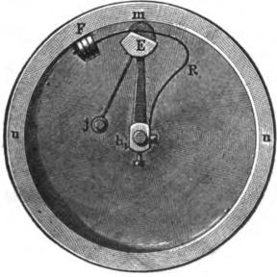
Fig. 377.
is fixed an eccentric E, which operates upon another powerful spring R, which is attached to the axis b₁ and upon which is placed a friction pad F. The entire system b₁ m j E R F turns with axis b₁ of the fly wheel V (fig. 370) within the ring u u.
When the apparatus is in action the axis b₁, which revolves simultaneously, sets the conical pendulum in motion through lever b₁ m j. When the proper speed is attained, the rod mj reins a certain distance from b₁ m, not so far, however, as represented in the drawing. Should the speed increase the rubbing friction F is pressed against u u by the eccentric E, and the speed is at once decreased.

630 THE TYPE PRINTING TELEGRAPH.

In the latest construction Mr. Hughes has somewhat simplified and improved the brake arrangements, as shown in fig. 378. Instead of the pivot m with the eccentric, a cylinder of bone is used, which is fixed eccentrically on the axis of the brake lever b, and presses immediately on the brake spring R This brake spring, upon the efficiency of which the action of the entire brake depends, reaches to the point of fastening b₂, by being attached to a rigid arm at b₃. In this manner the proper form of the spring is more easily established and maintained.
In place of the friction F (fig. 377), a piece of hempen cord, the end of which somewhat resembles a brush, is used. This friction is much more uniform and very seldom needs renewal.
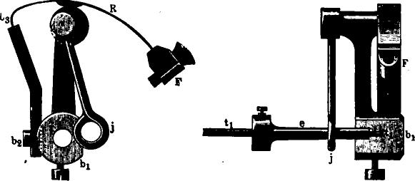
fig 378. fig. 379.
In order to prevent wear on the thin end of the vibrating pendulum rod t t, a small steel collar e (fig. 379) is placed over the rod at that point and firmly held by means of a screw.
Upon the instrument table (fig. 369) are two binding screws P L, of which P is connected with one of the poles of the send. ing battery and with the pins k under the sledge. L is connected with one end of the coils of the electro-magnet E and the line. Also upon the table are metallic studs 1 and 2, and a switch arm which is connected with a metal strip I. The strip I is connected to the metal parts of the entire apparatus, and the plate 1 is in connection with the other end of the coil of the electro-magnet. When the arm is placed on the stud 1 the instrument

HUGHES'S TELEGRAPH. 631 is in position for receiving, and for sending when the arm is on stud 2. In receiving, when the arm is upon the stud 1, a current arriving from the other station proceeds through L, magnet E, switch and stud 1, to the metallic parts of the instrument, thence to the rotating axis Q (fig. 366) of the sledge, and t1en, as none of the pins k are raised, from the contact screw v to the spring r₁ and over P and Q₁ to the ground.
The unison of the sending and the receiving instruments is effected in the following mariner:
The sending operator depresses one of the keys—for example, the letter B—several times in succession. If, at the receiving station the same letter is printed at each impulse, the synchronism is perfect and needs no adjustment. If, on the contrary, different letters are printed in succession, the synchronism is not perfect and needs regulating. It can easily be seen by the order of the succession of letters whether the instrument is running too fast or too slow.
If the letters printed upon the paper at the receiving instrument run ahead, as B C 0, etc., then the receiving instrument is running faster than the sending. If the letters run back, as C B A, then it is running too slow. In either case the adjustment of the sliding weight w (fig. 369), higher or lower upon the vibrating tongue z, by means of the crank G, will bring both instruments in unison. With the pendulum governor the same result is attained by moving the ball P by the adjusting screw u (fig. 368_{).}
When the instruments are brought to a corresponding speed, the instruments are brought to a corresponding speed, message is transmitted letter by letter by depressing the keys at the sending station. As we have seen before, at the movement a contact pin is brought forward by the depression of a key it is struck by the steel rider upon the sledge, thus closing the circuit of the line at exactly the same time that the letter on the type wheel, corresponding to the key depressed, is over the impression roller. After each word the blank key is depressed and the paper is moved forward the space of a letter without receiving; an impression.

632 THE TYPE-PRINTING TELEGRAPH.
In fig. 380 is represented the usual circuit arrangement of the Hughes system. K represents a key, K" the connecting point of battery L B, k the pin appertaining to the key, Q the upper and P the lower part of the sledge axis, S the rider of the sledge, v its contact screw, which is in contact with r_{l} as long as S is not raised, connecting Q with P, E the electromagnet, L the line, T T' the ground plates, and L B the battery.
Now, when at station I a key is depressed, for example, the letter M, the circuit is closed as soon as the rotating sledge comes in contact with the pin k. The current from L B then flows from + to K" k S (v being separated from r₁ and there-
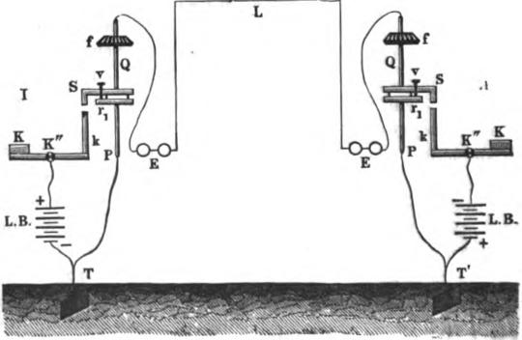
Fig. 380.
fore S from P) Qf E and line L to station II. At station II through Ef Q v r_{i} (as S is not raised, and consequently v is in contact with r₁) P T' to the ground.
To insure a better connection of the sledge axis Q with the metallic body of the apparatus than that afforded by the beveled wheel and the spring which presses on the upper end of the sledge axis, Hughes places on the upper bed plate of axis Q a powerful spring which presses laterally upon the axis. The closing of the circuit consequent upon the depression of the key sets the printing mechanism in action, the operation of which has

HUGHES'S TELEGRAPH. 633

heretofore been fully described. Precisely the same effect is Produced by the depression of any other key, as the letters upon the type wheel correspond in position with the pins of the keys. When both instruments revolve at the same rate of speed and start from the same point, the instant that the sledge comes in contact with a pin, that instant the corresponding letter upon the type wheel is over the impression roller and is taken off upon the paper.
As we have seen, only one impulse of the current, and that of very short duration, is required to effect the transmission of each letter. This is a very great advantage, but it should not be overlooked that, as shown in fig. 380, the strength of the
Fig. 381.

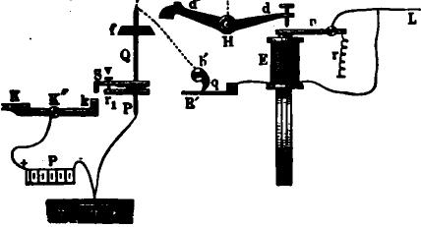
L
current upon its arrival at the distant station can never be as great as at the starting point, owing to the fact that during transmission only the battery at the sending station is in action. The adjustment of the magnet has therefore to be changed whenever the instrument is changed from sending to receiving.
In order to overcome this inconvenience, Mr. Hughes has proposed an alteration in the circuit arrangements, which is very
Ingenious, and seems to be well adapted to its purpose. Fig. 381 shows this arrangement d d' is the lever, which, through the armature n, at each action of the current, couples axis b1 to printing axis b'. As shown heretofore, axis b’ carries a number cams One of these cams q (figs. 372 and 373), at every revolution of the axis, is brought in contact with a spring R' (fig
634 THE TYPE-PRINTING TELEGRAPH.

381 and 373), which is in a shunt circuit from the line through the magnet. This contact is maintained during the time the axis is stationary. The cam is brought into connection with the battery upon the depression of a key, through contact pin k and the sledge. The duration of this contact during the time of the revolution of the cam is so calculated that the current has the power only to cause a movement of the armature at the sending station, but almost at the same moment the current in full force flows upon the line by another route, and with equal power operates the magnet of the receiving station.
Suppose now that at the sending station a key K is depressed. The current, in the first place, will take this course: From +
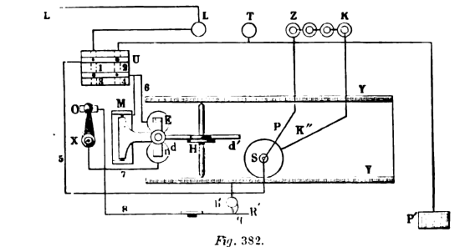

pole to K" k S (when the rider collies in contact with pin /) Q f b' R', magnet h; and line L t.. the distant instrument and to the ground. This current, however, is too weak to release the armature of the receiving instrument, as it has to pass through the coils of both magnets and the shunts. At the sending instrument, where at this time it has a direct course, it releases the armature, but as soon as the armature comes in contact with the contact screw of lever (1 d', the cam q having left its contact with R', the circuit is made through d d and n, cutting out the magnet of the sending station; the current by this route has sufficient power to release the armature of the receiving instrument, and thus to set the printing mechanism in action.

HUGHES'S TELEGRAPH. 635
In the operation of the Hughes system it is necessary that the
poles of the battery should be in opposition to the poles of the natural magnets. Where this cannot be so arranged in a permanent manner, a commutator or pole changer is provided, as shown in hg. 382. The wire L is fastened in the binding screw L the ground wire in T; Z and K are the poles of the battery. The binding screws L and T are connected with both lower metallic bars-of the commutator U; one of the two upper metallic bars connects through the wire 5 to the lower axis P of the sledge, the other through wire 6 to one of the ends of the coil E of the electro-magnet and also to the metallic axis of the armature n. The other end of the wire of the coil is connected through 7 with a switch X, whose contact stud 0, through wire ^{8,} Is in connection with spring R', against which the cam q of the printing axis lies in a position of rest. The zinc pole Z of the battery is connected with the lower axis P of the sledge and ªlso with wire 5. The copper pole is connected to the axis K" of the twenty-eight keys.
At the sending station, when both the holes 2 and 3 of the commutator are stopped, the zinc pole of the battery is to the ground, and the instrument is ready for the transmission of a message. If a key is now depressed a + current will flow from
K to the axis K" and to the protruding key pin, to the rider S of the sledge, thence to its upper axis Q (tig. 3S1), which is connected to the metallic parts of the work Y Y, and also to the printing axis U. From b' the current proceeds to cam q, which is against spring R'; from R' over 8 O and the switch X, over 7to the coil of electro-magnet E, thence over 6 to the lower horizontal bar at U, and thence by the plug in hole 3 to the binding screw L, from whence it flows to the line and the distant station. As this current passes through the electro-magnet the armature is released, the printing axis revolves, and the current takes another course, a circuit being established between n and d d’
Its route is now from the metallic parts Y Y of the works,
the axis H of the lever d d', over n to the axis bed M, and through U and 3 as formerly, but the coils are cut out, and the

636 THE TYPE•PRINTING TELEGRAPH.

current flows with full power to the line. At the receiving station the arrangements are the same, except that the commutator plugs are in holes 1 and 4. The arriving current takes its way over L U 1 5 S P to the metallic parts of the machinery, and further through b'qR' 8 0 X 7 E 6 U 4 and T to earth at P'.
It will now be easily comprehended that a current which is transmitted during the revolution of the printing axis, can have no influence on the impression, and thus a regular interval of time must ensue between the depression of one key and that of another. While in action the printing axis revolves seven times during one revolution of the type wheel and sledge; hence the type wheel and sledge have made only one-seventh of a revolution, passing over but four key pins, when the revolution of the printing axis is completed.
It follows from this that the operator, in depressing keys successively, must always allow a space of four keys between a depressed key and the key to follow. For example, the letter A is sent, and it is desired to send either of the letters B C D or E. in immediate succession; it would not be possible to do so in the same revolution of the sledge, for the printing axis would not have completed its revolution after printing A in time for any letter between A and F. Each letter within the range of four following the last letter transmitted requires a full revolution of the sledge. Thus it will be seen that the time required to transmit a word is not wholly governed by the number of letters it contains, but to a greater extent by the peculiar position of the letters as they follow each other down the alphabet from A to Z. For instance, the word " Hotel " would require two revolutions, thus:
First revolution .blank ……….. H 0 T
Second “ ……………………………………E L
Paris would require three revolutions:
First blank ...… P
Second…………………………………A R
Third ………………………………. I S

HUGHES'S TELEGRAPH. 687

Berlin requires five revolutions, and the word Telegraph six, viz:
First blank T
Second……………………………………. E L
Third E
Fourth…………………………… G R
Fifth……………………………….A P
Sixth ……………………………………. H
A skilful operator will send one or more letters during every revolution of the sledge. Should this not be done, not only would loss of time ensue, but the synchronism of the instrument would be imperiled, as it is never absolutely correct The perfection is given by the correcting wheel, which can act only at the sending of a letter.
In ordinary practice the number of revolutions of the sledge and type wheel range from 110 to 120 per minute. Occasionally ^{it is} run at a greater speed. In this respect much depends upon the length of line operated, and the degree of insulation, and also to the skill of the operator. For land lines of 250 to NO miles in length the speed is usually maintained at about 120 ^{r}evolutions. At this rate the number of words transmitted per minute will average 81. A greater speed would allow of a greater number of words, and vice versa.
Experience has shown that while a speed of 120 revolutions Per minute can advantageously be maintained upon lines of 250 or 30O miles, yet upon circuits of much greater length, say from ⁴⁰⁰ to 500 miles, the number of revolutions should not exceed 100, and upon submarine lines of very great length not more than from 18 to 20. In the latter case a slight alteration is necessary in the construction of those parts which couple the
Printin_{g} axis with the wheel work, as a speed from 40 to 50 revolutions per minute is required in order to procure the proper action of the printing axis under the present arrangement. Although by the Hughes system it is possible to operate direct over circuits of considerable length, the range can be greatly increased by the use of automatic repeaters. In one

638 THE TYPE-PRINTING TELEGRAPH.
way this can be accomplished by the use of two polarized relays, but this has the disadvantage of leaving no record of the work done by the relay at the office in which it is placed.
Another way, which allows the message to be recorded at the repeating station at the same time it is repeated to a point beyond, consists in allowing the apparatus used as a repeater to send an auxiliary current after the arriving current, by which the latter becomes strengthened and better enabled to perform its work at the distant apparatus. This contrivance is similar to that of the repeating relay, and is arranged in the following manner:
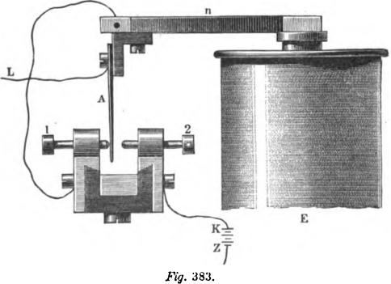
Upon the armature n (fig. 383) an insulated spring A is fixed, which is connected to the line. This spring oscillates between the contact screws 1 and 2, the former being connected to the armature n. 2 is connected with battery pole K. When the armature is drawn to the poles of the magnet the spring A rests against screw 1, and when the armature is released the spring comes in contact with screw 2, so that while the armature is in a position of rest the arriving current passes through the spring A to the screw 1, and thence through the electro-magnet E (fig. 384) and the sledge axis Q into the line. When the

HUGHES'S TELEGRAPH. 639
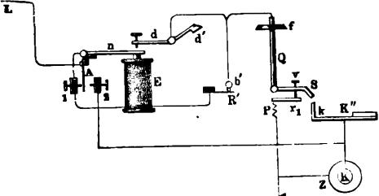
armature is released and the spring A comes in contact with screw 2, another and more powerful current, as shown in the following drawings, passes from the battery at the repeating station through screw 2 and the spring A to the line and distant station.
In applying this auxiliary current, the battery poles are not changed, and merely by moving an " alteration" screw it is possible to change from one system to the other, whilst in applying the repeater in the usual form, the arrangement of the poles would be different.
It will readily be seen that by the arrangement a real translation by means of two apparatus can easily be effected. Two
T
Fig. 334.
binding screws only are required to be fixed on the instrument table with which to connect the ends of the coil to the resting contact points of the springs A of each apparatus. In repeating, the new current should not pass through the receiving magnet, therefore the contact point should not be connected to the coil of its own apparatus.
For an easy comparison with what follows we have in fig. 385 again illustrated the connections of the apparatus at a terminal station (fig. 381), though somewhat differently arranged. In this and also in fig. 386 similar parts of the apparatus are represented by similar characters. Fig. 387 represents the connections at an intermediate station, with the repeating arrangement for
sending an auxiliary current.

640 THE TYPE-PRINTING TELEGRAPH.
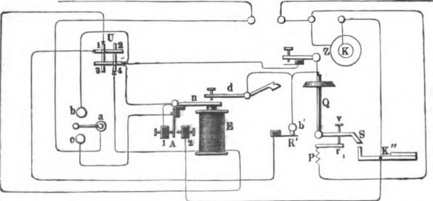
Fig. 386 illustrates the complete circuit arrangement of an intermediate station adapted to the system of current strengthening, which is in operation when the switch a of the inserter is
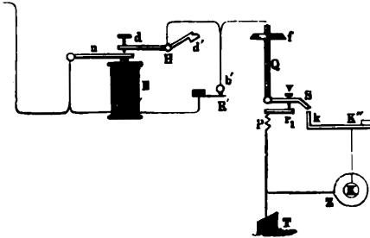
.R9. 385.
placed on b, while, if placed on c, the apparatus would operate in its usual manner. When the wire is in good condition the terminal stations can work together without auxiliary aid, but when in consequence of leakage or other trouble the main cur-
FYg. 386.
rent becomes feeble, the intermediate station can act as a repeater in delivering the auxiliary current.
Fig. 387 shows the connections in an intermediate station

HUGHES S TELEGRAPH. 641

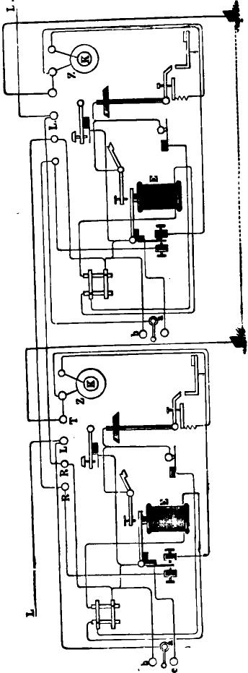 | 00  00

642 THE TYPE-PRINTING TELEGRAPH
which is provided with two instruments. This arrangement. allows the intermediate station to hold communication with both terminal stations at the same time, as well as to throw a strengthening current upon the line.
THE AMERICAN COMBINATION PRINTING TELEGRAPH.
After the patents of Mr. Hughes were purchased by the American Telegraph Company in 1856, the apparatus underwent a number of successive modifications by Mr. Phelps, with a view of adapting it more perfectly to the requirements of the American telegraphic service. The changes thus introduced were of such a radical nature that they eventually resulted in the development of a virtually new invention, having but few features in common with the original Hughes apparatus. These improvements were substantially completed in 1859, and the instruments were at once extensively introduced into service on the more important circuits between Boston, Albany, New York, Philadelphia and Washington.
Most of the instruments then placed upon the lines have been in constant use up to the present year (1876), without requiring any considerable repairs.
The combination instrument, as it is familiarly termed by the employ6s, for the reason that it combines certain features of each of its predecessors, the house and the Hughes apparatus, is represented in perspective in fig. 388. The only element of the Hughes apparatus which is preserved in this is the principle of printing from a continuously revolving type-wheel, which moves synchronously with the transmitting mechanism at the sending station.
Each of the twenty-eight keys has attached to it a metallic lever extending hack underneath the horizontal transmitting cylinder directly in the rear of the key-board. These levers are flexible to a certain extent in a lateral direction, but are rigid vertically, and the upper surface at the end of each lever is formed into an angular stud. The transmitting cylinder is kept

THE AMERICAN COMBINATION TELEGRAPH. 643
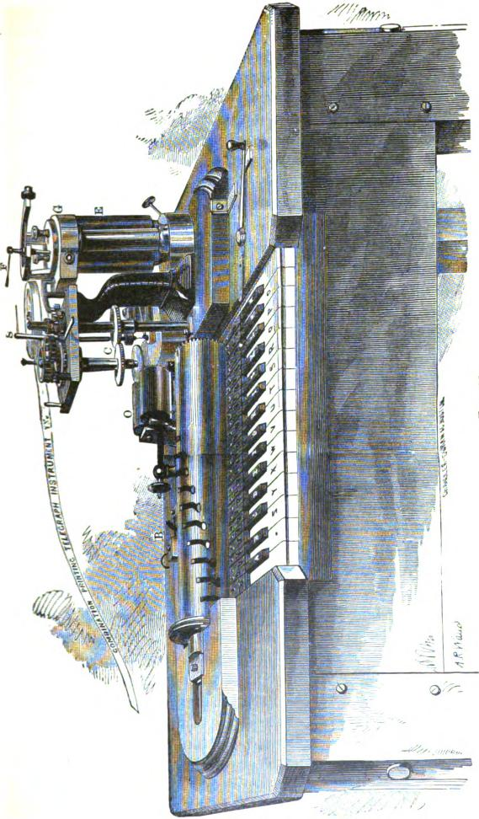

644 THE TYPE-PRINTING TELEGRAPH.

in rapid revolution by means of the friction pulley and band seen at its left end, which is driven by a fly-wheel and crank or treadle, or by steam power. A series of curved slots are spirally ranged around the cylinder in succession, there being one slot for each key, and these slots being placed at a distance apart of one twenty-eighth part of the circumference of the cylinder. Directly back of the transmitting cylinder is the circuit-closer B, which is connected with all the key-levers by a mechanical device which operates as follows: If any particular key is depressed, the corresponding lever is pressed upwards against the revolving cylinder, and when the corresponding slot comes round to it, the stud on the end of the lever enters the slot, and is forced sidewise by the curved form of the latter, this movement being permitted by the flexibility of the levers. This lateral movement on the part of any one of the key-levers acts upon a slide-bar connected with the whole series, and closes the circuit at B by pressing two platinum contact points together. The circuit remains closed while the straight portion of the slot is passim!: the stud of the key-lever. The effect produced is therefore precisely the same as in the case of the revolving sledge and chariot of the Hughes apparatus, but the mechanism is considerably less complicated.
The right hand end of the transmitting cylinder is connected by a bevel-gear to au upright shaft, which is in turn geared to the type-wheel shaft at C. The electro-magnetic governor is geared to the same shaft, and is controlled by a local battery acting upon the electro-magnet O. This governor consists of a heavy iron cylinder, which is caused to revolve rapidly by means of a geared connection with the transmitting cylinder as before stated. A segment of the iron cylinder is cut out, and mounted upon a strong spring. When in rapid revolution this segment is thrown outward by the centrifugal force, which overcomes the spring, and acting upon a series of compound levers, raises a vertical pin within the hollow axis of the governor, and presses it against the lower end of the upright spindle S. This contact closes tile circuit of the electro-magnet 0, which instantly

THE AMERICAN COMBINATION TELEGRAPH. 645
attracts its armature, and in so doing presses a friction brake against the revolving cylinder, reducing its speed. But on the other hand the slightest diminution of the speed breaks the local circuit again, releasing the brake, and thus a uniform motion is obtained which may be regulated within any required limits by raising and lowering the adjustable spindle S, for which purpose the latter is fitted with a screw movement.
The receiving apparatus is controlled by the electro-magnet E, which was formerly placed directly in the main circuit, but is now more commonly operated by a local circuit and ordinary Morse relay. The armature of this magnet is connected with a cylindrical slide-valve within the chamber G, hung upon
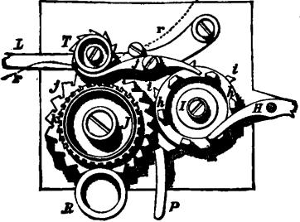
Rg. 389.
steel wire spring, adjustable by the screw F. This valve is
exactly similar in principle to that of the House apparatus, and

by means of compressed air acting upon a pistols, controls the
escapement lever. The manner in which the printing is effected be understood by reference to fig. 389, which is a plan view of the printing mechanism.
The printing-wheel I is carried by a friction connection upon the upright main shaft of the instrument, which receives its motion from the transmitting cylinder. Upon its upper surface, near its periphery, are fixed six equidistant angular pins h h. A decent on the end of the escape-lever H takes hold of one of these

646 THE TYPE-PRINTING TELEGRAPH.

pins, whenever the circuit of the electro-magnet E is broken, but instantly releases it when the circuit is closed. Therefore the effect of each electrical pulsation sent through the electromagnet of the receiving instrument by the transmitting apparatus at the other station, is to release one of the pins h h, allowing the printing-wheel Ito perform one-sixth of a revolution, when it is again arrested by the detent of the escapement lever catching the next pin. Meanwhile the type-wheel J is constantly revolving, being carried by friction from a second axis, which is geared to the upright main shaft, as shown at C, in fig. 388. Thus it will be understood that when revolving freely, the printing-wheel I and type-wheel J of the receiving instrument, and the transmitting cylinder of the sending instrument perform the same number of revolutions in the same time, or, in other words, move synchronously. The type-wheel .T has twenty-eight characters upon its circumference, and underneath these are two circles of teeth j and k, these teeth being equal in number to the characters upon the type-wheel. The operation of printing a letter is as follows : When the printing-wheel I is released by the action of the electro-magnet, it performs one-sixth of a revolution, as before explained. Two distinct operations are effected by this movement of the printing-wheel; fig A, one of the six angular teeth i i upon its periphery enters between two of the teeth j upon the type-wheel. and effects any necessary correction of the error in its position arising from slight inaccuracies in the action of the governor, by moving it a little forward or backward upon its axis; second, one of the angular pins le forces back the tail of the lever j, and thus brings the paper strip r, which is carried by the cylindrical platen T into contact with the type which is at that instant passing upon the ty14.,wheel. A circle of t^{e}eth upon the platen below tile paper interlock with the corresponding teeth k upon the type-wheel, and thus the two revolve together as long as the contact lasts between the paper and the type. By this means the feeding of the paper is in reality accomplished while the impression is taking place. This method of effecting the impression is far superior to that employed upon the Hughes instru-

PHELPS'S ELECTRO-MOTOR TELEGRAPH. 647
ment, as the letters are never blurred or rendered imperfect in consequence of a want of exact correspondence between the movements of the type wheel and the platen while the impression is being taken. The type are inked by a felt roller R, which revolves in contact with them. The unison stop-lever p is employed by the receiving operator to arrest the type-wheel at the zero or dash, when starting. It is thrown off, and the, type-wheel released at the first movement of the printing-wheel, by one of the pins h h striking against a projection on the upper surface of the lever. The lever L supports the platen and its appurtenances, and is pushed back so as to throw the impression lever out of gear with the printing wheel, when sending.
The mechanism of this instrument is not at all complicated, and it has proved itself remarkably well adapted to long and hard service. The manipulation of the key-board is essentially the same as that of the Hughes instrument, but owing to the greater speed at which the type-wheel may be made to revolve without injury to the mechanism, its working capacity is much greater. The Hughes instrument is seldom if ever run at a speed of over 130 revolutions of the type wheel per minute, while the combination instrument has been operated for a num^{be}r of years on the Western Union lines at the rate of 190 revolutions Per minute, the transmitting capacity being of course augmented in the same proportion. In order to give an idea of the ^{e}fficiency of the combination instrument, it may be mentioned that on one occasion 670 ordinary commercial messages of average length, printed in full, were transmitted from New York to Philadelphia between 9 o'clock A. N. and 5.30 P. M., and even with this vast amount of work the capacity of the instrument was
not fully tested, as the circuit was unoccupied for a portion
of the time.
PHELPS'S ELECTRO-MOTOR PRINTING TELEGRAPH.
In the summer of the year 1875, a new type-printing instrument was introduced upon the lines of the Western Union Telegraph Company between New York and Washington. This

648 THE TYPE-PRINTING TELEGRAPH.

instrument, like the combination, was the invention of Mr. Phelps, and was the successful consummation of nearly ten years of thought and experiment, in which the inventor was materially aided by the cordial co-operation of the President and Electrician of the Western Union Telegraph Company. The practical results of a year's continuous operation in actual service on the most important telegraphic route in the United States, have shown beyond a doubt that this invention is far in advance of any of its predecessors, in respect to speed of transmission. ability to work over long lines, and freedom from derangement, to say nothing of its superior convenience and economy.
The type-wheel and printing mechanism of Mr. Phelps's instrument is operated by a rotary electro-magnetic engine, or electro-motor, which is set in action by a local battery. This improvement at once does away with a number of the principal obstacles which have prevented the more general use of type-printing instruments. Thus in the Hughes instrument, which, as we have seen, is driven by a heavy weight acting upon a train of wheel-work, the moving parts of the apparatus must necessarily be made very light, and this in turn gives rise to frequent breakages and derangements, while, on the other hand in the combination instrument, in which the working parts are very strong and durable, the power required to propel the machinery is considerable, and if the work is at all continuous, renders it necessary to make use of a steam-engine or other power, which is in most cases exceedingly inconvenient.
The Phelps, apparatus as now constructed consists of the following principal parts :
- The transmitting apparatus, consisting of the key-board and circuit closing devices.
- The receiving or printing mechanism.
- The automatic unison mechanism.
- The electromotor and speed governor.
The principle upon which this instrument acts may perhaps be best described as a combination of the synchronous and step-by-step movements. Like the Hughes apparatus, the transmit-

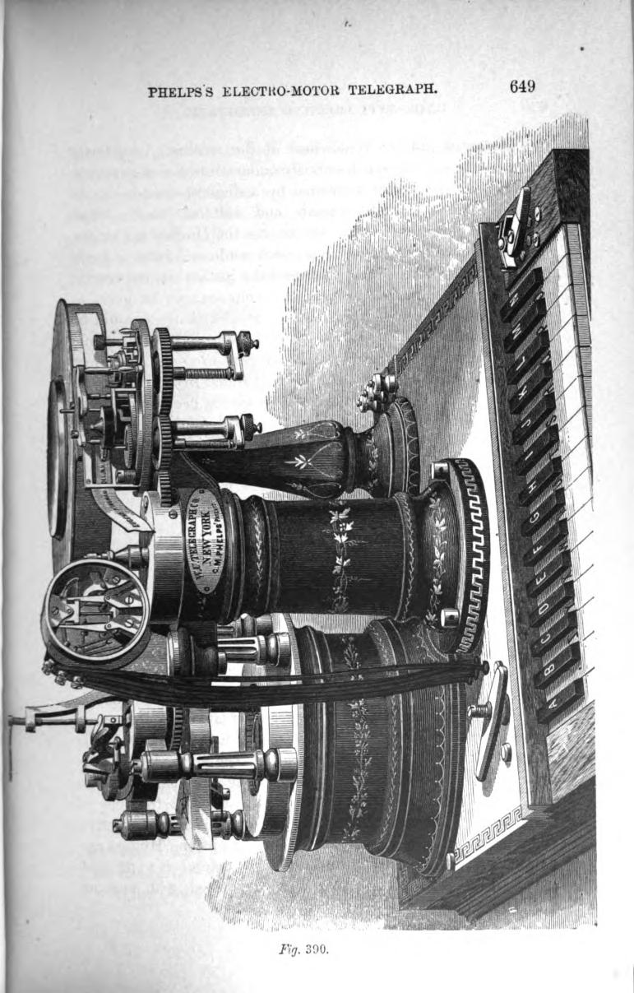
PHELPS S ELEGTRO-MOTOR TELEGRAPH. 649

650 THE TYPE-PRINTING TELEGRAPH.

ting apparatus and the type-wheel of the receiving instrument are caused to revolve synchronously under control of a governor, and each separate letter is printed by a single pulsation of the electric current of a determinate and uniform length, transmitted at a determinate time, but unlike the Hughes apparatus, the motion of the type-wheel is arrested while each letter is being printed, and is automatically released the instant the impression has been effected. Thus a speed of revolution may be given to the type-wheel in this instrument far greater than it would be possible to attain by means of a step-by-step movement, while at the same time letters which happen to come in direct sequence upon the key-board may be printed from during the same revolution. Owing to these features, it has been found possible for a skillful manipulator to attain a speed of transmission upon this instrument exceeding anything which has hitherto been regarded as possible. The various parts of the apparatus are mounted upon a heavy iron bed-plate, which is secured to a hard wood base about 18 inches by 23, as shown in fig. 390, which is a perspective view of the instrument. The key-board is seen in front, and consists of twenty-eight keys, marked with the different letters of the English alphabet, together with a period and space, or as it is technically termed, a "dash'' key. The right-hand white key is a blank key, and is not used. In the middle of the instrument, directly in the rear of the key-board, rises a hollow cylindrical column A, within which is a circular range of twenty-eight vertical slide-rots, one of which corresponds to each key of the key-board. The column A also contains the mechanism by which the circuit-closer is actuated. A transverse vertical section of the column A is shown in fig. 39L which is exactly half the actual size of the parts. The vertical slide rods are arranged as shown at a a, passing through guide apertures in the plate A, and a similar corresponding plate at the foot of the column. The connection or the keys with their respective slide-rods is effected in the same manner as in the Hughes apparatus, and will be readily understood by reference to fig. 364 (pave 613). The slide-rods a a are provided with angular

PHELPS'S ELECTRO-MOTOR TELEGRAPH. 651
heads a_{s} a₁, which project towards the centre of the hollow column; their inner ends rest in slots formed in a guide ring a_{s}, which projects from the upper surface of the plate A_{l}. The inner ends of the heads a_{l} a₁ form a compact circle about an inch and a half in diameter, as best seen by reference to fig. 892, which is a horizontal section of the column A taken through the hollow spur wheel E, some of the parts beneath being broken
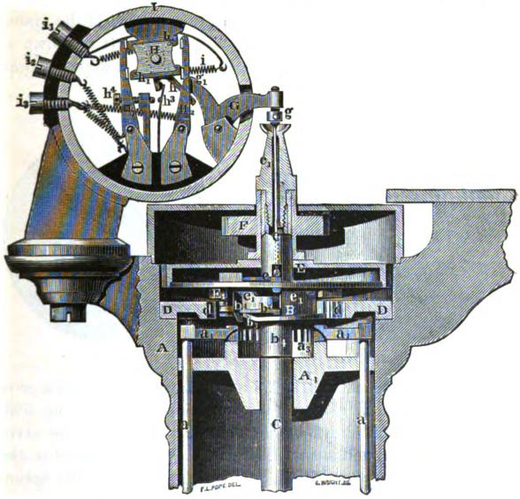
lig. 391.
away in order to exhibit their relative arrangement more clearly. There are of course 28 of these slide-rods, and when any key is depressed, the corresponding slide-rod and its angular head is elevated. The manner in which the pulsations of the current are transmitted upon the depression of the keys is as follows :
In the centre of the hollow column A is a vertical shaft C.

652 THE TYPE PRINTING TELEGRAPH.
which is caused to revolve continuously at the rate of 240 revolutions per minute, by means of a hollow spur wheel E, which receives its motion from the electro-motor by means of gearing, as will be hereafter explained. The speed with which this shaft revolves is controlled by a governor attached to the motor, and is almost absolutely uniform. Upon the shaft C is a hollow flanged collar B; this is not fixed rigidly to the shaft, but is loose upon it As the collar and its attachments perform a very important function in the operation of the trans• mitting apparatus, it will be described in detail. It is shown in side elevation in fig. 391; in inverted plan, or as it would appear

Fig. 392. Fly. 398.
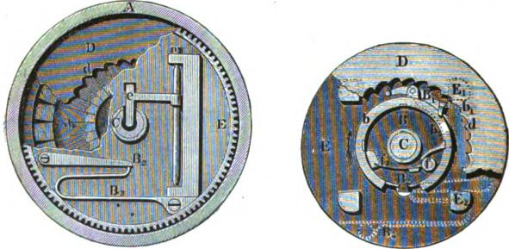
viewed from beneath, in fig. 393; in transverse vertical section in fig. 394; and in plan or top view separately in fig. 395. When none of the keys are depressed, the collar B revolves with the shaft C and wheel E, being coupled to them by the catch B₂ (figs. 393 and 394), which is pressed by the spring B₃ (fig. 392), into one of four shallow vertical grooves cut in the outer periphery of the collar B. A dog B₁ is pivoted to the flange of the collar, and carries a sharp projection b₁, which revolves almost in contact with a circle of 28 ratchet shaped teeth d, formed on the inner edge of a stationary annular plate D (see figs. 391 and 393). The tail b, of the dog B₁ extends through an opening into the interior of the drum, where

PHELPS’S ELECTRO-MOTOR TELEGRAPH. 653
it rests against a roller f mounted upon a spring f_{l} (figs. 393 and 395). The bottom of the collar B is formed into a flange or rim b, as seen in fig. 393 (in which, however, a small portion of the flange is represented as being broken away in order to show the position of the catch B₂). The under surface of this flange is not exactly at right angles to the axis of the collar, but consists of two inclines, as best seen in figs. 391 and 393, where b₃ represents one incline, which is short and sudden, while the other one is very gradual and in the reverse direction, extending entirely around the remaining portion of the circle. The flange revolves with the collar of which it forms a part, in the direction indicated by the arrow in fig. 393, being immediately above the inner ends of the angular heads of the slide rods a a. Upon the
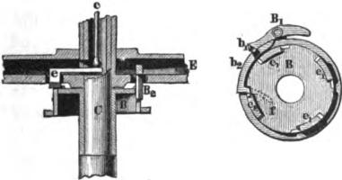
Fig. 394. Fig. 395.
top of the he collar are four projections with beveled corners, e_{l} e_{l} el, e_{l} (figs. 391 and 395), each of which occupies one-eighth of its circumference. A horizontal pusher e mounted upon an .arbor within the hollow wheel E, and which is shown in figs. 391, 392 and 394, carries a short beveled arm which extends downward and alongside of one of the projections e_{l}. The foot of a slender vertical rod c rests upon this lever, and extends upward through the hollow part c, of the shaft C, to the screw g. This rod c, when pushed upward, serves to actuate the circuit-closer, as will be hereafter explained.
With the aid of the above description of the transmitting mechanism, it will now be possible to understand what takes place when one of the keys, for instance the dash, is depressed,

654 THE TYPE-PRINTING TELEGRAPH.

the corresponding slide a is raised, and its angularly shaped head a, is pressed against the under surface of the flange b upon the collar B, which, together with the shaft C, is revolving at the rate of four revolutions per second in the direction indicated by the arrow in fig. 393. At the instant the incline b₃ passes over the elevated slide head, the sharp head b₁ of the dog B₁ is struck by it, and in consequence of its peculiar inclined form the dog is forced outward, and into contact with the opposite ratchet tooth d in the plate D, by which the rotation of the collar is instantly arrested at that point, although the shaft C and wheel E continue to revolve as before. This is permitted by the catch B₂, for the reason that the catch overcomes the pressure of the spring B, and slips out of its groove in the periphery of the collar. On the under side of the wheel E are four wedge-shaped cams E₁ E₂, etc. (figs. 391 and 393), and after the shaft C and wheel E have moved through one fourth of a revolution (the collar remaining stationary), the next succeeding cam strikes the head b₁ of the dog B₁ and forces it back into its original position, freeing it from the stationary ratchet tooth in the plate D, while at the same instant the catch B₂ drops into the next succeeding groove in the collar B, which then revolves as before with the shaft C until it is arrested by the depression of another. key.
The revolution of the wheel E and its attachments, while the-collar remains stationary, causes the pusher e to be pressed upwards by the passing beneath it of one of the beveled projections e₁ on the top of the collar, and thus the rod c is pushed upwards.
When therefore a key is depressed, no action takes place-until the head of the dog B₁ in its revolution arrives at the corresponding slide rod bead, when the revolution of the collar B is instantly arrested during the time in which the shaft C is making one-fourth of a revolution, at the end of which time it is again released by the automatic action of the mechanism as above explained, and permitted to revolve with the shaft as before. While the collar B is thus arrested, the beveled end

PHELPS'S ELECTRO-MOTOR TELEGRAPH. 655
of the pusher e passes over the projection e_{l}, raises the rod c within the hollow shaft, and operates the circuit-closer. As the shaft C makes four revolutions per second, it follows that the motion of the collar B is arrested for precisely -hr of a second by the depression of each key; and as the length of the projections e_{l} which determine the length of time during which the rod c is e:evated and the circuit closed, is one-eighth of the circumference of the collar, the duration of the electrical pulsation produced by the elevation of the rod c will lie A- of a second of time.
The circuit closing mechanism, as arranged by Mr. Phelps in his latest instruments, admits of either the single-current or the double-current system of transmission being employed, by merely changing the connections. This portion of the apparatus is enclosed in a cylindrical case I, fitted with plate glass heads. The arrangement of the parts is clearly shown in the sectional view, fig. 391. H is a quadrangular plate of ivory mounted upon a horizontal rock-shaft, upon which is also rigidly fixed an arm h projecting downwards. Upon the upper and lower edges of the insulating plate H are fixed metallic bars h_{i} h₂. A spiral spring attached to the insulated screw i₁ takes hold of a short arm projecting upward from the axis of II (the arm is not visible in the figure, being behind H). The tension of this spring keeps the arm h pressed against the friction roller 9_{t} upon the lever G, and the latter in turn presses downward by means of the adjustable screw g upon the vertical rod c. The spring also serves to conduct the electric current from the screw i„ which is ^{c}onnected with the negative or zinc pole of the main battery, to the bar h_{e}. A second screw directly behind i, and insulated froth it, is attached to the copper pole of the battery and is also eO¹¹nected by means of a curved wire and spring i to the metallic bar h_{i}. Thus in effect h_{i} is the positive and h, the negative
Pole of the main battery. II, and 11₂ are two upright contact levers which are connected respectively to the line wire and to the earth. The line wire is attached to the screw i_{s} whence the connection is completed with the contact lever II_{i} by means of a spiral spring which also serves to keep the latter pressed con-

656 THE TYPE-PRINTING TELEGRAPH.

stantly against the bar h₂. Behind i_{s} is another similar screw, to which the earth wire is attached, and connected by a spiral spring with H₂. Thus, when the apparatus is arranged for working by the double-current system, a negative current flows to line at all times when none of the keys are depressed, by way of i_{t} h₂ H₁ and i_{s}. When, however, the rod c is raised by the action of the transmitting mechanism, the polarity of the current upon the line is reversed, for by the action of the lever G and roller _{g1} upon the arm h, the position of the plate H is shifted so as to bring the negative pole of the battery, represent. ed by h ₂, into connection with the earth at H₉, while the positive pole of the battery h_{i}, is at the same instant put into connection with the line at H_{p} If it is desired to work by means of the single-current system, that is, by simply making and breaking the circuit from one pole of the battery, as in the American Morse system, the battery wire is attached to the screw /², which connects by a spiral wire with the post which supports the adjustable contact screw 11,, while the line wire is connected with the contact spring 11₃. As will readily be seen by reference to the figure, the depression of the arm h by the lever G will permit the spring 1), to come in contact with the screw 11₄. Thus it will he understood that the raising of the rod c will cause the line current either to be reversed or to be closed for 2¹8 of a second, each time a key is depressed, according as the apparatus is connected for double or for single currents.
The pulsations thus transmitted are conducted through a relay connected with the sending as well as with the receiving instrument. With the double-current system a polarized relay is used (page 509), while for single currents an ordinary relay such as that described on page 439 serves an excellent purpose. The action of either relay upon the receiving portion of the apparatus is the same, inasmuch as its office is merely to close a local circuit iii which is included the electro-magnet for controlling the action of the printing mechanism.
The printing mechanism is represented in the plan view, fig. 396, while the outline drawing, fig. 397 (which is of full size),

PHELPS'S ELECTRO-MOTOR TELEGRAPH. 657
shows more clearly the arrangement and mutual action of the different parts. These are compactly arranged upon a horizontal circular plate, which is supported by a bracket upon the hollow column A, at the right of the transmitting machinery. The type-wheel T is rigidly fixed upon the same axis with, and directly above a wheel T₁ of the same diameter, which is provided with twenty-eight sharp ratchet-shaped teeth, as shown in the figure. The wheels T and T₁ are upon a sleeve, and are attached by means of a friction plate to the axis of a toothed wheel T_{s} (shown in dotted lines in fig. 397, and also in the per-
Fig. 396.

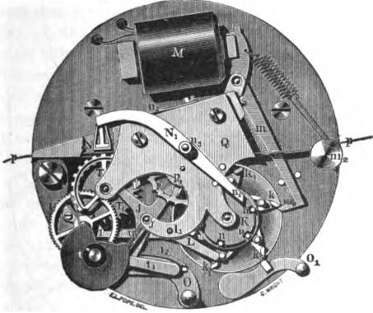
_{f.}
112
perspective view, fig. 390), which receives its motion from the wheel
upon the shaft C, through the intervention of an idle wheel
^{F}1.
As the wheels F and T₂ have each the same number of teeth, they must necessarily revolve synchronously. The type wheel T is inked by means of the ink-roller t (fig. 396) which is mounted upon a horizontal swinging arm t₁, and is constantly pressed against the type-wheel as it revolves, by the action of a spring t₂. In fig. 396 the contiguous portions of the type-wheel T and the ink-roller t are represented as being broken away in order to exhibit some of the parts lying beneath.

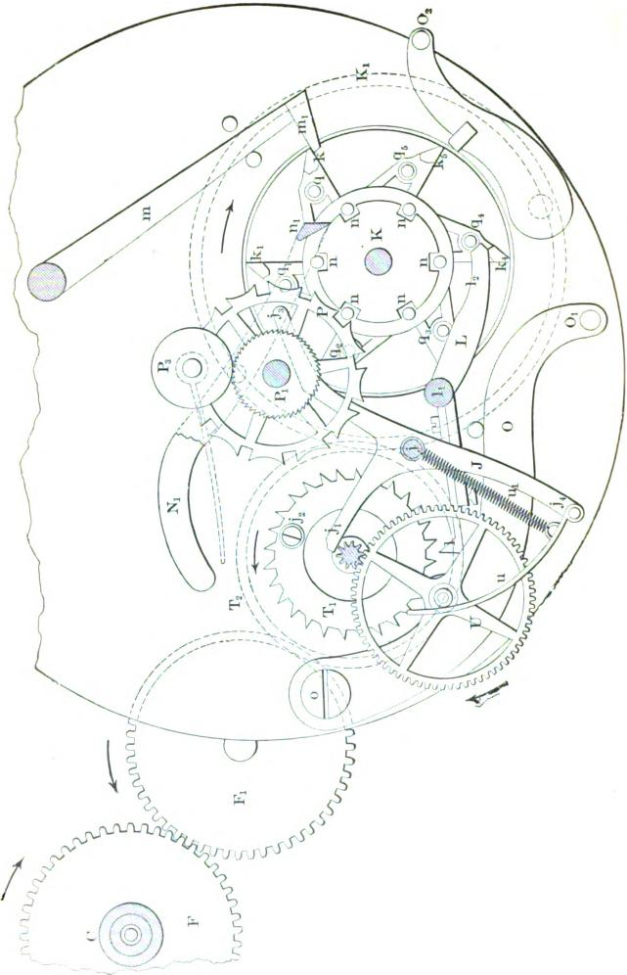

PHELPSS ELECTRO-MOTOR TELEGRAPH. 659

The star-shaped printing wheel K is perhaps the most important part of the entire printing mechanism. Under control of the electromagnet M, it performs the fourfold office of arresting the type-wheel at the proper point when a letter is to be• printed; of forcing the platen and the paper into contact with the type thus presented, and instantly withdrawing it; of moving the paper forward the proper distance after the letter has been thus printed, and finally of releasing the type-wheel after the printing has been effected. The printing-wheel is carried by friction upon the vertical axis of a toothed wheel K which receives its motion directly from the wheel T₂ upon the type-wheel axis, as shown in figures 390 and 397. There are 58 teeth in the wheel T₂ and 98 in the wheel K_{i}, consequently the former makes a little more than one and one half revolutions to each one of the latter.
The electro-magnet M is actuated by a local battery connected with the receiving relay as before explained. To its armature is fixed the lever m, the latter being armed with a detent which takes hold of one of the points k of the printing-wheel, whenever no current is passing through the magnet. The detent m₁ is kept in position by the tension of a spiral spring attached to the adjusting spindle m₂. The printing-wheel K, being connected with the wheel K₁ by a frictional coupling, would revolve with the latter in the direction of the arrow, were it not held in check by the decent m_{i}.
The printing-wheel K has six equidistant angular studs or pallets, k k k₂, etc., projecting from its circumference, which serve as stops upon which the detent m₁ successively acts. Two concentric rows of vertical pins are inserted in the upper surface of the printing-wheel; there are six of these pins in each row. The outer row of pins q q1 q2 73 q4 75 act upon a stop-lever which arrests the type-wheel, while the inner row n n n act upon the platen at the proper moment for giving the impression, and also upon the mechanism for moving the paper.
The operation of printing a letter is as follows: When the detent m₁ is momentarily lifted by the action of the electro

660 THE TYPE-PRINTING TELEGRAPH.
magnet M upon its armature, the pallet k is released and the printing-wheel K is carried forward one-sixth of an entire revolution by reason of its frictional connection with the wheel K₁ beneath it. This movement of the printing-wheel successively produces the following results : An angular projecting stud on the end of type-wheel stop-lever L is caused to pass between the pallet k₄ and the pin q₄. As this lever turns upon a fulcrum at 1₁ the detent 1 at its opposite extremity is instantly inserted between two teeth of the wheel T₁, and thus the revolution of the type-wheel T (which is carried by friction from wheel T₂) is suddenly arrested at that point. The details of this portion of the mechanism will be best understood by reference to fig. 398, which represents the parts enlarged to twice the actual
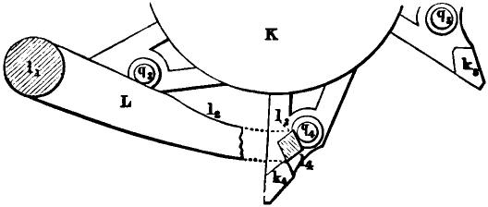
Fig. 398.
dimensions. When the pin q₄ moves in the direction of the arrow, it bears against the inclined surface 1, of the stop, and forces the lever L into a position by which the type-wheel is locked. The lever is retained in this position by the pin as it glides along the curved surface 1₂, thus holding the type-wheel in check until the inclined face of the succeeding pallet k₅, coming in contact with the correspondingly inclined surface /₄ upon the lever L, returns the latter to its normal position, in readiness for the next repetition of the movement. Thus upon the release of the printing-wheel K by the detent m_{i} the type-wheel is instantly arrested, held in cheek while the printing-wheel makes one-sixth of a revolution, and then released, the relative rate of

PHELPS'S ELECTRO-MOTOR TELEGRAPH. 661
motion of the type-wheel and printing-wheel, as determined by the gearing, being such that the type-wheel is arrested for a length of time equal to precisely one fourth that occupied in making a complete revolution, or, in other words, for _{i}t- of a second. Its movements are therefore synchronous with those of the collar B of the transmitting apparatus, both in respect to its periods of motion and of rest.
During the time in which the type-wheel is thus held in check by the stop-lever L, the following movements take place, viz: the inclined surface of the pallet n_{i} on the end of the lever N, (figs. 396 and 397), which lies in the path of one of the pins n n upon the wheel K, is struck by the pin, and thus the platen N, on the opposite end of the lever, is caused to press the paper strip p p momentarily against the opposite type upon the type-wheel, from which it is again withdrawn by the action of the spring n₂ as soon as the pin n is free from the pallet n₁. The device for moving the paper forward is next brought into action. This is a modification of the mechanical movement known as the Geneva stop, the convex tooth being omitted. One of the row of pins n, etc. (see fie. 397), enters into one of the twelve notches in the periphery of the wheel P and carries it forward one twelfth of a revolution. Upon the axis of the wheel P is a roller P, with a fine milled edge, against which presses a jockey roller P_{s} mounted upon a spring. The paper strip p p is fed from a continuous roll, and passes through suitable guides in the frame Q between the rollers P₁ and P₂, by the movement of which i it s carried forward the proper distance after the impression of each letter has been made.
It now remains to describe the automatic unison mechanism. which is one of the most interesting of the minor accessories of the Phelps apparatus. In all type-printing systems it is of course necessary that the transmitting mechanism of one instrument and the type-wheel of the other should be in exact correspondence, and to effect this some means must be employed to ensure their starting together. In the Hughes and combination instruments this is accomplished by a simple stop-lever, which

662 THE TYPE-PRINTING TELEGRAPH.

takes hold of a stud upon the type-wheel whenever it is thrown into the path of the latter by the receiving operator. The first movement of the printing mechanism releases the type-wheel, which starts from the dash or space. It is therefore only requisite that the transmitting operator should release the type-wheel by first touching the dash key, and the other letters of the alphabet will necessarily fall into their proper relation. In Mr. Phelps's instrument an improvement is added by which the type-wheel is automatically arrested at the dash or zero point, whenever it is permitted to make a few revolutions without printing. Upon the upper surface of the wheel T₁ (fig. 397), directly under the type-wheel, is a pin j₂, which is filed to a flat surface on the side towards which the wheel itself revolves, as indicated by the arrow. J is a three armed stop-lever, turning upon a fulcrum/. U is a toothed wheel mounted so as to revolve freely upon a pin fixed in, the horizontal lever 0, by moving which it may be thrown in or out of gear with a corresponding pinion on the type-wheel axis, at the pleasure of the operator. Ordinarily it is kept in gear with the pinion, and receives therefrom a slow rotary motion in the direction indicated by the arrow. A curved arm u, pivoted to the arm /₄ of the stop-lever J, is constantly pressed against the revolving axis of the wheel U by the tension of the spiral spring U₁. The friction between the axis of the wheel U and the curved arm u has the effect of slowly but continually swinging the stop-lever J around towards the left, whenever the type-wheel is in motion. If the printing-wheel K meantime continues stationary, in the course of four or five revolutions of the type-wheel the lever J will be swung round into such a position that a stop which projects downward from the end of the arm j₁ of the stop-lever will be thrown into the path of the stop j₂ upon the wheel T₁, which latter will come in contact with it in its next revolution; the type-wheel will thus be arrested with its dash or blank space opposite the platen, in which position it will remain until the printing mechanism is again operated. The instant, however, that the printing-wheel K is released by the action of

PHELPS'S ELECTRO-MOTOR TELEGRAPH. 663
the electro-magnet, the stop-lever J is thrown back into the position shown in fig. 397, because its third arm j_{s} now lies directly in the path of the pin 9,₂ upon the printing-wheel. So long as one or more letters are printed at every revolution of the type-wheel, a continual succession of pins will strike against the arm j₃ and prevent the stop-lever J from being swung around far enough to arrest the type-wheel, unless the operation of printing be suspended during several successive revolutions of the type-wheel axis, when the type-wheel will be automatically arrested, as before explained.
The electro-motor and its governor are mounted upon the base of the instrument at the left and to the rear of the hollow column A, which contains the transmitting mechanism. The motor consists of eight electro-magnets arranged in a circle, within which a revolving shaft carries a circular row of soft iron armatures, five in number. The commutator is so connected that the electro magnets act successively as the armatures come within their influence, and cease to act just as the latter arrive at a point opposite to the poles of the magnets. By this means a constant attraction is exerted upon the armatures, which causes the shaft to revolve with great rapidity. The motor is provided with a centrifugal governor, which acts to reduce the quantity of electricity flowing through the actuating magnets whenever the speed becomes too great, by which means its motion is rendered perfectly uniform.
Fig 899 is a horizontal transverse section of the motor, showing the arrangement of the electro-magnets and armatures, and construction of the commutator, and fig. 400 is a vertical transverse section of the same. The figures are half the actual size of the parts.
The electromagnets R R, etc., eight in number, are arranged in a circle within a cylindrical case R,. The magnets are of the ordinary form, having cores 0.5 inches diameter and 1.25 inches in length, wound with insulated copper wire 0.042 inches 41allieter. Five soft iron armatures, r r, etc are arranged at equal distances around the periphery of a hub r, of brass, upon

664 THE TYPE-PRINTING TELEGRAPH.
a vertical shaft Q, supported at its lower end in an adjustable step or bearing Q₁, and at its upper end in a top plate Q₂. The motor battery is connected by the screw al to the insulated lever S, which is mounted upon a spring s, and pressed down-
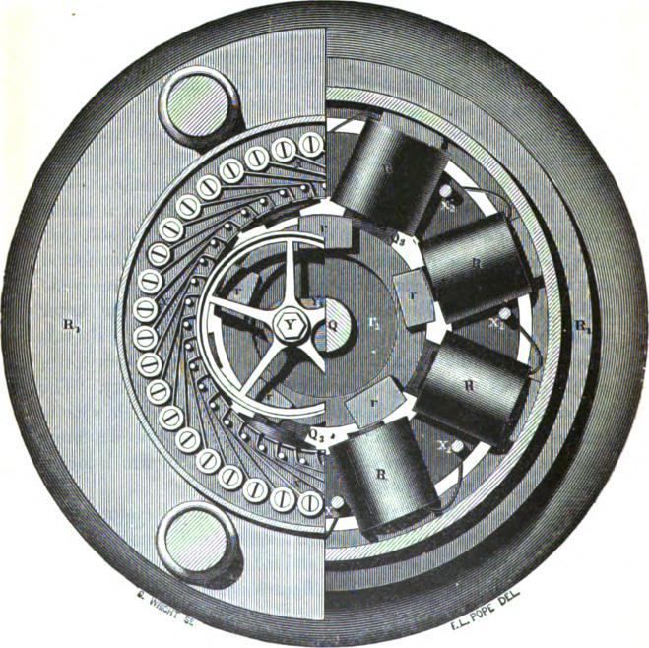
lIg. 399.
ward by the action of the screw S₁ acting upon a fiat spring 8,. The screw S₁ serves to regulate the speed of the machine in the manner about to be explained. W is a thick piece of metal

PHELPS'S ELECTRO-MOTOR TELEGRAPH. 665
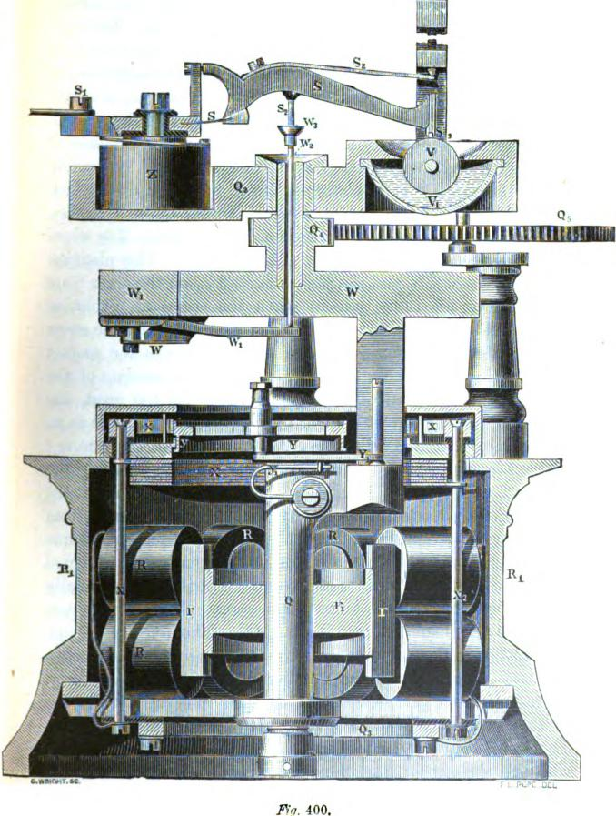
.no 400.
it megir k1'l Fir
mngm
.%
IIII
666 THE TYPE PRINTING TELEGRAPH.

mounted upon the main shaft Q of the motor, and serves as a counterbalance or fly-wheel. A section of this, W₁, is mounted upon a spring w, and has an arm w₁ attached to it. The rapid revolution of the shaft Q when the motor is in motion, tends to throw the section W, (which acts as a weight) outwards by centrifugal force. When this takes place the arm w₁ is raised, the pin _{u'2} (which passes through the upper part of the shaft Q, the latter being hollow,) is forced upwards, and by means of the cup w₃ and insulated pin 8₂ raises the lever S by bending the spring S₂. V is a platinum faced wheel or disc, which revolves slowly by means of a worm acting upon a toothed wheel fixed upon its axis, not shown in the figure. The wheel V revolves in a cup V, partially filled with oil. The platinum edge of the wheel V and the platinum stud 8₃ on the lever S are in contact at all times, except when the speed of revolution exceeds the rate to which the machine is adjusted by the screw S₁. The constant motion of the wheel V keeps the contact surfaces clean, and there is but little friction on account of the oil. When the speed of the machine becomes too great, the weight W, being thrown outward by the centrifugal force as its supporting spring w bends, raises the inner end of the arm w„, which lifts the lever S by means of the rod w₂, breaking the contact between s₃ and V, and by thus diminishing the battery force, at once lessens the speed of the motor. The current from the motor battery, passing through tile lever S, wheel V and frame of the machine to the commutator next described, is directed through the several electro-magnets in succession, and finally finds its way back to the battery 1.)v a common battery wire connected to the insulated metallic ring Q₃. The number of con- tact springs in the commutator is equal to the number of electromagnets multiplied by the number of armatures, viz., forty. Each separate electro-magnet is charged each time it is approached by either of the five armature3 during their revolution. This is effected by connecting each of the magnets R 13, etc., with one of eight flat metallic segments X (which are insulated from each other, and placed close together within the frame of

PHELPS'S ELECTRO-MOTOR TELEGRAPH. 667

the machine), by means of insulated rods x₂ to which the magnet wires are fastened. Five of the forty commutator springs xx x, etc., are connected to each of the conducting segments X X by means of studs x_{i} passing through the frank and insulated therefrom, each fifth spring being connected by means of its corresponding stud to the same conducting segment The frame or case R₁ of the motor has a circular opening in its top plate, within which opening the contact wheel Y runs. This wheel Y is mounted at the end of a link Y₁, which is hinged to a projection from the main shaft Q, and is constantly pressed against the inner edge of the opening in the frame by a spring y1. so that the frictional contact is always sufficient to turn the contact-wheel. The periphery of the latter is grooved, as shown at y, and runs upon the edge of the opening, as upon a railway track. The contact-wheel Y also runs in contact with the ends of the commutator springs x x, which yield sufficiently to bring each successive one into contact with the wheel before the preceding one is out of contact. The portion of the periphery of the wheel Y which runs in contact with the springs is of larger diameter than that which runs upon the frame, as will be seen by referring to the figure. The object of this arrangement is to cause the surface of the wheel Y to slide or rub upon the springs xx as it revolves, and thus keep the surfaces clean without unnecessary wear.
It will of course be understood that the wheel Y forms an electrical connection between the frame and the successive commutator springs as it revolves, and thus charges the electromagnets in rotation, each magnet being charged five times -during one revolution of the main shaft Q, by which means -each armature is attracted and released at the proper moment. In order to avoid the spark which would otherwise be produced at each breaking of the contact between the stud 8, and the platinum faced contact-wheel V, a permanent connection is made between the screw s_{i} and the frame of the machine by means of a resistance coil Z, which, when the contact between s₃ and V is interrupted, conveys a sufficient quantity of current

668 THE TYPE-PRINTING TELEGRAPH.
from the battery to the motor to cause the latter to revolve, but at a rate of speed considerably less than the normal rate to which the machine is adjusted. The effect of breaking and closing the contact between s_{s} and V is therefore merely to increase and diminish the total resistance of the circuit by an amount equal to the value of the resistance Z, and the extra or induced current, having a path through the coil Z, occasions but an inappreciable spark upon the contact-wheel V.
The revolution of the motor is communicated to the instrument by means of a pinion Q₄, which gears into a wheel Q₅ of.
LINE
MAIN BAT
about four times the number of teeth, and this in turn is geared directly to the hollow wheel E upon the shaft C of the transmitting machinery (figs. 391 and 392).

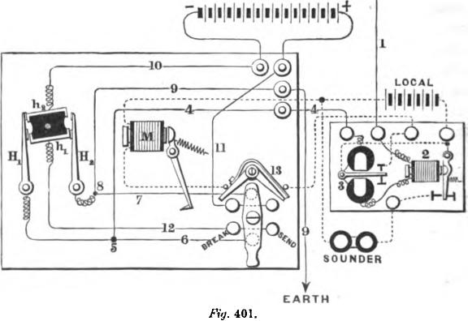
Fig. 401.
LOCAL
The arrangement of the main and local circuits in the Phelps instrument is shown in the diagram, fig. 401. The switch is placed at the right of the keyboard and is represented in position for receiving. The current enters at 1 and passes through the. relays 2 and 3, thence by wires 4, 5 and 6, through the switch,.

PHELPS'S ELECTRO-MOTOR TELEGRAPH. 669,

and thence by wires 7, 8 and 9 to the earth.. The relay 3 is a polarized relay of Siemens's or other suitable construction, and closes its local circuit under the influence of the positive pulsations sent to line by the transmitting instrument The auxiliary relay 2 has a non-polarized or neutral armature, and is very much less sensitive than the relay 3, so that it is not affected by the ordinary pulsations passing over the line. The object of this relay is to enable the receiver to break or stop the sender during the transmission of a despatch, or to answer a call signal, as will be hereafter explained. The relay 3 operates the printing magnet M by means of a local battery of six small cells. If the receiver wishes to stop the sender, lie turns his switch to the position marked " break," which throws his own main battery into the line circuit, by way of 5 H_{i} h₂ 10 11, switch lever, 12
H₂ and 8. The effect of this is to double the strength of the pulsations passing through the relay 2, and cause it to actuate a small sounder placed in a branch circuit from the common local battery. This effect takes place upon both the sending and receiving instruments, and the sending operator is thus notified of the interruption by the working of the sounder. The break 13 opens the local circuit of the printing magnet M, whenever the switch is turned to "break,⁻ and thus prevents the printing mechanism from operating and introducing superfluous characters into the printed record. When sending, the switch is turned to the point marked "send." the connections being precisely the same as when turned to " break," except that the local circuit of the printing magnet now remains intact, and the printing mechanism may be stopped, if desired, by pushing in the stop O, in fig. 896.
The manipulation of this instrument is theoretically very simple, although it will be obvious that a vast amount of practice is required on the part of an operator before he can expect to be able to finger the keyboard with the skill and rapidity which is necessary in order to develop the full capacity of the instrument, which exceeds even that of the Combination. For example, an actual trial was made, an operator sending continuously for

670 THE TYPE-PRINTING TELEGRAPH.

five consecutive minutes, the matter being an ordinary newspaper despatch from Washington, selected at random. The number of words transmitted during this length of time was 290, containing 1,634 characters, inclusive of letters, points and spaces, or 58 words per minute—a rate of• speed which some of the more skillful operators can maintain for a long time. By a careful analysis of the above despatch it was found that the alphabetical sequence of the letters was such that an average of two characters could be printed from during each revolution. Therefore, by depressing two keys and permitting the instrument to revolve at the normal rate, its actual capacity was easily ascertained by counting the number of revolutions per minute. This was found to be 166, = 332 letters, or 59.3 words per minute.
The operator, before commencing to transmit a despatch, sets his motor in motion by closing the circuit of the motor battery by means of a button switch at the left of the keyboard. He then turns his switch to "send," and depresses a certain predetermined series of keys, the pulsations from which operate the relay and printing magnets of each instrument with a distinctly audible sound, serving as an alarm. The receiving operator signifies his readiness to proceed by changing the position of his switch from "send" to " break" for a moment, which causes the sending operator's pulsations to manifest themselves upon his own sounder. The sender then depresses his blank or dash key, transmitting the pulsations in groups of three with an interval between each group, so that the receiver may adjust the speed of his motor. When the latter has accomplished this he signals the sender by turning the switch to "break " for a moment. The sender then allows the instrument to make a few revolutions, so as to bring the automatic unison of the receiving instrument into action, and then proceeds to transmit his communication, letter by letter, being careful to commence with the clash or blank key. In case the two instruments get out of correspondence, which seldom happens unless the line is in bad order, the receiver can stop the sender at any time by turning the switch to " break."

PHELPS'S ELECTRO-MOTOR TELEGRAPH. 671
The local battery which drives the motor consists of two large Bunsen cells, charged with Poggendorff’s bichromate solution in contact with the carbons in the porous cell, and diluted sulphuric acid in the outer or zinc cell. The containing jars are of glass, 9 inches in diameter and 6 inches high. The zinc cylinders are 8 inches outside diameter and 0.5 inches thick, within which is placed a porous cell 7.5 inches diameter. The carbon element consists of two rectangular plates, placed parallel and about 2 inches apart, each plate being 5 by 6.5 inches. This battery will run the motor continuously for fifteen hours without requiring a renewal of the bichromate solution.
It has not been found necessary to adapt any repeater to this system, as it has proved itself capable of working direct at full speed between New York and Chicago, a distance of 1,000 miles by the route of the line.

CHAPTER XXXV.
REPORTING AND PRIVATE LINE TELEGRAPHS.
ONE of the most important applications of the type-printing telegraph in large cities is that of simultaneously recording the market prices of stock, gold, cotton, exchange, together with other financial and commercial information, at the offices of the different merchants, brokers and others who are interested there-
in. This extensive and important system of reporting telegraphs
has wholly grown up since the 3 ear 1866. For many years the want of some better means of distributing information of this kind from the different business centres than by messengers was fully realized, and this desideratum has been accomplished in the most satisfactory manner by the application of the electric telegraph.
LAWS.S GOLD INDICATOR.
Early in 1866 Mr. S. S. Laws, of New York, devised an instrument for reporting the fluctuations of the gold market, which was adopted by the gold exchange to announce to its members at the Board the official prices. The instrument worked satisfactorily, and Mr. Laws thereupon conceived the idea of extending the system to the offices of the various members of the Board, by placing a duplicate instrument in each office and connecting them by wires with the standard instrument in the Exchange, by which means each fluctuation of price exhibited upon this instrument could be simultaneously shown upon all the others. This plan was successfully carried out during the year 1867.
The Laws apparatus worked upon the step-by-step dial principle. It had no index or pointer, as the dials themselves were rotated. There were three dials to each machine, in the form of wheels, the rim of which only was in view. Upon this rim were

CALAHAN'S STOCK TELEGRAPH. 673

placed numerals; upon the two first the simple figures from 1 to 0: upon the third were all the fractions by eighths, from 1/8 to 7/8.
Upon the operator's desk at the Exchange were two keys for opening and closing the circuit, each key being connected to one of two wires; and as many times as the operator broke and closed the circuit with either of the keys, just so many steps would the dial operated by it be moved, each pulsation carrying the dial forward or backward one step, according to which key was used, disclosing to view the figure in order.
The advance and retrograde movements were effected by two separate magnets, acting by means of an escapement in opposite directions upon the same toothed wheel, fixed upon the axis of the dial indicating the fractions, from which the other dials were operated by a mechanical device similar to that employed in the well known revolution indicator.
The operation of this machine was entirely visual, no printed record being made for reference.
The success of this instrument being assured, and the results obtained being so great, many busy minds at once became engaged in perfecting a machine which would report the quotations of the stock market. In this, however, it was necessary to have a printed record, as the large list of securities dealt in utterly precluded the use of a visual telegraph.
CALATIANS STOCK TELEGRAPH.
In 1867, Mr. E. A. Calahan, of New York, invented an instrument operated by three wires, which fulfilled the necessary requirements. A company was formed which speedily introduced
In this instrument, although the results obtained were
deferent, there were some points which apparently infringed upon the invention of Mr. Laws, and litigation became probable. To prevent this, the rival interests were merged into one, and new company was formed under the name of the Gold and stock Telegraph Company. This company employed the Laws instrument to report gold quotations and the Calahan to report stocks Time Calahan instrument is represented in fig. 402.
L

674 REPORTING AND PRIVATE LINE TELIGRAPHS.
This instrument has been greatly improved since its introduction; the main current now entirely controls the action of the receiving instrument, instead of, as formerly, repeating the pulsations by means of a local battery in each office. The construction and operation of this instrument is very simple, so that only a very brief description of its parts and manner of working will be necessary to enable the principle to be fully understood. As before mentioned, three wires are employed; one each for two electromagnets engaged in moving two separate type-wheels, and one to effect the printing. Upon one of these type-
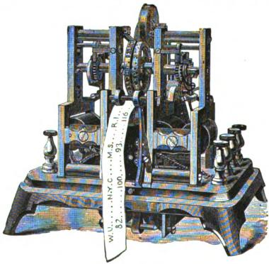
Fig 402.
wheels are all the letters of the alphabet and upon the other-the nine numerals and the fractions by eighths. These type-wheels are upon different axes, but are placed side by side; beneath them is a platen over which passes a narrow strip of paper from a continuous roll. This platen is upon a lever, upon one end of which is an armature, which is, at the will of the operator, attracted by a third electromagnet, connected to the third wire. The movement of the typewheels is effected in precisely the same manner as that of the dials of the Laws instrument, they being moved step by step, each bringing a new letter

CALAHAN'S STOCK TELEGRAPH. 675

or figure forward. and upon the required one being arrived at, an impression is taken. At the operator's desk are placed two transmitters, one for each of the wires which control the movement of the type-wheels. These transmitters are upon the same Principle as that of the Breguet dial, page 567, and the letters and figures upon the dials correspond in number and in position with the letters and figures upon the type-wheels, and are marked for the convenience of the operator with letters or figures in the same consecutive order.
The operation of this instrument can now be easily understood from the following description. The stock to be quoted may be called Western Union Telegraph, and the price eighty-two. In order to economize time, the names of stocks are abbreviated as much as possible, the abbreviations being of such nature as to he unmistakable and readily understood.
To report the quotation of this stock the operator brings the movable arm in the centre of the first transmitting dial to the Point marked W., so as to ensure by the successive impulses of electricity, the rotation of the type-wheel to the proper position. The stoppage of the arm causes the wheel to become, as it were, locked. The circuit of the third wire is then closed, and the Paper is brought against the letter and an impression taken. The arm is then carried to a point corresponding with the stop or period upon the type-wheel, which is similarly impressed upon the paper, and is then taken to the point representing U, and then again to the stop or period, impressions being made in each ^{e}ase. Thus far the name W. U. is recorded. The movable arm upon the second dial is now rotated under similar conditions to the point corresponding with the figure 8 upon the second type-wheel, and then to the point representing 2, and, impressions being taken, the whole quotation stands recorded upon the paper, " W. U. 82." The types are inked by an ink roller which ^{r}ests upon the type-wheel and which is rotated by the friction moused by the motion of the latter.
A. number of other instruments for reporting purposes have been brought out from time to time, all of which, of any value,

676 REPORTING AND PRIVATE LINE TELEGRAPHS.
are owned by the Gold and Stock Company. One of these instruments, the " Universal Stock Printer," fig. 403, is used upon several of the circuits operated by that company. The operation of this instrument is, like the Laws and the Calahan, upon the step by-step-principle; but in no other feature, except that two type-wheels are employed, is there any particular resemblance. With this, two wires only are necessary, one to
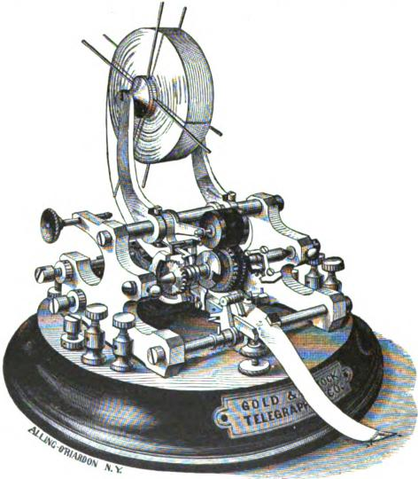
Fig. 403.
operate the two type wheels and the other to effect the printing By a peculiar arrangement the type-wheels may be shifted so that one magnet will control either of them.
This instrument works on two wires, and performs two operations, to wit., rotation of the type-wheel and the impression of the letter.
THE UNIVERSAL STOCK TELEGRAPH. 677
One electro-magnet with an armature secured to a double acting escapement, acting on a toothed wheel, rotates the type-wheels step by step. This magnet is connected with one wire, and is called the type-wheel magnet.
Another magnet, acting upon an armature secured to the printing lever, effects the impression of a letter, shifting of the type.wheels and feeding of the paper. This magnet is placed within the second circuit, and is called the printing magnet.
There are two type-wheels, one having letters, the other having figures and fractions. Both wheels are immovably fixed upon a sleeve which slides endwise upon the shaft carrying them. These wheels are carried around with the shaft by a pin placed in a notch of an arm secured to the shaft. This arm is called the crook piece. The shifting mechanism is also secured to this arm.
The shifting of the type-wheels is effected by rotating them to a point where the shifting lever is directly over the shifting pins, extending upwards and secured to a plate upon the side of the printing lever, the upward motion of which throws the type-wheels over to one side or the other, according to the .shifting lever over the pins. In shifting the type-wheels the shifting lever is so adjusted in relation to the characters upon the type wheel that when they are rotated to the period after the " &," and the printing lever raised, the figure wheel will be thrown into a position to be printed from; and when the type-wheel is rowed to the period next to the letter "A," and the printing lever raised, the letter wheel will be thrown into a position to be printed from, a brass shield on each side of the pad preventing the type-wheel - which is not being used from coming into contact with the paper.
The type-wheels are provided with a notched disc, which revolves with them. Upon the left side of the printing lever is an
arm having a V shaped point. This, in conjunction with the
notched disc, is used for the purpose of locking the type-wheels side to which they may have been shifted, and prevents
them from jarring out of position when they are being rotated.

678 REPORTING AND PRIVATE LINE TELEGRAPHS.

There are but two points where the type-wheels are free to move either way, viz: when they are at the period and in a position to be shifted, and when the notch in the disc is opposite the V shaped arm.
This instrument is also provided with mechanism whereby any number of them in a circuit may be brought to a given point by the transmitting operator.
This is done by turning the transmitter four times around without printing, when an arm working in a worm or screw upon the type-wheel shaft is carried in the path of a pin, stopping all the type-wheels at the dot next to the letter A. By closing the printing lever circuit the arms are all thrown away from the stop pin, and the type-wheels left free to move. The principle of this arrangement is the same as that upon the Phelps motor printer.
The amount of battery required to work each instrument (after enough battery has been put on to overcome the line resistance) is two carbon cells when the type-wheels are rotated at a speed not exceeding 18 revolutions per minute; two and one half cells when the speed is between 18 and 30; and three cells when the speed is not more than 42 revolutions per minute; or, in other words, to increase the speed of the instruments the battery power must be correspondingly augmented.
PHELPS'S STOCK PRINTER.
Mr. Phelps has recently perfected a printer (fig. 404) which is coining into extensive use on the lines of the Gold and Stock Telegraph Company, and is regarded as the most perfect instrument for the purpose for which it is designed that has yet been produced. It requires but one line wire, prints either letters or numerals at will by means of a double type-wheel, arid is capable of transmitting at the rate of thirty words per minute. In its general principle it bears sonic resemblance to the House apparatus. The type-wheel axis is driven by a weight or spring and train of clock-work, so arranged that it may be run constantly for five or six hours without rewinding. A recoil

PHELPS'S STOCK PRINTER. | 679
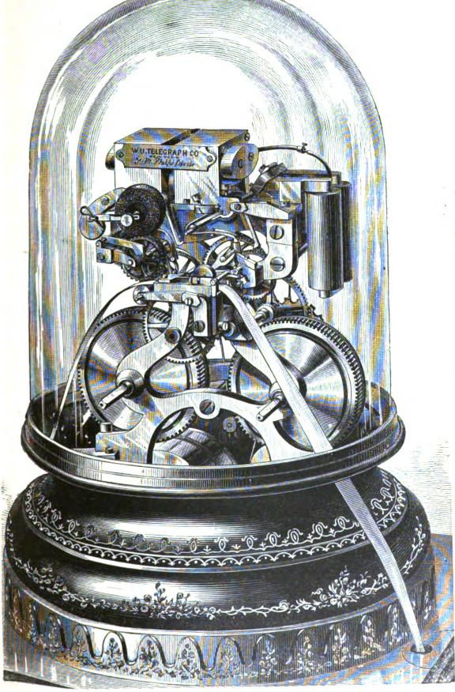
Fig. 404.

680 REPORTING AND PRIVATE LINE TELEGRAPHS.

escapement controls the type-wheel, and this is in turn controlled by the polarized armature to which it is attached. The latter vibrates between the opposite poles of two electro-magnets placed in the same circuit, arranged so as to face each other, the polarized armature being common to both. In the same circuit is placed the printing electro-magnet, which has a soft iron or neutral armature. Whenever this armature is attracted a detent is lifted, which releases the printing train, and gives the impression by means of an eccentric on the last axis of the train. The pulsations which produce the step-by-step movement of the type-wheel are of alternate polarity, and thus the polarized armature is alternately attracted and repelled by the two magnets between which it vibrates. These rapidly alternating pulsations pass through the printing magnet, but succeed each other with such rapidity that the latter has not sufficient time to become charged. until a pause is made, when its armature is instantly attracted and the printing mechanism released. The movement for feeding the paper is the same in this instrument as in the electro-motor printer, and it is also provided with an automatic unison, differing in form, but the same in principle with that before described. The letters and numerals are placed upon two parallel type-wheels upon the same shaft, the platen being shifted from one wheel to the other by an automatic device under control of the sending operator, similar to that used in the universal instrument before described.
This instrument can be operated at the rate of thirty words per minute over a line of considerable length, and is therefore much more efficient than the instruments previously described which are designed for the same purpose.
The transmitting apparatus is represented in fig. 405, and consists of a key-board and cylinder with spiral pins, like those of the House and Froment instruments, which is driven by a rotatory electro-motor precisely like that before described (pages CO3 to (368). A toothed wheel of large diameter, geared to the transmitting cylinder, acts simultaneously upon a series of pole changers arranged around its periphery, each of which

PHELPS'S STOCK PRINTER. 6S.

Fig 405.
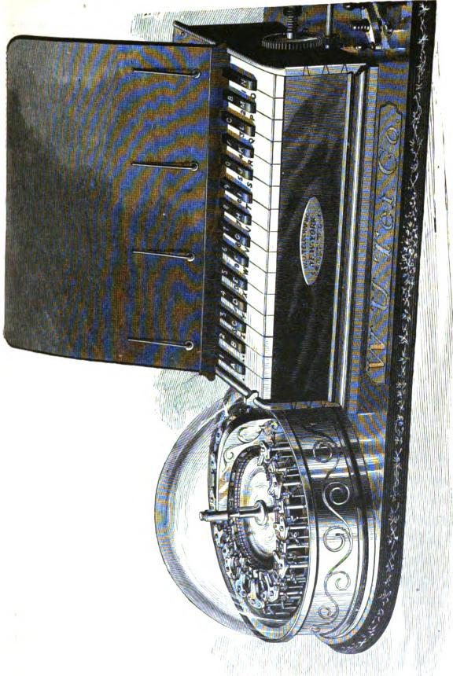

682 REPORTING AND PRIVATE LINE TELEGRAPHS.

operates a separate line wire. By this means a dozen or more wires are so arranged as to radiate from a central point, each having a number of printing instruments in connection, and thus correct reports of the fluctuations of the markets are simultaneously printed in hundreds of different offices, exchanges, etc., at the same instant, every instrument being entirely under the control of a single operator at the central station.
GRAY'S PRINTING TELEGRAPH FOR PRIVATE LINES.
The Gold and Stock Telegraph Company of New York, after the establishment of the extensive system of lines and instruments for reporting the quotations of the gold and stock exchanges which has been alluded to, decided to add a private line department to their rapidly increasing business. The company accordingly made arrangements to purchase or control all the most valuable patents for printing instruments adapted to this purpose, other than those already owned by it. It then proceeded to construct pole lines of the most substantial, durable and costly character, through the principal business portions not only of New York, but the adjoining cities and suburbs of Long Island and New Jersey, the latter being brought into connection by a large number of submarine cables. The plan of. operations adopted was that of erecting a sufficient number of lines to meet the probable requirements of the business, which could then be made available to connect any required points within the range of the company's field of operations. By this means it was enabled to furnish at short notice, to parties desiring it, a complete telegraph line, equipped with type-printing instruments, batteries and other necessary requirements. and by means of a trained corps of skilful and efficient employ(:s, to assume the entire charge of it for a very moderate annual rental. That this policy was an eminently sagacious one, has been sufficiently attested by the subsequent rapid development of the system.
The necessity of providing for use upon this class of lines a printing telegraph instrument of easy and simple manipulation,

GRAY'S PRIVATE LINE INSTRUMENT. 683
requiring no scientific or mechanical knowledge, or previous experience on the part of the person operating it, was early recognized by the officers of the company, and has led them to extend the most liberal encouragement to all inventions and improvements in that direction. The result of this wise policy has been that a number of instruments and methods of great value have been developed and perfected, and afterwards extensively introduced into practical use.
One of the best of these instruments for private lines, and one which is perhaps more extensively used than any other throughout the United States, is Gray's Automatic Printer, of which fig. 406 is an illustration.
As will he seen by reference to the figure, the mechanism of Gray's apparatus is mounted upon a. handsomely ornamented won base, the working parts being protected from dust by glass shades. The key-board extends across the front of the base, and consists of twenty-eight keys, upon which are engraved the different letters of the alphabet, with the necessary punctuation points, etc. The blank key at the extreme right is used to start the instrument. Beneath the small glass shade at the rear of the key-board is an upright polarized relay, behind and above which is situated the type-wheel and printing apparatus.
The communications are printed as received upon a•continuous strip of paper, which is fed from the roll above. The type-wheel is made to revolve by means of a double-acting pallet escapement, attached to an armature which vibrates between the poles of two local magnets within the hollow base of the instrument At the back of the instrument, directly in the rear of the type-wheel, is a cylindrical brass case containing what is called the
sunflow
radially er." This is a flat annular disc of platinum, divided
into equal segments corresponding in number to the transmitting keys, each of these segments being connected to its corresponding key by an insulated wire. A circuit closing arm, rigidly attached to the type wheel shaft, travels over the divided dice as the shaft revolves, and places the latter in electrical con-
nection successively with each se!rment. The sanie circuit

684 REPORTING AND PRIVATE LINE TELEGRAPHS.
(which is that of the main line) is conducted through the coils of the polarized relay, and this, by means of a local circuit, controls the escapement magnets above alluded to.
The general principle upon which the instrument acts may
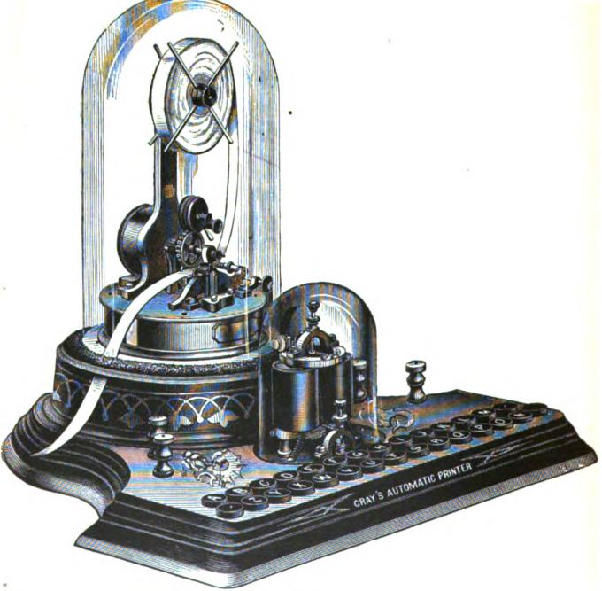
Ayr. 406.
now be understood without difficulty, although the details would require special drawings to render their description entirely clear. Upon breaking the main circuit, by depressing the extreme right hand key, the relay moves and the local magnets

PHELPS'S PRIVATE LINE INSTRUMENT. 685
release the escapement, which in turn allows the type-wheel to move forward a step, carrying with it the moving arm upon the sunflower. By means of a pole-changer attached to one instrument only in each circuit, the direction of the line current is reversed for each letter passed over, and thus the polarized relay and escapement magnets continue to vibrate automatically until the sender depresses some other key. The depression of this key breaks the circuit leading to the corresponding segment of the sunflower, and when the travelling arm reaches this segment the main circuit is interrupted, the escapement cannot act, and the type wheels of both instruments come to a stand. The letter or character _{upon} th_{e} t_{ype}-_{w}h_{ee}l _{corres}p_{on}di_{ng} t_{o} th_{e} k_{e}y which has been depressed upon the sending instrument being thus brought opposite the paper strip, the impression is effected bya, magnet in the local circuit, which is instantly brought into action upon the cessation of the vibrations of the relay armature.
Thus it will be seen that any person who can read and spell can transmit communications upon this instrument merely
^{lin}gering the appropriate keys, and that these may be automatically recorded even in the absence of an attendant, at one or more distant points.
Tins instrument is a comparatively recent invention, having been first introduced so lately as the autumn of 1871, since which time about a thousand have been manufactured and set in operation. The ordinary speed of transmission attained by Persons who have become familiar with the positions of the letters of the key-board is usually from 14 to 16 words per minute. The apparatus is very simple and in practice is not found to be liable to disarrangement. It can be worked on lines of any required length.
PRELPs's PRINTING TELEGRAPH, FOR PRIVATE LINES.
This instrument somewhat resembles Gray's in its external appearance, but differs widely in principle and in the details of its ^{e}"nstruction. The transmitting apparatus is driven by clock-'c'wk beneath the key hoard, which consists of a semicircular triple row of ivory headed pins, engraved with the letters of the

686 REPORTING AND PRIVATE LINE TELEGRAPH&
• | 

alphabet, as shown in fig. 407. The type-wheel is propelled by a double acting escapement, which is operated by an armature suspended between two electro-magnets, as in the stock printer. The printing magnet is beneath the base of the instrument and not visible in the figure. The principle upon which the appara-
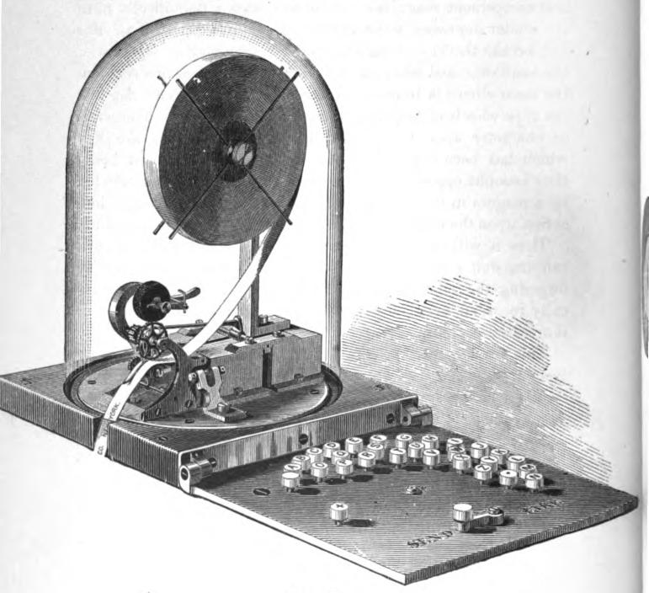
.FYg. 407.
ti_{n}s is operated is substantially the same as that of Mr. Phelps's
stock printer, which has already been described.
A more recent design, which is arranged with a piano key-
board, is shown on the following page.

PHELPS S PRIVATE LINE INSTRUMENT. 687
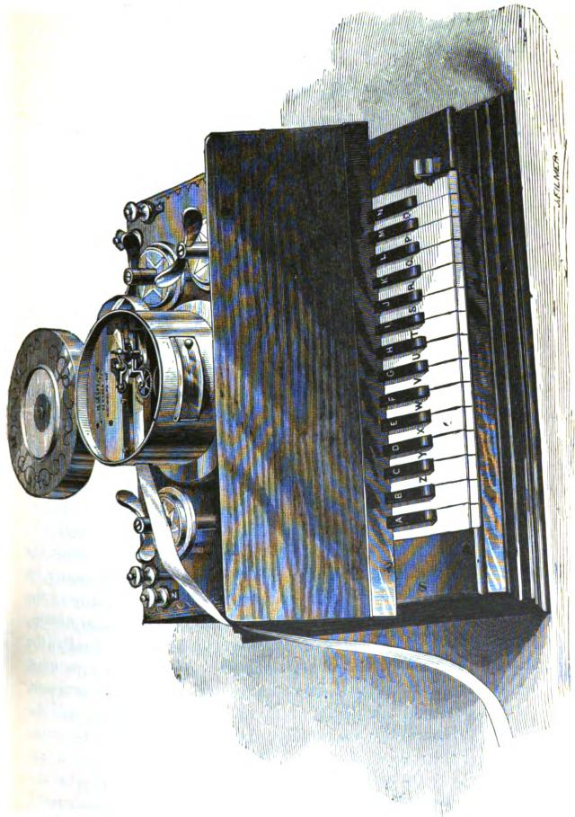

CHAPTER XXXVL

THE AUTOMATIC TELEGRAPH.
IN the system of telegraphy usually known as the automatic or fast method, the signals representing letters are transmitted over the line through the instrumentality of mechanism. The general advantage thus proposed to be obtained consists in the much greater quantity of intelligence which can be transmitted in a given time by mechanical means than by hand, and in the fact that this may be accomplished by having the separate dispatches prepared or composed by a number of operators simultaneously; or in the case of .a single dispatch of great length, by dividing it into what are called by printers "takes" or convenient portions. These separate portions are transmitted in their proper succession, and at a high rate of speed, by means of automatic mechanism, and thus the labor of a number of operators may be utilized by a single wire.
In estimating the actual speed of transmission as compared with the ordinary systems, it is obvious that a number of circumstances must be taken into account, viz: the cost and nature of the apparatus; the number of employ6s required to prepare the copy for transmission; the number of employ6s necessary to receive and prepare. it for delivery at the distant station; the comparative time required to prepare the copy for transmission; the time actually occupied in the transmission; and finally, the distance to which it can be transmitted. All these points must necessarily be considered in order to arrive at a fair estimate, for it is apparent that if a given quantity of intelligence, and the same intelligence, be presented at the same moment to be transmitted by the respective systems of telegraphy, the one which first delivers the intelligence with completeness and accuracy at the distant station will, other things beinr,, equal, have demonstrated its superiority. Secondary only to this is the important question

THE AUTOMATIC TELEGRAPH. 639

of economy, especially in respect to the cost of labor, for it is evident that an increase in the speed of transmission, to be of practical value, must be obtained without any considerable sacrifice of economy.
The immense rapidity of the passage of the electric current would seem to suggest that there is scarcely a limit to the quantity of intelligence that may be transmitted in a given time by means of mechanism. In fact, however, it is materially limited by two things: first, the time required for the action of the necessary mechanical instrumentalities by which the signals are transmitted and received; and second, the effects of electro-static induction. which, as we have already seen in Chapter XXVII, is always present in a well insulated wire. At a moderate speed of transmission the retardation and prolongation of the signals is not perceptible, because its duration is but a small fraction of the time between one signal and another; but as the speed is increased the interval between the succeeding signals becomes less and less, so that at length a point is reached at which the inductive effect, however short its absolute duration, lasts during the entire interval. These effects, however, may he to a considerable extent compensated by appropriate devices, and it is obvious that this may be done with more accuracy in the case of automatic than in that of manual transmission.
It is somewhat interesting to note that the automatic process was the original mode devised by Morse for the first practical demonstration of his invention, and is therefore the oldest form of the recording telegraph. Morse's apparatus has already been fully described in Chapter XXX.
The automatic process of transmission may be conveniently divided into four distinct operations : First, the composition or preparation of the copy; second, the placing of the prepared matter in its proper order in the transmitting apparatus; third, the mechanical operation of transmitting and receiving, which takes place simultaneously, and fourth, the translation or copying of the despatches for delivery.
The principal point of difference in the several systems which

690 THE AUTOMATIC TELEGRAPH.

have been proposed, consists in the various methods which have been made use of for preparing the copy for transmission—such as perforated paper bands, movable type, metallic bands with characters composed of insulating material placed thereon, paper bands with embossed characters, etc. The methods of transmission and reception of the message are usually very similar, the latter being either recorded by an electm-magnetic or electro-chemical register, and in some instances printed. The autographic or fac-simile process of transmission, which is in reality an automatic process, will be considered in a subsequent chapter.
BAIN'S AUTOMATIC TELEGRAPH.
The origin of the modern automatic telegraph is to be found in the invention of Alexander Bain, of Edinburgh, which was
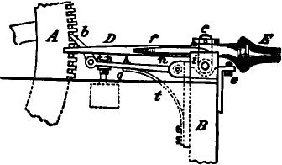
Fig. 408.
patented in England on the 12th of December, 1846. His first method of preparing messages for transmission, so far as its material parts are concerned, is represented in fig. 408, which is a side elevation, and fig. 409, which is a plan view of the composing machine. A is a vertical metallic disc, the size of which is in proportion to the length of the dispatch to be composed. It is provided with a great number of notches cut in its periphery, in each of which lies a metallic pin s, parallel to the axis of the disc. The whole series of pins are kept in position by means of twine or thread tied round the edge of the disc, as shown in fig. 409. In order to prepare a dispatch the disc A is placed in a frame B, so that the pins s s (which in

BAIN'S TELEGRAPH. 691
their normal position project an equal distance on each side of the disc), as the disc revolves step by step, pass successively between the jaws of the tongs C D. The tongs are normally kept in a middle position by springs f f, but may be turned upon an axis c either to the left or the right, by means of a handle E, and thus any particular pin s which is opposite the tongs may be pressed longitudinally to the right or to the left. By depressing the handle vertically, it moves upon a pivot i, and by means of the pawl 1), causes the disc A to advance a distance of one tooth forward, thus bringing the succeeding pin between the jaws of the tongs, and so on. The different positions of the pins s s correspond to the telegraphic characters. The transmission is effected by placing the prepared disc in a frame
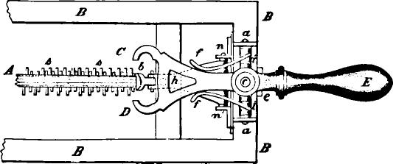
Fo. 409.
'and causing it to revolve uniformly by clock-work; a spring connected with the negative pole of a battery and with one line wire, passing over and making contact with the projecting points on one side, and another spring attached to the positive pole and the second line wire, making contact with the pins on the other side, while the axis of the disc itself is connected to the earth.
This apparatus was a crude and impracticable one, but in the specification of the same patent Bain describes an improved method, which is substantially the one which has proved most successful in practice up to the present time. This consisted in making use of a kind of punch, by which two lines of perforations, conventionally grouped to represent letters, are punched out of a narrow strip of paper. In order to transmit the riles-

692 THE AUTOMATIC TELEGRAPH.

sage, the perforated slip, which appears as shown in fig. 410, is conducted over a metal cylin ler. Two metallic springs press upon the paper as it passes over the cylinder, 'and these are arranged in line with the two rows of perforations. As the perforations pass under the springs these latter drop through and touch the metallic cylinder, thus forming an electrical contact
a ft
;12%GO •OoIQ o ⁻I ooGO I y
a ^{I} a
Fig. 410.
In his recording apparatus Bain discarded electro-magnetism altogether, and employed electro-chemical decomposition instead, as Davy had done in 1838. The strip of paper on which the dispatch is to be recorded is conducted through a trough where it is saturated with a solution composed of six parts water, one part sulphuric acid, and two parts of a saturated solution of yellow prussiate of potash. It then passes over a roller of metal and underneath two styles or pens of iron wire which rest upon it. These are connected by two line wires with the positive poles of two batteries at the sending station. The passage of the current through the saturated paper from the styles to the roller, produces colored marks upon the paper by the chemical decomposition of the iron style, and thus a record is made which
I- 0 N D O N
Fig. 411.
corresponds precisely to the perforations in the paper strip at the sending station. Fig. 411 shows the appearance of the record made in this way.
Bain afterwards materially simplified his automatic process by making use of the dot and dash characters of Morse, which being perforated in a single line, required but a single transmitting spring. This system was experimentally operated in the United States in 1848 and 1849, and in England as late as

BAIN'S TELEGRAPH. 693
1852, but was abandoned in both countries, principally for the reason that no convenient mechanism for perforating the paper bad then been invented. A system of lines were however constructed between New York, Washington, Boston and Buffalo, and other points, in 1849 and 1850, which were operated by the Bain method of recording, and a finger-key transmitter, exactly the same in principle as that of Morse. Fig. 412 shows the arrangement of such a circuit. A is the receiving and B the sending station, z k is the battery, the copper pole k being to line and the zinc to earth at P1. The depres•
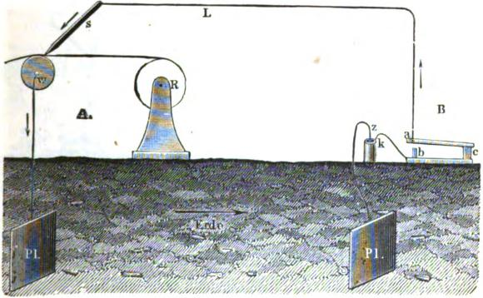
Fig. 412.
sion of the key a transmits a current over the line L in the direction of the arrows, which passes down the iron style s into the metallic roller w, and thence to the earth. A strip of chemically prepared paper from the roll R is caused to pass uniformly by clock-work over the roller w and underneath the style, and the record is made in the manner previously explained.
In 1851, the saturated strip of paper passing over a roller as just described, was replaced by a circular sheet of paper lying on a horizontal metal disc, upon which the writing style disposed the group of dots and dashes in a continuous spiral line.
•
■

694 THE AUTOMATIC TELEGRAPH.
In Austria Dr. Gintl introduced a system substantially the same as Bain's, which is represented in the diagram, fig. 413. Two terminal stations are shown, each provided with a complete set of apparatus, consisting of a key, battery and recording apparatus. The latter consists of a pair of rollers, W W, which are moved by clock-work, and draw the paper strip P forward from the roll R, through the vessel B containing the chemical solution, and thence under the style s which"tests upon the con, vex metallic surface M. A switch is provided which is not represented in the figure, and which serves to conduct the cur-
1Vg. 418.

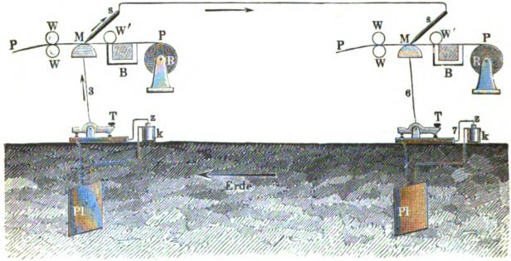
,
%/gf, //_{z}4V, •
rent around the recording style, or, in other words, directly from 'the key to the line, when sending.
The electrochemical method of recording possesses several important advantages. It can be operated with a feeble current and through a great length of line, while variations and irregularities in the current do not seriously interfere with the legibility of the record. As there are no moving parts whose mechanical inertia is .to be overcome, there is scarcely any limit to the rapidity with which successive signals may be recorded. On the other hand, the use of chemical paper is in some respects inconvenient for the operators, and practical difficulties also arise in
•

SIEMENS AND HALSKE'S APPARATUS. 695

transmitting simultaneously to a number of different stations, as well as in repeating from one line to another.
SIEMENS AND HALSKE'S AUTOMATIC TELEGRAPH.
In 1853 Siemens and Halske, of Berlin, brought out an automatic process, which consisted of a three-keyed hand punch for preparing the perfbrated paper, and an electro-magnetic recording apparatus. The perforator consisted of two punches placed side by side, and three keys. By depressing the first key a single round hole is punched in the• paper. The second key operates both punches simultaneously, producing an oblong double hole, and in both cases the paper is fed along the proper distance in readiness for the next perforation. The third key advances the paper after each letter so as to form the required space between this and the next letter. Perforators upon this principle have also been constructed by Digney and Wheatstone, though at a later date. The recording apparatus was upon Morse's plan, and consisted of the register shown in fig. 233 and the relay shown in fig. 279.
Of course, with such an apparatus it would not be possible to obtain a speed of over 30 or 35 words per minute—which was, nevertheless, greater than could be obtained by hand at that date. Many of the lines built by Siemens and Halske, in Russia, during the years 1853—'51—'55, were equipped with this appa-
ratus. •
Experience proved, however, that the actual advantage gained was not at all in proportion to the extra trouble involved in perforating the messages, and the method soon fell into disuse and was superseded by the ordinary Morse system. One of the greatest drawbacks was the difficulty of keeping the receiving relay adjusted when working at high speed, and this led Dr. Werner Siemens to the use of alternating currents in order to avoid this defect. This lie first did in 1856, although) it should be mentioned that he had been anticipated therein two or three years by Varlet' in England. Experimenting in this direction Siemens was successively led to the invention of the system of

696 THE AUTOMATIC TELEGRAPH.
transmission by induced currents (page 538), of the polarized relay (page 509), and of the polarized ink writer (page 513). In 1862 he patented his fast type transmitter, which has been used to a considerable extent upon the Prussian lines. In this the currents are generated by a magneto electric apparatus, termed the cylinder inductor, which has already been explained in connection with the dial telegraph of the same
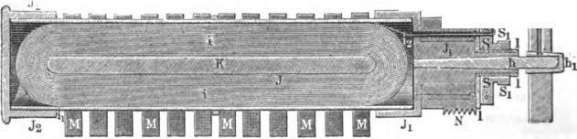
⁴24.4
Pg. 414.
inventor (page 596). Fig. 414 is a longitudinal, and fig. 415 a transverse section of the cylinder inductor, which is better known as the Siemens armature. When this is made to revolve at a uniform rate between the poles of a range of permanent magnets M M, rapidly alternating positive and negative pulsations are produced in the coil of insulated wire i i, which is
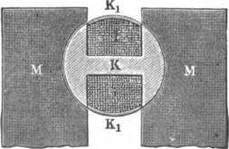
R. 416.
wound upon the armature. The end of the wire at i_{t} is attached to the brass cap J₂ at one end of the armature, and the other terminal /₂ to the cap S, which is insulated by the ivory bushing / from the metal of the armature.
As in the original apparatus of Morse, the communications are composed in type cut from sheet metal. These were at first

SIEMENS AND HALSKE'S APPARATUS. | 697
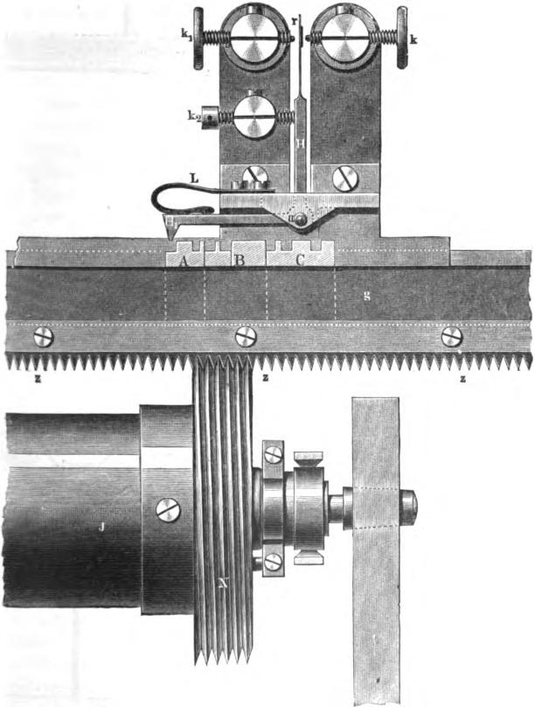
Fig. 416.

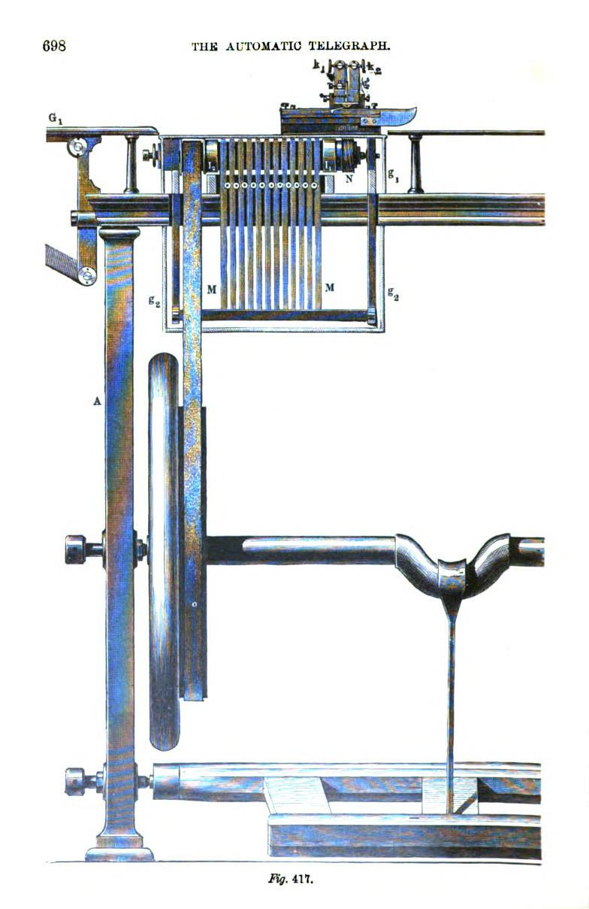
THE AUTOMATIC TELEGRAPH.
698
lig. 411.

SIEMENS AND HALSKE'S APPARATUS. 699

made to represent Morse characters, but afterwards separate type were used for dots, dashes and spaces. These are set up in a port-rule or composing stick g, fig. 416, which, together with the type, is caused by the action of the machinery to pass horizontally under a wedge shaped tooth H, upon one arm of an angular lever, while the other arm H carries a contact spring r, which vibrates between two adjustable stops k and k₁. The screw k is connected with the earth and the lever H H_{i} with the coil of the inductor, and thence with the line. When, therefore, a projection, representing a dot or a dash, passes under the tooth H₁ the spring r is pressed against the stop k, and the current from the inductor passes into the line. It is obviously necessary that the speed with which the type move should correspond exactly with the revolutions of the inductor. This is accomplished by the simple
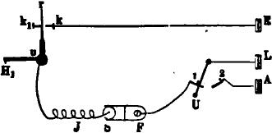
1,y. 118.
but effective device of an endless screw N, figs. 416 and 417, which is placed upon the axis of the inductor, and works into the teeth of a rack z z z on the under side of the port-rule. Fig. 417 is a front elevation of the machine showing the treadle and pulley by which it is kept in motion.
Fig. 418 represents the arrangement of circuits, the reference letters being the same as in the preceding cuts; the switch IT turned on 1 when sending, placing the inductor J in circuit between the earth at E and the line L. When receiving, the switch is turned on 2, which connects the line to the receiving instrument, usually a polarized ink writer. The speed of transmission attainable by this apparatus is from 60 to 80 words per minute. In a letter to Professor Morse, in 1868, published in his report on the telegraphic apparatus at the Paris Exposition,

700 THE AUTOMATIC TELEGRAPH.
Siemens and Halske state that this apparatus will transmit seventy dispatches per hour. The time occupied in composing each dispatch in type is five minutes, in distributing the same four minutes. Twelve employes are necessary for setting up and distributing; two for transmitting, and two for receiving and writing down the dispatches. This apparatus has also been arranged for working with alternate battery currents. Fig. 419 shows the arrangement so clearly that no particular explanation is needed. The lever k₁ k₉ is oscillated by means of an arm provided with a tooth, arranged to pass over the face of the type in the moving port-rule. To facilitate the setting and distribut-
P
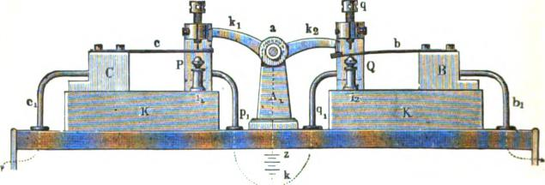
Fig. 419.
ing of the type for this apparatus, very ingenious machines, operated by means of keys like those of a piano, have been invented by Siemens and Halske.
GARNIERS AUTOMATIC TELEGRAPH.
Experiments were made on a large scale in France, prior to 1857, with the automatic process invented by Paul Gamier, which is represented by fig. 420 and fig. 421. The transmitting cylinder A is 18 or 20 inches in diameter and has a spiral groove cut in its periphery, in which are inserted movable pieces of metal. The message is prepared by placing these in position to form telegraphic characters upon substantially the same principle as the apparatus of . Bain, described on page 690, the metallic parts required to represent the dispatch being pushed to the left.

HUMASTON'S APPARATUS. 701
In order to transmit the message the cylinder A is caused to revolve at a uniform rate of speed, while, at the same time, it moves laterally upon its axis B C, which is provided with a screw thread. Fig. 421 shows the manner in which a contact spring h

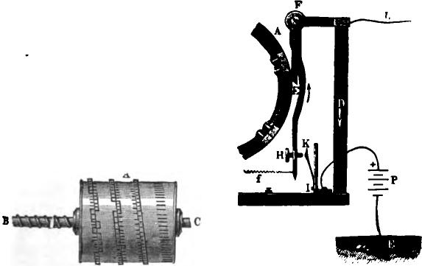

F. 420. Fig. 421.
is pressed upon by the screw H whenever the projections, which form the characters upon the cylinder A, pass under the tooth E, thus making contact between the battery P and the line L.
HUMASTON.S AUTOMATIC TELEGRAPH.
In 1857 John P. Humaston, of Connecticut, patented an apparatus for perforating paper strips for transmission in automatic telegraphy, which was an important advance not only over the system of type transmitters, but also over the perforating apparatus previously in use. The perforated paper process has a very important advantage over the type process, inasmuch as the time required for distributing the type is saved. In addition to this saving, Humaston's machine perforated an entire letter or character of the Morse alphabet at a single movement, and thus rendered it possible to prepare the dispatches with ranch greater celerity than had before been possible. In Humaston's apparatus

702 THE AUTOMATIC TELEGRAPH.

a series of horizontal punches are placed parallel and side by side opposite the paper, and a mechanical device connected with and operated by the keys of the key-board, selects the punches required to form the telegraphic character corresponding to the key which is depressed, A single punch forms a dot, and any two adjacent punches a dash. The proper punches having been selected by depressing a key, these are driven through the paper strip by the operation of a treadle, when the punches are withdrawn the paper is fed forward the proper distance by means of a stop-wheel graduated to correspond with the varying lengths of the telegraphic characters, and thus a uniform space is ensured between the successive characters, however greatly their respec tive lengths may vary. Many experiments were made, in connection with this perforator, with the Bain system of transmission, which had been somewhat modified and improved by Humaston, on the lines of the American Telegraph Company from 1861 to 1866, in which a speed of 100 to 120 words per minute was attained upon ordinary circuits, but the system was never brought into actual service.
WHEATSTONE'S AUTOMATIC TELEGRAPH.
This apparatus was first patented in England by Wheatstone, in 1858, and with its subseqtent improvements has been brought to such perfection, that it is now in very extensive use on the telegraph lines not only of the United Kingdom but of several other countries. Wheatstone made use of the perforated paper strip of Bain, together with the three-keyed perforator and polarized receiving instrument of Siemens. All these devices were, however, materially modified and adapted to each other in new ways. At first the Wheatstone automatic apparatus recorded in characters similar to those of Steinheil, but this was afterwards changed, and the record is now made in the ordinary 'Morse characters.
The plan of making contact directly through the perforations of the paper, originated by Bain, is found in practice to be liable to several objections : dust or fibres of the paper are apt to inter-

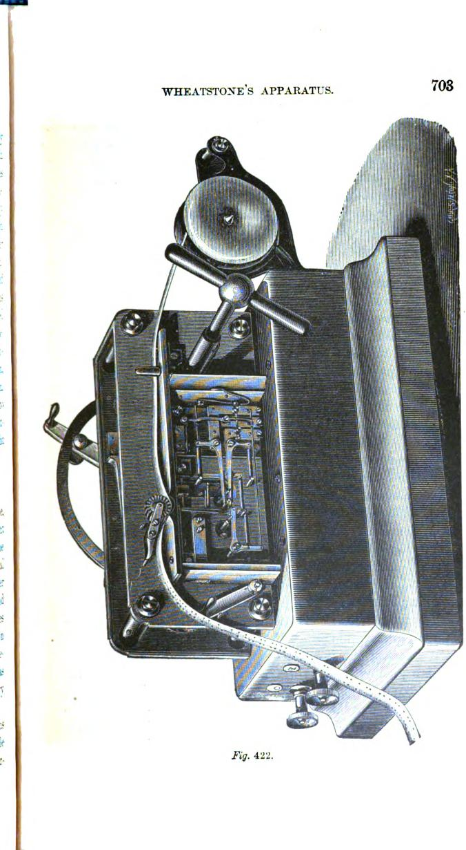
WHEATSTONE'S APPARATUS.
708
G
g
Fig. 422.

704 THE AUTOMATIC TELEGRAPH.

fere with the contacts, and, what is more important, the edges of the perforations act upon the brush in a manner which prevents it from touching the metal wheel over a considerable portion of the space allowed for contact. Better results are obtained by lengthening the perforations in the paper and running the. machine proportionately faster. In Wheatstone's transmitter, as. now employed by the Postal Telegraph Department of Great Britain (fig. 422), the contacts are made between levers and studs, the paper being used only to regulate the movement of these contact pieces. This arrangement gives much more uniform and trustworthy contacts than can be obtained between a brush or spring and a revolving wheel, and affords great facilities for the production of the compensating currents which are-required at high speeds. The principle of the apparatus is, that the polarized armature of the electro-magnet, which causes the marking disc to touch the paper, shall not have a tendency to leave the paper when the marking current ceases, but shall remain always in the same position in which it is left by the last current. The machine is arranged to send a series of reversals or alternate -}- and — currents at definite and regular intervals, and the function of the perforated ribbon is to decide whether these currents of either sign shall or shall not pass out to the line. An ebonite rocking beam (R, fig. 423), moved by wheel. work, carries three pins; that on the left hand is connected to. line, that on the right hand to earth; the centre pin is insulated and serves to connect the curved lever B with one or other of the battery levers Z C, according to the position of the rocking beam. Under the beam lie the two levers A B. These levers are pivotel independently, but. are in electrical connection through the spiral springs II III attached to them, and through. the frame of the instrument. On the ends of these levers, A B, are pivoted two vertical needles, one of which, V, regulates the production of the marking, the other, VI, that of the reverse or spacing current. These levers are not fixed to any of the moving parts of the apparatus, but are firmly pressed upwards by the spiral springs II IIi, so as to follow the movements of

WHEATSTONE'S APPARATUS. 705
the rocking beam, and remain in contact with the pins inserted into this beam so long as their upward movements are unchecked. The needles attached to this lever determine whether line contacts should be made or broken at the moment battery contact is made. They rise alternately until they touch the paper ribbon; if there be a bole opposite their points, they pass through it and the contact is undisturbed; but should there not be a hole, their motion and that of the lever is stopped, and the pin on the rocking beam continuing to rise, contact is broken between it and the lever.

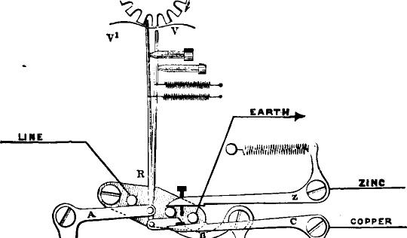
A.
0
EARTH
z
e _{O}
UNE
ZINC
COPPER
vl

IIIMA^{I}WO-MNAMWM"r,
Fig. 423.
Fig. 423 shows the apparatus in a position for sending a negative current. The levers Z and C are the poles of the battery. The lower lever C touches the right hand pin on the rocking beam, and as this pin is in connection with the earth, the copper pole is in connection with the earth also. The upper lever Z which is in connection with the zinc pole of the battery, rests on the centre pin of the beam, and is in connection with the line through the lever B, the spiral springs H HI and the frame of the instrument, the lever A, and the left band pin; and thus a negative current has been sent to line.

706 THE AUTOMATIC TELEGRAPH.
Fig. 424 shows the position when the current is broken. The rising of the lever A is prevented by the paper, the vertical needle V', attached to it, not meeting with a hole in the ribbon. Here the contact between the lever A and the left hand pin is broken, and no current passes to the line.
When the speed of transmission is increased beyond a certain rate, which varies with the length of the circuit, a difficulty arises which is partly due to induction when the potential of the line wire varies with the interval between the currents, and partly to what may be called the inertia of the electro-magnet of the
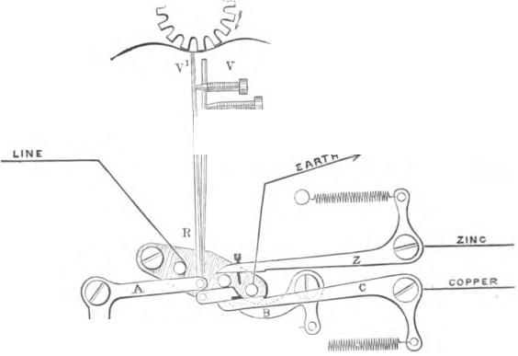
receiving apparatus, the time occupied by the magnetizing and demagnetizing the iron varying also with the interval between the currents, and probably even in a comparatively short suspended wire, not more than seventy words per minute would be attained under Bain's method, where the currents are sent precisely in the same manner as by an ordinary single current key.

_{T}-knonNot.,--
C>-AWNAWIINAW⁻ '}'9,9wINMAVOITi
11 Hl an
Fig. 424.
By the use of alternating currents speed is increased, but is still considerably lower than the maximum attainable on a given line. A succession of equal currents of opposite signs, at

WHEATSTONE'S APPARATUS. 707

equal intervals, will give perfectly distinct dots at a very much higher speed than the dots and dashes of an alphabet can be produced.
Wheatstone's apparatus produces the Morse signs by currents of equal duration; or, in other words, by a succession of dots; but as the intervals between the currents are necessarily unequal, the alphabet is more slowly produced than a series of equidistant dots. The speed of a succession of letters (an alphabet) depends also on the distance between the letters; the greater the interval the slower the speed, because an additional element of variation in the electrical condition of the wire and the magnetism of the receiver is thus introduced. Speed is generally limited more by defects in the formation of the letter than by the loss of dots, or running together of marks, and the defects are greatest where there is the greatest irregularity in the intervals between currents, as, for instance, in F — —
. It is necessary, then, to apply a system of
compensating currents to maintain as great a uniformity as possible in the condition of the wire and electromagnet.
This was effected in the first instance by bridging over the break in the circuit which occurs when the pin is stopped by the paper by resistance coils, so that a weak current was sent in the interval of break, the strength of which currents was regulated by varying the resistance. This system was further improved upon by an alteration of the transmitter, by which the compensation was more accurately applied, and it is upon this principle the apparatus is at present constructed.
Fig. 425 is intended to represent a piece of the perforated ribbon; the perforations which regulate the contact-making portion of the transmitting apparatus are represented by the larger circles, while the centre row of holes is represented by the smaller circles; by this row of holes the paper is carried forward in the transmitter.
The slip is perforated for the letter R of the International alphabet. This letter has been selected as being one which is always much deformed, and which shows the effect of a dot pre-

708 THE AUTOMATIC TELEGRAPH.
ceding and following a dash. The upper row of holes is that which allows a positive or marking current to be sent when the vertical pin V (figs. 423 and 424) of the transmitter passes through one of them. The lower row of holes allows a negative current to be sent in the same way when the vertical pin VI (figs. 423 and 424) of the transmitter rises through one of them.
Fig. 426 represents the letter R (International alphabet) as received at high speed on a line where the original system of intermittent currents is used. It will be seen that, in the case of the dot before the dash, a +, then a—, and finally a second -4-that is, two positive and one negative currents are sent to form the dot and to commence the dash: that is, twice as much posi-
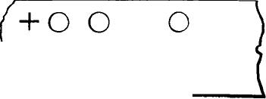
mMEN ism

O O O O O
( 0 0 0
+ +
Figs. 425, 426, 427.
tive as negative current, and the dot is consequently much elongated, and has a tendency to run into the dash. In the case in which the dot follows the dash, it will be seen that the effect is exactly the reverse of the former, and for the finish of the dash a — current is sent followed by a ±, and finally by a second —current, the last two forming the dot; that is two — and one -4-currents, so that in this case the line is charged negatively in excess; consequently the space between the dash and dot is considerably increased, and the dot much shortened or lost altogether.
Fig. 427 shows the letter R as received where compensating

WHEATSTONE'S APPARATUS. 709
currents are used, and is perfect with respect to the length of the marks and the spaces between them. The compensating currents are represented by the smaller signs. It will be seen that, before the commencement of the dot, the line is charged negatively, instead of being left clear, as in the original system, and prevents the elongation of the dot before the dash, as already explained.
In the case of the dot following a dash, it will be seen that a positive compensating current is sent before the terminating current for the dash, so that the line is not too much negatively charged, as where no compensating currents are used, and the elongation of the space separating the dash from the dot, as well as the diminished size of the dot itself, is prevented. (Fig. 427.)
In a circuit composed partly of over-ground wires, and partly of buried or submarine wires, the position of the underground work or cable will affect the speed at which the two stations can receive from each other. If the buried portion or portions be symmetrically placed with respect to the two stations, as when the land lines at each end of a cable are of equal length and resistance, the two stations will be able to receive equally well; but if the land lines on one side be much longer than at the other, the rate at which the station at the end of the shorter land line will be able to receive, will be less than that at which the station situated at the end of the longer land line can receive from the other. This difference of speed is sometimes very considerable, and the difference is the greater as the lengths and resistances of the land lines on each side of the cable are the inure different.
The London and Amsterdam circuit is composed of first a suspended wire of 130 miles,•then a cable of 120; lastly, on the Dutch side, a suspended wire of 20 miles.
Here it was found that the relative speeds of signaling were as 9 to 6, the higher speed being Amsterdam to London. The rate to Amsterdam was increased by decreasing the resistance of the batteries; and still further by the insertion of a high

710 THE AUTOMATIC 'TELEGRAPH.

resistance (as much even as 5,000 ohms) at Amsterdam (in the receiving circuit only), to delay the discharge of the cable.
But in the case of the London-Dublin circuit, where the land lines were 266 and 10 miles respectively, and the cable 66, in all 342 miles, the addition of resistance at Dublin in the receiving circuit has no appreciable effect, because the length of land line on this side is too great to permit the cable to be sufficiently charged. Here the speeds are 40 and 80 respectively. In fact, the speed to Cork from London is 38 words, or nearly as high as London to Dublin, though the distance is greater, the English line being 296, cable 62, and Irish line 124 miles, or in all 484 miles. Here the resistance per mile of the wire is less, the wire being of a larger gauge; but the more central position of the cable has a considerable effect. Moreover, the resistance of the English line is equal to only 149 miles of the Dublin line, so that the potential of the English end of this cable can be raised above the corresponding end of the Holyhead cable. The apparatus, as at present made, can be arranged either to send what are technically called permanent currents, or to represent an ordinary double current key; or, secondly, to send short initial and final currents separated by an interval of insulation, called the intermittent system; or, thirdly, a strong initial and final current, each followed by weaker currents of the same sign, the strength of which can be regulated with great exactness by the amount of resistance which is placed in the battery circuit. This is called the compensated system.
To practice the system of working is this : If the weather be dry, and the insulation high, the intermittent, or perhaps the compensated system, with a very high resistance, giving a very weak compensation current, is used. When there is escape from wire to wire, the permanent system or the compensated, with a low resistance. This is to keep out the stray current on the same principle as the double current key. In the case of contact it is sometimes found serviceable to add resistance at the receiving end of the circuit, increasing the battery power; this is simply to lessen the tendency to receive the leakages from the adjoining wires.

WHEATSTONE'S APPARATUS. 711

It has been already shown how resistance is used at the receiving end of the circuit where there are submarine cables. It is used on ordinary land lines for a similar purpose, that of balancing the position of buried wires. It is found that on east and west wires the speed is decreased about noon. The cause is not clear, but it probably is due to the ordinary diurnal variation in earth currents. There may also be something due to the increased resistance of the wires from the increased temperature. In all cases speed is increased by inserting a shunted condenser at the receiving end.
There is also a very noticeable amount of embarrassment due apparently to the magnetic inertia of the electro-magnet of the receiver.
On short circuits it begins to be felt with permanent currents at 70 words; with intermittent at an intermediate speed varying with the strength and duration of the compensation current. To overcome this defect experiments have been made with a view of dispensing with the electro-magnet, adopting the well known principles of a light movable helix and a large fixed magnet, or a helix within a helix. It may be interesting to state the actual speed attained in practice with the Wheatstone apparatus.
To Aberdeen |  | 60 words per minute.
" | Sunderland | 90 IL 4:
"  " | Manchester  Liverpool..  120
" | Cardiff....

In some cases as many as four intermediate stations are introduced on the circuits devoted to the press, on which 1,000 words are sent simultaneously to each station in twenty minutes with regularity. For news work the ribbons are punched in duplicate, or even in triplicate, and the same ribbon is used for several sets of stations in succession. Indeed, were it not for the automatic system, it would be difficult for the Post-office to convey the large amount of matter handed in by the Press Associations.
1

712 THE AUTOMATIC TELEGRAPH.
SIEMENS S AUTOMATIC TELEGRAPH.
The following description of this ingenious and beautiful system is abridged from an article published by the inventor, Dr. Werner Siemens, in 1867. The perforated paper slip is employed for effeetiag the transmission, the circuit being closed directly through. the perforations in the paper, somewhat as in Barns
_{m}eth, while a polarized ink-writer of peculiarly delicate con-
struction is used for receiving. The apparatus consists of the followine. parts:
- The perforator, either in the form of a simple hand perforator, or a more complicated and effective key board perforator, which punches the despatch in the paper slip in the form of groups of circular holes.
- The transmitter, which, by means of alternate currents of e_{q}ual duration, either V4,1t:iie or magneto-electric, serves to transmit the despatelt over the line.
- The receiver, which consists of a polarized ink-writer, with sheet ir,,a cores, and which, owing to its freedom from residual inagaetism and large range of adjustment, is capable of recording very rapid pulsations.
Besides these another instrument is provided for the purpose of pi•rforating an optidistant series of round holes of uniform size la the centre of the paper strip, which in tins method is required 1,..ftre the telegraphic characters properean be perforated. The 11, iies made by this apparatus in the strip are perfectly uni-
form. and are of nit inept in diameter midi of an inch apart.
Tile paper strip having been thus prepared, is ready to be passel through the regular perforator. The hand perforann-beiag. the simplest will be first described. Fig, 428 is a plan view ,,f the apparatus, and lig. 429 is a side elevation, looking
front wards B. The three horizontal cylindrical punches 1,
2. 3, are movable in the direction of their lene⁻th, and are capable oaf beili_{g}: 144:veil into corresponding apertures in the Steel die plate a. The paper strip 5, 6, having already been provided with the middle row of perf wations, passes between the die plate a and the .orass guide block which carries the punches. The kliS-

SIEMENS 'S APPARATUS. | 718
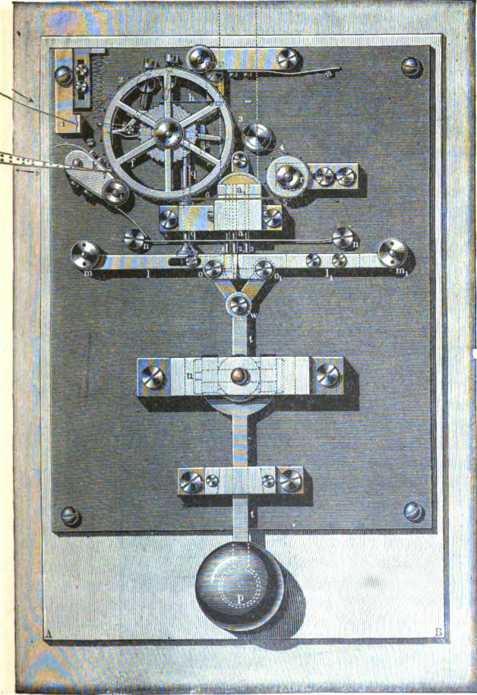
Fig. 428.

714 THE AUTOMATIC TELEGRAPH.
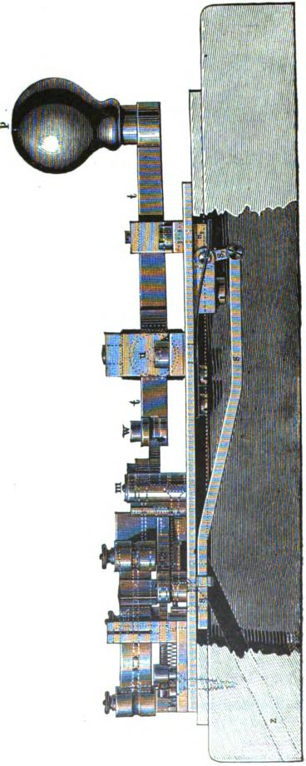

SIEMENS S APPARATUS. 715

tance between the punches 1 and 2 is * of an inch, while that between 2 and 3 is of an inch. When, therefore, punches 1 and 2 are simultaneously driven through the paper the two resulting perforations are .- of an inch apart. With punches 1 and 3 they are ₃ of an inch apart.
The perforations are made at a uniform distance of - of an inch one each side of the middle row of perforations, and, as will be shown hereafter, transmit alternate pulsations in such a manner as to produce the Morse characters upon a polarized recording instrument. The punches are driven through the paper by the action of the two horizontal levers 1 and 1₁, pivoted respectively at m and m_{i}. The adjacent free ends of these two levers are cut out and made to lap over each other in such a way that the lever 1 will act upon punches 1 and 2, and the lever 11 in like manner upon 1 and 3. The flat spring n n serves to withdraw the punches from the dies when released by the levers. Either of the levers 1 or 1, may be operated at pleasure by pushing the knob p of the handle t to the right or left, which causes the jointed connecting links o and o_{f} connected with the punch levers to be brought into action.
The paper strip is fed by the wheel f, which has a row of equidistant short pins upon its periphery; these enter into the centre line of holes previously perforated in the strip, which latter enters in the direction of the arrow at 1, and thence is led through guides, by the way of 1, 2, 3 and 4, round a smaller but similar wheel r, which keeps it stretched tight, and thence leaving this wheel at 5 it passes between the punches and the dies back to the wheel f, and finally under the jockey roller i, when it is released by the blade k which separates it from the wheel j: The motion of the latter is regulated by a ratchet wheel on its axis, operated by means of a pawl and lever, which latter receives its motion from the rod q. The lever 1, as well as the lever 1, (the latter being lengthened for the purpose) act upon this roil, and push the pawl forward the distance of one tooth or two teeth, according to which lever is operated, and the recoil of a spiral

716 THE AUTOMATIC TELEGRAPH.
spring pushes the ratchet wheel forward the proper distance after the punches have been withdrawn from the paper. In order to
form the space between the successive characters provision is
made for advancing the paper, without punching it, by depressing the knob p when in its middle position. This is effected by
the angle lever s, s„ which acts upon a horizontal bar s, as seen in fig 429. This acts upon the pawl in the same manner as the rod 7 before described. The little discs cut out by the punches are carried away by the channel z, fig. 429.
In order, therefore, to compose a despatch, the knob p is pushed to the right to form a clot, to the left for a dash, and downward to form the space after each letter—this movement bein, also made twice at the end of each word. A skilful operator can perforate about twenty words per minute with this instrument.
Siemens's keyboard perforator serves the same purpose as the one just described, but, like Humaston's apparatus, perforates a complete character by a single touch of the appropriate key. This enables it to he operated at a much higher rate of speed than the hand perforator. Indeed, a skilled operator can perforate at the rate of forty or fifty words per minute by the aid of tins machine.
Fig. 430 is a plan view of the essential parts of the keyboard perforator, which will enable its operation to be understood. A series of twenty horizontal cylindrical punches, c c, are arran,ed parallel to each other, passing through a guide bar, and a corresponding series of dies formed in the steel die plate g. The whole series of punches pass throtn.th a steel spring, 7/ 7I, each one being formed with a shoulder winch gives it a bearing against the spring. Each separate punch is also provided with a spiral spring in addition, which is not visible in the figure. The paper, previously provided with a centre line of perforations, as before explained, is led between the die plate g and the guide plate which carries the punches, and is fed from a roll P over the wheel by means of a feed wheel f, precisely like that in the hand puncher. A series of parallel horizontal push bars, kh,

SIEMENS APPARATUS. | 7t7
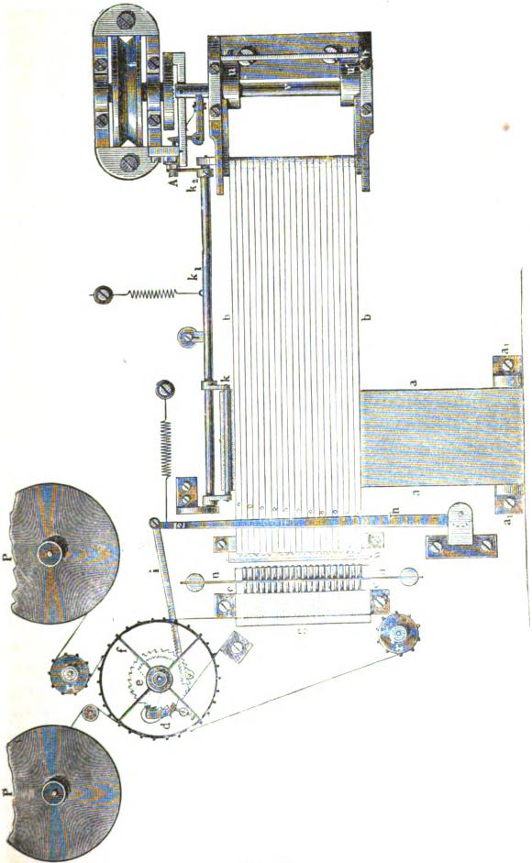
Fig. 4A.

718 THE AUTOMATIC TELEGRAPH.

twenty•one in number (one more than the number of punches), collectively movable in the direction of their length, are placed transversely upon the bed of the machine, and serve to act upon the punches in a manner hereafter to be explained. When in their normal position the left band ends of the push bars are slightly lower than the plane of the series of punches. The right hand end of each of the bars is hinged to a common axis, mounted upon a movable frame.
The levers a a, connected with the keys of the keyboard, are very thin laterally, but of sufficient depth to give the necessary strength; they are brought close together and hinged to a common axis, a_{l} a„ from whence they extend backward at right angles to and directly underneath the series of push bars. When, therefore, a key is depressed, the corresponding lever of the series a a is raised, but as its upper edge beneath the push bars. is cut out into teeth and spaces corresponding , to the character it is intended to represent, it does not lift all the twenty-one push bars, but only such as are required to operate the particular combination of punches which will perforate the corresponding character, while the remaining bars are not moved. In addition to selecting the proper push bars and raising the ends. of these into line with the range of punches, the same movement of the key lever lifts a rod attached to the crank k upon the shaft k₁, causing the latter to turn upon its axis, and this. movement, in turn, by means of the crank k₂, actuates a device which couples the axis v and the eccentric movement u u to the constantly revolving pulls t, which is kept in rotation by a treadle, fly wheel and band. When this coupling is thrown into gear by the depression of any one of the keys, the shaft v with the eccentrics u u instantly makes one revolution and uncouples itself; the whole series of push bars is driven suddenly to the left, and such of them as have been raised into line with the series of punches strike against their corresponding punches and drive them through the paper, returning again to their places by the action of the spiral springs which surround them as soon as the push bars are withdrawn. The push bars are bevelled at the

SIEMENS'S APPARATUS. 719

ends, and the transverse horizontal separating blade w supports the raised bars while they are acting upon the punches, while the remaining bars pass underneath it.
Owing to the varying length of the telegraphic characters, it is necessary to adopt a special and ingenious device for feeding the paper, the distance which must be pushed forward being the greater as the character last perforated is longer., This result is obtained by means of a lever, h, which is acted upon by a series of pins upon the push bars. These pass freely underneath the lever, except when raised by the action of a key, in which case they strike against it and carry it along. As the pins act at varying distances from the fulcrum of the lever, it is evident that the pin which strikes the nearest to the fulcrum will communicate the greatest angular motion to the lever; therefore, as all the characters are formed commencing at the rear bar, the greater the number of bars required to form the character, the nearer the fulcrum of the lever h will the last pin strike, and the greater will be its angle of motion. The movement of the lever h, whether greater or less, is communicated by the rack bar i to the feed dog d, which slips over a greater or less number of teeth, according to the extent of its movement, as determined by that of the lever h, and on the return of the latter by the power of its attached spiral spring, it turns the wheel f and feeds the paper the appropriate distance. The hindmost push bar has no corresponding punch, as it is merely used to produce a space.
The manner in which the telegraphic signals are formed and transmitted by means of the perforations will now be explained. Fig. 431 represents the construction of the transmitter designed for operating with magneto-electric currents. The currents are produced by the revolution of a cylinder inductor or Siemens armature, figs. 414 and 415, which is shown at a, being placed between the poles of a range of permanent steel magnets m m. As we have already seen, this arrangement produces two electric pulsations of opposite polarity at each revolution. The toothed spur wheel z z is turned by the crank k, and is geared to a pinion on the axis of the inductor a. The insulated metallic wheel f

I
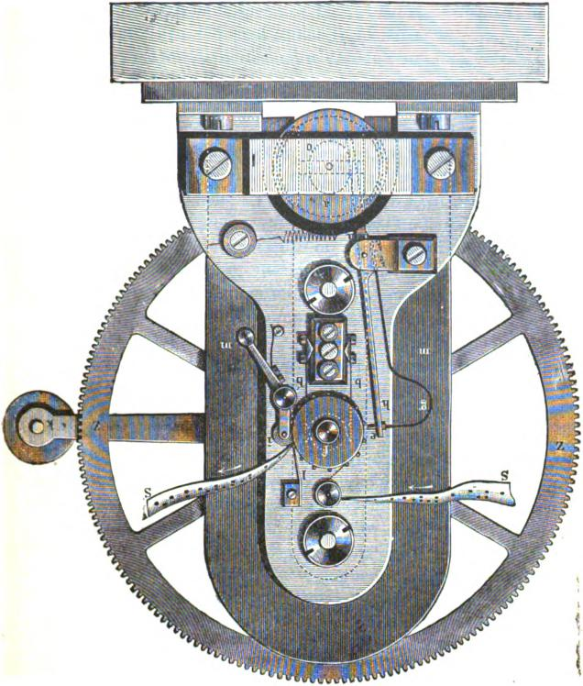
lIcIVIIIKCIRI )LLVICO.L.1V HELL OZ4

SIEMENS S APPARATUS. 721

upon the crank shaft is provided with pegs upon its periphery, which enter into the middle per-

0
00
0
O
0
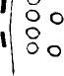
I | O O  D 0 0 0 0 0

O
00
I ³
0 c₎

I. | 0  0  O O  O | O O  O <CI

O O
_{O}O
I O iz) I O _{c}p
I O
\ O _{c)}
432.
- ^{I} forations in the transmitting strip S S, and carry
- it forward with a uniform motion in the direc-
I non of the arrows. The proportion of the gear.
- Mg is such that two electric pulsations from
-fr. the inductor, alternately positive and negative, are produced during each advance of ± of an inch in the movement of the perforated strip.
- The contact point e placed on the end of a curved spring g, which is mounted upon a rocking lever h, is caused to oscillate by the action
- of the oval cam wheel o upon the axis of the
- inductor. One terminal of the inductor coil is
- connected with the earth through the frame of the apparatus, and the other with the lever h
- and contact point e. The line wire is connected
- with the insulated metallic wheel f by means
- of contact springs b 1)¹. Consequently, as often as the contact point e touches the periphery of
- the wheel f a current from the inductor is sent into the line. If, however, the perforated strip
- of paper be put on the wheel, then the current can go to line only when the contact point e falls into one of the perforated holes, otherwise
- the circuit will be interrupted by the paper. Fig. 432 represents a part of a perforated slip
- containing the word BERLIN in the Interno-+ tional alphabet. The middle row of perfora-
- are used only to guide the paper, all the contacts being made through the upper row. The contact point e strikes the paper every
- of an inch, owing to the action of the mechan-
- ism, and is charged with alternate positive and
negative pulsations from the inductor, as de-
+
noted by the + and — signs below. The

722 THE AUTOMATIC TELEGRAPH.
signals are received upon a polarized ink writer at the distant station. The contact point goes through the first perfora-
tion at the left, and transmits a or marking current. The
next succeeding — and currents are cut off by the ab-
sence of perforations. The next current is a — or spacing mu-
m
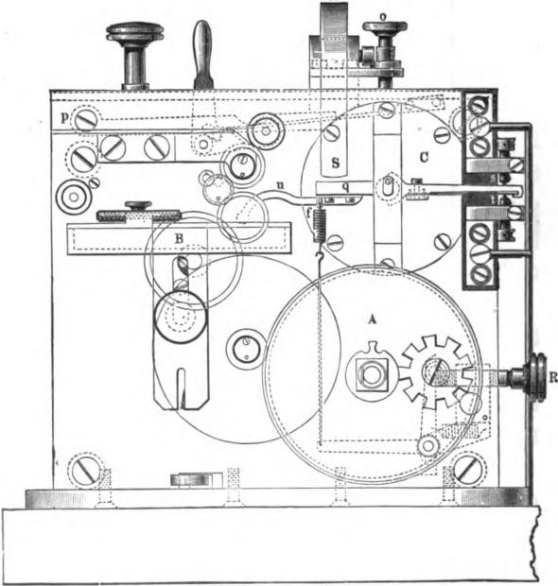
Fig. 483.
rent, which goes into the line and terminates the initial dash of the B. Then three + or marking and three — or spacing currents are sent in alternate succession, which completes the final three dots of the B. The corresponding characters, as they are written by the ink-writer, are placed above the strip for eompari-

SIEMENS'S APPARATUS. 723
son. It will be observed that all signals, whether dots or dashes, are commenced with a current, and can be terminated only by a — current. The apparatus is sometimes arranged with a' treadle instead of a hand crank, and it may be arranged to work with battery currents by substituting a simple reversing commutator for the magneto-inductor described.
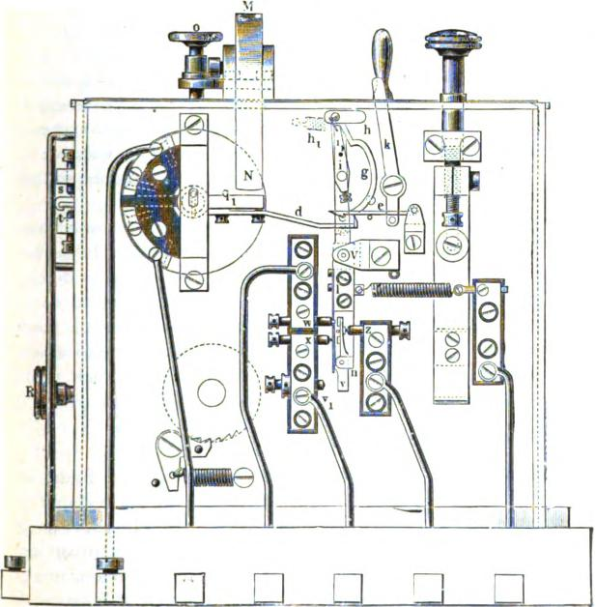
117g 434.
Fig. 433 is a front and fig. 434 a rear elevation of the ink-writer used on the Indo-European line, which has its wheel work so arranged that the speed may be instantly changed so as to adapt it either for automatic or hand transmission. Its

724 THE AUTOMATIC TELEGRAPH.

general construction is the same as that of the instrument shown on page 490, having an external spring barrel .A, an adjustable ink reservoir B, and a centrifugal regulator or governor. The principal peculiarity of this instrument is in the construction of the polarized magnet. Within the single coil C is a movable core provided with pole pieces q q„ which are attracted or repelled according to their polarity by the permanent magnet M, which is made adjustable by the screw o. To the pole piece q is attached the arm u which carries the marking wheel. The other arm vibrates between the adjustable stops s and t, and is provided with a repeating contact spring for use when needed.
The recording apparatus is provided with an ingenious and effective self-starting and stopping mechanism, which is shown in detail in fig. 434, but which it is not necessary to describe in this connection.
The automatic apparatus thus constructed and operated was used on the Lldo-European line as early as 1868. It has for many years been used in the central telegraph station at Berlin, for transmitting weather reports in several directions at once. Siemens's automatic system may justly be regarded as the most ingenious and original one in existence, and is the one to which rival systems have been indebted for many of their most valuable and even essential features.
THE AMERICAN AUTOMATIC TELEGRAPH.
An automatic system was patented in the United States in 1869 by George Little, of New Jersey, in which the perforating apparatus was operated by electro-magnetism. The paper strip was fed to the cutters by a feed wheel, carrying a revolving armature upon its axis, which was driven by an electro-magnet, forming a small motor. The punch and die were also actuated by electro-magnets. The perforator was manipulated by a tablet formed of non-conducting material with the telegraphic characters inlaid in metal, and a style or circuit closer attached to one pole of the battery by a flexible conductor, the other pole being in connection with the inlaid characters of the tablet. When the

LITTLE'S SYSTEM. 725

person composing the message drew the style at a uniform rate of speed over one of the inlaid characters upon the tablet, alter-
nate pulsations of electricity were produced for feeding the
paper and perforating it by the action of the electro magnet. The transmitting machine was similar to that of Bain, except that it
was driven by an electro-magnetic motor, while the record was made by electro-chemical decomposition, a platinum roller being employed in place of the iron stylus of Bain.
In 1839 a telegraph line was constructed from New York to Washington, about 280 miles in length, which was intended to be operated by this system. It was soon discovered, however, that the transmission at high speeds was very materially retarded by the effects of induction, which caused the dots and dashes to run into each other and become indistinct and illegible. The perforating apparatus was also found to be totally inadequate to the requirements of an efficient service. Little, in 1870, succeeded in partially overcoming the effects of inductive action by means of a shunt passing around the receiving instrument in which an adjustable rheostat was inserted. This device rendered the recorded signals much more distinct, but still fell short of what was required. Soon afterwards it was discovered that, by the insertion of an electro-magnet in the shunt passing around the receiving instrument, the signals at high speeds and on long lines were vastly improved. This effect is owing to the opposing induced currents set up by magneto-electric action within the short circuit formed by the shunt and the receiving instrument A keyed perforator upon the same general principle as that of Siemens —(fig. 430) was also introduced, by which the transmit, Ling slip could be prepared at a rapid rate. The perforations, as made by this machine, are arranged in two lines and grouped to form the dots and dashes of the telegraphic characters in the manner shown in fig. 435. The lower row of perforations are of comparatively small size, and by themselves each represent a single dot The dash is formed by two of these smaller perforations in the lower line combined with a single large perforation in the upper line. The circuit closer of the transmitting

726 THE AUTOMATIC TELEGRAPH.

machine consists of two small rollers running side by side and electrically connected together. As one of these rollers runs over the upper and the other over the lower line of perforations, the effect produced by passing over a group of two small perforations and one large one is to close the circuit three times as long as for a single small perforation, so that, as transmitted, one dash is equal to three dots.
The arrangement of circuits shown in fig. 436 is the one which has been adopted for long circuits. A represents the transmitting and B the receiving station. At the transmitting station two equal batteries, E and E₁, are placed in the main circuit with their like poles towards each other, and normally produce no effect upon the line. When, however, the battery E₁ is shunted by the closing at the transmitter of the short circuit,

NMI MIN =I NMI SIM
0 0
OOO O O O O O OO O O
I'll. 435.

1, 2, 3, 4, the current of the battery E passes over the line to the receiving station. When the circuit at the transmitter is broken the flow to line ceases, and the return or static charge is neutralized by the magneto-electric discharge from the induction coil M, which consists simply of an electro-magnet with its armature permanently in contact with its poles. The recording instrument at the receiving station is shunted with a series of helices M, arranged upon iron cores, the former being continuous while the latter is divided into sections which may be connected or disconnected by the insertion or withdrawal of iron contact plugs, so as to increase or diminish the length of core under a single inductive action. In this way the duration of the discharge from the helices may be adjusted to correspond with that of the line. It is obvious that the discharge from the helices.

THE AMERICAN SYSTEM. 727
M₁, which occurs at the termination of each signal passing over the line, will be in the reverse direction to the primary current, and will therefore tend to neutralize and destroy that portion of the inductive discharge from the line which tends to pass through the receiving instrument at B. This effect is greatly augmented by means of the adjustable condensers C, which are arranged in connection with resistances r r r, so that the time of the discharge may be graduated to produce the best effect On
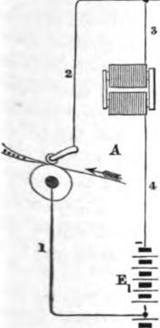 | 31 | 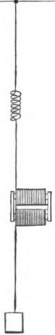 | 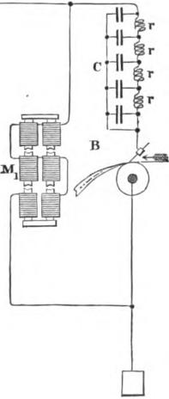
IMO
E

Fig. 436.
zvery. long circuits it has been found advantageous to connect the ^{inaL111}- line with the earth at one or more intermediate stations, ^{i}L^{I-}tiding in this derived circuit an electro-magnetic coil of very 'at resistance, as shown in fig. 436. On circuits of moderate ^{let)}RILL the battery E₁ is dispensed with and an adjustable rheo-
is_{m} placed in the wire 3, so that the current passing through
¹²Iazty be regulated to produce the proper inductive effect. The

728 THE AUTOMATIC TELEGRAPH.

condensers C are not used except upon very long circuits. The above described improvements in the American system are nearly all included in the patents of T. A. Edison.
AUTOMATIC MECHANICAL TRA.NSMITTERS.
A certain class of instruments, which differ in some important .respects from the automatic apparatus hereinbefore described, and which from their construction may appropriately be termed automatic mechanical transmitters, have formed the subject of a series of inventions and improvements ever since the first introduction of the Morse telegraph, although they have not thus far proved to be of any especial value in a practical point of view. By means of a machine of this kind each character of the telegraphic alphabet, however complex, is formed and transmitted over the line by a single touch of a key, as in the type printing instrument. Several inventions of this kind were made and abandoned by Morse during the experimental stage of his invention which preceded its introduction into actual service. A few years later Mr. A. F. Park, of Troy, N. Y., constructed a very elaborate and perfect transmitter of this kind, which gave excellent results. Many other inventors have attempted the same thing, with results more or less satisfactory.
SIEMENS'S AUTOMATIC CYLINDER TRANSMITTER.
This instrument unites the two functions of composing and transmitting messages automatically, by means of a single apparatus of comparatively small dimensions. These two functions arc independent of each other, although they are both carried on at the same time. The cylinder transmitter is placed directly in the circuit of the line, and the message is composed by depressing the keys of a keyboard, as in a type printing instrument. The rapidity with which the keys may be manipulated depends upon the velocity of the revolving cylinder, the speed of which is independent of the working of the keys. The message is received in Morse characters, but the difference in the length of the signals and spaces does not depend upon the time the keys

SIEMENS'S CYLINDER TRANSMITTER. 729

are depressed; on the contrary, they always appear of their normal length, whether the sender occupies more or less time between the depression.of two following keys. The spaces between the words are produced by a blank key. The keys are arranged in seven rows of seven keys each, in such a manner that the letters most frequently used are placed most conveniently to the position of the hand.
The apparatus may be arranged to send single or double (alternating) currents, with or without earth discharge, according to the circuit for which it is required.
The transmitting capacity of the apparatus depends upon the rapidity with which the operator is able to finger the keys. An expert operator can touch five keys per second, which would produce 3(X) characters per minute, equal to about ninety mes^{sa}ges per hour. The advantage which is intended to be realized ^{b}y the use of this apparatus is a material increase of speed without danger of defective formation of signals, as in hand trans^{mi}ssion. The apparatus may be used at any moment in place
of the ordinary Morse key. Fig. 437 is a perspective view of
the
instrument, and fig. 438 is a sectional view, showing the
^{e}ssenti_{a}l parts of the internal mechanism. The most important feature of this is the cylinder D, which revolves upon its axis. The periphery of the cylinder is fitted with sliding pins s 8, Placed close to each other and parallel with the axis of the ^{c}Y^{li}llider. These, when pressed against at one end by the pusher ^{n}' ^{ar}e displaced to a certain distance in the direction of their toill, Groups of displaced pins, variously combined, consti-^{e} types for the automatic transmission of the telegraphic ^{si}g^{n}als. Thus three successive displaced pins represent a dash; ^{aBi}llgle displaced pin between two others in their normal position a. dot; one or more not displaced represent a space of ter or less length.
'Y the depression of a key a group of pins is displaced from its _{al} Irk normal position upon the surface of the cylinder, the group
^{W}aLYs corresponding to the character representing the letter
u
P^{mz)}rt the depressed key. The cylinder is also caused to re-

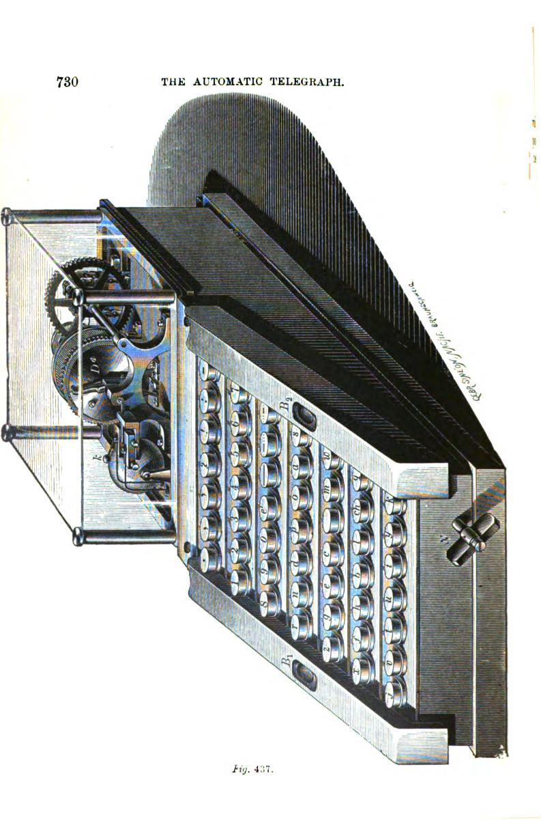
THE AUTOMATIC TELEGRAPH.
730
17.Y. 4:;7.

SIEMENS'S CYLINDER TRANSMITTER. 731
volve, by the effect of a weight or spring, to an extent corresponding to the length of a given character, thus presenting a new series of pins to the pusher n.
Fig. 43$.

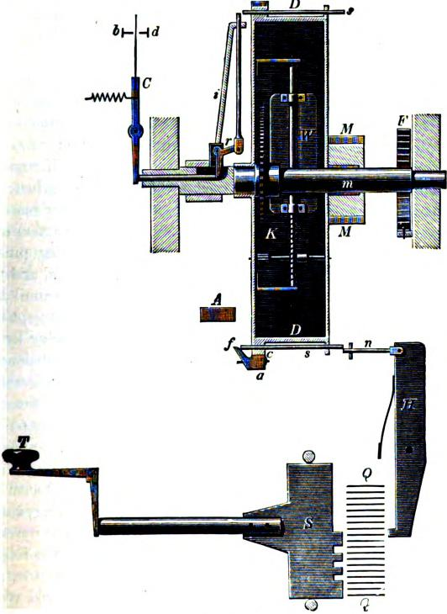
Fal
Each key T (fig. 438) is connected with a vertical plate of metal S in such a manner that when it is depressed the corresponding plate S is pushed forward. The projections upon the

732 THE AUTOMATIC TELEGRAPH.

edges of these plates (which of course are differently arranged for each letter) push forward a series of horizontal slides Q Q, of which there are nineteen in all, each operating upon a separate pivot •d lever H. Each of these levers is provided with a pusher n. When, therefore, the slides Q Q are pressed forward they act upon the levers II, which in turn push forward⁻the sliding pins s a, by means of the pushers n. A pointer i, connected to the axis m (upon which the cylinder D rotates independently), is geared to the clockwork within the cylinder, and is set in motion by the spring F, which, being attached to the spindle m, is made to wind up each time the cylinder rotates. The cylinder is provided with ratchet teeth c, in which engages a spring pawl a, having an inclined projection f, and whenever this pawl is engaged with the ratchet teeth the cylinder remains at rest. When one of the levers II is moved by the action of a finger key, so as to displace one or more of the sliding pins s, these latter at the same moment disengage the pawl a, and the cylinder 1) revolves by the action of the clockwork until the pawl a again drops into gear. The pawl, however, is kept out of gear so long as any of the projecting pins 6 are passing by its inclined projection f, and the width of the latter is sufficient to allow the cylinder to revolve for an additional distance, which corresponds to the ordinary space between the characters. It may here be remarked that the pushers n, after acting u; on the sliding pins, pass beneath the line of the pins and do not therefore impede the motion of the cylinder D.
The pins, after passing the pawl a, are carried round with the cylinder in their protruded position, and the pointer i in passing over them, causes the contacts to be made by which the currents are transmitted to the line. This is accomplished in the following manner: ⁻Upon the pointer i, near its axis, is mounted the bell crank lever r, to one arm of which is jointed a rod which extends along the pointer beyond its extremity, while to the other arm is jointed a similar rod, which extends axially through a hollow _{h}art of the spindle m, on which the pointer is mounted. When the pointer i passes over a projecting pin the radial rod

SIEMENS'S AUTOMATIC CHAIN TRANSMITTER. 733

is pushed inward, which causes the axial rod to be pushed outward, thus actuating the contact lever C, which acts like an ordinary key and transmits the signals to the line.
After the pins s s have performed their office they pass under a fixed incline, which restores them to their normal position.
The pointer i, together with the cylinder D, makes jerking rotations independent of its own motion in the opposite direction, the speed of the pointer being regulated by the fan W. According to the greater or less rapidity with which the operator presses down the successive keys T T, either the jerking movement of the cylinder or the contrary movement of the pointer will prevail; that is to say, in the former case the pointer will be carried further round, away from the stop A, while in the latter case it will approach the stop, moving in the opposite direction, or in other words, the store of prepared letters between the stop A and the pointer i will be either diminished or augmented. The entire rotation of the pointer is somewhat less than one revolution, and as soon as the pointer reaches the limit of the movement which is allowed for storing the letters which are to be telegraphed automatically, a bell is struck, which indicates to the operator that the speed of fingering the keys should be lessened. As soon as the operator stops working the keys no more pins are pushed out, the pawl a drops into the ratchet teeth and stops the movement of the cylinder, while the pointer 1, which may at the time be some distance behind, will still continue to revolve until it comes in contact with the stop A.
This apparatus has been employed on the line between Berlin and Breslau, in Germany, and is said to have given very satisfactory results, its speed of transmission being somewhat greater than that of the Hughes apparatus.
SIE3dENS'S AUTOMATIC CHAIN TRANSMITTER.
This apparatus somewhat resembles that last described, except that it is designed to produce Steinheil's writing, consisting of groups of dots arranged in two lines, instead of /gorse's. The sliding pins, instead of being disposed on the periphery of a cyl-

734 THE AUTOMATIC TELEGRAPH.

inder, are carried by an endless chain. The displacing of the pins is effected in much the same manner as that last described. There are, however, two contact levers, one of which is operated by the pins which are made to project to the right, and the other by those which project to the left. One contact lever sends positive and the other negative currents to the line. For the rest the apparatus is very nearly the same as the cylinder transmitter.
SIEMENS'S AUTOMATIC TYPE-PRINTING TELEGRAPH.
This apparatus was invented in 1873, and so far as external appearance is concerned, is very similar to the cylinder transmitter illustrated in fig. 437. The internal mechanism will be understood by reference to fig. 439. The message to be sent is composed in the usual manner by depressing the keys in proper succession upon the key-board. By means of two groups of levers H₁ and II„ the sliding pins a a are displaced in one direction or the other upon the periphery of the cylinder D. The displaced pins operate upon two contact levers C_{I} and 0₂, exactly as in the apparatus illustrated in fig. 438, and as the same letters of reference are used the detailed description need not be repeated. The contact levers C_{r} and C₂ transmit positive and negative currents of equal length into the line, by means of which the type-wheel at the receiving station is controlled; that is to say, the letter which is to be transmitted is brought into position to be printed. To accomplish this the type-wheel is provided with a double escapement; the escapement, set in motion by currents of one polarity, advances the type-wheel by leaps of four letters at a time, while that set in motion by currents of the other polarity advances it but a single letter. The key-board does not contain the numerals, which latter are expressed by letters, preceded and followed by a special sign, and the inventor thus succeeded in reducing the number of pulsations required to bring the type-wheel to any given letter to a maximum of eight. The twenty seventh division of the type-wheel is blank, because twenty-seven steps cannot be made

SIEMENS'S AUTOMATIC TYPE-PRINTING TELEGRAPH. 735
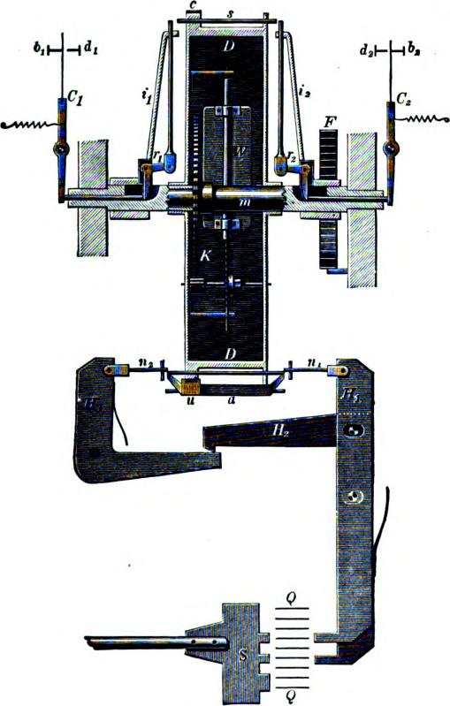
Fly. 439.
by less than nine pulsations, six leaps of four letters and three of one letter each. Consequently thirty-one divisions of the type-wheel are available for producing twenty-nine letters and signs, the thirtieth division being reserved for the special sign for in-

736 THE AUTOMATIC TELEGRAPH.

dicating numerals, and the thirty-first for the space between the words. The type-wheel returns to the zero point after the printing of each letter. The speed of this printer is ver; considerable, as when the letters are arranged in proper succession but three or four pulsations on an average are required for each letter, and the action of the printing mechanism and the return of the type-wheel to zero follows almost instantaneously.
It will be seen that this printer possesses the l eculiarity that the operator may finger the keys with great irregularity provided it is done in proper succession, and that the letters are stored up, as it were, in the transmitter, and sent off with regularity and precision by the action of the mechanism.
PHELPS'S AUTOMATIC TYPE PRINTING TELEGRAPH.
A modification of the electro-motor type printer, described in Chapter XXXIV, has been made by Mr. Phelps, in which the somewhat complex transmitting mechanism is replaced by a circuit-closer actuated automatically by a perforated strip of paper. The circuit is not closed directly through the perforations, but by means of a device arranged upon somewhat the same principle as the Wheatstone automatic transmitter. It will easily be understood, from the description which has already been given of the printing mechanism, that it is only necessary that tire distances between the successive perforations should correspond with mathematical accuracy to the distances apart upon the type-wheel of the successive letters which they represent, and that the strip should be carried along synchronously with the type-wheel of the receiving instrument, to insure the proper reception and printing of the message.
In order to prepare the paper strip for automatic transmission Mr. Phelps has invented a perforating machine operated by a key-board precisely like that of the electro-motor instrument. By depressing the proper keys in succession, the respective single perforations which represent the various characters are made in the paper band at the precise distances apart required. Another valuable feature of this perforator consists in the addi-

JAITE'S SYSTEM OF TELEGRAPHY. 737

tion of a type•wheel by means of which each letter of the despatch is printed above the perforation representing it, and by the same movement of the mechanism. The perforator may be readily operated at a moderate rate of speed by an unskilled person, and hence it is possible for correspondents who desire to do so, to prepare their own messages by means of one of these machines, and it would also be possible for a telegraph company to transmit these prepared messages at a very low rate. A skilled operator can work Mr. Phelps's perforator at the rate of fifty or sixty words per minute with ease.
C. H. G. Olsen, a Norwegian mechanician, has quite recently adapted a similar automatic arrangement to the Hughes instrument, which was exhibited in 1875 at the telegraphic conference in St. Petersburg.
JAITE'S SYSTEM OF TELEGRAPHY.
The telegraphic system invented by G. Jaite of Berlin, in 1868, may, perhaps, be properly included among the descriptions of automatic telegraphs, although the automatic feature is in a great measure subsidiary to the main purpose of the invention, which is to provide a means of working at a high speed to any distance however great. This is accomplished by the use of what may be termed a mechanical repeater, which re-transmits the signals by means of mechanism set in action by a sensitive electro-magnet.
Jaite's apparatus does not record the dots and dashes of th Morse alphabet, but resembles Steinheil's, inasmuch as the writ ing consists solely of dots grouped in two lines. The two lines of dots are produced by positive and negative currents of equal duration, which are transmitted by means of two Morse keys T₁ and 'I', (see fig. 440, which is a perspective view of the complete apparatus). The arrangement of the keys with respect to the battery and the line and earth wires is shown in fig. 441, in which k and k₁ are the key axes, n and n, the front contacts, and o and o, the rear contacts. B is the mai❑ battery. When the left hand key is depressed a positive or copper current is

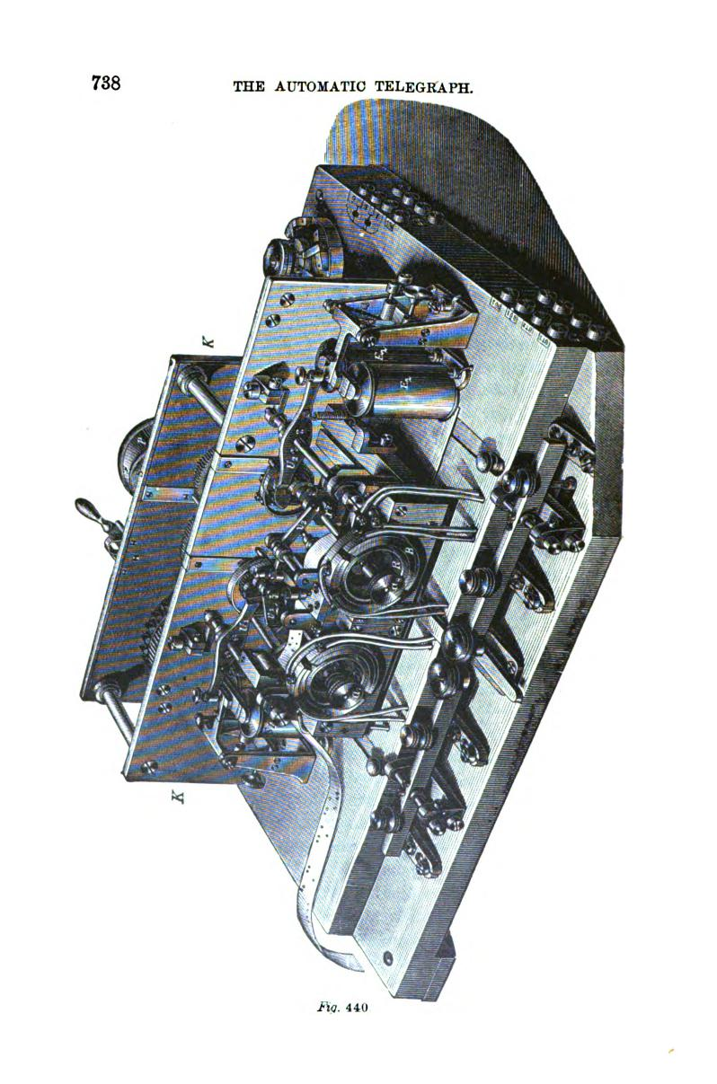

JAITE'S SYSTEM OF TELEGRAPHY. 73A
sent to line, while the right hand key in like manner sends a zinc or negative current
The receiving apparatus consists of two electro-magnets E, E₂ (fig. 440) whose cores are normally polarized by permanent
_L,
n
T T
44L
magnets, exactly as in the Hughes apparatus (page 625). When, therefore, no current is passing, the armatures of both electro-magnets are attracted by their poles. If by means of the key T₁ a positive curvent, or by the key T₂ a negative pulsation or dot is sent over the line, then one or the other armature is released and flies off by the action of a spring, as in the
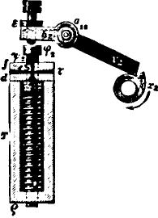
Fig. 442.
Hughes instrument, and striking one of the detent levers U₁ U₂ causes the corresponding axis carrying a cam x₁ or x, to make a revolution. This is effected by coupling the front portion of the axis, which is normally stationary, to the rear portion, which is kept in constant revolution by the clockwork K driven by a weight or spring.

740 THE AUTOMATIC TELEGRAPH.

The record is made by circular perforations in the paper strip, which represent dots, and are not only more legible than any other mode of marking, but the strip may be used without further preparation for automatic transmission over another circuit. The perforating mechanism is clearly shown in fig. 442. The revolution of the cam x₂ in the direction of the arrow lifts the arm v₂ and depresses the arm h, of the punch lever. The paper strip is fed through between the plates f and d and the punch is driven through it by the depression of h„ while the spiral spring underneath returns the latter to its position again when the pressure is withdrawn. Upon the completion of a single revolution the cam x₂ is caught by the detent lever U₂, which in the meantime has returned to a state of rest A revolving circuit.closer or commutator on the same axis with the cam x₂ serves to retransmit the pulsation into the next circuit without shortening it, as the ordinary repeater does, and this operation may be repeated indefinitely upon any number of circuits.
It would require too much space to refer in detail to the great number of other methods of automatic telegraphy of more or less value which have been suggested from time to time. It may, however, be mentioned that Mr. C. Westbrook, of Pennsylvania, in 1867 constructed an automatic transmitter in which the embossed characters produced by the Morse register upon a strip of paper were used instead of perforations to operate the circuit•closing mechanism, and which gave very satisfactory results on an experimental trial.

CHAPTER XXXVIL
AUTOGRAPHIC OR COPYING TELEGRAPHS. •

THE autographic telegraph has never been practically employed to any considerable extent in the transmission of messages. The reason of this is partly because the rate of transmission has generally, if not always, been too slow to enable them to be profitably employed for the transmission of ordinary communications, and partly because the occasions which require the production of an autographic copy of a message are compara-ratively infrequent. From the fact that no skilled labor is necessarily required for the transmission of despatches upon this plan, the original copy being prepared by the sender of the message, and the received copy being in condition for immediate delivery as it comes from the instrument., many have regarded the autographic) process as one destined in future to furnish a less expensive mode of telegraphing than any hitherto in use. Much remains to be done, however, before the realization of these expectations can be regarded as in any degree probable, although some of the methods already invented exhibit a high degree of ingenuity, and under favorable conditions have produced very excellent results
BAKEWELL'S COPYING TELEGRAPH.
In 1850 a copying telegraph was brought out by Mr. F. C. Bakewell, of London, by which despatches were transmitted in the actual handwriting of the sender. The apparatus is represented in fig. 443. c is a metallic cylinder which revolves at a rapid and uniform rate by means of a system of clockwork M. A toothed wheel upon one end of the cylinder gears into a pinion upon an axis which is parallel to that of the cylinder, and has a fine screw thread cut upon it for its en-

742 AUTOGRAPHIC OR COPYING TELEGRAPH&
tire length. The nut q is capable of moving laterally upon the screw thread, and carries an arm to which is attached a metallic style or tracer r, the end of which rests upon the surface of the cylinder c. It will readily be understood from the arrange. ment of the mechanism that when the cylinder revolves the tracer will be carried along laterally by the thread of the screw, and will, therefore, describe a continuous spiral line upon the surface of the cylinder. Both the stations in correspondence are provided with the same apparatus. At the sending station the message is written upon a sheet of tin foil, or paper hay_{L}
-
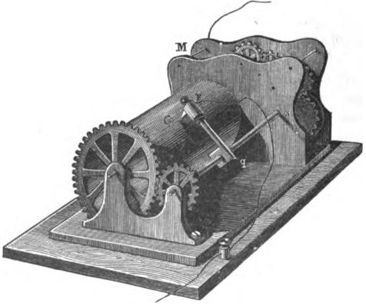
Fig. 443.
ing a metallic conducting .surface, with a pen dipped in a nonconducting ink or varnish—for example, a solution of resin in alcohol. The letters thus written form upon the conducting surface a number of non-conducting lines, which suffice to interrupt the electric contact, although the deposit of resinous matter is so slight as not to be perceptible to the touch. At the receiving station a sheet of paper of the same size is used, this being chemically prepared in the same manner as the paper used for Bain's method. The arrangement of the connections

BAKEWELL'S COPYING TELEGRAPH. 743
is shown in fig. 444. The line wire L forms a connection between the respective cylinders c and c', through the frame of the clockwork M M₁. R R₁ are the keys, and B B₁ the main batteries; the remaining connections will be readily understood from the diagram.
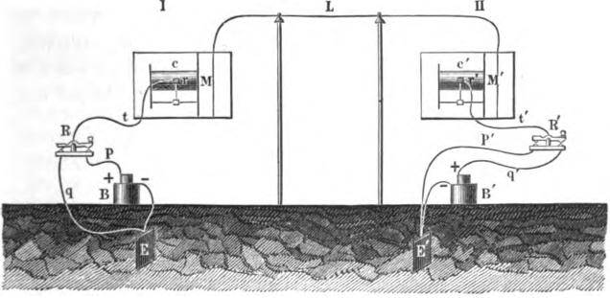
Pig. 444.
The message on tin foil is fixed round the cylinder c, at the transmitting instrument, which instrument is a counterpart, in its mechanical arrangements, of the receiving one, and either of them may be used to transmit or receive messages. The metal style r which is in connection with the battery, presses on the tin foil, and is carried along by an endless screw as the cylinder revolves, exactly in the same manner as the iron wire that draws lines on the paper on the receiving instrument, which is arranged on the electro-chemical plan of Bain. The varnish writing when interposed between the style and the tin foil, interrupts the electric current; consequently, at every part where the electric current is interrupted by the varnish at one instrument, the style ceases to make marks upon the paper at the other station. Both cylinders are so regulated that they rotate exactly together; therefore, the successive breaks of the electric current by the varnish letters

744 AUTOGRAPHIC OR COPYING TELEGRAPHS.

cause corresponding gaps to be made in the lines on the paper; and the succession of these lines, with their successive gaps where the letters occur, produces on the paper of the receiving instrument the exact forms of the letters. The letters appear of a white or pale color on a ground of blue lines, there being about nine or ten lines drawn by the wire to make one line of writing.
Bakewell used an electro-magnetic governor to attain synchronism in the movements of the two apparatus, without which it would certainly have been impossible to have obtained any satisfactory results.
CROSS COPYING TELEGRAPH.
M. Charles Cros, of Paris, has invented a chemical copying telegraph, which differs in construction from that of Bakewell in the style travelling round the cylinder, instead of the latter turning underneath the• style, and in the adjustment of the synchronism six times during every revolution. The apparatus consists of a clockwork driven by a heavy weight, and giving °. horizontal motion to the cylinder and a rotary motion to an axis carrying the style. The style is fixed to the end of an elbow piece, and travels round the cylinder, always in the same plane; but as the cylinder, when the apparatus is in motion, is moved sideways, the style describes upon its surface a long line in the form of a close helix. The styles of the two apparatus do not move regularly, but are arrested and released six times in every revolution, for the purpose of regulating the synchronism. When one apparatus goes faster than the other, its style is arrested by the armature of an electro-magnet, until the slower one has come up with it and closed the circuit which releases them together.
CASELLI'S PANTELEGHAPH.
As early as 1856 Abli6 Caselli made his first experiments with his electro-chemical copying telegraph, at Florence, Italy, and

CASELLI'S PANTELEGRAPH. 745

the following year a working model was constructed for him by Froment, of Paris. For several years Casein devoted himself to the improvement and perfection of his invention, and in 1866 it was introduced into practical service both in France and Russia. Caselli's apparatus is really an improved form of Bakewell's invention. It consists substantially of three parts—the recording or writing apparatus, the mechanism for regulating the synchronism and the system of auxiliary batteries for charging and. discharging the line.
A front elevation of Caselli's apparatus is shown in fig. 445, two exactly • similar instruments being employed at the two corresponding stations. A pendulum L, about six feet in length, is suspended from the top of an iron frame P Q. The bob M of the pendulum is of iron, loaded with lead, and weighs about 16 lbs. The latter swings between two electro-magnets, E and E', which become alternately magnetic by the action of a local battery 0 B, whose circuit is closed through them alternately by the action of the second pendulum U. The alternate action of the electro-magnets E E' serves to keep the pendulum L in motion, and through this the remainder of the mechanism. At the right side of the frame are two curved metallic tablets XX', one of which is shown in fig. 445; upon this is placed the original message which is to be transmitted at the sending station, or the prepared paper at the receiving station. Each instrument having two of these tablets it is possible to transmit and receive a message at the same time. As the two tablets X and X' are exactly alike, it will only be necessary to refer to one of them in this description. Above the tablet X a frame ,p q is mounted upon a vertical lever A B (fig. 446), which turns upon its centre on a horizontal axis. The connecting rod Z is jointed to the lower end B of the lever, and to the pendulum rod L. Thus the swinging of the pendulum rod causes the frame p q to move to and fro over the convex surface of the tablet X. The adjustable counterpoise K K' serves to balance the weight of the frame p q upon the centre of motion of the lever A B, which is coincident with the axis of the cylinderl of which X is a segment.

746 AUTOGRAPHIC OR COPYING TELEGRAPHS.
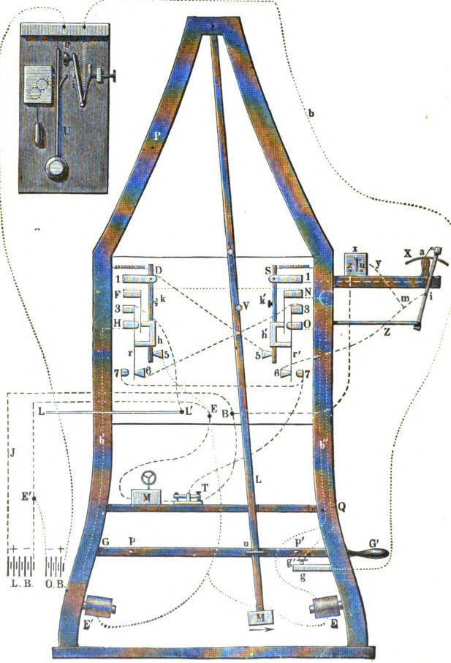
Fig. 445.

CASELLI'S PANTELEGRAPH. 747
The frame p q carries a shaft provided with two screw threads v v', each of which is clasped by a nut to which is attached a clamp a. At each complete revolution of the shaft the clamps are caused to move laterally the distance of one turn of the screw thread.
The revolution of the screw is effected by an escape wheel 0 (figs. 446 and 447) of twelve teeth. A fork R (fig. 447) is pivoted to the lever A B, and carries two pallets, r r', which alternately act upon the escape wheel. The fork is pushed back and forth at the end of each stroke by means. of the tappets h h', which alternately strike against the set-screws m n. Hence, at each
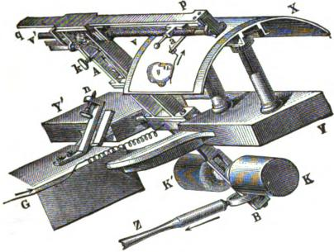
Fig. 446.
Oscillation of the lever A B towards m or n, the ratchet wheel 0 and the screws v v' turn through one twenty-fourth of a complete revolution, and consequently the clamp a is moved laterally one eighth of a millimetre.
If a style be fixed in the clamp a (fig. 446) so as to press by its elasticity against the surface of a sheet of paper laid upon the tablet X and leave a mark upon it, it is evident that by the oscillation of the frame p q, and the lateral motion at right angles, caused by the screw v v', the whole surface of the sheet would be covered with parallel ruled lines one eighth of a millimetre apart. The apparatus, however, is so arranged that the style

748 AUTOGRAPHIC OR COPYING TELEGRAPHS.
is lifted from the paper while passing in one direction over the tablet X, and in like manner upon the other tablet while pass. ing in the opposite direction. The mechanism by which this movement is effected is shown in figs. 447 and 448.
Two metallic bars C and c are arranged parallel with the screw v, and are of the same length of the latter. Their position is shown in the detached cross section, fig. 448. The bar C is fixed and is loosely surrounded by a quadrangular piece which is connected by a joint with the nut a'. The other bar c, on the

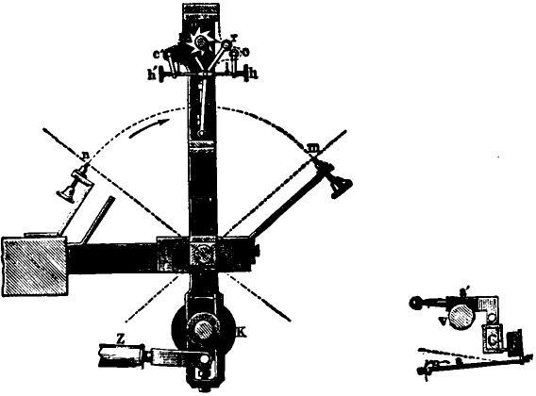

Fig. 441. ITg. 448.
contrary, terminates in pivots, one of which carries an arm t (fig. 430). The clamp or wire holder a is attached to the bar c, as shown in fig. 448. When at the end of the stroke the tappet
strikes the stop m, and, acting upon the arm 1, lifts the style from the paper by slightly turning the bar c upon its pivots. The arm /in like manner acts to drop the style upon the paper on the return movement.
The synchronism of the corresponding instruments is maintained by means of a pendulum, as follows : The current which

CASELLI'S PANTELEGRAPH. 749
actuates the electro-magnets E E' is derived from the local battery 0 B of considerable power. From the positive pole of this battery the current proceeds, as shown by the fine dotted line in fig. 445, to a commutator controlled by a clockwork and pendulum U, which latter is exactly one fourth the length of the pendulum L, and therefore vibrates twice as rapidly. When the pendulum U is in a position of rest, the contact arm i rests against the stop g, and the local circuit is continuous through the wire b to the contact plate F, which forms part of a double commutator, set up on both legs of the frame and represented on a
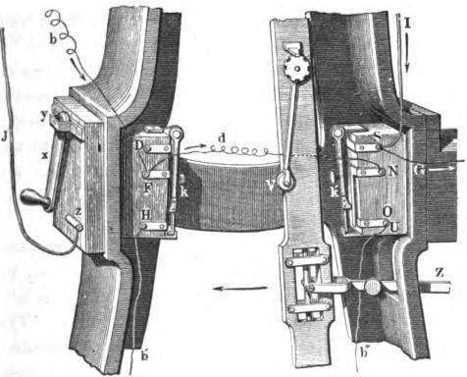
/V.449.
large scale in fig. 449. From this point the local current proceeds alternately to the electro-magnets E and E', according to the position in which the commutators are placed by the vibrations of the pendulum rod L. In order to effect this a sliding roller V is fixed upon the pendulum rod, which, at each half oscillation, alternately strikes against the two pivoted arms /c and k'. Each of the latter rests against a spring, the two springs being attached respectively to the contact plates F and N, but when in a state of rest they are slightly separated from the lower

750 AUTOGRAPHIC OR COPYING TELEGRAPH&
contact plates H and O. When the pendulum swings to and fro the roller V strikes against the arms /c and k' alternately, and by depressing the springs, connects F with H or N with O, as the case may be. When the pendulum is in an intermediate position, touching neither k nor k', the local circuit is, of course, open at F and N. When, however, the pendulum has nearly completed its swing, for instance, towards the left, and contact is made between F and H, the electro-magnet E' is charged and attracts the pendlum bob M. The same action takes place alternately upon the opposite side, and these impulses are sufficient to keep the pendulum in motion and to supply the slight power needed to carry the moving parts of the machine connected with it.
In order to release the pendulum bob M at the completion of its swing, the local circuit is broken at the proper moment by the pendulum U (fig. 445) by means of a projecting arm, which touches the knob i and lifts the spring from the contact point g. The same operation is repeated upon the opposite side, and thus the motion of the pendulum is kept up indefinitely or until arrested by means hereafter to be described.
It will now be easy to understand how the synchronism of the large pendulum at the sending and receiving station is controlled by the movements of the small pendulum U, which is, of course, in this a;Taratus a matter of the utmost importance. The knob i (fig. 445) may be adjusted nearer to or farther from the arm on the pendulum U by means of a delicate micrometer screw. In the former ease the range of oscillation of the large pendulum L decreases, and in the latter case it increases.
The reader will now be able to understand the manner in which messages are transmitted and received by Caselli's apparatus. At the sending station the message, or any drawing or diagram which it is desired to transmit, is written in bold lines with ordinary ink. upon silver paper, so called, which is prepared expressly for the purpose by coating the surface with tin. This is fastened by clips upon the surface of the tablet X, and through the clips the metallic surface is in connection with the negative

CASELLI'S PANTELEGRAPH. 751
pole of a main battery and with the earth, while the positive pole of the battery is attached to the clamp a and to the line. In fig. 450 z z is the metallic surface of the paper, L B the line battery, L the line, and E the earth. When the pendulum at the sending station is set in motion, the clamp and the style attached thereto commence to traverse the entire surface of the metallic paper. As long as the style is in contact with the metallic surface the main battery is shunted through wires 1, 2 and 3, but whenever this contact is broken by the style passing over the insulating writing, its current passes through 1 to the line and through the clamp a at the receiving station and finally to earth. The clamp holds an iron wire style which traverses a sheet of paper laid on the tablet X, the paper being chemically
Fig. 450.

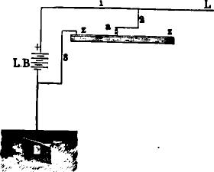
LB=
prepared according to Bain's method. As the pendulums at the receiving and sending stations swing in exact time with each other, it is manifest that when the style at the sending station passes over a line of the non-conducting writing, a corresponding blue line will he drawn upon the chemical paper at the receiving station. After half an oscillation of the pendulum has been completed the styles are moved laterally one eighth of a millimetre, but as the clamp and style are lifted from the paper during the last half oscillation of the pendulum, this portion of time occupied in its motion is lost, but may nevertheless be utilized for sending another message in the opposite direction by means of the duplicate portion of the apparatus. After a com-

752 AUTOGRAPHIC OR COPYING TELEGRAPHS.
plete oscillation the styles at both stations will have moved late'. ally one eighth of a millimetre. During the first half of the second oscillation there will appear upon the paper at the receiving station a second series of blue lines exactly parallel to the
19a4e, .So 644o to. I yte a2 0⁻
14j. 451.


49-ffedei4_ -tgege, a '—/mac
43 -epazreei cog
dae;fgOi

•
first, and about one eighth of a millimetre distant from them. In this way the two instruments continue to operate until the style at the sending station has gone over the whole surface of the metallic paper, and that at the receiving station has produced

CASELLI'S PANTELEGRAPH. 758

in parallel ruled lines a copy of the despatch written upon the metallic paper. A fac-simile of such a despatch as received by Caselli's apparatus is shown in fig. 4M of the actual size. In fig. 449 the several parts of the apparatus are represented in position for transmitting. A current arriving by line wire 1 proceeds by way of S and G to the clamp which carries the style, thence through the chemical paper to the tablet X and to earth. If, on the contrary, a message is to be sent, the switch x is turned on z. The current from the battery at the sending station then proceeds through J to z and over the switch to y, which latter is connected with U by a wire not shown in the figure. From U the current passes by k' to the contact S. Here it finds two routes, as already shown in fig. 450, one direct to line and the other the shunt route through the transmitting tablet.
The effects of inductive action in prolonging the signals upon lines of considerable length, and where the current is broken and closed with rapidity, has been referred to in connection with the subject of automatic telegraphs in a preceding chapter. This difficulty becomes. a very serious one in an autographic telegraph, as the edges of the letters become, as it were, blurred and illegible. The marks are not of uniform color or thickness, but are broadest in the middle and tapered off at the ends. The method adopted by Caselli to overcome this difficulty will be understood by reference to fig. 452. A represents the sending and B the receiving station. X is the transmitting and X' the receiving tablet. P is the main battery at the sending station, connected as before explained, while p and p' are two auxiliary batteries of three cells each, placed in the main circuit at each station, the poles of the latter being reverse to those of the main battery P. The opposing current set up by the batteriesp and p' is not sufficient to materially weaken that of the main battery P, but the instant that the latter is cut off from the line by the closing of the shunt circuit through X, the discharging current is met and destroyed by the current of the battery p', and thus the ends of the lines upon the chemical paper are cut off sharply and distinctly. At the same time the constant auxiliary battery p keeps

754 AUTOGRAPHIC OR COPYING TELEGRAPHS.
the line A B constantly charged, and thus, at each closing of the battery P, tends to diminish the duration of the variable electric condition. By this device the successive pulsations from the battery P are made to succeed each other with great rapidity; even as many as 300 per second have been sent without rendering the writing indistinct Caselli also found that the leakages which occurred by reason of defective insulation between p and p' had a favorable effec•upon the speed of transmission. Acting upon this suggestion, when working on very dry days the line between Paris and Marseilles, a distance of 900 kilometres (559 miles), he made a connection between the line and the earth at Dijon, an intermediate station, in which he inserted a
A
- P
7
a
R
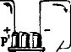
Fig. 452.
rheostat of very high resistance. On shorter lines the auxiliary batteries are not required; for example, on the Paris-Lyons circuit the insertion of an adjustable leak is found to be sufficient An artificial resistance or spark coil is usually placed in the battery circuit at the sending station, to diminish the spark that would otherwise occur at the opening and closing of the shunt circuit upon the transmitting tablet
In order to exchange signals for various necessary purposes, a Morse apparatus is combined with the Caselli apparatus and thrown into circuit momentarily at the end of each stroke of the lame pendulum, which renders a slight addition necessary to the commutators. In fig. 445 M is an ink writer and T a key.

CASELLI'S PANTELEGEAPH. 755
The contact springs N and F, as we have already seen, control the working of the pendulum, while D and r, S and r' serve to pat the Morse apparatus in circuit at the end of each half oscil-
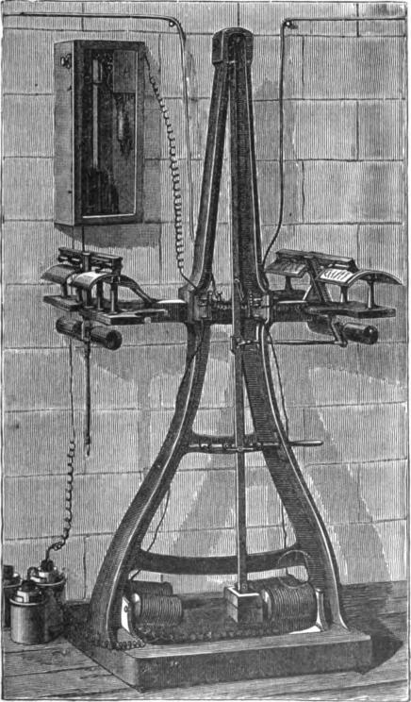
FVg. 453.
^{la}tion. The arrangement of the connections is clearly shown in ^{fi}g^{. 4}45 and need not be explained in detail. The switch x is ^{tur}ned on z to transmit and on u to receive.

756 AUTOGRAPHIC OR COPYING TELEGRAPHS.
When the apparatus is not in use the lever G G' is raised and interrupts the contact between g' and g, breaking the circuit of the local battery 0 B. In order that the Morse apparatus may be in circuit when the autographic apparatus is not in use, the pendulum is caught by the stopping pins p or p' when the lever G G' is raised, which holds it at one end or the other of its stroke. In this position the Morse apparatus is directly in connection with the line, so that both stations may exchange communications by its means.
In the apparatus employed in France, a perspective view of which is shown in fig. 453, the blue lines upon the chemical paper have a length of 111 millimetres (4.37 inches), and this distance is passed over in about one second, at each half oscillation of the pendulum. The lines being one fourth of a millimetre apart, it follows that the time required to go over a despatch of the smallest size (27 millimetres wide) is 1 minute 48 seconds. On such a paper a message of 25 or 30 words may be written, and perfectly reproduced at a distance of 300 miles. Hence, 45i- despatches, of 20 words each, may be sent per hour. By making use of finer writing, 60 despatches of 20 to 25 words have been exchanged in an hour been Paris and Lyons, but this is a speed difficult to obtain under average conditions.
It has been proposed to transmit Morse characters by the Cas-elli apparatus, and it is easy to see how this could be accomplished, but it would necessarily be inferior to the automatic apparatus described in the preceding chapter.
MEYER'S AUTOGRAPHIC TELEGRAPH.
In order to do away with the inconveniences inseparable from the use of chemically prepared paper in autographic telegraphy, several inventors have proposed to make use of ordinary paper, upon which the marking may be done with printing ink. A system of this kind, in common with Bakewell's and .Caselli's, involves the principle of the synchronous movement of two similar parts, such as cylinders, conducting plates or styles; but (lifters from these in respect to the receiving apparatus, which

MEYER'S AUTOGRAPHIC TELEGRAPH. 757
consists of a writing point or marking wheel controlled by an
electro-magnet.
One of the most ingenious and effective of the electro-magnetic
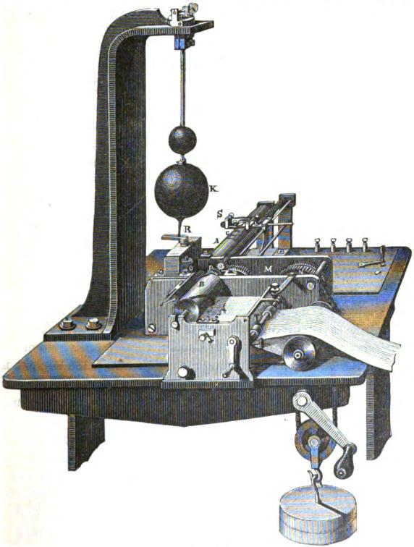
Fig. 454.
copying telegraphs is that of Meyer, which is represented in fig. 454. At each station the synchronously moving iron style is re-

758 AUTOGRAPHIC OR COPYING TELEGRAPHS.

placed by a cylinder B, having a single spiral rib forming a screw of one turn projecting from its circumference. The cylinder B revolves rapidly by the action of the clock work M. At the sending station this screw glides over a sheet of tin foil, upon which the communication is written, as in Caselli's arrangement. At the receiving station an ink-roller, seen at the left and above the cylinder B, revolves in contact with the edge of the screw thread. Just beneath the cylinder B lies a band of paper taken from a continuous roll, and this, together with the tin foil sheet at the sending station, advances a small fraction of an inch at each revolution of the cylinder.
At the sending station the screw thread upon the cylinder B is only in contact with one point upon the surface of the metallic sheet; so also at the receiving- station, only one point upon the paper band can be in a position to be brought in contact with the screw thread above it; and provided the movements of the parts at both stations are perfectly synchronous, these points will always correspond upon the two separate instruments.
At the transmitting station a current is sent to the line as often and as long as the screw comes in contact with the non-conducting writing upon the tin foil; this is accomplished by a shunting arrangement similar to that of Caselli, consequently, when the screw passes over the conducting metallic surface, the current is cut off from the line.
At the receiving station tie current passes through an electromagnet, whose action raises a platen located directly under the cylinder B, and the paper pressing the latter against the inked edge of the screw thread, thereby produces au impression. As the two instruments revolve synchronously the whole series of marks will be an exact reproduction of the writing upon the copy. The synchronism is regulated by varying the position of the ball K upon the rod R, the whole arrangement forming a conical pendulum, which is found to be practically efficient.
LENOIRS AUTOGRAPHIC TELEGRAPH.
This apparatus bears some resemblance to Bakewell's in its form, but the writing is performed by electro-magnetic instead

LENOIR'S AUTOGRAPHIC TELEGRAPH. 759
of electro-chemical action. Fig. 455 is a plan of the connections at the sending and receiving stations, and fig. 456 is an elevation of the respective instruments in which the connections are also shown. In fig. 456 A and a represent the frame enclosing the clockwork, which turns the hard rubber cylinder B or b at the sending and receiving stations. C and c are shafts having a screw thread cut throughout their length, upon which the blocks D and d are moved laterally from left to right as the screws revolve. The vertical axes F or f are connected with the cylinders by means of bevel gear. The cylinders make 15 revolutions
Fig. 455.

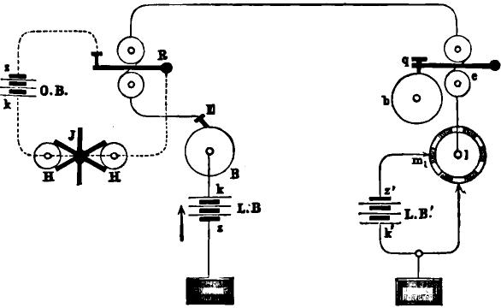
O.B.
per minute, while the vertical shaft makes 150 in the same time. The original copy of the message is written in the usual manner, with non-conducting ink upon metallic paper. This is wrapped around the cylinder B, which is so arranged that it may conveniently be taken off for this purpose. While the cylinder is revolving the metallic paper is connected, by means of a contact spring which presses against a metallic ring on the end of the cylinder, with the copper pole k of the main battery L B. The point or style E, which rests upon it, completes the circuit only when it touches the metallic paper in places free from writing.

760 AUTOGRAPHIC OR COPYING TELEGRAPHS.
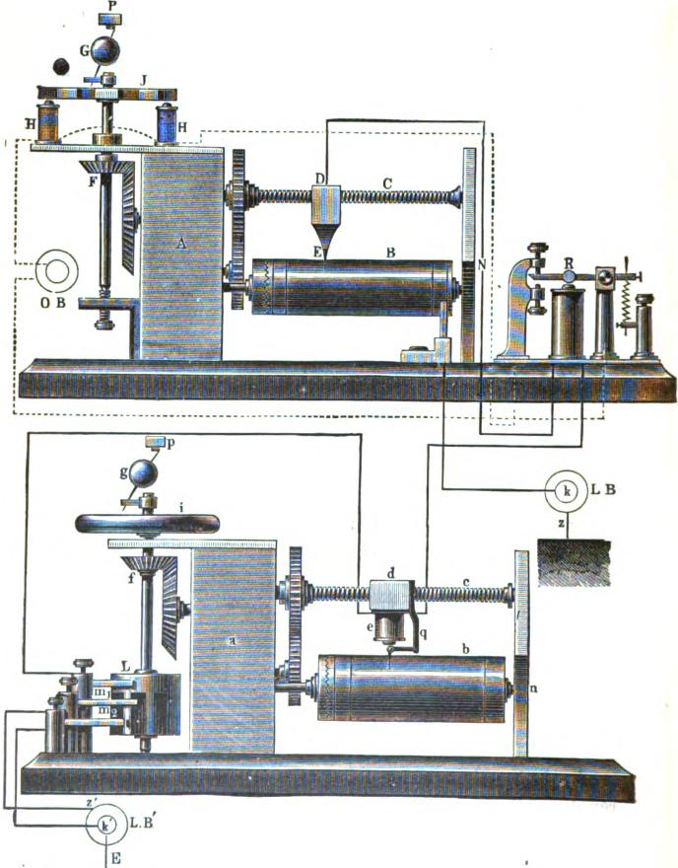

Fig. 456.

LENOIR'S AUTOGRAPHIC TELEGRAPH. 761

At the receiving station the entire surface of the cylinder B is covered with a thin coating of indigo ink, and loosely wrapped in a sheet of thin tracing paper. The movable block d carries an electro-magnet e, which has a tracing point attached to its armature. When the armature is released the point falls against the paper by its own weight, and by its pressure causes the opposite side of the paper to take up ink from the cylinder, but when the armature is attracted the tracing point is removed from the paper. At the sending station the vertical axis F carries six armatures radiating at equal distances apart like the spokes of a wheel, which, as they revolve, pass successively over the poles of the two electro-magnets H H; it also communicates a rotary motion to the conical pendulum G above it, which serves to regulate the synchronism. The shaft fat the receiving station carries a . fly-wheel i in place of the radial armatures at the sending station, and also a conical pendulum g. At the lower end of the same shaft is a cylindrical commutator, having six conducting segments separated by insulating pieces. As the commutator revolves, the axisf is alternately put in connection through the contact springs m, and m_{a} with the zinc and copper poles of the main battery L B'. The axis f is permanently connected with the electro-magnet e.
The synchronous movement of the clockwork at the two stations is controlled by the action of a relay R, the armature of which is adjusted by means of its retracting spring, so that it requires the combined current of the main batteries at both ends of the line to move it.
By reference to the connections, as shown in figs. 455 and 456, it will be seen that the position of the apparatus is such that the spring m, is insulated, while spring in, is in electrical connection with L and,/ If we suppose the tracing point E to rest on that portion of the metallic paper not covered with insulating ink, the main battery L B will transmit its current to the line, passing through the relay R (but not affecting it), and thence through time magnet e at the receiving station, causing it to lift the style from time paper, and finally passes to the earth by the way of L and spring ma.

762 AUTOGRAPHIC OR COPYING TELEGRAPHS.

If now the clockwork at both stations be set in motion, the tracing point E will pass over the non-conducting lines of writing, breaking the circuit for a greater or less length of time, and allowing the style to fall back against the paper for a corresponding period of time. While this is going on, however, the main battery L B', at the receiving station, is brought into periodical action .by the commutator L on the vertical shaft f, and thus its current is thrown upon the line, in addition to that of the battery L B, six times during each revo-ution of the vertical shaft f Each of these pulsations will operate the relay R, closing the circuit of the local battery 0 B, and thus, by means of the electro-magnets H H acting upon the radial armature J, will exert an accelerating or retarding influence upon the shaft F. As this correction is applied six times during each revolution, the movement of the machinery at the sending station is brought into perfect accord with that at the receiving station without difficulty.
When the tracing point E has traversed the whole surface of the copy upon the cylinder B at the sending station, and the style has in like manner traversed the paper at the receiving station, the tracing paper is removed from the cylinder, and the writing transferred to an ordinary sheet of paper by means of a press.
Lenoir's apparatus is very ingenious in principle, and is much more simple than Caselli's, while its speed of transmission is considerably greater. In consequence, however, of the method of operating with two different strengths of current, the synchronism is maintained with great difficulty upon a line having any escapes or faults which give rise to fluctuations in the strength of the working current'
SAWYER'S AUTOGRAPHIC TELEGRAPH.
Mr. W. E. Sawyer, of Washington, D. C., has recently invented an autographic system possessing several novel features. In this method the original messages are written on ordinary writing paper, with common ink, containing a little

BONELLI'S TYPO-TELEGRAPH. 763

glycerine, to prevent its drying too rapidly. The writing is then dusted with powdered shellac, and laid, face downwards, upon a thin plate of clean zinc. The plate and paper are next passed between heated rollers, by which process a reversed copy of the writing is transferred to the zinc plate in non-conducting lines, the whole process occupying but three or four seconds. The metallic plate is finally bent round a cylinder, similar to that of Lenoir's apparatus, while at the receiving station a sheet of chemical paper is wrapped round a similar cylinder. Each cylinder is driven by a small electro-motor provided with a heavy fly-wheel. The synchronism is adjusted at one point during each revolution of the cylinders; this is effected by the transmission of a pulsation of reverse polarity, which retards the movement of either cylinder in case it tends to run faster than the other. The original copy being reversed upon the zinc plate, it is, of course, necessary to run the receiving instrument in the opposite direction, in order to bring out the /tic-simile as it should be. By a peculiar arrangement of the line batteries, which it is difficult to explain without a diagram, Mr. Sawyer has succeeded in overcoming much of the difficulty heretofore experienced in autographic systems, owing to the effects of electro-static induction upon long lines. It is obvious that the above described process of transferring the original messages from ordinary paper to a metallic plate for transmission, is a vast improvement over the method of Caselli and his successors, who, as we have seen, make use of metallic paper. The plate itself is not only a far better conductor, but the lines of insulating writing are much harder and sharper, and the transmission more exact and perfect than when the metallic paper is used.
BONELLI'S TYPO-TELEGRAPH.
This system, invented by the Chevalier Bonelli, of Italy, resembles somewhat both the automatic and autographic systems which have been described. The message to be transmitted is first set up in type arranged in a single line, with the necessary

764 AUTOGRAPHIC OR COPYING TELEGRAPHS.
punctuation points and spaces. The type are then made to pass underneath a comb having five metallic teeth, as shown at M in fig. 457. Each of these teeth is insulated from the others, and is connected with a separate line wire. At the receiving station the line wires L are connected with five metallic styles N, which also form a comb, and these rest on a strip of chemically prepared paper. The line of type and the chemical paper are made to pass under the respective combs, at a uniform rate, by means of suitable clockwork. The principle of operation being the same as in Bain's telegraph, heretofore described, it will readily be seen that each letter passed over at the sending station will he reproduced at the receiving station by five rows of colored dashes, which, taken collectively, represent in succession the individual letters which appear as shown in fig. 457. The

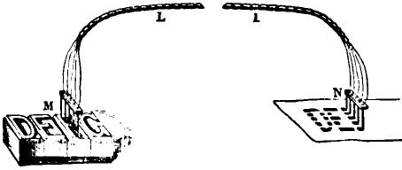

Fig. 457.
accuracy of the synchronism is in this apparatus a matter of comparatively little importance. If the receiving instrument runs slower or faster than the sending instrument the letters will be compressed or extended, but their characteristic form will remain unaltered.
Instead of iron Bonelli found it preferable to employ platina for the material of his marking styles. The paper is prepared with a solution of nitrate of manganese, which, under the action of the current, produces nitric acid, and leaves a brown mark. Unfortunately this solution is much less sensitive than the prussiate of potash, and necessitates a more powerful current.
The arrangement of circuits preferred by Bonelli is shown in fig. 458, which represents a single one of the five wires em-

BONELLI S TYPO-TELEGHAPH. 765
ployed. I is the sending and TI the receiving station. M is the platinum tracing point or circuit-closer which traverses the type A B. At the receiving station N is the marking point and C D the chemical paper. The main batteries P and P' at the respective terminals of the line, are placed with like poles to the line (zinc in both cases). The copper pole of P at the sending station is to the earth, while at the receiving station the copper pole of P' is connected to the marking point N. The chemical paper C D rests on a metallic plate in direct connection with the earth. The main battery at the sending station is divided into two unequal sections P and p, either section of which may be used at pleasure, being thrown in or out of circuit by a switch. This battery is shunted by the circuit-closer M whenever contact
I. R L L₁ It,

Fig. 458.
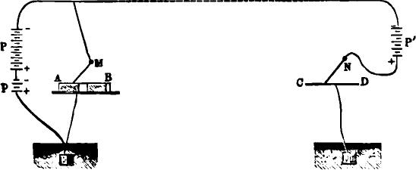
is made with the type A B, and this permits the current of the battery P' to traverse the line and make a mark on the chemical paper.
On a well insulated line the opposing batteries may be of equal strength; indeed, it is advantageous to make the battery P' at the receiving station somewhat the stronger, though nut sufficiently so to mark the paper. If, on the contrary, the line is subject to considerable escape and leakage, then the battery
P p should be increased, in order to compensate for the weak-
ened current produced thereby.
The apparatus itself consists of a car A B (fig. 459), running back and forth on the rails II II' and K K', which form a

766 AUTOGRAPHIC OR COPYING TELEGRAPHS.
track. The car passes under two combs M and N, M being the sending and N the receiving comb. On the upper surface of the car is a metallic frame D, which holds the types, and another one C, which supports the chemical paper. These pass success-
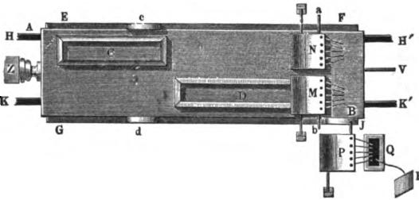
Fig. 459.
ively under the combs M and N, so that the transmission of one message is always followed immediately by the reception of another. At the other station the arrangement is reversed, the types being placed in the rear and the chemical paper in front.
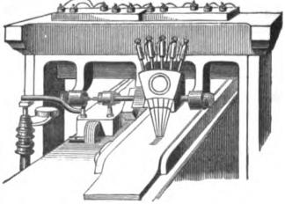
1Vg. 460.
The combs M and N are fixed upon hinges a b, and are raised and lowered by the car, as it traverses the track, by means of suitable projections c d upon its sides (figs. 459 and 460). A third comb P serves as a commutator, and is made to connect

BthsTELLI'S TYPO-TELEGRAPH. 767
the five line wires with the earth by dipping into a vessel of mercury Q, when a message is to be received.
The car is moved by clockwork, through the intervention of a cord V. When at rest it is in contact with a buffer Z, at both stations, in which position it is retained by means of a detent, this being so arranged as to be released by the action of an electromagnet. The magnets at both stations are connected with one of the line wires through the buffer Z; hence, when the first current is sent they become magnetic, releasing the car and clockwork by means of the detent. Both cars start at the same time and complete their journey in 15 to 20 seconds, during which time two despatches of 26 to 30 words each are exchanged. The car is then replaced in its former position, supplied with a fresh message in type and another sheet of chemical paper, and the operation is repeated.
Owing to the great number of wires required, this telegraph, although a very ingenious one, has never proved to be of any commercial value. An American inventor has devised a method of perforating the Roman lebters in a strip of paper by means of a key-board perforator, which is an improvement upon Bonelli's type method, but still remains open to the same objections in a practical⁻point of view.

CHAPTER XXXVIII.
SIMULTANEOUS TRANSMISSION IN OPPOSITE DIRECTIONS.

THE various methods which have been devised of simultaneously transmitting two or more communications in the same or opposite directions over a single wire, including the duplex, quadruplex and other similar combinations, may be appropriately classed under the general head of multiple telegraphs. The possibility of making use of a single wire for the simultaneous transmission of two or more communications seems to have first suggested itself to Moses G. Farmer, of Boston, about the year 1852. He proposed to employ two rapidly revolving synchronous commutators, one at each end of the line, which would serve to bring the latter successively and simultaneously into connection with two or more short branches at each terminus, in each of which ordinary telegraphic apparatus might be inserted. Thus the current, in the corresponding branches at either station, though apparently continuous, would actually be composed of rapidly recurring synchronous pulsations. From the difficulty of maintaining synchronism between the corresponding instruments and other causes, nothing of practical value resulted from the invention, though successful experiments were made on a small scale on one of the municipal lines of Boston in 1852. The same idea, however, has more recently been carried out by Meyer, who exhibited at Vienna, in 1873, an apparatus upon this principle capable of transmitting four simultaneous communications, which will be described hereafter.
The methods of multiple transmission which within the past few years have proved to be of so much value in practical telegraphy, are based upon an entirely different principle from the above, which may be properly considered an outgrowth of the invention of Dr. Wilhelm Gintl, Director of the Austrian State Telegraphs in 1853—an invention which directed the labors of

GINTL'S METHOD. 769

both European and American inventors into a new and fruitful field.
The different methods or processes of multiple transmission way be conveniently classified as follows;
- The simultaneous transmission of two communications in opposite directions.
- The simultaneous transmission of two communications in the same direction.
- The simultaneous transmission of four communications, two in each direction.
The simplest of these processes and the earliest to be successfully employed in practice, is that first mentioned, viz., simultaneous transmission in opposite directions. The conditions to be fulfilled in practically carrying out this method of telegraphy are—first, that the receiving instrument at the home station shall remain entirely unaffected by the movements of the transmitting key at that station, while at the same time it shall remain free to respond to the currents transmitted by the key at the distant station; and second, that the in-coming currents from the distant station shall always be provided with an uninterrupted passage to the earth, through the apparatus of the home station
GINTL'S METHOD.
As previously stated, the first effort in the direction of a practical solution of the problem in question was made• by Dr. Gintl, whose experiments were performed on the line between Prague and Vienna in July, 1853. In Gintl's method the first condition was fulfilled by the use of a differential relay—that is, a relay whose helices are composed of two distinct wires, one of which is traversed by the main line current, and the other by that of a local or equating battery. These coils, wound in opposite directions upon the cores, when connected in their proper circuits, exert equal and opposite magnetic effects upon the relay, so that when the key is depressed, although the entire current of the main battery passes through one wire of the relay, it still remains perfectly unaffected. In order to close the circuit of

770 SIMULTANEOUS TRANSMISSION IN OPPOSITE DIRECTIONS.
the main and equating battery at the same instant a double key is used, consisting of two separate levers insulated from each other, connected together by an insulating cross-piece, and having in front a common knob. Fig. 461 is a plan of Gintl's arrangement; a b c and a' b' c' represent the double key. The equating circuit I II, represented by dotted lines, passes through one wire of the relay (usually the outer and thicker). It includes a local battery, and is opened and closed by the key at a b. The front contact of the other side of the key is connected to the positive pole of the main battery L B, the negative
46L

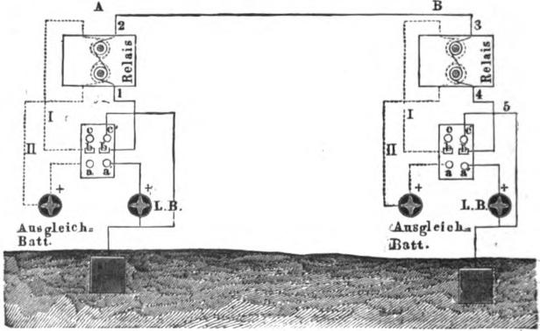
A B
2
⁻40
Ant gelds., Bati
pole being to earth. The middle contact or key axis b' is connected to the other coil of the relay by the wire 1, and thence to the line wire at 2. The rear contact c' of the key is connected directly to the earth.
By inspecting the connections it will be seen that when the double key at station A is depressed, the current of the main battery at that station is sent to line through one wire of the relay, while at the same instant the circuit of the equating battery passes in the opposite direction through the other wire of the

FRISCHEN'S METHOD. 771

relay. If, therefore, the strength of the equating current has been properly adjusted, the effect of the current transmitted to line will be entirely neutralized, as far as its action upon the home relay is concerned.
If, now, while the key at station A is transmitting a current to the line, that of station B is also depressed, the main battery at B is put to line with its poles reverse to that of the battery at A, and the current of the main line disappears. Thus the equilibrium previously established by the equating battery is destroyed, and the relay at A will give a signal corresponding to the time the key at B remains depressed. Daring the whole time that the key is kept down at A the relay at B will respond, whether the key at B is depressed or not, because, as we have seen, the effect of B's own current upon his relay is neutralized by his equating battery. If, therefore, both stations work their apparatus at the same moment, the respective relays will respond properly thereto.
There is, however, one position of the apparatus in which the signals transmitted from one station are not perfectly received at the other. This is when, during the manipulation at either station, the lever of the key is removed from the back contact c c' until it touches the front contact a a', or vice versa. In these cases the main circuit is momentarily interrupted at b, interfering with the signal which should be given by the relay at the same station. Thus, the second of the two conditions referred to is imperfectly fulfilled by this apparatus. In practice it was also found to be a great and insuperable difficulty to maintain the balance between the main and equating circuits for any length of time.
FRISCHEN'S METHOD.
An important improvement upon Gintl's method was invented early in 1854, by Carl Frischen, an inspector of telegraphs in Hanover, and which is in a great measure free from the objections which proved fatal to the practical success of its predecessor. As Frischen's invention is the basis of

/772 SIMULTANEOUS TRANSMISSION IN OPPOSITE DIRECTIONS.
some of the most successful methods of duplex telegraphy now in use, its construction and the principles of its operation will be explained in detail. Fig. 462 is a diagram showing the arrangement at one of the terminal stations, the other, of course, being a duplicate of it. R is the receiving relay provided with two separate coils, so arranged that when equal currents pass through them they will exert an equal and opposite magnetic effect upon the cores, and thereby neutralize each others One pole of the main battery B is connected to the earth, and the other to the front contact 1 of the key K. The back contact 3 of the key is connected directly to the earth, while to the lever
L
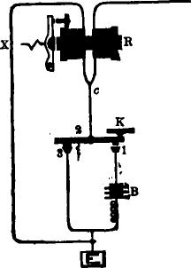
119. 462.
2 is attached a wire which divides at c, one branch going through the right hand coil of the relay to the line L, and the other through the left hand or opposing coil, and thence to the earth. It is obvious that by making the resistance in the two branches which diverge from the point c exactly equal, a current can be sent to the line by the depression of the key K without affecting the relay R. This may be accomplished by inserting a rheostat at X, in the left hand circuit, which for convenience may be termed the artificial line. Fig. 463 is a complete plan of the arrangement at both stations, which are distinguished by the letters A and B. The main batteries L B at each station are

FRISCHEN'S METHOD. 773
placed with their poles to the line and — poles to the earth. It and R' are the receiving relays, each wound with two separate coils, as before explained. The rheostat, W or W', in the artificial line at each station, must be so adjusted as to make its resistance exactly equal to that of the line A B added to that of one wire of the relay at the distant station.
If now the key at station A is depressed, the current from the main battery L B will divide at the point 3, one portion going by way of 4 and 6 to the line, passing through one coil of the relay, thence from the line through one coil of the relay at the
A li
Pig. 463.

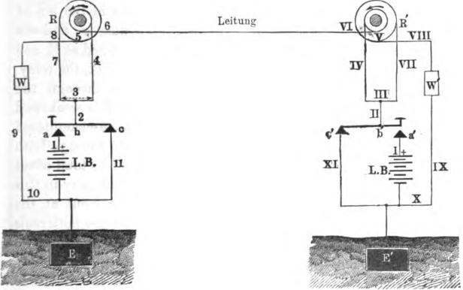
Leit un:
.7/
XI
Ix
VI
distant station B, by way of VI and IV, thence by III and If to the key lever at b', back contact c' and wire XI to the earth, the other portion going from 3, in an opposite direction, through the home relay by way of 7, 8, rheostat W and wires 9, 10 to the earth. These two branches of the current will be equal to each other, as before explained, and will produce no effect upon the relay at A for that reason. The relay at B. on the other hand, will be affected by the current coming from A, and will respond to the movement of the key at the latter station.

774 SIMULTANEOUS TRANSMISSION IN OPPOSITE DIRECTIONS.

If now the key at B be also depressed, one half of the battery current tends to go to the line, but as it meets the current from A of opposing polarity, the current in the main line is neutralized or becomes null. The current in the artificial line at each station being no longer opposed by the line current, will operate the respective relays, and the signals given will correspond to the length of time the key is depressed at the opposite station. Thus it will be seen that each station receives its signal through the action of the distant battery only.
In the arrangement described a third position occurs when one of the sending keys, for instance, at B, is in the act of changing from the rear contact c' to its front contact a', and vice versa, in which case the current from A is interrupted at b', and is, therefore, forced to pass through the second coil of the relay, but this time in the same direction, and thence through the. rheostat W' to the earth. The current arriving at B is weakened one half in consequence of the additional resistance encountered. at W', but this is compensated for by its passing through both coils of the relay at B, in the same direction, and its total effect upon the relay, therefore, is not lessened. The difficulty in this. connection arises from the fact that when the current at the receiving station is thus momentarily made to traverse both coils. of the relay, together with the rheostat, it necessarily causes a❑ unequal division of the current between the two opposing relay coils at the sending station, as the resistance of the main line becomes about double that of the artificial line, and thus the sender's relay is affected. As this always occurs either at the beginning or the end of a signal, no actual inconvenience is experienced, except possibly when the transmission is unusually rapid. A peculiarity of this, in common with many other methods of simultaneous double transmission in opposite directions, consists in the fact that it may be operated with equal facility when the main batteries are arranged with agreeing instead of opposing poles.
In the autumn of 1854 Siemens and Ilalske, of Berlin, inde--

FRISCHEN'S METHOD. 775
pendently invented a method precisely the same as that of Frischen, with the exception of the relay, which was constructed in the manner represented by fig. 279, page 506, one coil being placed in the main and the other in the artificial line. Finding that they bad been substantially anticipated by Frischen they purchased his invention, and afterwards introduced the method into experimental use on some of the German telegraphs. Frisch-en's invention was patented in England by R. S. Newall, and was worked experimentally there in 1854 and '55. It was only in
L
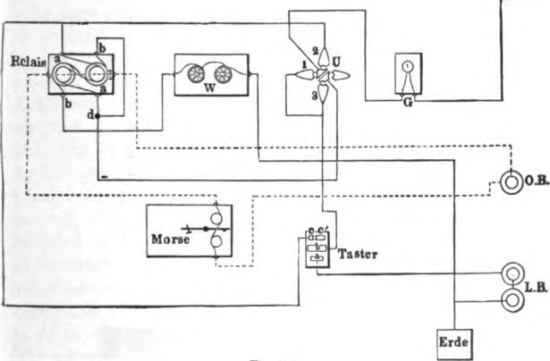
Jig. 4b4.
Holland that the system at this time succeeded in maintaining a permanent foothold, it having been used in that country for many years on the line between Amsterdam and Rotterdam, and on this comparatively short route, and at a moderate speed of transmission, was found to answer an excellent purpose.
Early in 1855 the Frischen•Siemens-Halske apparatus was put in operation between Vienna and Munich, a distance of 345 miles, and also between Vienna and Trieste, 338 miles. In August of the same year Dr. J. B. Stark, of Vienna, published

776 SIMULTANEOUS TRANSMISSION IN OPPOSITE DIRECTIONS.
a report on the working of the system, in which he stated that it had been in daily use for several months on both these circuits with entire success; and, also, that by means of a repeater fitted up at Vienna, Munich and Trieste were enabled to correspond directly. Fig. 464 shows the apparatus, as arranged by Stark, so as to be available either for double or single working. It differs from the arrangements previously described merely in the addition of a peg switch or commutator U and a galvanometer
G. Ordinarily the pegs are placed in 2 and 3; but if it is desired.
L
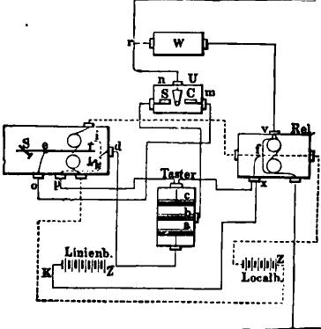
F. 465.
to pork the apparatus as an ordinary open circuit, or " single," as it is technically termed, the pegs are placed in 1 and 3. The change can thus be made instantly from one system of working to the other. He also devised the ingenious arrangement shown in fig. 465, by means of which, when the switch U is turned on C, the received message is automatically repeated back over the same line to the station from which it was sent, the register lever acting as a key. By changing the switch to S the apparatus is ready for simultaneous double correspondence upon the usual

GINTL'S CHEMICAL METHOD. 777

plan. At Vienna the two lines leading respectively to Munich and Trieste were provided with a Swiss commutator, so that by merely changing the pegs they might be worked by either of the plans described, or be arranged to simultaneously repeat from one line to the other in both directions. Stark also devised a modification of Frischen's method, which consisted in using an ordinary relay in the main circuit, and for the artificial line, employing a small number of convolutions of wire wound on the outside of the relay coils, giving but little resistance. By this arrangement the current going to the main line would be somewhat diminished on account of the low resistance of the branch or artificial line, but this is more than made up by the much greater number of convolutions through which it passes. In this latter improvement, however, he had been anticipated by Prof. E. Edlund, of Stockholm, who published in June, 1855, a description of a method which he had employed between Stockholm and Upsala, in August, 1854, and which had been invented by him without knowledge of Frischen's method, to which it bears considerable resemblance. Edlund's relays were constructed with two opposing coils of unequal resistance; the coil included in the main line having 5,000 convolutions, while that of the artificial line could be varied between 700 and 1,170 convolutions—the balancing of the action upon the relay being effected by increasing or decreasing the number of convolutions in the circuit of the artificial line, instead of employing a rheostat The advantage claimed by Edlund consists in the fact that in the third or intermediate position of the key referred to on page 774, the arriving current meets but little resistance in its path to the earth. According to his measurement the variation of the main line current is only in the proportion of 1 to 1.14 instead of 1 to 2, as in Frischen's method, while a better result is obtained, owing to the greater number of convolutions of the relay included in the main circuit
GINTL'S CHEMICAL METHOD.
In consequence of the unsatisfactory practical results obtained from the apparatus described on page 769, Gintl had recourse to

778 SIMULTANEOUS TRANSMISSION IN OPPOSITE DIRECTIONS.
the electro-chemical process of recording, by which he succeeded in obtaining much better resulis. At an exhibition before many of the leading telegraphic officials in October, 1854, Gintl's new method operated very satisfactorily between Vienna and Linz. Fig. 466, which is taken from a paper published by Gintl in 1855, represents the invention in its improved form, as arranged at one of the terminal stations. E is the main battery with its positive pole to the line and negative to the earth. The wire a connects the battery with the front contact of the key, while the wire c connects the back contact with the earth. The wire b is attached to the axis of the key, and goes to the electro-chemical
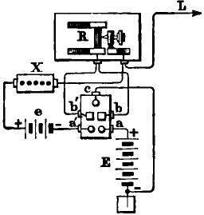
Hg. 466.
register R and thence to the line L. A compensating battery e is arranged with its poles in opposition to those of the main battery E, and is closed at a' b' simultaneously with the closing of the battery E at a b when the key is depressed. The battery e tends to send an opposing current through the chemical paper, and by means of the rheostat X this is adjusted so that it is just strong enough to neutralize the action of the main current Thus, if E and e represent the electro-motive forces of the two batteries, X the resistance of the rheostat, and L that of the line, including the apparatus at the distant station, then
E: e:: L: X;
in which case the current passing through R will be null, the

GLNTL'S CHEMICAL METHOD. 779

receiving instrument being in the same condition as the bridge wire of a Wheatstone balance. Any current, however slight, from the distant station, would destroy the equilibrium, and cause a mark to be made upon the chemical paper. By a subsequent improvement, made known in June, 1855, Gintl succeeded in avoiding the still existing difficulty of the breaking of the circuit of the in-coming current by the key in passing from the front to the rear contact, and vice versa, and at the same time dispensing with the auxiliary compensating battery. This arrangement will be understood by reference to fig. 467. When the instrument is in use the wires a and b are connected by means of a peg inserted at d, and thus when the key is at rest the battery is on short circuit by the way of a d b and c. The
L
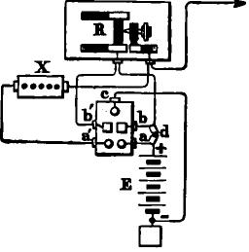
1Tg. 467.
moment the key is depressed this circuit is broken at c, while at the same time the branch circuit is closed at a' b'. The rheostat Xis so adjusted that its resistance is less than that of the chemical paper. Consequently, the out-going current goes from b to the binding screw of the register, where it divides, one portion going through the chemical parer to line, and the remainder by way of b' a' and X to line. The resistance of X is diminished until the portion of the current going through R is not sufficient to mark the paper, except when aided by a current from the remote station. It is evident that the latter has at all times an uninterrupted path to the earth, whatever may be the position of the key.

780 SIMULT4NEOIIS TRANSMISSION IN OPPOSITE DIRECTIONS.
NYSTROM'S METHOD.
In the latter part of 1855 a method involving the same general principle as that of Gintl, but in a much more practical form, was invented by C. A. Nystrom, of Oereboro, Sweden, an account of which was published in January, 1856. Nystrom's principal improvement consisted in an attachment by which the connection of the main line with the earth remained unbroken, irrespective of the position of the key. Fig. 468 represents this arrangement. The supplementary contact lever a b c, turning upon an axis at b, is normally kept in contact with its anvil at c by means of a spring. When the key K is depressed, the circuit of the main battery E is closed between K and a before the previously existing earth contact at c is interrupted, cone).

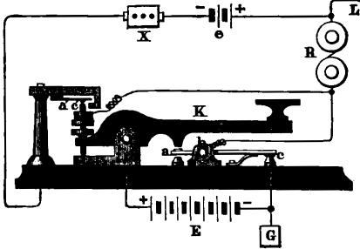
X
F. 4G8.
quently the in-coming currents from the line, after passing through the receiving instrument R, have an uninterrupted path to the earth from the point b, either through c or K, whatever may be the position of the key. This was a most valuable improvement, and under the name of the continuity-preserving transmitter, is in extensive use at the present day.
The effect of the out-going current upon the home receiving instrument was neutralized by the use of Gintl's arrangement of an opposing auxiliary battery e and rheostat X, brought into action by insulated contact points a' c' attached to the key, the

PREECE'S METHOD. 781
principle of which arrangement has been already explained in connection with fig. 466.
PREECE'S METHOD.
A method of simultaneous transmission in opposite directions was invented by W. H. Preece, of Southampton, England, in 1855, and was tried in 1856 between Liverpool and Manchester, but apparently with indifferent success. It was, however, revived in 1872, and was worked on several English lines with much better results. The diagram, fig. 469, will serve to illustrate the principle of Mr. Preece's method. Its characteristic feature consists in the balance upon the relay of the home
B
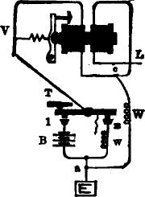
Rg. 469.
station being effected, not by two branch currents from the same battery, as in Frischen's plan, but by the entire current in one direction and a branch of the entire current coming from the other direction. If we suppose the relay R of fig. 469 to be wound with two separate and equal wires, and the branch line c W a to be disconnected, then any current sent to line by the depression of the key T, or any in-coming current from the line L passing to the earth through the back contact 3 of the key, would have no effect upon the armature of the relay. If now the branch c W a be connected, having a resistance equal to that of the line L beyond the point c, and the key T be depressed, the entire current of the battery B would pass through

782 SIMULTANEOUS TRANSMISSION IN OPPOSITE DIRECTIONS.

the left hand coil of the relay, while only one half of it would pass from the point c to line through the opposing coil, the remainder going to earth by way of c W 'and a. On the contrary, an in-coming current would also divide at c in the inverse proportion of the resistances c V a and c W a, and the portion passing by way of V would nearly counteract the effect of the undivided current in the other coil. Consequently, the problem is to weaken as much as possible the effect of the undivided current in the left hand coil of the relay at the sending station, together with that of the arriving current in the same coil, which tends to prevent the relay from giving signals by counteracting the effect of the other coil. In practice Mr. Preece effects this result by the use of a Siemens polarized relay, the wire a W c being connected at a point c, between the two coils, which are so wound as to oppose each other when a current is sent through them consecutively in the ordinary manner. With this arrangement it is only necessary to remove the adjustable pole-piece of the left hand coil to a greater distance from the armature than the right hand one to effect a balance, so that the relay will respond to in-coming currents, but will not be effected by outgoing currents.
SIEMENS AND HALSKE'S METHOD WITH TWO RELAYS.
The English patent of Siemens and Halske, taken out in 1854, described a method of simultaneous transmission which consists in a slight modification of the ordinary connections used in working the open circuit Morse system. The main battery at each station is inserted between the front contact of the key and the earth. Two receiving relays are required at each terminus, one being placed between the line and the key axis and the other between the rear contact and the earth, and a recording instrument is connected with a local battery and both relays, so that the action of either one or both together will operate it. The armature of the first relay is adjusted so that it can only be moved by the combined current of both main batteries, that of the second relay so that the unaided current of the distant

ZUR NEDDEN'S METHOD. 783

battery is sufficient to accomplish the same result. When therefore the key is at rest, the in-coming current passes through its rear contact and both relays; the relay of low adjustment responds while the other is unaffected. If now the key be depressed, the circuit is transferred from the branch containing this relay to the branch containing the main battery, and the combined current of both batteries passes through the relay of high adjustment. This method is of no practical value, for the reason that a break must necessarily occur in the local or register circuit every time the latter is transferred from the armature of one relay to that of the other, to say nothing of the circumstance that the main circuit is completely interrupted while the key is passing from its front to its rear contact, or vice versa—a defect which this apparatus possesses in common with the earliest plan of GintL
ZUR NEDDEN'S METHOD.
Early in 1855 Dr. Zur Nedden published a description of a method which is virtually an improvement upon the one above described, and was not improbably suggested by it. Fig. 470 is a diagram of Zur Nedden's apparatus. The relay R₁ is wound with finer wire than the relay R, so that it has about twice the number of convolutions in its helices. The register or sounder S is so connected as to be operated by the local battery e upon the closing of either or both of the relays R and R_{I}. To shorten as far as possible the break of continuity which occurs whenever the key passes from its rear to its front contact, or vice versa, which was a fatal defect in Siemens and Halske's arrangement, as above noted, Zur Nedden constructed the key as follows: A metallic thimble a is inserted iu the base board of the key and projects a little below its under surface. A flat spring b is also secured to the under side of the base, and by virtue of its own elasticity presses against the thimble a when the key is at rest, forming an electrical connection therewith. The contact screw c, directly underneath the free end of the spring b, is mounted upon an insulated bracket,

784 SIMULTANEOUS TRANSMISSION IN OPPOSITE DIRECTIONS.
and should be so adjusted as to be almost in contact with the spring. Whenever the key K is depressed, an adjustable pin, which is inserted in the key lever, passes through the hollow thimble and strikes the spring b, which is instantly pushed away from a and into contact with c, and this is done so quickly that the break in the continuity is scarcely perceptible. Otherwise the arrangement is the same as that of the common three point key—a corresponding to the rear contact, b to the axis, and c to the front contact.
The operation is as follows: When the key K is depressed, the current of the main battery E flows to line at L, by way of
4 L
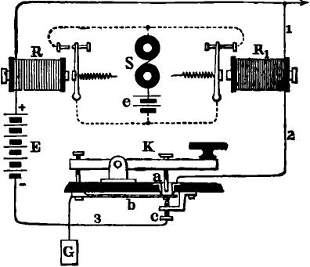
Pig. 470.
b, c, 3 and 4, passing through the relay R of few convolutions, which does not respond to the current of a single battery. When the key is at rest the in-coming currents pass by way of wire 1 through the more sensitive relay R₁, thence to the earth at G, by way of 2 and b. The relay R₁ responds and operates the sounder S. If while the distant key is still closed the home key be also depressed, the route of the in-coming current is trans-ferred from the branch 1 and relay R₁ to the branch 4 and relay R, but as the combined current of the main batteries at both

FARMER'S METHOD. 785

stations now passes through the relay R it will respond, and will continue the signal upon the sounder S which was commenced by the other relay.
Although this method is a decided advance upon its predecessor, yet it is open to the same objection in one respect, inasmuch as any signal commenced by one relay and completed by the other would be interrupted at the moment the main circuit was transferred from one to the other. In all cases a perceptible time would elapse after the local circuit was broken by one relay and before it was closed by the other.
FARMER'S METHOD.
In 1858 Moses G. Farmer, of Salem, Massachusetts, patented a method of simultaneous transmission, in which lie substantially adopted Gintl's arrangement for neutralizing the effect of the out-going current upon the relay of the home station, in connection with the form of relay used by Siemens and Halske, which is represented in fig. 279, page 506. The batteries and instrument_{s} were so arranged as to be operated by a reversal of the main line current. The diagram, fig. 471, illustrates the principle of Farmer's method. The key K, when depressed, simultaneously lifts three separate contact levers, k, k₁ and k₂. The contact levers k₁ and k₉ are so connected with the main battery B, line wire L and earth E, that the depression of the key has the effect of interchanging the poles of the main battery with respect to the line and earth wires, or in other words, of reversing the current upon the line, precisely as in case of the key illustrated in fig. 270, page 500. It will be observed that this reversal is effected without at any time interrupting the continuity of the main circuit. The relay R is constructed with two separate coils, r₁ and r₂, the former being included in the main circuit, between the key and the earth, and the latter in the circuit of a local or equating battery b, which is so arranged as to be closed by the contact lever k, whenever the key is depressed, at the same instant that the battery is reversed upon the main line. The cores of the two coils of the relay are provided Nvitli beveled pole

786 SIMULTANEOUS TRANSMISSION IN OPPOSITE DIRECTIONS.
pieces, which are so arranged that they act as armatures to each other. The core of r, is fixed, while that of r₂ turns upon its axis, the arm r which opens and closes the local circuit of the register or sounder (not shown) being rigidly attached thereto. When the poles of the two magnets ?_{I} and r₂ attract each other the arm r is pressed against the stop p and the local circuit is closed, but when the attraction ceases, or is succeeded by a repulsive action, the spiral spring acts, drawing down the arm r and opening the local circuit. The action of the apparatus is as follows: The main batteries B at the two terminal stations are
.FIg. 471.

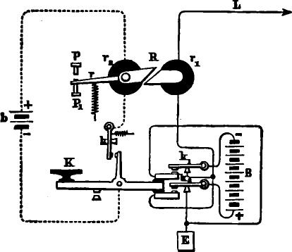
..........
L
preferably arranged with their negative poles to the line, as shown in fig. 471. In the normal position of the apparatus these neutralize each other, and there is no current upon the line. The equating circuit is open at k, and there is no attraction between the poles of the magnets r, and r₂ of the relay R. If now the key K is depressed, the battery B at the home station is reversed; its polarity then coincides with that of the battery at the distant station, and the combined current of both batteries traverses the line, producing a corresponding magnetic effect in the coil r₁; at the same instant the equating circuit is closed at

FARMER'S METHOD. 787

k and the current of the equating battery b traverses the other coil r₂, giving it an equal and opposite magnetic polarity, in consequence of which the home relay is unaffected by the depression of the key at the same station. When the key at the remote station is depressed and the home key is not, the relay responds, because the equating current is absent in the coil r₂. If the home key be depressed, the depression of the distant key causes the main batteries to oppose each other, in which case the signal at each station is given by the action of its own equating battery. By an obvious modification of this plan the equating circuit might be taken from the main battery B, dispensing with the special battery.
In Farmer's arrangement, as in Nystrom's, the continuity of the main circuit is never interrupted, and in addition to this the resistance of the circuit remains the same, whatever may be the position of the key.
A second patent was taken out in 1859, by the same inventor, for another method of simultaneous transmission in opposite directions, which is in effect an improvement upon that of Zur Nedden (fig. 470). Instead of two relays of an unequal number of convolutions, Farmer employed a single relay with two separate coils arranged in the same way, thus avoiding the interruption arising from the transfer of the local circuit from one relay to the other. He also made use of a continuity preserving key, but in other respects the principle of the apparatus is the same as that of Zur Nedden.
Fig. 472 is a diagram of the connections representing a terminal station A and an intermediate station C, of which there may be any required number. It is only necessary to describe the arrangement at the terminal station A, as the intermediate station differs therefrom but slightly in a particular which will hereafter be referred to. The relay is provided with two coils, r and r₁, which are so wound as to assist instead of opposing each other, as in Frischen's plan. The coil r₁ contains about twice as many convolutions of wire as the coil r, or it may be otherwise arranged; the object being that with a given

788 SIMULTANEOUS TRANSMISSION IN OPPOSITE DIRECTIONS. current the coil r₁ shall exert twice the magnetic effect upon the relay that the coil r does. The line wire which enters the station is divided into two branches at k, one branch going directly to the earth by way of 2 and 1, passing through the coil r₁, and the other by way of K, 3, and 4, passing through the coil r. For transferring the in-coming current from one of these branches to the other Farmer employed a continuity-preserving key K k upon the same principle as that used by Nystrom in 1855. When the apparatus is in a position of rest, as shown in the figure, the route of the in-corning current is by way of 2 r₁ and 1 to the earth at E. If the key K is depressed, the circuit of the main battery is
A 4 1.. L c L
....-3.
^{m}r---43.•-1⁻ a" ^{e}'^{m}r'r—,;•---,..
2
ii K 3

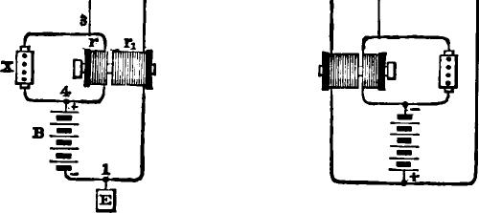

.PYg. 412.
closed by the contact of its rear end with the supplementary contact lever k, which is at the same time lifted from the point 2. The out-going current now passes through the coil r of the relay at the home station, and through the coil r₁ at the distant station. As the coil r, produces twice as great a magnetic effect upon the relay It as the coil r, it is easy to so adjust the respective relays that the distant one shall attract its armature, while that at the home station remains unaffected. When both keys are depressed the circuit is through the coil rat each station, but the effect upon each relay is doubled, because the line is traversed by the combined current of two batteries.

FARMER'S METHOD. 789

In order to render it certain that the receiving instrument at the home station should remain unaffected by the out-going current, Farmer made use of the same device which had been employed by Gintl in 1855, and which was described in connection with fig. 467, viz., an adjustable rheostat X placed in a branch circuit or shunt passing around the receiving instrument, by which means so much of the out-going current can be made to pass through the shunt that the remaining portion will not be sufficient to produce any effect upon the receiving instrument In this patent Farmer also described a method of repeating from one circuit to another in simultaneous transmission. This, however, as we have seen, had been accomplished by Stark on the Munich, Vienna and Trieste line as early as 1855, and by a method substantially identical.
The simple and ingenious method of inserting any required number of intermediate stations, which was devised by Farmer in connection with this invention, deserves notice. Such an intermediate station is represented at C in fig. 472. The only variation from the ordinary arrangement of a terminal station consists in connecting the line wire running in one direction in the place of the earth wire. When the key is depressed at the intermediate station the relays of both terminal stations respond, as the battery traverses the entire line. This arrangement is, of course, equally applicable to Frischen's or any other substantially similar method of simultaneous transmission. In a subsequent patent the same inventor described a simpler arrangement, in which a relay having but a single coil is employed, and the action of the home battery upon it is prevented by means of an adjustable shunt, which carries a considerable portion of the out-going current by another route.
The different inventions of Farmer were experimentally worked on the line between Boston and Portland, and elsewhere, in 1858 and 1859. They never came into extended practical use—not so much perhaps from lack of intrinsic value as from other causes, such as the comparatively inferior condition of the lines at that early date, and the fact that the require-

790 SIMULTANEOUS TRANSMISSION IN OPPOSITE DIRECTIONS.

ments of the service were then so moderate as to be satisfactorily met by the use of the ordinary modes of transmission.
FRISCHEN'S METHOD WITH POLARIZED RELAYS.
In January, 1863, Frischen published a description of a modification of his invention of 1854, in which he employed Siemens's polarized relays, wound with two equal and opposing coils, in combination with a positive and a negative main battery at each station, one being connected with the front and the other with the back contact of the key. When the key is depressed the polarity of the outgoing current is reversed, as in Farmer's method. The connections are in all other respects the same as. in Frischen's arrangement of 1854, and the operation differs so. little from the latter that further description is not necessary.
MARON'S METHOD.
In 1863, Maron, a Prussian telegraphic inspector, published a. description of a method invented by him, in which the receiving-instrument was placed in a neutral position in respect to the outgoing currents. This, as we have seen, had already been accomplished by Gintl, as described in connection with fig. 466, and also by Nystrom, as shown in fig. 468; but Maron succeeded in effecting the same thing in another and better way, without the equating or compensating battery. In his latest arrangement Gintl had attempted to do this, but in an imperfect manner. By Maron's method, on the other hand, a perfect balance may be maintained in the wire containing the receiving instrument, and this renders it unnecessary to use any special form of instrument, the system of telegraphy employed being a matter of entire indifference. Fig. 473 represents Maron's arrangement of circuits. The main battery B has its respective poles connected to the axis 2, and to the rear contact 3 of the key, so that when the key is in a position of rest the battery is on short circuit, but when it is depressed the current goes to the line. The artificial resistances a, b and X form three sides of a Wheat-

MARON'S METHOD. 791
stone balance, and the line L, together with the earth, constitute the fourth side. The receiving instrument R is placed in the bridge wire 5, 6. It is obvious, therefore, that if the resistances are adjusted in the following proportion, viz :
a : b : : L : X,
neglecting the resistance of the earth, which is usually too small to affect the result, the bridge wire 5, 6, will be neutral with respect to any current entering the system at the point 4. Consequently the out-going currents, which pass into the line whenever the key K is depressed, will produce no effect whatever
S L
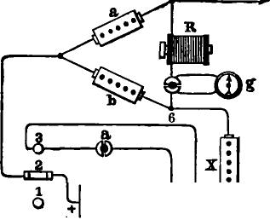
1Tg. 473.

4
ONO  B | 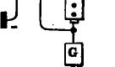

upon the instrument in the bridge wire. On the other hand, the in-coming current over the line L will divide at 5, part going through the wire 5, 6, relay R and rheostat X, and the remainder by the way of a, 4 and 3 to the earth. For the convenience of the operator when balancing the resistance X against that of the line, Maron proposed to place a galvanometer g in the bridge wire, which could be short circuited by a peg when not in use.. By the withdrawal of another peg at d the main battery could be disconnected when the apparatus was not in use. Maron found by calculation that the most favorable results wore obtained by making the resistance X equal to one half that

792 SIMULTANEOUS TRANSMISSION IN OPPOSITE DIRECTIONS.

of the line, and consequently b equal to one half of a. He also suggested the employment of a continuity-preserving key in connection with the apparatus, upon substantially the same principle as that of Nystrom.
STEARNS'S METHOD WITH DIFFERENTIAL RELAY.
At the period when Mr. Joseph B. Stearns, of Boston, commenced his experiments in simultaneous transmission, which was in 1868, very little was known in America respecting the previous labors of European electricians in the same direction.. The methods of Gintl, Frischen and Siemens-Halske may be said to comprise all that were at that time familiar, even by name, to American electricians. Mr. Stearns, therefore, naturally turned his attention to the improvement of the last named method, as the one which had, up to that time, given the best results in practice. Mr. Stearns's apparatus was put in operation on two or three circuits in 1868, but was, however, very sparingly employed until 1872. During this year important improvements were added, which led to its immediate adoption upon many of the most important lines in the United States under the name of the duplex telegraph, which had been applied to it by Mr. Stearns. The general principle of Stearns's apparatus does not differ materially from that of Frischen, and will be readily understood by reference to fig. 474. The key is replaced by a transmitter T, which is controlled by a key K, a local battery 1, and an electro-magnet 1. The principal object in introducing this modification was to adapt it to the use of the American operator, who is accustomed to hearing the accompaniment of his own sounder when transmitting, but there are some incidental advantages, among which may be mentioned the fact that the movement of the transmitter from the front to the rear contact, or the reverse, is much quicker when operated by an electro-magnet than when operated by hand. Experience also shows that the operator can transmit more rapidly and with less fatigue when the apparatus is thus arranged. The transmitter acts upon exactly the same principle as Nystrom's key,

STEARNS'S DIFFERENTIAL METHOD. 793
the contact of the battery with the line being made before the contact between the latter and the earth is interrupted. The action of the apparatus is so similar to that of Frischen as to require but a brief description. The resistance X in the artificial line is made equal to that of the main line. When the key K is depressed the circuit of local battery Z is closed, the electromagnet t attracts its armature, operating the transmitter T, which first makes contact at a, and almost at the same instant lifts the contact-lever, which is uivoted at b, and breaks contact at c. The current from battery B now goes by way of the transmitter T, and thence through a and b to the point d, where it divides
L
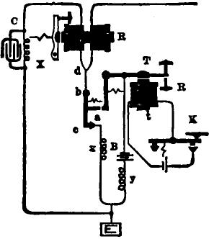
Fig. 474.
into two equal portions, one going through the right hand coil of the differential relay R to the line L, and thence to the earth at the distant station, and the other by way of the left hand coil of the relay through the rheostat X, and thence directly to the earth. As these two branches or divisions of the current are equal and opposite in their effects upon the relay R, it will not respond. The in coming currents from the distant station, on the contrary, pass only through the right hand coil of the relay R, and thence find their way from d to the earth by way of b, c and x, or else by b, a, T, B and y, the route depending upon the

794 SIMULTANEOUS TRANSMISSION IN OPPOSITE DIRECTION&

position of the transmitter. The resistance y is termed the spark coil, and is only required when a battery of small internal
resistance is used, in which case the spark caused by the momentary short circuiting of the battery at a c would otherwise cause some embarrassment. The resistance x is made equal to the resistance of the battery (added to that of the spark coil in case the latter is used), and thus the in-coming current a) ways meets with exactly the same resistance, irrespective of the route by which it passes from the point d to the earth at E.
In Chapter XXIV, which treats of the phenomena of charge and discharge in land lines, it has been stated that when a battery is connected to a long line for a moment, and the line is then detached from the battery and instantly connected to the earth through a galvanometer, that a return charge passes from the line to the earth, which suddenly deflects the needle. While referring to that chapter for a full explanation of the causes which produce this effect, it may be stated that the conditions of simultaneous transmission in opposite directions are such as to render it necessary to arrange the connections in a manner which produces precisely the same effect upon the relay. For example, in fig. 474, we have seen that the outgoing current, so long as the key is depressed, passes to the line through the relay R without affecting the latter. When the key is raised the battery contact is broken at a, while at the same instant the line is connected to the earth at a The
result of this is, that upon a line of say fifty or more miles in length, a return discharge occurs at the termination of each
transmitted signal, which passes through the right hand coil only
of the home relay, and produces a false signal, which tends to create confusion in the reception of signals coming in the oppo.
site direction. This difficulty increases rapidly when the length
of the circuit is increased, so that in a line of 400 miles or more the received signals become utterly unintelligible. It was this
serious practical difficulty, far more than any other, which stood in the way of the general introduction of simultaneous transmission for many years. In fact, it was not until 1872 that any

STEARNS'S DIFFERENTIAL DUPLEX TELEGRAPH. 795

effective means of surmounting it was discovered. Early in that year Mr. Stearns, while experimenting upon a line between New York and Buffalo, applied a condenser composed of alternate sheets of tin foil and paraffine paper, which he connected to the artificial line on each side of the rheostat X, as shown at C, in fig. 474, which at once and effectually disposed of the difficulty in question and rendered duplex telegraphy a practical and efficient system for every day work. The principle upon which the condenser acts is merely that of causing a discharge to pass through the left hand coil at the same moment the return discharge from the line passes through the right hand coil, and thus balancing or neutralizing the effect of the induction currents or discharges upon the home relay.
STEARNS'S DIFFERENTIAL DUPLEX, AS OPERATED BY THE WESTERN UNION TELEGRAPH COMPANY.
In adapting the duplex method to the practical requirements of the telegraphic service, it has been found necessary to make some modifications in the apparatus in order to render it more convenient in respect to its manipulation and adjustment.
Fig. 475 is an elevation of the transmitter, or, as it is sometimes called, the sending sounder. The local circuit and key are connected to the electro-magnet L M by means of the binding screws L L. The wire leading to the earth is attached to the binding screw 1, which is in electrical connection through a standard with the lever D of the transmitter. The line wire is attached at 2, and is connected by a wire with the flat spring B, which is mounted with an insulating support C upon the lever D. The main battery wire is attached to the screw 3, and is thus connected with the contact screw A. When the transmitter is in the position shown in the figure its local magnet is active, the key being supposed to be depressed in order to send a current to line. The spring B, representing the line, is in contact with the screw A, representing the main battery. Now, if the key is released, the. left hand end of the lever D is

796 SIMULTANEOUS TRANSMISSION IN OPPOSITE DIRECTIONS.
depressed, and the end of spring B is brought in contact with the bracket on the extremity of lever D, and is at the same instant removed from A. Thus the line is transferred from, the battery to the earth or vice versa without interrupting the circuit.
The diagram opposite (fig. 476) represents the arrangement at a terminal office. The continuous lines represent the main wires, and the dotted lines the local wires. K K' are keys in a local circuit which operates the transmitter T. L L' are local batteries. M is a main battery, G ground. S, common Morse sounder. Rh, rheostat. C, condenser. R, duplex relay; t, t'
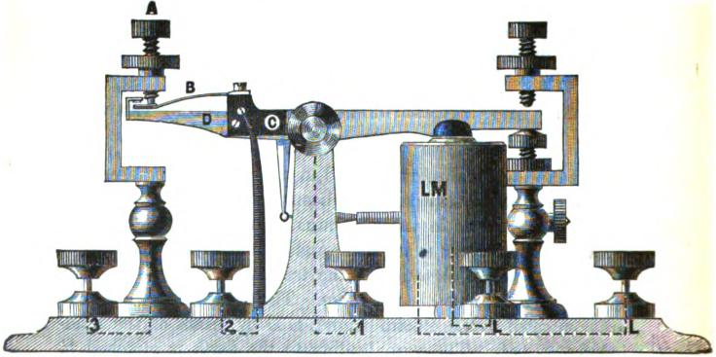
Ag. 475.
are binding posts connected with the adjustable resistance coils; r, r' are the terminals of small resistance coils used for maintaining an equal resistance when line is to earth through battery, or to earth direct. The connections of the wires with the various parts will be readily traced. The plugs in the resistance coils must be removed until the resistance of the coils equals the resistance of the line. When they are equal the armature of the relay will not be affected by the working of the transmitting sounder. The object of the condenser is to receive a charge from the main battery equal to that entering the line, which

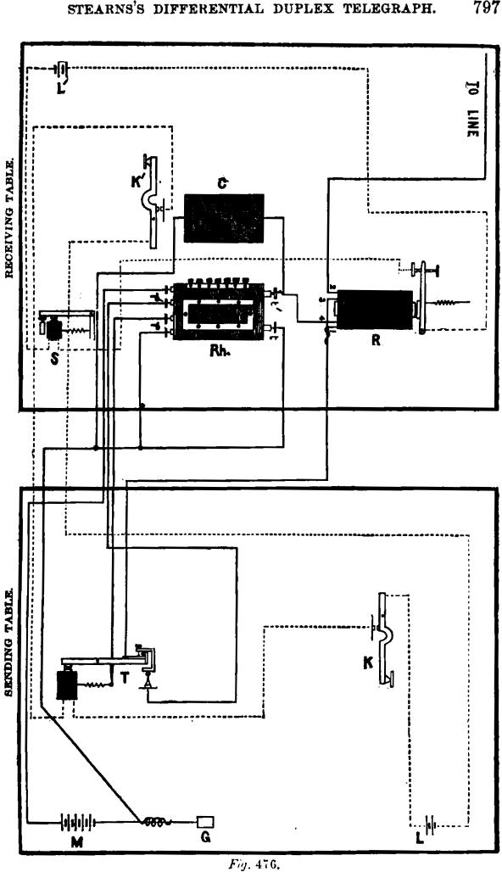
EARNS'S DIFFERENTIAL DUPLEX TELEGRAPH.
797
Fog. 47G.
r
r
L
—
RI

798 SIMULTANEOUS TRANSMISSION IN OPPOSITE DIRECTIONS.
charge being returned through the.relay coil connected with• the rheostat, at the same time that the line returns its charge through the other coil, neutralizes its effect upon the armature.
The small resistance coils represented in fig. 476 as being enclosed in the box containing rheostat Rh at r and r', are generally enclosed in separate boxes.
Fig. 477 illustrates the method devised for regulating the condenser charge by means of a rheostat.
Strips of brass are placed upon the top of the rheostat for the • purpose of affording a means of adjusting or regulating the
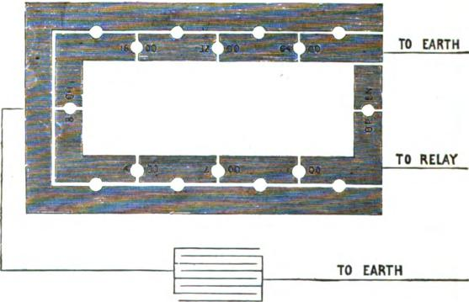
Fig. 477
effect of the condenser charge upon the relay, when the condenser has an electro-static capacity greater than that of the line wire.
For convenience of explanation, let us suppose the rheostat composed of a number of equal resistances, say 1,000 ohms each (fig. 478), and the static capacity of the line be four micro-farads, and that of the condenser to be eight micro-farads. If the condenser wire be connected, as is usual, at a, or between the relay and the rheostat, it will receive a high charge from the battery, and when the battery is removed will return the whole, or nearly the

STEARNS'S DIFFERENTIAL DUPLEX TELEGRAPH. 799

whole of the charge through the relay to the earth, and the charge being greater than that returned from the line, will overbalance the latter and produce a movement of the armature. If the condenser wire be connected at any other point—as, for example, between the coils b and o—it will not receive so high a charge from the battery as it would if connected at a, and this smaller charge upon returning will divide, a portion only of it passing in the direction of the arrow g through the coil b and the relay to the earth; the other portion of the charge passing th;ough the coils c and d in the direction of the arrow h to the earth. Again, if the condenser wire be connected at e, or between the rheostat and the earth, it will receive no charge at all from the battery, and, of course, can return none.
h
_{b.} TO RELAY TO EARTH
0. •
e a

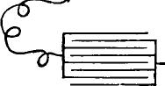 | TO EARTH

Foy. 4/8.
Thus it will be seen, that by connecting the condenser at dif-ferent points between the coils of the rheostat, any required portion of the charge can be sent through the relay.
The rheostat is arranged substantially as shown in fig. 477.
The strip S furnishes a means of connecting the condenser between any two coils of the rheostat, and thus regulating the quantity of charge which shall flow from the condenser through the relay with sufficient exactness.
In making up the resistance necessary to balance the line in any case, as many as possible of the low numbers should be used, so that these low resistances, or any of them, may be interposed between the relay and the point where the condenser is connected.

800 SIMULTANEOUS TRANSMISSION IN OPPOSITE DIRECTIONS.

STEARNS'S BRIDGE DUPLEX, AS ARRANGED BY THE WESTERN UNION TELEGRAPH COMPANY.
This apparatus is arranged upon the same general plan as that of Maron (fig. 473), in combination with a transmitter like that represented in fig. 475, and a suitably arranged condenser.
Fig. 479 will serve to show the principle upon which this invention is based. H, A, B, etc., represents the apparatus at one
end of a line; and A', B', etc., the apparatus at the other
end. In this diagram the line L constitutes one side of the balance, the resistance coil, or rheostat R, the opposite side, while the other two sides are formed by two branch circuits, A and B. The receiving instrument is placed in the bridge between F and G. The two branch circuits unite at H, and are connected by a wire to the lever 1 of key S. When the knob of the key is depressed a current is sent along the wire to H, and there branches, a portion passing through the resistance coils A to line L, and a portion through resistance coils B and R to the earth.
Now, if the resistance of the branch A bears the same proportion to that of L that the resistance of B bears to R, then no current will pass through the relay. For example, suppose the resistance of A to be 1,000 ohms, L 4,000, B 500, and R 2,000, then no current would pass through the relay at the transmitting station, because the resistances in the opposite circuits on each side of the bridge are in the same ratio to each other—that of two to one—and, consequently, the receiving instrument will be unaffected by the signals transmitted from the home station. When, however, a current from the distant station is sent to line, a portion of it passes through the receiving instrument in the bridge, for, at the point F, it finds two paths to pursue, one through the resistance A to the lever 1, and small resistance v or to and battery to the earth, and the other through the relay and coils B and R to earth.
When two or more paths are open to the passage of a current, it will divide itself between them in proportion to their several conductivities.

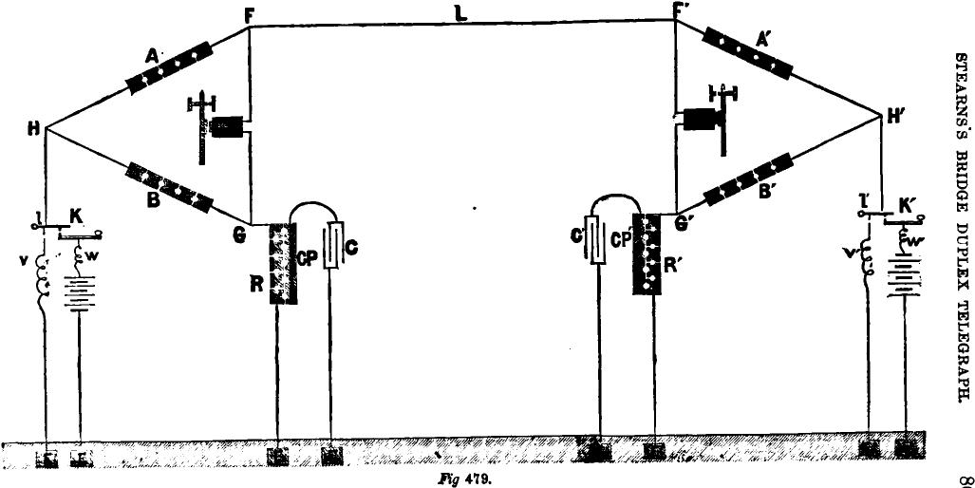
BTEARNS.S BRIDGE DUPLEX TELEGRAPH.
Pig 479.
O0

802 SIMULTANEOUS TRANSMISSION IN OPPOSITE DIRECTIONS.

If the resistance of the relay is 500 ohms, the total resistance 500 X 2000 of the branch, of which forms a part, will be 500+
500 + 2000 = 900, and the resistance of the branch F A being 1000, the joint
900 X 1000 900,000
resistances of the two branches at F would be
900--1000 1,900
473 ohms, which, added to the resistance of the line, 4,000 ohms, would make the resistance of the circuit 4,473 ohms. Now, if the electro-motive force is 50,000 units, the strength of current at
F would be 11.18 units, and this current would be divided between the two branches in proportion to their conductivities. (conductivity being the reciprocal of resistance). Thus the conductivity of the branch F A would be .0010 and that of the
G R .0011, and hence 47.62 per cent. of the received current, or 5.32 units, would flow through the branch A to the ground, and 52.38 per cent, or 5.86 units, would flow through the relay to-the ground. Of course the amount of current flowing through the relay can be increased or decreased by modifying the resistances in B and R.
Key K is so arranged that the line is always connected to the ground, either through the back contact direct, or through the front contact and battery. v and w are small resistances, placed in the circuits to prevent the battery from being put even momentarily on short circuit, and also for the purpose of maintaining a uniform resistance in the circuit when the line is connected to earth direct, or through the battery. C is a condenser, for-compensating the static charge from the line, and is attached by a wire to- a brass plate C P, on the rheostat R, which is provided with holes for plugs, for connecting it with the resistance coil plates, whereby the condenser charge can be sent through any portion of the resistance coils, as desired.
Figs. 475 and 480 are illustrations of the apparatus in use by⁻the IV estern Union Company in the bridge duplex.
Fig. 480 shows the adjustable resistances, condenser plate and binding screws for connecting the apparatus. The outer

STEARNS'S BRIDGE DUPLEX TELEGRAPH. 808
circular ring corresponds to the point H in fig. 479, and is attached to binding screw T, which is connected by wire with binding screw 2 in fig. 475, corresponding with the lever / in fig. 479. The discs in the outer circle are connected with resistance coils of 40 ohms each, terminating with resistances of 400 and 600 ohms, respectively, and corresponding with rheostats A and B in fig. 479. The discs in the inner circle are attached to resistance coils of 1,000, 2,000 and 4,000 ohms each, corresponding with rheostat R in fig. 479, and are connected with binding screw E, which is attached to an earth wire. The large disc in the centre is attached to binding screw C, which is connected with the condenser.
The line wire, and one side of the relay, is connected with binding screw L, and the other side of the relay with binding screw R By inserting a plug at different points in the series of holes between the outer circle of discs and the circular ring, the two sides of the bridge, corresponding with A and B, fig. 479, can be varied at pleasure; and by inserting plugs in the holes between the inner circle of discs, the third side of the bridge, corresponding with rheostat R, in fig. 479, can be lengthened or shortened, as desired. By inserting a plug between the inner circle of discs and the condenser plate, any portion of the charge can be sent to line that is desired.
When the duplex is employed in working a cable of consider. able static capacity, it is desirable to modify the above condenser arrangement somewhat, because the latter discharges so much. quicker than the former, and it is necessary to make the discharges of the condensers and cables equal in duration as well as in quantity. If a cable returns, for example, a certain charge, say 10 m. f., a condenser having a capacity of 10 m. f. will not produce a balm⁻ice, !or the reason that the condenser discharges so much more quickly than the cable. To make the discharges equal in duration as well as amount, resistance should be introduced between the condenser and the branch circuit.
The following arrangement has been found to work well upon a cable of 18 rn. f A resistance of 160 ohms is inserted between

804 SIMULTANEOUS TRANSMISSION IN OPPOSITE DIRECIIONS.
the first series of condensers and the fourth side of the bridge, at the right of point G, fig. 479, and a resistance of 50 ohms is inserted between the first and second series of condensers. The first series of condensers returns its charge to the relay through the resistance of 160 ohms, and the second group of condensers returns its charge through the 50 ohm coil, and also the 160
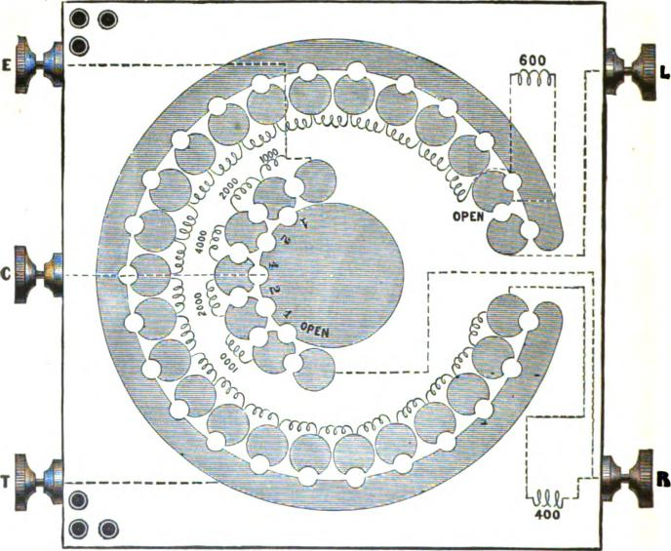
Ag. 480.
ohm coil. The charge of the second group is retarded slightly more than that of the first group. The 160 ohm coil was wound with one copper wire, but had no iron core, and it was found to' retard the charge as much as 250 ohms rheostat resistance. A coil with an iron core would retard the charge much more, because the charge current would have more work to do at that

COMPARISON OF BRIDGE AND DIFFERENTIAL SYSTEMS. 805

point, and a part of it would be converted into magnetism for a while, and afterward reconverted into electricity and continue the current at the last when it is needed. With the above combination the static balance is absolutely perfect, not the slightest quiver of the armature being observable when the circuit is opened and closed. During rainy weather, when a part of the circuit is composed of a land line, it is necessary to remove a part of the condensers, but not the retardation coils.
The bridge duplex possesses many points of superiority over the differential, and is inferior in only one; but that one is of such a nature as practically to exclude it from use on long circuits. Its defect is that, with equal battery power, its magnetic strength is less than that of the differential. In order to deter. mine the difference between the two systems in this respect, let us assume two lines of 6,000 ohms each, equipped, one with the differential and the other with the bridge, and at each end of each a battery of 80 cells Grove, having an internal resistance of 40 ohms and an electro-motive force of say 150 volts. Also, suppose the resistance of the bridge relay and of each of the two wires of the differential to be 500 ohms, and of the spark coils 100 and 140 ohms each. Under these conditions the resistance of the combined circuits working from each battery will be (including the internal resistance of the batteries) in the differential .3,542 ohms, and in the bridge 2,054 ohms, provided the latter is arranged with resistances of 1,500, 500, and 2,000 ohms on three of the sides.
The currents from the batteries will be, on the differential .0423, and on the bridge .0730 farad. From the battery each current divides, passing over two separate circuits. The strength of current, being in inverse proportion to the resistance in each of the two circuits from either battery, that passing to line on the differential will be .0212, and on the bridge .0183 farad. The lines being perfectly insulated, these figures will also represent the quantity of current arriving from the distant station.
The strength of the electro-magnet of the receiving instrn-ment, other things being equal, is directly proportional to the,

806 SIMULTANEOUS TRANSMISSION IN OPPOSITE DIRECTIONS..

number of turns of wire in the helices; and in any electromagnet of given dimensions the number of turns is in proportion to the square root of the resistance of the wire composing the helices. The bridge and differential relays at present in use are generally of the same dimensions; and for purposes of comparison, at least, they should be so. Assuming the resistance of each half of the differential relay to be 500 ohms, it is evident that, in estimating the proportion between the number of turns of wire in the differential and bridge relays, the former should be regarded as a single relay of 1,000 ohms. The whole number of turns in the differential relay will therefore bear the same proportion to the number in the bridge relay (the.
resistance of which is 500 ohms), as {17.(7,00 to 415TO. Now
V1.000 = 81.62, and 607.) = 22.26. The whole number of turns of wire in the differential will therefore be to the number in the bridge as 3162 to 2236. But the received current passes: through only one half of the differential relay; therefore, in estimating the comparative effect of the current upon it, it must be: regarded as having but half that number of turns, that is 1581.. If, therefore, the whole of the received current could be made. to pass through the bridge relay, as it does through one half of the differential, and these currents were of equal strength in. each case, the bridge relay would give the greater magnetic. effect in the proportion of 2236 to 1581. The latter of these conditions, however, cannot be fulfilled, and in the case under consideration neither is. With the bridge arranged as described, the proportion of arriving current passing through the relay will be very nearly exactly _{a} of the whole. This arriving current, as above shown, is .0183 farad, I of which is .0114. To obtain the proportionate strength of the two relays we have only to multiply the number of turns of wire in the helices of each by the quantity of current passing through each. Thus we have for the differential 1581 X .0212 = 33.51, and for the bridge 2236 X .0114 — 25.49; or, in other words, the magnetic strength of the bridge relay will be a little more than 76 per cent. of that: of the differential in the case under consideration.

STEARNS'S AND SMITH'S ELECTRO-MECHANICAL METHOD. 807

The apparent advantages possessed by the bridge over the differential system are :
- It is less liable to injury by lightning.
- It requires less condenser capacity.
- The capacity of the condenser, or rather its neutralizing effect upon the relay, can be more conveniently made adjustable to the varying conditions of the line.
- The resistances are more easily and quickly adjusted by the operator.
These advantages make the bridge preferable to the differential on short lines of low resistance, where the comparative lack of power is not a material disadvantage, and especially where batteries with low internal resistances are used.
THE DUPLEX TELEGRAPH AS OPERATED BY THE POST-OFFICE
TELEGRAPHS IN GREAT BRITAIN.
The method suggested by Frischen in 1863, in which he proposed to employ differential polarized receiving instruments, and arrange the keys so as to send reversals, has been adapted to Stearns's apparatus in Great Britain, with the most excellent practical results. Fig. 481 illustrates the arrangement of the apparatus so clearly that scarcely any explanation is needed. The key is provided with a switch so that the battery may be disconnected when not required for working. A differential galvanometer is employed for convenience in balancing the resistances with accuracy. The rheostat coils are arranged in a circle, and contact is made by means of two arms resembling the hands of a watch, one of which is connected to the higher and the other to the lower resistances. A series of retardation coils is connected with the condenser, so that its return discharge may be graduated to correspond with that from the line. The polarized relay is of Siemens's pattern, with differential helices.
STEARNS'S AND SMITHS ELECTRO-MECHANICAL METHOD.
In 1872 Mr. Stearns obtained a patent for a method of simultaneous transsmision, which consists in combining with the re-

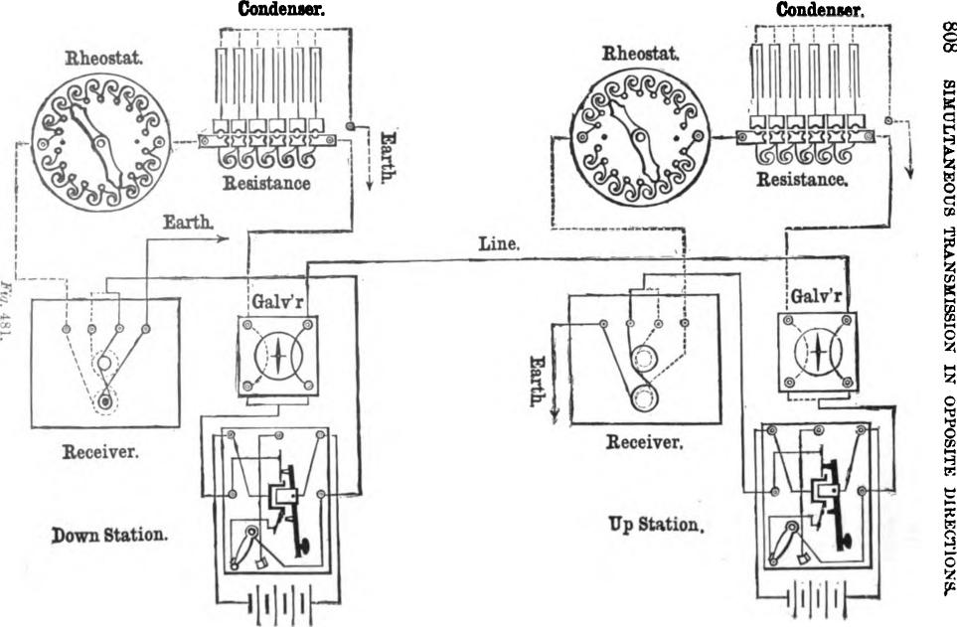
;
- \
Down Station.
Receiver.
Earth.
Galdr
Line.
Galv'r
Receiver.
Up Station.
Hill I 1-
SIMULTANEOUS TRANSMISSION IN OPPOSITE DIRECTIONS.
Rheostat.
Condenser.
[I INV

Resistance
Rheostat.

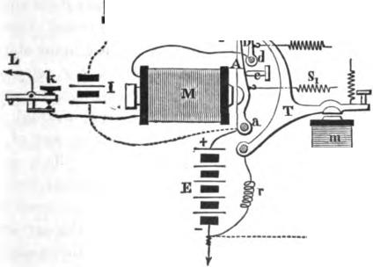
SMITH'S ELECTRO-MECHANICAL METHOD. 809
ceiving magnet a device controlled by the transmitter, which, by mechanical means, prevents the home instrument from responding to the signals transmitted from the home station, but does not prevent it from responding to the signals of the distant station. This method was afterwards independ_{a}pntly re-invented by Mr. G. Smith, whose apparatus, although upon precisely the same principle as that of Stearns, is arranged in a more convenient manner, and has been found to operate admirably in practical service. The details of Smith's arrangement will be understood by reference to fig. 482.
M is the receiving relay, which operates the sounder S in the
.............

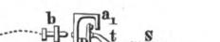
b
1. t
--------
-------- ----- •
C
Fig. 482.
usual manner by means of the local battery L The armature lever A of the relay turns on an arbor at a, and plays between the front and back contact stops b and c. D is a contact lever having its fulcrum at d. When the transmitter T is in its position of rest its projecting arm t is in such a position that the arm D is drawn against it by the tension of the adjustable spiral spring a, as shown in the drawing, and is, therefore, in electrical contact therewith; but when the armature of the transmitter is depressed, the arm t is withdrawn, and the lever D falls back, by the tension of its spring s, against the projecting stop a_{l} of the relay armature A.
The connections are arranged as follows:

810 SIMULTANEOUS TRANSMISSION IN OPPOSITE DIRECTIONS.

One pole of the main battery E is connected to the fulcrum a of the relay armature A, and the other pole to earth at G. The fulcrum of the transmitter T is also connected to earth, a spark coil r being inserted, equal in resistance to the battery, in the usual manner. The line L goes first to the helices of the relay M and thence to the fulcrum d of the contact lever D. The transmitter T may be worked directly by hand in the same manner as an ordinary key, but it is preferable to arrange it in the ordinary way with a local magnet m and key K, as in the figure.
It being understood that the diagram represents the normal position of the apparatus when not in use, the principle of its operation will be very easily understood. The armature spring s, is adjusted to correspond to the in-coming or received currents from the battery of the distant station. When the home station has its key K open, as represented in the figure, the relay and sounder respond to the writing of the distant operator, the same as a plain relay; the currents entering at L pass through the relay M, and thence find their way to the ground by way of the contact lever D, transmitter T, and spark coil r. The upper spring s is so adjusted that when acting in conjunction with the spring a_{l} their combined pull will hold the armature lever A in its back stop c with sufficient force to withstand the attraction produced in the relay magnet M by the action of the main battery E, either at the home or the distant station alone, but the combined effect of the two batteries, when both of them are in circuit at the same time, will be sufficient to overcome the combined tension of the springs without difficulty. This being the case, it will be seen that when the armature of the transmitter T at the home station is depressed, that the arm t is drawn back, when the spring s pulls the contact lever D against the stop a_{l} of the armature lever A, which connects the main battery E to the line through the home relay M, but at the same time the combined tension of the two springs s and s₁ is exerted to prevent its armature from responding. Tf, however, the distant key is depressed, and the battery of the distant station also placed in

VAES'S METHOD. 811

circuit, the tension of both springs is overcome, the armature A responds to the increased attraction of the magnet M and closes its local circuit at b, thus recording the signal from the distant station.
In working this apparatus it is of course necessary that the main batteries should be placed with unlike poles towards each other, as in the ordinary closed circuit system.
This apparatus may be worked at an intermediate station as well as at a terminal one, the only change being to replace the ground wire by the remaining line wire, as shown by the dotted line L₁.
The apparatus, when set up in this way, may be provided with an ordinary Morse key with circuit closer k placed in the line circuit. This having been done, the whole arrangement can be "singled up" or converted into an ordinary closed circuit Morse system at a moment's notice by the following procedure : Each terminal station closes the key K and slackens the adjustment of the spring s. Each way station slackens the spring s in the same manner, but leaves the key K open. By means of the key k any station, way or terminal, may correspond with any other, precisely as in ordinary working.
When arranged for duplex working, any station, whether way or terminal, may call any other station and work duplex with them whenever the line is not in use elsewhere.
This apparatus has been tested in practical service, both for through and intermediate business, upon circuits of various lengths, up to 450 miles of No. 6 gauge wire, and has proved entirely successful. It may also be used at intermediate or way stations in connection with the Stearns differential duplex.
VAES'S METHOD.
In 1872 Mr. J. F. Vaes, of Rotterdam, published a description of a method of simultaneous transmission, which he had experimentally tried in the latter part of 1868 upon a line of 180 miles in length, with satisfactory results both as regards the Morse and the Hughes system. By an inspection of fig. 483.

812 SIMULTANEOUS TRANSMISSION IN OPPOSITE DIRECTION&
which illustrates the principle of Vaes's method, it will be seen that, so far as it goes, it is identical with that of Stearns, consisting of Frischen's.differential receiving instrument combined with Nystrom's key, and having a rheostat inserted between the point 5 and the earth, to compensate for the internal resistance of the battery. In adapting his method to the Hughes printing telegraph, Vaes makes use of two instruments in each office, one for sending and the other for receiving. The electro-magnet of the former is wound with a single wire, while that of the latter is provided with two wires. These are connected in such a way that the out-going current passes through both wires of the send-
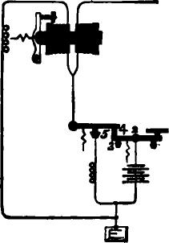
Rg. 483.
ing instrument, while the in-coming current passes through one wire only of the receiving instrument
WINTER'S METHODS.
The following methods of simultaneous transmission were patented in Great Britain by George K. Winter, an English telegraphic engineer residing in India: Mr. Winter makes use of opposing batteries, and thus the battery power required is little more than that required for single working, while the adjustment of compensating changes in the insulation of the line is simplified. At each end of the line the battery is permanently

WINTER'S METHOD. 813

connected with the same pole to earth in each case. The receiving instrument is inserted between the battery and the line at at each end. At a point in the coil of the instrument, much nearer to the battery end than the line end, the wire is connected with one terminal of a key, the other terminal being connected with earth. The effect of depressing the lever of the key is to connect together these two terminals. A resistance coil may, if necessary, be inserted between the battery and the instrument.
Fig. 484 shows the general arrangement A and B represent the two terminal stations; 1 is the line between them. At each station i is the receiving instrument, k key, b battery, e the earth connection and r a resistance coiL Suppose one-tenth of the wire of the instrument i is between k and r and nine-
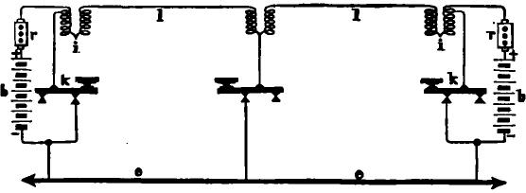
Fig. 484.
tenths between k and l; let the resistance r be nine-tenths that of the line, and let us first suppose the insulation of the line to be perfect. If now the key at A is depressed the battery b is on short circuit through the resistance and one-tenth of the instrument. The current from the battery at B flows through the whole of the instrument at B, the whole of the line wire and nine-tenths of the instrument at A. Its action upon the instrument at A is antagonistic to that of the battery acting locally at that station, and as it has to go through about nine times the resistance, it has only about one-ninth of the strength of the current of the battery on short circuit at A, but as it has nine times as many convolutions of the instrument wire to pass through, the actions are just balanced, and the instrument at A is un-

814 SIMULTANEOUS TRANSMISSION IN OPPOSITE DIRECTIONS.

affected. At B, however, it is evident that the whole of the battery acts through the whole of the coil of the instrument, and produces a signal accordingly, which is only slightly weakened by the insertion of the resistance r. When B communicates with A matters are simply reversed. When both keys are depressed at once, the battery at each station acts locally, and the action on each instrument is only about one-tenth less than the action of the whole of the battery when, after traversing the line, it acts upon the whole of the coil of the instrument as in single sending,
Now, suppose the insulation to become imperfect, there will be a slight current from each battery running through the instrument to line, and tending to produce a signal. All that is neces-

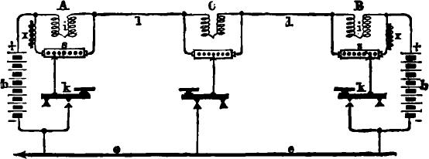

Rg. 485.
nary to remedy this is to give the instrument a bias against making a signal equal and opposite to the effect produced by the leakage current. With most instruments this is done by the ordinary adjustment of the instrument with which the operators are already familiar.
Another but less effective method by the same inventor is shown in fig. 485. In this arrangement, the key, instead of being connected to a point in the wire in the interior of the instrument coil, is joined to a point in a resistance s acting as a shunt on the receiving instrument, much nearer to the battery end of the shunt than the line end. A suitable proportion between the resistance s and the instrument coils is say 4 or 5 to 1. The point where the key is connected may, if required, be made adjustable by means of a sliding contact.

SMITH'S METHOD. 815

Both the above arrangements can be applied to intermediate instruments very simply, by making the point where the key is connected nearer to the middle of the instrument coil in the first arrangement, and of the shunt in the second method. The intermediate stations can then communicate with each other or the terminal stations in duplex and without batteries. The arrangements of the intermediate stations are shown in the figures.
The effect of the static induction of the line in the opposed battery system is as follows: When both keys are in their normal position the potential of the whole line is raised or lowered by the opposing batteries above or below that of the earth, and the line will in consequence hold a charge which will depend for its quantity upon the inductive capacity of the line. When either of the keys is depressed, the potential of the circuit at that point will be made the same as that of the earth, and half the charge of the line will flow out through the line coil of the instrument. In the second of the two systems (see fig. 485) the effect of the charge and discharge will be lessened by part being carried off by the shunt. It is evident, therefore, that at each depression of the key, we have a strong instantaneous current flowing in one direction through the line coils of the instrument, whereas when the key is raised there is another instantaneous current flowing in the opposite direction through the whole coiL The effects of the inductive discharge, when not compensated, are, on the whole, much less marked in this than in the open circuit system.
Mr. Winter's method of effecting the compensation for the inductive discharge is by winding the shunt on the battery side of the key upon an iron core, as shown at x in fig. 485.
SMITH'S METHOD.
Mr. Gerritt Smith, Assistant Electrician of the Western Union Telegraph Company, has invented a method of duplex working which differs materially from any of the systems referred to heretofore, and which has proved successful in its practical working.
' The principle on which the operation of Mr. Smith's system

816 SIMULTANEOUS TRANSMISSION IN OPPOSITE DIRECTION&
depends will be best understood by reference to the familiar illustration in fig. 486. Suppose a b c to represent a telegraph line, attached at one end a to the grounded battery E, of say 100 cells, while the other end c is connected directly to the earth. Let the resistance of the line be 4,000 ohms. A current of moderate and uniform strength would flow through the line from the positive pole of the battery at E to the earth at c. If a wire, having practically no resistance, is now connected from the line wire at a to the ground, ag indicated by the dotted line a_{l}, a very powerful current will flow through it. This current is equal to the full power of the battery E; in other words, the battery is placed on short circuit, and the current flowing over the line to c becomes practically nothing. Now, instead of the wire a_{l}, if a second battery of 100 cells is connected between
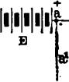
2000 2000 0
l_{ig}
Cl
EARTH
Fig. 486.
the point a and the ground, with its positive pole likewise to the line, its current will exactly neutralize that of the battery E in the short circuit, but a current will pass over the line from a to c as before.
If the connection b₁ be made to the earth from the middle of the line at b, a current will flow from that point to the earth as before; but it will be much weaker than in the former instance, as it is obliged to pass through 2.000 ohms of line resistance between a and b. This current may be neutralized as in the former case, by inserting a battery in the wire b₁, with its positive pole to the line, but in this case the current being weaker, a smaller number of cells, say fifty, will be sufficient to oppose it, and when this is done, the current from E will pass to c as before.
It will be readily understood that it is not at all essential that

SMITH'S METHOD. 817

the point b should be in the geographical centre of the line to produce the above effect. The 2,000 ohms between a and b may consist merely of a resistance coil, while the 2,000 ohms between b and c may consist of, say 100 miles of line, more or less. Precisely the same result will follow as in the first instance. The battery of 50 cells at 1), will balance the 100 cells at E, in either case; there will be no current whatever in the wire b₁, and a relay inserted in it would remain entirely unaffected if the circuit of both batteries were opened and closed simultaneously. A current would, however, flow from b to c whenever the two batteries were connected to the system.
Mr. Smith has applied this principle to the working of a
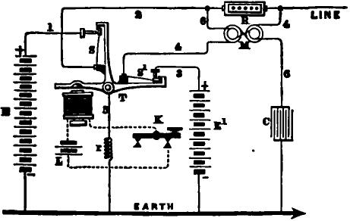
Fig. 48'i
duplex in the following manner : The transmitter T (see fig. 487) is worked either directly by the finger of the operator, or preferably by a magnet, local battery and finger key K, as in the Stearns duplex. It is so arranged that the two batteries E and E₁ are both placed in circuit simultaneously whenever the key is depressed. The circuit of battery E, when closed, passes through the wire 1, spring 8 of the transmitter T, wire 2, and rheostat R, to the junction of wire 4 and the line, where it meets the opposing current from battery E₁, which comes through wires 3 and 4, including one wire of differential relay M. The current of the principal battery E is materially weakened by the

818 SIMULTANEOUS TRANSMISSION IN OPPOSITE DIRECTIONS.

resistance of the rheostat R, so that a much smaller battery E₁ is sufficient to oppose its tendency to find its way back to the earth through the wire 4 and relay M. It, therefore, goes over the line to the distant station, and operates the instrument at that point. Thus we have the first condition of duplex working provided for, as the two batteries E and E₁ exactly neutralize each others effect in the wires 3 and 4 and relay M.
The currents received from the distant station over the line divide at the junction of the wire 4, one portion going to the earth through the rheostat R and wire 2, and the other portion through the wire 4 and relay M, recording the signal. It will be seen that so far as the strength of the out-going current is concerned, it is quite immaterial what the resistance of the relay M is, and this may, therefore, be made of whatever resistance will produce the most favorable effect with the in-coming current.
An ordinary relay might be used with this duplex, but in practice it has been found preferable to substitute a differentially wound relay. The extra circuit of this forms a part of the wire 6, which is attached to the battery 2, and to one side of a condenser C, the other side of which is connected to the earth. By this contrivance the' return current or static charge is effectually compensated. When the circuit of the battery E is closed the condenser C takes a charge. When the battery is removed from the circuit the line and the condenser discharge themselves simultaneously, but the two charges pass off in opposite directions through the two wires of the differential relay, and their effect upon its cores is therefore null.
The resistance of the spark coil r should be made equal to that of the joint resistance of the batteries E and E₁. The balance of the whole system is obtained by varying the rheostat R
Instead of a transmitter with the continuity-preserving springs a s,, an arrangement might be used which would short circuit both batteries when the key is up, by a connection which would be interrupted when the latter is depressed, so as to allow the current to flow to line.
The above duplex system has been tested on a number of

HASKINS'S METHOD. 819
different lines of the Western Union Company with the most satisfactory⁻results. The resistances of the lines in good weather varies from 5,000 to 6,800 ohms. With 175 gravity cells in battery E, and 135 similar cells in battery E₁, the resistance which is required in R to effect a balance with 6,300 ohms in the line is about 1,711 ohms. The differential relay used had a resistance of about 300 ohms on each side.
HASKINS'S METHOD.
The following method of simultaneous transmission was invented in the early part of 1874 by Mr. C. H. Haskins, General
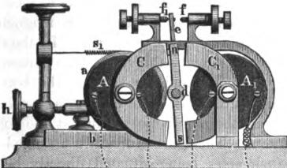
3 | k | 1
LINE
E
.FTg. 488.
Superintendent of the lines of the North Western Telegraph Company at Milwaukee, Wis. The novelty of the invention consists principally in the peculiar manner in which the receiving relay is constructed and operated, and we will, therefore, give a description of this part of the apparatus before explaining the general principle of operation.
Fig. 488 is an end view of the relay, the connections and other parts of the apparatus being shown on a small scale and in outline, for convenience of explanation. The relay consists of two spools or helices A A₁, which are placed parallel to each other

H2O SIMULTANEOUS TRANSMISSION IN OPPOSITE DIRECTIONS.

and connected together at the point 2, so as to form a continuous circuit from 1 to 3, precisely in the same manner that the helices of an ordinary relay are arranged. Instead, however, of connecting the two cores together by means of a yoke piece or back armature, so as to form a single electro-magnet, as is usually done, semicircular pole pieces of soft iron, C and C₁, are attached to each end of the core of each helix. Therefore each core, with its pole pieces and helix, in reality constitutes a distinct electromagnet, having four poles, the two poles at one end having always a magnetic polarity opposite to the two poles at the other end, whenever a current is passing.
Between the two helices A A₁, and parallel to them, is a shaft or axis d, carrying at each end a permanently magnetic bar n s, which may be termed a polarized armature. In the drawing, n represents the north pole and 8 the south pole of one armature, the former being at the top and the latter at the bottom. The position of the armature at the other end of the axis is exactly the reverse of this, the south pole being at the top and the north at the bottom. These armatures are arranged as shown in the figure, their poles being situated directly between the poles C C_{i} of the electro-magnets which face each other. A contact arm e, rigidly attached to the axis d, projects upward at a point midway between the two polarized armatures, and is provided with a contact point. The arm e plays between the adjustable stops' and f,, the latter being insulated, and opens and closes the local circuit of the receiving sounder in the same manner as an ordinary relay. An adjustable spiral spring 8, retains the armature in the position shown in the figure, the local circuit being open when no current is passing. The coil A is mounted in a frame a, which slides in a bed plate b, and is capable of being moved by means of the screw h to or from the other coil and the armature. Thus it will be seen that the adjustments arc virtually the same as in the ordinary relay.
The arrangement of the connections is indicated in outline in the figure. The main batteries at each end of the line are placed with their unlike poles towards each other, precisely as in the

HASKINS'S METHOD. 821

usual arrangement for a Morse circuit. When both keys are at rest, the main line is to ground at each end through both helices A A_{l} of the relays, and also through the resistance r. The key merely serves, when depressed, to connect the battery to the main line at a point between the helices of the relay.
There are but three different electrical conditions of the line possible when this apparatus is working, which are as follows :
- When the home key is open and the distant key closed. If each battery consists of say 100 cells, the resistance of the line 1000 ohms, rheostat r 1200, and relay helices 200 each; the
strength of current in this ease will be 1000 -:-(200 1000
400 1200) = 0.35. This current will go to earth at the borne
station through both helices of the relays, and the force acting upon the armature n 8 in opposition to the spring s, will be 0.35 X 2= 0.70 when the distant key is closed, and nothing when it Is open.
- When the home key z closed and the distant key open. The current from the home battery divides at the point 2, and to avoid complexity we will assume that the battery has no internal resistance. The strength of the current going to line will be 1000 (200 + 1000 400+ 1200) = 0.35; which will there• fore act in one coil A_{l} of the home relay in opposition to the spring 8₁ with a force of 0.35. The other branch of the current going through the rheostat at the home station has a force in A of 1000 (200 + 1200) = 0.71, which is double that 'of the current going to line, and acts in the same direction with spring e_{t}. Thus the armature of the home relay is held still with a force of 0.36 whenever a current is sent to line.
- When the home and distant keys are both closed. In this case the line current, in consequence of both batteries being on, becomes 2000 (200 1000 + 200)=1.66; which acts upon the coil A_{l} upon the line side, but is opposed by the current in A on the rheostat. side in both relays. This, as in the f( Amer ease, amounts to 0.71. Therefore, the effective force acting 'Toil each armature in opposition to the spring, to give a signal, will be 1.66 — 0.71 = 0.95.

822 SIMULTANEOUS TRANSMISSION IN OPPOSITE DIRECTIONS.

Thus, in this arrangement we would have, under the conditions stated, an effective force acting upon the armature tz 8, varying from 0.70 to 0.95. It will at once be seen that this margin enables the operators to work freely over escapes and changes of resistance in the line. Thus, in the case cited, in. order to disturb the balance of the sender's relay, so as to give him back his own signals, the resistance of the line must be diminished sufficiently to increase the strength of current from 0.35 to 0.71—more than double—which would require a very heavy leakage. In practice, the resistance of the rheostat r is made a constant quantity, all necessary adjustments being-effected precisely as in an ordinary instrument, and with no more inconvenience.
The Stearns condenser c may be applied when necessary, in the manner shown in the figure. for the purpose of neutralizing the static discharge.
EDISON'S METHODS.
A method of simultaneous transmission, invented by T. A-Edison •of New Jersey, in 1873, is shown in fig. 489. Its peculiarity consists in the fact that the signals are transmitted in one direction by reversing the polarity of a constant current, and in the opposite direction by increasing and decreasing the strength of the same current. The relay R at station A consists of two soft iron electro-magnets r₁. and 7.₂ which act upon the same armature lever, thereby closing the local circuit of the sounder or other receiving instrument in the usual manner. The transmitter T is operated by a key and local battery as in Stearns's method, and is so arranged that when the key is in a position of rest the negative current from the battery E₁ passes to line through the electro-magnet r₂ of the home relay R, but if the key is depressed the lever T of the transmitter makes contact between the battery E and the earth, and at almost the same instant interrupts the previously existing contact between E₁ and the earth; thus there is at all times either a positive current going to line through r₁, or a negative current through r2.

EDISON'S METHOD. 82$

At station B the currents pass through a polarized receiving instrument R_{I}, and thence through a rheostat X to the earth. The tension of the spring of relay R is adjusted so that the current going to line is not sufficient to overcome it except when the rheostat X is cut out by depressing the key K at station B. Consequently A sends to B by reversing the polarity of the current without changing its strength, while B sends to A by changing the strength of the current irrespective of its polarity.
The polarized relay can be placed at a number of stations on the line, and each will be able to receive the signals from the stations transmitting the positive and negative currents. A neutral or Morse relay may also be placed at a number of stations,
LINE
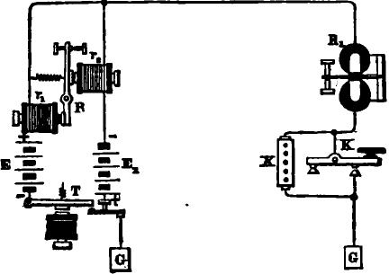
Fig. 489
if devices are applied to prevent the mutilation of the signals by change in the polarity of its iron core.
The principle embodied in this invention, as we shall hereafter see, has been successfully employed in quadruplex transmission by the introduction of suitable modifications in the arrangement of the apparatus.
In 1874 Edison invented a method of simultaneous transmission by induced currents, which has given very satisfactory results in experimental trials. The arrangement of the apparatus differs from Stearns's in that a compound differential induction coil I i_{t} i₂ (fig. 490) is substituted in place of the home relay; the middle or secondary coil I being connected to a polarized re

824 SIMULTANEOUS TRANSMISSION IN OPPOSITE DIRECTIONS.
ceiving instrument R. The out-going currents divide between i_{t} and i_{y}, and as these- oppose each other in their action upon the iron core, no induced current is set up in L The in-coming currents pass through i ₁ alone, and thus an induced current is generated in I at the beginning and end of every signal which operates the polarized receiving instrument R. The latter may be either a relay or an ink-writer.
It would require too much space to refer in detail to the great number of minor modifications which have been made in the different methods of simultaneousa transmission in opposite direc-2.
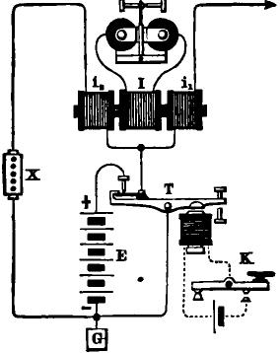
J. 490.
tions, both by European and American inventors. It is believed that every invention of the kind possessing any essential novelty has been explained with sufficient clearness to give the reader a correct comprehension of the subject, both in general and in detail The system, in some form, is now in use on the more important land lines in nearly every country in the world, and the adaptation of it to submarine lines also has thus far been quite successful. In the United States the duplex has since 1874 been largely superseded by the quadruplex method, which has now been brought to great perfection, and will be described at length in a succeeding chapter.

CHAPTER =X.
SIMULTANEOUS TRANSMISSION IN THE SAME DIRECTION.
THE success of the ingenious invention of Frischen, in 1854, was sufficient to give an entirely new direction to the minds of many enterprising European electricians, and during the following year the problem of simultaneous transmission in the same direction, which naturally suggested itself as the next step in the progress of invention, was solved with more or less success by the independent labors of a number of different inventors.
In any system of simultaneous double transmission in the same direction, two keys are required at the sending station, and at least four different electrical conditions of the line must be provided for, one for each of the four following cases:
- When the first key is closed and the second key open.
- When the second key is closed and the first key open.
- When both keys are closed.
- When both keys are open.
The methods of Stark and Siemens, though differing in detail, were arranged upon one general principle, the four electrical conditions of the line being as follows :
- A positive current having a strength of 1.
- A positive current having a strength of 2.
- A positive current having a strength of 3.
- No current.
STARK'S METHOD.
The first attempt made in this direction was by Dr. J. B. Stark, of Vienna, in 1855. His method consists of sending from the transmitting station, by two keys, two currents of different strength, which on arriving at the receiving station, each set a relay in motion.

826 SIMULTANEOUS TRANSMISSION IN THE SAME DIRECTION.
The relays are arranged in such a way that, when the weaker currents traverse the line, only one of them responds; when the stronger current traverses the line, the other relay alone responds; and lastly, when both currents go together, both the relays respond to them.
At the sending station Stark arranged two keys as in fig. 491; K being a simple Morse key, and K' a similar lever, supplied at the back with an insulated earth contact, which it moves against the two anvils 5 and 6. The usual front and back contacts of the keys are marked in the figure 1 and 8 respectively, and the levers 2. The battery is divided into two unequal parts, b and c, the number of elements represented by b being double that of
K
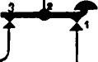
_{l}a
Re!'
/lg. 491.
c. The battery c is put into circuit with the line by pressing down the key K; b, by the key K'; and both together by depressing both keys at the same time.
The copper pole c is, therefore, connected to the contact 1 of K, the zinc pole of same to 5 of K'. Copper pole of b is connected with 1, and zinc pole with 6 of K'. The lever of K' is in connection with the back contact, 3 of K; the line is brought to the lever 2 of K, and the back contact of K' goes to the relay, etc.
When K alone is depressed, the currents of c pass from z (5 and 4 of K') to earth, and from c (1 and 2 of K) to line.

STARK'S METHOD. 827
When K' is depressed, the currents of b pass from z (6 and 4 of K') to earth, and from c (1 and 2 of K') to line.
When both K and K' are depressed, the united currents of b and c pass from zinc of b (6 and 4 of K') to earth, and from copper of c (1 and 2 of K) to line.
By the depression of one or other or both the keys at the sending station, three different strengths of current are therefore produced, which are in the relation of 1, 2, 3. These currents we will call S, S, and S
At the receiving station all currents pass through relays I and II, fig. 492. A common local battery, E₁, serves both these instruments; its zinc pole being connected with the lever of each
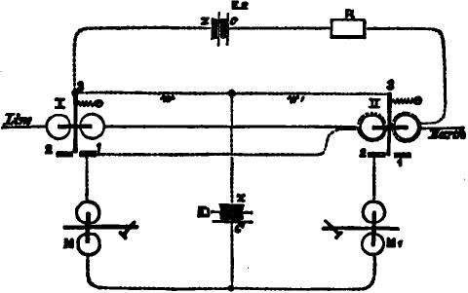
Fig. 492.
of them, and its copper pole with their metal contacts. The relay II is furnished with outer coils, which are put into circuit with another local battey E₉, and a resistance R, by means of the lever of relay L
The lever of relay I is held on its insulated contact by a spiral spring, whose force is adjusted so that the currents S, or those of the portion, c, of the battery, are unable to move it, but so that it is easily moved by S₁ and S₂—the currents of section b and the whole. Relay II, on the contrary is adjusted delicately, so as to respond to the weaker currents.

828 SIMULTANEOUS TRANSMISSION IN THE SAME DIRECTION.

When, therefore, the key K at the sending station is pressed down, the current of c is sent through the line, and passes through the coils of relays I and II to earth. Relay I is unaffected, but relay II is put in action, and the register or sounder M₁, in the local circuit (E₁, z, relay II, 3, 2, M₁, c, etc.), records whatever signals are given by K.
When K' is depressed at the sending station, current S₁ is transmitted, and the lever of relay I deflected against the local contact. Thus two local circuits are closed; the first is that including the battery E₂, R, and the extra coils of relay II, by which the action of the line current in this relay is counteracted, and the lever held still against the insulated contact; therefore M₁ does not respond to these stronger currents. The second local circuit is that of the sounder or register M and battery E₁.
The intensity of the counteracting battery E₂, whose magnetic effect upon the armature of relay II we will call S₃, is regulated by the interposed resistance R, until it balances the magnetizing power of the line current sent by K.
The third case is that in which, during the manipulation of the two keys, both happen to be pressed down together. When this occurs the current S₂ of the whole battery goes through both the relays I and IL Relay I is put in action as before, and closes its local circuit and that of the counteracting battery E_{r} But as the opposite magnetic effect S_{s} of the extra coils of relay II is only equal to that of S₁, and since S₂ is equal the sum of S and S₁, it is evident that the relay II will be acted upon by the difference of the magnetic effects due to the line and the counteracting currents, or by S, which is precisely the same as that produced when K alone is depressed. The register or sounder M₁ will therefore also be set in motion. Other arrangements were also invented by Stark for telegraphing in the same direction at the same time to different stations along the line, both directly and by translation.
Siemens's method, which is very similar to that of Stark, was invented at nearly the same time.
There are two serious difficulties, leaving minor ones out of

STARK'S METHOD. 829

consideration, which are inherent in every system of simultaneous double transmission in the same direction. In the first place, when either key is passing from its front to its rear contact, it causes a momentary interruption of the signal which is at the same time being transmitted by the other key. The second difficulty is a still more serious one, and arises in the following manner: In the simultaneous operation of the apparatus there must, of necessity, frequently be a change from a positive to a negative condition, or vice versa, of the line, or at least of the relays or receiving instruments, consequent upon the movement of a single key; yet it is evident that the reversal of the magnetic polarity of a receiving instrument by the action of one key must interfere with a signal which is being given upon it at the same time by the action of the other key. This difficulty⁻is met with, in some form, in every possible arrangement of the receiving instruments. Neither Stark nor Siemens suggested any method of remedying these serious defects, and judging from his published paper on the subject, the latter evidently considered them insurmountable.
It is evident that Dr. Stark, even at this early date, clearly saw that the successful solution of the difficult problem of simultaneous transmission in the same direction included as a necessary consequence the solution of the problem of quadruple transmission also; for a knowledge of the invention of Gintl, as perfected by Frischen, was all that was needed to show that it was equally applicable either to a single or a double telegraph in one direction.
In the first published description of his method, dated at Vienna, October 31, 1855, Stark concludes as follows:
"With the method of double transmission in the same direction we may also combine that of counter transmission (gegen-8prechen), and hence arises the possibility of simultaneously exchanging four messages upon one wire between two stations, which will, however, hardly find any application in practice."
This is unquestionably the earliest published suggestion of what is now known as the quadruplex system.

830 SIMULTANEOUS TRANSMISSION IN THE SAME DIRECTION.
KRAMER'S METHOD.
The method invented by Kramer, shortly after the above described method of Stark had been made known, accomplished the desired result by means of another and better arrangement of currents for the different positions of the keys, as follows :
- A negative current having a strength of 1.
- A positive current having a strength of 2.
- A positive current having a strength of 1.
- No current.
To avoid the interruption, which in Stark's method was caused by the movement of one key while a signal was being given by the other, Kramer made use of a device originally invented by Gintl (fig. 467, page 779), viz., that of keeping the battery constantly on the main circuit, but shunted by the key, so that when.
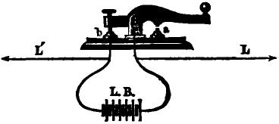
.FYg. 493.
the latter was depressed the short circuit was broken and the current flowed to line, but when raised the battery was again short circuited.
Fig. 493 shows the manner in which the main battery L B was connected with the key and the line wire L L'. This plan effectually disposed of the difficulty in question, but was injurious in its effect upon the batteries, as these were kept closed on short circuit whenever the keys were at rest.
The arrangement at the receiving station is shown in fig. 494. The currents which arrive from the sending station pass successively through three separate relays R₁, R₂ and R₃, of which the armature levers only are represented in the figure. The armatures of R₁ and R₃ are polarized, so that the former responds only to negative and the latter only to positive currents of any

ICRAMER'S METHOD. 831

strength. R_{e}, on the other hand, is a soft iron or neutral relay, but is adjusted so as to respond only to currents having a strength of 2. The arrangement of the registers or sounders M₁ and M_{e} and the local batteries b₁ and b_{s} will be understood by reference to the figure.
In a position of rest, when there is no current upon the line, the local battery b₁ is closed on short circuit, by way of relay levers a_{l} and as, and thus the register or sounder M₁ is cut out. The local circuit of M_{e} is open at a_{s}.
When the first key alone at the sending station is depressed, and a negative current having a strength of 1 is sent through the relays, R, only responds. This breaks the short circuit of the local battery b_{s} at a₁ and M₁ responds.
When the second key alone is depressed, sending a positive current having a strength of 2, the relays R_{e} and R_{e} respond.
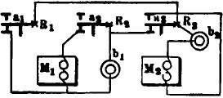
F. 494.
The local circuit of M_{e} is closed by a_{s}, but no effect is produced upon M₁ by the movement of a_{s}.
When both keys are depressed simultaneously, a positive current of the strength of 1 goes to line, and the lever a_{s} of relay R_{e} alone responds, but this operates both M₁ and M₂, the former by breaking the short circuit, and the latter by direct closing on its front contact in the ordinary manner.
If the first key is closed and the second key worked, the line current is changed from negative to positive every time the latter is depressed. As neither of these currents has sufficient strength to overcome the tension of the spring of the armature lever a_{s}, this will remain at rest as in the diagram, while a₁ and a_{s} move alternately. Thus the local of M₁ is constantly closed

832 SIMULTANEOUS TRANSMISSION IN THE SAME DIRECTION.

through the back contact of a,, while M, responds to the movements of the second key.
Practically, the above method of operating a register or sounder by closing and breaking a shunt, is a very unsatisfactory one. It not only exhausts the local battery with great rapidity, but the demagnetization of the iron cores takes place with far less rapidity when the battery is cut off by a shunt, even of very small resistance, than when it is completely interrupted by breaking the circuit in the usual way, and this renders it impossible to receive and record the telegraphic signals with the rapidity that is necessary in modern telegraphy.
EARLY METHODS OF SIMULTANEOUS TRANSMISSION IN THE
SAME DIRECTION.
In October, 1855, A. Bernstein, of Berlin, devised a plan for the simultaneous transmission of two messages in the same direction, which is shown in fig. 495.
The transmitting apparatus consists of two independent circuit preserving keys K₁ and K_{s} in connection with batteries B₁ and B₂, the former composed of, say 10, and the latter 20 cells, as shown in the figure at station A.
The movements of these keys produce three different electrical conditions in the line, according to their respective positions with reference to each other, as follows:
- First and second keys open. The route of the circuit may be traced as follows: From the earth plate G, through wire 6, adjustable stops 5 and 4, wire 3, to adjustable stops 1 and 2 and line L. This may be considered the normal condition of the keys, in which position no current passes to the line.
- First key closed and second key open. The route is from earth plate G to wires 6, 7, main battery B₁, thence to lever /₁ of key K₁₇ and wire 3 to stops 2 and 1 and line L to distant station as before. In this position of the keys the smaller battery B, only is in circuit, sending to the line a positive or + current of + 10.
- Second key closed and first key open. The route now is

BERNSTEIN'S METHODS. 833
from earth plate G, wire 6, to stops 5 and 4; thence by wires 3 and 8, to main battery B₂, and lever 1₂. of key K₂ j thence by wire 9 to stop 1, and line L to distant office. In this position of the keys the larger battery B₂ only is in circuit₎ sending to line a positive or current of + 20.
4. First and second keys both depressed. The route of the circuit in this case is from earth plate G, wire 6, 7, to battery B₁, lever l_{s}; thence to stop 4, and wires 3, 8, and battery
Mg. 495.

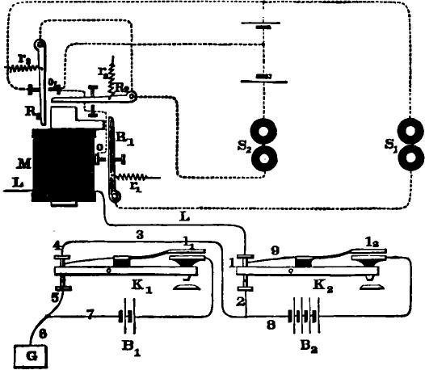
¹
8₁8
12
B₂ to lever /₉, wire 9 to stop 1; thence to the line L and distant station as before. In this position of the keys both batteries are in circuit, sending to line a positive or + current of + 30.
At station B a receiving instrument or relay is made use of, composed of a single electro-magnet M, having three armatures R₁, R₂ and R₃, to each of which are attached retractile springs r₁, r_{s} and r_{s} respectively, with local circuits and sounders S₁ and S₂, as shown in the figure.

834 DOUBLE TRANSMISSION IN THE SAME DIRECTION.

Sounder S, should respond solely to the movements of key
- and sounder S,, in like manner, to the movements of key
- while both should respond when keys _{K1} and K, are simultaneously depressed.
The manner in which this result is attained will be understood by reference to the following explanation of the effect of each of the previously mentioned electrical conditions of the line upon the receiving instrument M at station B :
- The normal condition of the transmitting apparatus.
No current to line.
The local circuit of sounder S₁ is open at point o, armature R, being held against its back stop by the retractile force of spring r₁.
Armature R₂ is, in a like manner, held against its back stop.
Armature R₃ rests 'upon its back stop, owing to the retractile force of spring r₃, in which position it will be observed that a local circuit is completed, in which are included sounder S, and both local batteries, but as the two latter have like poles together, their effect upon sounder S₂ is substantially neutralized; consequently, the latter remains inactive.
- Positive current from battery B, only = + 10.
The local circuit of sounder S₁ is closed between the point o and armature R₁, because the action of the current upon the relay M is strong enough to overcome the•-spring r₁, and force armature R₁ against the stop o.
Armature R₂ remains on its back stop, because the power of the current upon the line is not sufficient to overcome the tension of spring r„.
Armature R₃ rests upon its back stop because the current is not strong enough to overcome the spring r₃. As in the first case, it will also be observed here that armature R,, in this position, completes a local circuit in which is included sounder Sr The latter, however, remains inoperative, for the reasons before explained.
- Positive current from battery B, = -I- 20.

BERNSTEIN'S METHODS. 835

The local circuit of sounder S₂ is closed between the contact point and armature R₉, because the power of the line current is sufficient to overcome the spring r₂, and move the armature R_{I} against its contact point. Armature R_{s} still remains on its back stop, because the current upon the line is not of sufficient strength to overcome the tension of spring r_{s}. In order to prevent a false signal from being given by sounder S_{i}, it is obviously essential, in this ease, that armature R, should make contact with the point o simultaneously with armature R₂, by which means the local battery of sounder S₁ is short-circuited, thus leaving the latter inoperative.
4. Positive current from both batteries (B₁ and B₂) = + 30.
The current upon the line in this ease is sufficiently powerful to overcome the tension of the retractile springs r₁, r₂ and r₃, and force the armatures R₁, R₂ and R₃ against their respective front stops o and o_{l}, operating the sounders S₁ and S₂.
Thus will be understood the manner in which the respective armatures of the receiving instrument are made to assume their different positions with relation to the electriCal condition of the line, so as to record the proper signals upon sounders S₁ and S₂.
Instead of the receiving instrument as devised by Mr. Bernstein, viz.: a single electro-magnet, with three separate armatures, of different adjustments, three independent relays may be used, with local connections the same, without departing from. the principle thereof.
A second method was also invented by Bernstein, in which he made use of both positive and negative currents.
Referring to the diagram, fig. 496, it will be observed that the transmitters, or keys, are circuit preserving, the sketch differing from the original in form, but not in principle.
The operation of the two keys gives rise to three strengths of current upon the line, according to their respective positions, with reference to each other, as follows :
The normal position of the keys is that shown in the figure, both being open.

836 DOUBLE TRANSMISSION IN THE SAME DIRECTION.
The route of the circuit, in each of the before mentioned positions of the keys K₁ and K₂, may be readily traced by reference to the drawing.
Key K, alone sends a positive or + current of, say, 10 cells from battery B.
Key K₂ alone sends a negative or — current from the same
battery — 10.
When both keys are simultaneously depressed, the negative
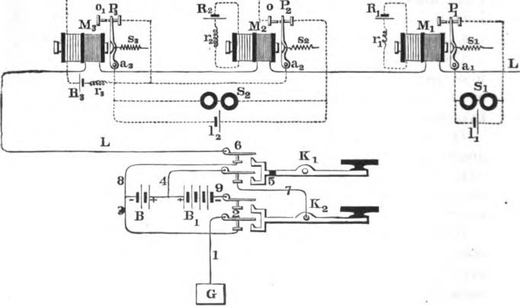
lig. 496.
pole of the smaller battery is insulated, and the larger battery B, sends a positive, or + current =, + 20.
Bernstein's receiving apparatus, in this case, is composed of three independent relays, polarized by means of the auxiliary local coils R₁, R₂ and R₃, the two former being constant, and the latter controlled by the armature a₂ of relay M₂, as shown in the figure at station B.
The sounders S₁ and S₂ are operated by shunting, instead of opening and closing the circuit.

BERNSTEIN'S METHODS. 837

The strength of the current in each of the auxiliary local circuits before mentioned may be changed at will, by varying the adjustable resistance coils r₁, r₂ and r₃. It should not, however, be of sufficient power to overcome the tension of springs a s_{s} and s_{s}.
The current from auxiliary local R₁, circulating in M„ is, say, = + 10, and that of auxiliary local R₂, circulating in M₂,
— 10. That of relay M₃ is brought into action only when armature a_{il}, of relay M₂, makes contact with stop o, at which time a current of + 10 circulates through M₃.
Bearing this in mind, it will be readily understood by the following explanation how the armatures a,, a₂ and a₃ of the receiving instruments M,, M₂ and M₃, respectively, are made ⁻to assume positions, with relation to the three electrical conditions of the line, so as to cause sounder S, to respond solely to the movements of key K₁, and sounder S₂, in like manner, to the movements of key K₂, while both respond when K₁ and K₂, at the sending station, are simultaneously depressed.
- K₁ alone depressed, a positive or + current to the line of + 10. The strength of this current, supplemented by that of the auxiliary local R₁, is sufficient to overcome the spring s₁, and move the armature a, forward, thus breaking the shunt between stop P, and armature al, and leaving sounder S, to be actuated by local battery 1₁.
The action of the line current upon relay M₂, in this case, tends to partially neutralize the effect of the auxiliary coil R₂; -consequently, the armature a₂ is held more firmly by spring s₂ in the position shown.
Armature a₃, of relay M₃, also remains on its back stop P₃, because the line current (viz. : + 10 :) is not of sufficient strength to overcome the spring s₃. Thus the shunt around sounder S₂ remains unbroken, and the latter is inoperative.
- Key K₂, depressed.
A negative or — current of — 10. In this case, the polarity of the line current is such as to partially neutralize the effect of the auxiliary local R,. The armature a, is, in consequence, held

838 DOUBLE TRANSMISSION IN THE SAME DIRECTION.

more securely by spring a, against stop P₁, thus preventing a signal being given on sounder S₁.
Armature a, of relay M₉ is carried from stop P₉ to o, because the strength of the line current, viz.: — 10, added to that of the auxiliary local (— 10), is sufficient to overcome the tension of retractile spring 8₂, thus breaking the shunt, and causing local battery 1, to operate the sounder S₉.
It will here be observed that when armature a₉ connects with stop o, the auxiliary local of relay M₃ is closed, the strength of
which (viz. : 10) being the same as that from the line, but of
opposite polarity, it only serves to substantially neutralize the effect of the latter upon relay M_{s}, and armature a₃ is held inactive by the retractile spring 8₃.
8. Keys K₁ and K₂, both depressed.
A positive or + current of + 20.
Armature a, of relay M₁ is caused to move forward, thus. breaking the shunt, and allowing a current from local battery 1, to operate sounder S_{i}. The line current in this case is of a polarity, and sufficiently powerful to completely neutralize the effect of the auxiliary local R₂ and exert a force upon relay M_{s}, tending to attract its armature a,; but the latter is held in the position shown, against stop P₂, by the retractile spring s„.
The armature a_{s} of relay M₃ is carried from stop P, to stop 0₁, because the line current is sufficiently powerful to overcome retractile spring a_{s}, thus breaking the shunt and permitting sounder S, to respond.
Practically, the method of using one receiving instrument. having three armatures is a very unsatisfactory one, for the reason that the effective attraction of the electro-magnet for any one of two or more armatures is materially lessened whenever one of the others is in contact, or nearly in contact, with its poles.
The manner of operating a register, or sounder, by closing and breaking a shunt, as in the system above described, would render it impossible to receive and record the signals with accuracy at any considerable degree of speed.

BERNSTEIN'S METHODS. 839

The use of three independent receiving instruments, though free from the objections just mentioned, does not obviate the difficulties which were inherent in the systems of simultaneous transmission in the same direction, invented by Stark and Siemens, in 1855, and which by the latter were considered insurmountable.
During the same year that Bernstein invented the methods of simultaneous transmission in the same direction, which we have described, Dr. J. Boscha, Jr., of Leyden, was engaged in the solution of the same problem. Boscha at first made use of three receiving instruments, two of them having polarized armatures, and the other a neutral armature.
To obviate a defect in this arrangement, caused by a reversal of the current upon the line, when a signal was being received upon the neutral relay, he subsequently devised the plan shown in fig. 497 in which all three relays are polarized. The operation of the transmitters K₁ and K₂ gives rise to three distinct electrical conditions of the line.
First: K₁ and K₂ both open. No current.
The armatures of the relays R₁, R₂ and R_{s} remain in the position indicated in the figure, the local circuit of battery e_{l} is open, and a shunt being closed around the battery e_{s}, sounders S₁ and S₂ are consequently inoperative.
Second: K₁ closed and K₂ open. Current — — 2.
This current causes R₁ and R_{s} only to respond; the former, immediately after breaking the shunt around battery e_{s}, closes the local circuit of battery e_{l}, thus operating sounder S₁. A signal upon S₂ is prevented by R_{s} opening the local circuit of battery e_{s}, at the same time that the shunt around the latter is broken by R₁.
Third: K₁ open and K₂ closed. Current = + 1.
This current causes R₂ alone to respond, thus breaking the shunt around local battery e_{s}, and recording the signal upon sounder S₂.
Fourth : K₁ and K₂ both closed. Current + 1 — 2 = — 1.

840 DOUBLE TRANSMISSION IN THE SAME DIRECTION.
This current causes R₁ only to respond, which, by first breaking the shunt around battery e₉, and then closing the circuit of battery e_{l}, causes the respective sounders S₉ and S₁ to respond.
In 1861, Edward Schreder,¹ of Vienna, published the following description of his improved method for the simultaneous transmission of two messages in the same direction (fig. 498) :
The transmitting devices consist of two continuity preserving keys, K and K₂, the operation of which gives rise to three distinct electrical conditions of the line, as follows :

-r | O1)

- 0
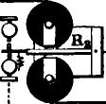
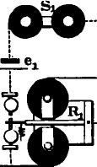
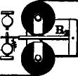

LI
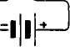
L
I
I
£
Fig. 487.1
First : Keys K₁ and K₂, both open. No current.
Second: K₁ closed, and K₂ open. Current = — 2.
Third: K₁ open, and K₉ closed. Current = + 1.
Fourth: K₁ and K₂ both closed. Current = — 1.
At the receiving station Schreder makes use of two relays, one
of which is provided with two polarized armatures, and the other
I Zeimehrift dee Deutsch-Oesterreichiechen Telegmphen-Vereine, heraueg•egeben in deesen Auftrage von der Kdniglich Preussiechen Telegraphen-Direction. Redigirt von Dr. P. Wilhelm Brix. Vol. VIII. Berlin, 1861. Page 85.

SCHREDER'S METHOD. 841
a single neutral armature, the former being known as the Stohrer relay, illustrated and described on page 542 of " Electricity and the Electric Telegraph."
Schreder also used a recording instrument, or sounder S_{s}, wound differentially, which, together with the sounder S₁ were controlled and operated by the relays R₁ and R₂, as hereafter explained.
It is obviously essential that sounder S₁ should respond solely to the movements of the key K₁, and sounder S₉ to the move-
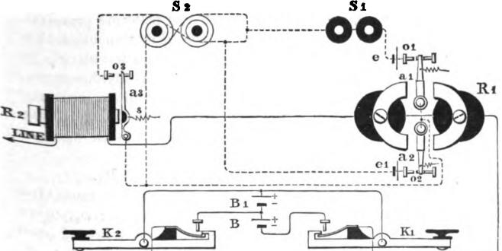
Mg. 498.
I:nents of key K₂, while both S₁ and S₉ should respond when 1K₁ and K₉ are simultaneously depressed at the sending station. The manner in which this is accomplished will be understood by reference to the drawing, and the following explanation of the effect of the before mentioned electrical conditions of the line; ⁻upon the relays, at the receiving station :
First: K₁ and K₂ open. No current.
The armatures a_{l} and a_{s}, of relay R₁, and armature a₉ of the relay R_{s}, rest in the position shown. The local circuits being open, sounders S, and S₂ are consequently inoperative.

842 DOUBLE TRANSMISSION IN THE SAME DIRECTION.

Second: K₁ closed, and K₂ open. Current = — 2 B.
The current in this case is of the right polarity, and of sufficient strength to actuate the relays R₁ and R₂, causing armature a₁ of the former, and armature a₃ of the latter, to make contacts with their respective stops o₁ and 0₃, thus closing the local circuit of battery e, and sounders S₁ and S₂. In order, however, that sounder S₁ alone should respond, it is essential that armatures a_{l} and a₈, of relays R₁ and R₂, should move simultaneously, that is to say, a_{s} should make contact with its front stop O₃ at the same time that a₁, of relay R₁, makes contact with its front stop o,, otherwise a false signal will be recorded upon sounder S₂, around the cores of which two paths are provided for the current to pass, but by a simultaneous movement of the armatures a₁ and a₃ the current passing through sounder S, is divided, each half passing around its cores in opposite directions, thereby rendering the latter inoperative. Armature a₂, or relay B₂, is held more firmly in the position shown in the figure, the local circuit of battery e_{l} remaining open between a₂ and stop 0₂.
rtird: K₁ open, and K₂ closed. Current = B₁.
The polarity of the current in this case is such as to cause the armature a₂, of relay R₁, to make contact with stop o,, thus closing the local circuit of battery e₁, which, passing around one half only of sounder S₂, causes the latter to respond.
Armatures a_{l} and a₃, of relays R₁ and R₉ respectively, remain in the position shown, thus rendering S₁ inoperative. Fourth : K₁ and K₂ closed. Current = — B.
In this case armature a₂, of the relay R„ remains in the position shown, the local circuit of battery e₁ being open at point (3₃. This current not being of sufficient strength to overcome the retractile force of spring s, of armature a_{s}, the latter also remains upon its back stop. Armature a₁, of relay R₁, is, however, caused to move forward, and make contact with its front stop 0₁, thus closing the local circuit of battery e, which, circulating through sounder S₁ and one half of sounder S₂, causes them both to respond.

CHAPTER XL

EDISON'S QUADRUPLES TELEGRAPH.
THE quadruplex system of telegraphy, by means of which four Communications, two in each direction, may be simultaneously transmitted over a single wire, has, within a few years, found very extensive practical application upon the lines of the Western Union Telegraph Company, and is at the present time Operated upon 160 lines, between almost all of the principal cities in the country.
The distinguishing principle of this system consists in combining at two terminal stations, two distinct and unlike methods of single transmission, in such a manner that they may be carried on independently upon the same wire, and at the same time, without interfering with each other. One of these r ethods of single transmission is known as the double current system, and the other is the single current or open circuit system. In the double current system the battery remains constantly in connection with the line at the sending stations, its polarity being completely reversed at the beginning and at the end of every signal, without breaking the circuit The receiving relay is provided with a polarized or permanently magnetic armature, but has no adjusting spring, and its action depends solely upon the reversals of polarity upon the line, without reference to the strength of the current In the single current system, on the other hand, the transmission is effected by increasing and decreasing the current, while the relay may have a neutral or soft iron armature, provided with a retracting spring. A better form, however, for long circuits, is that of the polarized relay, especially adapted to prevent interferences from the reversals sent into the line to operate the double current system. In this system, therefore, the action depends solely upon the strength

844 QUADRUPLE% TELEGRAPHY.

of the current, its polarity being altogether a matter of indifference
It will thus be apparent that by making use of these two distinct qualities of the current, viz., polarity and strength, combined with the duplex principle of simultaneous transmission in opposite directions, four sets of instruments may be operated at the same time, on the same wire. This method possesses, moreover, the important practical advantage that the action of each of the receiving relays is perfectly independent. Each receiving operator controls his own relay, and can adjust it to suit himself without interfering with the other.
Fig. 499 shows the quadruplex apparatus, as arranged upon the bridge plan, which was at first employed by the Western Union Telegraph Company in 1874, when the system was placed upon its lines.
T₁ is a double current transmitter or pole-changer, operated by an electro-magnet, local battery e_{l} and finger key K₁. The office of the transmitter T₁ is simply to interchange the poles of the main battery E₁, with respect to the line and ground wires, whenever the key K₁ is depressed; or, in other words, to reverse the polarity of the current upon the line by reversing the poles of battery E₁. By the use of properly arranged spring contacts, 3, 5₂, this is done without at any time interrupting the circuit. Thus the movements of the transmitter T₁ cannot alter the strength of the current sent out to line, but only its polarity or direction. The second transmitter, T₂, is operated by a local circuit and key K₂ in the same manner. It is connected with the battery wire 12, of the transmitter T₁, in such a way that when the key K₂ is depressed, the battery E_{l} is enlarged by the addition of a second battery, E₂, of two to three times the number of cells, by means of which it is enabled to send a current to the line of three or four times the original strength, but the polarity of the current with respect to the line of course still remains, as before, under control of the first transmitter T_{i}.
At the other end of the line are the two receiving instruments R₁ and R₂. R₁ is a polarized relay with a permanently mag-

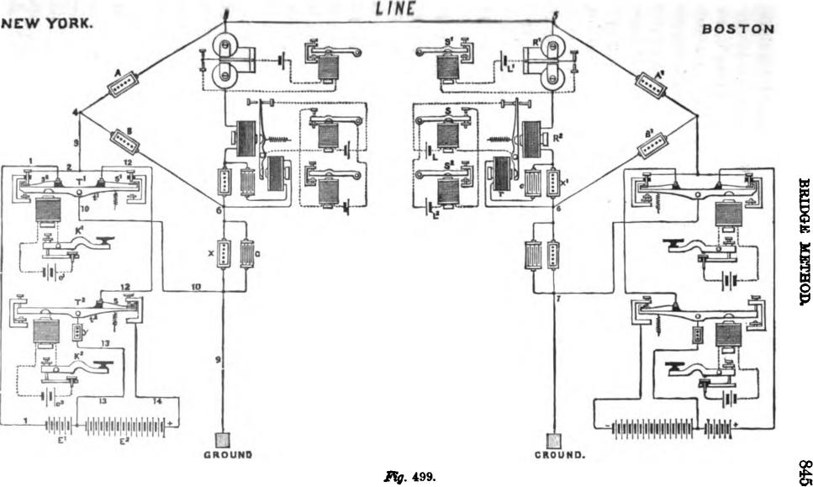
Iv
Ag. 499.
E

846 QUADRUPLES TELEGRAPHY.

netic armature, which is deflected in one direction by positive, and in the other by negative currents, without reference to their strength. This relay consequently responds solely to the movements of key K₁, and operates the sounder S₁ by a local circuit from battery L₁ in the usual manner. Relay R_{s} is placed in the same main circuit, and is provided with a neutral or soft iron armature. It responds with equal readiness to currents of either polarity, provided they are strong enough to induce sufficient magnetism in its cores to overcome the tension of the oppoging armature spring. The latter, however, is so adjusted that its retractile force exceeds the magnetic attraction induced by the current of the battery E₁, but is easily overpowered by that of the current from E₁ and E₂ combined, which is three or four times as great Therefore, the relay R₂ responds only to the movements of key K₂ and transmitter T₂.
The same difficulty which troubled former inventors arises again in this connection. When the polarity of the current upon the line is reversed during the time in which the armature of R₂ is attracted to its poles, the armature will fall off for an instant, owing to the cessation of all attractive force at the instant when the change of polarity is actually taking place, and this would confuse the signals by false breaks if the sounder were connected in the ordinary way. By the arrangement shown in the figure, the armature of the relay R₂ makes contact on its back stop, and a second local battery L₂ operates the receiving sounder S_{r} Thus it will be understood that when relay 11₂ attracts its armature, the local circuit of sounder S₂ will be closed by the back contact of local relay S; but if the armature of R₂ falls off, it must reach its back contact, and remain there long enough to complete the circuit through the local relay S and operate it before the sounder S₂ will be affected. But the interval of no magnetism in the relay R₃, at the change of polarity, is too brief to permit its armature to remain on its back contact long enough to affect the local relay S, and through the agency of this ingenious device the signals from K₃ are properly responded to by the movements of sounder S2.

BRIDGE METHOD. 847
By placing the two receiving instruments R₁ and R₉ in the bridge wire of a Wheatstone balance, and duplicating the entire apparatus at each end of the line, the currents transmitted from either station do not affect the receiving instruments at that 'station. Thus in fig. 499 the keys K₁ and K_{s} are supposed to be at New York, and their movements are responded to only by the receiving relays R₁ and R₉ at Boston. The duplicate parts Which are not lettered operate in precisely the same manner, but in the opposite direction with respect to the line.
In applying this system of quadruplex transmission upon lines of considerable length, it was found that the interval of no magnetism in the receiving relay R₉ (which, as before stated, takes place at every reversal in the polarity of the line current) was greatly lengthened by the action of the static discharge from the line, so that the employment of the local relay S was not sufficient to overcome the difficulties arising therefrom. A rheostat or resistance X₁ was therefore placed in the bridge wire with the receiving instruments R₁ and R₂, and shunted with a condenser C of considerable capacity. Between thelower plate of the condenser and the junction of the bridge and earth wire an additional electro-magnet r was placed, acting upon the armature lever of the relay R₉, and in the same sense. The effect of this arrangement is, that when the current of one polarity ceases, the condenser c immediately discharges through the magnet r, which acts upon the armature lever of relay R₂, and retains it in position for a brief time before the current of the opposite polarity Strives, and thus serves to bridge over the interval of no magnetism between the currents of opposite polarity.
It will be seen that the combination of transmitted currents in this method differs materially from any of those used in previous inventions. They are as follows :
- When the first key is closed and the second open, + 1
- When the second key is closed and the first open-3 or-4
a. When both keys are closed +3 or+4
4. When both keys are open. —1

848 QUADRUPLE% TELEGRAPHY.

Here we discover another very important practical advantage in the system under consideration, which is due to the fact that the difference or working margin between the strengths of current required to produce signals upon the polarized relay and upon the neutral relay, respectively, may be increased to any extent which circumstances render desirable. Within certain limits, the greater this difference the better the practical results, for the reason that the range of adjustment of the neutral relay increases directly in proportion to the margin. The ratio of the respective currents has been gradually increased from 1 to 2 to as high as 1 to 4, with a corresponding improvement in the practical operation of the apparatus.
From what has been said, therefore, it will be seen that before it became possible• to produce a quadruples. apparatus capable of being worked at a commercial rate of speed upon long lines, it was essential that its component parts should have arrived at a certain stage of development. When, in the early part of 1872, simultaneous transmission in opposite directions was for the first time rendered practicable upon long lines by the combination therewith of the condenser, the first step was accomplished. It now only remained to invent an equally successful method of simultaneous transmission in the same direction, which, as we have seen, was done in 1874. The application of one or more of the existing duplex combinations to the new invention, to form a quadruplex apparatus, soon followed as a matter of course.
The following method of simultaneous transmission in the same direction was invented in December, 1875.
Fig. 500 is a diagram of the apparatus as arranged for quadni-plex transmission. The lever t_{i}, with its appendages, constitutes the first or single-point transmitter, which is the same as that of the Stearns duplex. being operated by an electro-magnet T „ local battery t and key h₁. The second or double-point transmitter consists of a quadrangular plate of hard rubber, E, mounted upon an axis, and capable of being oscillated by the arm e, which is rigidly attached to it. By means of a spring e₁, the

DIFFERENTIAL METHOD. 849
arm e presses upon a roller fixed upon one end of the lever d, which forces the other end of the lever against the stop d₁. The lever d carries the armature of the electromagnet T₉, which, like the single point transmitter, is operated by a local battery and key K₉. The oscillating plate E has four insulated contact points! g, f_{l}, g₁, upon its respective angles. The contact levers F and G are mounted on axes at each end of the plate E, and
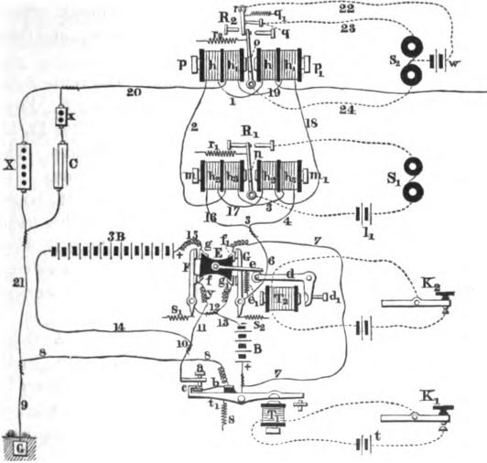
Fig. 500.
are pressed against it by springs s_{t} s₂. When the transmitter is in a position of rest, as shown in the figure, F is in contact with f and G witlif_{i}, and the parts are kept in this position by the action of the spring e_{l}. When key K₉ is depressed, the arm e is raised by the action of the electro-magnet T₂ upon the bent lever d; this turns the plate E upon its axis, and brings F into contact with g and G with g,

850 QUADRUPLE% TELEGRAPHY.

In this apparatus, as in the one previously described, there are four different electrical conditions possible when transmitting two simultaneous despatches in the same direction, as follows :
- Both keys in a position of rest. This position is represented in fig. 500. Disregarding for the present the receiving instruments and their connections, the circuit may be traced as follows : From the earth at G through wires 9 and 8, contact spring b, lever t_{i}, wire 7, contact pointf₁ and lever G, wires 6 and 5, and thence through the receiving instruments to the line L Thus the line wire is connected to earth without any battery, and there is no current upon the line.
- The first key closed and the second key open. The route is the same as before from the earth at G to contact spring b. From this point it now diverges through contact lever F, wires 12, 13, and battery B to wire 7, and thence to the line as before. The battery B is now in circuit and sends a current to line.
- The second key closed and the first key open. The route is now from the earth at G, through wires 9 and 8, contact spring b and lever t₁, as in the first instance, thence through battery B, wires 13, 12, contact lever G, wires 6, 5, and through the receiving instruments to line. The same battery B now sends a — current. to the line.
- Both keys closed. The route is now from the earth at G, by wires 9 and 8 to contact spring b; thence by contact point a and wire 14 to battery 3B; thence by wire 15, through g to lever F, wire 12 and g , to contact lever G, and finally through wires 6 and 5 to the line. The battery 3B, which contains about three times as many elements as B, now sends a + current to the line. It will thus be seen that the two batteries B and 3B are never thrown together on the line at the same time, as in the previous arrangement.
The receiving apparatus consists of two sounders, S₁ and S₂, which are controlled by two relays, R₁ and R₂, fig. 500. The
line wire L, on entering the receiving station, passes through the coils of both relays, and thence to earth through the transmitting apparatus. Both relays are provided with polarized armatures,

DIFFERENTIAL 1ETHOD. 851

and are preferably constructed with two electro-magnets m m„ arranged with their poles facing each other, with a permanently magnetized armature between the opposite poles.
The arriving current, entering the relay R₁, passes through the wire 2 and coil h, of magnet m and h, of m„ which are so arranged that a + current will cause the polarized armature n to be attracted by m₁ and repelled by m, while with a — current the opposite effect will be produced.
The armature of relay R₁ is provided with a retracting spring r„ and operates the sounder S₁ by, means of a local battery 1₁, in the ordinary manner. The relay R₂ consists of two electromagnets p and _{p1,} and its armature is also provided with a retracting spring r,; but it differs materially from the other relay in the arrangement of its local connections. The polarized armature o is held by the tension of the spring r,, not against a fixed stop, but against the free end of a movable contact lever r, the opposite end of which turns upon an axis. The contact lever r is itself held against a fixed stop q by a spring q₁, the tension of which considerably exceeds that of spring r₃. The local battery w is placed in the wire 22, leading from the contact lever r to the differential sounder S_{s}.
The manner in which the receiving instruments operate in each of the four different electrical conditions of the line is as follows :
- No current. The local circuit of sounder S₁ is kept open by the action of spring r₁ on armature n, and it remains inactive. The opposing branch circuits 23 and 24 of sounder S₂ are both. closed by relay R₂, which render it also inactive.
- Current of + B. The relay R₁ (which is affected by positive currents of any strength) operates sounder S₁. The armature of relay R₂ is pressed more strongly against contact lever r, but not with sufficient power to overcome the spring q₁. Sounder S₂ is therefore unaffected.
- Current of — B. The armature of relay R₁ is attracted toward its back stop, and S₁ is not affected. The armature of R, is attracted to the right, and opens wire 24, which permits

•

852 QUADRUPLES TELEGRAPHY.
the local battery w to operate the sounder S₂ by way of wires 22 and 23.
4. Current of + 3B. The armature of relay R„ operates as in the second case. The increased power of the current from the battery of many elements causes the armature of R₂ to overcome the resistance of spring q.₁, and break the local circuit of wire 22, leaving the sounder S₉ free to operate by way of wires 22 and 24. Thus the + 3B current operates both sounders.
In order to adapt this system to quadruplex transmission, additional helices h h₁ and h₃ h_{s} are placed upon the receiving relays R₁ and R₂, which are placed in the circuit of an artificial line, arranged according to Stearns's differential duplex method, which diverges at the point 5 and goes by way of 16, 17, 18, 19, 20 and 21 to the earth at G, and is provided with the usual rheostat X and condenser C. The small rheostat x is employed to regulate the time of discharge from the condenser.
By the arrangement of the contact lever r, in connection with the armature lever o of relay R₂, and the local circuits as above described, the reversal of polarity upon the line takes place without interrupting the signal upon sounder S₉, for the reason that when the armature o is acted upon by the reversal it goes directly over from one extreme position to the other, without stopping at the intermediate position long enough to affect the sounder S₂, even if there is a considerable interval between the successive currents.
An improvement upon the above arrangement was subsequently invented, in which an entirely novel combination of currents upon the line was employed, and which does not require the polarity of the current to be reversed during the transmission of a signal. In fig. 501, T₁ is a local eleetro-magnet, which operates the single point transmitter t₁, under control of the key K₁. The key K₂ in like manner controls the double point transmitter t₂. The four electrical conditions of the line in the different positions of the keys are as follows:
1. Both keys open. This is the position represented in the figure. The route of the current is from the earth at G, through

DIFFERENTIAL METHOD. 853
wire 1, spring b, lever t₁, wires 2 and 8, contact point o, spring 0, wires 4 and 5, battery B, wires 6 and 7, contact point n, and spring N, thence by wire 8 to line L The battery B sends a ± current to line.
2. First key closed and second key open. The route is sow
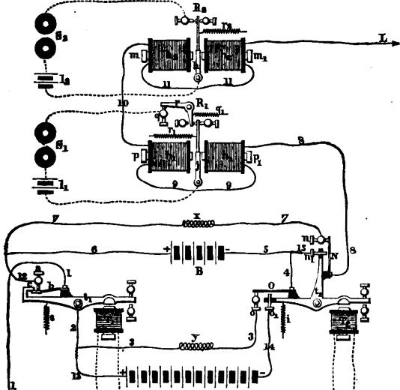
^{9"}
3B fla_{t}
J. 501.
from earth at G, by wire 1 and spring b to point a, wires 12 and 7 and thence as before to the line. In this case there is no battery in circuit, and no current goes to line.
3. Second key closed and first key open. The route is now from earth at G by wire 1, spring b and lever t ,, wires 2 and

•

854 QUADRUPLEX TELEGRAPHY.
13, battery 3B, wire 14, point o„ spring 0. wires 4 and 15, contact point n„ spring N and wire 8 to the line. The large battery 3B sends a — current to the line.
4. Both keys closed. The route is from earth at G by wire 1, spring b, contact point a, wires 12 and 6, main battery B, wires 5 and 15, contact point n₁, spring N, and wire 8 to line
L In this case the lesser main battery sends a — current to line.
The receiving apparatus consists of two sounders S₁ and S₂, controlled by two relays R₁ and R₉, both of which have polarized annatures, and are constructed in the same manner as those described in connection with the last method. The armature of relay R₂ is provided with a retracting spring ?_{it}, and operates the sounder S₂ by means of a local battery /₂, in the usual manner. The polarized armature j, when no current is passing through the line, is held by a spring r₁ against the free end of a contact lever r, which is in turn held against the fixed stop q by the tension of a spring q₁, which considerably exceeds that of the spring r,.
The manner in which the receiving instruments operate in each of the four conditions of the line is as follows: 1. Current of + B. The local circuit of sounder S₁ is kept open by the action of the positive current upon the polarized armature of relay R₁, which is sufficient to overcome the tension of spring r₁₁ and it therefore remains inactive. 'The local circuit of sounder S₂ is kept open by the action of the positive current upon the armature h of relay R₂, in addition to the action of spring r₁. 2. No current. The armature j of relay R₁ is drawn by the tension of spring r₁ over against the contact lever r, thus completing the local circuit of sounder S₁. The armature of R₂ is held back by spring r₂, thus breaking local circuit of S₂ 3. Current of - 3 B. In this case the action of the negative current from the greater battery causes the polarized armature to press against the contact lever r and overcomes the tension of spring q₁, and thus, although the local circuit is still closed between the armature j and contact lever r, it is now broken

COMBINED DIFFERENTIAL AND BRIDGE METHODS. 855

between the latter and the fixed stop q, and hence sounder S_{i} remains inactive. On the other hand, the negative current carries the armature h of relay R„ to the left, closing the local circuit and actuating the sounder S₂. 4. Current of - B. This current is not sufficient to overcome the tension of spring q₁, and, therefore, the contact lever r continues to rest against stop q, and the local circuit of S_{i} is completed. Relay R₂, which operates by negative currents of any strength, closes its local circuit through the sounder S₂.
In this arrangement it will be seen that a reversal of polarity upon the line cannot occur while a signal is being given by either key. This method may be readily united with any suitable duplex method to form a quadruples combination.
Fig. 502 is a diagram illustrating a quadruples method, based upon that shown in fig. 499, but embodies several important modifications and improvements not shown there. This arrangement was extensively employed for some time upon the Western Union lines, especially upon the longer circuits, and was found to be, in many respects, far superior to that first introduced. It will be seen that no changes were made in the principle of the transmitting portion of the apparatus, or the combination of currents sent to line in the different positions of the keys, but portions of the receiving apparatus were materially altered.
In fig. 502 the polarized relay R₁, and its accompanying sounder, are placed in the bridge 5, 6, as before. The neutral relay,* which was formerly placed in the bridge wire also, is discarded altogether, and is replaced by a compound differential polarized relay R₂. This is inserted, not in the bridge wire, but in the line and earth wires; these respectively form the third and fourth sides of the bridge, of which A and B are the first and second sides. Thus, when the resistances A and B are made equal, the outgoing currents will divide equally between the line and the earth, and will neutralize each other in their effect upon the relay R₂. The latter consists of two electro-magnets facing each other, with a polarized armature between them. When no current is passing, th, polarized armature is held in a central

856 QUADRUPLE% TELEGRAPHY.
position between two spring contact levers N N₁, and the circuit of the local relay S is completed through these and the armature lever. The springs of the contact levers N N, are adjusted with sufficient tension to prevent them from responding to the current of the small battery E, at the sending station, but the additional current from battery E_{ll} will overcome the spring
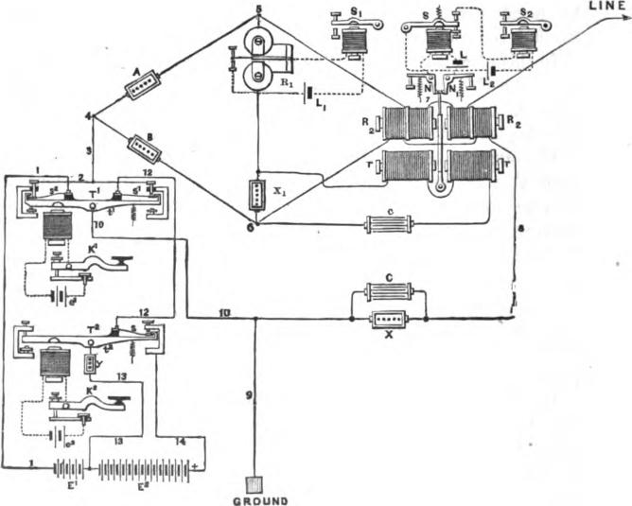
Fig. 502.
of N or of N₁, according to its polarity, and thus break the circuit of the local relay S, which by its back contact will operate the sounder S_{r} The electro-magnets r r are arranged to act in conjunction with R₂ R₃ upon the same armature lever, and are connected with a condenser c and a rheostat X, in the bridge wire, for reasons which have been fully explained on page 847.

DIFFERENTIAL METHOD. 857
Fig. 503 shows the connections of another form of quadruplex apparatus, embodying several important improvements that are not found in the apparatus heretofore described. Both receiving relays R₁ and R₃ are provided with differential helices and polarized armatures, and in general the differential method is employed
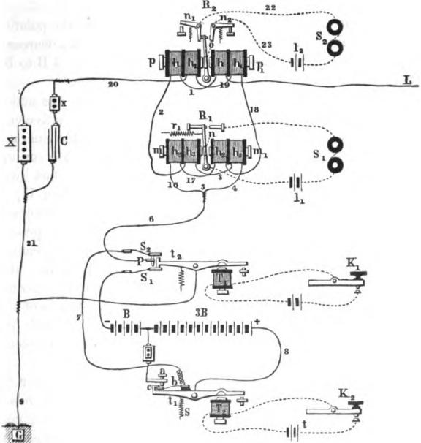
FTg. 503.
throughout in place of the bridge. The relays R₁ and R₂ may be constructed as shown in the figure, or according to Siemens's pattern. Experience has shown that the latter form gives, on the whole, the most satisfactory results, and it has therefore been adopted in all the more recent apparatus. The combination of

858 QUADRUPLES TELEGRAPHY.

the outgoing currents differs from that employed in the original quadruplex, and is as follows:
K₁ open and K₂ open, current traversing line + 4 B
K₁ open and K₂ closed, " IL B
K₁ closed and K₂ open, " — 4 B
K₁ closed and K₂ closed, " It t4
. B
As in the original quadruple; key K₁ controls the polarity of the current going to line, but the depression of K₂ decreases the outgoing current, irrespective of its polarity, from 4 B to B; or, in other words, cuts off the battery 3 B altogether.
The only matter requiring detailed explanation is the action of the relay R₉. .When both keys are at rest, the positive cur-
rent of both batteries (-I- 3 B B) is passing over the line, and
the polarized armature is pressed against the contact lever n₁, which yields, thus allowing it to separate from the contact lever n,, and the circuit of the sounder S₂ is broken. When K₁ is closed, the polarity of the entire battery upon the line is reversed, and the armature passes over to the other side and presses against n₂ in the same manner, so that the sounder S₂ cannot be operated by the stronger currents of either polarity. But the depression of the key K₂ in either case decreases the current, until it is unable to withstand the tension of the springs of the contact levers n₁ n₂, and thus the local circuit through the sounder S₂ is completed, and the latter consequently responds to the movements of key K₂.
On circuits exceeding 200 miles in length, the sounder S_{s} is preferably operated through the medium of a local relay, arranged as in fig. 502. The combination of the outgoing currents in different positions of the keys is also rearranged, so as to conform to the original plans (rigs. 499 and 502), and is as follows :
K₁ open and K₂ open, current traversing line |  |  | + B
K₁ open and K₂ closed, " a t4
+ 4 B
K₁ closed and K₂ open, " | a | a | — B
K₁ closed and K₂ closed, " | a | a | — 4 B

ARRANGEMENT OF APPARATUS FOR LONG CIRCUITS. 859

Figs. 504 and 505 comprise a plan view and diagram of a quartette table, arranged for quadruples working on a long cir-
cuit, showing the relative positions of the different parts of the
apparatus. In fig. 504 the compartment at the top of the figure is for receiving, and the other for sending; while in fig. 505 the
sending operator occupies the upper compartment and the receiving operator the lower one. The letters and figures of reference indicate the same parts as in fig. 503. Additional letters of reference will be explained elsewhere. The main circuits are indicated by broken lines, and the local circuits by dotted lines.
In all of the methods of multiple transmission hitherto known, whereby two distinct communications may be simultaneously transmitted over one conductor in the same direction, or combined with any suitable one of the several known methods of simultaneous double transmission in opposite directions, so that four distinct communications may be transmitted simultaneously, without interfering with each other, it has been necessary to make use of a double-acting receiving instrument or relay at the receiving station; composed of a single electro-magnet having two or more armatures, or else of two or more independent receiving instruments.
The practical objection to the first mentioned arrangement is that the effective attraction of the electro-magnet for any one of two or more armatures is materially lessened whenever one of the others is already in contact, or nearly in contact, with its poles. Thus the movements of the separate armatures necessarily interfere with each other, which interference tends to confuse the signals. The second arrangement, viz., the use of two independent receiving instruments, although being free from the above mentioned objections, is liable to certain other defects, the principal of which are as follows: When the apparatus is arranged for the simultaneous transmission of four communications, two in each direction, it is found difficult to adjust the equating resistances and condenser capacities, so that neither of the two receiving instruments are affected by the variations in

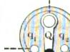
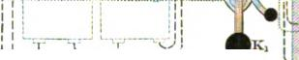

860 QUADRUPLE% TELEGRAPHY.
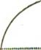
1 13
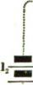
C
,
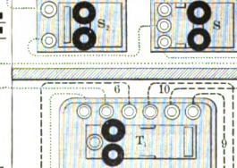
; I
I
^{I}I
t_{j}
L
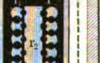

I\ L___________-___I-------7-87-------------
i
,
⁻⁻0⁻
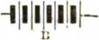
Fig. 504.
EXPLANATION OF FIGS. 504 AND 505.
K„ Key of No. I sending operator.
T,, Double current transmitter, operated by
K, or k,.
I)„ Transmitter local, of three cells.
k„ Key of No. I receiving operator.
R„ Single polarized relay.
8,, Receiving sounder operated by ditto.
4, Sounder local, of two cells.
K,, Key of No. 2 sending operator.
T,, Single current transmitter, operated by
K, or k,.
e., Transmitter local, of three cells.
k„ Key of No. 2 receiving operator.
R,, Compound polarized relay.
8, Local relay or repeating sounder of ditto.
1. Local of repeating sounder (two cell6i.
8,, Receiving sounder. operated by S.
1 , Sounder local, of two cells.
1Vmaller division of main battery.
8 Larger division of main battery.
Switch for cutting out main battery and connecting line to earth while balancing. X, Large rheostat for balancing resistance of line.

ARRANGEMENT OF APPARATUS FOR LONG CIRCUITS. 861
LINE
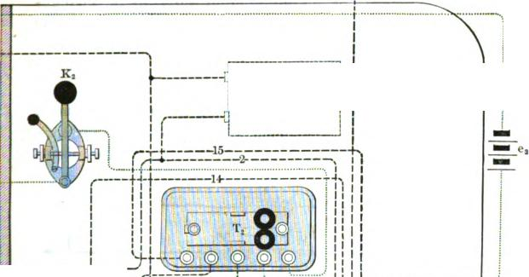
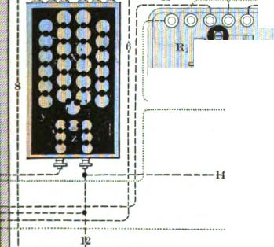
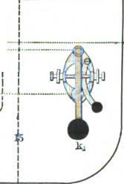

0
—
,
I III | I

EARTH | 3B

Fig. 606.

y, itneostat for compensating resistance of battery 8 B.
8, Rheostat for compensating resistance of entire main battery 8 B + B.
c, Equalizing condenser placed between main and artificial lane.
y Condensers for compensating static dis-
charge from main line. The quantity and duration of the condenser discharge are regulated by means of the adjustable rheostats r and r₁. The arrangement shown is employed only on lines
exceeding 400 miles in length. When a static balance is obtained, e, should have about twice au many sheets as e, (both being adjustable). The condenser c should receive its charge through about half the resistance required for both. For example, if the number of sheets required in c, were 80, and in e, 80 (total 90) and the resistance required for both were 2,000 ohms, y would require 1.000 and c, 1,000. On lines of less than 400 miles the arrangement shown in fig. 808 answers every purpose.

862 QUADRUPLE% TELEGRAPHY.
the strength or polarity of the outgoing currents; as the changes necessary to effect the proper adjustment or balance of one receiving instrument destroy the balance of the other, and much care and skill are, at times, required to accomplish the desired result.
Again, when two receiving instruments are used, one must be sufficiently sensitive to respond readily to weak currents. The other must be much less sensitive, responding only to cur-
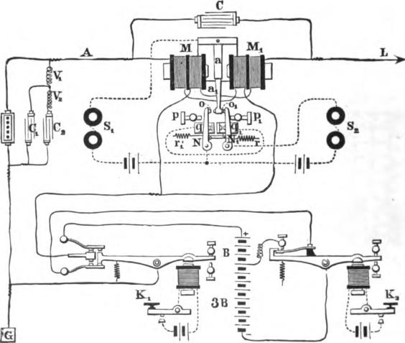
Fig. 506.
rents of greater strength. The current required to actuate the latter instrument sometimes affects injuriously the working of the more delicate one.
- To meet these difficulties, a somewhat novel and ingenious arrangement has been devised, which is shown in fig. 506. The principal part of the improvement consists in the use of a new form of double acting relay, composed of a double electro-magnet

DOUBLE ACTLNG RELAY. 863

and a single armature, the latter capable of being placed, by the action of the former, in four different positions corresponding to the four possible positions of the two keys at the sending station. By means of suitably arranged contact-levers, two independent local circuits are brought into action by the same armature in its different positions, so as to actuate two independent sounders.
The diagram shows the receiving instrument or relay at one terminal station, combined with other well known apparatus, in order to effect the simultaneous transmission and reception of two communications, in the same or in opposite directions, or both, upon one conductor.
With the exception of the arrangement of contact-points and their respective local connections with the levers N and N₁, and armature a_{l}, by means of which the latter controls the local circuits which operate the sounders S₁ and S₂, the construction of the receiving instrument is precisely the same as that used in the quadruples system, which we have just considered, and which is fully described on page 858. As shown in the figure, the contact-levers N and N₁ of the receiving instrument turn freely upon suitable fulcrums at their lower ends, while their free upper ends, when at rest, are held against the adjustable contact points q q₁ by the tension of the adjustable springs r r₁. A contact point o is upon the upper extremity of the contact lever N; and 0₁ is an insulated stop occupying a corresponding position upon the lever N₁. The contacts q _{q1} are so adjusted as to allow the ann a_{l}, which is rigidly attached to the armature a, to play between the stops o and O₁ upon the contact levers, which limit its motion in each direction, except at such times as the armature a moves with sufficient power to overcome the retractile force of springs r r₁, in which case the lever N or N₁ is pressed away from the contact q or q_{i} until it strikes against the adjustable stop p or p,.
The operation of the two independent transmitters or keys h₁ and K₂, at the sending station, gives rise to four different electrical conditions of the line, according to their respective positions with reference to each other, as follows :

884 QUADRUPLEX TELEGRAPHY.

- First and second keys both open. This is the position of the apparatus shown in the figure. In this position of the keys both main batteries are in circuit, sending to line a positive
or current of + B ± 3 B = +4 B.
- First key closed and second key open. In this position both main batteries are also in circuit, sending to line a negative or — current of —3 B - B = -4 B.
- Second key closed and first key open. In this position the smaller of the two main batteries only is in circuit, sending to line a positive or current of a strength of + B.
- First and second keys both closed. In this position the smaller battery only is in circuit, sending to line a negative or — current of a strength of - B.
At the distant terminal of the line L, the apparatus is arranged precisely as shown in the figure.
It is essential that one sounder (for example, S₁) should respond solely to the movements of the key K₁, and the other sounder, S₂, in like manner to the movements of the key K₂; while both should respond when both keys are simultaneously depressed. The manner in which this result is accomplished will be understood by the following explanation of the effect of each of the above mentioned electrical conditions of the line upon the receiving instrument
- Positive current from both batteries (+ 4 B). The local circuit of sounder S₁ is open between the point o and arm a_{l}, and that of S₂ between the lever N₁ and the stop q₁, because the action of the current upon the armature a, tending to attract it toward M_{i}, is strong enough to overcome the tension of the spring r₁, and force the lever N₁ against the stop p₁.
- Negative currents from both batteries (— 4 B). The local circuit of sounder S₁ is closed at the point of contact between arm a, and contact lever N but that of sounder S_{a} is broken between the contact lever N and the stop q, because the strength of the current upon the line is so great as to overcome the tension of the spring r, and force the lever N against the stop p.

DOUBLE ACTING RELAY. 866

B. Positive current from battery B only (+ B). The local circuit of sounder S₁ is broken between the arm a₁ and the contact o on the lever N, but that of sounder S₂ remains closed, because the power of the current upon the line, though sufficient to move the arm a₁ away from the stop o, is not able to overcome the spring r₁, and separate the lever N₁ from the stop q₁.
4. Negative current from battery B only (— B). The local circuits of both sounders S_{i} and S₂ remain closed, because the strength of this current is sufficient to bring the arm a₁ into contact with the stop o upon the contact lever N, but is not enough to overcome the spring r, and thus separate the lever N from the stop q.
Thus it will be understood that the armature a is caused to assume four different positions corresponding to the four different electrical conditions of the line.
When the armature is in either of its extreme positions the local circuit of the sounder S₂ is broken. When the armature passes directly over from one extreme position to the other, it, of course, closes the local circuit for an instant as it passes the middle point, but not long enough to produce any effect whatever upon the sounder S₂, which remains inactive.
Condensers C/ and 0₂ are connected to the artificial line A for the purpose of compensating the static discharge of the line. The adjustable rheostats V_{i} and V, are used in order to regulate the action of the condensers and render their charge and discharge nearer the same duration as that of the line.
An independent condenser C is arranged with one set of its poles in connection with the main line L, and the other set with the artificial line A.
No effect is produced upon this condenser by the outgoing current, as the potential of the latter is substantially the same on each side.
The incoming current from the distant station, meeting with the resistance of the helices M M₁, flows into and charges the condenser, which remains charged until a reversal of the current takes place upon the line, when it instantly discharges itself and

866 QUADRUPLE% TELEGRAPHY.

sends a momentary pulsation through the electro-magnets M M₁, thus tending to hasten the action of the receiving magnet upon its armature at each reversal, thereby improving the signals upon long lines.
The effective action of this condenser may be much increased if desired, by augmenting the resistance of the helices M M₁, or by inserting additional resistances between these and the junction of the wires leading to the condenser on each side.
The double acting receiving instrument here described, and shown in the figure, is equally serviceable in connection with the arrangement of main batteries illustrated and described on pages 848 and 852.
The apparatus has been tested in practical service upon all of the longest circuits on which the quadruplex system is worked from the Western Union Telegraph Company's New York office, and continued in constant use for one week on the New York and Albany circuit with very satisfactory results. In regular practice, however, it has been found preferable to use two independent relays, thus enabling each operator to adjust his own instrument.
On February 7, 1877, a test was made on a direct circuit between New York and Chicago, via Pittsburgh, Pa., a distance of 913 miles, and the simultaneous reception of two communications in the same direction was accomplished at a speed of thirty words a minute on each of the respective sounders S_{i} and S₂.
Fig. 507 shows a general plan of the quadruplex apparatus now in use on the lines of the Western Union Telegraph Company, and which embodies the more recent improvements.
The transmitting devices, both in construction and mode of operation, are precisely similar to those referred to in connection with fig. 506, so that it will be necessary here to refer only to the effect produced by the operation of the two independent transmitters or keys, which is as follows:
1. Key K₁ and K₂ both open. In this position the entire battery is in circuit, sending to the line a negative or — current of - B -3 B = -4 B.

IMPROVED RELAY. 867
- Key K₁ open and K_{s} closed. In this case battery 13 only is in circuit, sending to the line a negative or — current of - B.
- Key K₁ closed and K₂ open. The entire battery is again in circuit, but in this case with the positive or + pole to the line, sending a current of + 3 B±B = + 4 B.
- Key K₁ and K₂ both closed. In this position the battery
Fig. 507.

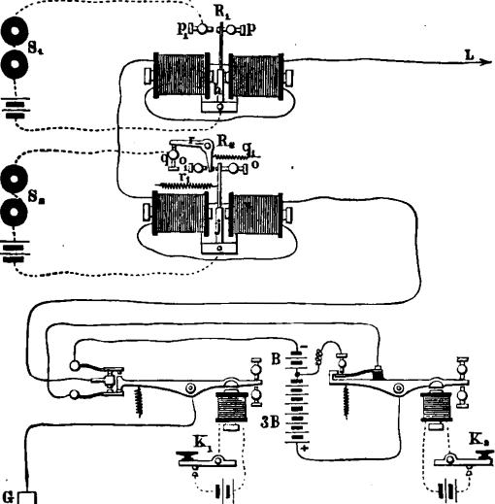
duo
................
O_{s}
ºsi
0
............................... •
- .--• ...............
G
2
3B
It,
B only is in circuit, sending to the line a positive or -1- current of + B.
Thus it will be understood that the line is caused to assume four distinct electrical conditions, corresponding with the four possible positions of the keys at the transmitting station.
The receiving apparatus consists of two sounders, S₁ and S₂, which are controlled by relays R₁ and 11₂. The construction of It,

ti68 QUADRUPLEX TELEGRAPHY.

is the same in every particular as chat heretofore described; it being, in fact, simply a polarized relay capable of responding to positive and negative currents.
The relay R₂, however, differs materially from relay R₁ in the arrangement of its local circuit connections, by means of which the sounder S₂ is operated; and the improvement upon the form of relay heretofore used consists chiefly in dispensing with one of the supplementary contact levers, whereby the apparatus is not only simplified, but made to work with greater facility and certainty through long circuits.
The normal position of the apparatus, when neither key at the transmitting station is depressed, is that shown in the diagram.
The manner in which the relays R₁ and R₂ operate in each of the four electrical conditions of the line mentioned, so as to cause he sounder S₁ to respond solely to the movements of key
- and the sounder S₂ in like manner to the movements of key
- and both in response to a simultaneous depression of keys K₁ and K₂, will be understood by reference to the following explanation:
- K₁ and K, both open. A negative or — current from both batteries (— 4 B). The local circuit of sounder S₁ is kept open, because the polarity of the line current tends to hold the armature h of relay R₁, on its back stop p. The local circuit of sounder S₂ is also open between armature j and lever r, because the current on the line is sufficiently powerful to overcome the spring r„ and hold armature j against stop o; thus sounder S, remains inactive.
- K₁ open and K₂ closed. A negative or — current from battery B only (— B). The local circuit of sounder S₁ remains open between stop _{p1} and armature h, because the polarity of the current is such as to 11(.,1d the latter against stop
p. The action of this current upon relay R, is to cause its armature j, assisted by spring r₁, to move to the left and make contact with the lever r, but not with sufficient force to overcome the retractile spring q₁, thus leaving armature j in a central position between stops o and o„ thereby closing the local circuit and operating sounder S,.

IMPROVED RELAY. 869

- K₁ closed and K₂ open. A positive or + current from both batteries (+ 4 B). This current causes the armature h of relay R₁ to move to the left, thus closing the local circuit at stop p₁ and actuating sounder S₁. The armature j of relay R₂ is also strongly attracted toward the left, pressing against the yielding lever r with sufficient force to overcome the spring q₁, and press the former against the stop o,, thus opening the local circuit of sounder S₂.
- Keys K₁ and K₂ both closed. Positive or current
from battery B only (+ B). Relay R₁, which is arranged to close its local circuit by positive currents of any strength, actuates the sounder S/ precisely as in the third case. The current upon the line in this case is not of sufficient strength to hold the armature j of relay R₂ against stop 0₁; consequently it moves, together with lever r, assisted by spring q₁, to a central position, thus closing the local circuit between armature j and stop q through lever r. thereby operating sounder Sg. When the armature j of relay R₉ passes directly over from one extreme position to the other: for example, from stop o to o_{i}, it will be observed that the local circuit is closed for an instant, but not long enough to produce any effect whatever upon the lever of sounder S₂.
It is therefore obvious that, with the apparatus as arranged above, two communications may be simultaneously transmitted over a single conductor, and the signals recorded with facility and accuracy.
In order that four communications may be made to pass simultaneously over a single conductor, it is only necessary to combine the apparatus here described with any one of the several known methods of simultaneous transmission in opposite directions. The arrangement in general use for the accomplishment of this purpose upon the Western Union Telegraph Company's lines is that known as the differential method. A system of duplex telegraphy known as the bridge method may be used instead of the differential, or, instead of either of these, a coin-bination of the differential and bridge methods. In practice the latter has been found preferable, more especially on the longer

870 QUADRUPLE% TELEGRAPHY.
circuits, where the signals have to be retransmitted automatically over an adjoining circuit, in which case it is absolutely essential that the signals should be recorded perfectly at the repeater station.
The last named plan is in operation on the New York and Chicago quadruplex circuit, arranged so that signals from New York and Chicago are at Buffalo automatically retransmitted in either direction. Before considering the arrangement for repeating from one circuit into another, however, it will first be well to describe the different instruments more in detail than we have yet done. A. few words also regarding the setting up and adjustment of the apparatus will not be out of place here.
DIRECTIONS FOR SETTING UP THE QUADRUPLEX.
The diagram, figs. 504 and 505, will sufficiently explain the manner in which the instrument should be set up and connected.
The smaller section of the battery B usually contains about one third the number of cells that the larger section 3 B does. The rheostat z should be as nearly as possible equal to the internal resistance of (B + 3 B) =4 B. The resistance of y should be equal to the internal resistance of the portion 3 B of the battery.
THE DOUBLE CURRENT TRANSMITTER.
This is represented at Ti in figs. 503, 504 and 505, and is operated by the key K₁ and a local battery e₁, usually of three cells. The double current transmitter is sometimes constructed as shown in fig. 508, but a simpler and far better arrangement has been recently introduced, which is shown in fig. 509. The drawing is an end view of the transmitter, and shows the pole changing apparatus distinctly. The adjustable contact screws a and a, are supported by and are in electrical connection with the post P, which is in turn connected with the line wire. The post also supports two contact springs S_{i} and S₂, which are insulated from it and connected by wires 1 and 12 with the zinc and copper

DOUBLE CURRENT TRANSMITTER 871
poles of the main battery, respectively. The lever t_{i} of the
transmitter is connected with the earth.
The proper adjustment of this transmitter is a matter of the
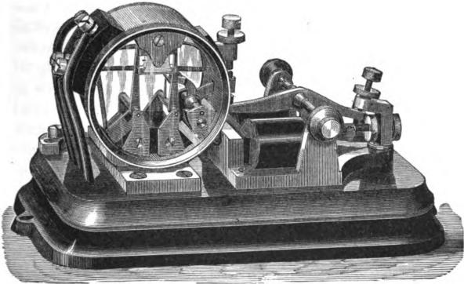
F. 508.
greatest importance to ensure the successful working of the apparatus. In order that it may follow the movements of the
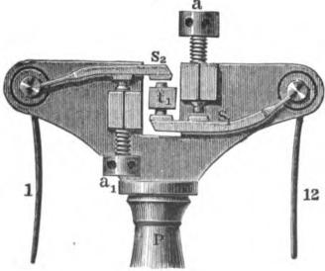
Fig. 509.
key with promptness, the play of the lever t, between its limit. ing stops near the electro-magnet should not exceed .1- of a❑ inch. The contact screws must be so adjusted that at a point

872 QUADRUPLE% TELEGRAPHY.
about midway of the stroke of the lever t₁ the springs S and S₂ will both be in contact with it at the same time, but for the shortest possible period. The easiest way is to first temporarily adjust the upper limiting stop at the opposite end of the transmitter lever t_{i}, so as to reduce the play of the lever to A- of an inch, or about half the ordinary distance allowed for a sounder. Then gradually raise the contact screw a until the spring S_{i} barely touches the lever t_{i}, being careful to move the screw no further than is necessary to do this. Then lower the contact screw a_{l}, and adjust the spring S₂ in the same way. Finally, raise the limiting stop at the other end of the lever, so as to give it the usual play of about ¹- of an inch. In its vibration the lever t_{i} should touch one of the springs S_{i} or S₂ at the same instant that it leaves the other. If the springs are adjusted too far apart there will be a break in the circuit, as the lever will break contact with one spring before it touches the other; if too near together, the battery will be placed on short circuit too long, from one contact being made before the other is broken. By careful adjustment this period can be reduced to almost nothing, and the more accurate this adjustment the better will be the performance of the apparatus.
TILE SINGLE CURRENT TRANSMITTER.
This is similar to the transmitter of the Stearns duplex. The play of the lever of the transmitter should be about A of an inch between the limiting stops and the contact screw A, fig. 510, adjusted so that when the key is closed and the transmitter in the position represented, the spring B will be slightly separated from the contact point on the end of the lever D.
THE COMPOUND POLARIZED RELAY.
This relay is represented by R₂, in figs. 603 and 504, and the sounder connected with it responds to the signals given by the double current transmitter at the sending station. The relay consists of four separate electro-magnets, arranged, in pairs, with their poles facing each other, upon opposite sides of a double

SINGLE CURRENT TRANSMITTER. 873
polarized armature. The connections and principle of operation have already been explained in connection with fig. 503. The proper adjustment of the armature and local contact levers of this relay is a matter of much importance, and the following directions should be carefully observed :
Fig. 511 is a perspective view of the compound relay, showing the contact levers and their adjustment The electro-magnets M M should be adjusted by means of the check nuts at the back, so that their poles are at equal distances from the opposite faces of the polarized armature a. The play of the armature lever
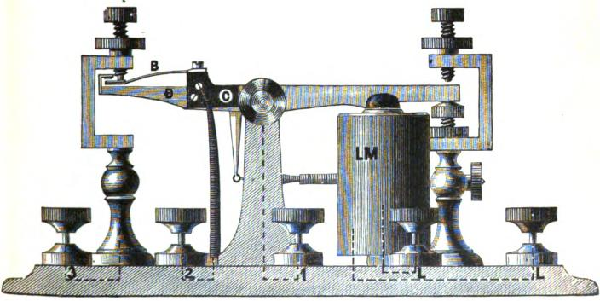
Fig, 510.
is regulated by the screw stops p_{s} and p_{s}, which limit the movements of the contact levers N N₁ in one direction, while the stops _{p1} and p_{s} limit them in the other direction. To adjust these levers, the screws _{p1} and lo_{s} should be withdrawn until the contact points upon the armature lever a are touched by those upon the levers N N₁ upon each side, so that the local circuit can pass through the lever from N to N₁ when the armature is in a middle position. but will be interrupted by its slightest movement in either direction. The play allowed to the contact levers by the stops p_{s} and p_{s} may be, with advantage, consider-

874 QuADRUPLEX TELEGRAPHY.
ably less than than that of an ordi nary relay. The proper tension of the springs u and n₁ depends upon the condition of the line current, anu will be referred to hereafter.
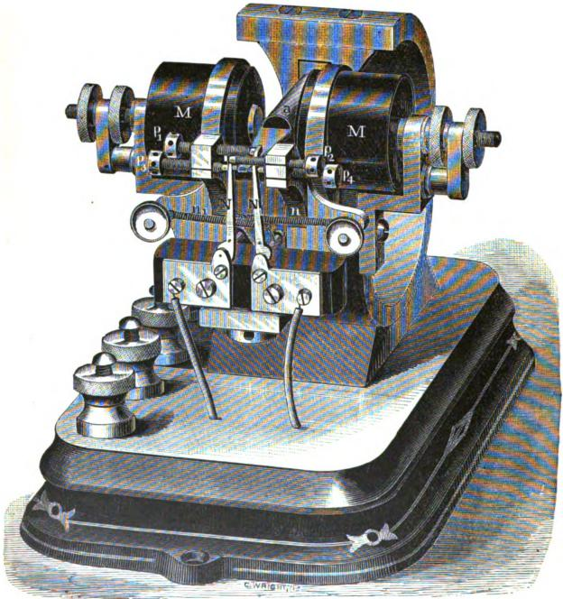
Fig. 511.
THE SINGLE POLARIZED RELAY.
This is shown at R₁, in figs. 502, 503 and 505, and is simply a Siemens polarized relay, which should he adjusted with a play about the same as that of the ordinary Morse relay. This may

ADJUSTMENT OF THE QUADRUPLES. 875

be, and usually is, constructed in the same form as fig. 511, but without movable contact levers N N_{I}.
ADJUSTMENT OF THE APPARATUS FOR WORKING.
The said arrangements having been properly made at both stations, one station, which for convenience we will call station A, commences by sending signals from the pole changing transmitter T₁, having been careful to leave key K₂ or k₂ of transmitter T₂ open. Station B then signals to station A in the same manner, which signals will be received upon the polarized relay R If the signals come reversed, or on the back stroke, the direction of the incoming current through the relay must be reversed. Station A next instructs B to ground. B complies by turning the arm of the switch Q (fig. 504) from _{q1} to q₂, which sends the incoming current direct to the earth through the resistance Z, which has already been adjusted to equal that of the entire bat-
tery (E₁ E₂). Station A then grounds by placing his own
switch in the same position, and adjusts his polarized relay R„ so that the armature will remain at rest indifferently upon either its front or back contact stop, when placed by the finger. Next, station A closes the single current transmitter T₂ by means of K₂ or k₂; turns the switch Q back to its original position, that is, to the left, sending the entire battery to line. The resistance X (fig. 505) should now be altered, until the armature of the polarized relay R₁ remains indifferently on either side when. placed by the linger as before. When this is accomplished, the line resistance and rheostat resistance in X will be equal.
To obtain the electro-static balance, station A transmits dots or dashes by means of transmitter T₁, and at the same time alters the capacity of the condenser c₁ c₂ (fig. 504), until it neutralizes the discharge which takes place at the end of each signal, and is manifested upon the relay R₁. The electro-static balance of this relay insures that of relay R₂ without further precaution. Finally, station A again turns switch Q to the right, upon point q₂, and station B now proceeds to obtain

876 QUADRUPLEX TELEGRAPHY.

a balance in the same way. Having accomplished this, he notifies A.
Station B is then requested to send from transmitter T₁, leaving T₂ open or at rest The signals are received at A on relay R₁, and at the same time the springs n n₁ (fig. 511) of the compound relay R₂ should be pulled up sufficiently to hold the armature a at rest in a central position, with the local relay or repeating sounder S (fig. 604) closed. Next, B is requested to leave transmitter T₁ at rest and send signals on T_{s}. These signals should be received at A upon the compound relay R₂ only. With currents of one polarity the armature a will move to the left, and with currents of the other polarity to the right, but in either case it should operate the sounder S₂ by means of the local relay S. When the armature passes from one extreme position to the other by a change of polarity upon the line, the relay should not give a false dot as it passes the central position. The contact points of the local relay or repeating sounder S should be adjusted as close as those of an ordinary relay.
The above described apparatus is suitable for use upon lines from 300 to 600 miles in length. For lines under 300 miles in length, the modification of the apparatus, shown in fig. 503, and which is of somewhat simpler construction, is usually employed.
Simultaneous transmission in opposite directions, at the rate of fifty-eight words per minute each way, is now carried on between New York and Washington, by the application of this quadruplex method to the Phelps electro-inotor printer. This leaves two sides free for exchanging service signals, or for carrying on two separate communications by the Morse apparatus.
The arrangement for repeating from one quadruplex circuit into another is very simple in principle, and consists in placing the two transmitters of one line in the same local circuits with the corresponding receiving sounders of the other line. The details are more fully described on page 889. By this arrangement New York is enabled to carry on four distinct communications simultaneously with St. Louis, a distance of about 1,100

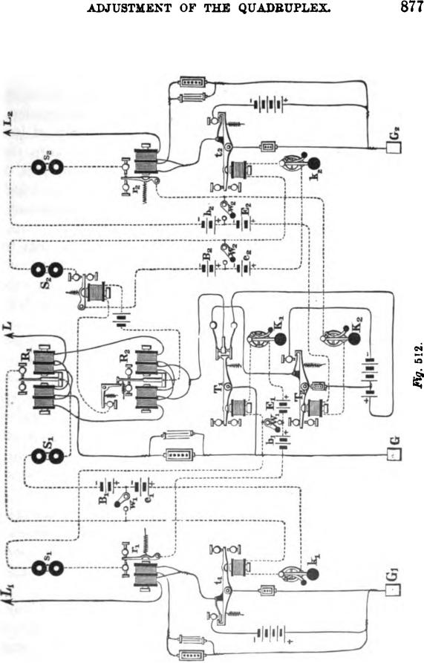
ADJUSTMENT OF TILE QUADRUPLES.
877
E
cif
1

878 QUADRUPLE% TELEGRAPHY.

miles, by means of a quadruplex repeater at Pittsburg; and with Chicago, 1,000 miles, by means of a repeater at Buffalo.
Although the quadruplex has, in a great measure, taken the place of the duplex upon many of the lines between the more important telegraphic centres, the latter system is, nevertheless, still employed to a considerable extent between points of less importance where the business is not sufficient to keep the quadruplex constantly employed; and in numerous cases it forms, in connection with this system, both a convenient and valuable auxiliary for supplying direct communication between several different stations at one and the same time.
There are various ways in which these two systems may be combined so as to meet the numerous requirements of the ser vice, but it will be necessary to describe and illustrate here only such as are now in actual operation and by experience have been found serviceable.
A plan of the apparatus as arranged at repeating station, forming the common terminus of one quadruplex and two duplex circuits, is shown in fig. 512. By this combination two independent communications passing in the same direction over the quadru-plex circuit may be automatically retransmitted from the repeating station over two separate and independent duplex circuits extending to different points, while at the same time two communications passing in the opposite direction over the duplex circuits may be repeated into and over the quadruplex circuit.
For convenience of explanation we will take an actual case, and suppose the repeating apparatus to be placed at Boston, which is in connection with New York, 240 miles distant, by quadruplex, ' and with Duxbury and St. John, respectively 40 and 469 miles distant by duplex.
In order to effect the desired retransmission of the different sets of signals passing through the apparatus, it is necessary to form separate connections between the several receiving instruments and the transmitters of the different lines into which the signals are to be repeated.
This is done by means of the local circuits, in a manner which will now be explained.

COMBINED QUADRUPLES AND DUPLEX CIRCUITS. 879

As ordinarily arranged for single circuit working, the relay R₁ (fig. 512) of the New York line L, operates the sounder S₁ by means of the local battery B,; and key k₁, the transmitter t„, of the Duxbury line L₁, by means of the local e₁. For direct through working, however, and in order that the received New York signals may be communicated from the relay R, to the transmitter t₁, and thus be repeated into the Duxbury line, a switch or button w, is so arranged that it forms, when closed, a part of each of the two separate local circuits containing the relay R₁ and the transmitter 1₁, but when open throws the two circuits into one, so that relay R₁ operates the transmitter t, as well as the sounder S₁.
In a similar manner the circuit, including sounder s_{i} of line L₁ is combined with that containing the transmitter T₁ of line L, by means of the button W_{i}, while the button W, connects the local circuit of R₂ in line L with that of the transmitter t₂ in the St. John's line L₂.
Another button w₂ in like manner also connects the local circuit of relay r₂ in line L₂ with that containing the transmitter T_{s} of line L.
When, therefore, the buttons W₁ W₂, w₁ and w₂ are all closed, the three main lines L, L₁ and L₂ may be operated independently; the New York line as a quadruples and the Duxbury and St. John's lines as separate duplex circuits.
When, on the other hand, the buttons are all open and the switches of keys K₁ K₂, k₁ k₂ closed, New York is able to transmit simultaneously two independent communications over the line L to Boston, where one of them will then be automatically retransmitted by the relay R, and transmitter 1₁ over line L₁ to Duxbury, and the other by relay R₂ and transmitter r„ over line L₂ to St. John's. While this is being done Duxbury and St. John's may also send communications simultaneously over lines L₁ and L₂ respectively to Boston, where relays r₁ and r₂ will then repeat them into line L and to New York. It will thus be seen that New York has practically separate duplex circuits to Duxbury and St. John's, and that any or all of the correspondence may be read at Boston.

880 QUADRUPLES TELEGRAPHY.

By properly arranging the buttons W₁ W₂, w₁ and w₂, either line of communication may be worked through direct or be divided at Boston without reference to what is being done on the other. The manner of effecting this will be sufficiently obvious without further explanation.
We have thus far considered that the signals transmitted from New York and retransmitted at Boston into line L₂ were copied at St John's, N. B. It is proper to state, however, that in practice New York and North Sydney, C. B., work the line together duplex, a distance of 1,159 miles, by means of a second duplex apparatus at St John's, constituting with the first a duplex repeater.
A modification of the plan shown in fig. 512, and just described, has developed a much wider field for practical operation. This consists in dispensing with one duplex circuit. Thus, for example, if the Duxbury line L₁, and the apparatus connected therewith be removed, it will readily be understood, from what we have already said, that New York and North Sydney would still be able to work duplex, while, at the same time also, New York and Boston could work duplex together without regard to what is passing between the two former.
Before describing the manner of working the quadruples in connection with the contraplex or diplex systems, it will first be well to devote a few words to the consideration of these systems alone.
The terms contraplex and diplex are here applied as specific names for designating clearly the way in which the particular simultaneous double transmission to which we wish to refer is ef-fected. Thus, for instance, two messages may be sent over a single wire in the same or in opposite directions, and when we do not care to particularize either, we simply allude to them under the more common generic name of duplex transmission,, which includes both. When, however, we wish to speak of either method by itself, we use the term diplex for simultaneous transmission in the same direction, and contraplex for that in opposite directions. As these terms arc not in very general use, this explanation here will not be out of place.

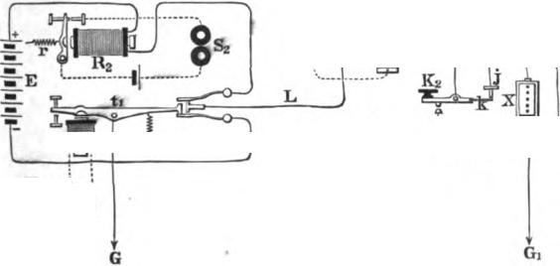
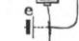

ARRANGEMENT FOR CONTRAPLEX TRANSMISSION. 881
Figs. 513 and 514 show the application of a contraplex system, in which one set of signals are made by a series of changes in the polarity of the current, and the other by changes in its strength.
In fig. 513, t₁ is the lever of a double current, or pole changing transmitter, which is operated by an electro-magnet m_{l}, local battery and key K₁.
The construction and operation of this transmitter is fully described on pages 871 and 872.
At station B, the receiving instrument R₁, having a polarized armature, is placed in the circuit of the line, and in consequence of the polarity of its armature, will respond to each reversal of
Station A. Static B.
^{S}'S
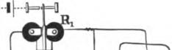
LOCI
¹;
K
.PTg. 513.
the current upon the line, produced by the movement of the double current transmitter t₁, and will open and close the local circuit of the sounder S₁, giving signals corresponding to the movements of the key K₁ at station A.
The line at station B, after passing through the receiving instrument R₁, is conducted to the earth at G₁.
A rheostat X is inserted between the receiving instrument R₁ and the earth, the resistance of which may be, say, from two to four times as great as that of the line. A key K, is connected with the line in such a manner as to shunt the rheostat X by a circuit of practically no resistance each time the key is depressed.

882 | QUADRUPLES TELEGRAPHY.
 | 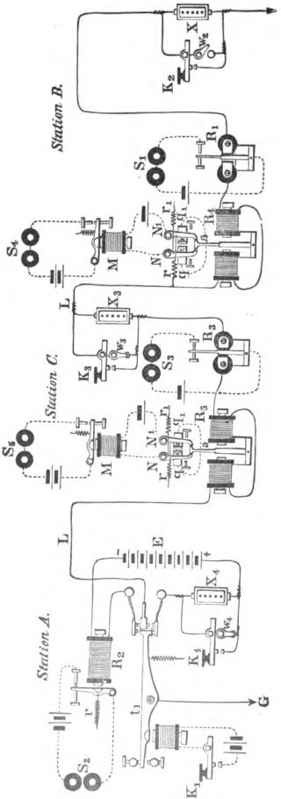

COMBINED DIPLEX AND CONTRAPLEX SYSTEMS. 8S3

In order that the operator may be able to hear his own signals, the key K₂ is provided with a spring contact arm k, which, when the key is depressed, is brought in contact with the stop J, thus shunting the rheostat X, and giving the signal at station A. The ordinary contact point of the key at, or nearly at, the same time, strikes upon its anvil, and closes the circuit of the local battery e through the sounder t, and thus duplicates the signal sent to the other station.
At station A a receiving instrument, R₂, having a neutral armature and adjustable spring r, is placed in one of the wires leading from battery E to the double current transmitter. The armature of the receiving instrument R₂ opens and closes the local circuit of the sounder S₂, in the ordinary manner. The retractile spring r of the receiving instrument R₂, should be strained up to a sufficient tension to withstand the attraction of the electro-magnet when the rheostat X is in circuit at the other station, while it will be easily overcome by the increased force of the line current, which results from the shunting of the rheostat X, and the consequent removal of its resistance from the circuit whenever the key K₂ is depressed.
By placing the receiving instrument R₂ in one of the wires leading from the battery to the pole changing transmitter t₁, the direction or polarity of the current traversing its coils is never changed, and consequently its armature has no tendency to fall off when the current is reversed upon the line.
It is obvious that any required number of receiving instruments similar to R₁, accompanied with the other apparatus shown and described at station B, may be placed in the circuit of the line at way or intermediate stations, all of which will simultaneously respond to the signals given by the key K₁ and transmitter
Fig. 614 is a modification and extension of the system, so arranged as to be capable of either transmitting two communications simultaneously in the same direction, or one in each direction, at pleasure.
If the keys K₁ and K₄ are operated at the same time, the

884 QUADRUPLE% TELEGRAPHY.

former will control the polarity and the latter, the strength of the current going to line from the battery E.
At the terminal station B, as well as at the intermediate station C, receiving instruments R₄ and R₅ are made use of, the construction and operation of which are fully described on pages 872 and 874.
The polarized armature a plays between two contact levers N and N₁, which are held against the stops q and q₁ by springs r and r₁; these springs being strained up to a tension sufficient to resist the electro-magnetic action of the weak current, which traverses the line when the rheostat X₄ is put in circuit by the opening of key K₄, but which will readily be overcome by the stronger current which passes when the rheostat is cut out, by the depression of key K₄.
The local relays M M, between the receiving instruments R₄ and R,, and their respective sounders S₄ and S₅, at stations B and C, when arranged in this manner, is a well known device for reversing the signals of the relays, in order that they may appear correctly upon the sounder.
Thus it will be understood that the sounding or recording instruments S₄ and S₅ at stations B and C, will respond each time the key K₄, at station A, is depressed, while in like manner the sounders S₁ and S₃, at stations B and C, will respond each time the key K₁, and transmitter t_{l}, at station .4., is operated.
The rheostats X, X,, and X₄, are cut out of the circuit when the operators at the respective stations are not using the line by means of the switches W2, W₃ and W₄, precisely as in the case of the ordinary closed Morse circuit.
In order to transmit communications in opposite directions at the same time, the operator at station A will use key K₁, and the operator at station B or C will use key K₂ or K₃.
With the apparatus constructed and arranged as in fig. 514, the operation may be briefly summed up as follows :
When key K₁ is operated sounders S, and S₃ will respond. When either K₂, K₃, or K₄ is operated by first opening the switches attached, sounders S₂. 5₄ and S₅ will respond.

COMBLNED DIPLEX AND CONTRAPLEX SYSTEMS. 885

It will, therefore, be readily understood that the following results may be obtained :
- Station A may send a message to C, and C at the same time send one to A, both of which may be read at B.
- A may send a message to B, and B at the same time send one to A, both of which may be read at C.
- A may send a message *to C, and at the same time B may send one to A, which latter may also be read at C.
- A may send a message to B, and at the same time C may send one to A, which latter may also be read at B.
- A and C may simultaneously send messages to B, the latter of which may be read at A.
- A and B may simultaneously send messages to C, the latter of which may be read at A.
- A may send messages to B and C at the same time.
- A may send two messages simultaneously to B, both of which may be read at C.
- A may send two messages simultaneously to C, both of which may be read at B.
- B and C can work together singly, precisely as in the ordinary closed circuit, Morse system; and,
- When it is not required to work duplex, A can signal B or C with either of his two keys.
All the results which have been described are accomplished by means of a single main battery E, placed at one terminal station A.
Fig. 515 represents a combination of the above system with the quadruplcx at a common terminal station, at which the connections are so arranged as to allow of the repetition of signals from one circuit into the other.
Taking an actual case, as before, we will suppose the repeating apparatus to be located at New London, which, for convenience, may be designated as station A. This is in communication with New York, 126 miles distant. by a quadruplex wire L, and with Norwich, Conn., and Worcester, Mass., by the line L„ 73 miles in length, the former being an intermediate and the latter a

886 QUADRUPLE% TELEGRAPHY.
terminal office, which we will designate respectively as stations B and C.
The apparatus at station A consists of a complete set of quadruplex instruments and a set of the instruments shown in fig. 513, both of which have already been described; consequently, it will only be necessary now to show the manner in which they are worked conjointly. •
The switch or button w₁ is so placed between the local batteries B₁ and e₁, that when closed it forms a part of each of the two local circuits containing the sounder S₁ and transmitter t_{i}, but when open the separate circuits are combined into one; and if the key k₁ be closed, the relay R₁ then operates both sounder

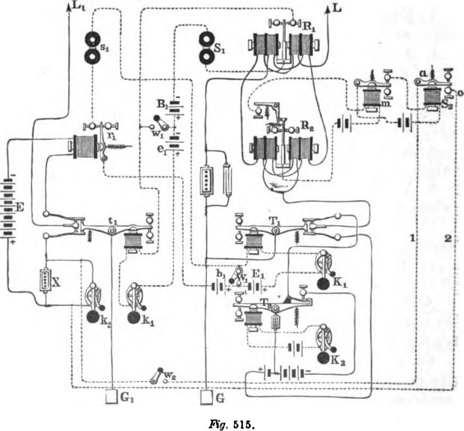
L,
SE
o-•
2 G
Frg. 515.

COMBINATION OF QUADRUPLES AND DIPLES SYSTEMS. 887

S₁ and transmitter t₁, and thus repeats the signals coming from line L into line L₁, and to stations B or C.
The local circuit containing the sounder s_{i} is, in a similar manner, separated from or combined with that containing the transmitter T₁ by means of the button W₁. In the latter case, relay r₁ operates transmitter T₁ as well as sounder .9₁, and thereby repeats the signals from L₁ over line L to New York.
The sounder S₂, which is operated by the relay R₂ of line L, may be arranged in connection with wires 1 and 2 and button w_{s}, so that when the latter is closed and key k₉ opened the shunt around the rheostat X is thereby extended through lever a and contact o of sounder S₂; and thus a second set of signals, received from New York on relay R_{s} at station A, may also be repeated into line L and to stations B and C.
The signals produced by the transmitter T₂, when key K₂ is operated, are received at New York upon a sounder corresponding to that of S₂ in the figure.
It will, therefore, be seen that with the apparatus thus arranged the following results may be obtained:
- New York may send a message to station C, and at the same time C can send one to New York, and both be read at A and B.
- New York may send to B, B to New York, and both be read at A and C.
- New York may send to C, and be read at A and B, while at the same time B may send to New York, and be read at A and C.
- New York may send to B, and be read at A and C, while C may send to New York, and be read at A and B.
- New York may send to B, and be read at A and C, while C also may send to B, and be read at A and at New York.
- New York may send to C, and be read at A and B, while at the same time B may also send to C, and be read at A and New York.
- New York may send to B, and be read at A and C, and at the same time A may also send to B, and be read at C and New York.

888 QUADRUPLE% TELEGRAPHY.

8. New York may send to C, and be read at A and B, and at the same time A may also send to C, and be read at B and New York.
9. New York and station A may work duplex continuously, without regard to what is passing between stations A, B and C.
10. New York may send two messages simultaneously to
A, one of which may be read at B and C, and at the same time two communications may pass over the line to New York, one from A and the other from C, the latter of which may be read at A and B.
11. New York may send two messages simultaneously to A, one of which may be read at B and C, and at the same time two may pass simultaneously over line L to New York, one from A and the other from B, the latter of which may be read at A and C.
12. New York may send two messages simultaneously to B, both of which may be read at A and C, and at the same time receive two from A.
13. New York may send two messages simultaneously to C, both of which may be read at A and B, and at the same time receive two from A.
14. New York may send two messages simultaneously, one to
A and the other to C, the latter of which may be read at A arid
B; and, at the same time, receive two, one from A and one from C, the latter of which may be read at A and B.
15. New York may send two messages simultaneously, one to A, the other to B, and the latter be read at A and C; and, at the same time, receive two, one from A and the other from
B, the latter of which may be read at A and C.
16. New York may receive two messages simultaneously from A, and, at the same time, transmit two distinct communications, one to B and one to C, or both to either station separately, and both may be read at A. Finally,
17. Station A may, by properly arranging the buttons w„ w₂ and W₁, divide the two lines L and L₁, and operate each

QUADRUPLE% REPEATER 889

separately; the former as a quadruplex wire to New York, the latter as contraplex or diplex to B and C.
Fig. 516 shows a plan of connecting the apparatus at a station forming the common terminus of two quadruplex circuits, so as to repeat from one into the other. We will suppose the station to be Cleveland, and that L₁ represents a quadruplex wire extending from that point to Buffalo, a distance of 183 miles, and L₉ a similar wire between Cleveland and Cincinnati, a distance of 250 miles. The apparatus comprises, in addition to two complete sets of quadruplex instruments, the four button switches, W, W₁, W₂ and W_{s}, which serve for giving direct through communication between Buffalo and Cincinnati, or for dividing the wires and thus allowing each of them to be worked separately.
For clearness of illustration, the relays, as shown in the figure, are not wound differently, and the rheostats and condensers forming the artificial lines have been omitted.
The arrangement of the local circuits of the several relays R₁, R₉, r_{l} and r₂, so that they may be separated from or combined with those of transmitters t₁, t₂, T₁ and T₉ respectively, by means of the buttons W, W₁, W₂ and W_{s}, is precisely the same as that shown in fig. 512, for repeating from one quadru-plex into two duplex circuits, and vice versa.
It will therefore be understood, from what has already been said, that when the buttons are all open, and the keys K₁, K₂, k₁ and k₂ closed, Buffalo may transmit two communications simultaneously over the line L₁ to Cleveland, where they will then be automatically retransmitted, one by relay r_{i} and transmitter T₁, the other by relay r, and transmitter T₂, over line L₂ to Cincinnati. The latter station may also transmit two independent messages at the same time to Cleveland, where, in turn, they will be retransmitted, one by relay R₁ and transmitter 1,, and the other by relay R₂ and transmitter t₂, over line L₁ to Buffalo.
By simply closing the buttons W, W₁, W₂ and W₃, the two circuits may be divided at Cleveland, and worked separately.

890 QUADRUPLEX TELEGRAPHY.
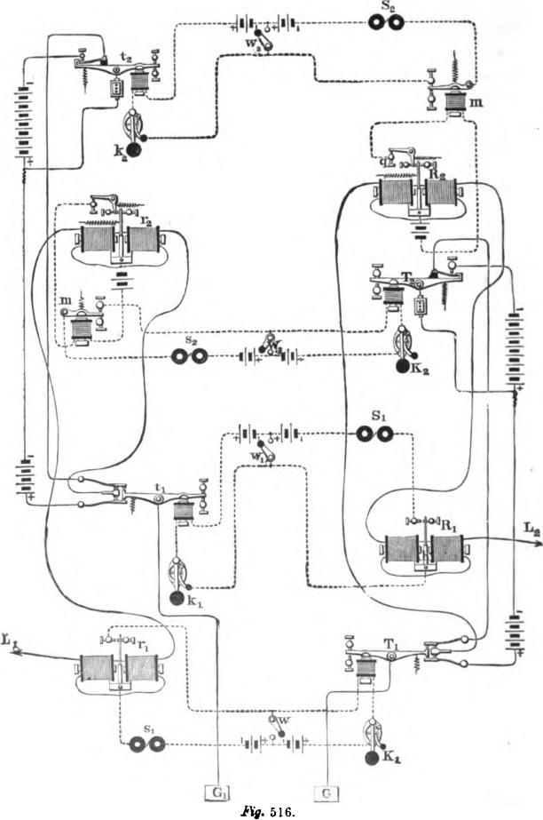
a.
.. ............... ..........
Ag. 516.

QUADRUPLEX REPEATER. 891

In regular practice, however, the circuits are worked in the following manner, so as to facilitate the exchange of business between the three points before mentioned :
The buttons W₂ and W_{s} are closed and W and W₁ opened. When thus arranged, Buffalo and Cincinnati are enabled to work together duplex, and, at the same time, Cleveland may work duplex to Buffalo over line L₁₇ and to Cincinnati over line L₂. The transmitter t₁ and relay r_{i} of line L₁ are so located on the desk or table, with regard to the corresponding apparatus of line 14₂, as to facilitate the adjustment of the several instruments.
Quadruples repeaters are similarly arranged for facilitating the exchange of business between numerous other points on the lines of the Western Union Telegraph Company, among which may be mentioned Boston, Albany and Buffalo; Buffalo, Detroit and Chicago; and New York, Hartford and Providence.
A combination of the two methods of duplex telegraphy, known as the bridge and differential systems, but differing materially in arrangement from that shown on page 845, is also used in practice. At Buffalo two complete sets of quadruplex apparatus, on this plan, are arranged by connecting the local circuits in precisely the same manner as shown in fig. 516, for repeating signals from one circuit into another, and, by this means, New York and Chicago are enabled to exchange four communications simultaneously, over a single wire, between these points.
A second wire between New York and Chicago is equipped with the quadruplex apparatus, and precisely the same arrange ment as the above is made at Buffalo for repeating from one circuit to the other. • At New York, however, the connections are such, that while its office and Chicago are working duplex on one side, the latter may also work duplex on the other side with any one of two or more branch offices in New York. The manner in which this is done will readily be understood from fig. 517 and the following explanation, which relate to the arrangement for a Boston wire, where it was first used; the one for the Chicago line, however, is just the same :

892 QUADRUPLE% TELEGRAPHY.

The complete quadruplex set in connection with the line L is supposed to be at the New York main office. Sounders s_{i} and S₄, and key k₁, at a branch office in the city, which we will call station A; and the apparatus consisting of sounders 8₂ and S_{s}, repeating relay m₉, key k, and local battery e₄, at a second branch office, which we will call B.
In order to provide for the simultaneous reception of two independent communications over line L, from Boston, one of which shall be received upon relay R₁ and sounder S₁, and, at the same time, also, upon sounder a, at station A, and that the other shall be received upon relay 14, sounder S₂ and upon sounder a, at station B as well, while separate communications are at the same time being sent to Boston from each of the two stations A and B, it is only necessary to connect the local or branch lines with the relays and transmitters of the quadruplex apparatus at the main office in the manner shown in the diagram (fig. 517). Ilere the route of the local or branch wire of the relay R₁ may be traced from the earth plate G₁, at the main office, to battery e, wire 1 and armature of relay R₁ to sounder S₁, and thence by wire 1, to sounder 3₁ and earth G₂ at station A. The route of the branch circuit of relay R₂ is from earth plate G₃ to battery e_{l}, wire 2, armature of repeating sounder M and sounder S₂, and thence by line 1, to sounder 8₂ and earth G₄ at station B. The routes of transmitters T₁ and T₂ may be similarly traced. It will be noticed, however, that the arrangement of the branch line, as well as local connections of transmitter T₂, differ materially from those of T₁, as in its normal position the former should remain open, and thus leave only the smaller portion of the main battery on the line. The keys K₂ and k₂ are not provided with circuit closing switches, and contact is made at the back point, instead of the front, as in the ordinary form. The normal position of these keys is that shown in the figure, in which they close the branch circuit and cause the armatures a and a₁ of repeating relays m₁ and m₉ to be attracted, and thus break the local circuits of transmitter T₂ at the main office, and sounder S, at B. By depressing K₂ or

ARRANGEMENT FOR BRANCH OFFICES. 893
14-₂, and consequently breaking the branch circuit, the armatures of the repeating relays m₁ and m₂ will be released, and the local circuits of transmitter T_{it} and sounder S₅ will be closed simultaneously. The operator at B is thus enabled to hear his own or other signals that are being transmitted by the main or other office on the branch line.
Fig. 517.

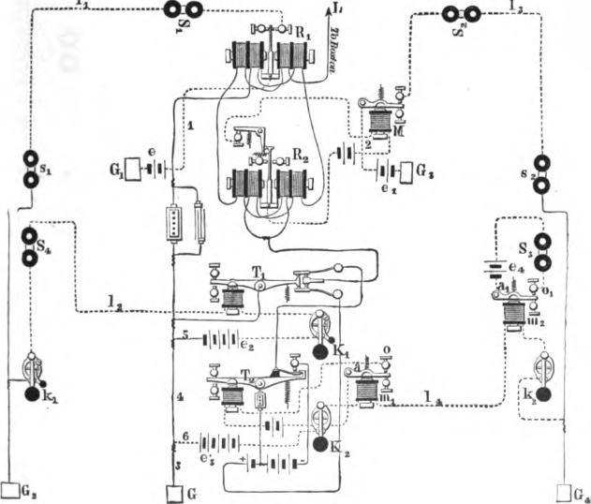
00
1_{1.}
It will therefore be sufficiently obvious that the signals received from the line L upon relay R₁ and sounder S₁ at the main office can, with equal facility, be read from sounder s_{i} at station A, while the latter office at the same time may, by depressing the key k₁, and consequently operating sounder S₄ and transmitter T₁, be sending signals to Boston or to some branch office at that place. In a similar• manner and at the same time,

894 QUADRUPLE% TELEGRAPHY.
station B may work duplex with another branch office at Boston, of which at that place there are five on one side of the quadru-plex and two on the other. The balancing and adjusting of the quadruplex, it will, of course, be understood, is all done at the main office.
The quadruplex is also arranged to work in connection with a single direct circuit containing any number of offices, and the plan has been found to serve an excellent purpose in practice, as communication can thereby be maintained between a distant

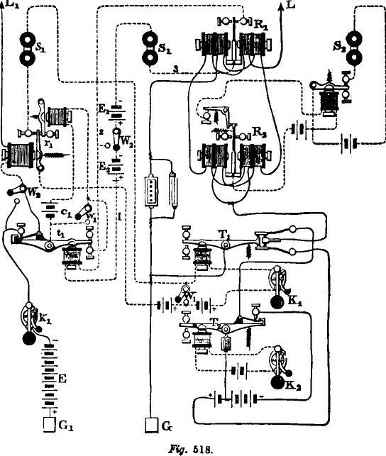
Ss.
E
Fig. 518.

QUADRUPLEX AND SINGLE CIRCUIT COMBINATION. 895

office on the quadruplex circuit and any one of the number on the single wire line.
Fig. 518 shows the details of the arrangement as adopted at St. Louis, for automatically repeating from one circuit into the other, the outfit consisting of one complete set of quadruplex apparatus and portions of a Milliken repeater. The line L, extending to Chicago, 280 miles distant, is connected with the quadruplex relays; and line L₁, extending to Kansas City, Atchison, Leavenworth and St. Joseph, with the Milliken relay r₁. The local circuit of this relay is separated from or connected with that of the transmitter T₁ by means of the switch W„ in precisely the same manner as in the preceding cases, and by means of the switch W₂, the local circuit of relay R₁ may be extended through the transmitter t_{o} or disconnected therefrom at pleasure. With the switch W₂ turned to the right, for example, as shown in the figure, the local circuit may be traced from the switch to local battery E₉, wire 1, transmitter t_{i} and wire 2 to relay R₁, thence by wire 3, sounder S₁ and battery E₁ back to the switch again. When it is turned to the left, battery E₂ and transmitter t₁ are thrown out of circuit and relay R, operates sounder S₁ alone. The local contact points at the front end of transmitter t_{i} are shunted out when desired, by means of the button or switch w₁; and the main contact points at the opposite end of the lever are in like manner cut out by means of button W. When, therefore, the switches W₁, w₁ and W are open, W₂ turned to the right and keys K₁ and k₁ closed, as shown in the figure, Chicago may exchange business with any one of the offices on L₁, the signals being automatically retransmitted at St Louis by relays R,, r₁ and transmitter T₁ and t. At the same time St. Louis and Chicago may also work duplex, using key K₂ and R₉ for that purpose.
By closing switches W,, w₁ and W and turning W₂ to the left, the two lines L and L₁, as will readily be seen, may be worked separately, the former as a quadruplex and the latter as a single Morse eiretlit.

896 ARRANGEMENT FOR NEUTRALIZING CURRENT INDUCTION. CURRENT INDUCTION.
The interference between well insulated telegraph lines, known as current induction, has from the first done a great deal toward preventing the proper working of the quadruplex system, and the question as to how the disturbing effects due to this cause might be overcome has, therefore, become one of considerable importance.
Mr. Charles H. Wilson, of Chicago, who has given considerable attention to the subject, has devised a plan for diminishing the difficulties just referred to.
Mr. Wilson seeks to accomplish his object by establishing a counter current in the disturbed conductor at the same moment and of the same strength and duration as that of the induced cur-
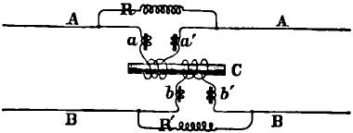
Fig. 519.
rent which is generated in it by the sudden change of potential in a neighboring wire.
Fig. 519 shows the application of the method to a single Morse line, but here it is of comparatively little practical importance, from the fact that these lines, as a general thing, can be supplied with strong currents, so that there is always sufficient working margin to cover the difficulties arising from induction. The primary wire of the induction coil C is in the circuit of one line, and the secondary coil in that of the other. The coils are so wound or connected to the lines that either will induce in the other currents of opposite direction to those induced by the remaining parts of the circuit. The electro-magnets represented at a, a', b and b', are employed for producing the proper retarding effect on the counter or neutralizing currents which are generated in the coils surrounding C, and the adjustable resist-

INDUCTION BETWEEN PARALLEL LINES. 897
ance R R of the shunt circuit serve to still further modify these currents, so that their action is subject to complete control
The manner in which the device is rendered effective will readily be understood from the diagram. Thus, for instance, if a current of any polarity is sent into the conductor A, a current of
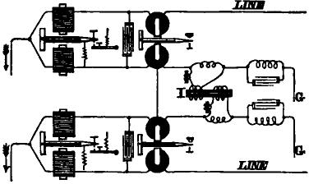
J. 520.
the opposite polarity will be induced in the line B, owing to its close proximity to the former, but at the same instant a similar current will also be induced in the coil to which it is joined, and, as the connection is so arranged that this current opposes that
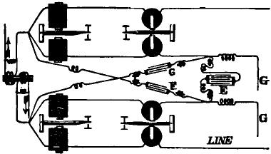
LINZ
Fig. 521.
induced by the proximity of the two conductors to one another, the proper action of the instruments will not be disturbed.
The arrangement for accomplishing the same result between two quadruplex circuits is shown in fig. 520. It is evident that, with the bridge or differential principle, all that is required to effect the end in view, is to cause the two artificial lines to act

898 QUADRUPLEX AND MULTIPLE TRANSMISSION.

upon each other in a manner similar to the action of the actual lines, and for this purpose an induction coil and system of magnets, similar to that just described, is inserted in the path of the two artificial lines at I.
Fig. 521 shows an arrangement of condensers substituted for the induction coils, which has been in extensive use on some of the long lines in the central division of the Western Union Telegraph Company. If the inductive effect of the two wires are equal, the condenser E is alone necessary to effect the neutralization; but when unequal, the two condensers F and G are required in connection with E.
MEYER'S METHOD OF MULTIPLE TRANSMISSION.
As an example of a totally different system of multiple transmission, based upon the principle of the division of a single current into rapidly recurring waves or pulsations, which was first attempted by Farmer in 1852, we will give a description of Meyer's apparatus, which was exhibited at the Vienna exposition in 1873, and which, although it embraces but little that is essentially new, yet as an experiment, in its success in utilizing the time which is lost in the working of a wire by a single operator, it is not without novelty, and the machinery of transmission in itself possesses considerable merit,
This system of apparatus has for its end the utilization of al] the currents which in a given time can be made to succeed each other in a wire, so that several operators, each sending 20 to 30 messages per hour, may transmit them upon the same wire.
The number of transmissions that a telegraph line will carry varies naturally with its conductivity. It is generally admitted that, with a speed of twenty-five messages per hour on a Morse instrument, about five pulsations of the current occur per second. Consequently, n being the sum of the currents which in a second
can succeed each other in a conductor, ₅ — represents the number
of receivers which it is possible to establish upon a single wire, or the number of operators that can work at the same time.

MEYER'S METHOD OF MULTIPLE TRANSMI.SSION. 899
The apparatus shown in fig. 522 is constructed for four trans- missions and is worked by four operators. At a speed of 75
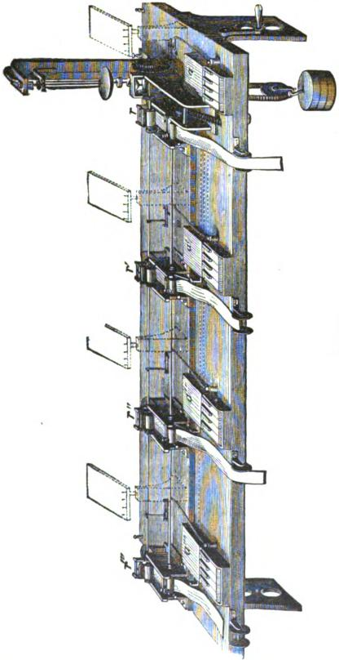
revolutions per minute, presenting four letters at each turn, it records 100 messages per hour with 20 pulsations of the current

900 QUADRUPLE% AND MULTIPLE TRANSMISSION.
per second. This is less than a maximum result, for experience has shown that telegraph lines can be worked at a much greater speed.
As the apparatus is arranged for transmission, four sets of keys, a a' a" a"', eight in each set, are placed with their receivers r r' r" r'" upon a table, each receiver having a strip of paper for recording, which is continuously being drawn from- a roll. A single clockwork movement, actuated by a weight and regulated by a conical pendulum, serves as the motor of all the receivers. The keys, as well as the receivers, are connected with the earth wire, and with the line wire in the latter case, through the distributor.
The distributor (fig.522a)is the principal feature of the instru-
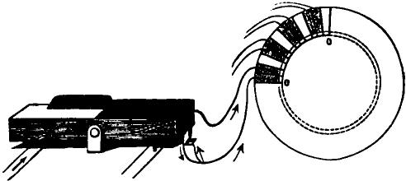
Fig. 522a.
ment. It is this which, during four equal intervals of time, directs the current of the battery successively toward each of of the four receivers of the receiving station. o o' is a disc of metal, fixed and insulated. It has 48 divisions; 12 to the quarter of the circle, of which eight—grouped two and two—are connected metallically by eight wires to the eight contacts of the keys; the others, to the number of four, are permanently connected to the earth. There are, thus, four cables of eight wires each, which start from the four sets of keys and end in the distributor. The groups or divisions are therefore sixteen in number, separated by intervals. The first half of a group, 1-48th of a revolution, gives place to a short contact; the entire group to one of double the length. An elastic contact spring,

MEYER'S METHOD OF MULTIPLE TRANSMISSION. 901

mounted upon the axis, traverses the circumference of the disc, and successively connects the four keys and four receivers with the line, so that the current transmitted or received during the passage of the spring over one of the quadrants is directed through the receiver to which it corresponds. Each operator thus has the line at his disposal during a quarter of a revolution. The transmitter is composed of eight keys, four black and four white, which are connected between the battery and the earth. The black keys represent dots and the white keys dashes. In order to transmit a letter, as many keys, black or white, are touched simultaneously as the letter to be produced has dots or dashes, taking care to start from the left key. As soon as the rotating contact spring, in its movement, passes over that section of the disc to which the keys depressed are connected, the signal or letter is transmitted, the spring passing to the next quarter section which is connected with the next set of keys, and which is being manipulated by another operator, and so on with all the sections. There is, in aid of sending, attached to each of the keys, an eccentric, the use of which is to raise after each letter a small rider, and this, falling by its own weight, produces a tick, beating the measure, during which each operator may work.
Fig. 5226 is an enlarged view of the receiver. Each receiver has for its printing mechanism a section of a helix, resembling an elongated spiral. This may be more easily understood by supposing a cylinder having upon its surface a raised rib extending spirally over its entire length. As the contacts from the sets of keys are placed in a straight line over this cylinder, it will be plain that only one key can be put into connection with the spiral rib at the same time. The helix of the receiver and the rubbing contact of the distributor make their revolutions in the same time and from the same starting point. An inking wheel revolves freely on each of the helices. The letters appear trans- versely upon the paper band (1. e., at right angles to the ordinary Morse characters), the paper being raised to the writing helix by the armature of the electro-magnet over which it passes. This
55

902 QUADRUPLE% AND MULTIPLEX TRANSMISSION.
transverse disposition of the letters presents a double advantage: it avoids confusion between consecutive letters, and reduces considerably the length of the paper band used for each despatch.
The multiple transmission, then, depends upon the identical revolutions in the same time of certain portions of the apparatus at distant stations. This is effected by the aid of a conical pendulum and a regulating system, by which a correcting current is transmitted every second. Further, it is arranged that the line should be put to earth at both extremities after each emission of the current.
It will be seen that this form of multiple telegraph, arranged
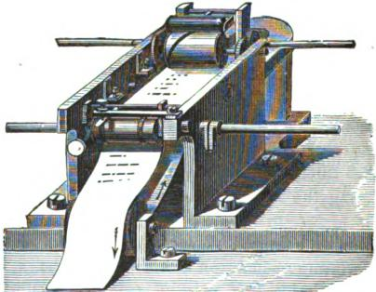
522b.
upon the best division of the time utilized by successive currents, has nothing in common with the system of double transmission, which has been developed from the inventions of Gintl and Frischen.

CHAPTER XLI.
APPLICATION OF THE DUPLEX TELEGRAPH TO SUBMARINE
CABLES.
The difficulties which attend the application of the duplex telegraph to subterranean lines of considerable length are greatly increased when the same methods are sought to be employed upon long submarine cables. The cause of this is generally known to be due to the great static capacity of these conductors.
The introduction by Mr. J. B. Stearns of the condenser in the telegraphic duplex✓ gave the first impulse to a series of experiments upon duplexing cables, which were begun in 1873 by Mr. C. V. de Sauty, electrical engineer of the Eastern Telegraph Company, upon the cable from Lisbon to Gibraltar. The system employed by Mr. de Sauty was the bridge method, an arrangement which readily suggested itself as the best for duplex transmission upon submarine cables. For land lines, which employ less sensitive apparatus, this method appears less advantageous, as it enables but a small part of the current to be utilized in the receiver, and the arm of the bridge being interpolated in a direction parallel to the receiver, acts as a shunt at the receiving station, and renders great rapidity of transmission very difficult. But the fact that it is only a small fraction of the receiving current which acts upon the receiving instrument, is precisely that which, in the case we are now considering—that is to say, in submarine telegraphy—constitutes an advantage, as that which is needed to paralyze the effects of the static charge with a smaller number of condensers.
DE sAurv's METHOD.
Mr. de Sauty conceived the idea that, in order to obtain the equilibrium at the transmitting station, it was necessary that

904 DUPLEX TELEGRAPH APPLIED TO SUBMARINE CABLES.
the artificial line should be an imitation as complete as possible of the actual cable. In the published description of his experiments he indicates no less than eight different arrangements, of which we reproduce only those which have given more or less satisfactory results.
As a sample in fig. 523, the artificial line in this case is formed by a combination of resistances and condensers. Instead of this arrangement, Mr. de Sauty had endeavored first,
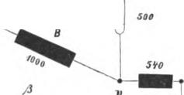
and by analogy with the method of Mr. Stearns, to introduce only a rheostat and a condenser; but this experiment was unsuccessful. When one of the levers of the key, M, is depressed, the current from the battery, B, goes to the point, C, of the bridge system furnished with two branches of equal value, A and B; the artificial line should then be equal to the resistance of the cable increased by the diminished resistance of the receiving station. One half of the current furnished by B then penetrates

0
I
20
CARL E 3985
0^{°1)}
A
C
RI
1000 1000 4000
38 3 U
• •- -
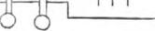
Rg. 523.

•

DE SAUTY'S METHOD. 905
in the cable and proceeds to the point, O, of the receiving station. Here it suffers a new division; two-fifths of this part of the current which arrives at the point, O, passes by the coils, R, of the Thomson siphon recorder, which serves as receiver, and thence flows by B to the earth, while the other three fifths return by A. As regards the other half of the current, that goes to the earth by the artificial line at the transmitting station.
Now, if the capacity of the artificial line was considerably less than that of the cable, a current from p to O would circulate momentarily, at the instant when the key is depressed. It is necessary, then, in such cases, to endeavor to equalize as much as possible the potentials at the points O and p. If, instead of the combined artificial line, they should place there a resistance and a condenser, of which the capacity should be equal to that of the cable, they would only obtain this equality of the potentials, because the conditions of the propagation of the electricity would be entirely different in the two circuits. If at the same time the keys at the two stations be depressed, the cable will then be, by virtue of known laws, free of current, or else it will overflow by a current of double force.
More recently Mr. de Sauty and Mr. Harwood have further perfected the system by operating a much greater subdivision of the artificial line. According to the opinion of Sir William Thomson, it would require, in fact, an infinite number of resistances and of condensers to obtain a perfect assimilation of the artificial line with the actual cable. Mr. Varley had already, about 1860, employed in a test circuit established for another purpose a very great number of resistances and of condensers.
The experiments of which we are about to speak were conducted by Messrs. A. and J. Muirhead and H. A. Taylor, and, in 1874, they secured a patent for an artificial cable, destined to replace the artificial line employed by Mr. de Sauty. In this arrangement the conductor consists of a ribbon of tin foil, from two fifths to three fifths of an inch in width, and having the form shown in fig. 624. This ribbon is covered, first, by a sheet of paraffined paper, which constitutes the dielectric of the

906 DUPLEX TELEGRAPH APPLIED TO SUBMARINE CABLES.

artificial cable, and this again by tin foil, which serves as a protecting envelope.
By superposing a great number of these elements in the following order: tin foil, paper, conductor, paper, tin foil, etc., a resistance can be constructed of considerable capacity in a relatively small space. These artificial cables are made in a large room, of which the temperature, sufficiently elevated. is always maintained constant; the paper used for the fabrication of the dielectric is as soft as silk and of excellent quality. According as the conducting ribbon is made wide or narrow, the resistance and the capacity varies. The latter depends also upon the degree of pressure to which the cable is subjected after the open
Fig. 624.
ation of the superposition. Once the final exact adjustment is finished, the whole is placed in a high and narrow mahogany box, having for cover a plate of ebonite, in which holes are made for the introduction of exactly numbered limit pins. A series of these pins, shown in fig. 525, correspond to the sections of the conductor, having different lengths; the inductive plates, J, are separated in groups which correspond with the pins, P, which are ordinarily connected between them and the earth. Each couple of boundary pins, S, form still, with the corresponding capacity J, a unit of length—a nautical mile—of the artificial cable.
Messrs. Muirhead and Taylor, however, obtained in 1876

DE SAUTY'S METHOD. 907

patents for other systems of construction of inductive artificial line. In one of these, for example, they employ, as conductor, plates formed of graphite paper, prepared in
W l_{i}t a certain manner, and of which the different
W
44 i... ¹4 superposed layers are alternately separated
i.., ,...
1 c.,
^{et}
X 0
Is
i tern does not appear to have given good re-
sults, which was to be foreseen, if we con-
(-10.:::-
1_{4.)} 1 Bider how difficult it is to establish sure communication with similar plates. Besides, the graphite is the worst material we can imag-\, ine for resistances; for, in addition to the fact that these resistances cannot be adjusted within one per cent, their value varies considerably by time.
Another process consists in surrounding a fine thread covered with silk with a metallic tissue. A priori, we recognize that an arrangement of this nature possesses only a feeble capacity compared to the resistances of tin foil, and is only proper to replace a condenser for compensating the charge upon land lines.
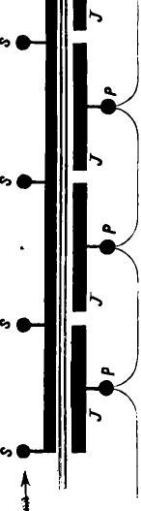
We shall return again later on to the detailed arrangement of the telegraphic duplex method of Muirhead, which has been applied within the last ten years to all the long cables of the Eastern Company, viz. : Marseilles-Bona, 1875; Bona-Malta, Suez-Aden, 1876; Aden-Bombay, 1877; and to the direct Atlantic and the Madras-Penang cables in 1878.
Another method of duplex for short cables has been applied by Mr. Ailhaud.
Fig. 526. This system is based upon the bridge and
differential methods. To avoid the employment of an *artificial cable, Mr. Ailhaud has resorted with success to divers processes,

908 DUPLEX TELEGRAPH APPLIED TO SUBMARINE CABLES.
which we describe further on. With regard to its practical application, it has given good results upon the Marseilles-Algeria and the Marseilles-Bona-Malta cables.
Messrs. Loffier and Higgs described, in 1878, a particular modification of the bridge method of duplex transmission upon cables, but we do not know if that method has received the sanction of practical operation.
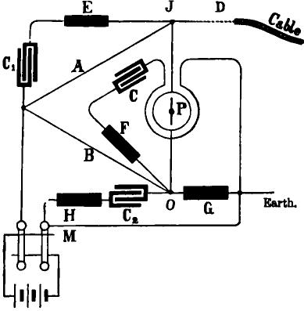
.FTg. 526.
In 1878 Mr. J. B. Stearns successfully applied a method of duplex transmission to one of the Atlantic cables of the Anglo-American Company, the details of which have not been published.
AILHAUD'S METHOD.
Fig. 526 represents the arrangement of Mr. Ailhaud, which has given satisfactory results upon the Marseilles-Algiers and the Marseilles-Bona-Malta cables.

AILH ALM'S METHOD. 909

The two branches of the bridge, A and B, are represented by the resistances of 2,000 ohms, A, and of 1,000 ohms, B. In order that at the transmitting station the bridge may be free of current, when one of the arms of the key, M, is depressed, it must have the following proportion:
2000 Cable + resistance of the receiving station.
1000 — Artificial line.
This proportion is only verified, however, for the currents in a stationary state; at the moment of depression of the levee the cable is charged, but more slowly than the condenser, C₂, interposed in a direction parallel to the artificial line, G; there is then necessarily a momentary passage of current from O to d, which causes a deviation of the needle of the reflecting galvanometer, P, serving as a receiving apparatus. In order to neutralize this injurious effect, which is called a kick, Mr. Ailhaud has devised the ingenious arrangement of emitting a current of the same force, but in a contrary direction to the charging current. The galvanometer, P, is, for this purpose, provided with a second coil, in which are interposed a rheostat, F, and a condenser, C, of considerable capacity. The effect of this arrangement is as follows : When the key, M, is depressed, the arrangement adopted by Mr. Ailhaud for the bridge resistances requires one third of the current to pass into the cable, while the other two thirds flow by G to the earth. This last division of the current penetrates at the same time in the condenser, C, charging it, and thus producing in the second coil of P, a current of which the direction is opposed to that of the current coming from the cable. The time of charge C is proportional to the product C X F, and upon short cables can be sufficiently assimilated to the duration of the current from the cable. If the key, M, is raised, the cable discharges by A and by P and B to the earth. This discharge generates a new current, which is neutralized by the current of discharge of the same value coming from C. The small condensers, C, C₁ and C₂, connected to the ends of the bridge, serve to produce a very exact adjustment.

910 DUPLEX TELEGRAPH APPLIED TO SUBMARINE CABLES.
The normal equilibrium is regulated in the first place by means of the resistance C. It is sufficient to vary this resistance until the needle returns to zero.
To regulate the equilibrium of charge and discharge, the condensers C_{I} and 0₂ are detached, and the resistance F, which regulates the condenser, or, in case of need, the capacity of the condenser, is varied until the movements of the needle have nearly ceased. The condensers C_{I} and 0₂ are then successively connected, and the several resistances are varied until the complete equilibrium is obtained. When it is very near equilibrium a mirror of an exaggerated sensibility is substituted for the ordinary mirror, which permits, by an amplification of the effects, the attainment of a perfect balance. The first mirror is then replaced.
Mr. Ailhaud considers, in certain cases, that it is advisable to insert still, between J and the end of the cable, a rheostat, which we shall call D. In practice, this arrangement can be justified, although an artificial prolongation of the conductor cannot have a favorable influence upon the rapidity of the signals.
The following table gives the different values of the resistances and conductors :
MARSEILLES-ALGIERS MARSEILLES-MALTA
CABLE. CABLE.

Branch A 2000 ohms,
21 microfarads, 21 microfarads.
B 1000 ¹⁰
Rheostat G 4900 it
44 F 10900 ti
it E 2600 it
if 5000 it
it D 1000 tg
Condenser C
C₁ 16 t4
It C₂ 2.5 it
Battery 10 volts,
2000 ohms
1000 "
7560 It
10700 6i
2400 ti
5680 ft 1000
16 if
2.5
7 volts.

THE MUIRHEAD SYSTEM.. 911
Fig. 627 represents another arrangement. When the key, M, is depressed, the current bifurcates at 0; one part penetrates by the helix, G, into the cable, and the other flows by g and V to the earth. The current of charge which is produced at the same time in G is neutralized by the fact that the portion of the current passing by g finds at the point U a road to traverse in the third spire, y, and charges the condenser C. This last cur-

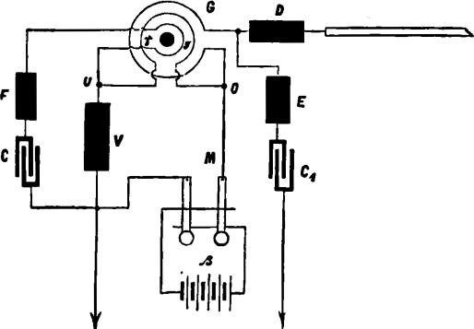 | CABLE

IV. 527.
rent of barge is opposed, in regard to its direction, to the one which circulates in G.
There is no necessity, we think, to enter in detail here into the effects which are produced by the laws of discharge.
THE MUIRHEAD SYSTEM.
Fig. 628 represer ts the arrangement which in practice has given the best results upxi the cable of the Direct United States Cable Company, as well as upon the long cables of the Eastern Company.

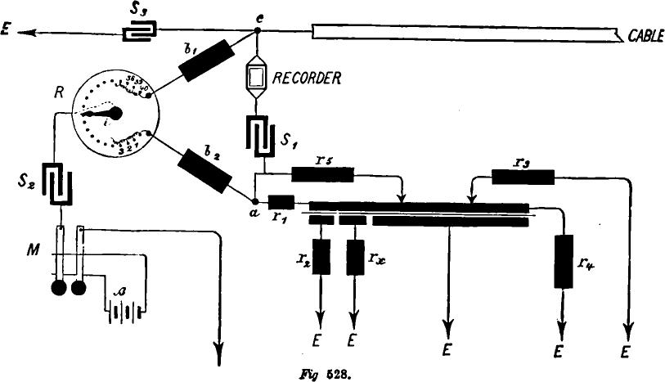
S_{i}
E
IV 628.

THE MUIRHEAD SYSTEM. 913

The two branches of the bridge b₁ and b₂ are composed of rheostats which permit of an interposition of 1,000 and 2,000 ohms; there is, besides, adjoining b₂ a smaller rheostat, containing a series of nine bobbins to 1,000 ohms and a series of nine bobbins to 10 ohms. The most exact adjustment of the branches of the bridge is obtained by means of the rheostat R, an instrument which contains forty bobbins to 0.25 ohm and one fixed bobbin—that is to say, which can be put in or taken out by means of a pin—of 10 ohms. The extremities of the forty bobbins, connected successively to each other, are attached to
the branchesof the bridge b₁, the current enters into the ap-
paratus by the axis of the pointer of the rheostat R.
Each change of the pointer, from one contact to the other, produces, consequently, an increase of 0.25 ohm in the resistance of one of the branches of the bridge, while that of the other branch is diminished by the same quantity. The actual cable is connected at the point c, and the artificial cable at the point a. This last cable is composed of a certain number of boxes, of which the construction has already been described. Each box has seven compartments; it has, therefore, upon the cover fourteen boundary pins, of which one half correspond to the different sections of the conductor, and the other to the inductive plates appertaining thereto. Experience has demonstrated that, for success in duplex transmission, it is necessary to assimilate as exactly as possible the commencement of the artificial line with the cable. Mr. Muirhead has, consequently, given to the first box, which should be inserted near to the point a, and which is called a special box, a particular construction.
The first part of this box, A, fig. 529, is composed of twelve compartments connected together in the ordinary manner, instead of the seven compartments which are in the other boxes; the inductive plate is, per contra, the same for all. It has besides six compartments, B, where the sections of the conductor, as well as those of the inductive plate, must be connected together outside of the box. This arrangement permits of the insertion

914 DUPLEX TELEGRAPH APPLIED TO SUBMARINE CABLES.
of resistances between the several sections of B, as seen in figs. 527 and 628.
In the bridge wire c a, fig. 528, is inserted the coil of a siphon recorder, or of a mirror receiving galvanometer, as well as a condenser, S₁, of a considerable capacity. It is of sixty microfarads upon the cable of the Direct United States Cable Company. A similar condenser, S₂, is found between R and one of the levers of the double key, M, of which the other lever is in communication with the earth. At the point c another small ad-
de a
J 9 5 8 7 8 9 70 If co A
^{i}jUnifsj,
E
2 box
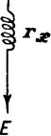
(Earth.)
Fig. 529.
justable condenser, S₃, is inserted, which enables the most exact balance possible to be obtained. If the cable and the artificial line are equal in resistance and capacity when b₁ =b₂, there is no current in the bridge of the transmitting station when one operates by simple transmission, or better, the current which traverses the bridge is of so short duration that it cannot cause any derangement Generally, those derangements will be always more feeble upon lines where they work with condensers than upon those where a current enters directly into the cable.
The experience of Mr. Muirhead has shown that for the sue-

THE MUISTUAD SYSTEM. 915
cess of duplex transmission it is necessary to adopt, at the commencement of the artificial line, different auxiliary arrangements, upon which we will dwell here for a moment. If the first inductive plates, fig. 528, are separated from the others and connected to the earth by the resistances r₂ and r, it is for the purpose of diminishing the charge from the commencement of the artificial line. Instead of that, if we should connect all the inductive plates together and give them all a communication with
the earth of a resistance r r₂ r,), the diminution would ex-
tend throughout the whole length of the artificial cable.
If the shunt r₅—of large resistance—be introduced between a and a point of the artificial conductor to be determined by experiment, the magnitude of the charge in the first part of the artificial line will be also less than in the second part. If, however, the resistance r, was given a corresponding value to r₅, this diminution would extend throughout the cable. Another diminution is still produced by 7₄, and the resistance 7.₃ serves to modify the speed. They cannot replace 1.₁ by 7₄, because in that case r₅ would have a very great value.
We give below the numerical indications relating to actual cables :
Torbay, ova Scotia.
Station of the Direct United States Cable Company:
b_{i} = 2,000 ohms, |  | or | /), = 2,000
b² = 2.040 | " |  | b₂= 2,045
r, = 0 | " | " | r_{i}= 28
7₄ = 400 | " |  | = 850
7₅ = 90.000 | " | " | 000  r₅ =85!-
S_{s} = 3.92 microfarads, " S₃ = 0
Bombay.
Station of the Aden and Bombay Cable of the Eastern Com-
pany: b₁= 2.005; b, = 2.035; =60; r₂=120: 7₃ =175,000.

916 DUPLEX TELEGRAPH APPLIED TO SUBMARINE CABLES.

Regarding the best method of establishing the balance, Mr. Muirhead gives the following instructions :
With one hand rapidly turn forward and backward the pointer of the rheostat R, during which the other band puts into circulation alternate, currents of short duration, by means of the double key M. In this case r₅ should have 100,000 ohms resistance, and be inserted as a shunt in a direction parallel to the first four boxes of the artificial line. If they do not succeed then in stopping the motion of the needle, they must modify in feeble proportions—starting with 0.01 microfarad—the capacity of S₃. They can also reduce the shunt from 5 to 10,000 ohms. If, finally, the needle continues to tremble, or, when the recorder is employed, if it produces a blurred line, they must then insert the rheostat r₃ between the first capacity boundary pin of the first box and the earth, as indicated in fig. 528. We have every reason to admit that the first arrangement of the balance is a very delicate operation, for, in the majority of cases where it is desired to introduce duplex transmission upon a cable, Mr. Muirhead himself proceeds to the place and personally directs the work.
Although a submarine cable is in a situation more favorable than an aerial line, the resistance of the conductor will vary, nevertheless, with the changes in the temperature of the sea. The artificial line is also influenced by the differences of temperature. The insertion of condensers, it is true, considerably diminishes the earth currents, but these earth currents, notwithstanding, manifest themselves in a troublesome manner from time to time, and occasionally the operators are obliged to return to simple transmission.
Within a short time Mr. Muirhead has applied a very simple arrangement, to which they have given the singular name of double block plan, and which we represent in fig. 530.
- Here there is inserted in each branch of the bridge a condenser, S₂ and S₃, of a considerable capacity. To S₃ is still connected a small condenser, S₄, having the following subdivisions: 0.01, 0.02, 0.03, 0.04; 0.1, 0.2, 0.2, 0.4; 1, 1; 2; in all, 5 micro-

THE MUIRHEAD SYSTEM. 917
farads, and the balance is established simply by means of S₄ and of R
The auxiliary arrangements of the artificial line being the same as in fig. 528, we do not think it necessary to reproduce them. The great advantage of this method is that the bridge resistances, b₁ and b₂, can be considerably diminished, which greatly reduces the retardation of the signals.
This could not be accomplished by the arrangements shown
in fig. 528, because the part b₁ R b₂ acts as a shunt for
the path of the current c, a; b₁ and b₂ must not then be made too small. It is, we think, superfluous to dwell longer upon this arrangement

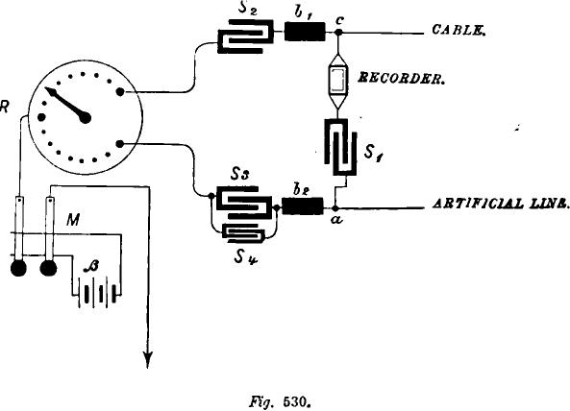
TEM
Ss be
s4.
ARTIFICIAL LING.
CABLE.
RECORDER.
Fig. 630.
We will only observe that it permits of ready change from du-
plex transmission to simple transmission. It is sufficient to isolate b₂ and the artificial line from the point a and to put the latter in communication with the earth.
At the point c, it will be necessary to insert a commutator,

918 DUPLEX TELEGRAPH APPLIED TO SUBMARINE CABLES.
which, during the reception, connects the cable with the recorder, and, during transmission, to b₁.
We give below the numerical indications of the Direct United States Cable Company at Torbay : S₁=- 10 microfarads; S₂= 40 rnicrofarads; S₃= 39 microfarads; S₄ = 0.27 microfarad; b =500 ohms; b₂= 494 ohms; r₁=28 ohms; r₂= 0; r.,.= 1300 oluns.
The double block method has been substituted for that of the arrangement shown in fig. 528 in the stations of the Direct Company and in various offices of the Eastern Company.
It is proper again to add that upon the cable of the Direct Company they use a mirror galvanometer as a receiver. The recorder, besides its higher price, is, it appears, subject to a considerable annual patent fee. It is maintained, moreover, that the reflecting galvanometer is the more rapid instrument. La Coin-pagnie Francaise du T616graphe de Paris a New York also make use of the galvanometer, whereas the Anglo-American Company employs, in greater part, the recorder.

CHAPTER XLI1.

ELECTRICAL MEASUREMENT.
An essential step in the direction of learning any branch of physical science is to find principles of numerical reckoning, and methods for practically measuring some quality connected therewith. The first step toward numerical reckoning of properties of matter, is the discovery of a continuously varying action of some kind, and the means of definitely observing it and measuring it in terms of some arbitrary unit or scale division. But to complete the science of measurement in any department, and especially in that of electricity, it is necessary to fix on something absolutely definite as the unit of reckoning.
UNITS OF MEASUREMENT.
Cavendish and Coulomb, in the last century, furnished the requisite foundation for a complete system of electric and magnetic measurement; but the first complete method of scientific measurement was that of Gauss, in his system of absolute measurement for terrestrial magnetism, which gave the starting impulse for the whole system of absolute measurement as it exists to-day throughout the range of electric science.
Gauss' principle of absolute measurement for electricity and magnetism, is merely an extension of the astronomers' method of reckoning mass in terms of the universal gravitation unit of matter; and of the reckoning of force adopted by astronomers, in common with all workers in mathematical dynamics, according to which the unit of force is that force which, acting on a unit of mass for a unit of time, generates a velocity equal to the unit of velocity. It leaves the units of mass, space and time to be assumed arbitrarily.
As early as 1851, Sir William Thomson began using the absolute system in the reckoning of electro motive forces of voltaic

920 ELECTRICAL MEASUREMENT.

cells, and the electric resistance of conductors, in electro magnetic units; and after advocating the general use of the absolute system for ten years, obtained the appointment of a committee of the British Association on electrical standards, which, in 1869, launched the absolute system for general use, with arrangements for the supply of standards for resistance coils in terms of a unit, first called the British Association unit, and afterward the ohm; of which the resistance reckoned in electro magnetic measure was to be, as nearly as possible, ten thousand kilometres per second. In 1861, Sir Charles Bright and Latimer Clark communicated a paper to the British Association, in which the names that are now in use—ohms, volts, farads and micro-farads—were suggested, together with a complete continuous system of measurement, which, while it did not fulfil all the conditions of the absolute system, fulfilled some of them in an exceedingly useful manner for practical purposes. Since 1871, the absolute system has been in general use in the United States and Great Britain, but it was ten years later before its definitive practical adoption by France, Germany and the other continental countries of Europe in conformity with the decree of the international conference for the determination of electric units, held at Paris in October, 1881. The decision adopted was, not to take the British Association unit, whose accuracy was the subject of well founded doubt, but that as soon as good evidence is given of a sufficiently near measurement for practical purposes of the resistance of any conductor, then the unit which the British Association had aimed at would be adopted; but it was to be left to the judgment and convenience of the users of standards when to make the change, should a change be necessary, from the British Association unit—the ohm—or from the Siemens unit—the resistance of a column of mercury at zero temperature, a metre in length and a square millimetre in section—in order to bring the measurement into more close agreement with the absolute reckoning.
FUNDAMENTAL UNITS.
For mechanical and electrical measurements, the centimetre,

DERIVED MECHANICAL uNrrs. 921

the gramme and the second have been adopted as the funda-mental•units of length (L), mass (M), and time (T), respectively; whence they, and the units derived from them, are called for brevity the C. G. S. system of absolute units. The intimate relation which exists between the centimetre and the gramme—the latter being the weight .of a cubic centimetre of distilled water at the temperature of its maximum density, viz., 4° Centigrade—is a peculiar advantage of these units.
DERIVED UNITS.
To quantities of different kinds separate units are respectively assigned. The numerical value of any concrete quantity is the ratio it bears to the unit of its kind. A unit of one kind of quantity is sometimes defined by reference to a unit of another kind of quantity, and still more frequently by reference to two or more units of other kinds. The units thus defined are called derived units, and the practical advantage of employing such units is, that they are more convenient for calculation than independent units would be, because they avoid the introduction of additional factors, which would involve needless labor in calculating and difficulty in remembering. The derived mechanical and electro magnetic units are the only ones we shall have occasion to describe here.
DERIVED MECHANICAL UNITS.
The C. G. S. unit of velocity (V) is the velocity of a body which passes over a centimetre in a second, and in fundamental units it is, therefore, equal to
L
T
Momentum or quantity of motion of a body is defined as the product of its mass into its velocity, hence its value is
L ML
MXT = T.
The unit of force (F) is that force which, acting on a gramme

922 ELECTRICAL MEASUREMENT.
of matter for a second, generates a velocity of one centimetre a second. This unit is named the dyne. Since a force is measured by the momentum which it generates per unit of time, and is therefore the quotient of momentum divided by time, the value of the dyne in fundamental units is
ML ML
T T •
Work is the product of the intensity of the force by the distance through which it operates. The unit of work is called the erg. It is the work done by a dyne in passing through the distance of a centimetre. Being the product of force and distance, 4 is equal to
ML ML²
T^{2 X L} Ti •
The C. G. S. unit of energy is also the erg, energy being measured by the amount of work done.
PRACTICAL MECHANICAL UNITS.
The C. G. S. unit of power is that power which does work at the rate of one erg per second. For practical work this unit is too small, as it necessitates the use of inconveniently large numbers. The kilogrammetre, for example, is equal to 98,000,000 ergs, and the gramme-centimetre is equal to 980 ergs. A second unit, equal to one million ergs, is therefore employed. This unit is called the meg-erg.
The horse power is still generally employed as the practical unit of work, although it does not harmonize with the C. G. S. system. It is equal to 33,000 foot pounds per minute, or 550 foot pounds per second; the foot pound being equal to one pound raised to a height of one foot. In C. G. S. units the foot pound is equal to 13.556,000 ergs, and the horse power to 7,455,600,000 ergs. The horse power is equal, also, to 76 kilo-grammetres per second.

TABLES OF DIMENSIONS AND OTHER CONSTANTS. 923
According to the definition of the dyne it will be seen that taking p as the weight of a gramme, and g the acceleration of
p dyne.
gravity, then — The weight of the gramme is thus
g 1
equal to g dynes, and as the value of g at any part of the earth's surface is about 980 centimetres per second, it is equal to 980 dynes. To obtain an exact result, the value of g at the station where the calculations are made must, of course, be actually ascertained.
TABLES OF DIMENSIONS AND OTHER CONSTANTS.
Fundamental Units.

Name of Unit.
Dimensions of Unit.
 | Unit of | Symbol. |  |  | Name of Unit.
Length.  Mass  Time |  | L  M  T |  |  | Centimetre. Gramme. Second.

Derived Mechaniod Units.
Unit of
Name.
Symbol.
Dimensions of Unit.
Velocity
Momentum • • • •
Force. Dyne.
Work and energy Erg.
Power Erg, per ma
ML÷T
ML² = T* MLI±T
Practical Mechanical Units.
Meg-erg  Gramme•centimetre  Kilogramme•metre  Foot pound  Horse power | 10⁶ Erge.  980. "  9.8 X 10⁷ Ergs.  1.3556 X 10⁷ Ergs.  7.456 X 10⁹ "

924 ELECTRICAL MEASUREMENT.

Heat Units.
The heat units based on the C. G. S. system are the degree which measures temperature, and the gramme degree, which is the quantity of heat necessary to raise one gramme of water from zero to one degree centigrade. The latter unit is equal to 4.1624 X 107 ergs.
DERIVED ELECTRO MAGNETIC UNITS.
The electrical units, which are based on purely mechanical measurements, have been determined from the natural relation existing between the various electrical quantities, and between these and the fundamental units. The electrical phenomena susceptible of measurement are four in number, viz.: electro motive force (E);. current (C); quantity (Q); and resistance (R). The immediate force producing a current, or, in other words, causing a transfer of electricity, is called electro motive force. Whenever electro motive force exists between two points of a conductor, those points are said to be at different potentials.
A difference of potential cannot exist in a conductor without effecting work or its equivalent; a weight may be raised, the conductor become heated, chemical decomposition effected, or soft iron magnetized. These effects are said to be due to a current of electricity in the conductor, and are proportional to its strength.
The quantity of electricity conveyed by any given current is simply proportional to the strength of the current and to the time (t) during which it flows.
When the electro motive force between two points of a circuit remains constant, the amount of work done is altered by modifying the material and form of the conductor, or, in other words, currents of different magnitudes are produced. The quality of a conductor, in virtue of which it prevents the performance of more than a certain amount of work in a given time by a given electro motive force, is called resistance.
The relations of these phenomena one to another and to

DERIVED ELECTBO MAGNETIC UNITS. 925
force and work were determined experimentally, independently
of the present units, and are as follows:
First, by Ohm's law, we have the equation
C = |  | (1)

From this it follows that the unit electro motive force produces
the unit current in a circuit of unit resistance.
Second, by Faraday's proof
*Q - Ct (2)
and from this equation it follows that the unit quantity is the quantity conveyed by unit current in unit time.
Our knowledge of electricity is derived from the mechanical, chemical and thermal effects which it produces. The connection between electrical magnitudes and mechanical work was determined by Joule, and, in mathematical language, is as follows:
W = C² Rt (³)
where W equals the work equivalent to all the effects produced in the circuit. From this equation it follows that the unit current flowing for a unit of time through a circuit of unit resistance will perform a unit of work or its equivalent.
The force exerted on the pole of a magnet by a current in its neighborhood is a purely mechanical one. This force (f) is proportional to the magnetic strength (m) of the pole of the magnet, and to the strength of the current; and if the conductor be bent in a circle of the radius (k) round the pole, the force is propor. • tional to the length of the conductor (L); it is also inversely proportional to the square of the distance (k) of the pole from the conductor. Hence we have
C L m k² |  | (4)

From this equation it follows that the unit length of the unit
current will produce the unit force at the unit distance.
From these four equations were determined the values of the

926 ELECTRICAL MEASUREMENT.
four electrical units in terms of L, M and T. It will be seen that in the fundamental equation (4), besides the measurement of time, space and mass, a fourth measurement (m) of a magnetic pole is required; but this measurement is itself made in terms of the mechanical units, for the unit pole is simply that which repels another unit pole at unit distance with unit force. Chemical and thermal effects are also measured by the unit of work.
The dimensions of the unit pole are
Li
_{T} .... (⁵)
By substituting this value for (m) in equation (4) the value of (C), the unit current is found to be
TA MI
= T (6)
From equations (1) and (3) we can deduce the relation
W=CEt

whence | ^{E}=^{w} |  | (8)

From equations (6) and (8) and the dimensions of W in fundamental units, the value of E is found to be
Li Mi
E= T² (9)
From equation (1)
R=
The dimensions of (It) are found by comparing those of (E) and (C) to be
R= | L | (10)

or those of a simple velocity.
Thus an intimate relation exists between the mechanical and
electrical units, which realizes the advantages of derived units

DERIVED ELECTRO MAGNETIC UNITS. 927
to which we have called attention, and furthermore, in one sense, these units are independent of any values that may be assigned to them.
The two units of electro motive force and of resistance, expressed by the C. G. S. system, would have too small a value for ordinary purposes. The unit of electro motive force, therefore, is practically expressed in one hundred millions of C. G. S. units of electro motive force, or 100 and the unit of resistance in one thousand millions of C. G. S. units, or 10°. As the three quantities, electro motive force, resistance, and current, are connected together by the simple law which is expressed as follows,
Electro motive force 10⁰
Current = = —
Resistance 10⁹
the practical unit of current is evidently equal to one-tenth of the absolute unit of current or 10⁻i.
The practical unit of quantity, which is plainly the quantity of electricity given by a practical unit of current in unit, time, is equal to one tenth of the C. G. S. unit of quantity or 10^{.1}.
The practical unit of electro motive force is called a volt.
ti t4 " resistance it ,g an olim.
41 i6 ft " current t4 an ampere.
" quantity a coulomb. The capacity of a condenser which holds one coulomb when charged to a potential of one volt is called a farad (K). The farad is thus the practical unit of capacity and its value is
to-¹
Farad= _{10,} =10⁻⁹ C. G. S. units of capacity.
= L⁻¹ T⁻² in fundamental units.
Standard practical units of resistance and of capacity have been constructed. Standards of intensity—strength of current —have not yet been made; but the values may be closely ascertained by graduated apparatus, such as the tangent galvanometer, or the electro-dynamometer. The intensity of a current is also readily measured by the chemical action which it is cap-

928 ELECTRICAL MEASUREMENT.

able of producing. The intensity of a current is the same at all points of the circuit which it traverses, and the chemical action is proportional to the intensity. The approximate measure of the ampere is the intensity capable of precipitating 4 grammes of silver per hour, or 1.19 grammes of copper, or 1.23 grammes of zinc, or of decomposing .09378 grammes of water per second. Current and resistance being known, electro motive force is readily calculated.
For defining quantities multiplied or divided by one million, the prefixes mega and micro are used (the meg-erg already described is an example), so that a meg-ohm stands for one million ohms and a micro-farad denotes one millionth part of a farad. Thus the sign 10⁶ would represent the prefix mega, and the sign 10⁻⁶ the prefix micro; or 1.000,000 and .000001 respectively.
In the practical application of these units the principle of the conservation of energy, which controls all problems in the measurement of force, is an element of great importance. The word energy is applicable to all physical manifestations. Conservation results from the important fact that energy, expended in any form, is always to be found integrally in some other form of work.
Potential, in mechanics, means the power of doing work; the electrical potential of any point in a body, or in space, is defined as the quantity of work done in bringing unit electrification from an infinite distance up to that point. Thus the potential at A may be different from that at B. If A be of higher potential than B, then, on connecting them by a conductor, a current will flow from A to B, and continue until the potentials are equalized. There is an analogy to this in the flow of water through pipes, where the difference of level corresponds to a difference of potential; this difference of level produces a hydrostatic pressure which corresponds to clectro motive force; when the tap is turned, the water flows out; that represents the current. Wherever there is a difference of potential, there is elec-tro motive force, and on completing the circuit,—the analogue of opening the tap,—a current will be established.

DERIVED ELECTRO MAGNETIC UNITS. 929
The terms electro motive force and difference of potential are thus not. exactly synonymous, and it is useful to distin- guish between them.
No standard of electro motive force has yet been devised : the electro motive force of a Daniell cell, however, is an approximation to the volt. According to Siemens it is 1.106 volts and according to Latimer Clark 1.079 volts. The latter figure is most generally adopted.
At the General Post Office, in London, a standard cell has been adopted, consisting of a Daniell's element, arranged as shown in fig. 497, consisting of three chambers. In the left
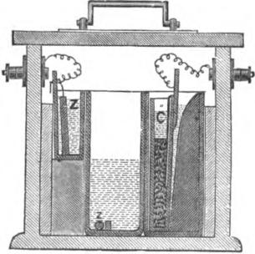
Fig. 497.
hand chamber is placed a zinc plate, Z, immersed in water, and in the right hand chamber a flat porous pot, C, containing a copper plate and crystals of sulphate of copper, the pot being kept immersed in water. These two chambers are called idle cells, as the zinc and porous pot are only kept in them when the cell is not in use. The centre chamber contains a semi-saturated solution of sulphate of zinc, and a piece of zinc rod, z, the latter lying in a small compartment at the bottom of the chamber. When the cell is required for use, the zinc plate and the porous pot and its contents are removed from their idle cells

930 ELECTRICAL MEASUREMENT.

and placed in the centre chamber; the cell is then ready for work. When the cell is no longer required for use, the.zine plate and porous pot are again placed in their respective idle chambers, and while the cell is at rest any sulphate of copper solution which may have become mingled with the sulphate of zinc solution in the centre chamber will be decomposed and the copper deposited on the zinc rod, thus keeping the solution always clear.
When in thoroughly good condition (assuming Clark's figure to be correct, as it is most generally taken), the foregoing cell has an electro motive force of 1.079 volts, but if it is in daily use the power is practically a little less than this, so in the post office the value is assumed to be 1.070 as being generally nearer the mark. If care be taken to keep the zinc plate clean, and the sulphate of zinc solution not too nearly saturated, say under 20 deg. Baume, 1.079 may be taken as correct.
A cell whose electro motive force is even more constant than that of the Daniell is extensively used as a standard in the United States. This cell, which was devised by Latimer Clark, and bears his name, is composed of pure mercury, on which floats a paste of mercurions sulphate, a plate of zinc resting on the paste. Contact with the mercury, which acts as the positive pole, is made with a platinum wire. The electro motive force is 1.457 volts.
The resistance of a circuit to the passage of an electric current varies directly as its length and inversely as its cross section. The ohm is represented approximately by the resistance of a galvanized iron wire, 100 metres in length and 4 millimetres in diameter, or by a column of mercury 1.06 metres long and one square millimetre section, or again by 48 metres of pure copper wire, 1 millimetre in diameter, at the temperature of zero, Centigrade. Standard resistances are made of silver platinum wire, the coils of which are separated from each other by sheets of hard rubber pierced with holes, the insulation being effected by the air. The coils thus composed are placed in a cylindrical box made from two copper capsules stamped out of the solid

DERIVED ELECTRO MAGNETIC UNITS. 931
metal and screwed into each other; this apparatus can be submerged in water without detriment.
In a circuit of one ohm resistance, whose ends differ in potential by one volt, the intensity of the current which flows is equal to one ampere. In any circuit the intensity of the current is
volts
Amperes =
ohms.
The coulomb is the quantity of electricity given by an ampere in a second. The quantity will also depend upon the electro motive force and the capacity of the body for holding or accumulating electricity, hence
Coulombs = farads X volts.
Capacity is defined by the relation
coulombs
Farads =
volts.
and hence
coulomb
17nit of capacity (the farad) —
volt.
The farad is rather large, and consequently the microfarad is preferred for practical measurements of capacity. The micro-farad is therefore 10¹⁶ C. G. S. units of capacity.
The watt is now generally employed as the practical unit of electrical power. It is the power conveyed by a current of one ampere in one second through a conductor whose ends differ in potential by one volt. In other words,
Current X electro motive force = watts.
A watt is equal to 10⁷ absolute units of work or ergs.
The joule is the practical electrical unit of heat or work, being the heat generated by an electro motive force of one volt in a circuit of one ohm resistance; or in other words, the heat generated by a watt in a second. It is equal to 10⁷ ergs. It is advocated in the C. G. S. system of practical units to express each number as the product of two factors, one of them

932 ELECTRICAL MEASUREMENT.
being a power of 10; and also to effect this in such a way that the exponent of the power of 10 shall be the characteristic of the logarithm of the number. Thus: 1,280,000 would be written as 1.28 x10⁶, and .000,128 as 1.28 x 10⁻⁴.
Following is a table of the electro magnetic units as given above, together with the formula) of the magnetic and electro static system of units.
Electro Magnetic System of Units.
Name of Quantity.
Symbol.
Dimensions of Units.
Quantity of electricity
Strength of the electric current
Electro motive force
Resistance of conductor..
Capacity
C LemeT-¹
B
LT—'
L⁻¹1`.
Practical Units.
Number of Absolute Units In One Practical Unit. | Definitions of units.

'Unit of
Name.
iResistance of a column of mercury 10 sq.-millimetre section and 106 centimetres long. Nearly that of a Daniell cell.
Current of a volt through an ohm.
An ampere for a second.
Unit quantity at unit potential.
J
Power conveyed by an ampere in a
1 second through a volt.
Heat generated by a watt in a second..
Resistance
Electro motive Force
Current.
Quantity.
Capacity .....
Power
Heat.
Ohm 10'
Volt 10'
Ampere 10⁻¹
Coulomb 10⁻¹
Farad 10⁻¹
Watt 10'
Joule 10'

ELECTRICAL WORK. 933 Derived Magnetic Units.
Electro Static System of Units.

Name of Quantity.
Symbol.
Dimensions of Units.
Strength of the pole of a magnet M
Moment of a magnet Ml*
Intensity of a magnetic field... I
Lank-)
Limirs
irimaT—t
Name of Quantity. | Symbol. | DImenolone  of Unit.. | Value In  Electro-Nlag-  netic Cults.
Quantity of electricity  Strength of electric current |  |  | vQf  vC
Electro motive force | e |  | E ÷ v²
Resistance of conductor | r | L—'T | R v²
Capacity | k | L | vek

- I — length between poles.
t y—8-1-10" centimetres per second approximately, and is the ratio of the electro
magnetic to the electro static unit of quantity.
ELECTRICAL WORK.
An electric current may be employed to do work of various kinds—chemical, magnetic, mechanical and thermal; and in every case where it does work it is done by the expenditure of a portion of the energy of the current. Ohm's law shows that the current produced by a given electro motive force is diminished in strength by anything that increases the resistance of the circuit; but the strength of the current may also be diminished, in certain cases, by another cause, namely, the setting up of an opposing electro motive force in the circuit. Thus, in passing a current through a voltameter, there is not only a diminution due to the resistance of the voltameter itself, but also a further diminution due to the opposing electro motive

934 ELK BICAL MEASUREMENT.
force—commonly referred to as polarization—which is generated while the chemical work is being done. So, again, where a current is used to drive an electro dynamic motor, the rotation of the motor will itself generate a counter current, which will diminish the strength of the working current. Whatever current, however, is not expended in this way in external work is developed as heat, either in the source of the electricity or in some other part of the circuit, or both. Heat, in fact, appears wherever the circuit offers a resistance to the current
DEVELOPMENT OF HEAT BY ELECTRIC CURRENT&
The number of units of heat developed in a conductor is proportional, 1st, to its resistance; 2d, to the square of the strength of the current; and 3d, to the time that the current lasts. The total quantity of heat developed in a circuit in the unit of time may be expressed by the formula
E_
H = Ci R = =CE,
where Fl is the quantity of heat produced, C the current, R the resistance, and E the electro motive force. So, also, if we consider any particular portion of a circuit the resistance of which is r, and where the difference of potential at the two ends of this section is e, then the quantity of heat developed in this portion of the circuit in the unit of time may be expressed by the formula
h = C⁷r = =eC.
The mechanical equivalent of the gramme degree heat unit, viz.: the amount of heat necessary to raise the temperature of 1 gramme of water 1 deg. C., is 4.2 X 1O⁷ ergs.
One gramme degree = 4.2 X 10⁷ ergs.
One joule = 10⁷ ergs.
1 gramme dog.
One joule — ₄ ₂ — 0.238 gramme degrees.
In other words, the mechanical equivalent of the quantity of

DEVELOPMENT OF HEAT BY ELECTRIC CURRENTS. 935
heat developed in t units of time in a circuit, the resistance of which is R, by a current of strength C, is given by the equations
W = JH = C² R ergs,
where J is Joules' dynamical equivalent of heat and H the heat in gramme degrees.
This law may be arrived at by the following calculation : The work W done by a current in moving Q units of electricity against an electro motive force E, is :
Q E,
and since Q = C t, and W = J H, we have :
JH = Ct E = C² R t,
C² R
Whence H = J.
But as C and R are here in absolute units, they must be multiplied by 10⁻² x 10² =10², to reduce to the ordinary case of amperes and ohms, whence
H = C² Rt÷ C2 = C² Rex 0.238.
This is equivalent to the statement that a current of one ampere per second, flowing through a resistance of one ohm, develops therein 0.238 gramme degrees per second.
The second of the above laws, that the heat is proportional to the square of the strength of the current, often puzzles young students, who expect the heat to be proportional to the current simply. But the consumption of zinc in a battery is also proportional to the square of the current; for, suppose that in working through a high resistance (so as to get all the heat developed outside the battery), we double the current by doubling the number of battery cells, there will be twice as much zinc consumed as before in each cell, and as there are twice as many cells as at first, the consumption of zinc is four times as great as before.
In any case, in order to double the current in a circuit of fixed resistance, we would have to double the electro motive

936 ELECTRICAL MEASUREMENT.
force. Let us suppose a circuit in which flows a current, C, due to an electro motive force, E, then, according to one of our definitions, the heat developed in the circuit would be
H C E.
Now let the current be doubled by doubling the electro motive force, and
H-2CX 2E-4CE,
which plainly shows that in doubling the current the heat has been increased fourfold, or as the square of the current.
Mechanical Work by Currents.—If an electro magnetic motor be introduced into a circuit in which there is an electro motive force E, the rotation of the motor will itself generate a counter electro motive force e. Calling the total resistance of the circuit R, the current flowing may be expressed by the following equation :
R — e
- ^{C—}
Now this current is developing not only a certain amount of heat in the circuit, but it is also doing mechanical work in overcoming the motor's friction, and perhaps driving machinery. The energy appearing as heat will be :
- H = Ci R.
The energy appearing as mechanical work may be represented thus :
- w = C C.
The total work done by the current is, therefore, equal to the sum of these two, that is :
- W = Ci R C e
Whence (⁵) W = C E
E— e
For ^{R} c
And substituting this value in (4)
W—C' (^{E} ^{—e} +Ce
Whence W = C E
If this mechanical work were transformed Into its equivalent
of heat, and this heat were added to that developed in the cir-

DEVELOPMENT OF HEAT BY ELECTRIC CURRENTS. 937

cult, the sum of the two would exactly equal the total amount of heat which would have been generated in the circuit had a resistance been substituted for the counter electro motive force of such a value as to maintain the current strength unaltered:
Chemical Work by Currents.—If a secondary battery be charged by an electro motive force E, and itself opposes a counter electro motive force e, the chemical work done in charging the battery is :
67 = 0 6
And the work appearing as heat will be :
H = C² R
Where R is the total resistance of the circuit.
The total work done in the circuit is clearly the sum of these
two.
W=Ce+C'R=CE
The heat equivalent to the chemical work done, if added to the heat due to the resistance of the circuit, would exactly equal the heat which would have been generated by the current in this circuit had an equivalent resistance been substituted for the counter electro motive force.
The counter electro motive force due to the motor and that of the battery are thus identically the same in their effect.
Rise of Temperature.—The elevation of temperature in a resisting wire depends on the nature of the resistance. The resistance of a short length of thin wire may be just the same as a long length of thick wire, in which case each will cause the same number of units of heat to be evolved; but in the former case, as they are spent in heating a short thin wire of small mass they will cause it to get very hot, whereas in the latter case they will perhaps only warm to an imperceptible degree the mass of long thick wire. If the wire weigh w grammes, and has a specific capacity for heat 8, then
H a w d,
where d is the rise of temperature in degrees centigrade. Hence
co R t
d = 0.24 X
8 W

938 ELECTRICAL MEASUREMENT.

Since the resistance of metals increases as they rise in temperature, a thin wire heated by the current will resist more and grow hotter and hotter until its rate of loss of heat by conduction and radiation into the surrounding air equals the rate at which heat is supplied by the current.
Thin wires heat much more rapidly than thick, the rise of temperature in different parts of the same circuit being, for dif-ferent thicknesses of wire, inversely proportional to the third power of the diameter.
Thus, suppose a wire at any point to become reduced to half its diameter, the cross section will have an area as great as in the thicker part. The resistance here will be 4 times as great, and the number of heat units developed will be 4 times as great as in an equal length of the thicker part. But 4 times the amount of heat requires 4 times the radiation, and the radiating surface having been reduced the metal will warm to a degree 8 times as great, and 8 .2³.
Mechanical Equivalent of Currents.—The mechanical work of a current may be calculated as follows: A current whose strength is C conveys through the circuit in t seconds a quantity of electricity = C t. But the number of ergs of work W, done by a cutrent is equal to the product of the quantity of electricity into the difference of potentials through which it is transferred, provided these latter are expressed in absolute
C. G. S. units, or w c
Now, if W ergs of work are done in t seconds, the rate of work is got by dividing W by t; whence
c v =
If C and V are expressed in amperes and volts, respectively, and it is desired to give the rate of working in horse power, it must be remembered that 1 ampere .10—i C. G. S. units of current; that 1 volt= 10⁸ absolute units of eleetro motive force, and that 1 horse power= 550 foot-pounds per second ^{m} 76 kilogrammetres per second = 76 x 10⁵ gramme-centimetres

DEVELOPMENT OF HEAT BY ELECTRIC CURRENTS. 939

per second 746 x 10⁷ ergs per second, whence
C amperes X V volts
746 — rate of doing work in H. P.

Chemical Work, by Currents.—The amount of chemical action is equal at all points of a circuit. If two or more electrolytic cells are placed at different points in a circuit, the amount of chemical action will be the same in all, for the same quantity of electricity flows past every point of the circuit in the same time. If all these cells contain acidulated water, the quantity, for example, of hydrogen set free in each will be the same; or, if they contain a solution of sulphate of copper, identical quantities of copper will be deposited in each. If some of the cells contain acidulated water, and others contain sulphate of copper, the weights of hydrogen and of copper will not be equal, but will be in chemically equivalent quantities.
The amount of an ion liberated at an • electrode in a given time is proportional to the strength of the current. A current of 2 amperes per second will cause just twice the quantity of chemical decomposition to take place as a current of 1 ampere per second would do in the same time.
The amount of an ion liberated at an electrode in one second is equal to the strength of the current multiplied by the electro chemical equivalent of the ion. It has been found by experiment that the passage of 1 ampere of electricity through water liberates .0000104 gramme* of hydrogen; hence a current whose strength is C will liberate C x .0000104 grammes of hydrogen per second. The quantity .0000104 is called the electro chemical equivalent of hydrogen. The electro chemical equivalent of other elements can be easily calculated if their chemical equivalent is known. Thus the chemical equivalentt of copper is 31.5; multiplying this by .0000104, we get as the electro chemical equivalent of copper the value .0003276 (grammes).
* Kohlrausch and Lord Rayleigh say .00001035; Mascart says .000010415. t The chemical equivalent must not be confounded with atomic weight.

940 ELECTRICAL MEASUREMENT.

The electrical congress which met in Paris in October, 1882, considered the question of the redetermination of the ohm, and after a prolonged discussion it was concluded that further experiments upon the unit of electrical resistance were necessary before a standard ohm could be adopted; and the governments participating in the congress were invited to encourage independent determinations of this unit.
Since the first meeting of the congress, various new determinations of the ohm have been made. Lord Rayleigh has obtained .986 as the mean of the results of three independent determinations of the standard British association unit now in use.
The electrical congress met again in Paris in April, 1884, and adjourned, after deciding on the standard value of the ohm as satisfactorily as may be at present. M. Mascart grouped the results of ohm determination in the following useful table:
Methodk | Experhnenterw | ¹Columnor no,. 01 In cowl-Inotrm | Methods. | Xxperhnenterc | Colornnof  toIn 0.1111- ,21W..
I. B. | .₁ British Association. Rayleigh-Schuster..  Rayleigh (18483) | 104.83  106.00  106.27 | 4  5 | ROW  Fr. Weber  (Lorenz(first) | 105.90  105.33  107.10
 | H. Weber  Kohirausch ..... | 106.16  105.81 | 8. Lorenz ... | Rayleigh..........  Lenz | 106.24  106.13
2. Weber (I.).. | -, Wiedemann........ | 106.19 |  | Lorenz (second).... | 106.19
 | ( Mascart | 106.33 |  |  | 108 46
 | IF. Weber | 105.02  105.79 | 7. Weber (II.) | {Dom  Fr. Weber.  Wild | 105.26  108.03
3. Kirchhoff .. | P;_{jaz}^{w}_{e}^{l}j,^{n}_{r}⁽_{o}^{l} _{ok}  106.29 |  |  | Bailie | 105,37
 | Mascart | 106.33 | 8. Heat | Joule 106.22
Thus the figures obtained by the different methods were—
B. A | 106.21
Weber's (I.) | 106.14
Kirchhoff's | 105.93
Loren:, | 106.1A
\Veber's (II.) | 105.47
Joule | 106.22
the mean of which was 106.02; but 106 was taken as a round figure, sufficiently near the truth for all practical and useful purposes; hence the congress decided that "the legal ohm should be the resistance of a column of mercury of one square millimetre section, and of 106 centimetres of length, at the temperature of freezing."

CHAPTER XLIII.

THE MEASUREMENT AND TESTING OF LAND LINES.
TELEGRAPH lines, however well constructed and cared for, are continually subject to interruptions of one kind or another. It becomes, in consequence, one of the most important of an operator's duties to be able to discover the nature and location of a fault at an early moment, so that steps may be taken for its removal with the least possible delay
LOCATING FAULTS IN LAND LINES.
Formerly most of the testing of telegraph lines was done from station to station by the use of the relay alone. When a fault occurred—a cross or a partial ground, for instance—the principal office would communicate with some station about midway along the line and request him to disconnect or open the faulty wire for a moment or two. This enabled the testing office to determine immediately which half of the line was defective. After the wire was again closed the next station in the direction of the fault was tested with in like manner, and so on until the defective point was located between two stations. If the distance was considerable, and especially if the line was located upon the highway, repairmen were sent out from both stations; but for lines along railroads it was seldom necessary to send more than one. When the distance between stations is short, and the fault does not happen to be of a kind likely to escape the eye of the repairer as he is carried by, the above provision answers very well.
Whenever practicable, however, daily tests of all important circuits should be made with the galvanometer from one or both terminal stations, and the results recorded in a book provided for the purpose. Circuits of less importance may be thus tested once in two or three days, or even once a week; but very frequent testing will prove to be advantageous in the end.

942 THE MEASUREMENT AND TESTING OF LAND LINES.

These tests, occupying but a few moments each day if made at stated times and in a systematic manlier, afford the only accurate information that can be obtained respecting the condition of the lines. They detect the leaky places and faulty joints, very often before the latter become so bad as to interfere with the working of the wires; and, in case of interruptions, furnish the data necessary for determining the position of the fault.
In the daily testing of land lines it is usual to make but two tests of each wire. These consist in finding the resistance opposed to the current, first, when the line is grounded at the distant end; and, second, when it is insulated. The first is called conductivity resistance, the second insulation resistance. (See Chapter XXIV, page 335.)
Besides keeping a record for local reference of the results obtained in this manner, all of the principal offices of the Western Union Telegraph Company are now required to fill out printed schedules containing separate columns for these measurements. These are then transmitted to the Electrician's office, and in this way a general supervision of all the lines is maintained.
As it is obviously impracticable to make every test with uniform battery power and galvanometers of equal sensitiveness, measurements taken at different times can only be made comparable by reducing them to some common standard of resistance. Every testing office should, therefore, be provided with the proper instruments for making the tests, and the person in charge be duly instructed in the manner of reducing them to units of resistance. The most convenient instruments for ordinary purposes are the tangent galvanometer and a set of standard resist, (wee coils.
TESTING BY THE TANGENT GALVANOMETER
This instrument, in the form adopted by the Western Union Conipany, is represented in 11g. 531. It consists of a magnetized needle a little less than an inch in length, suspended upon a point above a dial five inches in diameter, and surrounded by four coils of wire, with resistances of 60, 20, 9 and 1 ohm each,

TESTING BY TEE TANGENT GALVANOMETER. 943
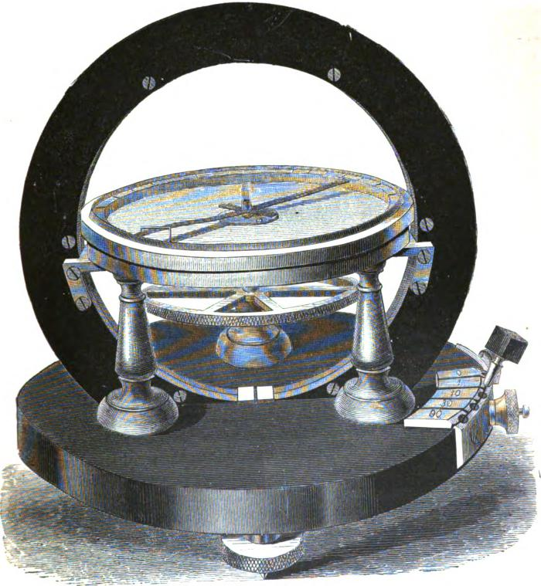
531.

944 THE MEASUREMENT AND TESTING OF LAND LINES.

and also by a band of copper, the resistance of which is so small as to be inappreciable. It is provided with five terminals, marked resl;ectively 0, 1, 10, 30 and 90, to which the coils are so connected that, by inserting a plug at 0, the copper band only is in the circuit; when the plug is at 1 the band and the one ohm coil of wire are in circuit; with the plug at 10 the band and the one and nine ohm coils are in circuit (making in all a resistance of ten ohms); with the plug at 30, all, except the sixty ohm coil, are in circuit; and with the plug at 90 all are in circuit, making the resistance of the galvanometer ninety ohms. Fixed to the needle, and at right angles with it, is an aluminum pointer extending entirely across the dial. The circumference of the dial is divided on one side into divisions proportioned to tangents of the degrees. The strength of any current passing through the coils of this instrument being directly proportional to the tangent of the angle of deflection, it is at once shown by the reading on the tangent side of the dial. The other is graduated to ordinary degrees of arc. When, therefore, readings are taken from the latter, they must be reduced to tangents; otherwise the result will not be correct This is done, as explained in Chapter XV, by taking from the table of tangents (see Appendix) the figures standing opposite to the readings in degrees. The instrument stands upon three leveling screws, by which it is adjusted to a level position. In galvanometers where the pointer stands above the scale, it is advisable, in order to avoid parallax error in reading the deflection, to place a piece of looking-glass on the bottom of the needle case. It is then only necessary, when taking the readings, to run the eye along the pointer to the looking-glass end, and see whether the reflected image coincides with the pointer at that end; if it does, we may be sure that when we look at the degrees scale we do so correctly.
Accompanying the galvanometer, and used in connection with it, is a rheostat, or box of resistance coils, so arranged that any desired resistance, from 1 to 10,000 ohms, may be thrown into the circuit
The instruments more recently constructed are provided with a set of resistance coils in the base of the galvanometer itself, of

TESTING BY THE TANGENT GALVANOMETER. 945
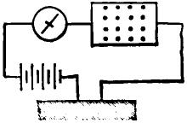
the respective values of 10, 600 and 5,000 ohms. The resistance of the galvanometer coils in the newer instruments are respect. ively 0, 1, 10, 60 and 200, which are found to be convenient in practice.
In working with the galvanometer great care should be taken to place it where it will be free from all outside inductive effects of relay or sounder coils, and of currents in the office wires. Unless clue attention is given to this matter very fallacious results may be obtained. The first step in using this galvau-
lig. 532.
ometer is to find the constant of the instrument. This consists in connecting it in circuit with a battery and known resistance, as in fig. 532. The magnitude of the resistance should also depend somewhat upon the line and insulation resistance to be measured. From 2,000 to 5,000 ohms will be found most convenient for average lines. Note the deflection; then disconnect the known resistance and place the line to be tested in circuit, as in fig. 533.
"4. ,
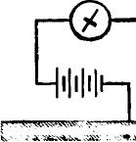
Fig. 633.
Note the deflections, both when the line is to earth at distant end and when it is open. The results can afterwards be reduced by proportion.
As an example, suppose, with the resistance of 5,000 ohms, a deflection on the tangent side of 100 divisions was obtained;

946 THE MEASUREMENT AND TESTING OF LAND LINES.
with the line in circuit and grounded at the distant end, 60 divisions; and when open, 30 divisions. We have already seen that the greater the resistance the less will be the deflection; in other words, that the resistance is inversely proportional to the tangent of the angle of deflection (in this case, numbers proportional to the tangents), consequently, as 60 : 100 so is 5,000 : x the unknown resistance, whence x = ¹ ⁴ ⁴ = 8.333, the conductivity resistance; and 30 : 100,-- 1,000 : x or -¹-fLIV-2.Q---= 16,666, the total insulation resistance. To obtain the mileage resistance of the latter these figures are multiplied by the length of the line in miles.
It will frequently be found necessary, especially in measuring the insulation of short lines with the above galvanometer, to use the degree side of the instrument, as the tangent side is not numbered above an angle corresponding to 45° of arc. When this is the case, it must be remembered that the tangents of the angle,, are to be taken.
A still greater range of measurement may be obtained by using a single cell of battery in taking the constant of the instrument, and then substituting any number of cells giving a convenient deflection to get the value of very high resistances. The figures thus obtained for the latter then require to be multiplied by the number of cells used, for the true values. It will be understood, of course, that the cells should all be of uniform strength. Culley gives a convenient form for recording these line tests, which is shown below :
Deflection with Lines in Circuit.
Constant of
Instrument No. 1. No. 2.
through
5,000 Ohms.
Resistance. Insulation.
Date.
State of
the
Weather.
Insulation.
Resistance.
75
100 Divisions.,
May 3d. GO 30
equal to 45'
35 Damp.

We have thus far spoken of the tangent galvanometer only.

RHEOSTATS OR RESISTANCE COILS. 947

For the ordinary daily tests this answers an excellent purpose. It is serviceable, also, and many times sufficient, in connection with the bridge, for many of the more difficult problems that are continually presenting themselves. In the case of faults in long submarine lines, however, when we wish to ascertain their position with as much accuracy as possible, still more sensitive instruments and very carefully adjusted rheostats are required.
For the class of measurements in which it is either required, by adjusting the resistances, to bring the galvanometer needle to zero, or to reproduce the same deflection in two measurements, a galvanometer having its scale graduated to degrees would be sufficient. It should be provided with an astatic pair of needles suspended by a fibre attached to a screw, by which the needles can be lowered on to the coils when not in use, thus preventing the fibre being fractured by moving the instrument.
When the instrument is to be used it should be placed on a firm table, and the screw attached to the fibre turned until the needles swing clear. The instrument should then be placed in such a position that the top needle stands as nearly as possible over the zero points. It should then be carefully leveled by the leveling screws attached to its base until the axis which connects the two needles together is exactly in the centre of the hole in the scale card through which it passes.
This adjustment of the needles is much facilitated in seine galvanometers by making the coils movable about the centre of the scale card by a rack and pinion, or a handle attached direct to the coils. The final adjustment can thus be made without shaking the needles.
RHEOSTATS OR RESISTANCE COILS.
On this subject Mr. II. R Kempe has published, in the Telegraphic Journal, some remarks which state the facts so clearly that we are induced to insert them here. They are as follows:
The essential points of a good set of resistance coils are, that they should not vary appreciably by variation of temperature, and that they should be accurately adjusted to the standard units,

948 THE MEASUREMENT AND TESTING OF LAND LINES.

so that each individual coil will test according to its marked value, and the total value of all the coils equal the numerical
suns of their marked values. In imperfectly adjusted coils each individual coil may apparently test correct, yet when tested all together their total value will be 1 or 2 units more or less than their numerical value; because, although an error of a fraction of a unit may not be perceptible in testing each coil individually, yet the accumulated error may be comparatively large.
The wire of the coils is, as a rule, of German silver, the specific resistance of which is but little affected by variations of temperature. The wire is insulated by a double covering of silk, and is wound double on ebonite bobbins; the object of the double winding being to eliminate the effects of self• induction. When wound, the bobbins are saturated with hot paraffin, which thoroughly preserves their insulation, preventing the silk covering from becoming damp, which might have the effect of short circuiting the coils and thereby reducing their resistance.
The small resistances are made of thick wire, the higher ones of thin wire, to economize space. When bulk and weight is of no consequence, it is better to have all the coils made of thick wire, more especially if high battery power is used in testing, as there is less liability of the coils becoming heated by the passage of the current through them.
A set of resistance coils generally consists of a number of coils of such values that any resistance from 1 to 10,000 can be obtained. One arrangement in general use has coils of the following values: 1, 2, 2, 5, 10, 10, 20, 50, 100, 100, 200, 500, 1000, 1000, 2000, 5000 ohms.
Another and more convenient arrangement is the following:
1, 2, 3, 4, 10, 20, 30, 40, 100, 200, 300, 400, 1000, 2000, 3000, 4000.
With these numbers any particular resistance that is required to be inserted can be seen almost at a glance. '
The way in which the different coils are put in is shown in fig. 534. The ends of the several resistances c, c, c, • • • • are inserted between the brass blocks b, b, b, • • • • Any of the

RHEOSTATS OR RESISTANCE COILS. 949
coils can then be cut out of the circuit between the first and last blocks by inserting plugs p between the blocks, as shown, which short circuits the coils between them; thus, if all the plugs were inserted, there would be no resistance in circuit, and when all the plugs were out all the coils would be in circuit.
There are various ways of arranging the coils in sets; one of
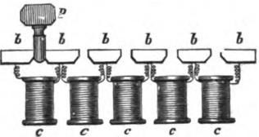
Fig. 534.
the most common is that shown in fig. 536, which is much used in submarine cable testing. The brass blocks here shown in plan are screwed down to a plate of ebonite which forms the top of the box in which the coils are enclosed. The ebonite bobbins are fixed to the lower surface of the ebonite top, the ends of the wires being fixed to the screws which secure the brass blocks. The holes in the middle of the blocks are convenient for holding
A
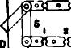
CC3E31=Q1=1:=3=11=3
moo
- • 14 II all UPI
M1=3=1
MI 3000t000 NMI 1004 550 2NIIIII)
14
"1="1D
F
F. 535.
plugs not in use. It will be seen that six binding screws, A, B, C, D, E, F, are provided : when we only require to put a resistance in circuit, the screws D and E would be used. The use of the other screws, and of the movable brass strap s, will be explained hereafter.
In using a set of resistance coils one or two precautions are

950 THE MEASUREMENT AND TESTING OF LAND LINES.
necessary. First of all it is necessary to see that the brass shanks of the plugs are clean and bright, as otherwise the insertion of a dirty plug will not entirely cut out of circuit the coil it is intended to; it is a good plan, before commencing to test, to give the plug a scrape with a piece of sand or emery paper, taking care to rub off any grains of grit which may remain sticking to it after this has been done.
When a plug is inserted it should not be simply pushed into the hole, but a twisting motion should be given it in doing so, so that good contact may be insured. Too much force should not be used, as the ebonite tops may be thereby twisted off in extracting the plugs. Care also should be taken that the neighboring plugs are not loosened by the fingers catching them during the operation of shifting a plug.
A
1000 100 10 10 00 1000
....- ₇- ,•11
IN,:
000 100 10 30 O111P
300
1.4110+1000.irt300.0..110.t.....
- - - •
4 10
D
Fig. 536.
Before commencing work it is as well to give all the plugs a twist in the holes, so as to see that none of them are loose. On no account must the plugs be greased to prevent their sticking, and their brass shanks should be touched as little as possible with lingers.
A useful set of coils for general purposes is that shown in outline in fig. 536. The general arrangement is the same as in fig. 535. Two keys, however, are provided, the contact point of the right key being connected, as shown by the dotted line, with the middle brass block of the upper set of resistances, the binding screw B' at the end of the key corresponding, in fact, when the key is pressed down, with the binding screw B shown

SIEMENS'S UNIVERSAL GALVANOMETER. 951

in fig. 535. In like manner, the binding screw A' corresponds with the binding screw A. In the place of the movable piece of brass between A and D a plug marked INF. (infinity) is provided, which answers the same purpose. An infinity plug is also placed at the second bend of the coils at the left hand of the figure.
When we require simply to insert a resistance in a circuit we should use the binding screws A' and E, the left hand key being pressed down when the deflection of the galvanometer needle is to be noted. The current can thus be conveniently cut off or put on when required, by releasing or depressing the key. Care should be taken that the two infinity plugs are firmly in their places, to insure their making good contact The key contacts should be occasionally touched with emery paper or a very fine
file, to insure their connection being good. •
SIEMENS'S UNIVERSAL GALVANOMETER
Another very convenient instrument for line work, and one much used in various sections of the country, is that known as Siemens's.
It consists of a comparatively sensitive galvanometer, which can be turned in a horizontal plane, combined with a Wheatstone bridge and three resistance coils of 10, 100 and 1,000 units, respectively.
For measuring the strength of a current the instrument is used as a sine galvanometer. For comparing electro-motive forces Professor E. du Bois-Raymond's modification of Poggen-clorff's 'compensation method is employed. (See page 275.) For measuring conducting resistances the instrument is used as a Wheatstone's bridge.
The unit of measurement employed with this instrument is the Siemens mercury unit One Siemens unit is equal to .953 ohms.
Figure 637 shows a plan, and fig. 538 an elevation of the instrument.
A is a circular plate of polished wood, supported upon three

952 THE MEASUREMENT AND TESTING OF LAND LINE&
leveling screws, b b b. In the centre of A a metal boss is inserted, in which turns the vertical pin a, which carries the instrument This pin supports the instrument firmly, but at the same time allows it to be turned freely round its vertical axis in its horizontal position. To the pin a is attached a circular disc of polished wood C, having a groove in its edge for the reception of the insulated wire composing the standard resistances. The disc C has a projection c which carries the four insulated terminals marked I, II, III, IV, as shown on fig 537. The terminals
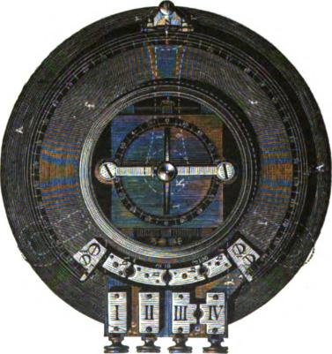
Fig. 537.
marked III and IV can be connected together by means of a plug.
Over C rests a somewhat larger disc of slate, the greater part of the circumference of which is turned to a true circular curve; but the part of this disc which is immediately above the projection c, on the lower disc, is cut out so as to leave a gap. This slate disc carries in its centre the galvanometer G, and in front of it four insulated terminals, h, h₂ h_{s} h₄, which may be connected with each other by means of plugs, and to the ends of

SIEMENS'S UNIVERSAL GALVANOMETER. 953
which the wires of the artificial resistances are connected, as shown in fig. 539. The galvanometer offers nothing extraordinary in its arrangement. It has an astatic needle system suspended from a cocoon fibre, and is wound with fine wire. The needle swings above a card board dial divided into degrees; as, however, when using this instrument the deflection of the needle is never read off, but the needle instead always brought to zero, two ivory limiting pins are placed at about 20 degrees on each side of zero.
The cocoon fibre is fastened to the knob K. One end of the
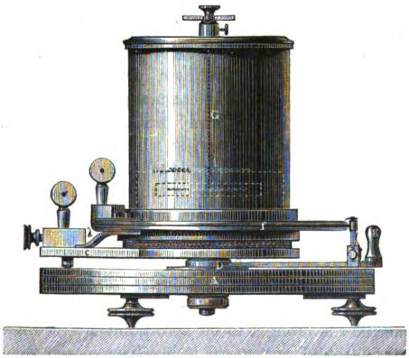
Rg. 538.
convolutions of the galvanometer wire is connected to terminal h_{i}, on the slate disc, and the other end is terminal IV, as shown in the accompanying diagrams.
A. slight groove is turned in the edge of the slate disc, and in this a tightly stretched wire, made of platinum or German silver, is inserted in such a manner that about half its diameter protrudes beyond the slate. The ends of the wire are soldered to two brass plates, / and /₁, which are placed at the angles formed

954 THE MEASUREMENT AND TESTING OF LAND LINE&

1
by the sides of the gap in the slate disc. The plate 1 is perms nently connected by a thick copper wire or metal strip to termi• nal h₁, and the other plate 1₁ is connected in a similar manner to terminal III.
Slate is adopted for the material of which to make the disci, because it is found by experience to be the material which is least sensitive to variations in the weather or temperature. The slate disc is graduated on its upper edge through an arc of 300 degrees, zero being in the centre, and the graduations figured up to 150 on each side at the terminals 1 and 1₁ of the bridge wire.
On the arm D, which turns on the pin a, and somewhat behind the handle g, there is a small upright brass arm d turning between two screw points r, and carrying in a gap at its upper end a small platinum jockey pulley e, turning on a vertical axis. This pulley forms the movable contact point along the bridge wire, against which it is kept firmly pressed by means of a spring acting on the arm d. The arm D, which is insulated from the other parts of the apparatus, is permanently connected with the terminal I. On the top of d a. pointer Z or a vernier is fixed, which laps over the upper edge of the slate disc and points to the graduations.
Fig. 539 represents the connections to be made when using the instrument as a Wheatstone bridge for measuring conducting resistances.
The needle i is brought to the zero point by turning the galvanometer G round its vertical axis. The vernier Z is brought by the handle g to the zero point of the large scale on the slate disc. A plug is inserted between terminals HI and IV. Two of the holes marked 10, 100 and 1000 are to be plugged and one left open, according to the extent of the resistance to be measured. 10 or 100 must be left open if the resistance is small, and 1000 if it is large. The two ends of the unknown resistance to be measured are connected to II and IV. Connect the + pole of a battery with terminal I and the — pole with II.
The lower diagram of fig. 539 represents the modification of the Wheatstone bridge which is employed in this instrument

SIEMENS'S UNIVERSAL GALVANOMETER. 955
The proportion between the unknown resistance x and the known resistance n, when the deflection is read off on the side of the slate disc marked A, is as follows :
x: n — 150 + a : 150--a or, x —^{150 + a} X n.
15i)— a
When read off on the B side of the disc,
150 — a
^{m=} 150+a X^{n}'
When the connections have been made, as shown in fig. 539,
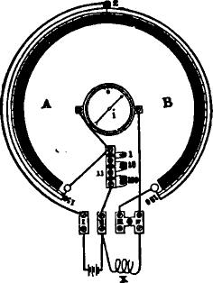
_{al}e_{r i4:}3_{e}
Fig. 539.
the needle i may be found to deflect to the right or B side of the instrument, and the vernier Z may then be pushed by the handle g also to the B side, until the needle is brought to zero; or if by moving the vernier to the B side the deflection is increased, the vernier Z should be pushed to A side, beyond the zero of the large scale, and until the needle is brought to the zero point of the small scale. If, when this is done, the vernier Z stands at 50 on the A side of the large scale, and at the same time at n, the plug is out which

956 THE MEASUREMENT AND TESTING OF LAND LINES.
puts the 100 units of artificial resistance into circuit, the following proportion will be obtained:
150 - 60 : 150 -I- 50 = :
200 X 100
z = 200 units.
100
If the needle is brought to zero of the small scale while Z stands at 50° on the B side of the large scale, and the 100 unit
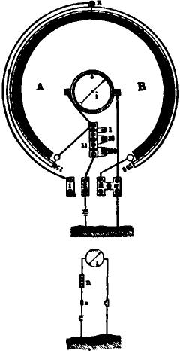
Fig. 540.
resistance plug is removed, the following proportion will be obtained :
150 + 50 150 — 50 = n :
100 X 100
x — 50 units.
200
For measuring the strength of a current, or the quantity which is passing over a conductor, the instrument is used as a sine galvanometer. Fig. 640 shows the connection of the wires for this purpose.

SIEMENS'S UNIVERSAL GALVANOMETER. 957

The needle t is brought to 0° of the small scale by turning the galvanometer G round its vertical axis. The vernier Z is brought to zero of the large scale on the slate disc. The hole between III and IV is unplugged. Plugs are inserted in 10, 100 and 1000. Connect one pole of a battery to II and put the other pole to earth. Connect the line to IV. The galvanometer is then to be turned in the same direction as the needle is deflected until the needle coincides with the zero point. While this is being done the large scale will move under the pointer Z, which must be left stationary; the sine of the angle indicated by Z will then give' the value proportionate of the strength of the current.
THE DIFFERENTIAL GALVANOMETER.
The differential galvanometer, invented by M. Becquerel, is a very useful and convenient instrument The needle is poised upon a pivot, or suspended by a silk fibre, as in the sine and tangent galvanometer, but instead of being surrounded with a coil composed of a single wire, as in those instruments, the coil is formed of two wires exactly equal in length, size and conduc- tivity, wound simultaneously round the frame, and similarly situated in respect to the needle. When, therefore, opposite and equal currents are sent through each of the wires the needle remains at zero, the current which passes through one wire exactly neutralizing the effect of that which passes through the other. If the current which passes through one half of the coil is stronger than that which passes through the other, the balance will be destroyed, and the needle will be deflected by the stronger current with a force equal to the difference in the strength of the two currents.
As the strength of an electric current from a given battery upon similar wires is inversely proportional to their length, if the current from a battery is divided between two such wires of unequal length, each connected to one of the wires of the coil, the shorter wire will receive a greater portion of the current than the longer one, and the stronger current in the shorter wire will overcome the current in the longer wire and deflect the needle.

958 THE MEASUREMENT AND TESTING OF LAND LINES.
The extent of the deflection will be proportional to the difference in the length or conductivity of the two wires, and the direction of the deflection will indicate which of the two wires is the longest.
Fig. 541 represents a double shunt differential galvanometer, manufactured by the Western Union Telegraph Company. The
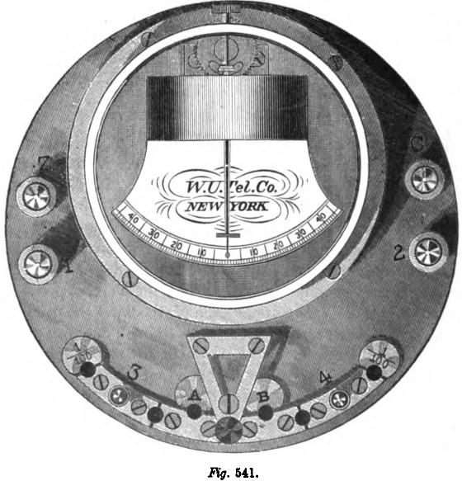
two wires forming the coil which surrounds the needle are indicated by two circular parallel lines, one circuit extending from 4 to B and the other from 3 to A. These wires have similar resistances, and are situated alike respecting the needle, so that when a battery is connected so as to divide its current between the two halves of the coil, no visible effect is produced upon the

THE DIFFERENTIAL GALVANOMETER. 959

needle, the current from 3 to A tending to deflect the needle to the left, while that from B to 4 tends to deflect it to the right; and since both forces are equal, the needle remains in a state of equilibrium. The instrument is provided with two shunts, one for each half of the coil of the galvanometer, so that either one or both halves of the coil may be shunted as desired. Each shunt has a resistance of -gly of half of the coil, so that when thrown into the circuit by the insertion of the peg, ₁9₀9.₀- of the current passes through the shunt, and only 1 _{u} through the half of the coil of the galvanometer.
In measuring the resistance of any conductor, both ends of which are at hand, the connections should be made as in the diagram, fig. 542.
The positive pole of the battery is connected with the thumbscrew C, and the negative pole with Z; one terminus of the adjustable rheostat with 3, and the other terminus with 1. The terminals of the conductor to be measured are connected with 4 and 2, and pegs inserted at A and B. Resistances are then to be inserted between 1 and 3, by removing pegs from the rheostat until the resistance in circuit 1 and 3 equals the resistance in 2 and 4. When the two resistances are equalized, and the key is depressed, the needle remains at zero of the scale. If the resistance which is being measured is greater than that of the rheostat, the current in circuit 1 and 3 will be stronger than that in 2 and 4, and the needle will be deflected to the left; if less than that of the rheostat, the current in circuit 2 and 4 will be stronger than that in 1 and 3, and the needle will be deflected to the right When the needle is not deflected on depression of the key the resistances..are equal, and the sum of the resistances inserted by the removal of the pegs in the rheostat is equal to the resistance which is being measured.
The resistance coils of, the rheostat which accompanies the differential galvanometer contain respectively 1, 2, 3, 4, 10, 20, 30, 40, 100, 200, 300, 400, 1,000, 2,000, 3,000 and 4,000 ohms, the sum of which is 11,110 ohms, and is the limit of measurement by the above plan. When higher

960 THE MEASUREMENT AND TESTING OF LAND LINES.
resistances are to be measured, a peg should be inserted between the metallic bar 3 and the disc marked _{T}h-, the other connections remaining as before. That portion of the current which traverses the circuit from C to 1 through the rheostat will now be divided into two parts, -M_{r} traversing the shunt, and -/-6-_{T} traversing one half of the coil of the galvanometer. As only Thy of that portion of the current which passes from C to 1 goes through one of the wires of the galvanometer, while the whole of
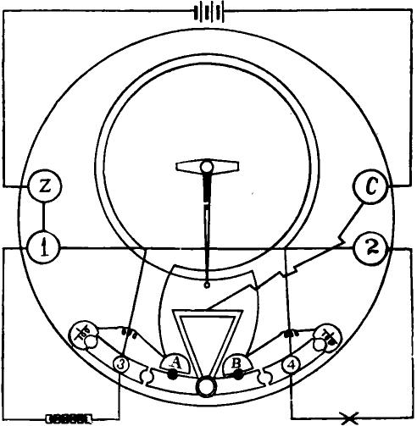
Rg. 542.
that portion passing from C to 2 passes through the other wire of the galvanometer, it is necessary, in order to produce equal effects upon the needle and to maintain its equilibrium, that the current in the circuit extending from C to 1 should be one hundred times stronger than in that from C to 2. This is effected by making the resistance of the rheostat one hundred times less than that of the conductor which is being measured. The resist-

TESTING BY DIFFERENTIAL GALVANOMETER. 961

ance of the coils which are inserted by removing the pegs from the rheostat must then be multiplied by 100, in order to get the actual resistance of the conductor. Resistances as high as a million ohms can be measured by this method. By shunting the opposite side of the coil resistances of less than one ohm may be measured upon the same principle.
In measuring insulation resistances exceeding one megohm (1,000,000 ohms) the following plan may be used : Connect the line to 4, and the positive pole of the battery to 3, the negative pole being grounded; insert pegs at A and B, and observe the deflection, which should not exceed 40. Remove the line wire and insert one end of a resistance coil whose opposite end is grounded. Shunt the galvanometer by inserting plugs on both sides, and reduce the number of cells in the battery to one tenth of the original number. Then vary the resistance coils so as to reproduce the same deflection as before, by causing the same quantity of electricity to pass through the galvanometer, and the resistance of the line will be found by multiplying the number of ohms unplugged in the rheostat by 100 X 10, or one thousand, the joint diminution of the current passing through the coil of the galvanometer by the shunts and the reduction of the battery.
CONDUCTIVITY TESTS BY DIFFERENTIAL GALVANOMETER.
In testing a telegraph wire for resistance to conductivity, when the atmosphere is dry and there is no escape, the connections should be made as in fig. 543. The positive pole of the battery is connected to thumbscrew C and the negative pole grounded. A ground wire is attached to the thumbscrew Z, which is con• netted by a wire with 1. One end of the rheostat is connected with 3 and the other end with 1. One end of the wire to be measured is connected with thumbscrew 4 and the distant end is grounded. When pegs are removed from the rheostat until the needle of the galvanometer remains at zero unaffected by the closing of the key, the resistance of the wire will be equal to the resistance unplugged in the rheostat. To ascertain the mileage

962 THE MEASUREMENT AND TESTING OF LAND LINES.
resistance of the wire its total resistance must be divided by its length in miles. Thus, if the total resistance of the wire is 4,000 ohms, and its length 250 miles, the mileage resistance will be 4,000 250 = 16 ohms.
In testing for resistance to conductivity in this manner, care must be taken to ascertain whether there is any escape of the
Zarth. Hailer, and /Arta.
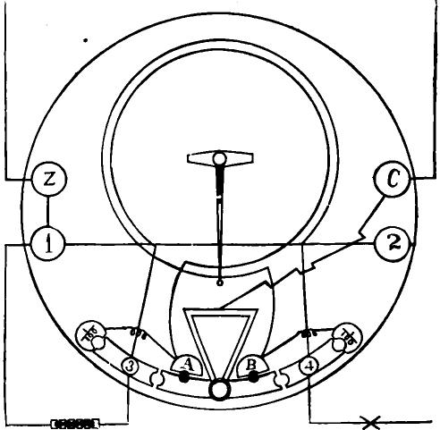
Lime.
.FY;. 543.
current, or mixture with other currents, arising from imperfect insulation, for if there is, the resistance of the circuit will be diminished and the wire will apparently be a better conductor than it actually is. Thus, if upon a wire whose mileage resistance is 16 ohms, one quarter of the current escapes from defective insulation, the apparent resistance of the wire by this measurement would be reduced to 12 ohms.
Sometimes, when a wire is tested for resistance in the above described manner, the results are interfered with by earth cur-

TESTING BY DIFFERENTIAL GALVANOMETER. 963

rents, which increase or diminish the testing current. If the earth currents are not very strong, and are without variation, an accurate test of the wire can be obtained by taking the mean of measurements made with -1- and — currents, or the deflection of the galvanometer needle produced by the earth current may be taken as the zero of the instrument instead of 0 of the scale.
In measuring the resistance of a wire which is imperfectly insulated, or where it is one of several on the same set of poles, it is best to make a loop by connecting it at the distant station without ground, to another wire extending between the same places. The termini of the loop are then connected with the galvanometer at 2 and 4, as in fig. 542. The ground wire is removed from the battery, and the negative pole connected with thumbscrew Z.
The mileage resistance is obtained by dividing the total resistance of the loop by the number of miles of wire which is embraced in it. Unless there is an escape upon both wires used in forming the loop this method will give reliable results. If there are three or more wires running to the distant station, the measurement can be made with still more accuracy by the following method : After one loop has been tested, substitute a third wire in place of a second in the loop and make another test; and then substitute the second wire in place of the first, and test again. Thus, for example, if the resistance to conduction of wires Nos. 1, 2 and 3 is wanted, connect at the distant station first Nos. 1 and 2 and measure the resistance of the loop so formed. Then connect Nos. 1 and 3 and measure the loop embracing those wires. Then connect Nos. 2 and 3 and measure their resistance.
The resistance of each of the three conductors can then readily be obtained from these figures. Thus, :suppose that Nos. 1 and
2 looped together measure 6,000 ohms, Nos. 1 and 3 measure
7,000 ohms, and Nos. 2 and 3 measure 8,000 ohms; by adding together the resistance of the first two loops, and subtracting the
resistance of the third, and dividing the remainder by 2. the resistance of No. 1 is found to be 2,500 ohms. [6,000 + 7,000=

964 THE MEASUREMENT AND TESTING OF LAND LINES.
13,000 - 8,000 = 5,000 2 = 2,500.] Subtracting this from 6,000, the resistance of No. 2 wire is found to be 3,500, and subtracting the latter amount fiom 8,000 gives 4,500 ohms as the resistance of No. 3.
The advantages arising from this mode of testing are that all interferences from extraneous currents and inaccuracies due to imperfect ground wires, as well as to escapes and earth currents, are eliminated.
TESTING FOR FAULTS BY THE DIFFERENTIAL GALVANOMETER.
We will now consider some of the methods employed in testing for the location of faults.
When a line becomes grounded the fact is generally made known by the consequent increase of the strength of current upon the line; or, if the ground is very distant, by the decrease of current. In such cases the position of the fault may be found in the following manner :
One pole of the battery at station I (fig. 544) is connected to the junction of the two coils of a differential galvanometer D G, the opposite pole being to earth. The galvanometer is also connected by one of its coils to the line L, by the other to the rheostat R, also to earth, and the end of the line at station II is insulated.
Let us suppose the escape or ground, having a resistance W, to be at N, and that the resistance of the line from the fault N to the two stations are respectively x and y. If we so adjust the rheostat R that the needle of the galvanometer remains at zero. it is evident, calling the inserted or unplugged resistances R.
that x + W = it, (I)
and if the line makes perfect contact with the ground at N, so
that W 0, then it
x =
or the resistance is directly as the length of the portion meas-
ured.
If, on the contrary, the fault at N presents a certain resist-

TESTING BY DIFFERENTIAL GALVANOMETER. 965
ante, the measurement must be repeated from the other station, by which we find the value,
+w = RI; (2)
and combining this with the first equation, we have
x -hy ± 2 W=R+R, (³) If now we indicate the known resistance (x+ y) of the entire
line by L, then
L + 2 W= R + R,
whence w = R — L (4)
2
Substituting this value of W in the first equation, we find that
of x to be
x =_- R — (R + R, —L) = (R — R, + L). (⁵) 2
In the same manner the value of y is found to be
V=}(R,—R+L).

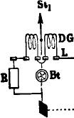 |  |  | I | :la
 | E | !w

Fig. 544.
As a general thing x y will be a little less than L, in consequence of the slight leakage at the various points of support. On this account the values obtained by measurement and calculation will usually be somewhat too small, the actual fault being somewhere between the distances indicated by x and y.
With the Western Union Company's galvanometer the connections for this test are made, as in fig. 545.
The following, sometimes called Blavier's formula, may also be employed for finding the distance to the fault in a single wire when measurements are made from one end only of the line :
x = R, — R, R, + RR,— RR,
In this formula R re,,resents the resistance of line when perfect; R₁ the resistance with distant end insulated : and R₂ the same with distant end to earth.

966 THE MEASUREMENT AND TESTING OF LAND LINES.
The above will be more fully considered under the head of cable testing, where additional information on what is known as the loop test will also be given, the latter being barely more than referred to below, when speaking of the measurements made by the differential galvanometer.
When the line is broken and the ends at the break are insu• lated, the relay no longer remains closed; if, however, a galvan-
Earth. Battery and Earth.
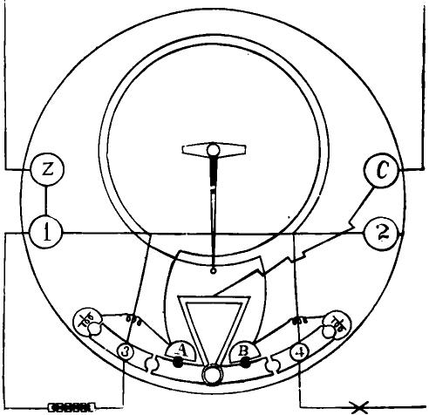
Fig. 545.
ometer is placed in circuit, and contact is made between the battery and line, a momentary deflection of the needle takes place, provided the line is well insulated and not too short. This is caused by the charging of the line, and the deflection becomes greater as the distance to the fault increases. If we now disconnect the battery and put tile line to earth through the galvanometer, the needle, meanwhile, having returned to zero, a

TESTING BY DIFFERENTIAL GALVANOMETER. 967

deflection in the opposite direction takes place, and the line is discharged. (See Chap. XXIV.)
As we have already remarked, the charge and discharge of a line act on the needle of the galvanometer in accordance with the same law that regulates the swing of a pendulum when the latter is influenced by a sudden blow; that is, the moving force is proportioned to the sine of half the angle of deflection. Consequently, if we have previously ascertained the value of the discharge for given lengths of line, and employ a known battery power and the same galvanometer, we have the means of determining the distance to the break with reasonable exactness.
If several wires are placed on one set of poles, and one of them is broken, it generally makes contact with one or more of the others, forming what is technically termed a cross. When this is the case, and we are certain that the wires do not make contact with the earth, the distance to the fault may be found in the following manner :
Both wires, L and L', are disconnected and insulated at the next available station beyond the fault, and a differential galvan ometer is inserted between line L and rheostat and a battery placed between the galvanometer and line L, as shown in figure 542, in which L is connected to the screw 4 and L' to the screw 2.
The rheostat is then adjusted so that the needle of the galvanometer stands at zero. We then have, if we retain the same signification for the letters as before,
z z = 2 x = R,
whence
z=
2
It frequently happens that the wires are of different gauges, and consequently of different mileage resistance; in this case -¹1 will not give the true value of x. This, however, may be found if we know the ratio of the resistance between the wires. For example, suppose that the mileage resistance of one wire, L, to be 10 ohms, and that of the other, L', 16 ohms. Then z+.⁻e— R, or z = R — x, and, since the distance is the same by both wires,
z = 16: 10

968 THE MEASUREMENT AND TESTING OF LAND LINES
whence z V. If, now, we combine the two equations, we find for the distance to the fault measured by the unbroken wire,
5R
— miles.
13 X 10
This test also gives us the location of the fault when one wire is in metallic contact with another and neither are broken. When, however, a resistance, W, of some magnitude is actually present at the point of contact, the test must be repeated from station II; we then have,
From the measurement made at station I,
R = 2 x + W.{ supposing the wires to be
and at station II, R, = 2 y + W 1 of the same gauge.
The sum of these is R + R, = 2 (x y) + 2 W.
Replacing x+y by the equivalent value L, we find
R, — 2 L
W=
2
and substituting this in the former equation, we have
x ₋R - R₁+ 2 L
4
R, - R + 2 L
The following is still another and a preferable way, inasmuch as it is not influenced by the resistance of the fault :
and v = 4

Disconnect one of the wires at the distant station and ground the other. Then connect the battery, galvanometer and rheostat to the wires at the home station, in the manner shown in figure 546, and adjust the resistance R and r until balance is obtained. We shall then have the proportion
cx:dx=r:R,
and if the whole resistance of the line cd is known, the distance from A to the fault is
r
cx = cd----.
R + r
A differential galvanometer is not needed in this method. Any single coil galvanometer will serve equally well.

LOCATING FAULTS IN UNDERGROUND WIRES. 969
It sometimes happens that one or more of the wires may be grounded and crossed at the same time. In most cases of this kind, however, the fault may be located when the measurements are made in accordance with one of the methods just given. It is assumed, in these cases, that the possibility exists of exchanging signals between the stations on opposite sides of the fault.
LOCATING FAULTS. IN UNDERGROUND WIRES.
When underground lines are laid in trenches from two to four feet deep, they are much less subject to injury than land lines. In the case of a break in such wires, when the line is comparatively short, the position of the fault may be found in the following manner :
One end of the line is insulated and the other connected to a
Ac a bB

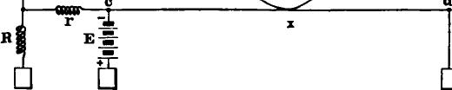

/lg. 546.
powerful battery; about half way between the two ends the gutta percha covering is pierced with a needle, so that the latter makes contact with the metallic conductor, the tongue is then placed against the needle. If a burning sensation is felt, the fault is still farther distant from the battery end, and the test must be repeated until the current is no longer tasted; in this way the location of the fault is reduced to narrow limits and soon found. The pierced gutta percha must be carefully mended again before it is left.
If the line has become leaky on account of damage to the gutta percha covering, causing more or less escape, the fault may be found frorn Siemens's method by calculating as follows :
Referring to fig. 547, suppose there is an escape or ground on the line a b at N, as represented by the dotted lines, ascertain

970 THE MEASUREMENT AND TESTING OF LAND LINES.
first the resistance of the batteries B and B₁, and also that of the galvanometer G and G,; the latter must be comparable with each other.
Second. The resistance of the wire from the battery to the ground plate E.
Third. The resistance of the earth. All of these measurements should be expressed in similar units.
Now let x and y represent the resistances of the conductor from a to b; m the sum of the resistances at a of the galvanometer
U
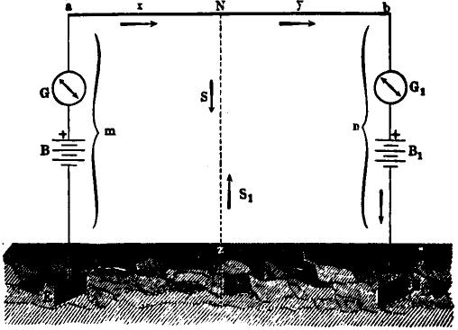
Fig. 547.
G, the battery B and conductor to earth E, including also the earth's resistance, and let n represent the sum of the end b, and z the resistance of the fault.
Let us further suppose that S and S₁ represent the strength of current measured on the galvanometer G and G₁ at a and b, when battery B is alone in circuit, battery B₁ being replaced by a wire equal to it in resistance, and let s and s₁ represent the strength of current when battery B₁ is in circuit and B replaced by an equivalent resistance.
Now, according to Kirchhoff's law (page 209) the sum of the

LOCATING FAULTS IN UNDERGROUND WIRES. 971
products of the currents and resistances in any closed conducting circuit is equal to the sum of all the electro-motive forces in circuit; consequently, if the battery B₁ is taken out and B retained in circuit, there will be no electro-motive force in the figure N E₁ z N; the current S, however, has an opposite direction at N z to S₁, as shown by the arrows; we will, therefore, have for the
figureNbE₁zN.
s_{i} y S, n + S, z — S z = 0,
or
Sz
=
= | y +n +is
and
S y + n+ z
S,
whence, also,
S—S, y+n
z
In the same manner, when B is cut out and B₁ placed in circuit,
we find — X ± 7/1
z
and dividing this latter equation by the former, we have
z _ (8— si)
y + n — so s
Now, as the sum of x y, the resistance of the entire line, is known, either x or y may be determined separately, and thereby the location of the fault be made known. The preceding method, however, is only applicable when there is but a single fault. In order, therefore, to satisfy ourselves that but a single one exists, we must insert a known resistance at one end of the line and re_ peat the test. If the result shows the defect to be at the same point as indicated by the previous test, we may be sure there is but one fault.
It will be obvious that these measurements may be made with a differential galvanometer and rheostat, proceeding in the manner indicated on page 913.
When there are several faults in the line the calculations become complicated, and the results are no longer sufficiently accurate to be of much practical value; in such cases it is better to test the faults separately from different stations.

CHAPTER XLIV.

THE MEASUREMENT AND TESTING OF SUBMARINE CABLES.
THERE are several different methods available for testing cables, the comparative advantages of which, in any particular case, depend very much upon circumstances. One method may be especially well adapted to certain tests, and at the same time unsuitable for others; or, again, we may be restricted to particular methods by the nature of the instruments at hand.
As a general thing either the Wheatstone bridge or a differential galvanometer is employed; when, however, the problem is one involving the measurement of very high insulation resistance, recourse is usually had to the method of deflections. If the mirror or other very sensitive galvanometer is used for this purpose, the constant of the instrument must be taken. This is done in the same manner as that indicated for the tangent galvanometer when treating of land lines (page 897). We should add, also, concerning this proceeding, that on account of the extreme sensibility of the mirror instrument, it is necessary to employ a shunt with it, and to make the sum of all the resistances in circuit equal to 10,000 ohms. The constant will then be the product of three factors—the deflection, the multiplying power of the shunt and 10,000, and this divided by the deflection obtained with any insulating substance in circuit, or, if another shunt is used, by the product of the shunt and deflection, gives the resistance sought in ohms.
In the above we have assumed, as is usual in practice, that the resistances of the battery and galvanometer are small
compared with the resistance to be measured, whether of insulation or conductivity. When this is not the case, and great accuracy is desired, it becomes necessary to take these resistances into account. 'Ile correct formula for such cases is
x=R _{d} $
v (1 + )— (G r) oluus.

TESTING CABLES DURING SUBMERSION. 973

Where x represents the unknown and R the known resistances, n the number of cells used with the unknown resistance
in circuit, 1 ₈ the multiplying power of the shunt, and G
and r the resistances of the galvanometer and cell respectively; d represents the deflection with the shunted galvanometer, It ohms resistance, and one cell battery in circuit, and d, the deflection obtained when the circuit includes n cells, the galvanometer and the unknown resistance.
Insulation tests are always made after the current has been allowed to flow into the cable for a definite time, usually one minute. Unless some systematic understanding of this kind were adopted no comparable measurement could be obtained, as the variation caused by absorption greatly influences the result.
During the laying of a cable, and before the vessel containing it puts to sea, some definitely arranged plan of proceeding should be agreed on, and the details thoroughly understood both on ship and on shore. The measures suggested by Siemens, which bear directly upon this point, may be summarized as follows :
One end of the cable is taken ashore and carried to the cable hut or station, where it is connected to a commutator clock. The latter • is arranged in such a manner that the measuring and speaking apparatus are placed in circuit, and the conductor insulated and put to earth automatically for definite intervals of time; these succeed each other in regular order. Similar arrangements
are also made on board ship, and the measurements repeated on shore. The results are then exchanged and testing goes on
again as before. The clocks must necessarily be in accord, and
the intervals of time be arranged with exactness. The measurements, also, should be made expeditiously and with care, and
the least possible time occupied in exchanging results, so that
should a fault occur while the shore tests are being made, the ship will not have paid out cable unnecessarily. When the
measurements made on ship differ considerably from those made on shore, it is an indication that a fault exists somewhere in the cable. In such cases the ship should be stopped immediately and the fault located.

974 THE MF.ASUREMENT AND TESTING OF SUBMARINE CABLES.
A method of continuous testing has been devised by Mr. Willoughby Smith, which has some decided advantages over the one just described. The principal one of these consists in allowing the electricians on board to observe the condition of the insulation uninterruptedly. At the same time correspondence between ship and shore can be maintained at pleasure. The system will be readily comprehended by reference to fig. 548.
The end a of the cable on shore is connected to a very great resistance, R, and the front contact of a manipulating key, K. The resistance, R, which may be of selenium or of gutta percba, has a resistance of 20 or 30 million ohms; its opposite end is connected through the mirror galvanometer G to earth. A condenser c is inserted between the lever of the key and earth.

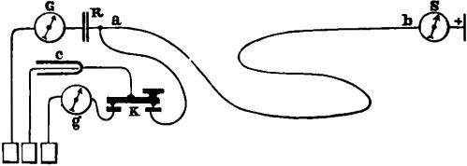 | *IF

Fig. 548.
On ship, the end b of the cable is connected permanently with a mirror galvanometer S, and battery of 100 cells to earth. The current of this battery causes a steady deflection of S, due principally to the leakage through the insulation, and of G on shore, due to the passage of the current through R. These deflections are observed and recorded every five minutes.
Continuity is observed on shore by the ship changing the direction of the current every fifteen minutes, which causes the deflections of G to be reversed.
Insulation on board is measured by the deflection of S, the resistance of R being too great to interfere with the result. Insulation on shore is observed by measuring the potential at R. This is done every five minutes by measuring the discharge from c. The key is pressed down for ten seconds, putting c to line; it is then

TESTING OF CABLES DURING SUBMERSION. 975

released, and the discharge measured upon the mirror galvanometer g, and the result communicated to the ship.
Speaking through the cable without interfering with the insulation test, is done by making R in the form of a condenser, and inserting a similar condenser between the end b and galvanometer S. Then, if either ship or shore charge the outside plates with
or — electricity, a corresponding impulse will be transmitted through the cable, and be indicated upon the galvanometer, although no electricity really enters or leaves the cable. By making the slight sudden deflections which are thus produced to the right band and left band represent respectively dots and dashes, a continued and speedy correspondence may be kept up during the testing.
In the case of a break iu a comparatively long cable, which is more or less liable to occur during the paying out, it may happen that the percha closes completely over the ends of the conductor and thereby preserves the insulation. In such cases the only way to determine the location of the fault is by comparing the static capacity of the separate portions with the average knot capacity of the cable. This might be done approximately by charging the cable from both ends with like battery power, and noting the discharge currents by means of comparable galvanometers. For example, suppose that 1 and l_{l} represent the two. lengths on each side of the break. and that a and a, are the respective angles of deflection, as shown by the galvanometers. Then we should have
/ : 1, -,-- sin. a: sin. a,
(see page 385), from which 1 and 1₁ could be easily determined, since 1+ l_{r}, the entire length of the cable, is known. Formerly such tests were made with very sensitive galvanometers, but the results were not found to be comparable with any degree of safety.
The best results from capacity measurements are obtained when comparison is made with a standard condenser, for which purpose the bridge system, as arranged by De Sauty, is admirably

976 THE MEASUREMENT AND TESTING OF SUBMARINE CABLES.
adapted, though the differential galvanometer and direct deflection methods are employed to a considerable extent.
De Sauty makes the cable and a standard condenser take the place of the resistances in two sides of the bridge, as shown in figure 549.
When, therefore, balance is obtained, we have
A x A
= _{LT} or x = c
C and x being the respective capacities of the condenser and cable.
Sir William Thomson has called attention to the fact that, while this method is an excellent one for shot t lengths, it is not
C
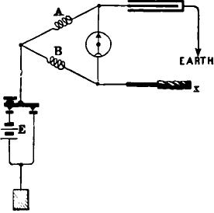
Kg. 549.
applicable to long submarine cables, on account of the manner in which the currents concerned in it are influenced by the inductive retardation. For this reason he prefers a modification of the system which renders it equally applicable to long and short cables. An arrangement of this kind is shown in fig. 550. and the following reference will explain the manner of employing it :
The two condensers (or condenser and cable) c C, to be compared, are put in series; that is, one plate of the condenser c, which we will call its second plate, is put in connection with one plate of condenser C, in this case armor of cable, which we will

COMPARISON OF STATIC CAPACITIES. 977
call its first plate. The first plate of condenser c will be called a, the connected second plate of c and first plate of C will be called b and the second plate of C will be called a'. Join a and a' in metallic connection through a wire, a Ba', of not less than several thousand ohms resistance, and let B, a point in this line of conduction, be put in connection with one terminal of an electrometer or galvanometer, the other terminal of which is to to be occasionally connected with b, by a make and break key, M. To commence, make and break contact at M several times, not too rapidly, and observe the effect on the indicator, whether electrometer or galvanometer. Then, with contact at M broken, establish a difference of potentials between a and a' by means of a battery, and after time has been allowed for electric equili_{O}
-
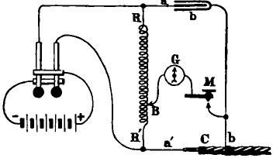
.Fiy. 550.
brium between c and C, make contact at M, and keep it made for a sufficient time. Then break contact at M and reverse the battery poles between a and a', after which allow sufficient time for the reestablishment of electric equilibrium between c and C, and make contact at M again. The ratio of the resistances, R R', between a and B, and between B and a' must be adjusted by varying one or both of them until the effect of making contact at M is the same with successive reverse applications of the battery to a and a'. (This effect will generally be zero, in laboratory and factory tests; but, because of earth currents, not exactly so in a submerged cable.) When the adjustment has been satisfactorily made, we conclude that
R': R = c: C; whence C = c--•

978 THE MEASUREMENT AND TESTING OF SUBMARINE CABLES.
This method is applicable, notwithstanding earth currents in moderation, to measure the resistance of a submerged cable of two or three thousand miles length, with only a single micro-farad as standard for capacity, and a battery of not more than 100 cells to charge it.
If the differential galvanometer is employed for making capacity tests, one of the coils must be provided with an adjustable shunt, by means of which the magnetic effect of one coil on the needle is made to balance that of the other; this is known as Varley's method.
A variable shunt is also desirable when the deflection method
2
t
B=
• it Li
E
:IP
Fig. 551.
is employed. In this case the deflection caused by the discharge of the cable is first noted 'Ind then reproduced by the discharge from the standard condenser, the shunt being adjusted and the operation reoeated until the desired deflection is obtained.
Loop tests by the bridye system.—In case of defective insulation in a cable containing more than one conductor, it is possible, by connecting two of the wires together, to obtain all of the advantages that would result from having both ends of the cable at hand. The following methods are applicable to such cases:
(1.) Let L₁ and L₂ (i1«. 551) represent the two conductors, and suppose there is an escape at F. Let also G represent the galvanometer; R, p and r the known resistance in the three sides

LOOP TEST BY THE BRIDGE SYSTEM. 979
of the bridge, B the battery, and E a plug switch for connect ing the bridge with the ground. The two conductors should be connected to the bridge in such a way that the fault is nearest the binding post marked 1, and the plug at E removed; the needle of the galvanometer is then brought to zero by adjusting B. Suppose, now, that x represents the resistance from 1 to the fault F, and that y represents the resistance from F to L_{I}, then
- x y = 1
the whole length of the line, and according to the laws of the
bridge (pages 211 and 212) we have also
 |  |  | r (x + R) = p y; ₁ ₋ ₋r _{R}
whence | (I,.) | x
 |  |  | + -
 |  |  | P
and |  |  | Y  (1 + R) | p
I ^{r}
p
or more simply, for practical purposes,
x= pl-rR
r+ p
and y = r (R +
p
If we wish to know the value of x and y in knots we have only to divide the above values by the number corresponding to the units in one knot. The great advantage of the method consists in the fact that the influence of polarization and varying resistance is eliminated, and, consequently, the results obtained by its use are very reliable. For this reason the loop test should always be employed whenever practicable. It is quite common_ in practice to make the resistance of the two sides of the bridge, p and r alike, we may then replace the one by the other in the formula; by this means we obtain the proportion
r/—rR _{or} I—R —
r + r 2
which greatly facilitates calculation.

980 THE MEASUREMENT AND TESTING OF SUBMARINE CABLES.
Again, by connecting the two ends of the looped wires directly to the bridge at L₁ and a, leaving R out, and adjusting r or p until balance is obtained, we shall find what the ratio of the two sides x and y is to one another, and thereby the resistance to
the fault, for
x y.=1,
the total resistance of the loop, whence
&=¹⁻x
and
p: r=z:l-z
from which we find
P¹
z=
r±p
If it should happen that the resistance of the fault does not
B
B
cc
At i^{t} f' f
Fig. 552.
differ greatly from the insulation resistance when the cable is perfect, a correction for the loop test will be required, as in this case the current has two paths—one due to the fault itself, the other to the conductivity of the insulating substance. The latter or resultant fault, as it is called, is, in a uniformly insulating material, equivalent to a defect at the centre of the cable, and its resistance is the same as the resistance of the whole cable when perfect. In case the insulation is not uniform throughout, the position of the resultant fault may be found by the ordinary loop test while the cable is in good condition.
In fig. 552 let A B be the cable with an actual fault at f, and let i represent the position of the resultant fault and f' the posi- tion of the fault as shown by the loop test.
Suppose, also, the resistance of the cable, when perfect, is R, and, when faulty, R', calling the resistance of the real fault z, we shall have
R z
R' =
Bea

CORRECTION FOR LOOP TEST. 981
the joint resistance of the fault and insulation of the cable; and from this we find the resistance of the fault to be
R R'
z =
R - R'
Referring again to the figure, let the length A f' fi and
A i = a, then i f' — a. Now, the greater the resistance R
with respect to z, the smaller will be the distance f' f, and finally, when z equals nothing, f' f also becomes nothing, or, in the form of a proportion,
R: z=if:ff.
Putting x for the distance f' f, replacing the other factors by their values, and multiplying, we have
R x — RR ^{R}R^{,(/}' ^{a),}
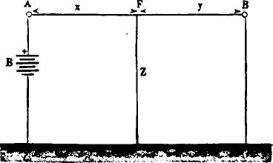
Fig. 553.
whence
R'
(fi a).
^{x} R — R'
which is the correction to be added to the value obtained by the loop test, in order to get at the true position of the fault.
When a fault occurs in the cable in which there is but a single conductor, and only one end of it is available at a time, the position of the defective spot may be determined by one of the following methods, provided the normal resistance of the conductor is known, as we always suppose it to be.
Let A B (fig. 553) represent a line in which there is a fault at

982 THE MEASUREMENT AND TESTING OF SUBMARINE CABLES.
F, and let us suppose that two measurements are made at each station—one with the distant end of the line to earth, the other with the same end insulated. Suppose, also, that we find for these measurements the values a a_{l} b b₁ respectively, and let the resistance of the line from A to the fault F equal x, that from B to F equal y, and let z equal the resistance of the fault itself; we shall then have, in accordance with the law of branch circuits,
- 1 = y
- a=x + Y^{z}
Y+z
- a, = + z
- b=y+ "
+ 2
- b, = y z
These equations enable us to determine the values of x and y,. and, if desired, of z also, in different ways.
1st. By combining equation (1) with the insulation measure-. ments equations (3 and 6) we find these values to be as follows:
(II,.) z — ^{b}l ±
_{mt.) y} a, __{h_}1₂
(II,.) z = ^{a,} + b, 1
2d. By combining equation (1) with the resistance measurements of the conductor equations (2 and 4) these values are expressed as follows :
(M_{I}.) — ^{a (1} ^{b)} (1 / b (I — a)\
a — b W a (1— b))
y — ^{b (I} a) /a (1— 6)‘
b — a k.¹ b (1 — a))
i'l(1— a — b)(b — a) ± a b (2 I — a —b)s)
(Ili_{a}.) z = ab^{(21— a —1)) 1}1
(b — a) ² k a b (2 1— a — b)
If, now, we divide x by y we shall have
(111₄.) x /a 1— b _{vT}
y 1—a

TESTING FROM ONE STATION ONLY. 983
which is the most suitable form for practical use. If we again
combine y. = 1/a and x y = 1 we shall have
Wr
(III₅.)
z
+
and (III₆.) 1
Y — + "
3d. If the measurements are made at station A only, fig. 554, we may find the values of x, y and z by combining equations (1) (2) and (3), from which we find
iv,. z = a — (a — a) _{(1—} a),
IV, y = (I — a) + W (a ₁— a) (I —a),
= (a, — a) + %/Ca_{l} — — a);
A
0 ²4)
Fig. 55'
and if the measurements are only made at station B we obtain the same values by combining equations 1, 4 and 5, which assume the following form:
- x = (1 — b) (b — b) b),
- y = b— V (b — b) (1 b),
- Z = — b) 1,4b — (1 —
It must be borne in mind that equations II to IV, inclusive, will only give correct results on condition that there is but a single fault; that its resistance remains unchanged during the several measurements; and that it does not give rise to polarization at the time of the tests.

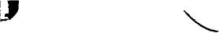

984 THE MEASUREMENT AND TESTING OF SUBMARINE CABLES.
As we never find all of these conditions fulfilled in any given case, it is important, in making the tests, to arrange matters so that the sources of errors shall be, as much as possible, eliminated.
Only such measurements as are made at one time should be used, for we can never be sure that the resistance of the fault will remain unchanged for any length of time. Moreover, as olarization greatly affects the results, special attention must be given to this part of the subject in order to eliminate its disturbing influence. What is known as Lumsden's test is directly applicable here. This consists in cleaning the conductor at the fault by applying the zinc end of from 60 to 100 cells of battery for several hours, with occasional reversals of a few moments only. During all of this time, and while the tests are being made, the conductor should remain insulated at the distant end. An approximate resistance test, with copper to line, is then made for the purpose of facilitating matters, as the last test must be made quickly. The copper end of the battery is now connected to the conductor for say two minutes, using two or three cells for every hundred units of resistance that have been measured. After this the cable is again connected to the bridge or differential measuring apparatus, and the final measurement made with zinc to line. As the needle now tends to one side or the other, we must endeavor to keep it at zero by inserting or cutting out resistance, shifting unit by unit so long as the needle is visibly affected by the operation. At a certain point, however, the needle flies clear over, and a change of several units will no longer suffice to bring it back. The unplugged resistance at this moment is the true resistance of the conductor to the fault.
Some practice in this kind of testing is necossary before very much reliance can be placed upon the results. Fortunately, however, considerable skill can be obtained in the laboratory from measurements made with pieces of punctured cable placed in a tub of salt water.
The use of comparatively large batteries has been advocated; it is also recommended that the number of cells be proportioned

REMARKS ON THE ELECTRICAL BALANCE. 985

in such a manner that the current escaping at the fault shall be the same for the measurements made from both stations. By making preliminary tests of x, y and z the number of cells n at A and n, at B for the final test, may be easily arranged. The proportions in the different formulas on pages 934 and 935 should then stand, approximately, as follows :
No. II. n:n₁=x-i-
" III. n: n, = x: y,
" IV.n : n_{i} = y (x + : cry + lz) at A.
n : n, = x (y : (xy " B.
In general, however, it will be found best to adhere to the plan just given, unless the earth current is very strong, and even then the battery proportions in Lumsden's test will usually suffice.
Respecting the preference to be given to these formulas, it may be remarked that the first is especially applicable when the fault is situated near the centre of the line, while the second is to be preferred for faults near the ends. In such cases it gives very safe results, for the reason that when a = b the formula
assumes the form of t-, but for the same reason, also, it cannot
be generally employed with good results when the fault is the centre of the line. The third formula is the least reliable of all.
As a general thing large faults are easier to locate than small ones, but the difficulties increase with the length of the cable, and as the normal insulation decreases. Care and an accurate knowledge of the distance between the two stations by the cable route are of very great importance. When due regard is given to these considerations a little skill, to be gained, by experience only, will lead to the greatest success in the practical application of the formulae
REMARKS ON THE BRIDGE OR ELECTRICAL BALANCE.
In the ordinary arrangement of the Wheatstone bridge the two sides a mid b, fig. 555, joined to the negative pole of the battery, are frequently made equal and constant for given tests;

986 THE MEASUREMENT AND TESTING OF SUBMARINE CABLES.
the unknown resistance, x, is then deduced from the knpwn and variable resistance, R If the latter has been so adjusted that the needie remains at zero and a = b, we have also R x.
When we wish to measure small resistances only, and especially if the same are of yr ires which do not require an appreciable time to attain their maximum charge, the above arrangement of the bridge answers very well; it is less satisfactory, however, when we wish to measure the resistance of cables. In such cases any variation in the resistance It (fig. 555), changes the resistance of the branch, C Rb Z, and thus modifies, also, the distribution of the current in both of the branch circuits, and as
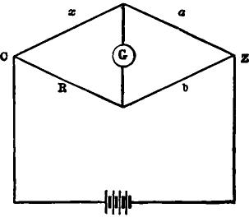
.F g. 555.
some time is necessary for the charge to redistribute itself between the two circuits, it becomes exceedingly difficult to know the exact moment when the resistance R represents the unknown quantity, x.
To obviate this difficulty, Sir William Thomson makes the resistance of the branch, C R b Z, constant, and varies nothing but the contact point of the galvanometer circuit, which is shifted to the side b or R until the needle rests on the zero mark. To ascertain the value of x, it is then only necessary to determine the resistance b and but as the latter is a function of the for
Trier, there is, iu fact, but one unknown quantity, x, to be determined.

THOMSON'S BRIDGE. 987
In this case we have x = e°.
The practical arrangement of this system is shown in fig. 556.
The resistances of the branches a and b (fig. 555) are represented by a series of coils, a b (fig. 556), each one of which terminates in a metallic contact plate. The latter are so placed consecutively in a straight line that the movable spring r, mounted
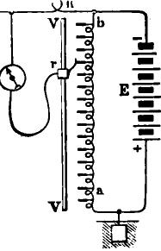
g
Fig. 556.
on the guide V V, and connected to one terminal of the galvanometer g, may be moved over or placed in contact with any one of them.
Figure 557 gives a better idea of this part of the apparatus; r is the fiat spring which presses against the contacts t, 1, t of the
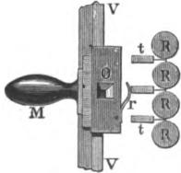
Fig. 557.
coils R, R, R The spring is attached to a movable glide 0, on the copper guide V V, friction between the guide and movable piece being such as to insure good metallic contact. A small square opening in the slide 0 permits the numbers corresponding

988 THE MEASUREMENT AND TESTING OF SUBMARINE CABLES.
to the resistance of the adjacent coils to be read on the scale below, where they are engraved and read each way, beginning
- at opposite ends of the scale. The second terminal of the galvanometer is connected to the resistance x; and the positive pole of the battery, as well as the distant end of the cable, are connected to earth. This arrangement, in reality, is the same as that shown in fig. 555, since the earth, in consequence of the low resistance, may be considered as the point of contact between a and x.
To make a test and find the value of a and b, upon which that of x depends, it is only necessary to slide the spring r, fig. 556, along the contact pieces of the coils, until the needle stands on

2G | 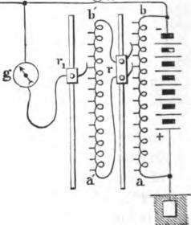

Fig. 558.
zero; then, as the indications are double, and numbered in oppo-side directions, the readings corresponding to the contact of the spring with the coils at once gives the values of a and b without calculation. The box, as usually constructed, contains one hundred coils of 1,000 ohms each, so that the total resistance a + b is equal to 100,000 ohms.
It will readily be seen that resistances grouped as above will not answer well for practical purposes. It consequently becomes necessary to provide some means for obtaining subdivision of each 1,000 ohms. Mr. Farley has effected this end by adding a series of coils, a' 6', fig. 558, to the first and making the num-

VARLEY'S BRIDGE. 989

ber of the latter 101 instead of 100, as in the former arrangement. The slide r, which connects with the terminal pieces of these coils, instead of being single, as in fig. 556, is double, and constructed in such a way as to leave between the contacts touched two free coils, which thus become combined in multiple arc, with the entire series a' b' representing the same value; the latter series being composed of 100 coils of 20 ohms each. It thus becomes easy, by means of a second movable contact spring r₁, carried by a guide, as in the first case, to determine on the new scale which of the coils corresponds to the resistance sought, and in this manner the value of the latter can be ascertained to within ten ohms of approximation.
It will be seen that the branch established between the first series, a b, and the second series, a' b', diminishes the resistance of the coils included between the two points of contact one half; or, in other words, that the joint resistance of the two coils and the series a' b' is 1000 ohms, which is just equal to the resistance of a single large coil. The two series of coils combined, therefore, do not, in reality, represent a greater resistance for the portion a b of the diagram a b R x (fig. 556) than the whole of
Thomson's bridge, but they enable us, when combined in this manner, to obtain readings on the galvanometer over 100 X 100 or 10,000 subdivisions instead of 100, as with the single series of coils. The above combination is the one that was employed for measuring the resistance of the Atlantic cable during its immersion.
As, in using this apparatus, a little calculation is required in order to arrive at the numerical value of x, which is equal to R a it has been found desirable, for rapid execution, to make
the instrument itself furnish the ratio hin multiples or submul-
tiples of 10; the resistance of x can then be seen at a glance, and calculation altogether avoided.
Mr. Varley has attained this result by means of the arrangement represented in fig. 559. In this combination the resistance R of Varley and Thomson's bridge is replaced by the system a b,

990 THE MEASUREMENT AND TESTING OF SUBMARINE CABLES.
a' b' (fig. 559), of which we have already spoken; and a third series of coils, c d, along which slides a spring e, in connection with the galvanometer, represents the resistance of a + b as in Thomson's bridge. In this manner the sensibility of the apparatus can be regulated under known conditions which are such as to furnish a constant for the ratio a in the equation
R a
= b •
For greater clearness in what is to follow we will represent (fig. 560) the theoretical arrangement of the new bridge reduced
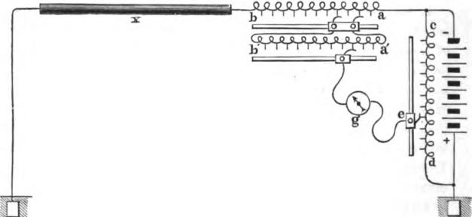
Pig. 559.
to its simplest form. In this figure, when the needle of the galvanometer arrives at zero in consequence of a displacement of the terminal i of the galvanometer circuit, the other end of the same circuit occupying the position m on c d, we have
a: c = b x: d;
whence b+ z = a —or x = a-- b,
and we find the ratio - immediately by noting the place occupied
by the spring e (fig. 559) on the scale c d. In Mr. Varley's apparatus the resistance coils of the series c d are fourteen in number,

VARLEY'S BRIDGE. 991
and arranged in the following manner, their total resistance being 100,000 ohms :
C
⁷⁻ 40909.1 •

- 1 .9 9.0 89.9 890.2 8100.8 40909.1
•
- 1000000 •
- 100000 •
- 10000 •
- 1000 •
- 100 •
- 10
•
1
- 0.1
8100.8 •
- 0.01
890.2 •
- 0.001
1 89.9 •
- 0.0001
9.0 •
- 0.00001
1 •
- 0.000001
- 1 •
100,000.0
As will be seen above, the series presents two symmetrical periods—an increasing and a decreasing one—and these represent the two sides, c and d. of the lozenge, abcd (fig. 560).
When the galvanometer circuit makes contact with the middle point of the two series, that is, when on contact 1 the side c is equal to d, each containing 50,000 ohms resistance, consequently the ratio d is equal to 1. When on the contact 10 the side c has
a resistance of only 9090.0 ohms, whiled has had its resistance in-
creased to 90909.1, and, consequently the ratio d is now equal to
10. In the same way, if the slide connecting with the galvanometer circuit is placed on the contact marked 1000, the side e will have a resistance of 99.9 ohms only, while d will have increased to 9990O1 ohms; in this instance, therefore, the ratio will be 1000. Again, by moving the slide on the contacts of the

992 THE MEASUREMENT AND TESTING OF SUBMARINE CABLES.
lower numbers, it will be found that on -001 the side d has a
resistance of 99.9 and c 99900.1 ohms, which gives for the ratio
d.001, and so on for the other contacts.
We thus see that the above arrangement enables us to find the ratio of d without any calculation whatever, these being given by
numbers corresponding to the contacts, consequently the operation for determining the value of x consists simply in reading the value of a and b from the scales a b, a' b', which are numbered in opposite directions, as before remarked; to a are then added as many ciphers, or, from it as many places are pointed off as are indicated by the readings opposite the points in contact upon the scale c d, and from this product b is subtracted.
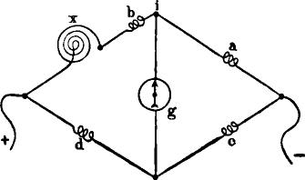
Fig. 560.
When arranged as in the above manner, the apparatus, besides being extremely simple, relieves the observer of the labor of computation, and is, at the same time, capable of measuring very high as well as very low resistances, it being only necessary to move the slide of the scale c d successively over the contacts of the ascending series, 1 to 1,000,000, to adapt it to the measurement of resistances of anv considerable magnitude : this will readily appear from the fact that the ratio d, by which a is
multiplied, increases, in this case, from 1 to 1,000,000. Similarly, by moving the slide over the decreasing series 1 to -000001, the apparatus becomes as perfectly adapted to low resistance

VARLEY'S BRIDGE. 993

measurements, the ratio being now a decimal fraction instead of a multiple of 10, as in the former case.
When we wish to measure resistance less than a, c should, of course, be greater than d. We may then neglect the term b, as in such cases the cable to be measured is so short that the introduction of this quantity has no appreciable influence.
For most factory and laboratory measurements, as well as for testing submerged cables, an electrometer is often advantageously employed in place of the galvanometer, especially in localities where the inductive action of machinery in motion is liable to interfere with the scale readings. It may also be used in connection with the galvanometer, and it is all but indispensable in locating faults by observing the potentials at different points in the line. One of the simplest methods of doing this is as follows:
One pole of a battery at a terminal station is connected to earth, and the other to one side of an unplugged rheostat, the opposite side of which is joined to the defective conductor whose distant end is insulated. Under these conditions the potential will fall regularly from a maximum at the junction of the rheostat and battery to a minimum at the fault; at this point, and at the distant end of the line, the potentials are presumed to be alike. We have, therefore, only to measure this quantity on each side of the rheostat, and at the distant end to obtain data for locating the fault.
Calling the potentials on each side of the rheostat P and PI, P being the highest, and that at the distant station p, the unplugged resistance R, and that of the line to the fault x, we have
P- P' : R = P' -p:x
and from this is derived the general formula:
(P' -p) R
P - P'
which, divided by the mileage resistance of the line, gives the distance to the fault,

CHAPTER XLV.

MISCELLANEOUS MATTERS.
WE have already referred to the Peltier electrometer, in Chap XXVI, when speaking of the insulation measurements of submarine cables. We will now give a brief description of Sir William Thomson's improved quadrant electrometer, an instrument which that distinguished scientist has brought to a very high degree of perfection. Fig. 561 gives a general view of the instrument, the principal parts of which are the jar, the needle and reflecting system, four pairs of quadrants, an auxiliary electrometer or gauge, for enabling the experimenter to know whether the needle is maintained at a constant degree of electrification, and a small inductive apparatus, termed the replen-isher, by means of which the potential of the jar can be raised or lowered as occasion requires. By far the greater bulk of the instrument is the jar, of white flint glass. This is supported on three legs by a brass mounting, cemented round the outside of its mouth. The latter is closed by a plate of stout sheet brass, with a lantern-shaped cover standing over a wide aperture in its centre. Beneath the cover, and within a circular metallic box, cut twice at right angles, so that the separate parts form quad rants a, b, c, d, fig. 562, is placed a thin alumnium needle n, whose shape somewhat resembles that of a double canoe paddle. The needle, at its centre, is rigidly fixed to an axis of stiff platinum wire (fig. 563) in a plane perpendicular to itself. At the top end of the wire a small cross piece y is fixed, to the extremities of which are attached the lower ends of two suspending silk fibres, the other ends being wound upon two pins, c d, which mad• be turned in their sockets by a square pointed key. By this means the tension of the fibres can be equalized and the needle caused to stand midway between the upper and under

THOMSON'S QUADRANT ELECTROMETER. 995
surfaces of the quadrants. The two silk fibres form what is termed the bifilar suspension, which has now superseded the single fibre and magnets of the original instruments. In the earlier forms a magnetic adjustment similar to that in the mirror galvanometer was employed to bring the needle to zero, but the bifilar suspension has been found to secure this result in a much more advantageous way. The pins c d are pivoted in blocks carried by springs e f, to allow them to be shifted horizontally when adjusting the position of the points of suspension. The ends of the screws a b, which traverse these blocks, rest against
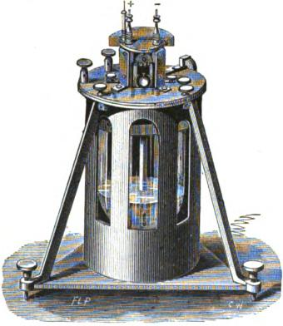
114). 561.
the fixed plate behind, so that when either is turned in the direction of the hands of a watch, the neighboring point of suspension is brought forward, and conversely. The needle may thus be brought to lie in such a position that the quadrants are symmetrically placed about it. Finally, by turning the conical pin h (which passes between the two springs and screws into the plate behind) to the right or left, the points of suspension are made to recede from or approach each other, and thus the sensi• tiveness of the needle is decreased or increased, within certain

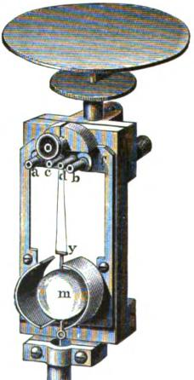
996 MISCELLANEOUS MATTERS.
limits, at pleasure. Just below the cross piece y is fixed the mirror m, which reflects the movements of the needle upon a scale placed in front. The needle itself is electrically connected with sulphuric acid in the bottom of the jar, by means of a fine platinum wire banging from its lower side, and kept stretched by a platinum or leaden weight below the surface of the liquid. It will thus be seen that the charge of the jar is communicated to the needle, and the higher the charge the more sensitive the
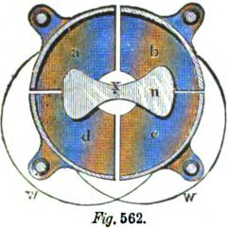
t
563.
needle becomes. The acid serves a double purpose; it keeps the air dry within the jar, and forms also the interior coating of the same. As the wire which dii s into the acid passes through the guard tube t, any great lateral deviation of the needle and its appendages is prevented, and liability to accident thereby much reduced, while at the same time the whole reflecting system has perfect freedom of motion round a vertical axis. The replenisher and auxiliary electrometer are not shown in the figure. Two electrodes or terminals, + and —, fig. 561, connect

THOMSON'S QUADRANT ELECTROMETER. 997

with the quadrants, opposite pairs of which are metallically connected by wires, w iv (fig. 562), and insulated from the rest of the instrument by glass stems projecting downward from the top of the jar. The third electrode seen in fig. 561 serves to charge the jar. Lateral and micrometric movements of the quadrants are both used for varying the adjustment of the instrument, and in some of the latest forms an induction plate has been added, which permits the instrument to be used for a greater range of measurement. A pamphlet containing clear and minute directions for performing all the necessary adjustments, charging, cleaning the works and preparing sulphuric acid, etc., accompanies each instrument.
THE CONSTRUCTION OF CONDENSERS.
Condensers are much used for comparing the electro-stati_{c} capacity of cables and electro-motive force of batteries, for joint testing, and for obviating the effects of earth currents in submerged cables. They are usually made of tin foil and various insulating substances. In Varley's condensers alternate sheets of very thin (silver) paper saturated with paraffin, and tin foil are used. Clark uses tin foil and sheets of thin mica coated with paraffin or shellac. Specially prepared gutta-percha, containing a large proportion of shellac, is also employed to insulate the sheets of foil or metallic plates, and air has been suggested for the same purpose—the latter with special reference to standard condensers, but the inconveniences attending its use is such that it is now rarely employed. The electro-static capacities of condensers are expressed in microfarads. The best mode of constructing a condenser is to cut up the tin foil into sheets of the size desired, arid to make of them two piles like the leaves of a book, the one which will represent the outer coating of a jar containing one sheet more than the other, which represents the inner coating; upon the extreme end of each of these piles place a tinned wire or strip of metal, and, by means of a soldering iron, run all the edges together, so as to make a perfect metallic connection. These books of tin foil should be well baked and warmed when about

998 MISCELLANEOUS MATTERS.

to be used, to drive off all moisture from the 'surfaces of the metal, and it is well, also, to rub each leaf, as it is laid down, with a warm, dry cloth. Cut sheets of paper large enough to allow a margin of at least an inch round three sides of the foil. The paper should be thin, not highly glazed, and should show no acid reacticn by reddening when moistened with a neutral solution of litmus. A very superior quality of paper is manufactured expressly for this purpose by Messrs. Crane & Co., of Dalton, Mass., which is used by the Western Union Telegraph Company. The paper should be baked thoroughly dry, placed in a vessel of paraffin kept well over its melting point, and then drained, sheet by sheet, as smoothly as possible. A well baked piece of wood, of the same size or larger than the paper, is laid upon a table, its face soaked with paraffin, and a sheet or two of paper laid upon it; upon this is laid the outer pile of foil with its soldered end somewhat projecting, and all its leaves turned back except the lowest one, which is to be rubbed smoothly out on the paper; lay over this two sheets of paper, and on the top of this the other book of foil, so placed that it lies exactly over the first sheet, excepting for the margins at the opposite ends; turn back, as with the other, all its leaves except the first, and upon this place two sheets of paper; continue this process, laying back upon the paper sheets of foil from the books alternately, and between each foil two sheets of paper; when the whole are in place cover with two or three sheets of paper and a board like the first. The whole should then be compressed by clamps or by screws passing through the two boards, and warmed up to the melting point of paraffin, increasing the pressure to drive out all excess. The first board should be provided with a binding screw at each end, to which the wire of the corresponding set of foils is soldered. It is desirable to keep a delicate galvanometer and a battery in circuit through these screws, so that if by any accident or defect a contact or circuit is completed during the process, the galvanometer will at once show it. Paper thoroughly dried, coated with or dipped into thin shellac varnish, and again dried, may be used instead of the paraffined paper, or thin sheets of

STEARNS'S APPARATUS FOR MEASURING WIRE. 999

ebonite, gutta percha or mica. It is exceedingly difficult to prepare a condenser which will not lose its charge.
STEARNS'S APPARATUS FOR MEASURING RESISTANCE OF
TELEGRAPH WIRE.
Fig. 664 represents an apparatus designed and employed by Mr. Joseph B. Stearns for measuring the resistance of telegraph wire at the manufactory. a and a' are A shaped steel contact supports, over which the wire whose resistance is to be measured is drawn by a winding drum. 1 and l' are weighted levers for keeping the wire in connection with the contact points. A B C D are the four sides of the bridge. G is a galvanometer, one terminal of which is attached to the junction/ of the sides A B, the other terminal being connected with a vernier sliding upon the graduated scale S, and carrying a rider for making contact between the bridge wire b and the sides C D of the balance. k and k' are wires connecting the contact pieces a and a' with the branch B of the balance. i and are wires connecting a standard resistance r with the branch A of the balance. E is a battery attached to the terminals T T of the balance.
The standard resistance r is made equal to that of a definite length of the wire to be tested, say one tenth of an ohm, and is composed of wire of the same size and quality as that which is being tested, and is placed in the same room with and near the latter, that both may be equally affected by changes of tempera. ture.
The measuring apparatus must necessarily be situated at some distance from the place where the wire is handled, to prevent the constantly changing masses of wire and the jar of the machinery from influencing the galvanometer. The two sets of leading wires i and k k' are of the same size, length and quality, each set having a joint resistance of say four tenths of an ohm, and are so placed as to be equally subjected to changes of temperature. The total resistance in each side of the balance is thus made five tenths of an ohm; and when the vernier is placed at

1000 MISCELLANEOUS MATTERS.
zero of the scale and the battery circuit is closed, no current passes through the galvanometer.
Suppose, for example, we desire to measure the resistance of a No. 8 iron wire, the maximum resistance of which must not exceed 16 ohms per mile. The contact points a and a' are for convenience placed at such a distance that the resistance of the length of wire betweenthemshall be a definite unit, say one tenth of an ohm. This, for the quality and size of wire above men_{E}
-
.2 Ohm k .2.01vm Fig. 564.

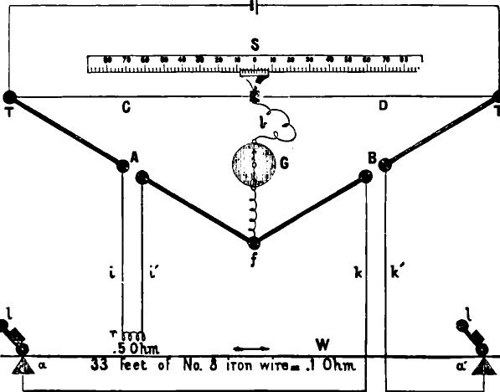
S
ss 70 uuuuu e s M es
.5 Ohm. W
33 Feet of No. 3 iron wire..1 Ohm
tioned, would be precisely 33 feet. In other words, if the resistance of one mile, or 5,280 feet of wire, equals 16 ohms, then the resistance of 33 feet of such wire would equal one tenth of an ohm.
The end of the wire from a bundle to be tested is now drawn from the reel through the contact points a a' and to the winding drum. While the workmen are attaching the end of the wire to

SPECIFICATIONS FOR GALVANIZED IRON WIRE. 1001

the drum, the person in charge of the measuring instruments observes that the needle of his galvanometer does not stand at zero, and he moves the vernier to the right or left, as the case may be, until the desired equilibrium is obtained. If the vernier has been moved five divisions to the right, and the whole scale is divided into six hundred equal parts, it will be manifest that the resistance of the tested wire is less than that of the standard, and a simple calculation will show how much less it is; thus 305 : 295 : : .1 : .0967 X 10 X 16 =15.47 ohms per mile; or, if the vernier has been moved one division to the left, then 299 : 301 ::
.1 : .10066 X 10 16 = 16.105, and shows that the wire has a
resistance of 16.1 ohms per mile, and is to be rejected.
The scale, instead of being divided arbitrarily, may, with advantage, be so divided as to show definite degrees of increase or decrease in the resistance of the tested wire; for example, one division of the scale may correspond with an increase or decrease of one tenth of an ohm per mile in the tested wire. When the scale is thus adjusted, it is only necessary to observe the position of the vernier upon the scale to know exactly the resistance of the wire per mile.
By placing a delicate polarized relay in the bridge wire, and using a battery of somewhat greater strength, the apparatus may be made to automatically report to the person in charge of the wire room any defect or undue resistance of the tested wire by ringing a bell, or by tripping a magnetic escapement or detent to stop the winding drum, by shifting the belt, or otherwise. When so arranged the services of an observer in the instrument room may be dispensed with.
Mr. Stearns measured nearly one thousand miles of wire with the above described apparatus, with such minute accuracy that the variation of the thousandth part of an ohm was always detected.
SPECIFICATION FOR GALVANIZED IRON TELEGRAPH WIRE FOR TILE WESTERN UNION TELEGRAPH COMPANY.
1. The wire to be soft and pliable, and capable of elongating 15 per cent. without breaking, after being galvanized.

1002 MISCELLANEOUS MATTERS.

- Great tensile strength is not required, but the wire must not break under a less strain than 2.5 times its weight in pounds per mile. Tests for tensile strength will be made by direct appliance of weight, or by means of a single lever, at the option of the inspecting officer.
- Tests for ductility will be made as follows : The piece of wire will be gripped by two vises, 6 inches apart, and twisted. The twists to be reckoned by means of an ink spiral formed on the wire during torsion. The full number of twists must be distinctly visible between the vises on the 6 inch piece. The number of twists in a piece of 6 inches in length not to be under 15.
- The electrical resistance of the wire in ohms per mile, at a temperature of 60°Fahrenheit, must not exceed the quotient of the constant number 5500 when divided by the weight of the wire in pounds per mile. Examples : A wire weighing 550 lbs. per mile (No. 6) should have a resistance not exceeding 5500 550 = 10 ohms per mile. A wire of 388 lbs. per mile (No. 8) should have a resistance not exceeding 5500 -+ 388 =14.1 ohms per mile. A wire of 335 lbs. per mile (No. 9) should have a resistance not exceeding 5500 335 = 16.4 ohms per mile.
- The wire to be cylindrical and free from scales, inequalities, flaws, sand splits and all other imperfections and defects. Each coil must be warranted not to contain any weld, joint or splice whatever in the rod before drawn.
- It is desired to obtain the wire in coils, all of one piece, of about 150 lbs. each. If this cannot be undertaken, the contractor may tender for the supply of wire with two pieces only to the coil, joined by the ordinary twist joint and carefully soldered. It should be stated in the tender whether there will be one or two pieces in each coil.
- The wire must be well galvanized and capable of standing the following test: The wire will be plunged into a saturated solution of sulphate of copper, and permitted to remain one minute, and then wiped clean. This process will he performed four times. If the wire appears black after the fourth immersion, it shows that the zinc has not been all removed, and that

COMPOUND WIRE. 1003
the galvanizing is well done; but if it has a copper color the iron is exposed, showing that the zinc is too thin.
COMPOUND WIRE.
At the present time a great deal of compound wire is coming into use on telegraph lines, and it frequently becomes desirable to know what amount of copper by weight per mile will be required to form a wire of a given resistance, the mileage resistance of steel being known. This can readily be ascertained from the joint resistance formula :
Calling the resistance of the given steel wire . S,
That of the copper. C, And the resistance which the wire is to equal, R We have from the above formula
Cs
R =
C S
and from this we find the copper resistance to be
RS
C-
S - R
Knowing now the resistance of the copper it is only necessary to divide the constant 871.786 thereby, and the quotient will be the weight of copper sought in pounds. A n example will make this clear :
Suppose the resistance of the steel to be 53.2 ohms per mile, and that we want a wire of 15 ohms resistance, how much copper must be deposited on the steel to give us the conductivity sought?
From the formula,
15 X 53.2
C, the copper resistance, = = 20.9 ohms.
531 -15
871.786
and — 41.7 lbs., the weight required.
20.9
In table IV, column VII, will also be found the weight of copper per mile, corresponding to the resistances in column XI. When any one of the resistances in the latter column is the same

1004 MISCELLANEOUS MATTERS.
as the resistance found for the copper, a simple reference to the corresponding line in column VII will give the required weight without calculation.
Sometimes the weight only of the steel is given, certain weights being selected so as to give proper tensile strength for particular purposes. When this is the case the steel resistance can be found with sufficient accuracy by dividing the constant number, 6383, by its weight per mile, as in the case of copper, 6383 being the constant or weight in pounds per mile ohm* for steel, as 871.781 is for copper.
USEFUL RECIPES.
Amalgamating Solution for Zincs. — Dissolve one part (by weight) of mercury in five parts of nitro-muriatic acid (one part H N O₃ to three parts H CL), heating the solution moderately to quicken the action; and, after complete solution, add another five parts of nitro-muriatic acid. It is best to use but a small quantity of the solution at a time. Apply with a brush. Dipping the zincs in large quantities of solution exhausts the latter unnecessarily.
Chatterton's Compound.—
Stockholm tar 1 part.
Resin 1 " By weight.
G utta Percha. 3 parts.
Shellac Varnish for Glass.—Put one ounce of the shellac of commerce into a wide mouthed eight ounce phial, containing five ounces of well rectified naphtha, wood or spirit. Close the bottle with a cork, and let it stand in a warm place until completely dissolved. Shake the mixture frequently, and psss the fluid through a paper filter; add rectified naphtha to the solution from time to time, in such quantities as will enable it to percolate through the filter. Change the filter when necessary.
- See note to table VI.

USEFUL RECIPES. 1005
Ebonite.-100 parts caoutchouc, 45 sulphur and 10 gutta-percha.
Insulating Varnish for Paper.—Dissolve one ounce Canada balsam in two ounces spirits of turpentine. Put into a bottle and digest at a gentle heat. Filter before cold.
Varnish for Silk—Boiled oil, 6 ounces, and 2 ounces of clear spirits of turpentine.
Electrical Cement.—Harris prefers the best sealing wax.
Amalgam for Electrical Machines.—Tin 1, zinc 2, mercury 4. Melt the zinc and tin first, pour into a wooden dish and add the mercury gradually.
Solder.*—For line wires—tin 1, lead ; or tin 1, lead 1.
Marine Glue, much used in Batteries.—Dissolve 1 part of india rubber in 12 parts of benzole, and to the solution add 20 parts of powdered shellac, heating the mixture cautiously over a fire. Apply with a brush.
Solutions for Chemical Paper.—
No. 1. Nitrate of ammonia, about 4 pounds.
Ferri-cyan. potassium " 1 oz.
Gum tragacanth, 4 "
Glycerine, 4 "
Water, 1 gallon.
No. 2. Nitrate ammonia, 2 lbs.
Muriate " 2 "
Ferri-cyan. potassium, 1 oz.
Water, 1 gallon.
No. 3. Iodide potassium, lb.
Bromide " 2 "
Dextrine or starch, 1 oz.
Water, distilled, 1 gallon.
* Connections in apparatus and test boxes must never he soldered with acids or chloride of zinc. These liquids cannot be entirely removed, and will corrode the metal. If spilled on wood, or even on ebonite, chloride of zinc never dries, and injures the insulation. Resin should always be used.

1006 MISCELLANEOUS MATTERS.
No. 4. 150 parts crystallized nitrate ammonia.
5 " ferro-cyan. potassium, and
100 " water.
No. 5. 1 part iodide of potassium, and
20 parts starch paste in
40 " water.
No. 6. Add two parts nitric acid and two of ammonia to a solution of prussiate of potash in water, about 1} oz. to the gallon.
No. 7. 1. part ferro-cyanide of potassium, saturated solution.
1 part nitrate of ammonia
1 part of each solution to two parts of water.
Of the above, No. 1 may be considered best for steady work on short circuits, being also of comparatively high resistance, it is least affected by leakages from other lines.
No. 2 is much more sensitive and can be made to record with the faintest trace of current, it is therefore well adapted for long circuits.
No. 3 is highly sensitive, and capable of the most perfect and beautiful work at an extremely high rate of speed.
Cement for Insulators.—Sulphur, lead, plaster of paris, with a little glue to prevent it setting quickly.
Muirhead's Cement.-3 lbs. Portland cement, 3 lbs. rough sand, 4 lbs. smiths' ashes, 4 lbs. resin.
Black Cement.-1 lb. rough sand, 1 lb. smith's ashes, 2 lbs. resin.
Siemens's Cement.-12 lbs. black iron rust or iron filings, 100 lbs. sulphur.
Sealing Faults in Fresh Water Cables.—When the poles of a battery are put in water, the latter is decomposed, — oxygen being developed at the -I-, and hydrogen at the — pole. If the ± electrode is copper, it will be oxidized by the gas formed on its surface, and this oxide is a very bad conductor. By putting

DICTIONARY OF TECHNICAL TERMS. 1007
the + pole of a battery of 100 volts to one end of a leaky cable, and insulating the other, the fault may be effectually sealed, and the cable worked through as if no fault existed.
DICTIONARY OF TECHNICAL TERMS.
The following is intended to supply concise definitions of terms for occasional reference, or to recall their full explanation to mind :
Amalgamation.—Zinc is protected from waste by having its surface coated with mercury. For the process see page 84.
Battery.—A combination of two or more voltaic cells coupled together in series.
Bridge, 1Vheatstone's.—An apparatus for measuring resistances by balancing the unknown resistance against one known and capable of adjustment.
Cell.—Each separate vessel in which a chemical action occurs, by which electricity is capable of being developed.
Circuit, Conductive.—The wires, instruments, etc., forming the path for the passage of the current.
Circuit, Inductive.—The term applies to static electricity; inductive circuits are partly composed of insulating material, as air or condensers.
Circuit, Derived.—When part of a circuit is divided into two or more parallel branches each of the branches is called a derived circuit.
Circuit, Combined.—In telegraphy two or more circuits, so connected by repeaters or otherwise that signals in one are reproduced in the other.
Circuit, Metallic.—One in which a return wire is used instead of the earth, as when two wires are looped.
Circuit, Telegraphic.—That connection between two terminal stations whereby signals can be passed from either one to the other without mechanical repeating or translating.
Commutator.—Break, contact-breaker, and circuit-changer or switch. They are of many forms, according to the purpose required.

1008 MISCELLANEOUS MATTERS.

Conductivity.—This is a relative term, and applies to that inherent property of any substance whereby the passage of electricity through it is effected with the least opposition; it is the reciprocal of resistance.
Conductors.—Substances which most freely permit electricity to pass. Formerly, it was thought that substances were of two distinct classes, conductors and insulators; but it is now known that the difference is one of degree only.
Connections.—Wires, etc., completing the circuit between the lines and different apparatus.
Current.—The supposed flow or passage of electricity or electrical force in the direction from + to — or positive to negative. It, therefore, originates at the zinc surface in contact with the solution, and passes from the zinc to the copper or other negative element in the liquid of the battery, but from the negative element to the zinc in the external circuit.
Current, Reverse.—A current in an opposite direction to the normal current.
Currents, Earth.—This term is used to indicate the currents that are observed in a circuit partially formed by the earth, when the batteries have been removed. They arc occasioned by the different action of the soil on the earth plates, or by a difference of potential in the earth between the places where the wire is grounded.
Deflection.—The angle or number of degrees through which the needle of a galvanometer moves when a current is passing through its coils.
Electrometer.—An instrument for measuring electric potentiaL
Electrornotke Force.—The force which developes electric tension or potential. In ordinary galvanic batteries the E. M. F. is set up by the attraction of the zinc for an acid radical; its degree depends upon the force and number of such chemical affinities in circuit, and inasmuch as there are also opposing affinities tending to develope E. M. F. in the opposite direction, the actual force depends upon the excess of the total affinities in the direction of the current, over those in the opposite direction.

DICTIONARY OF TECHNICAL TERMS. 1009
Galvanometer.—An instrument for measuring currents.
Induction.—The name given to effects produced outside of a force exerting body, or out of the circuit to which the force is directly applied.
Insulators.—Bodies possessing high electrical resistance. All insulating substances, however, allow some electricity to pass.
Telegraphic Insulators are the glass, porcelain, or vulcanite supports for the wires, which tend to prevent electrical communication between the latter and the earth.
Intensity.—The old term for the properties now described as electromotive force and potential. Batteries were said to be arranged for intensity when the cells were coupled together in series.
Measurement—See Units.
Negatire.—In the battery, the copper, carbon, or platinum plate.
Ohm.—A unit of resistance, called also the B. A. unit
Ohm's Laws. —Formula devised by Ohm, for calculating unknown electrical magnitudes from certain given data. The symbols should represent fixed units to obtain definite results. Putting E for the electro motive force, R for resistance, and C for current, the relations are represented as follows :
Current = C = F.
It
Resistance = R = —
C
Electromotive Force =E=CxR
and knowing any two of these magnitudes the third is readily obtained.
Polarization of Plates.—This term is applied to an action which occurs whenever the current passes from liquid to solid conductors; there forms on the surface of the latter a film different from the liquid, by which there is not only a greater resistance introduced, but an electromotive force is generated, opposing that of the current, so that if suddenly connected to a galvanometer, and the main circuit broken, a reverse current will be main-tamped for some time.

1010 MISCELLANEOUS MATTERS.

Poles.—The wires, plates, etc., leading from the battery; their name is the opposite of that of the plate they lead from; thus the zinc is the positive metal or element of the battery, but the wire leading from the zinc is the negative pole.
Positive.—In the battery, the zinc plate.
Potential.—A word used to indicate a condition for, or tendency to do work. Difference of potential is a difference of electrical condition, in virtue of which work is done by positive electricity, in moving from a point more highly electrified to one electrified in a less degree, or one not electrified at all. The idea of potential essentially involves a relative condition of two points, so. that no one point or body can be said to have an absolute potential, but for brevity the word is used alone to denote the difference between the electrical condition of the body or point and that of the earth, which is assumed to be zero.
Reduced Length.—A term sometimes used to express a resistance in the terms of its equivalent length of wire or resistance.
Resistance.—The opposition presented by the circuit to the development of the current. It is an inherent property of every substance, varying only in degree.
Retardation.—A term applied to the inductive action which reduces the rate of signaling in submarine cables, etc.
Rheostat—A variable artificial resistance, employed for measuring unknown resistances.
Secondary Wire, in coils, is the long and fine wire in which the induced current is set up by the magnetic reaction of the core.
Units.—The various bases of any system of measurement. Absolute units are based upon the units of mass, length and time-1 gramme, 1 metre and 1 second; the fundamental unit is that force which can generate a velocity of one metre per second, gravity being a force of 9.811 such units. The centimetre is also used in place of the metre. For practical use larger units have been devised by the British Association, viz :
Electromotive Force and Potential.—The volt .10⁶ or 100,000 absolute units.
Resistance.—The ohm = 10⁷ or 10,000,000 absolute units.

DICTIONARY OF TECHNICAL TERMS. 1011
Current—The ampere, = 10 — ² or •01 absolute unit per
second.
Veber.—The unit of current (now called the ampere).
Volt.—The unit of electromotive force.
Voltameter.—An apparatus for measuring the current by its
chemical action.
Weight per Mile-ohm.—A term used to designate in pounds
the weight of metal required to give, for a mile length of the
material, a resistance of one ohm.
These weights, for steel, iron and copper are, as follows :
Steel, as used in compound wire 6383 lbs. Iron, such as supplied to the W. U. Tel. Co. 4884 " Copper, pure 872 "
By dividing the above weights by the weight per mile of any given wire of the different materials, we get the approximate mileage resistance of such wire at 60° Fahr. in ohms.
CONSTRUCTION OF ELECTRO MAGNETS.
As a result of numerous experiments, the following dimensions are recommended for ordinary electro magnets to be worked with tolerably strong currents. The length of core to be six times its diameter; the thickness of the layer of wire with which the bobbin is wound to be equal to the diameter of the core; the core to project to a distance equal to half its diameter from the bobbin; in the case of horseshoe electro magnets, the quantity of iron in each core and in the sole plate and armature to be the same; and the width of the armature to be equal to the diameter of the core. In the case of electro magnets to be worked with weaker currents, the diameter of the cores may be diminished in comparison with the other proportions. Short electro magnets are quicker in action than long ones; and magnetized soft iron acquires and loses small accessions of magnetism more readily than if in the neutral state.

1012 CONSTRUCTION OF ELECTRO-MAGNETS.
¹The electro-magnet is composed of a magnetic core, or cylinder of iron; a helix, which consists of an insulated conductor, wound upon a bobbin, and surrounding the core, and an armature, a piece of iron, 'usually of prismatic form, placed transversely in front of the ends of the core, which ends are termed the poles of the electro-magnet.
If the core is composed of a straight cylinder the electromagnet is termed a bar magnet, and usually acts by means of one of its poles only, but if the core is bent in such a manner that both its extremities may act upon the same armature, it is termed a horse shoe or U magnet. The same result may also be obtained by uniting several pieces together. Thus two cores of iron connected together by a yoke or bridge piece of the same metal, each core being surrounded by a bobbin, constitutes an
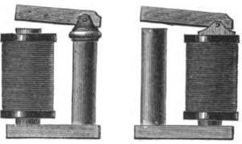
Fig. 564a. Ft. 564b.
electro-magnet with two branches, this being, in fact, the form in which electro-magnets are usually constructed, but many other forms are also employed, to a greater or less extent. When the electro-magnet just described is without a helix or coil upon one of its cores, it is termed a single coil magnet. Figs. 564a and 564b represent two forms of this kind of electro-magnets.
The earliest experiments which were made with the view of improving and perfecting the electromagnet, demonstrated that the effective force of an electro-magnet is proportional to the strength of the magnetizing current and to the number of convolutions in the magnetizing helix; and that in order to produce the most advantageous effect, the resistance of the helix should
'Abstract from Expose des Application de l'Electricite, by Ct. Th. Du MonoeL

MAXIMUM OF MAGNETIZATION. 1013

be equal to that of the portion of the circuit not included in the helix.
Subsequent experiments proved that a mass of iron is susceptible of a certain maximum of magnetization only, and only within certain limits is the force of the electro-magnet proportional to the square root of the diameter of the iron cores, or simply to the diameters, if we take into account their action on the armatures. These experiments also proved that in order to develop in two electro-magnets of different diameters the same proportional part of their maximum magnetism, the product of the current multiplied by the number of evolutions must be proportional to the square roots of the cubes of the diameters. A still later series of carefully conducted experiments showed that the magnetic force not only increases as the square root of the diameter of the core, but is also proportional to the square of the length. The attraction which results from this fOrce, however, diminishes in the ratio of the square root of the distance of the middle or neutral point of the core from the armature.
The result of these experiments shows that the attractive force exerted by an electro-magnet upon its armature is proportional to the diameter of the core and to the square root of its length.
The investigation of the question of magnetic saturation proves that the maximum of saturation depends solely upon the mass of iron contained in the electro-magnet, irrespective of its form; and that the maximum degree of magnetization, of which a mass of soft iron is susceptible under the influence of the electric current, is more than five times as great as that which a corresponding mass of hardened steel is capable of retaining.
When the electro-magnet exerts its attraction on an armature of soft iron, it creates a new magnet, which, reacting in turn on the first, induces a similar action, thus proving that the attractive force of electro-magnets is proportional to the square of the strength of current for a like number of convolutions, and to the square of the number of convolutions for like strength of current. This law can, however, only be considered as rigorously

1014 CONSTRUCTION OF ELECTRO-MAGNETS.

exact when the electro-magnet and the armature contain about the same mass, and their magnetic state is near the point of saturation; that is to say, that which these magnetic pieces would retain if, being of tempered steel, they were magnetized to a maximum. We will only acid, that it follows from the preceding law, that if the strength of current (acting on the electro-magnet) and the number of convolutions in the helix vary at the same time, which is nearly always the case, since by increasing the number of convolutions without changing the battery, we increase the resistance of the circuit, the attractive force of the electro-magnet becomes proportional to the square of the strength of current multiplied by the square of the number of convolutions. When the electro-magnet, instead of acting on an armature of soft iron, exerts its action upon another electro-magnet, the attraction is proportional to the sum of the products of the strength of current by the number of convolutions in the two helices. Finally, when the electro-magnet acts upon a steel armature magnetized to saturation, the attractive force is simply proportional to the product of the strength of current by the number of convolutions. It will be observed at the same time that the nature and diameter of the wire of the magnetizing helices exert no influence, provided the strength of current does not vary.
In the laws of the electromagnet which have thus far been summed up, the armature has been assumed to be of sufficient dimensions to render it capable of receiving the same amount of magnetism as the core itself—a condition which is necessary in case the attraction exerted upon the armature is represented by the square of the force proper of the electro-magnet. In order that the law may hold good in the case of an electromagnet which has arrived at its maximum point of saturation, it is evidently necessary that this armature should present a mass nearly equal to that of the core which is directly magnetized by the helix, while in order to satisfy the conditions of the law of proportionality of the forces, with respect to the diameters and lengths, the armature should be of about the same dimen-

PROPORTION OF FORCES TO DIAMETERS. 1015

sions as the electro-magnet. Hence we arrive at the conclusion that the maximum of force of which an electro-magnetic system, composed of a helix, core and armature, is capable, is developed when the dimensions of the two latter in respect to their length and surface are equal.
The proportion of the forces to the diameters indicates that the former depends more upon the surfaces than upon the magnetic masses. It follows from this principle, that if a second armature is attached to the inactive pole of a straight electromagnet, the effective force of the combined system ought to be considerably augmented; for the reason that the electro-magnet with its first armature constitutes, in point of fact, an electromagnet of double length. Therefore, the maximum of force ought to be developed when the length of the second armature is also equal to that of the electro-magnet If we consider the system with reference to the first armature, we arrive at the following general law :
In a straight electro-magnet, the length of whose core exceeds that of the magnetizing helix, at the end opposite the armature, the force progressively increases with the length of the core, until the total length becomes three times that of the bobbin. This result is confirmed by experiment. We are now able to establish other conditions of maxima in respect to double electromagnets. In fact, since the length of the magnetic core which projects beyond the magnetizing helix becomes more and more favorable to the development of magnetic force until the core becomes three times the length of the helix, we can readily understand that the force can be still further augmented by causing this mass of iron to react on the armature, and by enveloping the latter in a second helix. Now, if this second helix is of the same length as the first, we then have two elec-tro-magnets, each of which is placed in its condition of maximum, and of which the part without the coils—which is usually
termed the yoke of the double electro-magnet should be equal
in length to one of the cores, if it is desired to keep it within the maximum conditions already established. We may, therefore.

1016 CONSTRUCTION OF ELECTRO-MAGNETS.

lay down the equality of the four constituent parts of the system, as the condition of maximum of double electro-magnets. This conclusion, which etperience has shown to he correct, explains several phenomena exhibited by electromagnets, to which we shall have occasion to refer in another place. The problem now under consideration is that of determining the best construction of the armature. If we only take into consideration the question of force without concerning ourselves with practical requirements, which are sometimes directly opposed to the conditions of maximum—as in cases where the utmost rapidity of motion is required, for example, when the mass of the armature should be as small as possible—it is obvious that the flat prismatic form is the best: for, inasmuch as the centre of the magnetic action in the armature coincides with its axial line, it is clear that the greater the thickness in the normal direction of the action of the magnet, the greater will be the distance between the latter and the middle point of the armature, and, therefore, the less the force. Consequently, the cylindrical form and the prismatic form of equal dimensions should be rejected. The best results will be attained by means of the thinnest possible armature placed broadside in front of the poles of the electro-magnet, for the reason that in that case the distance from the magnetic centre of the armature to either pole of the electro-magnet will be at its minimum. In fact, experiment shows that with an armature one inch in breadth and one eighth of an inch in thickness, the difference in the respective forces resulting from the position of the armature, whether flat or edgewise, is the ratio of ninety-two to fifty-nine.i
¹ The form and mass of the armatures should depend upon several considerations, but principally upon the functions which they are required to fulfil. In respect to force alone, these armatures ought always to be a little broader than the poles which act upon them; the length ought to exceed by four or five lines the polar extremities of the magnet, and their thickness ought to vary according to the force of the magnet. It is even asserted that for a given magnetic force, this thickness is susceptible of a maximum, beyond which there is a loss of power when the thickness is still further augmented. It is easy to understand that this condition of force cannot always be realized, for if we require a very rapid move-went of the armature, we ought to make the latter as light as possible.

MOVEMENT OF THE ARMATURE. 1017

On the other hand, it is easy to understand, that in order to allow the greatest possible amount of play with the least loss of power, it is preferable to pivot the armature in such a way that one of its extremities is in contact with one of the magnetic cores, and the other end alone movable. In this manner the armature moves angularly, and the force which is developed, compared with that which is obtained from the same armature moving parallel to the axis of the cores, is nearly double, being in fact, in the ratio of one hundred and twenty-five to sixty-four. The reason of this is obvious, when we consider that the distance through which the attractive force is exerted is by this arrangement diminished nearly one half. From the comparison which we have already made, with the yoke uniting the cores of the double electro-magnet with its armature, we can readily see that when these four parts are equal to each other they constitute a double system, in which each one of the magnetic cores composing a special electro-magnet has a distinct armature, which armature being of the same length and surface as the magnetic core which acts upon it, may give rise to a magnetic reaction under conditions analogous to those of the action produced by the magnetic core itself. But this is no longer the case when the armatures as well as the yokes are of greater or less dimensions. In this case it may happen, either that these armatures cannot furnish the sum of magnetism necessary to enable them to resp)nd to the action, or, on the other hand, that the cores themselves do not possess sufficient magnetic mass to respond fully to the reaction which would otherwise be produced. In this case the. forces depend upon the shortest parts constituting the magnetic system, but as the proportion of the total force which they are individually able to furnish is proportional to the square root of their length, and as one of these parts cannot vary in length unless the other also does, the result is, that when the different parts of a double electro-magnet are not equal, the force is proportional to the length of the shortest part. This fact was long since discovered and made known by Dub. As corollaries to this law, the latter gives the following deductions, which may be readily comprehended without further explanation :

1018 CONSTRUCTION OF ELECTRO-MAGNETS.

- The attractive force of an electro-magnet is proportional to its length, when the lengths of all the different parts of which it is composed increase in the same ratio.
- The maxima of attractive force are proportional to the various lengths of the systems, of which the component parts are respectively of equal length.
- The attractive force remains constant when the shortest parts are equal to each other, whether these are represented by the electro-magnet or the armature.
According to the British Association committee, electromagnetic forces should be measured by the method of repulsion, and the unit of electro-magnetic force is represented by the repulsion exerted between two like magnetic poles placed at a distance of one metre apart, and acting upon each other with a force represented by cir (gramme-metre). Nevertheless, as the greater part of the experiments which have been made up to the present time with electro-magnets have been made by means of a balance and weights, the existing ratio between the two systems of measures still remains to be ascertained.
The accompanying plates show the various forms of electromagnets generally used for electrical purposes. Figs. 564c to 564i inclusive are electro-magnets, whose poles are straight, bevelled, tapering or flattened, according to the purpose needed. In fig. 564e the copper end pieces are soldered to the core of the electromagnet. In fig. 564f the core is hollow, with two iron disks at the extreme ends to increase the polar surfaces, and to serve as end pieces for the bobbins. Fig. 564/i shows Bonelli's electromagnet, in which the armature forms a part of the magnetized core, and by receiving from the helix a direct magnetization, makes the attraction between the two parts more powerful.
Fig. 564i shows an electro-magnet provided at both ends with
c.
two iron pallets. This plan is used to advantage as an armature of an electro-magnet, in which case the pallets correspond to the poles of the electro-magnet. This arrangement has been adopted by Mr. Maroni for the Italian Morse instruments. Figs. 565 to 570 and 574, 575 and 577 show the various forms which have been

VARIOUS FORMS OF ELECTROMAGNETS. 1019

given to the double branched electro-magnets. Fig. 566 shows the best known and more generally used form. Fig. 567 shows an electro-magnet in which the helix is wound around the iron core without retaining disks at the ends; the various spirals are wound so as to form two truncated cones in opposite direction to their base. This form of electro-magnet is especially made use of in Clark's instruments to favor the effects of induction, which is more energetic in the centre of the cores than at the extreme ends. Fig. 669 shows an electro-magnet with hollow cores and iron end pieces. Fig. 568 shows an electro-magnet with one coil. By bringing near together the two branches of such an electro-magnet, and bending the free branch around, as shown in fig. 570, we may bring the two poles of the electromagnet very near together, and hence make them react at the same time on an armature placed endwise, and of very small size. A similar form, and devised for the same purpose, has been adopted by Mr. Hughes for the two bobbin electro-magnets of his telegraphs, the branches, however, being bent back, as in fig. 574.
If a soft iron cylindrical case is placed around the bobbin and soldered to the circular end piece of a straight electro-magnet, this cylinder will share the magnetism of the end piece, and will present a like pole to its free end; hence there would be at one of the ends of the electro-magnets a circular pole, in the centre of which the other pole would be found, as shown in fig. 572. Manufacturers of these tubular electro-magnets claim a great superiority for them in strength over the other forms. Electromagnets of this style have been used in electro-motors, the poles being oblong instead of circular, as shown in fig. 578.
If we place over an iron tube electro-magnet like that in fig. 564f, two soft iron cylindrical cases, leaving between them toward the middle of the electro-magnet, a small open groove, we shall obtain a circular electro-magnet having a different pole on each of the two iron cases which surround it, and hence acting through its two poles at the same time on a longitudinal or circular armature, on which it rests. This form of magnet, as

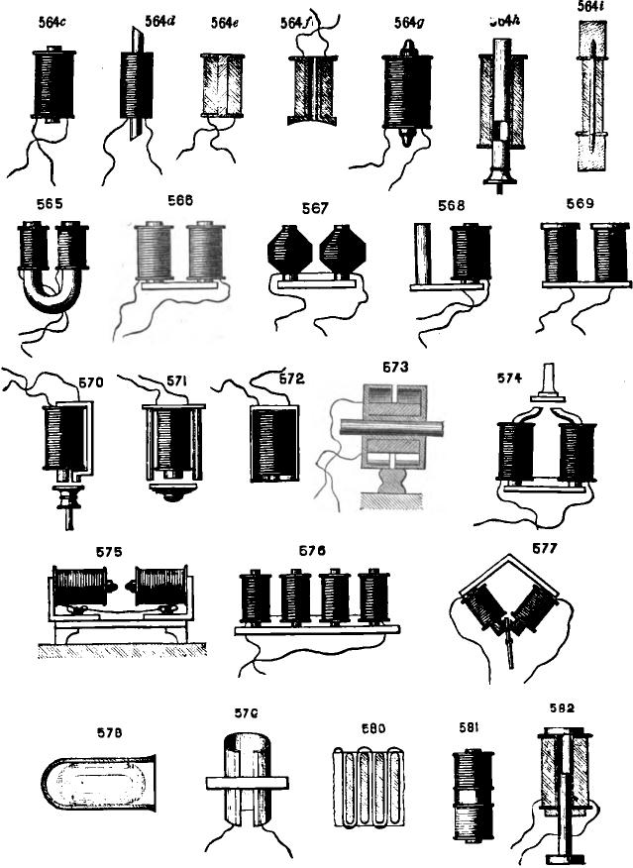
564i
564a
588
569
565
567
568
574
575
676
iIi II IIi! . Ihrpolirloo4
- .
57G
582
57B
E80

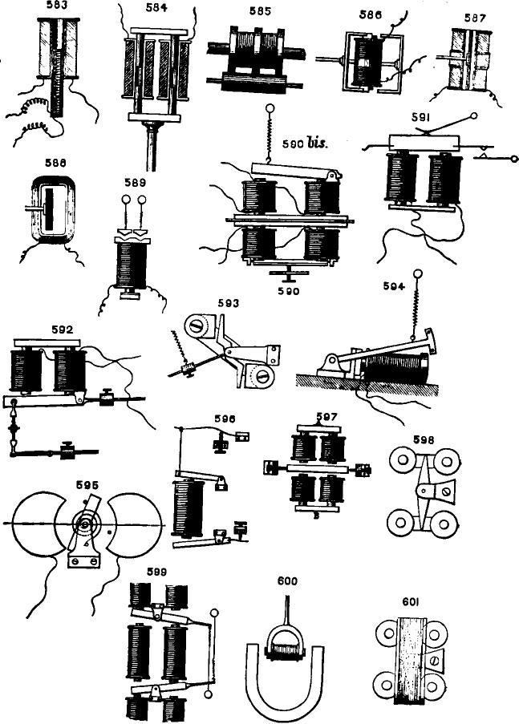
583
587
600
601

1020 CONSTRUCTION OF ELECTRO-MAGNETS.

shown in figs. 573, 585, has been proposed for magnetizing the wheels of locomotives on railroads, and as an electro-transmitter of motion to supply gears.
By bending the yoke at right angles the two opposite poles of an electro-magnet may be made to face each other, as shown in 575; and by cutting the yoke in two, and sliding the two free parts in a groove made in a plate of soft iron, the distance of the poles from each other may be regulated at will. When it is desired that an armature should oscillate between the two poles of an electro-magnet, in which case magnetic armatures are usually employed, there are three ways that may be followed; the poles of the electro-magnet may be bent in such a way as to stand opposite to one another at any desired distance apart, or the two cores are brought sufficiently near each other to allow the oscillation to take place between them; or, lastly, the cores themselves are inclined at the proper angle to bring the poles near to each other. The latter method possesses a slight advantage over the others, in not requiring any marked lengthening of the cores, which is always detrimental; and at the same time it allows a direct attraction on the armature, which is more powerful than lateral attractions. Fig. 577 shows a magnet of this description.
Electro-magnets, with multiple poles, as shown in 576, are sometimes employed for large electro-motors. These magnets consist of an iron bar, carrying eight, ten and twelve, or even more, iron cores, on which the magnetizing helices are placed; the even branches are all magnetized alike, or are of the same polarity, while the uneven are of the other. The result is that any one of these poles always stands between two poles whose magnetism is opposite to that of the one considered. Electro-magnets of this construction are very powerful, and consequently of considerable importance in the construction of electro-motors. Attempts have also been made to magnetize iron plates in different ways. 579 shows one arrangement of this kind constructed by Joule, in which the plate is rolled into a cylindrical form, and the wire wound around it in the direction of the length of the cylinder

ELECTRO-MAGNETS WITH MULTIPLE POLES. 1021

By cutting a series of grooves in an iron plate, and introducing therein an insulated wire, bent back upon itself, as shown in fig. 580, Mr. Pulvermacher has succeeded in making electromagnets, with multiple poles, similar to those of Mr. Froment With a single wire, however, these magnets are not very powerful; but, as they occupy but very little room, their number may be multiplied considerably. By making the grooves larger and the projection thicker, the wire may be turned back on itself several times, and the magnetic effect thereby be correspondingly increased. Among the various other methods of constructing this style of electro-magnets, there is one suggested by Mr. Pul-vermacher which is worthy of note, as giving a large amount of magnetic power within a comparatively limited space. It consists in making the plate itself of sheet iron bands, one twenty-fifth of an inch thick, placed one next to the other, and separated only by sheets of card board. An electro-magnet of this form, when compactly enclosed within its copper frame, and having projections of only one fourth of an inch, will, it is said, give good results, although but a single conductor of about one eighth of an inch diameter is wound in the grooves.
ARRANGEMENT OF ARMATURES.
The armature of an electro-magnet, whether consisting of a temporary or permanent magnet, or simply of a soft iron bar, may be arranged in various ways relative to the electro-magnet, which acts upon it. It may be hinged to the two bobbins of the electro-magnet, or other suitable fixture in their neighborhood, as in fig. 590, in which case its movement is effected parallel to the axial line of the electro-magnet; and, consequently, the attraction of the two poles on the iron is equal at both ends. It may be articulated by one end, as in fig. 590, bis, in which case the movement takes place in an angular manner with respect to the axial line; and hence the action of the two poles on the iron is unequal, but, nevertheless, very efficacious, as one of the poles acts nearly in contact: or, lastly, it may be articulated between the poles of the electro-magnet by means of

1022 CONSTRUCTION OF BLECTRO-MAGNETS.

a pivot parallel to the branches of the latter, as in fig. 593. The movement then partakes of a tilting motion, and the attraction is effected in a lateral direction. This arrangement of armatures, however, applies only to the direct action of electromagnets, which may be either normal or lateral. When we desire to employ the force of the latter on their armatures, through their reciprocal magnetic reactions, the arrangement of the armatures may be modified in three different ways.
They may be fixed flatwise, with regard to the poles of the electro-magnet, to the end of a lever, whose opposite end is hinged near the yoke of the electro-magnet, and whose motion is, consequently, in a direction at right angles to the line joining the poles. The armature, being then placed about one twenty-fifth of an inch above the polar ends of the electro-magnet, is carried over the poles by the magnetic action of the latter until its centre coincides with the axial line of the magnet. This is, as remarked elsewhere, one of the best means of obtaining a large excursion of the armature; but, when the magnet is somewhat powerful, there is some risk of bending the supports. Fig. 594 sufficiently indicates this arrangement. The second way of arranging armatures to obtain a similar magnetic reaction is to pivot them so as to tilt, as shown in fig. 593. above the ends of the magnet, which is provided with soft iron pole pieces. Siemens employed this method, in 1848, for his dial telegraph.
The third arrangement consists in pivoting them in such a way as to allow of their turning between the poles of the electro. magnet, the edges of which have been hollowed out in order that the armature may turn freely through nearly half of a circumference, as in fig. 595. This is evidently the best arrangement, as the normal attraction of the poles, which is not concerned in the angular displacement of the armature, is in this case exerted at the two extreme ends of the armature, and in opposite directions. There is, consequently, no injurious results to be apprehended either to the pivoting or from any flexion of the armature or pieces that support it.
One advantage in employing electro-magnetic arrangements of

ARRANGEMENT OF THE ARMATURES. 1023
this description, besides the greater armature excursions, is that with the armature at but a little distance from the poles of the electro-magnet, the direct magnetic action, which is always the strongest,' reacts from the first instant of the armature's movement, which is precisely opposite to what takes place in other systems of attraction, and hence it is that its advantages in many instances are so marked. Two methods of arranging the armatures, and allowing the use of bar electro-magnets in place of double branched magnets, are shown in figs. 586 to 588. These were first employed in a couple of electro-motors exhibited in 1855. In one, the armature is bent twice at right angles to itself, so as to bring its extremities opposite the two poles of the electromagnet; the piece which supports it stands perpendicular to the axis of the electro-magnet, and passing through the latter, may also carry another armature, as shown in fig. 586. In the other arrangement, the electro-magnet is hollow, and the armature in this case, a straight bar of iron, is placed inside the iron cylinder, and the armature support passes through the electro-magnet; the action of the latter is manifest in one direction or another, accord. ing to the proximity of the armature to one or the other of the inner sides of the cylinder. Preferable forms, on account of the simplicity of the arrangement of the various parts, arc shown in figs. 587 and 588, in which an oblong shape is give❑ to the el ectro-magnets.
In using any of the different combinations here referred to, it is well, whenever practicable, to pivot the armatures on points, for which purpose it is only necessary to employ screw supports in the framework. Sometimes, however, spring supports may be used instead, in which case they are also made to serve as retractile springs to withdraw the armature after the current has been interrupted. (See lig. 591.) This arrangement is especially advantageous when a continuous vibration of the armature is
I Experience shows that the electro-magnetic force of an electro-magnet is greater at the edges of the poles than at its centre, a fact of which we can readily convince ourselves by suspending a piece of soft iron and exposing it normally over the polar centres. The iron will be drawn from the vertical towards the edges.

1024 CONSTRUCTION OF ELECTRO-MAGNETS.

desired, as in electric bells and electro-medical instruments. When two different mechanical effects are to be obtained from a single electro-magnet, without the employment of magnetic armatures, two soft iron armatures, placed parallel to and alongside of each other, are required; but in such cases the retractile springs must be unequally stretched.
By arranging two separate batteries in connection with a transmitter corresponding to an electro-magnet of the previous description, and adjusting the springs properly, it is possible to actuate either one of the armatures at will without the other taking part in the movement.
In the arrangement shown in fig. 584, in which the armature plunges into the magnetizing helices, we have another form of electro-magnet, whose action is similar to that of a piston in a steam engine. Each part is composed of two cylinders of soft iron, united by a yoke of the same metal, and thus really forming a double electro-magnet, although but a single pair of helices are employed.
Various other arrangements of electro-magnets with permanently magnetized armatures are also employed. The simplest arrangement for this kind of magnets is that represented in fig. 596, which is nothing more than a bar electro-magnet provided with one or two armatures jointed at one end. The arrangement, however, is not well adapted for use, except when it is desired to produce a double mechanical effect by means of a single wire. When greater force is required two bar electro-magnets may be employed, placed side by side, as shown in fig. 599. The armatures are then pivoted at their centres, and their limiting contacts are placed on opposite sides of a connecting lever, or of the ends of the armatures themselves, the adjustment being so regulated that the magnetic reaction of the electro-magnet on the latter, or vice versa, at the moment of attraction, will not interfere with the desired mechanical effects, notwithstanding the similarity of the poles which stand opposite to each other. It must not be understood, however, with two bar electro-magnets arranged so as to present unlike poles on the same side of an armature, that the

ELECTRO MAGNETS WITH POLARIZED ARMATURES. 1025

latter can be applied as shown in 596 with advantage; on the' contrary, such is not the case, as the increased attractive effect of the pole nearest the pivoting of the armature is far less marked than the decrease in the magnetizing power of the current, due to the increased resistance of the circuit by the introduction of an additional helix. But by combining the armatures, as shown in 597, almost equally good results might be obtained.
With the foregoing arrangements combined with other forms of electro-magnets, such, for instance, as that shown in 599, the application of permanently magnetized armatures is easily made, and the magnetic energy somewhat increased.
When magnetic armatures are to be acted upon by both attraction and repulsion, double electro-magnets should be employed. 597 and 598 show the more frequently used forms; and both present the advantage of allowing the additional action of a third force, which may be gravity. In 597 the armature is a thin magnetized piece of steel, suspended from two pivots so as to oscillate between the four poles of two double electromagnets, whose helices are connected in such a way that the ends of the magnets facing each other are of opposite polarity when the current circulates. When the current is interrupted, the weight of the armature keeps the latter in a vertical position, equidistant between the poles. In 598 the armature is pivoted at its centre, so as to vibrate between the poles of two electromagnets, but it will, of course, be understood that a single double electro-magnet may be employed. 600 represents a form in which the electro-magnet itself is movable while the armature is fixed, but the arrangement is not a good one where rapidity of movement is desired. 601 shows still another combination, somewhat similar to that represented in 598, but in which the armature is of soft iron and rendered magnetic by the addition of a surrounding coil, instead of being permanently magnetic itself.
The same principle has also been tried in connection with the quadruplex system in the earlier experiments, when an electromagnetic, instead of a polarized, armature was used.

1026 THE ELECTRIC TIME SERVICE.

STANDARD TIME, NEW YORK CITY.
The standard time of New York City has for some months been determined by the dropping of a ball above the Western Union Telegraph building, at the corner of Broadway and Dey Street, precisely at noon each day, by an. operator seated in the National Observatory, at Washington.
The upper portion of fig. 602 shows the time ball raised a little above the supports on which it is received when it falls, and also the structure of the iron pole on which the ball slides. The plan of the ball is shown in fig. 603. Though from a distance the ball appears to be solid, it is in reality composed of a dozen thin vanes of sheet copper disposed radially, half of them semicircles, the rest crescents. By this device the visual effect of a solid ball is secured with the least possible resistance to the wind or to the air when falling. The man in the figure stands two hundred and eighty seven feet above the street, and the ball rises twenty-eight feet higher. The ball falls twenty-three feet. and is received by the six plungers already mentioned, which enter the closed cylinders attached to the ball, providing as many air cushions for the arrest of the motion of the ball without the shock. The moment the ball begins its downward course is noon.
Five minutes before noon the officer in charge of the station climbs to the room in the tower, shown in fig. 604, and raises the ball nearly to the top of the pole. This is done by means of a drum fixed at the right hand end of the table; the cord from the drum passing upward through a box to the foot of the tower, thence through the air to the top of the pole, where it passes over a pulley and is attached to the ball. Two minutes before noon a signal is received from Washington that all is ready, whereupon the ball is raised to the top of the pole, and the crank removed. The ball is now held in position by means of the lever shown in the cut, one end of which engages the ratchet wheel of the drum, the other being caught in the notch in the little standard to the left. The latter is attached to the armature of an electro-magnet, which is placed in telegraphic connection

DROPPING THE WESTERN UNION TIME BALL. 1027
with the National Observatory, at Washington. At the moment of noon, New York time, the officer in charge at Washington closes the circuit; the armature is retracted, the lever disengaged,
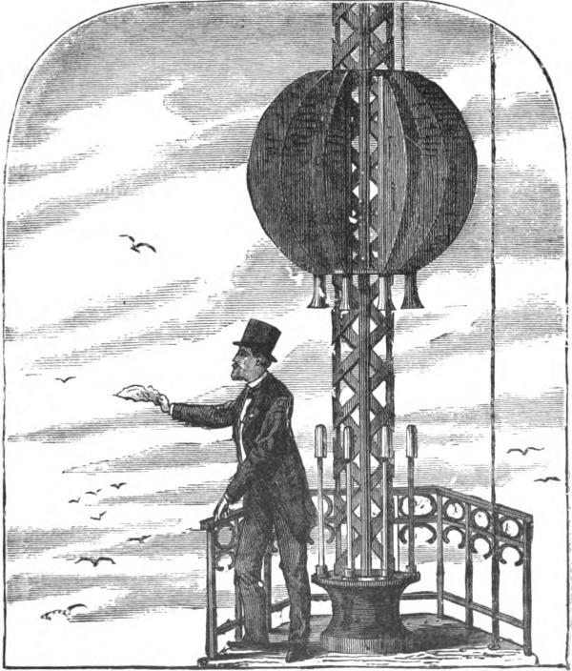
Fig. 602
and the ball drops. The instant the ball reaches the base of the pole the fact is automatically reported at Washington through the electric tell tale shown at the left end of the table, fig. 604.

1028 THE ELECTRIC TIME SERVICE.
Owing to the great height of the ball when raised, it is visible for many miles around; and directly or indirectly the clocks and watches of some two millions of people are thereby kept from straying far from the true time. Even as far off as Bayonne, N. J., according to a local paper, the principal of a public school regulates his clock daily by the falling ball. The ball and its discharging apparatus were designed by Mr. George M. Phelps, superintendent of the Western Union manufactory. The public service thus rendered by the Western Union Telegraph Company is wholly gratuitous, and affords not only a notable illustration of the public spirit of this great corporation, but also an illustration of the far reaching indirect benefits which applied

Rg. 603.
science is constantly conferring upon modern life, free of expense to the recipients.
But the time service does not end here. To reap the full benefit of the time ball, a great number of people must watch for its fall; that takes time, and time is money. It is cheaper to employ one man with a little machinery to regulate the time of all, and the service is much more surely attended to. Accordingly, Mr. J. Hamblet has introduced a system of constant time service, by which our clocks may be kept constantly under the electrical control of a central regulator or standard clock, which is kept in exact time with the clock of the National Observatory, at Washington, due allowance being made, of course, for the difference in geographical position.

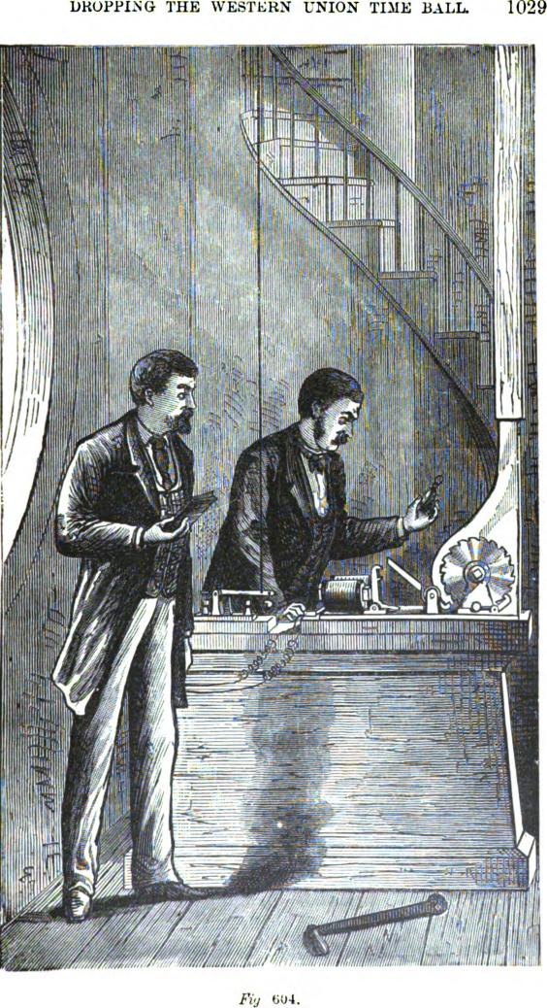
DROPPING THE WESTERN UNION TIME BALL
1029
— a
_{ri}
#
Fig 604.

1030 THE ELECTRIC TIME SERVICE.

The central regulator is stationed in the Western Union Telegraph Company's building, and is so constructed as to keep time with the highest attainable accuracy. In addition, it is every day compared with the clock of the National Observatory, at Washington, and checked by the daily time observations made at the observatories at Allegheny, Pa., and Cambridge, Mass., with which it is in telegraphic connection. By this it must not be inferred that the clock in question is kept in exact accord with either or all of the observatory clocks, that being a mechanical impossibility. The range of variation, however, is kept within a few hundredths of a second. It is possible to measure and record the hundredth part of a second. Fig. 605 will make clear how it is done. It shows a section of the paper tape of the chronograph, which is used in comparing the standard clock with the clock of the Washington Observatory. The chrono-
SW-YORK CLOCK
WASHINGTON CLOGS
0 20 48 GO 80 12.7  Fig. 605. |  |  | SW-YORK CLOCK  WASHINGTON CLOGS

graph is electrically connected with both clocks, and records the pendulum beats of each on the strip of paper. If the beats are exactly synchronous, the dots stand side by side. If the beats are not synchronous, the dots will be separated by an interval, long or short, according to the difference of the clocks—that is, the difference in time between the beginnings of corresponding beats—and the speed of the chronograph. Supposing the clock to be beating seconds, and the chronograph to discharge an inch of tape each second, it is obvious that the dots recording the beats of each clock will stand one inch apart. It is obvious, too, that the lineal space between the recording dots of two clocks not beating exactly together can easily be measured, as shown by the scale placed below the dots in the cut (fig. 605), and thereby the difference in time exactly determined.
The next step in the time service is to distribute the accurate

DISTRIBUTION OF TIME SIGNALS. 1031
time thus maintained to such as want it, which is done through an electrical attachment to the standard clock. This controlling clock was constructed by K Howard & Company, of Boston, from designs by Mr. Hamblet, and has a Dennison gravity escapement. The front clock plate and the electrical mechanism are shown in fig. 606. The wheel in the centre with the second hand revolves once a minute. One of its thirty teeth has been
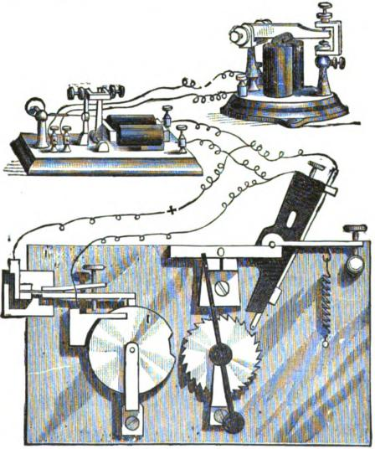
606.
filed away, the vacant space causing the omission of the tick which would otherwise mark the fifty-eighth second of the minute The remaining teeth act upon a delicate jeweled spring, which breaks an electric circuit at the passage of each tooth. The two wires connecting with this spring and its banking operate the relay, at the left of the figure, and through it the sounder,

1032 THE ELECTRIC TIME SERVICE.

which indicates the beginning of each minute by a pause of two seconds. The beginning of each five minutes is identified by a pause of twenty seconds, obtained through the agency of the five minute wheel to the left of the seconds wheel. At each revolution of the five minute wheel the lever at the top drops into the notch in the wheel, making electric connection between the two wires governing the relay, thus preventing the minute wheel from breaking the circuit for the space of twenty seconds. At the right, near the top of the figure, is shown a sounder, which may be located at any point on the lines. It is by means of these sounders, with which the recipients of the s:Tvice are supplied, that their time pieces are regulated.
The practical advantages of this constant and trustworthy time service will appear to any one who has to do with important commercial or industrial affairs. One of the great sources of friction in social and business intercourse is time variation and uncertainty. The maintenance of a common and authoritative standard will go far to lessen such friction, to the great time saving of all classes, and the prevention of many mistakes and misunderstandings. Where thousands are engaged, delays of no more than a minute at a time amount in practical effect to the loss of hours, days, even months of individual labor. In a factory employing only three hundred men, a variation of one minute in the signal for starting and stopping means the loss of one man's work for a whole day.
DUPRES CALL-STUD FOR FIRE ALARMS.
The principal advantage of this device consists in the combination of an automatic tire alarm with the ordinary push button of an electric bell. For this purpose Dupre fastened to the lower metallic strip y, fig. 608, a nut made of fusible alloy in such a manner as to prevent, under normal conditions, the con• tact of this strip with p. This push button acts like an ordinary push button until the piece of alloy fuses at a convenient temperature, ,,enerally about 37° C.; then the lower spring, g, is released, rises, and comes in contact with the upper spring, p,

ELECTRIC CALL BELLS. 1033

thus closing the circuit and causing a continuous ringing of the bell. Another arrangement consists of the combination of an automatic fire alarm with a bell pull in a manner analogous to the above.
ELECTRIC CALL BELLS.
THE introduction of call bells or alarms, which have now become of such extensive application in hotels, factories, elevators, and wherever else their service has been desirable, or where it has been found convenient to employ electricity for operating them, followed, as a matter of course, with the early introduction of the electric telegraph. The invention of these instruments may, therefore, be said to date as far back as that of the telegraph itself.
It will readily be understood that, whatever may be the system of telegraphy employed for correspondence between places distant from or near to each other, it is important, first of all, to have some means at command by which the attention of the correspondent with whom we wish to communicate may be obtained; and this, of course, for cases under consideration, includes the means of producing a noise of some kind within his hearing. A wide field has thus been allowed for the exercise of man's constructive faculties; and the devices which have been successively introduced to meet the want have consequently been exceedingly numerous. Their general development, however, has been very much the same as that of the telegraph.
Professor Wheatstone, in his earliest telegraph experiments, made use of a call which was run by clock work, the movement of the latter being controlled by the action of an electro-magnet. This seems to have been about the first really practical instrument of the kind introduced, and even it was not considered altogether satisfactory in its operation at that time. Since then, however, the apparatus has been so much improved and simplified in one way and another, and the various domestic uses to which it has been applied have given rise to so many different forms, that a knowledge of their details becomes desirable. We

1034 ELECTRIC CALL BELLS.
have, therefore, thought it worth 'our while to devote a chapter to the consideration of the more important of this class of instruments.
The push button or key used in short circuits serves to close the latter in a very simple and effectual manner. Its general plan will be made apparent by reference to figs. 607 and 608.
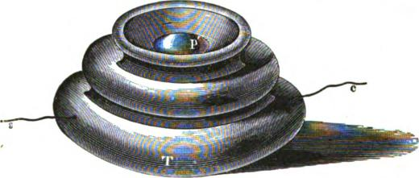
/1g. 607.
The former shows the case T of wood or other insulating substance, within which are secured the two metallic strips p and g, one above the other. In its normal state the upper strip is separated from the other by a steel or spiral spring. When, therefore, such a key is inserted in the circuit the latter remains open, but may be closed when desired by pressing upon the
P'
c
Fig. 60&
knob p', which brings the points p and g together. Upon the removal of the pressure the circuit is again opened by the retractile force of the spring.
Various patterns of keys are made to suit the different purposes for which they are to be used. The form shown in fig. 607 is the ordinary one. Fig. 609 represents another form, used for electric doer bells, in which the circuit closer is contained

COMBINATION KEYS. 1035
within a hollow in the base, the latter being usually of marble, and provided with screws for securing it wherever desired.
Fig. 610 is a convenient form for combining a number of keys within a small compass; eight push buttons, corresponding to as many distinct circuits, are arranged at equal distances around a cylindrical case, within which the connections between the

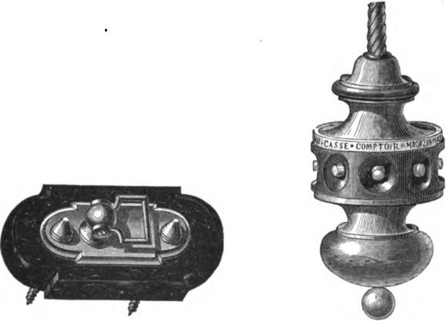

Fig. 609. Fig. 610.
metallic strips and wires are made. Each wire is separately insulated by a silk covering, and the whole wound together into a single strand, where they leave the case.
COMBINATION KEYS.
With the keys above described it is evident that the signals last only so long as the button is depressed by the operator; it will also be observed that the operator has no means of knowing with certainty that a signal has been given, and that he must therefore be still less sure of its having been noticed. To meet this defect, and provide a suitable arrangement for every requirement, a special combination is needed, such as is shown in fig.

1036 ELECTRIC CALL BELLS.
611. This consists of a case containing a magnetic needle, an electro-magnet, and the metallic contact springs a b and c d. One end of the coil of the electro-magnet E is attached to the screw e, the other to the line wire by the insulated screw V. The spring a b is connected to the binding screw r leading to the battery, the other, c d, to the plate at e, by which communication with the line is made through the coil of the electro-magne.. To the axis of the magnetic needle, A, is fastened a ping, which presses against the platinum contact r, when the lower pole is attracted by the electro-magnet, and the needle
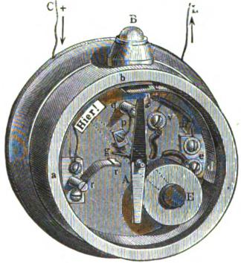
IV. 611.
thus made to take up the position represented by the dotted lines opposite which, on the cover, is the word understood, or here. The axis of the needle is also in electrical connection with the metallic back of the instrument, to which are attached the metallic plate p and binding screw q, so that all three are electrically connected. The small plate connecting with C, a and r is insulated from the back, and a spiral wire n m joins q with the binding screw e and coil of E. In its normal position the pin g rests against a stop not shown.
The operation of the key will now be readily understood.

APPARATUS FOR GIVING THE SIGNALS. 1037
When the knob B is depressed the current from C passes along ab and cd toe and through the coil of E to V, thence to line L and other apparatus, where an audible or visible signal is to be given. The attraction of the needle A by the electro-magnet E, causing the former to point to the word here on the cover, enables the operator to see that the key has properly performed its officq, At the same time the deflection of the needle brings the pin gin contact with r, so that the current now has a second route through springs r r and g, and the needle remains deflected after the finger has been withdrawn from B. Thus a continuous signal is given until noted by the person for whom it is intended, who then interrupts the circuit momentarily by such means as are provided for the put-pose. With the interruption of the circuit the needle returns to its normal position, and thus shows that the signal has been received. When a vibrating bell, to be described presently, is used for the call apparatus, a continuous to and fro movement of the needle takes place as long as the circuit remains uninterrupted.
APPARATUS FOR GIVING THE SIGNALS.

The ordinary form of bells used for giving single taps is shown in figure 612.
It consists of an electromagnet MM, opposite whose poles, n a, is placed the armature with its clapper, le. The latter, in its normal position, is held back from the bell G by a spiral spring attached to the movable upright d, which serves to regulate its tension. The stroke of the armature is limited by the set screw r. Another form devised by Breguet, in which the prolongation of the armature lever
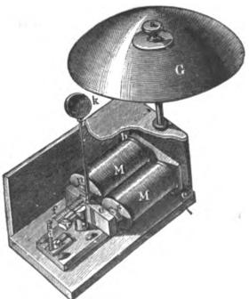
Fig. 612.

1038 ELECTRIC CALL BELLS.
is a rather stiff spring, is shown in figure 613. When such an apparatus is placed in circuit with a battery and one of the push button keys already described, a ringing tap is given every time the button is depressed. By combining a certain number of taps, with proper intervals between them, it is possible to corn.

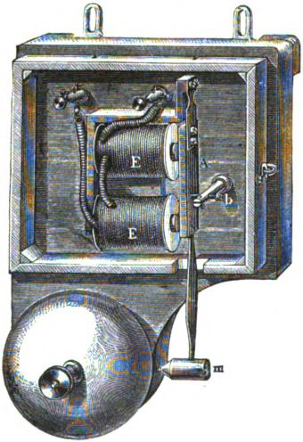
•

1Tg. 613.
municate words and sentences, and thus, besides being a simple call, the apparatus becomes a veritable telegraph.
THE VIBRATING BELL.
The principle employed in this arrangement is shown in figure 614. MM are the coils of an electro-magnet, which are so connected that one end of the wire leads to the binding post B and the other to the post C. To the latter is also attached a straight spring which carries the armature e, and, when the current is not

THE VIBRATING BELL. 1039
circulating, tends to keep it withdrawn from the poles of the magnet and against another spring, r; this again is in electrical communication with the binding post D, and both B and D are connected respectively to A and E by brass strips.
When such an apparatus is included in the circuit with the battery and push button, and the button is depressed, the current arriving at b passes through the coils to the post C and arma-
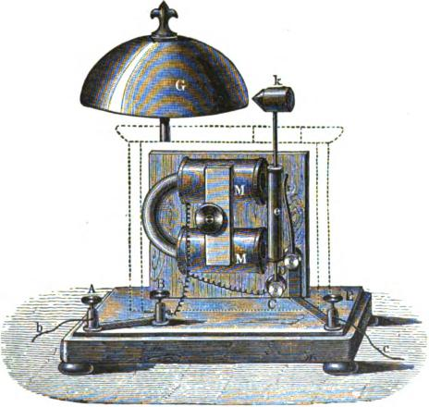
.FTg. 614.
ture e, thence via the spring r to post E and wire c, completing the circuit. The soft iron cores consequently become magnetized and attract the armature which interrupts the current at r, this causes the cores to become demagnetized again and the armature falls back against the spring, when the circuit is once more established and an attraction follows as before. Thus a rapidly vibrating movement is set up and continued as long as the button is depressed or the circuit remains closed by the needle pin before referred to.

1040 ELECTRIC CALL BELLS.
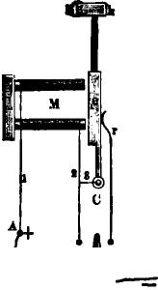
By a slight modification of the connections in the bell instilment the apparatus can be used both as a vibrator and as an instrument to give simple taps. The general plan is shown in fig. 61E., in which M and e refer to the same parts as in the last. S is a switch which can be turned on B or E at pleasure. When it is on E the connections are precisely the same as those just described and the apparatus becomes a vibrating instrument; when turned on B there is no interruption of the current with
B
Fig. 615.
the attraction of the armature, and the instrument simply re• sponds by single taps to each closing of the circuit by the push button. The path of the current, when the switch is on B and E, is sufficiently evident from the figure without further description.
DOUBLE BELLS.
When it is desirable to produce a very loud sound, double bells and double electro-magnets are usually employed in the vibrating apparatus. Figure 616 represents an arrangement of this kind. The current, arriving at the binding post C, follows the metallic strips in connection therewith to D and D', thence through the coils M M' and strips H V, H' V' to the contact springs R B' and armature A. From A the continuation of the circuit may be traced by way of B and binding post Z, which

DOUBLE BELLS. 1041
leads back to the battery. One of the bobbins, M for instance, is wound so as to produce a greater magnetic effect than that produced by the other M'; this causes the armature A to be drawn towards M until the circuit of the latter is broken at It; M' now acts alone until interrupted in turn by the break at R', when the same alternation is begun anew. Thus, at each
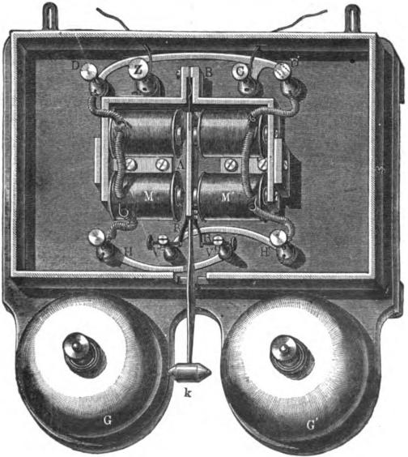
lip. 616.
vibration of the armature, one of the two bells is struck with considerable violence, and the noise, with rapidly recurring strokes, is well calculated to arrest the attention.
In double bells of this kind the line circuit is never broken by the vibrating armature—the effect of this movement being merely to shift the current from one coil to the other. This, in

1042 ELECTRIC CALL BELLS.
some particular cases, is an advantage of considerable importance.
In general, the principle of all vibrating bells is that of the self-acting make and break; but, when the contacts are rigid points, the vibrations of the armature take place only within narrow limits, and the arrangement cannot very well be utilized for ringing a bell. Siemens has devised•a plan, in his dial instruments, which answers the purpose much better, by giving the armature a greater range of movement; but the adaptation of this device to the ringing of bells for simple calls is a little troublesome, and, in fact, for general use, would be altogether too complicated. By far the most preferable way of obtaining the desired range of stroke is that already described, in which a spring of some kind forms part of the path for the current, and
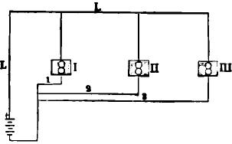
Fig. st;.
which, with the attraction of the armature, follows the latter for such a distance as ma}• be required.
When one battery is to serve for operating several of the bells above described, the vibrators cannot all be placed in one circuit, as each one intorrupts the circuit independently of the others; and it is impossible, or rather impracticable, to make the armatures of the various instruments so that they will all vibrate in exactly the same time, or always be in unison.
The plan generally adopted for such cases is shown in figure 617, where each bell, I, II, III, has a separate conducting wire of its own, as represented by the numerals 1, 2, 3, and a return wire, L L, serves for all. If, now, one of the bells is operated by the pressure of a push button in 1, 2 or 3, as the case may be,

NON-INTERRUPTING CIRCUIT BELLS. 1043
it acts without in any way interfering with the others, as they are all quite independent of the circuit thus interrupted.
SINGLE BELLS TO BE WORKED WITHOUT INTERRUPTING THE
CIRCUIT.
The fault just noticed in connection with the vibrating armature, causing a break at each vibration, may be remedied in a very easy manner simply by causing the armature to cut its own magnet out of circuit after each attraction. The principle works very satisfactorily, and will be readily understood by reference to figures 618 and 619, which represent two phases of its application. m m are the coils of the electro-magnet; a, the armature to which the clapper k is attached by means of a rather stiff

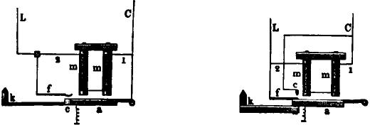

Fig. 618. Pig. 619.
spring, and f an elastic steel spring, which readily follows the to and fro movement of the armature for a short distance. In figure 618, the armature itself forms part of a shunt circuit, by which the current is withdrawn from m m. As will be seen, a current arriving at C passes through the wire 1, coils m m and wire 2 to the line L; the armature is thus attracted to the spring f, and a second route made for the current by way of a c f As the resistance of this route is exceedingly small, compared to that of the helices, almost the entire current passes by the new path, and the cores become demagnetized. The retractile force of the spring now preponderates, and the armature falls against the back stop, breaking the shunt circuit on its way. By this means the magnetism of the cores is again renewed, and a con-

1044 ELECTRIC CALL BELLS.
stant vibration kept up. In figure 582, the forward movement of the armature brings a spring f against a contact c, and forms the shunt quite independent of the armature.
As either of these arrangements does not break the main circuit, any desired number of them can be placed in the same line and worked without interfering with each other.
When the bell system is to be used for long distances, or when a very loud ringing is desired, for which purpose the main line current, as a rule, is not sufficient, a relay and local battery are
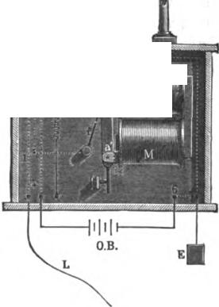
generally used; and with the heaviest apparatus, requiring still more power, the ringing is done by means of weights.

41141, ',0'm
Fig. 620.
Figure 620 represents an arrangement devised by Aubine, in which a single set of electro-magnets, M M, serve both for the relay and the call. A small projection on the upper end of the armature a, when the latter is in its normal position, supports the lever 8, keeping it from making contact with spring 4, and, at the same time, holding it firmly against spring 2. When now a current is sent into the line, it passes along the connection 1 to

ELECTRIC ALARM WITH RELAYS. 1045
spring 2, thence to lever 3 and its connecting wire to spring f and armature a, and from there on through the coils to earth. This causes an attraction of the armature; lever 3 falls down on spring 4 and closes the local circuit, which again results in a magnetization of the core. The armature is thus made to vibrate in the manner already described, and a violent ringing is set up, which continues until, by pressure on the knob b, lever 3 is again raised and supported by the armature projection.
I)
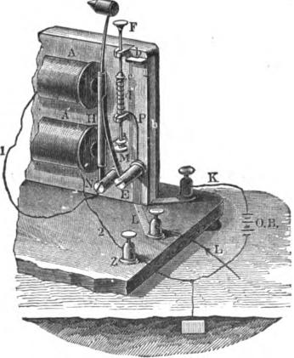
Fig. 621.
Figure 621 represents another relay based upon similar prin. ciples, and much used in France. The main line circuit is sufficiently apparent without further explanation. The local battery O B is inserted between the binding post K and Z. From K an insulated copper strip b b leads upward, and at the top is bent so as to catch the pin e, when the latter is carried upward by the spiral spring d. A projecting pin from the armature, when the latter is not attracted, serves to keep the rod F M depressed. With the arrival of the line current the armature is attracted and

1046 ELECTRIC CALL BELLS.

the rod released; this allows the spring d to act, and close the local circuit at e b when the ringing is commenced. By pressing on the knob F the lower end of the rod is caused to engage with the projecting armature pin, and the apparatus is once more ready for another call.
SIEMENS AND HALSKE'S STATION ALARM.
This is shown in figure 622, and consists of an ordinary relay and bell magnet, with an automatic make and break arranged upon the same principle as Siemens' dial instrument. m in are the coils of the relay magnet, and P and 1² its terminal wires, one of which leads to line, the other to earth. The poles only of the bell magnet are shown at M M, one of its coils is connected 'to the binding post Z, the other to a V shaped piece of metal, termed the shuttle, which, in its normal position, rests with one end against an adjustable screw in the plate E, the latter also in metallic connection with the relay lever a. The local battery is joined to the binding posts Z and K. When a current is sent into the main line the armature a is attracted and closes the local circuit; this charges the magnet M M and actuates armature A, but after passing a little distance the long projecting arm on the latter moves the shuttle against the stop r and breaks the local circuit; the spring F, being no longer restrained, now withdraws the armature, but in doing so causes the shuttle to close the circuit once more, and thus a constant ringing is maintained as long as the main line is closed.
BREGUET'S ALARM OR CALL.
With most of the apparatus heretofore described the call or alarm is only maintained for such a period of time as the circuit may be closed by the person giving the signal, or, as with the arranement shown in fig. 620, until the messenger called stops the ringing by depressing the knob. Various other combinations have been suggested by Aubine, Breguet and others, by means of which a single signal is made to give any number of taps.

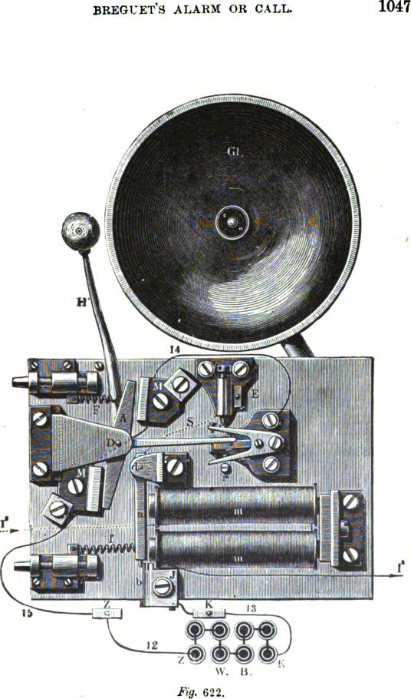
1047
1
BREGUET'S ALARM OR CALL.
I 001101014ol
w. B.
.Rg. 622.

1048 ELECTRIC CALL BELLS.
Breguet's arrangement is shown in figure 623, and its operation may be described as follows: The line current arriving at L in consequence of the key being depressed, passes to the contact screw S, thence by way of the lever C c, pivoted at C, through the coils of the electro-magnet E to the armature a and contact b to earth. The armature is thus drawn forward for a short distance, but returns immediately afterward, owing to the break in the circuit occasioned by the movement, and closes the circuit again. In this manner a vibratory motion is set up, and with each backward movement of the armature the toothed wheel R
F1g. 623.

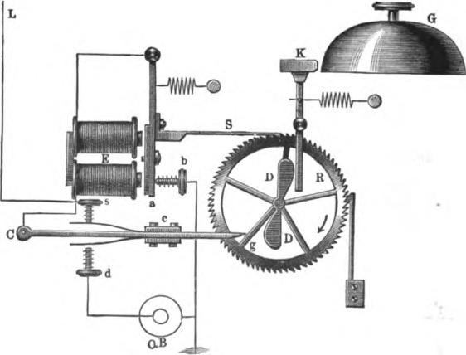
43.B
is forced forward one cog, so that the lever c C is soon released from the pin g and falls on the contact screw d, placing the local battery in circuit. The continued vibration of the armature keeps the wheel in motion, the arm D is thus brought against the hammer lever, and the latter carried forward a certain distance and then released, when the hammer strikes against the bell with considerable force. With the complete revolution of the wheel the pin g engages with the lever C c again, and once more closes the main current.

COMBINATION OF CALL BELL AND RELAYS. 1041)
COMBINATION OF A SINGLE CALL BELL WITH TWO OR MORE
RELAYS FOR SEVERAL LINES.
When two or more wires terminate at one place a single call bell may be made to answer for them all, but in such cases each relay must be provided with some arrangement such as the rod F M in fig. 621, to show on which of the lines the signal has been sent. Fig. 624 shows an arrangement of this kind. A is the electro-magnet of the relay, whose armature ends in a bent hook, H, which engages with the rod F I; m and n are two screws attached to the upright, D K, and serve to limit the play
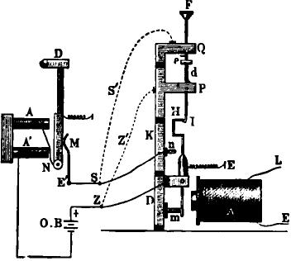
Fig. 624.
of the armature. This upright is made in two parts, insulated from each other; the one marked D is connected to one.pole of the local battery; the other, K, is connected by a wire S to the interrupting spring M of the vibrating bell already described. When the armature of the relay magnet is attracted, its upper part is brought in contact with the screw n and the lopal circuit is completed, at the same time the attraction of the armature releases the rod F I, which is raised by the action of the spring d, and thus shows, when attention is called by the bell, which line has given the signal.

1050 ELECTRIC CALL BELLS.

Each of the several relays are connected with the bell magnet in the manner shown in the figure, so that there are virtually as many distinct keys for closing the local circuit as there are relays. After the call has been observed the knob F is again depressed when it engages with the armature and is held until released by another signal.
It is frequently desirable that the bell should continue to ring after the main line current has ceased; and, in order that this may be the case, the upper part of the pillar D K, fig. 624, is made the same as its lower part, in two sections, P and Q, and each insulated from the other. Two wires, S' Z', shown by the dotted lines, connect Q and P respectively to the wires S and Z when, therefore, the rod F I is released, the action of the spring d bri❑gs the small platinum tipped piece e against a similar contact on Q and forms a second closing of the local circuit, so that the bell continues to ring until the call has been observed and the knob depressed.
SIEMENS AND HALSKE'S RELAY WITH ANNUNCIATOR PLATE.
These instruments are made in a very perfect manner, and are much used on the German Fire Alarm Telegraph. Fig. 625 represents a perspective, and fig. 626 a sectional view of the relay, which does not differ materially fro:n the ordinary forms, except in the addition of the annunciator disk and lever b c d, pivoted at c. The relays are made for both open and closed circuits, the one represented being designed for closed circuits. The line connections are male at 1 and 2. K and B connect with the Morse recording apparatus, while the alarm bell is joined to A and the metallic piece W V. In its normal state the lever of the disk is held in a horizontal position by the hook on the lever a a, but with any interruption of the main circuit the armature is drawn off by the action of spring/ and releases the disk, which is now raised to a vertical position by the weight b; this closes the call circuit at i at the same time that the armature a a, falling on the back contact in, actuates the Morse recording

RELAY WITH ANNUNCIATOR PLATE. 1051

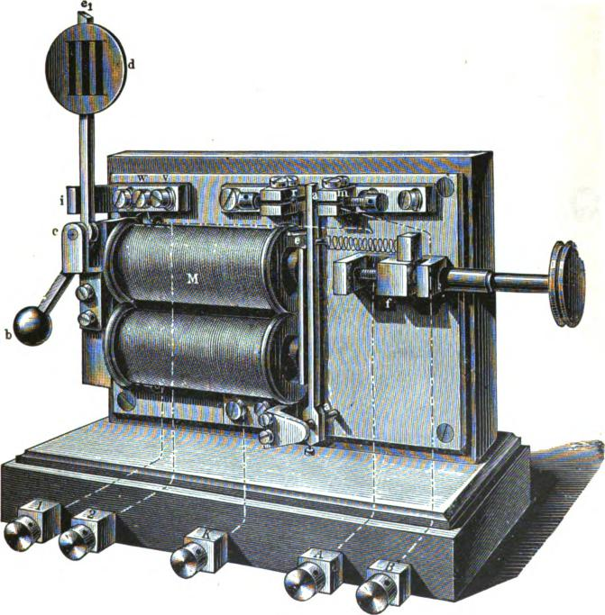
Fig 625.

1052 ELECTRIC CALL BELL&
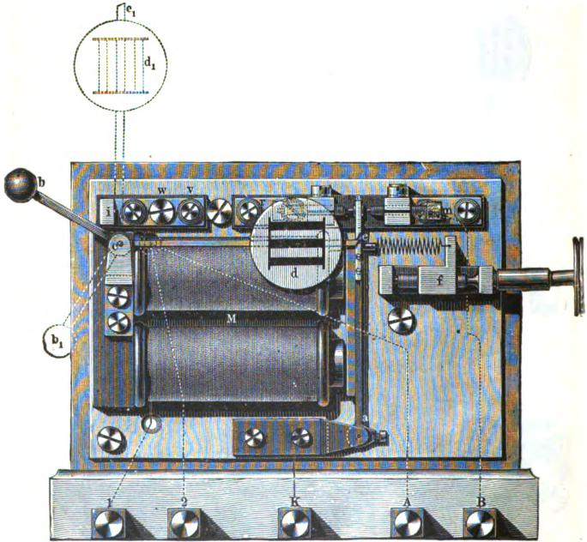
Fig. 626.

CLOCK WORK ALARM. 1053
instrument. When the automatic vibrating bell is used the ringing is kept up until the lever and disk are returned to their horizontal position by the operator.
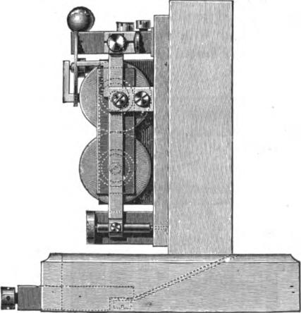
Mg. 627.
CLOCK WORK ALARM.
These calls are constructed in various ways, to suit the different purposes for which they are to serve; in some the hammer is operated by weights or springs, and made to give a single stroke for each impulse of current sent into the line; in others, the strokes are repeated a certain number of times; or again, the ringing is continuous; but in all cases the current has only one function to perform, that of releasing the train of clock work. This is usually accomplished by the action of an electromagnet on its armature, and the weights or springs cause the signalling. An important and much used apparatus of this kind is that of Efagendorff 's, which gives but a single stroke for each depression

1054 ELECTRIC CALL BELLS.
of the signaling key, and which is therefore preferable to the vibrating bells for many purposes, especially in places where the rattle of the latter is likely to be more or less annoying.
The use of weights or springs for causing the separate bell taps is also to be preferred to the tapping from a clapper cartied by the armature lever, as with the latter arrangement, owing to an occasional tardy withdrawal of the hammer, the signals are not always very distinct.
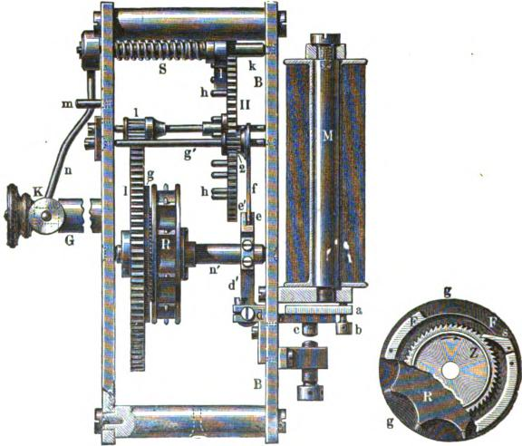
Fig. 628. Fig. 629.
Figures 628 to 631, inclusive, show the princip❑l parts of Hagendorff's apparatus; the letters refer to the same parts in each figure.
Figure 628 gives an interior view of the works. B B is part of the brass frame to the back of which is attached an electromagnet M; fig. 630 represents the inside view of the same plate. The wheel I, fig. 628, is loose on the axis n' and carries a disk

CLOCK WORK ALARM. 1055
g, better shown in figure 629; this is provided with a detent S and spring F F, which presses the former into the teeth of the ratchet wheel Z, thus preventing the latter, as well as the wheel R_{I} which is fastened to it, from turning in the direction indicated by the arrow without at the same time causing the wheel 1 to turn with it The wheel R is provided with radial pins which catch in a chain passing over it and attached to the weight P,
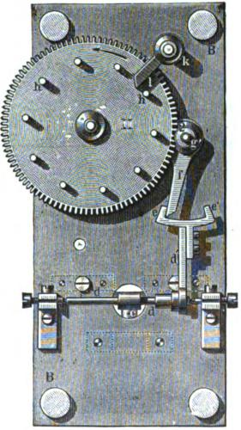
Fig. 630.
fig. 631, the pins serving to prevent the chain from slipping. As will be seen, the ratchet allows the wheel Z and R to be freely turned in a direction opposite that indicated by the arrow; this raises the weight P, which, in descending again, sets the whole train in motion, wheel 1 communicating its movement to wheel 11, and the latter, in turn, acting on axis g' and stop lever f connected to it

1056 ELECTRIC CALL BELLS.
The wheel 11, fig. 630, carries near its circumference eight or ten projecting pins, h h, which raise the arm 1 on the axis A A powerful spring, S, surrounding this axis and in communication with it and with the frame of the apparatus, tends continually to keep the arm depressed. When, therefore, the latter is raised by the revolution of the wheel the spring is subject to considerable tension, and as soon as a pin passes from under the arm, causes
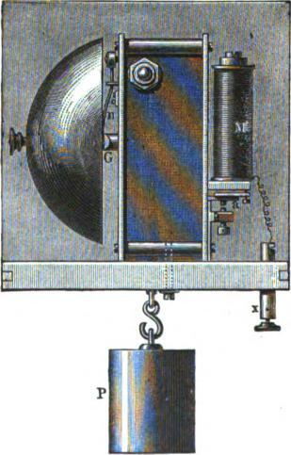
IQ. 630.
the latter to descend, and the hammer K, attached to the axis k by the arm n, strikes the bell with some violence. The pin m serves to limit the play of the arm n.
Figure 628 represents the relay armature attracted. When no current passes in the coils of the magnet the armature remains down and the train work is arrested by the arm f, which catches in the escapement d' e e'. The ends e e' of the escapement are so made that the back one e is a little nearer than the front

CLOCK WORK ALARM. 1057

one e to the plate B B, but the two are attached to one piece, and move together with any movement of the armature. The operation of the apparatus will now be readily understood. When a current is sent into the line the armature of magnet M is attracted, the front point é of the escapement, fig. 628, is moved to the left, and the arm f is carried forward by the action of the weight on the train work to e, and as soon as the circuit is broken e moves toward the back B B, and the arm makes one complete revolution, when it is stopped again by el. Simultaneously with this movement the pins h h pass under the arm 1, and the hammer strikes against the bell, making one tap for each make and break in the circuit.
THE ELECTRO-MOTOGRAPH.
The salient feature in this discovery is the production of motion and of sound, by the stylus of the Bain telegraph instrument, without the intervention of a magnet and armature. By the motion thus produced, any of the ordinary forms of telegraph printing or sounding instruments or relays may be worked. More than this, the apparatus operates in a highly effective manner under the weakest electric currents, rendering it possible to receive and transmit messages by currents so weak that the ordinary magnetic instruments fail to operate, or even to give an
, indication of the passage of electricity. The apparatus is shown in figs. 632 and 633.
In fig. 632 A is a lever pivoted upon a universal joint C, and is provided at its extreme end with a screw F, tipped with platina, resting upon a strip of moistened paper, which is carried. forward (in the direction shown by the arrow) by the drum G. This drum G is continuously rotated by clock work. The spring S is used for the purpose of creating a pressure of the point F on the moistened paper.
The spring R is to draw the lever to the left and against the point X. L is a main battery, K a key. The zinc pole of the battery is connected to the point F, while the carbon pole is connected to the metallic drum G, through the key K. When K

1058 THE ELECTRO-MOTOGRAPH.

is closed, the chemicals with which the paper is saturated are decomposed by the passage of the current through the paper, and the lever rests against the point X, closing the local circuit containing the sounder AX and local battery LB. If the key K is opened, the normal friction of the platina point F upon the paper is so great that the spring R is insufficient to keep it against the point X, and it is carried forward by the rotation of the drum to the point D, where it remains until the key K is again closed; then, by the passage of the current, the friction is reduced so as to be imperceptible, and the spring R easily pulls the lever against X, where it remains as long as the current is allowed to pass. As will be seen from this brief description, the
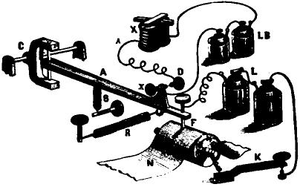
/lg. 632.
lever is moved backward and forward by a difference in frictions, caused by the decomposition of the chemicals (a solution of chloride of sodium and pyrogallic acid), with which the paper is moistened, by the passage of the current.
Why the paper becomes so extremely slippery on the passage of the current, the inventor is unable to state.
The apparatus is extremely sensitive, and can be worked over a circuit of two hundred miles with two cells of battery. Some idea of its wonderful sensitiveness may be formed from the statement that by employing a delicate construction of mechanism and using clock work to actuate the same, a movement of the lever has been obtained, sufficient to close a local circuit,

THE POLARIZED HOTOGRAPH. 1059
with a current that was incapable of discoloring paper, moistened with potassic iodide, or of moving the needle of an ordinary galvanometer.
Unlike a magnet, no secondary currents are set up, upon opening and closing the circuit, to delay the movements of the lever; neither has it cores to consume more time, in charging and discharging, but moves with a maximum effect instantly.
The plan shown in fig. 633 is called a polarized motograph.
The key K alternately connects the batteries A and B to the lever of the motograph, one sending a positive and the other a negative current. The current from the battery A passes to the
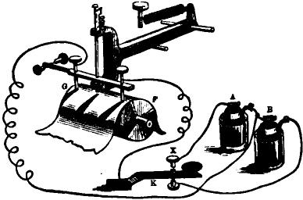
Fig. 633.
point X, thence through the paper to the point G, up through G back to the other end of the battery A. Thus hydrogen is generated on the point F, which becomes slippery, while oxygen is generated on the point 0-, which retains its normal friction; hence the point G is carried to the right by the rotation of the drum. If the direction of the current be reversed by putting on the battery B, hydrogen is generated on the point G, which becomes slippery, and oxygen on F, which retains its normal friction, and the lever is thrown to the left.
The diagram is arranged merely to illustrate the principle of the invention.
In practice, a single battery and reversing key are used.

1060 THE ELECTRIC COUNTER.

DUMOULIN-FROMENT'S ELECTRIC COUNTER FOR GAS METERS.
The method hitherto most frequently employed for ascertaining the revolutions of a machine was to mechanically connect the counter with the rotatory shaft. Some used the electric current, which made a new figure appear on the counter at each emission of the current. The problem is far more difficult, however, when we have to deal with several independent apparatus, each with its own rotation, and when the counter must totalize the numbers of the separate shafts.
In some cases mechanical transmission cannot be used, for the totalizing counter must be placed at a distance so that readings can be made at any hour, day or night, and no light is allowed to be brought into the places where the partial counters are placed. Electricity had to be used to fulfil these conditions, and M. Dumoulin-Froment has succeeded in surmounting all these difficulties. As the movements of gas meters are absolutely independent of each other, it might happen that at certain moments there would be a concordance between the current emissions of two or several of the meters, in which case the various currents arriving simultaneously in the totalizer, the action would be exactly the same as for a single emission, and the totalizing counter would be practically in arrears of the actual consumption as indicated by the partial counters.
The inventor has met this difficulty by storing the simultaneous emissions of the current, to send them only in succession to
the totalizing counter, so that each will have the same effect as if it were alone at the time. He has brought into requisition for this purpose the remanent magnetism of electro-magnet. Fig. 634 represents the distributing system which stores the current emissions and sends them successfully to an ordinary shaped electric counter, fig. 635, which adds them up. The separate parts of an electro-magnet of the distributor are show⁻0 in fig. 636.
The distributor contains four electro-magnets, the details of which are seen in fig. 636. Each of them communicates with

DUMOULIN-FR0MENT'S ELECTRIC COUNTER 1061
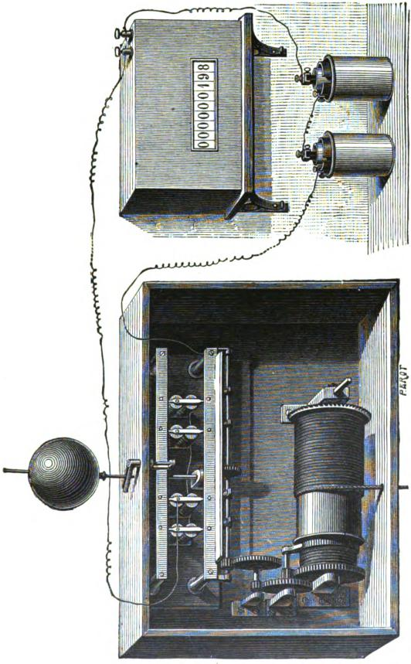

1062 THE ELECTRIC COUNTER.
one of the partial counters, and is traversed by a current at the moment that there has been a complete rotation of the shaft of the corresponding partial counter. Before each electro-magnet A (fig. 636), is an iron plate, B, separated from the poles of A by a delicate spring B.
The totalizer can receive no current as long as the armature remains attached to the electro-magnet It is only when the blade leaves the electro-magnet that there is an emission of the current in the totalizer. We must, therefore, avoid having two armatures leaving their electro-magnets at the same time, in order to
prevent the corresponding emissions being confounded and mingled in the totalizer. To do this, we have a clock work run by weight and regulated by a conical pendulum, which produces the rotation of the shaft as seen in the section in C. The shaft has a cam in front of each electromagnet, these cams being wedged in such a manner that the steel knives at their ends are regularly arranged in a spiral form round the shaft. During their rotation the cams meet the pieces D, fixed at the lower end of the armatures B, when these latter are set against the electromagnets A. The rotation of the shaft, C, is considerably shorter

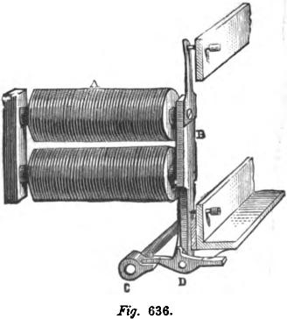
Fig. 636.
₋,_{r}

CARPENTER'S PROPORTION GALVANOMETER. 1063

than that of the gas meters. The working of the system is as follows:
The armature, B, of each magnet remains separated from it as long as the corresponding counter has not finished its revolution. At that moment a current is sent into the electro-magnet, A, and the armature, B, is attracted. The current sent by the partial meter traverses the electro-magnet, A, but for a short time, while the armature, B, remains attached to the electromagnet by the action of the remanent magnetism, and the totalizer receives nothing; the rotation of the shaft, C, however, puts the cam in motion, the armature is separated from the electromagnet, and, at the same moment, a current is sent to the totalizer, which indicates a unit more. In the next revolution, if the armature has not been again attracted during the interval, the cam on the shaft, C, will pass on without touching D, and there will be no emission to the totalizer as long as the armature, B, is not again attracted. As the gas meters make their revolutions less rapidly than the shaft, C, there cannot be two successive emissions until the cam has detached the armature, and consequently, there can be no revolution that is not marked. In case the four gas meters should complete their revolutions simultaneously the four electros would simultaneously attract the four blades, but the four currents would only be sent successively to the totalizer, since they correspond to the successive passage of the cams before the pieces D. The totalizer would thus mark the right indications in any case.
CARPENTER'S PROPORTION GALVANOMETER.
This apparatus, fig. 637, is composed of two circular frames arranged at right angles and containing two identical circuits. There is a small magnetic needle suspended by a cocoon thread in the centre of the instrument, free to turn in a horizontal plane, and a mirror, which allows the positions of the needle to be ascertained exactly.
The aim of the apparatus is to give the direction of the horizontal component of the magnetism at the point of the field

1064 CARPENTER'S PROPORTION GALVANOMETER.
where the needle is situated. Now, at any one point of this field, the force that a magnetic pole would bear—supposing the terrestrial action eliminated—results from the composition of the forces issuing from each of the two circuits, when they are traversed by a current. In the centre those two forces are
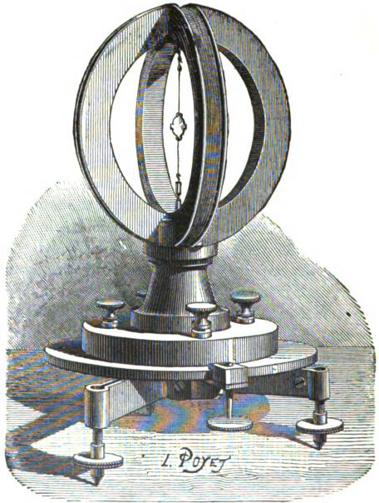
Mg. 637.
horizontal, perpendicular to each other, and proportionate to the respective intensities of the currents that engendered them. The resultant is, therefore, horizontal, and its direction depends only on the proportion of the intensity of the currents. This proportion is given very exactly by the trigonometric tangent of the

MEASURPNG RESISTANCES. 1065

angle a, formed by the resultant and one of the components. The angle is besides very easily measured. The instrument, therefore, gives the proportion of intensities of two currents, and this fact may be made the basis of a certain number of applications, among which is the measuring of resistances.
Measuring Resistances.—The two coils of the galvanometer being identical, a current that is intended to bifurcate between them will divide into two exactly equal currents. But, supposing a resistance that is to be ascertained is added to one of the circuits, the division of the current will be made in inverse proportion to the resistances. Another method would be to add at the same time to the other circuit a known resistance of the same order as the unknown resistance, so as to keep the readings in a part of the scale where they are more exact and more easily found. The instrument, however, gives the proportion of intensity of the derived currents and, therefore, gives the proportion of resistances, or the value of the unknown resistance inserted with the known resistance of the circuits of the apparatus. For convenience of the calculation, an ohm is given as the resistance to the circuits of the galvanometer.
The observations having been made on a scale of tangents, the calculation shows that the relative error made in estimating a resistance, x, is proportional to the relative error of reading,
properly so called, and to the factor in which R is the com-
mon resistance of the two circuits of the compass.
If the unknown resistances are always added to the same circuit of the galvanometer, the angular field of the readings is reduced to 45 degrees.
Adjusting the Apparatus.—The forces that belong to each circuit must be perpendicular to each other. These two forces must be equal for a same intensity of current. The two circuits, joined end to end, will be simultaneously traversed by a current. The needle must occupy the diagonals of the angle formed by the two positions which it would take if the current passed successively into each circuit. If this condition be not fulfilled, The length of the wire of one of the coils must be increased or

1066 SIEMENS ELECTRIC FURNACE.

diminished. The circuits must have the same resistance. Any current that bifurcates between them should divide into two equal derivations, and the needle mark a deviation of 45 degrees. If this condition be not filled, the value that is lacking on the less resisting circuit will be completed by a wire that must be outside the frame, and which, consequently, will not change the action of this circuit on the needle.
Influence of Terrestrial fflagnetiam.—All that is requisite to eliminate the disturbing action of terrestrial magnetism is, either to place the suspending thread of the needle parallel to the lines of force of the terrestrial field, or, the apparatus remaining vertical, to restore the needle to equilibrium in the plane of the magnetic meridian, by a rotation at each observation.
SIEMENS ELECTRIC FURNACE.
This apparatus, fig. 638, is a voltaic arc regulator, in which the arc is represented by the material to be fused, or already melted, the positive pole by a crucible of gas carbon or graphite, and the negative pole by a bundle of carbon rods. The substance fused by the arc is generally a quantity of steel, consisting of broken files.
It is the heat developed by the resistance of the metal to the passage of the current which produces the fusion. To regulate the length and the resistance of the arc maintained in the crucible, a solenoid, included between the upper carbon and the crucible in a derived circuit, is employed. This coil attracts a core of soft iron suspended from the extremity of a scale beam, and acting thereby to lift the upper carbons attached to the opposite end of the lever, maintains at every moment a proper separation between the carbon crucible and the opposed pole, however the condition of the material submitted to fusion may vary. The regulation is adjusted by a weight gliding upon the beam. The current is supplied by a powerful Siemens continuous current dynamo-electric machine.
To accomplish the fusion of steel, it is necessary to produce a temperature higher than 1,800°, and to supply a quantity of heat

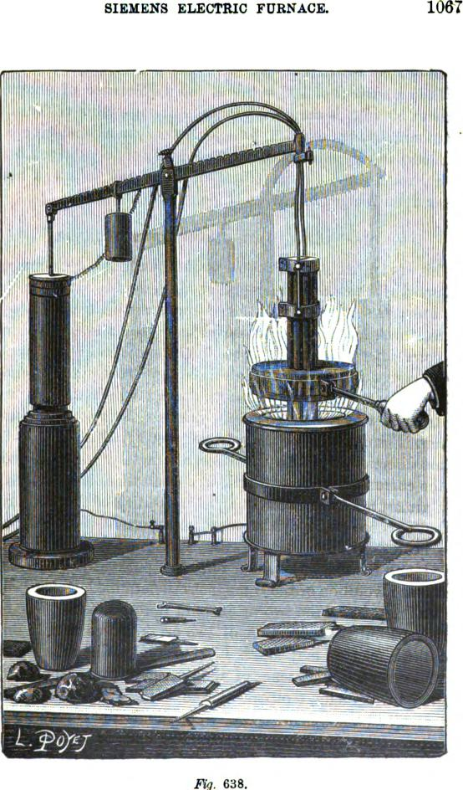
SIEMENS ELECTRIC FURNACE.
1067
1¹
I ,
oOloi 77⁻
638.

1068 ELECTRO-CHRONOMETRIC INDICATOR.

which theoretically must be at least equal to 850 joules per pound of steel fused.
When a current of 100 amperes and a difference of potential of about 50 volts is employed, there is disengaged in the furnace an amount of heat equal to 5.04 joules per second, which corresponds to an expenditure of electric energy of about seven horse power, requiring an expenditure of about ten effective horse power upon the generating machine.
THOMAS' ELECTRO-CHRONOMETRIC INDICATOR.
This apparatus, fig. 639, consists of a straight electro-magnet, the poles of which are prolonged at right angles to the core by two armatures, which clear the spool, and are again bent at right angles toward each other, close to the spool and parallel with the core. Between them there is left a space wherein a permanent magnet, in the form of an S, is supported upon a vertical axis. This axle carries an endless screw which engages with the train of wheels that drives the hands. Every half minute a current is sent through the electro-magnet by the regulator, first in one direction and then the other, alternately. The direction of the current is so determined, that each time it develops in each armature of the electro-magnet a polarity of the same kind as that opposed to it by the contiguous pole of the S magnet. The nearest or like poles of the S magnet are, therefore, repelled, and the most remote or opposite poles attracted, whereby a half revolution of the S magnet is determined, which brings the unlike poles of the two magnets in juxtaposition. . The current is permitted a duration of two or three seconds, in order that the S magnet may attain its position. When the electric current ceases, the influence of the S magnet causes the electromagnet to maintain, temporarily, the polarity it had acquired, and to act as a magnetic break, which holds the S armature in position. The transit of the succeeding current in the reverse direction inverts the polarization of the electro-magnet, and causes the S magnet to complete its revolution, and so on. The endless screw engaged with the train of wheels carries the hands

THOMAS' ELECTRO-CHRONOMETRIC INDICATOR. 1069
forward at each movement. In virtue of its inertia, the S magnet tends to fly past the position of equilibrium. To obviate this inconvenience, the velocity it has acquired toward the end of
each half turn is retarded by a pin inserted in the axle of the endless screw, which rubs against a flexible strip of metal depending from the frame above.

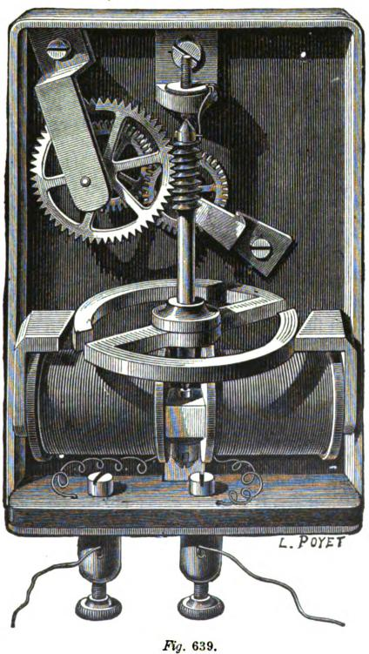
dahth/Madlilk/hildiaaa.
77-_{N}
_{loon}
;
r: I It'll .₁

Fig. 639.

1070 ELECTRO-AUTOMATIC FIRE EXTINGUISHER

The apparatus requires no further regulation. The rotation is produced, whatever may be the distance between the extremi• ties of the S armature magnet and the electromagnet, and this distance may vary between one and three-twentieths of an inch. The electric force acts, through the electro-magnet, upon the long arm of a lever, the S magnet, while the effect is transmitted by the short arm of the lever, the endless screw, which is the inverse of other gearing. The power of the apparatus may be graduated by the dimensions of the S magnet, and of the elec-tro-magnet, and by the size and length of the wire which surrounds the soft iron core. By augmenting the intensity of the 'battery employed, a great number of clocks may be included in one cir,cuit, and dials of six feet in diameter may be associated in circuit with the smallest clocks.
MAXIM'S ELECTRO-AUTOMATIC FIRE EXTINGUISHER FOR
USE IN THEATRES.
As fires in theatres almost invariably begin on the stage, the system of automatic extinguishers is established there; the upper part of the stage—the friezes—being provided with a regular system of suitably distributed pipes. These pipes are ordinarily filled with slightly compressed air, the water being stopped by a cock, which can be seen in fig. 640, under the footlights. In the upper part are cocks that are kept closed and out of gear when in their normal position. Small combustible cords, stretched from the dangerous points, keep in place the gearing, which prevents the cocks from opening. In case of fire, the cords are naturally burned, the cocks opened, and the air escapes, while by a combination of levers and gearing, worked by a valve, kept raised by the air pressure, the cock beneath the stage is opened, the water under pressure flews through the pipes, which were previously filled with air, and is poured in streams over the points where the cords were burned, and at once inundates the place where the fire began.
Mr. Maxim employs electricity for the purpose of obtaining a rapid disengaging gear, and thus dispenses with the cord and

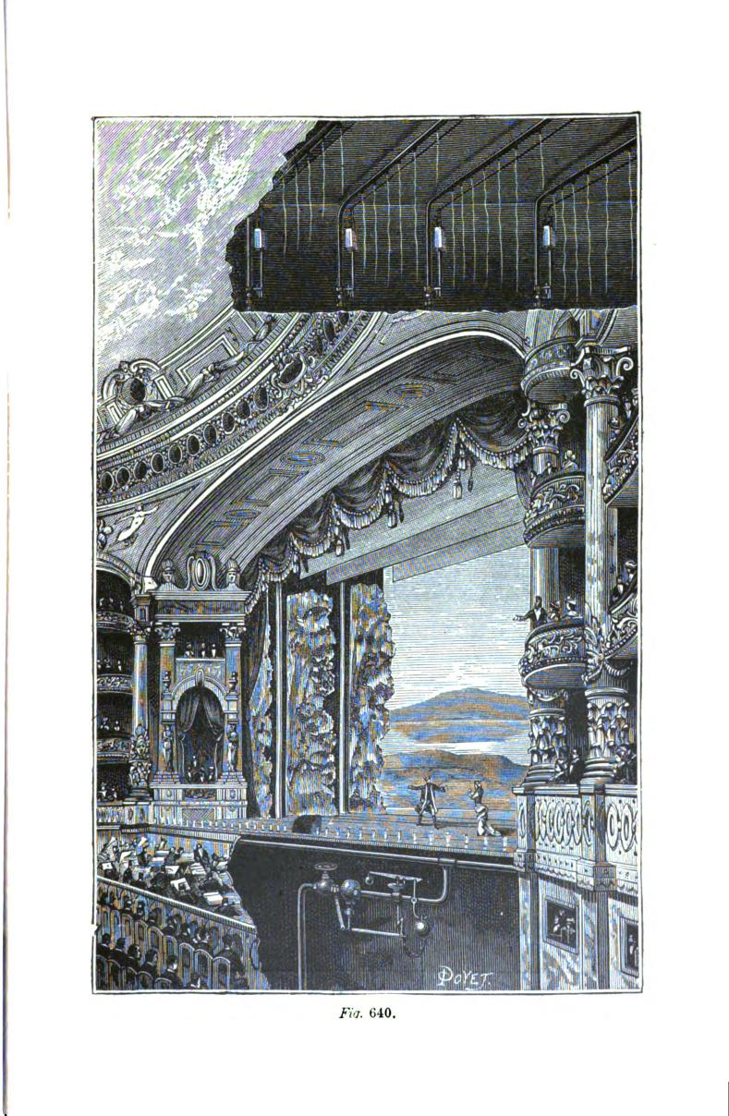

1072 ELECTRO-AUTOHATIO FIRE EXTINGUISHER.
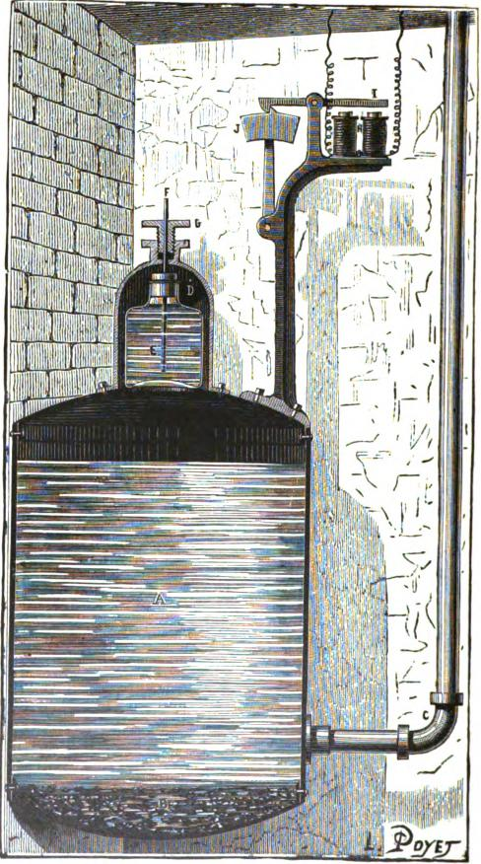
Fig. 641.

ELECTRO-AUTOMATIC FIRE EXTINGUISHER. 1073

the compressed air in the pipes. Fig. 641 shows this arrangement. A reservoir, A, filled with water, is provided with a dome, D, in which is a glass bottle containing sulphuric acid. When one of the electric alarms is set going, it sends a current into the electro-magnet, II, the armature I is attracted and releases the hammer, J, which falls on the iron rod, F; the latter slides in its packing and, striking the bottom of the bottle, breaks it. The acid falls into the water and comes in contact with pieces of chalk in the bottom of the reservoir, A, thus immediately disengaging an abundant supply of carbonic acid gas, by which the water is put under pressure and inundates the point in danger.
To open an aperture near the burning point, a few cells of Leclanche's battery are used, while water holes in the shape of ajutage and closed with a cap are arranged at certain distances from each other. The stopper cap contains a little gun cotton, which is inflamed by a platina spiral which connects with the battery and the fire alarm. The result is, that the water under pressure escapes at the point where the local explosion takes place on the breaking out of fire.
In another arrangement devised by Mr. Maxim, fire alarms are arranged along the stage for the purpose of closing an electric circuit when the temperature rises above a certain degree at that point. This alarm is composed of two metallic plates, R R (fig. 642), forming a spring, separated by a small block of fusible metal T, which is electrically insulated from the plates R R, by two small sheets of paper. Similar apparatus are placed at suitable distances. If the temperature rises sufficiently to melt. the metallic block T, the plates will come in contact and close the circuit.
The current then traverses the electro-magnet M (fig. 642), which attracts the armature N, and causes the lever N O to swing. The weight, F, being no longer kept in a vertical position, falls, and describes from left to right a quarter of a circle. A hand, G, which is fixed on the same lever as the weight F, frees the end of the lever H. The weight F, acting on II, by a combination of levers P and K, opens the cock C, and the water

1074 ELECTRO-AUTOMATIC FIRE EXTINGUISHER.
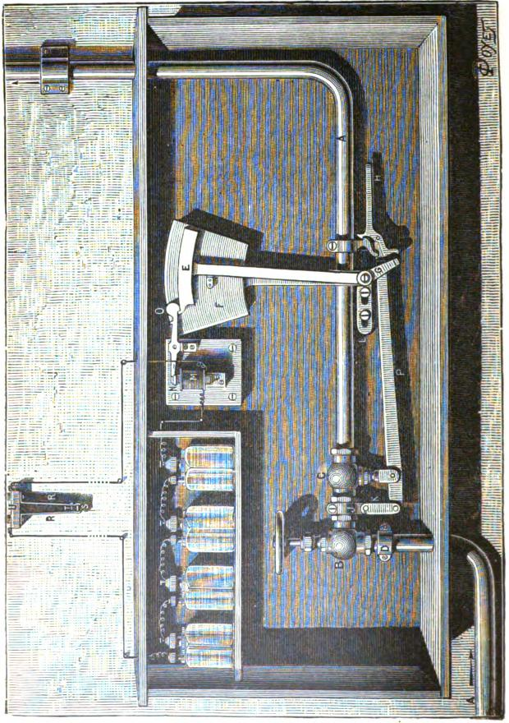

ELECTRO•AUTOMATIC FIRE EXTINGUISHER 1075
in the municipal main, being no longer stopped, flows freely into the pipe system A. The apparatus also opens a pipe in the neighborhood of the alarms, and inundates the threatened point.
The pipes have orifices, A, fig. 643, closed by a cap B, having an elastic and water tight washer, C. It is kept in place by screws D D, having a wormed shoulder which screws in turn in small cylinders containing gun cotton or other explosive matter. The screws D are perforated lengthwise by a central hole through which very combustible wicks are passed. If a fire bursts out, the wicks take fire, explode the gun cotton, the cap is blown off, and the orifice is opened. In another arrangement the aperture is opened by the electric current. To this end
each of the small cylinders, like those in fig. 641, has an insulating socket traversed by a conducting wire. The lower extremity of this conductor has a small platina wire connected with the negative pole of the battery, while the positive pole is attached to a wire which is rolled in spiral form round the wire leading to the upper extremity of this conductor. The two wires are separated by a very combustible insulating substance, and a coating of a conducting fusible metal. The combustion of the insulating matter and the fusion of the metal produce a contact between the wires which closes the circuit, and the platina wire placed in the cylinder becoming incandescent, sets fire to the gun cotton.

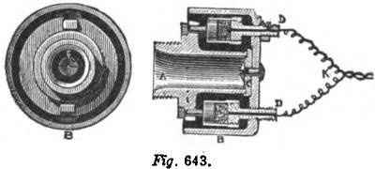
Kg. 643.
The cock, C, must open every time that the fire alarms work, and for this purpose all the dilatable apparatus are placed in

1076 BROOKS UNDERGROUND TELEGRAPH SYSTEM.
derivation, and connected with the conductor going to the elec.-tro-magnet of the automatic cock. Each closure of the circuit in the dilatation apparatus blows off the covering from the corresponding water pipe, and causes an electro-automatic opening of the cock C.
BROOKS' UNDERGROUND TELEGRAPH SYSTEM.
In this system copper wires, wrapped in cotton or flax and bound together so as to form a flexible cable and enveloped in a tightly braided coating of jute, are drawn into an iron pipe,
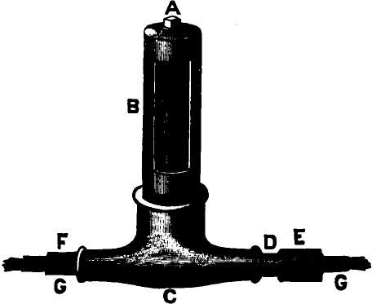
.FVg. 644.
which is then filled with paraffine oil. Joint boxes, fig. 644, are provided at suitable distances for splicing adjacent cables. Fig. 645 shows the construction of a splice box capable of accommodating 400 wires, which enter the box through the main conduit C, consisting of a lap welded iron pipe two and a half inches in diameter. These boxes are made of cast iron and have an inside diameter of seven inches. D is a movable cover which screws into the top of the box, A, thus rendering the

BROOKS UNDERGROUND TELEGRAPH SYSTEM. 1077
wires easy of access. Branch wires may be taken out of either side of the box through an outlet, E. When the box is to be used for splicing the ends of adjacent cables, sufficient room for
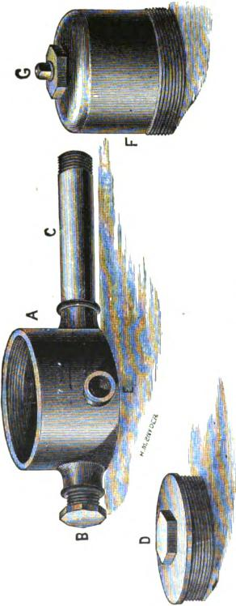
the operation is obtained by the use of a cast iron dome, F, which is substituted for the cap, D, and is provided with a mov-

1078 LEWIS' IMPROVED LINSIMATOlt
able cover, G, for the purpose of filling the box with oil after the splice has been made. Oxidation of the outside of the pipe is usually prevented by enclosing it in a wooden trough and filling the space between the pipe and the trough with pitch.
LEWIS' IMPROVED INSULATOR.
Mr. Lewis has made an exceedingly simple, but valuable, im• provement in the method of fastening the line wire, to the ordinary form of glass or porcelain insulator, by means of which
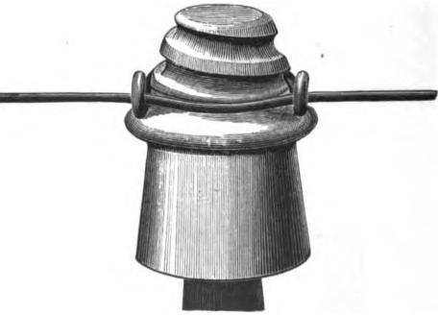
Fig. 646.
the old and troublesome binding is entirely dispensed with, and the line wire is quickly and effectually secured without the use of tools. A conical and expanding screw thread, fig. 646, is formed upon the exterior of the upper portion of the insulator, similar to that upon the point of a gimlet, and the fastening is accomplished by hooking on the line a rigid galvanized iron clip of horseshoe shape, and inserting the conical screw therein. The insulator is provided not only with a conical exterior expanding screw, but also with an interior female screw, adapted to turn upon a supporting pin, provided with a corresponding

INSULATOR FREED FROM RUST. 1079
screw thread, by means of which the insulator is secured to the pin by the same movement that fastens the wire to the insulator.
By these improvements the insulator is kept free from the usual streaks of rust, which are found under the binding wire now in use, and which are due to the cracking off of the coating of zinc in the process of binding it around the line wire. The resistance of the ordinary insulator is considerably diminished, in consequence of the binding wire being in close contact with the glass or porcelain, and forming a great number of receptacles for dirt and moisture, a defect to which the improved form is not subject, because the line wire and clip only touch at three points. It is well known that oxidation and an injurious chemical action also take place to a greater extent where the binding wire is wrapped around the line wire than at any other point, and that breakages are more frequent at those points than elsewhere. As Mr. Lewis' improvement entirely dispenses with the wrapping, its use ought to result in a material diminution of interruptions of that character.

CHAPTER XLVI.
D.ARLINCOURT'S RELAY.
A practical defect in the Siemens polarized relay, described on page 509, Vol. I., is that the force of restitution is sometimes less than the rest force, so that when the current ceases the tongue C C', fig. 647, may fail to return from the stop D' to the stop D. This is partly due to adhesion between the surfaces of the tongue and the stop D', and partly to residual magnetism. It will be observed, moreover, that the force of restitution, which takes the place of the retractile force in a neutral relay, is a fixed and constant quantity in the Siemens relay, quite independent of the magnitude of the working force, which constitutes another defect. To remedy these defects, Mr. C. F. Varley introduced the double current system, by which the line wire is connected, during the pauses between the signals, to the opposite pole of the battery; a positive current being employed to attract the tongue, and a negative current to throw it back to its initial position, thus obtaining a force of restitution which could be made even greater than the working force, while the working force and the force of restitution both follow the variations of the condition of the line and always remain proportional to one another.
The defects incidental to the design of the Siemens relay have also been very successfully overcome by Mr. d'Arlincourt by means of a relatively slight, but novel modification of the instrument. The novelty of the relay in principle is attested by the fact that in a description of it published in the Journal Telegraphique of Berne, its action was misinterpreted, while in his report to the French administration on the Vienna Exhibition, Mr. Cl6rac says: " This second armature vibrates as the first, under the direct action of the line current, but, when this
11

PRINCIPLE OF ACTION. 1081
current ceases, it effects still a final beat under the influence of a magnetic reaction, of which the cause has not, thus far, been completely explained." Subsequently, however, Mr.
La
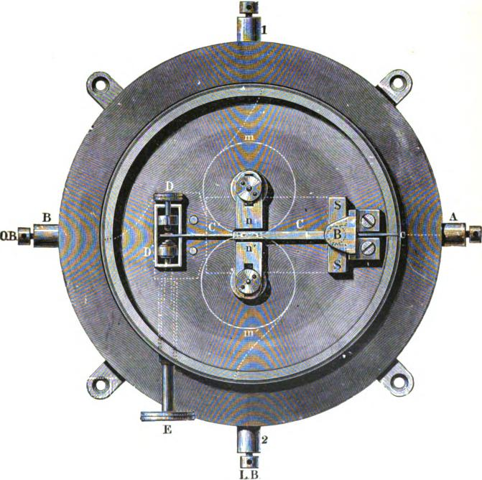 | OR
Fig. 647.

Schwendler, in India, and Count Du Moncel, in France, correctly explained its action, which we reproduce.
If the soft iron rod, A B, fig. 648, be wound with insulated copper wire in the way shown in the figure, and a current be sent

1082 D'A IN CO IIRT'S RELAY.
through the wire in the direction indicated by the arrow, then the core will assume a south polarity at A, and a north polarity at B. If the wire be wound continuously and symmetrically along A B, there will be a single neutral line, x o x', passing through the centre, o, of the electro magnet, at right angles to its axis, and the whole of one half, A o, of the rod will be south,
x
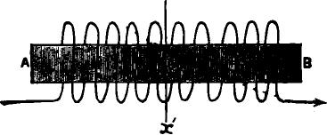
Fig. 648.
while the whole of the other half, B o, will be north. If, however, the wire be wound symmetrically, but not continuously (the middle part of the bar being left uncovered), as in fig. 649, there will be three neutral lines, viz.: x o x' (passing as before through the middle point of the rod); y y' (passing through the
right hand helix, and lying nearer to o than to B); and z z', passing through the left hand helix, and lying nearer to o than to A. From A to z z', the rod will be south, from z z' to x o x', north (weaker than the former); from x o x' to y y', south (equal to the latter); and from y y' to B, north (equal to the first). As the bare space intervening between the two helices diminishes, so do

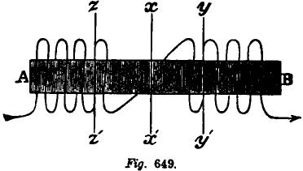
y'
ITg. 649.

PRINCIPLE OF' ACTION. 1083
the two neutral lines y y' and z z' (fig. 649) approach toward the principal neutral line, x o x'; and they finally coincide with it when the rod is covered with wire throughout, as shown in fig. 648. Consider the case represented in fig. 649. So long as the current continues to flow through the coils it is distributed in the manner indicated above. If, however, we interrupt the current an action supervenes which has been taken advantage of by Mr. d'Arlincourt, and constitutes the novelty of his relay. As already stated, the outer poles are stronger than the inner poles, and hence, at the moment of interrupting the current, the residual magnetism due to the outer poles will be greater than that due to the inner poles, and will overcome it. Further, the outer poles have a greater distance to travel to neutralize one another
x
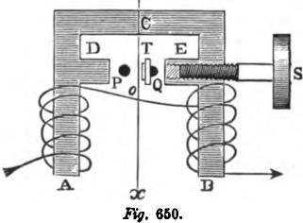
than the inner poles, and will consequently outlive them. Hence, when the current is interrupted, the neutral lines, y y' and z z', will rapidly approach toward the principal neutral line, x o x', and coincide with it, thus leaving the half A o of the rod temporarily magnetized south throughout its length, and the half B o temporarily magnetized north throughout its length. It will be seen, therefore, that as soon as the current is interrupted the polarity of the core lying immediately on either side of the principal neutral line, x o x', is temporarily reversed.
Bearing the foregoing principles in mind, we will now examine the construction and operation of the relay, which is shown in fig. 650.

1084 D'ARLINCOURT'S RELAY.

A B C is of soft iron, forming the core of a horseshoe electromagnet, wound in the manner indicated. D and E are projections to bring the core near the tongue. T is a -horizontal section of a vertically pivoted soft iron tongue, polarized by a large permanent magnet, and free to play between the stops P and Q, which are respectively the local contact and the rest stops. S is an adjusting screw of soft iron for regulating the sensibility of the instrument, by varying the mass of iron present in the projection E. x o x' is the principal neutral line of the electro-magnet.
We shall assume the end T of the tongue to be a south pole. Suppose the stops P and Q to be adjusted so that they both lie to the right of the neutral line x o x'. The tongue T is attracted by both the projections D and E, but since it is necessarily nearer to E than to D it will rest in contact with the rest stop Q.
Now, suppose a current to flow through the wire in the direction indicated by the arrows. Then A will become a south pole, and B a north pole; D a weaker north pole, and E a weaker south pole. Hence, since T is a south pole, T will be attracted by D and repelled by E; and, if the resultant force be sufficiently great, T will move over and rest in contact with the local contact stop P, and remain there so long as the current continues to flow. When the current is interrupted, T tends by its own inductive action (since it is nearer E than D) to return to Q; but, over and above this, the moment the current is interrupted D is changed to a south pole and E to a north one, so that T is now attracted toward E and repelled from D. Under the influence of these forces, if sufficiently strong, the tongue T will return and rest against Q, where it will be ready to be moved by a fresh current.
If, instead of adjusting the stops P and Q so that they both lie to the right of the neutral line x o x', we adjust them so that they both lie to the left of the neutral line, then normally,
e., when no current is passing, the tongue T will rest in contact
- with the stop P. Now, suppose a current to pass as before in

RAPIDITY OF ACTION. 1085
the direction indicated by the arrows. Then since, as before, T is attracted toward D and repelled from E, the tongue will not move, but will only press harder against the stop P so long as the current continues to pass. The instant, however, we interrupt the current, the polarity of D and E is reversed, D temporarily becoming a south and E a north pole. Hence T will now be attracted by E and repelled by D temporarily. Under the influence of this momentary reverse force, if sufficiently strong, the tongue will fly over from P to Q. But this force being essentially transient the tongue will as quickly return to its normal position. Hence, when the relay is adjusted as here described, at the closing of the circuit there will be no motion of the tongue, but at the opening of the circuit the tongue will execute a complete oscillation, i. e., will move from P to Q and back again. From the peculiar flick with which this movement is executed by the tongue, Mr. d'Arlincourt has very aptly compared it to the stroke of a whip.
It is easy to see that if the signalling current be sent in the proper direction through the coils of the relay, the line wire attached to the tongue, and earth or zinc to the stop Q, every time the key is opened, earth or zinc will be momentarily put to line.
Instead of the residual magnetism being a retarding influence, as in other forms of electro-magnets, Mr. d'Arlincourt employs it as an antagonistic force, and thus obtains great rapidity of action. The stronger the line current received, the stronger also the residual magnetism, and consequently the stronger the antagonistic force, and hence this relay requires very little adjustment

CHAPTER XLVIL
THE HARMONIC TELEGRAPH OR TELEPHONE.
THE transmission of sounds over a telegraph line, or, to speak more accurately, the reproduction of musical tones at a distance by means of electro-magnetism, is not only in itself a matter of great scientific interest, but has of late assumed so much impor- tance, in view of its possible applications in practical telegraphy, that a work of this kind would scarcely be complete without some explanation of the principles involved, and a brief state• ment of the practical results thus far obtained.
The peculiar sensation which we call sound is excited in the organs of hearing by the vibratory motion of bodies, when transmitted to the ear through an elastic medium. It is always the result of rapid oscillations imparted to the molecules of elastic bodies, when their equilibrium has been disturbed either by a shock or by friction. Such bodies tend to return to their first position of equilibrium, but only reach it after performing on each side of that position a decreasing series of very rapid vibratory movements. A simple musical tone results from a continuous rapid and uniformly recurring series of vibrations, provided the number of complete vibrations per second falls within certain limits. If, for example, the vibrations number less than seven or eight per second, a series of successive noises are heard instead of a tone, while if their number exceeds 24,000 to 36.000 per second, the ear becomes incapable of appreciating the sound.
The ear distinguishes three distinct qualities in sound. 1. The tune or pitch, by virtue of which sounds are high or low, and which depends upon the rapidity of the vibratory movement. The more rapid the vibrations the more acute will be the sound. 2. The intensity, by virtue of which sounds are loud or soft, and which depends upon the amplitude of the vibrations.

THE PHENOMENA OF SOUND. 1087
8. The quality or timbre, by which we are able to distinguish a note sounded upon, for example, a violin, from the same note when sounded upon a flute. By a remarkable series of experi- mental investigations, Helmholtz succeeded in demonstrating that the different qualities of sounds are due to the different intensities of the harmonics which accompany the primary tones of those sounds.
The different characteristics of sound may be graphically represented and the phenomena thus rendered more easy of comprehension. In fig. 651, for example, let the line e_{l} 8 represent a certain length of time, and the continuous curved line the successive vibrations producing a simple tone. The curves above
Fig. 651.

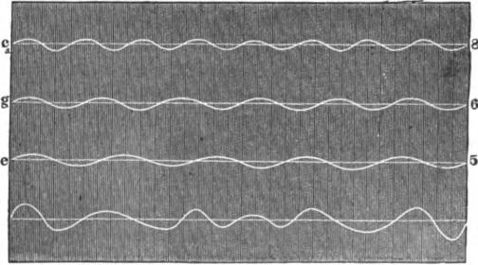
9
e
5
the line represent the compression of the air, and those below the line its rarefaction : the air, an elastic medium, is thus thrown into vibrations which transmit the sound waves to the ear. The ear is unable to appreciate any sensations of sound other than those produced by vibrations which may be represented by curves similar to that above described. Even if several tones are produced simultaneously, the elastic medium of transmission is under the influence of several forces acting at tl►e same time, and which are subject to the ordinary laws of mechanics. If the different forces act in the same direction the total force is represented by their sum, while if they act in opposite directions, it is represented by the difference between them.

1088 THE HARMONIC TELEGRAPH OR TELEPHONE.

In fig. 651 three distinct simple tones, c_{l}, g and e, are represented, the rapidity of the vibrations being in the proportion of 8, 6 and 5. The composite tone resulting from the simultaneous production of the three simple tones is represented graphically by the fourth line, which correctly exhibits to the eye the effect pro- duced upon the ear by the three simultaneously acting simple tones.
It will also be observed that the curves in the diagram represent the three characteristics of sound which have been referred to. The pitch is denoted by the number of vibrations or waves recurring within a given horizontal distance; the intensity, by the amplitude of the vibrations—that is, their comparative height above or depth below the horizontal line; and the timbre or quality, by the form of the waves themselves. It is, therefore, easy to understand that if, by any means whatever, we can produce vibrations whose curves correspond to those of a given tone, or a given combination of tones, the same impression will be produced upon the ear that would have been produced by the original tone, whether simple or composite.
REISSS TELEPHONE.
The earliest experiments in the production of musical sounds at a distance, by means of electro-magnetism, appear to have been made in 1861, by Philip Reiss, of Friedrichsdorf, Germany. His apparatus was constructed in the manner shown in fig. 652.. A is a hollow wooden box, provided with two apertures, one at the top and the other in front. The former is covered with a membrane S, such as a piece of bladder, tightly stretched in a circular frame. When a person sings into the mouthpiece M, which is inserted in the front opening, the whole force of his voice is concentrated on the tight membrane, which is thrown into vibrations corresponding exactly with the vibrations of the air produced by the sound of the singing. A thin piece of platinum is glued to the centre of the membrane and connected with the bindinc, screw a, in which a wire from the battery B is fixed. Upon the membrane rests a little tripod e f g, of which

REISS'S TELEPHONE. 1089
the feet e andf rest in metal cups upon the circular frame over which the skin is stretched. One of them, f rests in a mercury cup connected with the binding screw b. The third foot g, consisting of a platinum contact point, lies on the strip of platinum which is placed upon the centre of the vibrating membrane and hops up and down with it By this means the closed circuit which passes through the apparatus from a to b is momentarily broken for every vibration of the membrane. The receiving instrument R consists of a coil or helix, enclosing an iron rod and fixed upon a hollow sounding box, and is founded on the fact, first investigated by Professor Joseph Henry, that iron bars, when magnetized by means of an electric current, become slightly elongated, and at the interruption of the current are re-
stored to their normal length. In the receiving instrument these elongations and shortenings of the iron bar will succeed each other with precisely the same interval as the vibrations of the original tone, and the longitudinal vibrations of the bar will be communicated to the sounding box, thus being made distinctly audible at the receiving station.

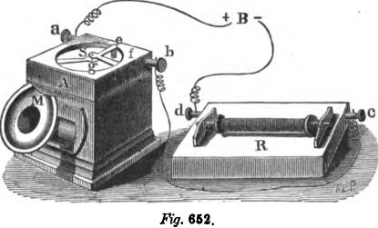
,
Fig. 652.
It is obvious that this apparatus is capable of producing only one of the three characteristics of sound, viz, its pitch. It cannot produce different degrees of intensity, or other qualities of tones, but merely sings the melodies transmitted with its own voice, which is not very unlike that of a toy trumpet Referring to the graphic representation of the composite tone, in fig. 651,

1090 THE HARMONIC TELEGRAPH OR TELEPHONE.

this apparatus would reproduce the waves at properly recurring intervals, but they would all be of precisely the same amplitude or intensity, for the reason that they are all produced by an electric current of the same strength.
The sounds produced by the above instrument are very weak, but Dr. Wright, by passing the current through the primary wire of a small induction coil, and placing a condenser consisting of two sheets of silvered paper back to back, in the secondary circuit, succeeded in producing, by its rapid charge and discharge, musical notes loud enough to be heard throughout a
large hall. GRAY'S TELEPHONIC APPARATUS.
It was observed by Mr. Elisha Gray of Chicago, in 1873, that if an induction coil be put in operation by means of an automatic circuit breaker or electrotome, and one of the electrodes of the secondary wire be held in the hand, while the dry finger of the same hand is rubbed upon a sonorous metallic plate, that a tone will proceed from the point of contact between the fingers and the plate, the pitch of winch corresponds exactly with that of the tone produced by the rapid vibrations of the circuit-breaker of the coil. Acting upon this hint Mr. Gray constructed a key-board of two octaves (fig. 653), each key of which, when depressed, sets in action a steel reed tuned to a certain definite rate of vibration, corresponding to its position in the musical scale. The vibration of the reed is kept up by the action of electro-magnets in the manner illustmited in fig. 654. One end of the reed a is rigidly fixed to a post I), while the other end is left free to vibrate under the alternate action of the electro-magnets e and f. The magnet e has a resistance of about 4 ohms, while that of the magnet f is about 30 ohms. Both magnets are placed in the circuit of the same local battery, and as a necessary consequence the one which has the higher resistance develops the strongest magnetism; but if the magnet of higher resistance be cut out of the circuit the attractive force of the other will be increased. When, therefore, the local circuit is closed at d by the depres-

GRAY'S TELEPHONIC APPARATUS. 1091,
sion of the key C, the whole current from battery L B passes through the magnet e, for the reason that f is shunted or cut out by the spring contact G, which rests against the reed and forms a connection by the way of 2, 1 b and G. The magnet e attracts the reed with a certain force until it has removed it from contact with the spring G, when the current is thrown through both magnets the attraction of e is at once greatly reduced, while that of f is correspondingly increased, and the reed is then attracted towards f until contact is reestablished at G. This operation is repeated indefinitely as long as the key C is de-
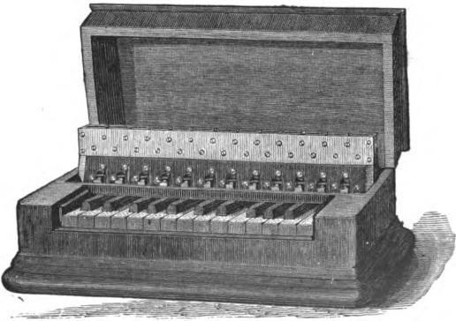
Fl.g. 653.
pressed, the rate of vibration being determined by the size and length of the reed, which corresponds with the fundamental of the note it represents. By this arrangement the centre of oscillation coincides with the centre of the reed when at rest, so that the pitch of the tone is not affected by any ordinary fluctuations in the strength of the current, as when only one magnet is used.
If the series of keys thus arranged, but with their reeds tuned to the different notes of the scale, be manipulated, a tune may be played; the instrument being in fact an organ whose motive power is electricity instead of compressed air.

1092 THE HARMONIC TELEGRAPH OR TELEPHONE.
The vibrations may be transmitted over a telegraphic line merely by connecting the main line with the reed, and thence through the contact spring I and key C with the battery M B and earth, as shown in fig. 654. All the other keys are connected in separate branches of the main line, between the points 1 and 4. Thus the depression of any key transmits a series of pulsations corresponding to its own note, and if two or more keys are depressed simultaneously, the resultant effect will be
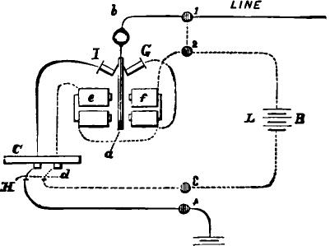
1Vr B
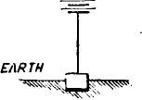
Fig. 654.
the same as in Reiss's method, that is, the pitch will be given and nothing more.
Among the various devices invented by Mr. Gray to convert these electrical pulsations into audible vibrations, one of the most curious is shown in fig. 655. It consists of a thin cylindrical wooden sounding box, the face of which is covered with thin sheet metal, and arranged so as to be turned by an insulated crank. The metallic covering of the cylinder is connected

(TRAY'S TELEPHONIC APPARATUS. 1093
through the stand with the earth. Now, if the operator holds the electrode connected with the line in one hand, and presses the fingers of the same hand against the metal plate, which is turned
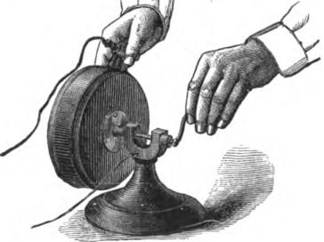
Fig. 655.
by the other hand, the tone which is being played at the other end of the line becomes distinctly audible, so as to be heard throughout a large room. The faster the plate is revolved the louder the tones become, and vice versa. The cause of this sin-
LINE
frig. 656.

A
a
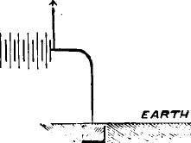
gular pnenomenon nas not been satisfactorily explained. A current of considerable potential, at least 50 volts, is necessary in order to produce the tones, and this may be most conveniently

1094 THE HARMONIC TELEGRAPH OR TELEPHONE.
obtained by the use of an induction coil at the receiving end of the line.
In the spring of 1874 Mr. Gray invented a method of transmission by means of which the intensity of the tones, as well as their pitch, was properly reproduced at the receiving station. This was a very important step in the development of the system, and was accomplished in the manner illustrated in fig. 656, which represents two transmitting reeds, A and B, and two receiving instruments A' and B', the local circuits and magnets being omitted to avoid confusion. Each transmitter is placed in a shunt wire around its own battery, while the main circuit runs directly through both batteries, so that each separate series of vibrations passes into the line accompanied by its own
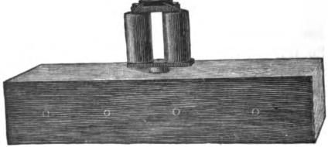
lig. 657. •
current, and thus the intensities of the vibrations, as shown by the varying height of the waves, when three tones are sent simultaneously, corresponds to the graphic representation on the fourth or bottom line of fig. 651. If two separate waves from two transmitters coincide, the intensity of the sound is increased by the joint action of the two batteries, and so on, and thus a tune may be reproduced, at any distance, with perfect accuracy, so far as its pitch and varying intensity is concerned. With a receiving instrument constructed as shown in fig. 657 the tones become very loud. It consists of an electro-magnet, having its armature rigidly fixed to one pole, and separated from the other by a space of h. of an inch, and mounted upon a hollow sounding box.

GRAY'S HARMONIC TELEGRAPH. 1096
GRAY'S HARMONIC MULTIPLE TELEGRAPH.
The practicability of simultaneously transmitting a number of distinct tones and reproducing them at a distance having been thus experimentally established, the utilization of these separate tones for the simultaneous telegraphic transmission of a corresponding number of different communications was next undertaken. The only thing necessary to be done was to effect the analysis of the composite tones into their constituents at the receiving station.
The possibility of thus separating composite tones passing through the air had been experimentally demonstrated by the celebrated German physicist, Helmholtz, and it only remained to discover some analogous means for separating the composite
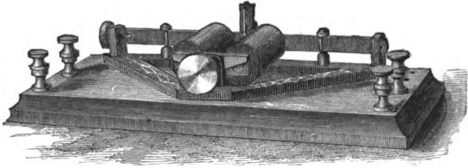
. Fig. 658.
vibrations communicates to the cores of an electro-magnet. This result was successfully accomplished by Mr. Gray, by the use of an instrument termed an analyzer, which is represented in 658, and consists simply of an electro-magnet, the armature of which is replaced by a steel ribbon, stretched in a metallic frame and provided with a tuning screw at one end, by which the proper tension may be given to it. If this ribbon is tuned to a certain note it will be thrown into vibrations whenever the pulsations from its corresponding transmitting reed traverse the electromagnet, but if another note be transmitted it will not respond. If, however, its own note be transmitted as a part of a composite tone, it will respond; but if this note ceases it will immediately stop. Consequently, it is only necessary to cause the main cir•

1096 THE HARMONIC TELEGRAPH OR TELEPHONE.
cuit at the receiving station to pass successively through as many analyzers as there are separate reeds at the transmitting station, each of which is tuned to the same note as its own reed, and will respond to that note only, whether sent singly or as a part of a composite tone.
In applying the apparatus to multiple telegraphic transmission, each electrotome or reed is mounted as in fig. 659, and operated by a common Morse key, by which the continuous tone is broken up into dots and dashes. The receiving instrument employed may be a simple Morse sounder, connected to the analyzer in a peculiar manner, so that the latter acts as a relay, opening and closing the local circuit of the sounder. A simpler construction of the analyzer, and one which renders the sounder unnecessary, is shown in fig. 660. The electro-magnet M
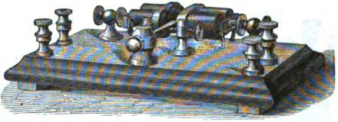
Fig. 659.
which has very short cores, is provided with an armature a,
rigidly attached to the lower core, but separated from the upper
one by a space of of an inch. This may be increased or diminished by moving the upper core in or out, by means of the screw 8. The armature is made thinner at the point b, being filed down until it vibrates to a certain note, the nicer adjustment being accomplished by adjusting the movable weight w. The whole is mounted upon a sounding box B, open at one end, which is termed a resonator. The principle involved in the action of the resonator is this : A volume of air contained in an open vessel, when thrown into vibrations, tends to yield a certain note, and consequently strengthens that note, when the latter is sounded in its neighborhood. By placing the instruments upon corresponding resonators the sound is greatly

GRAY'S HARMONIC TELEGRAPH. 1097
strengthened, so that an operator may readily read by sound the telegraphic characters into which the continuous tone is broken by the transmitting key.
Fig. 661 shows the same arrangement of the electro-magnet
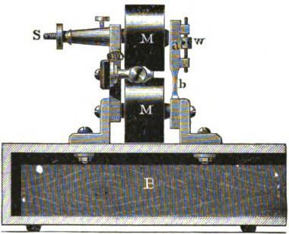
Fig. 660.
and armature, mounted upon an ordinary wooden base instead of a sounding box, and arranged as a relay to open and close local circuit. The light contact lever c is armed with a contact point at its free end, resting merely by the weight of the lever
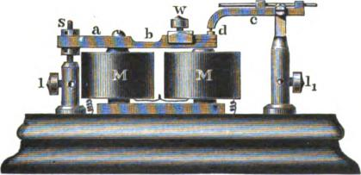
lig. 661.
itself in the concave cup d upon the extremity of the armature
a. When the armature is thrown into vibration the contact lever
hops up and down, and does not close the local circuit (which is connected to 1 and /₁), with sufficient firmness to actuate the

1098 THE HARMONIC TELEGRAPH OR TELEPHONE.
sounder, but when the vibration stops the local circuit is closed. This reverses the writing upon the sounder, but it may be operated, as in the quadruplex, by means of a local relay.
Mr. Gray has also combined his harmonic with the Morse system of telegraphy, so that two communications may be simultaneously transmitted in either direction upon a line having intermediate stations, the apparatus being so arranged that while a communication is being transmitted from one terminal station to the other by the harmonic system, either terminal station or any way station may receive a message from or transmit one to either of the terminal or any one of the way offices by means of the ordinary Morse apparatus.
Fig. 662 represents the instruments, in connection with the line, at a terminal station, including both the telephonic, or elec-tro-harmonic, and the ordinary Morse apparatus, the former consisting of transmitter T, key K, local batteries e, el and e², vibrator or reed V, receiving instrument or analyzer A, repeating relay Al, sounder S, rheostat R¹ and main battery B; and the latter consisting of relay D, sounder Sl, key K', rheostat R and condenser C, the earth terminal of the line being at G. Each intermediate office is equipped with the Morse apparatus only„

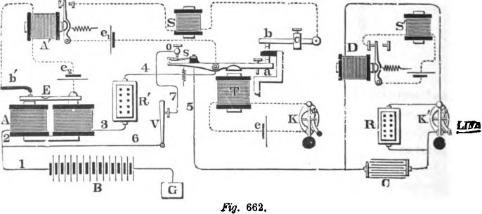
5
II
III
III
Fig. 662.

COMBINATION OF HARMONIC AND MORSE TELEGRAPH. 1099

including the condenser and rheostat; while the terminal stations have both the electro-harmonic and the Morse apparatus, arranged as shown in the diagram.
To simultaneously transmit two communications in the same or in opposite directions, sounder S must respond solely to the movements of key K and transmitter T of the harmonic apparatus; while sounder Si, which is connected with the Morse instruments at the distant terminal and at the several intermediate offices, must respond solely to the movements of key Kt.
This is accomplished as follows: The transmitter T, which is similar to that used in the duplex and quadruplex systems, is operated by key K. The auxiliary lever b, one end of which rests upon a suitable fulcrum, while the free end rests upon the anvil of transmitter T, serves, in connection with the armature a of the latter, to control the local circuit of sounder S in a manner and for a purpose to be hereinafter described. The vibrator or reed V (which, with the receiving instrument or analyzer A, are illustrated and described on pages 1092 and 1097) is kept constantly in vibration by electro-magnets, and tuned to a pitch corresponding to the reed E of the receiving instrument A. A small secondary lever bt, having one end pivoted and the other resting upon the free end of the armature E, controls the local circuit of the relay Al, and reverses the signals of the receiving instrument A, so that they may appear correctly upon the sounder S. The normal condition of the key K¹ of the Morse apparatus is closed, while that of key K and transmitter T is open. The route of the circuit is from the earth G, battery B and wires 1 and 2, to the receiving instrument A; thence by wire 3 to rheostat RI, and wire 4 to the lever a and spring 8 of transmitter T; thence by wire 5 to relay D and key K¹ to the line. With key K closed, and the consequent operation of transmitter T, the route of the circuit is changed as follows: From earth G and wires 1 and 6 to the vibrator V, and wire 7 to stop o and spring s of transmitter T; thence by wire 5 to relay D and key Kt to the line and distant station, as before.
The resistance of rheostat Ri and helices A should equal that

1100 THE HARMONIC TELEGRAPH OR TELEPHONE.

caused by the vibration of the reed V, so that no variation in the strength of the current going to the line may be manifested in the Morse relay D when the transmitter T is either open or closed. The rheostat R should be so adjusted that when inserted in the line by opening the key K¹, it will diminish the strength of the current to an extent sufficient to cause the armature of the Morse relay D to yield to the force of its retractile spring, thus opening the local circuit of sounder Si.
The condenser C is connected on one side to wire 5, and on the other to the front stop of key K', so as to shunt the relay D and rheostat R, and thus, when the key is opened and the resistance R introduced into the circuit, the full diminution of the current does not take place instantaneously, but only after an exceedingly brief interval of time and in a gradual manner, while the condenser is charging. By this means the effect of a sudden change in the current on the receiving instrument A, which would tend to make the latter give a false signal, is entirely avoided. The condenser also assists in maintaining a uniform condition of magnetism in the cores of the Morse relay D, by discharging through the electro-magnet between the vibrations.
The lever b, which rests upon the anvil of transmitter T, serves to prevent a false signal being given upon the sounder S, caused by the sudden release of the reed E from the attractive force of the magnets A. The upper limiting stop of the lever a of the transmitter T is insulated from the anvil; and, together with the lever b, forms a portion of the local circuit of sounder S, so that when the lever a approaches the magnet T the local circuit of sounder S is broken; and, when released from magnet T, the force with which it strikes against the upper limiting stop causes the lever b to vibrate enough to compensate for the vibrations of the reed E of the receiver A, caused by the latter being restored to its previous condition, thus preventing a false signal being given upon the sounder S. The sliding weight c is to regulate the movement of the lever b.
Thus by a depression of key K and the consequent operation of transmitter T, the electrical pulsations caused by the vibrating

BELL'S HARMONIC MULTIPLE TELEGRAPH. 1101

reed V will pass to the line and operate the analyzer A and reed E at the distant terminal, so as to record the desired signal upon sounder S, without producing any effect upon the Morse instruments at the several intermediate stations; while at the same time, by means of key K and rheostat R and relay D, a communication may be transmitted to, or received from any of two or more way offices, equipped with suitably arranged Morse instruments.
BELL'S HARMONIC MULTIPLE TELEGRAPH.
In 1875, Mr. A. G. Bell, the inventor of the electric speaking telephone, perfected a method of harmonic multiple telegraphy by which two or more communications could be simultaneously transmitted over the same wire without interference. The apparatus consisted of a series of automatic circuit breakers, each having a different rate of vibration, placed in branch circuits diverging from the same pole of the main battery, the other pole of which was connected to earth. To each of these branches a key was connected, by the depression of which the corresponding branch was connected to the main line.
Thus upon the depression of any one of the keys the corresponding circuit breaker was set in action, transmitting its pulsations through the line; and when two or more keys were simultaneously depressed, two or more distinct sets of electrical vibrations were sent through the line. The receiving instruments were electro-magnets, with steel reeds for armatures, each tuned to respond to its own transmitter. The main circuit at the receiving station passed through the instruments in succession and thence to the earth.
LA COCK'S HARMONIC TELEGRAPH.
La Cones transmitter is composed of a series of tuning forks, kept in continuous vibration by electro-magnets. The receiving instruments consist of tuning forks of soft iron, arranged to close the circuit of a local battery, when thrown into vibration by the pulsations passing over the line.

CHAPTER XLVIIL

DELANY'S MULTIPLEX TELEGRAPH.
Mr. Delany's synchronous multiplex method of transmission, although based, like Meyer's, upon the principle of the division of a single current into rapidly recurring pulsations, differs very materially from the latter in the method of accomplishing it. Like Meyer, Delany synchronously rotates two disks placed at the opposite ends of a line for the purpose of giving the latter in sufficiently rapid succession to the several corresponding instruments situated at each end; but while Meyer slowly and imperfectly obtains his synchronism by clock work, Delany rapidly and effectually secures his by the intermittent action of an electro-magnet.
Fig. 663 represents two distant stations, X and Y, respectively, electrically connected by a single line wire. The apparatus at each end of the line is identical. A steel fork a, at each station, is automatically vibrated by the action of the local battery L B, and the electro-magnet A. The cores of the latter being prolonged in the direction of the free ends of the vibrating fork by the adjusting screws a'. The object of this adjustment of the extended magnet poles is to enable them to be approached toward, or withdrawn from the tines of the vibrating fork, so as to regulate with great nicety the rate of vibration of the latter.
Platinum contacts, x and x', are placed on the inner faces of the tines of the fork, and make and break contact with delicate contact springs, y y', supported by adjustable insulated levers B, B', pivoted on the bed plate of the apparatus. The adjustment of these levers is secured by the thumb screws b, b, against which they are drawn by the action of spiral springs.
The local battery circuit a', runs from the positive pole of the battery, through the coils of the vibrator magnet A. to the head

DIAGRAM OF THE APPARATUS. 1103

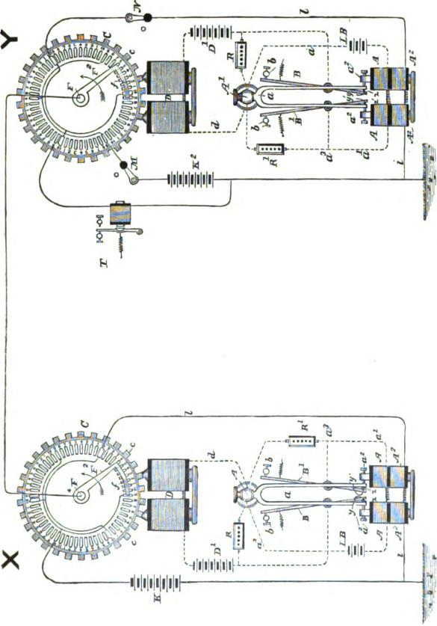
Co
co
co

1104 DELANY'S MULTIPLEX TELEGRAPH.

of the fork, and through the contacts y, y', to the insulated lever B¹, from whence it passes back to the opposite pole of the battery. In order to prevent injurious sparking of the contacts x' and y', a resistance coil R', is placed in a shunt circuit around them, extending from the point, a', to the head of the fork, and to the insulated arm B'.
The fork being mechanically put into a vibratory motion, will automatically make and break its local circuit, and thus send impulses into the magnet A, that will continuously maintain the vibrations of the fork.
The making and breaking of contacts x and y (which are placed in connection with the opposite tine of the fork), consequent on the fork's vibration, opens and closes the circuit of another local battery in which is placed an electro-magnet, D, the function of which is to maintain the continuous rotation of the transmission apparatus C.
This circuit passes from the positive pole of the motor battery D', to the lever B, through the platinum contacts y and x, to the tine of the fork, to its head or support A', and thence through the wire d, to the coils of the motor magnet D, and back to the opposite pole of the battery. A resistance, R, placed in a shunt between the head or support of the fork and the line of the lever B, prevents injurious sparking between the platinum contacts x and y.
As the continuous vibration of the fork is automatically maintained by the local battery L B, it will, at each vibration, make and break the contacts at x and y, and thereby make and break the motor circuit. The alternate magnetization and demagnetization of the cores of the motor magnet D causes the rotation of the transmission apparatus C. The cores of the magnet D have their faces shaped so as to conform to the circumference of the apparatus C, the teeth of which pass in close proximity to the faces of the curved magnet poles.
The arrangement of the motor magnet and transmission disk C, the latter provided with projections c c, is the invention of Poul La Cour, and is styled by him a phonic wheel.

ROTATION OF THE PHONIC WHEEL. 1105
The main line has one of its ends connected with the trailing brush/through the radial arm F² and vertical shaft F. As the shaft F rotates, the line is therefore brought into successive electrical connection with the series of insulated contacts in the upper face of the table. The toothed armature or phonic wheel C is securely keyed to the vertical shaft F. In order to equalize the speed of rotation of the apparatus, a cylindrical vase of wood filled with mercury is attached to the face of the phonic wheel C, and rotates with it. The cores of the motor magnet D can be readily adjusted toward or from the armature teeth on the phonic wheel C by the motion of a screw.
The synchronous rotation of the phonic wheel C is brought about in this manner : When the wheel C is at rest, one of its teeth c nearest a pole of D will be attracted toward it. Should, however, the phonic wheel be set into motion with a velocity that shall cause a tooth, c, to pass the pole D for each intermittent impulse of the current traversing the coils of D, the wheel will be maintained in a rotation, the speed of which will be controlled by the frequency of intermission of the current. That is to say, the speed of rotation of the phonic wheel C, and consequently the rapidity with which the successive contacts are made by the trailing arm f, are regulated solely by the duration of the oscillation of the fork a. In starting the disk C, an impulse of rotation is given to it somewhat in excess of the speed at which it will be maintained by the motor magnet, by means of a thumb piece on the shaft F, and then, as the speed of rotation decreases, the armature teeth will come into proper relation with the poles of the magnet, and into the periods at which. the makes and breaks occur in the circuit traversing its coils, and the disk will be continuously driven by the motor magnet.
Any suitable number of insulated contacts may be placed on the circular table; sixty are shown in the figure. In practice these contacts are connected in accordance with the special number of circuits which it is desired to simultaneously maintain on the same wire. In the figure it is arranged so that four separate circuits shall be established on the same line wire. The

1106 DELANY'S MULTIPLEX TELEGRAPH.

sixty contacts are placed in six independent series, numbered from 1 to 10 consecutively. Two of the contact pieces, in each series of ten, are connected in the same circuit, and as there are six series, each of the circuits so connected has twelve contacts for each rotation of the disk. The l's and the 5's in each series are all connected in one circuit; the 2's and the 6's in another circuit; the 3's and the 7's in another circuit, and the 4's and the 8's in another circuit, thus providing four separate circuits in all. The contacts, therefore, from one to eight in each series, are apportioned among the four independent circuits, each of which will receive, for each revolution of the trailing brush twelve contacts and twelve electrical impulses, as will be afterward described. The detailed mechanism by means of which the separate and independent circuits so obtained are utilized for the transmission and reception of messages consists of four Siemens polarized relays, four Morse sounders, and four transmitting sounders. The first relay is connected with the contacts 1 and 5; the second relay with the contacts 2 and 4; the third relay with the contacts 3 and 7, and the fourth relay with the contacts 4 and 8. Similar instruments and circuits are placed at each end of the line, and the corresponding relays at the two terminal stations are connected with the correspondingly numbered contacts. When, therefore, the trailing contact brush at each station simultaneously touches the contacts bearing the same number, the corresponding instruments connected with these contacts at each station will be placed in communication over the main line; and if the trailing brushes f, at each station, are maintained in synchronous rotation, they will pass regularly and simultaneously to the next contact, and successively over the similar contacts at each station; and during the time that the trailing contact brushes are on the correspondingly numbered contact pieces at each station, a complete and independent circuit, that has no connection whatever with the other circuits, is established between these stations.
Under the arrangements described, each of the four separate circuits will be placed in independent electrical connection with

METHOD OF TRANSMITTING MESSAGE& 1107

the main line twelve times for each rotation of the distributing wheel C. Assuming the normal rate of vibration of the fork at eighty-five vibrations per second, and that the distributing wheel C is furnished with thirty armature teeth, or polar projections, the armature disks and trailing brushes will be rotated at the rate of two and five-sixths times per second, so that the corresponding instruments at the two stations will be placed in independent electrical communication with the main line thirty-four times each second. This number of contacts per second will give to each set of operators a practically unbroken circuit, so that the operators at any two connecting stations may communicate with each other, in either direction, as if they had a separate and independent line devoted entirely to their exclusive use.
We will now describe, in greater detail, the method adopted for transmitting and receiving the messages over any or all of the four circuits so provided. The main battery, split and grounded in the middle, has its positive pole connected with the back stops of the transmitting sounder, and its negative pole with its front stops. The act of transmitting, therefore, sends into the line impulses of opposite polarity, and permits of the employment of polarized relays.
Since each operator's circuit is made up of numerous rapid contacts with the main line at the rate of thirty-four contacts per second, each of the ordinary Morse characters sent into the main line is made up of more than a single contact, proportioned in number to the length of the character. The ordinary Morse relay could not therefore be employed for the reception of these characters, since the numerous breaks comprised therein would be recorded by the armature of the relay. In order to avoid this confusion, and to make the relays respond not to mere pulsations caused by the successive makes and breaks, but only to the reversals in polarity, caused by the connection of the split battery with the transmitting sounders, the polarized relays have been used in place of ordinary relays, because the armatures of the polarized relays may be made to remain in the position that the last current has placed them until a reversal of the

1108 DELANY'S MULTIPLEX TELEGRAPH.

current changes their position, notwithstanding that the finer vibrations comprised in these reversals are continuously passing through the magnet of the polarized relay. This feature of the invention is due to Mr. E. A. Calahan, the inventor of the Gold and Stock Printing Telegraph, described on page G78, and who has been associated with Mr. Delany from the commencement of his investigations on the subject, and whose ability and great mechanical skill have very materially aided the full develop. ment of the system.
The most essential feature of the system is undoubtedly the maintenance of the synchronous movements of the trailing brushes over the contact pieces on the table. This Mr. Delany has effected by an automatic device, which is said to be so successful in practice that the synchronism can be perfectly maintained for days without one instrument varying from the other the six-hundredth part of a second. The means by which this practically absolute synchronism is maintained are comparatively simple, and mainly consist in the automatic transmission of correcting impulses sent over the main line from one instrument to the other, at such times only as the distant instrument is slightly in advance or behind the nearer instrument. These correcting impulses are utilized for the purpose of slightly increasing or decreasing the rate of vibration of the distant fork, and consequently the rate of rotation for the trailing brush at the distant station.
The manner in which these impulses are obtained when needed is as follows: It will be observed, by referring to fig. 663, that at station X three of the O's farthest removed from each other are connected together, and to a battery, K'; and that three of the 10's, that are likewise farthest removed from each other, are connected together and to a line 1, which passes through two correcting coils A' A', on the cores of the vibrator magnet A A, and thence to earth. The remaining three intermediate 9's and 10's are not connected with any circuit. At station Y, the 9's, corresponding with those connected with the battery at X, are left open, while the alternate 9's are connected with the battery K':

SYNCHRONOUS MOVEMENT OF BRUSHES. 1109

while the 10's at Y, which are connected with each other and with the correcting coils A' A' on the cores of the vibrator magnet, correspond with those which are unconnected at station X; the 10's at station Y, corresponding to the connected 10's at station X, being also thrown out or unconnected. At both stations the three 10's which are connected with the correcting coils on the cores of the vibrator magnet are built out or extended toward the adjoining 9's that are unconnected with any circuit.
In order to provide room for the expanded or extended 10's, without disturbing the symmetrical arrangement of the remaining contacts, the plates provided for the static discharge of the line, and which are located between each of the successive contacts of the circular table, are omitted, and their place occupied by the extension of the expanded 10's, so that the space between the expanded 10's and the 9's which precede them is the same as the spaces between the remaining contacts. Since the 9's preceding the extended 10's and corresponding in position to the battery connected 9's are open or disconnected, and since the static discharge plate between the 9's and the 10's at the distant end is retained, no bad results are experienced.
As long as the trailing contact brushes are moving synchronously at both stations and rest on correspondingly numbered contacts at the same moment, no occasion will exist for the correction of either apparatus; should, however, the instrument at Y run a trifle faster than at X, the trailing brush f, at station Y, will touch the extended side of a 10 contact, while the brush at X is still on a battery connected 9. An electrical impulse, consequently, will flow from the battery K, at station X, over the main line, and through the contact 10, at Y, and the line 1, to the correcting device at that station.
As thus arranged, the correcting impulses are retarding ones, since they are called into action only when the instrument at one end of the line gains in speed slightly on the other by cutting a resistance out of the circuit of the vibrator battery. The effect of this is to increase the strength of the current traversing

1110 DELANY'S MULTIPLEX TELEGRAPH.

the coils of the electro magnet A, and consequently its magnetic attraction for the tines of the fork. There thus results an increased amplitude of the fork's vibration, and a consequent lowering or decrease in the rapidity of its vibration. This retardation will, of course, affect the speed with which the transmission wheel is rotated, and consequently retard the rotation of the trailing brush.
The local circuit of the vibrator generally works through an adjustable resistance. When, however, the apparatus at one station runs slightly in advance of that at the other station, and a correcting impulse is consequently received through the main line and the line 1, a relay placed in the latter is energized, and its armature drawn from its back stop, thus breaking a local circuit and permitting the armature of a second electro magnet to rapidly pass to its back stop, and thus complete a shunt circuit around the adjustable resistance so as to cut it out of the vibrator circuit. The consequent increase in the current strength of the vibrator circuit that is thus produced momentarily retards the rats of vibration of the fork, and consequently slows the rotation of the trailing brush and causes it to drop back on its proper contact,
As there are three broad segments to be touched in each revolution, this synchronizing pulse may be sent thrice, twice, once, or not at all, as may be necessary, in either direction during each revolution. The two distributors may thus be kept within one quarter of the width of the narrow segments of each other; this corresponding to a synchronism of about 0.001 of a second, or about 0.002 of a revolution.
Of course the speed of the Delany apparatus is inversely proportional to the length and directly as the size of the conducting wire. It will probably produce four transmissions satisfactorily upon an extra good one hundred mile circuit. It has one advantage over the quadruples, in that the transmissions can all be made in either direction, but as now worked the sender has to stop at the end of each message for O. K., there being no arrangement for breaking.

CHAPTER XLIX.
PNEUMATIC TRANSMISSION.
THE transmission of messages between the branch and central stations in the large cities, by means of pneumatic tubes, constitutes an important and valuable feature of the modern telegraphic establishment.
Messages are sent from the Central office by compressed air, and to the Central office by exhaust air, the engine, pumps and valves being at the Central office.
To the pumps are attached two large mains, one for pressure and the other for vacuum. These mains are carried from the engine room to the operating room, where the pneumatic tubes aye situated, and are of such dimensions as to obviate the effect of the intermittent action of the air pumps.
The valves are of two kinds, single and double sluice, and are so arranged that they can be employed for exclusively forwarding messages by compressed air; exclusively receiving messages by exhausting air; and for alternate forwarding and receiving through a single tube.
The arrangement of the single sluice valves is shown in figs. 664 and 665. T is the tube which forms the prolongation of the underground conductor.
To receive a carrier at the Central office the lower end of this tube is closed by raising the hinge valve C (which has a rubber packing); the stop cock V is then turned, which establishes a communication through T and S with the vacuum main. A vacuum is produced in T, and the valve is kept closed by atmospheric pressure. The carrier on arrival forces it open, but, as the shock which the carrier receives upon its arrival destroys its momentum, it is drawn up by atmospheric pressure and suspended against the opening 0 of tube S. As soon as valve C falls the operator shuts the stop cock V, and the carrier being no

1112 PNEUMATIC TRANSMISSION.
longer held by the outside pressure, falls out of the tube T by its own weight
To send a carrier from the Central office, it is placed in the tube T, fig. 665, and the operator, by means of the handlebar In, pulls the sliding apparatus, formed by the rods g and the crossbar d, which latter meets the ring b, fixed on the rod f, and carries this with it. The obturator K, fixed to the end of f, is thus made to close the extremity of the tube T. When this closure is complete, the inclined plane h, fixed on one of the rods
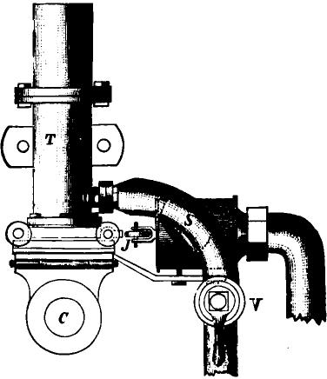
V. 664.
g, meets and pushes back the roller j, thus opening a valve within the cylinder L and establishing communication between the reservoir of compressed air and the tubes M and T. The carrier is thus forced forward in the tube, and whenever its arrival is announced by the electric bell, the slide is pushed back to its normal position.
If the rod f were connected rigidly with the cross-bar d, a cer tain effort would be required to push back the slider, owing to

THE SINGLE SLUICE VALVE. 1113
the friction due to the pressure on the surface of the obturator. This effect is avoided by making the rod f slide in the cross-bar between the limits b and 4 for in pushing it back, the inclined plane first leaves the roller j, and the compressed air ceases to
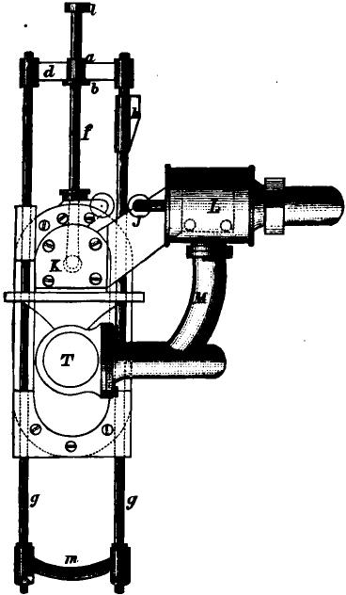
Fig 665.
enter the tube, then the cross-bar meets the ring 1, and the rod f removes the obturator without difficulty.
The greater portion of the parts which form the valves are made of brass. They are attached to strong boards, the one in a vertical and the other in a horizontal position. The latter forms

1114 PNEUMATIC TRANSMISSION.
the table, and receives the carriers to be sent, and those which
are received from the corresponding offices.
The accompanying diagrams show, fig. 666 a back view, fig.
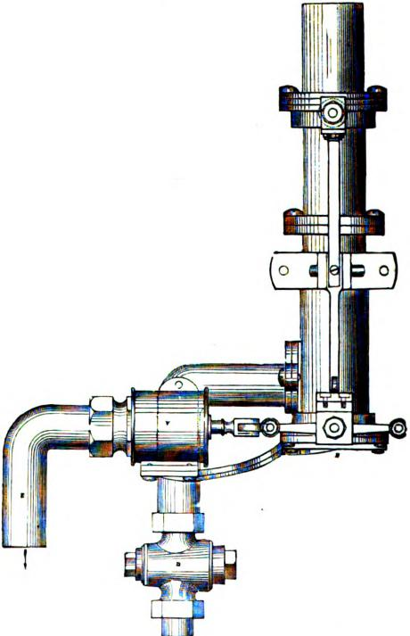
!
Fig. 664.
667 a section, and fig. 668 a top view of the double sluice pneu⁻matic valve. The following is a description of the method of using it and of its action.

THE DOUBLE SLUICE VALVE. 1113
To send a carrier by the forwarding or outward tube, the method of working is as follows: The carrier containing the message is inserted up the mouth of the pneumatic valve P (fig. 667) into the message chamber M, until its buffer is held by the
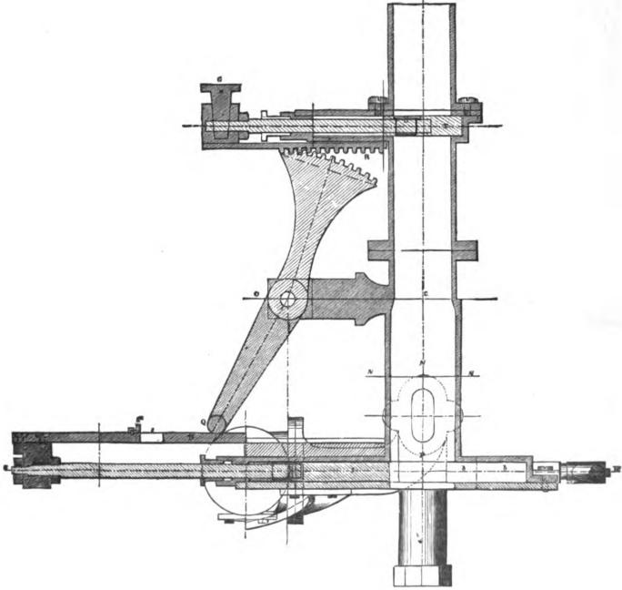
Hg. 667.
contraction at C, which is the true diameter of the message tube. (The drawings show the valve in its normal position.) The handle II is then drawn forward, carrying with it the sluice valve S, until the mouth of the message pipe P is closed. By

1118 PNEUMATIC TRANSMISSION.
Ibis time the stop Si strikes against the tail of the quadrant Q, pressing it into the slot s of the steel slide•bar B, and by the continuation of the motion necessary to bring the sluice valve S to the end of the sluice box b, bringing with it the tail of the quadrant, which is centered at 0, gives an opposite motion to its other extremity, which, fitting into the rack II, opens the top sluice T. During this motion an inclined plane I (fig. 668), which is fixed upon one of the side rods carrying the lower sluice, passes between the fixed roller F and the roller fitted upon the pressure valve V, establishing communication between the pres-
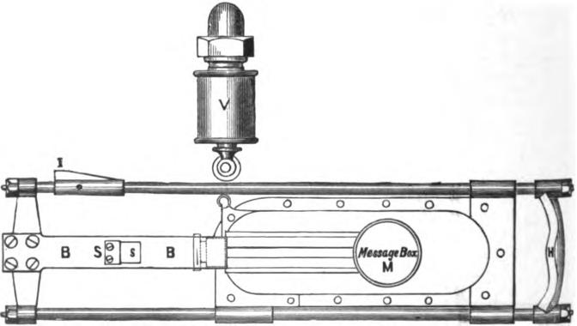
Mg. 668.
sure main and the message pipe; the air thus admitted immediately acts upon the lower part of the carrier (which portion it expands, so as to make it fit the pipe with as little friction as possible) and forces it onwards to its destination. If it be necessary to send a second carrier while the first is in transit (a process which is undesirable), the handle H (fig. 667) is pushed back to its normal position, thus producing a reverse motion of the valves by closing the upper part of the tube before the lower part is opened, and preventing any discharge from the message tube. The second carrier is then inserted and the handle

THE DOUBLE SLUICE VALVE. 1117

pulled forward as previously explained, again opening communication with the compressed air in the main. The time necessary for this operation being about four seconds, it can be easily understood that in the length of pipe the momentary cutting off the pressure is hardly felt, so that the speed of the first carrier is not necessarily lessened. It must be understood that the cock D (fig. 666) is always closed.
The foregoing description applies to a pneumatic tube used entirely for forwarding carriers by means of compressed air.
For receiving carriers, the communication between the pres_ sure main and the pressure valve V is first cut off by means of a stop cock fitted upon the tube E, but lower than is shown in the diagram. The handle H is then drawn forward, and the stop cock D opened, thereby establishing communication be tween the message pipe and the. vacuum main. The carrier inserted at the distant end is then pushed forward by atmospheric pressure, until it arrives in the message box M, and signals its arrival by the sharp noise caused by its striking the sluice valve S. The handle H is then pushed back, the stop cock D having been previously closed; and, by the arrangement already described, the message pipe is closed by means of the sluice valve T (fig. 666), and the bottom of the tube being open the carrier falls out of the message chamber N.
It will be remembered that before the admission of compressed air the forwarded carriers are held at C. The buffers of the received carriers, however, having passed this point, the carriers rest free in the chamber NI and drop out.
When the tube is used for a constant succession of carriers from the out station, it is necessary to pull forward the handle H immediately after the taking out of any carrier. The short space of time occupied in this operation will not have any ap preciable effect upon lessening the speed of the succeeding carrier. It will be seen, therefore, that a number of carriers may be continuously passing in succession through the tube. It is, however, undesirable to permit more than one carrier to be in transit at the same time.

1118 PNE U MATIG TRANSMISSION.
Where the traffic is not sufficient to warrant the expense of an up and down tube, one tube only is worked in both directions in the following manner :
The top sluice T is entirely thrown out of use. This is done by removing the plug G. The rack R is then removed, and the sluice valve T drawn back, and held in that position by a small clamp made for the purpose. The tube is then in its normal state for alternate traffic, and entirely open to the atmosphere.
To forward a carrier it is inserted in the message chamber as previously described, and the handle H drawn forward. The sluice valve S first closes the orifice P, after which the continuation of the motion opens the pressure valve, by means of the inclined plane on the slide rod, and the carrier is forced to its
FYg. C69.
destination. The handle H is, immediately on the arrival of the carrier being signalled, pushed back sufficiently far to remove the inclined plane from between the rollers, so as to close communication between the message pipe and the pressure main, but not far enough to remove the sluice valve from over the mouth of the message chamber. By this means the compressed air which remains in the pipe expands to the atmospheric pressure through the distant end of the pipe only.
To receive a carrier, the cock D (fig. 667) is opened, and a communication is thus established between the vacuum main and the message pipe. The carrier is pushed forward from the distant end, as in the case of the continuous working, and signals its arrival by striking the sluice. The vacuum is then cut off by closing the cock D. On pushing back the handle the carrier falls out

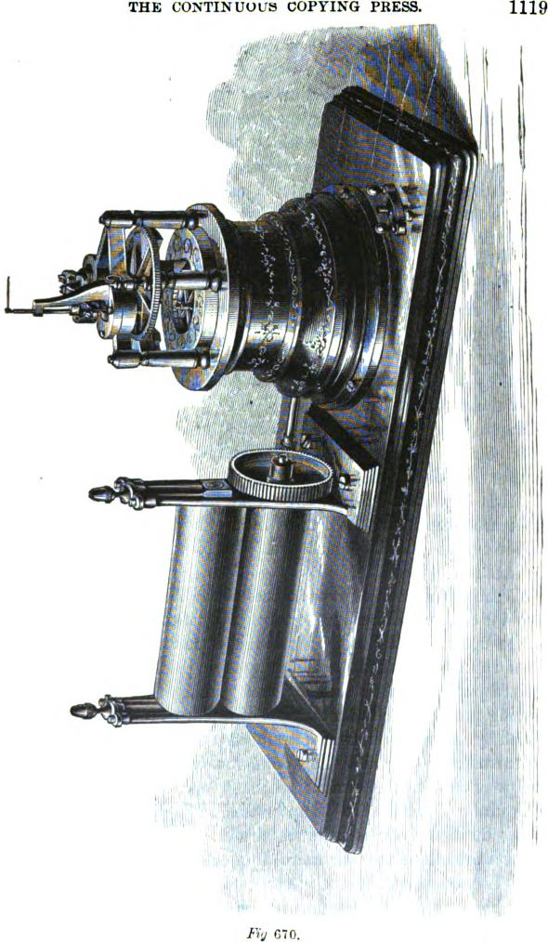
THE CONTINUOUS COPYING PRESS.
1119
Fry 670.

1120 PNEUMATIC TRANSMISSION.

A system of electric signals is used between the central station and the outlying stations, consisting of a single stroke bell with indicator, to signal the departure and arrival of carriers, and for answering the necessary questions required in the working.
The carriers or pistons in which the messages are placed are made of a cylindrical box of gutta percha, one sixth of an inch thick and six inches in length. A section of one of these carriers is shown in fig. 669. The gutta, percha is covered with felt or drugget, which projects beyond the open end of the carrier. This part expands by the pressure behind, causing it to fit the pipe exactly. The front of the carrier is provided with a buffer or piston, which just fits the brass tube This buffer is formed of several pieces of felt.
To prevent the messages getting out of the carrier, its end is closed by an elastic band, which can be stretched sufficiently to allow the messages to be put in.
At the branch stations, where no. tipparatu-, is required, the message tube terminates with the end downwards, above the counter or table, so that nothing can fall into it by accident. •
Tubes are made of lead, iron and brass. In London lead tubes are preferred. In Berlin iron only are used. In Paris both iron and brass are employed. In New York brass tubes are exclusively used.
All messages received at the offices of the Western Union Company for delivery, either by the tubes or by messenger, are written by the operator on the proper blank forms with copying ink, and a duplicate is taken, for filing, by laying a sheet of dampened unsized paper upon the message, and passing the two through a copying press. The latter consists of a pair of rollers, which are turned by steam power, an electro-motor, or by hand, according to circumstances. Fig. 670 shows one of these presses driven 1 y a Phelps electro-motor, similar to that employed to propel the type-printer described in Chapter XXXIV. This method of taking duplicate copies is much neater, and is in many other respects preferable to the manifold process employed in Europe, whi_{c}h is only used in this country when a large number of copies are to be taken of the same despatch, as in the case of press news.

CHAPTER L
THE SIPHON-RECOHDEH.
THE effects of induction in perfectly insulated circuits attracted the attention of scientists from the origin of submarine telegraphy, and they sought to apply practical means to obviate the retardation of telegraphic signals. Sir• William Thomson employed himself, with great success, to produce an apparatus which he has gradually improved, and which Mr. White, a clever optician of Glasgow, now constructs for the numerous submarine telegraph companies. The apparatus of Sir William Thomson has been utilized under different forms, but they are all based upon the same principles, and in all the signals are formed by a light capillary tube, at the extremity of which ink or any other colored fluid is poured out or ejected upon a band of paper; this tube forms part of a bobbin put in motion by the received current, and is attached to it either directly or by means of a stretched fibre.
The capillary tube, curved in the form of a siphon, plunges by its shortest branch in a stationary reservoir, filled with a colored fluid, whence the ink passes to the extremity of the long branch, either by atmospheric pressure, or is ejected from the siphon upon the paper in a succession of fine dots, by an electric current traversing the ink and the siphon as far as the paper. In this case the paper passes over a metallic plate positively electrized, while the capillary tube is negatively electrized. A very powerful difference of potential is maintained between the tube and the metallic plate, so as to create a succession of sparks between them, which causes the ink to be ejected from the siphon upon the paper in a succession of fine dots. These dots leave a trace of the position of the tube at every instant, and their conjunction and succession being continuous, they form a

1122 THE SIPHON-RECORDER
very apparent line without at all retarding by friction the movement of the tube acting under the influence of the receiving apparatus.
This receiving apparatus is composed of a very light rectangular coil of exceedingly fine insulated wire. A part of this coil is under the influence of a very powerful magnetic field, produced
Fig. 671

Is
IV4
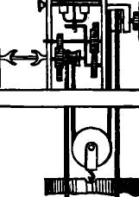
i.
4 r4
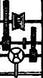
either by large permanent magnets, or by electro-magnets excited by a local battery, This magnetism acts with very great force upon the coil when a current traverses it. This coil is, prop• erly speaking, nothing but a rigid skein, for the wires which compose it are coiled upon a wooden form, which is removed when the skein is complete. All the turns of the wire adhere together, for the coiled wire is covered with shellac. When the

SIR WILLIAM THOMSON'S FIRST APPARATUS. 1123
block is removed, the separation is maintained above and below by means of two little pieces of ebonite, which serve for the suspension and for the attachment of the weights.
The first apparatus of Sir William Thomson is represented in plan and in elevation by fig. 671. This form, although but little employed upon the long submarine cables, tends to return with some modifications. Upon cables of medium lengths the spluttering of the ink is not necessary; the signals are not deformed by a slight friction upon the paper; the electrization of the

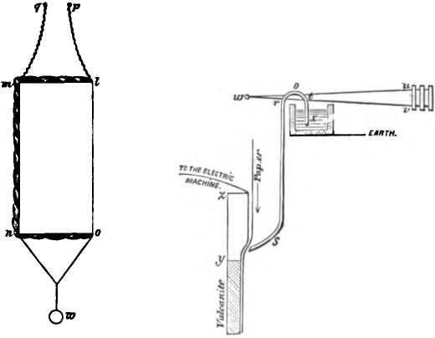

Fig. 672. Fig. 673.
ink by a machine becomes, consequently, unnecessary, and the movement of the paper, which is generally obtained by means of this electrical machine, can be derived from a clock-work movement carried by weights or springs. It has consequently great economy of battery, and we shall see later that this factor is not negligible in the apparatus which must put in motion a magneto-electric machine and exciter, in a relatively short circuit, composed of the bobbins of great electro-magnets. The old recorder returns then to favor, because it has fixed magnets, and can in certain cases operate without the electric mill.

1124 THE SIPHON-RECORDER.

The permanent magnet is formed from pieces of steel bound together, and produces the magnetic field in the contracted space which separates its poles, N S, in m. This magnet is made of straight steel bars, united by a junction piece and with poles of soft iron.
Fig. 672 represents the elevation of the light bobbin, or rather of the skein of fine silk covered copper wire, supported by the small pieces of ebonite in / m and n o. The sides m n and lo contain only some wire, of which all the turns are cemented together by gum lac or by paraffine wax. In the first apparatus which we have described, the side / o was strengthened by a very strong wire in front to relieve the bobbin of all effort, and the axis of suspension was placed near the side strengthened. The skein was besides suspended by two silk threads, 1p and m q, in such a position that the side in n hung in the magnetic field of the poles of the magnet, and could oscillate in a direction parallel to the straight bars which formed this magnet The weight w, which hangs below the skein, adds to its directrix force, since all oscillation from this bifurcate suspension slightly raises the weights. The particular construction of this bobbin reduces to its minimum the movement of the moving parts The side m n being very flat, permits the poles of the magnet to exercise the greatest magnetic force possible, and the length of this same side, to expose a considerable portion of the wire of the bobbin to the action of the magnetism of the magnet Sir William Thomson has obtained the best results with a copper wire weighing 53 milligrarnmes per metre, and in giving twenty turns to the skein. The two extremities of the wire of the bobbin are rolled around the suspension fibres and attached to the binding posts B B (fig. 671), and the receiving current which brings the signals to the register, passes from these buttons to traverse the suspended bobbin and to the earth.
So long as the current does not circulate in the skein, it rests immobile and is solely directed by the bifurcated suspension. The great permanent magnets, moreover, exercise no action upon its direction; but, as soon as the current passes in the bobbin,

ADJUSTMENT OF THE DIRECTRIX FORCE. 1125

the side m n of the skein will be driven outside the poles or attracted more inside, following the sense of the current, and in a direction parallel to the straight bar magnets. The direction of this impulse will depend upon the direction of the current, and the magnitude of the deflecting force will depend—other things 'being equal—upon the force of the received current. The side
n of the skein will go forward and backward, under the effect of the continually variable current transmitted by the cable, and, thanks to the lightness of the skein, will rapidly follow the currents in their changes, so that at each instant its position will correspond 'to the force of the current at that moment In order to aid it, the directrix force of the weight and of the bifurcated suspension must be adjusted in such a way that the natural oscillations of the bobbin, when no current passes, shall be much more rapid than those required in the formation of the signals. The adjustment of the free oscillations corresponding to the speed of the signals, is facilitated by the employment of a deadener which permits of the adoption of a very feeble directrix force and consequently a greater deviation and also separation in the marks. We are able to utilize no matter what form of deadener, based upon the friction of solids or of fluids, and we may also employ a vane plunging in water or glycerine; but Sir William Thomson obtained good results, in the first apparatus which we have described, by means of a light spring, pressing upon the side m n of the bobbin and deadening also the vibrations.
The receiving coil follows the movements of the current as promptly as the little mirror of the reflecting galvanometer; but the current produced a greater utilizable force, to move the parts of the recorder, and this augmentation of force is employed to move a registering apparatus which, in the original apparatus, is combined with the bobbin in the following manner: a simple filament of cocoon silk is attached at ni of the bobbin, and at r of the siphon of the apparatus (fig. 673). The siphon t r s is suspended upon a double thread v w u, on one side, in such a manner as to enable it to turn around a horizontal axis.

1126 st l'ilON-IZECOR DER.

The directrix force of this double thread is adjusted in such a manner that the siphon is able to follow the movements of the side in n of the bobbin to which it is attached. It maintains besides always taut the cocoon fibre which binds v (fig. 673) to in (fig. 672). The distance of the point of attachment r of the axis it, t is about. one-tenth of the length of the longer branch of the siphon, so that all movement of the side in n of the bobbin is represented by a movement ten times greater at the inferior extremity of the siphon. This last apparatus is formed of a tube of slender glass, curved in the form shown by fig. 673 which shows also the paper upon which the signals are registered. This paper moves, under the extremity of the siphon, in a direction perpendicular to that in which this extremity operates. The short branch of the siphon plunges besides in the reservoir of ink.
The plate of copper z y, upon which the paper band is carried opposite to the lower extremity of the siphon, is put in communication with an electric machine which is permanently charged with electricity of hi_{g}h tension, while the siphon itself communicates with the earth. It results that a series of small and very rapid discharges force the siphon to splutter the ink from the reservoir upon the paper. The apparatus must be adjusted in such a manner that the siphon can oscillate from two to ten times in the time employed to produce each signal or each separate part of a letter.
An ordinary electric machine or better a Ruhmkorff coil will serve to produce these discharges. Sir William Thomson has modified the induction machine of Varlet', as we have seen. In the first recorder this machine was put in motion by a clockwork apparatus, serving also to move the band of paper. The clock-work movement has nothing peculiar about it. It is carried by a weight, and in fig. 671 is clearly shown in C.
In the flist induction machine of Sir William Thomson a disk of vulcanite, A A (figs. 674), provided with several pieces of metal a°, a `, a², etc. (which we call carriers), is maintained in rapid rotation around a fixed axis. In their circumferential

THE INDUCTOR AND RECHARGER. 1127
movement, the carriers rub lightly against two feeble springs B and B', placed tangentially at the two extremities of an even diameter. One of these springs is connected to the earth and the other to the insulated metal piece D, called receptor. This piece is analogous to the principal conductor of the ordinary electrical machine. The point of contact b of the earth spring with the carriers is subject to the influence of an electrized body E called inductor. When the inductor is electrized positively, each contact, in quitting the spring b, carries away with it the negative electricity which it gives to the receptor D, in its contact with the spring c'. The inductor and the receptor are placed so
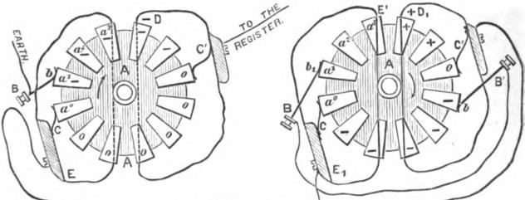
EARTH
Fig. 674.
as to envelope as much as possible the point of contact of the corresponding spring.
In fig. 674 the receptor and the inductor are indicated in section, in order to show the carriers and the contacts. We see, from the preceding, that the inductor engenders a negative charge upon all the carriers in turn, and that the carriers transfer in their turn and in succession, this negative charge to the receptor, which communicates it then to the plate z y placed under the siphon. We know that this negative charge traverses the paper and the siphon in order to return to the earth. In order to obtain good work from the machine, the inductor E (fig. 674) should always be maintained at a high and constant tension. Sir William Thomson has consequently been brought to add to

1128 THE SIPHON-RECORDER.

his machine an apparatus of assistance designated under the name of recharger. This second apparatus is exactly similar to the first, and its form and arrangement are the same as those of the inductor; it contains, however, two more springs, B and B', and the connections are arranged in a different manner (fig. 674). Two of the springs c and c', called receptor springs, are connected to the inductors E' and D, and the springs B and B', called connection springs, are united to one another by a wire. The carriers, in turning in the manner shown by the arrow, touch the receptor springs, at the time that they are entirely covered by the corresponding inductor; they touch the connection springs a little after the interruption of the contact with the receptor springs, and at the time when they are still in great part covered by the inductor.
See now what takes place. Suppose that one of the inductors E, may be in contact with the earth, and that the connection spring and the wire which joins B B' may be insulated. Suppose also that the other inductor D' may be electrified positively and in contact with the inductor E of the induction machine situated at the left; if the carriers turn rapidly upon their axes in the direction indicated by the arrows, each carrier, after having passed the contact C, and by the time that the contact b shall establish itself, shall receive a negative charge by induction, whilst the spring b, and the carrier which it touches shall receive at the same moment a positive charge. These effects are produced by the redistribution of the electricity in the isolated system composed of two c:u•riers, the connecting springs and the wires, under the influence of induction.
Immediately after, the contact is broken in b and b_{p} so that the two carriers retain their positive and negative charges until they come in contact with the inductors by the springs C and C',; then the negative charge passes to the earth by E' and the positive charge abandons the carrier at the interior of D, in order to distribute itself upon the exterior surface of D,, following the known laws of induction; the repetition of this act occasions an indefinite accumulation of positive electricity upon ll, an

EXTERIOR VIEW OF THE INDUCTION MACHINE. 1129

a
a•
I I
accumulation which is only limited by the perfection of its insulation, which prevents the dispersion of the electricity by conduction or the spark. The charges of electricity, positive and negative, are indicated by the signs + and — upon the carriers.
When they are discharged, or a little after, they carry a 0. In the exterior view of the induction machine (fig. 675), it has been necessary to take away E₁, in order to show the disk and the carriers. When the apparatus operates, the copper plate z y and the paper which covers it strongly attracts the extremity of the siphon, and, under the influence of this attraction and of a rapid vibration, due to some feeble discharges, but continuous electricity, the ink is projected in a succession of fine droplets
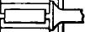
Fig. 675.

a
I
⁻from the siphon upon the paper. These little drops form upon the band unrolled by the clock-work movement, a continuous line which registers the position of the extremity of the siphon at each moment and, following which, it is brought forward or attracted backward by the fibre r m, to mark its position above or below the medium line of the zero. The line thus traced is consequently a continuous curve corresponding to the oscillations of the bobbin, and consequently to the variable currents which produce it as well as that of the signals which its movements indicate. These signals, in which the upper points indicate the dots of the Morse alphabet, and the lower points the dashes of the same alphabet, are represented in fig. 676. When no current traverses the bobbin, the effect of the siphon will be to produce simply a straight line upon the band. Any

1130 THE SIPHON-RECORDER.

short signals, positive or negative, will produce small angles above or below the zero line.
1
Fig. 676 represents the signals indicating the international Morse alphabet, given on page 480, produced by the siphon-recorder when transmitted over a short cir-
- cuit. When these signals are transmitted through a submarine cable they become more or less distorted
- according to the length of the cable and the speed of transmission. Fig. 324, on plge 560, is a fac-simile of
- the writing of the siphon-recorder at a speed of eighteen or twenty words per minute through a cable of 800 miles in length. On page 561 there is an example of the record made in working through a still longer cable. These illustrations will serve to show the effect upon the siphon-recorder of the various disturbing influences which are encountered upon long submarine or subter.
^{14.} ranean telegraph lines, and which effectually prevent
- the use of any other recorder upon them.
The first apparatus which we have just described has since been greatly improved, and the new form which Sir William Thomson has given to it, although by no means
- changing its principle, has made a new and above all
- more sensitive instrument. The three essential organs,
- the electric mill, the signal bobbin and the siphon, have
- been changed in such a manner as to give the most satis-o_{k} factory results.
0. THE MOUSE-MILL.
- In this apparatus, the electric mill combines the two functions of electro-magnetic motor (of which the move.
- meat serves to unroll the paper band), and of induction machine, of which the sparks, directed to traverse the siphon, cause the continuous splutt?ring of the ink upon the paper. All scientists know the difficulties which are experienced in maintaining a constant flux of static
Fig. 67G. electricity in an electric machine placed in an apart-
ment occupied by numerous persons. In spite of these dill-

THE MOUSE-MILL. | 1131

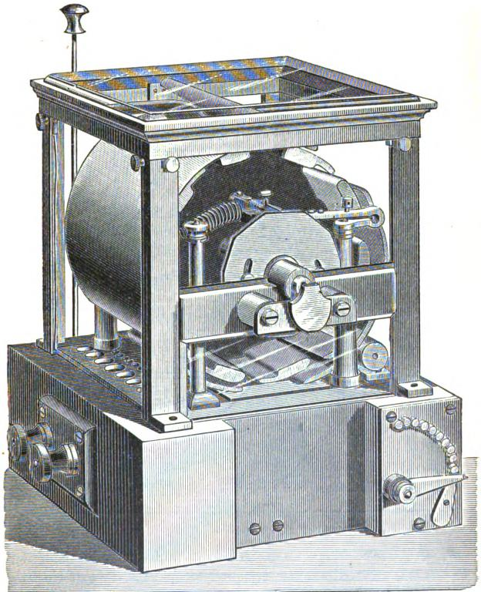
Fig. VI.

1132 THE SIPHON-RECORDER
culties the electric mill, or mouse-mill, rarely makes a default in the service.
Figs. 677 and 878 represent the whole of this electric mill. A series of soft iron bars, al, a², ....al ⁰, are arranged as the staves of a barrel, but they do not touch each other. The iron rods
Fig. 679.

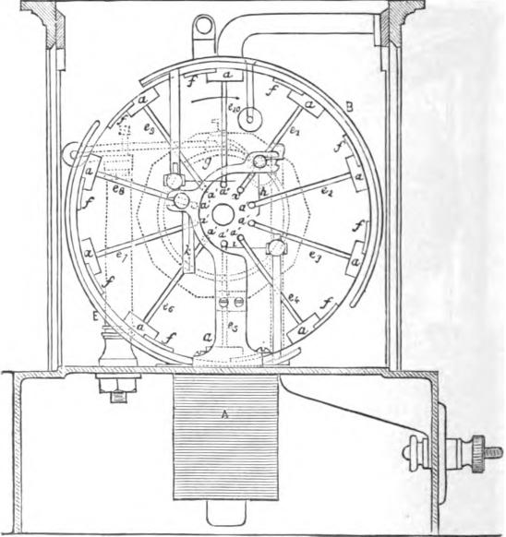
a
_{e}t_{, e}2_{,....e}to keep them in place and connect them to a central disk of ebonite attached to an axis c. An electro-nia,rnet, of which the soft iron bars conic close to the base of the mill, communicates by two binding screws with a special tray battery, of which we give a description farther on. When the current from this battery traverses the electro-magnet A, the

OPERATION OF THE INTERRUPTER. 1133

r
5
soft iron bar nearest to it is attracted, but as soon as it has arrived over the electro-magnet, an interrupter suppresses the current of the battery and the bar passes the electro-magnet by its acquired motion. This movement suffices to put the battery again in circuit, the second bar is attracted, passes in its turn the electro-magnet by breaking the circuit of the battery, and so on.
THE INTERRUPTER.
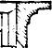
B
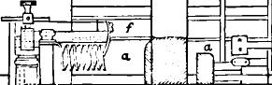
0.
i^{f}
E
---------
Fig. 679.
The arrangements of the interrupter are represented in figs. 680, 681, and 682. The two poles of the battery come one to ' d and the other to e. The circuit is closed when the platina screw c, fixed to the spring d, rubs upon the contact piece e. At every other moment, the ebonite bar Jr, insulates these two contacts from each other. The moving contact piece c is formed of

1134 THE SIPHON-RECORDER.
a bit of large platinum wire soldered to the extremity of the steel spring d. This extremity is attached to a bit of knitting-needle x, fixed in a line with the spring and extending about two centimetres beyond the contact piece c. The other extremity of the spring is fixed to the metallic piece g with which it is in contact, making also part of the circuit which is complete when the moving piece c presses the fixed contact e so that

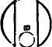
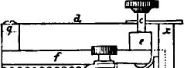

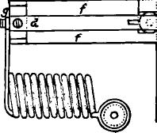
_{o}'er—,
Fig. 680. Fig. 681.
the needle x descends upon the cut side of the cam A. The cam lifts the needle a., and interrupts the contact, leaving it free to re-establish it by its proper elasticity at the desired moment. The spring d, nearly horizontal when it establishes the contact, submits to a sufficiently considerable flexion. Dis- • mounted and recovering its normal form, this spring is bent This arran2:eincnt assures the contact. A thumb-screw, w, serves to raise or lower the spring d and to regulate the duration of

OPERATION OF THE DECAGON CAM. 1135
the contacts. The precise instant of these contacts is obtained by wedging the cam upon its axis and in fixing it in the desired position by means of the set screws i and j. The cam A, being decagon, raises the movable spring ten times per turn and interrupts and re-establishes the contact between c and e the same number of times, thereby causing the electromagnet to act the same number of times upon the soft iron bars of the mill.
The supports of the axis of the electro-magnetic machine are
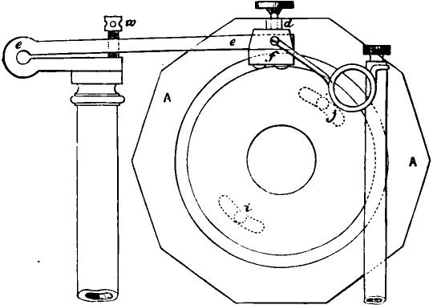
Fig. 682.
constructed so as to offer only a very feeble friction. This is obtained by placing the pivots upon the rollers, d d (fig. 679). These pivots are retained by two parallel guides with soft friction which prevent them from sliding out of the rollers. The movement of the support is maintained following its axis by two
steel plates fixed perpendicularly to this axis at a distance
slightly superior to its length. The steel rollers d d, are rounded upon their edges, the pivots plunge in a cup full of fine oil; they are then (as well as the pivots of the principal support) constantly lubricated. The cheeks which guide this support

1136 THE SIPHON-It ECORDER.

do besides carry the friction almost entirely upon the rollers, for the friction sustained by the guide only serves to maintain the pivots in place.
The speed of the mill is regulated by resistances added to or removed from the circuit of the electro-magnet In some appa. ratus, the spark which is produced by the interrupter at the point e is diminished by the employment of a shunt permanently connecting the extremities of the bobbins of the electromagnetic machine. We have said that this part of the apparatus had for its object the moving of the paper. The extremity of the support of the mill is supplied, on the outside of the glass case, with a grooved pulley upon which passes an endless
cord forming a band. Whip-cord is most convenient, although they also employ sometimes, round leather thongs as in sewing machines. The endless cord rolls upon a lar.,,e wooden disk, J (figs. 684 and 685), of which the axis projects in front of the instrument A leaden wheel acts as a weight and carries several grooves of different radiuses by which the speed of the movement of the paper can be varied at pleasure. A second band, passing over the groove of a pulley fixed to the axis of the unrolling cylinder communicates the movement of the mill to the system of cylinders carrying the paper. The lower cylinder is maintained by a spring which presses it against the paper band. Guides keep in place the wooden disk and prevent the transmission of mechanical vibrations of the principal motor to the paper. The mill operates also as an induction apparatus. .For tills purpose
the ebonite disk g carries ten little brass rods, _{a}2,
which conduct the electricity. The disk g (fig. 678) and the pins which it supports are surrounded in part by a metallic envelope carefully insulated from the pins by a coating of pa r-alline or gum lac. This circular metallic envelope forms two parts of equal dimensions of which one, E, communicates with the earth, while the other, B, is completely insulated. The electricity of this second half-cylinder must flow away to traverse the siphon by the conductor p (fig. 679), the reservoir of

THE OPERATION OF THE MOUSE-MILL. 1137
ink, the siphon and the band of paper, under which is found a metallic plate communicating with the earth and the second cylindrical part of the inductor. All the pieces supporting the siphon and the reservoir of ink are of carefully paraffined ebonite. •
THE OPERATION OF THE MOUSE-MILL.
In turning in the manner indicated by the arrows (fig. 683), the staves of the mill pass successively under the half-cylinders fixed to the inductors, the pins rub against the springs a a', b b',
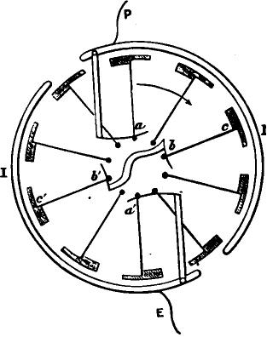
Fig. 683.
where a communicates with the inductor P and a' with the inductor E, the other two springs b and b' being connected between them and carefully insulated from the mass of the apparatus. Let us suppose that the conductor P may be elec-trized positively when the apparatus commences to turn. The staves opposed, c and c', are in metallic contact between them for the reason that the pins which unite them touch at the springs
b and b'. At this moment, the positive charge of P decomposes the electricity of c and c', attracting the negative fluid towards
c and repulsing the positive towards c'. But in turning, c comes

1188 THE SIPHON-RECORDER.

in contact with a' and its negative charge flows to the earth; on the other side c' comes to touch a and its positive charge being transported into P, augments the quantity of positive electricity existing already in this inductor, which has the effect to increase the inductive action of P upon the successive staves of the apparatus. Thus the charge of P goes on increasing at each turn of the mill. The action has cause as soon as the potential of the inductor P is a little different from that of the inductor E. If P was negative in reference to E at the beginning, it would then be upon P that the negative charge would accumulate. It would be very difficult, if not impossible, to reduce E and P so exactly to the same potential as t.) prevent P from taking a very high charge likewise after several turns of the mill.
The carriers (we thus call the staves) and the inductors sometimes permit the sparks to escape and traverse the layer of air which separates them, which is then an indication that the insulation of the pieces is imperfect, and in this case the layer of paraffine or of lac must be renewed.
The electricity of high potential which is accumulated upon B (figs. 678 and 679) is not communicated directly to the ink in the siphon in order to prevent the sparks from flying off between the point of the siphon and the metallic plate upon which the paper band passes. The inductor B is put in communication with a brass rod p, which can be raised or lowered at pleasure, and which is maintained at a convenient distance from a metallic plate. The electricity itself passes by the air, from the point to the horizontal plate, next, by the inkstand and the siphon, to the earth, which ends at the metallic plate situated under the band of paper. An excess of electricity determines in the siphon vibrations intense enough to distort the signals. This excess of electricity may be carried to the earth without passing by the siphon by means of a horizontal rod fixed in the mass of the apparatus, and which can bebrought more or less near, according to need, to the conducting rod p.
Certain qualities of paper oppose a considerable resistance to the passage of electricity, principally in dry weather. They aug.

INCREASING THE CONDUCTIBILITY OF PAPER. 1139

ment the conductibility of these papers by soaking the rolls in pure water, or, better, in a solution of two in 100 of nitrate of ammonia. This result is obtained also, not unfrequently, by simply depositing during a certain time the roll to be used upon the grate of zinc of the tray battery. Sometimes also they make use of steam by placing under the band, as it unrolls, a metallic plate full of water heated by gas.
A lead slide, in which they keep a small piece of pumice stone soaked in sulphuric acid, permits of the maintenance of the interior of the mill very dry, which is besides hermetically closed with plate glass. Only very concentrated and very pure sulphuric acid is employed, which is boiled for half an hour with some sand and some crystals of ammonia, In certain cold and humid stations they are obliged to heat the mill by passing a current of very hot steam through a lead tube coiled in the slide and connected to a tin boiler heated by gas or alcohol.
Thanks to these precautions and to the perfect insulation of the supports, the electrification of the ink and of the siphon can be maintained very uniform. The perfection of the signals depend also upon the siphon itself and upon the adjustment of the signal bobbin.
The siphon-recorder works as follows :
THE BOBBIN AND SIPHON.
The bobbin and the siphon are arranged upon a frame (figs. 684, 685 and 686), maintained in place between the electromagnets by the screw-nut C, which is fixed to the back of the half-cylinder in font N N, supporting the two large bobbins M M. The frame of the bobbin S is suspended by a silk thread passing upon the pulley r (figs. 687 and 688). The position of this pulley can be varied by means of the thumb-screw w. At the centre of the bobbin is a piece of soft iron, s, 3, which increases the intensity of the magnetic field at the centre of which the bobbin is suspended.
Two weights suspended to the frame of the bobbin slide in the guides z; the fibres of silk which support them pass under

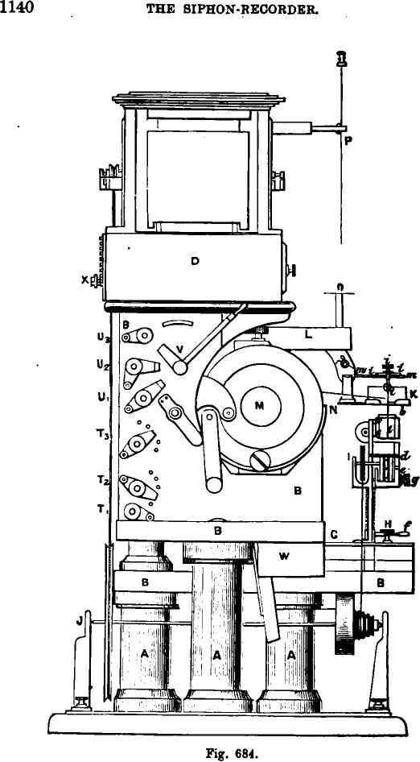
D
4
1140 THE SIPHON-RECORDER.
U
U
Ty
Fig. 684.

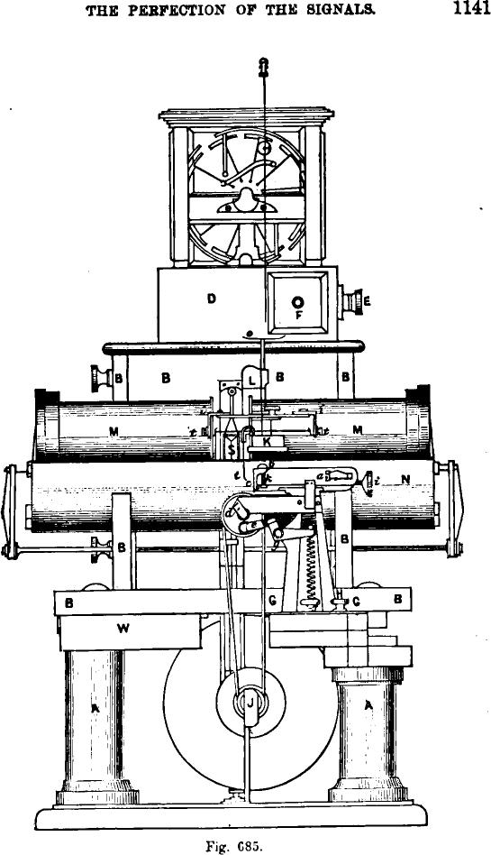
THE PERFECTION OF THE SIGNALS.
1141
Fig. 685.

1142 THE SIPHON-RECORDER.

the bridge x from which they can vary at pleasure the relative distance to the bobbin by the aid of the thumb-screw y. They change also the period of vibration of the bobbin by more or less tightening the silk threads which suspend the weight near the bridge x. In certain apparatus they obtain the same result in a more simple way, represented in fig. 683A. The bridge is double, and consists of two rods, a, and a, fixed in the same plane upon a common piece which can be raised or lowered at pleasure; it is attached to the weight W and passes in front of a, and in the rear of a,. They thus avoid the inclined plane, and the weight can remain freely suspended. Referring to the figures 687 and 688, p and q are the wirebinders of the extremities of the bobbin; they communicate, by the attached wires, with the switches T₅ and T, of the whole apparatus. Above and to the right of the bobbin is attached a filament of cocoon v, the other end of which is fixed to a small vertical lever, u, called
Figs. 684 and 685 —A, A, A.—Wooden supporta. B, B.—Frame-work of the apparatus. C.—Covering of the mill, which can be removed from B, B in order to regulate the apparatus. D.—Inferior parts of the mill containing the moving electro-magnet. E.—Terminal of electro-magnet. F.—Lead slide-valve containing the pumice stone and the sulphuric acid. G.—Triangular copper plate carrying the mechanism for moving of the paper and its accessories. H.—Screw fixing A with respect to B and permitting the whole system for moving the paper to ad. vance or to recede. I.—Pulley situated upon the axis of the unrolling cylinder and guiding the paper. K.—Reservoir of ink, put in metallic communication with the plate 0, but perfectly insulated from the system by the piece of ebonite L, except the communication formed by the syphon t, t. M, M.—Large electromagnets, between the poles of which is suspended the signal bobbin S. N, N.—Half-cylinder of soft iron, forming at the same time the bed and the armature of the electro-magnets M, M. O.—Copper plate, forming the collector of the electricity engendered in the mill. P.—Copper rod terminated in a point and conducting the electricity collected by the plate 0. R.—Rectangular skein of Sne insulated copper wires, forming the signal bobbin. T„ T,, T₅.—Terminal limits of the signal bobbin attached to the commutators radiating upon a series of derivations which can be introduced in the circuit of the bobbin S. II,, II,, II,.—Terminal limits of the battery, of which the two poles are attached to the two ex. treme screw-studs. V.—Commutator of the battery, by means of which they can transmit the entire battery or by halves in the electromagnet
valve implements. X.—Commutator permitting of the insertion in the bobbins of the mill of the resistances which vary the speed of rotation.

COMPLETE VIEW OF THE SIPHON-RECORDER. 1143
tea.
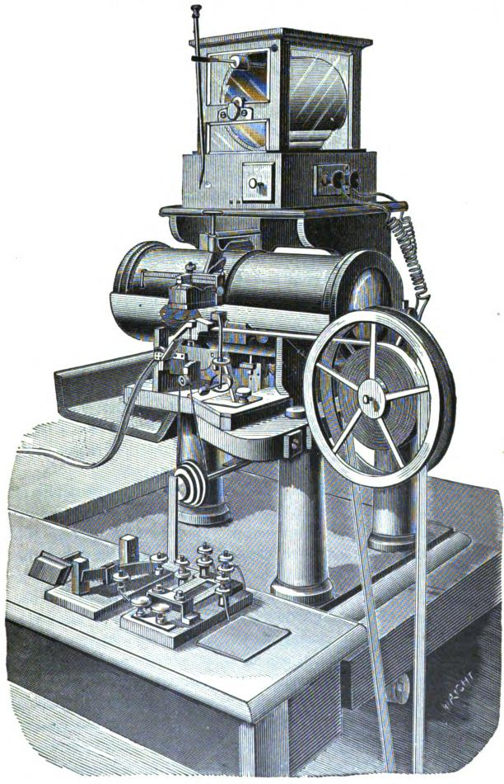
I e
6¹⁴

*ay/ ilia IN

1144 THE SIPHON-RECORDER.

a multiplier. At the upper end of this lever another filament
of cocoon attaches it to the left extremity of a sort of little alu-
minum saddle supporting the siphon. They often dispense with
the multiplier by attaching the bobbin directly to the siphon.
The aluminum saddle is supported by a fine metallic wire, /1,
fixed to the two extremities of the bridge i (fig. 689) and to some small curved steel springs. Some thumb-screws, U, attached to these springs permit of giving to the wire the desired tension. Behind the frame of the bobbin and in a direction opposed to the point of attachment, v, is fixed another fibre connected to the moving-piece o, by which they can vary the position in the groove by the adjusting screw n. By turning n outward a greater strain is put on the fibre leading from o to the signal coil, and by turning n inward the strain is lessened. They can thus increase or diminish, as desired, the effort of this wire and counter-balance with exactitude the effort which the bobbin sustains on the other side. This part of the regulation is very delicate. The desir-
~Q₹ able vertical tension of the weight is obtained very
easily, but, once the horizontal regulation is obtained,
it has there no more to occupy itself on.
The bridge i i (fig. 687), which supports the saddle of the siphon is fixed in the groove of the piece m m, by means of the screw-nut j. By properly moving the bridge in the groove forward or backward, we obtain the adjustment of the siphon in respect to the paper. The torsion of the metallic wire also contributes to the ob-
Fig. 683A. .
w
ject of this adjustment. The piece m m is besides a small hinge, and in raising it we can lift the siphon out of the reservoir of ink in which it is plunged. This hinge raises the bridge by means of a curved groove carefully arranged in the metal, in such a manner that the wire which connects the siphon to the signal bobbin receives no tension by this movement. The reservoir lc contains the ink, in which the shorter branch of the siphon is plunged. This ink is ob-

COMPOSITION OF THE INK. 1145
tained by dissolving in water the best aniline blue of commerce. By dissolving in half a glass of water as many crystals as can be taken upon the point of a knife, we obtain a perfectly fluid ink of a fine dark blue, which does not thicken.
FABRICATION OF THE GLASS SIPHONS.
The stations are provided with a quantity of fine glass tubes
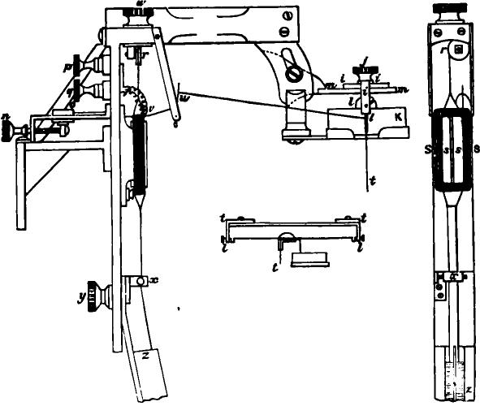
Fig. 687. Fig 688.
to make siphons of. When the stock fails they can renew it by heating over a gas flame, or better at the jet of a Bunsen lamp, a tube of soft glass about five millimetres in diameter. When it is sufficiently softened, they draw it out to the diameter required and cut it in pieces of about ten centimetres. The very fine siphons give very distinct signals, but they require more electricity on the part of the mill, and they become ob-

1146 THE SIPHON-RECORDER.
structed when the ink carries away with it dust or other residuum. In order to give to the tubes the siphon form (fig. 690) they take one of the tubes and simply heat it at the proper points with the red-hot carbon proceeding from a wood match of which the flame is extinguished; by bolding the tube in a convenient position, it curves itself by its own weight when the glass is soft. It is then turned by band as practice requires.
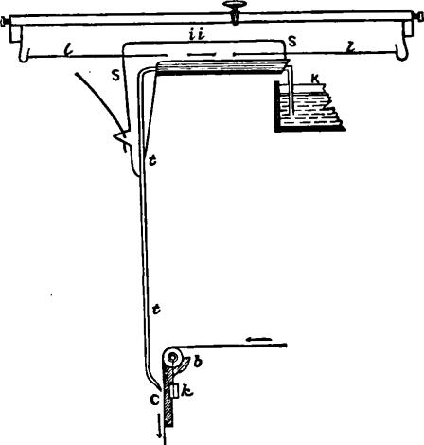 | 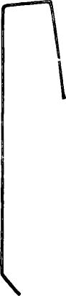
Fig. 689. | Fig. 690.

The longer branch of the siphon must have a length of six centimetres and the point must be brought forward so as to form an angle of about 180 degrees with this branch. In heating the angles, care must be taken that the glass is not too soft, which would diminish its interior diameter. They sometimes smooth the extremities of the siphon upon an emery stone so that they may not tear the paper when approached too near. Upon comparatively short circuits, where they do not need great sensibility, they can employ a siphon of great diame-

FIXING THE SIPHON UPON THE SADDLE. 1147

ter, and in this case, if the paper passes quite near the siphon, the ink flows in a very uniform L.shion without electrification. In this case it goes without saying that the point must be treated with particular care. The siphon is fixed upon the saddle which supports it (fig. 689) with a little pure wax by means of a small spoon bill. They then raise the bridge in order to take out of the reservoir the shorter branch of the siphon of ink, which they must remove.
The apparatus forming the whole of the bobbin and of the siphon is frequently furnished in duplicate, so as to be immediately replaced in case of need. It is the same with the electric mill and of the little chariot G, H which determines the movement of the paper.
THE MOVEMENT OF THE PAPER.
The paper enters at the right and is maintained tight by a small steel spring, a (figs. 684, 685 and 686). It passes then over the roller-guide t which can be raised or lowered by means of the screw k, then upon a slightly convex plate banging vertically. From there it is engaged between the rollers d and e, in order to be horizontally discharged at the left. The roller e presses strongly against the drum d by means of its support which is attached to a strong retained lever, by its spiral spring f This spring can be relaxed at pleasure in order to renew the paper. The whole system of movement is supported upon a triangular foot G, fixed to the solid wooden mass of the apparatus by the screw H. A transverse groove traversed by this screw permits the apparatus to advance or recede so as to place the siphon in the axis for unrolling the band of paper. Outside of the shunts, of which we speak farther on, we can increase the sensibility of the apparatus by means of the following precautions:
The more the bridge x under which the attachment of the weight passes shall be lowered, the more the distance which separates it from the bobbin will be lengthened and the more this last will freely oscillate around its vertical axis (figs. 687 and 688).

1148 THE SIPHON-RECORDER.

The weights which dirigent the bobbin are able to vary between certain limits. It suffices that they should be sufficiently heavy to bring the bobbin back to its normal position without a sensible interval between the cessation of the current and the corresponding return movement; five to six grammes suffices for each of the two weights.
We diminish besides the directrix force in bringing nearer the silk cords which support these weights. We see upon fig. 688 that these cords are connected together just below their point of attachment to the bobbin; we connect them in the same manner under the bridge x, but it is not necessary that these suspension threads should touch each other. This method of augmenting the sensibility of the apparatus is preferable to the lightening of the weights, and does not diminish the stability of the bobbin.
The arm of the multiplicator lever u (fig. 687) can be augmented by lowering its point of attachment to the bobbin, or by elevating that which connects it with the siphon. This lever is fixed at its lower extremity, by means of virgin wax, to a little stretched wire at the bottom of the frame indicated in the figure. A light weight fixed to its base maintains it in position.
ADJUSTMENT OF THE PAPER.
To release the paper, turn the handle/ in a direction opposite to the motion of the hands of a watch. Thus the roller e is allowed to fall about an eighth of an inch, and the paper is quite free, so that it may he slipped out with ease, and, though the driving drum d revolves, the paper is not drawn along. To clutch the paper against the driving drum, turn the handle f in the reverse direction. To regulate the distance of the paper from the point of the siphon, turn the milled head h. To bring the line made by the siphon to the middle of the paper, loosen the elarnping•screw II, when the whole paper stage G G can be easily moved backward or forward to the desired position. To make the paper run evenly between the rollers d and e, turn the small screw k, which will either elevate or

INSTALLATION OF THE APPARATUS. 1149

depress the nearer end of the roller b until all works true. To alter the speed of the paper, shift the band in front from one pulley to another. If necessary, alter the speed of the mill.
ARREST OF THE APPARATUS.
When the apparatus does not work, they cut the circuit of the large electro-magnets by turning the commutator V (fig. 684). They arrest also the movement of the mill by breaking the contact X; the siphon is taken out of the reservoir of ink and emptied by suction of all the ink which it contains in order to prevent it from drying to the interior. It is also in this manner that they withdraw or clear out the foreign substances that the ink contains. This operation demands great precautions, because they might thus not only break this fragile organ, but also stretch it beyond convenient limits, or break some of the fastenings of the cocoon filaments.
If the apparatus ceases to work for a short time, the cord for moving the paper can be placed upon the smaller pulley, the speed of unrolling is then diminished, as well as the use of the paper; or better still, the lever g of the compressor roller e (fig. 685) being lowered by relaxing the spring f, the paper does not pass away and the ink accumulates in large drops. Another resource consists in forming an endless band of paper of about two yards by pasting its two extremities together. This band, by coming continually in front of the siphon, will receive the marks of the point, and will thus economize the roll of paper. The electric mill must never be arrested without at. the same time lifting up and emptying the siphon. When the apparatus is installed on the ground floor it is placed upon a light brick pillar, or better still, upon a pedestal of stone resting upon the ground. This pedestal is independent of the writing table which ought to extend about a foot from the base of the apparatus, making nearly the table shown in fig. 686. This arrangement prevents the apparatus from suffering all concussion proceeding from shocks of the table. When the offices must be situated on the upper floors, the apparatus is placed

1150 THE SIPHON-RECORDER.

upon a marble table resting upon strong iron brackets securely embedded in the masonry of the walls. It is necessary as far as possible to place the apparatus on the right of a window, in order that it may be well lighted at the left. When they place the apparatus upon a light pillar or upon a marble table, it must be absolutely level in order that the signal bobbins may hang freely, and that the electric mill can turn freely upon its axis without friction.
THE ELECTRICAL CONNECTIONS OF THE SYSTEM.
The following are the electric connections of the apparatua We have already described those of the mill. The intense magnetic field in which the bobbin moves is produced by the current of a local battery of eight large elements of a tray' battery which traverses two strong electro-magnets (figs. 685 and 691):
The zinc pole of this battery arrives in Z, the copper pole in C, and the binding screw H is attached to the middle of the battery. The switch J permits of the interruption of the current of the local battery or of the utilization of the whole or of half of it. The binding screws E and D permit the passage of one-half of the local current in one electro-magnet, the other half in the other, or the entire current by the two electro-magnets or solely by the one or the other. Suppose the lever J in communication with the binding screw E and the other communications disposed following the figure; the current passes then from C by B D, there it divides, and finds upon the two routes equal resistances—one-half of the current traverses A and returns by E to the other pole of the battery in Z, the other half passes from D to G, traverses A' and returns by F to the battery in Z. If the commutator M is removed from the contact E and N be substituted, the entire current will pass from D around from A, then to E, from there to G around from A', then it will return by F to Z. If M is put in communication with E and N be at the same time removed from D, the entire current only passes by the electro-magnet A. If N is in communication

THE ELECTRICAL CONNECTIONS. 1151
with D and M removed from E, the entire current only passes by the electro-magnet A'. Experience shows that the disposition indicated upon the figure furnishes the greatest electromagnetic force. If, moreover, each of the bobbins has a resistance of about seven ohms, the resistance of the circuit in series will be fourteen ohms; it will only be that of seven when only one bobbin shall act, and of three and a half in multiple arc.
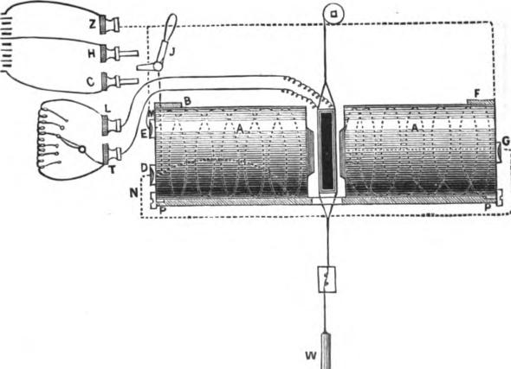
Fig. 691.
The distances between the electro-magnet and the signal bobbins are regulated by screws. The amplitude of the oscillations of the bobbins depend a great deal upon the force of the electro-magnets. It depends also a great deal upon the speed of the transmissions, and a slow manipulation gives always more ample and better defined signals.
In order to register the transmitting signals it is necessary to make a part of the passing current traverse the bobbin of the recorder of the station which transmits. This part of the cur-

1152 THE SIPHON-RECORDER.
rent must moreover rejoin the principal current before it enters the cable, or else it must be made to pass away to the earth. These systems give then two different arrangements of communications. They have proposed several arrangements of these two systems. Fig. 692 shows an arrangement in which no portion of the current is carried to the earth at the transmitting station.
T„ T₂, T_{o} are the three terminal binding screws placed at the left of the recorder. On the uppermost binding screw T,
there is a quadrant slide which permits of the insertion between T₁ and T_{o} of variable resistances of eight ohms and under. T₁ and P₂ are connected to the two extremities of the signal bobbin

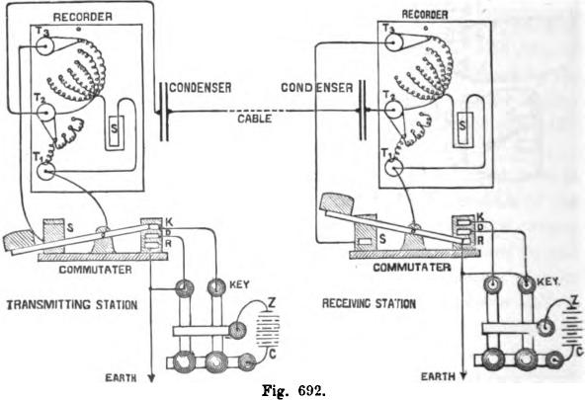
RECEJANC STATION
CONDENSER CONDENSER
CABLE
KEY
TRANSMITTING STATION
EARTH
Fig. 692.
S. Attached to T₂ is another quadrant slide, by means of which
variable resistances of 500 ohms and upward can be inserted between T₂ and T_{o} in such a manner as to form a shunt to the bobbin S. When the permutator fixed to T₂ is not in contact with any of these shunts, the only communication between T_{o} and T₁ is that furnished by the bobbin itself, which consequently is not shunted. T₂ is connected to the cable or to the con-

THE ELECTRICAL CONNECTIONS. 1153

densers, if any are used. At the sending station the current from the key enters the recorder simultaneously by T, and T₃. The greatest part of the current reaches T₃ by way of T₃ in consequence of the feeble resistance of this part of the circuit. A very feeble portion reaches T₂ from T„ traversing at the same time the bobbin and the shunt, if there is one. The combined resistance of the bobbin and of the shunt inserted between T₁ and T₂ is much greater than the resistance existing between T, and T,, consequently only a very small portion of the current goes to T₂ by way of T₁. Hence only a very feeble part of the current passes through the coil. The commutator is formed of a metallic lever, moving upon a horizontal axis. Its central part communicates with T₁. In order to transmit they pull down the commutator, so as to connect K to S, which communicates with T₃; consequently the key communicates with T₁ and with T_{a}, as we have said before. In order to receive, they raise the lever, and thus put T₁ to the earth, at the same time that they isolate S and the resistances which there terminate in T. The current from the correspond. ing station which enters in the recorder at T_{r} finds no passage by T₃, and is compelled to pass from T₂ to T₁ by the bobbin and the shunt. The contact-piece D of the key permits of the discharge of the cable to the earth when they raise the lever in order to pass from the transmission to the reception. The lever ought to touch this contact D before having entirely abandoned the contact S, so that the cable may be for a moment put to earth to traverse only the very feeble resistance between T_{r} and T₃. We should remark that the batteries are reversed at the two stations, or, which is the same thing, that the position . of the line is different upon the two keys. This disposition is necessary in order that the transmitted and received signals shall be registered in the same direction upon the apparatus when the mounting which we have described is employed.
Fig. 693 shows an arrangement in which the portion of current which registers the signals transmitted by the sending station goes to the earth. When sending they establish the contacts

1154 THE SIPHON-RECORDER.
2 and 3 and isolate 1. The current coming from the key enters simultaneously in the recorder by T₁ and T_{s}, and are consequently at the same potential. Between T, and the earth they introduce a very great resistance, about 5000 ohms, varying according to requirements. The small resistances between T_{s} and T_{s} being an excessively small fraction of the great resistance placed between T₂ and the earth, the potential of T, will be very little inferior to that of T,. But T₂ is very little below
RECORDER
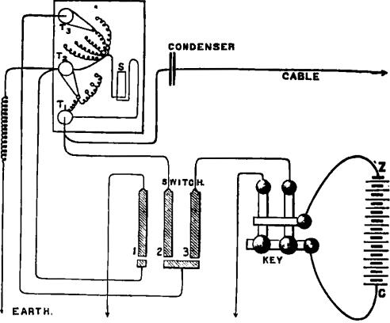
Fig. 693.
that of T₁, and there will therefore be a very feeble current from T₁ to T₂ to traverse the signal bobbins.
In order to receive, they establish the contact No. 1, and they interrupt those of 2 and 3. They put, therefore, T₂ in direct communication with the earth, and the received current enters by T₁, traverses the bobbin and goes to the earth by T₉. In this arrangement the currents transmitted and received of the same name traverse the bobbin in the same direction; it is not necessary then to reverse the direction of the currents at the corresponding stations, as in the other disposition. The

THE ELECTRICAL CONNECTIONS. • 1155 •

commutator must be constructed in such a manner that in turning on the transmission we establish at once the contact No. 2, rupturing en suite No. 1, in order to establish finally No. 3. When we pass to the reception, No. 3 must be ruptured first, then No. 1 established, and finally No. 2 suppressed. This order prevents the signal bobbin from receiving any violent shock by the discharge from the cable.
The transmitted signals which are registered by means of this second disposition are much better defined and more legible than those which are obtained by the other means. It is above all the case when condensers are employed, or when the signals are transmitted by means of the automatic transmitter of Sir William Thomson and Professor Fleeming Jenkin, which we shall describe later on.
BATTERIES.
The batteries employed to carry the electric mill and to charge the electro-magnets are of large surface and have only a very feeble interior resistance. They are a modification of the Daniell battery, and Sir William Thomson has designated them under the name of Trays. They consist of large flat wooden trays O¹°, 41 squared at the base and widening at the summit; they are lined interiorly with lead in order to render them water-tight. The positive pole is formed by a thin sheet of copper placed at the bottom of the trough. Upon the four angles a block of varnished stoneware supports a grating of zinc, forming the negative metal which is enveloped in a sheet of parchment paper <figs. 694 and 695). This envelope is designed to prevent the copper from depositing upon the zinc; it acts also as a diaphragm, and as the paper is besides solidly fixed to the grating by a large string and by sealing wax, it retains homogeneously the whole of the zinc grate which time deteriorates. The trays are connected to one another by being piled one on the top of another upon a wooden frame provided with four porcelain insulators, in such a manner that the copper of one is connected to the zinc of the preceding by contact of the lead sheathing of the upper one with the four corners of the zinc plate below

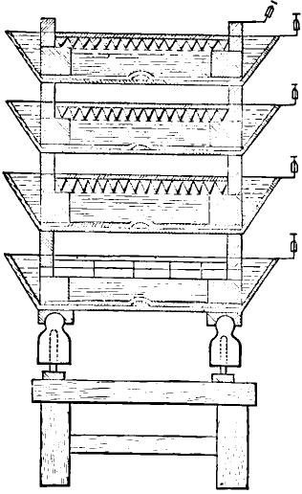
Fig. 694.
1156 • THE SIPHON-RECORDER.
on which it rests. Each of the lead trays must be carefully protected in the interior, upon the edges, sides and bottom, by a varnish of gum-lac, except upon the part which connects the copper to the zinc. Care must be taken not to varnish over the strip of copper which is soldered to the bottom of each tray. They also varnish the lower part of the copper plate,

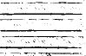
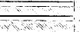
d_t

⁻1
pA/VVVVVVVVVVVW₄. Fig. 695.
except at the corners where it must make contact with the carefully scraped lead sheathing. When the varnish is dry, they place the plate of copper upon the bottom of the tray with the varnished side down, and assure its contact at the centre by causing the strip of copper which is soldered there to act as a spring. Sometimes they make an opening at the centre of the copper plate and pass the strip of copper through this opening, is order to lay it upon the denuded surface of the copper; but it be-

THOMSON'S TRAY BATTERY. 1157

comes then difficult to clean the battery, when the deposits of copper have consolidated the parts together, and it is preferable to establish the contact below.
Each lead tray should have a stout copper wire soldered to it, projecting about three inches from one corner. Each zinc must be protected by a square of parchment paper bent round below it, and folded neatly at the corners. The paper must be pressed against the zinc between finger and thumb on each side of the corner, and the bight or bend of the paper drawn diagonally away from the corner; then the bight must be folded round the vertical corner of the zinc, and pressed against the flat zinc surface on one side or the other of the corner. Then secure the bight with sealing wax, where one side of it is pressed against the paper on the vertical zinc surface. Care must be taken that the edge of the paper be an inch above the upper level of the bars of the zinc grating. It must be bound firmly to the zinc by twine passing under the parchment paper and tied over the zinc above: also by a long piece of twine several times round the square.
To support a pile of trays take four blocks of wood or stone, each four or five inches square in horizontal dimensions and of any convenient height, and place them on the floor in positions to bear the four corners of a tray. The pile must be so placed as to give ready access to each of its sides. Put a piece of thick sheet gutta-percha, six inches square, on the top of each of the wooden squares, and then lay down the first tray upon them, seeing that it is properly levelled. This is most easily done by pouring a small quantity of water into the cell, and seeing whether it lies evenly over the bottom. Put four stoneware blocks, each about 14 inch cube, in the corners of the tray on the top of the copper sheet, and put one of the zinc gratings resting with its four corners on these props. Put a solution of sulphate of zinc of the specific gravity of about 1.1 into the tray (this solution may be prepared by mixing one part by weight of the salt to five parts of water, or two pounds of the salt to one gallon of water), pouring in first between the edge of the tray

1158 THE SIPHON-RECORDER.

and the parchment paper, and afterwards filling up to the level of the top of the zinc grating by pouring some of the solution directly on the zinc over the paper. See that the top corners of the zinc, and the bottom corners of the tray rest upon it, and are all properly tinned, scraped clean and dry. Place a lead tray resting with its four corners on the upper projecting corners of the zinc. Place four stoneware props in the corners of this second tray, put a second zinc upon them, and fill with the solution as before. Proceed thus until a pile of from six to ten trays, one over the other, is made and filled with liquid. Solder a stout copper wire to one of the corners of the top zinc to serve as an electrode. In the same way make as many piles as are required. Leave a space at least one foot broad between each pile and its neighbor, connect the piles in series, the top zinc of one pile to the lowest lead tray of the next one. They form thus a battery which can be increased to ten elements, but three or four suffices to work the mill and eight to charge the bobbins upon the lines of medium length, say 800 or 900 nautical miles. On the Atlantic cables they employ twenty or more.
The crystals of sulphate of copper must be crushed in grains of the size of a pea, and weighed out in small quantities. To charge the battery drop four ounces in each cell; one ounce separately upon each of the four sides, equally distributing it between the two blocks of stoneware props successively. It is necessary to avoid pouring it upon the parchment or the zinc. When the sulphate of copper is poured in it is necessary to put the battery in circuit, in order to avoid the interior local action as much as possible. It is not necessary to employ the same battery to charge the electro-magnets and to work the mill, and separate sets of cells should be used for each; but if circumstances demand this double employment, it is convenient then to form the two circuits by dividing the electrodes into the same number of elements. In effect, in this case, the bobbins of the magnets must be considered as a shunt relatively to those of the electro-magnetic machines or reciprocally, and then the battery must be the same for the two circuits. The practice of using

THOMSON'S TRAY BATTERY. 1159

part of the battery employed to work the magnets to work the mill is also very objectionable. The wire from the zinc pole of the battery intended for the magnets comes to the terminal U₃; that coming from the copper pole attaches itself to U,; an intermediary wire from an intermediate tray in the series comes to U₂, and the commutator V thus permits of the application of the whole or a part of the battery as desired (see fig. 684).
MAINTENANCE OF THE BATTERIES.
The keeping in repair of the tray batteries demands constant attention, if it is desired to maintain them in good working order. By the reaction the lower liquid is despoiled, whilst the upper layer is enriched. In order to re-establish the equilibrium of the densities, it is necessary to add some grains of sulphate of copper, always in quantities of four ounces divided in four parts, and to remove a part of the lower solution of sulphate of zinc which has become too dense, replacing it by pure water. A funnel of special form permits of the distribution of this water uniformly upon the surface of the grating. A siphon, of which the shorter branch plunges about midway of the liquids, removes the surcharged solution of sulphate of zinc. In the batteries in constant use it is necessary to remove each day some sulphate of zinc, and a little graduated hydrometer permits of the maintenance of the density of the solution below 1.3. The battery must be supplied each day with sulphate of copper. The blue color of the lower solution in the tray disappears completely as soon as the crystals fail, and this sign is always followed by an enfeeblement of the effect due to the battery. It is almolIttely indispensable not to leave the battery in repose while this blue color exists. If it must rest without use for any length of time, it is necessary to put it on short circuit until all the sulphate of copper has been consumed. The accumulation of sulphate of zinc in the upper solution produces deposits of salt upon the borders of the tray, and if they are not removed and the battery shall be badly kept,

1160 THE SIPHON-RECORDER.
these deposits may form a contact between the zinc element and the borders of the tray forming the copper element_{s} which may put the battery on short circuit.
TESTS OF THE BATTERY.
It is expedient to make frequent tests of the battery. In order to measure the intensity and the resistance of one of the elements or of a series of them, it is necessary to employ a galvanometer with very long bobbins and to add a sufficient resistance, so
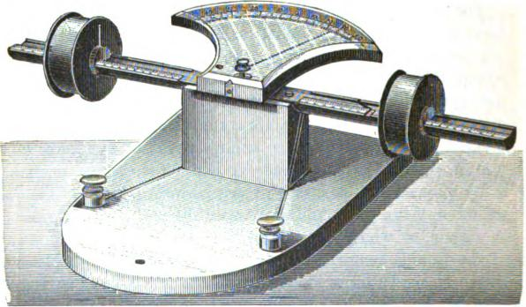
Fig. 696.
that the total resistance may considerably exceed that of the greatest interior resistance to measure. A tangential galvanometer of a new form, and constructed especially for this object by Sir William Thomson (fig. 696), has its arc divided following the tangents, in such a manner that the degrees of each are simply proportional to the current. The resistance of these bobbins in series is about 4000 ohms, and by varying the distances between the bobbins and the needle it can be-applied, without varying at all its adjustment, to batteries of from one to fifty elements. A mirror galvanometer with strong controlling magnets, giving a rapid movement of oscillation to the needle and a

TESTS OF THE BATTERY. 1161

quick action, is likewise a very convenient measuring apparatus. The delicacy of the mirror galvanometer will require, without doubt, in this case, the addition of from 100 to 400,000 ohms of resistance to its own circuit. It is necessary, also, to obtain a suitable degree of sensibility by the employment of magnet controllers, or by the addition of suitable resistances, but in any case by means of derivations.
The galvanometer which serves to measure the battery must be kept in place, and with some wire conductors put in connection with the electrodes of the elements or of the battery which they desire to test. The suspension fibre, as well in the tangential galvanometer as in the mirror, must be sufficiently fine, in order that its torsion may not sensibly alter the zero. In order to make an observation, take a bobbin of convenient resistance and connect the extremities directly to the two poles of the battery to be tested. The resistance of this bobbin can be varied to half or double or treble that of the battery tested, its length should never be less than two metres for a single element, or double in metres the number of elements in series forming the battery. If its resistance must be less than an ohm, this bobbin can be formed of two or several fine copper or platina wires, twisted together. In all cases the turns of the bobbin must be well insulated from one another. If too short a wire is used, the thermal action of the battery will be too strong—consequently, the length of two metres is a minimum which it is best to exceed. When the length is only two metres per element, the current must not be maintained in the bobbin for more than two or three seconds at a time, or otherwise it will be too quickly heated.
We know, in fact, that if a current is maintained to traverse a copper wire with an electro-motive force equal to that of a good Daniell element, the temperature of the wire rises, by
n metres, from _{n} —degreesderees centigrade per second, supposing that
it loses none of the heat thus communicated.
In order to make an observation, they read first the deviation

1162 THE SIPHON-RECORDER.
D, produced by the battery to traverse the simple circuit of the galvanometer and of the resistance added, if there is any. Then they apply the bobbin directly to the poles of the battery to make sure of the contacts, and observe the new deviation D'. Let S be the resistance of the bobbin of derivation and B be the resistance of the battery; we shall have:
D -D'
B _{D},
or more rigorously still,
D — D'
+
B=S
D'—D —
a
where G denotes the resistance of the circuit of the galvanometer, that is to say the resistance of the bobbins of the galvanometer, plus the resistance added exteriorly, if there is any. When G is very large, in comparison with S, the quantity
•
_{G + S} is nearly equal to the unit, so that the numerator becomes D — D', or nearly, which suffices in practice; moreover _{T}y^{s}
being a very small fraction, the denominator becomes D', or nearly, whence results the formula approximately indicated above.
If D — D' is a number of divisions too small to give a good result, it is necessary to employ a derivation having, less resistance. • If, however, D' is too small, a derivation having more resistance must be employed.
When a battery composed of n elements in series is thus
tested, ^{B} is the medium interior resistance per element. When
they test only a single element, B represents the resistance of that element.
The intensity of the battery is deduced from the simple deviation D, by observing which should give a single element of good quality, if they should test it in the same manner.
For example, if V indicates the deviation that should produce

TESTS OF THE BATTERY. 1163

an electro-motive force of a volt, a good Daniell element should give a deviation equal to 1.07 x V. In applying, once for all, this Daniell element, and in dividing the observed deviation by 1.07, we shall have an approximation sufficiently valuable for V for the particular adjustment of the galvanometer employed. It is necessary, be it understood, to find again the value of V, if the adjustment is changed. Supposing then that V shall be known for the adjustment employed in each occasion, we shall have •
D
R
or E indicates the intensity or the electro-motive force in volts of the element or battery tested by the process described above.
If —^{B} is found much less than 1.07, the battery is defective in
intensity. Let E be the electro-motive force of the battery in volts, B its interior resistance and R the resistance of the electro-magnets, to traverse which the circuit is complete when the apparatus works; all these values being, moreover, determined in ohms, the quantity of electricity, circulating per second, will be :
B
+ B'
determined in terms of a unit equal to the quantity necessary to charge a condenser of one farad to the potential of a volt. The quantity of zinc dissolved in each element rises, conse-
quently, to ₃₀)„ x _{B} grammes per second, or 1.2 x _{R} _{B}
grammes per hour, and the quantity of sulphate of copper
employed is 4.75 x _{B} grammes per hour, or 114 x R B
grammes per day.
For example, suppose twenty tray elements of the recorder in good condition: their electro-motive force will be about twenty-one volts, and the total interior resistance about three ohms. The bobbins of the electro-magnets, if they are in series, give a resistance of about fourteen ohms.
Putting then E = 21, B = 3 and R = 14, we have :
4.75 x 21
17

11.64 THE SIPHON-RECORDER.

that is to say 5.87 grp.mmes of consumption of sulphate of copper in each element per hour, or 141 grammes in twenty-four hours, will be more than one kilogramme in eight days.
The disposition of the bobbins of the electro-magnet in series or in multiple arc, influences considerably the consumption of the sulphate of copper. If the arms of the lever, which make contact with the studs with which the electro-magnets are furnished, are placed as in the design (fig. 684), the bobbins are in series; but if the three arms are in contact with their respective studs, the bobbins are in multiple arc, and only give a resistance of about four ohms. By simply transferring the arms to the left side of the apparatus from the stud behind to that in front, the right bobbin is only put in circuit, and in putting the two arms of the left lever upon their respective studs, raising at the same time the contact of the right arm, the left bobbin is only put in circuit. Thus, each bobbin can be used separately with a resistance of seven ohms. Following the conditions of the battery, one of the combinations described above gives the best signals; but it must not be lost to view that the more the resistance in circuit is lessened, the faster the battery is consumed. Thus, when the bobbins are employed in multiple arc, it consumes about four times as much copper as when employed in series.
The efficiency of the entire battery or of each of its separate elements, furnishing a current to traverse the bobbins of the electro-magnet, is measured in the following manner, without interrupting or troubling in any manner the employment of the apparatus in transmission. They should attach first the electrodes of the battery to the galvanometer and to the two extremities of the electro-magnet and observe the deviation D; then they should join them successively to the pole of each element, in order to observe the deviations D,, B₂, etc., in each ease. They should find that their sum is equal to D. Whenever the apparatus shall not be employed in transmission, they can determine the intensity and the resistance of each element without employing a special derivation by the following process, which they will find easy to use in practice. Now, as each of

MEASURING THE EFFICIENCY OF THE BATTERY. 1165
the electrodes of the entire battery has its place upon the extremities of the bobbin of the electro-magnet, we will designate D as preceding; then D,; then, without lifting the electrodes of the galvanometer from the poles of the first element, we will cut. the circuit of the eleetro-magnet by means of the commutator V; let D'₁ be the deviation then observed. We will proceed in the same manner for each of the other elements; let D₃, D'₂, D₃, D'₃ be the derivations observed. If B'₁, B_{y} indicate the respective resistances of each element, and E₁ E₂, etc., their intensities, we shall have :
E, = 1.07 X D', E₂ = 1 07 X D'₂
— , —, etc.,
- C
E. —D E. — D.
B, = R B, = R ,etc.,
D
where R indicates the resistance of the bobbin of the electromagnet.
In the actual instruments, R has about 14 ohms when the two bobbins are in series, and about 3.5 ohms when they are joined in double arc. Let C be the deviation given by a good Daniell element, measured directly through the galvanometer. The efficiency of the entire battery upon the electro-magnet will be, in volts :
1.07 X D
and that of each separate element, in terms of the same unit, will be:
1.07 X D, 1.07 x D,
—, —, etc.
C C
In observing the deviation for each element, it is necessary to take care to note its direction. It should be able to produce a notable deviation of any element of the battery in series, as well as its direction, that might be opposed to that which corresponds to its efficiency.
This case was produced, for example, in a battery of n elements in a good state of intensity, where the resistance of
one of these elements exceeded — of the sum of all the re-

1166 THE SIPHON-RECORDER.

aistances, interior and exterior in circuit. When this case presents itself in an element, it is necessary that it shall be immediately excluded from the circuit, by means of a wire joining the electrodes of the elements above and below, and to add some crystals of sulphate of copper in order to restore its condition.
The elements in use ought to be tested often to assure their efficiency. An element which has not worked fifteen consecutive days, nor shown, in general, any sign of weakness, may still be deficient in sulphate of copper.
Let us suppose that the weight of water in each tray may be 14,000 grammes; a dissolution of 840 grammes of zinc will raise the density from 1.1 to 1.3. This would result in the consumption of 3400 grammes of sulphate of copper. It is desirable to take an exact account of the quantities of sulphate of copper placed in each tray, from time to time; and it is necessary, also, before adding new sulphate of copper, to test the density of the liquid by means of a hydrometer. As soon as the density of the liquid, which is found at the level of the zinc grate, approaches 1.35, it is necessary to remove a part of this liquid, and to replace it with fresh water.
The siphon-recorder of Sir William Thomson, such as we have described it, is remarkable for the reason that all of its varied functions are performed without mechanism and by the force solely of the electric currents which it receives. And although the mouse-mill may be only an improvement of the electric machine of Varley, who had been himself preceded in this invention by Belli (the apparatus of this inventor was shown at the museum of the electrical exposition in Paris in 1881), and the hanging bobbin, in an intense magnetic field, may have been patented by Alexander Bain, a long time ago, the perfect combination of the various organs of the recorder constitute of themselves a complete invention. The apparatus has also been greatly improved by Mr. Jamieson, formerly electrician of the Eastern Telegraph Company, and now Principal of the College of Arts and Science of Glasgow, who has applied himself especially to the

JAMIESON'S IMPROVED MOUSE-MILL 1167

improvement of the mouse-mill. He has placed it upon a circular plate, upon which he has been able to so adapt a bell cover, that it neither admits dust nor humidity from the outside, which considerably facilitates the production of the necessary electricity for the electrization of the ink. This circular form of the cover of the mouse-mill facilitates also the access to all its parts (figs. 697 and 62,8), and, in order to dry the mill more perfectly, Mr. Jamieson has contrived to make a current of hot air pass around it, provided by a Bunsen gas-burner, confined in a copper cover of the form indicated by fig. 699.
The interrupter of which we have spoken has been completely modified, and the new form which Mr. Jamieson has given to it renders it very durable. Figs. 700 and 701 show it in plan and in elevation. The old cam C W of steel, with ten side cuts, has been retained; it is fixed to the axis S of the drum, and in its revolution the angles press each in their turn the extremity of a very light aluminium lever, A L, pivoting upon the fixed point C. This lever is terminated at the left by a fork in which a small ebonite roller, E W, is free to roll. This roller presses against the cam, under the effort of a steel or copper spring, B P. At the right extremity of the lever is screwed a large platina wire, P W., terminated by a spherical head of ebonite, E. The lower extremity of this wire establishes and interrupts the contact with a circular tablet of platina, P P, having about the dimensions of a half-dollar piece. It is there that the circuit of the battery of the mouse-mill is automatically opened and closed from 1000 to 1250 times a minute, causing the revolutions of the mill to vary from 100 to 125 in the same time.
The platina plate rests upon a strong cylindrical copper base, B, which in its turn is placed upon an ebonite plate, E B, which supports and insulates the whole of the metallic pieces of the interrupter from the base. By means of the lever L, which is terminated by a very fine channel, the platina plate can be unscrewed and turned so as to present a new point of contact; it can also at pleasure be removed from or brought near to the platina wire P W with the piece B, which supports it. Thus, as soon as

T | 1168 THE SIPHON-RECORDER.
 | 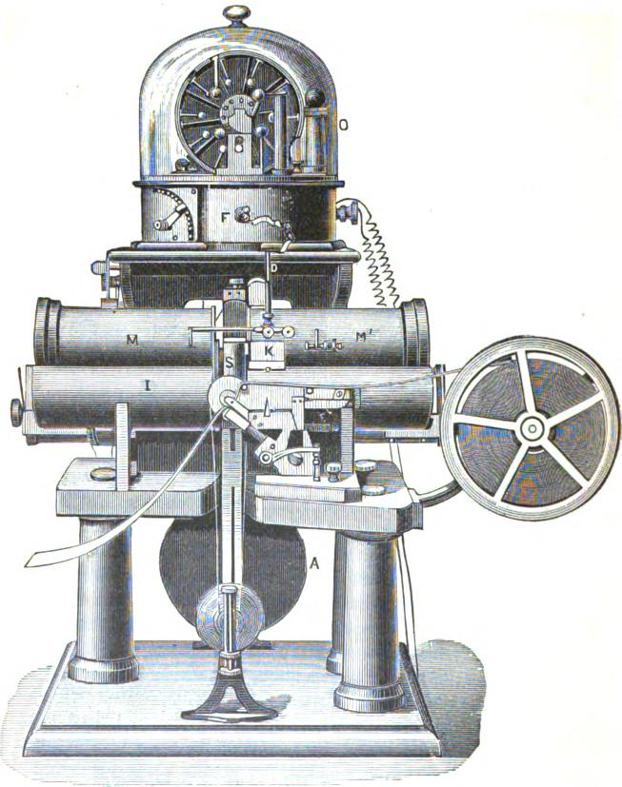
 | Fig. 697. | i

JAMIESON'S IMPROVED MOUSE MILL. 1169
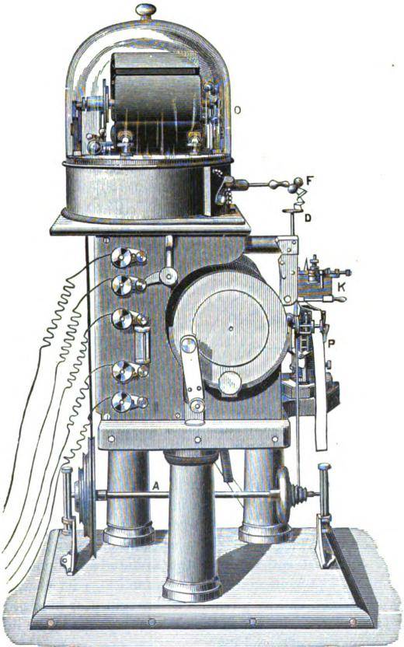
Fig. 698.

1170 THE SIPHON-RECORDER.

the point of contact of the platina becomes dirty or consumed by the continued action of the electric sparks, a new surface of the plate can be put in action: the plate is fastened in it matters not what position by a quarter of a turn of the lever L, at the right. When, after a year or eighteen months of usage the plate is consumed, or its whole surface is full of holes, it is sufficient to turn it around in such a manner as to substitute the lower for the upper face. This new arrangement offers the advantage of assuring the operation of the interrupter and of economizing the time lost in adjustments. It is adapted without
Fig. 699. Fig. 701.

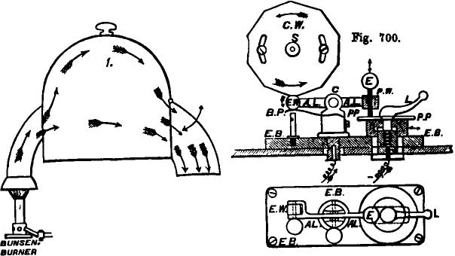
BUNSEN. BURNER
doubt to other applications than those which we have indicated and constitutes of itself a useful invention.
Mr. Jamieson has also improved the mill by rendering the induction plate movable. This piece, formerly fixed, can be adjusted or raised entirely from the armatures without stopping the mill. The induction plate communicates its charge to a knee, F, which can at pleasure be brought near to or removed from the plate D, by which the electricity passes in the ink and the siphon (figs. 697 and 698).
The best means which have been found to make the electricity flow from F to D is the interposition between these two

JAMIESON'S IMPROVED MOUSE-MILL. 1171

points of a bit of string or of card, forming the block of the despatches. In the old forms of mill the light gilded contact springs, which establish and interrupt the current with the armatures during the process of induction, were fixed in an inconvenient manner, and consumed the armatures quite fast by friction. These armatures are now provided with a cyclindrical envelope, which can be changed or renewed at pleasure. The small springs are, moreover, terminated by a cylindrical enlargement which admits of its using less speed, and the four fixed contact pieces are besides supported by round ebonite balls easily adjustable. All the armatures, as well as the insulated parts of the mill, are covered with a varnish of gum-lac of the purest quality. This is a great improvement upon the paraffine wax, with which they were formerly served, and the mill as thus arranged furnishes always a good quantity of electricity, even in humid weather, or in tropical climates, where the atmosphere is constantly charged with humidity. All the parts of the mill are arranged so as to reduce as much as possible the discharge by the surrounding air.
The whole instrument (fig. 702) was formerly entered by an opening carefully arranged in the semi-circular armature, which receives the two electro-magnetic bobbin holders M M' (fig. 697). Mr. Jamieson has happily modified this dangerous arrangement by cutting the armature so as to give admittance to all of fig. 702, without raising the heavy bobbins from their bed, merely by closing the opening, after this introduction, by means of a little iron door which restores all its force to the electromagnet. We comprehend in fact that the bobbins M M' having their exterior poles united by the soft iron armature which serves them as a bed, virtually form a horse-shoe magnet, of which the interior poles are brought very close together. It is expedient, therefore, that the soft iron envelope shall be continuous and that the small iron door shall be kept closed, in order that the electro-magnets may preserve all their force. These bobbins work now only in series.
The apparatus contains moreover other improvements. The

1172 THE SIPHON-RECORDER, •

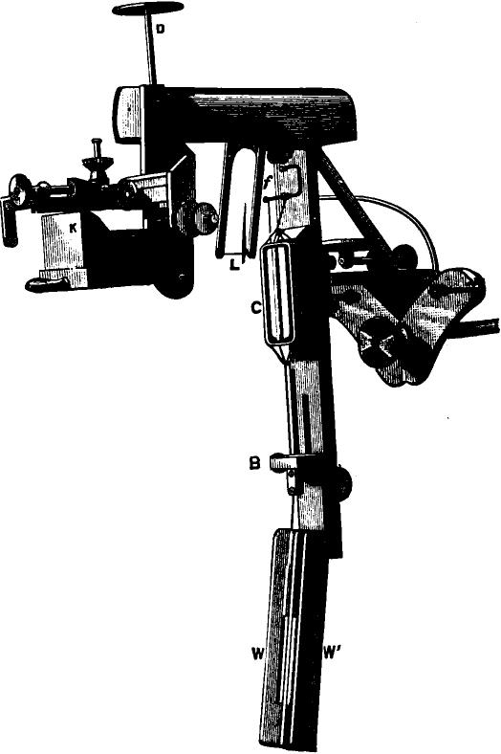
Fig. 702.

LAURITZEN'S SIMPLIFIED RECORDER. 1178

inductors of the mill can be adjusted by means of screws and the upper inductor can be removed at pleasure without disturbing any other part of the. apparatus. The ink is arranged in such a way that it can be removed without risk of breaking the siphon and without touching its support This support, is moreover, very much improved and contains the adjustments of torsion and tension necessary to the site of the siphon (fig. 702). An adjusting screw permits moreover of giving to the fibre the desired tension between the siphon and the signal bobbin. All of these screws have ebonite heads so that the fingers receive no electric charge during the adjustments. The guides of the moving wheels are also happily modified, as well as other pieces of detail which, in the new apparatus, can be easily reached by the front, the back and the sides. But it is above all the mill which has received the greatest attention from Mr. Jameison, and which was itself happily inspired by the advice and criticisms of his old colleagues. This part of the siphon-recorder is in fact the delicate point of the apparatus and all that tends to improve its insulation and to increase its electric power is of considerable practical advantage. We can all easily comprehend the time lost occasionally in the starting of a machine which frequently finds an obstacle to the work in the surrounding air. The siphon-recorder would be very much simplified then if they could suppress the mouse-mill, and indeed, for all the cables under 500 nautical miles, it serves only a few for moving the paper, and the electrization of the ink becomes unnecessary, since the signals can be formed without the friction of the siphon upon the paper, much diminishing their amplitude. The line from Marseilles to Bone is worked under these conditions, whilst at present that from Fredericia (Jutland) to Arendal, as well as the section from Fredericia to Newcastle, of the cables of the Great Northern Telegraph Company, are working by means of a simplified recorder invented by the engineer of the company, Herr Lauritzen. In this apparatus the two electromagnets are replaced by four very small bobbins of which the poles are arranged in the form of a cross. The signal bobbin is

1174 THE SIPHON-RECORDER.

replaced by two needles placed back to back, and so shaped as to furnish four points, each extremity of which is under the influence of the four poles of the electro-magnets. This needle system is connected to a very fine silver siphon which plunges into the ink and draws it up by capillary suction, The point of the siphon touches the paper and the line of ink is uninterrupted. With a battery of 20 Leclanch6 cells, this apparatus works admirably and does not require continued attention, since it is only rarely deranged. The general tendency of the service favors the suppression of the mill, and the approaching expiration of the patent of Sir William Thomson, will cause, without doubt, some radical modifications in the siphon-recorder. We shall be excused then for believing it desirable to preserve a description of the numerous changes brought to the apparatus by the inventor himself. These changes have not ended and the application of the apparatus to cables of variable lengths, have brought the inventor back to the primitive form in which the signal bobbin acts under the influence of fixed magnets.
Fig. 703 indicates the last form given to his apparatus by Sir William Thomson for lines of medium length. The mouse-mill has completely disappeared, the electrification of the ink being entirely useless; the bobbins of the electro-magnets are replaced by fixed magnets formed of straight steel bars united in the base and above by breeches of soft iron. The wheel of the paper band is fixed underneath the horological apparatus which carries the paper, between the two parts of the fixed magnet forming the horse-shoe. The arrangement of the signal bobbin is nearly the same as that which has been described before; this bobbin acts in the intense magnetic centre formed by the two poles of the magnet, and surrounds a piece of soft iron, which augments the action of this centre. The ink is supported by a flexible rod, fixed to the piece of soft iron, and the siphon is attached directly to the signal bobbin, of which it follows all the movements. The extremity of the siphon arriving at the paper is adjusted to the centre of the

SIR WILLIAM THOMSON'S LATEST IMPROVEMENTS. 1175

band by means of the lever d, which carries the signal bobbin to the right or to the left as required. The platform upon which the band passes is adjusted by means of a screw, f, and in such a manner that the ink may be drawn from the siphon with the least possible friction upon the paper. If, in the movement of the siphon, the marks fail upon one of the sides, it is
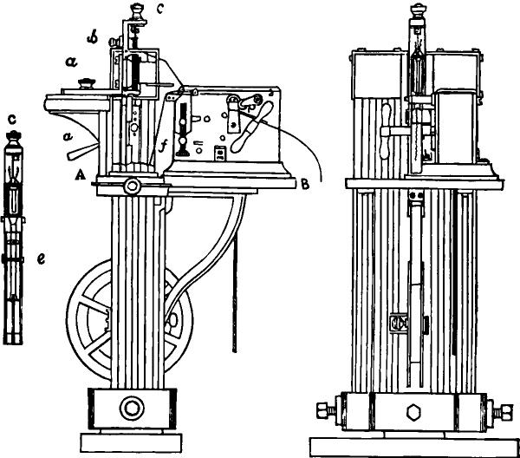
Fig. 703.
an indication that the platform is not absolutely level. It is necessary then to level by relaxing the screw which fastens the horological apparatus to the table, and by the insertion of wedges if that is necessary. The suspension of the bobbin does not differ from that which exists in the preceding apparatus described, and the figures sufficiently indicate its arrangement. The part of the apparatus above A B rests upon a table; the part below rests upon the ground. The horological movement

1176 THE SIPHON-RECORDER.
is impelled by a weight which can be replaced by a spring, all the effort made consisting in moving the paper. The French Administration has adopted this last apparatus for its Algiers cables. The service of the submarine lines has certainly gained in speed since the employment of the recorder, and, as the French Administration thinks of making use of the duplex and of an automatic transmission, we shall look forward with interest to the results which they shall be able to obtain with this apparatus, which is, besides, applicable to the subterranean lines in course of construction.

CHAPTER LI.
THE AUTOMATIC CURB-SENDER.
THE commercial value of long submarine lines depend evidently upon the speed with which the signals can be transmitted through them; it is natural, therefore, that electricians should have sought to increase this speed considerably by inventing some automatic apparatus much exceeding the speed of transmission by hand. From the beginning of cable working the advantage of employing alternate positive and negative currents has been recognized, and the history of submarine telegraphy presents a great number of double current transmitting keys, which have greatly facilitated the operations of submarine lines. The " zinc-sender" of Varley is without doubt the oldest form of the double-current Morse keys, and his sector key, in the same manner as all the more modern forms which have appeared since, have all had in view the transmission of reversed currents after each emission, to discharge the line for the following emission.
We have seen, however, that upon the long Atlantic cables and upon those of the Indian Ocean, the signals are no longer formed as by the ordinary Morse key, although the elements of the Morse code may have been preserved. The keys employed with the mirror and the recorder no longer send the dashes and dots of the same polarity, but properly speaking dots of equal length and of opposite polarity, according as they desire to indicate the dashes or the dots of the Morse code. The foundation of these alternately positive and negative currents entirely change then the anterior conditions of transmissions; it is, moreover, favorable to the conditions exacted by the submarine cables, and witn the aid of the condensers which intervene at the two extremities of the line, and thanks to the movable zero of

1178 THE AUTOMATIC CURB-SENDER.

the apparatus used, the speed and the produce obtained, above all by duplexing the line, the " curbing system" has become practically useless. In fact the signals are formed not by the currents sent directly into the cable, but by inductive impulsions which can be regulated at pleasure, and they thus obtain without effort the maximum speed which they can expect from the cable by means of the ordinary transmitting keys worked by hand; nevertheless this transmission has its defects and it is very frequently irregular. It varies, moreover, with the employes, whose temperaments differ, and they have found it necessary to search for an automatic transmitter, preserving strictly the exact proportions of the signals both in their length and spacing; this is the end which has been attained by the apparatus invented by Messrs. Thomson and Jenkin. It increases, moreover, the ordinary speed of transmission by transmitting an inverse current after each signal, but experience shows that upon cables of great length the effective working speed cannot be sensibly increased beyond that which can be attained with the ordinary hand keys.
The "curb-sender," or automatic transmitter, tried upon the long cables of the Eastern Telegraph Company has been abandoned for the reasons given above. It could, without doubt, however, be employed with advantage upon the Algerian cables, where the French Government is thinking of adopting the siphon recorder of Sir William Thomson. The French Administration thinks of using the Wheatstone perforators and transmitters for forming the automatic signals upon its cables; the relatively short length of these submarine lines offer, moreover, an advantage which the very long cables of the commercial companies do not possess. The study of this question tends, therefore, to assume a somewhat important attitude, and it will certainly be interesting to know what results may be obtained upon cables of which the length and dimensions appear to be very favorable to automatic transmission.

THOMSON AND JENKIN'S AUTOMATIC CURB-SENDER. 1179

The object of the automatic curb-sender is to diminish the retardation of signals in long cables caused by inductive embarrassment. This is effected by making each signal to be produced, not simply by one current, as in ordinary sending, but by two currents, the second of which is opposite in name to and of somewhat shorter duration than the first. The number of currents is not necessarily limited to two, but for the present purpose it will suffice to consider the case of a signal produced by two currents only.
In the Proceedings of the Royal Society for 1855, Sir William Thomson showed how the effect at the distant end of a cable, caused by the application of a battery at one end, could be calculated and represented graphically in what, is called the curve of arrival. After contact is first made at the sending end between the cable and one pole of the battery (the other pole being to earth), a certain interval of time elapses before any effect is felt at the distant end. This interval of time is denoted by the letter a.* After the interval of time a has
krt. log 4
* Sir William Thomson shows that the value of a in seconds is —_{xi} e(₃)
where k and e are the values in electric static units of the resistance and capacity per unit of length, and 1 is the length. A consideration of the dimensions of the two systems of units shows that the formula remains unchanged when k and e are expressed in electro-magnetic units. Since 1 ohm = 10' electromagnetic units of resistance, and 1 microfarad = 10 — ¹° electromagnetic units of capacity, we have
_{a} = R C 1² _{log} /41
10uno 3,
where R is the resistance per knot in ohms, C the capacity per knot in micro-farads, and 1 the length in knots. Thus a in seconds = .000000029 RC/*. If R' and C' be the total resistance and capacity respectively, a = .000000029
For the Direct United States Cable of 1875 (2420 knots), whose total resistance is 6980 ohms, and capacity 991 microfarads, a would be .202 seconds; for the artificial cable in the Physical Laboratory of Glasgow University, a=.144 seconds; for the French Atlantic Cable, a = .245 seconds; for the Suez-Aden Cable, a= .233 seconds. Sir William Tnomson's theoretical re-ults were experimentally verified by Professor Fleeming Jetikin (Phil. Trans. 1862). For fuller information on the speed of signalling. see Jenkin's Electricity and Magnetism, pp. 327 —333, and Phil. Jfag., June. 1865.

1180 THE AUTOMATIC CURB-SENDER.
passed, a current begins to issue from the cable at the receiving end, and increases in strength very rapidly. After a further interval of 4a or after a period of 5a from the first application from the battery, it attains about half its maximum strength, and there is very little sensible increase in strength after a time equal to 10a has elapsed. The curve of arrival is drawn by taking distances along O X (fig. 704) to represent intervals of
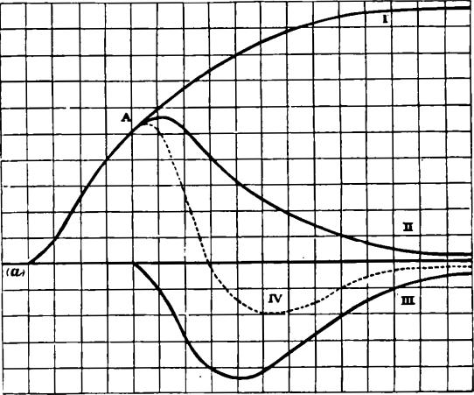
mil⁻
A
U
0
Fig, 704.
time, and distances along O Y to represent strengths of current. Curve No. L shows the gradual increase in strength of the received currents at one end of a cable where the battery is applied to and kept in contact with the other end. For a distance corresponding to the interval of time a, the curve does not sensibly deviate from the straight line OX; in other words, no effect is observable at the receiving end during this time.
If now, instead of being continuously applied to the battery at the sending end, the cable had been applied to it during a

THE PRINCIPLE OF CURB-SENDING. 1181

short interval of time and then disconnected from the battery and connected to earth, the curve of arrival would be of the form shown by curve No. IL* Curve No. II. shows the effect of applying the battery during a length of time equal to 4a, and then putting the cable to earth. It will be seen that a current gradually diminishing in strength continues to flow out of the cable at the distant end for a considerable time after the battery has been disconnected. This continued discharge is what gives rise to the difficulty experienced in reading the signals sent through long cables.
The principle of curb•sending is to check this discharge by sending into the cable a second current, which will neutralize the bad effects of the first. Thus let the cable, instead of being put to earth after having been in contact with one pole of the battery during the time 4a, be put in contact with the opposite pole of the same battery for an interval of time equal to 3a, and then be put to earth. The second contact would, if it had taken place alone, have produced a current at the distant end represented by curve No. III. The joint effect of the two opposite currents—the first for an interval of time 4a, and the second immediately following it, and lasting for an interval of time, 3a—will be to produce a received current represented by curve No. IV., whose ordinates are the algebraic sums of the ordinates of II. and III. Curve No. IV. thus represents the curve of arrival given by a signal current of duration, 4a, followed by an opposite or curb current of duration, 3a.
The curve of arrival for any current or combination of currents is actually traced on paper by the siphon•recorder. Since the deflection of the siphon is sensibly proportional to the strength of the current at any instant, its deflection will correspond to the distances measured in the direction of 0 Y; and
* The falling curve is of exactly the same form as the curve of arrival and the actual curve, showing the arrival of an impulse, is obtained by superposing the one upon the other. Thus the distances between curves I. and II. are equal to the ordinates of curve I., if the former are taken as far from the point A ae the latter are taken from the point at which curve I. leaves the line 0 X.

1182 THE AUTOMATIC CURB-SENDER.
since the paper moves at a uniform speed, and in a direction at right angles to the direction in which the siphon is deflected, the distances it runs will measure intervals of time, and will correspond to distances measured along 0 X. Hence the curve traced by the point of the siphon will represent the curve of arrival, and all theoretical considerations respecting the curve of arrival will apply equally to the practical form of the curve drawn on the paper slip.
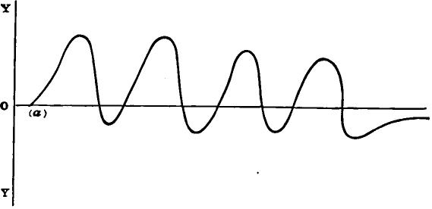
The curve of arrival, traced according to the considerations on page 1179, is the curve of arrival in the case where the line is worked directly, without condensers at either end. The effect
Fig. 705.
of *ntroducing condensers is to convert what was formerly a continuous current into an impulse. The curve produced at the receiving end by the application and continued contact of a battery at the sending end would no longer be of the form of curve I., fig. 704, but would soon reach a maximum, after which it would fall back towards the zero line. It will be readily seen that this would of itself cause something of a curbing effect on signals, since the curve due to a short application of the battery would now come faster back to the zero line than formerly. This effect of condensers is partly the reason why signals are so much sharper and more legible when condensers are used than whe❑ a line is worked direct. Of course, the application of a reversed current to curb the signals is advantageous when condensers are used as well as when they are not.

TEE ADVANTAGE OF' CURB-SENDING. 1183
The advantage of curb-sending, in giving a sharp outline to the signals, and in bringing the siphon of the recorder or the spot of light from the mirror back (wholly or partly) to zero between successive signals, will be seen by a comparison of figs. 705 and 706.
Fig. 705 shows the theoretical form of the letter 11 (four deflections above the zero line) when each deflection is produced by a signal current of a duration equal to 4a, followed by a curb (i. e., a reversed) current of a duration equal to 3a. This proportion of curb is unnecessarily large for so low a speed, as is shown by the fact that the curve is brought back past the zero line between the signals.

0  Y | 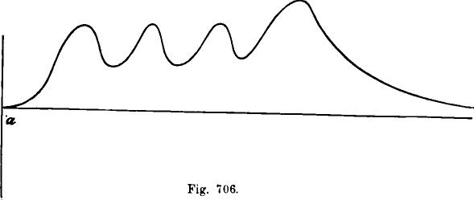

Fig. 706 shows the form of the same letter, sent at the same speed and under the same conditions, except that the signals are uncurbed. Li this case each of the applications of the battery lasts for a time equal to 4a, and the cable is put to earth at the sending end between the signals for a time equal to 3a. instead of having a reversed current sent into it during that time. Thus in both cases the total intervals of time used in making each signal is 7a.
Such a speed as this (one signal per 7a) would be very slow
in the case of a long cable. actual rate of transatlantic
signalling is about one signal per 1.5a. At this speed the uncurbed curve shown in fig. 706 becomes indistinct, and the successive impulses are barely distinguishable. The curbed signals,

1184 THE AUTOMATIC CURB-SENDER.

on the other hand, give a curb somewhat resembling that in fig. 706, where the return towards the centre or zero line between the signals is only partial and not complete, as in fig. 705, but is immensely greater than what is observed when uncurbed signals are sent at the same speed. This greater degree of legibility produced by curbing enables the speed to be increased. Experiments with the artificial cable in the physical laboratory at Glasgow appear to show that by using curbed signals, and transmitting them automatically, as high a speed as one signal per a can easily be attained on a long line. In other words, the gain in speed due to the use of the automatic curb-sender appears to be at least fifty per cent.
In order that curb-sending should be successful, it is indispensable that the contacts which give rise to signal and curb currents should be made and broken at perfectly definite instants; in other words, perfect correct spacing is required. It has hitherto been found to be impossible to obtain this by the use of hand keys, but it is possible to have perfectly correct spacing by the aid of automatic machinery.
The principle on which the automatic curb-sender works is as follows :
The message to be transmitted is punched on a slip of paper in right and left holes corresponding to the dash and dot of the telegraphic alphabet. A line of central holes is also punched to facilitate the drawing along of the paper. The punched slip is put into the sender, and carried along at a uniform rate by clock-work. When either a right or a left hole passes um ler one of two prickers, the corresponding pricker descends into the hole, and by doing so lifts the end of a spring into the rim of a wheel, which revolves once during the time occupied in the passage of one space in the punched paper. The spring so caught remains in the rim of the wheel during a complete revolution, and while it remains there makes an electrical connection between the battery and another set of springs. The latter set are acted on by a double cam, which revolves in the same time with the above-mentioned wheel, and by the contacts made

OPERATION OF REVERSAL OF CURRENTS. 1185
during its revolution sends first the current from one pole of the battery, and then that from the other pole, during a somewhat shorter time, into the cable. If the spring acted on by the pricker on the left hand is raised, the first current is that from the copper pole, and the second current that from the zinc pole; if it is the pricker on the right that has entered a hole in the
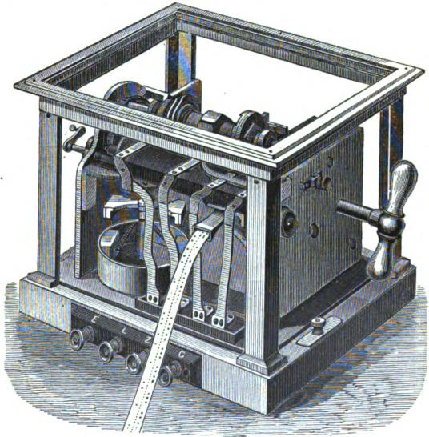
Fig. 707.
paper, the sequence of currents is opposite to that just given. Thus an operation of reversal of currents takes place during the passage of every space in the paper, but whether the signal current is to be "copper" and the curb current "zinc," or vice versa, is determined by whether the pricker has fallen into a hole on the left side of the paper or on the right.
Figs. 707, 708 and 709, which are engraved from photographs,

1186 THE AUTOMATIC CURB-SENDER.
give three general views of the instrument. In Figs. 708 and 709 the glass case and the standards which carry it have been removed, in order to allow the works to be better seen.
The Driving Power.—The motion is kept up by the descent of a weight, which has occasionally to be wound up by hand. In order that the driving power may continue during the time taken to wind up the weight, the power is communi-
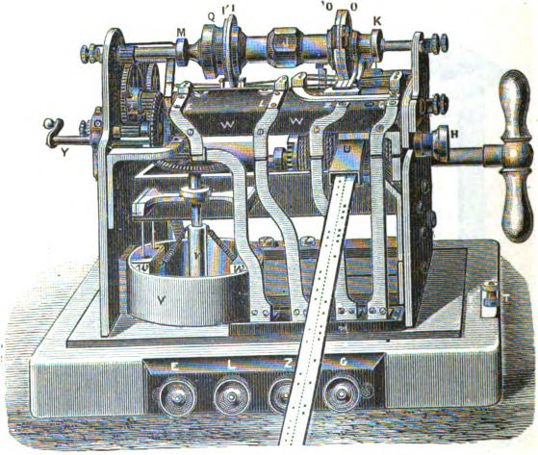
Fig. 108.
cated to the machinery not directly from the drum on which the cord of the weight is wound, but indirectly through a spring which is kept in a partially wound-up state during the descent of the weight, and which gives out the energy so stored up in it during the time that the weight is being wound up. This secures an approximately uniform driving power even during the winding up of the weight.
The arrangement will be understood by reference to fig. 710. The axle A A' which carries the spring box S and the drum

ARRANGEMENT OF THE DRIVING POWER. 1187
D, on which the cord attached to the weight is wound, is divided at p into two parts capable of revolving independently of one another. A ratchet wheel R' is so arranged that when the drum D is turned by means of the handle so as to wind up the weight,
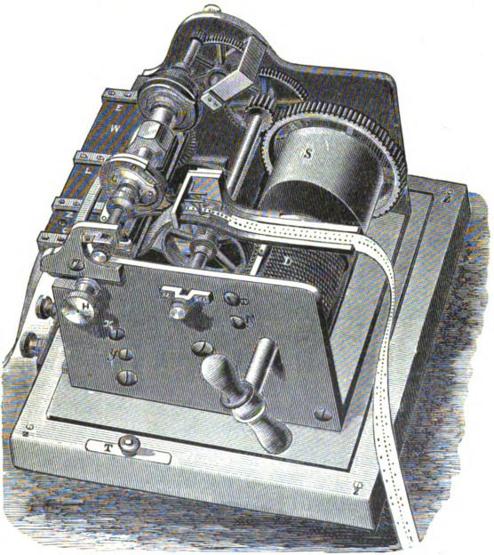
Fig. 109.
the part A'p moves independently of A p, and during that time the machinery is driven by the spring in S. When the weight descends, however, causing A' p to revolve in the opposite direction to that of the winding up, the ratchet wheel R' no longer allows the motion of A' p to take place alone, but makes A p be carried round with A' p. This winds up the spring

1188 THE AUTOMATIC CURB-SENDER.
until the force exerted by the tension of the spring exceeds the resistance of the machinery to motion. When this happens the spring box S also revolves, driving the machinery. Thus before the weight can begin to produce motion of the machinery, it. must first wind up the spring in S to a certain extent, and the store of energy thus accumulated suffices to drive the machine at an approximately uniform rate while the weight is being wound up. A second ratchet wheel, R, prevents the spring from running down without driving the machinery while the weight is being wound up.
The Governor.—The speed of the machinery, and consequently the speed of transmission of signals, is regulated by means of
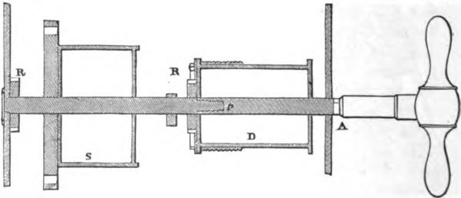
Fig,. 710.
a friction governor (figs. 707 and 708). In the form of governor shown there is a vertical revolving spindle, to which motion is communicated by means of a pair of bevel wheels. To the spindle is fixed a cross-bar, t (fig. 708), from each end of which a weight, w, hangs by flexible springs. As the spindle revolves these weights are carried round with it, and their centrifugal tendency causes them to press against the inside surface of a ring or cylindrical box, V. This pressure causes friction, and checks the motion of the machine. The centrifugal tendency of the weights is resisted by a couple of springs, which pull them inwards towards the axis. So long as the centrifugal force of the revolving weights is insufficient to overcome the

MEANS OF ALTERING THE SPEED. 1189

•
tension of the springs and to force the weights against the ring, the governor does not oppose the motion of the machinery, which therefore becomes accelerated, until the centrifugal force of the weights become sufficient to bend or extend the springs to such an extent that the weights rub against the ring. The friction so produced prevents any further increase of speed from taking place. If now the tension on the springs be by any means increased, the amount of centrifugal force 'required to produce the distension necessary to allow the weights to press against the ring is increased also. Hence the speed will be increased. Similarly, by lessening the tension on the springs, the amount of centrifugal force required to distend them is .diminished, and the speed is consequently reduced. This affords a means of altering the speed, which is effected in the following manner: The ends of the springs which tend to pull in the weights are fixed to a collar, u, which slides up and down on the spindle. This collar is connected by means of levers to the handle T, the movement of which causes the collar to slide up and down. When the collar u is raised, the tension on the springs is increased, and therefore the speed is increased also. When the collar is lowered, the tension on the springs, and therefore the speed, is lessened.
In another form of friction governor, the motion of the machinery is communicated to the vertical spindle by means of the rolling contact of two discs at right angles to one another, and the whole frame-work of the governor is supported by means of a contrivance called a geometrical slide,* which enables it to move freely vertically up and down, but in no other direction.
* The geometrical slide has five bearing points, each of which is free to move ⁻upon the surface on widen it rests. The sixth point, which keeps the framework of the governor in equilibrium, is the point in which the vertical disc is touched by the horizontal disc. This mode of support gives rise to a couple tending to cause the whole frame-work of the governor to revolve about a horizontal axis, and this couple is balanced by the moment of the pressure between the two discs about the same axis. Thus the pressure between the discs is kept at a constant amount for all different positions into which the frame-work of the governor may be brought for different adjustments.

1190 THE AUTOMATIC CURR-SENDER.

The revolving spindle carries the weights, as in the former case. When the frame-work is moved up, the horizontal disc attached to the revolving spindle of the governor approaches the centre of the vertical disc attached to the machinery. Consequently the latter rotates faster relatively to the former, and the machinery will revolve very fast before the spindle revolves fast enough to cause the weights to press outward against the ring. In this form of governor the tension of the springs which hold in the weights is kept unchanged, so that the rate of revolution of the spindle of the governor remains constant; but the rate of revolution of the machinery relatively to that of the spindle is changed by altering the height of the whole frame-work of the governor. This is effected by means of a suitable handle on the right-hand side of the instrument. In this form of governor a further provision is made for increasing the range of possible speed, by altering the tension on the spiral springs which hold in the weights. This is done by means of screws inside the governor, and attached to these spiral springs.
The Starting and Stopping is effected by means of the screw Y, fig. 708, on the left-hand side of the instrument, which, when turned in the direction of the hands of a watch, advances so that its end presses against the back of the vertical bevel wheel, which communicates motion to the governor. This jams the wheel, and prevents the machinery from moving. When the screw is turned through about half a turn in the other direction, the wheel is freed, and the machinery is free to run.
The revolution of the machinery effects two objects. It carries on the paper by means of a toothed roller or spur wheel, working into a central row of holes in the punched paper, and it causes a spindle to rotate on which cams are fixed, which make certain electrical contacts. The toothed roller which carries on the paper ribbon has sixty teeth, and it revolves once for every sixty revolutions of the axles which carries the cams. Hence the cams make one complete revolution for every space in the paper. The paper has the message punched on it in the form of side holes corresponding to the dot and dash of the

FRONT ELEVATION OF THE PAPER WHEEL 1191
alphabet, with a continuous row of central holes or indentations which answer the purpose of holes. The central holes or indentations are required to carry the paper on; the electrifical effects are produced by the side holes only. Fig. 711 shows the appearance of a piece of the punched paper ribbon. A space between two letters is formed by one central hole, and a space
r0 OOO O O 00 O 00 O O 000 O O 0 0 0 00 00 0 0 0 0 0 0 0 0 0 C 0 0 0 0 0 0 0 0 0 0 0 0 0 0 0 0 0 0 O O O O O O O O O
Fig. 711.
between two words by two central holes. (The spaces may also be made in another way, see page 1196.)
The Paper Wheel, or toothed roller which carries along the paper, has two grooves on its circumference, one on each side of the central row of spurs, and over these the side holes in the paper pass. Fig. 712 shows a front elevation of the paper
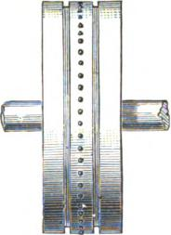
Fig. 712.
wheel. Above the groove stand two prickers, one on each side, which descend through the side holes as they pass under them, but which cannot descend except when side holes are passing. One end of a lever is attached to each pricker, the other end of which lifts up a small steel spring when the pricker descends.
In fig. 713, B is the toothed roller which carries along the paper. P is one of the prickers, which is set so as to stand over
ji

1192 THE AUTOMATIC CURB BENDER.
one of the two rows of side end holes. Rigidly attached to P, and pivoted at h, is the forked lever F, upon the lower end of which, i, the end of the above-mentioned spring rests (this spring is not shown in Sg. 713; it is marked a in fig. 714 below); the other end, k, presses up against the rim of the cam
G. The spring j tends to force P down; but the rim of G prevents k from rising, and therefore P from descending. The
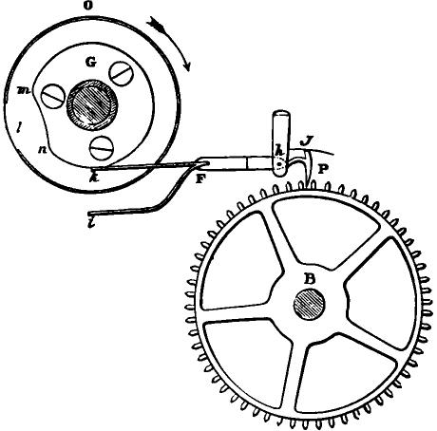
Fig. 713.
cam wheel 0, of which G is a part, makes one complete revolution in the time taken by the paper to move on through one space. When a side hole in the paper passes under P, P would descend into it if k were able to rise. As the cam wheel revolves, a recess, m n, in the rim of G passes over k. At this point k is free to rise. Simultaneously an opening, 1, in the rim of 0 passes over the end of the spring which rests on i. Then, if a hole in the paper is passing under P, P descends, i rises, and lifts the end of the spring through the opening 1 into the pro-

OPERATION OF THE TOOTHED ROLLER. 1193

jetting rim of the wheel 0. When n passes over k, k is depressed, and P rises out of the hole in the paper. The spring a (fig. 714) remains caught in the rim of 0 until a revolution is completed, when the opening 1 comes round again, and allows the spring to fall out. By this time the series of operations which makes up the signal is completed. The cam wheel has two sides precisely alike, 0 and 0', the one corresponding to the pricker which stands over the dot holes, the other to the pricker which stands over the dash holes. The electrical effects produced by the raising of the springs by means of the descent -of the prickers will be described further on.
In order that either pricker should descend and raise its cor-
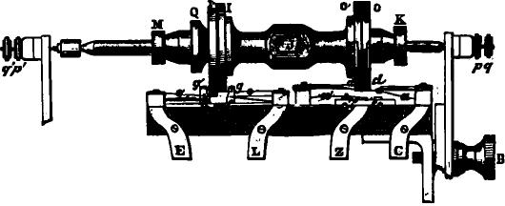
Fig. 714.
responding spring into the rim of the cam wheel 0, three conditions must be fulfilled. 1st The opening 1 in the rim of 0 must be over the end of the spring which rests on i. 2d. The recess m n in the cam G must be over the end of the lever k. 3d. A hole in the paper must be passing under the pricker in question. By the construction of the machine the first two of these conditions necessarily happen together, for the cams 0 and G are rigidly fixed relatively to one another, and the opening in the .one and the recess in the other pass the lowest point at the same time in the revolution. The third condition must be made to happen at the same time with the other two by adjusting the cam wheel 0 relatively to the paper wheel B, which is done by turning the former round upon its axle and clamping it in any desired position. When the instrument is properly adjusted,

1194 THE AUTOMATIC CURB-SENDER.

the recess m n will pass over k just when the centre of one of the side holes in the paper is passing under P. Then the descent of the pricker, which begins when m passes, and its ascent, which is completed when n passes, will both take place during the passage of a hole under P, and the pricker will not touch the edges of the hole, either in falling or in rising. This prevents the holes in the paper from becoming torn or dragged at the edges, and admits of the same slip of paper being used many times over.
The axle which carries the cam wheel O is shown in front elevation in fig. 714. This axle, as we have seen, makes one complete revolution for every space in the paper. O and O' are the two sides of the cam wheel. This cam wheel, O O', is called the determining cam. The two sides of it are insulated from the axle and from one another by vulcanite. a and a' are the two springs which are lifted by the lower ends of the forked levers ii' into the rim of O O' through the openings 11' when the corresponding prickers descend into the holes in the paper. The springs a and a' carry small pointers projecting above and below, and tipped with platinum. When a dash, or right-hand side hole, passes, the spring a is raised into the rim of O, and remains there during a complete revolution. In the figure it is represented as being held up in this position. When held up in the rim of O a is kept in contact with the upper contact spring d, while the spring a' remains in contact with the lower contact spring c'. Similarly, if a dot hole had passed, a would have remained down and in contact with c; while a' would have been caught up and held up in contact with d'. So long as no hole in the paper passes, both the springs a and a' remain down in contact with the lower contact springs c and c'.
The zinc pole of the battery is permanently connected to the lower contacts c and c'; the copper pole to the upper contacts d and d'; when, therefore, a dash hole passes, copper is connected to a and zinc to a'; and when a dot hole passes, copper is connected to a' and zinc to a.
On the same axis with the determining cam wheel, and

THE SIGNAL AND CURB CAMS. 1195
revolving along with it, are two other cams—I' and I—called respectively the signal and curb cams. They are insulated from one another by a disc of vulcanite, and are insulated from the axle and from the determining earn by the vulcanite tube J. They are fixed relatively to one another by a small vulcanite screw. Fig. 716 gives a side view of the signal and curb cams.
The signal cam has a projecting edge extending for rather
more than half the circumference; the curb cant I has a projecting edge which begins where the projection on I' leaves off, and which leaves off where that on I' begins. Underneath these cams are the springs e and e' (fig. 714). During rather more than half the revolution the projecting edge of I' depresses
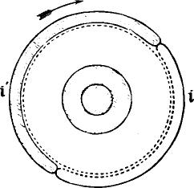
Fig. 715.
the spring e', and causes it to make contact with the lower contact spring f, while the spring e remains up and in contact with the upper stud g. When the projecting edge of I' has passed, e' rises, and makes contact with y', while simultaneously the projecting edge of I depresses e, and holds it in contact with f during the remainder of the revolution. Thus during rather more than half the revolution, e' is in contact with f, and e with g, and during rather less than half the revolution e is in contact with f and e` with g'. These actions depend simply upon the revolution of the axle, and are not affected by the punched paper or by the positions of the springs a and a', but the electrical effects which these actions produce do depend upon the position of a and a' and are therefore determined by the holes in the paper.

1196 THE AUTOMATIC CURB-SENDER.

Electrical Action. —The spring a is permanently in connection with the lower contact springs f andf. The spring a is perms-nently in connection with the upper contact studs g and g'. The spring e' is permanently connected to earth, and the spring e to the line. The electrical changes which take place during a revolution of the axle will be understood by a reference to the diagram, fig. 716, in which the letters refer to the same parts as in fig. 714 In the diagram the spring a is represented as having been raised into the rim of the determining cam by the descent of the right-hand pricker into a hole in the paper. At the instant that a rises the projecting rim of the signal cam I' comes round and depresses e'. Thus the copper pole of the battery is connected by way of d, a, f and e' to earth, while the zinc pole
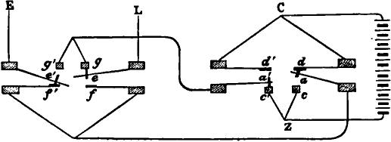
Fig. 716.
is connected by way of c', a', g and e to line, and a negative current enters the cable to produce the " dash " signal. This state of things lasts for rather more than half tho revolution until the projecting rim of the signal cam I' has passed and that of the curb cam I has come round. Then e' rises and e is depressed, no change, however, taking place in the position of a and a'. The zinc pole is now connected by way of c', a', g and e' to earth, while the copper pole is connected by way of d, a, f and e to line. This sends a positive current into the cable to produce the curb to the " dash " signal, which lasts as long as the spring e is depressed by the curb cam. The joint effect of the two currents is, as we have already seen on page 1181, to produce a clearly defined "dash" signal. When the revolution is completed, a falls out of the determining cam through the open-

RELATIVE LENGTHS OF CURRENTS. 1197

ing 1, and, unless another signal immediately follows that which we have been considering, the copper pole of the battery is disconnected both from line and from earth.
If, instead of a dash hole, a dot hole in the paper had passed; the pricker on the left side would have descended, and the spring a' would have been raised into the rim of 0', while a remained down. The reversal of the springs e and e' operated on by the signal and curb cams would have gone on as before. Thus during the passage of I' the zinc pole of the battery would have been connected by way of c, a, .1⁷ and e' to earth, while copper would have been connected by way of d', a', y' and e to line. Similarly, during the 'passage of I, copper would have been connected by way of d', a', g' and e' to earth, while zinc would have been connected by way of c, a, f and e to line. There would thus have been a positive signal current followed by a negative curb current of shorter duration, the joint effect of which would have been to produce a " dot " signal.
The relative lengths of the signal and curb currents depend upon the relative lengths of the projecting rims of the cams I' and I.* Whether the longer current shall be positive and the shorter negative, or vice versa, is determined by the position of the springs a or u' in the rim of the wheel 0 0', which is therefore called the determining cam wheel. If a succession of holes passes under either of the prickers, the corresponding spring is held up continuously in the rim of the determining cam wheel until all have passed, because, while the space 1 is passing, the descent of the pricker into the hole causes the end i of the forked lever to rise, and so prevents the spring from falling out of the rim. If a dot and a dash hole pass simultaneously under the prickers, both the springs a and a' will be raised, and no
* With regard to the proportion which the length of the signal cam ought to bear to that of the curb cam, it should be understood that the greater the speed of signalling is relatively to the retardation, or value of a (page 1179), for any cable, the more nearly equal should the signal and curb came be. If the speed of signalling on different cables be varied so as to be the same relatively to a for each cable, the same pair of cams will be suitable for all.

1198 THE AUTOMATIC CURB-SENDER.

electrical effects will be produced, for the zinc pole of the battery will be disconnected. Hence two side holes opposite to each other may be used to produce a space, instead of no side hole.
The Contact Plate.—The several contact springs, with their contact pieces and connections, are all fixed on a slab of vulcanite called the contact plate W (figs. 708 and 709). The contact plate is secured in position by means of the screw H, which causes three projecting points in the frame-work of the instrument to press against a hole, a V groove in line with the hole, and a plane, in a piece of metal connected to the contact plate (fig. 714). This mode of support is called a geometrical clamp; it has this advantage, that the plate cannot take up any other than one certain position, and a single screw is sufficient to keep it fixed.
The springs c, c', d, d', f and f' are provided with brass guard bars or stops, which limit their range of motion and prevent them from vibrating when the instrument is running fast, or from sticking to and following the moving springs a, a', e and e'.
The two halves of the determining cam are insulated from one another and from the axle by vulcanite. Each of the forked levers connected to the prickers is completely insulated. The signal and curl) earns are also insulated from one another and from the axle—hence no electrical contacts take place except those which have been considered. The mode in which the signal, curb, and determining earns are fixed to the axle will be understood by reference to fig. 714. J is a vulcanite tube to which the determining cam O O' is rigidly fixed. The brass screw K on the right of the determining cam clamps it and the tube J on to the axle by jamming them against the shoulder M. The vulcanite screw Q on the left of the signal cam clamps it and the curb on to this tube, and therefore to the axle also.
Single and Double Curb.—In the foregoing description of the electrical action, it has been assumed that the spring e' was depressed by the signal cam at the same instant that the spring

SINGLE AND DOUBLE CURB. 1199

a or a' rose into the rim of the determining cam. This arrangement would give the whole of the signal current first, followed by the whole of the curb current, and the revolution would begin with the beginning of the former, and end with the end of the latter. A signal may, however, be produced by the joint action of more than two currents, and may represent the resultant effect of three or any number of currents following each other in alternate directions, and being of different lengths.
So long, however, as the form of signal and curb cams described above remains unaltered, there are only two other combinations possible, and these are easily obtained by changing the position of the signal and curb cams relatively to the determining cam.
The arrangement which has hitherto been assumed to exist is called single curb. In it the spring e' is depressed at the instant that a or a' rises, and the beginning of the passage of the rim of the signal cam coincides with the beginning of the signal.
If the signal and curb cams are turned round on the axle so as to be slightly in advance of the determining cam, it is evident that when either a or a' rises, the spring t/ will already have been depressed for some time, and the first current sent will be shorter than formerly, by an amount represented by the distance through which the cams I 1' have been turned forward. The second or curb signal will, however, be as long as before, for the spring a or a' will continue up during the whole time of the passage of the rim of the curb cam. But since the signal and curb cams are in advance of the determining cam, the rim of the curb cam will all have passed before the spring a or a' has fallen out of the rim of the determining cam. Hence, before the signal is ended, the rim of time signal cam again depresses the spring e' and sends a current into the cable of the same name as that first sent. This is, however, of short duration, for as soon as that fraction of the signal cam's rim has passed which represents the distance by which the signal and curb cams are in advance of the determining cam, the revolution will be complete, the spring a or a' will drop out of the rim of the latter,

1200 THE AUTOMATIC CURB-SENDER.
and no farther contacts will occur in that signal. There will thus have been three currents produced, the first and third being of the same name and the second of the opposite name. The second curbs the first, and the third curbs the surplus curbing effect of the second on the first. Of course the sum of the first and third bears the same relation to the second as the length of the signal cam bears to the length of the curb cam. This arrangement is called double curb. Fig. 717 shows the theoretical form of the letter E sent with double curb, the first current being of a duration equal to 3a, the second of an equal duration, and the third of a duration equal to la, the total time
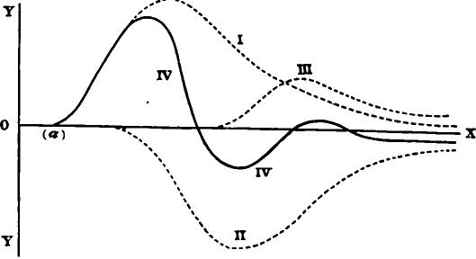
Fig. 717.
being 7a, as in the examples previously given. The full line IV. is the resultant signal, of which the dotted lines L, II. and III. are the components.
Preparatory Curb. —If the signal and curb cams are turned back so as to be slightly behind the determining cam, then when a or a' rises e is already depressed, and continues so for a short time, and thus a short curb current is sent first, then the whole of the signal current follows, and lastly the remainder of the curb. This arrangement is called preparatory curb. Fig. 718 shows the theoretical form of the letter E given by it. The period of the preliminary curb current is la, that of the signal current 4a, and that of the signal curb 2a, the total period being 7a as before.

PRODUCTION OF SHARPLY DEFINED SIGNALS. 1201.
We are thus able with a given pair of signal and curb cams to produce three different arrangements of the currents which go to make up a signal. A perfectly curbed signal—that is to say, a signal in which the curb of arrival comes rapidly down to the zero line, and never crosses or leaves it—could only be produced by using an infinite series of curbing currents alternate in direction, and each somewhat shorter than its predecessor. Of course such an arrangement is practically impossible. When the curbing is necessarily imperfect, as it always is in practice, it appears that the arrangement described above as single curb
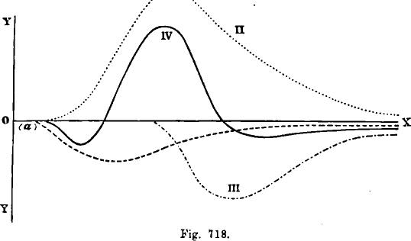
is the best of the three. This is a question which will best be decided by actual trial. It appears likely, however (independently of any consideration of the form of the curve of arrival), that the best means to produce a sharply-defined signal would be to make use of the single curb arrangement, thereby bringing, in the first place, the maximum influence at command to hear upon the indicator (the needle or coil, as the case may be) to deflect it, and then, in the second place, the maximum influence at command to cause it to return to its normal position—always provided that within the limits of a single signal the second influence is insufficient to cause a return much past the zero position. This last condition can always be made to hold

1202 THE AUTOMATIC CURB-SENDER.

good by limiting the length of duration of the curbing current relatively to the speed of the signalling.
Adjustment of the Contact Plate.—To put in the Contact Plate.—Lift off the top of the case and remove the front glass plate. Introduce a piece of the paper ribbon. Start the machinery, and stop it when a piece of the paper in which there are no side holes punched is passing under the prickers. This will cause the ends i i' of the forked levers to lie in their most depressed position. Then slip in the plate, taking care that the springs ee' are not bent by being pressed against the sides of the signal and curb cams, and that the ends of the spring a a' take up their proper positions on the top of the lower ends i of the forked levers. When one of the three small feet on the side of the frame-work enters the hole, the other the groove, and the the third presses on the plane surface on the piece of metal on the right-hand side of the contact plate, the plate will be in its proper position, and is to be secured there by tightening up the screw H.
In removing the contact plate the same precautions have to be observed. The ends i 1¹ of the forked levers should be depressed by having a piece of unpunched paper under the prickers.
The platinized contacts on the various springs should be cleaned frequently. They must be kept free from all traces of oil, and should be frequently dusted with a camel's-hair brush. If the contacts made are defective or fail, the points of contact should be cleaned with a very fine file.
Care must be taken that when the springs a, a', e or e' rise or fall, they do not make contact with both their upper and their lower contact springs simultaneously. If they did so the battery would be short-circuited, and sparks would FIRS which would burn the contacts. If any one of the springs a, a', e or e' is observed, when rising or falling, to make one contact before it breaks the other, the guard bars which limit the play of the contact springs must be gently bent until this no longer occurs. Two contact plates are provided with each instrument. When

ADJUSTMENT OF THE CAMS. 1203

the instrument is in constant use the contact plates should be changed every second day, and the one not in use should be carefully cleaned before being replaced.
Adjustment of the Determining Cam.—Start the machine with a piece of punched slip in it, and stop it at the instant a side hole is passing under one or other of the two prickers. Then, taking hold firmly of the vulcanite tube J (fig. 714), loosen the brass screw K on the right. Be careful not to apply so much force as to bend or twist the axle. The cams 0 0' and vulcanite tube J (as well as the cams I I') will then be free to move round on the axle. Turn them round until the centre of the openings 11 in the rim of the determining cam wheel are just over the springs a a'. The pricker under which there is a hole in the paper will then be able to descend into the hole, and to raise its corresponding spring into the rim of the determining cam. The centre of the hole in the paper should just be passing under the pricker at the instant that the centre of the opening 1 is passing over the spring a. When the cams are turned round into such a position that this happens, secure them and the tube J in that position by screwing up K.
This adjustment is of the utmost importance. 'When signals fail the cause is almost always bad adjustment of the determining cam. It is difficult to judge by eye whether the pricker is exactly over the centre of the hole in the paper. When the adjustment has been made turn the axle slowly round by hand backward and forward, and observe whether the prickers tear either the back or front edges of the holes. If the adjustment is perfect, they will fall into and rise out of each hole when the axle is turned either backward or forward without touching the paper at either edge of the hole.
Adjnstment of the &plat and Curb Cams.—(1.) For Single Curb.—Take hold of the vulcanite tube J firmly with the right hand, and loosen the screw Q with the left. The signal and curb cams I' and I will then be free to slip round upon the tube J. Put in a piece of punched paper, start the machine and stop it just when one of the prickers is

1204 THE AUTOMATIC CURB-SENDER.

descending into a hole, and is raising its corresponding spring into the rim of the determining cam. Turn the signal and curb cams round until the projecting edge of the signal cam I' is just depressing the spring e. Then secure the cams in this position by tightening up the screw Q. This adjustment is perfect when the depression of the spring e' is exactly simultaneous with the rise of the spring a or a'. The axle should be allowed to revolve very slowly by checking its motion with the hand, so that it may be seen whether this adjustment is right; and if not, the cams I and I' must be shifted round until a state of perfect adjustment is reached.
- For Double Curb.—Adjust as above for single curb, and then, loosening the screw Q, turn the cams I I' slightly round on the axle, moving their upper sides away from you as you stand in front of the instrument. In other words, turn the cams round so as to be slightly in advance of their previous position, so that (say) half an inch of the projecting rim of the signal cam I' has already passed over the spring e' before the spring a or a' rises up into the opening in the rim of the determining cam. Secure the cams in this new position by screwing up Q. The depression of e', which has now occurred before a or a' rises, will produce the second curb of the previous signal. (Seepage 1199).
- For Preparatory Curb.—Adjust as above for single curb, and, then, loosening the screw Q, turn the cams I I' slightly round upon the axle, moving their upper sides toward you as you face the instrument; that is, turn the cams round so as to be slightly behind their position when adjusted for single curb; then tighten up Q. The spring t' is now not depressed until some time after the spring a or a' has risen, but the spring e is depressed during that time, and thus a short curb current is applied to the cable at the beginning of the signal. (See page 1200.) The distance by which the cams are put back from their position for single curb should not exceed about half an inch measured along the rim.
Speed of the Machinery.—The means by which the speed is

SPEED OF THE MACHINERY. 1205

altered have been described already (page 1188). In the first form of governor there mentionel, which is the one shown in figs. 707 and 708, the speed is altered by sliding backward or forward the handle T (fig. 708), which has the effect of raising or lowering the collar u on the spindle of the governor. This increases or diminishes the tension on the springs, which pull in the weights w w. When the tension on the springs is increased, a greater speed is required to give centrifugal force enough to the weights to cause them to diverge and press against the ring or box V. It is not until they press against the box that they cause any cheek to the motion of the machine, but as soon as they do press against the box the friction so produced prevents any fUrther increase of speed. Hence the more tension there is on the springs, the faster will the machine go.
In the second form, the tension on the springs which prevent the weights from diverging is not altered during adjustment, and consequently the maximum rate of revolution of the governor remains constant; but the whole frame-work of the governor is moved up or down so that the relative rates of revolution of the machine and of the governor is altered (page 1189). In this form the speed can be still further altered by varying the tension on the springs which hold hack the weights. This can only be done, however, when the machine is standing still. Care must be taken that both weights are held back with equal force, so that when they are caused to diverge by the revolution of the governor they may both touch the ring at the same time, and press against it equally.
The box of the governor must be kept clear of dust and oil. The weights must not be allowed to scrape against the bottom of the box. They can he raised by loosening the screws which clamp the two pieces of straight spring by which each weight is suspended. These screws must be firmly secured before the machine is started.
No attempt should be made to vary the speed of the machine by altering the driving weights. A weight of about 14 lbs. will generally be found to do well.

1206 TIIE AUTOMATIC CURB-SENDER.

All the bearings of the axles must be kept well oiled. If the bearings are too tight, they may be loosened by means of the bearing screws q q' (fig. 714). After loosening the nuts p p' the screws can be turned either out or in, and when the desired adjustment is arrived at all change will be prevented by tighten. ing up p and p'. These and the similar screw bearings on the other axles also afford the means of moving any one of the axles along for a short distance in the direction of its length.
The inner cams of the determining earn wheel (G and G') must be kept well oiled, for otherwise the friction on them of the levers k and k' (fig. 713) will check the running.
Electrical Connections.—The battery power required for the automatic sender is considerably greater Than that required in working by hand, not only because the curbing reduces the size of the signals, but also because the speed of sending with the auto is much greater than with the hand key, and consequently the maximum deflection of the coil or needle at the receiving end is a smaller fraction of the whole possible deflection.
When the automatic sender is used, it is, of course, necessary to provide a hand key, which may be equally thrown into circuit, and for the reasons just given a separate battery should be used on the hand key of a much smaller number of cells than that used on the auto. No rule can be laid down as to the amounts of battery power. For long cables it will probably be found that twice as many cells are required on the auto as on the hand key.
In order to join up the automatic sender in circuit with the recorder, the connections shown in figs. 692 and 693 have one or other of them to be set up. A switch of the form shown in fig. 719 has next to be provided. By means of the lever handle of this switch, the terminal C can be connected at will either to A or to B. The wire which leads from the sending key to the recorder switch has then to be disattached from the sending key, and attached instead to the terminal C of this second switch. Then from B a wire must lead to the band key, which is to be provided with a suitable sending battery, and from A to the

THE RECORDER CONNECTIONS. 1207
terminal marked L in the automatic sender. The terminal E of the auto is connected to earth, and the terminals C and Z of the auto are connected to the copper and zinc poles of another (and larger) sending battery. Then by simply turning this switch over to the right the hand key will be thrown into circuit, while by turning it to the left the auto will be joined up instead.
The arrangement of the recorder connections shown in fig. 693 is the most suitable for use with the automatic sender. The automatic signals recorded at the sending station when that arrangement is made use of are very much more easily read than they are when the system shown in fig. 692 is adopted. In the latter case the curb, or second and reversed part of the signal,
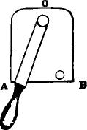
Fig. 719.
comes out nearly or quite as prominently as the first part or signal proper. Thus the letter e will appear on the recorder slip at the sending station as two deflections, one above and one below the line, almost exactly equal in amplitude, in form like the letter a on thi receiving slip, and the letter a on the sending slip will appear like an on the receiving slip. This makes the sent signals difficult to read, but no such difficulty is felt when the part of the current which records the signals at the sending station is allowed to go to earth there, as it is in the arrangement of connections shown in fig. 693 (page 1154).
Failure of Signals.--If complaints are made that signals sent by the auto occasionally fail to be recorded at the receiving end, that dots and dashes are now and then missed, it will be necessary—

1208 THE AUTOMATIC CURB-SENDER.

•
1st. To look at your recorder slip, and see whether the signals which are reported to have failed at the other end appear there. If they do, then the fault must be at the other end, but if they do not
2d. Read your perforated slip, and see whether the holes corresponding to the signals which have failed have not been missed in the punching.
3d. If the failures are still not accounted for, they must be due to the imperfect adjustment of the auto, or to bad spacing in the punched paper.
Stop the machine when a hole is passing under one of the prickers, and just when the opening / in the rim of the determining cam is passing over the springs. If now the pricker is fairly over the centre of the hole (page 1203), the adjustment is perfect for that hole, and, if the spacing of the holes in the punched slip is regular, the adjustment must be perfect for all holes. In some of the forms of punchers about to be described the spacing in the paper must be perfect, but in another of the forms it is possible that the side holes may sometimes vary slightly in position relatively to the centre holes. Suppose that one of the side holes is slightly behind its proper position. Then at the instant that the opening / is passing over the springs the hole in the paper will not be under the pricker as it should be, and consequently the pricker will not be able to descend and the signal will be missed. It will generally be found possible in this case to avoid having any signals missed by using an imperfect adjustment of the auto as follows: Take a slip of the badly spaced paper, on which some words which you know are punched, and run it through the machine very slowly, checking the revolution by hand. Watch the springs, and read the words. by their movements, and notice carefully what signals fail. See whether the failures are caused by the corresponding holes being behind their proper positions, or in advance of their proper positions. If you find that the failures are due to the former cause, then loosen the screw K (fig. 714) and turn the cams slightly backward, so that when a properly spaced hole is

GENERAL DIRECTIONS. 1209

passing the pricker may descend, not into the centre of it, but near to its bad edge. Then when one of the holes passes which has been punched slightly behind its proper position, it is almost certain that some part of it—probably a part near the forward edge—will be passing under the pricker at the right instant, so that the pricker will descend and the signal be transmitted. Of course if the faulty holes had been in advance of their proper position, it would have been necessary to turn the cams slightly forward.
4th. When signals are reported to fail, although the prickers enter the corresponding holes, all the contact springs, etc., must be cleaned.
A good plan for seeing whether the prickers are entering the holes is to take a piece of the punched paper and smoke it by drawing it through the flame of a lamp or candle; then run it through the machine. Every time the recess in n in the cam 0 (fig. 713) comes round the prickers will descend, and if a solid part of the paper is passing under them they will leave marks on the smoked paper at the points where they touch it. If these marks are seen close to the edge of the side hole, the prickers have evidently not entered the holes, and the adjustment must be looked to.
General Directions.—When the outer case of the instrument has to be removed, it should be taken off bodily by taking out the screws at the four feet z z z z (fig. 709). The various brass pieces of the case should not he separated from one another, as a difficulty would probably be experienced in putting them together again.
If it is desired for any reason to remove the paper trough U (figs. 703 or 709) or the prickers, the contact plate must be first removed; then the axle which carries the cams should always be taken off. This is done by taking out the screw r (fig. 709), which secures a standard which carries the bearings for the right-hand end of the axle. When the screw r is taken out this standard comes off, and the axle is thus easily removed without having its bearings interfered with. The paper trough and

1210 THE AUTOMATIC CURB SENDER.

pickers can then be removed bodily by taking out the screws x y x y on the right-hand side plate of the instrument, which secure the angle pieces carrying the trough. In this way the trough and prickers can. be taken off together without any of the small screws being touched which fix together the supports of the prickers.
Care must be taken that the successive turns of the string wound upon the driving drum D do not overlap each other, for if they do they are liable to come in the way of the projecting spurs on the toothed wheel which carries the paper along.
The string which suspends the driving weight must hang freely, and not chafe against the sides of the hole in which it passes through the table.
PUNCH ES.
The machines for perforating the paper ribbon used in the automatic sender are of several forms. One puncher is adapted for punching side holes only, and the paper used for it may l-e prepared beforehand by having a properly spaced row of central holes punched in it. This puncher has three finger keys. When any one of the three keys is depressed, the paper is carried along a step. When the central key is depressed nothing further happens, but when either of the side keys is depressed a side hole is perforated in addition to the paper being moved forward. It is essential that the paper should be at rest when the punch enters it, and should continue at rest so long as the punch is in it. The machine is therefore arranged so that the movement of the paper happens early during the stroke or depression of the key, and the punch is not forced through the paper until the end of the stroke. The manner in which this is effected will be readily understood by an inspection of the machine. The feed motion, by which the paper is carried along, may not, however, be so readily understood without explanation. The paper is carried along by the revolution of a toothed roller, the teeth of which enter the previously prepared central holes. On the same axle with this toothed roller is a ratchet wheel, having

USING THE PUNCHES. 1211

the same number of teeth as there are in the roller, so that the paper advances one space when the ratchet wheel is pushed forward one tooth. The ratchet wheel is caused to advance by the following means: The depression of any of the three keys is made, by means of a spring, to communicate horizontal motion to the pivoted end of a long horizontal pawl, the other end of which gears into the upper side of the ratchet wheel. When the key is depressed this pawl is pressed along, and the ratchet wheel advances. The end of the pawl which gears into it is thus carried upward as well as along, and by the time that the ratchet wheel has advanced through the space corresponding to one tooth the end of the pawl has risen so far that the back of the pawl presses upward against a firm stop fixed above it. This prevents any further advance of the ratchet wheel during the remainder of the stroke. The horizontal pressure on the pivoted end of the pawl continues, however, and consequently the ratchet wheel (and therefore the toothed roller and the paper) is held firm during the descent of the punch. When the key is allowed to rise, the horizontal pressure on the pawl ceases, it is pulled backward by a suitable spring, and its weight causes the unpivoted end to fall down into gear with the next tooth of the ratchet wheel. The ratchet wheel is prevented from following the horizontal pawl backward by a second pawl or click.
In using this instrument, it is not essential to have paper in which a central row of holes has previously been punched. If a slip of plain paper be used, the toothed roller will make a series of central embossed marks or indentations, which will be found to answer the purpose of central holes sufficiently well, for the paper so prepared will run through the automatic sender, the teeth in the spur wheel of which will enter the successive central indentations in the paper. It will be found necessary, when embossed paper is used, to apply a strong retarding force to the paper as it enters the auto, so as to prevent it from riding on the top of the spurs, instead of being pierced by them. This retarding force is easily applied in exactly the same way as it is

1212 THE AUTOMATIC CURB-SENDER,

applied in the siphon recorder, by passing the paper under a spring guide, the pressure of which upon the paper will cause friction and hold back the paper. (See a fig. 685, page 1141.)
The depression of the keys of this puncher is most easily -effected by the help of light woollen mallets, on the end of which india-rubber is fixed, or, better still, by putting fingerstalls tipped with india-rubber over two fingers of each hand. Care must be taken not to strike a sharp or violent blow, but rather to make the blow as much like a shove as possible. If the blow be too sharp, the paper will not have time to advance through a complete space before the punch enters it, and a misplaced or torn hole will be produced. Violent blows are also very apt to break the springs by which the feed motion is worked. To avoid breakage, multiple springs are used for the dot and dash keys. If the single spring under the centre key should break, it is not necessary tc interrupt the work to put on a new spring, for the spaces may be made by depressing both side keys simultaneously.
The bridge which forms a back stop for the keys should be adjusted so as just to touch the backs of the levers, without pressing on them, when they are in their raised position.
The Power Puncher.—In this form of puncher the heavy work is done by power stored up in the form of a wound-up spring or raised weight, and the operator, by depressing the finger keys, releases a detent, and so allows the stored up power to take effect. Hence the name, in which the prefix " power" has the same significance as it has in the term " power loom."
In the power puncher there are three finger keys—for the dot, dash and space. When any one of these is depressed, a detent allows one tooth of an escapement wheel to pass. There are twelve teeth on the wheel, so that the axle which carries it revolves through one-twelfth of a whole revolution for every depression of a key. On the same axle is fixed a cam wheel called the paper cam, with twelve projections on it, which act (as they pass) upon one end of a lever, the other end of which carries forward a ratchet wheel tooth by tooth. On the same axle

THE POWER PUNCHER., 1213

with a ratchet wheel is a toothed roller which gears into the central row of holes in the paper. The paper is thus moved forward one space whenever any one of the three keys is depressed. The projections on the cam are so designed as to make the paper start and stop slowly at each movement, so as to secure uniform spacing at different speeds. There is a second ratchet wheel fixed on the same axle with the one just mentioned, into which a pawl is made to gear just as the punch is entering the paper. In this way the paper is held perfectly steady during the descent of the punches. The feed motion of the power puncher is identical with that of the single lever puncher, which is described at greater length on page 1214.
There are three punches corresponding to the centre hole and the two side holes. The manner in which they are forced down into the paper is as follows • On the axle, which carries the escape. ment wheel and paper cam, there is a second cam wheel fixed, called the punching cam, on whose rim there are twelve wedge-shaped projections. One of these passes over the central punch, and depresses it every time that the axle revolves partially owing to the depression of any one of the three keys. If the centre key is depressed, then nothing occurs except the release of the detent and the consequent partial revolution of the axle, which causes the paper to advance one space, and causes one central hole to be punched. Neither of the side punches is affected, because they are somewhat shorter than the central punch, and so allow the revolving wedges of the punching cam to pass without depressing them. But if one of the side keys is depressed a packing piece slides in over the top of the corresponding side punch, and, the detent being released as before, the revolving wedge of the punching cam cannot now pass without depressing' both the centre and the side punch, which has been (so to speak) lengthened by the introduction of the packing piece. If both side keys are simultaneously depressed, both packing pieces are slipped in over the punches, and all three hoics are punched.. The effect of this would be, as we have seen on page 1196, to produce a space in the sending.

1214 THE .AUTOMATIC CURB SENDER.

The spring or weight has to be wound up from time to time. With an ordinary Morse spring the power puncher will punch about twenty words without needing to be wound up afresh.
Great care must be taken to keep the fingers clear of the keys which are intended not to be depressed, otherwise the packing pieces may be slipped in accidentally and false signals be produced.
The best way to put in the paper is to double it over the end of a piece of steel spring about six inches long, and push the spring and paper in together, care being taken to draw back the spring before beginning to punch.
The Single Lever Puncher.—In this puncher the principle of packing pieces is used, and the feed motion is the same as that of the power puncher, but the work is entirely done by hand. There is a long horizontal lever, on the end of which nearest to the operator there are three finger keys. When any one of these keys is depressed, the near end of the lever is depressed with it. Fixed to the lever is a projection, A (fig. 720), with a cam-shaped surface, and as the lever is depressed this cam slides along the surface of another piece, B, in 'contact with it, and gives a reciprocating motion to B. The piece B actuates the feea in the manner described below. When the centre key is depressed the lever descends, works the feed, and a centre hole is punched. When either of the two side keys is depressed, a packing piece slides in over the top of the corresponding side punch; then the lever descends, works the feed, and punches both a side and a centre hole. A spiral spring, fixed to the distant end of the lever, pulls it back when the pressure of the fingers is removed.
The feed mechanism is shown in fig. 720. The paper is carried along by a toothed roller, C, whose teeth enter the centre holes. This roller is placed immediately behind the punches. Fixed on the same axle as the roller are two ratchet wheels, D and E, whose teeth face opposite ways. D is the one by means of which the paper is drawn along; the other one, E, is required

THE FEED MECHANISM. 1215
in order that the paper may be held so as to be perrectly incapable of moving during the time that the punches are entering and leaving it. During the early part of the descent of the lever the piece B descends, and carries with it a spring pawl F, fixed on the side of it nearest to the centre of the instrument, and gearing into the upper side of the ratchet wheel D. This pawl pulls the ratchet wheel round one tooth, and consequently causes the paper to advance through one space. When the advance is complete, a click, G, working oh the lower side of
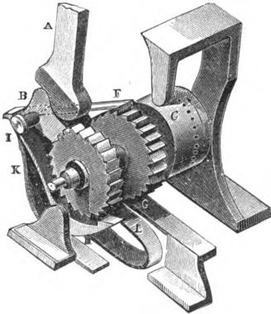
Fig. 7 20.
the same ratchet wheel, falls into gear, and so prevents the wheel from turning the wrong way during the hack-stroke. Just before the punch or punches enter the paper, a pawl, H, on the outer side comes into gear with the ratchet wheel E on its lower side. This pawl has been gradually rising during the descent of the lever, but it only comes into gear when the paper is just about to be punched. It remains in during the whole time that the punch or punches are in the paper, and insures that the paper does not move during that time. As the lever is allowed to rise, this paul falls out of gear; the paul F rises so as to

1216 THE AUTOMATIC CURB-SENDER.
catch hold of the next succeeding tooth of D, while the click G prevents the roller from turning backward. The paul H is actuated by a pin, I, projecting from the outer side of B. There is a spring, K, pressing on the back of paul II, in order to disengage it from the ratchet wheel E when the lever rises. There is also a spring, L, pressing on the back of B, to make it rise when the lever rises. The two springs K and L are fastened by screws under the sole-plate of the instrument.
The surface of the cam A is so shaped as to start the paper gradually, and also so as not to bring any force to bear upon B, during the actual punching of the paper. The feed motion is completely over before the punch enters the paper.
The springs and pawls for the feed motion are usually provided in duplicate. Before attempting to take the machine to pieces, the operator ought to make sure that he understands what the conditions of perfect working are. The pawl F must begin to pull round the ratchet D the instant that the lever begins to descend. It must cease to pull as soon as the paper has advanced one space, and before the punch begins to enter the paper. At the instant that it ceases to pull the click G must fall into gear, and at the same instant the pawl H must come into action. During the remainder of the descent of the lever no force must be brought to bear upon B by the cam A. although A continues moving.
•

CHAPTER LIL
EDISON'S MAGNETIC BRIDGE.
PERHAPS no electric measuring instrument has proved more useful in practice, especially if we consider the various forms which it has assumed, than the device contrived by Christie and commonly known as Wheatstone's bridge. It was with the belief that a similar instrument could be constructed, which should perform the same service for magnetic measurements, that the exr,eriments were made, the results of which are embodied in this apparatus.
The Wheatstone bridge is based upon the fact that if two points of different electric potentials are united by two conducting paths, the fall of potential along these paths is absolutely the same, provided that these paths are absolutely alike electrically. Consequently, if two points equidistant from the place of higher potential be connected together, no current will flow through the connecting wire. So, by analogy, if two points be maintained at a constant difference from one to the other through two or more paths, the magnetic potential will be absolutely uniform in all, provided these paths be magnetically identical. Hence, at any two points equidistant from a given terminal, the magnetic potential is the same, and these points would be without differential action upon a magnetic pole.
The magnetic bridge may be constructed in the form of a rhomb, the typical form of the Wheatstone bridge. For this purpose the four sides are made of the purest Norway iron, as soft as possible, and thoroughly annealed. To the acute angles of the rhomb are connected the poles of a long U-shaped electromagnet, whose function is to develop the desired magnetic potential difference at these points. Connected to the two obtuse angles, and projecting inward, are two bars of Norway iron simi-

1218 EDISON'S MAGNETIC BRIDGE.
lar in section to those forming the sides. Their inner ends, which are hollowed out, approach to within about a half inch of each other. (Fig. 721.) Between these ends a stirrup, B, is suspended by means of a silk fibre, A, which stirrup carries a short needle consisting of a thin tube of hardened steel, C, well magnetized. To the stirrup is attached either a pointer, E, moving over a graduated arc, or, better, a mirror by means of which the deflection can be read in the usual way with a lamp-stand and scale. (Fig. 722.)

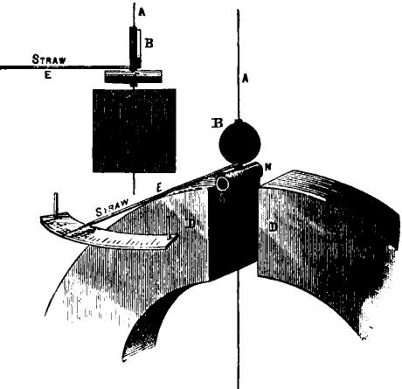
A

way
Fig. 721.
In the instrument now in use in Air. Edison's laboratory the magnetic bridge is in the form of a rectangle, the ends or poles of the elekro-magnet being connected to the middle of the short sides, while the bars which pass inward to the needle are joined to the middle of the longer sides. The four halves of these longer sides constitute the sides of the bridge. The two at one end
- of the rectangle are fixed, the two at the other end are movable. The two bars which pass inward to the needle are curved so as

CONSTRUCTION OF THE EDISON BRIDGE- 1219
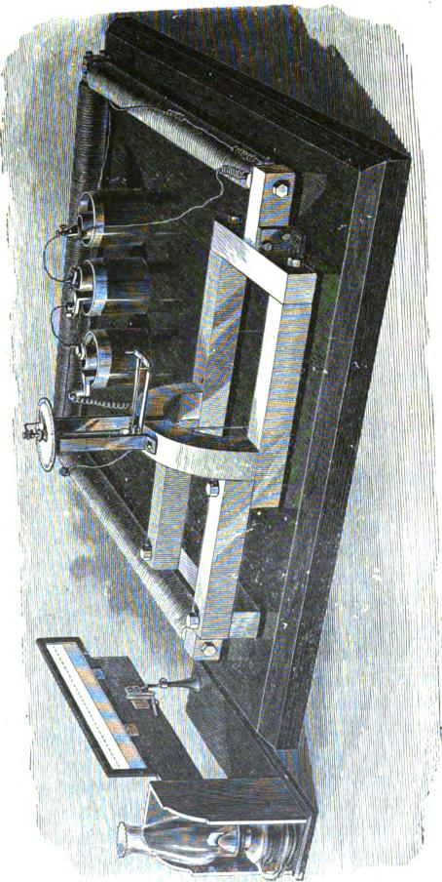

1220 EDISON'S MAGNETIC BRIDGE.

to form a semicircle standing above the plane of the rectangle. The needle itself is similar in construction to that above described, but is suspended by a wire attached to a torsion head.
It will be readily seen that when the electro-magnet is charged a constant difference of magnetic potential is maintained at the two ends of the rectangle, so that if the four bars constituting the sides of the bridge are magnetically identical, there will be no difference of magnetic potential between the ends of the bars which pass to the needle, and hence there will be no deflection; but if one of the movable bars be loosened, the needle is at once deflected, and in a direction depending upon the side the bar occupies. If the bar be entirely removed, the deflection is a maximum, of course. And if it be replaced by another bar dif-fering in cross section, in quality of iron, or in any other way which affects the magnetic conductivity through the bridge, the deflection shows at once the amount of difference between that bar and the original one taken as a standard. The instrument is extraordinarily delicate, and the principal difficulties encountered in using it have arisen in the attempt to preserve this delicacy while at the same time the range of the apparatus is maintained.
The magnetic bridge was devised for the purpose of testing readily the quality of the iron purchased for the construction of dynamo-electric machines. Very great variations are observed in iron supposed commercially to be of the same quality; consequently, the potential difference developed by a dynamo having field cores of such iron can never be exactly calculated. But by comparing the iron which is to be thus used, in the magnetic bridge, its exact value for dynamo purposes may be determined, and the constants of the generator thus accurately calculated in ad vance.
But this bridge, it would seem, will be equally useful for testing iron and steel for other purposes. By its means, not only may the character and quality of the metal be ascertained in terms of any desired standard, but flaws in the interior of a bar, such as a car axle, may be discovered at once.

OPERATION OF THE EDISON BRIDGE. 1221
Constructed with sufficient care and attention to details, the magnetic bridge may, without doubt, be made a most valuable instrument of precision for the furtherance of scientific research. The theory of its action is extremely simple, and it is the exact counterpart of an ordinary Wheatstone bridge constructed for measuring low resistance and immersed in water, since, now, whatever is true electrically of the one is true magnetically of the other. Not only may the laws of magnetic conductivity be investigated by means of this balance, for all pars and dia magnetic bodies, but the variation of this conductivity under the action of various physical agencies, such as heat, pressure, strain, etc., may be determined.

-

TABLE I.

WEIGHT PER LINEAL FOOT OF WIRES OF DIFFERENT METALS,
BY AMERICAN GAUGE.
No.ofifflzeofeach  Gauge. _{I} number. |  | Wrought  Iron. | Steel. Copper.  I |  | Brass.
Ina. lbs. |  |  | Lb& Lbs. lbc
0000 .46000 |  | .560740 | .566030 .640513 .60517G
000 | .40964 | .444683 | .448879 I .507946 I .479908
00 | .36480 | .352659 | .355986 .402830 .380666
0 | .32486 | .279665 | .282303 i .319451 |  | .301816
1 | .28930 | .221789 | .223891 I .253342 |  | .239353
2 | .25763 | .175888 | .177548 .200911 |  | .189818
3 | .22942 | .139480 | .140796 | .159323 | .150522
4 | .20431 | .110616 | .111660 .126353 |  | .119376
5 | .18194 | .087720 | .088548 .100200 |  | .094666
6 | .16202 | .069565 | .070221 | .079462 | .075076
7 | .14428 | .055165 | .055685 | .063013 | .059545
8 | .12849 | .043751 | .044164 | .049976 | .0472t9
9 | .11443 | .034699 | .035026 | .039636 | .037437
10 | .10189 | .027512 | .027772 | .03142G | .029687
11 | .090742 | .021820 | .022026 | .024924 | .023549
12 | .080808 | .017304 | .017468 | .019766 | .018676
13 | .071961 | .013722 | .013851 | .015674 | .014809
14 | .064084 | .010886 | .010989 | .012435 | .011746
15 | .057068 | .008631 | .008712 | .009859 | .009315
16 | .050820 | .006845 | .006909 | .007819 | .007587
17 | .045257 | .005427 | .005478 .006199 |  | .005857
18 | .040303 | .004304 | .004344 .004916 |  | .004645
19 | .035890 | .003413 | .003445 .003899 |  | .003684
20 | .031961 | .002708 | .002734 .003094 |  | .002920
21 | .028462 | .012147 .002167 .002452 |  |  | .002317
22 | .025347 | .001703 .001719 .001945 |  |  | .001838
23 | .022571 | .001350 .001363 |  | .001542 .001457
24 | .020100 | .001071 | .001081 .001223 .001155
25 | .017900 | .0008491 | .0008571 .0009699 .0009163
26 | .01594 | .0006734 .0006797 .0007692 .0007267
27 | .014195 | .0005340 .0005391 .0006099 .0005763
28 | .012641 | .0004235 .0004275 |  | .0004837 | .0004570
29 | .011257 | .0003358 | .0003389 | - .0003835 | .0003624
30 | .010025 | .0002663 | .0002688 | .0003042 | .0002874
31 | .008928 | .0002113 | .0002132 | .0002413 | .0002280
32 | .007950 | .0001675 | .0001691 | .0001913 .0001808
33 | .007080 | .0001328 | .0001341 | .0001517 .0001434
34 | .006304 | .0001053 | .0001063 | .0001204 .0001137
35 | .005614 | .00008366 | .00008445 | .0000956 .00009015
36 | .005000 | .00006625 | .00006687 | .0000757 .0000715
37 | .004453 | .00005255 | .00005304 | .00006003 .00005671
38 | .003965 | .00004166 | .00004205 | .00004758 .00004496
39 | .003531 | .00003305 | .00003336 | .00003775 .00003566
40 | .003144 | .00002620 | .00002644 | .00002992 ' .00002827
Specific gravities, 7.774 I 7.847 8.880 |  |  |  |  | 8.386
Weights of a cubic foot, 495.87 ; 490.45 I 554.988 |  |  |  |  | 524.16

TABLE

COMPARISON OF AMERICAN AND BIRMINGHAM WIRE GAUGES,

BIRMINGHAM.
AMERICAN.
AMERICAN. BIRMING-
HAM.

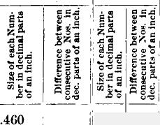

.4096.4 .36480 .32405 .28930 .25763 .22942
4 .20431
5 .18194
6 .16202
7, .14428
8 .12840
9 .11443
10 .10189
11 .09074
12 .08081
13 .07196
14 .00408
—1
10 .05707 .00702
10 .05082 , .00025
17₁.04520 .04520 .00556
18 .0403 .00495
.454 .425 .380 .340 .300 .284 .259 .238 .220 .203 .180 .165
.148
.029
.045
.040
.040
.016
.025
.021
.018
.017 .023 .015 .017 .014
.014
.011
.014
.012
.05036 .04484 .03994 .03556 .03167 .02821 .02511 .02237 .01992 .01774 .01579 .01406
.072 .011 ¹.005 .007 .058 .007 .049 .009
.01254 .134
.01105 .120
₁
.00993 .109
.00885 I .095
.00788 ..083
No. of Wire Gauge.
0000
000
00
0
1
2
3
0  6 | if.  za.  ;79!  O | Ft⁵  tg.°  E⁷4,  tzg.  tat  O | &  cz—  0 | E⁴f;  .⁵¹  w  c+Fa  ti .  t
19 | .03589 | .00441 | .042 .007
20 | .03196 | .00393 | .035 | .007
21 | .02846 | .00350 | .032 | .003
22 | .02535 | .00311 | .028 | .004
23 | .02257 | .00278 | .025 | .003
24 | .0201 | .00247 | .022 | .003
25 | .0179 .00220 |  | .020 | .002
26 | .01594 | .00196 | .018 | .002
27 | .01419 | .00174 | .016 | .002
28 | .01264 | .00155 | .014 | .002
29 | .01126 | .00138 | .013 | .001
30 | .01002 | .00123 | .012 | .001
31 | .00893 | .00110 | .010 | .002
32 .00795 |  | .00098 | .009 | .001
:33 .00708 |  | .00087 | .008 | .001
34 .0063 |  | .00078 | .007 | .001
35 | .00561 | .00069 | .005 | .002
36 | .005 | .00061 | .004 | .001
37 | .00445 | .00055
38 | .00396 | .00049
39 | .00:353 | .00043
40 | .00314 .00039

TABLE
Table of Relative Resistance of Gutta Pereha at Different Temperatures,

Temp. Temp.  Degrees Resistance. Degrees  Fakir. Fahr. | Temp.  Resistance. i Degrees | Resistance.

90 | 0.394 70 1.364 50 |  |  |  | 4.712
89 | 0.420 69 |  | 1.451 49 |  | 5.013
88 | 0.447 | 68 | 1.543 | 48 | 5.334
87 | 0.475 67 |  | 1.642 | 47 | 5.675
86 | 0.506 66 |  | 1.747 | 46 | 6.038
85 | 0.538 | 65 1.859 45 |  |  | 6.425
84 | 0.572 | 64 1.978 44 |  |  | 6.835
83 | 0.609 | 63 2.104 43 |  |  | 7.273
82 | 0.648 62 |  | 2.239 42 |  | 7.738
81 | 0.689 61 |  | 2.382 | 41 | 8.233
80 0.733 60 |  |  | 2.535 | 40 | 8.760
79 0.780 59 |  |  | 2.697 | 39 | 9.132
78 | 0.830 | 58 | 2.869 | 38 | 9.917
77 | 0.883 | 57 | 3.053 | 37 | 10.55
76 | 0.940 | 56 | 3.248 36 |  | 11.22
75 | 1.000 | 55 | 3.456 35 |  | 11.94
74 | 1.064 | 54 | 3.680 34 |  | 12.71
73 | 1.132 | 53 | 3.912 33 |  | 13.52
72 | 1.204 | 52 | 4.162 32 |  | 14.38
71 | 1.282 51 |  | 4.429

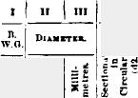

as A. 13 E IV.
COPPER W IRE.
SPECIFIC GRAVITY, 8.9.
TI I VII
Till I IX I X I XI I XII
LKNOTH. RKRISTAACK or PORK Corr., AT GO' FAR.
I
Wszoarr.
°hum per Pound.
.001450 .00M12
muss
.004810
.007126
.010610
.016176
.osnos
.041956 .072114 .127157 .191446
In II1.. Id.)
220
208
180
165
148
184
120
109
95
88
72
65
58
49
42
85
32
28
25
22
20
18
16
14
13
12
10
9
Cans Ohm.
per1000 per
feet. Nlla
Grains
per
for.
(w.)
48400 1024.9 410)9 872.6 82403 686.1 27225 576.5
21904
17956
14400
11881
2.41 9025
2.11 6889
1.88 5184
1.t5 I 4225
3864
2401
1764
1225
Pounds Per 000
feet.
146.41 ¹778.045 124.66 ¹657.0)3 98.01 517.498 82.86 434.861
68.26 349.853 54.29 286.651 43.56 2W.997 35.94 1:4.763
27.80 144.144 23.84 110.085 15.68 82.790 12.78 67.478
Feet Feet
per per
Pound. Oton.
6.88 4681.1 8.02 8985.7 10.203134 .8 12.14 2633.7
15.10 2119.9 18.44¹1787.0 22.951392.9 27.821149.4
878.1
665.3
501.5
78.25, 408.7
102. 310.8
187.68 282.8
187.40 170.6
969.88 118.5
.2186 1.1278
.2509 1.3248
.8190 1.6843
.3797 2.0048
.4719 2.4916
.5757 8.0397
.7179 3.7905
4.5986
6.0477 7.9358 10.5288 12.9180
16.9889 22.7815 30.9404 44.5582
Pounds Twr
5.59
5.16
4.57
4.19
8.76
8.40
8.05
2.77
5
6
7
8
9
10
11
12
13
14
15
16
17
18
19
20
21
22
24
23
26
28
29
83
31
82
413.8
880.2
804 . 9
M1 .6
191.1 145.9 109.77 89.469
.8700
1.1454 1.5030 1.9941 2.4466
3.2176
4.3062₁

5.8399
8.4381
36.63
47.98
68.77
68.080 50.844 87.354 25.941
21.684 16.602 13.285 10.249
8.470
6.861
5.421
4.151
3.579
3.049
2.119
1.715
1.855
1.018
.529
.839
1.47
1.24
1.07
.89
.81
.71
.64
.56
.51
.46
.41
.36
.33
.30
.25
.23
.20
.18
.13
.13
51.3163 33.3486 28.1741 19.5677
9.719
7.263
5.316
8.706
8.098
2 .372
1.891
1.464
1.210
.980
.7744
.5930
.331059 .502740 1.0981 2.2783
1024
784
484
400
824
256
196
169
144
100
81
64
49
25
16
99.1 10.094 53.2963I
75.8 13.185 69.61681
60.5 16.589 87.62*
46.8 21.357 112.7660
88.7! 25.843 136.451
81.3 31.904 168.458 24.8¹ 40.878 218.196 19.0,^{I} 52.782 i 278.426
.51131 2.6997, 1955.79 18.8¹₁ 61.1604¹ 822.927 .4354 2.3006 2295.68 13.9, 71.7250 87E.708
. 8006¹ 1.59771 3304.69 9.7,^{I} 103.349 545.683
.2456 1.2936 4081.61 7.8127.692 674.214
I I I
, I
.1936! 1.02.4 6165.29 6.2 161.545 852.968
.1483 .7830 6743.09 4.7 210.879 1118.441
. _{I} 0756^{I} .399213227.51I 2.4 '413.784 ,2184.780
.0484 .255620661.1h 1.55645.705 3409.822
3.2570 5.5585 8.7457 14.587
21.811 32.528. 52.140 88.924
119.617 164.658 841.586 521.189
834.427 1421.976 5473.332 13341.014
16.3574 822.79 12.5242 421.58 9.0845 528.82 7.7299 663.06
6.3888 826.44 5.1744 1020.40 4.0888 1231.32 3.1216 1686.34
33 8
34 7
35 5
36 4

TABLE V.
FOR CALCULATING APPROXIMATELY THE RESISTANCE OF COPPER
AT DIFFERENT TEMPERATURES FAHRENHEIT.
To increase from lower temperature to higher, multiply the resistance by the num- ber in Column 2. |  |  |  | To reduce from higher temperature to lower, multiply the resistance by the number in Column 4.
^{N°}' ^{°f} I Column 2. Degrees. I |  | _{De}^{N}_{gree}°'^{°f}_{8.} | Column 2. | _{De}^{N}_{gree}"_{B.} I Column 4. |  | NO of Column  Degrees. 4.
0 | 1. 16 |  | 1.0341 | 0 | 1. | 16 | 0.9670
1 | 1.0021 | 17 | 1.0363 | 1 | 0.9979 | 17 | 0.9650
2 | 1.0042 | 18 | 1.0385 | 2 | 0.9958 | 18 | 0.9629
3 | 1.0063 | 19 | 1.0407 | 3 | 0.9937 | 19 | 0.9609
4 | 1.0084 I | 20 i | 1.0428 | 4 | 0.9916 | 20 | 0.9589
5 | 1.0105 | 21 | 1.0450 | 5 | 0.9896 | 21 0.9569
6 | 1.0127 | 22 | 1.0472 | 6 | 0.9875 | 22 | 0.9549
7 | 1.0148 | 23 | 1.0494 | 7 | 0.9854 | 23 | 0.9529
8 | 1.0169 | 24 | 1.0516 | 8 | 0.9834 | 24 | 0.9509
9 | 1.0191 | 25 | 1.0538 | 9 | 0.9813 | 25 | 0.9489
10 | 1.0212 | 26 | 1.0561 | 10 | 0.9792 | 26 | 0.9469
11 | 1.0233 | 27 | 1.0583 | 11 | 0.9772 | 27 | 0.9449
12 1.0255 |  | 28 | 1.0605 | 12 | 0.9751 | 28 | 0.9429
13 | 1.0276 | 29 | 1.0627 | 13 | 0.9731 | 29 | 0.9409
14 | 1.0298 | 30 | 1.0650 | 14 | 10.9711 | 30 | 0.9390
15 | 1.0320 |  |  | 15 | 0.9690
 |  |  |  |  | ._ _

'"1" A. El IC VI.
IRON WIRE.
The above table is calculated upon the basis of tests of wire such as is now furnished the Western Union Telegraph Co. The mean of a great many of these tests gives 4,884 lbs. per mile-ohm; that is, the amount of metal by weight in a mile length of wire, having ono ohm resistance, is equal to 4884 lbs. By dividing this constant by the weight per mile of any other size wire of the same material, we obtain the resistance in ohms per mile of such wire. The breaking weight of any of the above size wires averages about three times its own weight per mile.

_{II} _{III} ^{T} I VI
VII 'VIII IX X
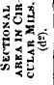
Feet Feet
per per
Pound. Ohm.
1.83
2.10
2.60
4.14
4.22
4.78
5.70
6.00
3106
2708
2172
1378
1350
1211
1008
958
727
618
678
409
95 2.41
83 2.11
72 1.83
65 1.65
0000
000
00
0
1
2
3
4
5
6
8
9
10
11
12
13
14
15
16
3.12
3.00
3.05
17 58
18 49
19 .12
20 35
1.47
1.23
1.07
.89
135 39.00
104 51.00
78 67.83
63 83.20
55 96.00
35.9 147.00
26.0 199.34
18.4 287.30
403.4 304.2 17.4 330.7 249.4 21.2 265.2 200.0 26.4 218.8 165.0 32.0
166.2 125.3 42.2 126.9 95.7 55.2 95.5 72.0 73.3 77.8 58.7 90.0
67.5 50.9 103.7
44.2 33.3 158.6
:12.5 24.5 215.5
22.6 17.0 310.6
90000
80656
67081
56644
48400
41209
32400
27225
21904
17956
14400
11881
9025
6889
5184
4225
3364
2401
1704
1225
B. W.
DIAMETER.
Gauge.
In MII..
Milli-
No. .00i in. _{metres.}
((L)
WMGHT.
Sp. GR.TAKEN AT 7.74.
Grains Pounds
per foot. Nile. (w.)
Ratio
RESISTANCE, , '
TEMP. 75.8' FARR., B•k_{a}.
Weight
to Weight
per 11 ile.
LENGTH.
Ohms Per
ile.
454 11.53 206116 3815.8 2877.8
425 10.80 180625 13326.4 2508.0
_{I} ' 380 9.65 144400 2659 3 2005.1
340 8.64 115600 ₁1691.0 1275.0
1.70
1.95
2.43
3.83
300 7.62
284 7.21
259 6.58
238 6.05
220 5.59
203 6.16
180 4.57
165 4.19
148 3.76
134 3.40
120 3.05
109 2.77
1657.4 1249.7 1485.4 1120.0 1235.4 931.5 1043.2 886.6
891.3 673.0 7.85 758.9 672.2 9.20 596.7 449.9 11.70 501.4 378.1 114.00
328
269
216
179
3.91
4.36
5.24
5.51
7.26
8.54 3.05
10.86 3.40
12.92 3.07
16.10 3.38
19.60 3.37
24.42 2.97
29.60 3.43

TABLE VII.
NATURAL SINES AND TANGENTS.

El
0.5
1
1.5
2
2.5
8
3.5
4
4.5
5
5.5
6
0.5
7
7.5
8
8.5
9
9.5
10
10.5
11
11.5
1.2
12.5
13
13.5
14
14.5
15
15.5
16
16.5
17
17.5
18
18.5
19
19.5
20
20.5
21
21.5
222
22.5
- | en  5 |  |  |  | 4 |  | i! | , |  | tl
.00872  .01745 | .00873¹  .01745.1 | 28  29.5 | .39073  .39875 | .42447  .43481 | 45.5  46 | .71925  .71994 | 1.01761  1.03553 | ¹68  68.5 | I .92718 I .93042 I | 2.47509  2.53865
.02618 | .02618 ¹ 24 |  | .40674 | .44522 | 46.5 | .72537 | 1.05378 1' 69 |  | .93358 1 2.60509
.03490 | .08192 24,5 .41469 |  |  | .45572 | 47 | .731a5 | 1.07237 69.5 |  | .93667 2.67462
.01862 | .04366 ¹ • 25 .42262 |  |  | .46630; 47.5 |  | .73728 | 1.09131 ¹¹ 70 |  | .93969 2,74748  I
.05234 | .05240 25.5 .43051 .47697 _{'48} |  |  |  |  | .74314 | 1.11061 -, 70.5 .94264 : 2.82391
.06105 | .06116 ^{I}26 .43897 .48773 _{48.5} |  |  |  |  | .74896 | 1.130291: 71 I .94552 I 2.90421
.06976 | .06992 26.5 .44620 .498.58 49 .75171 |  |  |  |  |  | 1.15037 ¹71.5 .94882 2.98;69
.07818 | .07870 127 ¹ .45399 I .50952 49.5 .76041 |  |  |  |  |  | 1.17085 I1 72 1 .95106 ¹ 8.07768
.08716 | .067481 27.5 .46175 .52056 50 |  |  |  |  | .76604 | 1.19175 II 72.5 -95372 I 8.17159
.09585 | .096% • 28 .46947 1 .53170 20.5 |  |  |  |  | .77162 | 1.21310.. 73 .95630 8.27085
.10453 | .10310 tX5 .47716 I .54295 I 51 |  |  |  |  | .77715 | ¹  1.234901¹ 73.5 I .958£51 8.37594
.1119X) | .11393 29 .48481 .55430 51.5 |  |  |  |  | .M261 | 1.25717 ',74 .96120 |  |  | 3.48741
.12187 | .12278 , 29.5 . .49242 , .56577 I 52 |  |  |  |  | .78801 | 1.27994 I. 74.5 . .96363 |  |  | 3.14)588
.13053 | .13165 30 I .51X100 _{I} .57735 52.5 |  |  |  |  | .79885 | 1.30323 75 I -⁹⁶⁵93 8.78205
.13917 | .14051 , 30.5 .50754! .581;04 58 |  |  |  |  | .79864 | 1.W701 75.5 .96815 ^{I} 3.86671
.14781 | ^{II}  .14945 81 1.51504 .60080 53.5 .80386 |  |  |  |  |  | 1.35142 76 I .97030 4.01078
.15613 | .15838 31.5 .&2250 .61280 , 54 .809112 |  |  |  |  |  | 1.37638 76.5¹ .97237 4.16530
.16505 | .16734 ¹ 82 1.52992 . .62486. 54.5 |  |  |  |  | .81412 | 1.40195¹ 77 ! .97487 ^{i} 4.33148  : •
17365 | .176T.) 32.5 .53730 , .637071 55 |  |  |  |  | .81915 | 1.42815 | . 77 5^{1 .976301} 4.51071
.18224 | .18533 33 .54464 .64940 i 55.5 |  |  |  |  | .82413 | 1.45501 | 78 .⁹78¹⁵ 4.70463
.19081 | I .19438 ₁33.5 I .55194 1 .66188 56 |  |  |  |  | .82904 | 1.48156 | 178.5 . .97999 |  | 4.91500
.19937 | .20345 . 84 ¹ .55919 .67450 , 56.5 |  |  |  |  | .83389 | 1.51084 | 79 I -⁹8163 |  | 5.14455
.20791 | .21.255 !: 34.5 . .56641 . .68728 57 |  |  |  |  | .83867 | 1.53987 | 79.5 I .98825 |  | 5.39552
.21044 | .22169 35 ! .57338 .76020 57.5 |  |  |  |  | .84339 | 1.56969 80 |  | .984111 | 5.67128
.22195 | .23080 35.5 .58070 .71329 56 |  |  |  |  | .84805 | 1.60033 80.5 |  | .98629 | 5.97570
.23345 | .24007 ¹ 36 .58779 .7V154 . 58.5 |  |  |  |  | .85204 | 1.63165 81 |  | .98769 | 6.3187.5
.21192 | .2493.2' 36.5..59481 .73996 , 59 |  |  |  |  | .85717 | 1.06128 . 81.5 |  | .98902 | 0.69116
.25038 | .²⁵961 87 1.60182¹ .75355; 59.5 |  |  |  |  | .86163 | 1.69766 ' 82 |  | .99en | 7.11537
.25882 | .26794' 37.5 '.60870 . .16732 60 |  |  |  |  | .86603 | 1.78205 | ' 845 | .99144 | 7.59575
.28781 | .277n I! se |  | .61566 | .78128 1, 60.5 |  | .871)36 | 1.76749 | 183 | .99255 8.14435
.27564 | .28674 ^{I}, 88.5 |  | .6!251 | .79543 1, 61 |  | .87462 | 1.80105 _{I}, 88.5 |  | .⁹⁹³⁵⁷ 8.77681
.28402 | .296211 89 |  | .⁽⁴⁹³² | .80978 ⁶¹.⁵ |  | .87882 | 1.84177 | 84 | .⁹⁹⁴³² 9.51136
.29M7 | .30573 39.5 |  | .63608 | .82433 62 |  | .88226 | 1.88073 | 184.5 | .⁹⁹⁵⁴⁰ 10.38.54
.80071 | .31529 40 |  | .64279 | .83910 6.¹¹.5 |  | .88701 | 1.9M93 | 85 | .⁹⁹⁸¹⁹ 11.4301
.30902 | .32492 '¹ 40.5 |  | .64945 | .85108 68 |  | .89101 | 1.96261 85.5 |  | .9⁹⁶⁹2 12.71162
.31730 | .83459 41 .65606 |  |  | .869:91 I 68.5 |  | .89493 | 2.00569 | 86 | -W³⁷⁵⁶ 14.3007
 | .34432 41.5 |  | .66262 | .88172 64 |  | .89879 | 2.05430 | 86.5 | .99813 16.34911
.33981 | .35411 ' 42 |  | .66913 | .90040 64.5 |  | .90259 | 2.09654 | 87 | .99⁸63 19.1811
.34822 | .36397 •' 42.5 .67559 |  |  | .916331 65 |  | .99631 | 2.14431 ₁87.5 .99905 , 22.!,038
.35(r.21 | .37388 •43 .68100 |  |  | .98251 65.5  . |  | .90996 | 2.194301 88 .99039 23.6303
.35837 | .38386 43.5 .68835 |  |  | .94896 60 |  | .91355 | 2.24504 88.5 .90966 38.1885
.36630 | .39391 44 .09466 |  |  | .96568 66.5 .91706 |  |  | 2.29981 89 .99985 • 57.29110
.37461 | .40102 144.5 .70W1 |  |  | .98269 67 .9•21E10 |  |  | 2.35585 89.5 .9'.1996 114.589
.34268 _{I} | .41421 , 45 1.70711 1.00000 67.5 .92383 |  |  |  |  |  | 2.41421 90 1.00100

TA.I31,30 VIII.
Showing the relative Conductivity and Resistance of
Metals and Alloys.
AT 0° CENTIGRADE OR 32° FAHRENHEIT.
Metals and Alloys. | Relative Conductivity.  I Silver (hard dui% n)-100. | Relative Resistance. Silver (bard drawn)-1.
Silver, soft  Copper, "  Silver, hard  Copper, "  Silver, standard  Gold, soft  Gold. hard  Gold, proof | 11⁻S.57  102.(0  100.00  99.95  80.63  79.30  77.96  72.55 | .92  .98  1.00  1.00  1.24  1.26  1.28  1.87
Copper with%  "..4 Gold4ir Silver and | 44.47 | 2.25
Aluminum | 33.76 | 2.96
Silver, with 5% Platinum | 31.64 | 3.18
Zinc, pressed ...... • • • • | 29.02 | 8.44
GUT' Metal, Austrian | 27.06 | 8.69
Cadmium | 23.72 | 4.21
Copper, with 36.7% Zinc 22 27 |  | 4.49
Copper, with 25% Zinc | 2.2.08 | 4.53
Iron, soft | 20.73 | 4.Ed
Silver, with 9.8% 18.04 |  | 5.54
Platinum, soft. 18.03 |  | 5.55
Cobalt | 17.2.2 | 5.81
Iron, hard | 16.81 | 5.95
Steel, about | 16.00 | 6.25
Gold•Silver, alloy | 15.03 | 6.65
Nickel, annealed | 13.11 | 7.63
Tin, pressed | 12.36 | 8.09
Copper, with 9.7% Tin 12.19 |  | 8.20
Gold,! with 15 2% Silver and  f 28.5% Copper 12.02  _{Gold,} J with 18.1% Silver and  15.4% Copper 10.60 |  | 8.82  9.43
Copper, with 10.3% Tin... | 10.21 | 9.79
Thallium | 9.16 | 10.92
Silver, with 27% Palladium | 8.52 | 11.74
Lead, pressed | 8.32 | 12.02
German Silver | 7.80 | 12.82
Sliver, with 33.4% Platinum... | 6.70 | 14.90
Arsenic | 4.76 | 21.01
Antimony | 4.62 | 21.65
Platinum, with 33.4% Iridium. | 4.54 | 22.03
Gold, with 15% Iron | 2.76 | 36.23
Gold, with 4.7% Iron | 2.37 | 42.25
Gold, with 5% Iron | 2.10 | 47.61
Gold, with 10% Iron | 2.06 | 48.54
Mercury | 1.63 | 61.35
Bismuth | 1.25 | 80.00

TABLE
IRON WIRE.
Worcester  Wire  Gauge. | Diameter. | Armor  section. | Weight of 1OO feet. | Weight of 1 mile. | Feet In 68 pounds. | Feet in 2000 pounds.
lice. | Inches. | 8q.Inch. | Pounds. | Pounds. | Feet. | Feet.
0000 | .898 | .1213 | 40.94 | 2182 | 154 | 4886
000 | .862 | .1029 | 84.78 | 1884 | 181 | 5759
00 | .831 | .08604 | 29.04 | 1588 | 217 | 6886
0 | .823 | .08198 | 27.66 | 1460 | 228 | 7230
1 | .288 | .0629 | 21.23 | 1121 | 296 | 9425
2 | .263 | .06432 | 18.84 | 968 | 848 | 10,905
8 | .244 | .048759 | 15.78 | 833 | 899 | 1.2,674
4 | .225 | .03976 | 13.89 | 707 | 470 | 14,988
5 | .207 | .038653 | 11.85 | 599 | 555 | 17,621
6 | .192 | .84952 | 9.73 | 514 | 647 | 23,555
7 | .177 | .024605 | 8.30 | 439 | 759 | 24,098
8 | .162 | .02081.2 | 6.98 | 887 | 906 | 28,784
9 | .148 | .017208 | 5.80 | 808 | 1086 | 34,483
10 | .135 | .014813 | 4 83 | 256 | 1804 | 41,408
11 | .120 | .011809 | 8.82 | 202 | 1849 | 52,858
12 | .105 | .008859 | 2.92 | 154 | 2158 | 68,498

TABLE a.
FRENCH MEASURES.
Millimetres. | Inches. Millimetres. |  | Inches. Millimetres. Inches.
1 | 0.039 45 |  | 1.771 | I 125 | 4.941
2 | 0.078 | 50 | 1.968 | 130 | 5.118
8 | 0.118 | 55 | 2.165 | , 185 | 5.815
4 | 0.157 | 6° | 2.362 | 140 | 5.512
5 | 0.197 | 65 | 2.659 | 145 | 5.708
6 | 0.288 | 70 | 2.758 | 150 | 5.908
7  8 | 0.275  0.815 | 75  80 | 2,953  8.149 | 155  160 | 6.103  6.299
9 | 0.354 | 85 | 8.848 | 185 | 6.498
10 | 0.394 | 90 | 8.544 | 170 | 6.693
15 | 0.590 | 95 | 8.740 | 175 | 6 890
20 | 0.787 . | i 100 | 8.987 | 180 | 7.087
25 | 0.984 | 105 | 4.134 | 185 | 7.234
80 | 1.18I | 110 | 4.831 | 190 | 7.480
85 | 1.878 | 115 | 4.528 | 195 | 7.677
40 | 1.575 | 120 | 4.744 | 200 | 7.874

TABLE XI.
FOR CONVERTING FRENCH WEIGHTS AND MEASURES INTO ENGLISH.
Multiply by the figures opposite the given names. The names of the equivalent
values in English units are given in the 3d and 6th columns.

Kilometre | .82187 | Miles. | Kilogramme ... | 2.2048 | Pounds Avdp..
Metre | 8.2814 | Feet. | Gramme | .03215 | Ounce Troy.
Metre | 39.3;08 | Inches. | Gramme | 15.432 | Grains "
Centimetre  Millimetre | .3937  .03937 |  | Centigramme .. Milligranune... | .1543  0.1543 | „ „

INDEX TO VOL. II.

A
LARM. electro-mechanical, 1033. Amalgam for electrical machines, 1005.
Automatic type-printing telegraph, 734.
B
LAYIER'S formula for locating fault, 965. Bridge, Wheatstone, 985; Thompson's modification, 966.
C
ALL stud for fire alarms, 1031 Cable, duplex transmission, 903. Capacity, measurement of, 976.
CaseIli's pantelegraph, 744.
Cement, electrical, 1005.
Chatter ton's compound, 1004.
Chemical paper, solutions for, 1005.
Circuit*, inductive, conductive, derived, 1007.
Compound wire for telegraph lines, 1003.
Contraples telegraphs, 768,833.
Condenser, construction and application,
997.
Conductivity, measurement of, 961.
Construct of galvanometer. 945.
Continuity preserving key. 780.
Copper, resistance of, table v.
Copying press for received messages, 1119.
Cross between wires, how to locate. 967.
Current strength, measurement of, 956.
Current, induction. 896.
1)
IFFERENTLAL galvanometer, tests by, 961. Diplex telegraphs, 843.
Dictionary of technical terms, 1007.
Differential relay for duplex transmission,
769.
Duplex telegraphs, 768, 825, 908.
⁻VRONITE, composition of, 1005.
Electro-motograph, 1057. Electro-magnetic motor, 661. Electrometer, Thomson's, 994. Electro-motive force, 927, 932, 1008. Electrical measurement, 919. Electrical work. 933.
Electro-nragnets, construction of, 1011 Electric call bells, 1033.
F
enno, definition of, 927. Faults, location of. in land lines, 941, 961; in underground line., 969; in
cables, 978.
G
LAgg, shellac varnish for, 111)4. Gold quotation indicator. 672. Gutty percha, resistance of, table iii.
_{H}isixtiovrz's analysis of sound, 1087.
I
NSULATING varnish for paper, 1005. Insulation resistance of line, 900. Insulation test of submarine cables, 972. Insulator, Lewis'. 1078.
Intensity, definition of, 1009.
K"' continuity preserving, 780.
L
AND lines, testing of, 941. Loop test for locating faults, 967, 978. Lumsden's test, 984.
M
ARINE glue, formula for, 1005. Measurement, electrical, 919. Measurement of land lines. 941.
Measurement of cables, 972.
Mileage resistance, how to find, 963.
Mile ohm. 963.
Mulrhead's cement, 1006.
Musical sounds, electric transmission of,
1086.
Measurement and testing of land ltnes, 941.
P
0", determination of by electrical congress, 940. ARK'S mechanical transmitter. 728. Pneumatic transmission, 1111. Polarized ink-writer, 723.
Potential, measurement by, 993.
_{Q}UADRUPLES transmission, 843.
R
zeniss for electrical use. 11111. Reduced length, definition of, 1010. Reiss' telephone_{r} 10,8.
Resistance Of telegraph wire, 9110. Resistance coils or rheostats, 947. Resistances, measurement of, 9.A. Retardation, 1010.
Rheostats and resistance coils, 947.
nix gas' galvanometer. 951.
1,1 SiclilelPe Method of locating faults, 969.
Signals, electric. 1O11.
Solder for line wires. composition of, 1005.
Smith's method of milli,. 974
Steel wire, how to find resistance of, 11111. Submarine cables, measurements of, 972.

11 INDEX.

Simultaneous transmission in opposite directions, or contraplex telegraphy, 768; methods of, Gintl's, 769; F rischen's, 771; Siemens' and Halske's, 774; Stark's. 776; Edlund's, 777; Nystrom's, 780; Preece's, 781; Zur Nedden's, 783; Farmer's, 786 ,• Marron's, 790; Stearns's, 792; Vaes's 811; Winter's, 812; Smith's, 815; Haskins's, 819; Edison's, 822; De Sauty's, 903; Ailhaud's, 908; Muir-head's, 911.
Simultaneous transmission in the same direction, or diplex telegraphy, 826; methods of; Stark's, 8.25; Siemens's, 828; Kramer's, 830; Bernstein's, 832; Boss-clia's, 839; Schreder's, 841; Meyer's, 898; Gray's, 1095; Delany's, 1102.
Simultaneoustranstaissiou in bothdirectlons, or quadruplex telegraphy, 843; bridge method, 845; differential method, 848; combined differential and bridge method, 855; differential method with polarized armature, 857; double acting relay, 863 • directions for setting up the quadruplex, 870; double current transmitter, 871; single current transmitter, 872; compound polarized relay, 873; single polarized relay, 874; adjustment of tne apparatus for working, 875; combined quadruplex and duplex, 879; coutraplex transmission, 88]; combined diplex and contraplex, 883; combination of quadruplex and diplex, 887; quadruplex repeater 891.
Sirt.on -recorder, 1121; Sir William Thom-son's first apparatus, 1123; construction of the bobbin 1126; suspension of the siphon, 11.25 Varley's modified induction machine, 1126; inductor and recharger, 1127; signals indicating the international :tiorse alphabet, 1130; mouse-mill, 1131; the interrupter, 1133; operation of the decagon earn, 1135; regulation of the sired of the mill, 1136; operation of the mouse-mill, 1137; bobbin and siphon, 1139; perketion of the signals, 1141; complete view of the Si-plion•recorder, 1143 - multiplier, 1144; fabrication of the glass siphons, 1145; movement of the paler, 1147; adjustment of the paper, 1148; arrest of the apparatus, 1149; electrical connections, 1150; batteries, 1155; maintenance of the batteries, 1159; tests of the battery,
1100; measuring the efficiency of the battery, 1165; Jamieson's improve-
ment. 1166; Lauritzen's simplified recorder, 1173; Sir William Thomson's last form of his recorder for lines of medium length 1174.
S peel heat ionS ter telegraph wire, 1001. Standard time tiir New York, 1026. Stearns's duplex telegraph, 807.
Siemens's duplex telegraph, 782; automatic telegraph, $95.
Stark's duplex telegraph, 925.
Schreder's duplex telegraph, 840.
Sir William Thomson's bridge, 987; elec-
trometer, 994.
Sound, phenomenon of, 1086.
Single polarized relay, 874.
Stock printer, Edison, 676; Phelps's, 678;
Callahan's, 673.
/Faso Err galvanometer, testing by, 942. 'rests of conductivity, 961.
Thomson's quadrant electrometer 994.
Telegraph, type printing, 603; Vail, 603; Wheatstone, 604; House, 605; Hughes, 609; Phelps, combination, 642; Phelps, electro-motor, 647; private lines, 672; Laws's gold quotation indicator, 672; Edison universal stock 678; Phelps, stock, 878; Gray, 682; Phelps, private line, 685,• automatic, 688 ,• Morse, 689; Bain, 691; Siemens-lialske, 095; Gar-niers, 700; Humaston, 701; Wheatstone, 702; Siemens, 712; Little, 724; Edison. 725; Park, 728; Siemens, 729, 733, 734; Phelps, 736; Jaite, 737; autographic or copying, 741; Bakewell, 741i Cros, 744; Caselli, 745; Meyer, 758; Sawyer, 762; Bonelli, 763; harmonic, 1086; Gray, 1095; Bell, 1101; La Cours, 1101; synchronous multiplex, Delany, 1102; pneumatic, 1111 ,• 1 homson's siphon-recorder, 1121; automatic curb-sender, 1177; l'homson and Jenkins's automatic curb-sender for long submarine hues, 1177; diminishing the retardation of signals. 1179; the curve of arrival, 1180; principle of curb-sending, 1181; operation of reversal of currents, 1185; driving power of the curb-sender, 1186; the governor, 1188; front elevation of the paper wheel, 1191; operation of the toothed roller, 1193; signal and curb-cams, 1195; electrical action, 1196; the contact plate, 1198; single and double curb, 1199: adjustment of the contact plate, 1202; adjustment of the cams, 1243; electrical connections, 1206; punches, 1210; the feed mechanism, 1215.
_{U}NITS of measurement, 919.
V
ARLEY'S bridge, 989; modified Induction machine, 1126; zinc sender, 1177. Various forms of electro-magnets, 1019. Vacs's differential duplex, 811. Vai la's printing telegraph, 603. Vibration of a steel fork, 1104.
W
HEATSTONE'S bridge, remarks on, 995; Edison's modification for measuring magnetism, 1217.
Winter's duplex, 81.2; Wilmot's double slake valves, 1115.
_{Z}ER NEDDEN'S duplex telegraph, 782.

i

4
1

40

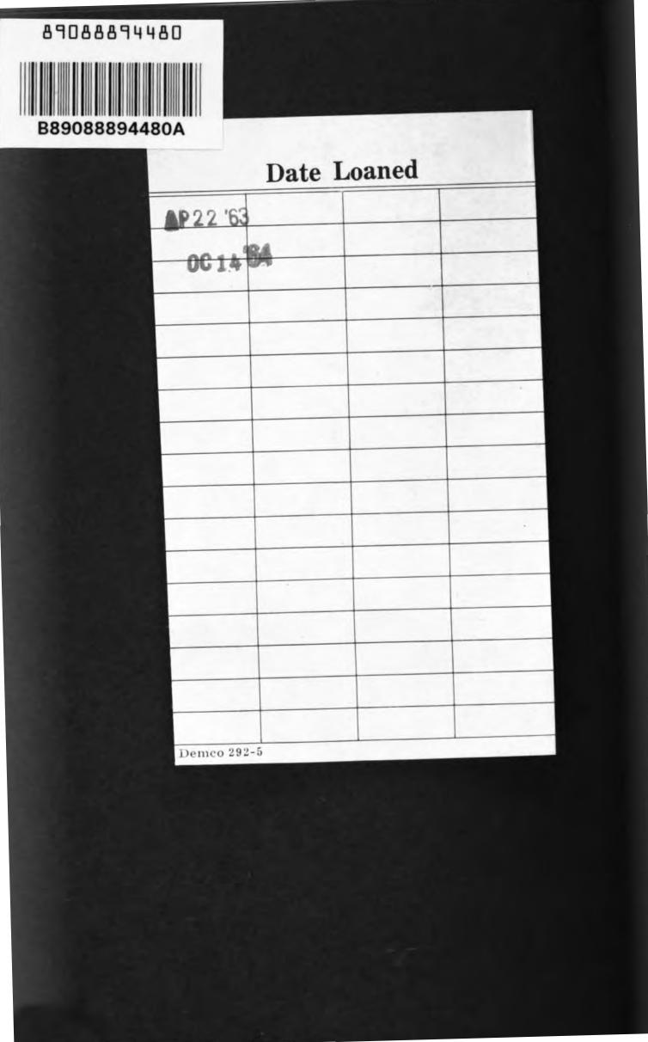
89088894480
B89088894480A
Date Loaned
1P22'
0C14
Demco 292-5

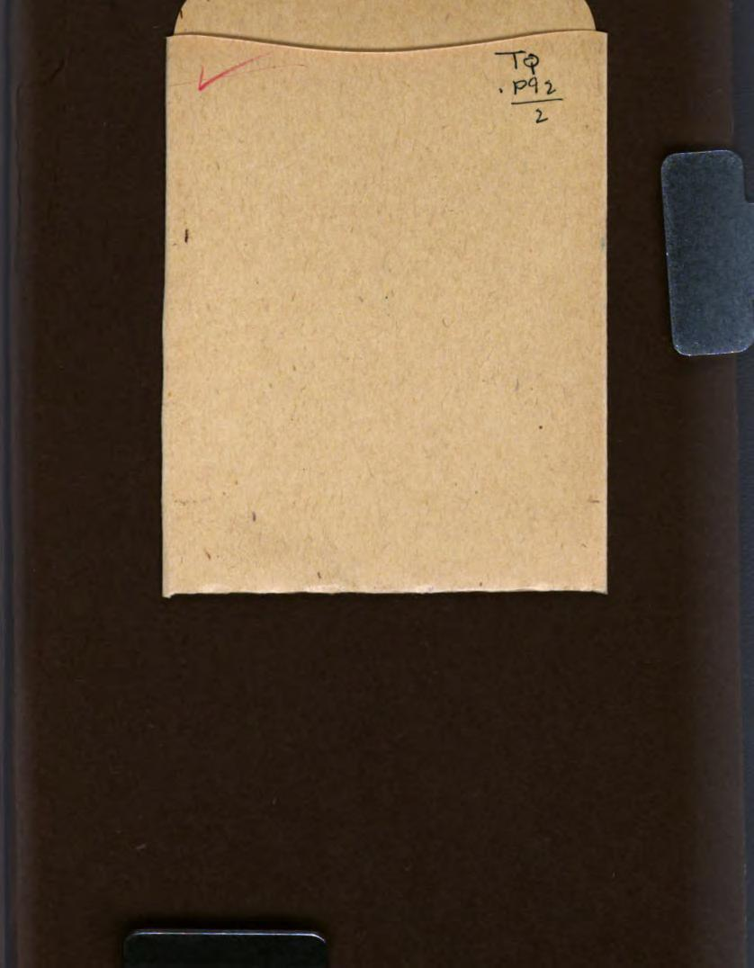

89088894480

b89088894480a

