POSTS
SECTION XVIII,
POSTS, TELEGRAPHS, AND TELEPHONES.

- Posts.

- The Commonwealth Postal Department.—Under the provisions of section 51 of the Commonwealth Constitution Act the Commonwealth Parliament was empowered to make laws with respect to the control of the postal, telegraphic, and telephonic services in Australia, and by proclamation, made under section 69 of the same Act, the six separate State Post and Telegraph Departments were amalgamated and taken over by the Federal Executive on the 1st March, 1901.
On the 1st December following, the Commonwealth Post and Telegraph Act 1901 came into operation, and the provisions of the various State Acts referring to the postal and telegraphic services thereby ceased to apply; it was, however, specially provided by the Act of 1901 that all regulations in force and all rates and charges levied under any State Act should continue in force and be applied in the same manner as if such State Act were not affected by the Commonwealth Act. The administration of the Act of 1901 was placed in the hands of a Postmaster-General, a responsible Minister with Cabinet rank, whilst a principal officer in each State was provided for under the style of Deputy Postmaster-General. The rates and charges levied in each State for the transmission of letters, telegrams, and postal articles, at the date of Federation, remained in force until the Post and Telegraph Rates Act came into operation on the 1st November, 1902. This Act secured uniformity throughout the Commonwealth in the rates charged for the conveyance of newspapers by post, and for the transmission of telegrams, but did not make any alteration in the charges made in the individual States for the transmission of letters, cards, parcels, and packets. At the present time there are anomalies in postal rates, to which reference is made hereinafter.

- First Post Office in Australia.—The first Australian office for postal purposes was established in Sydney by Lieutenant-Governor Paterson under a Government order dated the 25th April, 1809, which declared that owing to complaints having been made that numerous frauds had been committed by individuals repairing on board ships on their arrival in port, and personating others, by which the} wrongfully obtained possession of letters and parcels, the Lieutenant-Governor had established an office at which all parcels and letters arriving by any vessel, addressed to the inhabitants of the colony, were to be deposited previous to their distribution. The office was in High-street (now known as George-street) at the residence of Mr. Isaac Nicholls, who was empowered '' in consideration of the trouble and expense attendant on this duty " to charge on delivery to , the addressee the following sums:—For every letter, one shilling; for every parcel not exceeding 20 Ibs. weight, two shillings and sixpence; and for all exceeding that weight, POSTS. 599 five shillings. A list was to be published in the Gazette of the names of persons to whom letters, and parcels were directed. Soldiers' letters were charged only one penny. The duties of this office were extended in June. 1810, by Governor Macquarie, who established it as a regular post office, at which all parcels and letters, either colonial or foreign, were to be deposited previous to their distribution. Mr. Nicholls was appointed postmaster and was authorised to charge on delivery to the addressee eightpence for ever}' English or 3 foreign letters of whatever weight, and for every parcel weighing not more than 20 Ibs., one shilling and sixpence, and exceeding that weight, three shillings. The charge on colonial letters was fourpence irrespective of weight, and soldiers' letters, or letters addressed to soldiers' wives, were charged one penny.

- Postal Services In Early Days.—After the establishment of the first post-office in Sydney very little improvement in regard to postal matters took place for a number of years, and it was not until 1825 that an Act was passed by Sir Thomas Brisbane, with the advice of the Council, "to regulate the postage of letters in New South Wales." This enactment provided for the establishment of post offices in Sydney and in other parts of the colony, for the appointment and payment of postmasters, and for the determination1 of rates for the conveyance of letters in the colony and for the delivery of letters from abroad. A proclamation under this Act was issued, fixing the rates of postage and the salaries and allowances of postmasters, and inviting tenders for the conveyance of mails between Sydney and Parramatta, Windsor and Liverpool; between Liverpool and Campbelltown; from Parramatta to Emu Plains, and thence to Bathurst. It was not, however, until 1828 that the provisions of the Act were put into full force and a system of general post-office communication was established. In that year rates of postage were fixed, depending upon the distance and the difficulty of transmission. The lowest single inland rate was threepence and the highest one shilling, the postage on a letter increasing according to its weight, the minimum fee being charged on letters not exceeding a quarter of an ounce. The fee for newspapers was one penny. Letters from New South Wales to Van Diemen's Land were charged threepence each, while other letters by ship were charged fourpence each single rate, and sixpence for any weight in excess. The Act of 1825 was amended by the Postal Act of 1835, under which the Governor was authorised to establish a General Post Office at Sydney, and to make rules and regulations, and to fix rates for the conveyance of letters and parcels. The charge on a single letter was fixed at fourpence for a distance of fifteen miles, fivepence for twenty miles, sixpence for thirty miles, and so on up to one shilling for 300 miles. For every letter sent by sea from one part of the colony to another the charge was fourpence. Newspapers printed in the colony, if transmitted within seven days from the date of publication, and all newspapers from abroad were conveyed free, while public officers and members of the Executive and Legislative Councils were allowed to frank letters, subject to prescribed regulations. In 1837 a post office was established in Melbourne, and a fortnightly service was established between that city and Sydney. In the same year stamps were introduced in the form of stamped covers or wrappers, which are said to have been the first postage stamps ever used. Post offices were established, and a postal service was organised in the other States of {he Commonwealth shortly after their settlement, and a tolerably good overland service by horses and mail coaches soon developed between the capitals and the up-country towns, villages, and stations as settlement progressed. In Tasmania the mails were delivered in 1824 by foot post once a fortnight, while in 1835 a mail cart made the journey twice a week from Hobart to Launceston—121 miles—in nineteen hours. In Western Australia the Legislative Council passed an Act establishing a postal department iii 1834; a weekly mail between Guildford and York and an overland monthly mail from Perth to King •George's Sound were commenced in 1841, and in the following year a regular mail service between all the settled districts of the State was inaugurated. By the year 1838 there were forty post offices in New South Wales, which at that time included the Port Phillip (Victoria) and the Moreton Bay (Queensland) districts, employing altogether 600 POSTS. fifty-two persons. The revenue for the year was £8391, and the expenditure £10,357, while a total number of 489,772 letters and 297,245 newspapers were dealt with at the post office in Sydney. In the same year the post office at Port Phillip transmitted 7424 letters and 2795 newspapers, the revenue being £230.
- Development of Postal Services.—The New South Wales Postal Act of 1835, referred to above, was amended in 1838, 1840, and again in 1851, when the postage on .town letters, i.e., letters received at any post office for delivery at such post office or at any place within the limits of the township in which such post office was situated, was fixed at one penny; for letters transmitted between separate postal towns the postage was two pence, and for letters received from or to be transmitted by ship to places beyond the limits of the colony the fee was threepence in addition to the inland postage. For parcels the rate was two pence up to four ounces weight, and one halfpenny for every additional ounce. The postage on all letters and packets was to be prepaid, and the Governor of New South Wales was authorised to arrange with the Governor of the newly established State of Victoria for the mutual exemption from further postage of all letters and packets received in either of the respective States, upon which the established rates of postage in the other said State had been already prepaid. Masters of vessels were obliged, under penalty, to deliver up all mails and postal packets, on demand, to the postmaster at any port, and masters of departing vessels were likewise compelled to take and deliver mails from one port to another, the masters being entitled, in each case, to an allowance of one penny for each letter or packet. It is interesting, at the present time, to notice that the Postal Amendment Act of 1840 contained a clause making it compulsory, under a penalty of from £10 to £50, for the masters of all steamboats or other vessels entering a port " to give timely notice of the near approach thereof, either by the ringing of a bell or by such other signal as may reasonably be expected to be distinctly heard or seen by the postmaster, a sufficient time before the actual arrival of such steamboat or other vessel, to enable him to receive or despatch any mail on board." Regular mail communication was established between Sydney and Adelaide in 1847, and the rate of postage, on a single letter, was fixed at one shilling and sixpence. In the State of Victoria an Act was passed in 1854 providing for the extension of postal facilities and fixing the rates to be charged for the transmission of letters. The postage on town letters was two pence ; on letters for transmission between separate postal towns, sixpence ; and on letters for transmission beyond the limits of the State, one shilling. Mails were conveyed along the main roads by mail coaches, built after, the style of the old-fashioned English coaches; after the discovery of gold, in 1851, coaches built on the model of the Mexican estafeta gradually supplanted the old style. Mails were despatched at night and were delivered with greater rapidity until they were finally sent by railway. The history of the post office in Australia, subsequent to the discovery of gold, has been one of great progress and improvement.
    - Number of Post Offices, Letters and Postcards, and Newspapers, 1841 to 1906. The number of post offices open in each State and in the Commonwealth at decennial periods since 1841, and at the end of each year from 1901 to 1906, inclusive, is given in the subjoined table, which also shews, for the same years, the total number of letters and postcards dealt with, and the number per 100 of the population, as well as the total number of newspapers dealt with, and the number per 100 of the population in each State and in the Commonwealth. The true total number of letters and postcards and of newspapers dealt with is not obtained by merely adding the figures of the several States together, since interstate letters are counted both in the State from which they are despatched and in that in which they are received for delivery. A second total is therefore given, excluding such interstate excess, obtained by subtracting from the first total for all the States half the sum of the number of interstate letters despatched and received in each of the States: —

POSTS. 601
DEVELOPMENT OF POSTAL SERVICES, 1841 TO 1906.

Year. | New South Wales. | Victoria. | Queensland, | South Australia. | Western Australia. | Tasmania. | Commonwealth. | C'wealth (excluding Interstate Excess).
NUMBER OF POST OFFICES, 31ST DECEMBER, 1841 TO 1906.
1841 | 56 | 3 | * | … | … | 143 | 102 | …
1851 | 101 | 44 | * | 72 | … | 51 | 268 | …
1861 | 340 | 369 | 23 | 160 | 14 | 100 | 1,006 | …
1871 | 570 | 706 | 81 | 286 | 39 | 144 | 1,826 | …
1881 | 973 | 1,158 | 141 | 488 | 52 | 206 | 3,018 | …
1891 | 1,384 | 1,729 | 307 | 629 | 86 | 328 | 4,463 | …
1901 | 1,684 | 1,637 | 411 | 713 | 187 | 376 | 5,008 | …
1902 | 1,693 | 1,645 | 433 | 702 | 197 | 369 | 5,039 | …
1903 | 1,708 | 1,646 | 441 | 706 | 218 | 370 | 5,089 | …
1904 | 1,726 | 1,652 | 450 | 711 | 243 | 371 | 5,153 | …
1905 | 1,744 | 1,655 | 447 | 711 | 261 | 370 | 5,188 | …
1806 | 1,769 | 1,659 | 468 | 706 | 281 | 373 | 5,256 | …

NUMBERS OP LETTERS AND POSTCARDS DEALT WITH IN EACH STATE AND IN THE COMMONWEALTH.
1841 | 720,168 | 56,704 | * | … | … | … | … | …
1851 | 975.318 | 504,425 | * | 364,595 | … | … | … | …
1861 | 4,369,463 | 6,109,929 | 515,211 | 1,540,472 | 193,317 | 835,873 | 13,564, 265 | 12,844,300
1871 | 7,509,500 | 11,716,166 | 1,792.644 | 3,162,774 | 668,957 | 1,189,994 | 26,040,035 | 24,382,301.
1881 | 26,355,600 | 26,308,347 | 5,178,547 | 10,758,605 | 995,188 | 2,632,329 | 72,278,616 | 67,640,800
1891 | 64,153,600 | §62.526,448 | 15,345,842 | 17,836,092 | 3,192,992 | 5,852,381 | 168,907,355 | 157,297,800
1901 | 82,783,467 | 82,598,886 | 23,269,622 | 21,395,216 | 17,450.878 | 11,173,493 | 238,671,562 | 220,177,642
1902 | 90,781,395 | 96,4«5,547 | 23,444,537 | 20,955,802 | 18,151,014 | 9,379,438 | 259,197,733 | 241.795,469
1903 | 92,238,211 | 38,810,621 | 24,244,089 | 22,153,343 | 15,786,777 | 9,911,692 | 263,144,733 | 244,945,361
1904 | 98,270,187 | 102,515.210 | 25,256,102 | 25,050,068 | 18,588,059 | 10,752,111 | 280,431,737 | 259,167,997
1905 | 111,960,588 | 110,455,170 | 27,309,605 | 29,094,568 | 22,106,829 | 12,615,971 | 313,542,740 | 289.584,931
1906 | 127,683,844 | 116,459,106 | 31,462,676 | 29,357,065 | 24,829,601 | 14,552,664 | 344,344.956 | 317,118,883

NUMBERS OF LETTERS AND POSTCARDS DEALT WITH PER 100 OF THE POPULATION.
1841 | 617 | 483 | * | … | … | … | … | …
1851 | 495 | 652 | * | 548 | … | … | … | …
1861 | 1,237 | 1,132 | 1,651 | 1,228 | 1.240 | 929 | 1.175 | 1,113
1871 | 1,478 | 1,590 | 1,489 | 1.712 | 2,668 | 1.175 | 1,553 | 1,454
1881 | 3,445 | 3,024 | 2,286 | 3.885 | 3,372 | 2,304 | 3,164 | 2,961
1891 | 5.616 | 5,460 | 3,870 | 5,548 | 6,414 | 3,929 | 5,270 | 4,907
1901 | 6,033 | 6,821 | 4,613 | 5,840 | 9,306 | 6,436 | 6,237 | 5,758
1902 | 6,519 | 7,964 | 4,592 | 5,715 | 8,508 | 5,285 | 6,675 | 6,226
1903 | 6,483 | 8,174 | 4,729 | 6,042 | 7,168 ' | 5,554 | 6,701 | 6,237
1904 | 6,793 | 8,470 | 4,832 | 6,686 | 7,919 | 5,991 | 7,038 | 6,504
1905 | 7,572 | 9,064 | 5,144 | 7,764 | 8,834 | 7,038 | 7,737 | 7,146
1906 | 8,363 | 9,453 | 5,879 | 7,648 | 9,488 | 8,078 | 8,358 | 7,698

NUMBER OF NEWSPAPERS DEALT WITH.
1841 | 1,126,873 | 120,227 | * | … | … | … | … | …
1851 | 762,307 | 456,741 | * | 517,722 | … | … | … | …
1861 | 3,384,245 | 4,277,179 | 427,189 | 1,089,424 | 137,476 | 895,656 | 10,211,469 | 9,603,000
1871 | 3,992,100 | 5,172,970 | 1,307,305 | 2,212,620 | 352,608 | 1,136,338 | 14,173,941 | 13,336,200
1881 | 16,527,900 | 11,440,732 | 4,530,263 | 5,927,332 | 715,046 | 2,345,700 | 41,486,973 | 38,063,800
1891 | 42,517,300 | {22,729,005 | 11,896,148 | 8,883,103 | 1,665,862 | 5,376,142 | 93,067,560 | 85,280,200
1901 | 52,317,650 | 26,297.430 | 12,804,964 | 9,572,723 | 7,975,208 3 | 7,440,146 | 116,408,121 | 102,727,383
1902 | 47,763,350 | 27,874,414 | 13,127,606 | 6,299,092 | 9,916,544 | 6,959,902 | 111,940,908 | 98,568,172
1903 | 37,900,840 | 31,364,421 | 13,510,626 | 6,124,802 | 8,125,086 | 7,183,733 | 104,209,508 | 92,844,014
1904 | 40,384,812 | 32,141,611 | 14,516,936 | 6,952,851 | 8,578,410 | 7,256,913 | 109,831,533 | 93,269,655
1905 | 44,599,104 | 29,563,169 | 16,337,562 | 7,737,218 | 10,054,035 | 9,173,172 | 117,470,260 | 97,789,906
1906 | 47,144,094 | 29,610,839 | 17,612,881 | 8,744,619 | 9,941,153 | 10,194,856 | 123,248,442 | 103,838,931

NUMBER OF NEWSPAPERS DEALT WITH PER 100 OF THE POPULATION.
1841 | 965 | 1,024 | * | … | … | … | … | …
1851 | 386 | 590 | * | 778 | … | … | … | …
1861 | 958 | 792 | 1,370 | 888 | 882 | 995 | 885 | 832
1871 | 786 | 702 | 1,086 | 1,198 | 11,407 | 1,122 | 845 | 795
1881 | 2,160 | 1,315 | 2,000 | 2,140 | 2,423 | 2,015 | 1,816 | 1,666
1891 | 3,722 | § 1,985 | 3,000 | 2,763 | 3,346 | 3,609 | 2,904 | 2,661
1901 | 3,813 | 2,172 | 2,538 | 2,617 | 4,253 | 4,285 | 3,042 | 2,685
1902 | 3,430 | 2,301 | 2,569 | 1,718 | 4,649 | 3,922 | 2,882 | 2,538
1903 | 2,664 | 2,594 | 2,635 | 1,661 | 3,580 | 4,035 | 2,653 | 2,364
1904 | 2,792 | 2,655 | 2,772 | 1,865 | 3,655 | 4,036 | 2,756 | 2,341
1905 | 3,016 | 2,426 | 3,078 | 2,045 | 4,018 | 5,121 | 2,899 | 2,413
1906 | 3,087 | 2,402 | 3, 291 | 2,278 | 3,797 | 5,658 | 2,992 | 2,520

* Included in New South Wales, § In 1880. II The figures up to and including the year 1903 are partially estimated.

(ii.) Number of Parcels mid Packets dealt with, 1901 to 1906. The following table shews the total number of parcels and packets dealt with in each State and in the Commonwealth during each year from 1901 to 1906, inclusive :—
NUMBER OF PARCELS AND PACKETS DEALT WITH, 1901 TO 1906.
State. | 1901 | 1902 | 1903 | 1904 | 1905 | 1906
PARCELS.
New South Wales | 736,496 | 785,528 | 834,329 | 924,920 | 994,144 | 1,162,185
Victoria | 310,674 | 366,028 | 429,295 | 424,924 | 469,496 | 510,822
Queensland | 309,053 | 303,497 | 314,312 | 358,280 | 389,266 | 464,370
South Australia | 77,341 | 86,086 | 112,330 | 132,390 | 146,064 | 167,081
Western Australia | 35,823 | 36,368 | 77,069 | 87,996 | 119,705 | 157,801
Tasmania | 40,400 | 47,087 | 57,947 | 64,274 | 69,212 | 76,537
Commonwealth | 1,509,787 | 1,624,594 | 1,825,282 | 1,992,784 | 2,187,887 | 2,538,796
C'wlth (excluding interstate excess) * | 1,369,069 | 1,468.616 | 1,651,140 | 1,790,883 | 1,958,815 | 2,283,998

PACKETS.
New South Wales | 14,479,891 | 16,209,912 | 15,471,092 | 18,560,464 | 22,082,950 | 24,038,946
Victoria | 14,235,342 | 12,179,520 | 12,545,132 | 14,388,832 | 14,964,652 | 16,266,829
Queensland | 7,333,094 | 7,453,165 | 8,126,787 | 8,430,488 | 10,121,206 | 10,231,159
South Australia | 1,627,616 | 1,768,981 | 2,206,887 | 1,977,994 | 2,208,646 | 2,972,699
Western Australia | 4,387,025 | 5,127,666 | 3,841,787 | 3,663,977 | 4,626,251 | 4,321,116
Tasmania | 2,238,632 | 2,599,446 | 2,961,620 | 2,901,154 | 3,029,205 | 3,528,373
Commonwealth | 44,301,600 | 45,338,690 | 45,153,305 | 49,922,909 | 57,032,910 | 61,359,122
C'wlth (excluding interstate excess) | 40,161,527 | 41,012,586 | 40,221,250 | 44,359,571 | 51,174,904 | 54,633,499

* In the figures given in this line allowance is made for the fact that in the aggregate obtained by adding together the results for the several States, interstate mail matter is included twice, being counted both in the despatching and in the receiving State. As to the method in which this allowance is computed, see page 600.

- Postal Matter Dealt with, 1901 to 1906.—In the preceding tables is shewn only the total number of letters and postcards, newspapers, parcels and packets dealt with—i.e., despatched and received—by the Postal Department in each State, regardless of the place from which they are despatched or of the place at which they are received for delivery. In the following tables the total numbers of letters and postcards, newspapers, parcels, and packets dealt with are divided into
    - those posted in each State for delivery within the Commonwealth,
    - those received in each State from places outside the Commonwealth, and
    - those despatched from each State to places outside the Commonwealth.

(i.) Matter Posted in each State for Delivery within the Commonwealth, 1901 to 1906. The matter dealt with under this heading is classified in the two following tables, shewing (a) matter posted in each State for delivery within that State, and (b) matter posted in each State for delivery in other States of the Commonwealth, while the third table (c) shews the total matter posted in each State for delivery within the Commonwealth, i.e., it shews the sums of the corresponding figures in tables (a) and (b).
(c) Matter Posted in each State for Delivery within that State, 1901 to 1906. The following table shews the number of letters and postcards, newspapers, parcels and packets posted in each State for delivery within that State during each year from 1901 to 1906, inclusive:—

NUMBERS OF LETTERS AND POSTCARDS, NEWSPAPERS, PARCELS, AND PACKETS POSTED IN EACH STATE FOR DELIVERY WITHIN THAT STATE, 1901 TO 1906.
State | 1901. | 1902. | 1903. | 1904. | 1905. | 1906.
LETTERS AND POSTCARDS.
N.S.W. | 5,691,853 | 5,129,527 | 5,029,303 | 6,236,232 | 7,458,758 | 8,896,101
Victoria | 4,268,461 | 4,840,160 | 4,529,610 | 5,012,658 | 5,906,712 | 6,789,349
Queensland | 2,450,980 | 2,444,813 | 2,749,391 | 2,014,913 | 2,242,225 | 2,712,888
South Aust. | 1,864,523 | 1,761,306 | 1,856,096 | 2,130,061 | 2,343,933 | 2,829,127
West. Aust. | 1,680,748 | 1,655,288 | 1,851,319 | 2,607,306 | 2,918,067 | 2,680,078
Tasmania | 2,536,300 | 1,774,752 | 1,727,921 | 2,273,810 | 2,510,983 | 2,842,007
C’wealth | 18,472,865 | 17,575,846 | 17,743,640 | 20,274,990 | 23,380,678 | 26,749,548
NEWSPAPERS.
N.S.W. | 41,571,970 | 37,775,680 | 27,725,960 | 28,284,096 | 30,303,360 | 30,832,896
Victoria | 14,000,095 | 14,901,804 | 18,064,141 | 17,800,589 | 12,948,945 | 12,634,907
Queensland | 8,764,496 | 8,717,366 | 8,683,904 | 9,460,181 | 10,505,320 | 11,460,017
South Aust. | 6,682,943 | 3,663,861 | 3,529,580 | 3,987,094 | 4,727,698 | 5,563,811
West. Aust. | 2,891,166 | 4,621,341 | 2,808,552 | 2,680,425 | 3,017,218 | 4,336,732
Tasmania | 4,797,476 | 4,427,758 | 4,659,597 | 4,411,549 | 6,310,208 | 6,767,566
C’wealth | 78,708,146 | 74,107,810 | 65,471,734 | 66,623,934 | 67,812,749 | 71,595,929

PARCELS.
N.S.W. | 591,656 | 631,261 | 667,041 | 739,666 | 788,183 | 926,638
Victoria | 206,409 | 239,016 | 281,985 | 262,216 | 291,271 | 312,084
Queensland | 251,085 | 242,328 | 255,160 | 279,514 | 302,886 | 376,045
South Aust. | 45,015 | 49,505 | 71,975 | 86,787 | 96,581 | 110,478
West. Aust. |  |  | 34,523 | 38,864 | 68,920 | 100,632
Tasmania | 18,535 | 20,947 | 29,029 | 32,926 | 33,760 | 37,162
C’wealth | 1,112,700 | 1,183,057 | 1,339,713 | 1,439,973 | 1,581,601 | 1,863,039
PACKETS.
N.S.W. | 11,461,597 | 13,129,324 | 12,245,488 | 13,770,518 | 16,767,982 | 18,270,237
Victoria | 10,128,622 | 7,683,184 | 8,015,331 | 9,039,944 | 9,524,237 | 10,459,968
Queensland | 5,222,546 | 5,431,727 | 5,620,802 | 6,352,844 | 8,005,610 | 7,780,438
South Aust. | 605,189 | 645,361 | 937,359 | 727,230 | 868,365 | 911,487
West. Aust. | 3,007,408 | 3,684,376 | 2,396,291 | 1,761,005 | 2,337,346 | 2,545,787
Tasmania | 1,401,836 | 1,559,806 | 1,789,891 | 1,912,863 | 2,107,201 | 2,412,387
C’wealth | 31,827,198 | 32,133,778 | 31,005,162 | 33,564,404 | 39,610,741 | 42,380,304

604 POSTS.
(b) Matter Posted in each State for Delivery in other States, 1901 to 1906. The following table shews the number of letters and postcards, newspapers, parcels, and packets posted in each State for delivery in a State other than that in which it was posted:—
NUMBERS OF LETTERS AND POSTCARDS, NEWSPAPERS, PARCELS, AND PACKETS POSTED IN EACH STATE FOR DELIVERY IN OTHER STATES, 1901 TO 1906:—

State. 1901. 1902. 1903. 1904. 1905. 1906.
LETTERS AND POSTCARDS.
State. | 1901.. | 1902. | 1903. | 1904. | 1905. | 1906.
N.S.W. | 5,671,853 | 5,129,527 | 5,029,303 | 6,236,232 | 7,458,758 | 8,896,101
Victoria | 4,268,461 | 4,840,160 | 4,529,610 | 5,012,658 | 5,906,712 | 6,789,347
Queensland | 2,450,980 | 2,444,813 | 2,749,391 | 2,014,923 | 2,242,225 | 2,712,888
South Aust. | 1,864,523 | 1,761,306 | 1,856,096 | 2,130,061 | 2,343,933 | 2,829,127
West. Aust. | 1,680,748 | 1,655,288 | 1,851,319 | 2,607,306 | 2,918,067 | 2,680,078
Tasmania | 2,536,300 | 1,774,752 | 1,727,921 | 2,273,810 | 2,510,983 | 2,842,007
C’wealth | 18,472,865 | 17,575,846 | 17,743,640 | 20,274,990 | 23,380,678 | 26,749,548
NEWSPAPERS.
N.S.W. | 4,226,410 | 3,472,890 | 3,648,260 | 4,646,004 | 5,558,772 | 7,249,098
Victoria | 6,730,697 | 7,182,888 | 6,457,244 | 7,591,956 | 9,224,864 | 9,572,498
Queensland | 868,529 | 835,997 | 1,019,072 | 726,250 | 850,462 | 818,634
South Aust. | 757,189 | 749,816 | 783,907 | 935,598 | 1,149,897 | 1,106,037
West. Aust. | 787,952 | 796,849 | 797,919 | 1,135,465 | 1,277,897 | 881,921
Tasmania | 304,254 | 321,704 | 324,624 | 351,882 | 330,750 | 365,117
C’wealth | 13,675,031 | 13,360,144 | 13,031,026 | 15,387,155 | 18,392,642 | 19,993,305
PARCELS.
N.S.W. | 58,928 | 58,797 | 64,376 | 71,398 | 83,057 | 97,926
Victoria | 49,988 | 62,443 | 72,975 | 83,182 | 93,756 | 104,827
Queensland | 12,633 | 13,400 | 14,046 | 17,701 | 18,096 | 20,896
South Aust. | 10,617 | 11,592 | 11,882 | 14,056 | 15,175 | 16,884
West. Aust. | 5,393 | 5,861 | 8,359 | 9,237 | 9,760 | 10,715
Tasmania | 2,559 | 4,170 | 4,054 | 4,953 | 5,684 | 6,275
C’wealth | 140,118 | 156,263 | 175,692 | 200,527 | 225,528 | 257,523

PACKETS.
N.S.W. | 1,292,172 | 1,178,251 | 1,202,019 | 2,259,228 | 2,713,553 | 3,400,754
Victoria | 1,700,851 | 1,714,684 | 1,596,890 | 1,865,814 | 1,786,938 | 1,893,565
Queensland | 816,927 | 822,901 | 995,663 | 343,958 | 353,812 | 550,092
South Aust. | 198,702 | 350,734 | 230,812 | 233,355 | 220,239 | 277,296
West. Aust. | 461,035 | 483,240 | 484,242 | 473,602 | 619,091 | 366,577
Tasmania | 98,580 | 99,681 | 143,739 | 156,142 | 161,353 | 226,581
C’wealth | 4,568,267 | 4,649,491 | 4,653,365 | 5,332,099 | 5,854,986 | 6,714,865

(c) Matter Posted in each State for Delivery within the Commonwealth, 1901 to 1906. The subjoined table shews the number of letters and postcards, newspapers, parcels, and packets posted in each State for delivery within the Commonwealth during each year from 1901 to 1906, inclusive, i.e., the figures in the subjoined table shew the sum of the corresponding figures for each State and during each year in the two last preceding tables:—

NUMBERS OF LETTERS AND POSTCARDS, NEWSPAPERS, PARCELS, AND PACKETS POSTED IN EACH STATE FOR DELIVERY WITHIN THE COMMONWEALTH, 1901 TO 1906.

State. | 1901. | 1902. | 1903. | 1904. | 1905. | 1906.
LETTERS AND POSTCARDS.

N.S.W. | 73,597,837 | 80,981,611 | 82,343,910 | 86,468,074 | 98,130,736 | 111,685,852
Victoria | 74,523,857 | 88,588,487 | 89,401,025 | 91,815,414 | 98,247,416 | 102,546,533
Queensland | 19,841,168 | 20,059,206 | 20,541,380 | 21,246,193 | 23,037,608 | 26,303,367
South Aust. | 18,775,109 | 18,420,324 | 19,578,738 | 21,818,375 | 25,678,573 | 25,406,706
West. Aust. | 14,008,216 | 14,660,492 | 12,196,471 | 13,086,708 | 15,786,595 | 19,217,339
Tasmania | 8,783,559 | 7,844,269 | 8,112,089 | 8,734,192 | 9,885,933 | 11,273,540
C’wealth | 209,529,746 | 230,554,389 | 232,173,613 | 243,168,956 | 270,766,861 | 296,433,337

NEWSPAPERS.
N.S.W. | 45,798,380 | 41,248,570 | 31,374,220 | 32,930,100 | 35,862,132 | 38,081,994
Victoria | 20,730,792 | 22,084,692 | 24,521,385 | 25,392,545 | 22,173,809 | 22,207,405
Queensland | 9,633,025 | 9,553,363 | 9,702,976 | 10,186,431 | 11,355,782 | 12,278,651
South Aust. | 7,440,132 | 4,413,677 | 4,313,487 | 4,922,692 | 5,877,595 | 6,669,848
West. Aust. | 3,679,118 | 5,418,190 | 3,606,471 | 3,815,890 | 4,295,115 | 5,218,653
Tasmania | 5,101,730 | 4,749,462 | 4,984,221 | 4,763,431 | 6,640,958 | 7,132,683
C’wealth | 92,383,177 | 87,467,954 | 78,502,760 | 82,011,089 | 86,205,391 | 91,589,234

PARCELS.

N.S.W. | 650,584 | 690,058 | 731,417 | 811,064 | 871,240 | 1,024,564
Victoria | 256,397 | 301,459 | 354,960 | 345,398 | 385,027 | 416,911
Queensland | 263,718 | 255,728 | 269,206 | 297,215 | 320,982 | 396,941
South Aust. | 55,632 | 61,097 | 83,857 | 100,843 | 111,756 | 127,362
West. Aust. | 5,393 | 5,861 | 42,882 | 48,101 | 78,680 | 111,347
Tasmania | 21,094 | 25,117 | 33,083 | 37,879 | 39,444 | 43,437
C’wealth | 1,252,818 | 1,339,320 | 1,515,405 | 1,640,500 | 1,807,129 | 2,120,562

PACKETS.

N.S.W. | 12,753,769 | 14,307,575 | 13,447,507 | 16,029,746 | 19,481,535 | 21,670,991
Victoria | 11,829,473 | 9,397,868 | 9,612,221 | 10,905,758 | 11,311,175 | 12,353,533
Queensland | 6,039,473 | 6,254,628 | 6,616,465 | 6,696,802 | 8,359,422 | 8,330,530
South Aust. | 803,891 | 996,095 | 1,168,171 | 960,585 | 1,088,604 | 1,188,783
West. Aust. | 3,468,443 | 4,167,616 | 2,880,533 | 2,234,607 | 2,956,437 | 2,912,364
Tasmania | 1,500,416 | 1,659,487 | 1,933,630 | 2,069,005 | 2,268,554 | 2,638,968
C’wealth | 36,395,465 | 36,783,269 | 35,658,527 | 38,896,503 | 45,465,727 | 49,095,169

Page 606

(ii.) Postal Matter Received in each State from Places Outside the Commonwealth, 1901 to 1906. The following table shews the number of letters and postcards, newspapers, parcels, and packets received for delivery in each State from places outside the Commonwealth:—

NUMBERS OF LETTERS AND POSTCARDS. NEWSPAPERS, PARCELS, AND PACKETS RECEIVED IN EACH STATE FROM PLACES OUTSIDE THE COMMONWEALTH, 1901 TO 1906.

State | 1901 | 1902 | 1903. | 1904. | 1905. | 1906.

LETTERS AND POSTCARDS.
N.S.W. | 2,150,357 | 2,551,893 | 2,552,105 | 2,961,837 | 4,017,563 | 3,851,371
Victoria | 1,416,894 | 1,757,202 | 1,707,639 | 2,205,662 | 2,685,050 | 2,910,239
Queensland | 851,905 | 890,316 | 893,388 | 862,284 | 872,485 | 988,917
South Aust. | 348,322 | 288,522 | 312,538 | 435,807 | 460,628 | 541,241
West. Aust. | 586,819 | 602,167 | 603,141 | 1,198,054 | 1,291,444 | 1,114,017
Tasmania | 327,498 | 252,282 | 228,085 | 199,158 | 411,911 | 414,059
Commonwealth | 5,681,795 | 6,342,382 | 2,961,837 | 7,862,802 | 9,689,081 | 9,814,844

NEWSPAPERS.
N.S.W. | 1,509,000 | 1,433,930 | 1,615,640 | 1,714,866 | 2,163,186 | 2,431,542
Victoria | 2,150,232 | 2,534,410 | 2,262,854 | 2,435,640 | 2,760,220 | 2,607,580
Queensland | 1,489,572 | 1,467,079 | 1,421,911 | 1,403,062 | 1,229,985 | 1,209,828
South Aust. | 654,799 | 514,328 | 453,974 | 563,455 | 515,949 | 488,578
West. Aust. | 1,036,275 | 1,054,761 | 1,055,771 | 1,021,557 | 1,176,276 | 816,763
Tasmania | 443,382 | 337,812 | 305,240 | 356,207 | 849,872 | 418,904
Commonwealth | 7,283,260 | 7,342,320 | 7,115,890 | 7,494,787 | 8,195,488 | 7,973,195

PARCELS.
N.S.W. | 30,415 | 30,168 | 30,816 | 34,011 | 33,369 | 38,285
Victoria | 20,345 | 23,502 | 26,702 | 26,449 | 26,503 | 28,847
Queensland | 9,440 | 9,990 | 10,192 | 14,300 | 10,387 | 11,889
South Aust. | 7,418 | 8,008 | 8,080 | 8,420 | 8,379 | 9,693
West. Aust. | 8,568 | 9,250 | 9,971 | 11,431 | 10,211 | 12,397
Tasmania | 4,438 | 4,778 | 4,636 | 3,922 | 4,881 | 5,143
Commonwealth | 80,624 | 85,696 | 90,397 | 98,533 | 93,730 | 106,254
PACKETS.
N.S.W. | 516,017 | 476,865 | 532,428 | 714,054 | 695.448 | 107,403
Victoria | 1,075,116 | 1,267,205 | 1,181,427 | 1,217,820 | 1,380,109 | 1,303,790
Queensland | 622,182 | 613,683 | 553,225 | 452,614 | 633,305 | 443,586
South Aust. | 327,399 | 257,164 | 226,986 | 281,727 | 257,974 | 244,289
West. Aust. | 191,533 | 196,893 | 196,919 | 431,600 | 439,525 | 430,499
Tasmania | 143,502 | 369,444 | 179,987 | 160,180 | 129,511 | 158,651
Commonwealth | 2,875,749 | 3,181,254 | 2,820,967 | 3,257,995 | 3,535,867 | 2,688,218
*This figure is determined on a basis different from that adopted in previous years.

POSTS. 607

(iii.) Matter Posted in each State for Delivery Outside the Commonwealth, 1901 to 1906. The following is a similar table and shews the matter posted in each State for delivery outside the Commonwealth :—

NUMBERS OF LETTERS AND POSTCARDS, NEWSPAPERS, PARCELS, AND PACKETS POSTED IN EACH STATE FOR DELIVERY OUTSIDE THE COMMONWEALTH, 1901 TO 1906.

State | 1901 | 1902 | 1903. | 1904. | 1905. | 1906.

LETTERS AND POSTCARDS.
N.S.W. | 1,039,610 | 2,145,760 | 2,292,000 | 2,900,424 | 3,297,050 | 4,073,309
Victoria | 1,335,572 | 1,235,388 | 1,890,706 | 2,217,936 | 2,602,122 | 3,100,550
Queensland | 550,491 | 562,193 | 549,904 | 575,005 | 621,601 | 670,330
South Aust. | 340,029 | 341,400 | 337,461 | 374,228 | 520,298 | 727,188
West. Aust. | 460,954 | 492,671 | 493,981 | 590,897 | 674,100 | 757,367
Tasmania | 618,390 | 294,867 | 459,469 | 429,000 | 836,686 | 1,065,433
Commonwealth | 4,945,046 | 5,072,279 | 6,024,121 | 7,147,490 | 8,551,857 | 10,394,177

NEWSPAPERS.
N.S.W. | 801,430 | 1,438,170 | 1,494,260 | 1,735,428 | 1,857,390 | 1,912,890
Victoria | 1,344,365 | 1,115,640 | 2,147,958 | 2,091,810 | 2,090,190 | 2,063,868
Queensland | 358,162 | 818,286 | 814,706 | 304,907 | 300,874 | 311,984
South Aust. | 162,422 | 141,766 | 147,093 | 148,431 | 127,508 | 167,179
West. Aust. | 210,988 | 248,614 | 247,998 | 252,788 | 254,566 | 207,531
Tasmania | 182,868 | 182,022 | 96,786 | 115,439 | 153,438 | 196,842
Commonwealth | 3,055,235 | 3,439,498 | 4,448,801 | 4,048,803 | 4,789,978 | 4,860,294
PARCELS
N.S.W. | 13,628 | 21,171 | 22,405 | 22,921 | 25,795 | 28,033
Victoria | 11,268 | 11,008 | 12,945 | 15,051 | 15,571 | 17,400
Queensland | 3,969 | 3,209 | 4,011 | 3,404 | 3,978 | 3,994
South Aust. | 3,589 | 3,944 | 4,007 | 4,307 | 4,512 | 5,080
West. Aust. | 1,676 | 2,734 | 2,110 | 3,125 | 3,232 | 3,833
Tasmania | 897 | 1,159 | 1,410 | 1,007 | 1,323 | 1,566
Commonwealth | 35,027 | 43,885 | 46,888 | 50,475 | 54,411 | 59,906
PACKETS.
N.S.W. | 409,231 | 535,125 | 508,000 | 689,424 | 813,530 | 1,003,317
Victoria | 590,051 | 542,448 | 642,974 | 915,210 | 919,218 | 837,204
Queensland | 85,978 | 70,442 | 82,009 | 82,273 | 80,215 | 73,941
South Aust. | 56,008 | 80,130 | 47,000 | 50,904 | 71,983 | 747,116
West. Aust. | 86,779 | 87,841 | 88,015 | 194,925 | 235,066 | 129,035
Tasmania | 89,802 | 49,458 | 34,993 | 41,098 | 50,278 | 48,743
Commonwealth | 1,318,509 | 1,371,450 | 1,403,057 | 1,973,834 | 2,170,290 | 2,839,356

608 POSTS.

- Postal Facilities, 1905.—The subjoined statement shews the area in square miles and the number of inhabitants to each post office (including receiving offices) in each State and in the Commonwealth at the end of the year 1906. It will be observed that the most sparsely populated States have the greatest number of offices in comparison with their population, but in order to judge the relative extension of postal facilities the area of country to each office must also be taken into account:—

SQUARE MILES OF TERRITORY AND NUMBER OP INHABITANTS TO EACH POST AND RECEIVING OFFICE, 1906.
State | N.S.W. | Vic. | Qld. | S.A. | W.A. | Tas. | C'wlth.
Number of square miles of territory to each post office in each State | 185 | 38 | 495 | 1,267 | 2,887 | 67 | 402
Number of inhabitants to each office | 667 | 532 | 395 | 538 | 774 | 459 | 556
Number of inhabitants per square mile | 4.92 | 14.0 | 0.80 | 0.42 | 0.27 | 6.87 | 1.38

- Rates of Postage.—The charges made for the postage of newspapers and parcels, and of interstate and foreign letters, are the same in all the States of the Commonwealth. The rates for the transmission of inland letters, however, are not uniform, the Post and Telegraph Act 1901 having specially provided that the rates and charges levied in any State should continue in force.

- Letters. The inland letter postage is at the rate of one penny per half-ounce on town and two pence per half-ounce on country letters throughout the Commonwealth, except in the States of Victoria and South Australia. In Victoria the charge made is one penny per half-ounce, and in South Australia, two pence per half-ounce, on all letters posted for delivery within the State. In Victoria the minimum charge was altered in 1890 from two pence per ounce to one penny per half-ounce, but the diminution in revenue at that time was so great that in 1892 the rate was again raised to two pence per ounce; on the 1st of April, 1901, it was once more reduced to one penny per half-ounce under the provisions of an Act passed in December, 1900. In New South Wales the town rate of one penny per half-ounce, which is in force in the metropolitan suburban district, is also in operation within a twelve-mile radius of Newcastle, and a thirteen-mile radius of the majority of the other principal country towns. In Queensland the town rate extends to all places within a radius of eleven miles from the General Post Office at Brisbane, and also includes all letters to be delivered from the same office at which they were posted. In Western Australia the town rate has effect within a radius of thirteen miles from the General Post Office at Perth, and in other towns and suburbs within a radius depending upon their population. The postage to the United Kingdom was reduced in January 1891, from sixpence per half-ounce via the Red Sea, and fourpence via the Cape of Good Hope, to the uniform rate of two pence halfpenny. In 1891 the States were represented at the Congress of the Universal Postal Union held in Vienna, and on the 4th July a convention was signed on their behalf, by which they joined the Union from the 1st October of that year. On that date the rate of postage to all British possessions and to foreign countries included in the Union was reduced to two pence halfpenny. The charge for postage of interstate letters and of letters to the United Kingdom and to British Possessions is now uniformly two pence per half-ounce throughout the Commonwealth; the rate on letters to foreign countries and to other places is two pence halfpenny for each half-ounce.

- Newspapers. The different rates charged for the carriage of newspapers in the various States, prior to Federation, continued after the control of the Postal Departments had been taken over by the Commonwealth, until the 1st of November 1902, when a uniform rate was imposed by the Post and Telegraph Rates Act 1902. On all newspapers posted for delivery within the Commonwealth (without condition as to the number contained in each addressed wrapper posted) by registered newspaper proprietors, or by news vendors, or returned by newsvendor or agent to the publishing office, a charge of one penny per twenty ounces on the aggregate weight is imposed. On all other registered newspapers posted within the Commonwealth for delivery therein the charge is a halfpenny per ten ounces for each newspaper. At the end of the year 1906 there were in all 962 publications registered in the Commonwealth under section 29 of the Post and Telegraph Act 1901 for transmission by post as newspapers. The charge on postage of registered newspapers for transmission to the United Kingdom and to other parts of the world is one penny up to four ounces, and a halfpenny for every additional two ounces. Newspapers which are not registered are charged at the' same rates as parcels or packets.

- Parcels. Parcels may not exceed 11 Ibs. in weight, 3 ft. 6 in. in length, or 6 ft. in length and girth combined. The rate for the inland postage of parcels is sixpence up to 1 lb., and then threepence for every additional pound. For interstate transmission the rate is eightpence up to 1 lb. and then sixpence per lb., and for transmission to the United Kingdom the rate is one shilling up to 1 lb., and sixpence for every additional pound.

8. Registered Letters.—Under section 38 of the Post and Telegraph Act 1901 provision is made for the registration of any letter, packet, or newspaper upon payment of the prescribed fee, and any person who sends a registered article by post may obtain an acknowledgment of its due receipt by the person to whom it is addressed by paying the prescribed fee (see hereunder) in advance at the time of registration in addition to the registration fee.

- Registration Fees. The fee payable upon registration of an article is threepence, and the fee payable in order to obtain an acknowledgment of the delivery of the registered article is two pence halfpenny in addition. Registered letters must, as a rule, be handed in at least half-an-hour before the closing of the mails.

- Number of Registered Letters Posted, 1906. The subjoined table shews the number of registered letters posted in each State during the year 1906—except in the State of Queensland, for which returns are not available—classified according to the places to which they were despatched for delivery, viz.:—

REGISTERED LETTERS POSTED DURING 1906.

State. | Posted in each State for Delivery within that State. | Posted in each State for Delivery in other States | Posted in each State for Delivery in New Zealand. | Posted in each State for Delivery in other Places outside the C'wealth. | Total.
New South Wales | 661,093 | 141,879 | 18,001 | 104,753 | 925,726
Victoria | 876,714 | 72,434 | 7,794 | 43,356 | 1,000,298
Queensland | ** | ** | ** | ** | **
South Australia | 166,102 | 26,986 | 1,128 | 11,682 | 205,898
Western Australia | 246,183 | 46,165 | 1,460 | 18,497 | 312,305
Tasmania | 164,159 | 12,373 | 1,020 | 4,809 | 182,361
*Commonwealth | 2,114,251 | 299,837 | 29,403 | 183,097 | 2,626,588
** Returns not available. * Exclusive of Queensland.

- Ocean Mail Services.—The question of regular steamship communication with Europe was first mooted in Sydney, and a meeting was held there in 1846 to consider the question. A committee was appointed to gather information on the subject, and eventually this body recommended the establishment of a steam service via Torres Straits and Singapore. No further step was, however, taken until 1849, when the Admiralty Department in London advertised for tenders for the conveyance of the mails between Singapore and Sydney. The tender of a company called the Indian and Australian Steamship Company was accepted, and a contract was entered into, but the company became involved in financial difficulties, and failed to carry out their undertaking.

610

The discovery of gold in Victoria, and the consequent increase in the population and commercial importance of Melbourne, induced the Imperial authorities to modify the conditions and to again invite tenders for a service between Singapore and Sydney, via King George's Sound, Adelaide, and Melbourne. The tender of the Peninsular and Oriental Company was accepted, and the service was inaugurated in September, 1S52, by the arrival at Melbourne of the "Chusan." This service was continued until 1854, when it was stopped in consequence of the Crimean War, but in 1856 a line of steamers was again started, and the service was carried on by the Peninsular and Oriental Company, in conjunction'with the Royal Mail Company, for some years.

- Mail Route via San Francisco. The service via the Red Sea did not at that time give much satisfaction to the public, and was looked upon with a certain amount of disfavour in New South Wales and New Zealand. The effect was to stimulate the colonists to agitate for an improved service, and proposals were made for the establishment of a line of mail packets from Sydney to Panama via Wellington, by rail across the isthmus, and thence to Great Britain. The result was that in 1866 the line was started, and continued in operation until the end of 1868, when it was terminated through the failure of the company by which it had been carried out. The completion of the railway across the American continent in 1869, with its western terminus at San Francisco, opened up a new and agreeable route, and in that year a monthly service was inaugurated by the Union Steamship Company, in conjunction with the Pacific Steamship Company, from Sydney to San Francisco via Auckland. This service was subsidised to the extent of £37,000 per annum, of which New South Wales paid £25,750 and New Zealand £11,250, and was continued until November, 1890, when a new contract was entered into and the amount of the subsidy largely reduced, the amount of the contribution being based upon the weight of mail matter carried. Various extensions of the contract were made, but the last agreement made between the New Zealand Government and the Oceanic Steamship Company of San Francisco expired on the 10th November, 1906, and has not since been renewed. (ii.) Route via Suez Canal. The establishment of a mail route via America had the effect of stimulating the steamship owners who were engaged in the service via Suez, and from that time there was a marked improvement in the steamers, as well as in the punctuality and speed with which the mails were delivered. The Peninsular and Oriental Company have, with very few interruptions, carried mails from the Australian States almost from the inception of the ocean steam service. Towards the end of 1878, the Orient-Pacific Company commenced carrying mails between Australia and the United Kingdom, and has continued to do so ever since. New contracts were entered into with the Peninsular and Oriental and the Orient Pacific Companies for a weekly service, subsidised by the Imperial Government and by all the States of Australia, to commence on the 1st February, 1898, for a period of seven years. The total amount of the subsidy was £170,000 per annum, of which £98,000 was payable by the Imperial Government and £72,000 by the Australian States in proportion to their population. These contracts expired on the 31st January, 1905, and pending negotiations for a new contract the mails were carried at poundage rates. On the 1st February, 1905, the Peninsular and Oriental Company commenced its eighth Australian contract with the British Postmaster-General on behalf of the Imperial Post Office only, and in connection with the India and China mail services, one payment being arranged for the whole service, and the Commonwealth Government not, as hitherto, being a party to the contract. Mails are still carried from Australia by the Peninsular and Oriental Company, but are carried at poundage rates and not under contract with the Commonwealth. On the 25th April, 1905, the Orient Pacific Company concluded a new contract with the Commonwealth Government for a fortnightly service between England and Australia, and the mails are now carried under this contract. The subsidy agreed upon is £120,000 per annum ; the contract expired on the 31st January, 1908, but has been extended until 1910, when a new mail contract comes into operation. The contract time is twenty-nine days between Adelaide and Naples, and the agreement contains conditions that only white labour is to be employed, and that steamers used in the service are to be fitted for the

611

conveyance of refrigerated cargo. The Orient Company have stipulated for liberty to cancel the contract at six months' notice, if any new legislation is imposed which would be detrimental to the Company's interest, unless the Federal Government indemnify them by an increase in subsidy to the extent of the loss imposed. Fremantle has, since the year 1900, been the first and last port of call for the mail steamers to Europe, in lieu of Albany, the original port of call; the Peninsular and Oriental and Orient-Pacific Companies' steamers sail alternately conveying the weekly homeward and outward mails.

(a) The New Mail Contract. On the 1st of January 1906, tenders were invited by the Commonwealth Postmaster-General for a fortnightly mail service between Adelaide and Brindisi, to alternate with a similar service to be provided by the Imperial Government, and a contract was entered into with Sir James Laing and Company Limited providing for a service at an annual subsidy of £125,000. This contract, however, fell through, and new tenders were accordingly called for. On the 15th of November 1907, an agreement was entered into with the Orient Steam Navigation Company Limited providing for a fortnightly service for a period of ten years, commencing in February 1910. The mail service is to be carried out by existing vessels belonging to the company and by five new mail ships, to be specially built, of at least 11,000 tons gross registered tonnage and of not less than seventeen knots speed. Two more new vessels are to be added within eighteen months and six years respectively from February 1910. The vessels are to call at Fremantle, Adelaide, Melbourne, Sydney, and Brisbane, and at least six of them at Hobart during the months of February to May, inclusive. The voyage from Brindisi to Adelaide is to be completed within twenty-six days fourteen hours, and from Adelaide to Brindisi within twenty-seven days two hours, but the latter period may be exceeded by thirty-six hours during the prevalence of the south-west monsoon. The amount of the subsidy is fixed at £170,000 per annum; but, if the earnings of the company be decreased, or the expenses increased, by reason of any Commonwealth shipping legislation passed subsequently to the date of the agreement, to the extent of not less than £5000 a year, the contractors have the right to terminate the agreement unless the subsidy is increased. Insulated space of not less than 2000 tons of forty cubic feet is to be provided in each of the new vessels, and the freights are not to exceed one halfpenny per Ib. for butter and sixty shillings per ton for fruit. White labour only is to be employed, and no discrimination is to be made between unionists and non-unionists. If before or during the sixth year of the period of the contract an accelerated service is provided by any competing line of mail ships, the contractors must, if so required by the Postmaster-General, provide a service equal to the competing service, at an increased subsidy, to be determined by agreement or arbitration. The Commonwealth flag must be flown on the mail ships, which the Commonwealth has the right to purchase at a valuation at any time. Within six months of the Postmaster-General establishing a permanent wireless telegraphy station at Rottnest Island, or at any point on the coast between Fremantle and Brisbane, the company must fit the mail ships with wireless telegraphy installations.

(b) French and German Subsidised Mail Services. Vessels belonging to the Messageries Maritimes and the Norddeutscher Lloyd, which are under contract respectively with the French and German Governments to convey mails monthly between Marseilles and New Caledonia and between Bremen and Sydney, via Genoa, also carry mails for the Commonwealth Government from Australia to Europe at poundage rates. The Messageries Maritimes service commenced in November, 1882; the total tonnage of vessels belonging to this company in the Australian service at the end of the year 1907 was 30,014 ton's, the amount of the annual subsidy granted by the French Government being £120,000, The first contract for the establishment and maintenance of a mail steamship line between Germany and Australia was made between the Imperial German Government and the Norddeutscher Lloyd in 1885, and the service was inaugurated in July, 1886, with the steamer "Salier."

(iii.) Route via Vancouver and Canadian-Pacific Railway. During the year 1893 a direct monthly service was started between Sydney and Vancouver, in British Columbia, via Wellington, in New Zealand, and thence to Liverpool via the Canadian-

612

Pacific Railway, the New South Wales Government paying an annual subsidy of, £10,000 for the maintenance of this service for a period of three years. In 1896 the agreement was renewed for a further period of three years, and in 1899 was again renewed for four years, subject to the same terms and conditions, except that the route was via Brisbane instead of Wellington. The contract was further extended, at an increased subsidy, from time to time until the 31st of July 1907, and afterwards, at a subsidy of £26,626 per annum, for a period of two years from the 1st of August, 1907.
- Other Ocean Mail Services. In addition to the mails via the Suez Canal and via Vancouver a number of other services, both regular and irregular, are maintained between the Commonwealth and various parts of the world, and also between the principal ports in the various States and a number of small ports in the less settled parts of the Commonwealth which are inaccessible by rail. The following statement gives a summary, in so far as returns are available, of all mail services maintained between the Commonwealth and other countries and between ports in the Commonwealth:—

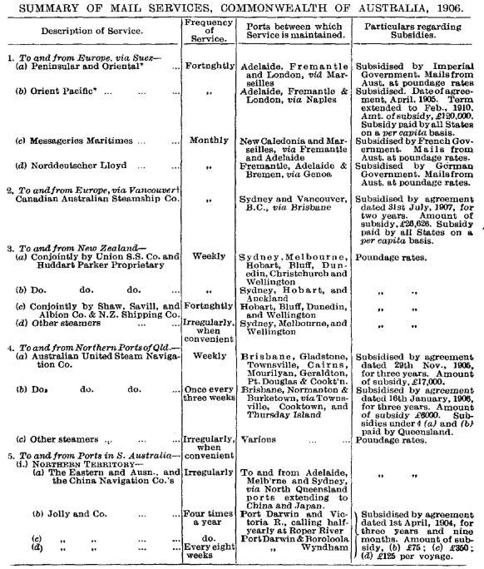

SUMMARY OF MAIL SERVICES, COMMONWEALTH OF AUSTRALIA, 1906.

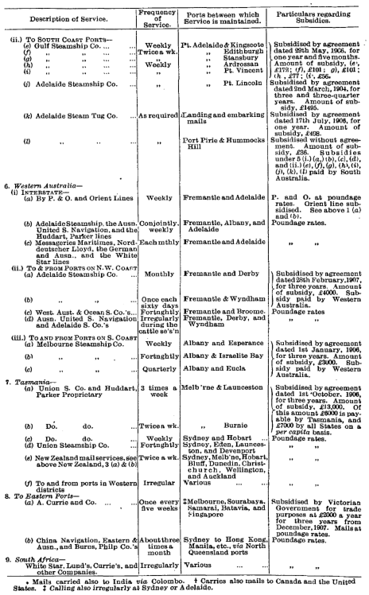
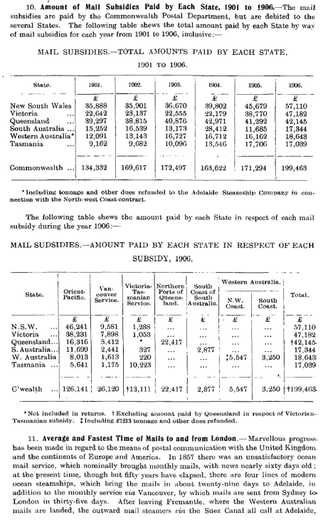
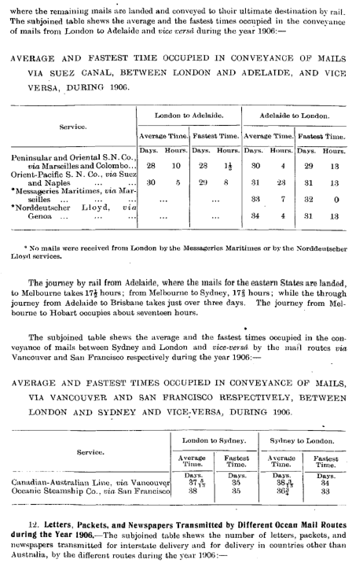
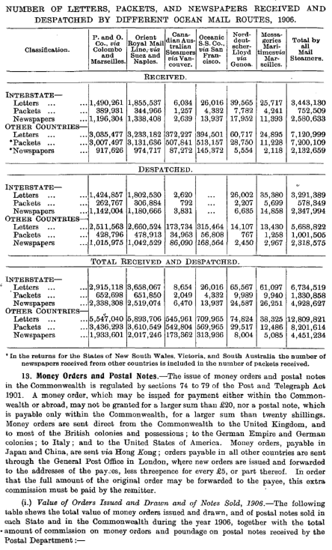
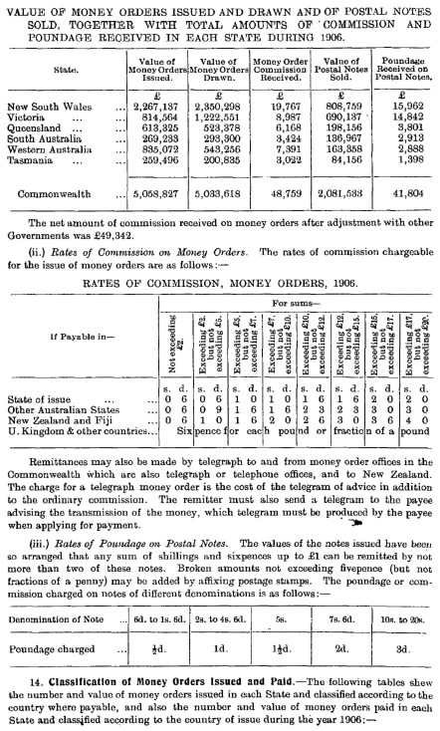
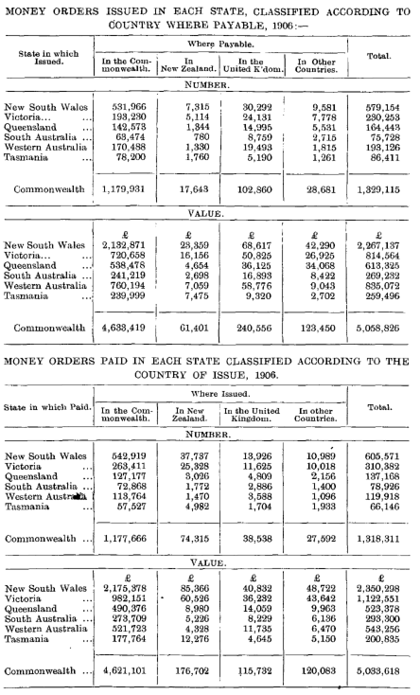
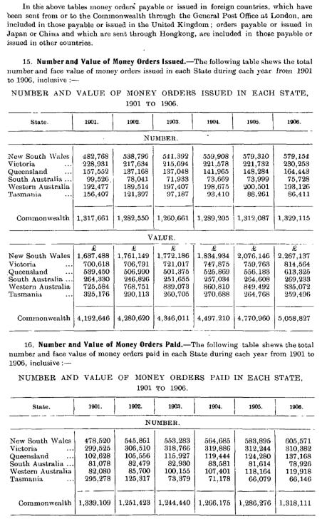
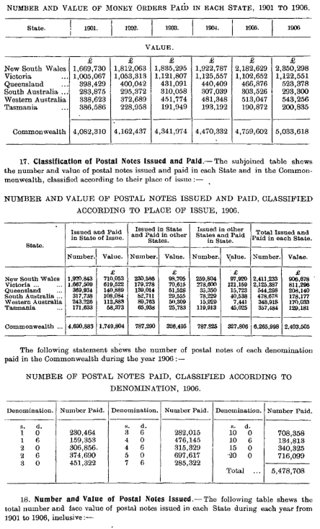
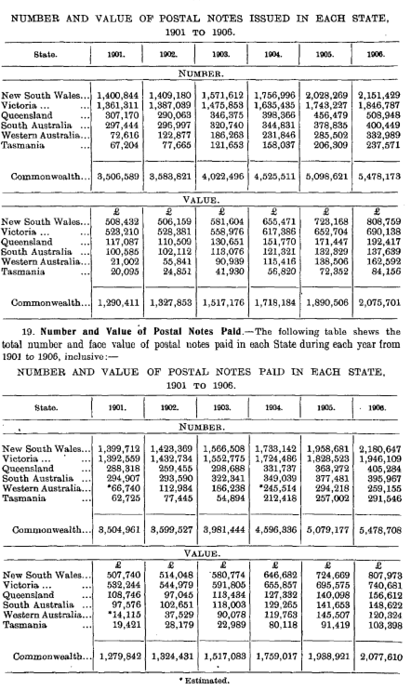
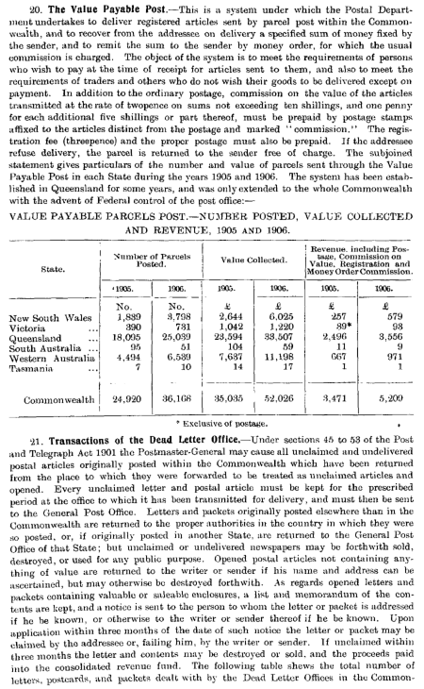
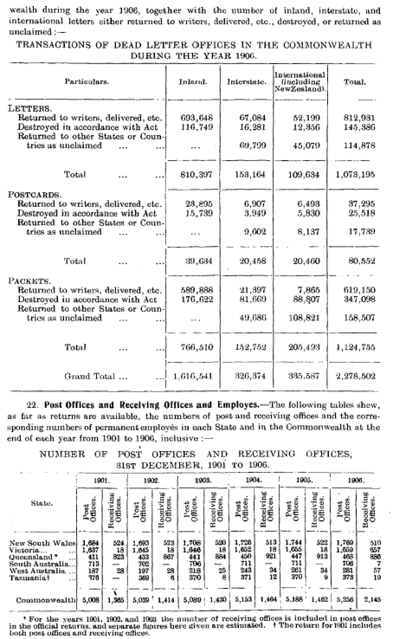
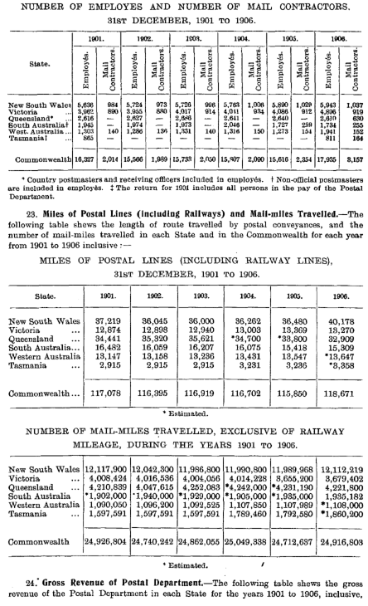
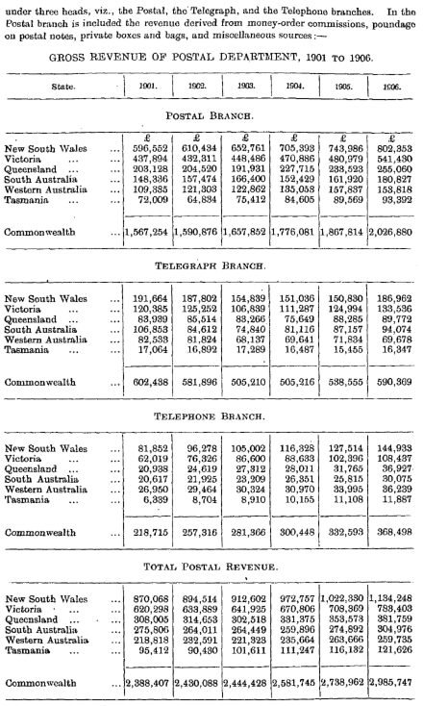
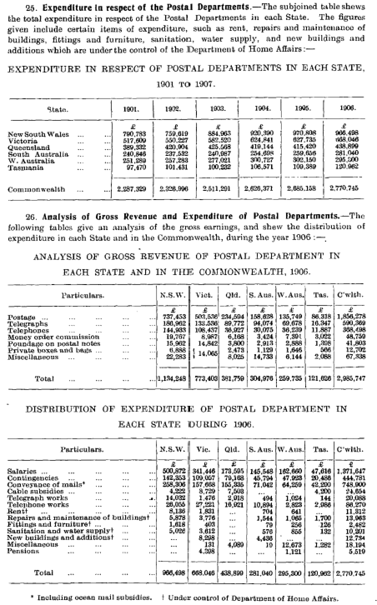
2. Telegraphs.
1. First Lines Constructed.—The electric telegraph was first introduced into Australia for use by the public in the year 1854, when a line from Melbourne to Williamstown was opened. The first line in South Australia, from Adelaide to Port Adelaide, was opened in 1856, while the first line in New South Wales was brought into operation in 1858, when the line from Sydney to Liverpool, 22 miles in length, was opened. In Tasmania the first telegraphic line was completed in 1857, while in the following year communication was established between Sydney, Melbourne, and Adelaide. The first line to be constructed in Queensland was that between Brisbane and Bockhampton, a distance of 396 miles, which was opened in 1864. In Western Australia the first telegraph constructed was from Perth to Fremantle, a distance of twelve miles, which was brought into use in 1869, and in the same year the cable joining Tasmania with the continent of Australia was completed. .

- Development of Services.-During the period from 1871 to 1881 great progress was made throughout Australia in the way of telegraphic construction, over 14,000 miles of line, exclusive of railway telegraph lines, being opened for use during the period mentioned, making the total length of the line open at the end of the year 1881, 25,470 miles. In the case of South Australia this increase was to a large extent due to the construction of the transcontinental lines (a) from Adelaide to Port Darwin (a distance of 2230 miles), which was completed on the 22nd August, 1872, at a cost of nearly half a million sterling, and (6) from Port Augusta to Port Lincoln, and thence along the coast of the Great Australian Bight as far as Eucla, on the Western Australian border. In Queensland there was a large increase resulting from the construction of the line to Normanton, on the Gulf of Carpentaria, while in Western Australia the line from Perth to Albany was extended as far as Eucla on the 9th December, 1877, thus establishing telegraphic communication between the six capital towns, Brisbane, Sydney, Melbourne, Adelaide, Perth, and Hobart. At the present time the systems of telegraph lines throughout Australia are well developed. The longest through line extends from Thursday Island, in Torres Straits, by submarine cable to Paterson, on the mainland of Cape York Peninsula ; from Paterson the line runs in a southerly direction as far as Brisbane, where it joins the main interstate line to Sydney, Melbourne, and Adelaide; from Adelaide it runs to Port Augusta, then on to Port Lincoln, on Eyre's Peninsula, and thence to Eucla, on the Western Australian boundary ; from Eucla the line extends along the coast of the Great Australian Bight to Albany, and thence it runs adjacent to the west coast of Western Australia as far as Onslow, via Perth, Geraldton, and Carnarvon. Prom Onslow connection extends to Broome, in Roebuck Bay, from which place communication is made to Singapore by the Eastern Extension Company's cable. From Roebuck Bay the line crosses the Kimberley district in an easterly direction, and then runs north as far as the terminus at Wyndham. Branch lines extend to all important coastal and inland towns. In Queensland a line runs to Burketown, near the coast of the Gulf of Carpentaria, via Normanton ; another line extends to Cloncurry and Urandangi, in the extreme west of the State. New South Wales, Victoria, and the south-eastern parts of South Australia are equipped with a considerable network of lines converging from the country districts towards the more important towns, while from Adelaide the transcontinental line, referred to above, runs in a northerly direction to Port Darwin, from which place communication is provided with Europe by submarine cable by way of Batavia, Singapore, and Madras. In Western Australia a line runs from Euela to the Coolgardie goldfields via Balladonia and Dundas, and from Coolgardie communication is provided with Perth, and with Sir Samuel, in the East Murchison district. 3. Length of Telegraphic Lines and Wire Open, 1901 to 1906.—The following table shews the length of telegraph lines and of telegraph wire, exclusive of railway telegraphs, available for use in each State at the end of each year from 1901 to 1906, inclusive :-—

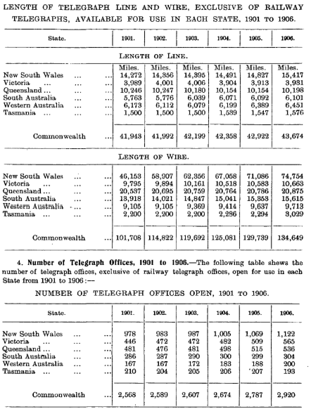

- Revenue and Expenditure, 1901 to 1908.— Particulars as to the revenue from the telegraph systems in each State for the years 1901 to 1906 are given on page 626, while particulars as to the expenditure for the year 1906 are also given on the same page.

- Number of Telegrams dealt with, 1901 to 1908.— The subjoined table shews the number of telegrams despatched in each State for delivery in that State, the number of telegrams' despatched in each State for delivery in other States of the Commonwealth and received for delivery in each State from other States, and also the total number of telegrams—exclusive of cablegrams—dealt with in each State. The last set of figures represent the sum of the corresponding figures for each State in the first two sets of figures. The true total for the Commonwealth in the last table, however, is not obtained by merely adding together the figures for the several States, since interstate telegrams are counted both in the State in which they are despatched and in that in which they are received. A second total is therefore shewn, obtained by subtracting from the first total half the sum of the number of interstate telegrams received and despatched :—

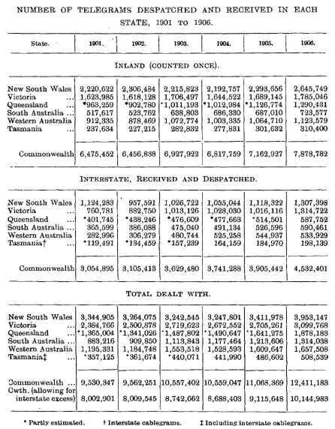

- Rates for Transmission of Telegrams.—The present rates for the transmission of telegrams within the Commonwealth were fixed by section 7 of the Post and Telegraph Rates Act 1902, and came into force on the 1st November, 1902. Under this Act charges are made for telegrams according to whether they are "ordinary" or "press" telegrams. "Press" telegrams are defined to mean those the text of which consists of political, commercial, etc., information, and of news intended for publication in a newspaper. The telegram must be sent by an authorised correspondent, and must be C30 SUBMARINE CABLES. addressed to a registered newspaper or recognised news agency. The subjoined tables shew the scales of charges:—

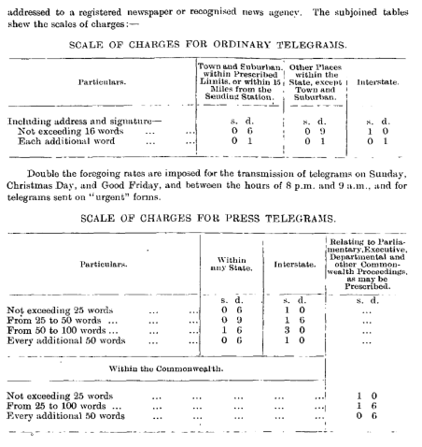

- Submarine Cables.

1. First Cable Communication with the Old World.—
As far back as 1857 the question of connecting Australia with the old world by means of submarine cables was brought forward in South Australia. No steps, however, were taken in the direction of constructing the cable until the year 1869, when various schemes were proposed. About this time the British Australian Telegraph Company was formed for the purpose of laying a cable to Australia without subsidy or guarantee. -Communication had already been provided between London and Singapore via Bombay and Madras, and also through Java from Batavia to Banjoewangie. The proposal of the above company was to lay cables from Singapore to Batavia and from Banjoewangie to Port Darwin, from which place connection would be made overland with the Queensland telegraph system at Normanton. It, was, however, subsequently decided that the company's line should end at Port Darwin, the South Australian Government undertaking to construct an overland line from Port Augusta to Port Darwin, a distance of 1971 miles. In November, 1871, the submarine cable was completed, and communication was established between Port Darwin and London. On the 22nd August, 1872, the construction of the line from Port Darwin to Adelaide was accomplished at an expenditure of nearly £500,000. The cable from Port Darwin is now under the control, of the Eastern Extension Telegraph Company.
- The Tasmania-Victoria Cable.—
In the meantime the cable joining Tasmania to the continent of Australia had been laid, and was opened for use in 1869, the total length being 170 miles. The cable starts from Flinders, near Cape Schanck, in Victoria, and ends at Low Head, at the mouth of the River Tamar, in Tasmania. The line is owned by the Eastern Extension Telegraph Company, and is subsidised by the Tasmanian Government to the extent of £4200 per annum ; the receipts are also guaranteed up to £5600 per annum. Both the subsidy and the guarantee expire in the year 1909. Negotiations for the purchase of this cable by the Commonwealth Postal Department have been in progress for some time, hut at the end of the year 1907 no settlement had been arrived at. »
- The Eastern Extension Company's Cables.—
In addition to the Victoria Tasmania cable and the original cable from Port Darwin referred to above, the Eastern Extension Company have constructed and have control over several other cables connecting with various places in the Commonwealth,
(a) In 1879 the original cable via Banjoewangie was duplicated, the States of New South Wales, Victoria, South Australia, Western Australia and Tasmania having agreed to pay the above company a subsidy of £32,400 per annum for a period of twenty years, the amount to be divided between the States on a population basis,
(b) In 1881 a cable was constructed connecting Broome, in Roebuck Bay, W.A., with Banjoewangie; from Broome there is direct telegraphic communication with Perth, from which place communication is made with the Eastern States by the interstate line via Albany, Eucla, and Port Augusta,
(c) In July, 1899, the company offered to lay a cable direct to Great Britain via the Cape of Good Hope, and also offered reductions in the rates charged, if the States would agree to certain conditions giving the company the right of direct dealing with the public. The States of South Australia, Western Australia and Tasmania accepted the terms offered, and New South Wales entered into the agreement in January, 1901. The cable was opened via Fremantle and Durban in October, 1901.
(d) Another submarine cable from Fremantle to Adelaide forms an alternative line of communication between the eastern States and Western Australia, (e) There is an alternative route, partly belonging to the Eastern Extension Company and connecting the Port Darwin-Singapore cable with London, via Hong Kong, Shanghai, Posiett Bay (Pacific Russia), Libau (Russian Baltic), and Newbiggin (England).
4. The Pacific Cable.— In July, 1898, a conference of' representatives of Great Britain, Canada, New South Wales, Victoria, Queensland, South Australia and New Zealand was held for the purpose of considering a project for a cable to be laid across the Pacific Ocean, touching only British territory on its way from Australia to Canada, thus providing an " All Red" route, as it is termed, for a cable system between England and Australia. In the following year it was agreed at a meeting held by representatives of the countries interested that the cable should be laid and that Great Britain should pay one-third of the cost; Canada, two-ninths; and the States of New South Wales, Victoria, and Queensland the remaining four-ninths. The construction and management of the cable were placed under the control, of a Board composed of seven members—two each from Great Britain, Canada, and Australia, and one from New Zealand—called the Pacific Cable Board. The Australian shore-end of the cable was landed at Southport, Queensland, in March, 1902, and the cable was completed and opened for use on the -3rd November, 1902. There are cable-stations at Norfolk Island, Fiji, and Fanning Island, and a branch cable runs from Norfolk Island to New Zealand. The following table shews particulars of the revenue, expenditure, total loss, and the proportion of the loss payable by the Commonwealth for each financial year since the opening of the cable :—

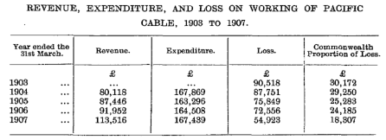

- New Zealand Cables.— A submarine cable joining New Zealand to the Australian Continent was laid in 1873. The line is 1191 miles in length. The Australian shoreend of the cable is at Botany Bay, while the New Zealand terminus is at Wakapuaka, near Nelson, in the Middle Island, from which place another cable, 109 miles in length, is laid to Wanganui, in the North Island. For a period of ten years after its opening the cable was subsidised by the New South Wales and New Zealand Governments, the total contributions amounting to £10,000 a year. The branch from Norfolk Island to New Zealand of the Pacific cable was opened on the 23rd April, 1902. The length of this cable is 597 miles, the New Zealand terminus being at Doubtless Bay in the north of the North Island.
- The New Caledonian Cable.—In April, 1892, a French company, known as the Compagnie Francaise des Cables Telegraphiques, entered into an agreement with the French, the New South Wales, and the Queensland Governments to lay down a submarine cable between New Caledonia and Queensland in return for guarantees by the French Government to the extent of £8000, and by the Governments of New South Wales and Queensland to the amount of £2000 each annually for a period of thirty years. The cable was opened for use in October, 1893, the Australian shore-end being at Bundaberg. The Governments of New South Wales and Queensland are entitled to use the cable for the transmission of official messages up to the amount of their guarantees.

- Number of Cablegrams Received and Despatched In each State, 1905 and 1906.—
The subjoined table shews the number of cablegrams received and despatched in each State and in the Commonwealth during the years 1905 and 1906. Returns for previous years are not available:—

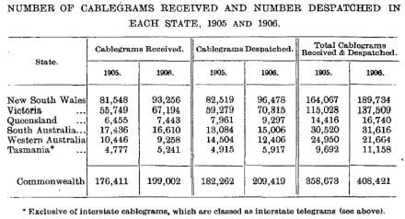

The following table shews the total number of cablegrams despatched and received in each State during each year from 1901 to 1906, inclusive

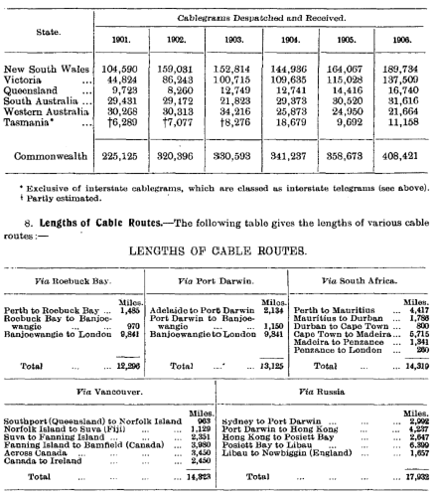

- Cable Rates.—In 1872 the cable rate to England was nine guineas for twenty words, but when word rates were brought into general use in 1875, the rate between Great Britain and Australia was fixed at ten shillings and sixpence, subsequently altered to ten shillings and eightpence. This remained the standard rate for eleven years, when the Eastern Extension Telegraph Company reduced it in 1886 to nine shillings and fourpence a word for ordinary messages, to seven shillings and a penny for Government messages, and to two shillings and eightpence a word for press messages. At a conference of the postal and telegraphic authorities held in March, 1891, a proposal to reduce the rates to four shillings a word for ordinary messages, three shillings and eightpenee for Government, and one shilling and tenpeuce for press messages was agreed to, the States of New South Wales, Victoria, South Australia, Western Australia and Tasmania undertaking to make good half the loss which the Eastern Company might suffer through such reductions. The States guaranteed to the company one-half of the amount of receipts short of the

sum of £237,736—the amount received by the company in 1889 in respect of cable charges—the other half to be borne by the company. The Government of South Australia was also guaranteed by the other contracting States against any loss to the revenue which the lower cable rates might cause in the working of the overland lines. Queensland subsequently joined the other States in these guarantees. Owing to various circumstances the cable traffic did not respond to the reductions, and heavy losses were incurred. It was, therefore, decided at a conference held at Melbourne to increase the rates for ordinary messages to four shillings and ninepence per word. The new rates came into force on the 1st January, 1393, concurrently with an agreement under which New Zealand joined the guarantees to the company and to South Australia.

- Present Bates to Great Britain. On the acceptance by three of the States of the terms offered by the Eastern Extension Telegraph Company for the construction of a cable via South Africa the rate for ordinary messages was reduced in May, 1900, to four shillings a word. It was further reduced to three shillings and sixpence in January, 1901, and to three shillings in January, 1902, at which amount the standard rate by all routes for cablegrams to Great Britain has since remained. The scale of reductions is governed by a revenue standard and when the latter averages £330,000 per annum a further reduction to two shillings and sixpence will be made.

- (ii.) Bates to New Zealand.—As a result of the completion of the New Zealand branch of the Pacific cable in 1902, the rates charged for cablegrams between Australia and New Zealand, except to and from Tasmania, were uniformly reduced to four pence half penny per word. Between New Zealand and Tasmania the charge was fixed at fivepence-halfpenny a word, but it has since been reduced to fourpence-halfpenny. The charge for ordinary cablegrams from New Zealand to Great Britain was reduced from the 1st June, 1902, from five shillings and twopence to three shillings and fourpence a word, and has since been further reduced to three shillings a word. 10. Cable Subsidies Paid by Each State, 1901 to 1906.—The agreements between the State Governments and the Eastern Extension Telegraph Company expired on the 30th April, 1900. Since the year 1895 the amounts guaranteed—£237,736 to the company and £37,552 to South Australia—have been met by the receipts, and the contracting States have, therefore, not been called upon to contribute. (a) The following table shews the total amounts paid by each State by way of cablesubsidies for each calendar year from 1901 to 1906, inclusive:—
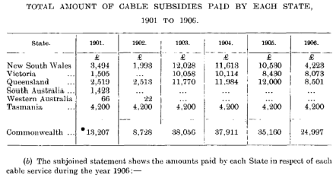
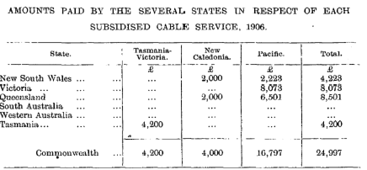

As the agreement in connection with the Tasmanian cable expires in 1909, and as there is a probability of the service being taken over by the Commonwealth Government, the guarantees will, in the course of another year, be reduced to those in connection with the New Caledonia cable and with the Pacific cable. Telephones.

1. Development of Telephone Services.—The Postal Departments of the several States have established telephone services in all the capital towns and in many of the important centres of population throughout the Commonwealth. For the purpose of bringing the use of the instrument more generally into use, the charges have in recent years been considerably reduced, with the result that the number of subscribers has largely increased. Particulars as to the revenue from telephone services in each State for the years 1901 to 1907 are given on page 626 ante, while particulars of the expenditure on telephone works in each State for the year 1907 are given in a subsequent table on the same page.

- Number of Telephone Exchanges, 1901 to l!)0lj. The following table shews the number of telephone exchanges in each State at the end of each year from 1901 to 1900, inclusive :—
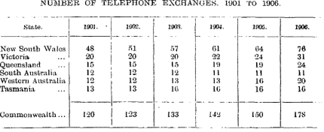

- Number of Telephonic Connections. The subjoined table shews the number of telephone connections to the various exchanges in each State at the end of each year from 1901 to 1906, inclusive:—

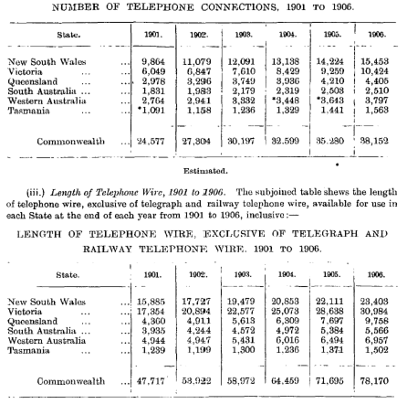

2. Telephone Rates.— On the 31st January, 1907. a uniform toll rate was established throughout the Commonwealth. Subscribers at the time at which this rate was introduced were allowed the option of continuing their subscriptions under the old flat rates, which differed in the several States, or of coming in on the basis of the new rates. The charges made to all new subscribers, or for transferred or extended services, are on the basis of the new rates. The rate charged under the toll system varies according to the population of the area over which the telephone service extends, and also according to whether the person connected subscribes to an exclusive, a two-party, or a three-party service. The following table gives particulars of the rates under the toll system:—
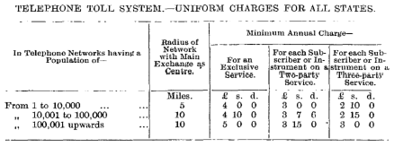

For the foregoing charges the Postal Department provides and maintains all necessary exchange equipment, subscribers' lines not exceeding one mile in length radially, one telephone wall-set for each subscriber, and allows 1000 effective calls to be originated by each subscriber in each half-year.

- Charges for Extra Calls. For all effective calls beyond 1000 half-yearly the subscriber js charged as follows:— For calls above 1000 and not exceeding 2000 half-yearly, two calls for one penny. For calls above 2000 and not exceeding 3000 half-yearly, three calls for one penny. For calls above 3000 calls half-yenly, four calls for one penny.
- Charges for Extra, Mileage. When the radial length of any line exceeds one mile the following charges are made :—

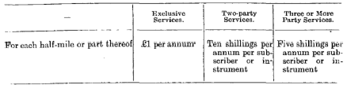

3. Miscellaneous Particulars, 1905. The following table gives various interesting particulars of the operation of the telephone services in each State for the year 1906 :—

