VP.O.A.82
AN AUSTRALIAN POST OFFICE HISTORY
BEAUDESERT
Prologue
Surrounded by the magnificent scenery of the rain forests and ranges that make up Binna Burra., Green Mountains, Tamborine Mountain and Beechmont resorts, Beaudesert, a modern town of some 3,600 people, was one of the earliest settled areas in the State. Soon after free settlement was proclaimed, the virgin forests echoed to the axe of the pioneers as they cut slabs for their primitive huts, while the grasses of open plains fed the hungry cattle. However, progress was often slow in those early days as vast holdings prevented closer settlement. Thirty years were to go by before the land was divided into smaller lots for sale. The proximity of this land to Brisbane and the south coast made them popular and within another 10 years town allotments were being sold for £100 each - quite a sum in those days. Settlement increased rapidly so that by the 1880s a private town existed. By this time the mail line from Brisbane had been consolidated. In the early days of the town, Cobb & Co. mail coaches were a familiar sight. However, the coming of the railway spelt the end of the romantic era of Cobb & Co. so far as Beaudesert was concerned. On its heels came the electric telegraph to flash messages across the land at the speed of light. Soon after Federation the miracle of the telephone burst upon Beaudesert and man could speak directly with man to near and distant places.
The record of these achievements makes a proud story, a story that spans 130 years in this short history and ends with the provision of a beautiful new Post Office building. Although brief, it tells of the development of communications by a band of dedicated people who helped make Beaudesert what it is today.
Early Exploration
Probably the first white explorer to see the wide and pleasant valley in which Beaudesert is located was Captain Patrick Logan, Commandant of the Moreton Bay settlement. He, with five convicts, travelled 100 miles up the Logan River (named after Logan) by boat in 1826.
The next exploring party consisted of Allan Cunningham, Captain Logan, Charles Fraser (colonial botanist) and five other men. They left Brisbane on First Postal Lines
As settlement spread out from Brisbane in farming communities such as Beaudesert, the needs of the pastoralists and agriculturists included the essential services of the mail to bring them news and information from their families, friends and the business world.
The first mail line from Brisbane to the southern inland area was to Logan River Reserve Post Office in 1864 by horseback once a week. On 1st January, 1868, a postal line was extended from Logan Reserve to Telemon (later called Christmas Creek) once a week by horse, a distance of 52 miles. "Beau Desert" was on this run. In 1872 the mail route operated from Logan Reserve to Village of Logan, Logan Bridge, Jimboomba (A.J. Henderson), Towns' Plantation, Beau Desert (White and Robinson), Tamrookum (W. Barker) and Telemon (G.C. Crump), a distance of 68 miles.
First Post Office
Apparently the mail was collected and deposited at White and Robinson's homestead for a number of years until a Post Office was officially commenced on 9th February, 1878, with Mr. D. Howard as the Postmaster on £12 p.a. He only remained a short time as Mr. F. Brayford took charge on 14th June, 1879. At the time the nearest Post Town for Beaudesert was Tamborine where mail was "made up" for and "sorted from" Beaudesert. The office was known as a Non Official Post Office by 1882.
Early Postal Lines
The Logan Reserve/Telemon Mail Service operated once a week by horse in 1874 and a branch line from Logan Reserve to Village of Logan twice a week.
In the meantime a Cobb & Co. coach service was commenced between Brisbane and Nerang Creek in January 1871, and three times weekly from 15th February. This greatly increased the capacity of nail carriage from Brisbane and speeded up the development of postal services in the district.
In 1877, the Logan Reserve/Telemon Postal Service was discontinued as a new Mail Service, No.151, was commenced between Brisbane and Beaudesert by coach twice weekly. The route included Browns Plains and McLean. The run also included a weekly trip by horseback from Beaudesert to Telemon (Christmas Creek), making the total distance of the route 61 miles.
Pugh's Almanac states the coach operated between Brisbane and Beaudesert on Wednesdays and Saturdays, leaving at 6a.m. and returning on Fridays and Mondays.
Money Order Office
Business continued to increase so that by 1886 a Money Order Office had been introduced. During that year, 12 Money Orders were issued to a value of £42.18.6, and 4 paid out to a value of £12.19.0. In 1887, 204 orders valued at £827.4.10 were handled.
Private Town
In 1885/6 records show Beaudesert as a private township with a population of twenty—five (25) served by a mail coach thrice weekly. By this date the Post and Telegraph authorities were interested in obtaining a site for the erection of a new Post and Telegraph building. In reply to a request for "a copy of any plan of land for a Township at Beaudesert, if any; if not to give a plan of any land available for Post and Telegraph Office" dated 15th February, 1886, from the Under Secretary of the Post and Telegraph Department, the Under Secretary, Department of Public Lands replied on 3rd March, 1886, "... you are informed that there is no Government township at Beaudesert. The nearest vacant land to the private Township is about 1 miles southwest edged red on the accompanying lithograph but is marked on the plan 'not to be sold'."
Acquisition of site for Post & Telegraph Office
However, the Postal authorities, anxious to acquire a site for a Poet Office, asked the Commissioner for Railways for information on the Railway Reserve at Beaudesert on 8th March, 1886. A tracing of the location of the proposed Railway Station was provided on 12th March, 1886.
On 1st June, 1886, a Mr. De Burgh Persse of Tabragalba Station considered the site near the Railway Reserve the most suitable for a station and township, as there was permanent water there and none at the private township.
Apparently the Postal authorities were satisfied with the station, as an inter-departmental memorandum dated 5th January, 1887, stated -
"Ask Railway Department to be good enough to arrange for Post and Telegraph Office in rail station
buildings, Beaudesert ..."
No firm date is available when the office began operation in the Railway Station but the Railway Station was opened on 16th May, 1888, and it seems certain a Post and Telegraph Office was set up there at the time or soon after. Mr. R. Scott was Officer-in-Charge at the time.
Apparently the location of the Post Office in the Railway Station was not suitable for the townspeople, so a petition was taken up by them on 2nd

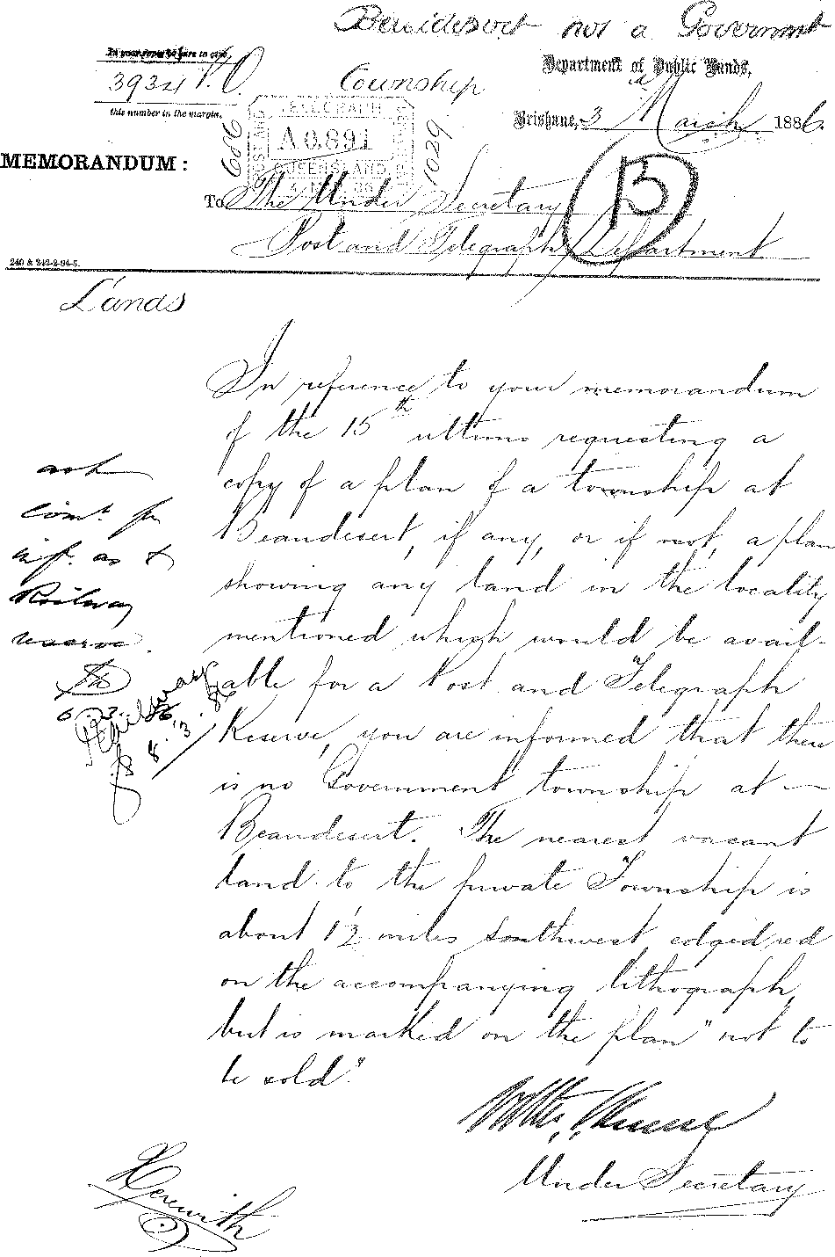
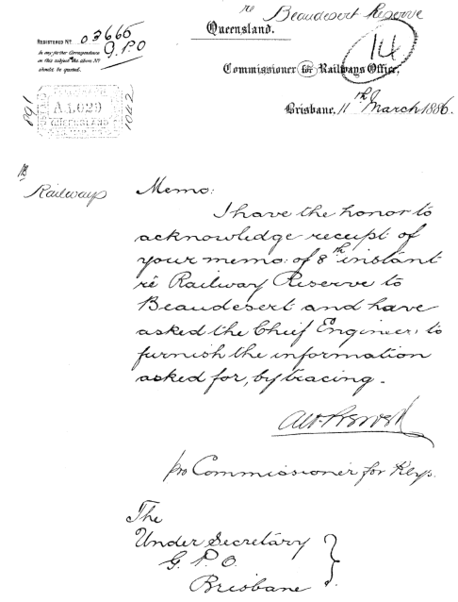

July, 1888, for a Post Office to be built closer to the business area (see copy of petition attached).
Construction of new Post & Telegraph building
On 25th May, 1888, the Under Secretary of the Post and Telegraph Department, aware of the need for a suitable site for a new Post Office, wrote to Mr. T. Fred Hassall, Acting Manager of the Bank of New South Wales, Beaudesert, asking for advice on suitable property there. He in turn contacted Mr. Thomas Brayford, who replied to Mr. Hassell on 2nd June, 1888, in these words - "... re securing a suitable site here for future offices for that Department, I beg to offer allotments No. 6 and 7, Corner of William and Anna Streets as marked on accompanying plan for the sum of one hundred pounds (£100). This offer to be open for fourteen days."
In the meantime, while officials were negotiating for the purchase of property, a number of residents forwarded a petition on 7th June, 1888, to the Under Secretary, Post and Telegraphs, recommending the purchase of Thomas Brayfordts allotments if they were at a reasonable price. (See photo copies attached).
Mr. Hassall followed up the advice from Brayford by advising the Under Secretary of the conditions. However, £50 each was offered but rejected by Mr. Brayford. The Bank wrote again to the Under Secretary (on 14th July, 1888) recommending the purchase at £100 as prices were rising rapidly. On the second approach by Mr. Hassell, Mr. Brayford agreed to sell for £50 per allotment as he considered the Post and Telegraph Office to be in an inconvenient position and was anxious to see it moved to a more central point (see letters dated 13th July and 25th August, 1888). The Government purchased the allotments, Nos 6 and 7, through Mr. Hassell of the Bank of New South Wales in August 1888.
About the time of the transaction of the business in acquiring the new property, a petition by a number of inhabitants of Beaudesert was forwarded to the Postmaster General in Brisbane. In this petition, twenty-nine people considered that the £500 allocated for the erection of a new building be "expended on Government property and would suggest that the most suitable and proper place for the building to be erected is on the land adjoining where the Railway Station now stands and also the premises at present used as a Post and Telegraph Office and we beg respectfully to request that the place mentioned may be selected for the new buildings as being most central and convenient for all parties." However, it was decided that the new building would be erected on the allotments in William Street purchased for that purpose.

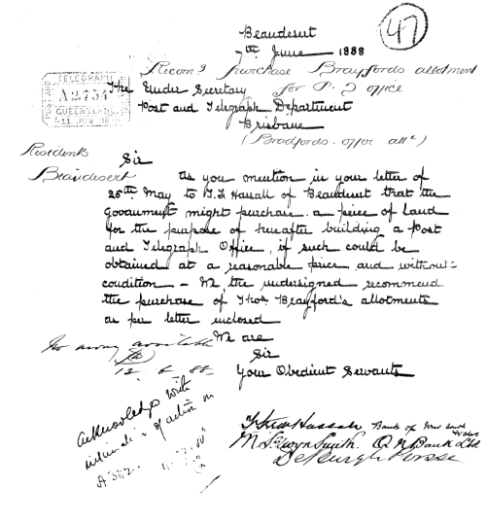

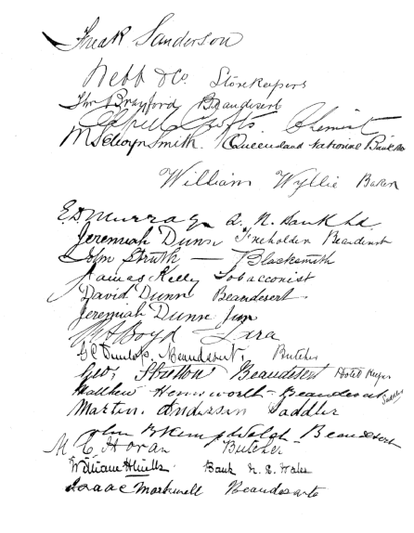

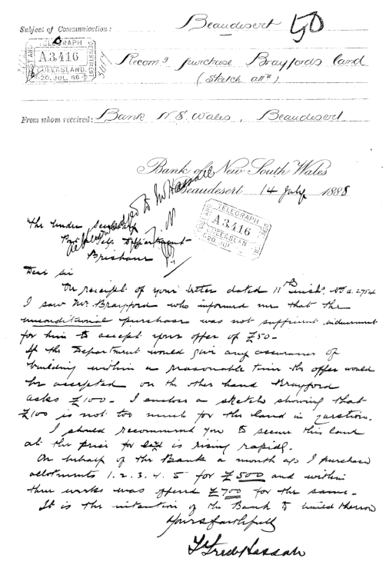

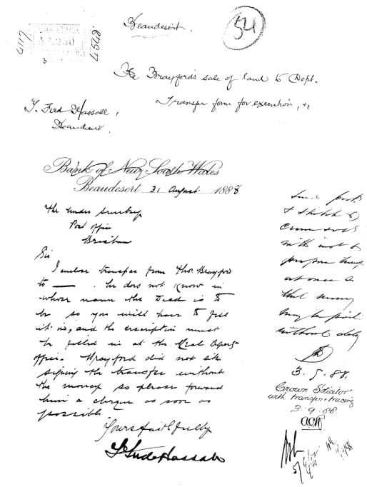

Tenders called
Tenders were invited in 1889 for the erection of the building, following approval of the plans in November 1888. The estimated cost was £500.
Department of Mines and Works,
Brisbane, 23rd January, 1889.
TO CONTRACTORS AND OTHERS.
POST AND TELEGRAPH OFFICE, BEADDESERT.
Tenders will be received at this Office until Four o'clock p.m. on FRIDAY, the 22nd February, from persons willing to contract for Erection of a Post and Telegraph Office at Beaudesert.
Tenders to be endorsed "Post and Telegraph Office, Beaudesert."
Plan, Specification, and form of Tender may be seen,
and further particulars obtained, at this Office.
The amount of preliminary deposit, to be enclosed by bank draft or bank notes with the Tender, is £15. (See Clause 1 in the General Conditions attached to the Specification.)
Tenders must be on a proper printed form, and state the time within which it is proposed to complete the work, and at the foot of every Tender there must be a memorandum signed by the party tendering, agreeing to deposit the sum of 10 per cent on amount of Tender as security for the due performance of the Contract in the event of the Tender being accepted, and under-taking in that event to execute and deliver at the Office of the Crown Solicitor, in Brisbane, within fourteen days from the usual notification of acceptance, a Bond to Her Majesty for securing such
performance; otherwise the Tender will not be taken into consideration.
The lowest or any Tender will not necessarily be accepted.
R. ROBERTSON,
Acting Under Secretary for Works.
Work begins
Mr. Robert Scott, the Postmaster at Beaudesert, advised Mr. A.F. Matveieff, Superintendent of Electric Telegraphs, on 10th April, 1889, that the contractor had "commenced the erection of the Post and Telegraph Office here, and upon examination of the Plan I find that provision is not made for sufficient light in the office, and I would most respectfully ask that another window be put in the east side of the building and a colonial oven be put in the kitchen, this would not be very expensive, about fifty shillings, and the contractor could put it in when building the kitchen chimney ..."

Approval was given on th6 3rd May, 1889, for the contractor to include the second window.
A fence with a gate was put up around the building by the contractor for an extra £50.
The officer in charge, Mr. R. Scott further stated in a letter dated 5th June, 1889, that there were certain alterations and additions necessary in the office layout to ensure privacy and security. He also reported -
"that there is no provision made to store the office stores such as Blue stone, magnesia, insulators, brackets etc etc and some sort of a cheep (sic) stable will be required as I have at times to keep my horse in at night to start early on line if it should be required. A building 16 x 10 divided into two parts (one place to be a store room the other a stall for my horse) could be put up at no very great expense."
On 10th June, 1889, Works Department was asked to take the necessary action to complete the work. The Postmaster was wired on 22nd June to instruct the contractor to proceed with these additions.
Completion of Building
Construction of the new Post and Telegraph building proceeded satisfactorily to its completion in September 1889. The Postmaster, Mr. Robert Scott, wired the Under Secretary on 7th September, 1889, that the contractor had handed him the keys to the new office, and asked if he should take possession of the building. Advice was sent and the Postmaster reported he took charge and moved "everything into it" on 9th September, 1889. The final cost was £670.
Construction of Railway Line
Earlier, the opening of the railway from South Brisbane to Beenleigh and Beaudesert made radical changes in transport to these areas. It meant passengers, goods and mail could be carried cheaply, regularly and faster than ever before. The South Brisbane Branch and South Coast Line was opened partly on 2nd June, 1884 with Stanley Street and South Brisbane Stations. The line was extended to Yeerongpilly by 1885 and further from Yeerongpilly to Loganlea on 9th April, 1885. Beenleigh was reached on 27th July, 1885, while a spur line from Bethania to Logan Village through Waterford and Buccan was completed on 21st September, 1885.
However, it was not until 16th May, 1888, that Logan Village was joined by line to Beaudesert, a distance of 20.15 miles.
The Postmaster in those years had to repair the telegraph line or cut down trees along the route, or pay for the latter work to be done. Mr. R. Scott, history records, rode his own horse, stationed at the Post Office yard overnight, to clear faults along the telegraph line. Some of the old outbuildings at the Post Office in William Street still stand.
The introduction of the telegraph to Beaudesert brought this station into a vast network of lines reaching out to far and remote areas of the State and interstate. This period was the peak of simple manual telegraphy before machines became perfected and the many operators necessary for repeating stations superseded by improved equipment.
It is interesting to note that Beaudesert became a Meteorological Station some time about or prior to July 1898. Morse was used to relay the data to the Meteorological Bureau for weather reports.
The coming of the telephone heralded the eventual disappearance of morse code and the "clacking" sounders of Electric Telegraph Stations. By 14th October, 1957, all telegraph equipment used for messages to and from Beaudesert had ceased functioning and telegraph messages were handled by telephone.
First Telephone Exchange
The introduction of the first manual telephone exchange at Beaudesert took place about 1907. A copy of an extract of the Telephone Directory for November 1909 is listed below:
BEAUDESERT TELEPHONE EXCHANGE
4 Beaudesert Hotel, J.H. Darragh, proprietor
38 "Beaudesert Times"
15 Beaudesert Tramway Line
40 Birkbeck, C.T., jeweller
22 Brisbane Trunk
33 Brook, S.A.
48 Brown, Hon. V.
Collins, J.G., Mundoolun Station
Collins, R.M., Tamrookum Station
Collins, W., Nindooimbah
9 Commercial Bank of Australia, Beaudesert
42 Dauth, 0., blacksmith
De Burgh Perese, Tabragalba Station
18 Dowrie, J., draper
11 Dr. Beet, Beaudesert
Drynan, A., Telemon Crossing
2 Enright, M., storekeeper, Beaudesert
47 Fraser, A.W., dentist

Beaudesert Telephone Exchange cont'd
43 Gilbert, J.H., baker
10 Grand Hotel, S.T. Wills, proprietor, Beaudesert
35 Henley, E.E., saddler
36 Holdgate, J. and C., storekeepers
49 Holtorf, nurse
1 Hospital, Beaudesert
37 "Independent" Newspaper Company
20 Jennings, G. (private residence), Cryna
8 Kerry Trunk Line
3 Lahey's Limited, sawmill, Beaudesert
41 Le Grand, S.R., undertaker
12 Logan and Albert Co-operative Dairy Company
7 Logan & Albert Hotel, P. Mulcahy, prop., Beaudesert
13 McDougall, J., butcher
17 Nindoombah, Tabragalba, Mundoolin Trunk Line
27 Police Station
29 Postmaster
28 Public Telephone
5 Q.N. Bank, Beaudesert
6 Railway Hotel, Massie, C.S., proprietor
24 Railway Station
23 Railway Trunk and Jimboomba and Veresdale
46 Rassmussen, L.O., saddler
14 Rick Brothers, storekeepers
39 School of Arts
26 Shire Council Office
16 Smith, M.S., auctioneer
32 Ditto residence
19 Spiers, C.S., chemist
45 Thams, C.A., builder
31 Tramway Station
50 Walsh, nurse
25 White, W.G., The Knoll
21 Winship, Audley, auctioneer, Beaudesert
Magneto switchboards were located in a small room on the top side of the Post Office (where the Postmaster's office was situated more recently). The equipment for the exchange was situated in a room at the rear of the building. Local and trunk wires joined on to the building by means of a large terminal pole on the footpath directly in front of the building. From this pole aerial wires connected to a crossarm on the gable of the building and were run down through the ceiling to the main distributing frame.
At the time of the opening there were about 50 telephone subscribers' services connected, including several "party lines" and four official services.
By the end of 1934 the number had risen to 159, 177 by 1939, 180 by 1944, 257 in June 1949, 358 in June 1954, 384 in 1957 and in 1972 to 6:4 subscribers' services including 22 "party lines".
Central (Common) Battery Exchange
With the increase in the number of subscribers' services after World War II, the need was seen to obtain now premises for the telephone exchange. Thus on 12th November 1952, the old magneto exchange was superseded by a new Central Battery Exchange situated in a building in Eaglesfield Street. A "local position" or "A" position switchboard of 600-line capacity with ultimate capacity of 1500 lines was installed at the time. There were 299 subscribers' services connected to the exchange.
Trunk Line Equipment
With Beaudesert situated over 40 miles from Brisbane, trunk carrier equipment for telephone lines was utilized as it became available. The first carrier system, Type S.O.T. No.27, 3 Channel, was brought into service in February 1940. However, it was dismantled in April 1940 to serve the Brisbane/ Gayndah trunk route.
On the 16th March, 1949, a single channel carrier, No.12 Type FA, previously Dalby/Brisbane was opened Beaudesert/Brisbane.
Military Camp
In 1946 the Beaudesert Post Office was handling postal transactions for over 30 personnel stationed at the Military Detention Camp at Round Mountain and during World War II just prior to this, the presence of large groups of military personnel in the district increased traffic considerably.
Certificates of Merit
At a special function held in the Civic Centre, Beaudesert, on the 4th March, 1966, the Postmaster General, the Hon. Alan S. Hulme, presented individual Certificates of Merit (the Post Office VC) to linemen Frank R. Jurd and George W. Ball for their outstanding devotion to duty during the night of a severe cyclone on 19th/20th July, 1965. These two men worked in constant danger to restore communications between Beaudesert and the outside world. Struggling in total darkness in thickly wooded country with flying branches and trees and flooded creeks, these two men repaired the main trunk line which had been severed. Many other technical staff in the area aided in the restoration of services at the time.

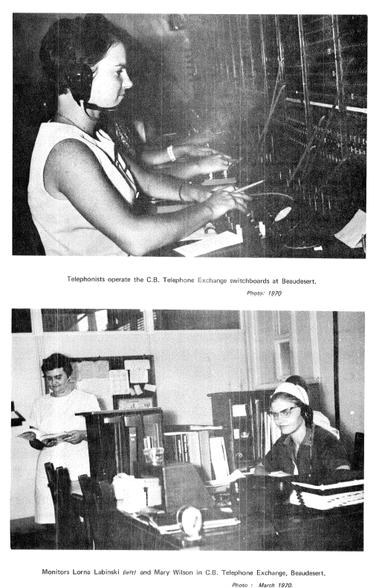
Line Depot
The old line depot situated for many years at the rear of the Post Office in William Street was closed when a new depot was opened in 1963 in Arthur Street at a cost of $17,200.
Postmaster's Residence
Acquisition of a residence for the Postmaster was effected in January 1965 at a cost of about $10,000, as the existing quarters in the old Post Office building were not considered of a desirable standard.
Proposed Automatic Telephone Exchange
A brick building was erected by contractor G.C. Nixon in 1969/70 at a cost of $44,623 for a proposed automatic telephone exchange building in Eaglesfield Street adjacent to the Central Battery Telephone Exchange.
Plans for New Post Office
A new Post Office building was proposed for Beaudesert to replace the old wooden building which had served the community for so many years. It was placed on the Design List for 1969/70 and designed by architects and engineers of the Commonwealth Department of Works, working to plans and functional data supplied by the Post Office Buildings and Properties Section.
Contract Let
Tenders for the new building were called on the 14th August, 1971, and closed on the 14th September, 1971. The contract was let to K.D. Morris & Sons Pty. Ltd. of Brisbane for $111,816 for completion in April 1972. Work began in October 1971 and was completed in June 1972.
Description of Building
The building consists of a steel portal-framed structure with a suspended reinforced-concrete floor and clay brick and glass external walls. As the site falls to a considerable degree from the rear to the front, the building was designed to overcome the problem of providing easy access for customers, particularly the incapacitated or mothers with prams, to the public space or other facilities and at the same time front the building to Brisbane Street. The solution was obtained by providing public telephones in a kiosk type of section of the building on ground level in the front of the building.

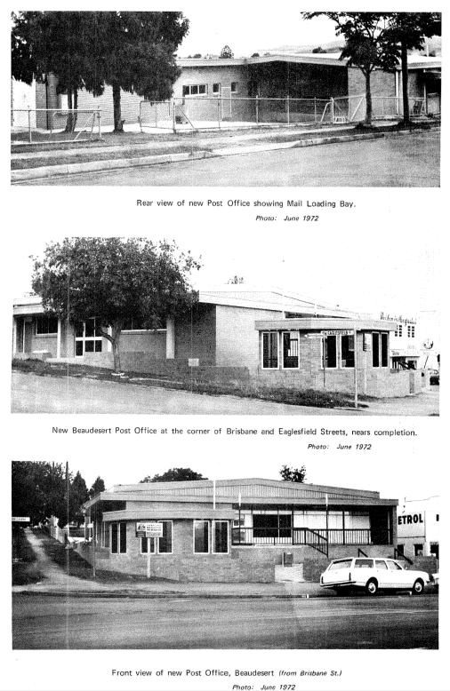
Access to the building from Eaglesfield Street was provided as an alternative to the main entrance of ramps and stairs from Brisbane Street.
The design also incorporated a ridged roof with galvanised steel decking, and a covered verandah at the front of the building for posting boxes, stamp selling machines, and private letter boxes.
The building is fully air-conditioned throughout to provide comfort-able conditions for customers and staff in weather extremes.
Post Office Staff 1972
Postal
Postmaster Grade IV - Mr. Vivian A. Tuck
Senior Postal Clerk Grade 2 - Mr. Francis B. Kelly
Postal Officer Grade 3 - Mr. Colin H. Myers
Postal Officer Grade 2 - Wilfred J. Rooks
Exempt Postal Officer - Mrs. Maureen I. Moss
Postman - Ken Jurd
Asst. Postal Officers - Wayne Ardrey
(telegram messengers) Kenneth Ardrey
Labourer Grade I (cleaner) - Joseph Ward
Telephonists
Monitors - Miss Lorna Labinsky, Mrs. Dorothy E. Branson
Telephonists - 11
Stationed at the Central Battery Telephone Exchange in Eaglesfield St.
Technical
Telecom Senior Tech. Officer Grade 2 - Mr. A. Daniels
Technical Officer - Mr. C. Schulz
Technicians - 4
Tech. Asst. - 1
Installation and maintenance of telephones, switchboards, small exchanges etc. is carried out over an area of approximately 1200 sq. miles.
Line Foreman - Robert J. Young
Linemen - 7
The area served by this support team who install and maintain telephone aerial lines and cables and underground cables, is approximately the sane area as for the technicians.
Services
Mail - Incoming
From Brisbane via Jimboomba and Gleneagle 9a.m. and 6p.m. daily; From Woodenbong, Rathdowney, Laravale, Innisplain 10a.m. daily; From Lamington via Hillview 10a.m. daily
No rail or air mail is received in Beaudesert.
Mail - Outgoing
To Brisbane via Gleneagle and Jimboomba 7.30a.m. and 3p.m. daily;
To Woodenbong via Rathdowney, Laravale and Innisplain 10.15a.m. daily.
Contract Mail Services
The following are the Mail Services under contract for the delivery of mail to the area around Beaudesert:
No. | Route | Contractor
M.S.98 | Upper Darlington (daily) | Mr. R. Johnston has  been operating this  service since 1928  (44 years)
M.S.293 | Overflow (3 weekly) | N.V. Greensil
M.S.411 | Barnes Box (daily) | L.E. Harmer
M.S.413 | Woods Box (daily) | A. Coleman
P.S.1041 | Tancreds Meatworks (daily except Sat.) | H. Bench
P.S.1916 | Draper Box (3 weekly) | L.E. Harmer

Official Opening
Upon completion of the new building, an official function was held at the Beaudesert Post Office on Friday, 7th July, 1972, at 3p.m. On this occasion the Hon. C.E. Barnes, M.P., on behalf of the Postmaster General, opened the building by handing over the keys to the Postmaster, Mr. Tuck. About 150 guests representing business, commercial, educational, religious, recreational and government organisations attended.
Unveiling of Plague
Following the opening ceremony, the Hon. C.E. Barnes, M.P., moved to the foyer and unveiled a bronze metal plaque to commemorate the occasion. The wording on the plaque consisted of:-
THIS POST OFFICE
WAS OPENED ON 7TH JULY 1972, BY
THE HON. C.E. BARNES, M.P.
Epilogue
Beaudesert has come a long way since the cattlemen opened up the country over a century ago. Where once tall grass grew it now has modern shops, buildings, homes, roads and bridges, a butter factory, meat works, a thriving dairy, beef and agricultural industry, hospital, sewerage, stud farms, and a
