The era of manually-operated telephone services at Beaudesert ended last week with the closure of Telecom's manual assistance centre.
The centre, in the Beaudesert telephone exchange building, employed three telephonists who handled operator-connected trunk calls, and enquiries from customers of Beaudesert and surrounding districts.
The three operators were all offered other positions with Telecom but declined.
This service will now be provided from Ipswich telephone exchange.
Ipswich District Telecom Manager (Mr Bob Bensley) said this week the Beaudesert manual assistance centre was no longer required following completion of a $1.2 million exchange automation project in the Beaudesert district.
Mr Bensley said about 300 subscribers were involved in the automation scheme.
He said these customers now had automatic telephones and access to the nationwide S.T.D. network, linking about 3000 telephone exchanges through¬out Australia.
"The automation program, south of Beaudesert, involved installation of new automatic exchanges at Rathdowney, Hillview, and Kerry.
"The existing automatic exchange at Barneyview was upgraded to meet customer demand in the area.
"Beaudesert gained its automatic telephone exchange in 1975 and the manual assistance centre was established in the new exchange building in Eaglesfield Street.
"The first Beaudesert manual exchange was established in 1907.
"At that time, there were about 50 telephone services in the town.
"Beaudesert was first linked to Brisbane by a trunk telephone line in early 1940.
"The equipment was subsequently removed to another location and it was nine years later, in 1949, the Beaudesert finally gained a permanent trunk link with Brisbane.
"Beaudesert's first telephone exchange was a magneto-powered manual switchboard which was replaced by a central battery model in 1952.
"In the past 71 years, telecommunications, technology has advanced sufficiently to enable subscribers in the Beaudesert district to enjoy the advantages of a sophisticated communications, network.
"Using this knowledge, Telecom will continue to provide customers in
both city and country areas with the best, most efficient telecommunication
facilities at the lowest practicable cost," Mr Bensley said.

LOGAN AND ALBERT " TIMES" (BEAUDESET) 27TH JUNE, 1975

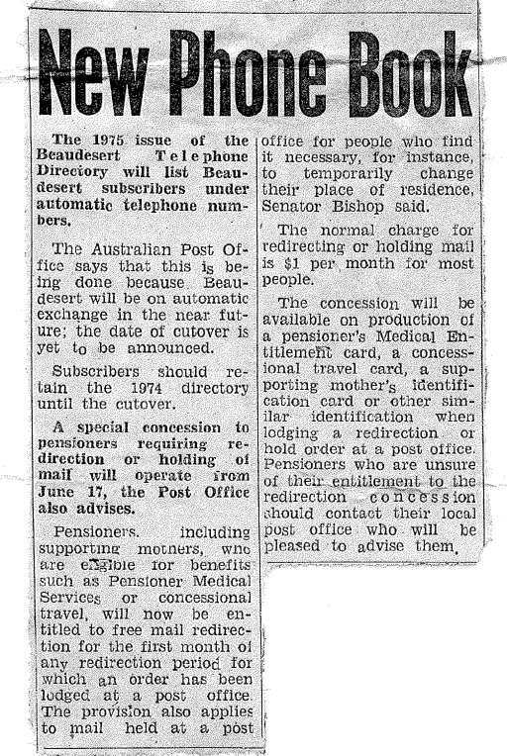

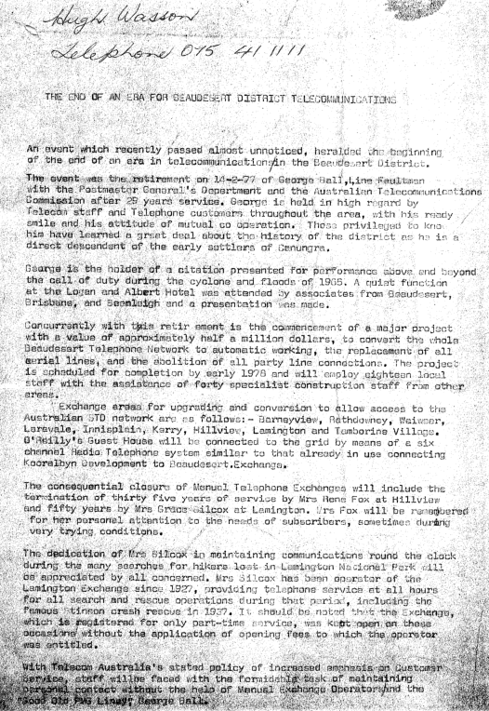

Hugh Wasson
Telephone 075 411111
The end of an era for Beaudesert District Telecommunications.
A event that recently passed almost unnoticed, heralded the beginning of the end of an era in telecommunications in the Beaudesert District.
The event was the retirement on 14/2/77 of George Ball, Line Fault man with the Postmaster General’s Department and the Australian Telecommunications Commission after 29 years of service. George is held in high regard by Telecom Staff and Telephone customers throughout the district, with his ready smile and his attitude of cooperation. Those privileged to know him have learned a great deal about the history of the district as he is a direct decedent of the early settlers of Canungra.
George is the holder of a citation presented for performance above and beyond the call of duty during the cyclone and floods of 1965. A quiet function at the Logan and Albert Hotel was attended by associates from Beaudesert, Brisbane, and Beenleigh and a presentation was made.
Concurrently with the retirement is the commencement of a major project with a value of approximately half $1,000,000, to convert the whole Beaudesert telephone network to automatic working, the replacement of all aerial lines, and the abolition of all party line connections.
The project is scheduled for completion by early 1978 and will employ 18 local staff with the assistance of 40 specialist construction staff from other areas. Exchange area for upgrading and conversion to allow access to the Australian STD Network are as follows.00:01:05 Speaker 2
Barney View, Rathdowney, Wiser, Laravel Comma, Innisplane, Kerry, Hillview, Lamington and Tambourine Village. O’Reilly’s guesthouse will be connected to the grid by means of a six channel radio telephone system similar to that already in use connecting corral development to Beaudesert Exchange.
Mrs Fox will be remembered for her personal attention to the needs of subscribers, sometimes during very trying conditions.
The dedication of Mrs Silcox is maintaining communications round the clock during the many searches for hikers lost in Lamington National Park. Will be appreciated by all concerned. Mrs Silcox has been an operator of the Lamington Exchange since 1927.
Providing telephone services at all hours for all search and rescue operations during that period, including the famous Stinson Crash rescue in 1937. It should be noted that the Exchange, which is registered for only part-time service, was kept open for these on these occasions. Without the application of opening fees to which the operator was entitled
With Telecom Australia's stated policy of increased emphasis on customer service, staff will be faced with the formidable task of maintaining personal contact without the help of manual exchange operators and the Good Queensland PMG liney. George Ball.

News Copy
EXPANSION am IMPROVEMENT OF TELEPHONE FACILITIES IN THE BEAUDESERT DISTRICT WILL CULMINATE IN THE COMMISSIONING OF THE BEAUDESERT AUTOMATIC LOCAL AND TRUNK SWITCHING ENCHANE ON WEDNESDAY, NOVEMBER 12.
ANNOUNCING THIS TODAY, THE STATE MANAGER, PAUL DUBOIS. SAID EXPENDITURE ON THE NEW BEAUDESERT FACILITY AMOUNTED TO $825,000. THIS COVERED EXTENSIONS TO THE EXCHANGE BUILDING ($115,000), PROVISION AND INSTALLATION OF EXCHANGE EQUIPMENT ($570,000) AND RETICULATION OF SUBSCRIBER CABLE ($140,000)
THE BEAUDESERT EXCHANGE HAS A CAPACITY FOR 1400 TELEPHONE SERVICES BUT WILL CATER INITIALLY FOR 800 SERVICES, THUS ALLOWING SUBSTANTIAL RESERVE CAPACITY FOR FUTURE DEVELOPMENT.
MR. DUBOIS SAID TELECOM AUSTRALIA PLANS FOR EXTENSION OF MODERN AUTOMATIC FACILITIES TO BEAUDESERT AND SEVERAL OUTLYING SMALLER EXCNANGES, HAD ACCOUNTED FOR EXPENDITURE IN EXCESS OF $1.5 MILLION.
"ON NOVEMBER 5 A 200 LINE AUTONATIC EXCHANGE WILL BE BROUGHT INTO £ERVICE AT JIMBOOMBA INVOLVING AN OUTLAY OF $70.00. THE JIMBOMBA EXCHANGE AND EXISTING AUTMATIC EXCHANGES AT BARNEY VIEW, BIDDADDABA AND VERESDALE WILL BE INCORPORATED INTO THE BEAUDESERT LOCAL AND TRUNK SWITCHING NETWORK IN ASSOCIATION TO THE CUTOVER OF THE BEAUDESERT EXCHANGE.”
ALTHOUGH THE INTRODUCTION OF AUTOMATIC FACILYTIPS FOR BOTH LOCAL AND TRUNK CALLS WILL RELIEVE TRAFFIC THROUGH THE BEAUDESERT MANUAL ASSISTANCE CENTER, IT WILL CONTINUE TO OPERATE FOR SOME TIME, IT WILL HANDLE CALLS TO AND FROM MANUAL EXCHANGES AT KERRY, HILLVIEW, LAMINGTON, TAMBORINE AND RATHDOWNEY, AND TRUNK CALLS FR0M BARNEY VIEW, WHICH WILL BE OPERATOR CONNECTED UNTIL S.T.D. ACCESS IS PROVIDED.

