ITEM |  |  | 1950/51 | 1960/61 | 1970/71
W.S.II. | No. of Repayments .. |  | 27 | ¹93 | 478
EXPENDITURE VOUCHERS | No. of Individual Payments |  | 1586 | 1640 | 1859
MONEY ORDERS | Issued .. .. ,. Paid .. .. .. | ..  .. | 2512  836 | 4369  1132 | 1699  942
SAVINGS BANK | Deposits .. ..  Withdrawals .. ..  Remittances .. .. | "  ..  .. | -  ._  - | 51 | 79  83  -
ALLOTMENTS PAID | Naval .. .. .. | .. | 40 | 211
PENSIONS PAID | Age, Invalid and Widows |  | 1918 | 2020
CHILD. ENDOWMENT | No. of Payments .. | .. | 6457 | 5441 | -
NON-LOCAL TELEPHONE  SUBSCRIBERS | At 30th June .. | .. | - | - | 369
LOCAL TELEPHONE SUBSCRIBERS | At 30th June .. |  | 341 | 477 | 660
PRIVATE BOXES | No. Let at 30th June | .. | 24 | 71 | 131

huge irrigation scheme at Maroon Dam on the Logan. It even has a Shire Council Coat of Arms registered with the College of Heraldry and a Boys' Town to help needy young men.
In the field of communications, by means of the phonogram system with Brisbane, access to hundreds of teleprinters scattered around Australia or even the world is available; by telephone callers may be connected within seconds to places as far away as Perth or San Francisco. Radio and Television are also useful communication media and now available.
From the earliest years of Beaudesert's life, the Post Office has aided in its development by providing mail, telegraph and telephone services. It has been proud to serve the community and plans with the new Post Office and other facilities to go right on serving Beaudesert.

Researched and written Issued with the compliments
by Malcolm M. Rea, of the Australian Post Office,
Historical Officer. Public Relations Section,
July 1972 G.P.O., Queen St., Brisbane.

Acknowledgements & References
State Archives, Annerley Road, Brisbane.
Commonwealth Archives, Cannon Hill, Brisbane.
Central Registry, Buildings & Properties Sub—Registry, Telecom. Div.
Sub—Registry, P.M.G. Dept., Brisbane.
Pugh's Almanacs 1872-1930.
Post Office Directories and Town & Country Guides.
Reports to Qld Parliament by Postmaster General 1863-1900.
Logan and Albert Times, Beaudesert.
The Courier Mail June 1967; Telegraph Newspaper April 1972.
Bureau of Census & Statistics.
Queensland Place Names Board, Survey Office, Dept. of Lands, Brisbane.
Official records and files on Beaudesert.
Early Beaudesert Telephone Directories.
Postmaster Beaudesert - Mr. Tuck.
Senior Telecom. Technical Officer, Beaudesert - Mr. A. Daniels.
Buildings & Properties Section, Eng. Div., P.M.G. Dept., Brisbane.

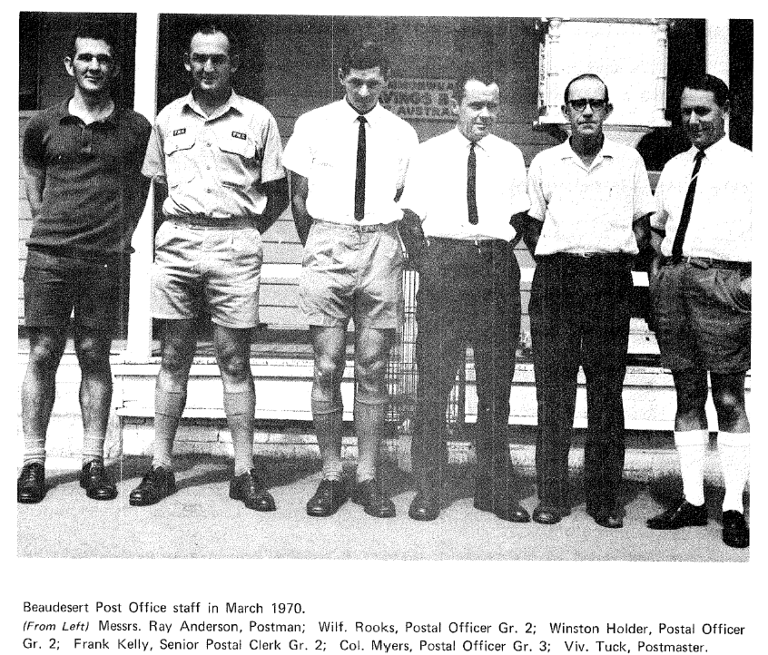
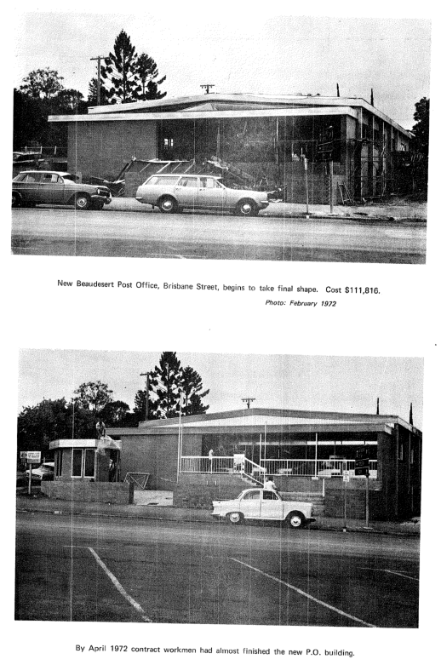
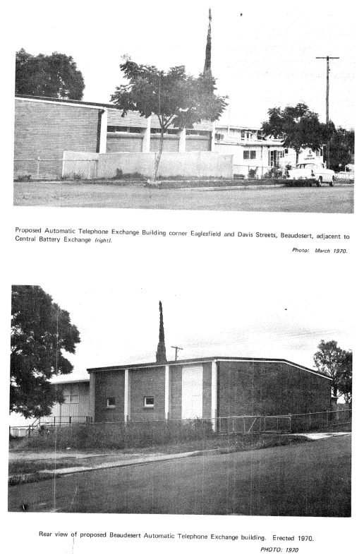
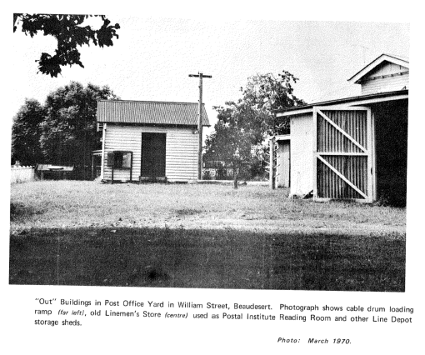

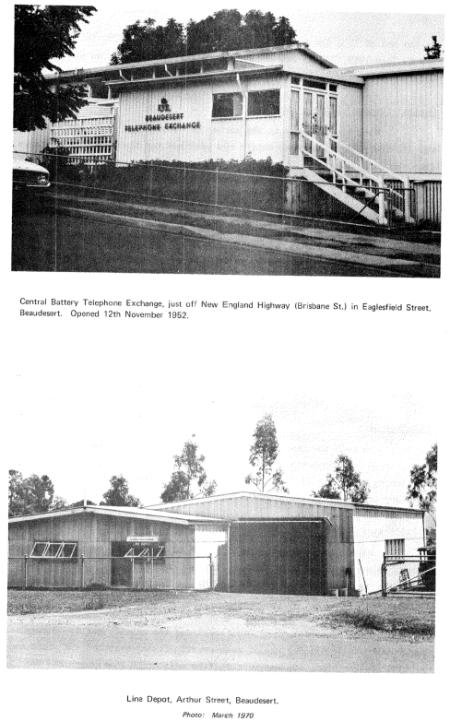
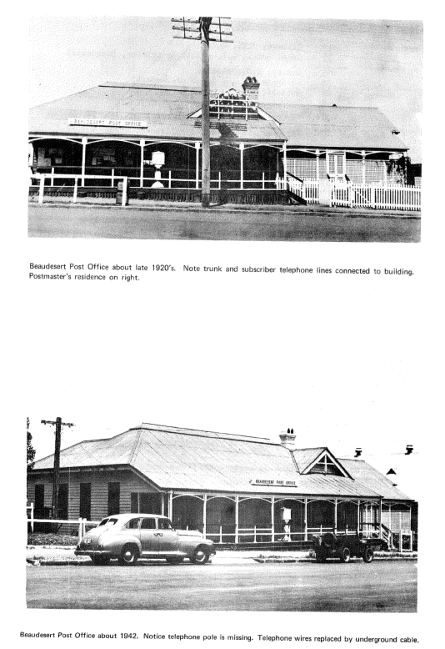
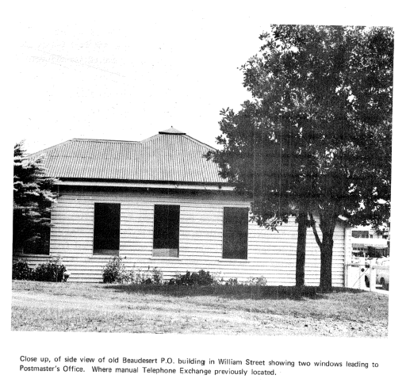

Stations on the route in 1888-1899 were:-
Stanley Street | Spring Creek
Woolloongabba | Kingston
Albert | Loganlea
Fairfield | Bethania Junction
Yeronga | Waterford
South Coast Junction | Buccan
Tennyson | Logan Village
South Brisbane Junction | Jimboomba
Rocklea | Cedar Grbve
Salisbury | Woodhill
Coopers Plains | Veresdale
Sunny Bank | Gleneagle
Runcorn | Beaudesert

As a comparison, the Stations on this line today are:-
South Brisbane | Fruitgrove
Vulture Street | Kuraby
Gloucester Street | Trinder Park
Park Road | Woodridge
Dutton Park | Kingston
Fairfield | Loganlea
Yeronga | Bethania
Yeerongpilly | WaterfOrd
Moorooka | Buccan
Rocklea | Logan Village
Nyanda | Jimboomba
Salisbury | Cedargrove
Coopers Plains | Woodhill
Banoon | Veresdale
Sunnybank | Gleneagle
Altandi | Laheys Siding
Runcorn | Beaudesert  47 miles

47 miles
The Electric Telegraph
Following the extension of an electric telegraph wire along the railway line from Bethania Junction on 14th July, 1886, a telegraph station was opened at Beaudesert on 26th July, 1886. This new line, with an additional wire from Brisbane to Beenleigh, totalled 77 miles of wire.
By the end of 1886, 593 messages valued at £40.14.3 were handled at the new telegraph office. The year's total for 1887 jumped to 1725 messages earning £116.9.5 revenue.
In 1888 there were two telegraph stations at Beaudesert, as was often the case in country towns which had a railway. One office was at the Post and Telegraph building and the other was at the Beaudesert Railway Station.
There was no telegraph messenger employed at the time to deliver telegrams, so some delay in delivery was experienced. However, a messenger was appointed some time later.

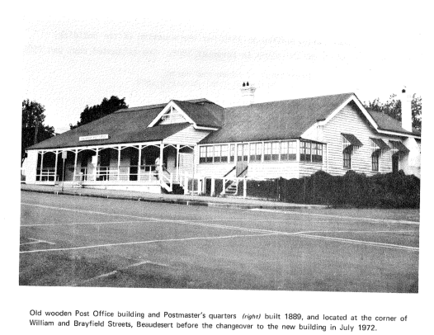

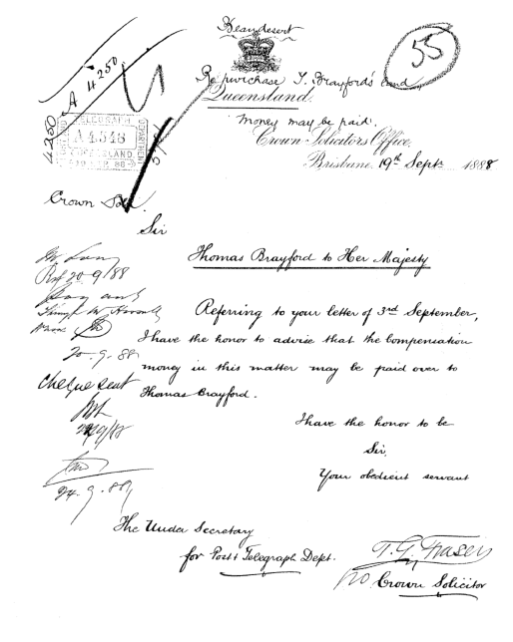

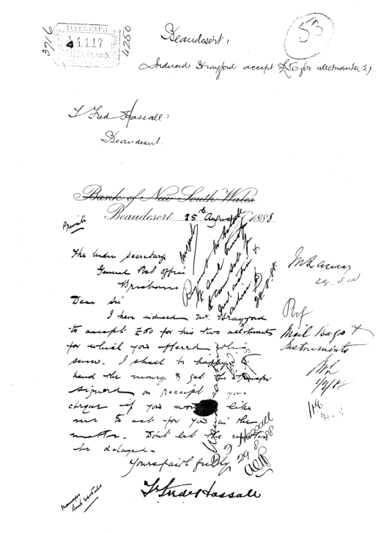

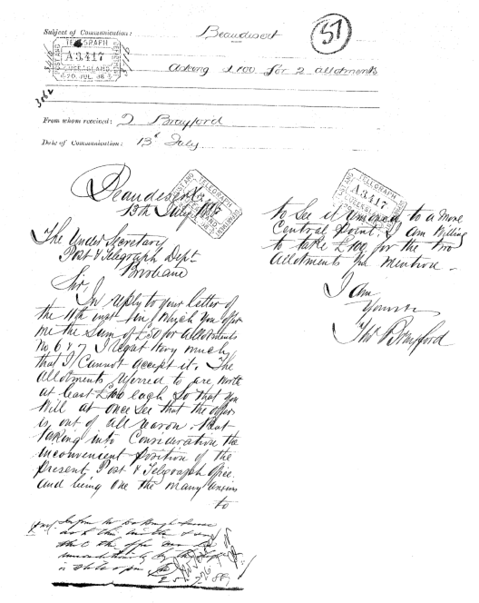

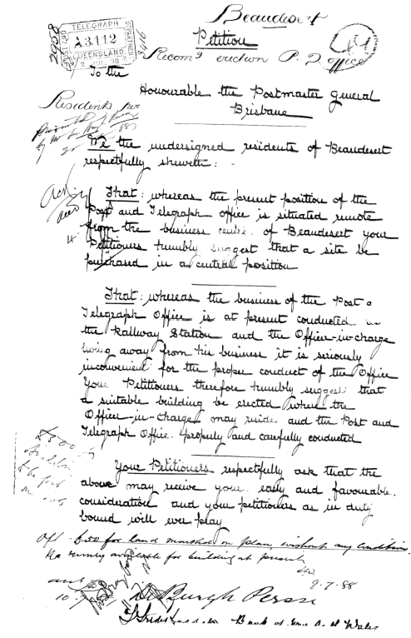
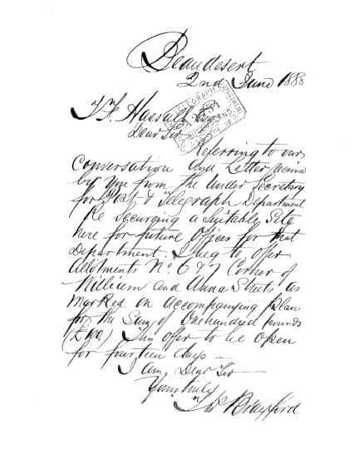

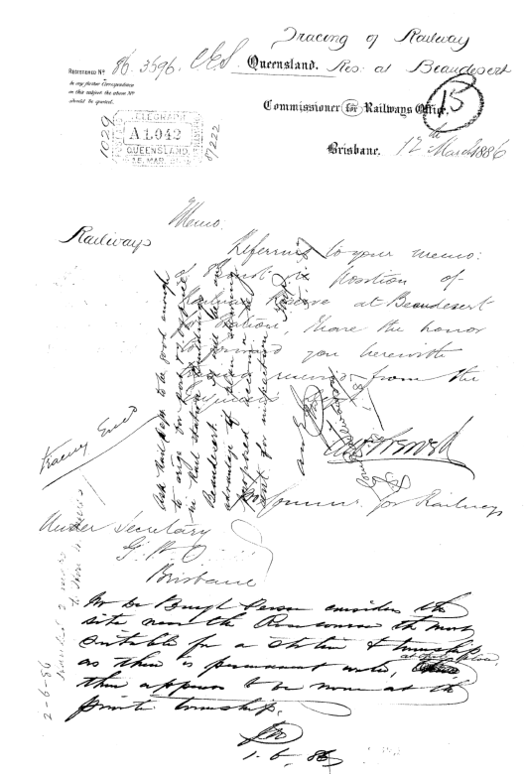

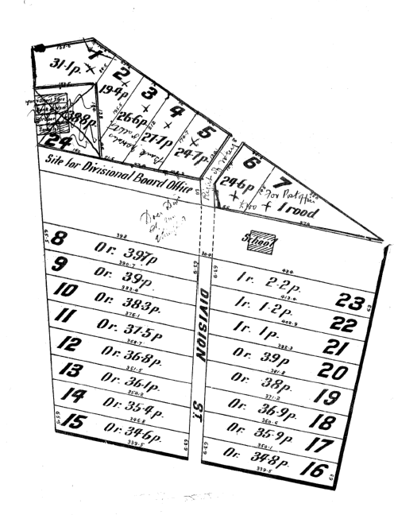

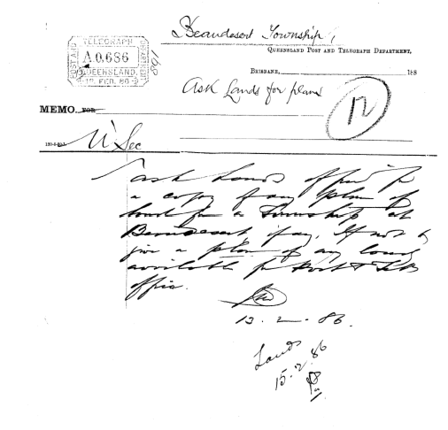

In 1881, Hill's Station was included in the service which was increased to three times weekly from 1st July, 1882.
Upon the opening of the Logan branch of the south coast railway line on 16th September, 1885, the Brisbane/ Beaudesert Mail Service, No.151, was shortened to Village of Logan/ Beaudesert three times a week by coach. This route continued until 16th May, 1888.
Also in 1881, a new service, No.167, commenced on 1st January, Beaudesert to Kooralbyn by horse twice a week. From 20th January, 1881, Telemon Crossing (Drynans) was included on this route, making the distance travelled 29i miles. In 1883 the service was operating three times a week, with route distance reduced to 19 miles. The 1892 records show the service as Beaudesert/ Rockbrook, 28 miles, three services to Kooralbyn and one to Rockbrook by buggy to Telemon Crossing thence by horse.
Other Mail Services
No,291. In 1883 a service Beaudesert/Hill's Selection, a distance of 20 miles twice a week by horse, was operating. On 16th July, 1888, this service was extended a further 3 miles to Hilton Dean.
No.305. A new service commenced on let January, 1883 - Beaudesert, McKinlay River and Mt. Merlin, 153 miles, by horse fortnightly. There is no record of this service after 1884.
No. 81. A service Beaudesert to Kerry commenced on 1st January, 1888, 17 miles three times a week by horse. It was still in service in 1892.
No.293. A service - Beaudesert Railway Station to Bromelton Receiving Office, °h. miles, six times a week by horse, commenced in 1889. It was still running in 1892.
No.431. A new service commenced on 9th October, 1889 - Beaudesert Post Office to the Railway Station, by horse, to meet mail trains.
Postal Note Office
In the meantime, Beaudesert office became a selling office for Postal Notes from 1st December, 1880. During the year ending 1881, Postal Notes issued were —

22 @ 1/-
10 @ 2/6
9 © 5/-
13 @ 10/-
Total 54 for £11.2.0.

24th July, 1828, to examine Mount Warning and the surrounding ranges on the now Queensland/New South Wales border. After travelling along the Logan River Valley they were hemmed in by steep, wooded ridges and progress further southwards with a dray became impossible. They retraced their steps part of the way and swung to a more westerly course. This brought them to a valley Logan had visited previously. After crossing the valley they came into view of the McPherson Ranges, which they climbed, naming Mt. Lindesay (renamed Mt. Barney later).
The next visit of significance was by a cattleman from Bathurst, N.S.W., employed by Suttors - one Edward Hawkins, with a mob of cattle.
Origin of Name
As was often the custom in those days after the free settlement proclamation, Hawkins drove a large number of cattle into virgin country from New South Wales until he saw unoccupied land he fancied. The rich alluvial flats caused by the Logan River and set between the Juberra and Birnam Ranges captured his interest and he took up a large holding in 1842. Hawkins named the property "Beau Desert" after his birthplace in England - "Beau Desert Park", an estate in Staffordshire.
Actually, the name Beau Desert is of Norman origin and occurs twice in England, meaning -
(1) a place of wild scenery in south Wales;
(2) a park on the river Trent in Staffordshire
(where Hawkins was born).
Early Settlement
Although Hawkins settled "Beau Desert", the New South Wales Government Gazette of 1848 stated it was J. Robinson who was granted leasehold of "Beau Desert", a 50,000 acre holding. The property was estimated to graze up to 1,500 cattle. Edward Hawkins was probably his manager who squatted on the land several years earlier. Robinson held rights until 1849 when William Sprott Boyd took over.
He was followed by Thomas Sutcliffe Mort, Robert Campbell III, and Michael E. Murnin, all in 1849. In February 1851, Campbell and Murnin asked that the lease be transferred to George Robinson and William Duckett White. Following the Crown Land Alienation Act of 1868 when leasehold properties were open to selection for freehold.
Robinson divided "Beau Desert" into freehold blocks for sale which took place from 1874. Thus the area opened up for closer settlement which eventuated into a farming community and the establishment of a town.

